MACHINE LEARNING · PARADIGM 3 OF 4 · LEARNING TO ACT FROM DATA
Deep reinforcement learning theory: why it learns, how fast, what logs teach
CLASSICAL tabular · asymptotic · worst case
NEW finite-time theorems · pessimism from logs · local limits

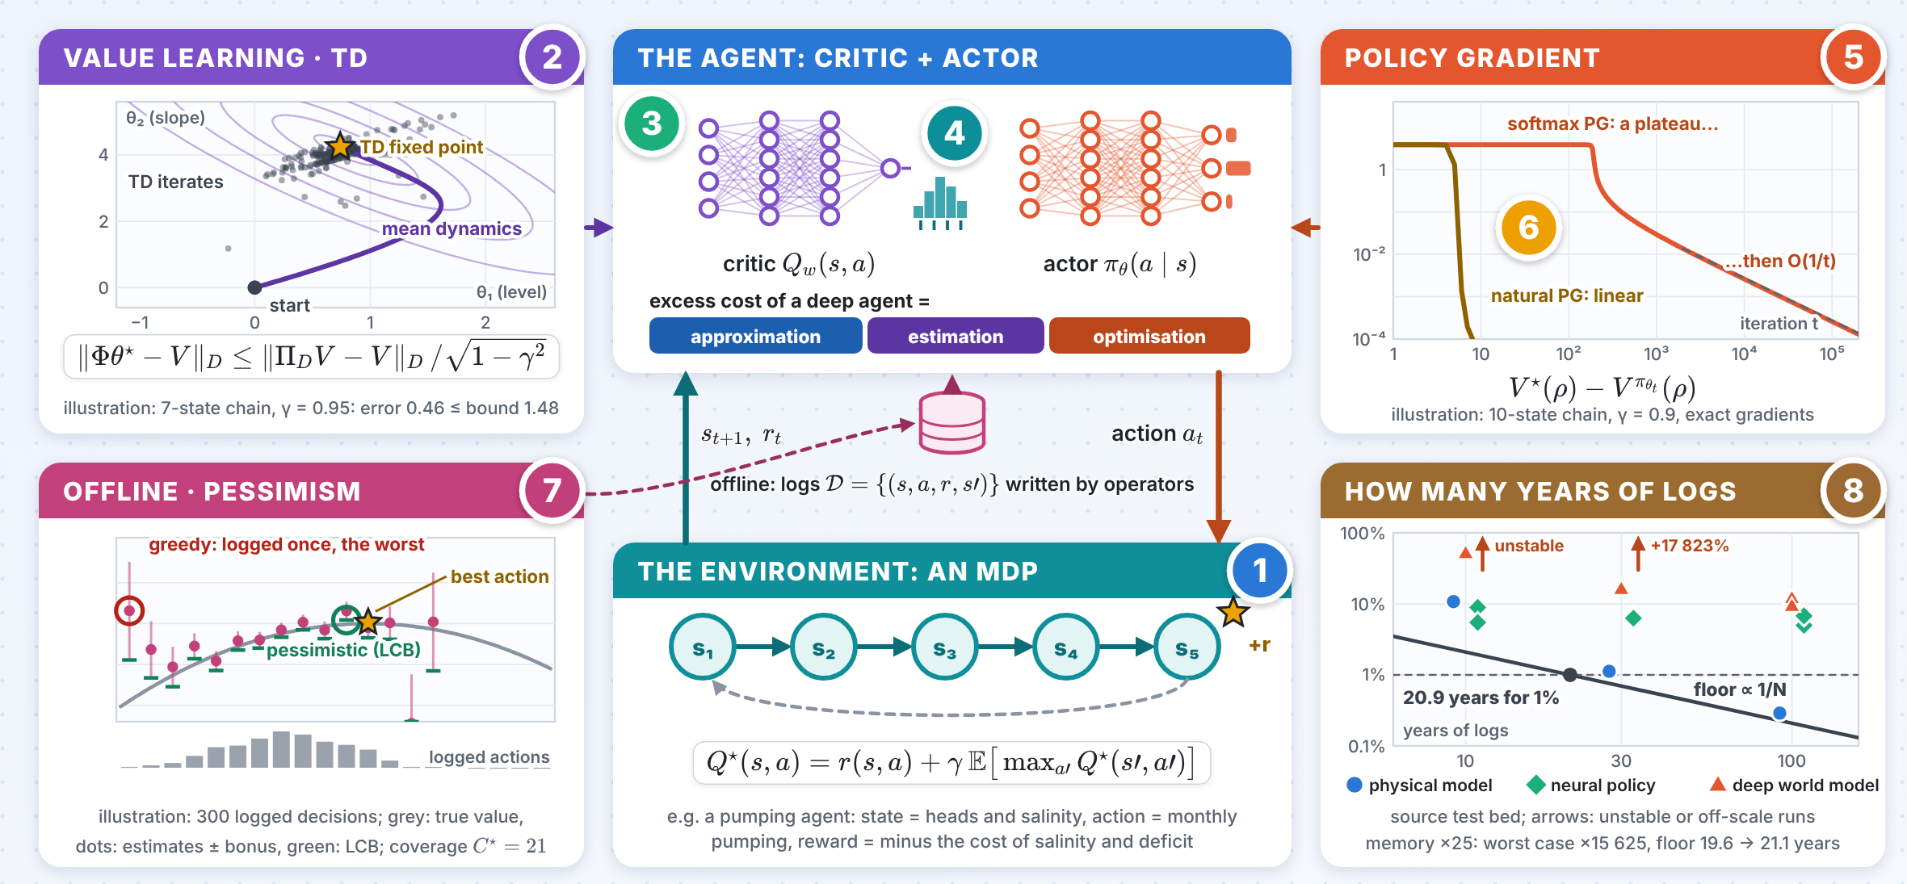
The numbers 1–8 in the picture point to the eight panels on the next pages; the innovation follows on the next page.

INNOVATION The years of data any learner needs
A local floor, for every learner, deep or not, trained on closed-loop logs.
1 The excess cost of a learned rule is a distance
$$J\left(π\right)−J^{⋆}=\overline{E}\left[{\left(q_{t}−q_{t}^{⋆}\right)}^{⊤}W \left(q_{t}−q_{t}^{⋆}\right)\right], W=R+B^{⊤}PB$$
For a linear–quadratic system with partial observation, the loss of any records-only rule is its weighted distance from the optimal action $q_{t}^{⋆}=−K E\left[z_{t}∣y_{≤t},q_{\text{<}t}\right]$, whatever the learner.
2 A local floor, in years of logs
$$\underset{N→∞}{liminf}N R_{c,N}\left(\hat{π}\right) ≥ \frac{1}{2} tr\left(HI^{−1}\right), N_{ε}=\frac{tr\left(HI^{−1}\right)}{2 ε J^{⋆}}$$
$H$: curvature of the cost in the physical parameters; $I$: Fisher information per month of the logs. A coastal-aquifer pumping agent needs 20.9 years of logs to come within 1% of the optimum with 4 parameters, 44.2 with 8; worst-case rates would grow with the cube of the memory.
20.9 yr for 1%, any learner
3 What shortens the years, and where deep agents land
$$d_{t}=ϕ d_{t−1}+σ_{d}\sqrt{1−ϕ^{2}} η_{t} ⇒ ΔJ_{op}=Wσ_{d}^{2} \text{for every }ϕ$$
Good operators write uninformative logs (timid ones: 10.8 years); logging their own toe reading halves the years (10.2); a recorded dither costs the same whatever its colour. Deep agents land far above the floor: a neural policy +5–9%, a deep world model 45–58 times it.
10.2 yr own reading logged

Deep reinforcement learning theory · panels 1–4
1 The MDP and the three errors  IDEA A deep agent errs because its network cannot represent the right function, its data are finite and its training stops short, and data from one policy judge another.  $$TQ\left(s,a\right)=r\left(s,a\right)+γ E\left[\max_{a′}Q\left(s′,a′\right)\right]$$  $$V^{π}\left(ρ\right)−V^{π′}\left(ρ\right)=\frac{1}{1−γ} E_{s∼d_{ρ}^{π}, a∼π}\left[A^{π′}\left(s,a\right)\right]$$  2020–2026 Error split explicit for deep fitted Q-iteration (Fan, Wang, Xie & Yang 2020) and neural actor–critic (Wang, Cai, Yang & Wang 2020); the shift costs a concentrability $C^{π}=maxd^{π}/μ$ (Rashidinejad et al. 2022). |  | 2 TD as stochastic approximation  IDEA TD follows no gradient, yet its mean dynamics are stable; one Markovian trajectory is enough, at the price of the mixing time.  $$θ_{k+1}=θ_{k}+α_{k}\left(r_{k}+γϕ{\left(s_{k+1}\right)}^{⊤}θ_{k}−ϕ{\left(s_{k}\right)}^{⊤}θ_{k}\right)ϕ\left(s_{k}\right)$$  $$EM\left(x_{k+1}−x^{⋆}\right)≤\left(1−c_{1}α_{k}\right) EM\left(x_{k}−x^{⋆}\right)+c_{2}α_{k}^{2}t_{α_{k}}$$  2020–2026 Finite-time bounds for linear TD with Markovian data (Bhandari, Russo & Singal 2021); a Lyapunov theory built on a generalised Moreau envelope $M$ that covers Q-learning (Chen, Maguluri, Shakkottai & Shanmugam 2024).
3 Deep Q-learning  IDEA Fitted Q-iteration is the clean model of DQN: the network enters only through a one-step regression error, plus a term that vanishes geometrically.  $$∥Q^{⋆}−Q^{π_{K}}∥_{1,ρ}≲\frac{C_{ρ,μ}^{1/2}}{{\left(1−γ\right)}^{2}}\max_{k<K}∥TQ_{k}−Q_{k+1}∥_{μ}$$  $$∂_{t}ρ_{t}=−η div\left(ρ_{t} g\left(⋅ ;ρ_{t}\right)\right)$$  2020–2026 Deep ReLU FQI: a vanishing algorithmic error plus a nonparametric statistical error (Fan, Wang, Xie & Yang 2020); in the mean-field regime neural TD converges while its features move (Zhang, Cai, Yang, Chen & Wang 2020). |  | 4 Distributional value learning  IDEA Learn the law of the return, not only its mean: what a water utility fears is the tail, a salinity limit exceeded in a dry decade.  θi←θi+αkτi−1mj​1{r+γθjx′<θi}  $$τ_{i}=\frac{2i−1}{2m}, ρ_{τ}\left(u\right)=u\left(τ−1\{u<0\}\right)$$  2020–2026 Quantile TD converges although its update is discontinuous and may have several fixed points, proved with differential inclusions (Rowland, Munos, Azar et al. 2024).

Deep reinforcement learning theory · panels 5–8
5 The landscape of policy gradients  IDEA The objective is not concave, yet gradient ascent finds the global optimum: gradient domination bounds the gap by a first-order quantity.  $$∇_{θ}V^{π_{θ}}\left(ρ\right)=\frac{1}{1−γ} E_{s∼d_{ρ}^{π_{θ}}, a∼π_{θ}}\left[∇_{θ}lnπ_{θ}\left(a∣s\right) A^{π_{θ}}\left(s,a\right)\right]$$  $$t_{ε} ≥ \frac{1}{η} {\left|S\right|}^{2^{Ω\left(1/\left(1−γ\right)\right)}}$$  2020–2026 Softmax PG converges at rate $O\left(1/t\right)$ (Mei, Xiao, Szepesvári & Schuurmans 2020) but can take time exponential in the horizon (Li, Wei, Chi & Chen 2023); no spurious stationary points when the class is closed under policy improvement, as in LQ control (Bhandari & Russo 2024). |  | 6 Natural gradients and mirror descent  IDEA Precondition by the Fisher information: for softmax policies the step is multiplicative, a mirror-descent step in KL; TRPO, PPO and soft actor–critic are relatives.  $$π_{k+1}\left(a∣s\right) ∝ π_{k}\left(a∣s\right) exp\left(η_{k} Q^{π_{k}}\left(s,a\right)\right)$$  $$∥Q_{τ}^{⋆}−Q_{τ}^{\left(t+1\right)}∥_{∞}≤C_{1}γ {\left(1−ητ\right)}^{t}$$  2020–2026 Entropy-regularised natural PG converges linearly at a nearly dimension-free rate (Cen, Cheng, Chen, Wei & Chi 2022); neural natural PG with a neural critic reaches a global optimum (Wang, Cai, Yang & Wang 2020).
7 Offline: coverage and pessimism  IDEA Logs written by others teach only what they cover; acting on a lower confidence bound makes coverage of one good policy enough.  $$\hat{π}=arg\max_{π} \min_{f∈F: E\left(f,π;D\right)≤ε_{0}}f\left(s_{0},π\right)$$  $$J\left(π^{⋆}\right)−E J\left({\hat{π}}_{LCB}\right)≲poly\left(\frac{1}{1−γ}\right)\sqrt{SC^{⋆}/N}$$  2020–2026 Pessimism at minimax rates (Rashidinejad, Zhu, Ma, Jiao & Russell 2022); Bellman-consistent pessimism (Xie et al. 2021); adversarially trained actor–critic (Cheng et al. 2022); one trajectory (Yan et al. 2023); limits of realizability (Jia et al. 2024). |  | 8 How many samples  IDEA Worst-case rates are settled and grow with the cube of the horizon; for a physical system the local (Hájek–Le Cam) answer is the useful one.  $$N^{⋆}\left(ε\right)≍\frac{\left|S\right|\left|A\right|}{{\left(1−γ\right)}^{3}ε^{2}}, N_{\text{Q-learning}}≍\frac{\left|S\right|\left|A\right|}{{\left(1−γ\right)}^{4}ε^{2}}$$  $$Regret\left(K\right)≲\sqrt{SAH^{3}K}, Z∼N\left(0,∇ψ I^{−1}∇ψ^{⊤}\right)$$  2020–2026 Minimax model-based planning for every accuracy (Li, Wei, Chi & Chen 2024); Q-learning one horizon factor worse (Li, Cai et al. 2024); online regret without burn-in (Zhang, Chen, Lee & Du 2025); a good representation is not sufficient (Du, Kakade, Wang & Yang 2020).

