State of the art II: inputs, dispersion and boundary conditions from rain
Twenty more papers from Oxford, Caltech, Berkeley and MIT (2020–2026), chosen for direct use; the state of the art and the step beyond it, in the form a NATO proposal asks for; and MATJA-GO, the guaranteed value of a measurement
Dulian Zeqiraj · November 2026 · review with a numerically tested innovation · companion to review I (GARANCIA-GO)
1. Outcome
• Twenty new papers, five per institution, 2020–2026, each with links (Section 3, Figure 1). None was a card of review I or of the earlier reviews. They were chosen for what we can use now: recharge from rain and satellites (C4, M2, B1, O2), the sea boundary as a relative sea level (C1, C3, C5, B2), the initial interface (O1), dispersion as a non-constant (M5), and the choice of where to measure (B3, B4, O3, M1). Every card states the state of the art the paper sets, what it cannot yet do for us, three lessons and an innovation step.
• State of the art and beyond, ready for the proposal (Section 2, Table 1). Seven topics; for each, the best current work, its limit for a coastal aquifer known only through rain, our step beyond it and the test that backs the step.
• Innovation: MATJA-GO, the guaranteed value of a measurement (Section 4). The value of an instrument is the guaranteed band width it removes, calibrated on simulated aquifers that carry the instrument's data; the choice is made on one pool of simulations and the guarantee is re-established on a fresh pool, so it holds for the design that was chosen (Proposition M1). Proposition M3 gives the exact law of what a finite ensemble gets wrong: an instrument that knows nothing about the goal shrinks the ensemble spread by the factor $1−δ_{N}$ and grows the error by $1+ε_{N}$, both about $d_{s}/\left(N−1\right)$.
• Test 1: the tide gauge with rain only (T6, 300 fresh simulated aquifers). It carries no information on the recharge, the inflow or $κ$: the exact posterior does not move. The raw ensemble says it narrows their bands by 15%; the guaranteed band in fact widens by 16–21%. For the sea level itself it is worth a factor 14. Of the 36 pairs of instrument and goal, 10 have a negative guaranteed value, and the price rule of Remark M3 predicts the sign of all 36.
• Test 2: choosing three instruments (T7). For the recharge and the inflow the raw ensemble, the exact posterior and MATJA-GO choose nearly the same loggers (final guaranteed half-widths within 9%). For $κ$ the ensemble claims 0.002 for its design, the exact posterior gives 0.018 and the guarantee 0.026: a factor 12 of overconfidence, and a third logger buys nothing that can be guaranteed. Every reported guarantee held on the fresh pool (share of weeks outside 0.092–0.101, whole-function coverage 0.90).
• Test 3: the exact law (T8). Over $N$ = 32–512 members the measured spread factors match $1−δ_{N}$ to within 0.003, and the error factors match $1+ε_{N}$ to within 18%. Even with 512 members a worthless tide gauge widens the guaranteed band by 6–9%.
• What to measure first when only the rain is known (Section 4.4): a logger in the middle of the aquifer for the recharge and $κ$, a logger near the inland edge for the inflow, a tide gauge only when the goal is the sea level or the toe, a deep salinity profile for dispersion; and, beyond two loggers, a larger ensemble before a third logger.

2. State of the art and the step beyond it
The problem is the one of review I (D1): a simulation of a coastal aquifer needs its input parameters (transmissivity, the recharge coefficient $κ$, the vadose delay $τ$), its dispersion coefficient and its boundary and initial conditions (sea level $η\left(t\right)$, inland inflow $q_{L}\left(t\right)$, recharge $r\left(t\right)$, initial head $h_{0}$), when the only series that is always there is the rain. Review I answered with guaranteed bands (GARANCIA-GO). This review asks the next question, the one a field campaign faces: which measurement should be added first, and what is it guaranteed to buy?
Text for the proposal. Recharge and boundary forcing can now be estimated from rain, soil moisture and space geodesy at basin to global scale (C4, M2, C2, O2), and seawater-intrusion risk has been projected globally with the recharge and sea-level drivers separated (C1). Calibration with few model runs is routine with ensemble Kalman methods and derivative-free optimisers (C4, O4), and monitoring networks are reduced with machine-learning pipelines (B3) or guided by zonation (B4). Two limits remain. First, none of these methods gives a finite-sample guarantee for the boundary conditions it estimates, and controlled experiments show that forecast intervals in porous-media flow are too narrow (M4). Second, measurements are chosen by the model's own spread, by interpolation skill or by information gain under the model, so an instrument that is worthless, or worse, can be valued positively. The project goes beyond the state of the art with guaranteed bands for every boundary and initial condition, calibrated on aquifers simulated from the rain (GARANCIA-GO, review I), and with MATJA-GO, which values each candidate instrument by the guaranteed width it removes, keeps the guarantee after the choice, and has an exact law for the error of ensemble-based design. Both are tested numerically below and in review I.
Table 1. State of the art (2020–2026) and the step beyond it. Card numbers refer to Section 3; S and D numbers to the references; T numbers to the tests of Section 4 and of review I.
Topic | State of the art | Its limit for our problem | Our step beyond | Evidence
Recharge and forcing from rain | Satellite + Hydrus emulator for global recharge (M2); Richards land model with EKI (C4); national rain-driven model (O2); rock moisture gates recharge (B1) | No guarantee; deterministic or uncalibrated spreads; a constant coefficient fails in dry years | Rain-conditional prior → simulated aquifers → guaranteed bands for $r$, $q_{L}$, $η$, $h_{0}$; threshold law in the prior (B1) | Review I, T1: share of weeks outside 0.095–0.100, whole-function coverage 0.899–0.901
Calibration with few runs | Ensemble Kalman inversion and pipelines (C4; S6, S7); derivative-free tuning (O4); PEST (O2) | The ensemble spread is not a guarantee; forecasters are overconfident (M4); equifinality (O4) | The calibrated factor ${\hat{λ}}_{D}/1.645$ is a measured inflation, design by design | T7: ensemble half-width for $κ$ up to 16 times too narrow; after calibration all guarantees hold (risk 0.092–0.101)
Choosing measurements | Ensemble-based design (S1); Bayesian design (S2); network reduction (B3); zonation (B4); guaranteed spatial inference (M1) | Value judged by the model's own spread or by interpolation skill; no guarantee after selection | MATJA-GO: value = guaranteed width removed; valid after selection (M1); exact law of the spurious value (M3) | T6: tide gauge −15% by the ensemble, +16 to +21% guaranteed; 36/36 signs predicted
The sea boundary | Global intrusion with recharge and sea-level drivers (C1); land motion at 90 m (C3); SWOT (C5); heads below sea level in 250 000 wells (B2) | Sea level taken as absolute; not assimilated; no local guarantee; no sign test | $η$ as relative sea level with land motion as an instrument; guaranteed sign test of $h−η$; altimetry against a tide gauge priced by MATJA-GO | T6: tide gauge cuts the sea-level half-width from 0.185 to 0.013 m and is worth nothing for $r$, $q_{L}$, $κ$
Initial conditions | Interface memory of past sea-level positions (O1) | Elsewhere the initial interface is assumed in equilibrium with today's sea | Initial interface drawn from a sea-level history in the prior; guaranteed $h_{0}$ band | Review I, T1A/T1: $h_{0}$ half-width 2.89 m with rain only, 0.25 m with four loggers
Dispersion coefficient | Dispersion set by flow disorder (M5); mixing is the hardest part to forecast (M3); permeability from salinity profiles (O1) | No field identification of dispersivity from rain or heads | Ancillarity of dispersion to rain and heads (review I, Proposition 6); calibrated width $w$; depth profiles priced as instruments | Review I, T4: heads leave $w$ at its prior (7.4–53.8 m); chloride facts move it to 16–65 m
Fast surrogates | Hard-constrained mixture-of-experts solvers (B5); neural operators (review I, B1, C1) | Surrogate error enters the band without a guarantee | Conformal calibration on simulated truths absorbs the remaining surrogate error | Review I, Propositions 1–2 (any reconstructor)

3. The twenty papers
Five papers per institution, all published in 2020–2026 (Figure 1). Four rules decided the selection: direct use for inferring inputs, dispersion or boundary conditions from rain with few data, or for choosing what to measure; a link to the institution at the time of publication (for Caltech this includes JPL, which Caltech manages; for Berkeley, Lawrence Berkeley National Laboratory); a contribution that is a state of the art in its field; and no paper that was a card in review I or in the earlier reviews of the series. The searches found no 2020–2026 paper from these institutions that identifies a field dispersivity from rain or heads, nor one that designs groundwater monitoring with a guarantee; both gaps are stated in Table 1.
Verification. The hosts doi.org, arxiv.org, openreview.net and most publisher pages were blocked in this environment, so every landing page was reached through search results that quote it, and every card is marked partly verified. Where an author list or a volume could not be confirmed, the card gives only what was seen and says so.
3.1 University of Oxford
O1 · Oxford · 2025
Groundwater dynamics beneath a marine ice sheet
Gabriel Cairns, Graham Benham, Ian Hewitt
The Cryosphere 19, 3725–3747 (2025); arXiv:2409.11848
Links: doi:10.5194/tc-19-3725-2025 · The Cryosphere · arXiv:2409.11848
Affiliation and verification: Mathematical Institute, University of Oxford (arXiv listing as quoted); Benham's affiliation at publication was not confirmed. Status: partly verified (landing pages reached through search results only).
What it does. A two-dimensional cross-section model of groundwater flow in a sedimentary basin beneath a marine-terminating ice stream, over geological time, with seawater intrusion (sharp interface), ice growth and retreat and the basin geometry. Seawater is trapped by cycles of grounding-line advance and retreat or in pockets of the basin geometry; water exfiltrates where the basin shoals and re-infiltrates where it deepens. The basin permeability is estimated by matching the salinity profiles measured beneath Whillans Ice Stream.
State of the art it sets. Seawater-intrusion dynamics under a moving marine boundary, with a permeability inverted from a few salinity profiles.
What it cannot yet do for us. No transition-zone width or dispersivity, no uncertainty quantification, two-dimensional only.
Input parameters. A worked case of estimating permeability from a few salinity profiles: close to our handful of chloride facts, and the reason why salinity data are worth more than heads for some inputs.
Dispersion coefficient. None: mixing is excluded by construction, so the model shows what a sharp interface can and cannot explain.
Boundary conditions from rain alone. Today's interface records past positions of the sea boundary, so the initial interface should not be assumed in equilibrium with today's sea level. The initial condition is an unknown with memory, to be put in the prior.
Innovation step for our problem. Draw the initial interface of the simulated aquifers from a past sea-level history instead of the present equilibrium. GARANCIA-GO then guarantees the initial condition too, and MATJA-GO prices one deep salinity profile against a logger for the initial interface.

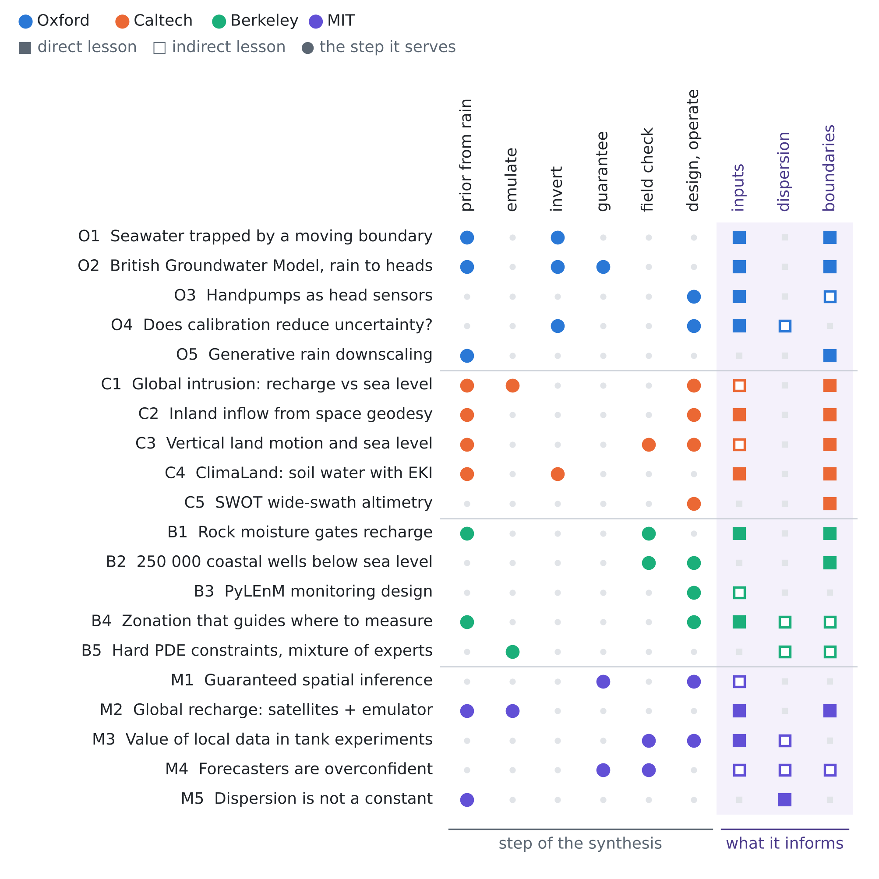
Figure 1. The twenty papers against the step of the synthesis they serve and the unknown they inform. Colour gives the institution; a filled square is a direct lesson, an open square an indirect one.
O2 · Oxford · 2024
Simulation of national-scale groundwater dynamics in geologically complex aquifer systems: an example from Great Britain
Marco Bianchi, Johanna Scheidegger, Andrew Hughes, Christopher Jackson, Jonathan Lee, Melinda Lewis, Majdi Mansour, Andrew Newell, Brighid Ó Dochartaigh, Ashley Patton, Simon Dadson
Hydrological Sciences Journal 69(5), 572–591 (2024)
Links: doi:10.1080/02626667.2024.2320847 · NORA record · BGS project
Affiliation and verification: Dadson: University of Oxford (Oxford ORA record and Oxford climate-network listing); his printed affiliation was not seen. Status: partly verified (landing pages reached through search results only).
What it does. The British Groundwater Model, built in MODFLOW 6 on an unstructured grid of 1 km or finer, is coupled to the ZOODRM recharge model, which computes daily recharge from rain and potential evaporation with land use and geology. Parameters are calibrated with PEST against groundwater levels and baseflow; the model reproduces the groundwater systems of Great Britain reasonably well, and the resilience to climate extremes differs by region with lithology and climate.
State of the art it sets. National-scale, rain-driven, integrated groundwater modelling: the practitioner's state of the art.
What it cannot yet do for us. Deterministic calibration, no salt transport or density effects, no uncertainty bounds.
Input parameters. The standard route to transmissivity and storage, PEST against heads and baseflow; deterministic, so it gives one value where we need a guaranteed band.
Dispersion coefficient. None (flow only).
Boundary conditions from rain alone. The recharge boundary is derived from rain through a distributed recharge model: exactly our route, at national scale.
Innovation step for our problem. Wrap a model of this kind in GARANCIA-GO: draw its uncertain recharge and aquifer parameters from a prior given the rain, run the PEST-calibrated reconstructor on each simulated aquifer, and calibrate its bands. A national model then carries a guarantee per aquifer, and MATJA-GO ranks the national logger network.

O3 · Oxford · 2020
Shallow aquifer monitoring using handpump vibration data
A. Manandhar, H. Greeff, P. Thomson, R. Hope, D. A. Clifton
Journal of Hydrology X 8, 100057 (2020)
Links: doi:10.1016/j.hydroa.2020.100057 · ORA record · accepted manuscript
Affiliation and verification: University of Oxford (ORA record; accepted manuscript hosted by Oxford Engineering Science). Status: partly verified (landing pages reached through search results only).
What it does. Accelerometers on the handles of nine Kenyan handpumps record for a year; machine-learning models fitted to each pump track the water level relative to the bottom of the rising main, combining regression with novelty detection. The authors present it as cheap, scalable aquifer monitoring wherever handpumps already exist.
State of the art it sets. Existing water infrastructure as hydrological sensors in data-scarce aquifers.
What it cannot yet do for us. The range is limited by the rising main; no salinity; no rule for which sites to choose.
Input parameters. Many cheap head series constrain transmissivity and recharge.
Dispersion coefficient. None.
Boundary conditions from rain alone. Head dynamics at existing wells constrain the timing of recharge and the inland inflow.
Innovation step for our problem. Existing pumps and wells are a cheap pool of candidate sites. Give each its own noise level (a vibration sensor is noisier than a logger) and let MATJA-GO choose among them: a noisy but free series can be worth more than a precise logger at the wrong place (Section 4 ranks the eight logger sites by their guaranteed value).

O4 · Oxford · 2022
Does model calibration reduce uncertainty in climate projections?
Simon F. B. Tett, Jonathan M. Gregory, Nicolas Freychet, Coralia Cartis, Michael J. Mineter, Lindon Roberts
Journal of Climate 35(8), 2585–2602 (2022)
Links: doi:10.1175/JCLI-D-21-0434.1 · Reading repository
Affiliation and verification: An Oxford ORA record exists; the Oxford author is most likely Cartis (Mathematical Institute), but the byline was not seen. Status: partly verified (landing pages reached through search results only).
What it does. The atmospheric model HadAM3 is tuned with the derivative-free optimiser DFO-LS using a limited number of runs. Several locally optimal parameter sets fit the observations about as well as the CMIP5/6 models; the spread of climate sensitivity among them is two to six times smaller than in CMIP; the remaining spread comes from sea-ice feedbacks the targets do not constrain, and structural uncertainty probably dominates.
State of the art it sets. An empirical measure of what calibration with few runs can and cannot reduce.
What it cannot yet do for us. No method for choosing the next observation and no formal guarantee.
Input parameters. Equifinality: several parameter sets fit equally well. Calibrating to heads can leave $κ$ and $τ$ unconstrained, so the band must be computed, not inferred from the fit.
Dispersion coefficient. By analogy, a process the calibration targets do not see stays unconstrained: dispersivity under heads-only data (first review, Proposition 6).
Boundary conditions from rain alone. None directly.
Innovation step for our problem. Turn the question of the title into a number: the guaranteed width before and after each calibration target is MATJA-GO's value of that target. Here the answer can be negative: a target the model cannot use well widens the guaranteed band (Proposition M3).

O5 · Oxford · 2022
A generative deep learning approach to stochastic downscaling of precipitation forecasts
Lucy Harris, Andrew T. T. McRae, Matthew Chantry, Peter D. Dueben, Tim N. Palmer
Journal of Advances in Modeling Earth Systems 14(10), e2022MS003120 (2022); arXiv:2204.02028
Links: doi:10.1029/2022MS003120 · PMC9788314 · arXiv:2204.02028
Affiliation and verification: Harris, McRae and Palmer: University of Oxford (search results; ORA file). Status: partly verified (landing pages reached through search results only).
What it does. Generative adversarial networks and VAE-GANs downscale ECMWF IFS rainfall over the UK by a factor of 10 and produce spatially coherent high-resolution maps. They match state-of-the-art pointwise post-processing and compare favourably on CRPS, power spectra and rank histograms.
State of the art it sets. Generative stochastic downscaling of rainfall: an ensemble of plausible local rain fields from a coarse forecast.
What it cannot yet do for us. Trained on a radar-rich UK, short-range, and no coverage guarantee.
Input parameters. None.
Dispersion coefficient. None.
Boundary conditions from rain alone. When "the rain" is a coarse product, the rain itself is uncertain: stochastic local fields give an ensemble of recharge forcings, and so of boundary conditions.
Innovation step for our problem. Make the rain a random input of the simulated aquifers: draw it from a generative downscaler conditioned on the coarse product, so the guarantees of GARANCIA-GO and the values of MATJA-GO include the error of the rain. A local rain gauge then becomes one more candidate instrument.

3.2 California Institute of Technology (with JPL)
C1 · Caltech · 2024
Climate-induced saltwater intrusion in 2100: recharge-driven severity, sea level-driven prevalence
Kyra H. Adams, John T. Reager, Brett A. Buzzanga, Cédric H. David, Audrey H. Sawyer, Benjamin D. Hamlington
Geophysical Research Letters 51(22), e2024GL110359 (2024)
Links: doi:10.1029/2024GL110359 · PMC11583115 · JPL news
Affiliation and verification: Adams and Hamlington: NASA Jet Propulsion Laboratory, managed by Caltech (JPL news release naming Adams as lead author); the byline itself was not seen. Status: partly verified (landing pages reached through search results only).
What it does. Ensembles of projected recharge and sea-level rise drive a global one-dimensional analytical model of the interface toe (Ghyben–Herzberg with Dupuit–Forchheimer flow, extended for coastline migration) in 60 638 coastal watersheds, each an unconfined, homogeneous aquifer. About 77% of the coastal areas below 60°N see intrusion by 2100. Falling recharge drives the severe cases, sea-level rise and coastline migration drive how widespread intrusion is, and sea-level rise matters more where the inland boundary is head-controlled rather than flux-controlled.
State of the art it sets. The first global projection of seawater intrusion that separates the recharge driver from the sea-level driver and shows that the type of the inland boundary decides which one dominates.
What it cannot yet do for us. Steady, sharp-interface and homogeneous: no mixing zone, no data assimilation and no local guarantee; the boundary type is assumed for each watershed, not identified from data.
Input parameters. The closed-form toe $x_{t}\left(K,\overline{r},\text{geometry}\right)$ is the cheapest emulator there is, and its sensitivity to the mean recharge converts a guaranteed band on $κ$ into metres of toe: the goal a stakeholder cares about.
Dispersion coefficient. None (sharp interface). The toe of such models is the 50% isochlor; the width of the transition zone has to come from chloride data (first review, Proposition 6).
Boundary conditions from rain alone. Whether the inland boundary is a flux or a head is the boundary question that decides the risk. In our test bed the inland inflow is witnessed only by heads near the inland edge, and MATJA-GO chooses exactly such a logger first for $q_{L}$ (Section 4).
Innovation step for our problem. Put the boundary type in the prior, as a mixture of a flux and a head boundary, and let MATJA-GO price the instrument that tells them apart: the guaranteed width of the toe under the mixture, with and without an inland logger, is the value of settling the boundary type.

C2 · Caltech · 2022
Subsurface water flux in California's Central Valley and its source watershed from space geodesy
D. F. Argus, H. R. Martens, A. A. Borsa, et al. (16 authors)
Geophysical Research Letters 49, e2022GL099583 (2022)
Links: doi:10.1029/2022GL099583 · ADS record · JPL news
Affiliation and verification: Argus: JPL/Caltech (JPL news release presenting the study as JPL work); the full author order was not confirmed, hence the short author list. Status: partly verified (landing pages reached through search results only).
What it does. GPS displacements, GRACE gravity, reservoir volumes and snowpack close the water budget of the Central Valley and its Sierra Nevada source. The valley lost 2.2 ± 0.7 km³/yr of groundwater over 2006–2021; storage swings 10.7 ± 1.1 km³ each year and peaks in April; inflows total about 50 km³/yr (28 from rivers, 17 from precipitation and 5 as deep mountain groundwater arriving in autumn and winter); about a third of the drought loss was recharged in the following wet years.
State of the art it sets. Closing a basin water budget, including the mountain-block groundwater inflow, from space geodesy.
What it cannot yet do for us. Basin scale with a dense GPS network; the uncertainty is not carried into a flow model, and there is no salinity.
Input parameters. The storage budget constrains the effective storage and the share of the rain that becomes recharge: a basin-scale prior for $S$ and $κ$.
Dispersion coefficient. None.
Boundary conditions from rain alone. The inland lateral inflow and its seasonal lag behind the rain are measured, not assumed. In our notation the geodetic storage signal is a spatial integral of $S ∂h/∂t$, linear in $q_{L}$ and $r$, so it is one more candidate instrument for the inland boundary.
Innovation step for our problem. Add "storage from geodesy" (a GNSS station or InSAR over the recharge zone) to the candidates of MATJA-GO: its guaranteed value for $q_{L}$ and $κ$ is computed before a station is bought, with the same calibration on simulated aquifers as a head logger.

C3 · Caltech · 2025
Variable vertical land motion and its impacts on sea level rise projections
Marin Govorcin, David Bekaert, Benjamin Hamlington, Simran Sangha, William Sweet
Science Advances 11(5), eads8163 (2025)
Links: doi:10.1126/sciadv.ads8163 · NASA news
Affiliation and verification: Govorcin: JPL/Caltech scientist and lead author, in a JPL–NOAA team (NASA release as quoted); byline not seen. Status: partly verified (landing pages reached through search results only).
What it does. Vertical land motion along the California coast is mapped at 90 m for 2015–2023 from Sentinel-1 InSAR and GNSS. Regional estimates such as those of IPCC AR6 understate it; in the fastest-sinking areas local sea level could rise by more than 45 cm by 2050, human-driven land motion adds up to 40 cm of uncertainty, and the Santa Barbara groundwater basin is rising.
State of the art it sets. The highest-resolution coastal land motion built into sea-level projections.
What it cannot yet do for us. Not coupled to aquifer flow or salinity; the land motion is not used to infer aquifer parameters.
Input parameters. Land motion driven by the aquifer carries information on storage changes, hence on the skeletal storage and on the recharge that refills it.
Dispersion coefficient. None.
Boundary conditions from rain alone. Our sea boundary $η\left(t\right)$ is the relative sea level: the sea surface minus the land motion at the coast. A tide gauge far away is a biased witness unless the local motion is added; Sentinel-1 covers the Albanian coast.
Innovation step for our problem. Write $η=η_{sea}−v$ with the land motion $v$ from InSAR as a second sea-boundary instrument. MATJA-GO then decides whether a local tide gauge, InSAR land motion or both are worth having for the toe, and the field check of the first review (Proposition 5) flags a land-motion drift as a shift of the prior.

C4 · Caltech · 2026
ClimaLand: a land surface model designed to enable data-driven parameterizations
Katherine Deck, Renato K. Braghiere, Alexandre A. Renchon, Julia Sloan, Gabriele Bozzola, et al.
Journal of Advances in Modeling Earth Systems 18(1), e2025MS005118 (2026)
Links: doi:10.1029/2025MS005118 · CaltechAUTHORS
Affiliation and verification: Braghiere and Renchon: Caltech (CaltechAUTHORS record); sources disagree on the length of the author list, so only the first five authors are given. Status: partly verified (landing pages reached through search results only).
What it does. Version 1.0 of the land model of the Climate Modeling Alliance, with soil, canopy and snow, running natively on GPUs. The soil solves the mixed-form Richards equation in the unsaturated and saturated zones, with freezing and thawing; an ensemble Kalman inversion pipeline is built in, and the worked example calibrates photosynthesis and stomatal conductance, a soil-moisture stress function and the snow albedo.
State of the art it sets. An open, GPU-native land model designed from the start for ensemble Kalman calibration and learned closures.
What it cannot yet do for us. Calibrated on surface fluxes, not on recharge or heads; no lateral groundwater flow and no saline coupling.
Input parameters. A Richards-equation column driven by the rain gives a physical recharge coefficient and vadose delay (our $κ$ and $τ$) with an ensemble, in place of the lognormal prior of the test bed.
Dispersion coefficient. None.
Boundary conditions from rain alone. It produces the recharge series $r\left(t\right)$, the upper boundary of the aquifer, from the rain and the soil properties, including the threshold behaviour of dry years (B1).
Innovation step for our problem. Use the ClimaLand ensemble as the generator of recharge for the simulated aquifers of GARANCIA-GO and MATJA-GO: the guarantees then cover the soil-physics uncertainty, and the same ensemble Kalman tooling inverts the heads.

C5 · Caltech · 2024
The Surface Water and Ocean Topography mission: a breakthrough in radar remote sensing of the ocean and land surface water
Lee-Lueng Fu, Tamlin Pavelsky, et al. (11 authors)
Geophysical Research Letters 51(4), e2023GL107652 (2024)
Links: doi:10.1029/2023GL107652 · DOAJ record
Affiliation and verification: Fu: JPL/Caltech, SWOT project scientist (JPL press kit); the given names of the other co-authors were not checked. Status: partly verified (landing pages reached through search results only).
What it does. First results of SWOT, launched in December 2022, over oceans, rivers and lakes: two-dimensional sea surface elevation at the resolution of radar imagery, in all weather, and water levels of rivers and lakes.
State of the art it sets. Wide-swath altimetry: two-dimensional water levels of the coastal sea and of inland waters from space.
What it cannot yet do for us. A repeat orbit gives a level every few weeks, not the continuous record of a tide logger; near-shore accuracy was not shown in the sources.
Input parameters. None.
Dispersion coefficient. None.
Boundary conditions from rain alone. Free levels of the coastal sea, of lagoons and of rivers, the water bodies that bound many Mediterranean coastal aquifers.
Innovation step for our problem. Add a SWOT-like instrument (one sea level every 21 days, larger noise) to the candidates and let MATJA-GO price free but sparse altimetry against a local tide gauge. Our test gives the answer for the recharge, the inflow and $κ$ with rain only: a sea-level record is worth nothing there, and the raw ensemble even calls it useful (Proposition M3); it pays only when the goal is the sea boundary or the toe.

3.3 University of California, Berkeley (with Lawrence Berkeley National Laboratory)
B1 · Berkeley · 2022
Bedrock vadose zone storage dynamics under extreme drought: consequences for plant water availability, recharge, and runoff
W. Jesse Hahm, David N. Dralle, Maryn Sanders, Alexander B. Bryk, Kristen E. Fauria, et al. (13 authors, with William E. Dietrich and Daniella M. Rempe)
Water Resources Research 58(4), e2021WR031781 (2022)
Links: doi:10.1029/2021WR031781 · UC Berkeley PDF · NSF PAR
Affiliation and verification: Bryk and Fauria: UC Berkeley (preprint record); the PDF is hosted by UC Berkeley's Angelo reserve. The author order is that of the preprint. Status: partly verified (landing pages reached through search results only).
What it does. Deep boreholes track rock moisture under a Mediterranean oak savanna in California. In the wet water year 2019 (647 mm of rain) the rock moisture refilled quickly to a characteristic storage capacity. In the drought of 2020–21 the winter gains were only about 54 and 20 mm: the rain never exceeded the capacity, so there was no recharge and no runoff, and the oaks rooted in the bedrock showed stress and dieback.
State of the art it sets. Direct field evidence that the storage capacity of the vadose zone gates recharge in a Mediterranean climate.
What it cannot yet do for us. One hillslope in weathered bedrock, not an alluvial plain; no estimator of the capacity from rain alone and no link to a coastal aquifer.
Input parameters. The recharge coefficient is not a constant: recharge stays zero until the rain fills a storage deficit, so a capacity and a threshold should replace the fixed $κ$, and part of the delay $τ$ is the time needed to fill the deficit.
Dispersion coefficient. None.
Boundary conditions from rain alone. A rain-only recharge law must allow zero recharge in a dry year. This explains why the first review found $κ$ twice as hard to pin down in a dry year as in a wet one (T1R).
Innovation step for our problem. Replace the linear recharge law $r=κ \left(k_{τ}*P\right)+e$ by a threshold law $r=κ max\left(0,k_{τ}*P−δ\right)+e$ with an uncertain deficit $δ$ in the prior. The calibration on simulated aquifers then covers dry years, and MATJA-GO tells whether a soil-moisture probe, the witness of the deficit, is worth more than a head logger for the recharge goal.

B2 · Berkeley · 2020
Groundwater level observations in 250,000 coastal US wells reveal scope of potential seawater intrusion
Scott Jasechko, Debra Perrone, Hansjörg Seybold, Ying Fan, James W. Kirchner
Nature Communications 11, 3229 (2020)
Links: doi:10.1038/s41467-020-17038-2 · eScholarship PDF · ADS record
Affiliation and verification: Kirchner: Department of Earth and Planetary Science, UC Berkeley (affiliation in the eScholarship PDF, as quoted). Status: partly verified (landing pages reached through search results only).
What it does. About 250 000 groundwater-level observations made since 2000 in wells within 10 km of the coast of the contiguous United States. Groundwater levels below sea level are common along more than 15% of the coastline, and landward hydraulic gradients affect more than 18% of the East Coast, more than 17% of the Gulf Coast and heavily pumped parts of the West Coast. Sea-level rise, subsidence and growing demand are expected to make this worse.
State of the art it sets. The largest observational assessment of the potential for seawater intrusion from heads alone.
What it cannot yet do for us. A head below sea level is necessary but not sufficient for intrusion: no salinity, no density correction, no transition zone and no uncertainty quantification.
Input parameters. None.
Dispersion coefficient. None.
Boundary conditions from rain alone. The decisive observable is the head near the coast minus the sea level: its sign decides whether the sea boundary drives water inland. It needs well tops surveyed to the sea-level datum, possibly the cheapest high-value measurement there is.
Innovation step for our problem. A guaranteed sign test: with GARANCIA-GO bands for $h\left(x_{c},t\right)−η\left(t\right)$, declare a landward gradient only when the whole band is below zero. This is a calibrated version of the 250 000-well screening, and MATJA-GO decides whether surveying well tops or a tide gauge comes first.

B3 · Berkeley · 2022
PyLEnM: a machine learning framework for long-term groundwater contamination monitoring strategies
Aurelien O. Meray, Savannah Sturla, Masudur R. Siddiquee, Rebecca Serata, Sebastian Uhlemann, et al. (11 authors, with Haruko M. Wainwright)
Environmental Science & Technology 56(9), 5973–5983 (2022)
Links: doi:10.1021/acs.est.1c07440 · eScholarship · code
Affiliation and verification: Wainwright: Lawrence Berkeley National Laboratory; Sturla: UC Berkeley, Environmental Science, Policy and Management (affiliation lines as quoted). A DSpace@MIT record also exists (Wainwright moved to MIT in 2022). Status: partly verified (landing pages reached through search results only).
What it does. An open Python pipeline for long-term groundwater monitoring: quality control, clustering of wells with similar dynamics, automatic choice of interpolation models (including proxy-based interpolation with spatial layers), and a well-optimisation algorithm that finds the subset of wells that best keeps the spatial-interpolation skill. It is demonstrated on the Savannah River Site F-Area (water table, pH, specific conductance, tritium, uranium).
State of the art it sets. The open, practice-ready reference for the data-driven reduction of a groundwater monitoring network.
What it cannot yet do for us. It chooses among existing wells by interpolation skill, without physics, without a guarantee on the uncertainty removed, and it cannot value a new kind of instrument (a tide gauge, a salinity profile).
Input parameters. Clustering the head records by their dynamics separates zones of transmissivity and of recharge response.
Dispersion coefficient. None: specific conductance is mapped, not read as dispersion.
Boundary conditions from rain alone. None directly.
Innovation step for our problem. Keep the pipeline and change the score: replace the interpolation skill by the guaranteed half-width $W\left(D\right)$ of the goal (recharge, inflow, $κ$, toe) and recalibrate on fresh simulated aquifers after the selection (Proposition M1). The keep-or-drop ranking then carries a finite-sample guarantee.

B4 · Berkeley · 2022
Watershed zonation through hillslope clustering for tractably quantifying above- and below-ground watershed heterogeneity and functions
H. M. Wainwright, S. Uhlemann, M. Franklin, N. Falco, N. J. Bouskill, et al. (11 authors, with S. S. Hubbard)
Hydrology and Earth System Sciences 26(2), 429–444 (2022)
Links: doi:10.5194/hess-26-429-2022 · HESS article · OSTI record
Affiliation and verification: Listed by the Watershed Function project of Lawrence Berkeley National Laboratory and in OSTI as DOE-supported LBNL work; the affiliation lines were not seen. Status: partly verified (landing pages reached through search results only).
What it does. Unsupervised clustering (K-means, hierarchical and Gaussian mixtures give similar zones) of airborne lidar, hyperspectral and airborne electromagnetic data, with satellite and streamflow data, for the East River watershed in Colorado. Hillslope-averaged metrics capture most of the variability; the resistivity of the top 20 m of bedrock follows the topography; the zones predict drought sensitivity and nitrogen export and are proposed for choosing where to measure and for model parameterisation.
State of the art it sets. The reference method for zonation from airborne electromagnetics and remote sensing, used to guide where to measure.
What it cannot yet do for us. The zones are not optimised for a prediction goal; no salinity, no guarantee, and a mountain watershed.
Input parameters. It reduces the conductivity and recharge fields to a few zone parameters: the few unknowns that a small-data ensemble needs.
Dispersion coefficient. Indirect: at a coast the resistivity is dominated by salinity (Archie's law), so an airborne survey is a witness of the transition zone, not of the conductivity.
Boundary conditions from rain alone. Recharge parameters per zone, $κ_{z}$ and $τ_{z}$.
Innovation step for our problem. Make the zonation goal-oriented: merge two zones only if the guaranteed width of the goal does not grow, and take one candidate logger per zone. On a coast, treat the airborne survey as a candidate instrument for the width $w$ of the transition zone, priced by MATJA-GO like any other.

B5 · Berkeley · 2024
Scaling physics-informed hard constraints with mixture-of-experts
Nithin Chalapathi, Yiheng Du, Aditi S. Krishnapriyan
International Conference on Learning Representations (ICLR 2024); arXiv:2402.13412
Links: arXiv:2402.13412
Affiliation and verification: UC Berkeley (arXiv and ICLR listings as quoted; code under the ASK-Berkeley GitHub organisation). Status: partly verified (landing pages reached through search results only).
What it does. Hard PDE constraints in neural solvers are costly in compute and memory. PI-HC-MoE splits the enforcement over sub-domains: each expert solves its part by differentiable optimisation, in parallel, and a router assembles the global solution. On one-dimensional diffusion–sorption and two-dimensional turbulent Navier–Stokes it has lower error than soft constraints and than one global hard constraint.
State of the art it sets. Scalable exact enforcement of PDE constraints inside learned solvers.
What it cannot yet do for us. No variable-density coupling, no uncertainty quantification and no field data.
Input parameters. None directly.
Dispersion coefficient. Diffusion–sorption is a solute-transport equation: a surrogate of salt transport that conserves mass exactly, so that its errors cannot pose as extra dispersion.
Boundary conditions from rain alone. Hard constraints can impose the boundary values exactly in a surrogate (our inference), so reconstructed sea levels and inflows enter it without leakage.
Innovation step for our problem. MATJA-GO needs hundreds of designs times hundreds of simulated aquifers, hence a fast solver. With a hard-constrained surrogate the calibration has to absorb only the remaining surrogate error, and that error is covered by the conformal step on simulated truths, so the guarantee survives the speed-up.

3.4 Massachusetts Institute of Technology
M1 · MIT · 2025
Smooth sailing: Lipschitz-driven uncertainty quantification for spatial association
David R. Burt, Renato Berlinghieri, Stephen Bates, Tamara Broderick
Advances in Neural Information Processing Systems 38 (NeurIPS 2025); arXiv:2502.06067
Links: arXiv:2502.06067
Affiliation and verification: All four authors at MIT LIDS (arXiv listing as quoted). Status: partly verified (landing pages reached through search results only).
What it does. Frequentist confidence intervals for spatial associations (the regression effect of a spatial covariate) that assume only spatial smoothness (a Lipschitz condition) and homoskedastic Gaussian noise, and need neither a correct model nor overlap between the sampled and the target locations. The authors report it as the first method with nominal coverage in this setting, where existing methods fail under misspecification and non-random locations.
State of the art it sets. The first coverage guarantee for spatial inference at locations without data.
What it cannot yet do for us. Linear associations, not predictions of a PDE simulator; Gaussian homoskedastic noise; no design step.
Input parameters. Honest intervals for the effect of a covariate (recharge, distance to the sea) on heads or chloride at unsampled sites.
Dispersion coefficient. None.
Boundary conditions from rain alone. None directly.
Innovation step for our problem. Its bias bound grows with the distance between sampled and target sites (our reading), which gives a design rule: put the next logger where the guaranteed interval shrinks most. MATJA-GO does this for a simulator instead of a regression, with the calibration on simulated aquifers in place of the Lipschitz constant.

M2 · MIT · 2026
Integrating satellite retrievals, numerical models, and machine learning for global groundwater recharge estimation
M. E. Soylu, D. Entekhabi, R. L. Bras
Water Resources Research 62(3), e2025WR040312 (2026)
Links: doi:10.1029/2025WR040312 · MIT Climate project
Affiliation and verification: Entekhabi: MIT faculty; the MIT Climate and Sustainability Consortium page lists his project mapping global recharge from SMAP. The byline affiliations were not seen. Status: partly verified (landing pages reached through search results only).
What it does. Hydrus-1D, a numerical model of the unsaturated zone, simulates the soil water fluxes; a Gaussian-process regression emulates it from SMAP soil moisture, GPM precipitation, ERA5 reanalysis and soil hydraulic properties; the recharge estimates are checked against GRACE storage changes. Rainfall, unsaturated conductivity and soil moisture are the strongest predictors, and the skill is weaker in arid and irrigated areas.
State of the art it sets. Global diffuse recharge from satellites with unsaturated-zone physics and a learned emulator.
What it cannot yet do for us. No uncertainty guarantee, weaker skill in dry and irrigated land (the Fushë-Kuqe plain is irrigated), and a coarse scale.
Input parameters. A satellite-based prior for the recharge coefficient, with the unsaturated-zone physics giving the delay.
Dispersion coefficient. None.
Boundary conditions from rain alone. It turns rain plus SMAP soil moisture into a recharge series: exactly our boundary condition known only through rain, with a second, free witness (soil moisture).
Innovation step for our problem. Put the emulator's recharge in the prior and calibrate it on simulated aquifers (GARANCIA-GO), and add SMAP soil moisture as a free candidate instrument for MATJA-GO. A free instrument with a negative guaranteed value, possible by Proposition M3, should still be left out.

M3 · MIT · 2024
Direct comparison of numerical simulations and experiments of CO₂ injection and migration in geologic media: value of local data and forecasting capability
L. Saló-Salgado, M. Haugen, K. Eikehaug, M. Fernø, J. M. Nordbotten, R. Juanes
Transport in Porous Media 151(5), 1199–1240 (2024); arXiv:2301.08875
Links: doi:10.1007/s11242-023-01972-y · arXiv:2301.08875
Affiliation and verification: Saló-Salgado and Juanes: MIT (DSpace@MIT record hdl 1721.1/154227, as quoted). Status: partly verified (landing pages reached through search results only).
What it does. CO₂ is injected into metre-scale, quasi-two-dimensional tanks and the experiments are compared with history-matched simulations. The models reproduce plume migration and convective mixing qualitatively and are accurate during injection, but agreement falls with time; results are very sensitive to the effective permeability and the capillary pressure; local data shorten the history matching, but the forecast skill stays about the same.
State of the art it sets. The most rigorous laboratory test of history matching for density-driven flow in porous media.
What it cannot yet do for us. Deterministic: no uncertainty quantification and no design of measurements; CO₂–brine, not seawater.
Input parameters. Permeability dominates the forecast, so it must be measured or tightly constrained.
Dispersion coefficient. Density-driven convective mixing is the hardest part to forecast, and its errors grow after the forcing stops.
Boundary conditions from rain alone. None directly.
Innovation step for our problem. More local data did not buy a better forecast: data must be chosen by their value for the forecast, not for the fit. MATJA-GO makes this precise: the value of an instrument is the guaranteed width of the forecast goal it removes, and it can be zero or negative (Proposition M3).

M4 · MIT · 2024
Experimentally assessing the uncertainty of forecasts of geological carbon storage
Jan M. Nordbotten, Martin A. Fernø, Bernd Flemisch, Ruben Juanes, Magne Jørgensen
International Journal of Greenhouse Gas Control 135 (2024)
Links: ScienceDirect · MIT ERL
Affiliation and verification: Juanes: MIT (Civil and Environmental Engineering, EAPS); announced by MIT's Earth Resources Laboratory. The article number was not verified. Status: partly verified (landing pages reached through search results only).
What it does. A five-day laboratory CO₂-storage experiment (FluidFlower) is the ground truth of a double-blind forecasting exercise. Expert groups forecast storage metrics on their own, then again after workshops and with other ways of framing uncertainty. The forecasts were unbiased, but their uncertainty intervals were too narrow to contain the truth; the participants' written comments showed they knew the task was hard, yet their numbers did not reflect it.
State of the art it sets. The first controlled measurement of whether forecast intervals in density-driven porous-media flow are calibrated.
What it cannot yet do for us. It diagnoses overconfidence but offers no remedy and no design of measurements.
Input parameters. Expert ranges for permeability, mixing and forcing are too narrow: priors elicited from experts need widening or calibration.
Dispersion coefficient. Mixing-dominated metrics were among the forecasts whose intervals missed the truth.
Boundary conditions from rain alone. The same overconfidence applies to boundary forcing chosen by judgment.
Innovation step for our problem. The remedy is the calibration on simulated truths of GARANCIA-GO, and its design version MATJA-GO: the factor ${\hat{λ}}_{D}/1.645$ is exactly the inflation that makes a design's band honest, measured rather than guessed (Remark M2). A FluidFlower-type benchmark with known truth is the ideal external test.

M5 · MIT · 2020
Chemotaxis under flow disorder shapes microbial dispersion in porous media
Pietro de Anna, Amir A. Pahlavan, Yutaka Yawata, Roman Stocker, Ruben Juanes
Nature Physics (published online 14 September 2020)
Links: doi:10.1038/s41567-020-1002-x · data (Zenodo)
Affiliation and verification: Juanes: MIT faculty, paper listed on his MIT CV; the byline, the volume and the pages were not seen. Status: partly verified (landing pages reached through search results only).
What it does. A microfluidic porous medium reproduces pore-scale flow disorder and chemical gradients. Tracking Bacillus subtilis shows that chemotaxis controls how long the bacteria stay in the low-flow pores, which doubles their dispersion coefficient.
State of the art it sets. Pore-scale, experimentally resolved control of dispersion by flow disorder.
What it cannot yet do for us. Microscale and an active tracer; no link to the width of field transition zones or to inversion.
Input parameters. None.
Dispersion coefficient. Dispersion is not a material constant: it depends on the low-velocity regions of the pore space and on the flow. Chloride is passive, but the lesson stands: treat the dispersivity as uncertain and scale-dependent, never as a fixed number.
Boundary conditions from rain alone. None.
Innovation step for our problem. Give the simulated aquifers a dispersivity that varies with velocity and scale, not one value, so the guaranteed chloride bands carry the structural uncertainty of dispersion; MATJA-GO then prices a depth profile of conductivity, the only witness of it (first review, Proposition 6).

4. Innovation: MATJA-GO, the guaranteed value of a measurement
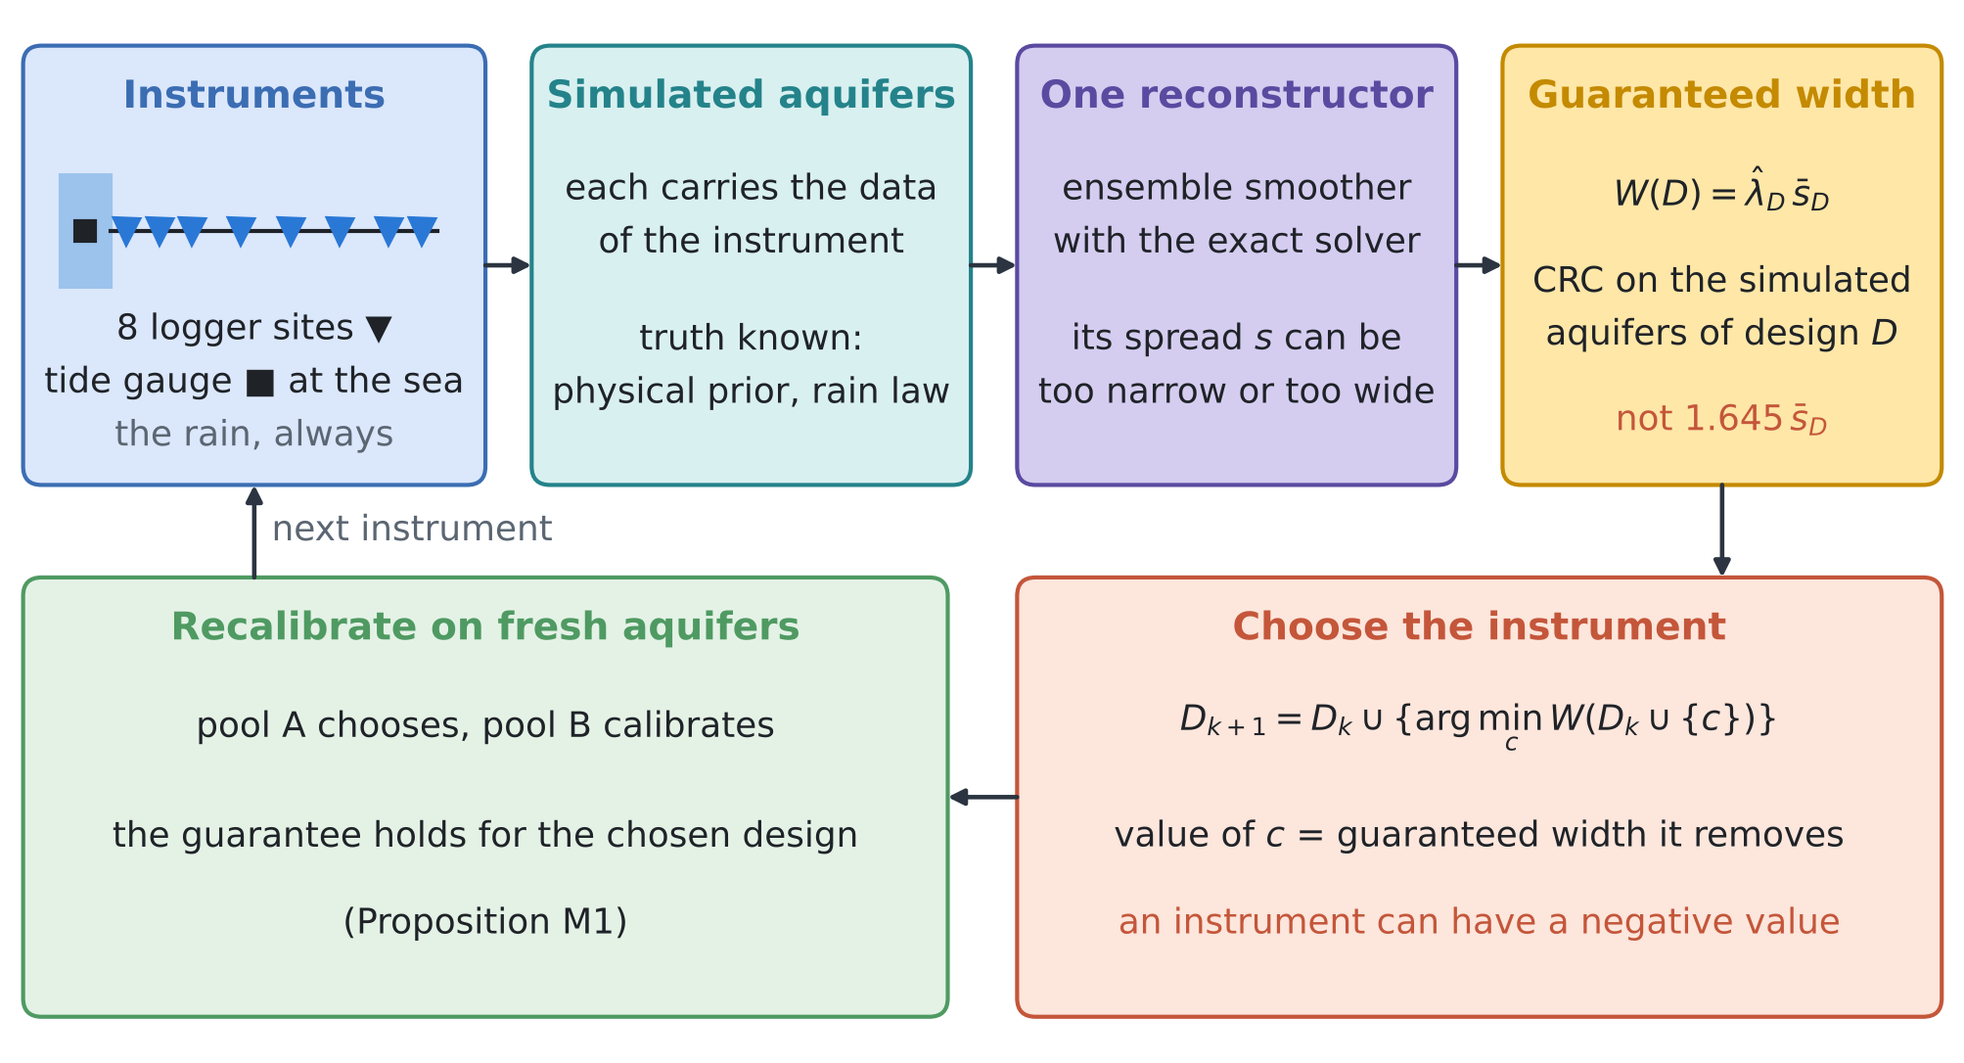
Figure 2. MATJA-GO. Each candidate design $D$ (rain plus a set of instruments) gets its own simulated aquifers, which carry the data that design would give; the same reconstructor runs on all of them; conformal risk control turns its spread into a guaranteed width $W\left(D\right)$; the instrument that removes most guaranteed width is added; and the chosen design is recalibrated on fresh simulated aquifers before its band is used.
4.1 The question and the set-up
The test bed is that of review I and RINDËRTIMI-GO (D2): a 5 km section of 32 cells and 64 weekly steps, transmissivity 1500 m²/d, storage 0.05, a recharge law $r=κ \left(k_{τ}*P\right)+e$ with the Erlang-2 vadose kernel ($τ$ = 14 d) and lognormal $κ$ (median 0.35, log-sd 0.25), and Gaussian random fields for the sea level, the inland inflow, the recharge error and the initial head. The rain is always known. The candidates are an automatic logger at one of eight sites (0.25, 0.75, 1.25, 2.0, 2.75, 3.5, 4.25 and 4.75 km from the sea; weekly heads, noise 2 cm) and a tide gauge (weekly sea level, noise 1 cm). The reconstructor is the ensemble smoother with the exact solver (128 members), started from the same prior ensemble for every design (common random numbers), so differences between designs are not sampling noise of the prior. Because the test bed is linear given $κ$, the exact posterior is available as an oracle; in the field it is not.
For a design $D$ and a goal (the weekly recharge, the weekly inflow, or $κ$), let ${\overline{s}}_{D}$ be the mean spread of the reconstruction on the simulated aquifers of $D$, ${\overline{σ}}_{D}$ the mean exact posterior standard deviation, and ${\hat{λ}}_{D}$ the conformal-risk-control multiplier of review I for the share of weeks outside the band $m±λs$, equation (2). Three criteria are compared:
$$E\left(D\right)=1.645 {\overline{s}}_{D}\text{, the raw ensemble;}$$  $$X\left(D\right)=1.645 {\overline{σ}}_{D}\text{, the exact posterior;}$$  $$W\left(D\right)={\hat{λ}}_{D} {\overline{s}}_{D}\text{, guaranteed: MATJA-GO;}$$ | (1)
$${\hat{λ}}_{D}=inf\left\{λ:\frac{n}{n+1}{\hat{R}}_{D}\left(λ\right)+\frac{1}{n+1}≤α\right\}\text{, with }{\hat{R}}_{D}\left(λ\right)=\frac{1}{n}\sum_{i=1}^{n}{L_{i}^{D}}\left(λ\right),$$ | (2)
where $L_{i}^{D}\left(λ\right)$ is the share of the 64 weeks of simulated aquifer $i$ outside the band, and $α$ = 0.10. The value of an instrument and the greedy choice are
$$V\left(c∣D\right)=W\left(D\right)−W\left(D∪\{c\}\right),$$  $$D_{k+1}=D_{k}∪\left\{arg\max_{c}V\left(c∣D_{k}\right)\right\}$$ | (3)
and the same with $E$ or $X$ in place of $W$ for the other two criteria. Selection uses pool A (150 simulated aquifers); every chosen design is then recalibrated and scored on pool B (300 fresh aquifers, split 300 times into calibration and test halves).
4.2 Guarantees, and what an ensemble gets wrong
Proposition M1 (the guarantee holds for the design that was chosen). Let pool A, pool B and the field case be independent, and let pool B and the field case be draws from the physical prior given the rain. Let $\hat{D}$ be chosen by any rule that uses pool A only (greedy on $W$, on $E$, by hand). If ${\hat{λ}}_{\hat{D}}$ is computed by (2) on pool B, the field band of design $\hat{D}$ satisfies $E\left[L_{n+1}^{\hat{D}}\left({\hat{λ}}_{\hat{D}}\right)\right]≤α$, and the sup-norm band of review I covers the whole function with probability at least $1−α$.

Proof. Given pool A, $\hat{D}$ is fixed. Pool B and the field case are independent of pool A, so given pool A they are still i.i.d. draws, and the reconstructor of design $\hat{D}$ is one fixed map applied to each of them; conformal risk control (anchor A1, Theorem 1) and split conformal prediction (anchor A2) apply conditionally on pool A. Take the expectation over pool A. □
Remark M1 (why a fresh pool). If pool A is used both to choose and to calibrate, the reported width is the minimum of several noisy estimates and is biased low, and the guarantee is lost unless a correction for the number of candidates is made (for example Learn-then-Test, S4). Here the bias is small: for the designs MATJA-GO chose, the pool-A width lies between 4% below and 6% above the fresh one, and the values below are all at the first step, where the best of nine candidates is taken. The fresh pool removes the question.

Remark M2 (when the ensemble ranks designs correctly). For large calibration pools ${\hat{λ}}_{D}→λ_{D}^{⋆}$, so $E\left(D\right)=\left(1.645/λ_{D}^{⋆}\right) W\left(D\right)$. The raw ensemble ranks two designs as MATJA-GO does if and only if their miscalibration factors $λ_{D}^{⋆}/1.645$ do not reverse the order of their spreads; in particular whenever the factor is the same for every design. The calibrated factor ${\hat{λ}}_{D}/1.645$ is therefore the inflation that makes design $D$ honest, measured on simulated aquifers instead of tuned by hand.

Remark M2 explains the two regimes of the tests. For the recharge and the inflow the factor lies within 1.02–1.71 and 0.95–1.67 over the 60 designs evaluated, but differs by only a few percent among the leading candidates of each step, which their spreads separate by more, so the rankings agree. For $κ$ it ranges from 0.99 to 15.8, and the raw ensemble can be trusted neither to rank designs nor to report widths.
Proposition M3 (an instrument that knows nothing about the goal). Let $θ$ be a scalar goal (one week of the recharge or of the inflow, or $κ$) and $c$ an instrument whose data $y_{c}$ are independent of $θ$ under the prior given the rain, with no other data. Let $C$ be the prior covariance of $y_{c}$, $R$ its noise covariance, $\hat{C}$ its sample covariance in an ensemble of $N$ prior members, and let the stochastic ensemble smoother update the ensemble with $y_{c}$. Then (i) the exact posterior of $θ$ is its prior, so the exact value of $c$ is zero; (ii) the expected ensemble variance ${\hat{s}}^{2}$ of $θ$ falls, and (iii) the error $e=θ−m$ of the ensemble mean becomes $e_{\text{+}}=e−Δ$ with $E\left[Δ∣e\right]=0$, a mean-preserving spread of $e$, with

$$E {\hat{s}}_{\text{+}}^{2}=\left(1−δ_{N}\right) E {\hat{s}}^{2},$$  $$E e_{\text{+}}^{2}=\left(1+ε_{N}\right) E e^{2},$$ | (4)
$$δ_{N}=\frac{1}{N−1} E tr\left[\hat{C}{\left(\hat{C}+R\right)}^{−1}\right],$$  $$ε_{N}=\frac{1}{N−1} E tr\left[\hat{C}{\left(\hat{C}+R\right)}^{−1}\left(C+R\right){\left(\hat{C}+R\right)}^{−1}\right].$$ | (5)
The factors do not depend on the goal. For large $N$, $\hat{C}→C$ and
$$δ_{N}≈ε_{N}≈\frac{d_{s}}{N−1}\text{, with }d_{s}=tr\left[C{\left(C+R\right)}^{−1}\right]\text{ the signal degrees of freedom of }c.$$ | (6)
Proof. Write the prior members as $\left(θ_{j},Y_{j}\right)$, $j=1,…,N$, with deviations $a_{j}=θ_{j}−\overline{θ}$ and $b_{j}=Y_{j}−\overline{Y}$, $B$ the matrix of the $b_{j}$. Independence makes $\left(θ,θ_{j}\right)$ independent of $\left(y_{c},Y_{j}\right)$. The gain is K=j​ajbj⊤B⊤B+N−1R−1 and the update $θ_{j\text{+}}=θ_{j}+K\left(y_{c}+ϵ_{j}−Y_{j}\right)$ with independent $ϵ_{j}∼N\left(0,R\right)$. (i) The likelihood of $y_{c}$ does not involve $θ$. (ii) Averaging the sample variance of $θ_{j\text{+}}$ over the $ϵ_{j}$ gives ${\hat{s}}^{2}−{\hat{C}}_{θY}{\left(\hat{C}+R\right)}^{−1}{\hat{C}}_{Yθ}$; since $E\left[aa^{⊤}\right]=σ^{2}\left(I−11^{⊤}/N\right)$ and $B^{⊤}1=0$, its expectation given $B$ is $σ^{2}−σ^{2} tr\left[\hat{C}{\left(\hat{C}+R\right)}^{−1}\right]/\left(N−1\right)$, and $E {\hat{s}}^{2}=σ^{2}$. (iii) The mean moves by $Δ=Kv$ with $v=y_{c}−\overline{Y}+\overline{ϵ}$; for Gaussian $y_{c}$ the sample mean $\overline{Y}$ is independent of $B$, so $v$ is independent of $\left(a,B,θ\right)$ with mean 0 and covariance $\left(1+1/N\right)\left(C+R\right)$. Hence $E\left[Δ∣e\right]=0$ and $EΔ^{2}=\left(1+1/N\right) E\left[K\left(C+R\right)K^{⊤}\right]$, which is $\left(1+1/N\right)σ^{2}$ times the trace in (5) divided by $N−1$; and $E e^{2}=\left(1+1/N\right)σ^{2}$. Replacing $\hat{C}$ by $C$ gives (6). □
Spurious covariances of small ensembles are well known in data assimilation, where they motivate localisation and inflation. Proposition M3 states their consequence for design exactly: an ensemble-based criterion (S1) gives a worthless instrument the value $1−\sqrt{1−δ_{N}}$ of the half-width, while its guaranteed value is negative, about $1−\sqrt{1+ε_{N}}$. For the tide gauge $d_{s}$ = 36.5; with $N$ = 128, $δ_{N}$ = 0.279 and $ε_{N}$ = 0.367 (Monte Carlo over 4000 ensembles), so the ensemble promises a 15% narrower band and delivers a 17% wider one.
Remark M3 (the price of an instrument, a first-order rule). An instrument that does inform the goal removes a fraction $ρ_{c}$ of its exact posterior variance, and the finite ensemble adds about $ε_{N}\left(c\right)≈d_{s}\left(c\right)/\left(N−1\right)$ through the data directions the goal does not share. To first order the guaranteed half-width is multiplied by $\sqrt{\left(1−ρ_{c}\right)\left(1+ε_{N}\right)}$, so the guaranteed value of $c$ is negative when

$$ρ_{c}<\frac{ε_{N}\left(c\right)}{1+ε_{N}\left(c\right)}.$$ | (7)
The rule needs only the exact information of the instrument and its signal degrees of freedom, both computable before it is bought. On the fresh pool it predicts the sign of the guaranteed value for 36 of the 36 pairs of instrument and goal, and the factor with a median error of 2.4% (largest 8.2%).
What is new. (1) The value of a measurement defined as the guaranteed band width it removes, calibrated on simulated aquifers that carry the measurement's data, with the guarantee kept after the selection (Proposition M1). (2) The ensemble ranking as a special case, correct exactly when the miscalibration factor is constant across designs, and the calibrated factor as a measured inflation (Remark M2). (3) An exact law for the spread and error of a stochastic ensemble smoother updated with a worthless instrument, for any goal (Proposition M3), and a first-order price rule that tells in advance when an informative instrument still has a negative guaranteed value (Remark M3). To our knowledge none of these appears in the forty papers of reviews I and II or in the design literature they cite.

4.3 Tests
T6 scores every single instrument added to the rain on the fresh pool; T7 runs the greedy choice of three instruments with each criterion and scores the chosen designs on the fresh pool; T8 measures the law of Proposition M3 for $N$ = 32 to 512 members on 300 further aquifers. Code and logs: experiments/matja_go/ (matja_exp.py, matja_single.py, matja_spur.py, matja_price.py).
T6: one instrument at a time. Figure 3 and Table 2. Every logger helps the recharge and $κ$, most in the middle of the aquifer; for the inflow the value grows towards the inland edge. The coastal logger at 0.25 km is the exception: it mostly witnesses the sea level, its exact value for the inflow is small (−7%), the ensemble promises −17%, and the guaranteed band widens by 9%. The tide gauge has no exact value for the recharge, the inflow or $κ$; the ensemble promises −15% and the guaranteed bands widen by 16–21%. For the sea level the roles turn: the tide gauge cuts its guaranteed half-width from 0.185 to 0.013 m, while 6 of the 8 loggers widen it slightly. In all, 10 of the 36 pairs have a negative guaranteed value, and Remark M3 predicts every sign.
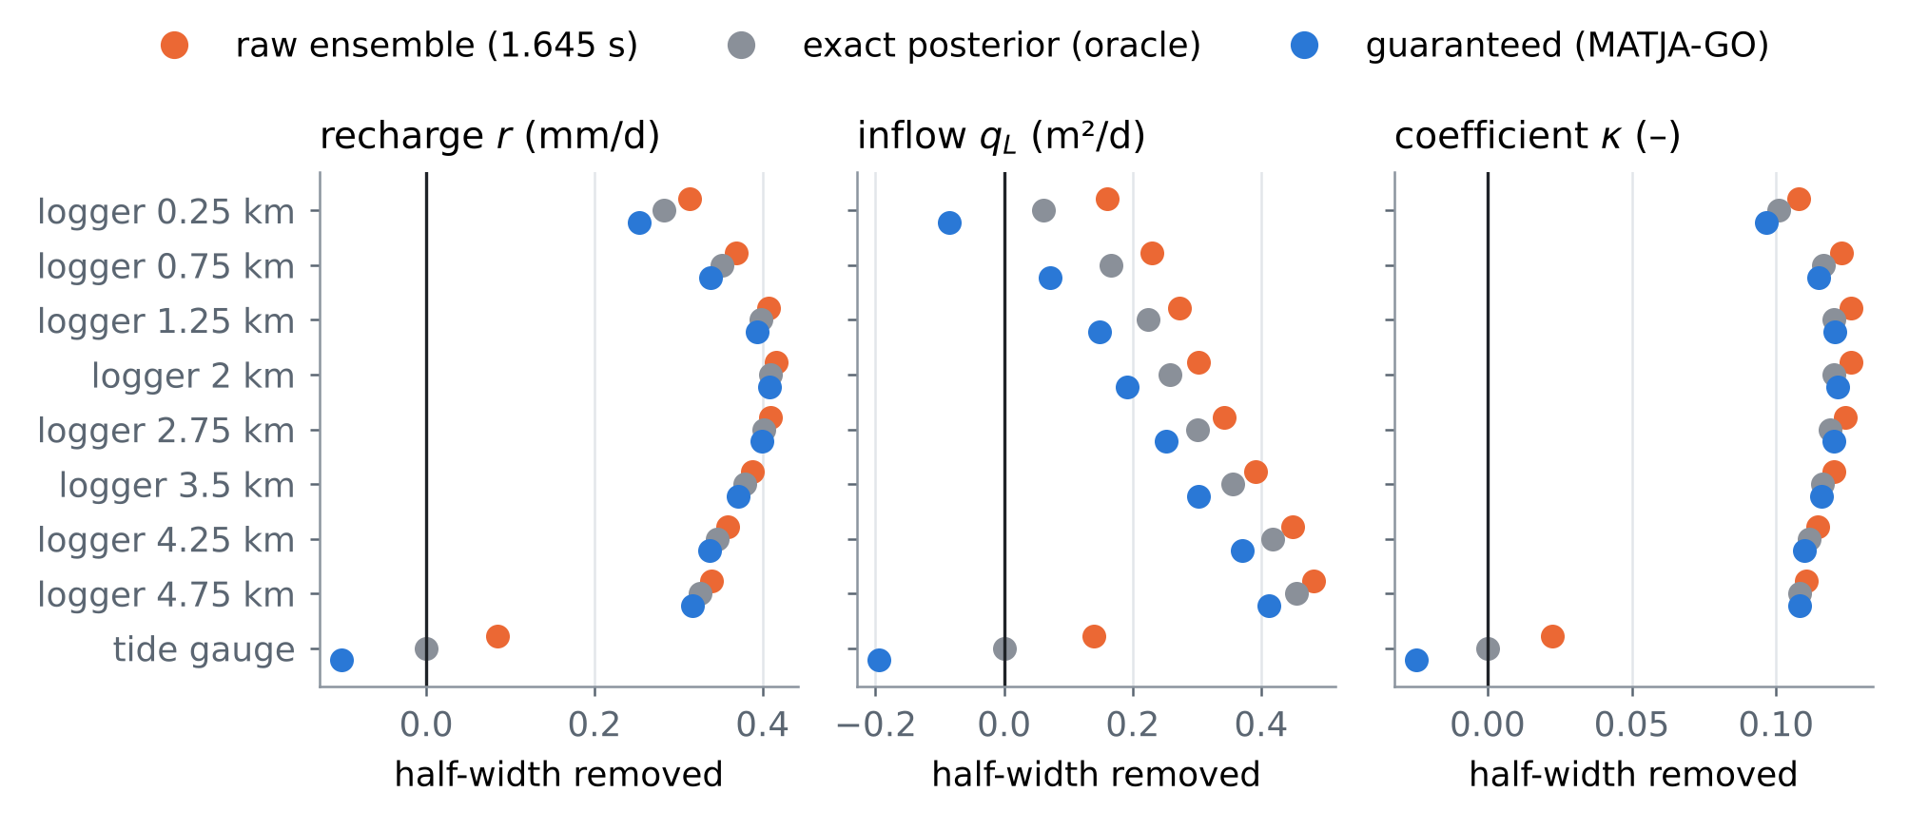
Figure 3. T6: the half-width removed by each instrument added to the rain, on the fresh pool, as the raw ensemble reports it (orange), as the exact posterior gives it (grey) and as it can be guaranteed (blue). Points left of zero widen the band.
Table 2. T6: change of the 90% half-width, in %, when one instrument is added to the rain: guaranteed / raw ensemble / exact posterior (fresh pool, 300 aquifers). Bold: a negative guaranteed value. Rain-only guaranteed half-widths: recharge 0.583 mm/d, inflow 0.942 m²/d, $κ$ 0.155, sea level 0.185 m.
Instrument | Recharge r | Inflow qL | Coefficient κ | Sea level η
logger 0.25 km | −44 / −56 / −50 | +9 / −17 / −7 | −62 / −71 / −67 | −35 / −50 / −44
logger 0.75 km | −58 / −65 / −62 | −8 / −25 / −18 | −74 / −81 / −77 | −12 / −28 / −21
logger 1.25 km | −67 / −72 / −70 | −16 / −29 / −24 | −78 / −83 / −80 | +3 / −12 / −6
logger 2.0 km | −70 / −74 / −72 | −20 / −33 / −28 | −78 / −83 / −80 | +5 / −8 / −1
logger 2.75 km | −68 / −73 / −71 | −27 / −37 / −32 | −77 / −82 / −79 | +7 / −7 / 0
logger 3.5 km | −64 / −69 / −67 | −32 / −42 / −38 | −75 / −79 / −77 | +8 / −7 / 0
logger 4.25 km | −58 / −64 / −61 | −39 / −49 / −45 | −71 / −76 / −74 | +8 / −7 / 0
logger 4.75 km | −54 / −60 / −57 | −44 / −52 / −49 | −70 / −73 / −72 | +7 / −7 / 0
tide gauge | +17 / −15 / 0 | +21 / −15 / 0 | +16 / −15 / 0 | −93 / −93 / −93

T7: three instruments chosen greedily. Figure 4 and Table 3. For the recharge the raw ensemble and the exact posterior choose the loggers at 2.0, 3.5, 4.75 km; MATJA-GO, after a tie at the second step (0.085 against 0.085 on pool A, 0.085 against 0.084 on the fresh pool), takes the loggers at 2.0, 3.5, 4.25 km, 9% wider at the end: a greedy path taken on a tie, not a wrong criterion. For the inflow all three choose the loggers at 2.75, 3.5, 4.75 km. For $κ$ the criteria part: the raw ensemble chooses the loggers at 1.25, 2.75, 4.75 km and claims 0.002, against 0.018 exact and 0.026 guaranteed; MATJA-GO chooses the loggers at 1.25, 2.0, 3.5 km and guarantees 0.023. After two loggers the guaranteed width of $κ$ stops falling (0.024–0.025 at two, 0.023–0.026 at three) while the exact posterior is 0.018: the reconstructor, not the data, limits $κ$, and the next resource belongs to a larger ensemble (T8), not to a third logger.
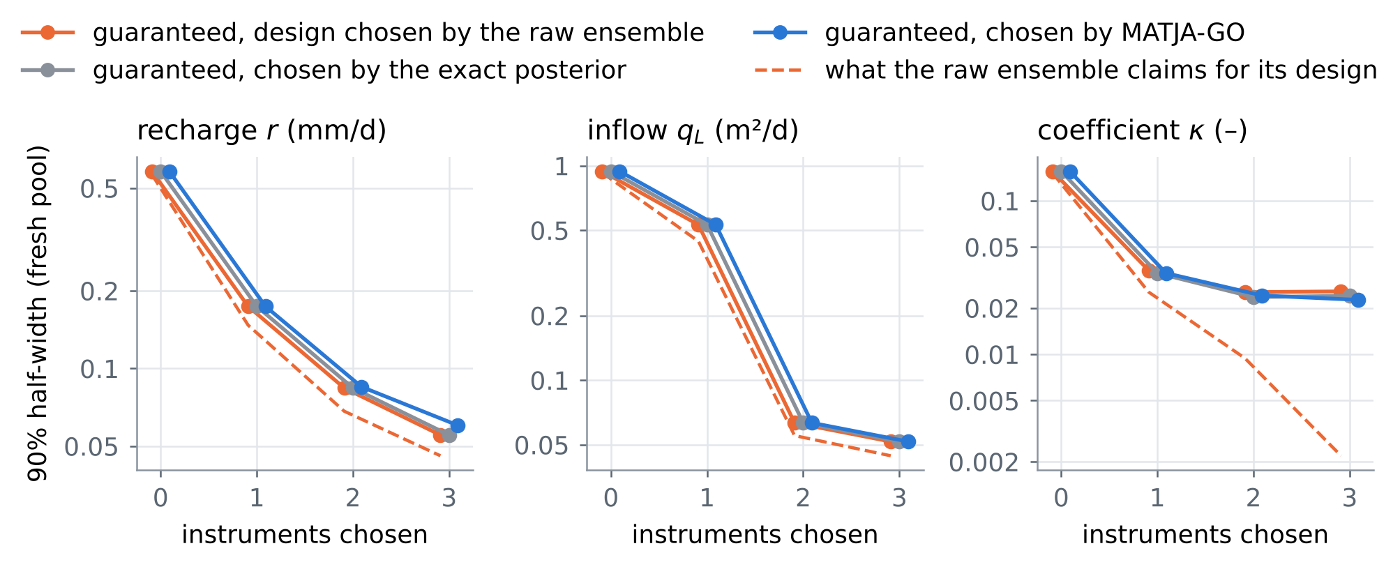
Figure 4. T7: guaranteed 90% half-width on the fresh pool against the number of instruments chosen by each criterion (markers offset sideways where they coincide), and the half-width the raw ensemble claims for its own design (dashed). For $κ$ the claim falls tenfold while nothing more can be guaranteed.
Table 3. T7: the design each criterion chooses after three steps, and on the fresh pool its raw-ensemble half-width, exact half-width, guaranteed half-width, and the achieved share of weeks outside / whole-function coverage (targets ≤ 0.10 / ≥ 0.90).
Goal | Criterion | Design after 3 steps | Ensemble | Exact | Guaranteed | Risk / coverage
recharge r (mm/d) | raw ensemble | loggers at 2.0, 3.5, 4.75 km | 0.046 | 0.049 | 0.055 | 0.093 / 0.90
 | exact posterior | loggers at 2.0, 3.5, 4.75 km | 0.046 | 0.049 | 0.055 | 0.093 / 0.90
 | MATJA-GO | loggers at 2.0, 3.5, 4.25 km | 0.050 | 0.054 | 0.060 | 0.093 / 0.90
inflow qL (m²/d) | raw ensemble | loggers at 2.75, 3.5, 4.75 km | 0.044 | 0.047 | 0.052 | 0.092 / 0.90
 | exact posterior | loggers at 2.75, 3.5, 4.75 km | 0.044 | 0.047 | 0.052 | 0.092 / 0.90
 | MATJA-GO | loggers at 2.75, 3.5, 4.75 km | 0.044 | 0.047 | 0.052 | 0.092 / 0.90
coefficient κ | raw ensemble | loggers at 1.25, 2.75, 4.75 km | 0.002 | 0.018 | 0.026 | 0.097 / 0.90
 | exact posterior | loggers at 2.0, 3.5, 4.75 km | 0.002 | 0.018 | 0.024 | 0.099 / 0.90
 | MATJA-GO | loggers at 1.25, 2.0, 3.5 km | 0.004 | 0.018 | 0.023 | 0.100 / 0.90

T8: the exact law of the spurious value. Figure 5 and Table 4. The tide gauge is added to the rain with ensembles of 32, 64, 128, 256 and 512 members. The spread factors of all three goals lie on $1−δ_{N}$ to within 0.003, the error factors on $1+ε_{N}$ to within 18% (the error is estimated from 300 aquifers and is noisier), and the first-order value $d_{s}/\left(N−1\right)$ is close for $N≥128$. The damage falls like $1/N$ but does not vanish: with 512 members the guaranteed band still widens by 6–9%.
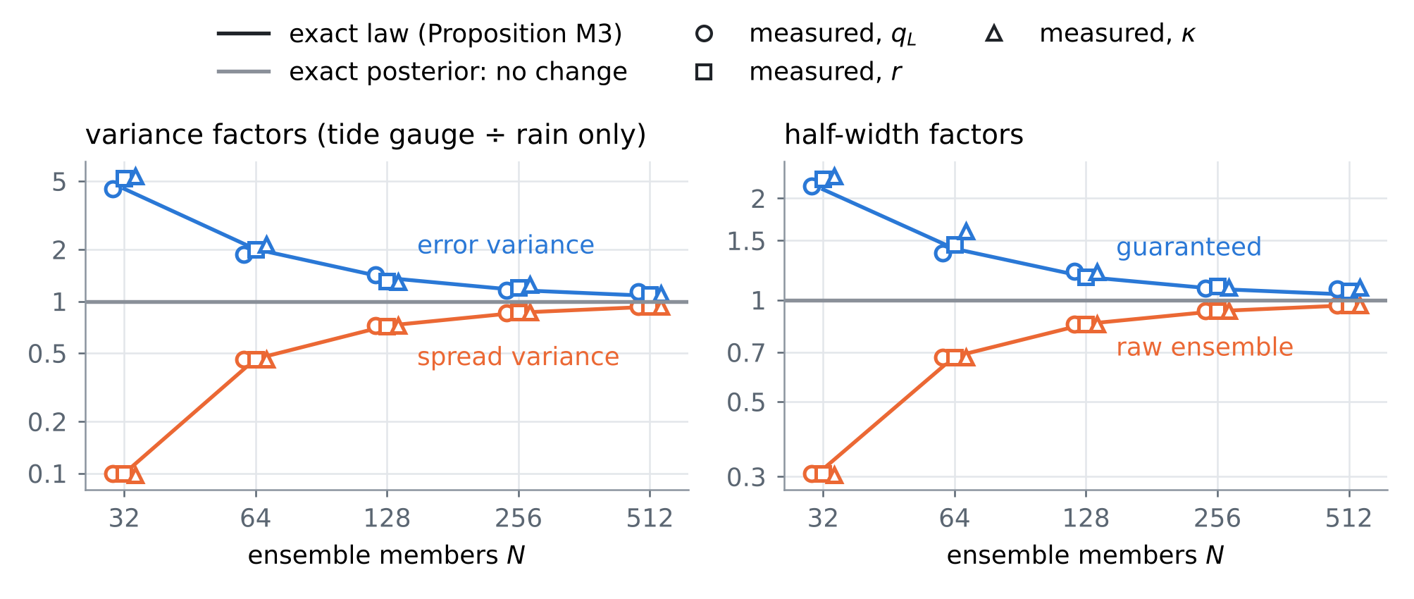
Figure 5. T8: a worthless tide gauge added to the rain. Left: spread and error variance factors against the ensemble size, with the exact factors $1−δ_{N}$ and $1+ε_{N}$ of Proposition M3 (lines). Right: the half-width factors of the raw ensemble and of the guaranteed band; the exact posterior does not change.
Table 4. T8: first-order value $d_{s}/\left(N−1\right)$, exact $δ_{N}$ and the measured spread-variance factor (range over the three goals); exact $ε_{N}$ and the measured error-variance factor; predicted / measured half-width factors of the raw ensemble and of the guaranteed band.
N | ds/(N−1) | δN | Spread factor | εN | Error factor | Ensemble hw | Guaranteed hw
32 | 1.176 | 0.900 | 0.098–0.100 | 3.510 | 4.53–5.32 | 0.316 / 0.303–0.306 | 2.12 / 2.17–2.32
64 | 0.579 | 0.538 | 0.459–0.461 | 1.008 | 1.87–2.14 | 0.680 / 0.675–0.676 | 1.42 / 1.38–1.59
128 | 0.287 | 0.279 | 0.718–0.723 | 0.367 | 1.30–1.42 | 0.849 / 0.847–0.849 | 1.17 / 1.17–1.22
256 | 0.143 | 0.141 | 0.859–0.861 | 0.161 | 1.16–1.25 | 0.927 / 0.927–0.928 | 1.08 / 1.08–1.10
512 | 0.071 | 0.071 | 0.928–0.929 | 0.075 | 1.09–1.14 | 0.964 / 0.963 | 1.04 / 1.06–1.09

4.4 What to measure first when only the rain is known
• For the recharge and κ: one logger in the middle of the aquifer (2.0 km here) removes 70% of the guaranteed half-width of the recharge and 78% of that of $κ$; a second logger far from it halves the recharge band again.
• For the inland inflow: the logger nearest the inland boundary first (44% of the half-width), then one at about two thirds of the way inland; two such loggers cut it to 7% of the rain-only value.
• For the sea level or the toe: a tide gauge, or land motion plus altimetry (C3, C5). For anything else a tide gauge is worthless with rain only and harmful to an ensemble that does not calibrate (T6).
• For dispersion: a deep conductivity or chloride profile; no head logger or tide gauge informs it (review I, Proposition 6).
• Beyond two loggers for κ: enlarge the ensemble or localise it before buying a third logger (T7, T8); and always recalibrate the chosen design on fresh simulated aquifers before its band is reported (Proposition M1).
5. Synthesis: forty papers in one procedure
Reviews I and II together give forty papers from the four institutions. Review I built the guarantee; this review adds the choice of what to measure and the forcing data that make the prior realistic. The procedure of review I keeps its eight steps; this is what the new papers and MATJA-GO change in each.
Step 1, the prior from the rain. Generate the recharge of the simulated aquifers with soil physics (ClimaLand, C4) or a satellite-trained emulator (M2), with a deficit threshold for dry years (B1); make the rain itself random when it comes from a coarse product (O5); write the sea boundary as a relative sea level with land motion (C3); draw the initial interface from a sea-level history (O1); give dispersion a velocity- and scale-dependent law (M5). Rain alone does not fix the response of a groundwater-dominated system, as the failure of rainfall–runoff learners in such catchments shows (S9).
Steps 2 and 3, few unknowns, fast inversion. Zones from airborne data reduce the fields to a few parameters (B4); a hard-constrained surrogate keeps the salt mass exact (B5); the closed-form toe of C1 is the cheapest emulator; ensemble Kalman inversion stays the workhorse (S6, S7), with the equifinality of O4 as a warning that a good fit does not mean a narrow band.
Steps 4 to 7, guarantee and check. Calibrate on simulated aquifers (review I, anchors A1 and A2), because expert and ensemble intervals are too narrow (M4, T7); test landward gradients with a guaranteed sign test (B2); treat a drift of land motion or a change of boundary type (C1, C3) as a prior shift for the field check of review I.
Step 8, the next measurement: MATJA-GO. Rank loggers, tide gauges, land motion, soil moisture, handpumps (O3) and existing wells (B3) by the guaranteed width they remove; compute the price rule (7) before buying; choose on one pool and recalibrate on another (Proposition M1). When the model itself chooses where to sample, conformal validity under the feedback shift (S5) is the route to keep the guarantee without a fresh pool; for several goals at once, Learn-then-Test (S4); for a guarantee per calibration set, the risk-controlling sets of S3.
For Fushë-Kuqe. The site has rain, a few heads and a handful of chloride facts. The order that follows from Section 4.4 is: one logger mid-plain for recharge and $κ$; one near the inland boundary for the inflow; a land-motion check of the coastal datum with Sentinel-1 (C3) before any tide gauge; and a deep conductivity profile across the transition zone for dispersion. The exact sites need the Fushë-Kuqe test bed in place of the 5 km section: to be run on the site geometry.
6. Limitations
• Every card is partly verified: landing pages were reached through search results only and no full text was read; where author lists or volumes were not confirmed, the card says so.
• The tests use a linear one-dimensional test bed with weekly steps; the exact posterior used as oracle is not available in the field, but MATJA-GO does not need it.
• Proposition M3 is exact for an instrument independent of the goal with no other data; with data already in hand the batch update is not the sequential one, and Remark M3 is a first-order rule checked on 36 pairs, not a theorem.
• The guarantees are marginal under the physical prior given the rain, as in review I; a wrong prior is caught only by the field check, and not always.
• The greedy choice can follow a tie down a slightly worse branch (T7, recharge); a look-ahead of two steps or keeping near-ties would remove that at a higher cost.
References
Anchors (provided by the user)
[A1] Angelopoulos, A. N., Bates, S., Fisch, A., Lei, L., & Schuster, T. (2024). Conformal risk control. The Twelfth International Conference on Learning Representations (ICLR 2024). arXiv:2208.02814 (PDF provided by the user). https://arxiv.org/abs/2208.02814
[A2] Tibshirani, R. (2023). Conformal prediction. Lecture notes, Advanced Topics in Statistical Learning, Spring 2023, University of California, Berkeley (PDF provided by the user). https://www.stat.berkeley.edu/~ryantibs/statlearn-s23/
The twenty papers of this review
[O1] Gabriel Cairns, Graham Benham, Ian Hewitt (2025). Groundwater dynamics beneath a marine ice sheet. The Cryosphere 19, 3725–3747 (2025); arXiv:2409.11848. https://doi.org/10.5194/tc-19-3725-2025
[O2] Marco Bianchi, Johanna Scheidegger, Andrew Hughes, Christopher Jackson, Jonathan Lee, Melinda Lewis, Majdi Mansour, Andrew Newell, Brighid Ó Dochartaigh, Ashley Patton, Simon Dadson (2024). Simulation of national-scale groundwater dynamics in geologically complex aquifer systems: an example from Great Britain. Hydrological Sciences Journal 69(5), 572–591 (2024). https://doi.org/10.1080/02626667.2024.2320847
[O3] A. Manandhar, H. Greeff, P. Thomson, R. Hope, D. A. Clifton (2020). Shallow aquifer monitoring using handpump vibration data. Journal of Hydrology X 8, 100057 (2020). https://doi.org/10.1016/j.hydroa.2020.100057
[O4] Simon F. B. Tett, Jonathan M. Gregory, Nicolas Freychet, Coralia Cartis, Michael J. Mineter, Lindon Roberts (2022). Does model calibration reduce uncertainty in climate projections?. Journal of Climate 35(8), 2585–2602 (2022). https://doi.org/10.1175/JCLI-D-21-0434.1
[O5] Lucy Harris, Andrew T. T. McRae, Matthew Chantry, Peter D. Dueben, Tim N. Palmer (2022). A generative deep learning approach to stochastic downscaling of precipitation forecasts. Journal of Advances in Modeling Earth Systems 14(10), e2022MS003120 (2022); arXiv:2204.02028. https://doi.org/10.1029/2022MS003120
[C1] Kyra H. Adams, John T. Reager, Brett A. Buzzanga, Cédric H. David, Audrey H. Sawyer, Benjamin D. Hamlington (2024). Climate-induced saltwater intrusion in 2100: recharge-driven severity, sea level-driven prevalence. Geophysical Research Letters 51(22), e2024GL110359 (2024). https://doi.org/10.1029/2024GL110359
[C2] D. F. Argus, H. R. Martens, A. A. Borsa, et al. (16 authors) (2022). Subsurface water flux in California's Central Valley and its source watershed from space geodesy. Geophysical Research Letters 49, e2022GL099583 (2022). https://doi.org/10.1029/2022GL099583
[C3] Marin Govorcin, David Bekaert, Benjamin Hamlington, Simran Sangha, William Sweet (2025). Variable vertical land motion and its impacts on sea level rise projections. Science Advances 11(5), eads8163 (2025). https://doi.org/10.1126/sciadv.ads8163
[C4] Katherine Deck, Renato K. Braghiere, Alexandre A. Renchon, Julia Sloan, Gabriele Bozzola, et al. (2026). ClimaLand: a land surface model designed to enable data-driven parameterizations. Journal of Advances in Modeling Earth Systems 18(1), e2025MS005118 (2026). https://doi.org/10.1029/2025MS005118
[C5] Lee-Lueng Fu, Tamlin Pavelsky, et al. (11 authors) (2024). The Surface Water and Ocean Topography mission: a breakthrough in radar remote sensing of the ocean and land surface water. Geophysical Research Letters 51(4), e2023GL107652 (2024). https://doi.org/10.1029/2023GL107652
[B1] W. Jesse Hahm, David N. Dralle, Maryn Sanders, Alexander B. Bryk, Kristen E. Fauria, et al. (13 authors, with William E. Dietrich and Daniella M. Rempe) (2022). Bedrock vadose zone storage dynamics under extreme drought: consequences for plant water availability, recharge, and runoff. Water Resources Research 58(4), e2021WR031781 (2022). https://doi.org/10.1029/2021WR031781
[B2] Scott Jasechko, Debra Perrone, Hansjörg Seybold, Ying Fan, James W. Kirchner (2020). Groundwater level observations in 250,000 coastal US wells reveal scope of potential seawater intrusion. Nature Communications 11, 3229 (2020). https://doi.org/10.1038/s41467-020-17038-2
[B3] Aurelien O. Meray, Savannah Sturla, Masudur R. Siddiquee, Rebecca Serata, Sebastian Uhlemann, et al. (11 authors, with Haruko M. Wainwright) (2022). PyLEnM: a machine learning framework for long-term groundwater contamination monitoring strategies. Environmental Science & Technology 56(9), 5973–5983 (2022). https://doi.org/10.1021/acs.est.1c07440
[B4] H. M. Wainwright, S. Uhlemann, M. Franklin, N. Falco, N. J. Bouskill, et al. (11 authors, with S. S. Hubbard) (2022). Watershed zonation through hillslope clustering for tractably quantifying above- and below-ground watershed heterogeneity and functions. Hydrology and Earth System Sciences 26(2), 429–444 (2022). https://doi.org/10.5194/hess-26-429-2022
[B5] Nithin Chalapathi, Yiheng Du, Aditi S. Krishnapriyan (2024). Scaling physics-informed hard constraints with mixture-of-experts. International Conference on Learning Representations (ICLR 2024); arXiv:2402.13412. https://arxiv.org/abs/2402.13412
[M1] David R. Burt, Renato Berlinghieri, Stephen Bates, Tamara Broderick (2025). Smooth sailing: Lipschitz-driven uncertainty quantification for spatial association. Advances in Neural Information Processing Systems 38 (NeurIPS 2025); arXiv:2502.06067. https://arxiv.org/abs/2502.06067
[M2] M. E. Soylu, D. Entekhabi, R. L. Bras (2026). Integrating satellite retrievals, numerical models, and machine learning for global groundwater recharge estimation. Water Resources Research 62(3), e2025WR040312 (2026). https://doi.org/10.1029/2025WR040312
[M3] L. Saló-Salgado, M. Haugen, K. Eikehaug, M. Fernø, J. M. Nordbotten, R. Juanes (2024). Direct comparison of numerical simulations and experiments of CO₂ injection and migration in geologic media: value of local data and forecasting capability. Transport in Porous Media 151(5), 1199–1240 (2024); arXiv:2301.08875. https://doi.org/10.1007/s11242-023-01972-y
[M4] Jan M. Nordbotten, Martin A. Fernø, Bernd Flemisch, Ruben Juanes, Magne Jørgensen (2024). Experimentally assessing the uncertainty of forecasts of geological carbon storage. International Journal of Greenhouse Gas Control 135 (2024). https://www.sciencedirect.com/science/article/pii/S1750583624001051
[M5] Pietro de Anna, Amir A. Pahlavan, Yutaka Yawata, Roman Stocker, Ruben Juanes (2020). Chemotaxis under flow disorder shapes microbial dispersion in porous media. Nature Physics (published online 14 September 2020). https://doi.org/10.1038/s41567-020-1002-x
Linked in the text (first review, earlier work and the field)
[S1] Dunbar, O. R. A., Howland, M. F., Schneider, T., & Stuart, A. M. (2022). Ensemble-based experimental design for targeting data acquisition to inform climate models. Journal of Advances in Modeling Earth Systems 14(9), e2022MS002997. https://doi.org/10.1029/2022MS002997
[S2] Huan, X., Jagalur, J., & Marzouk, Y. (2024). Optimal experimental design: formulations and computations. Acta Numerica 33, 715–840. https://doi.org/10.1017/S0962492924000023
[S3] Bates, S., Angelopoulos, A., Lei, L., Malik, J., & Jordan, M. I. (2021). Distribution-free, risk-controlling prediction sets. Journal of the ACM 68(6), Article 43, 1–34. https://doi.org/10.1145/3478535
[S4] Angelopoulos, A. N., Bates, S., Candès, E. J., Jordan, M. I., & Lei, L. (2025). Learn then test: calibrating predictive algorithms to achieve risk control. Annals of Applied Statistics 19(2), 1641–1662. https://doi.org/10.1214/24-AOAS1998
[S5] Fannjiang, C., Bates, S., Angelopoulos, A. N., Listgarten, J., & Jordan, M. I. (2022). Conformal prediction under feedback covariate shift for biomolecular design. Proceedings of the National Academy of Sciences 119(43), e2204569119. https://doi.org/10.1073/pnas.2204569119
[S6] Calvello, E., Reich, S., & Stuart, A. M. (2025). Ensemble Kalman methods: a mean-field perspective. Acta Numerica 34, 123–291. https://doi.org/10.1017/S0962492924000060
[S7] Huang, D. Z., Schneider, T., & Stuart, A. M. (2022). Iterated Kalman methodology for inverse problems. Journal of Computational Physics 463, 111262. https://doi.org/10.1016/j.jcp.2022.111262
[S8] Barber, R. F., Candès, E. J., Ramdas, A., & Tibshirani, R. J. (2023). Conformal prediction beyond exchangeability. Annals of Statistics 51(2), 816–845. https://doi.org/10.1214/23-AOS2276
[S9] Lees, T., Buechel, M., Anderson, B., Slater, L., Reece, S., Coxon, G., & Dadson, S. J. (2021). Benchmarking data-driven rainfall–runoff models in Great Britain. Hydrology and Earth System Sciences 25, 5517–5534 (partly verified; subtitle not confirmed). https://doi.org/10.5194/hess-25-5517-2021
[S10] Angelopoulos, A. N., & Bates, S. (2023). Conformal prediction: a gentle introduction. Foundations and Trends in Machine Learning 16(4), 494–591. https://doi.org/10.1561/2200000101
Data and project documents
[D1] Zeqiraj, D. (2026). Inputs, dispersion and boundary conditions from rain alone: twenty papers from Oxford, Caltech, Berkeley and MIT (2020–2026) and GARANCIA-GO, guaranteed bands calibrated on simulated aquifers ("review I"). docs/literature/Literature_review_Inputs_Dispersion_Boundary_Conditions_from_Rain_Oxford_Caltech_Berkeley_MIT_2020-2026.docx in this repository.
[D2] Internal documents of the project: RINDËRTIMI-GO, "Reconstructing all boundary conditions of a coastal aquifer from rain and the Fushë-Kuqe data" (November 2026; test bed and ensemble smoother with the exact solver); SHIU-GO (rain law, Erlang-2 vadose filter); the code of this review in experiments/matja_go/.
Verification note. The bibliographic data of the twenty cards come from search results that quote the publisher, arXiv, proceedings or repository pages; doi.org, arxiv.org, openreview.net and most publisher hosts could not be opened directly in this environment. The anchors were read from the PDFs provided. Every number of Sections 1, 2 and 4 is computed by the code in experiments/matja_go/ and experiments/garancia_go/.

