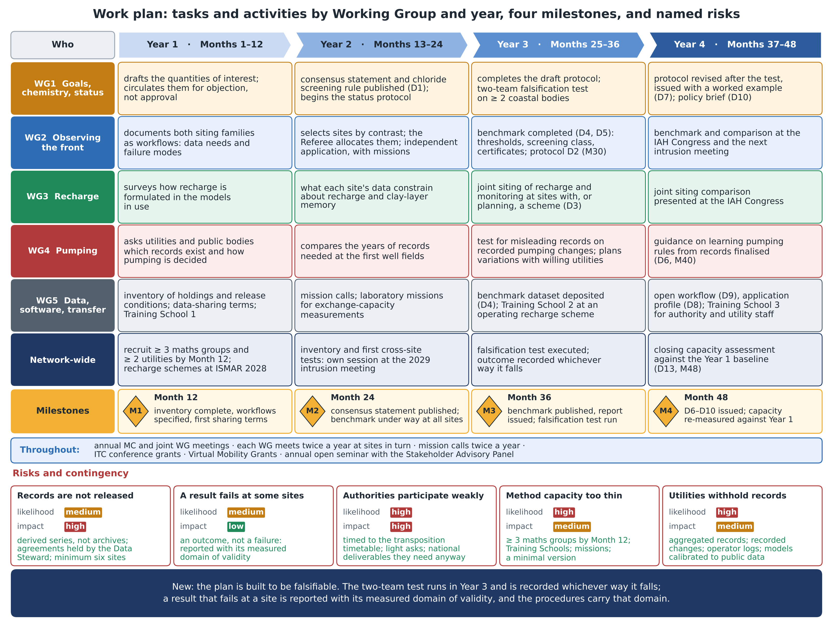
Figure. Work plan: the tasks and activities of each Working Group, and of the network as a whole, in each year of the Action, with deliverables; milestones M1 to M4; the networking tools used throughout; and the five named risks with their likelihood, impact and contingency. Content as in annex sections 3.B and 3.C.

