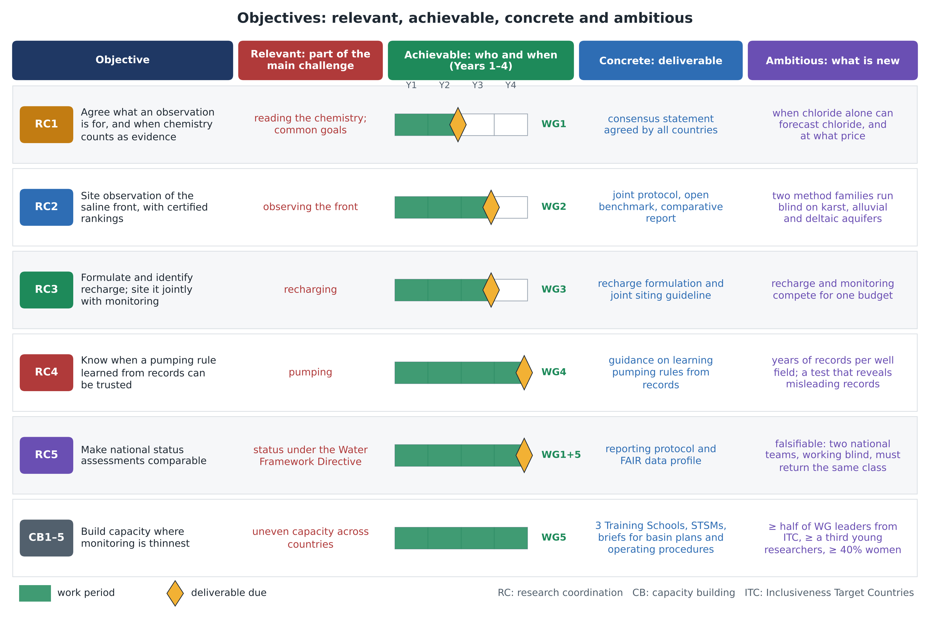
Figure. The five research coordination objectives (RC1–RC5) and the capacity building objectives (CB1–CB5): the part of the main challenge each addresses, the Working Group that leads it and the year its deliverable is due, the deliverable, and what is new.

