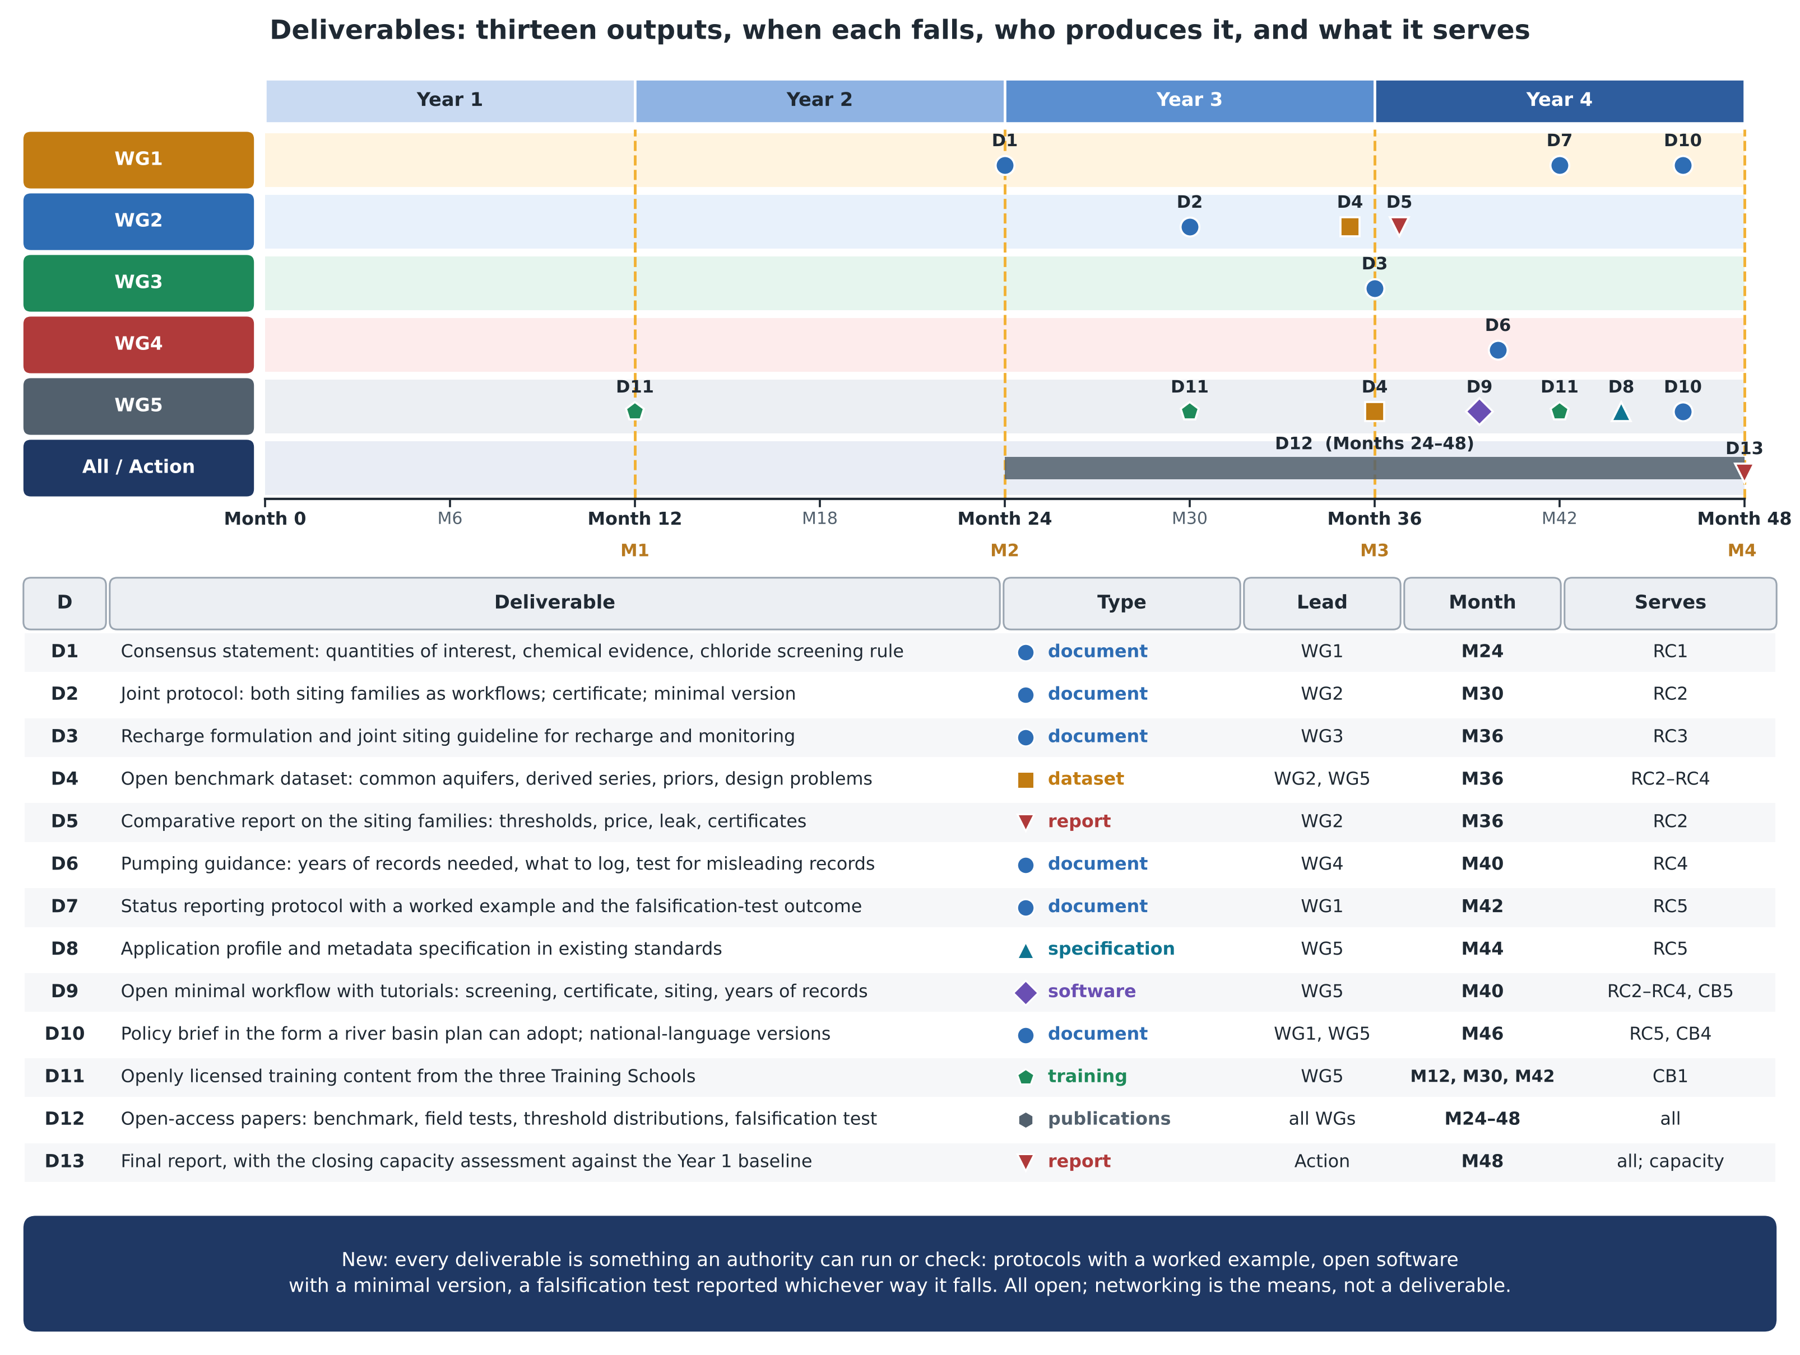
Figure. Deliverables D1 to D13: when each falls on the Working Group lanes (marker shape and colour give its type), with milestones M1 to M4; and, for each, its type, lead Working Group, month and the objective it serves. Content as in annex sections 1.B and 3.C.

