CERTAIN-COAST — Dissemination Plan
Certified early warning for seawater intrusion, liquefaction and extreme sea levels at the wellfields, port and energy landfall of a subsiding Adriatic coast
CERTAIN-COAST produces two kinds of results: methods that any coast can reuse, and warnings about specific critical infrastructure. The dissemination plan treats them differently. Methods, software, verification statistics and policy conclusions are made as open and as widely used as possible; asset-level vulnerability results go only to the operators and authorities who must act on them. Every output passes a release gate before it leaves the project. The plan reaches seven audiences with products timed to the project's decisions, and is measured by indicators reported to the SPS Programme. It is delivered through WP6 (T6.1–T6.4), with D6.1 (open software and data, Month 33) and D6.2 (operating procedures and policy brief, Month 36).
1. Aims
• Use. The operators of the wellfields, the port and the energy landfall run the system and adopt procedures for it, and civil protection uses its bulletins after events.
• Policy. National authorities receive evidence on coastal subsidence, relative sea level and critical-infrastructure protection in a form they can use for planning.
• Science. The coupled model, the certified alarms and the network design are published openly and can be tested and reused by others.
• Transfer. Other subsiding coasts with wellfields, ports and energy landfalls, in the Adriatic and beyond, can repeat the analysis with the open software and training material.
• Protection. Nothing released helps an adversary find where critical infrastructure is most vulnerable.
2. Audiences and what each receives
Audience | What they need | What CERTAIN-COAST gives them | Main channels
Water utility, port authority, energy landfall operator | Warnings they can act on, with known reliability | Bulletins with certified miss rates; joint pumping rule; operating procedures; training (restricted tier) | Bulletin interface; workshops; on-site training
Civil protection and national authorities | One consistent picture after events; numbers for planning | Post-event reports; relative sea level at each asset; policy brief | Briefings; workshops; policy brief
NATO SPS Programme, Allies and partners | Evidence of security value and a capability others can adopt | Progress and final reports; project summary for SPS communication; transfer workshop | Reports; final event; SPS channels
Scientific community | Methods, data and code to test and reuse | Open-access papers; open software; synthetic test coast; verification statistics | Journals; conferences; open repository
Operators and agencies of other coasts | A way to repeat the analysis on their coast | Coast kit: software, test case and training material | Transfer workshop; webinars
Students and early-career researchers | Skills across geoscience, data science and security | Training school; supervised work; co-authorship | School; exchanges
Public and media in Durrës and Albania | Clear information on coastal risks and what is being done | Plain-language summaries in Albanian and English; news at key moments (screened) | Website; local media; public event

3. Two tiers: open methods, restricted vulnerability
A map of where a port would liquefy or where an energy landfall would flood is valuable to its operator and to an adversary. CERTAIN-COAST therefore separates what is published from what is shared only with those who must act (Risk Assessment, R20):
Result | Open (public) | Restricted (operators and authorities)
Methods and software | All algorithms, code, documentation and a synthetic test coast | —
Coastal motion | Regional land-motion maps; the relative-sea-level method | Values at named asset points
Model and hazards | Model structure, calibration method, results aggregated or anonymised | Asset-level intrusion, liquefaction and flooding maps
Alarms | Verification statistics: observed miss and false-alarm rates with intervals | Thresholds, bulletin contents, sensor locations inside sites
Procedures and policy | Generic procedure template; public version of the policy brief | Operator-specific procedures; annex with asset details

Release gate for every output
• Classify. The author classifies each output as open or restricted using the data plan (T7.2).
• Review. Operators review any manuscript or dataset that uses their data within an agreed period (indicatively 30 days); the review may remove sensitive content but cannot block the publication of methods.
• Adapt. Sensitive content is aggregated, anonymised ("a port", "an energy landfall") or moved to the restricted annex.
• Sign off. The coordinator records the decision in the release log.
4. Products and events
Product or event | Content | Audience | Month | Task
Website and visual identity | Public summary, news and non-sensitive results in English and Albanian | All; public | 3, updated | WP6
Kick-off stakeholder workshop | Needs, thresholds, data access and the acceptable false-alarm rate | Operators; civil protection | 2 | T3.1, T7.2
Open-access papers (at least six) | Coastal motion; coupled model; certified surrogate; certified alarms; network design and seismic velocity; verification in operation | Science | 15–36 | WP1–WP5
Conference presentations | For example EGU General Assembly, AGU Fall Meeting, Salt Water Intrusion Meeting, SIAM Conference on Uncertainty Quantification | Science | Each year | WP6
Training school | Hands-on work with the coast kit | Early-career researchers; students | 14 | T6.1
Mid-term workshop | Model and network results; dry run of the bulletins | Operators; civil protection | 18 | WP2, WP4
Live bulletins | Twelve months of certified warnings, logged with outcomes | Operators; civil protection | 23–34 | T5.2
Operator training | Running the system; what a miss rate means | Operator and civil-protection staff | 24–36 | T6.2
Open software and data (D6.1) | Code, documentation, synthetic test coast, open data, verification statistics | Science; other coasts | 33 | T6.3
Transfer workshop | Coast kit for other Adriatic and Mediterranean coasts | Other coasts; Allies and partners | 35 | T6.3
Policy brief and procedures (D6.2) | Subsidence, water supply, critical-infrastructure protection; operator procedures | National authorities; operators | 36 | T6.4
Final workshop and live demonstration | The system in operation; results; hand-over | All | 36 | WP5, WP6
Press releases | Kick-off, network installed, start of live bulletins, final event | Public; media | 2, 12, 23, 36 | WP6
Reports to NATO SPS | Progress and final reports with the risk register and indicators | NATO SPS | 12, 24, 36 | T7.1

5. Timeline
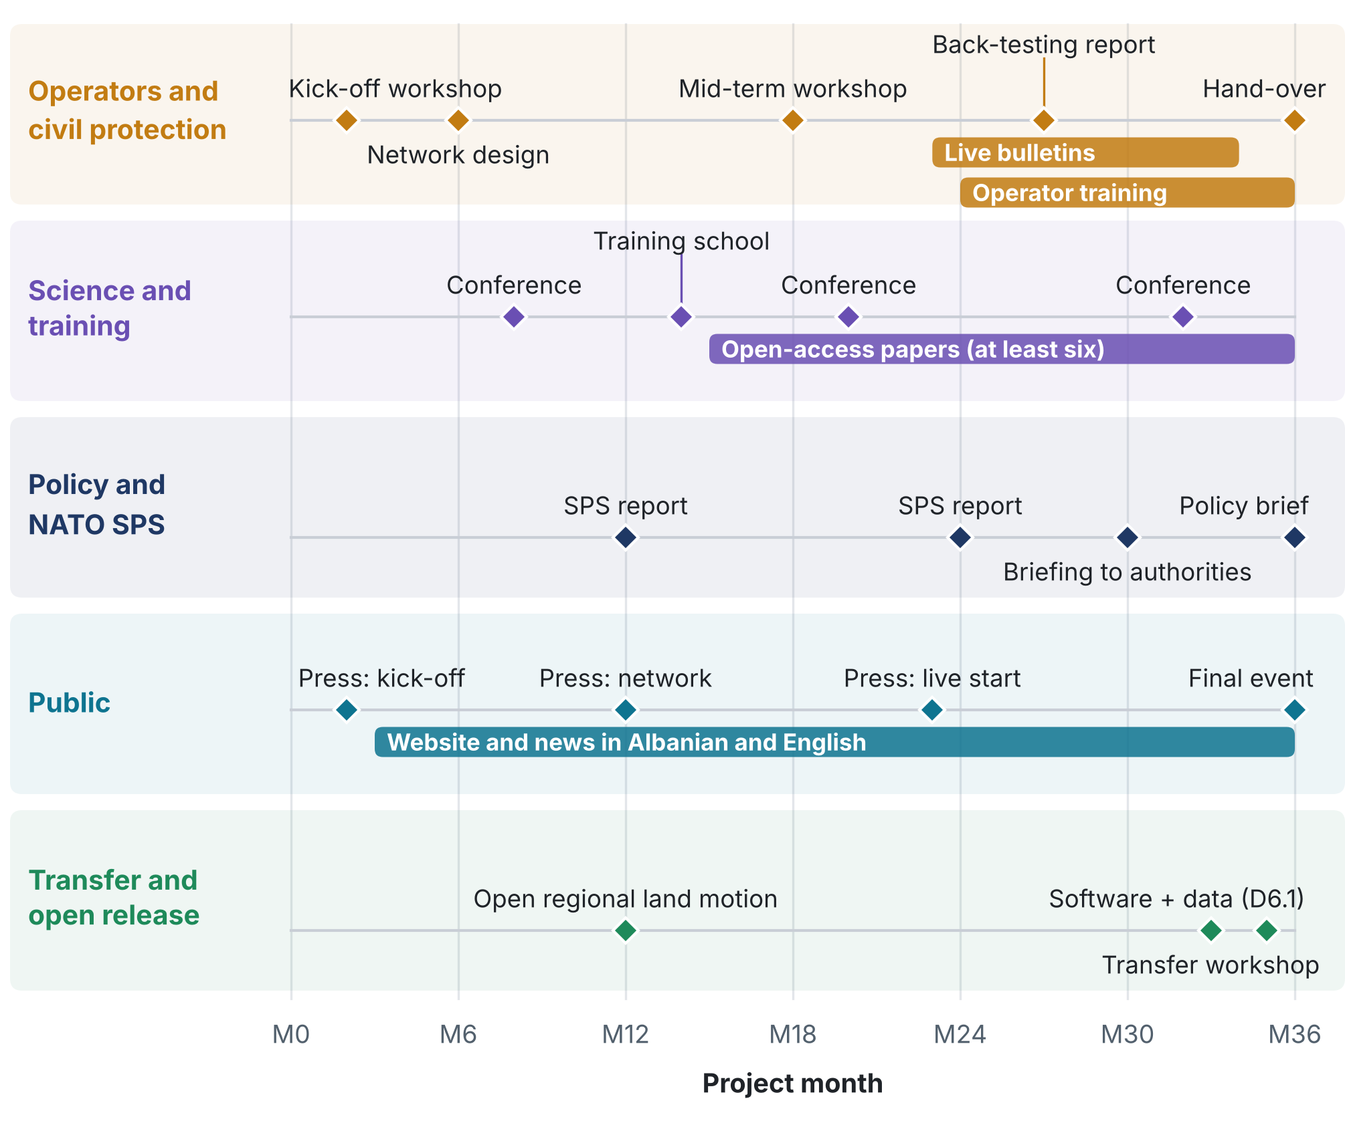
Figure 1. Dissemination over the 36 months by audience. Diamonds: events and deliverables; bars: continuous activities. Conference months are indicative and depend on the start date.
6. Indicators
Targets are indicative and are reported in each progress report to the SPS Programme.
Indicator | Target | Evidence
Open-access peer-reviewed papers | At least 6 | Publication list with open links
Conference presentations | At least 8 | Presentation list
Open software and data release with documentation | 1 release with a persistent identifier (D6.1) | Repository
Groups testing the software on another coast | At least 2 | Transfer workshop; repository records
Operator and civil-protection staff trained | At least 20 | Training records
Early-career researchers trained | At least 6 | Training records
Operating procedures adopted | At least 1 per asset | D6.2
Stakeholder workshops | 3, plus 1 transfer workshop | Agendas and participant lists
Policy brief delivered to national authorities | Delivered (D6.2) | Delivery record
Outputs screened before release | 100%; no sensitive disclosure | Release log

7. Acknowledgement, licences and ownership
• Acknowledgement. Every output acknowledges the support of the NATO Science for Peace and Security Programme, as the grant requires.
• Licences. Software under an OSI-approved open-source licence (for example Apache-2.0); open data under CC BY 4.0; papers open access.
• Ownership. Operator data remain the property of the operators and are used under the access agreements of T7.2.
• Publication rules. The consortium agreement sets the review period and limits review to sensitive content and confidential data.
• Languages. Public and operator materials in Albanian and English; scientific outputs in English.
8. What is new in this dissemination plan
• Open verification of a restricted service. The observed miss and false-alarm rates of the live warnings are published with their confidence intervals, so anyone can check the certified guarantee without seeing a single vulnerable location.
• Security-screened open science. A two-tier plan and a release gate make the methods fully open and keep asset-level vulnerability closed, so openness and protection of critical infrastructure do not conflict.
• Uncertainty as a number each audience can act on. Operators receive a miss rate with every bulletin; planners receive relative sea level at each asset instead of a regional trend; the public receives plain-language summaries.
• A coast kit, not only papers. Software, a synthetic test coast and training material let another coast repeat the analysis without the project team.
• Products timed to decisions. Workshops, training and live bulletins follow the project's decision points: thresholds before design, a dry run before operation, procedures before hand-over.

