CERTAIN-COAST — The project at a glance
Structure, communication, team, deliverables and timeline of the work plan
The five figures show the work plan of the proposal: who leads each work package, what passes between them, how the results reach each audience, who does the work, when each deliverable is due and where the evidence gates stand on the critical path. They are drawn from the same tables as the form (work packages, tasks, deliverables, milestones, risks and participants), so the figures and the form cannot disagree.
Innovation
A work plan built around evidence gates: each certified result is tested at a gate with a stated pass test and a fallback before the next work package relies on it, and the gates stand on the critical path, so the plan shows where the project can fail early and what it does then.

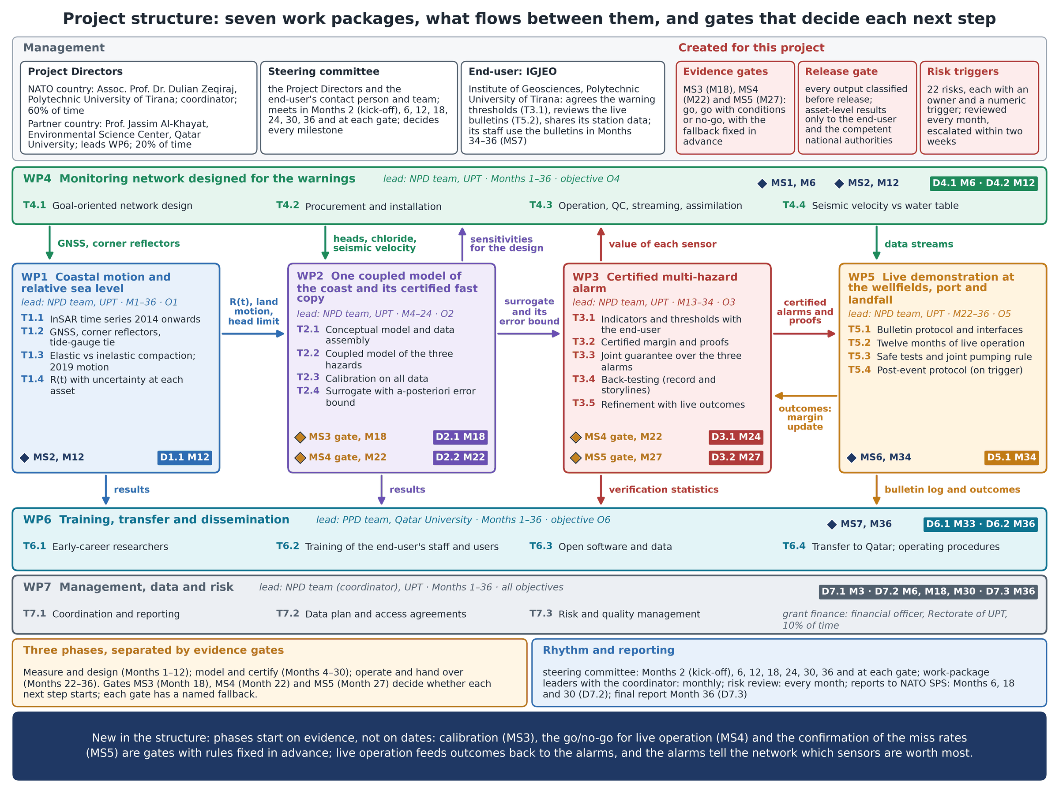
Figure 1. Project structure: the Project Directors, the steering committee and the end-user IGJEO; the seven work packages with their leads, months, tasks, milestones and deliverables; what flows between them; and the three evidence gates.

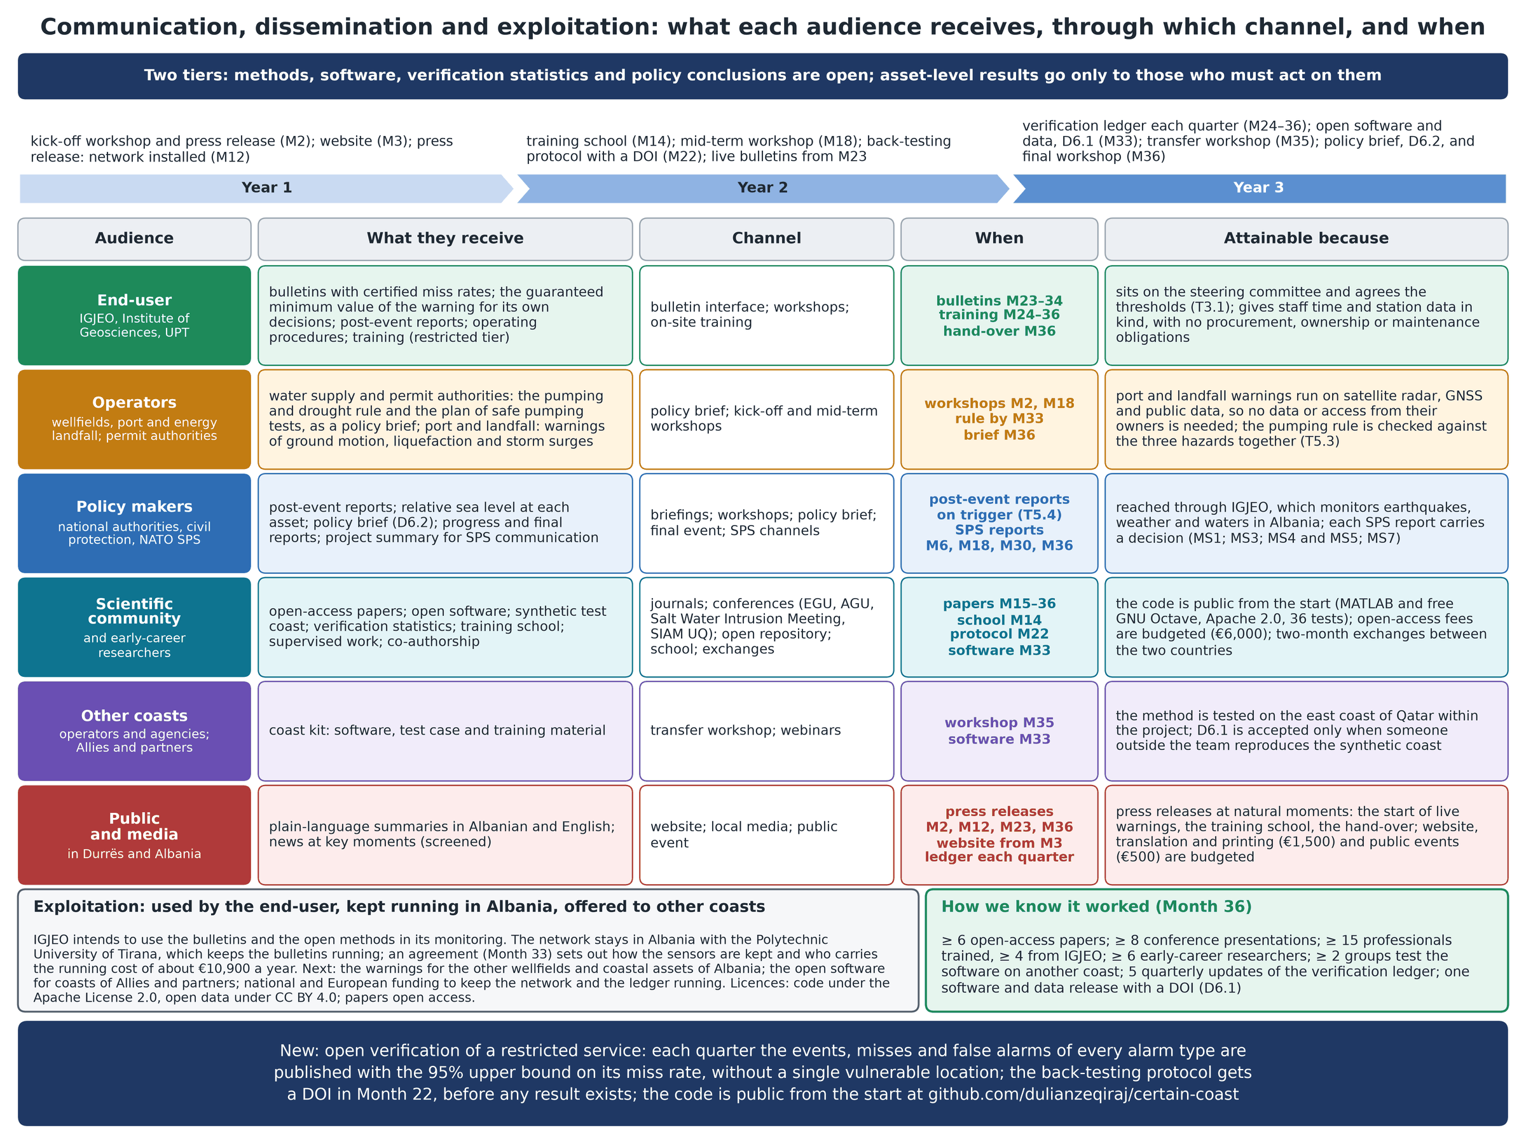
Figure 2. Communication, dissemination and exploitation for six audiences: what each receives, through which channel, when, and why it is attainable; the exploitation after the project and the indicators for Month 36.

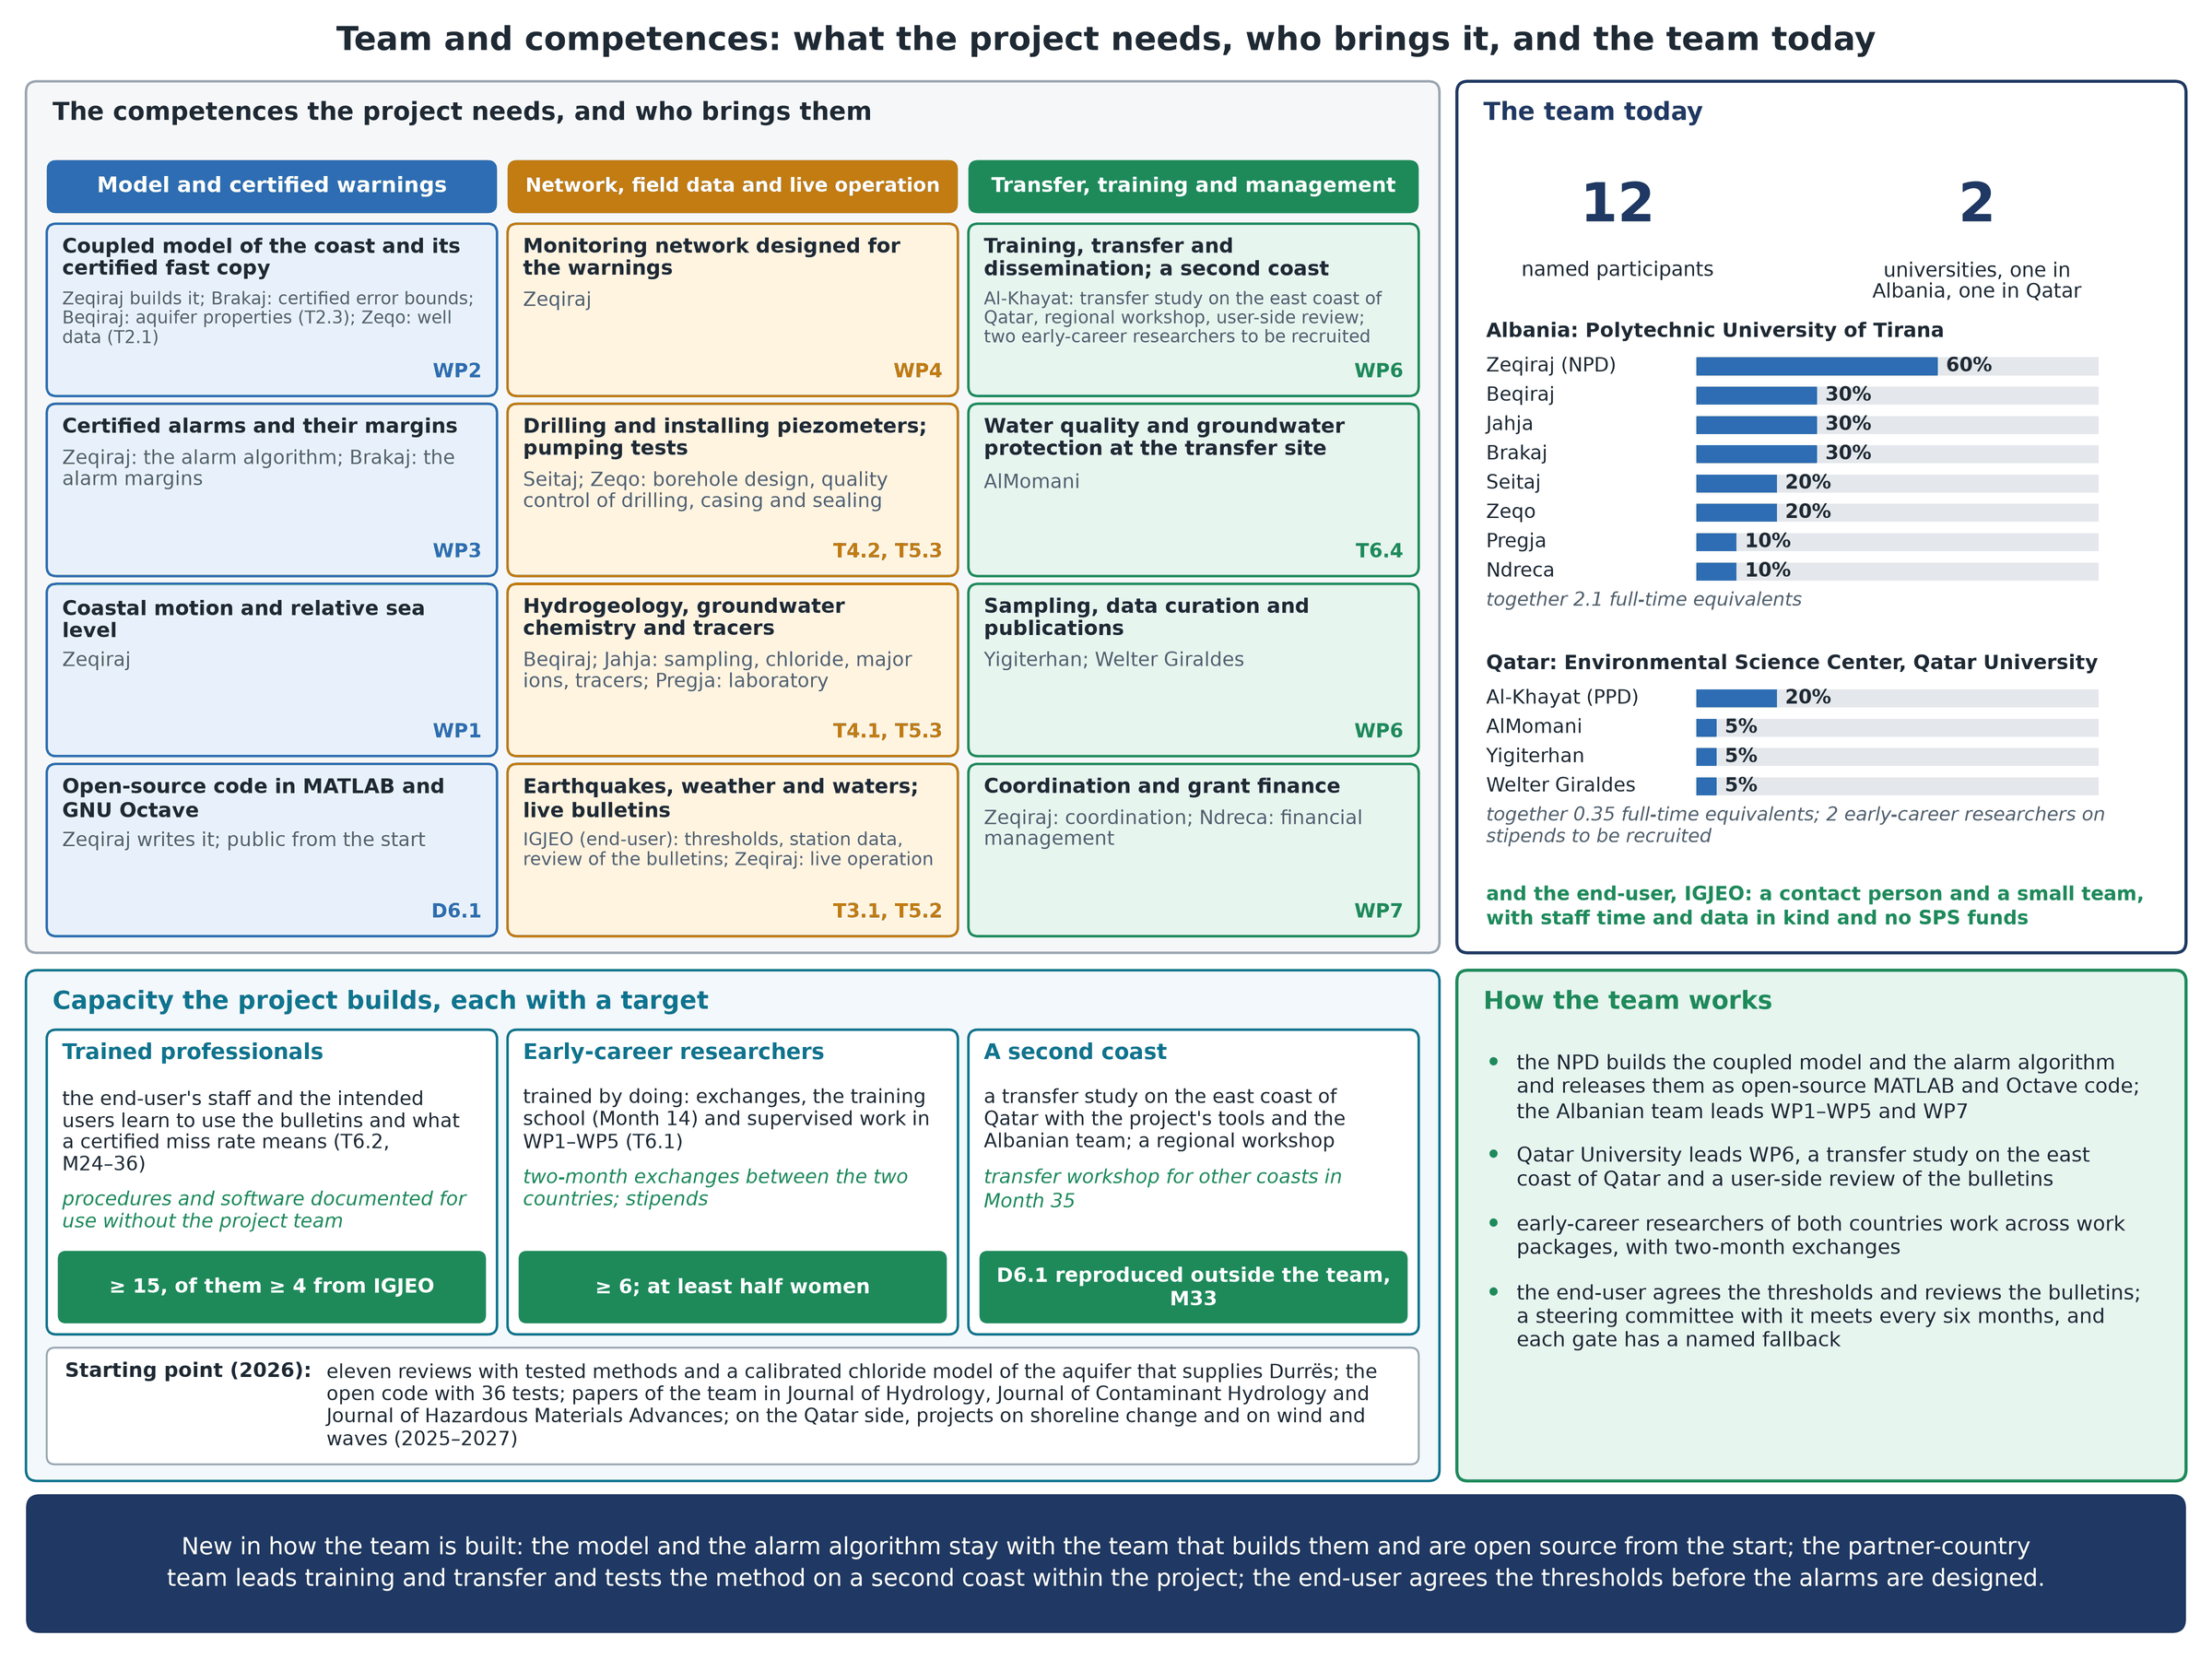
Figure 3. The team and its competences: the twelve competences the project needs and who brings them, the twelve named participants with their shares of time (2.1 full-time equivalents in Albania, 0.35 in Qatar), the capacity targets and how the team works.

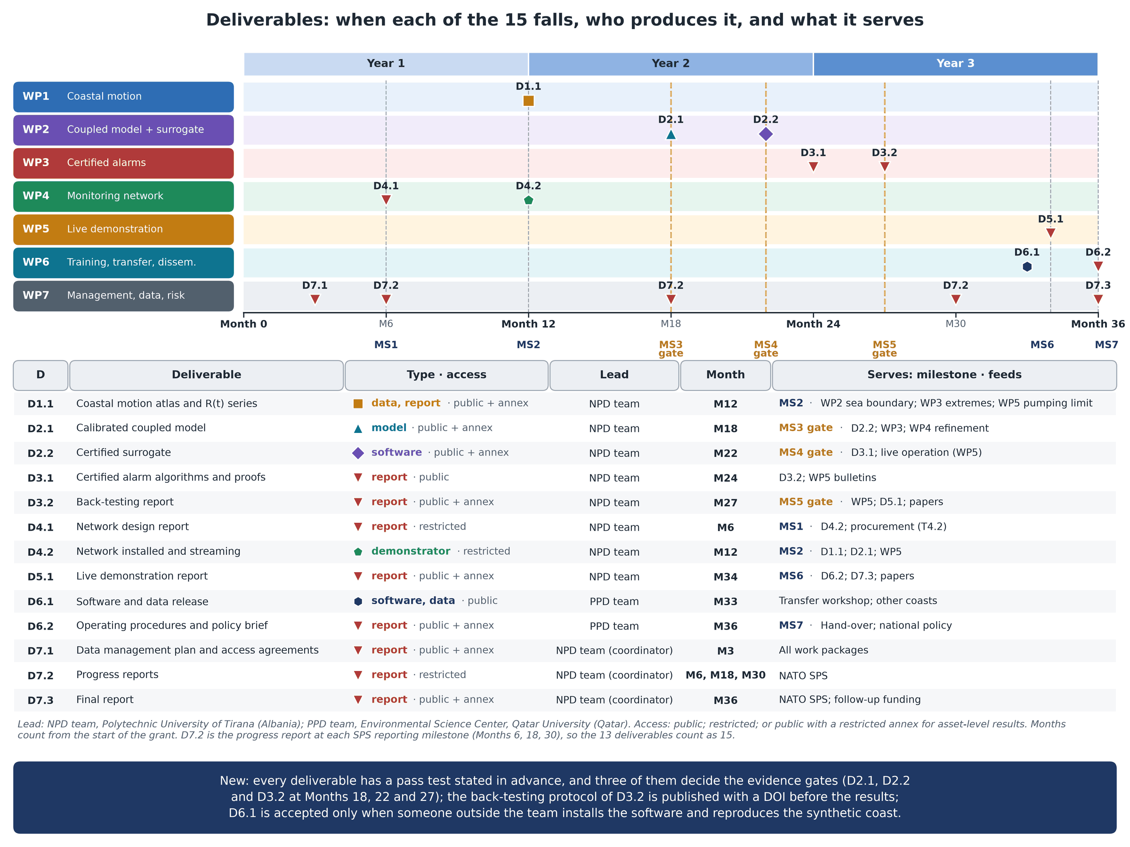
Figure 4. Deliverables: the 13 deliverables (15 counting the three progress reports) on a timeline of Months 0–36 by work package, with their type and access, lead and month, and the milestone and work each one serves.

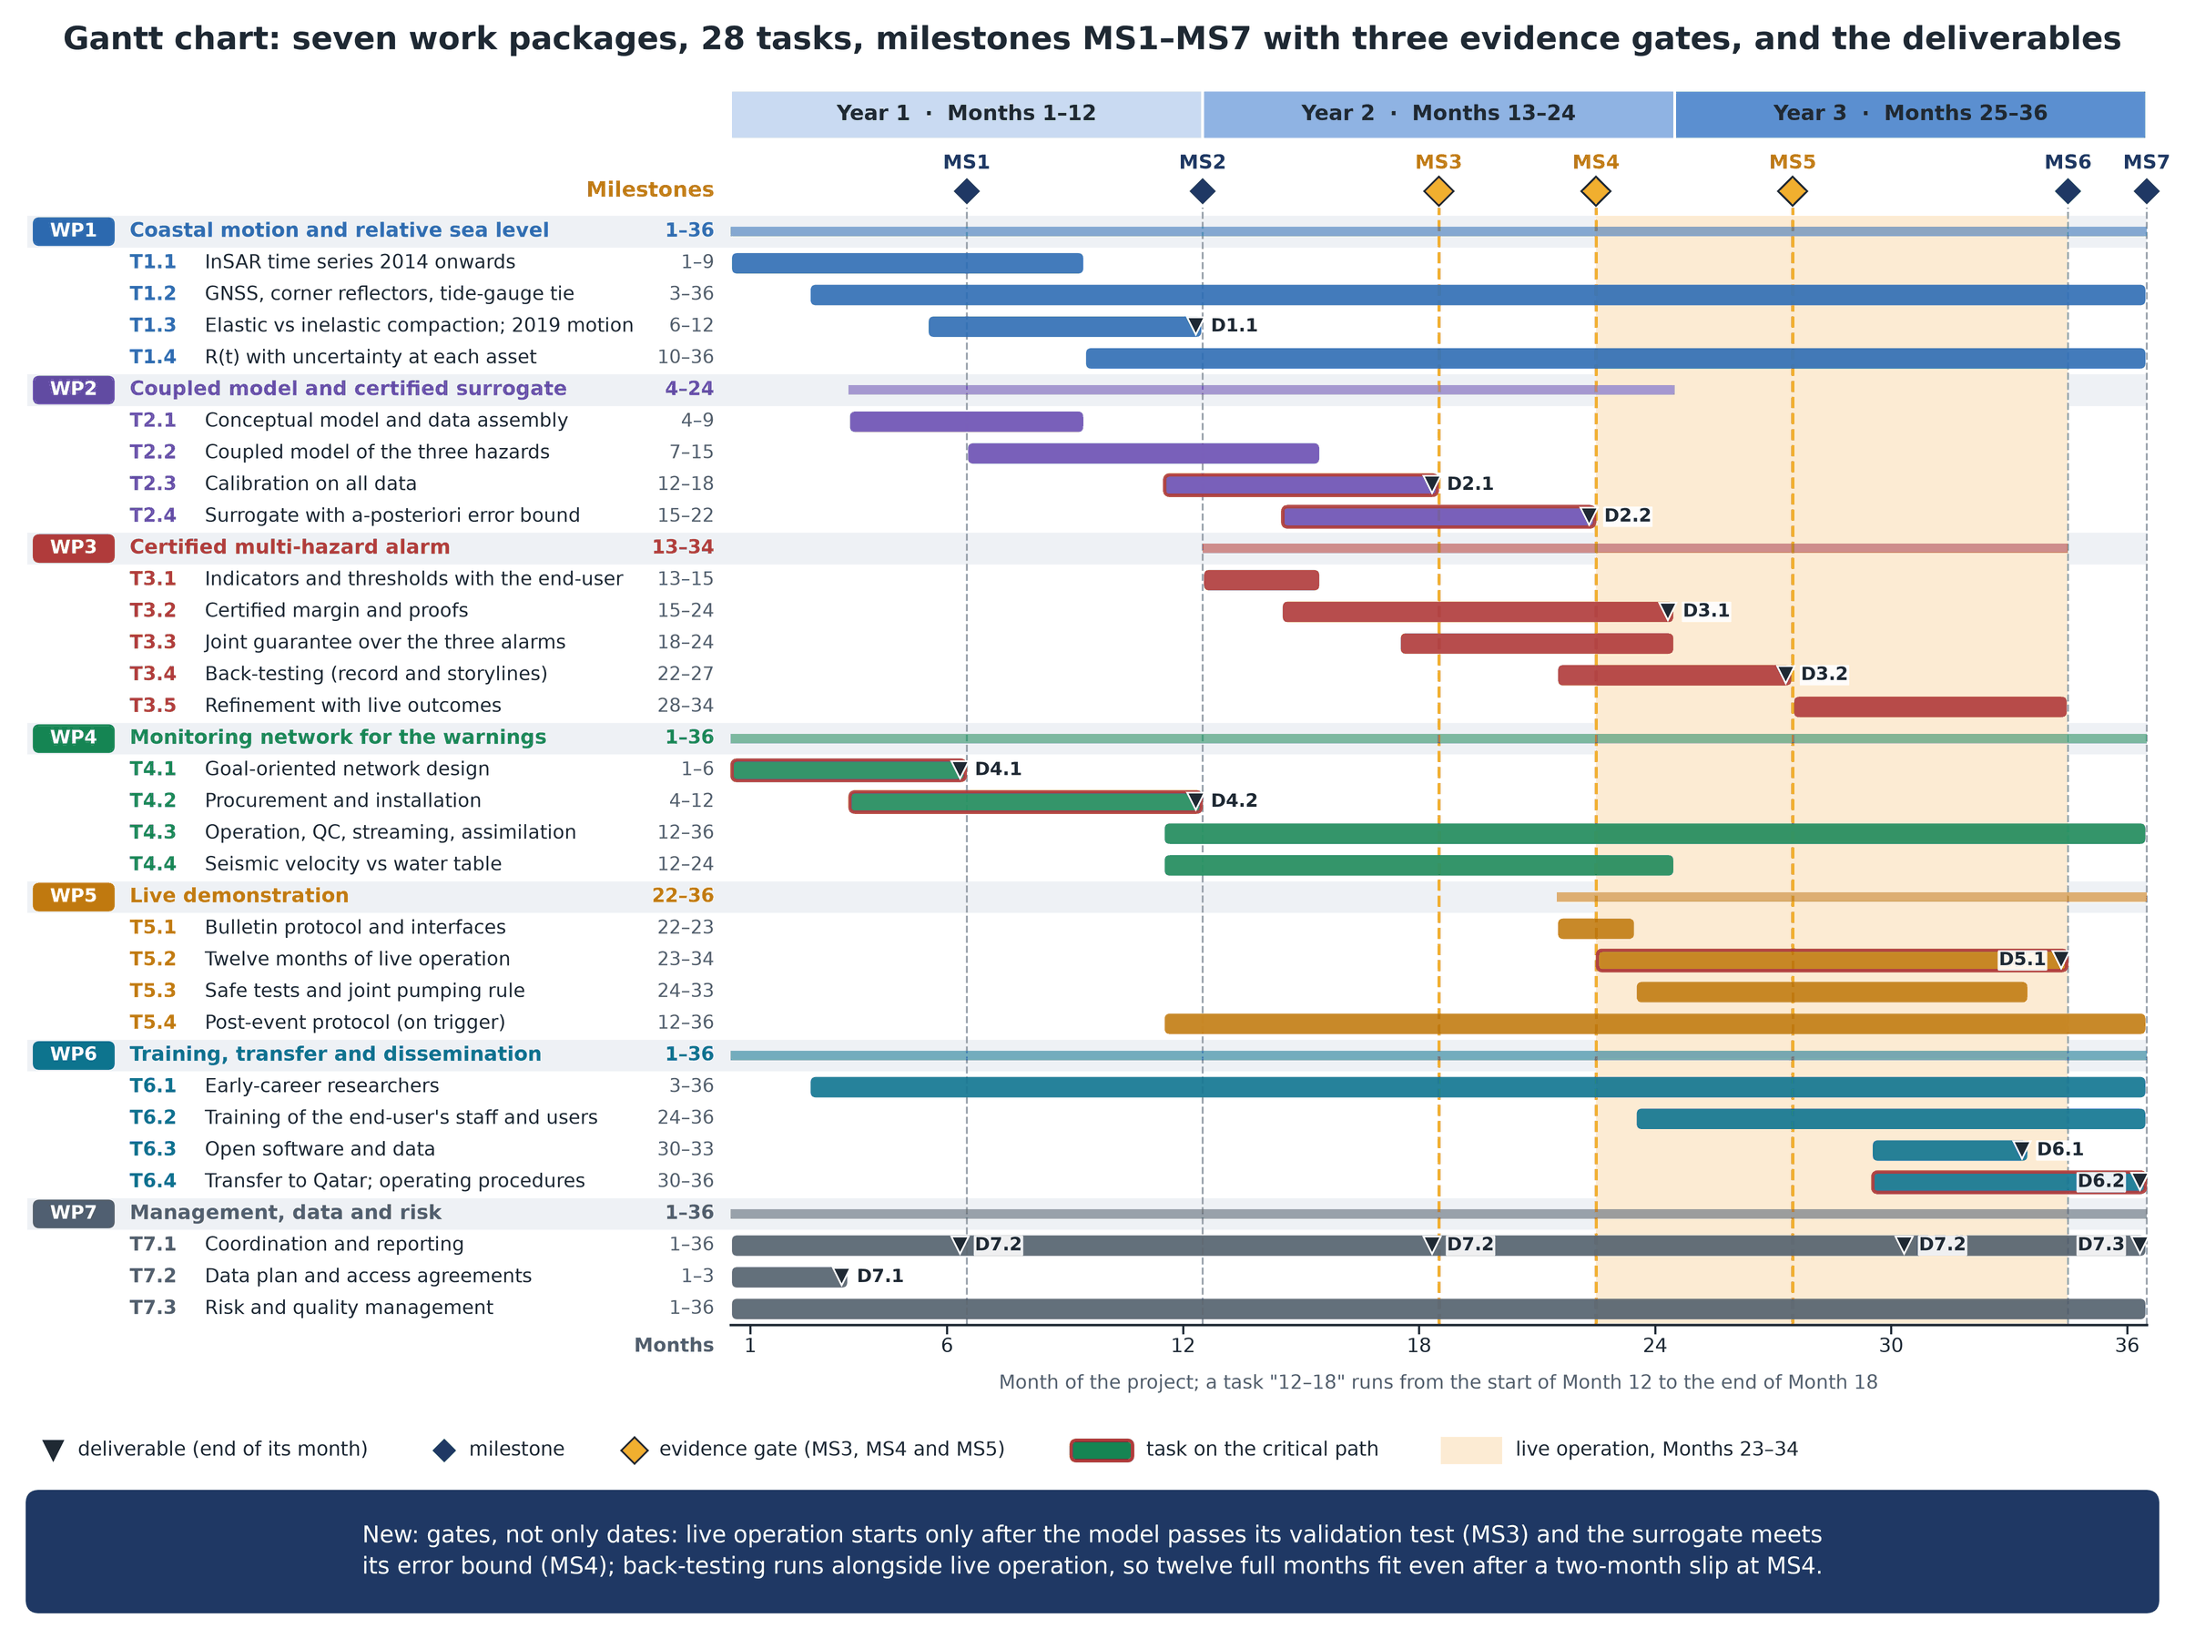
Figure 5. Gantt chart of the seven work packages and 28 tasks over 36 months: the milestones MS1–MS7, the evidence gates MS3–MS5, each deliverable at the end of the task that produces it, the critical path and the live operation in Months 23–34.

