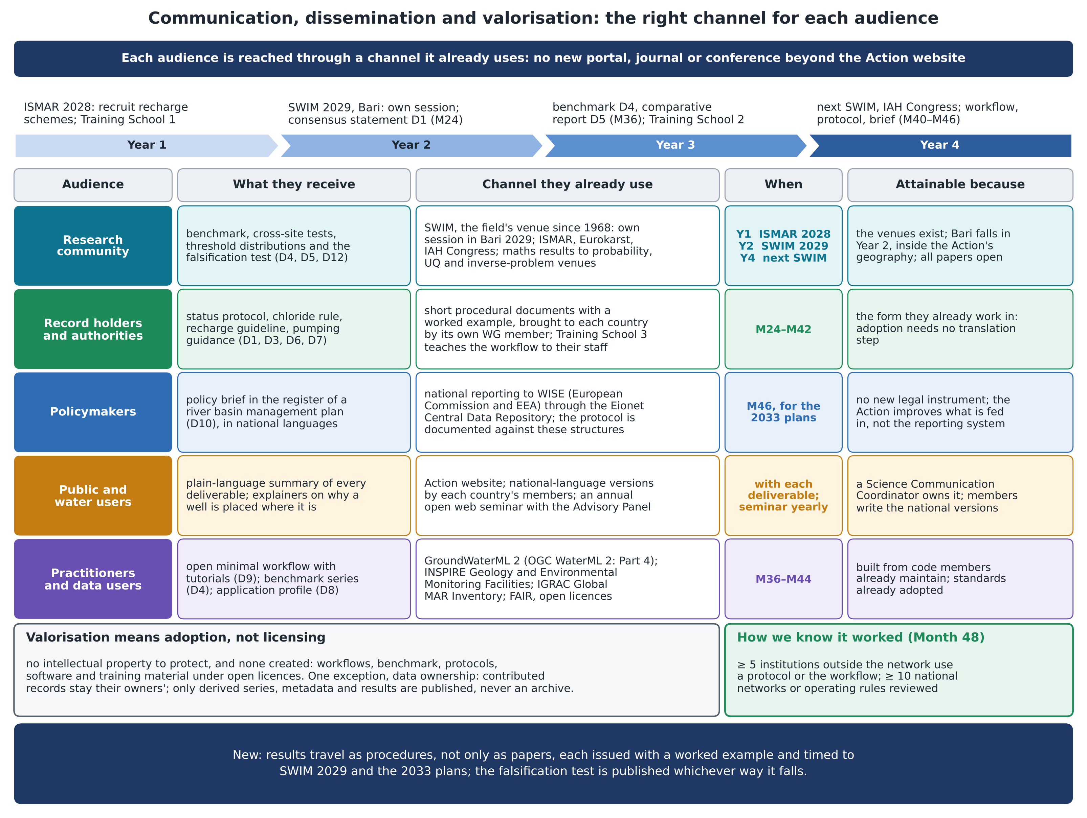
Figure. Communication, dissemination and valorisation: for each audience (research community, record holders and authorities, policymakers, the public and water users, practitioners and data users) what it receives, the channel it already uses, when, and why the plan is attainable; the Year 1–4 timeline of venues and outputs; valorisation as adoption. Content as in annex sections 2.A, 2.C and 3.C.

