State of the art III: when the rain itself is uncertain
Twenty more papers from Oxford, Caltech, Berkeley and MIT (2020–2026) on rainfall products, recharge, mixing and coastal boundaries; the state of the art and the step beyond it; and RESHJA-GO, guaranteed boundary conditions when the rain is known only through a product
Dulian Zeqiraj · November 2026 · review with a numerically tested innovation · companion to reviews I (GARANCIA-GO) and II (MATJA-GO)
1. Outcome
• Twenty new papers, five per institution, 2020–2026, each with links (Section 3, Figure 1). None was a card of reviews I or II or of the earlier reviews. This batch looks at the one input the two first reviews took as exact: the rain. Every card states the state of the art the paper sets, what it cannot yet do for us, three lessons (inputs, dispersion, boundary conditions) and an innovation step.
• State of the art and beyond, for the proposal (Section 2, Table 1), and a map of all sixty papers of reviews I–III against the eight steps of the procedure (Section 5, Table 3).
• Innovation: RESHJA-GO (Section 4). "Knowing only the amount of rain" usually means knowing a product (satellite, reanalysis, a distant station) with a bias and daily errors. Proposition R1: a rain bias is invisible to every check made with heads, and $κ$ has a floor that no logger removes. Proposition R2: the vadose filter averages the daily errors over $n_{eff}$ effective rain days and passes the bias untouched; the covariance of the filtered error can be computed from the product itself. Proposition R3: the guarantees of review I hold again when the simulated aquifers carry the product's errors.
• Test: calibrating as if the product were exact breaks every guarantee (T9, 400 simulated aquifers per setting, 20% bias, daily errors of relative variance 0.43). With loggers, the band of $κ$ misses in 0.70–0.76 of the cases, the whole-function coverage of the recharge falls to 0.02–0.21, of the inflow to 0.49–0.82 and of the sea level to 0.72–0.76; more loggers make it worse. Calibrated with the product's errors, every guarantee holds (share of weeks outside 0.093–0.103, coverage 0.90).
• The floor and the gauge (T10). With the product, eight loggers bring the guaranteed half-width of $κ$ only to 0.108, against the floor 0.091 of Proposition R1 and 0.023 with exact rain, while $c=κb$ shrinks to 0.028. A local rain gauge with one logger gives $κ$ to 0.045, which the product does not reach with eight; with two loggers it gives the recharge to 0.087 mm/d against 0.114 with the product. The first instrument to buy is a rain gauge.
• The filter law (T11). On 300 rain records the measured variance of the filtered error matches $v/n_{eff}$ to a median of 4.1%; the mean $n_{eff}$ is 5.7 rain days, not the 57 of steady rain, so a product with poor daily skill still leaves a weekly forcing error of about 28%. Using that covariance in the recharge prior (R2 prior) cuts the guaranteed recharge half-width with eight loggers from 0.104 to 0.069 mm/d.

2. State of the art and the step beyond it
Reviews I and II (D1, D2) treated the rain as exact and asked which bands can be guaranteed and which measurement buys most. In practice the rain of a coastal aquifer is rarely measured on site: it comes from a reanalysis such as ERA5-Land, a gridded product such as E-OBS, a satellite product such as IMERG, or a station tens of kilometres away. This review asks what the guarantees become when the rain itself is uncertain, and what to do about it.
Text for the proposal. Rainfall products are now available everywhere at daily or finer resolution and are routinely corrected, downscaled or blended with gauges (Section 3), and recharge, groundwater and coastal boundary conditions are increasingly estimated from them. Their errors are known to be large at the scale of one aquifer, but they are carried into groundwater models, if at all, as a scenario or an ensemble without a guarantee. The project goes beyond the state of the art in three ways: it proves that a rain bias cannot be detected or corrected with heads and sets the floor it imposes on the recharge coefficient (Proposition R1); it gives the exact law by which the unsaturated zone averages daily rain errors, and uses it as a data-driven prior for the recharge error (Proposition R2); and it restores finite-sample guarantees for every boundary function when only a rain product is known (Proposition R3, RESHJA-GO), with a rule for when a local rain gauge is worth more than further head loggers. All three are tested numerically below.
Table 1. State of the art (2020–2026) and the step beyond it. Card numbers refer to Section 3; T numbers to the tests of Section 4.
Topic | State of the art | Its limit for our problem | Our step beyond | Evidence
Rainfall products for hydrology | Global multi-product evaluations (O1, O2); machine-learning-merged rainfall (O3); extreme-preserving gridded data (B2); downscaling of extremes (M1); observation-weighted projections (C2); optimal-transport debiasing (C3) | Skill scored on discharge or after calibration, which hides the bias; no error law for one site | The product's error law in the simulated aquifers (Proposition R3, RESHJA-GO) | T9: κ coverage 0.24–0.30 if the product is treated as exact; 0.90 with its errors
How rain errors reach the aquifer | Forcing resolution turns into metre-scale head bias (B1); elasticity curves (O4); atmospheric rivers and recharge (B3); state-dependent satellite rain errors over land (C4) | Deterministic sensitivities, no law that can be used as a prior | Exact filter law with the effective number of rain days and a covariance computed from the product (Proposition R2, R2 prior) | T11: measured variance on v/n_eff; mean n_eff 5.5 against 57 for steady rain
Identifying the recharge coefficient | Calibration per product (O2); parameters absorb forcing errors (B1) | κ calibrated on one product does not transfer; the bias is undetectable | κ has a floor under a rain bias; report c = κb (Proposition R1) | T10: κ 0.108 with eight loggers, floor 0.091; c to 0.028
Measuring the rain | Gauge-corrected products (O3); regional water-balance closure from gravimetry (C5); InSAR and GRACE storage (C1) | The value of a local gauge is not computed against that of head loggers | The gauge as a candidate instrument of MATJA-GO, valued by the guaranteed width it removes | T10: a gauge and one logger give κ to 0.045, the product with eight loggers 0.108
Future rain and the coast | Mechanisms and 12 km projections of Mediterranean drying (M2, M3); fresh discharge hotspots at river mouths (B4) | Scenarios without guarantees; a drying climate and a biased product look the same to heads | Circulation-conditioned rain in the simulated aquifers; shift bound for the future law; a long gauge record | Proposition R1 and review I, Proposition 4
Dispersion and mixing | Homogenised dispersion closures (O5); cross-group mixing benchmark with physical truth (M5); tracer mixing with Bayesian uncertainty (B5) | No field identification of dispersivity; closures not tested against truth | Velocity-dependent closure and uncertain end members in the simulated aquifers; bands scored against a physical benchmark | Review I, Proposition 6 and T4

3. The twenty papers
Five papers per institution, all published in 2020–2026 (Figure 1). The rules of reviews I and II apply: direct use, a link to the institution at the time of publication (JPL for Caltech, Lawrence Berkeley National Laboratory for Berkeley), a state-of-the-art contribution, and no paper that was a card in an earlier review. This batch gives priority to rainfall products and their errors, then to recharge from rain, mixing and dispersion, and coastal boundaries.
Verification. The hosts doi.org, arxiv.org, openreview.net and most publisher pages were blocked in this environment, so every landing page was reached through search results that quote it, and every card is marked partly verified; where an author list or a volume could not be confirmed, the card gives only what was seen and says so. The search budget of the session ran out before every affiliation could be seen; card C4 gives its author's institution from our own knowledge and says so.
3.1 University of Oxford
O1 · Oxford · 2024
Global-scale evaluation of precipitation datasets for hydrological modelling
Solomon H. Gebrechorkos et al. (with Dadson, Slater and Wortmann; the full author list and the other given names were not confirmed)
Hydrology and Earth System Sciences 28(14), 3099–3118 (2024)
Links: doi:10.5194/hess-28-3099-2024 · HESS article · author page
Affiliation and verification: Gebrechorkos: corresponding author at the School of Geography and the Environment, University of Oxford (article summary as quoted; his Oxford staff page lists the paper); Slater and Wortmann also Oxford. Status: partly verified (landing pages reached through search results only).
What it does. Six global precipitation products (ERA5, CHIRPS, MSWEP, TerraClimate, CPCU and PERCCDR) force the WBMsed global hydrological model for 1983–2019, and the simulated discharge is scored at 1825 stations. MSWEP, then ERA5, has the highest correlation and KGE at more than half of the stations; PERCCDR is worst, with biases up to 99% and normalised RMSE up to 247%. No product is best everywhere, so the choice must be made basin by basin.
State of the art it sets. The global, model-based evaluation of rainfall products for hydrology.
What it cannot yet do for us. It scores discharge, not heads or recharge, and gives a ranking, not an error law usable at one coastal site; no guarantee.
Input parameters. A product's bias is absorbed by the recharge coefficient (and by the transmissivity where heads scale with $r/T$): $κ$ calibrated on one product does not carry over to another, as Proposition R1 says.
Dispersion coefficient. None.
Boundary conditions from rain alone. The spread between products at one pixel is a measured envelope of the rain, hence of the recharge in time.
Innovation step for our problem. Set the bias prior $s_{b}$ of RESHJA-GO from the spread of the products at the site (ERA5, MSWEP, CHIRPS …) and draw $b$ from it in the simulated aquifers. The floor (4) of $κ$ is then known before any model run, and so is the value of a local gauge.

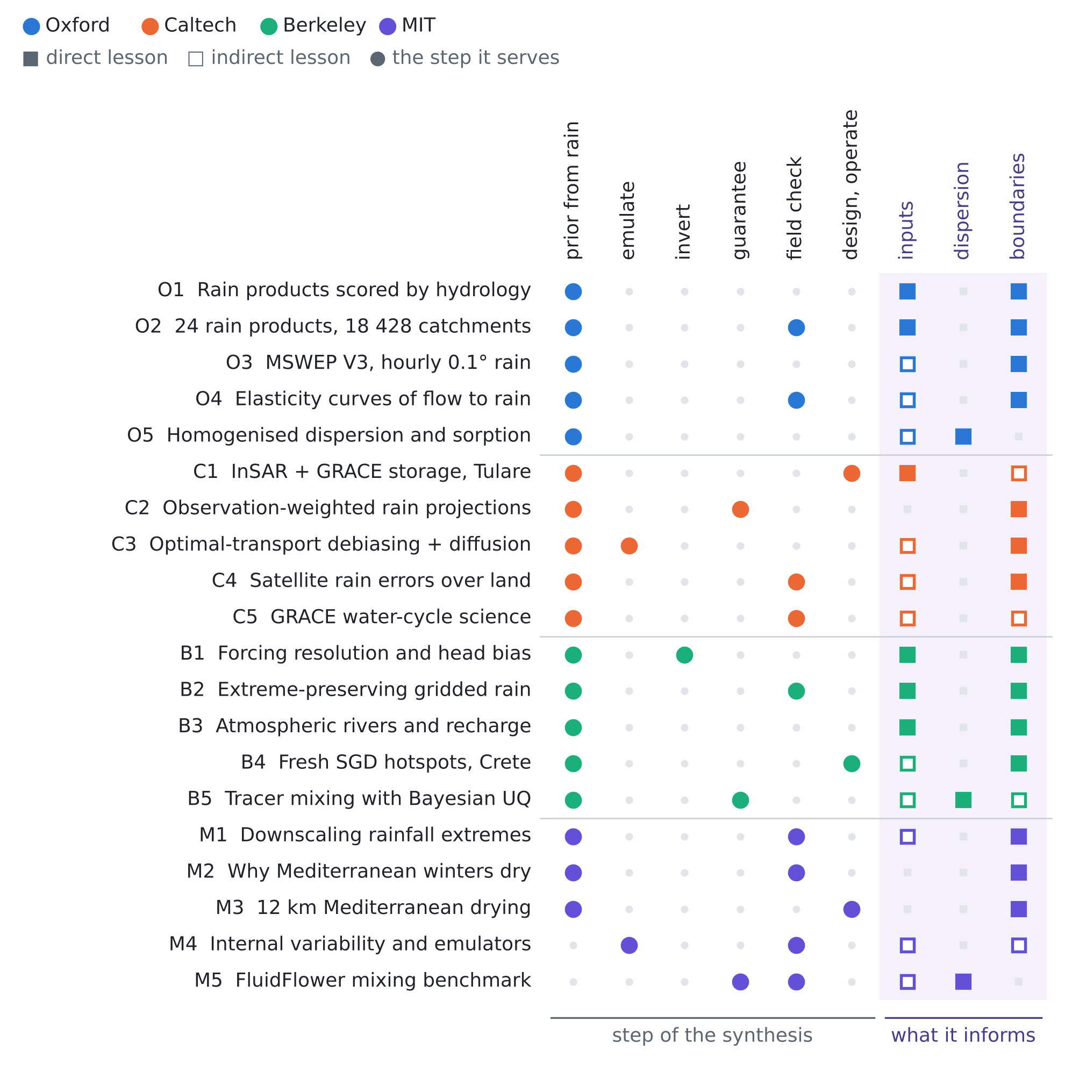
Figure 1. The twenty papers against the step of the procedure they serve and the unknown they inform. Colour gives the institution; a filled square is a direct lesson, an open square an indirect one.
O2 · Oxford · 2026
Comprehensive global assessment of 24 gridded precipitation datasets across 18 428 catchments using hydrological modeling
Ather Abbas, Yuan Yang, Ming Pan, et al. (16 authors, with Solomon H. Gebrechorkos and Hylke E. Beck; author list from the preprint)
Hydrology and Earth System Sciences 30(11), 3399–3423 (2026)
Links: doi:10.5194/hess-30-3399-2026 · HESS article · preprint
Affiliation and verification: Oxford link through Gebrechorkos, who is at the Oxford School of Geography and the Environment on his 2024 HESS paper (O1) and in a 2026 EGU abstract; his affiliation in this paper's author block was not seen. Status: partly verified (landing pages reached through search results only).
What it does. An HBV model is calibrated against daily streamflow in each of 18 428 catchments smaller than 10 000 km², once per product, for 24 satellite, reanalysis, gauge and merged products. MSWEP V2.8 is best overall (median KGE 0.78), GDAS the best reanalysis (0.72, ERA5 0.71) and GPM+SM2RAIN the best satellite-only product (0.64); skill and error characteristics differ strongly by region.
State of the art it sets. The largest product-by-product hydrological test of rainfall.
What it cannot yet do for us. Skill is measured after calibration, which compensates the bias, and on streamflow, not groundwater; no error bound for one aquifer.
Input parameters. Calibrating once per product shows that the model parameters absorb the product bias: the trap of Proposition R1, at global scale.
Dispersion coefficient. None.
Boundary conditions from rain alone. The catchments have our scale, so the regional rankings guide which product should drive the recharge, and the KGE gaps between products measure how uncertain the rain is.
Innovation step for our problem. Skill after calibration is the wrong yardstick for recharge: two products with equal KGE can imply different $κ$. Rank products instead by the guaranteed width they leave for the goal, computed with RESHJA-GO and each product's error law, which penalises the bias that calibration hides.

O3 · Oxford · 2026
MSWEP V3: machine learning-powered global precipitation estimates at 0.1° hourly resolution (1979–present)
Xuetong Wang, Raied S. Alharbi, Oscar M. Baez-Villanueva, et al. (15 authors, with Solomon H. Gebrechorkos and Hylke E. Beck)
arXiv:2602.01436 (preprint, February 2026)
Links: arXiv:2602.01436 · EGU26 abstract · MSWEP
Affiliation and verification: Gebrechorkos: School of Geography and the Environment, University of Oxford, and University of Southampton (EGU26 abstract of the same work, as quoted); his affiliation in the arXiv PDF was not seen. Status: partly verified (landing pages reached through search results only).
What it does. Hourly 0.1° rainfall from 1979 to near present with about two hours of latency. Stacked machine-learning models merge satellite and (re)analysis precipitation and temperature with static variables into a baseline, which is then corrected with daily and monthly gauge data (57 666 and 86 000 stations, EGU26 abstract). The baseline reaches a median daily KGE of 0.69, against 0.61 for ERA5.
State of the art it sets. Machine-learning-merged, gauge-corrected global rainfall at hourly 0.1°.
What it cannot yet do for us. A preprint; no per-pixel uncertainty in what was seen; the gauge correction may reuse the gauges one would validate against; coastal Balkan cells not evaluated in what was seen.
Input parameters. The best candidate long rain series where local gauges are sparse.
Dispersion coefficient. None.
Boundary conditions from rain alone. 47 years of hourly forcing allow a long spin-up, so the initial head and interface can be generated by the forcing history instead of guessed.
Innovation step for our problem. Use the product's daily skill to set $v$ in (2) and its gauge density to set $s_{b}$. Proposition R2 then gives what survives the vadose filter, $v/n_{eff}$: the weekly forcing error of an MSWEP-class product at a site is known before any model run.

O4 · Oxford · 2024
Elasticity curves describe streamflow sensitivity to precipitation across the entire flow distribution
Anderson, Brunner, Slater and Dadson (given names not confirmed)
Hydrology and Earth System Sciences 28(7), 1567–1583 (2024)
Links: doi:10.5194/hess-28-1567-2024 · ORA record
Affiliation and verification: First author, Slater and Dadson: School of Geography and the Environment, University of Oxford (article summary as quoted; ORA record); Brunner's affiliation not seen. Status: partly verified (landing pages reached through search results only).
What it does. The precipitation elasticity of streamflow is estimated at many flow percentiles instead of the mean only. These elasticity curves are computed for 805 US catchments and clustered by shape; the annual-median elasticity gives an incomplete picture, and available water storage is the likely control of the curve shape. The code is published.
State of the art it sets. Precipitation sensitivity resolved over the whole flow distribution, with storage as its control.
What it cannot yet do for us. Streamflow in the US, not groundwater; elasticity from historical co-variation, not from product error; no uncertainty bounds.
Input parameters. How much a rain error moves the outputs depends on storage and on the state (low or high flow), hence on $S$ and $τ$.
Dispersion coefficient. None.
Boundary conditions from rain alone. Inland inflow and baseflow respond to rain through storage; a quantile-dependent elasticity is a compact way to build inflow scenarios from rain alone.
Innovation step for our problem. In our model the elasticity of the recharge to a rain bias is exactly one ($r∝κb$), and that of the heads is set by storage. An elasticity curve of heads to rain, computed on the simulated aquifers, tells in which states (drought, flood) a rain error does most damage, which is where the RESHJA-GO bands widen.

O5 · Oxford · 2024
A homogenised model for dispersive transport and sorption in a heterogeneous porous medium
L. C. Auton, M. P. Dalwadi, I. M. Griffiths (initials as on the authors' 2022 companion paper)
arXiv:2410.11519 (2024); manuscript under review
Links: arXiv:2410.11519 · manuscript
Affiliation and verification: Manuscript hosted on Griffiths' page at the Mathematical Institute, University of Oxford; the affiliation block and the final venue were not seen. Status: partly verified (landing pages reached through search results only).
What it does. Multiple-scales homogenisation of transport through an array of arbitrarily shaped obstacles whose microstructure varies slowly in space gives effective advection, dispersion and sorption coefficients. The effective diffusivity carries a dispersive part that follows a power law consistent with classical Taylor dispersion.
State of the art it sets. A mathematically derived dispersion–sorption closure for slowly varying heterogeneous media.
What it cannot yet do for us. Idealised two-dimensional microstructure, no density coupling, no field data and no field identification.
Input parameters. Sorption enters as an effective retardation.
Dispersion coefficient. Dispersion is velocity-dependent and varies in space, $D\left(x,\left|v\right|\right)=D_{m}+c\left(x\right) {\left|v\right|}^{n}$, not a constant: the width of the transition zone should depend on the flow, and the prefactor and exponent are the unknowns to infer from the chloride facts.
Boundary conditions from rain alone. None.
Innovation step for our problem. Give the simulated aquifers the closure $D=D_{m}+c {\left|v\right|}^{n}$ with uncertain $\left(c,n\right)$ instead of one dispersivity. Heads never inform it (review I, Proposition 6), so the rain product cannot spoil it either, and its guaranteed band carries the uncertainty of the closure.

3.2 California Institute of Technology (with JPL)
C1 · Caltech · 2022
Using Sentinel-1 and GRACE satellite data to monitor the hydrological variations within the Tulare Basin, California
Donald W. Vasco, Kyra H. Kim, Tom G. Farr, J. T. Reager, David Bekaert, Simran S. Sangha, Jonny Rutqvist, Hiroko K. Beaudoing
Scientific Reports 12, 3867 (2022)
Links: doi:10.1038/s41598-022-07650-1 · PMC8907331
Affiliation and verification: NASA Jet Propulsion Laboratory, managed by Caltech (JPL/NASA coverage as quoted: a JPL research team; Kim a JPL postdoctoral fellow); the per-author affiliation block was not seen. Status: partly verified (landing pages reached through search results only).
What it does. Sentinel-1 InSAR deformation and GRACE/GRACE-FO water storage are fitted together with a simple two-layer model: an unconfined near-surface aquifer above a confined one, separated by the Corcoran clay. Once the long-term compaction trend (about 0.3 m/yr of subsidence) is removed, virtually all the month-to-month ground motion is explained by changes in the aquifers, and rain can raise the water table while the ground still sinks.
State of the art it sets. Joint calibration of a minimal layered aquifer model on InSAR and GRACE, separating the rain-driven water table from the pumping-driven confined response.
What it cannot yet do for us. The GRACE footprint is far larger than one coastal plain, thick compressible clays give a deformation signal a small plain may lack, and there is no salinity and no rain uncertainty.
Input parameters. Two compartments with two time scales: a fast unconfined layer driven by rain (our $κ$ and $τ$) and a slow confined layer driven by pumping, with storage identified from deformation and mass together; Sentinel-1 covers Albania.
Dispersion coefficient. None.
Boundary conditions from rain alone. Seasonal deformation constrains the storage state and the inland inflow.
Innovation step for our problem. Ground motion responds to the recharge, so like the heads it sees only $c=κb$ (Proposition R1): InSAR cannot remove the floor of $κ$ under a rain bias. It is free, though, and MATJA-GO values it for the recharge function like a dense but noisy logger network.

C2 · Caltech · 2020
Bayesian model averaging of climate model projections constrained by precipitation observations over the contiguous United States
Elias C. Massoud, H. Lee, P. Gibson, P. Loikith, D. Waliser
Journal of Hydrometeorology 21(10), 2401–2418 (2020; volume and pages from a repository record)
Links: doi:10.1175/JHM-D-19-0258.1 · ORNL record
Affiliation and verification: Listed on Massoud's JPL Science people page (search result); the article's affiliation block was not seen. Status: partly verified (landing pages reached through search results only).
What it does. Bayesian model averaging weights a multi-model climate ensemble by how well each model matches the observed precipitation over the contiguous US. The weighted estimate reproduces mean rainfall better than the ensemble mean (RMSE 0.49 against 0.65), and its uncertainty spread is about a third of the total spread of the multi-model ensemble.
State of the art it sets. Observation-constrained averaging that narrows precipitation projections about threefold.
What it cannot yet do for us. The observations are treated as truth, so the error of the gauge or gridded product is not modelled; the narrower spread has no coverage guarantee.
Input parameters. Rain scenarios can be weighted by their fit to the short local record before they drive the calibration of $κ$ and $τ$.
Dispersion coefficient. None.
Boundary conditions from rain alone. Weighted future recharge scenarios.
Innovation step for our problem. The observations the weights are fitted to are themselves a product with a bias, and by Proposition R1 a model can be up-weighted for matching that bias. Fit the weights on simulated products whose truth is known and recalibrate on a fresh pool (review II, Proposition M1), so the narrowed spread keeps its coverage.

C3 · Caltech · 2023
Debias coarsely, sample conditionally: statistical downscaling through optimal transport and probabilistic diffusion models
Zhong Yi Wan, Ricardo Baptista, Anudhyan Boral, Yi-Fan Chen, John Anderson, Fei Sha, Leonardo Zepeda-Núñez
Advances in Neural Information Processing Systems 36 (NeurIPS 2023); arXiv:2305.15618
Links: NeurIPS 2023 · arXiv:2305.15618
Affiliation and verification: Baptista: California Institute of Technology (arXiv rendering, as quoted); the other authors at Google Research. Status: partly verified (landing pages reached through search results only).
What it does. A two-stage method for downscaling without paired data: an optimal-transport map removes the bias at the coarse scale, then a probabilistic diffusion model adds the small scales by conditional sampling. It is shown on one- and two-dimensional fluid flows at 8× and 16× upsampling and keeps the physical statistics even when the low-frequency content of input and output differs.
State of the art it sets. Separating bias correction (optimal transport) from small-scale generation (diffusion) in unpaired downscaling.
What it cannot yet do for us. Not shown on precipitation, with its zeros and intermittency, in what was seen; needs a high-resolution training set; no coverage guarantee.
Input parameters. A principled way to turn a biased reanalysis into station-like rain samples that drive the ensemble of $κ$ and $τ$.
Dispersion coefficient. None.
Boundary conditions from rain alone. An ensemble of recharge series from a coarse product.
Innovation step for our problem. Its two stages map onto the two error terms of (2): the transport map treats the bias $b$, the diffusion model the daily errors. Proposition R2 says the daily errors matter only through $v/n_{eff}$ and the bias fully, so the debiasing stage is the one that needs a guarantee: calibrate its residual bias on simulated pairs and feed it to RESHJA-GO as $s_{b}$.

C4 · Caltech · 2021
Adapting passive microwave-based precipitation algorithms to variable microwave land surface emissivity to improve precipitation estimation from the GPM constellation
F. Joseph Turk, S. E. Ringerud, Y. You, A. Camplani, D. Casella, et al. (12 authors, with C. Prigent and C. Peters-Lidard)
Journal of Hydrometeorology 22(7), 1755–1781 (2021)
Links: doi:10.1175/JHM-D-20-0296.1 · CNR repository
Affiliation and verification: Turk: NASA Jet Propulsion Laboratory, Caltech, to our knowledge; the byline affiliation could not be seen in this environment, so this card has the weakest affiliation evidence of the twenty. Status: partly verified (landing pages reached through search results only).
What it does. Over land the surface-emissivity part of passive-microwave measurements is much more variable than over the ocean, with varying sensitivity to near-surface precipitation. More than six years of GPM coverage give new insight into emissivity over land, snow and ice, which is used to improve the physically and semi-physically based retrievals of the constellation.
State of the art it sets. Emissivity-adaptive passive-microwave precipitation retrieval across the GPM constellation.
What it cannot yet do for us. Retrieval level only: no propagation into hydrology and no coast-specific error numbers in what was seen.
Input parameters. The error of a satellite product over a coastal plain depends on the surface state: wet soil changes the emissivity, so the rain error is correlated with the state that drives recharge.
Dispersion coefficient. None.
Boundary conditions from rain alone. A caution against using land–sea mixed pixels as the recharge forcing at a coast.
Innovation step for our problem. A state-dependent rain error breaks the independence assumed in Proposition R2. Simulate it in the aquifers (the daily error depending on antecedent wetness; Proposition R3 still holds) and expect a filtered error larger than $v/n_{eff}$, because the errors then cluster in the wet spells that make the recharge.

C5 · Caltech · 2023
Water cycle science enabled by the GRACE and GRACE-FO satellite missions
Matthew Rodell, John T. Reager
Nature Water 1, 47–59 (2023)
Links: doi:10.1038/s44221-022-00005-0 · NTRS record
Affiliation and verification: Reager: NASA Jet Propulsion Laboratory, Caltech (NTRS preprint, as quoted); the byline of the journal version was not seen. Status: partly verified (landing pages reached through search results only).
What it does. A review of how satellite gravimetry moved from the fringes of hydrology to a core tool of water-cycle and water-resources science. Terrestrial water storage, an Essential Climate Variable, is observed only by these missions; high-profile groundwater-depletion studies drove the interest, GRACE-FO followed in 2018, and a further mission is in development.
State of the art it sets. The reference synthesis of GRACE hydrology.
What it cannot yet do for us. Far too coarse for one coastal plain, and no method for rainfall uncertainty.
Input parameters. Gravimetry gives a regional prior or check on the storage budget, hence on the recharge coefficient.
Dispersion coefficient. None.
Boundary conditions from rain alone. Regional storage and inflow anomalies.
Innovation step for our problem. Storage change from gravimetry does not depend on the rain product, so a regional water-balance closure (product rain minus evaporation, runoff and storage change) tests the product's bias, the one thing heads can never test (Proposition R1). It gives a regional estimate of $s_{b}$ for RESHJA-GO.

3.3 University of California, Berkeley (with Lawrence Berkeley National Laboratory)
B1 · Berkeley · 2020
Sensitivity of meteorological-forcing resolution on hydrologic variables
Fadji Z. Maina, Erica R. Siirila-Woodburn, Pouya Vahmani
Hydrology and Earth System Sciences 24(7), 3451–3474 (2020)
Links: doi:10.5194/hess-24-3451-2020 · HESS article · eScholarship
Affiliation and verification: Maina and Siirila-Woodburn: Energy Geosciences Division; Vahmani: Climate and Ecosystem Sciences Division, Lawrence Berkeley National Laboratory (preprint affiliation lines, as quoted). Status: partly verified (landing pages reached through search results only).
What it does. The integrated model ParFlow-CLM is forced with WRF meteorology downscaled at 0.5 to 40.5 km over the undammed Cosumnes watershed in California. Errors in the spatial pattern of the forcing propagate through the land surface and appear later in time: localized groundwater-level biases reach 5–10 m and surface water about 3 m, depending on season and location, with "serious implications for model calibration".
State of the art it sets. The first systematic tracing of how forcing resolution turns into metre-scale groundwater-head bias in an integrated model.
What it cannot yet do for us. A deterministic sensitivity study of one snow-affected watershed: no probabilistic rain-error model, no guarantee and no salinity.
Input parameters. Calibrating $T$, $κ$ and $τ$ against a coarse rain field makes them absorb the forcing error; because the error is lagged, it is confounded with $τ$.
Dispersion coefficient. None.
Boundary conditions from rain alone. The resolution of the rain field is itself an error of the recharge-in-time condition, and an initial head obtained by spin-up inherits a delayed bias.
Innovation step for our problem. Their delayed bias is what Proposition R2 predicts: the filter turns forcing errors into lagged recharge errors with covariance $K diag\left(P^{2}\right) K^{⊤}$. Use that covariance as the recharge-error prior (R2 prior) instead of letting $κ$ and $τ$ absorb the error; in T10 it cut the guaranteed recharge band with eight loggers by a third.

B2 · Berkeley · 2021
An extreme-preserving long-term gridded daily precipitation dataset for the conterminous United States
David W. Pierce, Lu Su, Daniel R. Cayan, Mark D. Risser, Ben Livneh, Dennis P. Lettenmaier
Journal of Hydrometeorology 22(7), 1883–1895 (2021)
Links: doi:10.1175/JHM-D-20-0212.1 · eScholarship · OSTI record
Affiliation and verification: Risser: Lawrence Berkeley National Laboratory (author list as quoted; OSTI record). Status: partly verified (landing pages reached through search results only).
What it does. Two widely used gauge-based gridded daily products for the conterminous US are compared with their station data: they reduce the annual 1-day maximum precipitation by 27%, increase the wet-day fraction by 25% and underestimate 20-year return values by 30%. The main cause is the time adjustment that puts gauge observations into a common time frame. The new 1/16° dataset omits it, and forcing a land-surface model with it raises the annual 1-day maximum runoff by 38%.
State of the art it sets. It identifies a bias created by how a product is built, corrects it, and quantifies how far it carries into runoff.
What it cannot yet do for us. US only; a deterministic correction without day-by-day uncertainty; not carried into recharge or groundwater.
Input parameters. A $κ$ calibrated on a product with smeared peaks is biased, so the recharge coefficient depends on which product was used.
Dispersion coefficient. None.
Boundary conditions from rain alone. Rain errors are systematic distortions of intensity and wet days, not white noise: the error law of the recharge condition must contain that structure.
Innovation step for our problem. Extend the error law (2) of RESHJA-GO to an intensity-dependent bias and a wet-day inflation (drizzle). Proposition R3 needs only that the law be simulated, and Proposition R2 still gives the filtered error, now with a bias that varies with intensity, hence with the season.

B3 · Berkeley · 2023
The role of atmospheric rivers on groundwater: lessons learned from an extreme wet year
Erica R. Siirila-Woodburn, P. James Dennedy-Frank, Alan Rhoades, Pouya Vahmani, Fadji Maina, Benjamin Hatchett, Yang Zhou, Andrew Jones
Water Resources Research 59(6), e2022WR033061 (2023)
Links: doi:10.1029/2022WR033061 · eScholarship
Affiliation and verification: Siirila-Woodburn: Earth and Environmental Sciences Area, Lawrence Berkeley National Laboratory (affiliation as quoted); the article number is taken from the DOI. Status: partly verified (landing pages reached through search results only).
What it does. The Cosumnes watershed in the record-wet water year 2017: a high-resolution regional climate model is coupled to a land surface–groundwater model with lateral flow, and water parcels are tracked from the atmosphere into the subsurface. Atmospheric rivers delivered more precipitation than other storms, but less of their water was stored at the end of the year, snow-derived recharge from them was much lower, and groundwater still declined because of pumping.
State of the art it sets. Tracking water from atmospheric moisture all the way into aquifer storage.
What it cannot yet do for us. One year and one watershed; no uncertainty quantification of the forcing; no coastal boundary.
Input parameters. $κ$ and $τ$ depend on the type and intensity of the storm: one constant $κ$ times the rain is misspecified for extremes.
Dispersion coefficient. None.
Boundary conditions from rain alone. Recharge partitioning depends on the type of event, and the year-end storage, the next year's initial condition, depends on pumping as much as on rain: record rain is not record recharge.
Innovation step for our problem. Make $κ$ event-dependent in the prior (smaller for intense events). Proposition R1 then says the heads identify an intensity-weighted $κb$, and the simulated aquifers must carry both the product's bias and the intensity dependence, or the guarantee of the recharge fails in wet years.

B4 · Berkeley · 2021
Capturing hotspots of fresh submarine groundwater discharge using a coupled surface–subsurface model
X. Yu, Z. Xu, D. Moraetis, N. P. Nikolaidis, F. W. Schwartz, Y. Zhang, L. Shu, C. J. Duffy, B. Liu
Journal of Hydrology 598, 126356 (2021)
Links: doi:10.1016/j.jhydrol.2021.126356 · eScholarship
Affiliation and verification: Z. Xu: Climate and Ecosystem Sciences Division, Lawrence Berkeley National Laboratory (open-science record and conference poster, as quoted). Status: partly verified (landing pages reached through search results only).
What it does. A coupled surface–subsurface model of Crete estimates the fresh submarine groundwater discharge at about 2.3×10⁸ m³/yr, 31% of the river discharge and 14% of the precipitation. Local maxima sit at river mouths, where gradients are larger and the structures more permeable, and the discharge responds to episodic rain in a delayed and prolonged way; segment values were compared with point measurements.
State of the art it sets. Spatially resolved, island-wide fresh discharge to the sea from a model driven by meteorology, on a Mediterranean coast.
What it cannot yet do for us. Freshwater only: no density, no mixing zone and no uncertainty quantification.
Input parameters. The delayed, prolonged response constrains $τ$, and 14% of the rain gives the order of magnitude of the effective recharge coefficient on a Mediterranean coast.
Dispersion coefficient. None.
Boundary conditions from rain alone. A rain-driven freshwater outflow at the shoreline, concentrated at river mouths (for Fushë-Kuqe, the Erzen and Ishëm mouths): a flux condition at the sea boundary.
Innovation step for our problem. The fresh outflow integrates $c f$ over the catchment, so a seepage or salinity survey at river mouths informs the same identifiable combination $c=κb$ as the heads (Proposition R1); with a rain gauge it pins $κ$ itself. Price both with MATJA-GO.

B5 · Berkeley · 2023
Constraining bedrock groundwater residence times in a mountain system with environmental tracer observations and Bayesian uncertainty quantification
Nicholas E. Thiros, Erica R. Siirila-Woodburn, P. James Dennedy-Frank, Kenneth H. Williams, W. Payton Gardner
Water Resources Research 59, e2022WR033282 (2023)
Links: doi:10.1029/2022WR033282 · eScholarship
Affiliation and verification: Authors from the University of Montana, Lawrence Berkeley National Laboratory and the Rocky Mountain Biological Laboratory (search results); deposited in eScholarship. Status: partly verified (landing pages reached through search results only).
What it does. CFC-12, SF6, ³H and ⁴He are measured in fractured-bedrock wells along a hillslope of the East River watershed. MCMC estimates the noble-gas recharge temperature, recharge elevation and excess air and propagates them into mean residence times from lumped-parameter models; every sample needs a binary mixture of young and old water, and the uncertainty is much larger than in the usual practice that propagates only analytical errors.
State of the art it sets. Full Bayesian propagation of tracer-input uncertainty into residence-time distributions.
What it cannot yet do for us. Lumped-parameter models in mountain bedrock: no spatial transport, dispersivity or transition-zone width.
Input parameters. The delay is a young–old mixture distribution, not one number.
Dispersion coefficient. A template for turning a handful of tracer facts into mixing fractions with honest uncertainty; not a dispersivity estimate.
Boundary conditions from rain alone. The tracer input itself is uncertain, as the chloride input of rain and sea is for us.
Innovation step for our problem. Treat the Fushë-Kuqe chloride facts like their tracers: a fresh–sea mixing fraction with uncertain end members inside the simulated aquifers, so the guaranteed band of the transition-zone width carries the end-member uncertainty together with the dispersion closure (O5).

3.4 Massachusetts Institute of Technology
M1 · MIT · 2024
Statistical-physical adversarial learning from data and models for downscaling rainfall extremes
Anamitra Saha, Sai Ravela
Journal of Advances in Modeling Earth Systems (2024; volume and article number not confirmed)
Links: doi:10.1029/2023MS003860 · MIT News · arXiv:2212.01446
Affiliation and verification: Both authors: MIT, Department of Earth, Atmospheric and Planetary Sciences (MIT News of 11 June 2024 and the follow-up arXiv listing, as quoted). Status: partly verified (landing pages reached through search results only).
What it does. Coarse climate-model rainfall (0.25°) is turned into high-resolution fields (0.01°) with uncertainty: an iterative Gaussian process explores the data on a manifold, a generative adversarial network adds the fine scales, and simplified physics is corrected with historical statistics. The fields match observed spatial patterns and risk distributions in Denver and Chicago, and training needs little data.
State of the art it sets. Fast downscaling of rainfall extremes that combines physics, statistics and adversarial learning, with uncertainty.
What it cannot yet do for us. Extremes only; tested in the US and Bangladesh; no gauge-error model, no propagation to recharge and no coverage guarantee.
Input parameters. With an ensemble of local rain fields, $κ$ and $τ$ can be conditioned on many plausible rain series instead of one.
Dispersion coefficient. None.
Boundary conditions from rain alone. Local rainfall ensembles, extremes included, from coarse data: a time-varying recharge input with uncertainty, past and future.
Innovation step for our problem. Use the downscaler as the generator of the rain of the simulated aquifers, so the rain is random and Proposition R3 applies, and check its ensemble against a gauge with the conformal p-value of review I: an ensemble that fails the check would break the guarantee of the recharge.

M2 · MIT · 2021
Elements of the dynamical response to climate change over the Mediterranean
Alexandre Tuel, Paul A. O'Gorman, Elfatih A. B. Eltahir
Journal of Climate 34(3), 1135– (2021; end page not confirmed)
Links: doi:10.1175/JCLI-D-20-0429.1 · DSpace@MIT
Affiliation and verification: DSpace@MIT deposit; hosted by the Eltahir (Civil and Environmental Engineering) and O'Gorman (EAPS) groups at MIT. Status: partly verified (landing pages reached through search results only).
What it does. Winter circulation changes over the Mediterranean are tied to the vertical structure of stationary waves and their zonal asymmetries. In winter the Mediterranean lies just north of the edge of the Hadley cell, which helps explain the stronger winter response, and a strong anomalous ridge drives the regional decline of precipitation.
State of the art it sets. The mechanism of Mediterranean winter drying, from stationary waves and the edge of the Hadley cell.
What it cannot yet do for us. GCM scale: no Adriatic downscaling, no daily statistics and no hydrology.
Input parameters. None.
Dispersion coefficient. None.
Boundary conditions from rain alone. The recharge season (winter) loses rain mainly through circulation, so future recharge and inflow scenarios should sample circulation uncertainty, not scale the rain.
Innovation step for our problem. For future guarantees the rain law itself shifts: draw the rain of the simulated aquifers from a circulation-conditioned weather generator (a ridge index), and bound what is lost when the calibration law and the future one differ with the shift bound of review I (Proposition 4).

M3 · MIT · 2021
Understanding climate change over the southwestern Mediterranean using high-resolution simulations
Alexandre Tuel, Kang, Elfatih A. B. Eltahir (the second author's given name was not seen)
Climate Dynamics (published online 2020; volume, pages and DOI not confirmed)
Links: DSpace@MIT · Eltahir group
Affiliation and verification: DSpace@MIT deposit and the Eltahir group page; the MIT Regional Climate Model is used. Status: partly verified (landing pages reached through search results only).
What it does. The MIT Regional Climate Model is run at 12 km, driven by three GCMs; forced by ERA-Interim it captures the space–time patterns of precipitation. Under RCP4.5 and RCP8.5 it projects significant winter and spring declines: even with strong mitigation the three main watersheds of Morocco dry by 34% in spring and 22% in winter, through circulation changes that advect dry Saharan air.
State of the art it sets. A 12 km, multi-GCM regional projection of Mediterranean drying, with its mechanism.
What it cannot yet do for us. South-western, not Adriatic, Mediterranean; CMIP5 scenarios; no daily bias correction aimed at recharge; no groundwater.
Input parameters. None.
Dispersion coefficient. None.
Boundary conditions from rain alone. The size of the seasonal decline brackets the recharge stress scenarios.
Innovation step for our problem. A 20–30% seasonal decline acts on the recharge exactly like a bias $b<1$ that drifts in time, and by Proposition R1 the heads cannot tell a drying climate from a wet-biased product. Only a long record of a trusted gauge separates them: a design argument for keeping one rain gauge for decades.

M4 · MIT · 2025
The impact of internal variability on benchmarking deep learning climate emulators
Björn Lütjens, R. Ferrari, D. Watson-Parris, N. E. Selin
Journal of Advances in Modeling Earth Systems 17, e2024MS004619 (2025); arXiv:2408.05288
Links: DSpace@MIT · arXiv:2408.05288
Affiliation and verification: DSpace@MIT deposit and the MIT Center for Sustainability Science and Strategy publication page; Ferrari and Selin are MIT faculty. The journal DOI was not seen printed. Status: partly verified (landing pages reached through search results only).
What it does. On ClimateBench a simple linear regression, close to pattern scaling, beat a 100-million-parameter deep emulator on three of four regionally resolved variables. The cause is the large internal variability of the targets: with ensemble means of 50 runs per pathway instead of 3, a deep model could win for precipitation, while linear methods stayed better for temperature.
State of the art it sets. It shows that emulator rankings, precipitation included, can be artefacts of internal variability.
What it cannot yet do for us. GCM scale, annual and regional fields; no daily rain and no groundwater.
Input parameters. Calibrating $κ$ and $τ$ on one short record risks fitting its low-frequency noise; parsimonious recharge models are safer.
Dispersion coefficient. None.
Boundary conditions from rain alone. Future rain scenarios should come from large ensembles or sample internal variability explicitly.
Innovation step for our problem. Internal variability is to the climate what the daily error is to the product: a noise the vadose filter averages only over $n_{eff}$ events (Proposition R2). Calibrate on many simulated rain records, never on one, so the guarantee covers it.

M5 · MIT · 2023
The FluidFlower validation benchmark study for the storage of CO₂
B. Flemisch, J. M. Nordbotten, M. Fernø, R. Juanes, et al. (full author list not confirmed)
Transport in Porous Media 151(5), 865–912 (2024; online 2023)
Links: doi:10.1007/s11242-023-01977-7 · DSpace@MIT
Affiliation and verification: Juanes: MIT (DSpace@MIT deposit; MIT Earth Resources Laboratory announcement). Status: partly verified (landing pages reached through search results only).
What it does. Repeated CO₂ injections into a metre-scale laboratory rig give a physical ground truth. Nine research groups forecast the outcome, alone and together, from a detailed petrophysical characterization of the sands, for multiphase flow, capillarity, dissolution and convective mixing, and the forecasts are compared with each other and with the experiment.
State of the art it sets. The first cross-group validation benchmark, with physical truth, for forecasts of density-driven mixing.
What it cannot yet do for us. CO₂–brine at metre scale, not seawater; no field dispersivity and no rainfall. It is the parent study of review II's cards M3 and M4.
Input parameters. Even a full characterization of the medium did not make the forecasts agree.
Dispersion coefficient. Predicted dissolution and mixing depend strongly on each group's model and closure: dispersivity and transition-zone width are uncertain inputs to infer and to test against known truth, not literature values.
Boundary conditions from rain alone. None.
Innovation step for our problem. A benchmark with physical truth is the ideal external test of a guarantee: calibrate GARANCIA-GO bands on simulations of the rig and score them against the measured outcome, the first test of simulation-calibrated bands against a real rather than simulated truth.

4. Innovation: RESHJA-GO, guarantees when the rain itself is uncertain
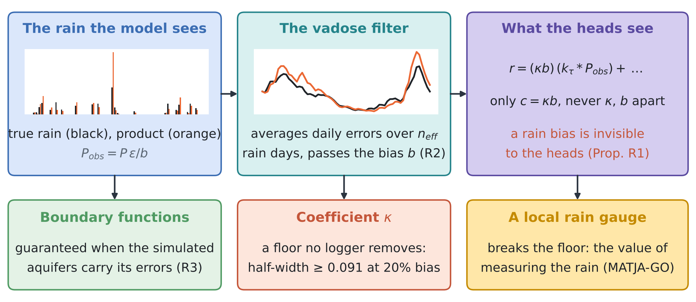
Figure 2. RESHJA-GO. The model sees a rain product with daily errors and a bias; the vadose filter averages the daily errors over a few effective rain days and passes the bias; the heads see only the product of the recharge coefficient and the bias. Bottom: what can be guaranteed. Insets: one simulated record, daily rain (true and product) and the filtered series.
4.1 The rain product and the set-up
The test bed is that of reviews I and II (D3): a 5 km section, 32 cells, 64 weekly steps, the recharge law (1) with the Erlang-2 vadose kernel $k_{τ}$ ($τ$ = 14 d) and lognormal $κ$ (median 0.35, log-sd 0.25), Gaussian random fields for the sea level, the inland inflow, the recharge error and the initial head, and the ensemble smoother with the exact solver (128 members) as reconstructor. The model now sees the rain through a product (2):
$$r\left(t\right)=κ \left(k_{τ}*P\right)\left(t\right)+e\left(t\right)$$ | (1)
$$P_{obs}\left(d\right)=\frac{P\left(d\right)}{b} ϵ\left(d\right)\text{, with }logb∼N\left(0,s_{b}^{2}\right)\text{ for the record,}$$  $$ϵ\left(d\right)\text{ independent, }E ϵ=1\text{, }Var ϵ=v\text{, day by day.}$$ | (2)
Here $s_{b}$ = 0.20 (a 20% bias of the record, typical of a gridded product at one site) and the daily errors are lognormal with log-sd 0.60 ($v$ = 0.43); a local gauge has $s_{b}$ = 0.05 and log-sd 0.10. Writing $f=k_{τ}*P$ and $f_{obs}=k_{τ}*P_{obs}$ for the weekly filtered rain, the heads respond to $r$, and
$$r=κ f+e=c f_{obs}−c δ+e\text{, with }c=κb\text{ and }δ=f_{obs}−f/b.$$ | (3)
Five settings are compared: exact (the reconstructor sees $P$, as in reviews I and II); naive (calibrated on simulated aquifers with exact rain, used where the rain comes from the product); aware (the simulated aquifers carry the product's errors, and the members' coefficient $c$ has log-sd $\sqrt{{0.25}^{2}+s_{b}^{2}}$); aware + R2 (also the filtered error $δ$ in the recharge prior, with the covariance of Proposition R2 computed from the product); and gauge (a local rain gauge). Designs: rain only, one logger (2.0 km), two (2.0 and 4.75 km), four (0.25, 1.25, 2.75, 4.25 km) and all eight sites of review II. Scores average 300 random draws of 200 calibration and 200 test aquifers from pools of 400.
4.2 Guarantees
Proposition R1 (a rain bias is invisible to the heads, and κ has a floor). Let the daily errors be absent ($ϵ≡1$). (i) For any data $y$ that do not measure rain (heads, sea level, chloride under the flow model), the likelihood depends on $κ$ and $b$ only through $c=κb$: no statistic of such data can detect $b$, and the field check of review I has power $α$ against any rain bias. (ii) If $logκ∼N\left(μ_{κ},s_{κ}^{2}\right)$ and $logb∼N\left(0,s_{b}^{2}\right)$ are independent of each other and of the other unknowns, then for every number of heads

$$Var\left(logκ∣y\right)≥s_{⋆}^{2}=\frac{s_{κ}^{2} s_{b}^{2}}{s_{κ}^{2}+s_{b}^{2}},$$ | (4)
with equality when $c$ is known exactly, so the 90% half-width of $κ$ cannot fall below about $κ_{med} sinh\left(1.645 s_{⋆}\right)$. (iii) The coefficient $c$ and the recharge function $r\left(t\right)$ are informed exactly as with exact rain, with prior log-sd $\sqrt{s_{κ}^{2}+s_{b}^{2}}$ for $c$.
Proof. Substituting (3) with $δ=0$ shows (i) and (iii). For (ii), by the law of total variance, $Var\left(logκ∣y\right)≥E\left[Var\left(logκ∣c,y\right)∣y\right]$; by (i), given $c$ the data carry no further information on $κ$, so $Var\left(logκ∣c,y\right)=Var\left(logκ∣logκ+logb\right)$, which is $s_{⋆}^{2}$ for independent Gaussians. □
With $s_{κ}$ = 0.25 and $s_{b}$ = 0.20, $s_{⋆}$ = 0.156 and the floor of the half-width is 0.091, six times the 0.023 that four loggers give with exact rain. A bias of the rain is the one error that more heads cannot repair.
Proposition R2 (what the vadose filter averages, and what it passes). Let ft=u​Kt,uPu be the weekly filtered rain, $K$ the weekly average of the Erlang-2 operator. Then $E\left[f_{obs}\left(t\right)∣P,b\right]=f\left(t\right)/b$: the bias passes untouched. Given $P$ and $b$, the filtered error $δ$ has covariance $Cov\left(δ\right)=v K diag\left(P^{2}\right) K^{⊤}/b^{2}$, and in relative terms

Varfobst∣P,bft/b2=vnefft, with nefft=u​Kt,uPu2u​Kt,u2Pu2. | (5)
For steady rain neff=1/u​Kt,u2≈4τ+1; for intermittent rain it counts the rain days inside the memory of the filter, weighted by $K P$. The covariance is estimated without bias from the product itself by $\frac{v}{1+v} K diag\left(P_{obs}^{2}\right) K^{⊤}$.
Proof. The filter is linear: fobst−ft/b=u​Kt,uPuϵu−1/b with independent zero-mean terms of variance $vP{\left(u\right)}^{2}/b^{2}$; and $E\left[P_{obs}^{2}\right]=\left(1+v\right)P^{2}/b^{2}$. □
Proposition R3 (the guarantee with a rain product). If the simulated aquifers draw the true rain, the bias and the daily errors from the error law of the product, and the reconstructor sees only $P_{obs}$ in every simulation as in the field, Propositions 1 and 2 of review I hold for $r$, $q_{L}$, $η$, $h_{0}$, $κ$ and $c$, whatever the reconstructor. If the error law is ignored, the guarantee is off by at most the total-variation distance between the residual laws with exact and with product rain (review I, Proposition 4), which T9 shows to be large.

Proof. Each simulated case (rain, bias, daily errors, unknowns, data) is an i.i.d. draw from one joint law, and the reconstructor is one fixed map of $\left(P_{obs},y\right)$; apply exchangeability as in review I. □
What is new. (1) The non-identifiability of the recharge coefficient under a rain bias, with the exact floor (4), and the fact that no check made with heads can detect the bias (Proposition R1). (2) The exact law of how the unsaturated zone averages daily rain errors, with the effective number of rain days $n_{eff}$ and a covariance computable from the product alone, used as a prior for the recharge error (Proposition R2). (3) Finite-sample guarantees for every boundary function when the rain is known only through a product, and the measured cost of ignoring the product's errors (Proposition R3, T9). To our knowledge, none of these appears in the sixty papers of reviews I–III.

4.3 Tests
T9: coverage. Figure 3 and Table 2. With exact rain every guarantee holds. Calibrated as if the product were exact, the guarantees collapse as soon as there are heads: the band of $κ$ misses in 0.70–0.76 of the cases (coverage 0.24–0.30), the whole-function coverage of the recharge is 0.02–0.21, of the inflow 0.49–0.82 and of the sea level 0.72–0.76. The heads make the reconstructor confident about the wrong forcing, so more loggers make it worse, not better. With the product's errors in the simulated aquifers (aware, aware + R2) and with a local gauge, every guarantee holds again: share of weeks outside 0.093–0.103, coverage 0.90.
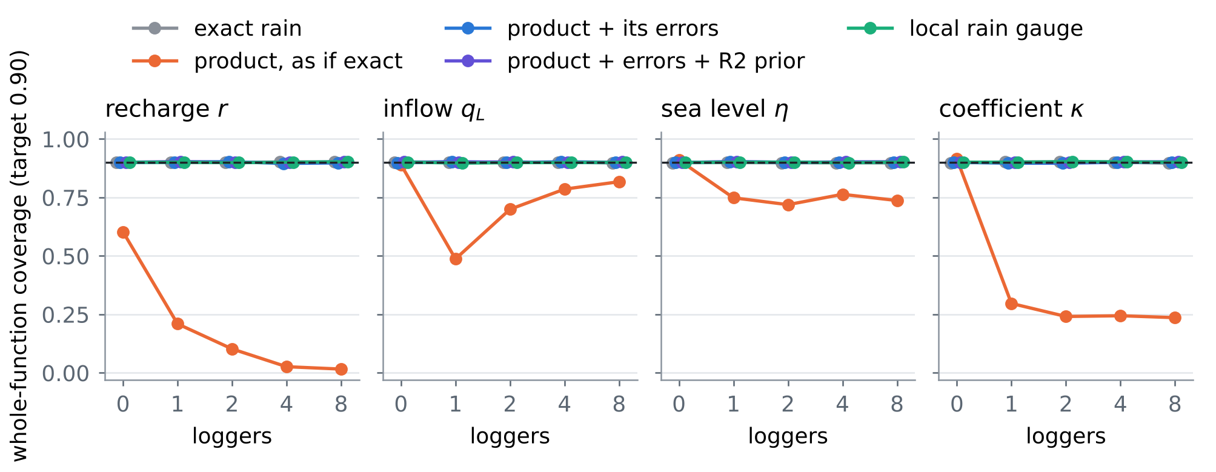
Figure 3. T9: whole-function coverage of the 90% bands against the number of loggers, for the five rain settings (dashed: target).
Table 2. T9: guaranteed 90% half-width / whole-function coverage (bold: coverage below 0.85). Units: recharge mm/d, inflow m²/d, sea level m, κ dimensionless.
Setting | Design | Recharge r | Inflow qL | Sea level η | Coefficient κ
exact rain | rain only | 0.579 / 0.90 | 0.927 / 0.90 | 0.188 / 0.90 | 0.151 / 0.90
 | 2 loggers | 0.086 / 0.90 | 0.105 / 0.90 | 0.208 / 0.90 | 0.023 / 0.90
 | 8 loggers | 0.041 / 0.90 | 0.038 / 0.90 | 0.036 / 0.90 | 0.023 / 0.90
naive | rain only | 0.608 / 0.60 | 0.927 / 0.89 | 0.188 / 0.91 | 0.151 / 0.91
 | 2 loggers | 0.086 / 0.10 | 0.105 / 0.70 | 0.207 / 0.72 | 0.022 / 0.24
 | 8 loggers | 0.041 / 0.02 | 0.038 / 0.82 | 0.036 / 0.74 | 0.023 / 0.24
aware | rain only | 0.861 / 0.90 | 0.966 / 0.90 | 0.192 / 0.90 | 0.143 / 0.90
 | 2 loggers | 0.152 / 0.90 | 0.132 / 0.90 | 0.253 / 0.90 | 0.108 / 0.90
 | 8 loggers | 0.104 / 0.90 | 0.041 / 0.90 | 0.040 / 0.90 | 0.104 / 0.90
aware + R2 | rain only | 0.880 / 0.90 | 0.968 / 0.90 | 0.192 / 0.90 | 0.146 / 0.90
 | 2 loggers | 0.114 / 0.90 | 0.108 / 0.90 | 0.212 / 0.90 | 0.107 / 0.90
 | 8 loggers | 0.069 / 0.90 | 0.039 / 0.90 | 0.037 / 0.90 | 0.108 / 0.90
gauge | rain only | 0.562 / 0.90 | 0.947 / 0.90 | 0.189 / 0.90 | 0.142 / 0.90
 | 2 loggers | 0.087 / 0.90 | 0.105 / 0.90 | 0.204 / 0.90 | 0.044 / 0.90
 | 8 loggers | 0.044 / 0.90 | 0.037 / 0.90 | 0.035 / 0.90 | 0.043 / 0.90

T10: the floor of κ and the value of a rain gauge. Figure 4. With the product the guaranteed half-width of $κ$ goes from 0.146 with rain only to 0.108 with eight loggers and approaches the floor 0.091 of Proposition R1 (the floor bounds the exact posterior; the guaranteed band of a finite ensemble sits a little above it), while the coefficient the heads can see, $c=κb$, shrinks to 0.028, as with exact rain (0.023). A local gauge, with its 5% bias, lowers the floor and gives $κ$ to 0.043. For the recharge the product costs a factor 2.5 in guaranteed width with eight loggers (0.104 against 0.041 mm/d); the R2 prior recovers part of it (0.069; with one logger it also cuts the inflow band from 1.41 to 0.93 m²/d), the gauge almost all (0.044). At equal numbers of loggers the gauge gives the narrower band for every goal, and for $κ$ the product with eight loggers does not reach what the gauge gives with one (0.045).
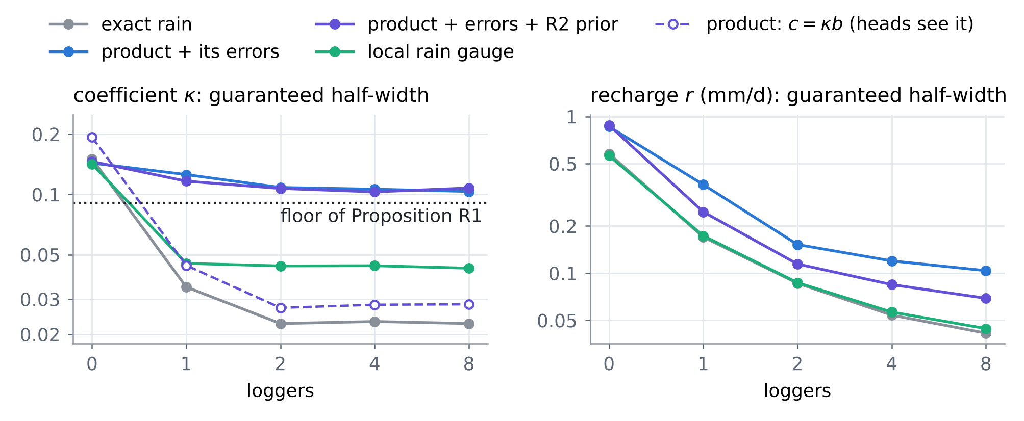
Figure 4. T10: guaranteed 90% half-width of $κ$ (left) and of the recharge (right) against the number of loggers; dotted, the floor of Proposition R1; dashed, the coefficient $c=κb$ that the heads see.
T11: the filter law. Figure 5. For 300 rain records of the rain law, the variance of the weekly filtered error measured over 200 draws of daily errors matches $v/n_{eff}$ with a median relative difference of 4.1% (largest 20.4%, Monte Carlo error). The effective number of rain days averages 5.7 (4.4–7.3 over the records), far from the 57 of steady rain: rain comes in few events, so the unsaturated zone averages few errors. A product with daily relative error 66% leaves about 28% in the weekly forcing; its bias stays whole.
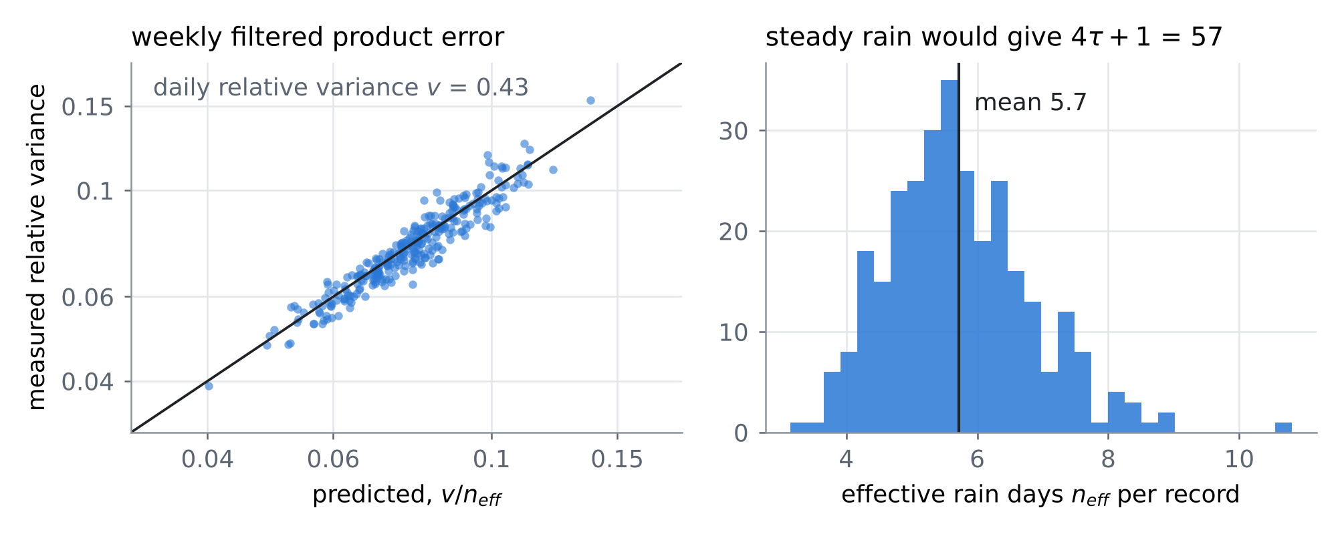
Figure 5. T11: left, measured against predicted relative variance of the weekly filtered product error, one point per rain record; right, the effective number of rain days $n_{eff}$ of Proposition R2.
4.4 What to do when the only rain is a product
• Never calibrate as if the product were exact. With heads, every guarantee collapses (T9).
• Put the product's error law in the simulated aquifers (Proposition R3), and the filtered-error covariance of Proposition R2 in the recharge prior; both need only the product and an estimate of its bias and daily skill.
• Report $c=κb$, not $κ$, unless the rain is measured on site: $κ$ alone has the floor (4) whatever the number of heads, and a rain bias is invisible to every head-based check.
• Buy a rain gauge first. In T10 a gauge and one logger give $κ$ more narrowly than the product with eight loggers, and at equal loggers the gauge gives the narrower band for every goal; with MATJA-GO (review II) its value is computed like that of any instrument.
• For Fushë-Kuqe, estimate $s_{b}$ and $v$ by comparing the product (ERA5-Land, E-OBS or IMERG) with the nearest station over the common period: to be computed with the station record.
5. Synthesis: sixty papers in one procedure
Table 3 places the sixty papers of reviews I–III on the steps of the procedure (review I, Section 5.2). Card numbers carry the review: I-O1 is card O1 of review I, III-C2 card C2 of this review. The reading is simple: reviews I and II are strong on inversion, guarantees and design; this review fills the first step, the prior from the rain, which every guarantee depends on.
Table 3. The sixty papers of reviews I–III against the steps of the procedure (a paper can serve several steps).
Step | Review I | Review II | Review III
prior from rain | I-O3, I-O5, I-C5, I-M1 | II-O1, II-O2, II-O5, II-C1, II-C2, II-C3, II-C4, II-B1, II-B4, II-M2, II-M5 | III-O1, III-O2, III-O3, III-O4, III-O5, III-C1, III-C2, III-C3, III-C4, III-C5, III-B1, III-B2, III-B3, III-B4, III-B5, III-M1, III-M2, III-M3
emulate | I-O1, I-O3, I-C1, I-B1 | II-C1, II-B5, II-M2 | III-C3, III-M4
invert | I-O1, I-O2, I-C2, I-C3, I-C4, I-B1 | II-O1, II-O2, II-O4, II-C4 | III-B1
guarantee | I-O4, I-C1, I-B2, I-B3, I-B5, I-M2, I-M3 | II-O2, II-M1, II-M4 | III-C2, III-B5, III-M5
field check | I-B2, I-B4, I-M4, I-M5 | II-C3, II-B1, II-B2, II-M3, II-M4 | III-O2, III-O4, III-C4, III-C5, III-B2, III-M1, III-M2, III-M4, III-M5
design, operate | I-O5, I-C5, I-M4 | II-O3, II-O4, II-C1, II-C2, II-C3, II-C5, II-B2, II-B3, II-B4, II-M1, II-M3 | III-C1, III-B4, III-M3

Order of work for a site known only through a rain product. (1) Estimate the product's bias and daily skill against any station, and build the simulated aquifers with them (RESHJA-GO). (2) Calibrate the guaranteed bands on those aquifers (GARANCIA-GO). (3) Choose the next instrument by the guaranteed width it removes, the rain gauge among the candidates (MATJA-GO). (4) Recalibrate the chosen design on fresh aquifers, and check the prior against the field with the heads, knowing that a rain bias will not show.
Three tools of the earlier reviews carry over unchanged: weighted conformal prediction when the rain law of the calibration and of the field drift apart (S1), risk-controlling sets for a guarantee per calibration set (S2), and ensemble Kalman methods as the reconstructor that the simulated aquifers calibrate (S3).
6. Limitations
• Every card is partly verified: landing pages were reached through search results only and no full text was read.
• The rain-error law is simple: one bias for the record and independent daily errors. Real products also have timing errors, missed and false events and errors that depend on intensity; the guarantee of Proposition R3 holds for whatever law is simulated, so the law must be estimated, not assumed.
• Proposition R1 is exact without daily errors; with them the floor holds approximately (T10).
• The test bed is linear and one-dimensional, as in reviews I and II.
References
Anchors (provided by the user)
[A1] Angelopoulos, A. N., Bates, S., Fisch, A., Lei, L., & Schuster, T. (2024). Conformal risk control. The Twelfth International Conference on Learning Representations (ICLR 2024). arXiv:2208.02814 (PDF provided by the user). https://arxiv.org/abs/2208.02814
[A2] Tibshirani, R. (2023). Conformal prediction. Lecture notes, Advanced Topics in Statistical Learning, Spring 2023, University of California, Berkeley (PDF provided by the user). https://www.stat.berkeley.edu/~ryantibs/statlearn-s23/
The twenty papers of this review
[O1] Solomon H. Gebrechorkos et al. (with Dadson, Slater and Wortmann; the full author list and the other given names were not confirmed) (2024). Global-scale evaluation of precipitation datasets for hydrological modelling. Hydrology and Earth System Sciences 28(14), 3099–3118 (2024). https://doi.org/10.5194/hess-28-3099-2024
[O2] Ather Abbas, Yuan Yang, Ming Pan, et al. (16 authors, with Solomon H. Gebrechorkos and Hylke E. Beck; author list from the preprint) (2026). Comprehensive global assessment of 24 gridded precipitation datasets across 18 428 catchments using hydrological modeling. Hydrology and Earth System Sciences 30(11), 3399–3423 (2026). https://doi.org/10.5194/hess-30-3399-2026
[O3] Xuetong Wang, Raied S. Alharbi, Oscar M. Baez-Villanueva, et al. (15 authors, with Solomon H. Gebrechorkos and Hylke E. Beck) (2026). MSWEP V3: machine learning-powered global precipitation estimates at 0.1° hourly resolution (1979–present). arXiv:2602.01436 (preprint, February 2026). https://arxiv.org/abs/2602.01436
[O4] Anderson, Brunner, Slater and Dadson (given names not confirmed) (2024). Elasticity curves describe streamflow sensitivity to precipitation across the entire flow distribution. Hydrology and Earth System Sciences 28(7), 1567–1583 (2024). https://doi.org/10.5194/hess-28-1567-2024
[O5] L. C. Auton, M. P. Dalwadi, I. M. Griffiths (initials as on the authors' 2022 companion paper) (2024). A homogenised model for dispersive transport and sorption in a heterogeneous porous medium. arXiv:2410.11519 (2024); manuscript under review. https://arxiv.org/abs/2410.11519
[C1] Donald W. Vasco, Kyra H. Kim, Tom G. Farr, J. T. Reager, David Bekaert, Simran S. Sangha, Jonny Rutqvist, Hiroko K. Beaudoing (2022). Using Sentinel-1 and GRACE satellite data to monitor the hydrological variations within the Tulare Basin, California. Scientific Reports 12, 3867 (2022). https://doi.org/10.1038/s41598-022-07650-1
[C2] Elias C. Massoud, H. Lee, P. Gibson, P. Loikith, D. Waliser (2020). Bayesian model averaging of climate model projections constrained by precipitation observations over the contiguous United States. Journal of Hydrometeorology 21(10), 2401–2418 (2020; volume and pages from a repository record). https://doi.org/10.1175/JHM-D-19-0258.1
[C3] Zhong Yi Wan, Ricardo Baptista, Anudhyan Boral, Yi-Fan Chen, John Anderson, Fei Sha, Leonardo Zepeda-Núñez (2023). Debias coarsely, sample conditionally: statistical downscaling through optimal transport and probabilistic diffusion models. Advances in Neural Information Processing Systems 36 (NeurIPS 2023); arXiv:2305.15618. https://proceedings.neurips.cc/paper_files/paper/2023/hash/94d13c2401fe119e57ba325b6fe526e0-Abstract.html
[C4] F. Joseph Turk, S. E. Ringerud, Y. You, A. Camplani, D. Casella, et al. (12 authors, with C. Prigent and C. Peters-Lidard) (2021). Adapting passive microwave-based precipitation algorithms to variable microwave land surface emissivity to improve precipitation estimation from the GPM constellation. Journal of Hydrometeorology 22(7), 1755–1781 (2021). https://doi.org/10.1175/JHM-D-20-0296.1
[C5] Matthew Rodell, John T. Reager (2023). Water cycle science enabled by the GRACE and GRACE-FO satellite missions. Nature Water 1, 47–59 (2023). https://doi.org/10.1038/s44221-022-00005-0
[B1] Fadji Z. Maina, Erica R. Siirila-Woodburn, Pouya Vahmani (2020). Sensitivity of meteorological-forcing resolution on hydrologic variables. Hydrology and Earth System Sciences 24(7), 3451–3474 (2020). https://doi.org/10.5194/hess-24-3451-2020
[B2] David W. Pierce, Lu Su, Daniel R. Cayan, Mark D. Risser, Ben Livneh, Dennis P. Lettenmaier (2021). An extreme-preserving long-term gridded daily precipitation dataset for the conterminous United States. Journal of Hydrometeorology 22(7), 1883–1895 (2021). https://doi.org/10.1175/JHM-D-20-0212.1
[B3] Erica R. Siirila-Woodburn, P. James Dennedy-Frank, Alan Rhoades, Pouya Vahmani, Fadji Maina, Benjamin Hatchett, Yang Zhou, Andrew Jones (2023). The role of atmospheric rivers on groundwater: lessons learned from an extreme wet year. Water Resources Research 59(6), e2022WR033061 (2023). https://doi.org/10.1029/2022WR033061
[B4] X. Yu, Z. Xu, D. Moraetis, N. P. Nikolaidis, F. W. Schwartz, Y. Zhang, L. Shu, C. J. Duffy, B. Liu (2021). Capturing hotspots of fresh submarine groundwater discharge using a coupled surface–subsurface model. Journal of Hydrology 598, 126356 (2021). https://doi.org/10.1016/j.jhydrol.2021.126356
[B5] Nicholas E. Thiros, Erica R. Siirila-Woodburn, P. James Dennedy-Frank, Kenneth H. Williams, W. Payton Gardner (2023). Constraining bedrock groundwater residence times in a mountain system with environmental tracer observations and Bayesian uncertainty quantification. Water Resources Research 59, e2022WR033282 (2023). https://doi.org/10.1029/2022WR033282
[M1] Anamitra Saha, Sai Ravela (2024). Statistical-physical adversarial learning from data and models for downscaling rainfall extremes. Journal of Advances in Modeling Earth Systems (2024; volume and article number not confirmed). https://doi.org/10.1029/2023MS003860
[M2] Alexandre Tuel, Paul A. O'Gorman, Elfatih A. B. Eltahir (2021). Elements of the dynamical response to climate change over the Mediterranean. Journal of Climate 34(3), 1135– (2021; end page not confirmed). https://doi.org/10.1175/JCLI-D-20-0429.1
[M3] Alexandre Tuel, Kang, Elfatih A. B. Eltahir (the second author's given name was not seen) (2021). Understanding climate change over the southwestern Mediterranean using high-resolution simulations. Climate Dynamics (published online 2020; volume, pages and DOI not confirmed). https://dspace.mit.edu/handle/1721.1/129749
[M4] Björn Lütjens, R. Ferrari, D. Watson-Parris, N. E. Selin (2025). The impact of internal variability on benchmarking deep learning climate emulators. Journal of Advances in Modeling Earth Systems 17, e2024MS004619 (2025); arXiv:2408.05288. https://dspace.mit.edu/handle/1721.1/163594
[M5] B. Flemisch, J. M. Nordbotten, M. Fernø, R. Juanes, et al. (full author list not confirmed) (2023). The FluidFlower validation benchmark study for the storage of CO₂. Transport in Porous Media 151(5), 865–912 (2024; online 2023). https://doi.org/10.1007/s11242-023-01977-7
Linked in the text (first review, earlier work and the field)
[S1] Barber, R. F., Candès, E. J., Ramdas, A., & Tibshirani, R. J. (2023). Conformal prediction beyond exchangeability. Annals of Statistics 51(2), 816–845. https://doi.org/10.1214/23-AOS2276
[S2] Bates, S., Angelopoulos, A., Lei, L., Malik, J., & Jordan, M. I. (2021). Distribution-free, risk-controlling prediction sets. Journal of the ACM 68(6), Article 43, 1–34. https://doi.org/10.1145/3478535
[S3] Calvello, E., Reich, S., & Stuart, A. M. (2025). Ensemble Kalman methods: a mean-field perspective. Acta Numerica 34, 123–291. https://doi.org/10.1017/S0962492924000060
Data and project documents
[D1] Zeqiraj, D. (2026). Inputs, dispersion and boundary conditions from rain alone: twenty papers and GARANCIA-GO ("review I"). docs/literature/Literature_review_Inputs_Dispersion_Boundary_Conditions_from_Rain_Oxford_Caltech_Berkeley_MIT_2020-2026.docx in this repository.
[D2] Zeqiraj, D. (2026). State of the art II: inputs, dispersion and boundary conditions from rain; MATJA-GO, the guaranteed value of a measurement ("review II"). docs/literature/Literature_review_State_of_the_Art_II_Inputs_Dispersion_Boundary_Conditions_from_Rain_MATJA-GO_Oxford_Caltech_Berkeley_MIT_2020-2026.docx in this repository.
[D3] Internal documents of the project: RINDËRTIMI-GO (test bed, ensemble smoother with the exact solver); SHIU-GO (rain law, Erlang-2 vadose filter); the code of this review in experiments/reshja_go/.
Verification note. The bibliographic data of the twenty cards come from search results that quote the publisher, arXiv, proceedings or repository pages; doi.org, arxiv.org, openreview.net and most publisher hosts could not be opened directly in this environment. The anchors were read from the PDFs provided. Every number of Sections 1, 2 and 4 is computed by the code in experiments/reshja_go/, experiments/matja_go/ and experiments/garancia_go/.

