TRANSFER · ROUTE R1 · A MODEL THAT CAN TRAVEL
One operator for every coastal aquifer: certify, assimilate, watch
CLASSICAL rebuild and recalibrate the model at every site
NEW one operator · a certificate · the certificate as model error

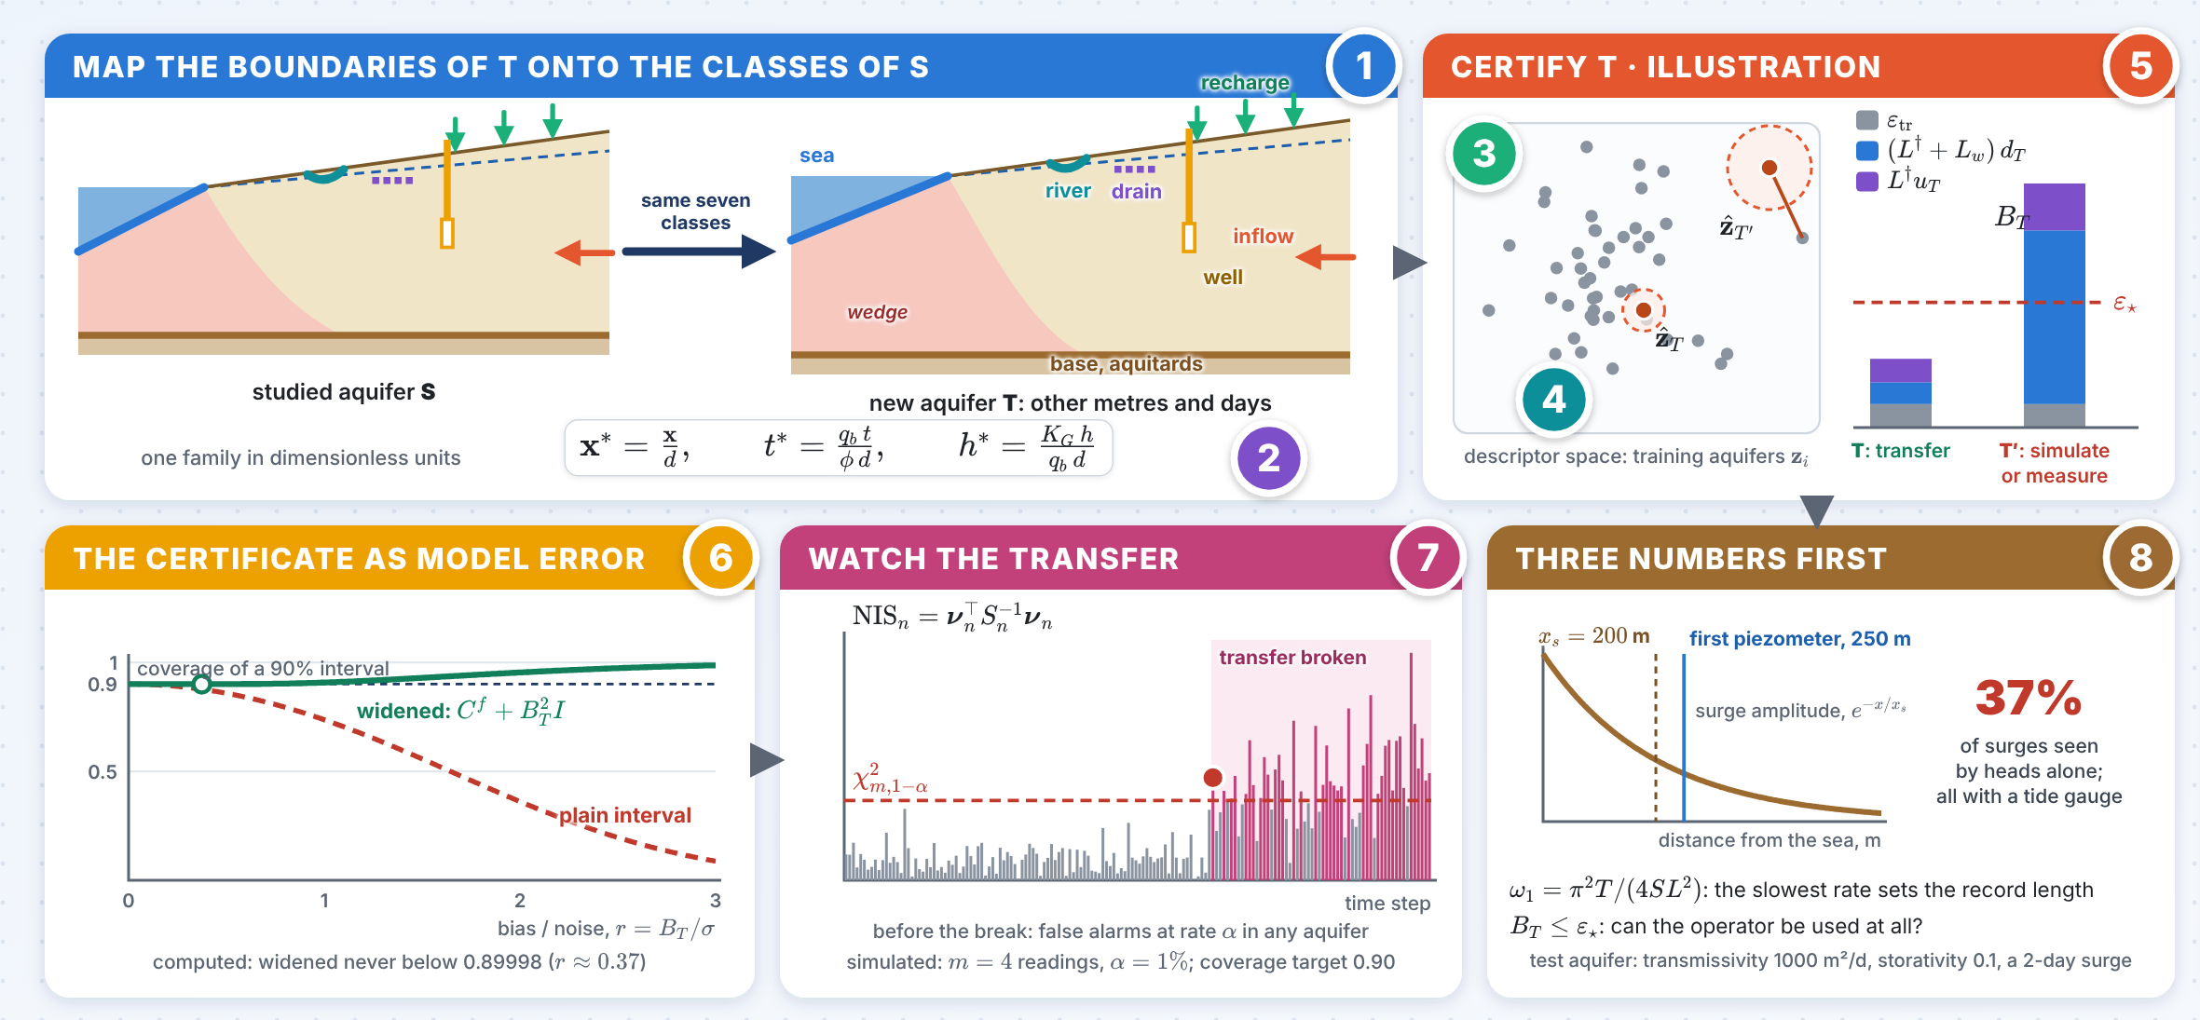
The numbers 1–8 in the picture point to the eight panels on the next pages; the innovation follows on the next page.

INNOVATION The certificate becomes model error
Not a yes or a no: the certificate enters the filter of the new aquifer, narrows with every datum and is watched.
1 A certificate the filter can use
$$C^{f} ← C^{f}+B_{T}^{2}I, B_{T}=ε_{tr}+\left(L^{†}+L_{w}\right) d_{T}+L^{†}u_{T}$$
For a Gaussian forecast with bias within $B_{T}$, the widened 90% interval covers the truth with probability at least 89.99% for every bias-to-noise ratio (minimum 0.89998 at $r≈0.37$).
≥ 89.99% coverage, any bias
2 The descriptor is a state
$$X_{T}=\left(v, b, γ, {\hat{z}}_{T}\right) ⇒ u_{T}↓ ⇒ B_{T}↓$$
Every datum of T updates ${\hat{z}}_{T}$ with the rest of the state, so the certificate narrows as the record grows.
$B_{T}$ ↓ with every datum
3 Three numbers before using the model
$$x_{s}=\sqrt{2Tτ/S}, ω_{1}=π^{2}T/\left(4SL^{2}\right), B_{T}≤ε_{⋆}$$
In the test aquifer of the assimilation note (transmissivity 1000 m²/d, storativity 0.1, a 2-day surge) $x_{s}=200$ m, short of the first piezometer at 250 m: heads alone recognised only 37% of the surges, a tide gauge all of them.
37% surges seen by heads
R1 stops at a boundary of T with no class, and near a change of regime (small $a$).

One operator for every coastal aquifer · panels 1–4
1 Map the boundaries of T  IDEA Every boundary of the new aquifer must fall into one of the seven classes: sea, recharge, rivers, drains, inland inflow, base with aquitards, wells.  $$∂Ω_{T}=Γ_{sea}∪Γ_{top}∪Γ_{riv}∪Γ_{drn}∪Γ_{in}∪Γ_{base}∪Γ_{w}$$  $$h_{f}=\frac{ρ_{s}}{ρ_{f}} η\left(t\right)−\frac{ρ_{s}−ρ_{f}}{ρ_{f}} z \text{on} Γ_{sea}$$  CHECK AT T A boundary with no class (a karst conduit, a tidal river, a sealing fault) means the family does not cover T: add that class to the simulations first. Rivers and drains are monotone switches, such as $q_{d}=−C_{d}{\left(h−z_{d}\right)}_{\text{+}}$, stable in any aquifer. |  | 2 Make the problem dimensionless  IDEA Scale by thickness $d$, inflow from land $q_{b}$ and conductivity $K_{G}$: aquifers in other metres and days become one family.  $$x^{⋆}=\frac{x}{d}, t^{⋆}=\frac{q_{b} t}{ϕ d}, h^{⋆}=\frac{K_{G} h}{q_{b} d}$$  $$a=\frac{q_{b}ρ_{0}}{K_{G}Δρ}, b=\frac{D_{m}ϕ}{q_{b}d}, s=\frac{S_{s}q_{b}d}{ϕK_{G}}$$  IN PRACTICE Groups of Abarca, Carrera, Sánchez-Vila & Dentz (2007, Advances in Water Resources), with $r_{K}=K_{z}/K_{x}$ and $ξ=L/d$; $s$: storage number, for tides, surges and pumping.
3 One point per aquifer  IDEA An aquifer becomes one point: its dimensionless groups and its log-conductivity in Karhunen–Loève coordinates.  z=θ, Y⋆, Y⋆=lnKxKG=k​ζk ψkx⋆  $$θ=\left(a, b, r_{K}, ξ, α_{L}/d, α_{T}/d, σ_{Y}^{2}, λ/d, s\right)$$  IN PRACTICE The operator maps a descriptor to the salinity field, $G^{†}:z↦c\left(x^{⋆},t^{⋆}\right)$. Aquifers that differ in metres and days can share $θ$; with the same geometry and boundary classes the transfer is then exact. |  | 4 Learn the operator once  IDEA Train one neural operator on simulations; keep its training error and local Lipschitz constants.  $$ε_{tr}=\max_{i}∥G^{†}\left(z_{i}\right)−G_{w}\left(z_{i}\right)∥, N≈C d_{eff}^{ 1+4α}log\frac{1}{δ}$$  $$L^{†}≈\max_{i,j \text{near} z}\frac{∥G^{†}\left(z_{i}\right)−G^{†}\left(z_{j}\right)∥}{∥z_{i}−z_{j}∥_{Z}}$$  IN PRACTICE A Fourier neural operator (Li et al. 2021, ICLR) or DeepONet (Lu, Jin, Pang, Zhang & Karniadakis 2021, Nature Machine Intelligence). $d_{eff}$: PCA dimension of the simulated fields; $N$ is a starting point, the learning curve decides.

One operator for every coastal aquifer · panels 5–8
5 Place T and certify  IDEA Estimate the descriptor of T from its data, measure its distance to the training aquifers and bound the error of the transferred model.  $$d_{T}=\min_{i}∥{\hat{z}}_{T}−z_{i}∥_{Z}, u_{T}=∥z_{T}−{\hat{z}}_{T}∥_{Z}$$  $$∥G^{†}\left(z_{T}\right)−G_{w}\left({\hat{z}}_{T}\right)∥≤B_{T}=ε_{tr}+\left(L^{†}+L_{w}\right)d_{T}+L^{†}u_{T}$$  DECISION $B_{T}≤ε_{⋆}$: transfer. Otherwise add simulations near ${\hat{z}}_{T}$, or measure the group $j$ with the largest $L_{j}^{†}u_{T,j}$. $L^{†}$ is large near a change of regime (small $a$: the toe moves fast inland); there the transfer is risky. |  | 6 Assimilate at T  IDEA The descriptor joins the state of the filter, and the certificate becomes model error.  $$X_{T}=\left(v, b, γ, {\hat{z}}_{T}\right), C^{f}←C^{f}+B_{T}^{2}I$$  $$X^{a}=X^{f}+C^{Xy}(C^{yy}+Γ)^{−1}\left(y+e−Y\right)$$  IN PRACTICE Every datum of T shrinks $u_{T}$ and with it $B_{T}$. Boundary priors, regimes (normal, surge, drought, flood) and the initial state are re-learned at T.
7 Watch the transfer  IDEA While the model runs at T, an alarm and a coverage count say whether the transfer still holds.  $${NIS}_{n}=ν_{n}^{⊤}S_{n}^{−1}ν_{n}>χ_{m,1−α}^{2} \text{under every regime}$$  $$\frac{1}{M}\sum_{j=1}^{M}{1}\left\{\left|x_{j}−{\hat{x}}_{j}\right|≤1.645 {\hat{σ}}_{j}\right\}≈0.90$$  CHECK AT T False alarms occur at exactly the rate $α$ in any aquifer (the assimilation note). An alarm under every regime, or a drop in coverage on twins of T: the transfer is broken; certify again with the updated ${\hat{z}}_{T}$, or add a regime or a closure. |  | 8 Carried over, rescaled, re-learned  IDEA Each boundary keeps its type of condition, is rescaled into the units of T and re-learned from its records.  $$η^{⋆}=\frac{K_{G}η}{q_{b}d}, R^{⋆}=\frac{R}{q_{b}}, Q^{⋆}=\frac{Q}{q_{b}d^{2}}, τ^{⋆}=\frac{q_{b}τ}{ϕd}$$  $$x_{s}=\sqrt{2Tτ/S}, ω_{1}=π^{2}T/\left(4SL^{2}\right)$$  CHECK AT T $T$, $S$: transmissivity, storativity. A boundary event decays inland over $x_{s}$ (Ferris 1951); a first piezometer beyond $x_{s}$ misses it: add a tide gauge. $ω_{1}$ sets the record length; mode $j$ is learnt within $t≈1/\left(2ω_{j}\right)$.

