TRANSFER · ROUTE R2 · A SHARED REPRESENTATION
A new aquifer from a few wells: one shared basis, the many give the prior
CLASSICAL calibrate each aquifer alone, from its own long records
NEW one basis for many aquifers · a few wells · the prior from the many

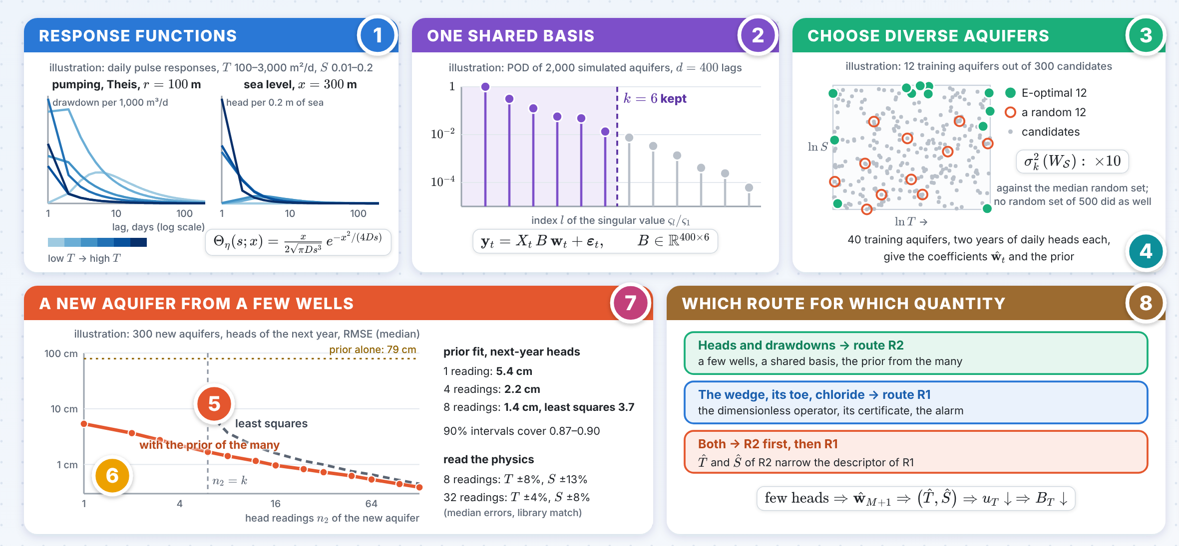
The numbers 1–8 in the picture point to the eight panels on the next pages; the innovation follows on the next page.

INNOVATION The many give the prior
The training aquifers become the prior of a new one: a few head readings give its heads, $T$ and $S$.
1 A prior from the many, honest with few readings
$$C_{w}=(Σ_{W}^{−1}+\frac{1}{σ^{2}}{\hat{B}}^{⊤}X^{⊤}X\hat{B})^{−1}, m_{w}=C_{w}\left(Σ_{W}^{−1}\overline{w}+\frac{1}{σ^{2}}{\hat{B}}^{⊤}X^{⊤}y\right)$$
Exact when the basis is known; with fewer than $k$ readings the intervals stay honest, only wider. Illustration ($k=6$): next-year heads to 2.2 cm from four readings, where least squares cannot start; 1.4 against 3.7 cm from eight; 90% intervals cover 0.87–0.90.
2.2 cm from four readings
2 A few readings give $T$ and $S$
$$\hat{p}=arg\min_{p}∥m_{w}−w\left(p\right)∥ ⇒ (\hat{T},\hat{S})_{M+1}$$
Amplitude fixes $T$, timing fixes $S/T$. Eight readings: $T$ within 8%, $S$ within 13% (medians); 32: 4% and 8%. A linear map $Ap+a$ is cruder: 26% and 36% even with exact coefficients.
±8% T from eight readings
3 Route R2 feeds route R1
$$B_{T}=ε_{tr}+\left(L^{†}+L_{w}\right)d_{T}+L^{†}u_{T}, x_{s}=\sqrt{2Tτ/S}$$
$\hat{T}$ and $\hat{S}$ narrow the descriptor uncertainty $u_{T}$ of route R1 and its certificate $B_{T}$, and set the skin distance $x_{s}$ and the slowest rate $ω_{1}$.
$u_{T}↓$ R1 certificate shrinks

A new aquifer from a few wells · panels 1–4
1 Response functions  IDEA A linear aquifer answers each forcing with a fixed response set by $T$, $S$ and the distances.  htτ=j​0∞Θjs;pt Fj,tτ−s ds  $$Θ_{Q}\left(s;r\right)=\frac{1}{4πTs}exp\left(−\frac{r^{2}S}{4Ts}\right), D=\frac{T}{S}$$  LITERATURE Pumping: the point source of Theis (1935); sea: a fixed-head boundary. Heads as sums of responses: Collenteur et al. (2019, Groundwater). |  | 2 One shared basis  IDEA Over the range of $T$ and $S$ the responses lie near a $k$-dimensional space: one basis, $k$ coefficients per aquifer.  $$Θ_{j}\left(s;p_{t}\right)≈\sum_{l=1}^{k}{w_{t,l}} b_{j,l}\left(s\right)$$  k=mink: l>k​𝜍l2≤ε2l​𝜍l2  ILLUSTRATION 2,000 simulated aquifers, $ε=0.01$: $k=6$ of $d=400$ lag weights. Then $y_{t}=X_{t}Bw_{t}+ε_{t}$, the multi-task model of Du, Hu, Kakade, Lee & Lei (2021, ICLR).
3 Choose diverse aquifers  IDEA Train on aquifers that span every direction of the basis: maximise the smallest singular value of their coefficients.  $$S^{⋆}=arg\max_{\left|S\right|=M} σ_{k}^{2}\left(W_{S}\right), W_{S}={\left[w\left(p_{t}\right)\right]}_{t∈S}$$  $$σ_{k}^{2}\left(W^{⋆}\right)≥Ω\left(\frac{M}{k}\right)$$  ILLUSTRATION E-optimal 12 of 300: $σ_{k}^{2}$ 10 times the median random set. Its basis misses $3.3×{10}^{−4}$ of the response energy (random sets: median $2.7×{10}^{−4}$, worst tenth above $1.0×{10}^{−3}$). Task diversity: Tripuraneni, Jordan & Jin (2020, NeurIPS). |  | 4 Learn the basis from all wells  IDEA All $n_{1}M$ readings of the training aquifers learn the basis together; each then needs only $k$ coefficients.  $$\left(\hat{B},\hat{W}\right)=arg\min_{B,W}\frac{1}{2n_{1}M}\sum_{t=1}^{M}{∥}y_{t}−X_{t}Bw_{t}∥^{2}$$  $$n_{1}≫ρ^{4}\left(d+log\frac{M}{δ}\right)$$  IN PRACTICE Here the basis comes from simulated responses; 40 training aquifers with two years of daily heads give ${\hat{w}}_{t}$. Meta-learning: Fallah, Mokhtari & Ozdaglar (2020, AISTATS).

A new aquifer from a few wells · panels 5–8
5 Fit the new aquifer from few wells  IDEA Only $k$ coefficients are unknown: about $k+log\left(1/δ\right)$ independent readings are needed, not $d$.  $$E\left[{ER}_{M+1}\right]≤Cσ^{2}\left(\frac{kdlog\left(κn_{1}\right)}{c n_{1}M}+\frac{k+log\left(1/δ\right)}{n_{2}}\right)$$  $$n_{eff}≈n_{2} \frac{1−ρ_{ε}}{1+ρ_{ε}}$$  ILLUSTRATION Least squares needs $n_{2}≥6$: next-year heads to 3.7 cm with 8 readings, 0.99 with 32, 0.45 with 128. Bound: Du et al. (2021); adaptive transfer: Reeve, Cannings & Samworth (2021, Annals of Statistics). |  | 6 The many give the prior  IDEA The coefficients of the training aquifers are the prior of the new one; the update is a small Bayesian fit.  $$w_{M+1}∼N\left(\overline{w},Σ_{W}\right), \overline{w}=\frac{1}{M}\sum_{t=1}^{M}{{\hat{w}}_{t}}$$  $$C_{w}=(Σ_{W}^{−1}+\frac{1}{σ^{2}}{\hat{B}}^{⊤}X^{⊤}X\hat{B})^{−1}≼Σ_{W}$$  ILLUSTRATION Exact when the basis is known; honest, only wider, with fewer than $k$ readings. Prior alone 79 cm; one reading 5.4 cm; four 2.2 cm; 90% intervals cover 0.87–0.90.
7 Read the physics, check  IDEA The fitted coefficients give $T$ and $S$ of the new site; the hold-out error and white residuals check the fit.  $$\hat{p}=arg\min_{p}∥m_{w}−w\left(p\right)∥ ⇒ \left(\hat{T},\hat{S}\right)$$  $$\text{hold-out error}\left(n_{2}\right)∝\frac{1}{n_{2}}, \text{white residuals}$$  ILLUSTRATION Matched to a library of 3,000 simulated responses: $T$ within 8%, $S$ within 13% from 8 readings. A linear map $w≈Ap+a$, as in Blanke & Lelarge (2024, ICLR), is cruder here: 26% and 36%. |  | 8 R1 and R2 together  IDEA Heads and drawdowns travel by R2; the wedge, its toe and chloride by route R1; R2 first narrows R1.  $$\text{few heads}⇒\left(\hat{T},\hat{S}\right)⇒u_{T}↓⇒B_{T}↓$$  $$B_{T}=ε_{tr}+\left(L^{†}+L_{w}\right)d_{T}+L^{†}u_{T}$$  WHERE R2 STOPS Unconfined aquifers with large drawdown, seawater intrusion and strong small-scale heterogeneity break the linear shared basis: there use route R1. Autocorrelated residuals count as fewer readings.

