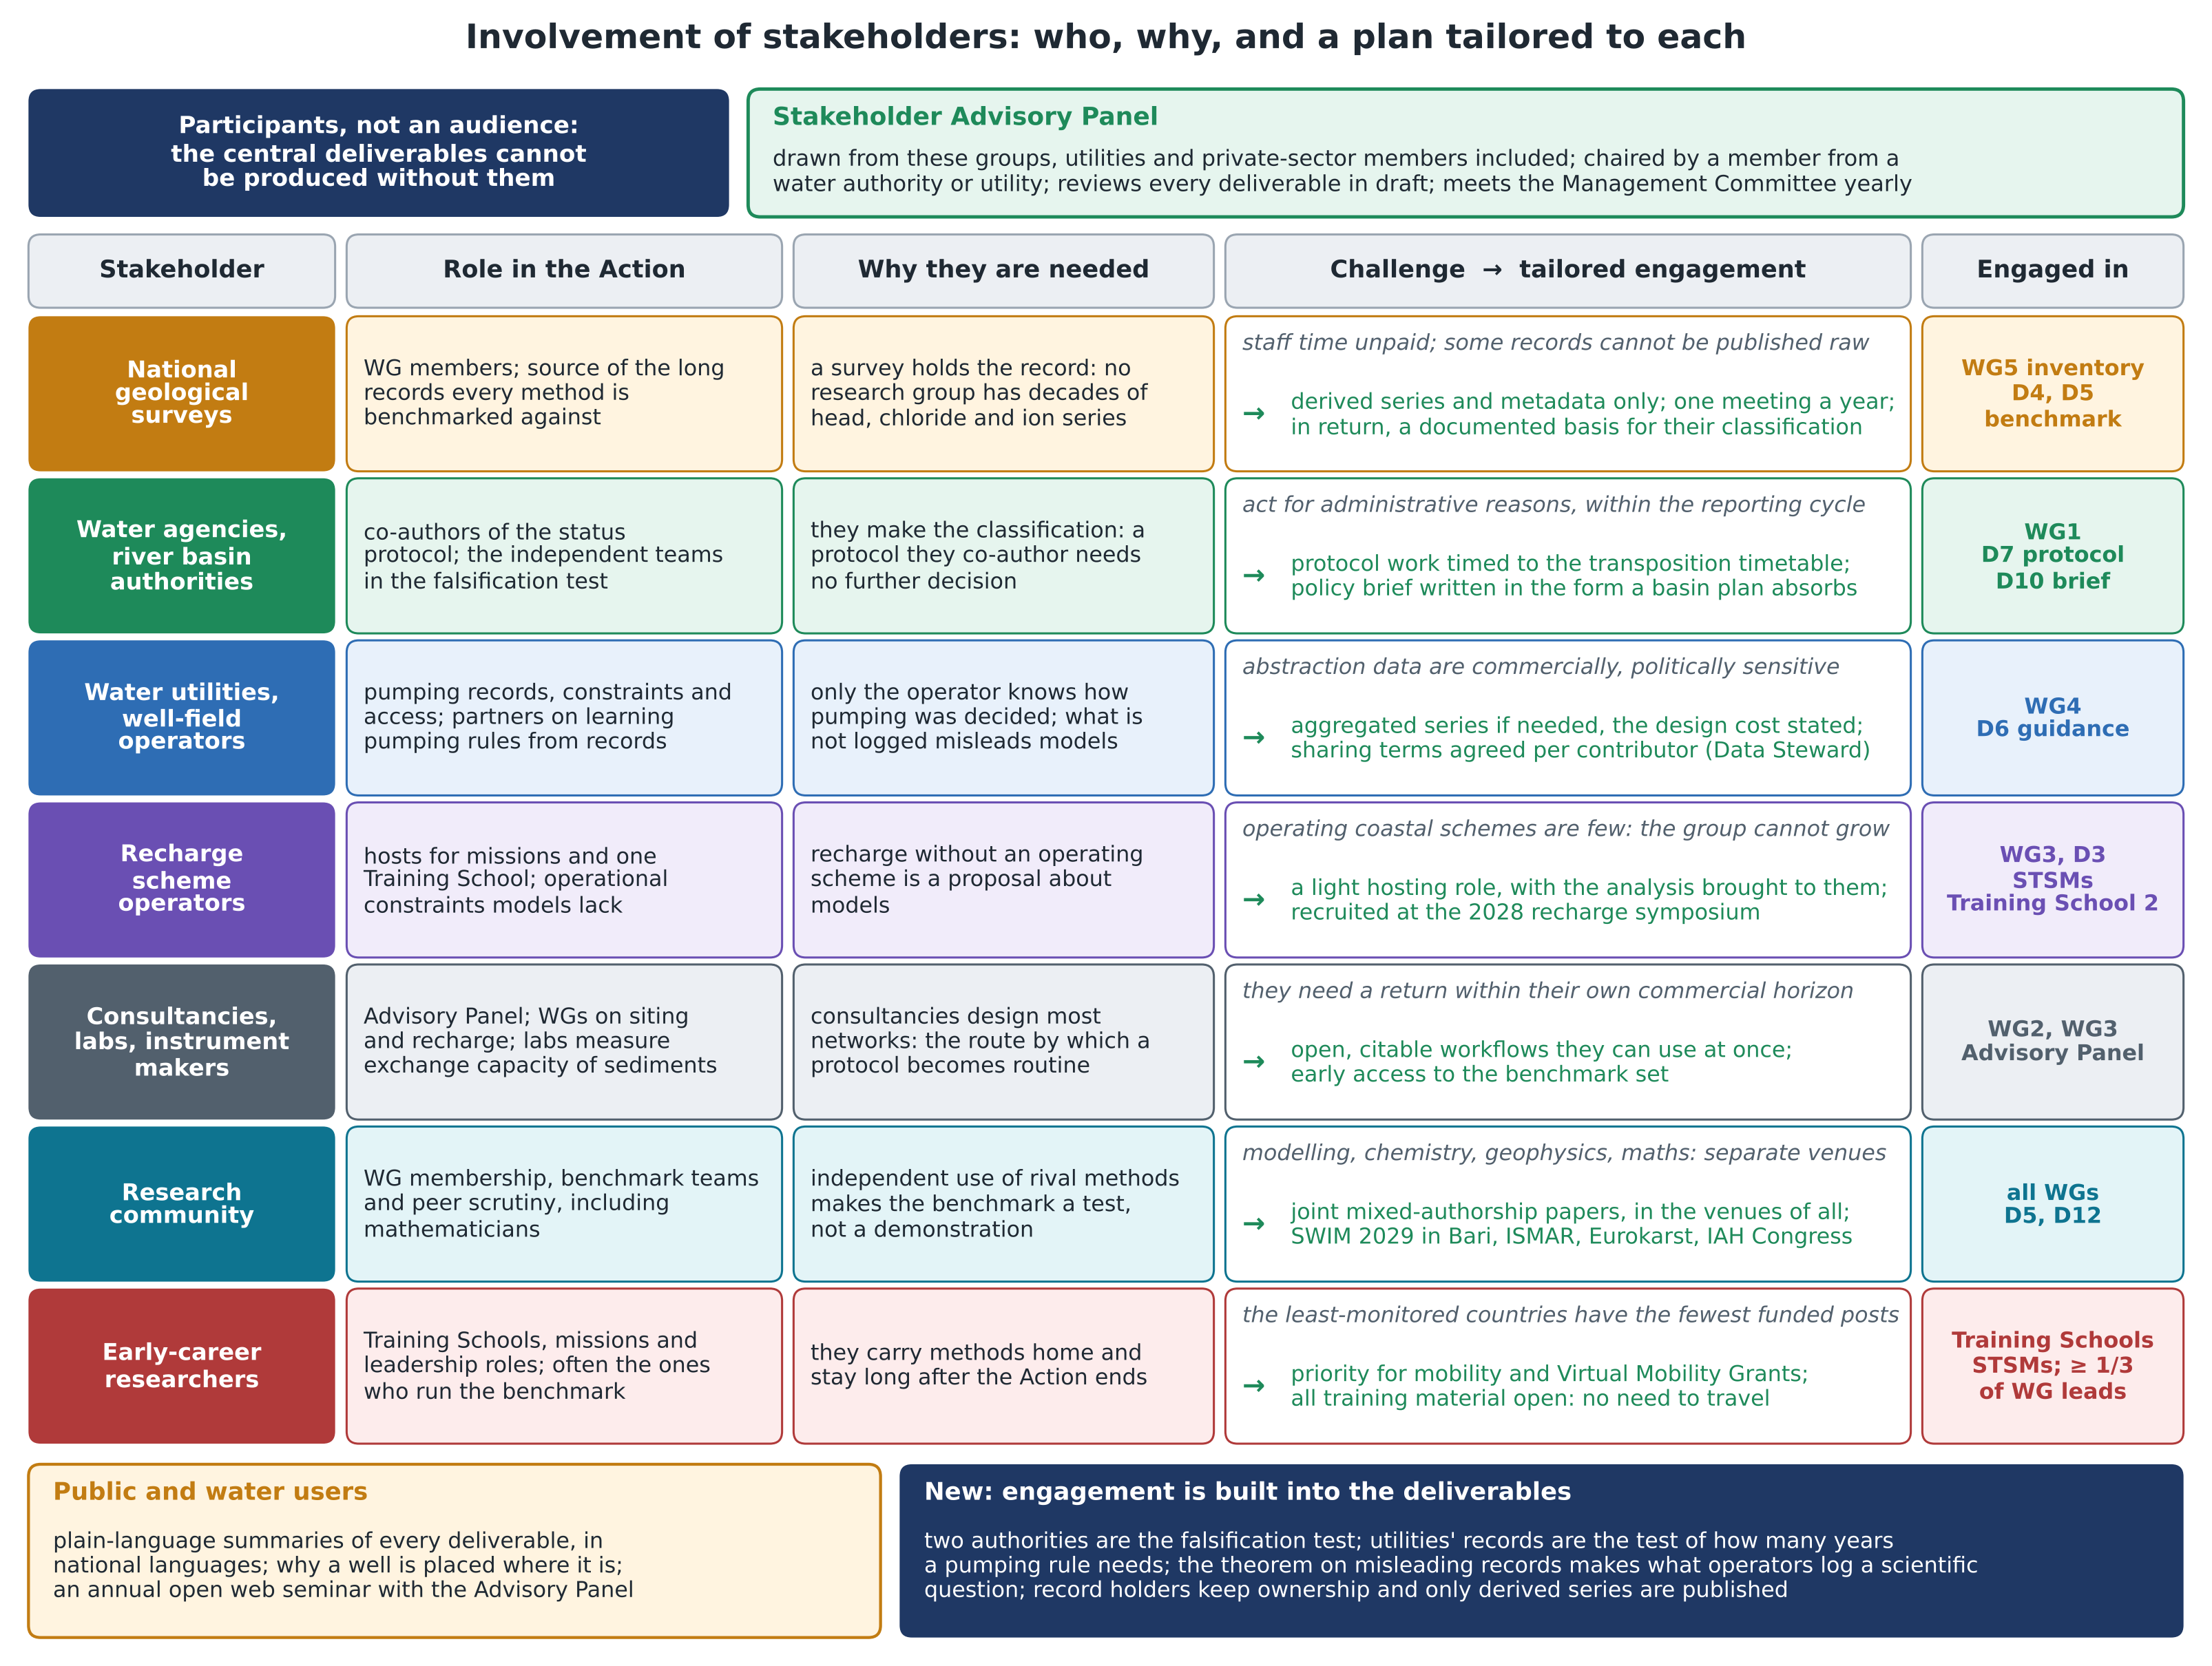
Figure. Involvement of stakeholders: the seven stakeholder groups, each with its role in the Action, why it is needed, the challenge it brings and the engagement tailored to it, and the Working Groups and deliverables in which it takes part; the Stakeholder Advisory Panel; the public and water users. Content as in annex sections 2.B and 2.C.

