State of the art IX: hidden confounders over time
The Time Series Deconfounder (Bica, Alaa & van der Schaar, ICML 2020) and its supplement, extracted; twenty papers from Oxford, Caltech, Harvard and MIT (2020–2026) on hidden confounding in time series; our analogues of its Figures 1 and 2 — who confounds the effect of pumping on salinity at Fushë-Kuqe; and FSHEHTA-GO, a deconfounder anchored in the physics of the heads
Dulian Zeqiraj · November 2026 · review with a numerically tested innovation · companion to reviews I–VIII
1. Outcome
• The article, extracted (Section 2): the problem and its three assumptions, the factor model over time and Theorem 1 with the proof of the supplement, the predictive checks, the recurrent factor model, the two outcome models (marginal structural models and recurrent marginal structural networks), all experiments of the paper and the supplement with their numbers (Table 1), and what the article leaves open.
• Twenty papers, five per institution, 2020–2026, each with links (Section 4, Figure 1), none of them a card of reviews I–VIII: substitutes and proxies for hidden confounders over time, panels with latent factors, checks and bounds, and physical attribution.
• Our analogues of Figures 1 and 2 (Section 5, Figures 2 and 3, Table 3). The treatments are the pumping rates of the $k$ wells, the outcome the salinity. The hidden multi-cause confounder is the dryness — heat and irrigation demand — which raises the pumping of every well and lowers the recharge; a hidden single-cause confounder is the crop stress of one farm, which raises one well's pumping and lowers the local recharge; the recharge is the path through which both reach the salt. Rain and past chloride are observed; the sea level causes the salinity but not the pumping, so it is not a confounder.
• Innovation: FSHEHTA-GO (Section 6). The substitute of the Time Series Deconfounder is built from the past, $Z_{t}=g\left({\overline{H}}_{t−1}\right)$, so it cannot see the fresh weekly news of a confounder. FSHEHTA-GO builds a second substitute from another measurement: the heads, with the known drawdown of the pumping added back and the head kernel removed, read the recharge — the path of every hidden cause. Proposition D1: the bias left by any history substitute does not vanish with more wells, it grows toward the unadjusted bias (0.60 in the summed effects). Proposition D2: the physics substitute restores ignorability. Proposition D3: a physics check falsifies the substitute and the single-cause assumption. Proposition D4: wrong physics leaks a bias linear in the drawdown error; the head kernel is identified by the fit.
• Numbers (T29–T32, 400 replications). Eight wells: the summed well effects (true sum 0.94) are overstated by +0.59 without adjustment, +0.56 with the learned history substitute, +0.15 with the best possible one, and 0.00 with the physics substitute (spread 0.05 against 0.32). Crop stress at one well biases its effect by +97% with the history substitute and +7% with the physics one. The physics check has size 6.0% and power 99–100%; the article's predictive check stays at p = 0.49–0.55 in every scenario.
• Text for the proposal (Section 3, Table 2) and a plan for Fushë-Kuqe: which loggers, which pumping test, which records (Section 6.6).

2. The article, extracted
2.1 What it is
Ioana Bica (University of Oxford and the Alan Turing Institute), Ahmed M. Alaa (UCLA) and Mihaela van der Schaar (Alan Turing Institute, UCLA and University of Cambridge), Time Series Deconfounder: Estimating Treatment Effects over Time in the Presence of Hidden Confounders, Proceedings of the 37th International Conference on Machine Learning, PMLR 119, 2020 (PMLR; code at github); 12 pages and a 9-page appendix (A1, A2). The question: estimate how a patient's outcome would respond to any future plan of several simultaneous treatments, from observational records in which some causes of both the treatments and the outcome were never recorded. The answer: exploit the fact that the hidden causes that matter act on several treatments at once, infer from the pattern of the treatments over time a latent variable that renders them conditionally independent, and use it as a substitute for the hidden confounders in a standard outcome model. It extends the deconfounder of Wang & Blei (S1) from one time point to time series.
2.2 The problem and the standard assumptions
For patient $i$, $X_{t}∈X_{t}$ are the time-dependent covariates, $A_{t}=\left[A_{t1},…,A_{tk}\right]$ the $k$ treatments (causes, binary or continuous) at time $t$, and $Y_{t+1}$ the outcome; ${\overline{A}}_{t}$ and ${\overline{X}}_{t}$ are the histories, and $Y\left(\overline{a}\right)$ the potential outcome under a treatment course $\overline{a}$. The target is the potential outcome of any plan ${\overline{a}}_{≥t}$ that starts at $t$, given the history:
$$\left[Y\left({\overline{a}}_{≥t}\right)\text{ | }{\overline{A}}_{t−1},{\overline{X}}_{t}\right].$$ | (1)
A regression fitted to the observational data estimates $E\left[Y\text{ | }{\overline{a}}_{≥t},{\overline{A}}_{t−1},{\overline{X}}_{t}\right]$, which equals the target under consistency (Assumption 1: if ${\overline{A}}_{≥t}={\overline{a}}_{≥t}$ the potential outcome is the observed one), positivity (Assumption 2: every treatment has non-zero probability at every history that occurs) and sequential strong ignorability,
$$Y\left({\overline{a}}_{≥t}\right)⊥A_{t}\text{ | }{\overline{A}}_{t−1},{\overline{X}}_{t} \text{for all} {\overline{a}}_{≥t}, t∈\{0,…,T\}.$$ | (2)
Ignorability holds if there are no hidden confounders, and it cannot be tested, because it involves the counterfactual outcomes. With hidden confounders, $Y\left({\overline{a}}_{≥t}\right)$ and $A_{t}$ remain dependent given the observed history, and $E\left[Y\left({\overline{a}}_{≥t}\right)\text{ | }{\overline{A}}_{t−1},{\overline{X}}_{t}\right]≠E\left[Y\text{ | }{\overline{a}}_{≥t},{\overline{A}}_{t−1},{\overline{X}}_{t}\right]$ (eq. 3 of A1).
2.3 The factor model over time and Theorem 1
At each time the factor model builds a latent variable from the history, $z_{t}=g\left({\overline{h}}_{t−1}\right)$ with ${\overline{h}}_{t−1}=\left({\overline{a}}_{t−1},{\overline{x}}_{t−1},{\overline{z}}_{t−1}\right)$, such that, together with $x_{t}$, it renders the treatments conditionally independent, and it is a latent variable model with the joint law (4):
$$p\left(a_{t1},…,a_{tk}\text{ | }z_{t},x_{t}\right)=\prod_{j=1}^{k}{p}\left(a_{tj}\text{ | }z_{t},x_{t}\right),$$ | (3)
$$p\left(θ_{1:k},{\overline{x}}_{T},{\overline{z}}_{T},{\overline{a}}_{T}\right)=p\left(θ_{1:k}\right) p\left({\overline{x}}_{T}\right)\prod_{t=1}^{T}{\left(p\left(z_{t}\text{ | }{\overline{h}}_{t−1}\right)\prod_{j=1}^{k}{p}\left(a_{tj}\text{ | }z_{t},x_{t},θ_{j}\right)\right)}.$$ | (4)
Figure 1(a) of the article draws this graph for one time step: ${\overline{H}}_{t−1}→Z_{t}$, $Z_{t}$ and $X_{t}$ into every $A_{tj}$, and everything into the next history. Figure 1(b) explains why it works: if another multi-cause hidden confounder $V_{t}$ were not captured by $Z_{t}$, the treatments would not be independent given $Z_{t}$ and $X_{t}$ (d-separation), so a factor model that fits rules it out; the argument fails for a single-cause confounder $L_{t}$ that touches one treatment and the outcome. Hence the one assumption the method adds, weaker than ignorability:
Assumption 3 (sequential single strong ignorability). $Y\left({\overline{a}}_{≥t}\right)⊥A_{tj}\text{ | }X_{t},{\overline{H}}_{t−1}$ for all ${\overline{a}}_{≥t}$, all $t$ and all $j$: there are no hidden single-cause confounders. The more treatments are observed, the weaker it is.

Theorem 1 (A1, A2). If the distribution of the assigned causes $p\left({\overline{a}}_{T}\right)$ can be written as the factor model $p\left(θ_{1:k},{\overline{x}}_{T},{\overline{z}}_{T},{\overline{a}}_{T}\right)$, then $Y\left({\overline{a}}_{≥t}\right)⊥\left(A_{t1},…,A_{tk}\right)\text{ | }{\overline{A}}_{t−1},{\overline{X}}_{t},{\overline{Z}}_{t}$ for all ${\overline{a}}_{≥t}$ and all $t$.

The proof of the supplement (A2, Appendix A). Definition 1 (sequential Kallenberg construction): the causes admit one at time $t$ if $A_{tj}=f_{tj}\left(Z_{t},X_{t},U_{tj}\right)$ for measurable $f_{tj}$ and $U_{tj}$ marginally uniform on $\left[0,1\right]$ with $\left(U_{t1},…,U_{tk}\right)⊥Y\left({\overline{a}}_{≥t}\right)\text{ | }Z_{t},X_{t},{\overline{H}}_{t−1}$. Lemma 1: such a construction at every step gives sequential strong ignorability, because the $A_{tj}$ are then measurable functions of $\left(Z_{t},X_{t},U_{t1},…,U_{tk}\right)$ and ${\overline{H}}_{t−1}$ contains $\left({\overline{Z}}_{t−1},{\overline{X}}_{t−1},{\overline{A}}_{t−1}\right)$. Lemma 2: a factor model gives the construction, under the regularity condition that the domains of the causes are Borel subsets of compact intervals. By Lemma 2.22 of Kallenberg (S4) — a probability kernel into a Borel space is realised by a measurable function of a uniform variable — $A_{tj}=f_{tj}\left(Z_{t},X_{t},U_{tj}\right)$ and $U_{tj}=h_{tj}\left(θ_{j},ω_{tj}\right)$ with $ω_{tj}$ uniform; the factor model makes the $ω_{tj}$ jointly independent; Assumption 3 makes each $ω_{tj}$ independent of $Y\left({\overline{a}}_{≥t}\right)$ given $\left(X_{t},{\overline{H}}_{t−1}\right)$, and the joint independence turns this into $\left(ω_{t1},…,ω_{tk}\right)⊥Y\left({\overline{a}}_{≥t}\right)\text{ | }X_{t},{\overline{H}}_{t−1}$; since $Z_{t}$ is built without the potential outcomes and the $θ_{j}$ are point masses, $\left(U_{t1},…,U_{tk}\right)⊥Y\left({\overline{a}}_{≥t}\right)\text{ | }Z_{t},X_{t},{\overline{H}}_{t−1}$. Theorem 1 follows from the two lemmas.
2.4 Positivity, predictive checks and identifiability
The substitute must itself satisfy positivity; it can be enforced by choosing a latent dimension $D_{Z}$ below the number of treatments. Whether the fitted factor model captures the distribution of the causes is assessed by predictive checks over time: for the patients of a validation set, $M$ replicas of the treatments are sampled from the factor model at each time and compared with the actual treatments through
$$T\left(a_{t}\right)=E_{Z}\left[logp\left(a_{t}\text{ | }Z_{t},X_{t}\right)\right], p_{t}=\frac{1}{M}\sum_{i=1}^{M}{1}\left(T\left(a_{t,\text{rep}}^{\left(i\right)}\right)<T\left(a_{t,\text{val}}\right)\right),$$ | (5)
whose ideal value is 0.5. On identifiability the article cites D'Amour (S2), who showed static cases in which the deconfounder is not identified; it answers that the variance of the outcome estimates over repeated draws of ${\hat{Z}}_{t}$ reveals non-identifiability (high variance), and that using the substitute trades confounding bias for estimation variance.
2.5 The factor model in practice
Standard factor models (PCA, deep exponential families) are static, so the article builds the factor model over time as a recurrent network with multitask output and variational dropout (its Figure 2):
$$Z_{1}=\text{RNN}\left(L\right), Z_{t}=\text{RNN}\left({\overline{Z}}_{t−1},{\overline{X}}_{t−1},{\overline{A}}_{t−1},L\right), A_{tj}=\text{FC}\left(X_{t},Z_{t};θ_{j}\right), j=1,…,k,$$ | (6)
where $L$ are trainable initial parameters, the recurrent cell is an LSTM, the $k$ fully connected heads (one hidden layer, sigmoid output for binary treatments, MC dropout for continuous ones) make the treatments independent given $Z_{t}$ and $X_{t}$, and variational dropout in the recurrent part lets one sample $Z_{t}$ and treatment replicas for the checks and for the uncertainty. Training: Adam, 100 epochs, 30 iterations of random search over learning rate (0.01, 0.001, 0.0001), minibatch (64, 128, 256), recurrent units (32 to 256), multitask units (32, 64, 128) and dropout (0.1 to 0.5) (A2, Tables 1–2; more capacity is selected when the confounding is strong). Baselines: the same network without multitask output, and an MLP factor model that sees only the previous step (A2, Appendix C). The article notes that dynamic factor models and factor-augmented autoregressions of econometrics could replace the network.
2.6 The outcome models
With the substitutes, the outcome model estimates $E\left[Y_{t+1}\left(a_{t}\right)\text{ | }{\overline{A}}_{t−1},{\overline{X}}_{t},{\overline{Z}}_{t}\right]=h\left({\overline{A}}_{t},{\overline{X}}_{t},{\overline{Z}}_{t}\right)$ one step ahead (A2, Appendix D). Marginal structural models (S6) weight each patient by the stabilised weights
$$SW_{t}=\frac{f\left(A_{t}\text{ | }{\overline{A}}_{t−1}\right)}{f\left(A_{t}\text{ | }{\overline{X}}_{t},{\overline{Z}}_{t},{\overline{A}}_{t−1}\right)}=\frac{\prod_{j=1}^{k}{f}\left(A_{t,j}\text{ | }{\overline{A}}_{t−1}\right)}{\prod_{j=1}^{k}{f}\left(A_{t,j}\text{ | }{\overline{X}}_{t},{\overline{Z}}_{t},{\overline{A}}_{t−1}\right)},$$ | (7)
with logistic propensity models in the cumulated past treatments, $X_{t}$, $X_{t−1}$, $Z_{t}$ and $Z_{t−1}$, and a weighted linear outcome model in the same terms. Recurrent marginal structural networks (S5) estimate the two propensities and the outcome with three recurrent networks (dropout 0.1; state sizes 6, 16 and 16; the hyperparameters of S5, A2 Table 5).
2.7 Experiments and their numbers
Simulation (A1, Section 6). $k=3$ observed time-varying covariates, each a single-cause confounder, and one multi-cause hidden confounder follow $p$-order autoregressions ($p=5$) that depend on the past treatments:
$$X_{t,j}=\frac{1}{p}\sum_{i=1}^{p}{\left(α_{i,j}X_{t−i,j}+ω_{i,j}A_{t−i,j}\right)}+η_{t}, Z_{t}=\frac{1}{p}\sum_{i=1}^{p}{\left(β_{i}Z_{t−i}+\sum_{j=1}^{k}{λ_{i,j}}A_{t−i,j}\right)}+ϵ_{t},$$  $$π_{tj}=γ_{A}{\hat{Z}}_{t}+\left(1−γ_{A}\right){\hat{X}}_{tj}, A_{tj}\text{ | }π_{tj}∼\text{Bernoulli}\left(σ\left(λπ_{tj}\right)\right), Y_{t+1}=γ_{Y}Z_{t+1}+\left(1−γ_{Y}\right)\frac{1}{k}\sum_{j=1}^{k}{X_{t+1,j}},$$ | (8)
with $α,λ∼N\left(0,{0.5}^{2}\right)$, $ω,β∼N\left(1−i/p,{\left(1/p\right)}^{2}\right)$, $η_{t},ϵ_{t}∼N\left(0,{0.01}^{2}\right)$, $λ=15$ in the treatment link, hats denoting sums over the last $p$ steps, and $γ_{A}=γ_{Y}=γ$ the degree of hidden confounding; 5000 patients, 20 to 30 steps, an 80/10/10 split, 30 simulated data sets. Results: the predictive p-values of the proposed factor model stay near 0.5 while those of the MLP factor model decay (Figure 3 of A1); the deconfounded MSM and R-MSN come close to the oracle that knows $Z_{t}$, with $D_{Z}=1$ and with the misspecified $D_{Z}=5$, do no harm at $γ=0$ (higher variance only), and fail — no better than no adjustment — when the single-cause confounder $X_{1}$ is removed, which violates Assumption 3 (Figure 4 of A1). With a true $D_{Z}=3$, underestimating it ($D_{Z}=1$) still helps, and $D_{Z}≥3$ is better (A2, Appendix E.1). Note for Section 6: in this simulation the innovation of the hidden confounder has standard deviation 0.01, so $Z_{t}$ is almost a function of the past — the regime in which a substitute built from the history can work.
Real data (A1, Section 7; A2, Appendix E). From MIMIC III, 6256 intensive-care patients, 25 covariates (lab tests and vital signs), daily aggregates over up to 50 steps, and three simultaneous treatments (antibiotics, vasopressors, mechanical ventilator); the outcomes are white blood cell count, blood pressure and oxygen saturation, with comorbidities and some lab tests left out, so hidden confounding is present but of unknown size. The tumour-growth simulation uses the pharmacokinetic-pharmacodynamic model of chemo- and radiotherapy with three patient subgroups as a static hidden confounder (10000/1000/1000 patients, 30 data sets). Table 1 collects the published root-mean-square errors.
Table 1. The numbers of the article (RMSE ×10², mean ± standard error). MIMIC III: A1, Table 1 (10 runs); with 3 covariates removed (temperature, glucose, haemoglobin): A2, Table 7; tumour growth (normalised by the maximum volume): A2, Table 6.
Setting | Model | Confounded | D_Z = 1 | D_Z = 5 | D_Z = 10 | D_Z = 20 or other
MIMIC, white blood cells | MSM | 3.90 ± 0.00 | 3.55 ± 0.05 | 3.56 ± 0.04 | 3.58 ± 0.03 | 3.54 ± 0.04
 | R-MSN | 2.91 ± 0.05 | 2.62 ± 0.07 | 2.41 ± 0.04 | 2.48 ± 0.06 | 2.55 ± 0.05
MIMIC, blood pressure | MSM | 12.04 ± 0.00 | 11.69 ± 0.14 | 11.63 ± 0.10 | 11.66 ± 0.14 | 11.57 ± 0.12
 | R-MSN | 10.29 ± 0.05 | 9.35 ± 0.11 | 9.45 ± 0.10 | 9.20 ± 0.12 | 9.63 ± 0.14
MIMIC, oxygen saturation | MSM | 2.92 ± 0.00 | 2.42 ± 0.02 | 2.43 ± 0.02 | 2.42 ± 0.01 | 2.40 ± 0.01
 | R-MSN | 1.74 ± 0.03 | 1.24 ± 0.05 | 1.21 ± 0.07 | 1.17 ± 0.06 | 1.28 ± 0.08
MIMIC, 3 covariates removed (white blood cells) | MSM | 3.90 all; 4.12 removed | 3.98 ± 0.02 | 3.85 ± 0.04 | — | D_Z = 3: 3.91 ± 0.03
 | R-MSN | 2.91 all; 3.11 removed | 3.05 ± 0.05 | 2.81 ± 0.03 | — | D_Z = 3: 2.87 ± 0.08
Tumour growth | MSM | 7.29 ± 0.14 | 6.47 ± 0.16 | 6.25 ± 0.14 | 6.31 ± 0.11 | oracle 6.92 ± 0.19
 | R-MSN | 5.31 ± 0.16 | 4.76 ± 0.17 | 4.79 ± 0.19 | 4.54 ± 0.17 | oracle 5.00 ± 0.15

In the tumour case the deconfounded models beat the oracle that knows the subgroups, because ${\overline{Z}}_{t}$ also carries time dependence (A2, E.2). On MIMIC the article stresses that the results need clinical validation.
2.8 What the article leaves open
Its own discussion (A2, Appendix F) names identifiability (D'Amour, S2; Kong et al. 2019; Wang & Blei 2019b) and proxy variables in the outcome model (Miao et al., S3) as future work. Three further limits matter for an aquifer. (i) The substitute is built from the past: a hidden confounder with large fresh innovations — a heat wave that makes every farmer pump this week — is invisible to $g\left({\overline{H}}_{t−1}\right)$; the article's simulation avoids the case (innovation 0.01). (ii) Assumption 3 is untestable and the predictive check cannot see its violation, nor a common innovation (Section 6.4). (iii) No physics: where a second measurement of the confounding path exists, as the heads measure the recharge, the method has no way to use it. FSHEHTA-GO addresses all three.
3. State of the art and the step beyond it
Reviews I–VIII (D1) guarantee bands for the boundary conditions, the recharge coefficient, the dispersion and the inputs of the Fushë-Kuqe aquifer when only the rain is known, and compute counterfactuals of the recharge, the heads and the salt. All of them treat the pumping as known and exogenous. It is neither: the pumping responds to the same dryness that lowers the recharge, so any estimate of what a cut in pumping would do to the salt is confounded.
Text for the proposal. Causal inference with hidden confounders over time has advanced through substitutes inferred from many causes, latent-factor panels, proxies and negative controls, instruments and bounds (Sections 2 and 4). All of them build their substitute from the treatments or from the outcomes, and none can see a confounder's fresh innovations or test the single-cause assumption. The project goes beyond the state of the art by reading the hidden confounding path — the recharge — from a second, physical measurement, the heads, through the known drawdown of the wells (FSHEHTA-GO); by proving that substitutes built from the past leave a bias that grows with the number of wells; by a calibrated physics check of the substitute and of the single-cause assumption; and by an explicit bias band for wrong physics, so that the effect of a pumping policy on the salinity of the Fushë-Kuqe aquifer can be estimated with its confounding removed and its remaining assumptions priced.
Table 2. State of the art (2020–2026) and the step beyond it. Card numbers refer to Section 4; T numbers to the tests of Section 6; TSD is the article of Section 2.
Topic | State of the art | Its limit for our problem | Our step beyond | Evidence
Substitutes for hidden confounders over time | The Time Series Deconfounder (TSD); factor substitutes in outcomes (O3) and panels (O5, M1, M4); proxies (O2, M5); time-order negative controls (H5) | Built from the past or from the treatments: misses fresh innovations, or is collinear with the treatments | A substitute read from another measurement — the heads — through known physics (Proposition D2) | T29: summed-effect bias +0.59 unadjusted, +0.56 TSD, 0.00 physics (8 wells)
Many causes | Multi-cause identification (TSD, M4, M5, C3); double asymptotics in units and times (O5) | More causes are taken to help | For substitutes built from the past, more wells make the summed bias worse (Proposition D1) | T29: best history substitute +0.15 at 8 wells, +0.53 at 64; limit 0.60
Checking the assumptions | Predictive checks (TSD); leave-outs (O1); subspace inclusion (M4); bounds (H4); parallel trends with sensitivity (H2) | Blind to a common innovation; no check of the single-cause assumption | A physics check of Assumption 3 and of the physics itself, calibrated by time shifts (Proposition D3) | T32: size 6.0%, power 99–100%; the TSD check p = 0.49–0.55 throughout
Inference with hidden confounders | Instruments over time (H1); double robustness (M3); debiased dynamic effects (M2); matching on histories (H3) | Exclusion, homogeneity or no hidden confounding given the history | A bias band for wrong physics, linear in the drawdown error; the head kernel identified (Proposition D4) | T31: 19% of β₁ per 10% drawdown error; a 40% too short kernel −47% → −1%
Physical attribution | Adjoint attribution (C4); lagged hidden states (C1); budget residuals (C5); natural experiments (O4) | Model-dependent; no identification of the pumping effect | Physics used only where it is known (drawdown), statistics where it is not (dryness, crop stress) | T30: local crop stress at well 1: β₁ bias +97% TSD, +7% physics

4. The twenty papers
Five papers per institution, 2020–2026 in the version cited (Figure 1), with a link to the institution at the time (JPL for Caltech), a state-of-the-art contribution, and no paper that was a card before (checked against reviews I–VIII and the covered-references list). Each card states the main result as the search results quote or closely paraphrase it, what it cannot yet do for us, three lessons (inputs, dispersion, boundary conditions) and an innovation step tied to the numbers of Section 6. Six are preprints or working papers (C3, H2, H4, M2, M3, M5), marked as such.
Verification. doi.org, arxiv.org, proceedings.mlr.press, proceedings.neurips.cc and most publisher pages could not be opened in this environment; landing pages were reached through search results that quote them, and every card is marked partly verified, with what could not be confirmed.
4.1 University of Oxford
O1 · Oxford · 2020
How Robust are the Estimated Effects of Nonpharmaceutical Interventions against COVID-19?
Mrinank Sharma, Sören Mindermann, Jan Markus Brauner, Gavin Leech, Anna B. Stephenson, Tomáš Gavenčiak, Jan Kulveit, Yee Whye Teh, Leonid Chindelevitch, Yarin Gal
Advances in Neural Information Processing Systems 33 (NeurIPS 2020), spotlight
Links: NeurIPS proceedings · arXiv:2007.13454 · OATML, Oxford
Affiliation and verification: Listed and hosted by the Oxford Applied and Theoretical Machine Learning group (Department of Computer Science); the affiliation block of the NeurIPS version was not seen. The arXiv v1 title was "On the robustness of effectiveness estimation of nonpharmaceutical interventions against COVID-19 transmission". Status: partly verified (landing pages reached through search results only).
What it does. Result. Two state-of-the-art models of the effect of nonpharmaceutical interventions are investigated and six variants with different structural assumptions are proposed. Generalisation is tested by holding out countries, and sensitivity to unobserved factors by letting interventions that were observed become unobserved ("NPI leave-outs"). Models that account for noise in the transmission compare favourably, and for them the policy conclusions are reported as remarkably robust; the authors also ground mathematically how the estimates should be read when common assumptions fail (abstract wording from search summaries).
State of the art it sets. A structural-sensitivity protocol for the effects of many overlapping interventions in time series.
What it cannot yet do for us. No identification result or bound; unobserved factors are probed only through observed interventions.
Input parameters. Report the pumping effects across the plausible range of $S$, $κ$ and $τ$; the vadose delay plays the role of the infection-to-report delay.
Dispersion coefficient. Unresolved mixing is better carried as process noise than as a fixed dispersion coefficient, as their noisy-transmission models suggest.
Boundary conditions from rain alone. Leave-out tests for us: hide one well, or the sea level, and refit; hold out a well field as they hold out a country.
Innovation step for our problem. Their leave-out is a check that the analyst controls. FSHEHTA-GO adds one that physics controls: the reading of the recharge from the heads must be independent of the pumping given the substitute. It rejects every confounded scenario (power 99–100%) at its nominal size (6.0% under no confounding), where the Time Series Deconfounder's own predictive check stays at 0.49–0.55.

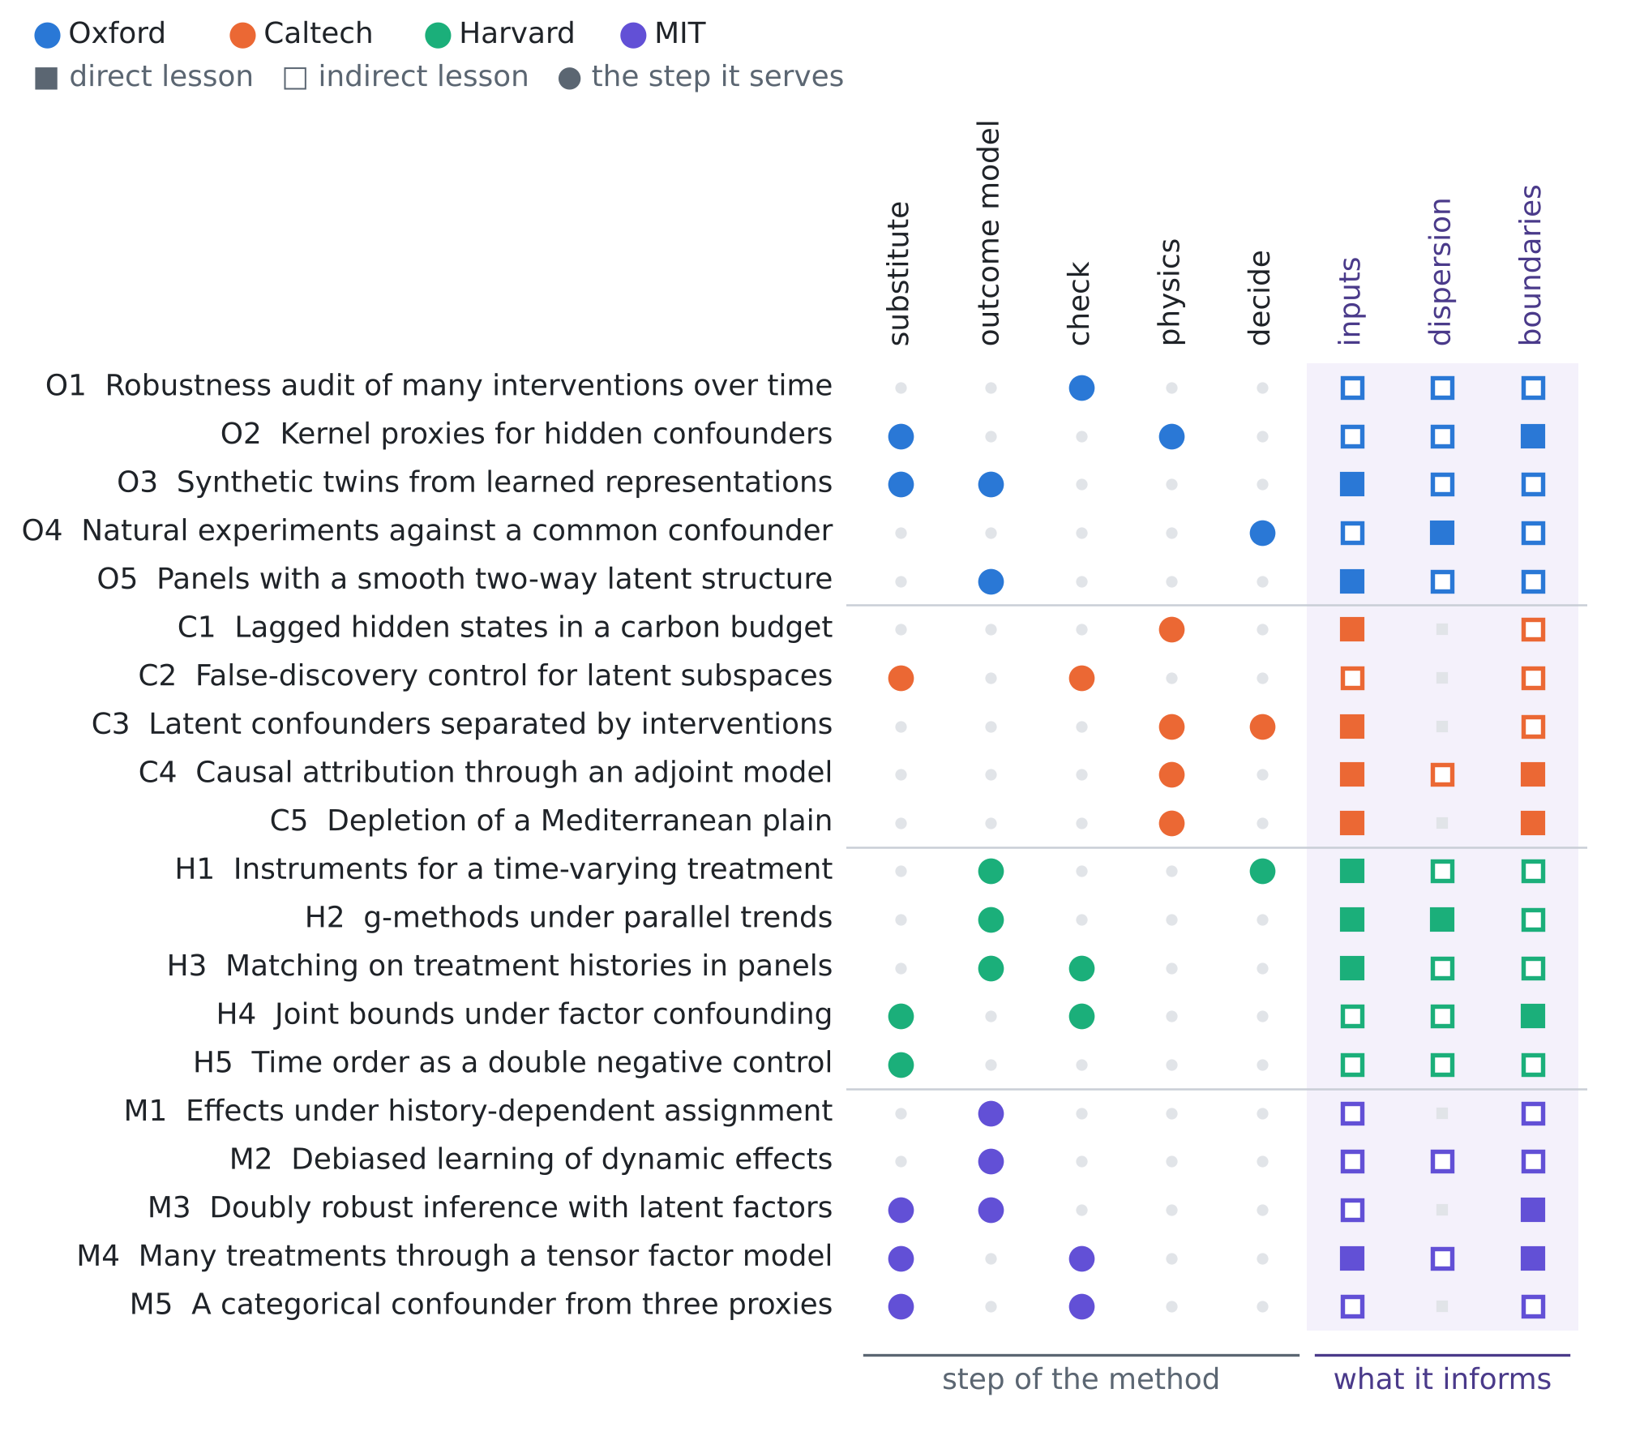
Figure 1. The twenty papers against the step of the method they serve and the unknown they inform. Colour gives the institution; a filled square is a direct lesson, an open square an indirect one.
O2 · Oxford · 2021
Proximal Causal Learning with Kernels: Two-Stage Estimation and Moment Restriction
Afsaneh Mastouri, Yuchen Zhu, Limor Gultchin, Anna Korba, Ricardo Silva, Matt Kusner, Arthur Gretton, Krikamol Muandet
Proceedings of the 38th International Conference on Machine Learning, PMLR 139, 7512–7523 (2021)
Links: PMLR · arXiv:2105.04544
Affiliation and verification: The IP Paris research-portal record lists the University of Oxford among the affiliations (with UCL, the Alan Turing Institute, ENSAE and MPI-IS); which author was at Oxford was not seen. Status: partly verified (landing pages reached through search results only).
What it does. Result. Two kernel estimators of the average treatment effect in the proxy setting of Miao, Geng & Tchetgen Tchetgen — KPV (two-stage kernel regression) and PMMR (maximum moment restriction) — both with consistency guarantees; the outcome bridge function solves a Fredholm integral equation and is learned in a reproducing-kernel Hilbert space. The completeness and bridge-existence assumptions were not read verbatim.
State of the art it sets. The first nonparametric (kernel) estimators for proximal causal inference with consistency guarantees.
What it cannot yet do for us. No time, no sequential proxies, no feedback from the outcome to the treatment.
Input parameters. An outcome-side proxy can be a head outside the cones of depression, a treatment-side proxy an irrigation index (crop evapotranspiration, farm electricity).
Dispersion coefficient. Dispersion smooths the chloride response, which should make the bridge smoother (our inference).
Boundary conditions from rain alone. The rain cannot be a proxy: it acts on chloride directly through the recharge.
Innovation step for our problem. The proxy route is the future work the Time Series Deconfounder names. FSHEHTA-GO takes it with a proxy whose bridge is known from physics: the heads, once the known drawdown is added back and the head kernel removed, are a linear reading of the recharge, the path through which every hidden cause acts. The bridge needs no kernel regression; the reading explains 0.74 of the hidden dryness in the case of Figure 4, the history substitute 0.63.

O3 · Oxford · 2021
SyncTwin: Treatment Effect Estimation with Longitudinal Outcomes
Zhaozhi Qian, Yao Zhang, Ioana Bica, Angela Wood, Mihaela van der Schaar
Advances in Neural Information Processing Systems 34 (NeurIPS 2021)
Links: NeurIPS proceedings · poster page
Affiliation and verification: A search summary of the paper header lists Ioana Bica at the University of Oxford and the Alan Turing Institute; the other affiliations were not seen. The earlier arXiv title was "SyncTwin: Transparent Treatment Effect Estimation under Temporal Confounding". Status: partly verified (landing pages reached through search results only).
What it does. Result. Untreated outcomes follow a latent factor model with an individual latent factor and a time-varying latent trend. The method learns a time-constant representation from the pre-treatment history and builds a synthetic twin from a few weighted control units; Proposition 2 bounds the bias of the individual effect by how close the learned representation is to the true latent factor once the synthetic representation matches the target, and Proposition 1 justifies the supervised loss. The abstract reports that it reproduced the findings of a randomised trial from observational records (no numbers seen).
State of the art it sets. Synthetic-control counterfactuals on learned representations, with a pre-treatment validity check.
What it cannot yet do for us. One treatment onset, a time-constant latent factor, no time-varying hidden confounder, no physics.
Input parameters. Time-constant well properties ($T$, $S$, screen depth, distance to the coast, $τ$) are the latent factor; donor wells with matching pre-change heads and chloride build the twin.
Dispersion coefficient. A dispersion mismatch between target and donors shows as pre-treatment misfit: a free diagnostic.
Boundary conditions from rain alone. A region-wide drought or sea-level trend is absorbed as the common trend; a drought demand that varies week by week and acts through pumping is not.
Innovation step for our problem. Same group, different factor: SyncTwin puts the factor in the outcomes, the Time Series Deconfounder in the treatments. FSHEHTA-GO shows why neither suffices for a fast confounder: a substitute built from the past misses the weekly innovations of the dryness (Proposition D1), and only a measurement of the path — the heads — recovers them.

O4 · Oxford · 2022
Opportunistic experiments to constrain aerosol effective radiative forcing
Matthew W. Christensen and about twenty co-authors, among them Philip Stier (the full list was not seen)
Atmospheric Chemistry and Physics 22, 641–674 (2022), review article
Links: doi:10.5194/acp-22-641-2022 · DOAJ record
Affiliation and verification: A repository listing gives the first author at the Pacific Northwest National Laboratory and the University of Oxford; Philip Stier is a co-author per DOAJ, his department was not seen. Status: partly verified (landing pages reached through search results only).
What it does. Result. Correlational estimates of aerosol effects on clouds are confounded because meteorology drives both. The review assembles perturbations from well-defined sources — volcanic eruptions, ship tracks, wildfire plumes — as natural experiments; cloud albedo perturbations are found strongly sensitive to the background meteorology, strong increases of liquid water path are largely ruled out when the experiments are averaged, and the scaling to the global forcing remains unclear (wording of the abstract as quoted).
State of the art it sets. A synthesis of natural-experiment constraints on aerosol–cloud forcing under a multi-cause confounder.
What it cannot yet do for us. Not a formal identification; extrapolation to the global scale.
Input parameters. Catalogue the opportunistic pumping shocks — power cuts, pump failures, new wells, bans — that are exogenous to the irrigation demand.
Dispersion coefficient. A sharp pumping shock acts as a tracer test: the transient chloride response reads the dispersion.
Boundary conditions from rain alone. Stratify the effect by the background state (wet or dry season, sea level, known rain) and average over events, as they stratify by meteorology.
Innovation step for our problem. Meteorology is to aerosol what dryness is to pumping: a multi-cause confounder. The idiosyncratic part of the pumping is our opportunistic experiment; Proposition D1 shows that it alone identifies the effect when the substitute leaves part of the common confounder, and that the share it buys shrinks as the number of wells grows (the bias of the summed effects tends to 0.60).

O5 · Oxford · 2023
Linear panel regressions with two-way unobserved heterogeneity
Hugo Freeman, Martin Weidner
Journal of Econometrics 237, 105498 (2023)
Links: doi:10.1016/j.jeconom.2023.105498 · arXiv:2109.11911
Affiliation and verification: The 2021 CeMMAP working paper (CWP39/21) gives Martin Weidner at the Department of Economics and Nuffield College, University of Oxford (search summary); the journal's affiliation block was not seen. Status: partly verified (landing pages reached through search results only).
What it does. Result. The error of a linear panel regression is an unknown smooth function of two-way unobserved fixed effects, which generalises additive and interactive fixed effects. Two estimators are analysed: Bai's interactive fixed-effects estimator with a number of factors that grows asymptotically, and a two-step estimator that first groups the heterogeneity and then fits additive grouped effects; both come with asymptotic convergence results, Monte Carlo evidence and an application to UK house prices. A later paper states that the sieve estimator does not reach root-$NT$ asymptotic normality.
State of the art it sets. Nonparametric two-way latent heterogeneity in linear panels, through growing-factor or grouped estimators.
What it cannot yet do for us. Linear in the regressors, no dynamics or treatment regimes; inference is not root-$NT$.
Input parameters. Chloride residuals plausibly look like $g\left(α_{j},γ_{t}\right)$: a well property and a time state.
Dispersion coefficient. Smoother responses are closer to low rank, so fewer factors are needed (our inference).
Boundary conditions from rain alone. A basin-wide drought acts through $γ_{t}$; feedback from past chloride to pumping breaks the exogeneity.
Innovation step for our problem. Their answer to latent structure is double asymptotics in wells and weeks. Proposition D1 gives the warning for our case: if the latent state also drives the treatments, more wells do not help a substitute built from the past — the bias of the summed effects grows with $k$ toward 0.60 (+0.15 at 8 wells, +0.53 at 64 for the best history substitute).

4.2 California Institute of Technology (with JPL)
C1 · Caltech · 2020
Lagged effects regulate the inter-annual variability of the tropical carbon balance
A. A. Bloom, K. W. Bowman, J. Liu, A. G. Konings, J. R. Worden, N. C. Parazoo, V. Meyer, J. T. Reager, H. M. Worden, Z. Jiang, G. R. Quetin, T. L. Smallman, J.-F. Exbrayat, Y. Yin, S. S. Saatchi, M. Williams, D. S. Schimel (initials as seen)
Biogeosciences 17, 6393–6422 (2020)
Links: doi:10.5194/bg-17-6393-2020 · NASA ESPO record
Affiliation and verification: The first author is at JPL according to the ORNL record of a later CARDAMOM review and the CARDAMOM code repository; NASA ESPO lists the paper; the per-author block of this paper was not seen. Status: partly verified (landing pages reached through search results only).
What it does. Result. With the CARDAMOM Bayesian data–model fusion system (Markov chain Monte Carlo), concurrent and lagged effects both contribute substantially to the 2001–2015 inter-annual variability of the tropical net biome exchange; the lagged part acts mainly through net primary productivity, which depends on inter-annual variations in the foliar carbon and the plant-available water states. The discussion-paper title was "Lagged effects dominate…"; a lagged share quoted by one summary was not checked and is not used here.
State of the art it sets. A data-constrained separation of concurrent and lagged drivers through hidden states.
What it cannot yet do for us. Model-based attribution of carbon fluxes; no formal causal identification.
Input parameters. The vadose delay $τ$ and the recharge coefficient $κ$ are our lagged water state.
Dispersion coefficient. Not covered.
Boundary conditions from rain alone. Antecedent storage is a time-varying confounder: it shapes later irrigation demand and later recharge.
Innovation step for our problem. Their hidden state has memory; so has our dryness. Proposition D1 makes the memory the deciding parameter: with persistence 0.98 the best history substitute leaves +0.06 of bias in the summed effects at 8 wells, with persistence 0.5 it leaves +0.29.

C2 · Caltech · 2020
False discovery and its control in low rank estimation
Armeen Taeb, Parikshit Shah, Venkat Chandrasekaran
Journal of the Royal Statistical Society Series B 82(4), 997–1027 (2020)
Links: doi:10.1111/rssb.12387 · CaltechAUTHORS · arXiv:1810.08595
Affiliation and verification: CaltechAUTHORS record; Venkat Chandrasekaran is Caltech faculty and Armeen Taeb's Caltech PhD thesis is dated 2020; the per-author affiliations were not seen. Status: partly verified (landing pages reached through search results only).
What it does. Result. Discovery in low-rank estimation is reformulated geometrically, through row and column spaces, so that a false discovery is defined for a subspace. Subspace stability selection, a generalisation of stability selection, runs a low-rank estimator on subsamples and keeps the subspace close to most estimates, with control of false discoveries; factor analysis and latent-variable models are among the applications. The exact bound was not read.
State of the art it sets. False-discovery control for the rank and subspace of factor and latent-variable models.
What it cannot yet do for us. Static; no causal or time-series semantics.
Input parameters. How many independent hydraulic combinations (for example the diffusivity $T/S$) the wells support.
Dispersion coefficient. Not covered.
Boundary conditions from rain alone. Keep a second common factor (the sea level, say) only if its subspace is stable.
Innovation step for our problem. The Time Series Deconfounder picks the latent dimension by a predictive check; a spurious direction soaks up treatment variation and destroys overlap. FSHEHTA-GO shows the extreme case: a substitute read from the current pumping makes the design near-singular (condition number 4×10⁵), while a substitute read from another measurement — the heads — keeps it at 39.

C3 · Caltech · 2021
Disentangling Observed Causal Effects from Latent Confounders using Method of Moments
Anqi Liu, Hao Liu, Tongxin Li, Saeed Karimi-Bidhendi, Yisong Yue, Anima Anandkumar
arXiv preprint 2101.06614 (2021); no peer-reviewed version was found
Links: arXiv:2101.06614 · CaltechAUTHORS
Affiliation and verification: Deposited in CaltechAUTHORS ("Version Submitted"); Yisong Yue and Anima Anandkumar are Caltech faculty; the per-author affiliations were not seen. A preprint: the only card of this review without a peer-reviewed venue at Caltech. Status: partly verified (landing pages reached through search results only).
What it does. Result. In a linear structural equation model whose latent confounders are independent sources and whose observed variables form a DAG, the method of moments establishes identifiability, and the identifiability and learnability guarantees hold when (soft) interventions are available; estimation uses a coupled tensor decomposition with linear constraints. The exact theorem was not read.
State of the art it sets. Identifiability of the observed causal effects under independent latent confounders, given interventions.
What it cannot yet do for us. Independent units, linear, no time dynamics or sequential treatments; a preprint.
Input parameters. Pumping tests and scheduled cuts are soft interventions: they separate the response coefficients from the latent drought.
Dispersion coefficient. Not covered; the model is linear.
Boundary conditions from rain alone. Irrigation demand is a skewed, non-Gaussian common source of all pumping, which helps independent-source separation; the rain enters as an observed exogenous input.
Innovation step for our problem. Their interventions identify what observation cannot. Ours is the pumping test: it fixes the drawdown coefficients the physics branch needs. Proposition D4 prices what a wrong test costs — the bias is linear in the error, 19% of $β_{1}$ per 10% error of the drawdown, predicted to within 2%.

C4 · Caltech · 2021
Causal Mechanisms of Sea Level and Freshwater Content Change in the Beaufort Sea
Ichiro Fukumori, Ou Wang, Ian Fenty (initials I., O., I. in the search results; the given names as in card VII-C1)
Journal of Physical Oceanography 51, 3217–3234 (2021)
Links: doi:10.1175/jpo-d-21-0069.1 · OSTST 2022 talk
Affiliation and verification: The companion dataset carries a JPL DOI prefix (10.48577/jpl.vsnuwe) and the work uses the ECCO state estimate; the per-author affiliations were not seen. Status: partly verified (landing pages reached through search results only).
What it does. Result. Causal relationships are quantified with the adjoint of the global, data-constrained ECCO ocean–sea-ice model over 1992–2017. The rise of the Beaufort Sea level is mostly halosteric, driven by a freshwater increase; seasonal change is dictated by the sea-ice variation and interannual change is mostly wind-driven through Ekman transport, while both forcings matter equally for decadal change. Wind-driven anomalies equilibrate within weeks, melt-driven changes persist for years.
State of the art it sets. Adjoint-based causal attribution, split by forcing and by time scale, in a data-constrained geophysical model.
What it cannot yet do for us. The causal claims rest on the model structure; the adjoint is linearised; no identification or uncertainty statement.
Input parameters. An adjoint of the salinized-area functional gives its sensitivities to $T$, $S$, $κ$ and $τ$.
Dispersion coefficient. The adjoint sensitivity to the dispersion follows in the same way; their fast and slow responses are our advective and storage-controlled ones.
Boundary conditions from rain alone. Unknown sea-side forcing and recharge are control variables of a state estimate.
Innovation step for our problem. They separate forcings by their response times; so does FSHEHTA-GO. The head kernel (weeks) and the salinity kernel (months) differ, and the head kernel is identified from the salinity fit: profiling it removes the bias of a wrong kernel (−47% of the 20% cut with the kernel 40% too short, −1% once profiled).

C5 · Caltech · 2021
Groundwater Depletion Signals in the Beqaa Plain, Lebanon: Evidence from GRACE and Sentinel-1 Data
Elias C. Massoud, Zhen Liu, Amin Shaban, Mhamad El Hage
Remote Sensing 13(5), 915 (2021)
Links: doi:10.3390/rs13050915 · MDPI
Affiliation and verification: A search summary of the article places Zhen Liu and Elias C. Massoud at the Jet Propulsion Laboratory, California Institute of Technology, with work carried out under a contract with NASA. Status: partly verified (landing pages reached through search results only).
What it does. Result. Groundwater storage of the Beqaa Plain from GRACE (June 2002 – April 2017) is obtained by removing GLDAS soil moisture, snow and canopy water and the Qaraaoun reservoir from the total water storage; groundwater loss accounts for most of the decline, with trends of about +0.08 cm/yr in West Beqaa, −0.01 cm/yr in Rashaya and −1.10 cm/yr in Zahle, corroborated by Sentinel-1 subsidence and monitoring wells.
State of the art it sets. Combined GRACE, InSAR and well detection of depletion in a data-poor Mediterranean plain.
What it cannot yet do for us. No causal separation of drought and pumping; no salinity; the satellite footprint is far larger than the plain.
Input parameters. Subsidence and heads together constrain the skeletal storage $S$.
Dispersion coefficient. Not covered.
Boundary conditions from rain alone. The residual "human" signal still contains the climate-driven loss of recharge: the confounding this review is about.
Innovation step for our problem. Budget attribution treats the residual as pumping; FSHEHTA-GO treats it as confounded. Without adjustment the summed well effects are overstated by +0.59 (in units of the salinity index per unit of pumping, true sum about 1); the physics substitute brings this to 0.00.

4.3 Harvard University
H1 · Harvard · 2021
Instrumental variable estimation for a time-varying treatment and a time-to-event outcome via structural nested cumulative failure time models
Joy Shi, Sonja A. Swanson, Peter Kraft, Bernard Rosner, Immaculata De Vivo, Miguel A. Hernán
BMC Medical Research Methodology 21, 258 (2021)
Links: doi:10.1186/s12874-021-01449-w · PMC8620657
Affiliation and verification: A search summary places the authors in the Department of Epidemiology, Harvard T.H. Chan School of Public Health; a copy is held in Harvard's DASH repository; the data are from the Nurses' Health Study. Status: partly verified (landing pages reached through search results only).
What it does. Result. g-estimation of structural nested cumulative failure time models is applied to instrumental variable analyses of time-varying treatments, and can use several measures of the treatment. The instrument conditions alone do not give a point estimate, so a homogeneity assumption is added. In simulations the instrumental estimates were close to the confounder-adjusted ones; in a Mendelian randomisation application the cumulative endometrial-cancer risk from age 45 to 72 was about 4.0% under "never drink" and 4.3% under "always half a drink per day".
State of the art it sets. Instrumental g-estimation for time-varying treatments with failure-time outcomes.
What it cannot yet do for us. Homogeneity and one valid time-varying instrument; developed for epidemiology.
Input parameters. Instruments for pumping: power cuts, tariff changes, pump breakdowns, permits.
Dispersion coefficient. The time until the chloride of a well exceeds a threshold is a natural failure time, and the dispersion shapes how its risk builds up.
Boundary conditions from rain alone. An instrument must be independent of the recharge and the sea-side state; homogeneity is doubtful near the sea boundary.
Innovation step for our problem. An instrument and a physics proxy are two answers to the same hidden confounder; the instrument needs exclusion, the proxy needs known physics. FSHEHTA-GO shows what the proxy buys when the hidden cause is local: crop stress at one farm biases the effect of that well by +97% with the history substitute and by +7% with the reading of a logger next to it.

H2 · Harvard · 2022
Structural Nested Mean Models Under Parallel Trends Assumptions
Zach Shahn, Oliver Dukes, Meghana G. Shamsunder, David Richardson, Eric Tchetgen Tchetgen, James Robins
arXiv preprint 2204.10291 (v1 April 2022, v8 August 2025); no journal version was found
Links: arXiv:2204.10291
Affiliation and verification: A summary of the arXiv listing gives James Robins at the Harvard T.H. Chan School of Public Health (the others at CUNY, Ghent, UC Irvine and Penn); the affiliation block of the PDF was not seen. Status: partly verified (landing pages reached through search results only).
What it does. Result. Structural nested mean models, known to be identified under no unobserved confounding, are also identified under a conditional parallel-trends assumption of the kind used in time-varying difference-in-differences; a sensitivity analysis to violations of parallel trends is given, and optimal regimes follow under the added assumption of no effect modification by the unobserved confounders. The models carry lasting effects of a blip of treatment and sustained interventions on continuous or multi-dimensional treatments; worked examples include floods and flood insurance, temperature and crop yields.
State of the art it sets. g-estimation for time-varying, continuous, multi-dimensional treatments without ignorability, under parallel trends.
What it cannot yet do for us. Parallel trends is doubtful for the nonlinear intrusion; a preprint.
Input parameters. The blip function over lags is the chloride response to a pumping pulse; the diffusivity $T/S$ and $τ$ set its shape.
Dispersion coefficient. The dispersion sets how long a blip persists, and hence the lag window the model must cover.
Boundary conditions from rain alone. A drought that shifts all wells alike satisfies parallel trends; one that acts more strongly near the sea boundary breaks it.
Innovation step for our problem. Parallel trends replace the absence of hidden confounders with an assumption about untreated trends. The physics substitute replaces it with a measurement: under correct physics it removes the multi-cause bias (the summed effects to 0.00), and Proposition D4 says exactly how a wrong drawdown leaks back — a band the sensitivity analysis can carry.

H3 · Harvard · 2023
Matching Methods for Causal Inference with Time-Series Cross-Sectional Data
Kosuke Imai, In Song Kim, Erik Wang (middle initial not confirmed)
American Journal of Political Science 67(3), 587–605 (2023)
Links: doi:10.1111/ajps.12685 · author PDF
Affiliation and verification: Kosuke Imai, Departments of Government and Statistics, Harvard University; the paper is hosted on his Harvard site. In Song Kim is at MIT; the third author's affiliation was not confirmed. Status: partly verified (landing pages reached through search results only).
What it does. Result. Each treated observation is matched to control observations of other units in the same period with an identical treatment history over the previous $L$ periods; the matched sets are refined by matching or weighting on covariates, and a difference-in-differences estimator follows, equal to a weighted two-way fixed-effects estimator. The assumptions are no spillover, carryover limited to $L$ periods, and parallel trends given the treatment history and the covariates; standard errors by a block bootstrap; the PanelMatch R package implements it.
State of the art it sets. A design-based matching and difference-in-differences method for time-series cross-sectional data, with diagnostics and software.
What it cannot yet do for us. No interference and finite carryover; treated versus control, so continuous pumping rates are not obviously covered (our inference).
Input parameters. The lag $L$ follows from $τ$ and the hydraulic response time $SL^{2}/T$.
Dispersion coefficient. A slow dispersive tail stretches the carryover and forces a large $L$.
Boundary conditions from rain alone. Wells sharing a cone of depression violate no-spillover; treatment may need defining at sector level.
Innovation step for our problem. Interference is the rule in an aquifer: the heads of one logger see every well. FSHEHTA-GO uses the interference instead of assuming it away — the known drawdown pattern is what lets the heads be read as recharge, and the reading is what the physics check tests.

H4 · Harvard · 2023
Partial identification and unmeasured confounding with multiple treatments and multiple outcomes
Suyeon Kang, Alexander Franks, Michelle Audirac, Danielle Braun, Joseph Antonelli
arXiv preprint 2311.12252 (v1 November 2023, v3 June 2025); no journal version was found
Links: arXiv:2311.12252
Affiliation and verification: Danielle Braun is Principal Research Scientist, Department of Biostatistics, Harvard T.H. Chan School of Public Health, and Michelle Audirac a data scientist of its NSAPH group (profile pages); the paper's own affiliation block was not seen. The v1 title was "Sensitivity analysis with multiple treatments and multiple outcomes with applications to air pollution mixtures". Status: partly verified (landing pages reached through search results only).
What it does. Result. Under a factor confounding assumption, joint partial-identification regions for several estimands can be more informative than regions for each estimand alone; negative-control (null-effect) constraints enter as a special case of the sensitivity bound, and a constrained optimisation gives the regions under arbitrary negative-control constraints. In the Medicare application to air-pollution mixtures, the detrimental effect of black carbon is robust to the potential presence of unmeasured confounding (wording as quoted).
State of the art it sets. Joint partial identification of multi-treatment, multi-outcome effects under factor confounding, with negative controls.
What it cannot yet do for us. Static: no time-varying treatment, no feedback; a preprint.
Input parameters. Bound the pumping effects jointly over several observation wells, under a shared drought factor.
Dispersion coefficient. A well outside the capture zone of a piezometer is a physical null pair: a negative control whose validity the dispersion decides.
Boundary conditions from rain alone. Unknown boundary fluxes and recharge behave as a common factor across treatments and outcomes.
Innovation step for our problem. They accept the factor model of the Time Series Deconfounder and answer D'Amour's non-identifiability with bounds. FSHEHTA-GO answers it with a second measurement: the static substitute is collinear with the treatments (condition number 4×10⁵), the physics reading is not, and point identification returns.

H5 · Harvard · 2024
Air pollution below US regulatory standards and cardiovascular diseases using a double negative control approach
Yichen Wang, Mahdieh Danesh Yazdi, Yaguang Wei, Joel D. Schwartz
Nature Communications 15, 8451 (2024)
Links: doi:10.1038/s41467-024-52117-8 · DOAJ record
Affiliation and verification: A search summary lists Yichen Wang at the Harvard T.H. Chan School of Public Health (and Yale) and Mahdieh Danesh Yazdi at Harvard Chan; Joel D. Schwartz is in its environmental epidemiology group. Status: partly verified (landing pages reached through search results only).
What it does. Result. Preceding-year hospitalisations serve as a negative outcome control and subsequent-year exposure as a negative exposure control, their expected values as a proxy for the omitted confounders. In US Medicare beneficiaries aged 65 and over (2000–2016), PM2.5, NO2 and warm-season O3 were positively associated with hospitalisations for stroke, heart failure and atrial fibrillation even in areas below PM2.5 9 μg/m³, NO2 40 ppb and warm-season O3 45 ppb.
State of the art it sets. A double negative control built from time order, in a national environmental panel.
What it cannot yet do for us. One treatment and a one-year lag; no multi-well or sequential strategies; no feedback.
Input parameters. Next-week pumping as a negative-control exposure and last-week chloride as a negative-control outcome, if the hidden demand persists over the lag (set by $τ$).
Dispersion coefficient. Slow dispersive transport makes chloride strongly autocorrelated, so lagged chloride is itself driven by past pumping.
Boundary conditions from rain alone. Managers who cut pumping after a salinity rise make future pumping depend on the outcome — a violation to design around.
Innovation step for our problem. Time order makes their proxies; physics makes ours. The difference matters when the confounder is fast: with a dryness persistence of 0.5 the history-based substitute removes almost nothing (summed-effect bias +0.56 against +0.57 unadjusted), the heads-based reading removes it all (0.00).

4.4 Massachusetts Institute of Technology
M1 · MIT · 2021
Learning Treatment Effects in Panels with General Intervention Patterns
Vivek F. Farias, Andrew A. Li, Tianyi Peng
Advances in Neural Information Processing Systems 34 (NeurIPS 2021), oral
Links: NeurIPS proceedings · arXiv:2106.02780
Affiliation and verification: Tianyi Peng's CV gives an MIT PhD (Operations Research) advised by Vivek Farias; no result quoted the MIT Sloan affiliation for this paper. Status: partly verified (landing pages reached through search results only).
What it does. Result. The observed matrix is a low-rank baseline plus noise plus heterogeneous effects on the entries where a 0/1 treatment pattern is one; the pattern may depend on the history. A convex nuclear-norm penalised fit with a de-biasing step recovers the average effect at an optimal rate for general patterns, described as the first guarantees of their type in this setting. The exact rate was not read.
State of the art it sets. Rate-optimal recovery of the average effect in panels with arbitrary intervention patterns.
What it cannot yet do for us. Binary treatment, an average effect only, no carryover.
Input parameters. The well × month baseline chloride, driven by the inputs and the rain, is plausibly low rank.
Dispersion coefficient. Not covered.
Boundary conditions from rain alone. Pumping decisions that react to past chloride are allowed by the history-dependent pattern.
Innovation step for our problem. A low-rank baseline absorbs the confounding only if the confounder is in the baseline. Our dryness also drives the treatment, week by week; FSHEHTA-GO reads it from the heads instead, and the summed effects come out unbiased (0.00) with a Monte Carlo spread of 0.05, against 0.32 with the history substitute.

M2 · MIT · 2022
Automatic Debiased Machine Learning for Dynamic Treatment Effects and General Nested Functionals
Victor Chernozhukov, Whitney Newey, Rahul Singh, Vasilis Syrgkanis
arXiv preprint 2203.13887 (v5 June 2023); no journal version was found
Links: arXiv:2203.13887
Affiliation and verification: The v2 PDF lists the first three authors at MIT and Vasilis Syrgkanis at Microsoft Research (search summary). Status: partly verified (landing pages reached through search results only).
What it does. Result. A dynamic treatment regime with discrete treatments is restated through a recursive Riesz representer of nested mean regressions; the representers are estimated by a sequence of loss minimisations whose minimisers are the multipliers of the de-biasing correction, so no auxiliary propensity model is needed; non-asymptotic rates hold for general machine learning. The assumptions are sequential conditional exogeneity, a surrogacy assumption for long-term effects and sequential positivity.
State of the art it sets. Debiased machine-learning inference for dynamic regimes without hand-derived corrections.
What it cannot yet do for us. Discrete treatments; no hidden confounding given the history; a preprint.
Input parameters. Short-term heads or chloride as surrogates of the long-term salinized area.
Dispersion coefficient. The surrogate horizon is set by the dispersive tail of the chloride response.
Boundary conditions from rain alone. Needs the history to contain the confounders — exactly what the physics reading supplies.
Innovation step for our problem. It would replace the inverse-propensity weights of the Time Series Deconfounder, whose products explode over long horizons, but it inherits sequential exogeneity. Proposition D2 supplies it from physics: with the recharge reading in the history, the pumping is ignorable, and the physics check confirms it at its nominal size.

M3 · MIT · 2024
Doubly Robust Inference in Causal Latent Factor Models
Alberto Abadie, Anish Agarwal, Raaz Dwivedi, Abhin Shah
Working paper, arXiv:2402.11652 (v3 October 2024; updated MIT version February 2026)
Links: arXiv:2402.11652 · MIT Economics PDF (Feb 2026)
Affiliation and verification: MIT Economics hosts the versions of 2024 and 2026; Abhin Shah's MIT thesis (DSpace 1721.1/158911) describes the doubly robust estimator with black-box matrix completion. Status: partly verified (landing pages reached through search results only).
What it does. Result. The average effect under unobserved confounding, with latent factors in both the outcomes and the assignment, is estimated by combining outcome imputation, inverse probability weighting and a new cross-fitting procedure for matrix completion; the error is asymptotically Gaussian at a parametric rate under provably valid matrix-completion error rates, irrespective of other properties of the completion algorithm. The exact rate conditions were not read.
State of the art it sets. Doubly robust, parametric-rate inference for causal latent factor models.
What it cannot yet do for us. Static: no treatment–confounder feedback over time.
Input parameters. No need to estimate $T$, $S$ or $κ$: their effect enters through the latent factors.
Dispersion coefficient. Not covered.
Boundary conditions from rain alone. A drought that drives pumping and recharge is covered if it acts through factors shared across wells and periods.
Innovation step for our problem. Double robustness protects against one wrong nuisance. FSHEHTA-GO has two substitutes that fail in different ways — the history one misses innovations, the physics one leaks a wrong drawdown — and the combination of both is unbiased whenever the physics is right (summed effects 0.00).

M4 · MIT · 2026
Synthetic Interventions: Extending Synthetic Controls to Multiple Treatments
Anish Agarwal, Devavrat Shah, Dennis Shen
Operations Research 74(2), 840–859 (2026; online December 2025)
Links: doi:10.1287/opre.2025.1590 · arXiv:2006.07691
Affiliation and verification: The arXiv PDF lists Devavrat Shah at MIT EECS (Anish Agarwal at Columbia, Dennis Shen at USC). Earlier versions had other authors and the title "Synthetic A/B Testing using Synthetic Interventions". Status: partly verified (landing pages reached through search results only).
What it does. Result. Potential outcomes form a low-rank tensor over units, times and interventions; under linear span inclusion of the target unit's factor in the donors' factors, all unit–intervention effects are recovered while each unit is seen under at most two interventions. One estimator is consistent and a bias-corrected one asymptotically normal; the estimator allows latent confounders that determine the assignment, and a subspace-inclusion test checks validity. Applications include simulations and California's Proposition 99.
State of the art it sets. Counterfactuals under many treatments from panel data, with inference and a falsification test.
What it cannot yet do for us. One intervention per unit after the pre-period; no sequential regimes or carryover; discrete treatments.
Input parameters. Unit factors stand for well properties ($T$, $S$, distance to the coast, $τ$): their span is identified, not the parameters.
Dispersion coefficient. Mixing-zone memory makes chloride depend on the pumping history, so an intervention must be a regime, not a weekly rate.
Boundary conditions from rain alone. Time factors shared by the wells carry the common forcings — rain, sea level, irrigation demand.
Innovation step for our problem. Their subspace-inclusion test and our physics check play the same role: falsify the assumption that makes the substitute valid. Ours is aimed at Assumption 3 and at the physics: it rejects a single-cause confounder at one well and a 30% drawdown error alike (power 99–100%).

M5 · MIT · 2026
Causal Inference with Categorical Unobserved Confounder via Mixture Learning
Aytijhya Saha, Stephen Bates, Devavrat Shah
arXiv preprint 2605.19006 (May 2026)
Links: arXiv:2605.19006
Affiliation and verification: A search summary of the arXiv listing gives the authors at MIT EECS and LIDS. A preprint, six months old. Status: partly verified (landing pages reached through search results only).
What it does. Result. Causal effects with a categorical unobserved confounder are identified from a mixture-learning perspective when at least three proxies are conditionally independent given the confounder, without classifying the proxies by role (identifiability of the mixture after Allman et al. 2009); each unit's posterior over the latent class is recovered by tensor decomposition, then the effects, with non-asymptotic guarantees. The rank conditions were not read.
State of the art it sets. Identification and estimation guarantees for a categorical confounder from role-free proxies.
What it cannot yet do for us. Independent units, no dynamics, a categorical confounder; unreviewed.
Input parameters. Proxies: a rain-based drought index, irrigated area from satellites, pump electricity.
Dispersion coefficient. Not covered.
Boundary conditions from rain alone. Dry, normal and wet regimes as a latent class acting on all wells and on the recharge; three wells whose pumping is independent given the regime are the three views.
Innovation step for our problem. Their three views are the multi-cause structure of the Time Series Deconfounder, made identifiable. The heads are a fourth, physical view, and the only one that sees a single-cause confounder near a logger: the well-1 check rejects it in 100% of the cases.

5. Our schemes: who confounds the pumping at Fushë-Kuqe
The translation is direct. A "patient" is the aquifer, a "time step" a week, the $k$ treatments the pumping rates $A_{tj}$ of the wells, the outcome the salinity $Y_{t}$ (the chloride at the monitored screens, or the salinized area of review VIII), the observed covariates $X_{t}$ the rain $f_{t}$ and the past heads and chloride. Figure 2 redraws the article's Figure 1(b) next to our case.
Who is a confounder, and who is not. A confounder causes both the pumping and the salinity by a path that does not go through the pumping. Table 3 sorts the variables of the problem by this rule and says what each needs.
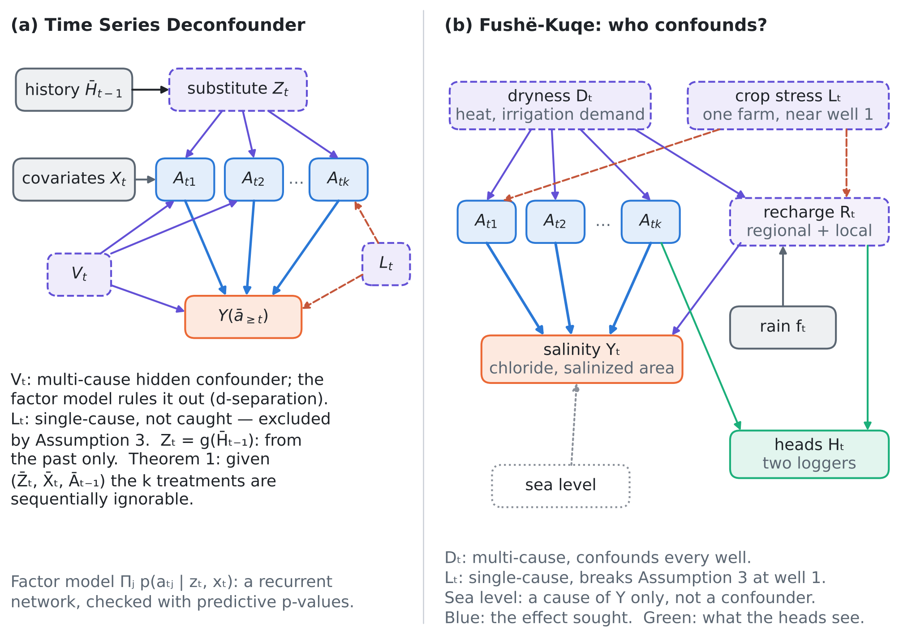
Figure 2. Our analogue of Figure 1 of the article. (a) The graphical factor model of the Time Series Deconfounder, after its Figure 1(b): the substitute $Z_{t}$ is built from the history and catches the multi-cause $V_{t}$ but not the single-cause $L_{t}$. (b) Fushë-Kuqe: the dryness $D_{t}$ (heat, irrigation demand) drives every well and lowers the recharge, the crop stress $L_{t}$ of one farm drives one well and the local recharge, and both reach the salinity only through the recharge, which the heads see once the known drawdown of the pumping is accounted for. The sea level causes the salinity but not the pumping.
Table 3. The variables of the pumping–salinity problem in the language of the Time Series Deconfounder, and how FSHEHTA-GO treats them.
Variable | Role | Observed? | Acts on | Treatment in FSHEHTA-GO
Pumping of well $j$, $A_{tj}$ | treatment (one of k causes) | yes, if metered (electricity or flow) | heads (drawdown), salinity | the effect sought, $β_{j}$ and the 20% cut
Salinity $Y_{t}$ | outcome | sparse samples, loggers | — | outcome model
Rain $f_{t}$ | observed covariate; a confounder if pumping reacts to it | yes | recharge, and pumping through irrigation | adjusted as $X_{t}$
Dryness $D_{t}$: heat, evaporative and irrigation demand | hidden multi-cause confounder ($V_{t}$ of the article) | no (evapotranspiration maps only in part) | all wells (up), recharge (down) | physics substitute; the history substitute only for its predictable part
Crop stress $L_{t}$ of one farm, a broken canal | hidden single-cause confounder ($L_{t}$ of the article) | no | one well (up), local recharge or return flow (down) | a logger near that well; the physics check
Recharge $R_{t}$, regional and local | mediator of the confounding: the path of $D_{t}$ and $L_{t}$ | no (only the rain) | heads, salinity | read from the heads (Proposition D2)
Past heads and chloride | history; managers react to them (feedback) | yes | next pumping | in the history; adjusted
Surface-water deliveries | possible multi-cause confounder | partly (irrigation board) | pumping (down), return-flow recharge (up) | covariate if the records exist; else in $R_{t}$
Well properties: $T$, $S$, screen depth, distance to the coast | static confounder (farmers pump where it pays) | partly | pumping, salinity response | well fixed effects, the $β_{j}$ themselves
Sea level, tide | cause of the salinity only | yes (tide gauge) | salinity, heads | not a confounder; a precision covariate

Figure 3 is our analogue of the article's Figure 2: the recurrent factor model becomes the history branch, and a physics branch is added next to it.
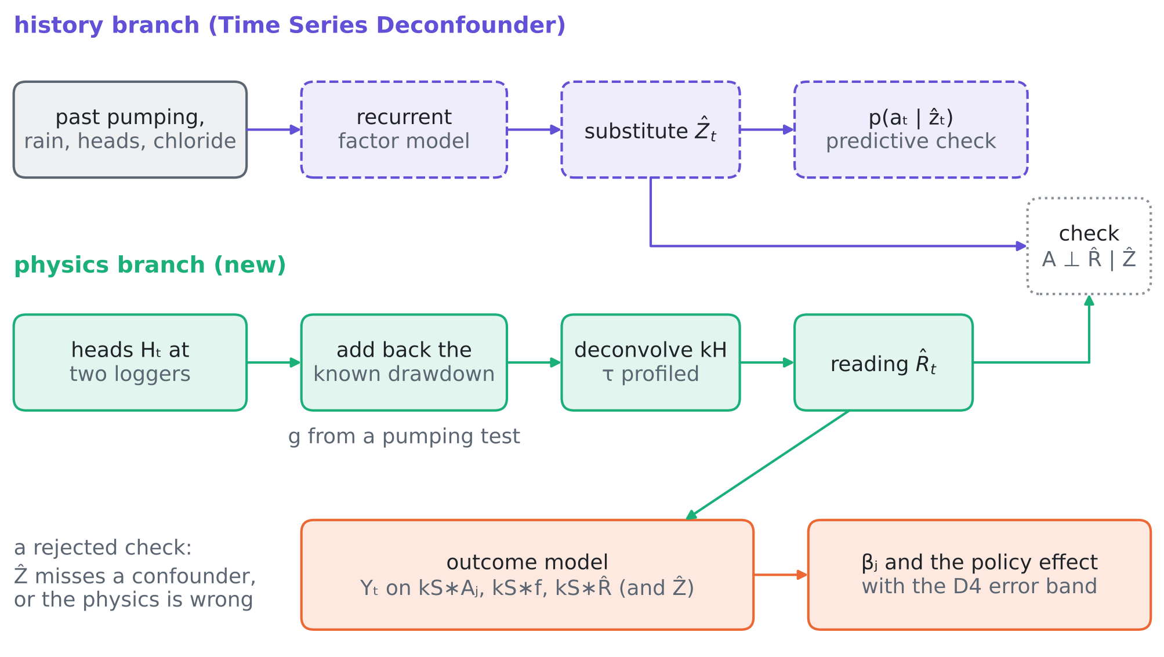
Figure 3. Our analogue of Figure 2 of the article. History branch: the factor model over time of the pumping (a recurrent network in the article, a dynamic factor model with a Kalman filter here) gives the substitute ${\hat{Z}}_{t}$ and the predictive check. Physics branch: the logger heads, with the drawdown of the known pumping added back (drawdown coefficients $g$ from a pumping test) and the head kernel deconvolved (its time constant profiled on the salinity fit), give the recharge reading ${\hat{R}}_{t}$. The physics check tests $A⊥\hat{R}\text{ | }\hat{Z}$; the outcome model uses the reading and returns the well effects and the policy effect with the error band of Proposition D4.
6. Innovation: FSHEHTA-GO, a deconfounder anchored in the heads
6.1 The test bed
A linear-response coastal aquifer in weekly steps, the first order of the Strack potential, which is linear in recharge and pumping for a fixed conductivity field (review VIII). With $k_{τ}$ the exponential kernel ${\left(k_{τ}*x\right)}_{t}=a{\left(k_{τ}*x\right)}_{t−1}+\left(1−a\right)x_{t}$, $a=e^{−1/τ}$:
$$D_{t}=ρ_{D}D_{t−1}+ν_{t}, L_{t}=0.9L_{t−1}+ξ_{t}, R_{t}=κf_{t}−bD_{t}+e_{t}, R_{t}^{\text{loc}}=−b_{L}L_{t},$$  $$A_{tj}=μ+λD_{t}+ψ 1\{j=1\}L_{t}+ε_{tj},$$  Yt=j​βjkS*Ajt−ρ kS*Rt−ρLkS*Rloct+ηt,  Hmt=−j​gmjkH*Ajt+qmkH*Rt+qmLkH*Rloct+emth. | (9)
$D_{t}$ (unit variance, persistence $ρ_{D}$) is the hidden dryness, $L_{t}$ the crop stress near well 1, $f_{t}$ the seasonal rain (observed), $Y_{t}$ a salinity index with a 10-week kernel, $H_{mt}$ two head loggers with a 4-week kernel, one next to well 1 and one inland. The $k$ wells lie 0.5–4 km along the coast, with $β_{j}=0.4e^{−x_{j}/1.5}$ and drawdown coefficients $g_{mj}=0.3e^{−\left|x_{m}−x_{j}\right|}$; $λ=0.5$, $σ_{ε}=0.5$, $κ=0.35$, $b=0.3$, $b_{L}=0.3$, $ρ=ρ_{L}=1$, $q=\left(0.5,0.5\right)$, $q^{L}=\left(0.5,0.02\right)$, logger noise 1 cm, 520 weeks after a 104-week burn-in. The estimands are the $β_{j}$ and the effect of a 20% cut of all pumping, −0.2μj​βj.
Estimators (least squares on the convolved regressors, Newey–West errors). No adjustment: $Y$ on $k_{S}*A_{j}$ and $k_{S}*f$. TSD substitute: plus ${\hat{Z}}_{t}$ and $k_{S}*{\hat{Z}}_{t}$, where ${\hat{Z}}_{t}=E\left[Z_{t}\text{ | }A_{1},…,A_{t−1}\right]$ is the Kalman prediction of a one-factor dynamic factor model of the pumping — the linear-Gaussian counterpart of the article's recurrent factor model, $Z_{t}=g\left({\overline{H}}_{t−1}\right)$. Best history substitute: plus $Z_{t}^{⋆}=E\left[D_{t}\text{ | }{\overline{D}}_{t−1}\right]=ρ_{D}D_{t−1}$ and $k_{S}*Z_{t}^{⋆}$, an oracle bound for any substitute built from the past. Static substitute: the factor score of the current pumping (the deconfounder of S1). Physics substitute: plus $k_{S}*{\hat{R}}_{m}$, with
Rmt=Hmt−aHHm,t−11−aH, Hmt=Hmt+j​gmjkτH*Ajt, | (10)
the head of logger $m$ with the known drawdown added back and the head kernel removed; with the profiled kernel, ${\hat{τ}}_{H}$ minimises the residual sum of squares of the outcome regression over a grid. True recharge: the oracle.
6.2 Propositions
Proposition D1 (history substitutes and the curse of many causes). Let the wells be exchangeable ($ψ=0$), let $W$ be the controls of an estimator and $\tilde{d}$, ${\tilde{A}}_{j}$ the residuals of $k_{S}*D$ and $k_{S}*A_{j}$ after projection on $W$. The large-sample bias of the summed effects is (11). If $W$ is a function of the past and independent of the idiosyncratic pumping, then $\text{Var} \tilde{d}≥v={\left(1−a_{S}\right)}^{2}\left(1−ρ_{D}^{2}\right)$ and the bias is at least (12), with equality for the best history substitute; this bound increases with $k$ to $ρb/λ$, the limit of the unadjusted estimator. A substitute that is a function of the current pumping instead makes the design singular.

$$B\left(W\right)=\sum_{j=1}^{k}{\left({\hat{β}}_{j}−β_{j}\right)}=\frac{ρ b k σ_{Ad}}{σ_{A}^{2}+\left(k−1\right)σ_{AA′}},$$  $$σ_{Ad}=\text{Cov}\left({\tilde{A}}_{j},\tilde{d}\right), σ_{A}^{2}=\text{Var} {\tilde{A}}_{j}, σ_{AA′}=\text{Cov}\left({\tilde{A}}_{j},{\tilde{A}}_{l}\right), j≠l,$$ | (11)
$$B^{⋆}=\frac{k λ ρ b v}{v_{ε}+k λ^{2}v}, v_{ε}=σ_{ε}^{2}\frac{1−a_{S}}{1+a_{S}}, \lim_{k→∞}B^{⋆}=\frac{ρ b}{λ}.$$ | (12)
Proof. The recharge brings the confounding term $ρ b \left(k_{S}*D\right)$ into $Y$; after the controls, by Frisch–Waugh–Lovell, $\hat{β}−β→Σ_{\tilde{A}\tilde{A}}^{−1}Σ_{\tilde{A}u}$ with $u=ρb\tilde{d}$. Exchangeability gives $Σ_{\tilde{A}\tilde{A}}=\left(σ_{A}^{2}−σ_{AA′}\right)I+σ_{AA′}11^{⊤}$ and $Σ_{\tilde{A}u}=ρbσ_{Ad}1$; Sherman–Morrison gives $1^{⊤}Σ^{−1}=1^{⊤}/\left(σ_{A}^{2}+\left(k−1\right)σ_{AA′}\right)$, hence (11). If $W$ is independent of $ε$, ${\tilde{A}}_{j}=λ\tilde{d}+k_{S}*ε_{j}$, so $σ_{Ad}=λv_{d}$, $σ_{A}^{2}=λ^{2}v_{d}+v_{ε}$, $σ_{AA′}=λ^{2}v_{d}$ and $B=kλρbv_{d}/\left(v_{ε}+kλ^{2}v_{d}\right)$, increasing in $v_{d}=\text{Var} \tilde{d}$. Since ${\left(k_{S}*D\right)}_{t}=a_{S}{\left(k_{S}*D\right)}_{t−1}+\left(1−a_{S}\right)ρ_{D}D_{t−1}+\left(1−a_{S}\right)ν_{t}$ and $ν_{t}$ is independent of the past, no function of the past removes $\left(1−a_{S}\right)ν_{t}$: $v_{d}≥v$, with equality when $W$ spans $D_{t−1}$ and ${\left(k_{S}*D\right)}_{t−1}$, which $Z_{t}^{⋆}$ and $k_{S}*Z_{t}^{⋆}=ρ_{D}{\left(k_{S}*D\right)}_{t−1}$ do. $B^{⋆}$ increases in $k$ and tends to $ρb/λ$; the unadjusted estimator has the same limit because its $v_{d}=\text{Var}\left(k_{S}*D\right)>v$. A substitute that is a linear function of $A_{t}$ makes $k_{S}*\hat{Z}$ a linear combination of the $k_{S}*A_{j}$. □
In words: with many wells the idiosyncratic pumping, which identifies the effect, averages out of the total, while the part of the dryness that the past cannot predict stays; the regression then credits the pumping with the salt that the fresh dryness brought. The "blessing of multiple causes" (S1) holds for substitutes built from the present, which positivity forbids; for substitutes built from the past it turns into a curse.
Proposition D2 (the physics substitute). Assume (E) the hidden causes reach the salinity only through the recharge components $r_{t}=\left(R_{t},R_{t}^{\text{loc}}\right)$, and (P) the heads are linear in pumping and recharge, with known drawdown $g$ and head kernel $k_{H}$, and the matrix $Q=\left[q,q^{L}\right]$ (loggers × recharge components) has full column rank. Then ${\hat{R}}_{t}=Qr_{t}+{\tilde{e}}_{t}$ with ${\tilde{e}}_{t}$ the logger noise filtered by the inverse kernel, independent of the pumping, and the regression of $Y$ on $k_{S}*A_{j}$, $k_{S}*f$ and $k_{S}*\hat{R}$ estimates $β$ with no confounding bias; what remains is an errors-in-variables bias that vanishes with the logger noise.

Proof. Adding back j​gmjkH*Aj removes the pumping from $H_{m}$ exactly, and deconvolving $k_{H}$ inverts the kernel: $\left({\tilde{H}}_{t}−a_{H}{\tilde{H}}_{t−1}\right)/\left(1−a_{H}\right)$ applied to $k_{H}*x$ returns $x_{t}$. So ${\hat{R}}_{t}=Qr_{t}+{\tilde{e}}_{t}$. With $c=\left(−ρ,−ρ_{L}\right)$ and logger weights $w$ such that $w^{⊤}Q=c$, which exist because $Q$ has full column rank, Y=j​βjkS*Aj+w⊤kS*R+η−w⊤kS*e; by (E) the hidden causes enter $Y$ only through $r$, so given $k_{S}*\hat{R}$ the error is independent of the pumping up to the term in $\tilde{e}$, which is correlated with the regressor $k_{S}*\hat{R}$ only (errors in variables) and has variance proportional to the logger noise. □
The rank condition is the physical form of Assumption 3: instead of "every hidden cause reaches two treatments", it reads "every hidden cause leaves a recharge footprint that a logger sees". Unlike Assumption 3, it can be met by design — by placing a logger next to the well whose farm is suspect.
Proposition D3 (the physics check). Under (E) and (P), if the substitute ${\hat{Z}}_{t}$ deconfounds the pumping, $A_{t}⊥r_{t}\text{ | }{\hat{Z}}_{t},f_{t}$, then $A_{t}⊥{\hat{R}}_{t}\text{ | }{\hat{Z}}_{t},f_{t}$, so the coefficient of ${\hat{R}}_{t}$ is zero in the regression of every $A_{tj}$ on $\left(1,{\hat{Z}}_{t},f_{t},{\hat{R}}_{t}\right)$. A significant coefficient falsifies the substitute — a missed multi-cause innovation or a single-cause confounder near a logger — or the physics (P). The statistic $S=\max_{j,m}\left|t_{jm}\right|$ is calibrated by circular time shifts of the residualised reading, which keep the autocorrelation of both series and break any link between them.

Proof. ${\hat{R}}_{t}=Qr_{t}+{\tilde{e}}_{t}$ with $\tilde{e}⊥A$; independence of $A_{t}$ and $r_{t}$ given $\left({\hat{Z}}_{t},f_{t}\right)$ carries over to any function of $r_{t}$ and an independent noise. Under the null the shifted readings are draws of a series independent of the pumping with the same autocorrelation, so the rank of $S$ among the shifted statistics is approximately uniform. □
The article's predictive check cannot do this: its statistic $E_{Z}\left[logp\left(a_{t}\text{ | }Z_{t},X_{t}\right)\right]$ sums per-treatment log-likelihoods, whose expectation is unchanged when the residuals share a common innovation, so the mean predictive p-value stays near 0.5 when the substitute misses a confounder.
Proposition D4 (wrong physics). (i) If the drawdown coefficients are wrong by a factor $1+γ$, $\hat{g}=\left(1+γ\right)g$, the physics estimator converges to βj−γm​wmgmj, with $w$ the weights of Proposition D2: a bias linear in $γ$, invisible to the fit (the residual is unchanged) but caught by the physics check. (ii) A wrong head kernel leaves a residual in the fit, so $τ_{H}$ is identified by the salinity fit, and profiling it removes the bias.

Proof. (i) With $\hat{g}=\left(1+γ\right)g$ and the right kernel, ${\hat{R}}_{t}=Qr_{t}+γgA_{t}+{\tilde{e}}_{t}$, so w⊤kS*R=w⊤QkS*r+γj​w⊤gjkS*Aj+… and the coefficient of $k_{S}*A_{j}$ absorbs $−γ{\left(w^{⊤}g\right)}_{j}$; the fitted values, hence the residual, do not change, while $\hat{R}$ now contains $A_{t}$ and the check rejects. (ii) With ${\hat{τ}}_{H}≠τ_{H}$, $k_{S}*\hat{R}$ is a different filter of $r$ plus a filtered pumping term, which no linear combination of the regressors turns into $w^{⊤}Qk_{S}*r$ when the recharge has a non-degenerate spectrum; the residual variance exceeds that of $η$, which the true kernel attains. □
6.3 What the history can and cannot see
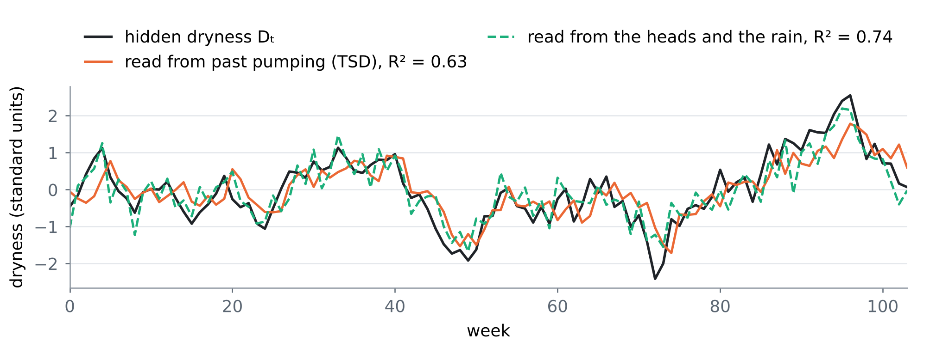
Figure 4. Two years of one simulated case: the hidden dryness, its best linear reading from the history substitute (R² = 0.63) and from the two heads and the rain (R² = 0.74).
The reading from the heads is not much more accurate in R² (0.74 against 0.63); what matters is where each errs. The history substitute lags the dryness and misses every fresh rise — exactly the weeks in which all farmers pump harder — so its error is correlated with the pumping. The reading from the heads errs by logger noise and by the recharge noise, which is independent of the pumping. Confounding bias depends on the first kind of error only.
6.4 Tests T29–T32
T29 — many wells, slow and fast dryness (Proposition D1; Figure 5, Table 4). For persistence 0.98, 0.9 and 0.5 and 2 to 64 wells. The unadjusted bias of the summed effects sits at the limit $ρb/λ$ = 0.60. The learned history substitute removes little (+0.56 at 8 wells, persistence 0.9). Even the best history substitute leaves +0.15 at 8 wells and +0.53 at 64, matching the closed form (12) (+0.13, +0.41); with a fast dryness (0.5) it leaves +0.29 at 8 wells. The physics substitute is unbiased at every $k$ (0.00), with a Monte Carlo spread of 0.05 against 0.32 for the learned substitute and 0.65 for the best one: the reading explains outcome variance instead of removing treatment variation. The static substitute makes the design singular (condition number 4×10⁵ against 39 for the physics design), and its estimates are meaningless. For the 20% cut at 8 wells the relative bias is −62% unadjusted, −59% with the learned substitute and +0.1% with the physics one. The article's predictive check gives p = 0.48–0.64 throughout.
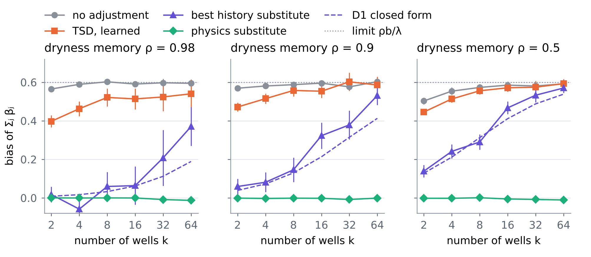
Figure 5. T29: bias of the summed well effects $Σ_{j}β_{j}$ against the number of wells, for three persistences of the hidden dryness (95% Monte Carlo intervals). The best history substitute follows the closed form of Proposition D1 and climbs to the unadjusted limit; the physics substitute stays at zero.
Table 4. T29: bias of $Σ_{j}β_{j}$ (true sum about 1 at 8 wells) and the Monte Carlo spread of the learned history and the physics substitutes (400 replications up to 16 wells, half as many beyond).
Persistence ρ | Wells k | No adjustment | TSD, learned | Best history | D1 closed form | Physics | Spread TSD / physics
0.98 | 2 | +0.57 | +0.40 | +0.02 | +0.01 | 0.00 | 0.32 / 0.03
0.98 | 8 | +0.60 | +0.52 | +0.06 | +0.03 | 0.00 | 0.47 / 0.05
0.98 | 16 | +0.59 | +0.51 | +0.06 | +0.06 | 0.00 | 0.55 / 0.06
0.98 | 64 | +0.59 | +0.54 | +0.37 | +0.19 | −0.01 | 0.52 / 0.08
0.9 | 2 | +0.57 | +0.47 | +0.06 | +0.04 | 0.00 | 0.24 / 0.03
0.9 | 8 | +0.59 | +0.56 | +0.15 | +0.13 | 0.00 | 0.32 / 0.05
0.9 | 16 | +0.60 | +0.55 | +0.32 | +0.21 | 0.00 | 0.36 / 0.06
0.9 | 64 | +0.60 | +0.59 | +0.53 | +0.41 | 0.00 | 0.31 / 0.08
0.5 | 2 | +0.50 | +0.45 | +0.14 | +0.13 | 0.00 | 0.16 / 0.03
0.5 | 8 | +0.57 | +0.56 | +0.29 | +0.31 | 0.00 | 0.20 / 0.05
0.5 | 16 | +0.58 | +0.57 | +0.47 | +0.41 | −0.01 | 0.21 / 0.06
0.5 | 64 | +0.59 | +0.59 | +0.57 | +0.54 | −0.01 | 0.17 / 0.08

T30 — a single-cause confounder (crop stress at well 1, persistence 0.98, 8 wells; Figure 6a). Without it ($ψ=0$) the effect of well 1 is overstated by +24% unadjusted, +20% with the learned and +2% with the best history substitute. With it ($ψ=1$) no history substitute helps (+97% learned, +102% best), as Assumption 3 predicts, while the logger next to well 1 lets the physics substitute bring the bias to +7% (the remainder is errors in variables). A single-cause confounder biases the effect of its well, not the uniform cut: in T32 it moves $β_{1}$ by +101% but the 20% cut by −0.9%, because the other wells carry the common part. What one wants to decide — which well to close, or how much to cut overall — decides which confounder hurts.
T31 — wrong physics (Proposition D4; Figure 6b, c). Drawdown coefficients 15% and 30% off shift $β_{1}$ linearly, 19% of $β_{1}$ per 10% of error, as predicted to within 2%; a 30% overestimate biases the 20% cut by −49%. The fit cannot see this, so the drawdown must come from a pumping test, and its uncertainty enters as the band of D4. A wrong head kernel (time constant 0.6 to 1.5 times the truth) biases the cut by −38% to −48% when kept fixed; profiled on the salinity fit, the true time constant is recovered in every replication and the bias stays within 1.0%.
T32 — the two checks (Proposition D3; Figure 6d; 400 replications, 99 shifts). Without confounding the physics check rejects in 6.0% of the replications at the 5% level (well 1 alone 5.5%); with a slow or fast multi-cause dryness, a single-cause stress at well 1, or drawdown coefficients 30% off, it rejects in 99–100%. The predictive check of the article returns p = 0.49–0.55 in all five scenarios: it cannot tell them apart.
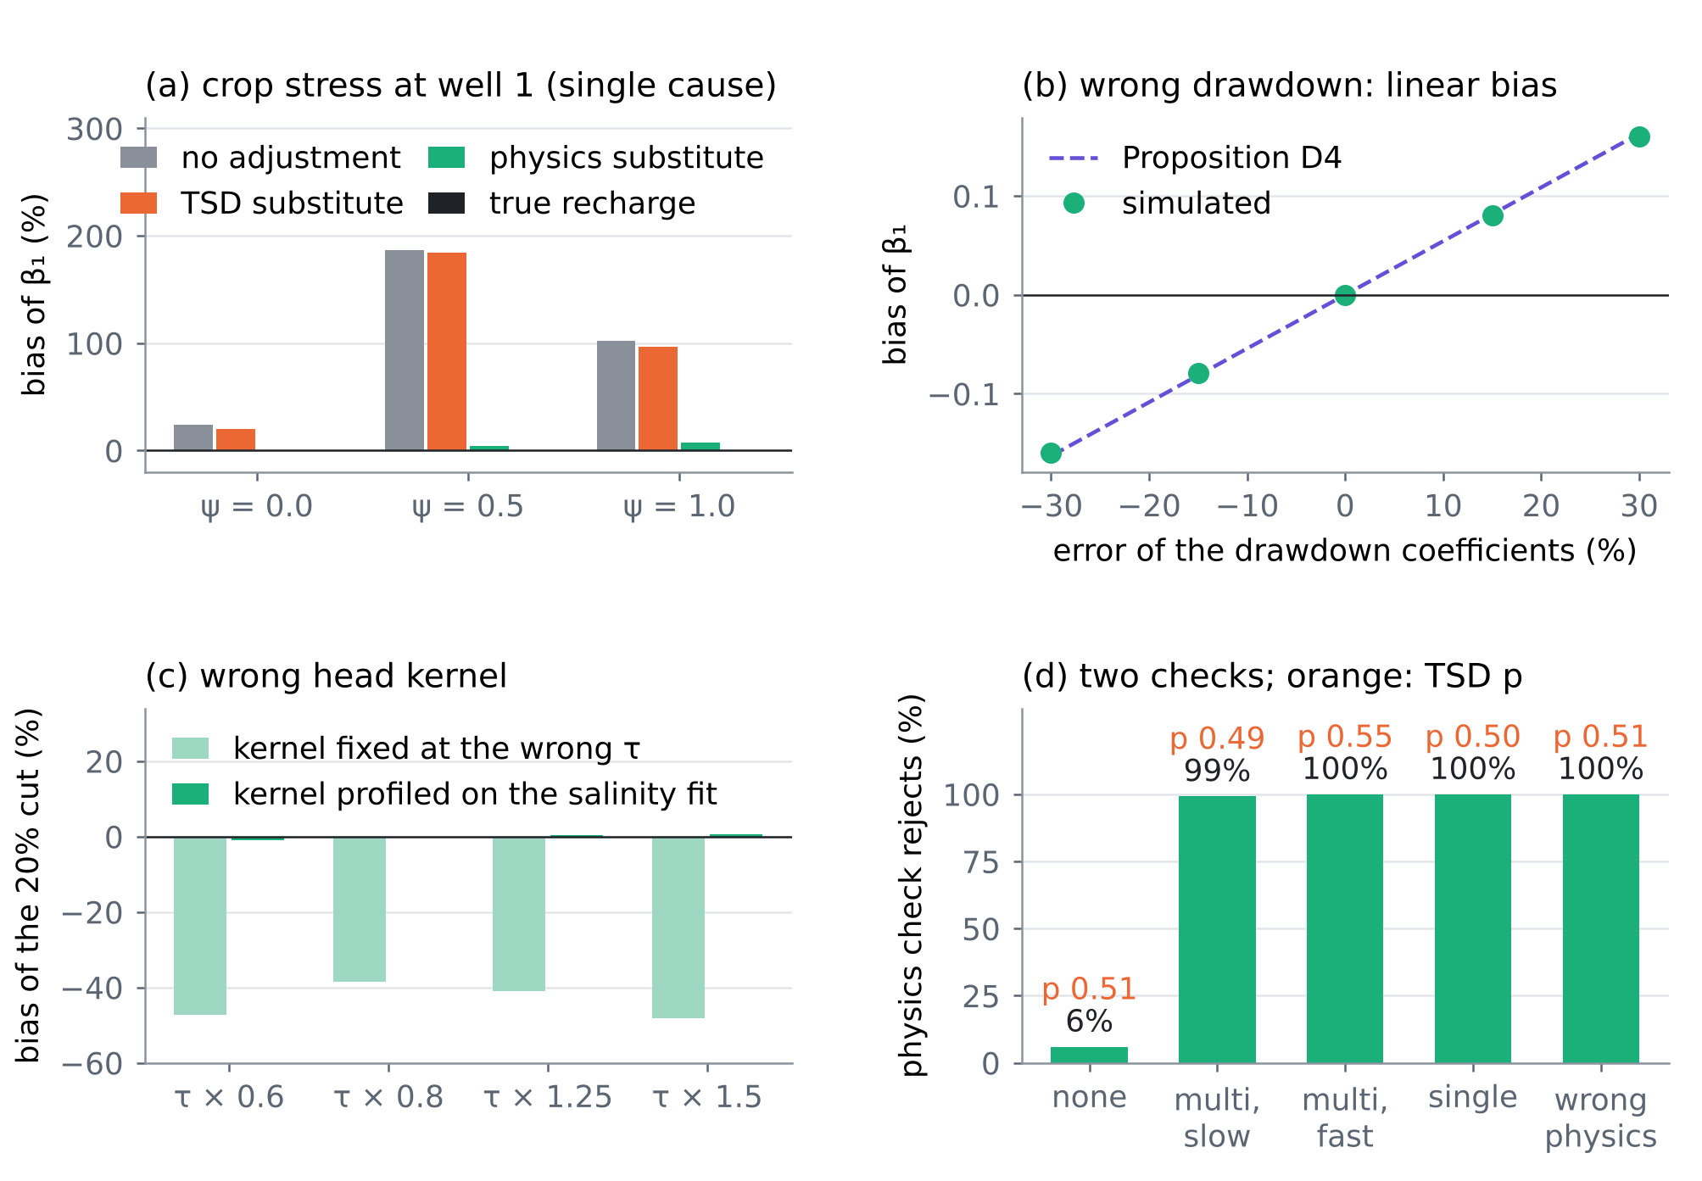
Figure 6. (a) T30: bias of the effect of well 1 under a single-cause confounder of strength ψ. (b) T31: bias of $β_{1}$ under wrong drawdown coefficients, simulated and predicted by Proposition D4. (c) T31: bias of the 20% cut under a wrong head kernel, fixed and profiled. (d) T32: rejection rate of the physics check at the 5% level (green) and the mean predictive p-value of the Time Series Deconfounder (orange), in five scenarios.
6.5 What is new
• A substitute from a second measurement. Every method of Sections 2 and 4 builds its substitute from the treatments, the outcomes or their time order. FSHEHTA-GO builds it from the heads, through the part of the physics that is known (drawdown, head kernel), and leaves to statistics only what is not (dryness, crop stress).
• The curse of many causes for history substitutes (D1): a closed-form bias that grows with the number of wells, explaining why the article's simulation (innovation 0.01) works and a heat wave would not.
• Assumption 3 made testable and designable (D2, D3): the single-cause assumption becomes a rank condition on the loggers, met by placing them, and checked by a calibrated test that the article's predictive check cannot replace.
• Priced physics (D4): a wrong drawdown leaks a bias linear in its error — a band from the pumping-test uncertainty — and a wrong head kernel is corrected by the fit itself.
6.6 What it takes at Fushë-Kuqe
Four records, three of which the project already plans (D2): (i) weekly pumping per well or well group, from meters or electricity bills (number of metered wells to be confirmed with the water utility and the irrigation board); (ii) at least two head loggers, one next to the well group whose farms are most likely to pump for local reasons and one inland, with 1 cm resolution; (iii) one step-drawdown or interference pumping test per well group, for the drawdown coefficients $g$ and their uncertainty, which sets the band of Proposition D4; (iv) the rain series and the chloride sampling of reviews I–VIII. The outcome model then estimates the effect on the salinity of each well group and of a uniform cut, with the physics check run before any effect is reported.
7. Synthesis and limits
The Time Series Deconfounder turns many treatments into a lever on hidden confounders: if a hidden cause acts on several treatments, their pattern over time reveals it. Our problem has many treatments — the wells — and a hidden cause that acts on all of them, so the lever applies; but the cause is weather-driven, with large weekly news, and the lever only reaches what the past predicts. The aquifer offers what a hospital ward does not: a second, physical measurement of the confounding path. Reading the recharge from the heads removes the confounding that the history leaves, sees a single-cause confounder near a logger, and turns the untestable assumption into a designable and testable one. The twenty papers supply the pieces around it: proxies and negative controls (O2, H5, M5), panels and latent factors (O3, O5, M1, M3, M4), instruments and bounds (H1, H4), checks (O1, M4), and physical attribution (C1, C4, C5).
Limits. The test bed is linear and Gaussian; the salinity of review VIII is nonlinear in the state, and the drawdown of an unconfined aquifer is linear only for small drawdowns. Assumption (E) fails if a hidden cause acts on the salt directly — for instance, salt carried by irrigation return flow — and then a third measurement (the chloride of the return flow) is needed. The physics check is joint: a rejection says that the substitute or the physics is wrong, not which. The Newey–West intervals under-cover in all estimators, the oracle included (coverage of $β_{1}$ about 0.80 at a nominal 0.90), so coverage statements need a block bootstrap. The cards are partly verified (Section 4).
References
The article and its supplement (provided by the user)
[A1] Bica, I., Alaa, A. M., & van der Schaar, M. (2020). Time Series Deconfounder: Estimating Treatment Effects over Time in the Presence of Hidden Confounders. Proceedings of the 37th International Conference on Machine Learning (ICML 2020), PMLR 119 (PDF provided by the user; the link follows the PMLR identifier bica20a of the supplement file). https://proceedings.mlr.press/v119/bica20a.html
[A2] Bica, I., Alaa, A. M., & van der Schaar, M. (2020). Appendix: Time Series Deconfounder (supplementary material, bica20a-supp.pdf, provided by the user). Code as given in the article: github.com/ioanabica/Time-Series-Deconfounder. https://github.com/ioanabica/Time-Series-Deconfounder
The twenty papers of this review
[O1] Mrinank Sharma, Sören Mindermann, Jan Markus Brauner, Gavin Leech, Anna B. Stephenson, Tomáš Gavenčiak, Jan Kulveit, Yee Whye Teh, Leonid Chindelevitch, Yarin Gal (2020). How Robust are the Estimated Effects of Nonpharmaceutical Interventions against COVID-19?. Advances in Neural Information Processing Systems 33 (NeurIPS 2020), spotlight. https://proceedings.neurips.cc/paper/2020/hash/8e3308c853e47411c761429193511819-Abstract.html
[O2] Afsaneh Mastouri, Yuchen Zhu, Limor Gultchin, Anna Korba, Ricardo Silva, Matt Kusner, Arthur Gretton, Krikamol Muandet (2021). Proximal Causal Learning with Kernels: Two-Stage Estimation and Moment Restriction. Proceedings of the 38th International Conference on Machine Learning, PMLR 139, 7512–7523 (2021). https://proceedings.mlr.press/v139/mastouri21a.html
[O3] Zhaozhi Qian, Yao Zhang, Ioana Bica, Angela Wood, Mihaela van der Schaar (2021). SyncTwin: Treatment Effect Estimation with Longitudinal Outcomes. Advances in Neural Information Processing Systems 34 (NeurIPS 2021). https://proceedings.neurips.cc/paper/2021/hash/19485224d128528da1602ca47383f078-Abstract.html
[O4] Matthew W. Christensen and about twenty co-authors, among them Philip Stier (the full list was not seen) (2022). Opportunistic experiments to constrain aerosol effective radiative forcing. Atmospheric Chemistry and Physics 22, 641–674 (2022), review article. https://doi.org/10.5194/acp-22-641-2022
[O5] Hugo Freeman, Martin Weidner (2023). Linear panel regressions with two-way unobserved heterogeneity. Journal of Econometrics 237, 105498 (2023). https://doi.org/10.1016/j.jeconom.2023.105498
[C1] A. A. Bloom, K. W. Bowman, J. Liu, A. G. Konings, J. R. Worden, N. C. Parazoo, V. Meyer, J. T. Reager, H. M. Worden, Z. Jiang, G. R. Quetin, T. L. Smallman, J.-F. Exbrayat, Y. Yin, S. S. Saatchi, M. Williams, D. S. Schimel (initials as seen) (2020). Lagged effects regulate the inter-annual variability of the tropical carbon balance. Biogeosciences 17, 6393–6422 (2020). https://doi.org/10.5194/bg-17-6393-2020
[C2] Armeen Taeb, Parikshit Shah, Venkat Chandrasekaran (2020). False discovery and its control in low rank estimation. Journal of the Royal Statistical Society Series B 82(4), 997–1027 (2020). https://doi.org/10.1111/rssb.12387
[C3] Anqi Liu, Hao Liu, Tongxin Li, Saeed Karimi-Bidhendi, Yisong Yue, Anima Anandkumar (2021). Disentangling Observed Causal Effects from Latent Confounders using Method of Moments. arXiv preprint 2101.06614 (2021); no peer-reviewed version was found. https://arxiv.org/abs/2101.06614
[C4] Ichiro Fukumori, Ou Wang, Ian Fenty (initials I., O., I. in the search results; the given names as in card VII-C1) (2021). Causal Mechanisms of Sea Level and Freshwater Content Change in the Beaufort Sea. Journal of Physical Oceanography 51, 3217–3234 (2021). https://doi.org/10.1175/jpo-d-21-0069.1
[C5] Elias C. Massoud, Zhen Liu, Amin Shaban, Mhamad El Hage (2021). Groundwater Depletion Signals in the Beqaa Plain, Lebanon: Evidence from GRACE and Sentinel-1 Data. Remote Sensing 13(5), 915 (2021). https://doi.org/10.3390/rs13050915
[H1] Joy Shi, Sonja A. Swanson, Peter Kraft, Bernard Rosner, Immaculata De Vivo, Miguel A. Hernán (2021). Instrumental variable estimation for a time-varying treatment and a time-to-event outcome via structural nested cumulative failure time models. BMC Medical Research Methodology 21, 258 (2021). https://doi.org/10.1186/s12874-021-01449-w
[H2] Zach Shahn, Oliver Dukes, Meghana G. Shamsunder, David Richardson, Eric Tchetgen Tchetgen, James Robins (2022). Structural Nested Mean Models Under Parallel Trends Assumptions. arXiv preprint 2204.10291 (v1 April 2022, v8 August 2025); no journal version was found. https://arxiv.org/abs/2204.10291v8
[H3] Kosuke Imai, In Song Kim, Erik Wang (middle initial not confirmed) (2023). Matching Methods for Causal Inference with Time-Series Cross-Sectional Data. American Journal of Political Science 67(3), 587–605 (2023). https://doi.org/10.1111/ajps.12685
[H4] Suyeon Kang, Alexander Franks, Michelle Audirac, Danielle Braun, Joseph Antonelli (2023). Partial identification and unmeasured confounding with multiple treatments and multiple outcomes. arXiv preprint 2311.12252 (v1 November 2023, v3 June 2025); no journal version was found. https://arxiv.org/abs/2311.12252v3
[H5] Yichen Wang, Mahdieh Danesh Yazdi, Yaguang Wei, Joel D. Schwartz (2024). Air pollution below US regulatory standards and cardiovascular diseases using a double negative control approach. Nature Communications 15, 8451 (2024). https://doi.org/10.1038/s41467-024-52117-8
[M1] Vivek F. Farias, Andrew A. Li, Tianyi Peng (2021). Learning Treatment Effects in Panels with General Intervention Patterns. Advances in Neural Information Processing Systems 34 (NeurIPS 2021), oral. https://proceedings.neurips.cc/paper/2021/hash/7504adad8bb96320eb3afdd4df6e1f60-Abstract.html
[M2] Victor Chernozhukov, Whitney Newey, Rahul Singh, Vasilis Syrgkanis (2022). Automatic Debiased Machine Learning for Dynamic Treatment Effects and General Nested Functionals. arXiv preprint 2203.13887 (v5 June 2023); no journal version was found. https://arxiv.org/abs/2203.13887
[M3] Alberto Abadie, Anish Agarwal, Raaz Dwivedi, Abhin Shah (2024). Doubly Robust Inference in Causal Latent Factor Models. Working paper, arXiv:2402.11652 (v3 October 2024; updated MIT version February 2026). https://arxiv.org/abs/2402.11652
[M4] Anish Agarwal, Devavrat Shah, Dennis Shen (2026). Synthetic Interventions: Extending Synthetic Controls to Multiple Treatments. Operations Research 74(2), 840–859 (2026; online December 2025). https://doi.org/10.1287/opre.2025.1590
[M5] Aytijhya Saha, Stephen Bates, Devavrat Shah (2026). Causal Inference with Categorical Unobserved Confounder via Mixture Learning. arXiv preprint 2605.19006 (May 2026). https://arxiv.org/abs/2605.19006
Cited from the article (as listed in its references)
[S1] Wang, Y., & Blei, D. M. (2019). The blessings of multiple causes. Journal of the American Statistical Association (as listed in the references of A1 and A2).
[S2] D'Amour, A. (2019). On multi-cause approaches to causal inference with unobserved confounding: two cautionary failure cases and a promising alternative. Proceedings of the 22nd International Conference on Artificial Intelligence and Statistics, 3478–3486 (as listed in A2).
[S3] Miao, W., Geng, Z., & Tchetgen Tchetgen, E. J. (2018). Identifying causal effects with proxy variables of an unmeasured confounder. Biometrika 105(4), 987–993 (as listed in A2).
[S4] Kallenberg, O. (2006). Foundations of Modern Probability. Springer (Lemma 2.22, as used in A2).
[S5] Lim, B., Alaa, A., & van der Schaar, M. (2018). Forecasting treatment responses over time using recurrent marginal structural networks. Advances in Neural Information Processing Systems, 7493–7503 (as listed in A2).
[S6] Robins, J. M., Hernán, M. A., & Brumback, B. (2000). Marginal structural models and causal inference in epidemiology (as listed in A2).
Data and project documents
[D1] Zeqiraj, D. (2026). Reviews I–VIII of this series (GARANCIA-GO, MATJA-GO, RESHJA-GO, ANKORA-GO, PRIRJA-GO, DYSHEMEJA-GO, SHKAKU-GO, KRIPA-GO), docs/literature/ in this repository.
[D2] Zeqiraj, D. (in preparation). From sparse hydrochemistry to decision-relevant information: probabilistic chloride mapping and goal-oriented monitoring design for seawater intrusion in the Fushë-Kuqe coastal aquifer, Albania (chloride_fk/ in this repository).
[D3] The code of this review: experiments/fshehta_go/ (fshehta_exp.py, fshehta_figs.py; results in res/).
Verification note. The bibliographic data of the twenty cards come from search results that quote the publisher, arXiv, proceedings or repository pages; doi.org, arxiv.org, proceedings.mlr.press, proceedings.neurips.cc and most publisher hosts could not be opened directly in this environment. The article and its supplement were read from the PDFs provided; the references marked S are cited as the article lists them. Every number of Sections 1, 3, 4 and 6 is computed by the code in experiments/fshehta_go/.

