Assembly of the equations and the solution algorithm
MONTIMI-GO (physics) with the SPIRANCA-GO / ROJA-GO decision layer: equations, coupling diagram and flowchart
Dulian Zeqiraj
Summary. Seawater intrusion threatens coastal supply wells, and stakeholders must decide how much to pump, where to site wells and when to sample chloride, including under intense rainfall, drought and behavioural change. This note assembles the governing equations into one system and gives its solution algorithm, with a coupling diagram and a flowchart. The physical core couples variable-density groundwater flow with hydraulic memory, Darcy flux with buoyancy, and salt transport with two immobile zones; dispersion, major-ion exchange, boundary conditions at the sea and inland faces, wells and a steady initial state complete the system. Each half-year season is discretised by finite volumes and implicit Euler, the memory states are eliminated exactly, and the coupled step is solved by a chord Newton method with an exact Jacobian; a discrete adjoint gives the gradient of the goal with respect to the well site. The goal is the chloride concentration at the supply screen against the 250 mg/L standard. A decision layer closes the loop within each season: a certified chloride alarm (SPIRANCA-GO), a watch that takes an extra sample when an extreme leaves the record (ROJA-GO), and a rule that cuts pumping after an alarm. The objective maximises the water delivered in the worst storyline, subject to a limit on the share of seasons above the standard. On a 780-cell section, one season costs 30 ms and about six Newton iterations. In tests on 20 synthetic aquifers, the rule kept exceedance below 10% in every storyline, whereas a static alarm reached 21%.

1. The assembled system
A vertical section of the coastal aquifer (unit width along the coast), finite volumes in space, implicit Euler in time. Unknowns per cell: head $h$ and sea fraction $c$; local memory states $h_{k}$, $c_{k}$ ($k=1,2$: silt and clay) are eliminated in each step.
$$S_{s}\frac{∂h}{∂t}+∇⋅q=W−\sum_{k=1}^{2}{s_{k}}a_{k} \left(h−h_{k}\right), \frac{∂h_{k}}{∂t}=a_{k} \left(h−h_{k}\right) \left(1\right)$$
$$q=−K \left(∇h+δ c e_{z}\right) \left(2\right)$$
$$n\frac{∂c}{∂t}+∇⋅\left(qc\right)−c ∇⋅q−∇⋅\left(nD∇c\right)+\sum_{k=1}^{2}{n} b_{k}a_{k} \left(c−c_{k}\right)=W_{in} \left(c_{inj}−c\right), \frac{∂c_{k}}{∂t}=a_{k} \left(c−c_{k}\right) \left(3\right)$$
$$nD \text{on a face}=nD_{m}+\frac{α_{L}q_{n}^{2}+α_{T}q_{t}^{2}}{\left|q\right|} \left(4\right)$$
ions i∈{Cl,Na,K,Ca,Mg,SO4,HCO3}: transport as in equation 3, Ki/j=βi1/zi aj1/zjβj1/zj ai1/zi, i​βi=1 5
$$h_{sea}=\left(1+δ\right) η_{ξ}\left(t\right)−δz, c=1 \text{on inflow}; q_{n,inland}=q_{in}R_{ξ,t}, c=0; W=−\overline{Q}\left(1+u_{t}\right) e_{Q}\left(x_{s}\right)−H_{t} e_{P} \left(6\right)$$
$$R\left(y^{0}\right)=0 \text{steady pre-development state}, \text{then 100 years of private abstraction alone} → \left(y^{0},z^{0}\right) \left(7\right)$$
Jt=1ΓsΓs​c dz, Clt=Cf+Jt Cs−Cf, Clt>250 mg/L⇔Jt>εlim=0.0109 8
Symbol | Meaning | Symbol | Meaning
$h, c$ | head, sea fraction | $S_{s}, n, K$ | storage, porosity, conductivity
$h_{k}, c_{k}$ | memory states (silt, clay) | $a_{k}, s_{k}, b_{k}$ | exchange rates, capacities
$δ$ | density contrast (0.025) | $α_{L}, α_{T}, D_{m}$ | dispersivities, diffusion
$η_{ξ}, R_{ξ,t}, H_{t}$ | sea level, recharge factor, private abstraction | $x_{s}, u_{t}$ | well screen, pumping anomaly
$β_{i}, a_{i}, z_{i}$ | exchanger fraction, activity, charge | $Γ_{s}$ | supply screen (top 20 m)
The tests use the goal-guided assembly of MONTIMI-GO: buoyancy, the two immobile zones and full coupling are kept; the hydraulic memory terms of (1), whose weight on the goal is small, and the ions (5), which never feed back, can be switched off.

2. One time step, the Newton solve and the adjoint
Implicit Euler eliminates the memory states exactly, $z_{k}^{n}=α_{k}z_{k}^{n−1}+β_{k}y^{n}$ with $α_{k}=1/\left(1+a_{k}Δt\right)$ and $β_{k}=1−α_{k}$, so that each step is one coupled system in $y^{n}=\left(h^{n},c^{n}\right)$:
Rn=VSshn−hn−1Δt+Div qn−Wn+k​Vskakαk hn−hkn−1Vncn−cn−1Δt+Divqncn−cnDiv qn−DivnDn−1∇cn+k​Vnbkakαk cn−ckn−1=0 9
with $q^{n}=−K\left(∇h^{n}+δc^{n}e_{z}\right)$ and the dispersion of the previous step. It is solved by a chord Newton method from a split predictor (flow with the old buoyancy, then salt with those fluxes):
$$J δy^{\left(i\right)}=−R_{n}\left(y^{\left(i\right)}\right), y^{\left(i+1\right)}=y^{\left(i\right)}+δy^{\left(i\right)}, J=\frac{∂R_{n}}{∂y^{n}} \text{refactored if} ∥δc^{\left(i\right)}∥>\frac{1}{2}∥δc^{\left(i−1\right)}∥, \text{stop: }∥δc∥_{∞}<{10}^{−10}, ∥δh∥_{∞}<{10}^{−8} \left(10\right)$$
The discrete adjoint of the converged scheme gives the gradient of any goal $J$ with one backward sweep:
Jn⊤λn=gn−Bn+1⊤λn+1, λN+1=0, dJdp=−n​λn⊤∂Rn∂p, Jn=∂Rn∂yn, Bn+1=∂Rn+1∂yn, gn=∂J∂yn⊤ 11

3. The decision layer
$$\max_{d} \min_{ξ∈Ξ} E_{ω}\left[\sum_{t=1}^{T}{β^{t}}\left(\overline{Q}\left(1+u_{t}\right)Δt−λ_{D}N_{c}Δt 1\{J_{t}>ε_{lim}\}−c_{s}n_{t}\right)\right], d=\left(x_{s},u_{dec},u_{cut},B,H_{max}\right) \left(12\right)$$
1Tt​PξJt>εlim≤ε ∀ξ, m=q1−α+δmax{0,ℓ} 13a
$$u_{t+1}=u_{cut}A_{t}+u_{dec}\left(1−A_{t}\right), A_{t}=1\{{\hat{Y}}_{t}−b_{t}≤y_{ℓ}+m\}, H_{t}=\overline{H}min\left(h_{ξ,t},H_{max}\right) \text{in a declared drought} \left(13b\right)$$
$$n_{t}=1\{t \text{ends a year}\}+1\{F_{t}\}, b_{t}=\frac{1}{K_{t}}\sum_{j=1}^{K_{t}}{e_{\left(j\right)}}, K_{t}^{2}\left(K_{t}+1\right)=\frac{2σ^{2}}{{\left(ρ_{t}Δ\right)}^{2}} \left(K_{t}=1 \text{if} ρ_{t}Δ≥σ\right) \left(14\right)$$
Here ${\hat{Y}}_{t}$ is the SPIRANCA-GO prediction of $Y_{t}=−\log_{10}J_{t}$ from the piezometer heads and the anchors (rainfall $r$, pumping $p$), $y_{ℓ}=−\log_{10}ε_{lim}$, $F_{t}$ the ROJA-GO detectors (gauge outside the record, jump of the head residuals) and $e_{\left(j\right)}$ the errors at the last chloride samples. The objective note gives the meaning of each term.

4. Coupling diagram and flowchart
Figure 1 (next page) shows how the blocks exchange their variables within one step and how the decision layer closes the loop from one step to the next. Figure 2 (the page after) is the flowchart of the whole computation; Section 5 lists the same steps with their equations and cost.

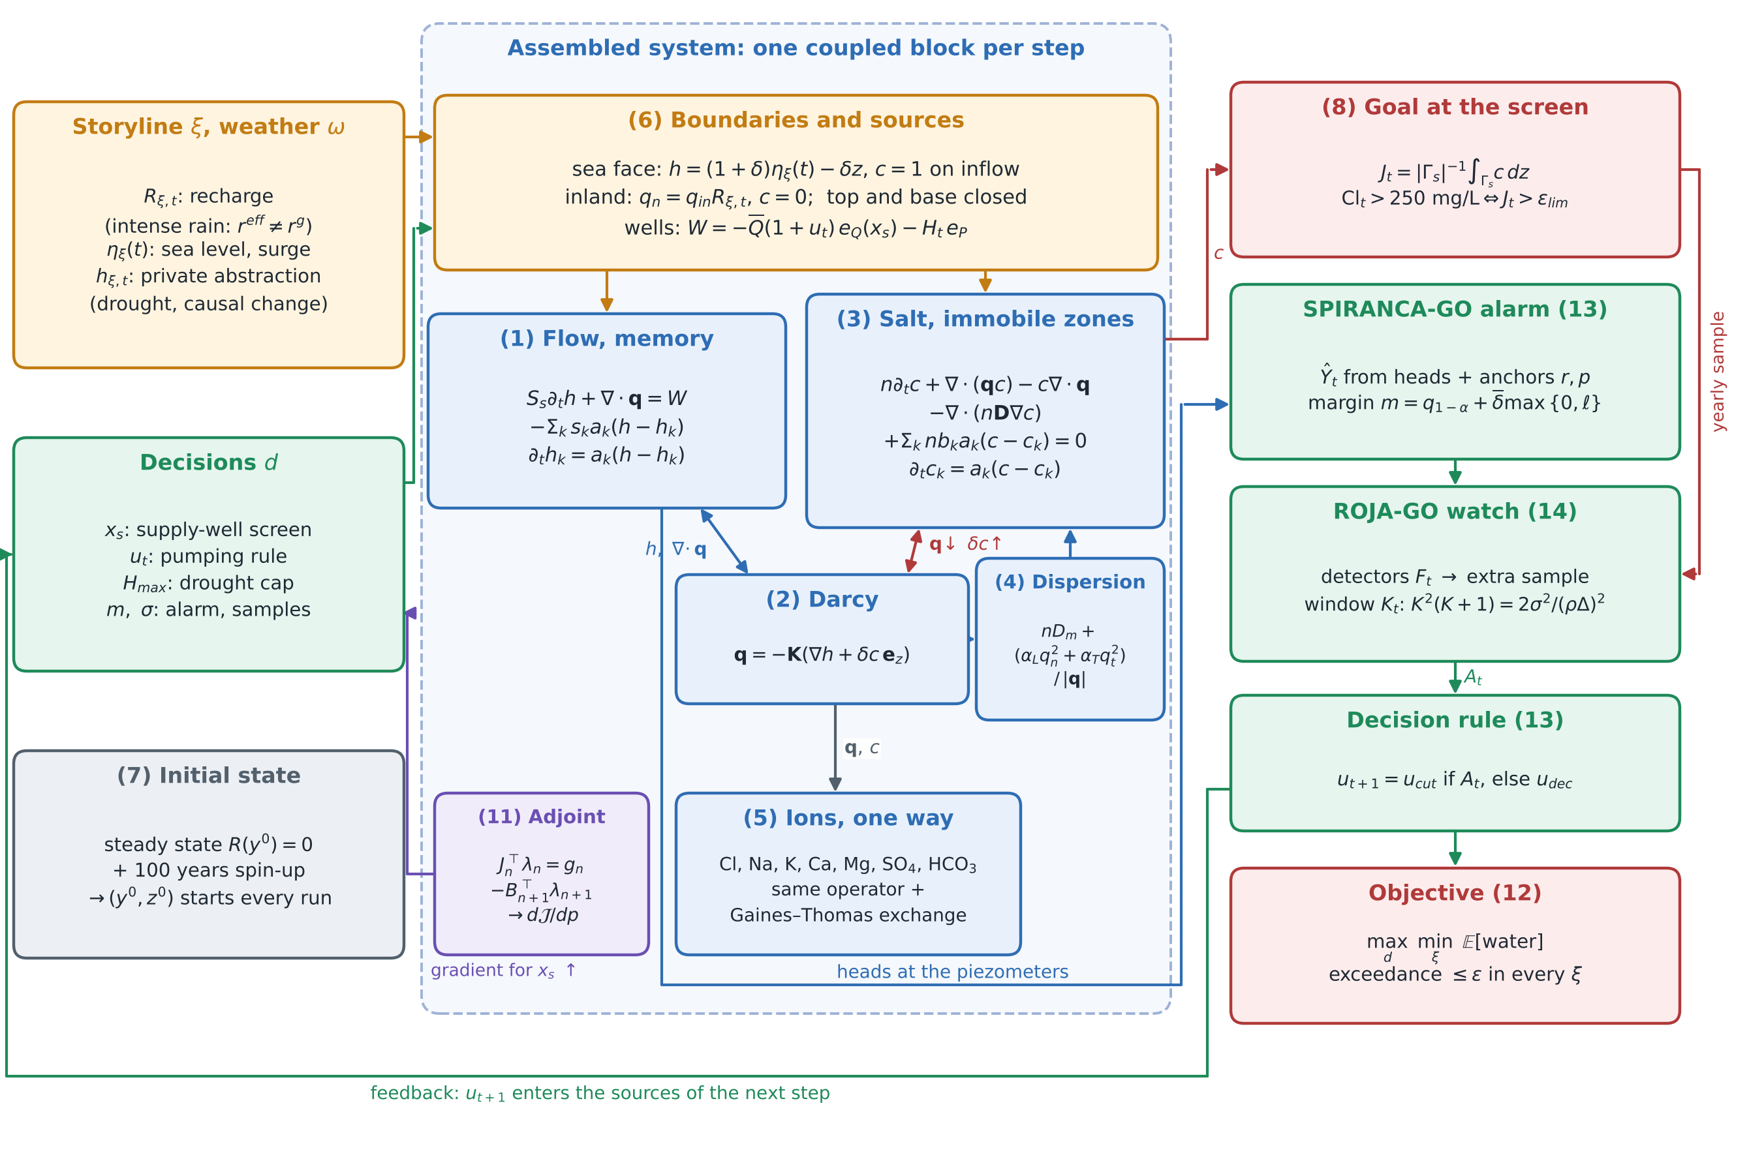
Figure 1. The assembled system: one coupled block per step (left to centre), and the decision layer that closes the loop (right); the decision returns as a source of the next step.
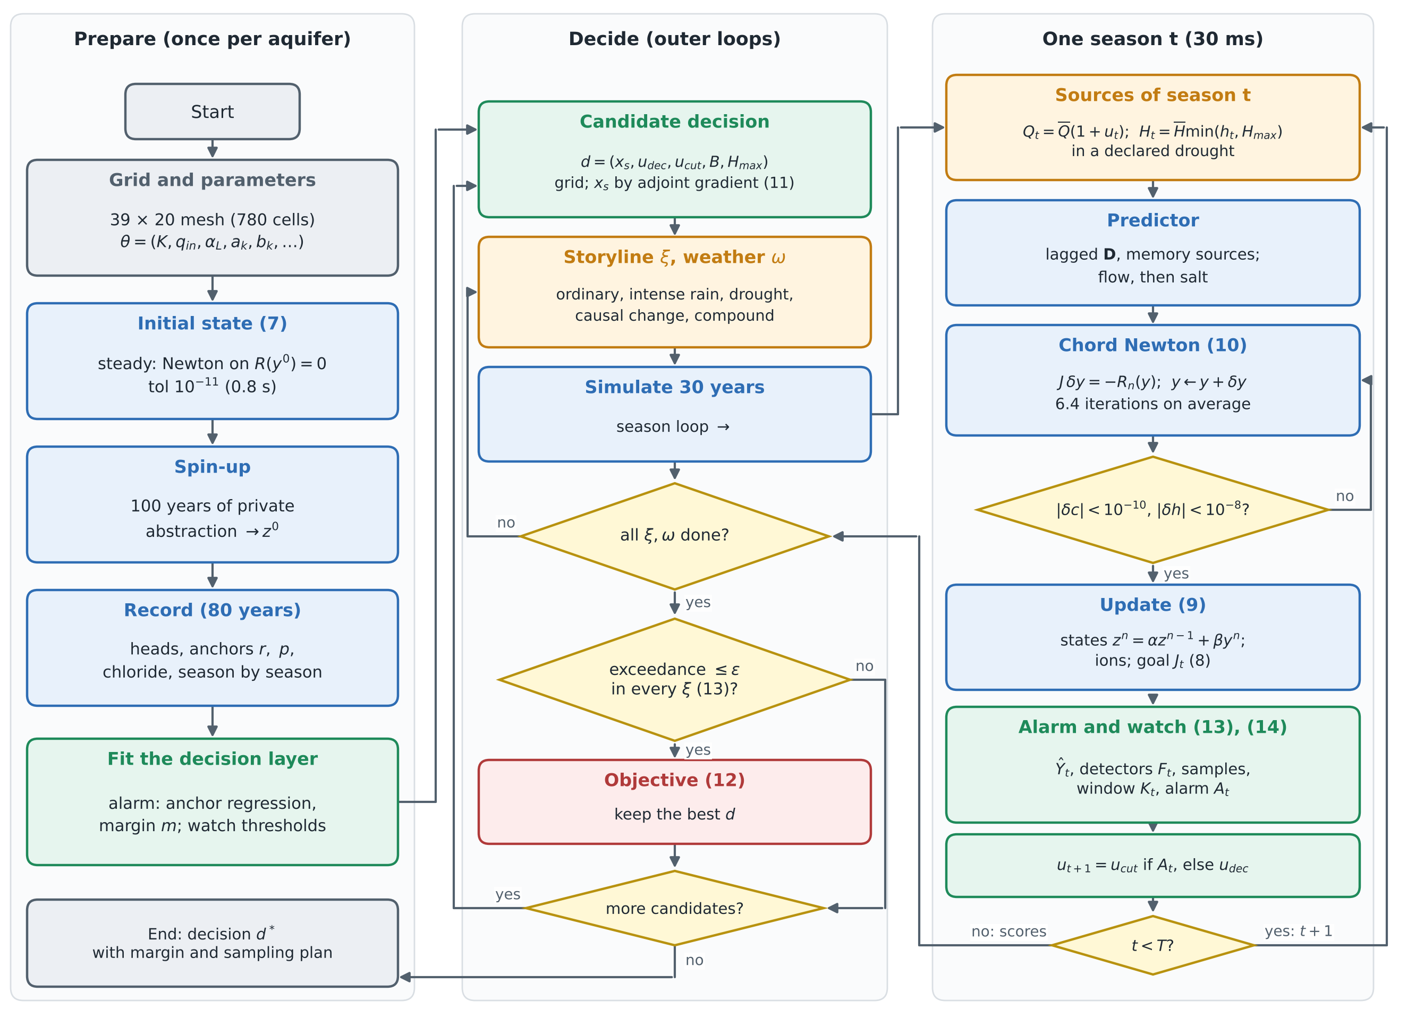
Figure 2. Flowchart of the solution: preparation (left), decision search (middle) and one season with the Newton solve and the decision layer (right).

5. The solution algorithm, step by step
Algorithm 1. Steps, equations and cost on the 39 × 20 goal-graded mesh (780 cells, 1,560 unknowns per step).
Step | Operation | Equations | Cost
1 | Grid and parameters $θ$; candidate set of decisions | — | —
2 | Steady pre-development state: Newton on $R\left(y^{0}\right)=0$, tol ${10}^{−11}$ | (1)–(6) steady | 0.8 s
3 | Spin-up: 100 years (200 steps) of private abstraction | (9)–(10) | 4 s
4 | Record: 80 years, heads at six piezometers, anchors, chloride | (9)–(10), (8) | 5 s
5 | Fit the decision layer: anchor regression (seasons 61–130), conformal margin + certificate (131–160), detector thresholds | (13), (14) | < 1 s
6 | For each candidate $d$, storyline $ξ$ and weather $ω$, for $t=1,…,60$: sources (6) → predictor → chord Newton (10) → update states, ions, $J_{t}$ → alarm and watch → decide $u_{t+1}$ | (6), (9)–(10), (8), (13)–(14) | 30 ms per season; 6.4 Newton iterations on average (13 at most)
7 | Score each storyline; check the constraint; evaluate the objective; keep the best $d$ | (12)–(13) | —
8 | Next candidate: grid over $\left(u_{dec},u_{cut},B,H_{max}\right)$; well site $x_{s}$ by the adjoint gradient | (11) | one backward sweep per storyline
9 | Output the chosen decision $d_{opt}$ with its margin and sampling plan | — | —
Remark (the closed loop costs no extra Newton work). The decision $u_{t+1}$ depends only on what is known at the end of season $t$, so it enters the next step as a known source $W^{t+1}$ in (6). The Jacobian $J$ of (10) is the same as in an open-loop run, and the decision layer adds only the evaluation of a linear predictor and two detectors per season. A candidate decision costs 5 storylines × 6 weather sequences × 60 seasons × 30 ms ≈ 1 minute per aquifer.
Innovation. One time loop carries both the coupled physics and the decision: the alarm, the watch and the rule act between two Newton solves, and the adjoint of the same residual (9) gives the gradient of the goal with respect to the well site. The inner parts of the decision problem have closed forms: the margin (13) certifies the alarm, and the window (14) minimises the re-anchoring error. Only the constraint needs simulation, so the outer search runs over five numbers.
Code: experiments/montimi_go/mg_model.py (equations (1)–(11)), experiments/spiranca_go/sv_model.py, sx_run.py and sh_run.py (decision layer (12)–(14)); diagrams: experiments/spiranca_go/review61/asm_figs.py.

