State of the art VII: what would have happened
Twenty more papers from Oxford, Caltech, Berkeley and MIT (2022–2026) on stochastic causality, counterfactual inference, causal generative models and causal attribution in the Earth system; the state of the art and the step beyond it; and SHKAKU-GO, guaranteed counterfactual bands for the recharge and the heads of a coastal aquifer when the rain had been different
Dulian Zeqiraj · November 2026 · review with a numerically tested innovation · companion to reviews I–VI (GARANCIA-GO, MATJA-GO, RESHJA-GO, ANKORA-GO, PRIRJA-GO, DYSHEMEJA-GO)
1. Outcome
• Twenty new papers, five per institution, all from 2022–2026, each with links (Section 3, Figure 1). None was a card of reviews I–VI, and none appears in the ten causal reviews written earlier for the project. They cover causal models of stochastic and dynamical systems, counterfactuals with identification theorems, counterfactual generators and digital twins, and counterfactual attribution of storms, rain, sea level and land water. Each card gives the main result, the state of the art it sets, what it cannot yet do for us, three lessons and an innovation step.
• State of the art and beyond, for the proposal (Section 2, Table 1), and a map of all one hundred and forty papers of reviews I–VII on the steps of the procedure (Section 5, Table 4).
• Innovation: SHKAKU-GO (Section 4). Reviews I–VI guaranteed bands for what happened. This review guarantees bands for what would have happened: the recharge and the head at an unmonitored well in the same 64 weeks had the rain been 40% lower (or a month later), given the rain and four loggers — Pearl's third rung, in the stochastic structural model of the aquifer. Proposition K1: the effect of the rain is free of every latent boundary condition, so a band for the recharge coefficient alone becomes a guaranteed band for the whole effect path. Proposition K2: with rain alone, counterfactual and interventional answers coincide; the value of abduction is a ratio of floors. Proposition K3: the coupling of the noise across the two worlds is not identified by any data; a band robust to it exists and has a price. Proposition K4: anchors make counterfactual guarantees checkable, but only as good as the mechanism.
• Test without shift (T21). Every guaranteed band is valid and close to the floor: 20 anchor twins give risk 0.056–0.094 at 1.06–1.18 times the floor; 300 simulated twins give 0.96–1.06 times the floor. A 40% drought lowers the head at the well by 1.94 m on average; the narrowest valid band for that effect has a half-width of 0.088 m.
• Test under shift (T21). With a 35-day field delay the simulator's mechanism is wrong: simulated twins fail (risk 0.77–0.91), and so do anchor twins for the effects (risk 0.142–0.493), because anchors cannot see a counterfactual. The enlarged law, with the delay unknown, is valid for all four goals (risk 0.083–0.097) at 1.06–1.68 times the floor. Under shifted parameters the anchor twins stay valid (0.058–0.097).
• Value of abduction and price of the coupling (T22, T23). Four loggers narrow the counterfactual floors 7.7–15.7-fold against rain alone. If the recharge error is not shared by the two worlds, the floors widen up to 13.5-fold; the band robust to every coupling keeps the risk at most 0.084.

2. State of the art and the step beyond it
Reviews I–VI (D1–D6) guarantee bands for the boundary conditions, the recharge coefficient and the inputs of a coastal aquifer when only the rain is known, and measure how close those bands come to the narrowest possible one. Every one of those bands answers a question about the world as it was. The questions a water authority asks after a dry decade are different: how much lower would the heads have been had the rain been 40% less, or the wet season a month later, in these same years, with this sea and this inflow? That is a counterfactual, the third rung of the causal ladder. It cannot be observed, even in principle, and the literature gives it either without uncertainty (attribution with a model) or with uncertainty but no guarantee (ensembles, Bayesian twins).
Text for the proposal. Causal inference for stochastic and dynamical systems now identifies counterfactual paths from impulse responses, abducts latent conditions with deep generative models, and attributes single storms and seasons with forecast systems (Section 3). None of these gives a guarantee that the counterfactual lies inside a stated band, and none says which unobserved boundary conditions matter for a counterfactual and which drop out. The project goes beyond the state of the art by giving distribution-free counterfactual bands for recharge and heads (SHKAKU-GO); by proving that the effect of a rain intervention is free of all latent boundary conditions, so that a guarantee on one coefficient becomes a guarantee on the whole effect path; by measuring the value of abduction of each monitoring design; and by stating openly the one assumption no data can test — the coupling of the noise across the two worlds — together with a band that is robust to it.
Table 1. State of the art (2022–2026) and the step beyond it. Card numbers refer to Section 3; T numbers to the tests of Section 4.
Topic | State of the art | Its limit for our problem | Our step beyond | Evidence
Counterfactuals in dynamical systems | Policy counterfactuals from impulse responses (M1); response-function emulators (M3); adjoint attribution of sea level (C1); dynamic mediation with carryover (B1) | Linear and point-valued: no band for the counterfactual path, no account of what the latent boundaries do | Effects are free of all latent boundary conditions and carry an anchor guarantee for the whole path (Proposition K1) | T21: head-effect band of 20 anchors, risk 0.093 (no shift), 0.097 (shifted parameters)
Abduction and counterfactual generators | Counterfactual likelihood with noise abduction (B2); trace replay with latent factors (M2); neural SDE generators (O5); counterfactual weather and storms (O1, B5) | The gain of abduction over intervention is not measured; rain-only counterfactuals are not recognised as interventional | Value of abduction as a ratio of floors; rung 3 collapses to rung 2 with rain alone (Proposition K2) | T22: four loggers narrow the counterfactual-head floor 15.7-fold, the head-effect floor 8.6-fold
Identification and its limits | Collider independence (O2); local causal identifiability of system parameters (O3); non-Gaussian Markov structure (C2); mixtures and latent factors (M5) | Rung-2 identification; the cross-world coupling of noise is fixed by assumption | The coupling is not identified by any data; a band robust to every coupling on a grid (Proposition K3) | T23: independent twin noise widens the counterfactual-recharge floor 5.0-fold; robust band, largest risk 0.084
Guarantees for individual effects | Conformal meta-learners (B3); sensitivity of causal machine learning (M4); probabilities of causation (B4); causal robust optimization (O4) | Exchangeable units; validity rests on conditions about unobserved counterfactuals | Anchor twins: anchors make counterfactual bands checkable, valid when the mechanism is right (Proposition K4) | T21: anchor risk 0.056–0.094 without shift; 0.142–0.493 for the effects under a 35-day delay
Mechanism error | Counterfactual attribution assumes the model mechanism (O1, B5, C1) | A wrong mechanism (here the vadose delay) is invisible to the counterfactual | Enlarged law with the delay unknown, calibrated on simulated twins | T21, T24: enlarged-law risk 0.083 (drought), 0.100–0.107 (late season) under the 35-day delay
Coastal boundary in the causal model | Sources of Mediterranean sea level (C3); pressure loading (C4); continental drying (C5) | Attribution of the boundary itself, not of the aquifer's response | The sea level as an exogenous shared history that cancels from rain effects (Proposition K1) | Section 4.1
Dispersion and mixing | No 2022–2026 causal paper on dispersion at the four institutions beyond those already used | Counterfactual chloride needs a transport model | Left for the next step, with the transport model of review I | –

3. The twenty papers
Five papers per institution, all published 2022–2026 in the version cited (Figure 1). The rules of the earlier reviews apply: direct use, a link to the institution at the time of publication (JPL for Caltech, Lawrence Berkeley National Laboratory for Berkeley), a state-of-the-art contribution and no paper that was a card before. The searches found that most theorem-level causal papers of the four institutions from these years are already in the ten causal reviews of the project; the batch therefore mixes theorems (O2–O5, C2, B1–B4, M1, M4, M5) with high-impact counterfactual attribution in the Earth system (O1, C1, C3, C4, C5, B5) and counterfactual systems (M2, M3). For Caltech no unused paper on causal generative models was found.
Verification. The hosts doi.org, arxiv.org, jmlr.org, proceedings.mlr.press, proceedings.neurips.cc and most publisher pages could not be opened in this environment, so the landing pages were reached through search results that quote them, and every card is marked partly verified; where an author list, a volume or the wording of a theorem could not be confirmed, the card says so. The journal version of O4 lacks volume and year, and M4 is forthcoming in its journal.
3.1 University of Oxford
O1 · Oxford · 2024
Event attribution of a midlatitude windstorm using ensemble weather forecasts
Shirin Ermis, Nicholas J Leach, Fraser C Lott, Sarah N Sparrow, Antje Weisheimer
Environmental Research: Climate 3(3), 035001 (2024)
Links: doi:10.1088/2752-5295/ad4200 · Oxford ORA
Affiliation and verification: Oxford ORA journal-article record; listed on the Oxford Physics pages of Ermis, Weisheimer and Leach (search summaries); the printed byline was not seen. Status: partly verified (landing pages reached through search results only).
What it does. Result (abstract wording). Using modified greenhouse-gas concentrations and changed initial conditions for ocean temperatures, the authors create two counterfactual scenarios of storm Eunice (February 2022) with the ECMWF operational ensemble, besides the forecast for the current climate. The results robustly indicate that Eunice became more intense with climate change and that similar storms will intensify with further forcing, consistently across lead times; the mechanism is more vorticity production through higher humidity in the warm conveyor belt. Methods to adjust the atmospheric initial conditions are named as an open problem. A storyline result, not a theorem; no wind or pressure numbers were seen.
State of the art it sets. Counterfactual attribution of one observed event inside an operational forecast system, conditioned on the event's own synoptic state, with lead-time consistency as the robustness check.
What it cannot yet do for us. No guarantee on the counterfactual; no principled rule for which parts of the initial state to keep.
Input parameters. None.
Dispersion coefficient. None.
Boundary conditions from rain alone. A template for "the same years, a different forcing": keep the abducted state, change the boundary forcing (the rain; by analogy the sea level) and keep only the parts of the initial state that are consistent with the counterfactual forcing — the initial-head question of the aquifer.
Innovation step for our problem. SHKAKU-GO answers their open problem for the aquifer: the initial head splits into a part in equilibrium with the forcing, recomputed in the twin, and a shared perturbation, and Proposition K1 shows that the perturbation, the sea level and the inflow all cancel in the effect. The counterfactual then carries a guarantee: 20 anchors bracket the drought effect on the head at the well with risk 0.093 (T21).

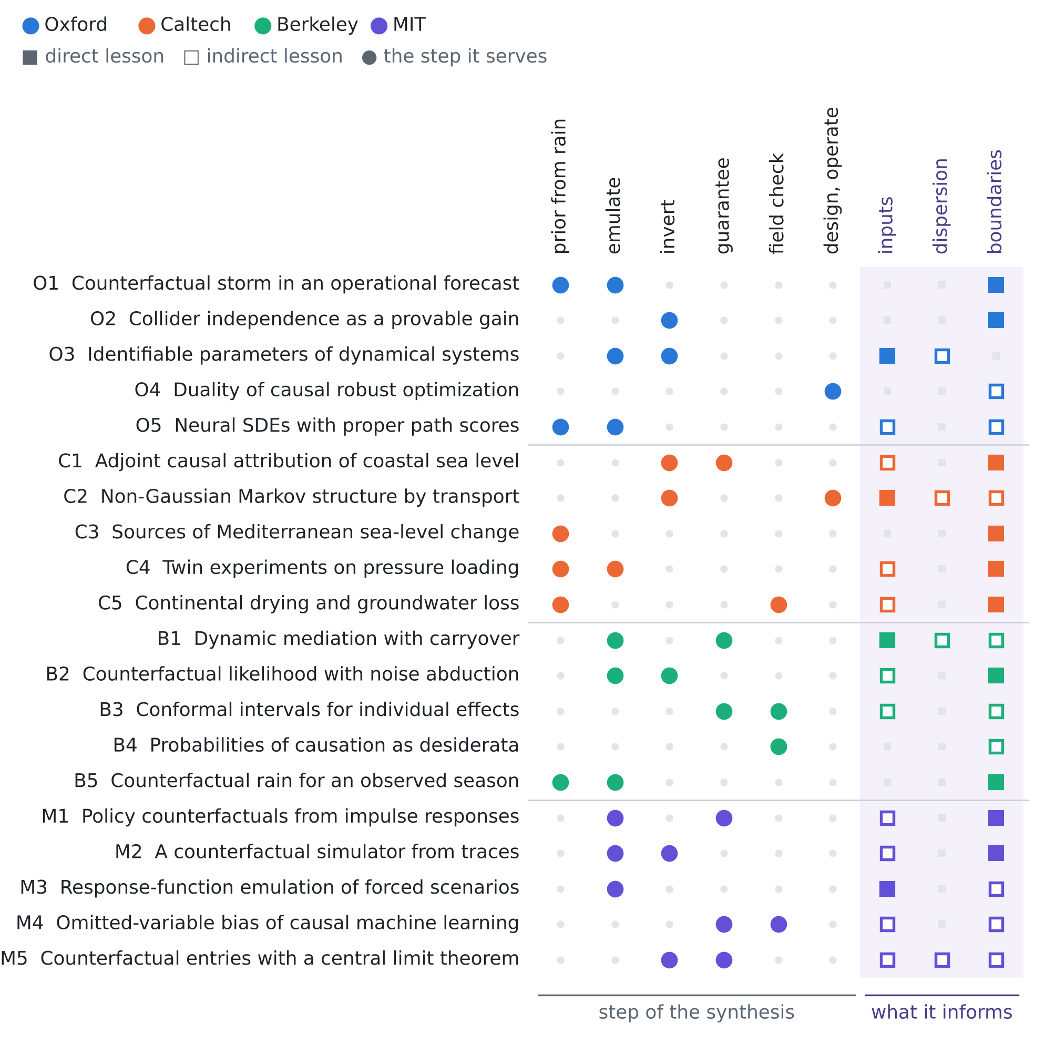
Figure 1. The twenty papers against the step of the procedure they serve and the unknown they inform. Colour gives the institution; a filled square is a direct lesson, an open square an indirect one.
O2 · Oxford · 2023
Returning The Favour: When Regression Benefits From Probabilistic Causal Knowledge
Shahine Bouabid, Jake Fawkes, Dino Sejdinovic
Proceedings of the 40th International Conference on Machine Learning (ICML 2023, oral), PMLR 202, 2885–2913
Links: arXiv:2301.11214 · ICML 2023 poster
Affiliation and verification: Bouabid and Fawkes at the Department of Statistics, University of Oxford; Sejdinovic at the University of Adelaide (search summary of the arXiv author block). Status: partly verified (landing pages reached through search results only).
What it does. Result (closely paraphrased). When the causal graph contains a collider, the independences it implies are an inductive bias for regression ("collider regression"). For RKHS hypothesis classes the authors prove a strictly positive generalisation benefit under mild assumptions and give closed-form estimators of the empirical risk minimiser, obtained by projecting the regressor onto the subspace that respects the independence; gains are shown on synthetic and climate-model data. The exact collider configuration and assumptions were not seen verbatim.
State of the art it sets. The first generalisation guarantee for using collider independence in supervised learning.
What it cannot yet do for us. Independent samples and a known graph; no time series and no counterfactuals.
Input parameters. None directly.
Dispersion coefficient. None.
Boundary conditions from rain alone. Rain and sea level (or inland inflow) are independent causes and the head is their collider: a regression of a latent boundary signal on rain and head must have a constant mean given the rain, which gives a provable variance gain.
Innovation step for our problem. The same independence is the hypothesis of Proposition K2: because the rain is independent of the latent histories, the rain alone gives only the interventional answer, and every gain of rung 3 over rung 2 comes from the heads, the colliders. Measured as the value of abduction, four loggers narrow the floor of the counterfactual head 15.7-fold and that of the head effect 8.6-fold (T22).

O3 · Oxford · 2026
Disentangling Dynamical Systems: Causal Representation Learning Meets Local Sparse Attention
Markus W. Baumgartner, Anson Lei, Joe Watson, Ingmar Posner
Proceedings of the Fifth Conference on Causal Learning and Reasoning (CLeaR 2026), PMLR 323, 119–165
Links: PMLR 323 · arXiv:2603.14483
Affiliation and verification: Posner at the Applied AI Lab, Oxford Robotics Institute; author e-mails at robots.ox.ac.uk (search summary); the other affiliations were not confirmed one by one. Status: partly verified (landing pages reached through search results only).
What it does. Result. A theorem establishes the identifiability of system parameters for local causal predictors, culminating in a graphical criterion: enforcing sparse causal relations between parameters and system components in a one-step-prediction decoder provably disentangles the representation of the system parameters, and the global causal structure gives only a lower bound on what local, state-dependent structure can guarantee. The assumptions build on mechanism-sparsity results; experiments on four synthetic domains (Dual Particle, Local Particle, Springs, Bounce) find local causal structure often necessary for full identifiability.
State of the art it sets. The first identifiability theorem for system parameters under local, state-dependent causal structure in dynamical systems.
What it cannot yet do for us. Synthetic benchmarks; deterministic decoders; no uncertainty guarantee.
Input parameters. A graphical criterion for when $T$, $S$, $κ$ and $τ$ are identifiable from few trajectories: each must act on a local, state-dependent part of the state.
Dispersion coefficient. It suggests that the dispersivity is identifiable only where it drives the state locally, in the transition zone while the interface moves (our inference).
Boundary conditions from rain alone. None directly.
Innovation step for our problem. Proposition K1 is a sharp instance for counterfactuals: the effect of a rain intervention depends on $κ$ and $τ$ only, so only those two must be identifiable and the latent histories may stay unidentified without harm. When $τ$ is wrong, anchors do not repair the effect band (risk 0.142 under a 35-day delay, T21); making $τ$ part of the law is the identifiability fix (risk 0.083).

O4 · Oxford · 2024
Duality of Causal Distributionally Robust Optimization
Yifan Jiang
SIAM Journal on Control and Optimization, doi:10.1137/25M1803954 (volume, pages and year of the journal version not seen); first version arXiv:2401.16556 (2024)
Links: doi:10.1137/25M1803954 · arXiv:2401.16556 · Oxford ORA thesis
Affiliation and verification: Oxford Mathematical Institute CV of the author and his Oxford DPhil thesis (2025) on adapted Wasserstein distances; the journal author block was not seen. Status: partly verified (landing pages reached through search results only).
What it does. Result (paraphrased). For distributionally robust optimization in a dynamic setting, where each candidate model is penalised by its adapted ("causal", non-anticipative) Wasserstein distance from a reference model, a dynamic duality formula reduces the discrete-time problem to a sequence of single-step problems; the paper is described as giving the first duality result for causal DRO in continuous time, with extensions to expected shortfall and optimal stopping. The exact assumptions were not seen.
State of the art it sets. Duality for causal (adapted-Wasserstein) distributionally robust optimization in discrete and continuous time.
What it cannot yet do for us. Decision-theoretic rather than counterfactual; the radius of the ball is not calibrated from data.
Input parameters. None.
Dispersion coefficient. None.
Boundary conditions from rain alone. A computable worst case of a recharge or head functional over all rain-process laws near the observed one that respect the flow of information (future rain cannot act on the past): a drought stress test that knows the filtration.
Innovation step for our problem. Their ball of rain laws is a natural set of interventions $P′$ for SHKAKU-GO, and in the linear test bed each counterfactual costs one matrix product (the map $g=K_{g}f$, Section 4.1), so the adapted worst case can carry a guaranteed band. Proposition K3 adds what no ball of rain laws contains: the band must also be robust to the coupling of the noise across worlds.

O5 · Oxford · 2023
Non-adversarial training of Neural SDEs with signature kernel scores
Zacharia Issa, Blanka Horvath, Maud Lemercier, Cristopher Salvi
Advances in Neural Information Processing Systems 36 (NeurIPS 2023)
Links: NeurIPS 2023 · arXiv:2305.16274
Affiliation and verification: Horvath and Lemercier at the Mathematical Institute, University of Oxford (search summary of the arXiv author block); Issa at King's College London; Salvi's affiliation not confirmed. Status: partly verified (landing pages reached through search results only).
What it does. Result (abstract wording). Neural SDEs are trained as continuous-time generative models with signature-kernel scoring rules instead of adversarial objectives; by showing strict properness of the kernel scores and consistency of the estimators, the authors give existence and uniqueness guarantees for the minimiser. Evaluation reduces to linear path-dependent PDEs with adjoint backpropagation, and the scores are defined for paths valued in infinite-dimensional spaces, so spatio-temporal data are covered. Experiments: rough volatility, conditional forecasts given an observed past (exchange rates), limit-order books (no numbers seen).
State of the art it sets. The first strictly proper, non-adversarial training objective for neural SDEs, with existence and uniqueness of the minimiser.
What it cannot yet do for us. No causal or interventional semantics; no coverage guarantee.
Input parameters. A consistent way to fit the drift and diffusion of a stochastic head or recharge model from few paths.
Dispersion coefficient. None directly.
Boundary conditions from rain alone. A structural stochastic generator of rain and inflow paths conditioned on the observed past; keeping the abducted noise path and changing the forcing gives a rung-3 generator (our construction, not theirs).
Innovation step for our problem. That construction is the twin of SHKAKU-GO with a learned generator, and Proposition K3 names what such a generator must also learn but cannot from data: the coupling of the noise across worlds. With the recharge error shared ($ρ$ = 1) the floor of the counterfactual recharge is 0.050 mm/d; with an independent twin noise ($ρ$ = 0) it is 5.0 times wider (T23), whatever the generator.

3.2 California Institute of Technology (with JPL)
C1 · Caltech · 2022
Local and Remote Forcing of Interannual Sea-Level Variability at Nantucket Island
Ou Wang, Tong Lee, Christopher G. Piecuch, Ichiro Fukumori, Ian Fenty, Thomas Frederikse, Dimitris Menemenlis, Rui M. Ponte, Hong Zhang
Journal of Geophysical Research: Oceans 127(6), e2021JC018275 (2022)
Links: doi:10.1029/2021JC018275 · PMC9285510
Affiliation and verification: Fukumori at the Jet Propulsion Laboratory, Caltech (search summaries of this record and of the 2022 JPO article page); the byline of this paper and the JPL affiliations of the other authors were not seen. Status: partly verified (landing pages reached through search results only).
What it does. Result. Adjoint sensitivities of the ECCO ocean state estimate are used to establish causality for interannual sea level at Nantucket: wind forcing explains about 67% of the variance and wind plus buoyancy forcing about 97%. The wind effect is mostly local, from the New England shelf; remote subpolar North Atlantic buoyancy forcing acts years later through slow advection, with a faster wave response within weeks; the hypothesis that Labrador Sea wind stress is a major driver is not supported. The response is linear, to first order about the state estimate.
State of the art it sets. Adjoint-based causal attribution of coastal sea level inside a dynamically consistent state estimate: fit the world (abduction), then propagate each forcing.
What it cannot yet do for us. Linear and deterministic; no uncertainty bands or coverage; no density-driven response.
Input parameters. The adjoint of the aquifer model about an assimilated state gives lagged sensitivity kernels of the heads to $T$, $S$ and $κ$; the lag of the peak rain sensitivity estimates $τ$ (our inference).
Dispersion coefficient. None.
Boundary conditions from rain alone. The sea-level boundary splits into a local, predictable part and a remote part with long lags; additive forcings drop out of a factual-minus-counterfactual difference when the response is linear.
Innovation step for our problem. Proposition K1 makes their linear attribution a guaranteed one: in the test bed the kernel of the heads to recharge is exact ($g=K_{g}f$), the effect is its product with $κΔf$, and the anchor band for $κ$ brackets the whole effect path with risk 0.093 (T21). Their "fit the world" step is the abduction whose value for the head effect is 8.6 with four loggers (T22).

C2 · Caltech · 2024
Learning Non-Gaussian Graphical Models via Hessian Scores and Triangular Transport
Ricardo Baptista, Rebecca Morrison, Olivier Zahm, Youssef Marzouk
Journal of Machine Learning Research 25(85), 1–46 (2024)
Links: JMLR 25(85) · arXiv:2101.03093
Affiliation and verification: Baptista with a caltech.edu address in the JMLR version (search summary); the earlier arXiv version lists MIT. Status: partly verified (landing pages reached through search results only).
What it does. Result (closely paraphrased). A conditional-independence score matrix $Ω$, built from integrated Hessian information of the log-density, scores whether $X_{i}$ and $X_{j}$ are independent given all other variables; $Ω$ bounds the conditional mutual information from above under stated assumptions, and the sparsity of the graph is explicitly linked to the sparsity of triangular (Knothe–Rosenblatt) transport maps. The SING algorithm estimates the density with a triangular map, thresholds $Ω$ and refits; the graph estimator is consistent; demonstrated on a chaotic system with local interactions. Exact assumptions and rates were not read.
State of the art it sets. Consistent nonparametric Markov-structure learning for continuous non-Gaussian laws, with an information-theoretic guarantee.
What it cannot yet do for us. An undirected graph (no causal direction); independent samples; no time-series version.
Input parameters. On a simulated joint ensemble of rain, recharge, heads, chloride, $T$, $S$ and $τ$, it shows which observations inform which parameters.
Dispersion coefficient. It can test whether the dispersivity is independent of the heads given the chloride; if so, only chloride facts constrain the width of the transition zone (our inference).
Boundary conditions from rain alone. It can test whether inflow and sea level are separated from the rain by the heads, i.e. which latent boundary conditions need abduction.
Innovation step for our problem. In the test bed that test has a closed-form answer, which SHKAKU-GO uses: given $κ$ and $τ$ the effect is independent of every latent history (Proposition K1), so its Markov blanket is $\{κ,τ\}$; the counterfactual level needs the histories, and four loggers narrow its floor 15.7-fold against rain alone (T22). Their score matrix computed on simulated twins would recover that blanket from samples.

C3 · Caltech · 2022
The Sources of Sea-Level Changes in the Mediterranean Sea since 1960
Francisco M. Calafat, Thomas Frederikse, Kevin Horsburgh
Journal of Geophysical Research: Oceans 127(9), e2022JC019061 (2022)
Links: doi:10.1029/2022JC019061 · Zenodo data record
Affiliation and verification: The Zenodo record of the reconstruction lists the Jet Propulsion Laboratory among three affiliations (with the National Oceanography Centre and the Green Climate Fund); which author holds it was not shown. Status: partly verified (landing pages reached through search results only).
What it does. Result. A spatial Bayesian reconstruction that combines tide gauges, altimetry and sea-level fingerprints splits Mediterranean sea level since 1960 into sterodynamic, contemporary gravitation–rotation–deformation, glacial isostatic adjustment and short-term components. Sea level fell by −0.3 ± 0.5 mm/yr over 1960–1989, because rising atmospheric pressure offset the sterodynamic rise, and rose by 3.6 ± 0.3 mm/yr over 2000–2018 through sterodynamic change and land-ice loss; since 2000 the Adriatic, Aegean and Levantine have risen fastest.
State of the art it sets. The first basin-wide Mediterranean sea-level reconstruction since 1960 with attribution by source.
What it cannot yet do for us. Coarse at the Albanian coast; vertical land motion uncertain; Bayesian credible intervals without a coverage guarantee.
Input parameters. None.
Dispersion coefficient. None directly.
Boundary conditions from rain alone. Component priors and rates for the Adriatic boundary of Fushë-Kuqe; in the structural model the sea level is an exogenous root not caused by the local rain, so a rain counterfactual keeps it at its factual value.
Innovation step for our problem. That is the shared-history assumption under which the sea level cancels from the effect (Proposition K1). Their components also define the natural sea-level counterfactual (no pressure offset), for which the same twin construction applies with the sea level, not the rain, as the intervened cause.

C4 · Caltech · 2022
Low-Frequency Dynamic Ocean Response to Barometric-Pressure Loading
Christopher G. Piecuch, Ichiro Fukumori, Rui M. Ponte, Michael Schindelegger, Ou Wang, Mengnan Zhao
Journal of Physical Oceanography 52(11), 2627–2641 (2022)
Links: doi:10.1175/JPO-D-22-0090.1
Affiliation and verification: Fukumori at the Jet Propulsion Laboratory, Caltech (search summary of the article page). Status: partly verified (landing pages reached through search results only).
What it does. Result. Twin model experiments with and without atmospheric-pressure loading, an intervention on one forcing, show that at periods of a month or longer and scales of about 300 km or more pressure loading drives basin-scale dynamic manometric sea-level variability of a few centimetres, largest over abyssal plains, shelves and marginal seas; on average it departs from the inverted-barometer response by about 10% or less at monthly and about 1% or less at annual periods.
State of the art it sets. Global interventional quantification of the dynamic (non-inverted-barometer) ocean response to pressure at satellite-gravimetry scales.
What it cannot yet do for us. Model only, without uncertainty quantification; no coupling to an aquifer; the Adriatic not studied specifically.
Input parameters. Indirectly: the barometric efficiency of a confined aquifer depends on storage (our inference).
Dispersion coefficient. None.
Boundary conditions from rain alone. At an annual step the inverted-barometer correction is good to about 1%, so pressure is a latent sea boundary that cancels from annual rain contrasts; at monthly steps in a marginal sea it may not, and should stay a nuisance.
Innovation step for our problem. Their twin experiment is the interventional design; SHKAKU-GO adds the counterfactual one, in which the data abduct the shared histories. The difference matters for levels, not for effects: with four loggers the value of abduction is 15.7 for the counterfactual head, while for the effect it acts through $κ$ alone (Proposition K1, T22).

C5 · Caltech · 2025
Unprecedented continental drying, shrinking freshwater availability, and increasing land contributions to sea level rise
Hrishikesh A. Chandanpurkar, James S. Famiglietti, Kaushik Gopalan, David N. Wiese, Yoshihide Wada, Kaoru Kakinuma, John T. Reager, Fan Zhang
Science Advances 11, eadx0298 (2025)
Links: doi:10.1126/sciadv.adx0298 · PMC12292907
Affiliation and verification: Wiese at the Jet Propulsion Laboratory (university news release); Reager's JPL affiliation not shown. Status: partly verified (landing pages reached through search results only).
What it does. Result. GRACE and GRACE-FO data since 2002 show continental drying (land outside Greenland and Antarctica) at unprecedented rates, the drying area growing each year by about twice the area of California; groundwater depletion accounts for 68% of the loss of terrestrial water storage over non-glaciated regions; four Northern Hemisphere "mega-drying" regions are identified, and the continents are reported to contribute more to sea-level rise than the ice sheets (a press framing to be checked against the paper).
State of the art it sets. A global attribution of continental drying to groundwater depletion inside the sea-level budget.
What it cannot yet do for us. About 300 km resolution; an accounting decomposition, not a causal identification of pumping against climate; no counterfactual.
Input parameters. A large-scale prior on the groundwater share of storage change (whether Albania lies in a mega-drying region was not checked).
Dispersion coefficient. None.
Boundary conditions from rain alone. Regional drying trends constrain a long-term decline of the inland inflow; the land-water term feeds the sea boundary.
Innovation step for our problem. Their accounting says what was lost; SHKAKU-GO says what would have been lost in a drier climate, with a band: in the test bed a 40% drought lowers the head at the well by 1.94 m on average, and four loggers bracket that effect with a floor half-width of 0.088 m (T21, T22).

3.3 University of California, Berkeley (with Lawrence Berkeley National Laboratory)
B1 · Berkeley · 2025
Multivariate dynamic mediation analysis under a reinforcement learning framework
Lan Luo, Chengchun Shi, Jitao Wang, Zhenke Wu, Lexin Li
The Annals of Statistics 53(1), 400–425 (2025)
Links: doi:10.1214/24-AOS2475 · arXiv:2310.16203
Affiliation and verification: Listed in the CV of Lexin Li (Biostatistics, UC Berkeley) on the Berkeley domain as "Annals of Statistics, 53, 400–425 (2025)"; the affiliation lines of the paper were not seen. Status: partly verified (landing pages reached through search results only).
What it does. Result. In a "Markov mediation process" with time-varying linear structural equations and multivariate, conditionally dependent mediators observed over many time points, an individual mediation effect is defined for each mediator through simultaneous interventions and split into an immediate effect and a delayed effect, the carryover through past treatments and mediators; a closed form, an iterative estimator with bootstrap inference and its asymptotics are given, and the method is applied to a 26-week randomized mobile-health trial. The exact conditions of the theorems were not seen.
State of the art it sets. The first definition, closed form and inference for multivariate dynamic mediation with carryover in a Markov process.
What it cannot yet do for us. Linear structural equations; interventional (rung 2) only; asymptotic; no distribution-free bands.
Input parameters. Rain → recharge (mediator) → head: $κ$ and $τ$ become the lagged path coefficients of the delayed effect, $T$ and $S$ the autoregression of the head.
Dispersion coefficient. Chloride as a second mediator (head → interface → chloride); the dispersivity sits in the coefficients of that equation.
Boundary conditions from rain alone. Rain is exogenous, like their randomized treatment; forcings that the rain does not affect enter additively and cancel in a contrast of two rain interventions (our inference).
Innovation step for our problem. SHKAKU-GO gives the finite-sample, guaranteed version for the aquifer: the effect through recharge is $κ g\left(Δf\right)$ (Proposition K1) and its anchor band holds for any law of the histories (risk 0.097 under shifted parameters, T21). Their immediate and delayed parts are visible in the late-season counterfactual: rain 30 days later raises the head at the well in 54% of the weeks and lowers it in the others.

B2 · Berkeley · 2025
Counterfactual generative modeling with variational causal inference
Yulun Wu, Louie McConnell, Claudia Iriondo
The Thirteenth International Conference on Learning Representations (ICLR 2025)
Links: ICLR 2025 poster · arXiv:2410.12730
Affiliation and verification: Wu at the University of California, Berkeley (search summary of the arXiv listing); McConnell at Genentech. Status: partly verified (landing pages reached through search results only).
What it does. Result. Theorem 1 gives a variational lower bound on the individual counterfactual log-likelihood $logp\left(Y′∣Y,X,T,T′\right)$ for variables that follow a twin-network Bayesian network, in which the factual and counterfactual outcomes and treatments are separate variables; aligning distributions on matched pairs enforces a disentangled abduction of the exogenous noise. The method beats the baselines "by a wide margin" in mean squared error on Morpho-MNIST, where true counterfactuals exist, and improves $R^{2}$ on single-cell perturbation data (numbers not seen).
State of the art it sets. A lower bound on the individual counterfactual likelihood, with noise abduction, inside a deep generative model.
What it cannot yet do for us. No coverage guarantee; identifiability conditions not seen; images and cells, not dynamical systems.
Input parameters. The abducted latent carries the aquifer-specific unknowns unchanged from the factual to the drought world.
Dispersion coefficient. None.
Boundary conditions from rain alone. Initial head, sea-level and inflow paths as exogenous noise abducted from heads and chloride; their target $p\left(Y′∣Y,X,T,T′\right)$ rather than $p\left(Y′∣X,T′\right)$ is the value of abduction.
Innovation step for our problem. In the linear test bed both laws are exact, so the value of abduction is a number: the floor of the counterfactual head falls 15.7-fold from rain alone, where rung 3 collapses to rung 2 (Proposition K2), to four loggers (T22). Their twin network takes the noise as shared across worlds; Proposition K3 shows that no data test this, and an independent twin noise widens the counterfactual recharge floor 5.0-fold (T23).

B3 · Berkeley · 2023
Conformal meta-learners for predictive inference of individual treatment effects
Ahmed M. Alaa, Zaid Ahmad, Mark van der Laan
Advances in Neural Information Processing Systems 36 (NeurIPS 2023, oral)
Links: NeurIPS 2023 · arXiv:2308.14895
Affiliation and verification: Listed on the Berkeley site of Alaa's lab and on the Berkeley Center for Targeted Machine Learning site; van der Laan is in Biostatistics, UC Berkeley. Status: partly verified (landing pages reached through search results only).
What it does. Result (close to the abstract). Split conformal prediction on the pseudo-outcomes of a CATE meta-learner gives intervals for individual treatment effects; inference is marginally valid if the pseudo-outcome conformity scores stochastically dominate the "oracle" scores evaluated on the unobserved individual effects, and common meta-learners such as the doubly robust learner satisfy a model- and distribution-free stochastic (convex) dominance condition that gives validity at practically relevant coverage levels (the exact range of $α$ was not confirmed).
State of the art it sets. The first general conformal wrapper for individual effects across meta-learners, with a checkable condition for validity.
What it cannot yet do for us. Marginal validity; exchangeable units rather than time series; overlap needed.
Input parameters. A distribution-free band for a unit-level drought effect from doubly robust pseudo-outcomes.
Dispersion coefficient. None.
Boundary conditions from rain alone. The propensity of a drought-level rain regime is known from the rain law, so the pseudo-outcomes need no treatment model (our inference).
Innovation step for our problem. Anchor twins are the aquifer's pseudo-outcomes: factual truth plus the effect of the simulator's mechanism (Proposition K4). Where the mechanism is right they equal the oracle twin and the band is valid (risk 0.056–0.094 without shift); under a 35-day delay they no longer dominate the oracle scores and validity fails for the effects (risk 0.142–0.493): the dominance condition, measured.

B4 · Berkeley · 2024
Desiderata for representation learning: a causal perspective
Yixin Wang, Michael I. Jordan
Journal of Machine Learning Research 25, paper 275, 1–65 (2024)
Links: JMLR 25 · arXiv:2109.03795
Affiliation and verification: Jordan at UC Berkeley (EECS and Statistics) in the JMLR version; Wang at the University of Michigan (search summary). Status: partly verified (landing pages reached through search results only).
What it does. Result. Non-spuriousness, efficiency and disentanglement of representations are defined as rung-3 quantities: non-spuriousness as the probability of sufficiency, efficiency as the probability of necessity, and both together as the probability of necessity and sufficiency of the representation for the label; they are made measurable through counterfactual quantities and their observable implications, which leads to the CAUSAL-REP algorithm for non-spurious representations of image and text data. The identification theorem itself was not seen.
State of the art it sets. A formal account of representation desiderata as probabilities of causation, in a top journal.
What it cannot yet do for us. Binary indicators; no time series; no bands.
Input parameters. None directly.
Dispersion coefficient. None.
Boundary conditions from rain alone. "Was the drought necessary and sufficient for the head drop, or for chloride crossing a threshold?" Under monotonicity (less rain never raises the head with the boundaries fixed) the probabilities of causation are identified (our inference).
Innovation step for our problem. Monotonicity is exactly what Proposition K3 puts at risk: with the recharge error shared, a 40% drought lowers the recharge in every week; with an independent twin noise it raises it in 12% of the weeks, while the head at the well, which smooths the noise, almost never rises (0.008%). Probabilities of causation for recharge thus depend on the untestable coupling, those for heads hardly.

B5 · Berkeley · 2022
Attribution of 2020 hurricane season extreme rainfall to human-induced climate change
Kevin A. Reed, Michael F. Wehner, Colin M. Zarzycki
Nature Communications 13, 1905 (2022); an Author Correction exists
Links: doi:10.1038/s41467-022-29379-1 · Author Correction
Affiliation and verification: Wehner at Lawrence Berkeley National Laboratory (search summary); the paper is indexed by the US Department of Energy (OSTI 1869672). Status: partly verified (landing pages reached through search results only).
What it does. Result (quoted figures). Human-induced climate change increased the extreme 3-hourly rainfall rates of the 2020 North Atlantic storms of at least tropical-storm strength by 10% and their extreme 3-day accumulations by 5% (11% and 8% for hurricane strength), with sea-surface temperatures 0.4–0.9 °C warmer in the season. Hindcasts start every 3 days from 1 June 2020; the counterfactual removes the anthropogenic signal from the initial temperature, humidity and sea-surface temperature fields (design as in the related Dorian study). What the Author Correction changed was not checked.
State of the art it sets. Whole-season, observation-conditioned (hindcast) attribution of extreme tropical-cyclone rainfall.
What it cannot yet do for us. Model-based; ensemble spread is not a calibrated band; Atlantic tropical cyclones, not Mediterranean rain.
Input parameters. None.
Dispersion coefficient. None.
Boundary conditions from rain alone. A recipe for a counterfactual rain series for the same years, conditioned on the observed weather: the forcing that a rung-3 question for Fushë-Kuqe needs.
Innovation step for our problem. Their counterfactual rain is the $P′$ of SHKAKU-GO. Fed into the twin it gives the aquifer's answer with a guarantee; but Proposition K2 says that the rain alone gives only the interventional answer, and Proposition K4 that the answer is as good as the mechanism: for a season shifted by 30 days, a wrong delay makes the anchor band for the head effect fail (risk 0.632), while the enlarged law gives 0.100–0.107 (T24).

3.4 Massachusetts Institute of Technology
M1 · MIT · 2023
What Can Time-Series Regressions Tell Us About Policy Counterfactuals?
Alisdair McKay, Christian K. Wolf
Econometrica 91(5), 1695–1725 (2023)
Links: doi:10.3982/ECTA21045 · Econometric Society · NBER w30358
Affiliation and verification: Wolf listed as "MIT and NBER" (search summaries); McKay at the Federal Reserve Bank of Minneapolis. Status: partly verified (landing pages reached through search results only).
What it does. Result (paraphrased from the abstract). In a general class of linearised structural dynamic models, the impulse responses to contemporaneous and news shocks to the prevailing policy rule — causal effects that can be estimated from time series — suffice to construct the counterfactual paths of all outcomes under an alternative rule: a sequence of shocks to the old rule is chosen so that, as the private sector perceives it, the instrument follows the path the new rule would imply. Under the assumption that policy affects private behaviour only through the expected path of the instrument (paraphrased), the counterfactuals are robust to the Lucas critique; with few identified shocks only rules whose deviations lie in their span can be evaluated.
State of the art it sets. The identification theorem for rule counterfactuals in dynamic structural models from estimable impulse responses alone.
What it cannot yet do for us. Linear; responses at all horizons needed; no uncertainty band for the counterfactual path; nothing on the coupling of noise across worlds.
Input parameters. $T$, $S$, $κ$ and $τ$ matter for a rain counterfactual only through the impulse response of the heads to rain; the response, not the parameters, is the sufficient statistic.
Dispersion coefficient. None (linear); the transition zone enters only if linearised about the present interface.
Boundary conditions from rain alone. In a linear aquifer the sea level, the inflow and the initial head enter additively and cancel in the counterfactual contrast; the analogue of their span condition is that a rain counterfactual needs only the response to the counterfactual rain.
Innovation step for our problem. Proposition K1 is their theorem for the aquifer, with uncertainty: the drought effect is $κΔg$, the push-forward of the posterior of $κ$, and 20 anchors make the whole effect path a guaranteed band (risk 0.093 without shift, T21). The span condition has a sharp analogue: under a wrong delay the band of the right $κ$ fails (risk 0.142).

M2 · MIT · 2023
CausalSim: A Causal Framework for Unbiased Trace-Driven Simulation
Abdullah Alomar, Pouya Hamadanian, Arash Nasr-Esfahany, Anish Agarwal, Mohammad Alizadeh, Devavrat Shah
20th USENIX Symposium on Networked Systems Design and Implementation (NSDI 2023), 1115–1147; Best Paper Award
Links: USENIX NSDI 2023 · arXiv:2201.01811 · MIT LIDS news
Affiliation and verification: Authors at MIT CSAIL, IDSS and LIDS (search summaries); MIT LIDS news item on the Best Paper Award. Status: partly verified (landing pages reached through search results only).
What it does. Result. Trace-driven simulators are biased because the traces depend on the algorithm in use when they were collected. CausalSim learns a causal model of the system dynamics together with latent factors per trace and replays each trace under another algorithm with the same latent conditions; unbiased simulation becomes tensor completion with extremely sparse observations, made possible by the distributional invariance of the latent factors across the arms of a randomized trial. On ten months of video-streaming data and on synthetic data it cuts the error by 53% and 61% on average against expert-designed and supervised-learning baselines. The formal theorem was not seen.
State of the art it sets. The first systems-scale counterfactual simulator: abduction of latent conditions per trace, then replay under a new intervention.
What it cannot yet do for us. Needs randomized and diverse interventions and low rank; no guaranteed bands; the noise coupling across worlds is fixed, not questioned.
Input parameters. $T$, $S$ and $κ$ belong to the shared mechanism learned once across years; each year's latent aquifer state is abducted and replayed with drought rain.
Dispersion coefficient. None directly.
Boundary conditions from rain alone. Sea level and initial head as latent per-year conditions held fixed in the twin; their invariance condition becomes "rain as-if random with respect to those conditions", the independence assumed in Proposition K2.
Innovation step for our problem. Their replay is the abduction step of SHKAKU-GO, and Proposition K3 is the warning their benchmark cannot see: the replay holds the latent noise fixed ($ρ$ = 1); if the recharge error is not shared across worlds the counterfactual recharge floor widens 5.0-fold (T23), and no trace, however long, says which coupling is true.

M3 · MIT · 2025
Rapid Emulation of Spatially Resolved Temperature Response to Effective Radiative Forcing
Christopher B. Womack, Paolo Giani, Sebastian D. Eastham, Noelle E. Selin
Journal of Advances in Modeling Earth Systems 17(1), e2024MS004523 (2025)
Links: doi:10.1029/2024MS004523 · DSpace@MIT
Affiliation and verification: Deposited in DSpace@MIT and listed by the MIT Center for Sustainability Science and Strategy; per-author affiliations were not seen. Status: partly verified (landing pages reached through search results only).
What it does. Result. Spatially resolved impulse-response functions of near-surface temperature to effective radiative forcing are obtained by direct deconvolution of CMIP6 output; the emulator reproduces five CMIP6 experiments with a mean global relative error of 1.49% at mid-century and 1.25% at the end of the century and runs a 1000-member ensemble in under a second. The remaining error is attributed to state-dependent feedbacks such as nonlinear Arctic sea-ice melt. No formal theorem.
State of the art it sets. Fast, spatially resolved linear-response emulation of forced scenarios, with the limits of superposition located.
What it cannot yet do for us. Deterministic, without bands or observation noise; linear.
Input parameters. Deconvolving rain against heads gives the response whose lag encodes $τ$ and whose size encodes $κ$, $T$ and $S$.
Dispersion coefficient. None.
Boundary conditions from rain alone. Sea-level and inflow contributions stay in the baseline and cancel between scenarios; state-dependent feedback is the warning for a moving interface.
Innovation step for our problem. The map $g=K_{g}f$ of the test bed is such a response function, exact to 10⁻¹⁴ (Section 4.1), so every counterfactual of SHKAKU-GO costs one matrix product. What their emulator lacks is the band: a 40% drought lowers the head at the well by 1.94 m on average, and with four loggers the narrowest valid band for that effect has a half-width of 0.088 m (T21).

M4 · MIT · 2022
Long Story Short: Omitted Variable Bias in Causal Machine Learning
Victor Chernozhukov, Carlos Cinelli, Whitney K. Newey, Amit Sharma, Vasilis Syrgkanis
The Review of Economics and Statistics, forthcoming, doi:10.1162/REST.a.1705 (volume and year not confirmed); NBER Working Paper 30302 (2022)
Links: doi:10.1162/REST.a.1705 · NBER w30302 · arXiv:2112.13398
Affiliation and verification: Chernozhukov and Newey at the Department of Economics, MIT (search summaries). Status: partly verified (landing pages reached through search results only).
What it does. Result (gist). For causal parameters that are linear functionals of the outcome regression (average effects, average derivatives, policy effects), the omitted-variable bias between the "short" parameter with the observed confounders and the "long" one with latent confounders is bounded through the long and short Riesz representers. The bound depends only on how much the latent variables add to the variation of the outcome regression and of the Riesz representer, and its identifiable parts are estimated by debiased machine learning with valid inference; plausibility judgments on the explanatory power of the omitted variables then give sharp bias bounds.
State of the art it sets. The general nonparametric sensitivity analysis and partial identification for debiased machine-learning causal functionals.
What it cannot yet do for us. Independent, static data and linear functionals; neither time series nor unit-level (rung-3) counterfactuals.
Input parameters. Unobserved heterogeneity of $T$, $S$ or $κ$ when estimating rain-to-head effects across wells gives bounds instead of points.
Dispersion coefficient. None.
Boundary conditions from rain alone. Latent inflow or sea level as omitted confounders: a latent with no link to the rain adds no bias, the regression analogue of Proposition K1.
Innovation step for our problem. Proposition K3 is a sensitivity analysis of the same spirit on rung 3. Its sensitivity parameter is the cross-world coupling $ρ$, which no data identify; the coupling-robust band is the union over a grid of $ρ$ in [0, 1], valid for every $ρ$ on the grid (largest risk 0.084, T23), at 3.05–13.95 times the width of the shared-noise band when the noise is in fact shared.

M5 · MIT · 2023
Causal Matrix Completion
Anish Agarwal, Munther Dahleh, Devavrat Shah, Dennis Shen
Proceedings of the Thirty Sixth Conference on Learning Theory (COLT 2023), PMLR 195, 3821–3826 (extended abstract; full paper arXiv:2109.15154)
Links: PMLR 195 · arXiv:2109.15154
Affiliation and verification: Agarwal, Dahleh and Shah at MIT (LIDS) and Shen at UC Berkeley (talk page and LIDS listing in search summaries). Status: partly verified (landing pages reached through search results only).
What it does. Result. In a low-rank latent-factor potential-outcomes model where missingness may depend on the latent factors (missing not at random) and under a linear-span-inclusion condition, the Synthetic Nearest Neighbours estimator — synthetic controls combined with nearest neighbours over anchor rows and columns — is finite-sample consistent and asymptotically normal for every missing counterfactual entry; this gives entry-wise consistency and a central limit theorem for matrix completion under missing-not-at-random data. The theorem is in the arXiv version; the COLT version is an extended abstract.
State of the art it sets. The first entry-wise central limit theorem for counterfactual entries under missing-not-at-random data.
What it cannot yet do for us. Asymptotic in units and periods; a fully observed anchor block is needed; Fushë-Kuqe has few heads.
Input parameters. In a wells × years matrix of heads, $T$ and $S$ become latent row factors that are never identified; the counterfactual head of a well in a drought year it did not see is borrowed from wells and years that did.
Dispersion coefficient. Chloride entries likewise, but only if low rank, which is doubtful near the front.
Boundary conditions from rain alone. Year-specific sea level and inflow are absorbed in latent column factors; monitoring gaps caused by them are allowed.
Innovation step for our problem. SHKAKU-GO gives the finite-sample counterpart for the head at an unmonitored well (1.5 km, between two loggers): its counterfactual band calibrated on 20 anchor twins is valid without shift (risk 0.077) and under shifted parameters (0.081), at 1.11 times the floor (T21).

4. Innovation: SHKAKU-GO, guaranteed counterfactuals
4.1 The two worlds
The test bed of reviews I–VI (D7; 32 cells, 64 weeks, a pumping well at 1.5 km, loggers at 0.25, 1.25, 2.75 and 4.25 km) is a structural causal model. Its exogenous variables are the daily rain $P$, the latent histories $z$ (sea level $η$, inland inflow $q_{L}$, recharge error $e$, initial-head perturbation $δh_{0}$), the recharge coefficient $κ$ and the vadose delay $τ$; the rain is independent of the rest. Its mechanisms are
$$f_{τ}=E_{τ}⋆P, r=κ f_{τ}+e, h=G z+κ g\left(f_{τ}\right)+c_{Q},$$ | (1)
where $E_{τ}$ is the Erlang-2 vadose filter, $G$ the head response to the latent histories, $c_{Q}$ the response to the known pumping and $g$ the head response to recharge, including the steady initial head of the mean recharge. $g$ is linear: $g\left(f\right)=K_{g}f$ with a fixed matrix $K_{g}$, checked against the solver to 10⁻¹⁴. The question "what if the rain had been $T\left(P\right)$?" is answered in a twin world that shares the histories, $κ$ and $τ$:
$$f′_{τ}=E_{τ}⋆T\left(P\right), r′=κ f′_{τ}+e′, h′=G z′+κ g\left(f′_{τ}\right)+c_{Q},$$  $$e′=ρ e+\sqrt{1−ρ^{2}} ξ,$$ | (2)
with $z′$ equal to $z$ except that the recharge error is $e′$, and $ξ$ a fresh draw with the law of $e$. $ρ=1$ is Pearl's shared noise: the unmodelled part of the recharge would have been the same. $ρ<1$ says it would have been partly different. The goals are the weekly effects and the weekly counterfactual levels at the pumping well, where no logger stands:
$$Δr=κ \left(f′_{τ}−f_{τ}\right)+\left(e′−e\right), Δh=κ g\left(f′_{τ}−f_{τ}\right)+G_{e} \left(e′−e\right), r′=r+Δr, h′=h+Δh,$$ | (3)
$G_{e}$ being the head response to the recharge error. Two interventions are tested: a drought $T\left(P\right)=0.6P$ and a late season, the rain arriving 30 days later. Given the data $y$ the goals are linear in the latent Gaussian histories for each $κ$, so their exact counterfactual law under any working law is a mixture over a 1201-point grid of $logκ$ (49 delays × 1201 for the enlarged law with the delay unknown, log-uniform on 7–56 d). Bands are 90% bands with an expected share of weeks outside at most $α$ = 0.10 (review I); the floor $W^{⋆}$ is the Neyman–Pearson floor of review VI computed under the real law. Methods: the exact counterfactual law under the simulator's law $P$ (centre $±λ$ sd), with $λ$ calibrated on 300 simulated twins, on 20 anchor twins (300 draws; Proposition K4), or set on the field cases themselves ("λ known"); and the enlarged law calibrated on 300 simulated twins of that law. Real laws as in reviews IV and VI: no shift, a 35-day field delay, shifted parameters; 600 field cases each.
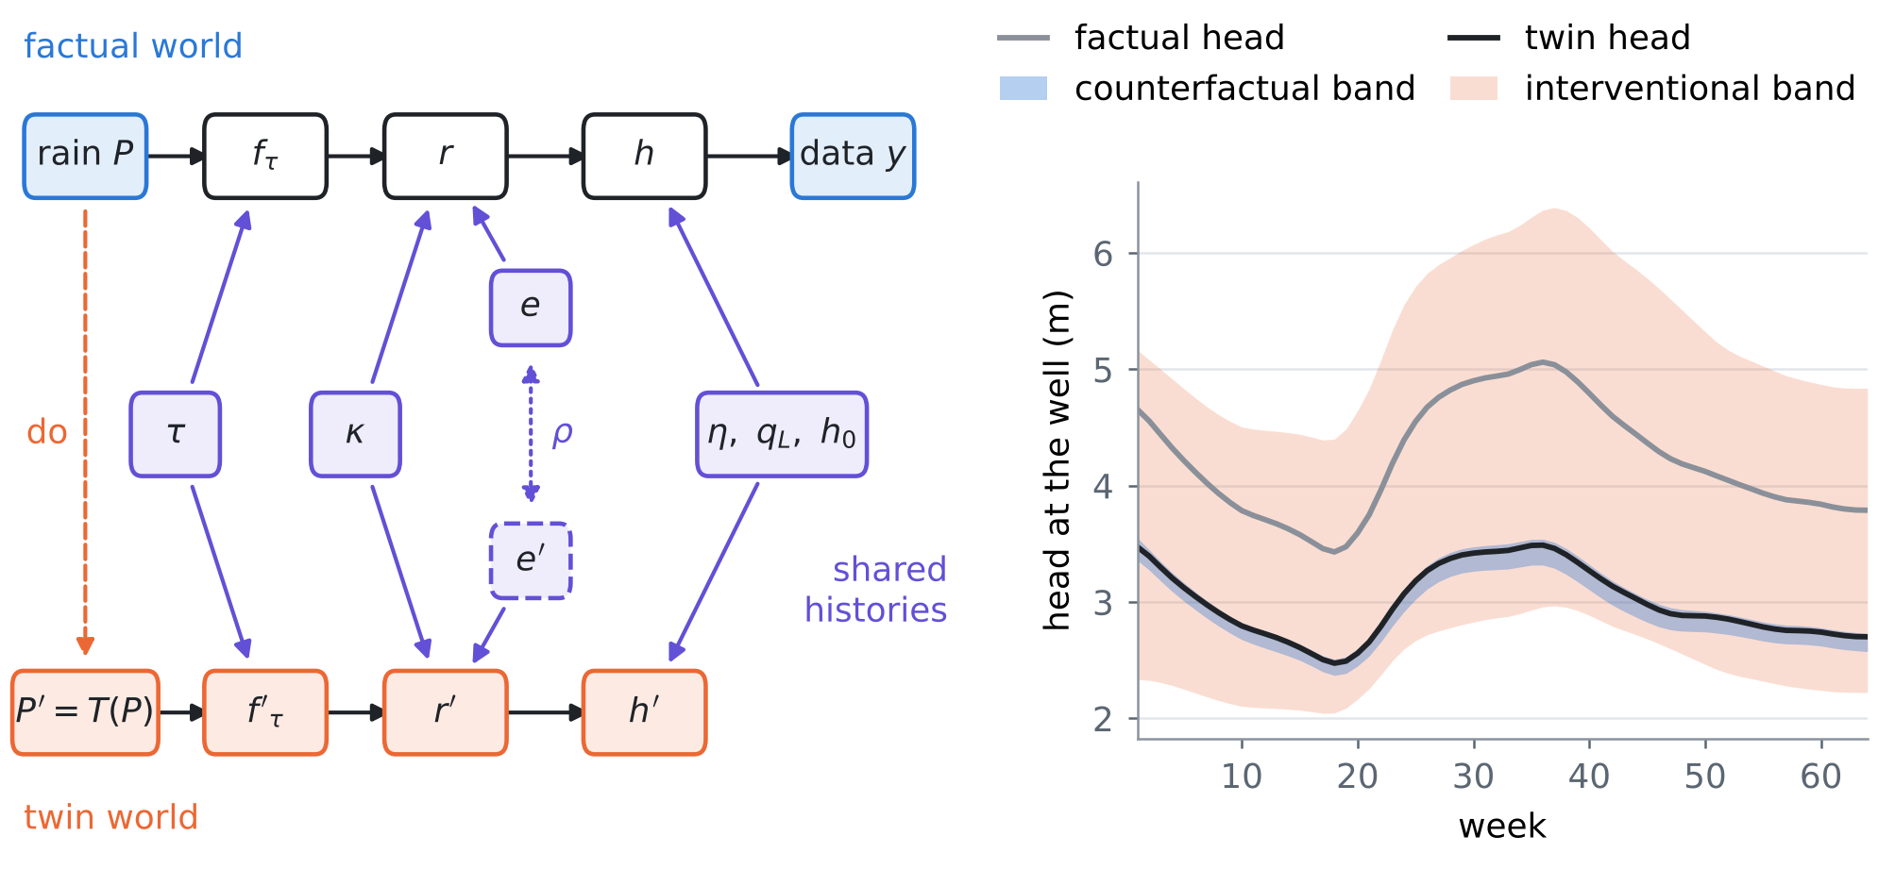
Figure 2. Left: the twin network of the aquifer. The rain is intervened on (dashed); the delay, the recharge coefficient and the histories of sea level, inflow and initial head are shared by the two worlds; the recharge errors are coupled by $ρ$. Right: one field case. The factual head at the well (grey), the head the twin world would have had under a 40% drought (black), the exact counterfactual band given the rain and four loggers (blue) and the interventional band given the rain alone (orange), both mean ± 1.645 sd.
4.2 Guarantees
Proposition K1 (the effect is free of the latent boundaries). Let $ρ=1$. Then $Δr=κ a^{r}$ and $Δh=κ a^{h}$ with $a^{r}=f′_{τ}−f_{τ}$ and $a^{h}=g\left(f′_{τ}−f_{τ}\right)$: the effect does not depend on the sea level, the inland inflow, the recharge error or the initial head. Hence (i) its counterfactual law given any data is the push-forward of the posterior of $\left(κ,τ\right)$, and for a known $τ$ the standardised score of the band "posterior mean $±λ$ sd" is the same in every week; (ii) if $τ$ is known and $C$ is a set for $κ$ with $Pr\left(κ∉C\right)≤α$, then $\{κa_{w}:κ∈C\}$ contains the whole effect path, all weeks at once, with probability at least $1−α$, for every law of the rain and of the histories; (iii) with $m$ anchors exchangeable with the field case in which $κ$ was measured, the conformal set for $κ$ is such a $C$.

Proof. Subtract (1) from (2): $c_{Q}$ cancels, $Gz′−Gz=G_{e}\left(e′−e\right)$ vanishes at $ρ=1$, and $κg\left(f′_{τ}\right)−κg\left(f_{τ}\right)=κg\left(f′_{τ}−f_{τ}\right)$ because $g$ is linear (its steady initial head is linear in the mean recharge). (i) The effect is a function of $\left(κ,τ\right)$; for a known $τ$ its posterior mean and sd in week $w$ are $a_{w}\hat{κ}$ and $\left|a_{w}\right|σ_{κ}$, so the score is $\left|κ−\hat{κ}\right|/σ_{κ}$. (ii) For each $w$, $κ↦κa_{w}$ is monotone, so $κ∈C$ puts every $κa_{w}$ in the image. (iii) The conformal guarantee of an exchangeable sample (A2). □
Proposition K2 (rain alone gives only the interventional answer). Because the rain is independent of the other exogenous variables: (i) given the rain alone, the counterfactual law of every goal equals its interventional law under $do\left(P:=T\left(P\right)\right)$; (ii) for every design, the floor of the counterfactual band is at most the floor of the interventional band, and their ratio $V=W_{int}^{⋆}/W_{cf}^{⋆}≥1$ is the value of abduction of the design; (iii) for the effects at $ρ=1$, abduction acts only through the posterior of $κ$ and $τ$.

Proof. (i) Given $P$ alone, the posterior of $\left(z,κ,τ,ξ\right)$ is its prior. (ii) The interventional band uses $P$ only; averaged over $y$, its coverage of the twin goal equals its interventional coverage, so it is a valid counterfactual procedure, and the floor over all procedures that may also use $y$ (review VI, F1) is no larger. (iii) Proposition K1 (i). □
Proposition K3 (the coupling across worlds is not identified). (i) The joint law of all factual quantities, and every interventional law, are the same for every $ρ$; the counterfactual law of the goals is not. No data, observational or experimental, determine $ρ$. (ii) For $ρ<1$ the effect involves the recharge error, and given $y$ and $κ$, $Var\left(e′−e\right)={\left(1−ρ\right)}^{2}V+\left(1−ρ^{2}\right)Σ_{e}$ with $V=Var\left(e∣y,κ\right)≼Σ_{e}$, which decreases in $ρ$ on [0, 1]: at $ρ=0$ the data cannot narrow the noise part at all. (iii) If $B_{ρ}$ is calibrated on simulated twins with coupling $ρ$ for each $ρ$ in a grid $R$, the union $⋃_{ρ∈R}B_{ρ}$ has risk at most $α$ under every coupling in $R$.

Proof. (i) $ρ$ enters only $e′$, which appears in no factual quantity; in a single interventional world $e′$ has the law of $e$ whatever $ρ$. (ii) $e′−e=\left(ρ−1\right)e+\sqrt{1−ρ^{2}} ξ$ with $ξ$ independent of $\left(y,e\right)$; the derivative of the variance is $−2\left(1−ρ\right)V−2ρΣ_{e}≼0$. (iii) The union contains $B_{ρ′}$, whose guarantee holds when the twins have coupling $ρ′$. □
Proposition K4 (anchor twins). Let anchors be cases exchangeable with the field case in which the histories and $κ$ were measured, and let the anchor twin of a goal be its factual value plus the effect computed with the simulator's mechanism (delay $τ_{P}$, $ρ=1$). (i) If the real mechanism is the simulator's, anchor twins are true twins, and a band calibrated on $m$ of them by conformal risk control has risk at most $α$ for every law of the exogenous variables. (ii) If the real delay $τ_{Q}$ differs, the anchor twin of an effect is off by $κ \left(a_{τ_{Q}}−a_{τ_{P}}\right)$, and no number of anchors removes this error: a counterfactual guarantee is only as good as its mechanism.

Proof. (i) The scores of anchor twins and of the field twin are exchangeable; apply conformal risk control (A1; review IV, A1). (ii) Subtract (3) under the two delays. □
What is new. (1) Distribution-free counterfactual bands for the recharge and the heads of an aquifer under a rain intervention, for the same years and given the data: rung-3 inference with a guarantee. (2) The cancellation theorem: the effect of the rain is free of every latent boundary condition, and an anchor band for the recharge coefficient becomes a simultaneous guarantee for the whole effect path (Proposition K1). (3) The value of abduction of a monitoring design as a ratio of floors, and the collapse of rung 3 to rung 2 with rain alone (Proposition K2). (4) The untestable coupling of noise across worlds made explicit, priced, and a band robust to it (Proposition K3). (5) Anchor twins, which make counterfactual guarantees checkable on real anchors, their failure under a wrong mechanism, and its repair by an enlarged law (Proposition K4). To our knowledge none of these appears in the one hundred and forty papers of reviews I–VII.

4.3 Tests
T21: drought counterfactuals under three real laws. Figure 3 and Table 2, four loggers. No shift. All bands are valid within sampling error and close to the floor: simulated twins 0.96–1.06 times the floor (risk 0.091–0.113; one calibration set of 300 twins, so a risk of 0.11 is within its sampling error), anchor twins 1.06–1.18 (risk 0.056–0.094), the enlarged law 1.06–1.46 (risk 0.085–0.098). The exact counterfactual law costs almost nothing in band shape: with $λ$ set on the field cases it is 0.99–1.10 times the floor (an in-sample multiplier, so a ratio a little below 1 is sampling noise). For the effects the anchor band is exactly the push-forward of the conformal band for $κ$ (Proposition K1): its score is the same in every week. Delay. The simulator's mechanism is wrong: simulated twins give bands of 0.85–1.02 times the floor that are invalid (risk 0.77–0.91) — every band narrower than the floor was invalid, as review VI F1 requires. Anchor twins remain wide but invalid for the effects (risk 0.142–0.493) and for the levels (risk 0.124–0.204), at 5.25–6.87 times the floor: they are computed with the wrong delay (Proposition K4 (ii)). The enlarged law is valid for all goals (risk 0.083–0.097) at 1.06–1.68 times the floor. Shifted parameters. The mechanism is right but the prior is wrong: simulated twins fail (risk 0.174–0.278), anchor twins are valid (risk 0.058–0.097) at 1.15–1.29 times the floor, while the enlarged law, whose prior does not contain this shift, is not repaired (risk 0.188–0.260). Anchor twins guard against a wrong prior, the enlarged law against the structural error it was built for, and neither against the other's failure.
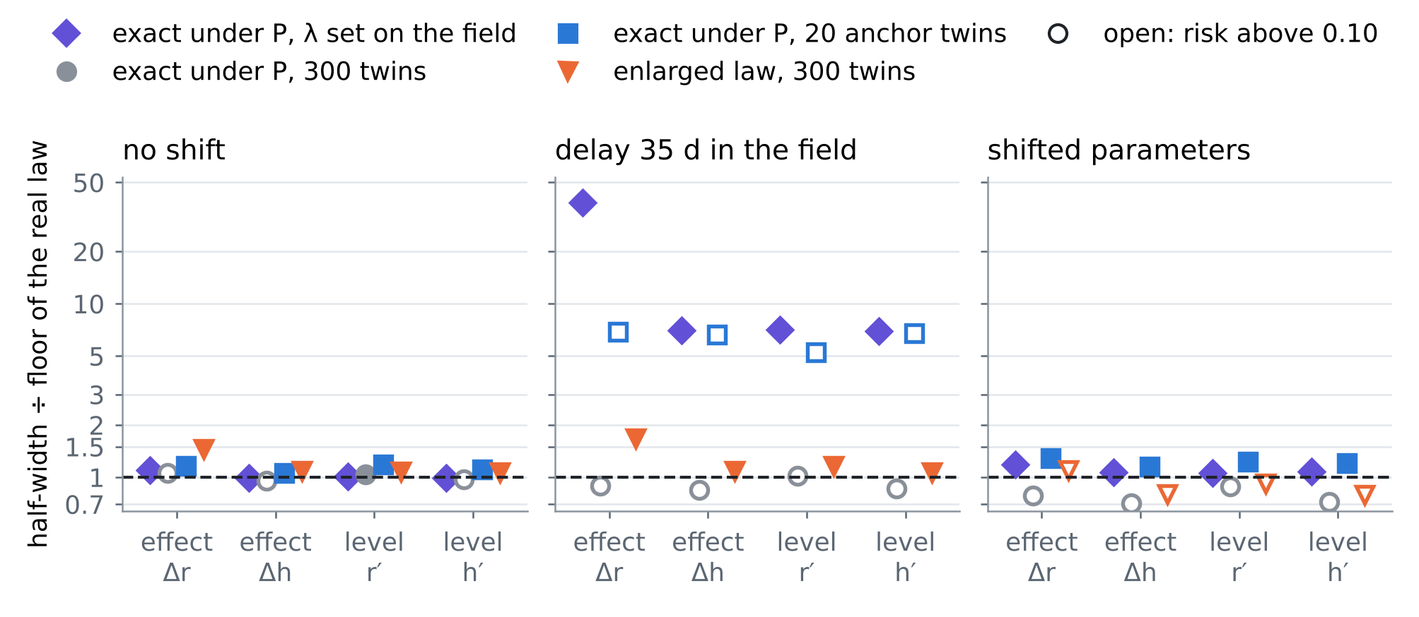
Figure 3. T21: half-width of each counterfactual band divided by the floor of the real law, for a 40% drought: effects on recharge and on the head at the well, counterfactual recharge and head. Open markers are invalid bands (risk above 0.10).
Table 2. T21: the floor (mean half-width; recharge mm/d, head m) and each band as a multiple of it, with its risk in brackets, for a 40% drought and four loggers.
Band | Effect Δr | Effect Δh | Level r′ | Level h′
No shift: floor $W^{⋆}$ | 0.0189 | 0.0883 | 0.0501 | 0.0893
exact under P, λ known | 1.10 | 0.99 | 1.01 | 0.99
exact under P, 300 twins | 1.06 (0.113) | 0.96 (0.113) | 1.04 (0.091) | 0.97 (0.107)
exact under P, 20 anchor twins | 1.17 (0.094) | 1.06 (0.093) | 1.18 (0.056) | 1.11 (0.077)
enlarged law, 300 twins | 1.46 (0.085) | 1.09 (0.092) | 1.08 (0.098) | 1.06 (0.096)
Delay 35 d: floor $W^{⋆}$ | 0.0222 | 0.0986 | 0.0507 | 0.0995
exact under P, λ known | 38.36 | 7.01 | 7.09 | 6.93
exact under P, 300 twins | 0.89 (0.914) | 0.85 (0.906) | 1.02 (0.771) | 0.86 (0.903)
exact under P, 20 anchor twins | 6.87 (0.493) | 6.61 (0.142) | 5.25 (0.204) | 6.75 (0.124)
enlarged law, 300 twins | 1.68 (0.083) | 1.09 (0.083) | 1.16 (0.097) | 1.06 (0.086)
Shifted parameters: floor $W^{⋆}$ | 0.0252 | 0.1172 | 0.0587 | 0.1181
exact under P, λ known | 1.18 | 1.07 | 1.06 | 1.08
exact under P, 300 twins | 0.78 (0.278) | 0.71 (0.278) | 0.88 (0.174) | 0.72 (0.271)
exact under P, 20 anchor twins | 1.29 (0.088) | 1.15 (0.097) | 1.23 (0.058) | 1.21 (0.081)
enlarged law, 300 twins | 1.10 (0.242) | 0.80 (0.255) | 0.92 (0.188) | 0.79 (0.260)

T22: the value of abduction. Figure 4. With rain alone the counterfactual floor is the interventional floor (Proposition K2 (i)): the rung-3 question has no better answer than the rung-2 one. One logger at 2 km already buys 2.8–9.7-fold, four loggers 7.7–15.7-fold and eight 8.9–16.4-fold (effect on recharge, effect on the head, counterfactual recharge, counterfactual head in that order: 8.6, 8.6, 7.7, 15.7 with four loggers). The floors never rose when loggers were added. For the effects all of this value comes through $κ$ (Proposition K2 (iii)); a tide gauge, which informs the sea level only, multiplies the value of abduction by 1.00 for the effects and by 1.00–1.03 for the levels.
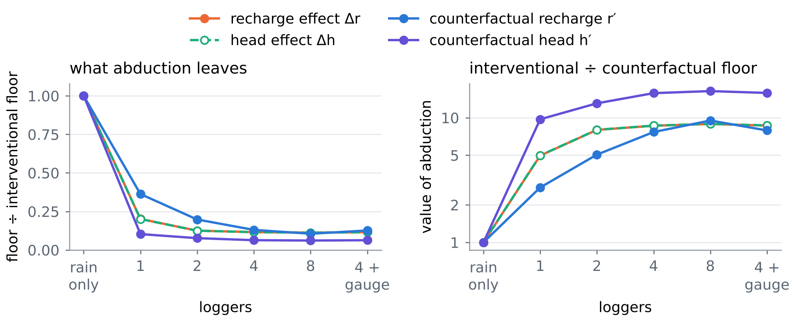
Figure 4. T22: the counterfactual floor of six designs relative to the interventional floor (rain only; left) and its inverse, the value of abduction (right). 40% drought, no shift, shared noise. The two effects coincide (dashed over solid): both are the posterior of κ, scaled week by week (Proposition K1).
T23: the coupling across worlds. Figure 5. If the recharge error of the twin world is only partly the factual one, the counterfactual floors widen: at $ρ$ = 0.6 by 2.2–10.6-fold, at $ρ$ = 0 by 2.7–13.5-fold (effect on recharge, effect on the head, counterfactual recharge and head). The band that assumes shared noise is then invalid (risk 0.509–0.881 at $ρ$ = 0.6, 0.635–0.923 at $ρ$ = 0); bands calibrated with the right coupling are valid (0.086–0.127), but the right coupling is never known (Proposition K3 (i)). The union over the grid $ρ$ ∈ {0, 0.25, 0.5, 0.75, 0.9, 1} is valid in every case (risk 0.000–0.084, including $ρ$ = 0.6, which is not on the grid), at 2.97–14.82 times the floor when the noise is in fact shared and 1.08–1.10 when it is independent. The coupling also decides monotonicity: with shared noise a 40% drought lowers the recharge in every week; with independent noise it raises it in 12% of the weeks, while the head at the well, which smooths the noise, rises in 0.008% of them.
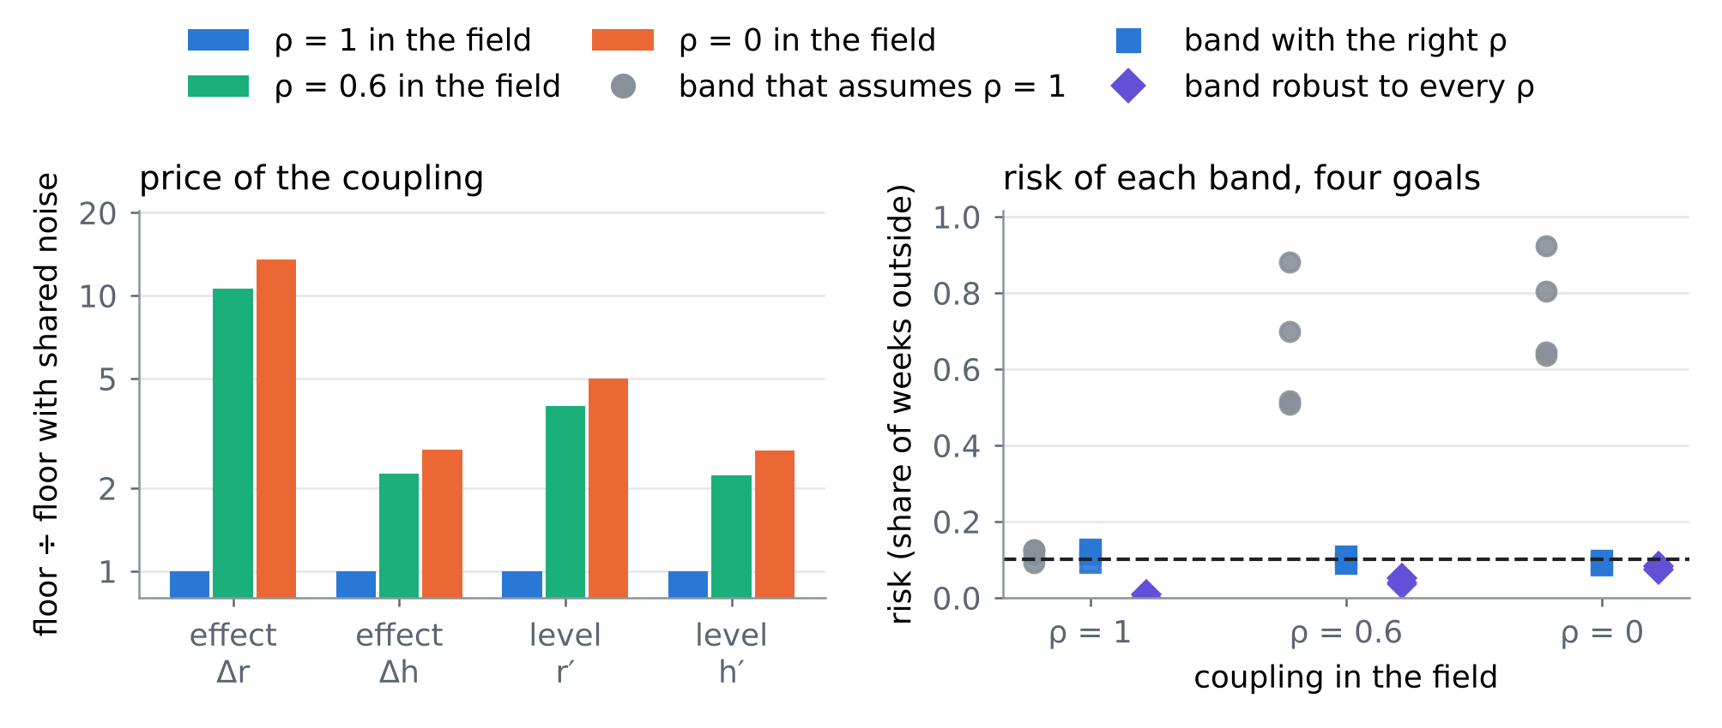
Figure 5. T23: the counterfactual floor for three couplings of the recharge error across worlds, relative to shared noise (left), and the risk of the band that assumes shared noise, of the band with the right coupling and of the band robust to every coupling on the grid (right; one marker per goal; dashed: α = 0.10). 40% drought, four loggers, no shift.
T24: a late wet season. Table 3. With the rain 30 days later the effect changes sign within the year (the head at the well is higher in 54% of the weeks) and depends strongly on the delay. Without shift every guaranteed band is valid within the sampling error of one calibration set (risk 0.056–0.112); the enlarged law pays 1.32–2.49 times the floor for not knowing the delay, much more than for the drought, because a shift in timing is what the delay controls. Under the 35-day delay simulated twins and anchor twins fail (risk 0.878–0.965 and 0.385–0.711), and the enlarged law gives 0.100–0.107 at 1.38–3.28 times the floor.
Table 3. T24: late season (rain 30 days later), four loggers; floor and each band as a multiple of it, risk in brackets.
Band | Effect Δr | Effect Δh | Level r′ | Level h′
No shift: floor $W^{⋆}$ | 0.0191 | 0.0162 | 0.0511 | 0.0225
exact under P, 300 twins | 1.11 (0.112) | 1.07 (0.112) | 1.05 (0.096) | 1.04 (0.106)
exact under P, 20 anchor twins | 1.24 (0.095) | 1.20 (0.098) | 1.20 (0.056) | 1.24 (0.059)
enlarged law, 300 twins | 2.49 (0.102) | 1.86 (0.096) | 1.32 (0.102) | 1.48 (0.100)
Delay 35 d: floor $W^{⋆}$ | 0.0134 | 0.0139 | 0.0471 | 0.0204
exact under P, 300 twins | 1.56 (0.965) | 1.24 (0.948) | 1.13 (0.878) | 1.15 (0.925)
exact under P, 20 anchor twins | 11.71 (0.711) | 9.22 (0.632) | 6.05 (0.385) | 7.03 (0.569)
enlarged law, 300 twins | 3.28 (0.106) | 3.17 (0.100) | 1.38 (0.103) | 2.28 (0.107)

4.4 Using counterfactual bands at Fushë-Kuqe
• Report the effect, not only the level: the effect of a rain scenario is free of the sea level, the inflow and the initial head (Proposition K1), so it can be guaranteed with anchors that measured the recharge coefficient alone; a counterfactual level needs the histories.
• Do not sell rung 3 with rain alone: without heads the counterfactual is the interventional answer (Proposition K2); the loggers are what turns a scenario into a counterfactual for these years, and their value of abduction can be computed before they are installed.
• State the coupling: whether the unmodelled recharge would have been the same in a drier world is an assumption no data test (Proposition K3). Report the shared-noise band and the coupling-robust band side by side; the plausible range of the coupling is to be set with the local hydrogeologists and the soil scientists.
• Trust the mechanism, or enlarge it: anchors check the factual part of a counterfactual, never the mechanism that carries it to the other world (Proposition K4). Name the structural unknowns (here the vadose delay) and put them in the law.
5. Synthesis: one hundred and forty papers in one procedure
Table 4 places the hundred and forty papers of reviews I–VII on the steps of the procedure. Card numbers carry the review: I-O1 is card O1 of review I, VII-C2 card C2 of this review. Review VII adds the counterfactual question: what the aquifer would have done under another rain, with a guarantee.
Table 4. The one hundred and forty papers of reviews I–VII against the steps of the procedure (card numbers of each review; a paper can serve several steps).
Step | I | II | III | IV | V | VI | VII
prior from rain | O3, O5, C5, M1 | O1, O2, O5, C1, C2, C3, C4, B1, B4, M2, M5 | O1, O2, O3, O4, O5, C1, C2, C3, C4, C5, B1, B2, B3, B4, B5, M1, M2, M3 | O2, O5, C5, B3, B5 | O4, C1, C2, C4, B3, B4, B5, M3, M4, M5 | – | O1, O5, C3, C4, C5, B5
emulate | O1, O3, C1, B1 | C1, B5, M2 | C3, M4 | O1, O3, O4, C1, M4 | – | C4, B5, M2, M3, M5 | O1, O3, O5, C4, B1, B2, B5, M1, M2, M3
invert | O1, O2, C2, C3, C4, B1 | O1, O2, O4, C4 | B1 | O4, C2, B2, M3 | B2 | O2, O3, C1, C3, B2, M1, M2, M3, M5 | O2, O3, C1, C2, B2, M2, M5
guarantee | O4, C1, B2, B3, B5, M2, M3 | O2, M1, M4 | C2, B5, M5 | O1, O3, C1, C2, C4, B1, B2, B3, B4, M1, M2 | O1, O2, O4, C3, C5, B1, B2, B4, M1, M2 | O1, O5, C1, C2, B1, B2, B3, B4, B5 | C1, B1, B3, M1, M4, M5
field check | B2, B4, M4, M5 | C3, B1, B2, M3, M4 | O2, O4, C4, C5, B2, M1, M2, M4, M5 | O2, O4, C1, C3, C4, C5, B1, M3, M5 | O2, O3, O5, C1, C3, C4, B5, M3, M4 | O1, C3, B4 | C5, B3, B4, M4
design, operate | O5, C5, M4 | O3, O4, C1, C2, C3, C5, B2, B3, B4, M1, M3 | C1, B4, M3 | B5, M1 | C5 | O2, O3, O4, C4, C5, M4 | O4, C2

Order of work. (1) Build the simulated aquifers from the rain with its errors (RESHJA-GO) and every named structural unknown, such as the vadose delay, as a random quantity of the law. (2) Compute the floor of each candidate design (DYSHEMEJA-GO) and choose instruments by guaranteed value (MATJA-GO). (3) Use the exact posterior where the model allows it. (4) Calibrate on real anchors (ANKORA-GO), horizon-matched when the law drifts (PRIRJA-GO). (5) For scenario questions, build the twin world with shared histories, guarantee the effect through the recharge coefficient, and report the coupling-robust band beside the shared-noise band (SHKAKU-GO). (6) Report every band with its ratio to the floor and the simulation-calibrated band alongside (GARANCIA-GO).
6. Limitations
• Every card is partly verified: landing pages, and the exact wording of the theorems, were reached through search results only. Several cards are attribution studies with stated results rather than theorems.
• The twin world keeps the histories of sea level and inflow. That is natural for the sea; for the inland inflow, which a drier climate would also lower, it is an assumption: if the inflow is a mediator of the rain it must be moved to the mechanism and the effect grows accordingly.
• The coupling-robust band is valid on a grid of couplings; between grid points it is checked numerically (ρ = 0.6), not proved.
• The enlarged law repairs the delay because the real delay lies inside its prior; it does not repair errors it does not contain, and under shifted parameters it is invalid (risk 0.188–0.260, T21); there only the anchors protect the guarantee.
• Dispersion does not enter the test bed; counterfactual chloride needs the transport model of review I and is left for the next step, together with a nonlinear (threshold) recharge mechanism, for which Proposition K1 holds only to first order.
References
Anchors (provided by the user)
[A1] Angelopoulos, A. N., Bates, S., Fisch, A., Lei, L., & Schuster, T. (2024). Conformal risk control. The Twelfth International Conference on Learning Representations (ICLR 2024). arXiv:2208.02814 (PDF provided by the user). https://arxiv.org/abs/2208.02814
[A2] Tibshirani, R. (2023). Conformal prediction. Lecture notes, Advanced Topics in Statistical Learning, Spring 2023, University of California, Berkeley (PDF provided by the user). https://www.stat.berkeley.edu/~ryantibs/statlearn-s23/
The twenty papers of this review
[O1] Shirin Ermis, Nicholas J Leach, Fraser C Lott, Sarah N Sparrow, Antje Weisheimer (2024). Event attribution of a midlatitude windstorm using ensemble weather forecasts. Environmental Research: Climate 3(3), 035001 (2024). https://doi.org/10.1088/2752-5295/ad4200
[O2] Shahine Bouabid, Jake Fawkes, Dino Sejdinovic (2023). Returning The Favour: When Regression Benefits From Probabilistic Causal Knowledge. Proceedings of the 40th International Conference on Machine Learning (ICML 2023, oral), PMLR 202, 2885–2913. https://arxiv.org/abs/2301.11214
[O3] Markus W. Baumgartner, Anson Lei, Joe Watson, Ingmar Posner (2026). Disentangling Dynamical Systems: Causal Representation Learning Meets Local Sparse Attention. Proceedings of the Fifth Conference on Causal Learning and Reasoning (CLeaR 2026), PMLR 323, 119–165. https://proceedings.mlr.press/v323/baumgartner26a.html
[O4] Yifan Jiang (2024). Duality of Causal Distributionally Robust Optimization. SIAM Journal on Control and Optimization, doi:10.1137/25M1803954 (volume, pages and year of the journal version not seen); first version arXiv:2401.16556 (2024). https://doi.org/10.1137/25M1803954
[O5] Zacharia Issa, Blanka Horvath, Maud Lemercier, Cristopher Salvi (2023). Non-adversarial training of Neural SDEs with signature kernel scores. Advances in Neural Information Processing Systems 36 (NeurIPS 2023). https://proceedings.neurips.cc/paper_files/paper/2023/hash/2460396f2d0d421885997dd1612ac56b-Abstract.html
[C1] Ou Wang, Tong Lee, Christopher G. Piecuch, Ichiro Fukumori, Ian Fenty, Thomas Frederikse, Dimitris Menemenlis, Rui M. Ponte, Hong Zhang (2022). Local and Remote Forcing of Interannual Sea-Level Variability at Nantucket Island. Journal of Geophysical Research: Oceans 127(6), e2021JC018275 (2022). https://doi.org/10.1029/2021JC018275
[C2] Ricardo Baptista, Rebecca Morrison, Olivier Zahm, Youssef Marzouk (2024). Learning Non-Gaussian Graphical Models via Hessian Scores and Triangular Transport. Journal of Machine Learning Research 25(85), 1–46 (2024). https://jmlr.org/papers/v25/21-0022.html
[C3] Francisco M. Calafat, Thomas Frederikse, Kevin Horsburgh (2022). The Sources of Sea-Level Changes in the Mediterranean Sea since 1960. Journal of Geophysical Research: Oceans 127(9), e2022JC019061 (2022). https://doi.org/10.1029/2022JC019061
[C4] Christopher G. Piecuch, Ichiro Fukumori, Rui M. Ponte, Michael Schindelegger, Ou Wang, Mengnan Zhao (2022). Low-Frequency Dynamic Ocean Response to Barometric-Pressure Loading. Journal of Physical Oceanography 52(11), 2627–2641 (2022). https://doi.org/10.1175/JPO-D-22-0090.1
[C5] Hrishikesh A. Chandanpurkar, James S. Famiglietti, Kaushik Gopalan, David N. Wiese, Yoshihide Wada, Kaoru Kakinuma, John T. Reager, Fan Zhang (2025). Unprecedented continental drying, shrinking freshwater availability, and increasing land contributions to sea level rise. Science Advances 11, eadx0298 (2025). https://doi.org/10.1126/sciadv.adx0298
[B1] Lan Luo, Chengchun Shi, Jitao Wang, Zhenke Wu, Lexin Li (2025). Multivariate dynamic mediation analysis under a reinforcement learning framework. The Annals of Statistics 53(1), 400–425 (2025). https://doi.org/10.1214/24-AOS2475
[B2] Yulun Wu, Louie McConnell, Claudia Iriondo (2025). Counterfactual generative modeling with variational causal inference. The Thirteenth International Conference on Learning Representations (ICLR 2025). https://iclr.cc/virtual/2025/poster/28343
[B3] Ahmed M. Alaa, Zaid Ahmad, Mark van der Laan (2023). Conformal meta-learners for predictive inference of individual treatment effects. Advances in Neural Information Processing Systems 36 (NeurIPS 2023, oral). https://proceedings.neurips.cc/paper_files/paper/2023/hash/94ab02a30b0e4a692a42ccd0b4c55399-Abstract-Conference.html
[B4] Yixin Wang, Michael I. Jordan (2024). Desiderata for representation learning: a causal perspective. Journal of Machine Learning Research 25, paper 275, 1–65 (2024). https://jmlr.org/papers/v25/21-107.html
[B5] Kevin A. Reed, Michael F. Wehner, Colin M. Zarzycki (2022). Attribution of 2020 hurricane season extreme rainfall to human-induced climate change. Nature Communications 13, 1905 (2022); an Author Correction exists. https://doi.org/10.1038/s41467-022-29379-1
[M1] Alisdair McKay, Christian K. Wolf (2023). What Can Time-Series Regressions Tell Us About Policy Counterfactuals?. Econometrica 91(5), 1695–1725 (2023). https://doi.org/10.3982/ECTA21045
[M2] Abdullah Alomar, Pouya Hamadanian, Arash Nasr-Esfahany, Anish Agarwal, Mohammad Alizadeh, Devavrat Shah (2023). CausalSim: A Causal Framework for Unbiased Trace-Driven Simulation. 20th USENIX Symposium on Networked Systems Design and Implementation (NSDI 2023), 1115–1147; Best Paper Award. https://www.usenix.org/conference/nsdi23/presentation/alomar
[M3] Christopher B. Womack, Paolo Giani, Sebastian D. Eastham, Noelle E. Selin (2025). Rapid Emulation of Spatially Resolved Temperature Response to Effective Radiative Forcing. Journal of Advances in Modeling Earth Systems 17(1), e2024MS004523 (2025). https://doi.org/10.1029/2024MS004523
[M4] Victor Chernozhukov, Carlos Cinelli, Whitney K. Newey, Amit Sharma, Vasilis Syrgkanis (2022). Long Story Short: Omitted Variable Bias in Causal Machine Learning. The Review of Economics and Statistics, forthcoming, doi:10.1162/REST.a.1705 (volume and year not confirmed); NBER Working Paper 30302 (2022). https://doi.org/10.1162/REST.a.1705
[M5] Anish Agarwal, Munther Dahleh, Devavrat Shah, Dennis Shen (2023). Causal Matrix Completion. Proceedings of the Thirty Sixth Conference on Learning Theory (COLT 2023), PMLR 195, 3821–3826 (extended abstract; full paper arXiv:2109.15154). https://proceedings.mlr.press/v195/agarwal23c.html
Data and project documents
[D1] Zeqiraj, D. (2026). Inputs, dispersion and boundary conditions from rain alone; GARANCIA-GO ("review I"), docs/literature/ in this repository.
[D2] Zeqiraj, D. (2026). State of the art II; MATJA-GO, the guaranteed value of a measurement ("review II"), docs/literature/ in this repository.
[D3] Zeqiraj, D. (2026). State of the art III: when the rain itself is uncertain; RESHJA-GO ("review III"), docs/literature/ in this repository.
[D4] Zeqiraj, D. (2026). State of the art IV: when the simulator is wrong; ANKORA-GO ("review IV"), docs/literature/ in this repository.
[D5] Zeqiraj, D. (2026). State of the art V: when the world drifts; PRIRJA-GO ("review V"), docs/literature/ in this repository.
[D6] Zeqiraj, D. (2026). State of the art VI: how narrow can a guarantee be; DYSHEMEJA-GO ("review VI"), docs/literature/ in this repository.
[D7] Internal documents of the project: RINDËRTIMI-GO (test bed and exact posterior); ATRIB-GO (probability that a pumping increase was necessary for a salinization event, with twin worlds; experiments/atrib_go/); the code of this review in experiments/shkaku_go/.
Verification note. The bibliographic data of the twenty cards come from search results that quote the publisher, arXiv, proceedings or repository pages; doi.org, arxiv.org, jmlr.org, proceedings.mlr.press, proceedings.neurips.cc and most publisher hosts could not be opened directly in this environment. The anchors were read from the PDFs provided. Every number of Sections 1, 2 and 4 is computed by the code in experiments/shkaku_go/ (with the test bed of experiments/dyshemeja_go/, experiments/ankora_go/ and experiments/rindertimi_go/).

