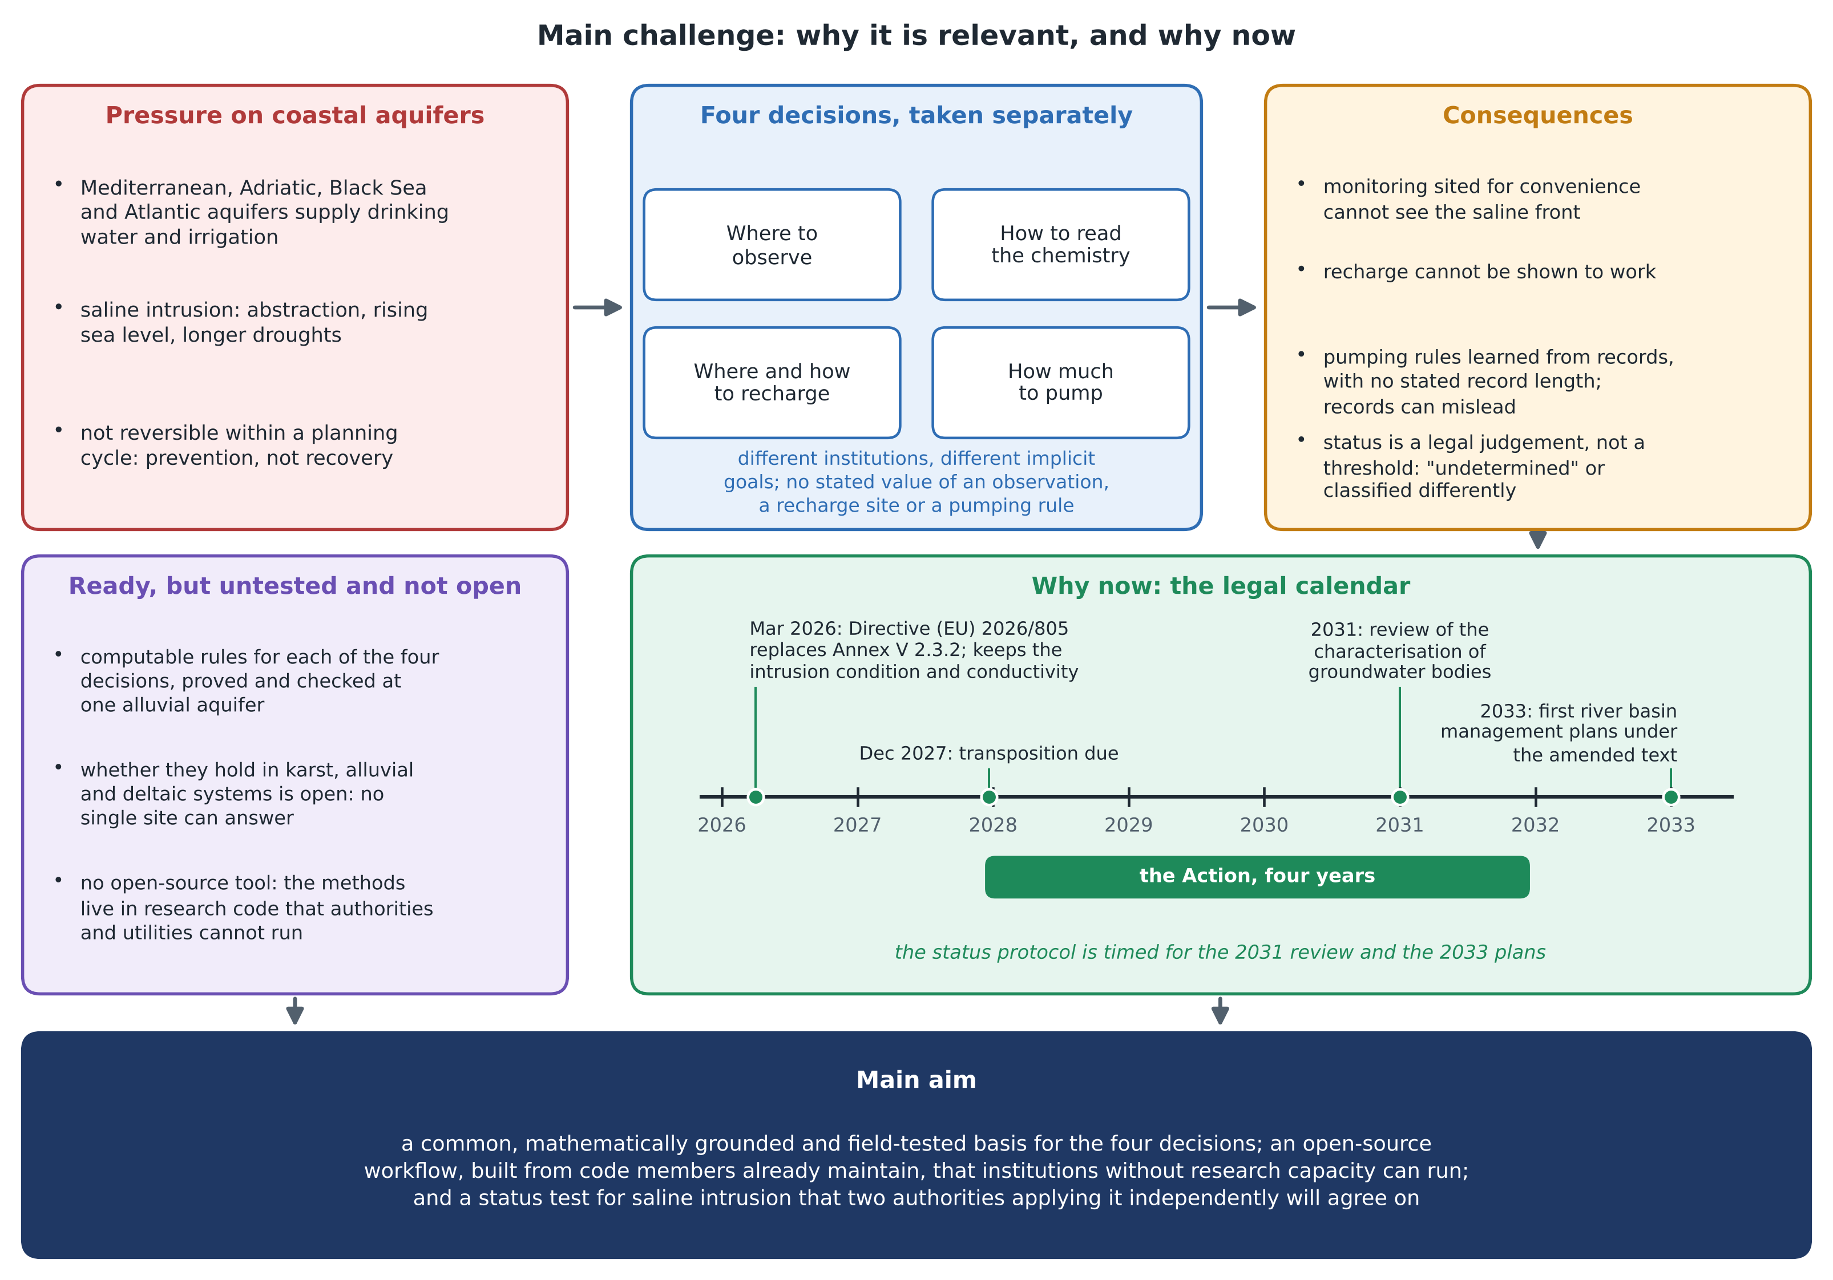
Figure. The main challenge: the pressure on coastal aquifers, four decisions taken separately and their consequences (relevance); the amended Annex V and the 2031 and 2033 milestones of the Water Framework Directive cycle (timeliness); and the main aim of the Action.

