State of the art V: when the world drifts
Twenty more papers from Oxford, Caltech, Berkeley and MIT (2020–2026) on forecasting through change, calibration over time, a drying and warming water cycle and a moving coast; the state of the art and the step beyond it; and PRIRJA-GO, guarantees that hold years ahead while the real law drifts
Dulian Zeqiraj · November 2026 · review with a numerically tested innovation · companion to reviews I–IV (GARANCIA-GO, MATJA-GO, RESHJA-GO, ANKORA-GO)
1. Outcome
• Twenty new papers, five per institution, 2020–2026, each with links (Section 3, Figure 1). None was a card of reviews I–IV or of the earlier reviews. They address the weak point review IV left open: its anchors, past years in which a boundary function was measured, are exchangeable with a future year only if nothing changes, while rain, evapotranspiration, the water table and the sea all drift. Each card gives the state of the art the paper sets, what it cannot yet do for us, three lessons and an innovation step.
• State of the art and beyond, for the proposal (Section 2, Table 1), and a map of all one hundred papers of reviews I–V on the steps of the procedure (Section 5, Table 3).
• Innovation: PRIRJA-GO (Section 4). Horizon-matched calibration scores every past year exactly as the field year will be used: $h$ years after a window of $L$ years whose level and spread re-centre and re-scale the band. Proposition P1: no weighting of past years removes a drift. Proposition P2: horizon matching removes it exactly when its level is polynomial and its spread exponential in time. Proposition P3: with $K$ years of record a guarantee reaches at most $K−L−8$ years ahead, a certificate $K−L−21$; for 30 years and $L$ = 5 that is 17 and 4 years.
• Test: under drift both earlier calibrations break (T15; 30 anchor years, a field year 1–20 years ahead, three drift laws). Calibrated on simulations, the share of weeks outside the 90% band is 0.30–0.34 for the recharge and 0.35–0.65 for $κ$ instead of at most 0.10. Calibrated on all past years as in review IV it is 0.20–0.59 for $κ$ and up to 0.22 for the recharge.
• The matched band holds (T16). With the level window ($L$ = 5) the risk is 0.003–0.082 for every goal and horizon under no drift, linear drift and the abrupt shift, and 0.030–0.100 up to 10 years under accelerating drift; beyond that it fails for $κ$ (0.17 at 15 years), as Proposition P2 predicts for a drift it does not cover. Matching the level alone is not enough: after the abrupt shift it leaves up to 0.19 of the recharge weeks outside.
• The price (T17). Without drift the matched band for the weekly goals is 1–14% wider than calibration on all past years up to 10 years ahead and narrower than the only plain rule that is valid for them, the last nine years (0.50–0.70 of its width). For the scalar $κ$ it costs 1.6–2.4 times the width, because its spread must be estimated from 5 values.

2. State of the art and the step beyond it
Reviews I–IV (D1–D4) guarantee bands for boundary conditions, choose instruments, handle an uncertain rain and, in review IV, make the guarantee independent of the simulator by calibrating on real anchors. Every one of those guarantees assumes that the calibration cases and the field are exchangeable. Across years they are not: the vadose delay grows as the water table falls, evaporative demand rises, the sea rises and land use changes. This review asks how long a band calibrated on the past stays valid, and how to make it valid for a stated number of years ahead.
Text for the proposal. Forecasting under structural change, online calibration and attribution of hydrological trends have advanced quickly (Section 3): robust devices adapt after breaks, online risk control keeps a long-run error rate under arbitrary drift, and global analyses quantify how warming and pumping move the water balance. None of them gives a guarantee for a boundary condition a stated number of years ahead from a short record. The project goes beyond the state of the art with horizon-matched calibration (PRIRJA-GO), which removes polynomial drift exactly and makes the guarantee hold at the horizon of use; by stating how far ahead a record of a given length can guarantee and certify a band; and by testing both against the simulation and anchor calibrations of the earlier reviews under realistic drift.
Table 1. State of the art (2020–2026) and the step beyond it. Card numbers refer to Section 3; T numbers to the tests of Section 4.
Topic | State of the art | Its limit for our problem | Our step beyond | Evidence
Forecasting through change | Smoothed robust devices across horizons (O1); indicator saturation for breaks and trends (O2); a century of hindcasts with changing skill (O3) | Point forecasts or skill scores; no coverage statement for a boundary function | Horizon-matched calibration: the band is calibrated at the lag at which it is used | Proposition P2
Calibration over time | Rolling risk control (B1); gradient equilibrium with constant steps (B2); conformal prediction under Lévy–Prokhorov shift (M1); weighted conformal theory (M2); decision-focused conformal sets (C5) | Long-run averages with feedback every period, or a static shift budget; no years-ahead guarantee | A guarantee for the year K + h from K anchor years, with no feedback in between | T16: risk 0.003–0.082 under no, linear and abrupt drift
Plain anchors under drift | Anchor calibration of review IV; weighted calibration beyond exchangeability | Old years carry less error than the future; weights cannot remove a drift | Proposition P1: no weighting beats the last nine years, whose bound still grows with h | T15: κ risk 0.20–0.59 with all past years, up to 0.65 with simulations
A drifting water cycle | Evaporative demand drives drought severity (O4); snow-to-rain shift (B3); groundwater decline under warming (B4); Mediterranean extremes (B5); recharge source shifts with pumping (M3); regime tipping (M4); European summer drying (M5); an abrupt drop in land water that did not recover (C3) | Measured or projected drift, but no guarantee for a band that must hold under it | The location–scale score: level and spread of the errors re-estimated in each window | T16: location only leaves up to 0.19 of the recharge weeks outside after the abrupt shift
The moving coast | Sea-level boundary from observations: quadratic extrapolation checked by hindcast (C1); a doubled rate of rise (C2); land motion at 30 m (C4) | Projections and records without a horizon of validity | Tide-gauge years as anchor years; horizon limited by the record length | Proposition P3: 17 years ahead for a 30-year record (L = 5), certificate 4
Benchmarks of shift | Real temporal and climatic shift for uncertainty (O5) | Scored by retention, not coverage | Coverage at stated horizons under drift, level and spread | T16: accelerating drift beyond 10 years breaks the level version (κ 0.17)
Dispersion and the transition zone | No 2020–2026 paper on a width that changes in time at the four institutions | Transition-zone width assumed stationary | Chloride-profile years as anchor years for the width, scored by horizon matching | Review I, Proposition 6 and T4; Proposition P2

3. The twenty papers
Five papers per institution, all from 2020–2026 (Figure 1). The rules of the earlier reviews apply: direct use, a link to the institution at the time of publication (JPL for Caltech, Lawrence Berkeley National Laboratory for Berkeley), a state-of-the-art contribution, and no paper that was a card before. This batch gives priority to calibration and forecasting under drift, then to measured drift of the water cycle and of the coast. Preprints, working papers and books are marked as such on their venue line. No 2020–2026 paper on a transition-zone width or dispersivity that changes in time was found at the four institutions; dispersion is served indirectly.
Verification. The hosts doi.org, arxiv.org, openreview.net and most publisher pages were blocked in this environment, so every landing page was reached through search results that quote it, and every card is marked partly verified; where an author list or a volume could not be confirmed, the card says so.
3.1 University of Oxford
O1 · Oxford · 2022
Smooth robust multi-horizon forecasts
Andrew B. Martinez, Jennifer L. Castle, David F. Hendry
In: Essays in Honor of M. Hashem Pesaran, Advances in Econometrics 43A, Emerald, 143–165 (2022)
Links: doi:10.1108/S0731-90532021000043A008 · INET Oxford
Affiliation and verification: Listed by the Institute for New Economic Thinking at Oxford and issued as Nuffield College (Oxford) Economics Working Paper 2021-W01; Castle and Hendry are at Oxford colleges and Climate Econometrics (card O2); Martinez's affiliation was not seen. Status: partly verified (landing pages reached through search results only).
What it does. Robust forecasting devices, read as local estimators of a long-run relation, adapt quickly after a break at the price of extra forecast-error variance. Smoothing them keeps most of the adaptation and cuts the variance, most at long horizons. The bias and variance after a location shift are derived analytically and checked by simulation; on UK productivity and US 10-year yields the devices sharply reduce persistent forecast failure (no numbers in the abstract).
State of the art it sets. An analytic account of how the post-break bias and variance of a forecast device evolve with the horizon.
What it cannot yet do for us. Point forecasts only, with no coverage statement; macroeconomic series.
Input parameters. Read the recharge coefficient as a level that can shift: re-estimate the local level instead of freezing the value of the anchor years; the bias–variance trade-off over the horizon is what sets how far ahead a band stays valid.
Dispersion coefficient. None.
Boundary conditions from rain alone. Sea-level trend, inland inflow and recharge in time as series with location shifts; the growth of the error with the horizon is the widening a band needs.
Innovation step for our problem. Their trade-off between adaptation and variance is our choice of the window $L$ in (1): a short window follows a break, a long one is less noisy. Horizon matching makes every $L$ valid under the conditions of Proposition P2, so $L$ can be chosen for width on an earlier stretch of the record without touching the guarantee; with $L$ = 5 the band held through the abrupt shift of T16 ($κ$ risk at most 0.054).

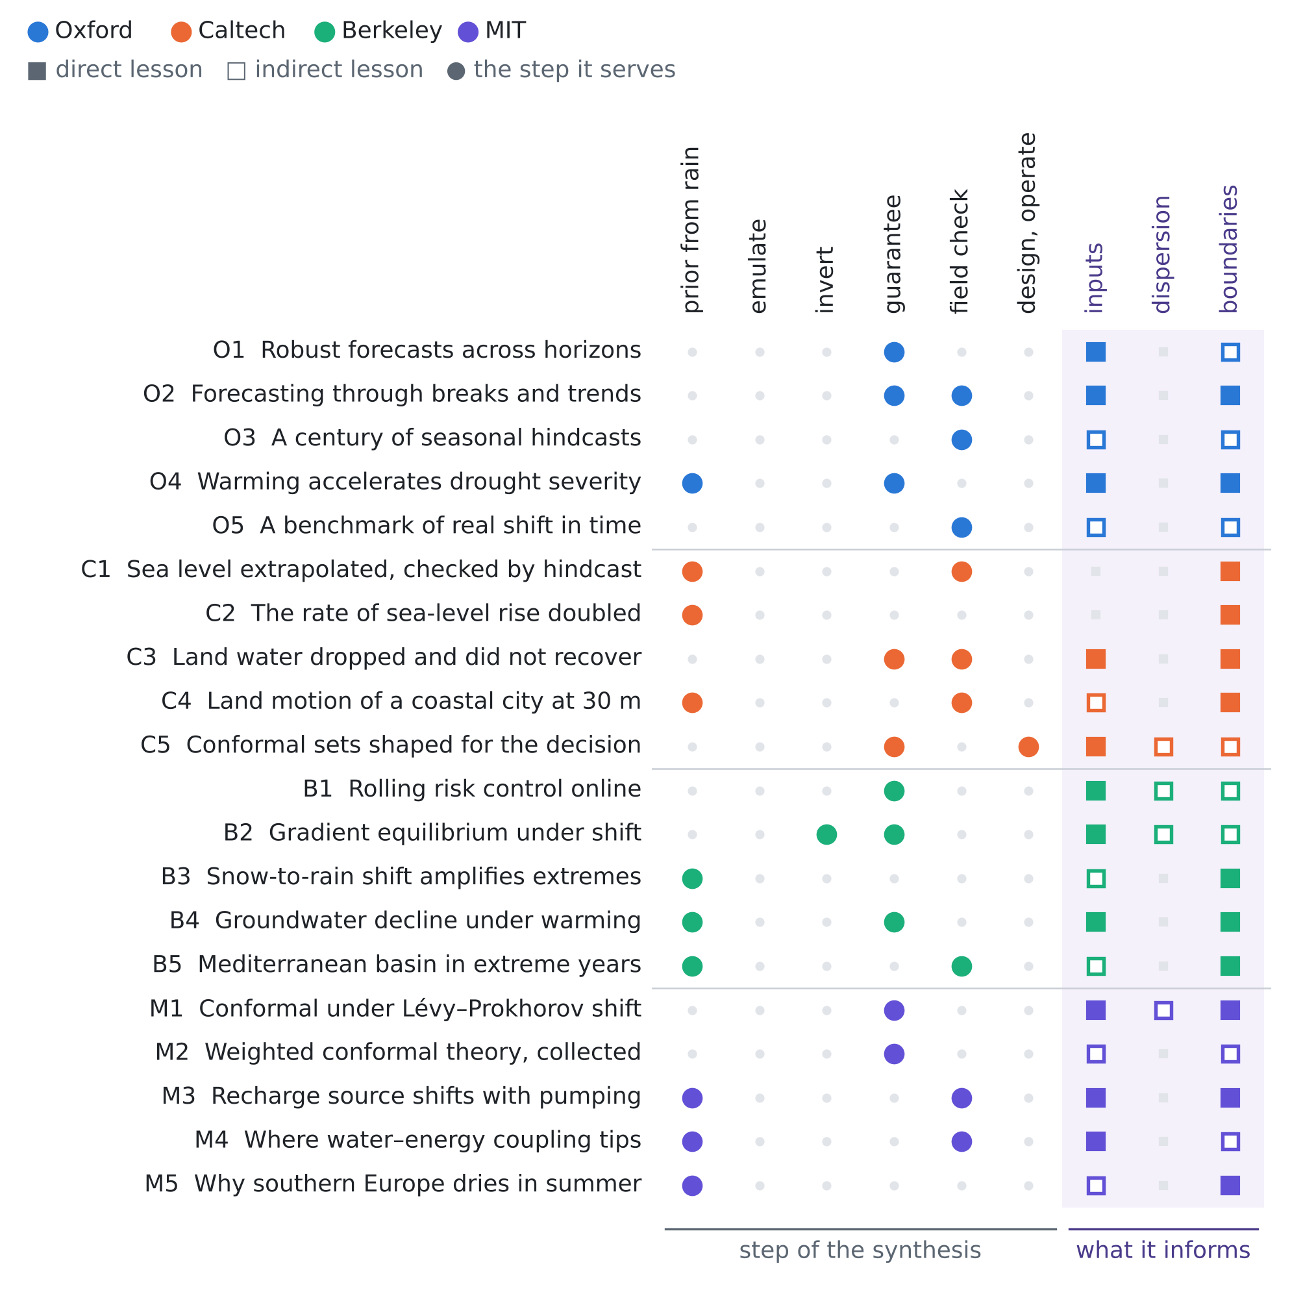
Figure 1. The twenty papers against the step of the procedure they serve and the unknown they inform. Colour gives the institution; a filled square is a direct lesson, an open square an indirect one.
O2 · Oxford · 2022
Forecasting facing economic shifts, climate change and evolving pandemics
Jennifer L. Castle, Jurgen A. Doornik, David F. Hendry
Econometrics 10(1), 2 (2022)
Links: doi:10.3390/econometrics10010002 · INET Oxford
Affiliation and verification: Castle: Magdalen College; Doornik and Hendry: Nuffield College; all with Climate Econometrics, University of Oxford (journal listing as quoted in a search summary). Status: partly verified (landing pages reached through search results only).
What it does. Economic, climate and pandemic series share a wide-sense non-stationarity: evolving stochastic trends, sudden location shifts, data revisions and changes of measurement. The paper examines what these do to the design and selection of forecasting models, covering stochastic trends, location shifts, broken trends and the forecasting of breaks, and uses trend-indicator saturation to detect a changing trend and forecast with the most recent one.
State of the art it sets. Indicator-saturation model selection that detects breaks and trend changes and forecasts through them.
What it cannot yet do for us. No interval coverage; the power of break detection with 20–30 annual values is not addressed; no hydrology.
Input parameters. Detect broken trends in the rain–recharge relation from the records and keep the anchors after the last break, where exchangeability with the future year is defensible.
Dispersion coefficient. None.
Boundary conditions from rain alone. Detect and extrapolate the latest trend segment of sea level and recharge; a detected break date marks where past anchors stop being comparable.
Innovation step for our problem. Detection and horizon matching complement each other. Through the abrupt shift of T16 the level-matched band stayed valid but widened (recharge half-width 0.13–0.29 mm/d against 0.06–0.07 without drift), because origins before the break score the break itself. Dropping the pre-break origins found by indicator saturation would narrow it, as long as at least 9 scores remain (Proposition P3).

O3 · Oxford · 2020
Seasonal forecasts of the twentieth century
Antje Weisheimer, Daniel J. Befort, Dave MacLeod, Tim Palmer, Chris O'Reilly, Kristian Strømmen
Bulletin of the American Meteorological Society 101(8), E1413–E1426 (2020)
Links: doi:10.1175/BAMS-D-19-0019.1 · Oxford ORA · hindcast data, CEDA
Affiliation and verification: Deposited in Oxford's repository ORA and listed on Weisheimer's Oxford Physics publication page; the per-author affiliations were not opened. Status: partly verified (landing pages reached through search results only).
What it does. Coupled seasonal hindcasts for 1901–2010 agree with operational systems in the recent period, but the skill for extratropical circulation indices (NAO, PNA) drops markedly in the middle of the century, and ENSO forecasts, very skilful recently and early in the century, are less so in the 1920s–1930s. The hindcasts are public.
State of the art it sets. A century-long coupled seasonal hindcast set that shows the multidecadal non-stationarity of forecast skill.
What it cannot yet do for us. Skill, not calibration or coverage; no hydrological variable; the causes of the changes are not settled.
Input parameters. A calibration fitted on recent decades, such as a rain-forecast-to-recharge map, need not hold in another: anchors from one era can mis-calibrate another.
Dispersion coefficient. None.
Boundary conditions from rain alone. The public 110-year archive is a ready test bed for the question of this review: calibrate on a rolling origin and measure how coverage decays with the lag.
Innovation step for our problem. Use the archive to test Propositions P2 and P3 on real forecasts: treat a seasonal rain forecast as the reconstructor and compare plain and horizon-matched bands across decades of changing skill. It would show whether a skill change of the size they report behaves like our abrupt shift, where the matched band held, or like the accelerating drift, where it failed for $κ$ after 10 years.

O4 · Oxford · 2025
Warming accelerates global drought severity
Solomon H. Gebrechorkos, Justin Sheffield, Sergio M. Vicente-Serrano, Chris Funk, Diego G. Miralles, Jian Peng, Ellen Dyer, Joshua Talib, Hylke E. Beck, Michael B. Singer, Simon J. Dadson
Nature 642, 628–635 (2025)
Links: doi:10.1038/s41586-025-09047-2 · Oxford ORA
Affiliation and verification: Gebrechorkos: School of Geography and the Environment, University of Oxford, also Southampton (search results); deposited in ORA. Status: partly verified (landing pages reached through search results only).
What it does. An ensemble of high-resolution global drought datasets for 1901–2022 shows drought severity rising worldwide. Atmospheric evaporative demand raised drought severity by 40% on average; dry regions get drier and wet regions also show drying; in 2018–2022 the land area in drought was 74% larger than in 1981–2017, and evaporative demand accounts for 58% of that increase.
State of the art it sets. A global, high-resolution, 122-year attribution of drought-severity trends to evaporative demand against rain.
What it cannot yet do for us. Drought indices, not recharge or heads; no site-scale guarantee.
Input parameters. With rain as the only series, the effective recharge fraction drifts down as evaporative demand rises even at unchanged rain: the rain-to-recharge map behind $κ$ is not stationary.
Dispersion coefficient. None.
Boundary conditions from rain alone. Anchors from the 1980s–2000s overstate recharge in future years; the gridded indices cover Albania and give a local drift per year.
Innovation step for our problem. Their evaporative demand is the natural regressor for the window centre of (1): a fit in demand instead of in time removes a drift linear in the demand even when the demand does not rise steadily (to be tested; Proposition P2 is exact for time only). Without such a correction, a $κ$ band calibrated on all past years left 0.20–0.59 of the field outside in T15.

O5 · Oxford · 2021
Shifts: a dataset of real distributional shift across multiple large-scale tasks
Andrey Malinin, Neil Band, Yarin Gal and others (the full author list was not seen)
NeurIPS 2021 Datasets and Benchmarks Track; arXiv:2107.07455
Links: NeurIPS Datasets and Benchmarks · arXiv:2107.07455 · OATML, Oxford
Affiliation and verification: Listed as a publication of Oxford's OATML group (Y. Gal, Department of Computer Science); the byline affiliations were not opened. Status: partly verified (landing pages reached through search results only).
What it does. A benchmark of real shift for uncertainty and robustness in three tasks: tabular weather prediction, machine translation and vehicle motion prediction. The weather data (September 2018 to September 2019) are split by time and by climate type: in-domain data share the training period and climates, while the shifted development and evaluation sets lie in other months and in snow and polar climates. Uncertainty is scored by retention curves.
State of the art it sets. A large benchmark of real temporal and climatic shift for evaluating uncertainty.
What it cannot yet do for us. Shifts of months, no physics; uncertainty scored by retention, not coverage.
Input parameters. A ready test of how calibrated bands degrade when the target period and climate differ from the calibration: the analogue of past anchors and a future year.
Dispersion coefficient. None.
Boundary conditions from rain alone. Shift in time and shift in climate type are separable, so a drift can be told apart from a change of regime in the forcing.
Innovation step for our problem. Score coverage, not retention: run plain and horizon-matched conformal bands on its weather task, where the time split and the climate split play the roles of our linear drift and abrupt shift. T15–T16 predict that plain calibration fails on both and the matched band holds on both, at a price in width for the second.

3.2 California Institute of Technology (with JPL)
C1 · Caltech · 2022
Extrapolating empirical models of satellite-observed global mean sea level to estimate future sea level change
R. S. Nerem, T. Frederikse, B. D. Hamlington (initials as seen)
Earth's Future 10(4), e2021EF002290 (2022)
Links: doi:10.1029/2021EF002290 · NOAA repository
Affiliation and verification: Hamlington: leader of the NASA Sea Level Change Team at JPL (NASA/JPL article); the affiliations of Frederikse and Nerem on this paper were not confirmed on the byline. Status: partly verified (landing pages reached through search results only).
What it does. A quadratic trend plus interannual (mainly ENSO) variability is fitted to the satellite-altimetry global mean sea level of 1993–2020, with a formal error assessment of the coefficients, and extrapolated 30 years: 16.4 cm by 2050 relative to 2020 (90% interval 11.3–21.4 cm), in agreement with SROCC and AR6. A hindcast before 1993 agrees well with tide-gauge global mean sea level over the second half of the 20th century. Rate and acceleration are assumed constant.
State of the art it sets. An observation-only sea-level band extrapolated 30 years and checked against held-out decades of tide gauges.
What it cannot yet do for us. Global mean only; Gaussian coefficient errors, no distribution-free coverage; the constant acceleration is assumed, not tested.
Input parameters. None.
Dispersion coefficient. None.
Boundary conditions from rain alone. A ready drift model for the sea boundary (trend, acceleration, ENSO term) with coefficient uncertainty; their hindcast is the template for testing how far ahead a band calibrated today stays valid.
Innovation step for our problem. Their hindcast is horizon matching done once; do it at every origin. Fit their quadratic model on each window of anchor years, score the year $h$ later and calibrate by (2): the band then holds $h$ years ahead without Gaussian coefficients, and the location-only score of Proposition P2 (i) with $p$ = 2 removes even a drift of degree 3. The record sets the reach: 30 years of altimetry with a window of 10 support 12 years (Proposition P3), so their 30-year extrapolation lies beyond what this record can guarantee distribution-free.

C2 · Caltech · 2024
The rate of global sea level rise doubled during the past three decades
B. D. Hamlington, A. Bellas-Manley, J. K. Willis, S. Fournier, N. Vinogradova, R. S. Nerem, C. G. Piecuch, P. R. Thompson, R. Kopp (initials as seen)
Communications Earth & Environment 5, 601 (2024)
Links: doi:10.1038/s43247-024-01761-5 · NASA Sea Level Change
Affiliation and verification: Hamlington: Jet Propulsion Laboratory, California Institute of Technology (search summary of the paper); the other affiliations were not seen. Status: partly verified (landing pages reached through search results only).
What it does. Global mean sea level rose 111 mm from 1993 to the end of 2023, and the rate rose from about 2.1 mm per year in 1993 to about 4.5 mm per year in 2023; if the trajectory continues, a further 169 mm is expected over the next 30 years, comparable to the middle of the AR6 range.
State of the art it sets. A 30-year satellite record showing that the rate of rise doubled, with an observation-based trajectory.
What it cannot yet do for us. Global only, no Adriatic value; the uncertainty of the acceleration was not seen.
Input parameters. None.
Dispersion coefficient. None.
Boundary conditions from rain alone. The rate of the sea boundary itself drifts: a band calibrated on the anchor years 1993–2008 would under-cover today.
Innovation step for our problem. A doubling rate is the accelerating history of T15–T16, where the all-years band failed for $κ$ and the recharge at every horizon and the level window failed for $κ$ beyond 10 years. For the sea boundary, whose error spread changes little in our test bed, the trend window removes a constant acceleration exactly from the location-only score (Proposition P2 (i), $p$ = 1); the choice between level and trend should follow the measured acceleration, not the convenience of the shorter window.

C3 · Caltech · 2024
An abrupt decline in global terrestrial water storage and its relationship with sea level change
Matthew Rodell, Anne Barnoud, Franklin R. Robertson, Richard P. Allan, Ashley Bellas-Manley, Michael G. Bosilovich, Don Chambers, Felix Landerer, Bryant Loomis, R. Steven Nerem, Mary Michael O'Neill, David Wiese, Sonia I. Seneviratne
Surveys in Geophysics 45(6), 1875–1902 (2024)
Links: doi:10.1007/s10712-024-09860-w · open copy, Reading · JPL news
Affiliation and verification: Landerer and Wiese share an affiliation in the byline; Landerer is a JPL scientist (his JPL CV) and the release is on jpl.nasa.gov, but the text of that affiliation was not seen. The lead author is at NASA Goddard. Status: partly verified (landing pages reached through search results only).
What it does. From GRACE and GRACE-FO, global land water storage (without glaciers and ice sheets) fell rapidly between May 2014 and March 2016 and had not recovered by 2023, its upper range staying about 1 cm water-equivalent below the earlier one. The early drop is attributed mainly to back-to-back El Niños, with a possible added net drying from warming; NASA's release notes that 13 of the 30 most intense droughts of the GRACE era occurred after January 2015.
State of the art it sets. The first global record of an abrupt drop in land water storage that did not recover.
What it cannot yet do for us. Footprints of 300 km or more; the attribution is left open.
Input parameters. A documented regime shift without recovery: anchor years before 2014 and after 2016 are not exchangeable, and the recharge coefficient may have stepped.
Dispersion coefficient. None.
Boundary conditions from rain alone. Recharge in time and inland inflow can carry a step rather than a trend, and the initial head need not return to its pre-drought level.
Innovation step for our problem. Their step is our abrupt shift. In T16 the level-matched band stayed valid through it for every goal (risk at most 0.066) while the all-years band failed ($κ$ 0.29–0.35, recharge 0.20–0.22), because the origins that straddle the step put the step itself into the calibration. The cost is width, which a detected break date can cut back (card O2).

C4 · Caltech · 2023
Localized uplift, widespread subsidence, and implications for sea level rise in the New York City metropolitan area
Brett A. Buzzanga, David Bekaert, Benjamin D. Hamlington, Robert Kopp, Marin Govorcin, Miller (given name not seen)
Science Advances 9(39), eadi8259 (2023)
Links: doi:10.1126/sciadv.adi8259 · JPL news
Affiliation and verification: Written by a team from NASA JPL and Rutgers University (JPL release of 27 September 2023); the byline was not seen. Status: partly verified (landing pages reached through search results only).
What it does. InSAR (2016–2023) and GNSS give land-motion velocities with uncertainties at 30 m. The metropolitan area sinks about 1.6 mm per year on average, consistent with glacial isostatic adjustment, with local hotspots (landfill areas of Queens, the I-78 corridor, Rikers Island) and modest uplift in parts of Queens and Brooklyn, which a co-author links possibly to groundwater pumping and injection.
State of the art it sets. Land motion at 30 m with uncertainties for a coastal metropolis.
What it cannot yet do for us. One city; the uplift mechanism is not resolved; seven years is short for a trend.
Input parameters. Indirect: deformation tied to groundwater use could constrain the history of pumping and storage.
Dispersion coefficient. None.
Boundary conditions from rain alone. Vertical land motion is a part of relative sea level that varies in space and time and can be switched on and off by groundwater management within a few years.
Innovation step for our problem. Land motion driven by pumping is a drift with a known driver: use the local InSAR velocity series as the regressor of the window centre of (1) for the relative sea level, so that the band follows the subsidence of the coastal plain (to be tested; Proposition P2 is exact for time). Sentinel-1 covers the Albanian coast, so the record exists.

C5 · Caltech · 2025
End-to-end conformal calibration for optimization under uncertainty
Christopher Yeh, Nicolas Christianson, Alan Wu, Adam Wierman, Yisong Yue
Transactions on Machine Learning Research (December 2025); arXiv:2409.20534
Links: arXiv:2409.20534 · code
Affiliation and verification: Caltech (the NeurIPS 2024 workshop page of an earlier version lists Yeh, Christianson, Wierman and Yue at the California Institute of Technology; Wu uses a caltech.edu address). Status: partly verified (landing pages reached through search results only).
What it does. The predictive model is trained jointly with the downstream robust-optimization objective, with a differentiable conformal calibration inside the training loop. General convex uncertainty sets are represented as sublevel sets of partially input-convex neural networks, coverage comes from conformal prediction, and the method beats two-stage estimate-then-optimize baselines on battery arbitrage and portfolio optimization.
State of the art it sets. Decision-focused conformal calibration of learned convex uncertainty sets.
What it cannot yet do for us. Exchangeability assumed; no drift; no physics.
Input parameters. Calibrate a joint set for $T$, $S$, $κ$ and sea level that covers and is shaped for the decision it feeds, such as a pumping cap or a warning.
Dispersion coefficient. The same for the set of dispersivity and transition-zone width.
Boundary conditions from rain alone. The same for the set of boundary functions.
Innovation step for our problem. Put horizon matching inside their training loop: the calibration step becomes (2) with the matched scores, so the decision set is shaped for the pumping decision and valid $h$ years ahead. Because their sets are trained end to end, the scores must come from anchor years not used in training, which lowers $n\left(h\right)$ and so the reach of Proposition P3.

3.3 University of California, Berkeley (with Lawrence Berkeley National Laboratory)
B1 · Berkeley · 2023
Achieving risk control in online learning settings
Shai Feldman, Liran Ringel, Stephen Bates, Yaniv Romano
Transactions on Machine Learning Research (November 2023); arXiv:2205.09095
Links: arXiv:2205.09095
Affiliation and verification: S. Bates: UC Berkeley; the other authors: Technion (search summary of the arXiv author listing). The TMLR venue was seen in one text copy only. Status: partly verified (landing pages reached through search results only).
What it does. Rolling risk control is a calibration wrapper around any online learner that keeps a user-chosen risk (miscoverage, false-negative rate and others) at a set level even when the data distribution shifts arbitrarily. It extends adaptive conformal inference from the 0–1 loss to general losses, can control several risks at once, and is shown on online depth estimation; a poor fixed step size delays adaptation.
State of the art it sets. The first online procedure that controls a general risk, not only coverage, under arbitrary drift.
What it cannot yet do for us. The guarantee is a long-run average over periods with feedback; nothing is said about a band used years ahead without feedback.
Input parameters. The conformal risk control of reviews I–IV can be run as a yearly update: each new anchor year with measured heads or chloride updates the calibration of the bands for $T$, $S$, $κ$ and $τ$.
Dispersion coefficient. The controlled risk can be a loss on the position or width of the transition zone, such as a misplaced isochlor.
Boundary conditions from rain alone. The same rolling control applies to bands for recharge in time and inland inflow.
Innovation step for our problem. Rolling control needs the truth every period; a boundary band for year $K+h$ gets it only $h$ years later. Horizon matching is the delayed-feedback version: the score of each past year is computed with the information available $h$ years before it, so the band is calibrated for exactly the delay at which it will be used (Proposition P2), and Proposition P3 says how long a delay a record of $K$ years supports.

B2 · Berkeley · 2025
Gradient equilibrium in online learning: theory and applications
Anastasios N. Angelopoulos, Michael I. Jordan, Ryan J. Tibshirani
Journal of Machine Learning Research 26, paper 25-0356, 1–68 (2025); arXiv:2501.08330
Links: JMLR 26 · arXiv:2501.08330 · Berkeley copy
Affiliation and verification: UC Berkeley (the paper is hosted on Tibshirani's Berkeley Statistics page; Jordan and Tibshirani are Berkeley faculty); the paper's affiliation lines were not seen. Status: partly verified (landing pages reached through search results only).
What it does. A sequence of iterates reaches gradient equilibrium when the average of the loss gradients along it tends to zero, a property that neither implies nor is implied by sublinear regret. Plain gradient and mirror descent reach it with constant step sizes, where regret usually needs decaying ones. Applications are post hoc corrections of black-box predictors under arbitrary shift: debiasing, calibrating predicted quantiles, and unbiased Elo scores.
State of the art it sets. A unifying theory of why constant-step online corrections stay calibrated under arbitrary shift.
What it cannot yet do for us. Average-type guarantees with feedback at every step; no statement for a fixed number of years ahead; no physics.
Input parameters. The rain-driven reconstructor can be debiased year by year with a constant step, so that the mean residual stays near zero while the law drifts.
Dispersion coefficient. None directly; the quantile application could target a quantile of the transition-zone width.
Boundary conditions from rain alone. Post hoc bias correction of recharge-in-time and inflow forecasts under drift.
Innovation step for our problem. Their constant-step correction is the online form of our window centre $c_{o}$: both track a drifting mean. Run it on the anchor years, then score each past year at lag $h$ after the correction, as in (1): the correction then removes the drift, and the calibration certifies what is left $h$ years ahead, which neither does alone.

B3 · Berkeley · 2023
A warming-induced reduction in snow fraction amplifies rainfall extremes
Mohammed Ombadi, Mark D. Risser, Alan M. Rhoades, Charuleka Varadharajan
Nature 619(7969), 305–310 (2023)
Links: doi:10.1038/s41586-023-06092-7 · LBNL news · eScholarship
Affiliation and verification: Lawrence Berkeley National Laboratory (Berkeley Lab news release; eScholarship copy). Status: partly verified (landing pages reached through search results only).
What it does. In high-elevation regions of the Northern Hemisphere, rainfall extremes rise by about 15% per °C of warming, twice the rate expected from water vapour alone, because warming shifts precipitation from snow to rain; this is shown in reanalysis and projections, and differences in how models split snow and rain explain 25–40% of the spread of the projections.
State of the art it sets. An attributed, quantified trend in rain extremes beyond the water-vapour scaling.
What it cannot yet do for us. Extremes only; no recharge or groundwater; snow regions.
Input parameters. When the phase of precipitation shifts, the recharge coefficient and the vadose delay of a mountain catchment cannot be taken as stationary.
Dispersion coefficient. None.
Boundary conditions from rain alone. A drift rate per degree for the rain extremes that feed the inland inflow from the mountains (for Fushë-Kuqe, the upper catchments of the rivers that reach the plain).
Innovation step for our problem. A drift rate per degree is what Proposition P1 needs to put a number on the bias of plain calibration: with a warming trajectory it gives a drift per year, and the bound $α+0.9 δ\left(h+4\right)$ then says how soon a band calibrated on past years of inflow stops being trustworthy. Horizon matching removes the need to know $δ$, but the rate tells which drift law to test.

B4 · Berkeley · 2024
Declining groundwater storage expected to amplify mountain streamflow reductions in a warmer world
Rosemary Carroll, Richard Niswonger, Craig Ulrich, Charuleka Varadharajan, Erica Siirila-Woodburn, Kenneth Williams (as seen; the list and its order were not confirmed)
Nature Water 2, 419–433 (2024)
Links: doi:10.1038/s44221-024-00239-0 · USGS record
Affiliation and verification: Ulrich, Varadharajan and Siirila-Woodburn: Lawrence Berkeley National Laboratory (Desert Research Institute news release); the byline was not seen. Status: partly verified (landing pages reached through search results only).
What it does. An integrated hydrological model reaching 400 m depth in the East River (Colorado headwaters) shows groundwater to be a large, steady source of streamflow. Under warming, greater forest water use cuts recharge and drains storage; the losses are largest in dry years and do not fully recover in simulated wet periods, and including the groundwater decline roughly doubles the annual streamflow reductions.
State of the art it sets. A deep integrated projection of how groundwater storage feeds back on streamflow loss under warming.
What it cannot yet do for us. One snow-dominated watershed; a model projection only; no uncertainty guarantee.
Input parameters. The effective recharge coefficient drifts down with evapotranspiration, and storage keeps a memory of dry years: past anchor years are biased for future ones.
Dispersion coefficient. None.
Boundary conditions from rain alone. Inland groundwater inflow declines over time, and the initial head of a future year depends on the history of dry years.
Innovation step for our problem. A decline that does not recover is a drift in the level and, through dry-year memory, in the spread of the errors: the location–scale form of (1) handles both, while location alone failed (recharge risk up to 0.19 after the abrupt shift of T16, against at most 0.066 with the scale). Their model is a ready generator of realistic drift laws for the test.

B5 · Berkeley · 2022
Projecting end-of-century climate extremes and their impacts on the hydrology of a representative California watershed
Fadji Z. Maina, Alan Rhoades, Erica R. Siirila-Woodburn, Peter-James Dennedy-Frank
Hydrology and Earth System Sciences 26(13), 3589–3609 (2022)
Links: doi:10.5194/hess-26-3589-2022 · eScholarship
Affiliation and verification: Listed under Lawrence Berkeley National Laboratory publications on eScholarship (search summary); the paper's affiliation lines were not seen. Status: partly verified (landing pages reached through search results only).
What it does. The undammed Cosumnes basin, with a Mediterranean climate, is modelled with ParFlow-CLM driven by a variable-resolution climate model under RCP8.5, comparing dry, median and wet years of 2070–2100 with historical ones. In the extreme years temperature rises by more than 2.5 °C and precipitation by more than 38% while snowpack falls by more than 90%; peak surface and groundwater storage rise by up to 75% and 23% and come earlier, and higher evapotranspiration then drives faster summer declines, fastest for groundwater.
State of the art it sets. An integrated surface–subsurface projection of extreme years, with groundwater, in a Mediterranean basin.
What it cannot yet do for us. One climate model and one scenario; few years per class; no observational check; no guarantee.
Input parameters. The seasonal timing of recharge (vadose delay, recharge coefficient) shifts with warming in a Mediterranean climate like that of Albania.
Dispersion coefficient. None.
Boundary conditions from rain alone. Recharge in time gets a larger seasonal amplitude (wetter winters, drier summers), and future initial heads differ from past ones.
Innovation step for our problem. A larger seasonal amplitude is a drift of the scale, not only of the level, of the reconstruction errors week by week: exactly the case where the scale of (1) matters (T16). Their projected years can be used as the future field of a test at a Mediterranean aquifer, with the past record as anchors.

3.4 Massachusetts Institute of Technology
M1 · MIT · 2025
Conformal prediction under Lévy–Prokhorov distribution shifts: robustness to local and global perturbations
Liviu Aolaritei, Zheyu Oliver Wang, Julie Zhu, Michael I. Jordan, Youssef Marzouk (the first three contributed equally; the order differs between listings)
Advances in Neural Information Processing Systems 38 (NeurIPS 2025); arXiv:2502.14105
Links: NeurIPS 2025 · arXiv:2502.14105
Affiliation and verification: Wang, Zhu and Marzouk: MIT (arXiv version 2 as quoted; the department differs between the PDF and the HTML); Aolaritei and Jordan: UC Berkeley. Status: partly verified (landing pages reached through search results only).
What it does. The shift between calibration and test data is modelled as a Lévy–Prokhorov ambiguity set, which covers local perturbations (every point moves a little) and global ones (a fraction of the mass moves anywhere). Pushing the set through the score reduces a high-dimensional shift to a one-dimensional one, so the worst-case quantile and coverage are computed exactly; the two parameters map explicitly to interval width and confidence, and the intervals stay valid under the shift (numbers not seen).
State of the art it sets. Exact worst-case conformal coverage under a two-parameter (local and global) shift ball.
What it cannot yet do for us. A static shift between calibration and test, with no model of how the shift grows with time.
Input parameters. Bands for $T$, $S$, $κ$ and $τ$ can be inflated by an explicit shift budget instead of assuming past anchors are exchangeable with the future.
Dispersion coefficient. The same robust quantile applies to scores for the dispersivity or the transition-zone width.
Boundary conditions from rain alone. If the drift of rain, evapotranspiration or sea level is written as a radius growing with the lead time, the band is valid while the radius stays within the budget.
Innovation step for our problem. Their radius is what horizon matching measures without being told: the scores of (1) at lag $h$ carry the shift accumulated over $h$ years, so the calibrated ${\hat{λ}}_{h}$ is a data-driven budget. Fit their two parameters to the matched scores at each $h$ to get an interpretable drift-per-year that can be extrapolated beyond the horizon limit of Proposition P3, with the guarantee then conditional on the extrapolation.

M2 · MIT · 2024
Theoretical foundations of conformal prediction
Anastasios N. Angelopoulos, Rina Foygel Barber, Stephen Bates
arXiv:2411.11824 (book, version 5, March 2026; to be published by Cambridge University Press)
Links: arXiv:2411.11824
Affiliation and verification: S. Bates: Department of EECS, MIT (arXiv PDF as quoted in a search summary); Angelopoulos: UC Berkeley; Barber: University of Chicago. The publication year of the printed book was not confirmed. Status: partly verified (landing pages reached through search results only).
What it does. A text that collects the core proofs of conformal and distribution-free inference, including a chapter on weighted variants (weighted quantiles, covariate shift, label shift, general training-to-test shift, and distribution shift against conditional coverage) and chapters on exchangeability and cross-validation methods.
State of the art it sets. The reference text that gathers the guarantees, including those beyond exchangeability.
What it cannot yet do for us. Theory only; the guarantees under drift in time depend on knowing the weights or the distances.
Input parameters. The formal basis for reweighting past anchor years toward a target year, with weights from covariates such as rain or evapotranspiration.
Dispersion coefficient. None specific.
Boundary conditions from rain alone. Weighting by sea-level or rain covariates is the textbook route to a drift-aware band.
Innovation step for our problem. Proposition P1 is the weighted bound of their weighted chapter applied to anchor years, and it shows the limit of the weighting route: with a drift growing with the lag, no weights that give a finite band beat the last nine years, whose bound $α+0.9 δ\left(h+4\right)$ still grows with $h$. Horizon matching leaves the weights alone and changes the scores instead.

M3 · MIT · 2023
Shift in groundwater recharge of the Bengal Basin from rainfall to surface water
Yusuf Jameel, Mason Stahl, Holly Michael, Benjamin C. Bostick, Michael S. Steckler, Peter Schlosser, Alexander van Geen, Charles Harvey
Communications Earth & Environment 4, 14 (2023)
Links: doi:10.1038/s43247-022-00650-z · DOAJ record
Affiliation and verification: Jameel: MIT (corresponding e-mail at mit.edu; funding from MIT's Abdul Latif Jameel Water and Food Systems Lab); Harvey shares his affiliation; the affiliation line itself was truncated in the results. Status: partly verified (landing pages reached through search results only).
What it does. Stable isotopes of groundwater, rain and surface water across Bangladesh and eastern West Bengal, run through a Monte Carlo mixing model with three end-members (rain, standing water, large rivers), show that the share of recharge from stagnant surface water rose by about 50% over about 70 years while direct rain infiltration fell in relative terms. Standing-water recharge enters mostly in the late dry season; the authors attribute the shift to irrigated rice fields, ponds and a steeper downward gradient from pumping.
State of the art it sets. The first basin-scale isotope evidence that recharge sources shift over decades because of pumping.
What it cannot yet do for us. A delta far from the sea, no salinity link; the result depends on the end-member values.
Input parameters. A rain-to-recharge coefficient calibrated on past years drifts as pumping grows; the coefficient and its season must be time-varying or tied to pumping.
Dispersion coefficient. None.
Boundary conditions from rain alone. Recharge in time and inflow from rivers or canals are not a fixed function of rain under growing pumping; isotopes give a cheap anchor that detects the drift.
Innovation step for our problem. Pumping growth is a drift of the recharge law that comes from the operator, so its rate is known in advance. Use the pumping record as the regressor of the window centre in (1), and isotope years as anchors for the source of recharge: the band for $κ$ then follows the pumping plan, which matters because a plain calibration on past years left up to 0.40 of the field outside for $κ$ under linear drift (T15).

M4 · MIT · 2023
Land surfaces at the tipping-point for water and energy balance coupling
Jianzhi Dong, Ruzbeh Akbar, Andrew F. Feldman, Daniel Short Gianotti, Dara Entekhabi
Water Resources Research 59(2), e2022WR032472 (2023)
Links: doi:10.1029/2022WR032472 · DSpace@MIT
Affiliation and verification: MIT (DSpace@MIT record; Entekhabi named at MIT); Dong's affiliation at the time was not seen; the DOI was formed from the article number. Status: partly verified (landing pages reached through search results only).
What it does. Soil-moisture drydowns are detected in global remote-sensing data without using precipitation, robustly to measurement noise, and each is classed as water-limited or energy-limited evaporation. A tipping-point metric measures how often a landscape switches between the two regimes; regions that switch often will see the largest change in water–energy coupling for a unit shift in soil moisture (no numbers quoted).
State of the art it sets. A global, precipitation-free diagnosis of switching between evaporation regimes.
What it cannot yet do for us. Surface soil moisture only; no recharge or groundwater closure; no projection.
Input parameters. Near the switching threshold, evapotranspiration and so the recharge coefficient respond nonlinearly to drift: the metric flags where a linear drift model is unsafe.
Dispersion coefficient. None.
Boundary conditions from rain alone. The drift of recharge can be diagnosed from satellite soil moisture even with rain-only ground data.
Innovation step for our problem. Their metric is a prior test of which part of Proposition P2 applies: where a landscape switches regimes often, the drift of $κ$ is likely to accelerate, and the level window, which failed for $κ$ after 10 years of accelerating drift (risk 0.17 at 15 years in T16), should give way to a shorter horizon or the trend window.

M5 · MIT · 2021
Mechanisms of European summer drying under climate change
Alexandre Tuel, Elfatih A. B. Eltahir
Journal of Climate 34(22), 8913–8931 (2021)
Links: doi:10.1175/JCLI-D-20-0968.1 · DSpace@MIT
Affiliation and verification: MIT (DSpace@MIT record; listed on Eltahir's MIT group site); Tuel also has a Bern record, so his own affiliation at publication was not confirmed. Not the same paper as cards III-M2 and III-M3. Status: partly verified (landing pages reached through search results only).
What it does. Observations and CMIP5 show that the dynamical mechanisms behind the decline of Mediterranean winter rainfall carry the drying into southern Europe in spring, which depletes soil moisture and, through the soil moisture–precipitation feedback, sets up drier summers; in northwestern Europe an anticyclonic anomaly west of the British Isles pushes the low-level moisture flow north. The framework explains the spread of model projections (no numbers quoted).
State of the art it sets. A mechanistic account linking winter dynamical drying to summer drying through soil-moisture feedback.
What it cannot yet do for us. No groundwater or recharge numbers; nothing specific to Albania.
Input parameters. The physical direction of the drift of the recharge season and the evaporative demand over the Balkans: a prior on the sign and season of the drift.
Dispersion coefficient. None.
Boundary conditions from rain alone. The recharge window shortens (spring loss) and summer evapotranspiration rises, so recharge in time should drift by season, not through one annual coefficient.
Innovation step for our problem. A drift that differs by season is a drift in the shape of the weekly errors, not only in their level: apply (1) per season (separate centres and spreads for the wet and the dry half-year), which keeps Proposition P2 exact for each half while halving the weeks per score; the horizon limit of Proposition P3 is unchanged because it counts years, not weeks.

4. Innovation: PRIRJA-GO, guarantees for a stated number of years ahead
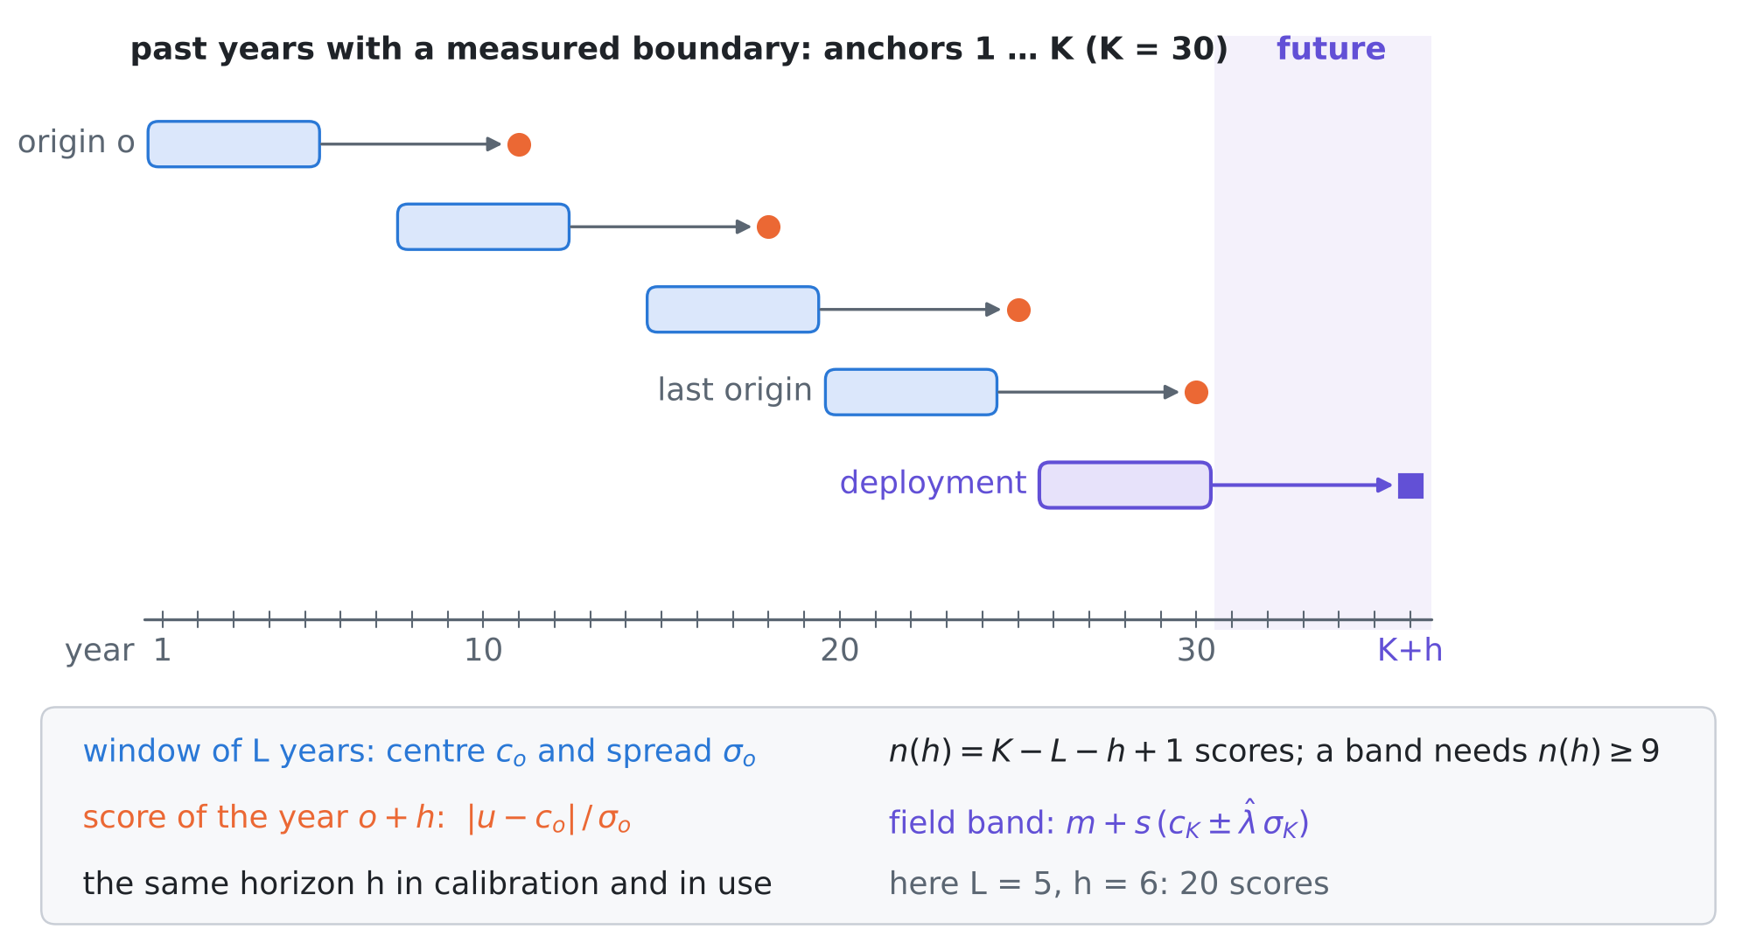
Figure 2. Horizon-matched calibration. Each past origin $o$ has a window of $L$ anchor years, whose centre $c_{o}$ and spread $σ_{o}$ re-centre and re-scale the score of the year $o+h$. The field band for the year $K+h$ uses the last window. The score is computed with the same lag $h$ in calibration and in use.
4.1 Anchor years and the set-up
An anchor year is a year in which the boundary function of interest was measured while the usual data were collected: a year of tide-gauge record for the sea level, a lysimeter or soil-moisture station for the recharge, a gauged reach for the inflow. The reconstructor of reviews I–IV is run on each anchor year (rain and the usual heads) and its standardised error $u_{t}\left(w\right)=\left(x_{t}\left(w\right)−m_{t}\left(w\right)\right)/s_{t}\left(w\right)$ is kept for every week $w$; ${\overline{u}}_{t}$ is its mean over the weeks. Anchors are years $t$ = 1, …, $K$ ($K$ = 30, one per year) and the field is the year $K+h$.
The test bed is that of reviews I–IV (D5): 32 cells, 64 weekly steps, the ensemble smoother with the exact solver (128 members) and four loggers (0.25, 1.25, 2.75, 4.25 km); the simulator keeps the year-0 law. Four real histories are compared (Figure 3). Without drift, every year follows the simulator. Under linear drift the vadose delay grows by 0.42 d per year (14 d to 35 d over 50 years, as the water table falls), the recharge-coefficient median falls by 1% per year, the inflow mean by 0.01 m²/d per year and the sea-level mean rises by 5 mm per year. Accelerating drift reaches the same values at year 50 quadratically. The abrupt shift is a new well field in year 24: the delay jumps to 28 d, the inflow mean drops by 0.5 m²/d and the coefficient by 25%.
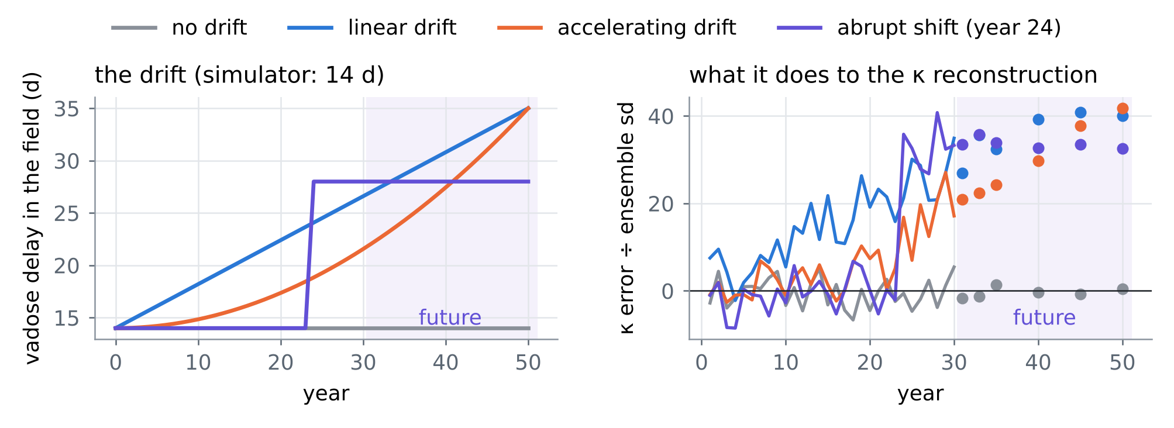
Figure 3. Left: the vadose delay of the four histories (the simulator keeps 14 d). Right: the mean standardised error of the $κ$ reconstruction in the anchor years (lines, averaged over the draws) and in the field years (dots). The heads absorb the drifts of the means; the delay does not drop out and builds a growing error.
For an origin $o$ with window $W_{o}=\{o−L+1,…,o\}$, let $c_{o}$ be the least-squares polynomial of degree $p$ through ${\left(t,{\overline{u}}_{t}\right)}_{t∈W_{o}}$ evaluated at $o+h$, and $σ_{o}$ the spread of the window (the root-mean-square deviation of $u_{t}\left(w\right)$ from ${\overline{u}}_{t}$ for weekly goals; the residual standard deviation of the fit for the scalar $κ$). The horizon-matched score of origin $o$ is
$$S_{o}\left(w\right)=\frac{\left|u_{o+h}\left(w\right)−c_{o}\right|}{σ_{o}}, o=L,…,K−h,$$ | (1)
and, with $L_{o}\left(λ\right)$ the share of the weeks of origin $o$ with $S_{o}\left(w\right)>λ$,
$${\hat{λ}}_{h}=inf\left\{λ:\frac{1}{n\left(h\right)+1}\left(\sum_{o=L}^{K−h}{L_{o}}\left(λ\right)+1\right)≤α\right\}\text{, with }n\left(h\right)=K−L−h+1,$$  $$\text{field band: }m+s \left(c_{K}±{\hat{λ}}_{h} σ_{K}\right).$$ | (2)
Degree 0 with $L$ = 5 is the level version, degree 1 with $L$ = 10 the trend version; the location-only ablation drops $σ_{o}$. The plain rules of T15 calibrate the unmodified scores $\left|u_{t}\left(w\right)\right|$ on simulations (review I), on all 30 anchor years (review IV), on the last nine years, or on all years with weights ${0.9}^{K−t}$ (weighted conformal prediction, S1). All calibrations are exact (weighted quantiles, no grid). Each result averages 300 draws of one anchor per year from 20 candidates; the risk is measured on 150 field cases of each target year.
4.2 Guarantees
Proposition P1 (the past is a shifted anchor). Let the anchor years have score laws $ρ_{t}$ and the field year $K+h$ the law $ρ_{K+h}$, all cases independent, and calibrate with weights $w_{t}∈\left[0,1\right]$. (i) The field risk is at most α+t​wt ϵt, with wt=wt/s​ws+1 and $ϵ_{t}$ the distance created by swapping year $t$ with the field year, $ϵ_{t}≤2 TV\left(ρ_{t},ρ_{K+h}\right)$. (ii) If $ϵ$ grows with the lag $l=K+h−t$, then among all weights that give a finite band at $α$ = 0.10 the bound is smallest for weight 1 on the last nine years, where it equals $α+\frac{1}{10}\sum_{l=h}^{h+8}{ϵ}\left(l\right)$; for $ϵ\left(l\right)=δl$ this is $α+0.9 δ \left(h+4\right)$, which grows with the horizon for every choice of weights.

Proof. (i) is the weighted, non-exchangeable bound of conformal risk control (anchor A1; Barber et al. 2023) with the loss bounded by 1; for independent cases the swap changes one pair from $ρ_{t}⊗ρ_{K+h}$ to $ρ_{K+h}⊗ρ_{t}$, at distance at most $2 TV\left(ρ_{t},ρ_{K+h}\right)$. (ii) A finite band needs $α\left(∑w+1\right)≥1$, that is $∑w≥9$. Minimising $∑w_{t}ϵ_{t}/\left(∑w+1\right)$ over $w∈{\left[0,1\right]}^{K}$ with $∑w≥9$ is a linear-fractional problem whose optimum puts weight 1 on the nine smallest $ϵ_{t}$; adding weight on a tenth year raises the ratio, because its $ϵ$ exceeds the mean of the nine. □
Proposition P2 (horizon matching removes polynomial drift). Let $u_{t}\left(w\right)=μ\left(t\right)+σ\left(t\right) ε_{t}\left(w\right)$, where the vectors $ε_{t}$ are independent and identically distributed across years (any law over the weeks). (i) If $σ$ is constant and $μ$ is a polynomial of degree at most $p+1$, the location-only scores $\left|u_{o+h}−c_{o}\right|$ have the same law at every origin and in the field year. (ii) If $σ\left(t\right)=σ_{0}e^{γt}$ and $μ$ has degree at most $p$, the scores (1) have the same law at every origin and in the field year, whatever the coefficients of $μ$ and the rate $γ$.

Proof. Write $t=o+τ$. The least-squares fit of degree $p$ reproduces every polynomial of degree at most $p$ in $τ$, and the $τ^{p+1}$ term of $μ\left(o+τ\right)$ has a coefficient that does not depend on $o$; so in (i) $u_{o+h}−c_{o}$ is a constant plus a fixed linear combination of $ε_{o−L+1},…,ε_{o},ε_{o+h}$, whose law does not depend on $o$. In (ii) the fit removes $μ$ entirely; numerator and $σ_{o}$ are both $e^{γo}$ times a fixed function of the same $ε$ (the spread is equivariant to scale and invariant to shifts), and $e^{γo}$ cancels. □
The scores are therefore identically distributed, which removes the drift from the calibration. Their windows overlap, so they are dependent; Proposition A1 of review IV then holds only approximately, and T16 measures how well. Neither part covers an accelerating drift with the level version ($p$ = 0, quadratic $μ$), and T16 shows the consequence.
Proposition P3 (how far ahead a record reaches). Horizon-matched calibration at horizon $h$ has $n\left(h\right)=K−L−h+1$ scores. (i) (2) has a finite solution only if $n\left(h\right)≥\left(1−α\right)/α$, that is $h≤K−L−8$ at $α$ = 0.10. (ii) A certificate $R≤α$ at confidence $1−δ$ needs $n\left(h\right)≥logδ/log\left(1−α\right)$, that is $h≤K−L−21$ at $α=δ$ = 0.10. With $K$ = 30: 17 and 4 years for the level version ($L$ = 5), 12 years and no certificate for the trend version ($L$ = 10). Each year of record adds one year of horizon.

Proof. Proposition A2 of review IV applied to the $n\left(h\right)$ scores: (i) the left side of (2) is at least $1/\left(n\left(h\right)+1\right)$; (ii) the same two-point law shows that fewer scores cannot certify. □
What is new. (1) Horizon-matched location–scale calibration, which removes a drift exactly when its level is polynomial and its spread exponential in time (Proposition P2), so a band calibrated on past years holds in a future year. (2) A horizon limit: how many years ahead a record of $K$ years can guarantee or certify a band, $K−L−8$ and $K−L−21$ years at $α$ = 0.10 (Proposition P3), a planning number for the length of a monitoring record. (3) The proof that no weighting of past years removes a drift (Proposition P1), and the tests that show both the simulation and the anchor calibrations of the earlier reviews breaking under realistic drift while the matched band holds. To our knowledge none of these appears in the one hundred papers of reviews I–V.

4.3 Tests
T15: plain calibrations under drift. Figure 4 and Table 2. Calibrated on simulations the band breaks under every drift: recharge 0.30–0.34, $κ$ 0.35–0.65, inflow and sea level 0.10–0.15. Calibrated on all 30 past years, as review IV would, it breaks too, because the old years carry less error than the field: $κ$ 0.20–0.59, recharge 0.10–0.22. The last nine years are valid for the weekly goals only by being extreme (risk 0.002–0.009: with nine anchors the band is the largest score seen) and still fail for $κ$ when the drift continues (0.10–0.45); decaying weights behave the same way, as Proposition P1 says.
T16: horizon-matched calibration. With the level window the risk is 0.003–0.082 for every goal and every horizon with a band under no drift, linear drift and the abrupt shift. Under accelerating drift it is 0.030–0.100 up to 10 years ahead and 0.17 for $κ$ at 15 years: a quadratic level is outside Proposition P2 for $p$ = 0. The trend window covers that case in principle but is noisy for the scalar $κ$ (0.047–0.130 across laws and horizons), so the level window with a horizon of at most 10 years is the robust choice. Matching the level without the spread fails after the abrupt shift (recharge up to 0.19, against 0.066 with the spread), because the shift widens the errors more than it moves them.
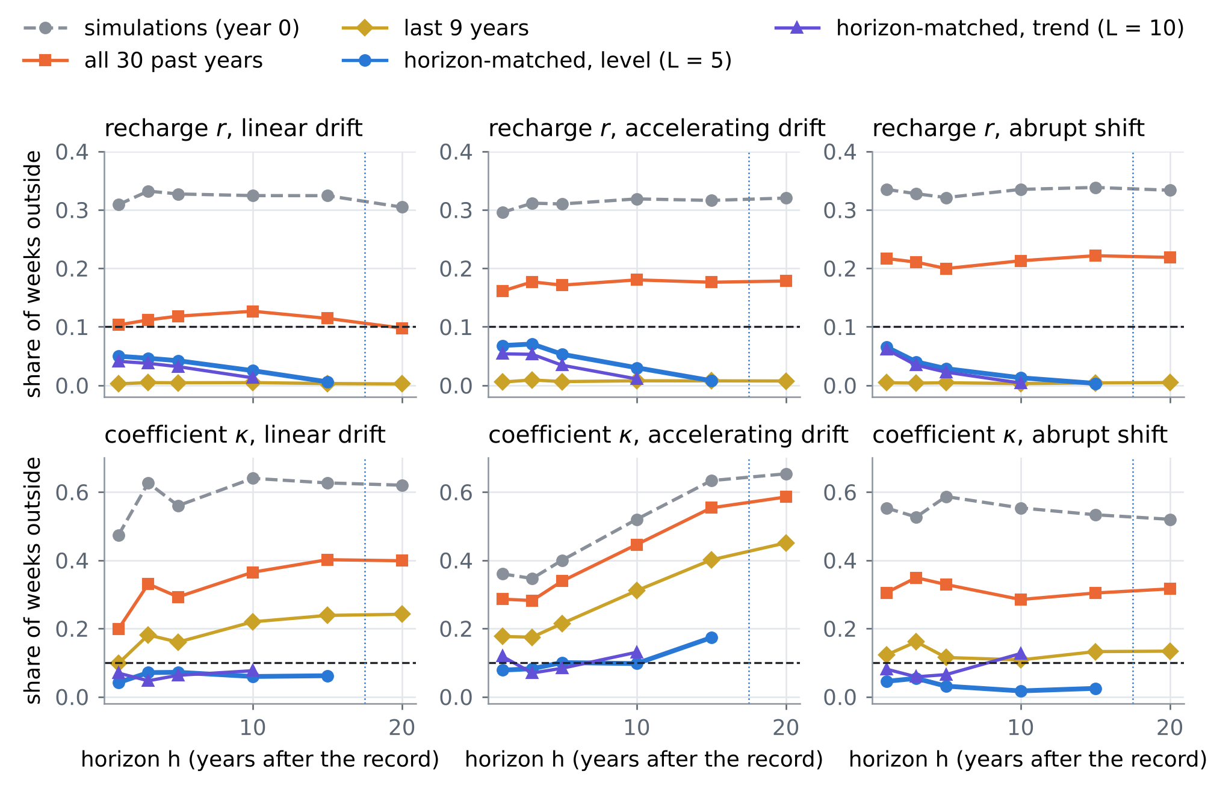
Figure 4. T15–T16: share of weeks outside the 90% band in the field year $K+h$, for the recharge (top) and $κ$ (bottom) under the three drift histories (dashed: target 0.10; dotted: the horizon limit 17 years of the level version; a missing point means that no band exists).
Table 2. T15–T16: realized risk (share of weeks outside; bold above 0.105). Plain rules at $h$ = 10 years; horizon-matched level version at $h$ = 1, 5, 10 and 15 years.
History | Goal | Sims | All 30 | Last 9 | Matched h=1 | h=5 | h=10 | h=15
no drift | recharge r | 0.085 | 0.060 | 0.003 | 0.066 | 0.061 | 0.043 | 0.026
 | inflow qL | 0.094 | 0.079 | 0.006 | 0.060 | 0.061 | 0.059 | 0.034
 | sea level η | 0.096 | 0.072 | 0.003 | 0.065 | 0.062 | 0.051 | 0.024
 | coefficient κ | 0.080 | 0.100 | 0.088 | 0.064 | 0.078 | 0.056 | 0.070
linear drift | recharge r | 0.324 | 0.127 | 0.005 | 0.050 | 0.042 | 0.025 | 0.006
 | inflow qL | 0.133 | 0.097 | 0.008 | 0.059 | 0.064 | 0.051 | 0.029
 | sea level η | 0.139 | 0.090 | 0.003 | 0.066 | 0.062 | 0.048 | 0.018
 | coefficient κ | 0.640 | 0.365 | 0.220 | 0.041 | 0.072 | 0.059 | 0.062
accelerating drift | recharge r | 0.319 | 0.180 | 0.008 | 0.068 | 0.053 | 0.030 | 0.008
 | inflow qL | 0.120 | 0.094 | 0.008 | 0.076 | 0.059 | 0.054 | 0.026
 | sea level η | 0.136 | 0.097 | 0.003 | 0.068 | 0.065 | 0.051 | 0.022
 | coefficient κ | 0.520 | 0.446 | 0.311 | 0.078 | 0.100 | 0.097 | 0.173
abrupt shift | recharge r | 0.335 | 0.213 | 0.003 | 0.066 | 0.028 | 0.013 | 0.003
 | inflow qL | 0.114 | 0.092 | 0.006 | 0.066 | 0.053 | 0.040 | 0.020
 | sea level η | 0.124 | 0.084 | 0.002 | 0.062 | 0.053 | 0.030 | 0.012
 | coefficient κ | 0.553 | 0.285 | 0.108 | 0.045 | 0.031 | 0.017 | 0.025

T17: the price and the reach. Figure 5. Without drift the matched band for the weekly goals is 1–14% wider than calibration on all past years up to 10 years ahead and 27–35% wider at 15 years, where only 11 scores remain; against the last nine years, the only valid plain rule for them, it is 0.50–0.70 of the width. For $κ$ the matched band is 1.6–2.4 times wider than the all-years band, because the spread of a scalar must come from the 5 values of the window. Under drift the band widens with the horizon as the errors do. The reach is that of Proposition P3: no band beyond 17 years with the level window and 12 years with the trend window, for a 30-year record.
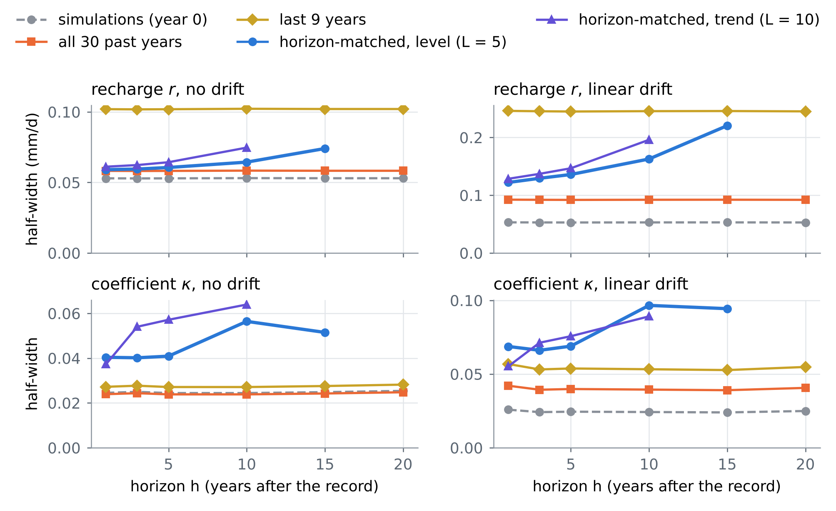
Figure 5. T17: half-width of the band against the horizon for the recharge (top) and $κ$ (bottom), without drift (left) and under linear drift (right). Plain rules do not depend on the horizon; the matched bands widen as fewer scores remain and as the errors grow.
4.4 Where the anchor years come from at Fushë-Kuqe
• Sea level: each year of a tide-gauge record with land motion corrected is one anchor year; the length of the usable record of the nearest gauge is to be confirmed with the national hydrometeorological service, and it sets the horizon of Proposition P3.
• Recharge and its coefficient: years with a lysimeter, a soil-moisture station with drainage, or a dense head campaign together with a local rain gauge; for $κ$ the rain gauge is essential (review III). Existing records: to be compiled.
• What drifts: the water table and with it the vadose delay (pumping), evaporative demand (O4, M5), the source of recharge under irrigation and pumping (M3), the relative sea level with subsidence, and land use. Each named driver gives a regressor that can replace time in the window fit of (1).
• Planning rule: a guarantee $h$ years ahead needs a record of at least $h+L+8$ years of anchors, 23 years for a decade ahead with the level window; a certificate needs $h+L+21$.
5. Synthesis: one hundred papers in one procedure
Table 3 places the hundred papers of reviews I–V on the steps of the procedure. Card numbers carry the review: I-O1 is card O1 of review I, V-C2 card C2 of this review. Review V adds the time axis to the guarantee: the band is calibrated for the horizon at which it will be used.
Table 3. The one hundred papers of reviews I–V against the steps of the procedure (card numbers of each review; a paper can serve several steps).
Step | Review I | Review II | Review III | Review IV | Review V
prior from rain | O3, O5, C5, M1 | O1, O2, O5, C1, C2, C3, C4, B1, B4, M2, M5 | O1, O2, O3, O4, O5, C1, C2, C3, C4, C5, B1, B2, B3, B4, B5, M1, M2, M3 | O2, O5, C5, B3, B5 | O4, C1, C2, C4, B3, B4, B5, M3, M4, M5
emulate | O1, O3, C1, B1 | C1, B5, M2 | C3, M4 | O1, O3, O4, C1, M4 | –
invert | O1, O2, C2, C3, C4, B1 | O1, O2, O4, C4 | B1 | O4, C2, B2, M3 | B2
guarantee | O4, C1, B2, B3, B5, M2, M3 | O2, M1, M4 | C2, B5, M5 | O1, O3, C1, C2, C4, B1, B2, B3, B4, M1, M2 | O1, O2, O4, C3, C5, B1, B2, B4, M1, M2
field check | B2, B4, M4, M5 | C3, B1, B2, M3, M4 | O2, O4, C4, C5, B2, M1, M2, M4, M5 | O2, O4, C1, C3, C4, C5, B1, M3, M5 | O2, O3, O5, C1, C3, C4, B5, M3, M4
design, operate | O5, C5, M4 | O3, O4, C1, C2, C3, C5, B2, B3, B4, M1, M3 | C1, B4, M3 | B5, M1 | C5

Order of work. (1) Build the simulated aquifers from the rain, with the rain product's errors (RESHJA-GO). (2) Use them to design the reconstructor and to choose the instruments by guaranteed value (MATJA-GO). (3) Collect anchor years, at least $h+L+8$ of them for a band $h$ years ahead (PRIRJA-GO, Proposition P3). (4) Calibrate the band by horizon matching (2), with the level window and $h$ at most 10 years unless the drift is known to be linear; with no drift it reduces to the anchor calibration of ANKORA-GO up to a small loss of width. (5) Report the simulation-calibrated band (GARANCIA-GO) and the plain anchor band alongside: the gaps between the three are the measured costs of not knowing the real law and of not knowing how it will drift.
6. Limitations
• Every card is partly verified: landing pages were reached through search results only.
• Proposition P2 needs a polynomial level and an exponential spread; real drift can accelerate, saturate or jump. T16 shows a valid band for a jump and a failure for acceleration beyond 10 years.
• The matched scores are dependent because the windows overlap; the guarantee is approximate, and T16 measures it in one test bed only.
• One anchor per year is assumed; in practice anchor years can be missing, and each gap shortens the reach of Proposition P3.
• The tests use the linear one-dimensional test bed of reviews I–IV and three illustrative drift histories.
References
Anchors (provided by the user)
[A1] Angelopoulos, A. N., Bates, S., Fisch, A., Lei, L., & Schuster, T. (2024). Conformal risk control. The Twelfth International Conference on Learning Representations (ICLR 2024). arXiv:2208.02814 (PDF provided by the user). https://arxiv.org/abs/2208.02814
[A2] Tibshirani, R. (2023). Conformal prediction. Lecture notes, Advanced Topics in Statistical Learning, Spring 2023, University of California, Berkeley (PDF provided by the user). https://www.stat.berkeley.edu/~ryantibs/statlearn-s23/
The twenty papers of this review
[O1] Andrew B. Martinez, Jennifer L. Castle, David F. Hendry (2022). Smooth robust multi-horizon forecasts. In: Essays in Honor of M. Hashem Pesaran, Advances in Econometrics 43A, Emerald, 143–165 (2022). https://doi.org/10.1108/S0731-90532021000043A008
[O2] Jennifer L. Castle, Jurgen A. Doornik, David F. Hendry (2022). Forecasting facing economic shifts, climate change and evolving pandemics. Econometrics 10(1), 2 (2022). https://doi.org/10.3390/econometrics10010002
[O3] Antje Weisheimer, Daniel J. Befort, Dave MacLeod, Tim Palmer, Chris O'Reilly, Kristian Strømmen (2020). Seasonal forecasts of the twentieth century. Bulletin of the American Meteorological Society 101(8), E1413–E1426 (2020). https://doi.org/10.1175/BAMS-D-19-0019.1
[O4] Solomon H. Gebrechorkos, Justin Sheffield, Sergio M. Vicente-Serrano, Chris Funk, Diego G. Miralles, Jian Peng, Ellen Dyer, Joshua Talib, Hylke E. Beck, Michael B. Singer, Simon J. Dadson (2025). Warming accelerates global drought severity. Nature 642, 628–635 (2025). https://doi.org/10.1038/s41586-025-09047-2
[O5] Andrey Malinin, Neil Band, Yarin Gal and others (the full author list was not seen) (2021). Shifts: a dataset of real distributional shift across multiple large-scale tasks. NeurIPS 2021 Datasets and Benchmarks Track; arXiv:2107.07455. https://datasets-benchmarks-proceedings.neurips.cc/paper/2021/hash/ad61ab143223efbc24c7d2583be69251-Abstract-round2.html
[C1] R. S. Nerem, T. Frederikse, B. D. Hamlington (initials as seen) (2022). Extrapolating empirical models of satellite-observed global mean sea level to estimate future sea level change. Earth's Future 10(4), e2021EF002290 (2022). https://doi.org/10.1029/2021EF002290
[C2] B. D. Hamlington, A. Bellas-Manley, J. K. Willis, S. Fournier, N. Vinogradova, R. S. Nerem, C. G. Piecuch, P. R. Thompson, R. Kopp (initials as seen) (2024). The rate of global sea level rise doubled during the past three decades. Communications Earth & Environment 5, 601 (2024). https://doi.org/10.1038/s43247-024-01761-5
[C3] Matthew Rodell, Anne Barnoud, Franklin R. Robertson, Richard P. Allan, Ashley Bellas-Manley, Michael G. Bosilovich, Don Chambers, Felix Landerer, Bryant Loomis, R. Steven Nerem, Mary Michael O'Neill, David Wiese, Sonia I. Seneviratne (2024). An abrupt decline in global terrestrial water storage and its relationship with sea level change. Surveys in Geophysics 45(6), 1875–1902 (2024). https://doi.org/10.1007/s10712-024-09860-w
[C4] Brett A. Buzzanga, David Bekaert, Benjamin D. Hamlington, Robert Kopp, Marin Govorcin, Miller (given name not seen) (2023). Localized uplift, widespread subsidence, and implications for sea level rise in the New York City metropolitan area. Science Advances 9(39), eadi8259 (2023). https://doi.org/10.1126/sciadv.adi8259
[C5] Christopher Yeh, Nicolas Christianson, Alan Wu, Adam Wierman, Yisong Yue (2025). End-to-end conformal calibration for optimization under uncertainty. Transactions on Machine Learning Research (December 2025); arXiv:2409.20534. https://arxiv.org/abs/2409.20534
[B1] Shai Feldman, Liran Ringel, Stephen Bates, Yaniv Romano (2023). Achieving risk control in online learning settings. Transactions on Machine Learning Research (November 2023); arXiv:2205.09095. https://arxiv.org/abs/2205.09095
[B2] Anastasios N. Angelopoulos, Michael I. Jordan, Ryan J. Tibshirani (2025). Gradient equilibrium in online learning: theory and applications. Journal of Machine Learning Research 26, paper 25-0356, 1–68 (2025); arXiv:2501.08330. https://www.jmlr.org/papers/v26/25-0356.html
[B3] Mohammed Ombadi, Mark D. Risser, Alan M. Rhoades, Charuleka Varadharajan (2023). A warming-induced reduction in snow fraction amplifies rainfall extremes. Nature 619(7969), 305–310 (2023). https://doi.org/10.1038/s41586-023-06092-7
[B4] Rosemary Carroll, Richard Niswonger, Craig Ulrich, Charuleka Varadharajan, Erica Siirila-Woodburn, Kenneth Williams (as seen; the list and its order were not confirmed) (2024). Declining groundwater storage expected to amplify mountain streamflow reductions in a warmer world. Nature Water 2, 419–433 (2024). https://doi.org/10.1038/s44221-024-00239-0
[B5] Fadji Z. Maina, Alan Rhoades, Erica R. Siirila-Woodburn, Peter-James Dennedy-Frank (2022). Projecting end-of-century climate extremes and their impacts on the hydrology of a representative California watershed. Hydrology and Earth System Sciences 26(13), 3589–3609 (2022). https://doi.org/10.5194/hess-26-3589-2022
[M1] Liviu Aolaritei, Zheyu Oliver Wang, Julie Zhu, Michael I. Jordan, Youssef Marzouk (the first three contributed equally; the order differs between listings) (2025). Conformal prediction under Lévy–Prokhorov distribution shifts: robustness to local and global perturbations. Advances in Neural Information Processing Systems 38 (NeurIPS 2025); arXiv:2502.14105. https://proceedings.neurips.cc/paper_files/paper/2025/hash/5c3760faa9de12a0ff5afb839581a09f-Abstract-Conference.html
[M2] Anastasios N. Angelopoulos, Rina Foygel Barber, Stephen Bates (2024). Theoretical foundations of conformal prediction. arXiv:2411.11824 (book, version 5, March 2026; to be published by Cambridge University Press). https://arxiv.org/abs/2411.11824
[M3] Yusuf Jameel, Mason Stahl, Holly Michael, Benjamin C. Bostick, Michael S. Steckler, Peter Schlosser, Alexander van Geen, Charles Harvey (2023). Shift in groundwater recharge of the Bengal Basin from rainfall to surface water. Communications Earth & Environment 4, 14 (2023). https://doi.org/10.1038/s43247-022-00650-z
[M4] Jianzhi Dong, Ruzbeh Akbar, Andrew F. Feldman, Daniel Short Gianotti, Dara Entekhabi (2023). Land surfaces at the tipping-point for water and energy balance coupling. Water Resources Research 59(2), e2022WR032472 (2023). https://doi.org/10.1029/2022WR032472
[M5] Alexandre Tuel, Elfatih A. B. Eltahir (2021). Mechanisms of European summer drying under climate change. Journal of Climate 34(22), 8913–8931 (2021). https://doi.org/10.1175/JCLI-D-20-0968.1
Linked in the text (first review, earlier work and the field)
[S1] Barber, R. F., Candès, E. J., Ramdas, A., & Tibshirani, R. J. (2023). Conformal prediction beyond exchangeability. Annals of Statistics 51(2), 816–845. https://doi.org/10.1214/23-AOS2276
Data and project documents
[D1] Zeqiraj, D. (2026). Inputs, dispersion and boundary conditions from rain alone; GARANCIA-GO ("review I"), docs/literature/ in this repository.
[D2] Zeqiraj, D. (2026). State of the art II; MATJA-GO, the guaranteed value of a measurement ("review II"), docs/literature/ in this repository.
[D3] Zeqiraj, D. (2026). State of the art III: when the rain itself is uncertain; RESHJA-GO ("review III"), docs/literature/ in this repository.
[D4] Zeqiraj, D. (2026). State of the art IV: when the simulator is wrong; ANKORA-GO ("review IV"), docs/literature/ in this repository (Proposition A3 corrected on 5 November 2026).
[D5] Internal documents of the project: RINDËRTIMI-GO (test bed, ensemble smoother with the exact solver); the code of this review in experiments/prirja_go/.
Verification note. The bibliographic data of the twenty cards come from search results that quote the publisher, arXiv, proceedings or repository pages; doi.org, arxiv.org, openreview.net and most publisher hosts could not be opened directly in this environment. The anchors were read from the PDFs provided. Every number of Sections 1, 2 and 4 is computed by the code in experiments/prirja_go/, experiments/ankora_go/ and experiments/garancia_go/.

