CERTAIN-COAST — Introduction
Certified early warning for seawater intrusion, liquefaction and extreme sea levels at the wellfields, port and energy landfall of a subsiding Adriatic coast
1. Three critical assets on one subsiding coast
Within a few kilometres of the Durrës coast in Albania, a NATO Ally since 2009, lie the wellfields that supply drinking water to the area, the country's main port, which handled 94.2% of Albania's sea freight in the second quarter of 2026 [1], and an energy landfall where supply arriving from the sea meets the national system. They stand on soft, compacting sediments near active faults. The Mw 6.4 earthquake of 26 November 2019 near Durrës killed 51 people, affected 202,291 and caused total effects of about €985 million [2]; field surveys found liquefaction at coastal, riverine and lagoonal sites [3].
The three assets face three hazards: seawater intrusion into the aquifer that feeds the wells, liquefaction of the ground beneath the port and the landfall during an earthquake, and extreme water levels from storms on a rising relative sea. Some threats act slowly, through subsidence and the landward advance of salt water, others suddenly, through earthquakes and surges, and the slow ones make the sudden ones worse.
2. One system, not three problems
The three hazards are moved by the same two variables, the relative sea level R(t), the sea level minus the vertical motion of the land, and the water table that sets pore pressure in the ground (Figure 1). Pumping, the one lever the operators control, pulls them in opposite directions: a lower water table draws in salt water and compacts the clays, raising R(t), but it also makes the ground less prone to liquefaction. A warning that looks at one hazard at a time can therefore recommend an action that shifts the risk from one asset to another.
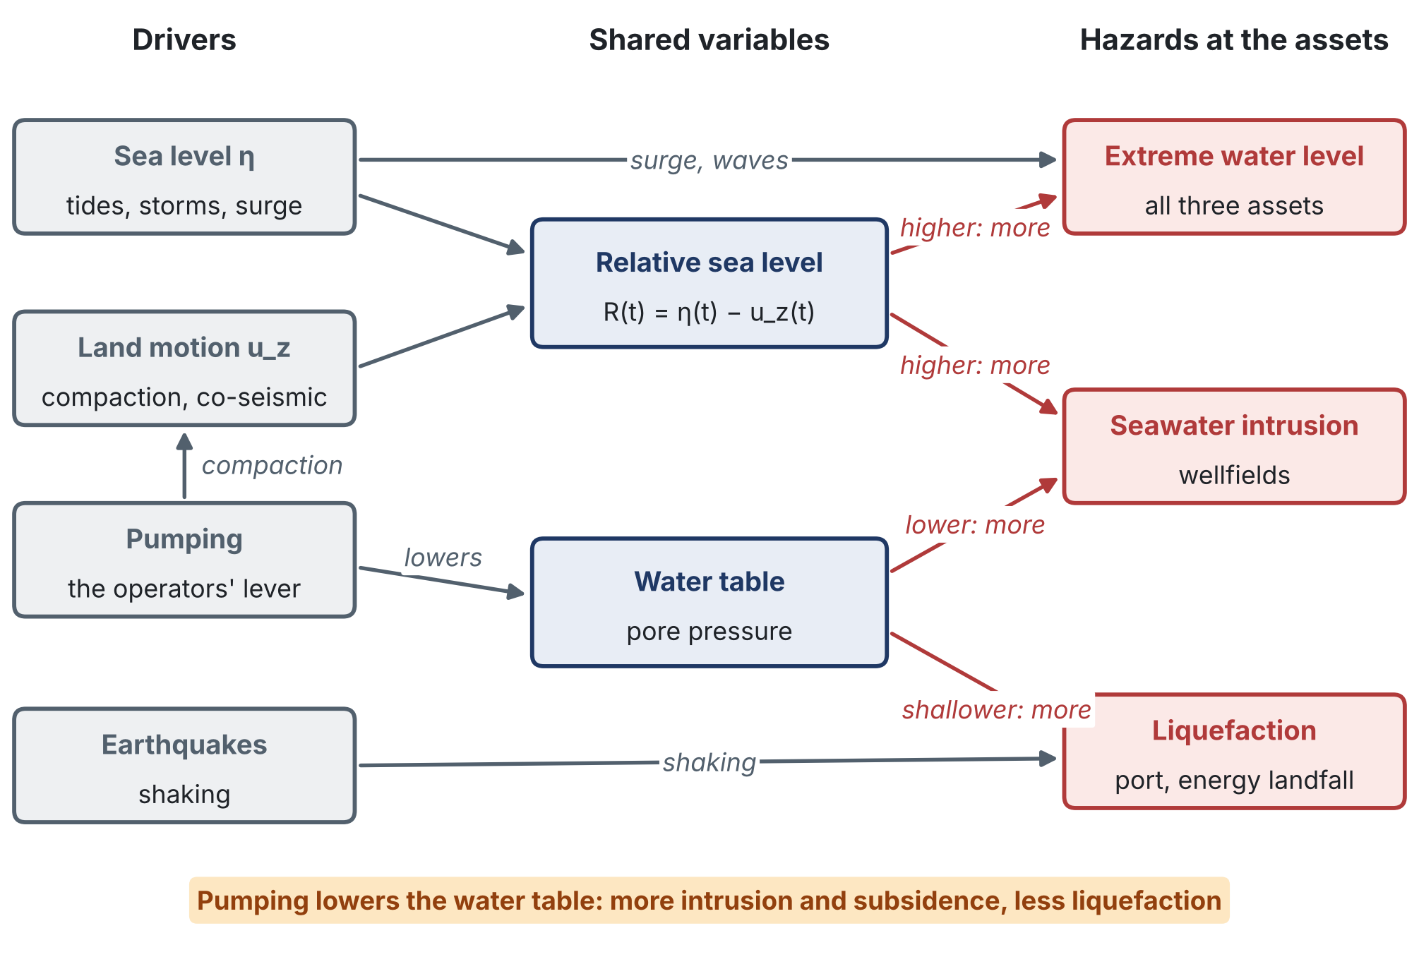
Figure 1. The coast as one system: four drivers act through two shared variables on three hazards at the three assets. Red arrows: the direction in which each shared variable changes a hazard.
3. The gap
The State of the Art, built on 30 key papers of 2020–2026, finds three gaps:
• No early warning treats the three hazards as one system, although they share relative sea level and pore pressure and are moved by the same pumping lever.
• No warning for any of them carries a guarantee. Certified methods assume exchangeable data or hold only on time average; none covers a slow physics model of a coastal hazard or states beyond the observed record.
• The new sensors are measured but not designed. InSAR time series, seismic noise and fibre are not chosen jointly with wells and samples to reduce missed warnings.
As a result, a decision-maker at the wells, the quay or the landfall cannot tell how often a warning will miss, and therefore what silence means.
4. Aim and objectives
Aim. To build, demonstrate and hand over an early-warning system for the Durrës coast in which the three hazards, seawater intrusion at the wellfields, liquefaction at the port and the energy landfall, and extreme sea levels at all three, come from one physical model of the coast; in which every warning is issued fast enough to act on; and in which every warning carries a stated, verifiable bound on how often it misses. The system protects three kinds of critical infrastructure on a NATO member's main port coast at once: water supply, port logistics and energy supply.
 | Objective | Proved by | Innovations
O1 | Measure the subsiding coast | D1.1 Coastal motion atlas and R(t) series (Month 12) | P1, P4, M5
O2 | Build one coupled physical model of the coast and a certified fast copy of it | D2.1 Calibrated coupled model (Month 18); D2.2 Certified surrogate (Month 22) | P2, P3, M4
O3 | Certify the warnings | D3.1 Certified alarm algorithms and proofs (Month 24); D3.2 Back-testing report (Month 27) | M1, M2
O4 | Design and install the monitoring network for the warnings | D4.1 Network design report (Month 6); D4.2 Network installed and streaming (Month 12) | M3, P5
O5 | Demonstrate the system in operation at the three assets | D5.1 Live demonstration report (Month 34) | P3, M1, M2
O6 | Transfer the system and build lasting capacity | D6.1 Software and data release (Month 33); D6.2 Operating procedures and policy brief (Month 36) | —
5. The approach in brief
CERTAIN-COAST runs for 36 months in 7 work packages. It measures the moving coast with InSAR, GNSS and a monitoring network designed for the warnings; models the three hazards in one coupled model with a fast, error-certified copy; certifies each alarm with a margin that bounds its miss rate; and operates the system live with the water utility, the port authority, the landfall operator and civil protection for twelve months before handing it over. Three evidence gates, at Months 18, 22 and 27, decide whether each phase starts. The requested budget is €382,500.
6. Why NATO SPS
• Resilience of an Ally: water, transport and energy are three of NATO's seven baseline requirements for civil preparedness [4].
• SPS Key Priorities: Environment, Climate Change and Security; Energy Security; Innovation and Emerging and Disruptive Technologies [5].
• Cooperation: NATO-country and partner-country scientists work on a shared security problem with the operators of the assets, and the partner country takes the methods home.
7. Reader's guide
The proposal answers the questions an evaluator asks; each is answered in the sections below.
Question | Where it is answered
Is it relevant to NATO security? | Security Relevance; Impact (Section 6)
What is known, and what is new? | State of the Art; Innovation; References
What exactly will be done? | Objectives; Methodology; Work Packages
When, and how is progress judged? | Work Plan; Timeline; Milestones (evidence gates); Deliverables
What can go wrong? | Risk Assessment (21 risks with triggers and fallbacks)
Who does it, and are the users committed? | Partnership; CVs of the Project Directors; Letters of Commitment
What will exist at the end, and for whom? | Expected Results; Impact; Dissemination Plan
Is it value for money, and will it last? | Budget; Sustainability
Is it done responsibly? | Ethics; Gender Balance; Data Management Plan
8. What is new in this introduction
• The problem drawn as one system. Figure 1 shows the drivers, the two shared variables and the three hazards with the direction of each effect, including the pumping trade-off that makes separate warnings unsafe.
• Every objective traced forward. Each objective names the deliverable that proves it and the innovations it carries, so the reader can follow a claim from this page to its test.
• A reader's guide by question. The guide maps the questions an evaluator asks to the sections that answer them, rather than listing chapters.
Sources
[1] INSTAT: Maritime Transport Statistics, Q2 2026. https://www.instat.gov.al/en/themes/industry-trade-and-services/transport-accidents-and-characteristics-of-road-vehicles/publikimet/2026/maritime-transport-statistics-q2-2026/
[2] EU Delegation to Albania: Release of the Post-Disaster Needs Assessment for Albania's recovery (February 2020). https://www.eeas.europa.eu/delegations/albania/release-post-disaster-needs-assessment-albania-recovery_en
[3] Mavroulis, S., Lekkas, E. and Carydis, P. (2021). Liquefaction phenomena induced by the 26 November 2019, Mw = 6.4 Durrës (Albania) earthquake and liquefaction susceptibility assessment in the affected area. Geosciences 11(5), 215. https://doi.org/10.3390/geosciences11050215
[4] NATO: Resilience, civil preparedness and Article 3 (baseline requirements). https://www.nato.int/cps/en/natohq/topics_132722.htm
[5] NATO Science for Peace and Security Programme (overview and Key Priorities). https://www.nato.int/cps/en/natohq/85291.htm

