State of the art XI: warnings for what happens between samples
The path-dependent neural jump ODE (Krach, Nübel & Teichmann, Stochastic Processes and their Applications 2026) and robust pricing and hedging with neural SDEs (Gierjatowicz, Sabate-Vidales, Šiška, Szpruch & Žurič, 2020), extracted; what they teach about forecasting from irregular records under model uncertainty; the state of the art for the NATO proposal; and SHTEGU-GO, certified warnings for the crossings that sparse samples never see
Dulian Zeqiraj · November 2026 · review with a numerically tested innovation · companion to reviews I–X
1. Outcome
• The two documents, extracted (Section 2). A1 learns the best possible forecast, the conditional expectation given what has been observed, from irregular and incomplete records of a generic, possibly path-dependent process, and proves that its neural jump ODE converges to it. A2 calibrates neural SDEs to the prices of liquid options and computes the interval of the price of an illiquid, path-dependent option over all models that fit the market, with a learned hedge as control variate.
• What we learn (Section 2.3): seven lessons and one gap common to both. A1 forecasts but gives no bound for what the model family cannot identify; A2 bounds over calibrated models but gives no guarantee when the truth lies outside the family, and neither asks which measurements would close the interval.
• The analogy (Section 4, Figure 1). Chloride sampled every few weeks or months pins only its marginal law — the "liquid prices". Whether it crosses the limit between two samples is a path functional, like a lookback option, and the marginals do not determine it.
• Innovation: SHTEGU-GO ("shtegu", the path; Section 5). Proposition S1: with the marginals fixed, the probability of crossing the limit within a season grows with the speed of the dynamics (Slepian), from the marginal tail to 1, so sparse samples alone never bound it. Proposition S2: the information a pair of samples carries on that speed falls as $τ^{2}e^{−2κτ}$ with the lag $τ$. Proposition S3: the band over all models consistent with the records (the robust price of A2) is certified with a conformal margin. Proposition S4: the online warning is the conditional probability of A1, and it needs the path and the head logger when the aquifer has memory.
• Numbers (T37–T40). With a correlation time of 8 days the chloride crosses 250 mg/L within a 120-day season with probability 0.78, 34 times the marginal tail (0.023); quarterly samples see a crossing in 3.1% of the seasons. The band that the records leave is 0.18–1.00 with quarterly samples, 0.48–1.00 monthly, 0.71–0.84 weekly and 0.76–0.80 with a daily logger. When chloride is skewed, the band of the Gaussian family covered the truth in only 74% of new aquifers with a logger; the conformal margin raised this to 90.3% on average. The online warning gained 20.3% in Brier skill with the head logger, against 6.9% from the sample path alone.
• For the proposal (Section 7): text for the state of the art and the methodology, two indicators and a sampling plan that measures the time scale of chloride at each wellfield.

2. The two documents, extracted
2.1 Optimal estimation of generic dynamics by path-dependent neural jump ODEs (A1)
Florian Krach, Marc Nübel and Josef Teichmann (ETH Zurich), Stochastic Processes and their Applications, 2026 (published version; arXiv:2206.14284v7, 25 August 2026, 55 pages; code). The problem is online forecasting: at every time, predict a stochastic process from the observations made so far, which arrive at random, irregular times and may cover only some of its coordinates. The process $X$ is a generic adapted càdlàg process — possibly non-Markovian, path-dependent or with jumps — observed at random times $t_{i}$ with masks $M_{i}∈\{0,1\}^{d_{X}}$ that say which coordinates were seen. The information is $A_{t}=σ\left(X_{t_{i},j},t_{i},M_{t_{i}}:t_{i}≤t, M_{t_{i},j}=1\right)$, and the optimal forecast in $L^{2}$ is the conditional expectation ${\hat{X}}_{t}=E\left[X_{t}\text{ | }A_{t}\right]$ (Section 2.4 of A1).
The model (Definition 3.13, Algorithm 1). A latent state $H_{t}$ follows a neural ODE between observations and jumps at each observation through a second network; the output $Y_{t}=\tilde{g}\left(H_{t}\right)$ is the forecast. Its inputs are the current time, the time of the last observation, the truncated signature of the interpolated observation path ${\tilde{X}}^{≤τ\left(t\right)}$ — which carries the whole observed past — the initial value, the running maximum, the number of observations and the time since the last one. The loss compares the output with the observed coordinates, after and before each jump:
$$Ψ\left(Z\right)=E\left[\frac{1}{n}\sum_{i=1}^{n}{(}{\left|M_{i}⊙\left(X_{t_{i}}−Z_{t_{i}}\right)\right|}_{2}+{\left|M_{i}⊙\left(Z_{t_{i}}−Z_{t_{i}−}\right)\right|}_{2})^{2}\right],$$ | (1)
and in practice an equivalent loss with $X_{t_{i}}−Z_{t_{i}−}$ in the second term, which trains more stably (Remark 4.10 of A1). The guarantee (Theorems 4.1 and 4.6): under Assumptions 1–6 — the observation times and masks independent of the process, every coordinate observable with positive probability, observation times that do not cluster, and integrability and regularity of the conditional expectation — the conditional expectation is the unique minimiser of $Ψ$, and the trained model converges to it as the networks, the signature level and the number $N$ of training paths grow. The conditional variance and moments follow by feeding $X^{2}$ or $e^{uX}$ as extra coordinates (Section 5); the stochastic filtering problem — a signal never observed at test time — is solved by training on simulated pairs of signal and observations in which the signal is revealed with probability $p_{k}∈\left(0,1\right)$ (Section 6). A companion paper extends the theory to noisy observations and to observation times that depend on the process (R6).
The experiments (Section 8 and Appendix C). A Poisson point process (metric below $2⋅{10}^{−5}$ after 30 epochs); a Brownian motion and its square for uncertainty bands (below $5⋅{10}^{−5}$); a fractional Brownian motion with Hurst parameter 0.05, where PD-NJ-ODE has the best metric, two intermediate variants about twice it and the original NJ-ODE about 16 times it; a correlated two-dimensional Brownian motion observed one coordinate at a time ($5.2⋅{10}^{−3}$), where the forecast of one coordinate reacts to observations of the other; filtering of a Brownian motion in Brownian noise ($5.4⋅{10}^{−4}$); PhysioNet patient records (test MSE $1.930⋅{10}^{−3}$ against $1.945⋅{10}^{−3}$ for NJ-ODE and $2.208⋅{10}^{−3}$ for the best latent ODE); and limit-order-book data of Bitcoin and Ethereum, where it extracts a little more than the stationary prediction while linear models and random forests overfit the noise.
What it leaves open, for us. (1) It needs $N$ independent sample paths of the process; one coastal aquifer is one path, so the training paths must come from simulated aquifers, as in its filtering setting. (2) Its guarantee is asymptotic convergence in $L^{2}$, not a coverage statement for a finite record. (3) It forecasts the process; a warning needs a functional of the future path — whether the limit is crossed — and a bound when the dynamics are not identified by the data.
2.2 Robust pricing and hedging via neural SDEs (A2)
Patryk Gierjatowicz, Marc Sabate-Vidales, David Šiška and Lukasz Szpruch (Edinburgh, Vega Protocol, Alan Turing Institute) and Žan Žurič (Imperial College London), working paper of 8 July 2020 (SSRN 3646241; code). The problem is model uncertainty: many models reproduce the prices of the liquid options, but they disagree about the price of an illiquid, path-dependent one. The model is an SDE whose drift and diffusion are neural networks, $dX_{t}^{θ}=b\left(t,X_{t}^{θ},θ\right)dt+σ\left(t,X_{t}^{θ},θ\right)dW_{t}$, with the traded asset a martingale under the pricing measure. It is calibrated to the liquid prices $p\left(Φ_{i}\right)$ and then pushed to the lowest and the highest price of the illiquid payoff $Ψ$ that the calibration allows:
$$\inf_{θ}E^{Q\left(θ\right)}\left[Ψ\right] \text{and} {\text{sup}}_{θ}E^{Q\left(θ\right)}\left[Ψ\right] \text{subject to} \sum_{i=1}^{M}{ℓ}\left(E^{Q\left(θ\right)}\left[Φ_{i}\right],p\left(Φ_{i}\right)\right)=0,$$ | (2)
solved by an augmented Lagrangian (Algorithms 2 and 3). Three devices make it work. A learned hedge as control variate: by the martingale representation theorem $Φ−\int_{0}^{T}{Z_{s}}dW_{s}$ has the same mean and smaller variance, and a network learns $Z$ (eq. 2.4); since the mini-batch gradient of the calibration loss is biased, with a bias bounded by $\frac{2}{N}{Var}^{1/2}\left[Φ^{cv}\right] {Var}^{1/2}\left[∂_{θ}Φ\right]$ for the square loss (Theorem 3.2), the hedge also reduces the bias. A tamed Euler scheme prevents moment blow-up of neural coefficients (eq. 2.7). A randomised, dropout-like training that differentiates one maturity at a time keeps memory constant and is unbiased (Theorem 4.1). The experiments calibrate local-volatility and local-stochastic-volatility neural SDEs (four hidden layers of 50 units per maturity) to European options with maturities of 2–12 months and 21 strikes, with calibration errors of order ${10}^{−9}$ to ${10}^{−4}$; ten runs from different initialisations, unconstrained and pushed to the lower and upper bound, give a range of prices for a lookback option $\max_{t}S_{t}−S_{T}$; the hedging error of the lookback was $E\left[s^{2}\right]=1.6⋅{10}^{−3}$ over 400,000 paths.
What it leaves open, for us. (1) The interval is over one parametric family; it is not a guarantee if reality lies outside it, and with too little information the class of calibrated models makes the bounds too wide to use (B6, cited in A2). (2) It does not say which additional observation would narrow the interval. (3) It is set in finance, with liquid prices observed every day; a coastal aquifer offers a few irregular samples a year.
2.3 What we learn
• 1. Forecast the conditional expectation, and train on what is observed, when it is observed (A1). The loss uses only the observed coordinates at the observation times, so gaps and partial observations need no imputation.
• 2. Carry the whole observed path (A1). For processes with memory the last value is not enough; the signature of the observed path restores the information (16 times lower error than the Markov NJ-ODE on fractional Brownian motion).
• 3. Use a second coordinate observed at other times (A1, correlated Brownian motion). A logger that sees part of the state sharpens the forecast of a coordinate sampled rarely.
• 4. Train on simulated pairs when the target is never observed (A1, filtering). This is how a warning for an unmeasured quantity can be trained from a calibrated simulator.
• 5. Fitting the data does not fix a path functional (A2). Models calibrated to the same liquid prices disagree about a lookback; report the interval over all calibrated models, not one model's value.
• 6. Reduce variance to reduce bias (A2, Theorem 3.2). A control variate makes the stochastic calibration and the bound computation faster and less biased.
• 7. Know when the interval is too wide (A2, B6). With too little information the robust interval says nothing; the remedy is more information, not more modelling.
• 8. The common gap. Neither document certifies its answer for a single, finite record when the truth is outside the model family, and neither asks which observation would close the gap. For a warning system both are the point: the warning must state how often it misses, and the monitoring design must buy the observation that makes the warning informative.
3. State of the art
Table 1 places the two documents among the lines of work a NATO reviewer will expect. Sources marked R are cited as A1 lists them, B as A2 lists them, W was checked against the publisher record; D are the project documents.
Table 1. Forecasting from irregular records and robust bounds: lines of work, what they give, and what they leave open for CERTAIN-COAST.
Line of work | Sources | What it gives | Open for CERTAIN-COAST
Irregular time series with neural ODEs | R2, R3, R4, R5 | Latent ODEs, GRU-ODE-Bayes, neural CDEs and rough DEs for sporadic data | No convergence guarantee for online forecasts
Neural jump ODEs | R1, A1, R6 | Online forecasts that converge to the conditional expectation, with jumps, memory, incomplete and noisy observations | Needs many paths; no finite-record coverage
Stochastic filtering | R7, A1 | Conditional law of an unobserved signal | Needs the joint law of signal and observations
Robust pricing, optimal transport | B1, B2, B3, B6 | Model-independent bounds for path-dependent options from liquid prices | Bounds often too wide; no data design
Calibration with neural networks | B4, B5, B8, A2 | Neural local and stochastic volatility; calibrated intervals for exotics | Interval within one family
Hedging and control variates | B7, A2 | Learned hedges that reduce variance and bias | Not a decision for an aquifer
Gaussian extremes | W1 | Slepian's inequality: a weaker correlation raises the chance of exceeding a level | Not used to bound warnings from samples
Guaranteed warnings | D1 | Conformal risk control and online calibration (in the CERTAIN-COAST form) | Calibrate observed outcomes, not crossings between samples

The pattern of the table is the case for the innovation. The forecasting literature has the optimal online predictor but not its bound, and the robust-pricing literature has the bound but not its certificate or the observation that would tighten it. A coastal warning needs all three, for an event — the chloride crossing its limit between two samples — that the samples themselves rarely see.
4. Our scheme: what happens between samples at a CERTAIN-COAST wellfield
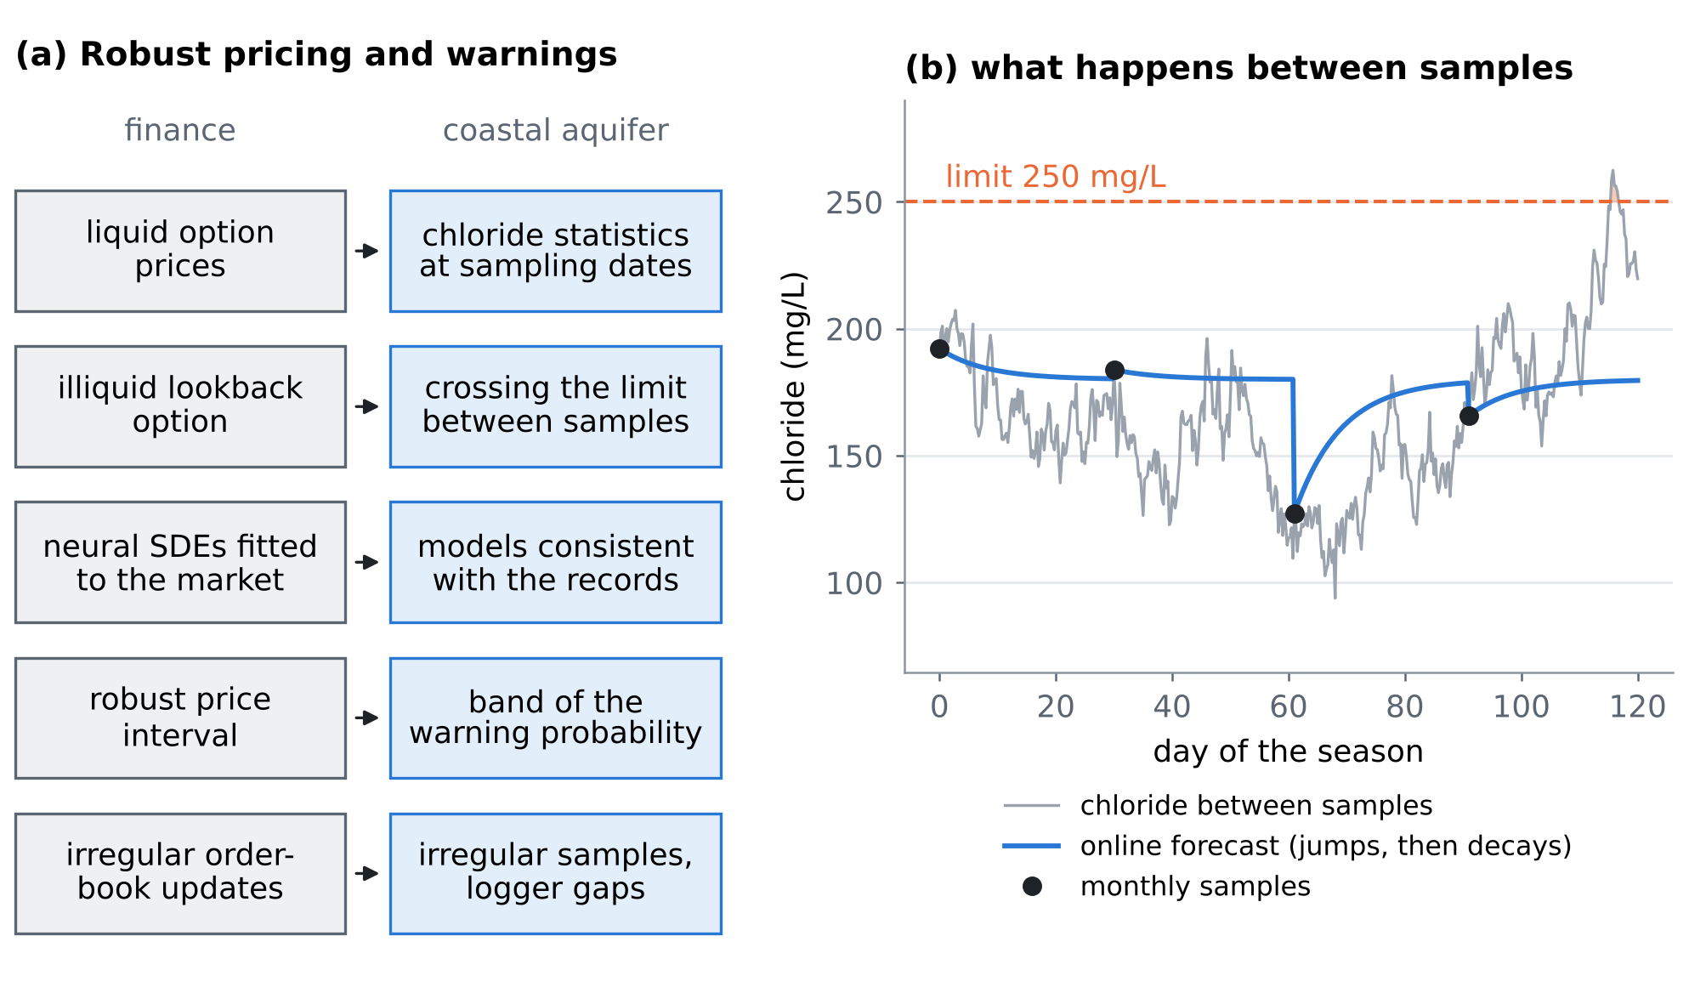
Figure 1. (a) The analogy between robust pricing (A2) and a coastal warning. (b) One season of simulated chloride with monthly samples: the limit is crossed between samples, and the online forecast (the conditional expectation of A1 for an Ornstein–Uhlenbeck chloride) jumps at each sample and decays towards the mean between them.
The water utility samples chloride at the wellfield wells for laboratory analysis; conductivity loggers, where they exist, read every few minutes. Chloride responds to pumping cycles, tides and storms within days, and to recharge over months. Write its standardised anomaly as a stationary process with marginal law $N\left(0,1\right)$, mean 180 mg/L and standard deviation 35 mg/L, so that the limit of 250 mg/L sits at $z=2.0$. The warning quantity is
$$p=P\left({\text{sup}}_{0≤t≤T}c_{t}≥z\right), T=120 \text{days},$$ | (3)
the probability that the limit is crossed at some time within a season, observed or not. The sampling campaigns pin the marginal law of $c$ at the sampling dates — the "vanilla prices"; $p$ is the "lookback". Table 2 completes the correspondence.
Table 2. Robust pricing and coastal warnings.
Robust pricing (A2) | CERTAIN-COAST | Consequence
Liquid option prices | Chloride statistics at the sampling dates | Pin the marginal law
Illiquid lookback option | Crossing of the limit within the season | A path functional
Neural SDEs calibrated to the market | Aquifer models consistent with the records | Many models fit
Robust price interval | Band of the warning probability | Report the band, not one value
Hedge as control variate | Analytic forecast as control variate; pumping as the lever | Cheaper, less biased
Irregular order-book updates (A1) | Irregular samples, logger gaps | Train on observed coordinates

5. SHTEGU-GO: certified warnings for what happens between samples
5.1 The marginals do not bound the crossing
Proposition S1 (Slepian ordering and the vacuous band). Let $c$ be a stationary Ornstein–Uhlenbeck anomaly with marginal law $N\left(0,1\right)$ and correlation $E\left[c_{s}c_{t}\right]=e^{−κ\left|t−s\right|}$. Then $p\left(κ\right)=P\left({\text{sup}}_{\left[0,T\right]}c≥z\right)$ is non-decreasing in $κ$, with

$$\lim_{κ→0}p\left(κ\right)=1−Φ\left(z\right), \lim_{κ→∞}p\left(κ\right)=1.$$ | (4)
Hence, over all models consistent with the marginal law, the band of the warning probability is $1−Φ\left(z\right)≤p<1$: the samples that pin the marginals bound the crossing only from below, by the marginal tail, and not at all from above. The same holds for any stationary Gaussian family whose correlations can be made arbitrarily small at positive lags.
Proof. Slepian's inequality (W1): for centred Gaussian processes with equal variances, if $E\left[X_{s}X_{t}\right]≥E\left[Y_{s}Y_{t}\right]$ for all $s,t$ then $P\left(\text{sup}X≥z\right)≤P\left(\text{sup}Y≥z\right)$ (for continuous processes through finite grids). Since $e^{−κ\left|t−s\right|}$ decreases in $κ$, $p$ is non-decreasing. As $κ→0$, ${\text{sup}}_{\left[0,T\right]}\left|c_{t}−c_{0}\right|→0$ in probability, so $p→P\left(c_{0}≥z\right)$. As $κ→∞$, the values at $m$ points spaced $T/m$ apart become independent, their maximum exceeds $z$ with probability $1−Φ{\left(z\right)}^{m}$, and $m$ can be taken as large as desired. □
5.2 What a pair of samples says about the time scale
Proposition S2 (information decays with the lag). For the stationary Ornstein–Uhlenbeck anomaly, one transition over a lag $τ$ carries the Fisher information

$$I_{τ}\left(κ\right)=\frac{τ^{2}ρ^{2}\left(1+ρ^{2}\right)}{{\left(1−ρ^{2}\right)}^{2}}, ρ=e^{−κτ},$$ | (5)
about $κ$. It decreases in $τ$ from $1/\left(2κ^{2}\right)$ at $τ→0$ and falls as $2τ^{2}e^{−2κτ}$ for $τ≫1/κ$. A record of $n$ transitions at lags $τ_{i}$ cannot give $κ$ a relative standard error below (κ2i​Iτiκ)−1/2≥2/n.
Proof. In standardised form $c_{t+τ}\text{ | }c_{t}∼N\left(ρc_{t},1−ρ^{2}\right)$. For this autoregression the Fisher information about $ρ$ is $\left(1+ρ^{2}\right)/{\left(1−ρ^{2}\right)}^{2}$; the chain rule with $dρ/dκ=−τρ$ gives (5). Its limit at small $τ$ follows from $1−ρ^{2}≈2κτ$; transitions of a Markov chain add their information, and $I_{τ}≤1/\left(2κ^{2}\right)$ gives the bound. □
With quarterly samples and a correlation time of 8 days, $ρ=1⋅{10}^{−5}$: the record says that chloride decorrelates between samples, but not how fast, and the upper end of the band of S1 stays at 1. A daily logger ($n=2921$ transitions) comes close to the bound: a relative standard error of 0.028 against $\sqrt{2/n}=0.026$.
5.3 The band over all consistent models, certified
Proposition S3 (certified robust band). Let $Θ\left(D\right)$ be the models of a family whose statistics match those of the record $D$ within their sampling error, and $B\left(D\right)=\left[\min_{Θ\left(D\right)}p_{θ}, \max_{Θ\left(D\right)}p_{θ}\right]$ the robust band (the interval of A2 with the record statistics as liquid prices). Let $D_{1},…,D_{J}$ be records of aquifers drawn from a broader law — a calibrated simulator with its misspecifications, or measured anchor periods — with true probabilities $p_{j}$ and distances $d_{j}=dist\left(p_{j},B\left(D_{j}\right)\right)$, and $δ$ the $k$-th smallest $d_{j}$, with $k$ the smallest integer not below $\left(J+1\right)\left(1−α\right)$. For a new aquifer drawn from the same law,

$$P\left(p∈\left[minB\left(D\right)−δ, maxB\left(D\right)+δ\right]\right) ≥ 1−α.$$ | (6)
Proof. The new distance and $d_{1},…,d_{J}$ are exchangeable, so the rank of the new one is uniform on $\{1,…,J+1\}$ (ties broken at random), and it is at most the $k$-th with probability at least $1−α$. □
The margin is zero when the family contains the truth and the band is wide; it is what a narrow band pays for being computed in a family that is too small. As in reviews I–VI, the guarantee holds for the law of the calibration aquifers; anchor periods measured at the site make it hold for the site.
5.4 The online warning
Proposition S4 (the warning as a conditional probability). Among all forecasts adapted to the information $A_{t}$ of irregular, incomplete records, the one that minimises the expected squared error against the event "the limit is crossed after $t$ and by $t+H$" is

$$p_{t}=P\left({\text{sup}}_{t<s≤t+H}c_{s}≥z | A_{t}\right).$$ | (7)
For a Markov chloride observed in full, $p_{t}$ depends only on the last sample and the time since it, so it jumps at each sample and evolves deterministically between samples — the structure of the neural jump ODE. When chloride is the sum of a fast (pumping, tide) and a slow (recharge) component, $p_{t}$ depends on the whole observed path and on any other coordinate that sees the slow part, such as a head logger observed at other times.
Proof. The conditional expectation of the indicator minimises the squared error among $A_{t}$-measurable forecasts (as for $\hat{X}$ in Section 2.4 of A1). For a Markov process the future given $A_{t}$ depends on the last observed state and the elapsed time only; for the sum of two independent Markov components the observed chloride is not Markov, and the slow component is estimated better from the path and from the head. □
5.5 The algorithm
SHTEGU-GO. Input: the warning event (the limit crossed within the season or within $H$ days), the sampling design, and a simulator family (the coupled model of CERTAIN-COAST with its uncertain parameters, or a flexible SDE family).
1. Statistics. From the record, compute what the design can see: the marginal law at the sampling dates, the correlations at the lags it samples, and the logger features where a logger exists, each with its sampling error.
2. Robust band. Simulate the family with exact Brownian-bridge maxima between time steps; keep the models whose statistics match within their error; report the lowest and the highest crossing probability (the inf and sup of A2).
3. Certify. Add the conformal margin of Proposition S3 from simulated aquifers of a broader law or from measured anchor periods.
4. Design. If the band is too wide to act on, add the observation that identifies the time scale — a conductivity logger, or pairs of samples a few days apart — as Proposition S2 prescribes, and recompute.
5. Operate. Train the online warning $p_{t}$ on simulated irregular records with the squared-error loss (the principle of A1), with the observed path and the head logger as inputs; issue $p_{t}$ with its certified band.

INNOVATION. SHTEGU-GO turns the robust bounds of mathematical finance and the online forecasts of neural jump ODEs into certified warnings for an event the samples rarely see: the crossing of a limit between two samples. (1) It shows that sparse sampling, which fixes only the marginal law, cannot bound this crossing from above (Proposition S1, through Slepian's inequality). (2) It gives the information a pair of samples carries on the time scale in closed form, so the monitoring design can buy exactly the observation that closes the band (Proposition S2). (3) It computes the band over all models consistent with the records, as A2 does for an exotic option, and certifies it for a single site with a conformal margin (Proposition S3), which A2 lacks. (4) It issues the warning online as the conditional probability that A1 learns, with the observed path and a head logger as inputs (Proposition S4). To our knowledge, neither document nor the sources of Table 1 bounds or certifies crossings between samples of an environmental record.

6. Tests
Set-up. Seasons of 120 days, simulated in steps of 0.25 day with the exact maximum of a Brownian bridge inside each step; records of 8 years; chloride mean 180 mg/L, standard deviation 35 mg/L, limit 250 mg/L ($z=2.0$). The four designs are quarterly, monthly and weekly laboratory samples (with ±20% jitter of the dates) and a daily logger. Checks. The bridge maximum adds the crossings between grid points (0.473 against 0.419 on the grid alone, correlation time 20 days); for a very slow chloride the crossing probability equals the marginal tail (0.0236 against 0.0228); the Fisher information (5) agrees with the variance of the simulated score (14.642 against 14.641 at a 7-day lag), and its short-lag limit is 0.5000 $≈1/\left(2κ^{2}\right)$ in units of $1/κ^{2}$.
6.1 T37: the crossing between samples, and what each design says
With a correlation time of 8 days (Figure 2a), the chloride crosses 250 mg/L within the season with probability 0.78, 34 times the marginal tail 0.023. Over correlation times from 400 days to a quarter of a day the probability rises from 0.073 to 1, never decreasing, as Proposition S1 states. Each design gives a 95% likelihood-ratio interval for the time scale, and the interval gives a band for the crossing (Table 3; 200 records per design). The band covered the true probability in 96%–98% of the records. Quarterly samples left the upper end at 1 in 98% of the records, and monthly samples in 96%. The samples themselves saw a crossing in only 3.1% of the seasons when quarterly, and in 57.1% with daily readings. The Cramér–Rao relative standard error of the time scale (Figure 2b) is 1376 with quarterly samples, 1.16 monthly, 0.103 weekly and 0.0278 with the logger.
Table 3. T37. Median band of the crossing probability left by each design (true value 0.78), the share of records whose upper end stays at 1, coverage, the share of seasons in which a sample was above the limit, and the Cramér–Rao relative standard error of the time scale.
Design | Samples | Band | Upper end at 1 | Coverage | Samples see | Rel. s.e.
quarterly samples | 32 | 0.18–1.00 | 98% | 98% | 3.1% | 1376
monthly samples | 96 | 0.48–1.00 | 96% | 98% | 8.7% | 1.16
weekly samples | 413 | 0.71–0.84 | 0% | 96% | 27.8% | 0.103
daily logger | 2922 | 0.76–0.80 | 0% | 96% | 57.1% | 0.0278

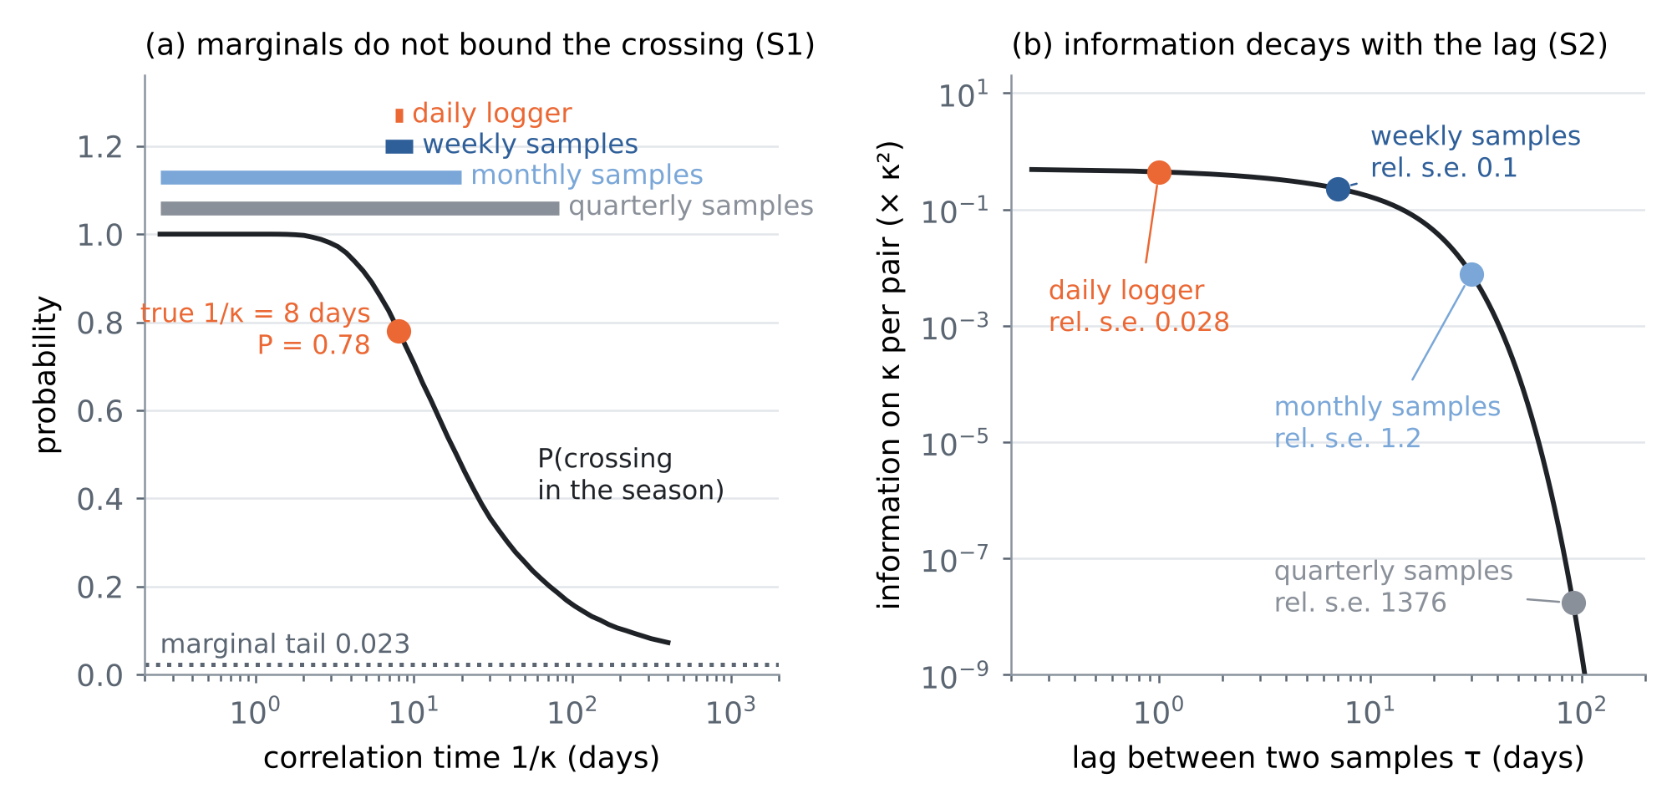
Figure 2. T37. (a) Probability of crossing the limit within the season against the correlation time (Proposition S1), the marginal tail, the true time scale, and the median 95% intervals of the time scale from each design (bars at the top). (b) Fisher information about the time scale per pair of samples against their lag (Proposition S2), with the lag and the Cramér–Rao relative standard error of each design.
6.2 T38: the band over a richer family
The robust problem of A2 in our setting: chloride is the sum of a fast and a slow Ornstein–Uhlenbeck component, $c=\sqrt{w} X_{f}+\sqrt{1−w} X_{s}$, with three free parameters, and the truth has a 3-day fast component (weight 0.6) and a 40-day slow one. A model is consistent when its correlations at the lags a design samples are within two standard errors of the observed ones. The band over the consistent models (Figure 3; true probability 0.80) is 0.07–1.00 with the marginals only, 0.17–1.00 with quarterly samples, 0.34–1.00 monthly, 0.62–0.97 weekly and 0.64–0.88 with a daily logger (676 consistent models out of the grid). Even the logger leaves a band of a quarter of the probability scale, because three parameters fit the same correlations at the sampled lags — the phenomenon A2 reports for exotics under perfect calibration.
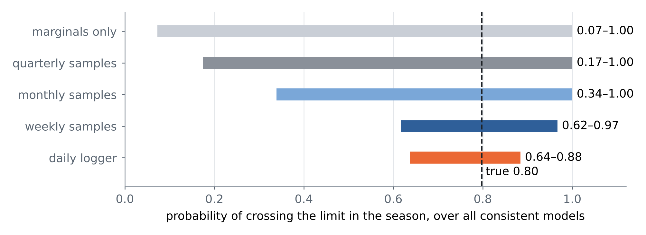
Figure 3. T38. Band of the crossing probability over all two-component models consistent with the statistics each design observes; dashed: the true probability.
6.3 T39: certification when chloride is skewed
Chloride is right-skewed. The test draws 400 aquifers from a broader law: a two-component anomaly pushed through a lognormal-type skewing map, with random time scales, weights, skewness, mean and standard deviation. For each, the band is computed with the Gaussian two-component family from the aquifer's own record. Half of the aquifers calibrate the margin of Proposition S3 and half test it, over 50 random splits (Figure 4). With monthly and weekly samples the band is wide (median widths 0.89 and 0.57) and covers the truth in 97% and 97% of the aquifers, so no margin is needed. With a daily logger the band narrows to a median 0.32 and its coverage falls to 74% (62% for the most skewed aquifers): the family is now too small for the precision of the data. The conformal margin (median 0.068) restores a coverage of 90.3% on average over the splits (10–90%: 86%–94%; target 90%), at a median width of 0.45.
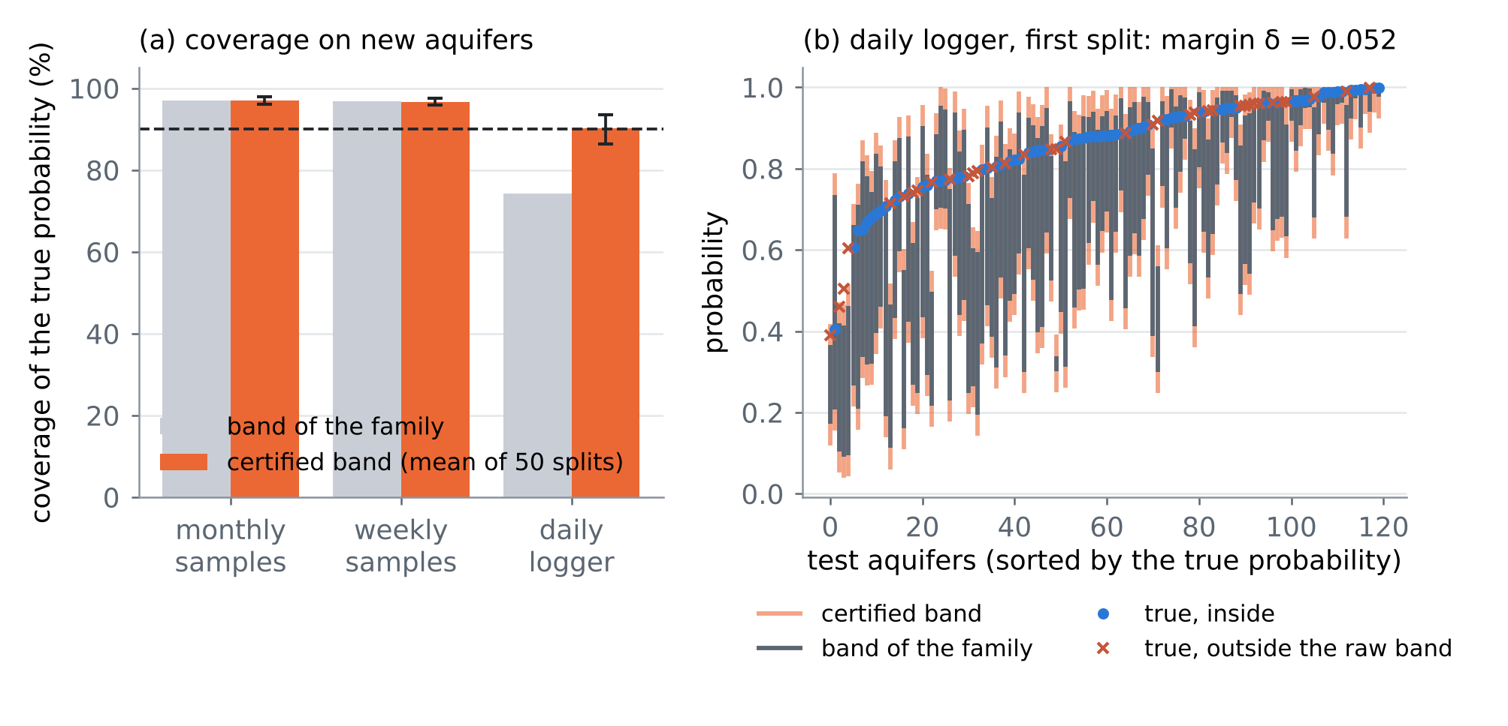
Figure 4. T39. (a) Coverage of the true crossing probability by the band of the Gaussian family and by the certified band, for new aquifers with skewed chloride (all aquifers for the family band; mean of 50 random splits for the certified band, bars 10–90%). (b) Daily logger, first split: bands and true probabilities of the test aquifers.
6.4 T40: the online warning
The truth is the two-component chloride; laboratory samples arrive at Poisson times (on average every 14 days) with noise; a head logger reads the slow component daily, with noise and 20% of the days missing. At a random time the warning is the probability that the limit (here $z=1.6$, crossed in 63% of the 30-day windows) is crossed in the next 30 days. Three forecasters are trained by the logistic loss on 24,000 simulated records (60% train, 40% test): with Markov features (the last sample and the time since it), with path features of the samples (the previous sample and gap, the mean and the maximum of the last 60 days, the number of samples) and with the head logger as well. Their Brier skill over climatology (Figure 5) is 6.1%, 6.9% and 20.3%. The sample path adds little because fortnightly samples barely resolve the slow component; the head logger, which observes it at other times, adds most — the incomplete-observation effect of A1, and the reason to log heads at the wellfield.
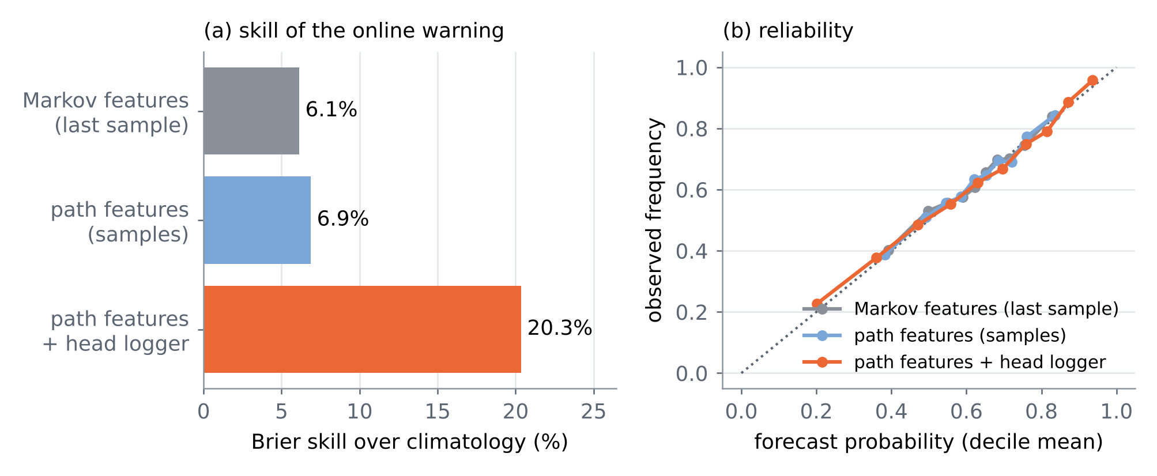
Figure 5. T40. (a) Brier skill of the online warning over climatology for three sets of inputs. (b) Reliability: forecast probability against observed frequency, by decile.
7. For the NATO form
7.1 State of the art (addition to field 5.3)
Online forecasting from irregular, incomplete records has a theory: path-dependent neural jump ODEs converge to the conditional expectation for generic, possibly path-dependent processes with jumps and incomplete observations (Herrera, Krach and Teichmann 2021; Krach, Nübel and Teichmann 2026). Robust finance bounds the price of a path-dependent option over all models that fit the liquid prices (Hobson 1998; Beiglböck, Henry-Labordère and Penkner 2013), and neural SDEs compute such intervals in practice (Gierjatowicz et al. 2020). Neither is applied to environmental warnings, and both leave two gaps: the online forecast has no finite-record guarantee, and the robust interval has no certificate outside its model family and no rule for the observation that would narrow it. For seawater intrusion the gap is concrete: a sampling programme pins the marginal law of chloride but not its time scale, and by Slepian's inequality (Slepian 1962) the probability that the limit is crossed between samples is then bounded below by the marginal tail and not at all above.

7.2 Methodology (monitoring and warnings)
For each wellfield the warning of a chloride crossing is computed for the whole season, not only at the sampling dates. The models of the coupled simulator that are consistent with the records give a band for the crossing probability, certified by a conformal margin calibrated on simulated aquifers and measured anchor periods. The monitoring design adds the observation that identifies the time scale of chloride — a conductivity logger, or pairs of samples a few days apart — where the band is too wide to act on. Online, the warning is the conditional probability of a crossing given the irregular samples and the head logger, learned from simulated records. In tests, a correlation time of 8 days made a crossing within a season 34 times more likely than the marginal tail; quarterly samples left the band at 0.18–1 and a daily logger narrowed it to 0.76–0.80.

7.3 Indicators and sampling plan
• Indicator 1. For each wellfield, the certified band of the seasonal crossing probability is at most 0.25 wide by Month 12 (test bed: 0.04 with a daily logger, 0.81 with quarterly samples).
• Indicator 2. The certified band covers the observed crossing frequency in back-testing at the stated level, at least 90% (test bed: 90.3% with the margin).
• Sampling plan. A conductivity logger in at least one production well of each wellfield, logging every 15 minutes; one campaign a year of paired laboratory samples 1, 3 and 7 days apart to measure the short-lag correlation; heads logged daily at the same wells (T40); the time scale re-estimated each season.
8. Limitations
• Simple families. S1 and S2 are proved for a stationary Ornstein–Uhlenbeck chloride; T38 and T39 use a two-component Gaussian family on a grid instead of neural SDEs. The coupled model of CERTAIN-COAST replaces them in the project.
• The forecaster is a stand-in. T40 uses logistic regression on hand-made path features, not a neural jump ODE, and is evaluated by its Brier score, not against the true conditional probability.
• Known marginals in T37. T37 takes the marginal mean and variance as known; T39 estimates them from each record.
• Certificates hold for the calibration law. The margin of S3 is valid for aquifers drawn like the calibration aquifers; measured anchor periods are needed for the site, as in reviews I–VI.
• No control variate. The hedge of A2 was not used; with the analytic Ornstein–Uhlenbeck forecast as control variate the Monte Carlo cost of the band would fall further.
References
The two documents (provided by the user)
[A1] Krach, F., Nübel, M., & Teichmann, J. (2026). Optimal estimation of generic dynamics by path-dependent neural jump ODEs. Stochastic Processes and their Applications (published version: doi.org/10.1016/j.spa.2026.105058); arXiv:2206.14284v7, 25 August 2026 (PDF provided by the user, 55 pages). Code: github.com/FlorianKrach/PD-NJODE. https://doi.org/10.1016/j.spa.2026.105058
[A2] Gierjatowicz, P., Sabate-Vidales, M., Šiška, D., Szpruch, L., & Žurič, Ž. (2020). Robust pricing and hedging via neural SDEs. Working paper dated 8 July 2020, SSRN 3646241 (PDF provided by the user, 34 pages). Code: github.com/msabvid/robust_nsde. https://ssrn.com/abstract=3646241
Cited from the neural jump ODE article A1 (as listed in its references)
[R1] Herrera, C., Krach, F., & Teichmann, J. (2021). Neural jump ordinary differential equations: consistent continuous-time prediction and filtering. International Conference on Learning Representations (ICLR 2021).
[R2] Rubanova, Y., Chen, R. T. Q., & Duvenaud, D. (2019). Latent ordinary differential equations for irregularly-sampled time series. Advances in Neural Information Processing Systems 32, 5320–5330.
[R3] De Brouwer, E., Simm, J., Arany, A., & Moreau, Y. (2019). GRU-ODE-Bayes: continuous modeling of sporadically-observed time series. Advances in Neural Information Processing Systems 32, 7379–7390.
[R4] Kidger, P., Morrill, J., Foster, J., & Lyons, T. (2020). Neural controlled differential equations for irregular time series. Advances in Neural Information Processing Systems 33.
[R5] Morrill, J., Salvi, C., Kidger, P., & Foster, J. (2021). Neural rough differential equations for long time series. International Conference on Machine Learning, PMLR.
[R6] Andersson, W., Heiss, J., Krach, F., & Teichmann, J. (2024). Extending path-dependent NJ-ODEs to noisy observations and a dependent observation framework. Transactions on Machine Learning Research.
[R7] Bain, A., & Crisan, D. (2009). Fundamentals of Stochastic Filtering. Springer.
[R8] Chevyrev, I., & Kormilitzin, A. A primer on the signature method in machine learning (as cited in A1).
Cited from the neural SDE article A2 (as listed in its references)
[B1] Hobson, D. G. (1998). Robust hedging of the lookback option. Finance and Stochastics 2(4), 329–347.
[B2] Beiglböck, M., Henry-Labordère, P., & Penkner, F. (2013). Model-independent bounds for option prices: a mass transport approach. Finance and Stochastics 17(3), 477–501.
[B3] Cox, A. M., & Obłój, J. (2011). Robust hedging of double touch barrier options. SIAM Journal on Financial Mathematics 2(1), 141–182.
[B4] Dupire, B. (1994). Pricing with a smile. Risk 7(1), 18–20.
[B5] Cuchiero, C., Khosrawi, W., & Teichmann, J. (2020). A generative adversarial network approach to calibration of local stochastic volatility models. arXiv:2005.02505.
[B6] Eckstein, S., Guo, G., Lim, T., & Obłój, J. (2019). Robust pricing and hedging of options on multiple assets and its numerics. arXiv:1909.03870.
[B7] Buehler, H., Gonon, L., Teichmann, J., & Wood, B. (2019). Deep hedging. Quantitative Finance, 1–21.
[B8] Hernandez, A. (2016). Model calibration with neural networks. Risk.
Checked against the publisher record in this review
[W1] Slepian, D. (1962). The one-sided barrier problem for Gaussian noise. Bell System Technical Journal 41(2), 463–501. https://doi.org/10.1002/j.1538-7305.1962.tb02419.x
Project documents and code
[D1] Zeqiraj, D. (2026). Reviews I–X of this series (GARANCIA-GO … NDERHYRJA-GO), docs/literature/ in this repository; the CERTAIN-COAST application texts and their references, docs/certain_coast/ (conformal risk control and online calibration: Angelopoulos et al. 2024; Gibbs and Candès 2024).
[D2] The code of this review: experiments/shtegu_go/ (shtegu_exp.py, shtegu_figs.py; results in res/).
Verification note. A1 and A2 were read in full from the PDFs provided. The references marked R and B are cited as A1 and A2 list them; they were not opened here. W1 was checked against publisher and index records found by search. Every number of Sections 1, 6 and 7 is computed by the code in experiments/shtegu_go/.

