Inputs, dispersion and boundary conditions from rain alone
Twenty papers from Oxford, Caltech, Berkeley and MIT (2020–2026), with links and what each one teaches; a synthesis of how to solve the problem when the conditions are few; and GARANCIA-GO, guaranteed bands calibrated on simulated aquifers
Dulian Zeqiraj · November 2026 · review with a numerically tested innovation
1. Outcome
• Twenty papers, five per institution, 2020–2026, each with its links (Section 3, Figure 1). None was a card in the earlier reviews of this series; the best-known works that were (calibrate–emulate–sample, Kalman inversion, transport-map smoothers, prediction-powered inference and others) are linked in the synthesis of Section 5. Every card says what the paper teaches for the input parameters, the dispersion coefficient and the boundary conditions when only the rain is known, and ends with an innovation step.
• Three facts decide the problem (Section 5.1). Rain fixes when recharge arrives, not how much; every boundary needs its own witness; and dispersion has no witness in rain or heads at all (Proposition 6): only chloride data move it.
• Innovation: GARANCIA-GO (Section 4). Boundary conditions are never observed, so conformal prediction has nothing to calibrate on. GARANCIA-GO calibrates on aquifers simulated from the physical prior given the rain, with the same reconstructor that is used in the field. It gives finite-sample guarantees for the share of weeks a boundary function leaves its band and for the whole function, a field check by conformal p-value, a shift bound that does not grow with the number of simulations, and a version that holds with high probability for one calibration set.
• Test on 500 simulated aquifers (rain + 4 head loggers). The raw ensemble left 0.17–0.20 of the weeks outside its nominal 90% band and missed $κ$ in 0.67 of the cases. Calibrated, the share of weeks outside is 0.095–0.100 (target ≤ 0.10) and the whole-function coverage 0.899–0.901 (target ≥ 0.90), at widths 1.11–1.36 (pointwise) and 1.71–2.04 (whole function) times the exact posterior. The guarantees hold on average from $n=20$ simulations; with the Hoeffding–Bentkus bound they hold for 93–100% of the calibration sets.
• Rain only, or a wrong model. With rain alone the guarantees still hold but the bands are wide: four loggers make them 1.6 times narrower for the sea level, 4.8–4.9 for inflow and recharge, 6.2 for $κ$ and 11.4 for the initial head. Calibrating with the field's own rain keeps the guarantee for that record (a dry and a wet year). A vadose delay 2.5 times longer in the field breaks every guarantee (whole-function coverage of the recharge 0.02) and raises the alarm in 0.67 of the cases; putting the delay in the prior restores coverage to 0.86–0.91.
• Fushë-Kuqe dispersion. The littoral head alone leaves the transition-zone width at its prior (7.4–53.8 m against 7.4–53.3 m); the chloride facts move it to 16–65 m; all facts give 12.8–47.8 m, and 13.9–54.9 m after the conformal calibration of the 90% interval.

2. The problem and the two anchors
2.1 What must be found, and what is known
A simulation of a coastal aquifer needs three groups of inputs that are rarely measured:
• input parameters: the transmissivity $T$ (or the conductivity $K$), the recharge coefficient $κ$ and the delay $τ$ of the unsaturated zone;
• the dispersion coefficient of the salt-transport equation, through the dispersivities $α_{L}$ and $α_{T}$ and their field signature, the width $w$ of the transition zone;
• boundary and initial conditions: the sea level $η\left(t\right)$, the inflow $q_{L}\left(t\right)$ through the inland boundary, the recharge $r\left(t\right)$ and the initial head $h_{0}\left(x\right)$.
The one time series that is always there is the rain $P\left(t\right)$ (a station, E-OBS or ERA5-Land), with a few heads and, at Fushë-Kuqe, a handful of chloride facts. The test bed of the RINDËRTIMI-GO note is the flow problem (1) on a 5 km section (32 cells, 64 weekly steps), driven by the recharge law (2):
$$S \frac{∂h}{∂t}=T \frac{∂^{2}h}{∂x^{2}}+r\left(t\right)−Q δ\left(x−x_{w}\right),$$  $$h\left(0,t\right)=η\left(t\right)\text{ at the sea, }T \frac{∂h}{∂x}\left(L,t\right)=q_{L}\left(t\right)\text{ inland, }h\left(x,0\right)=h_{0}\left(x\right)$$ | (1)
$$r\left(t\right)=κ \left(k_{τ}*P\right)\left(t\right)+e\left(t\right)\text{, with }k_{τ}\left(s\right)=\frac{s}{τ^{2}} e^{−s/τ}$$ | (2)
Here $k_{τ}$ is the Erlang-2 kernel of two linear reservoirs in series ($τ$ = 14 d), $κ$ is lognormal (median 0.35, log-sd 0.25), and $e$, $η$, $q_{L}$ and $h_{0}$ are Gaussian random fields around random means; $T$ = 1500 m²/d, $S$ = 0.05 and the pumping $Q$ is known. Given the rain and $κ$ every unknown is Gaussian and the heads are affine in them, so the exact posterior is a one-dimensional mixture over $κ$: it is the reference against which every band below is scored. Salt enters through the advection–dispersion equation (3), whose dispersion tensor holds the dispersion coefficient:
$$\frac{∂\left(ϕc\right)}{∂t}+∇⋅\left(q c\right)=∇⋅\left(ϕ D ∇c\right),$$  $$D=\left(D_{m}+α_{T}\left|v\right|\right)I+\left(α_{L}−α_{T}\right) \frac{vv^{⊤}}{\left|v\right|}$$ | (3)
At Fushë-Kuqe the calibrated areal model of the chloride study replaces (3) by a sharp interface at depth $ζ$ (Strack's single potential, Strack 1976) with a dispersive transition zone of width $w$:
$$c\left(z\right)=Φ\left(\frac{z−ζ}{w}\right)\text{, }Cl={Cl}_{f}+\overline{c} \left({Cl}_{s}−{Cl}_{f}\right)$$ | (4)
so $w$ is the field footprint of the transverse dispersion and $\overline{c}$ is $c$ averaged over a well screen. The prior of $w$ is lognormal (median 20 m, log-sd 0.6), with the recharge $R$ and the conductivity scale $η_{g}$ among the other unknowns. The facts (Cenameri & Beqiraj 2016) are the area whose shallow chloride exceeds 250 mg/L (15% of the 349 km² polygon), the littoral head (about 3 m), the seawater fraction of the mid-depth screens (4.7%) and chloride below 30 mg/L in the north-eastern recharge band.
2.2 Anchor 1: split conformal prediction
For any score (large means a poor fit) and exchangeable scores $S_{1},…,S_{n+1}$, the empirical quantile (5) covers the next score (Tibshirani 2023):
$$\hat{q}=S_{\left(⌈\left(1−α\right)\left(n+1\right)⌉\right)},$$  $$1−α≤P\left(S_{n+1}≤\hat{q}\right)≤1−α+\frac{1}{n+1}$$ | (5)
The lower bound needs only exchangeability; the upper bound holds when the scores are almost surely distinct. Nothing is assumed about the model that produced the scores: a poor model gives wide bands, not a wrong coverage. If $n<\left(1−α\right)/α$ the quantile is infinite, so at $α$ = 0.10 at least nine calibration cases are needed.
2.3 Anchor 2: conformal risk control
Conformal risk control (Angelopoulos, Bates, Fisch, Lei & Schuster, ICLR 2024) replaces the indicator of non-coverage by any loss $L_{i}\left(λ\right)$ that is non-increasing and right-continuous in $λ$, bounded by $B$, with $L_{i}\left(λ_{max}\right)≤α$. With Rnλ=1ni≤n​Liλ,
$$\hat{λ}=inf\left\{λ: \frac{n}{n+1}{\hat{R}}_{n}\left(λ\right)+\frac{B}{n+1}≤α\right\},$$  $$α−\frac{2B}{n+1}≤E\left[L_{n+1}\left(\hat{λ}\right)\right]≤α$$ | (6)
The upper bound is their Theorem 1 (exchangeable losses); the lower bound is their Theorem 2 (i.i.d. losses with no jump at a fixed $λ$) and cannot be improved in general (their Proposition 1). For an arbitrary sequence $Z_{1},…,Z_{n+1}$ their Proposition 4 adds $B\sum_{i=1}^{n}{TV}\left(Z_{i},Z_{n+1}\right)$ to the upper bound.
2.4 Why the anchors cannot be applied as they stand
Both anchors need calibration cases whose truth is known. For boundary conditions there are none: nobody measures the inflow through the inland boundary week by week, nor the recharge, nor the initial head field, and the dispersion width is measured at no well. Calibration pairs can only be simulated. GARANCIA-GO (Section 4) makes this precise: the guarantee becomes a guarantee under the physical prior given the rain; a field check says whether the field contradicts that prior, and a shift bound says what is lost if it does.
3. The twenty papers
Five papers per institution, all published in 2020–2026 (Figure 1). Three rules decided the selection: relevance to inferring inputs, dispersion and boundary conditions from rain and few data with calibrated uncertainty; a link to the institution at the time of publication; and no paper that was already a card in an earlier review of this series (those are linked in Section 5 instead). Each card gives the links, the evidence of affiliation, what the paper does, three lessons (input parameters, dispersion coefficient, boundary conditions from rain alone) and an innovation step for our problem.
Verification. The hosts doi.org, arxiv.org, openreview.net and most publisher pages were blocked in this environment, so every landing page was reached through search results that quote it. No card could be checked against the full text, and all are marked partly verified; the evidence line of each card says what was seen.
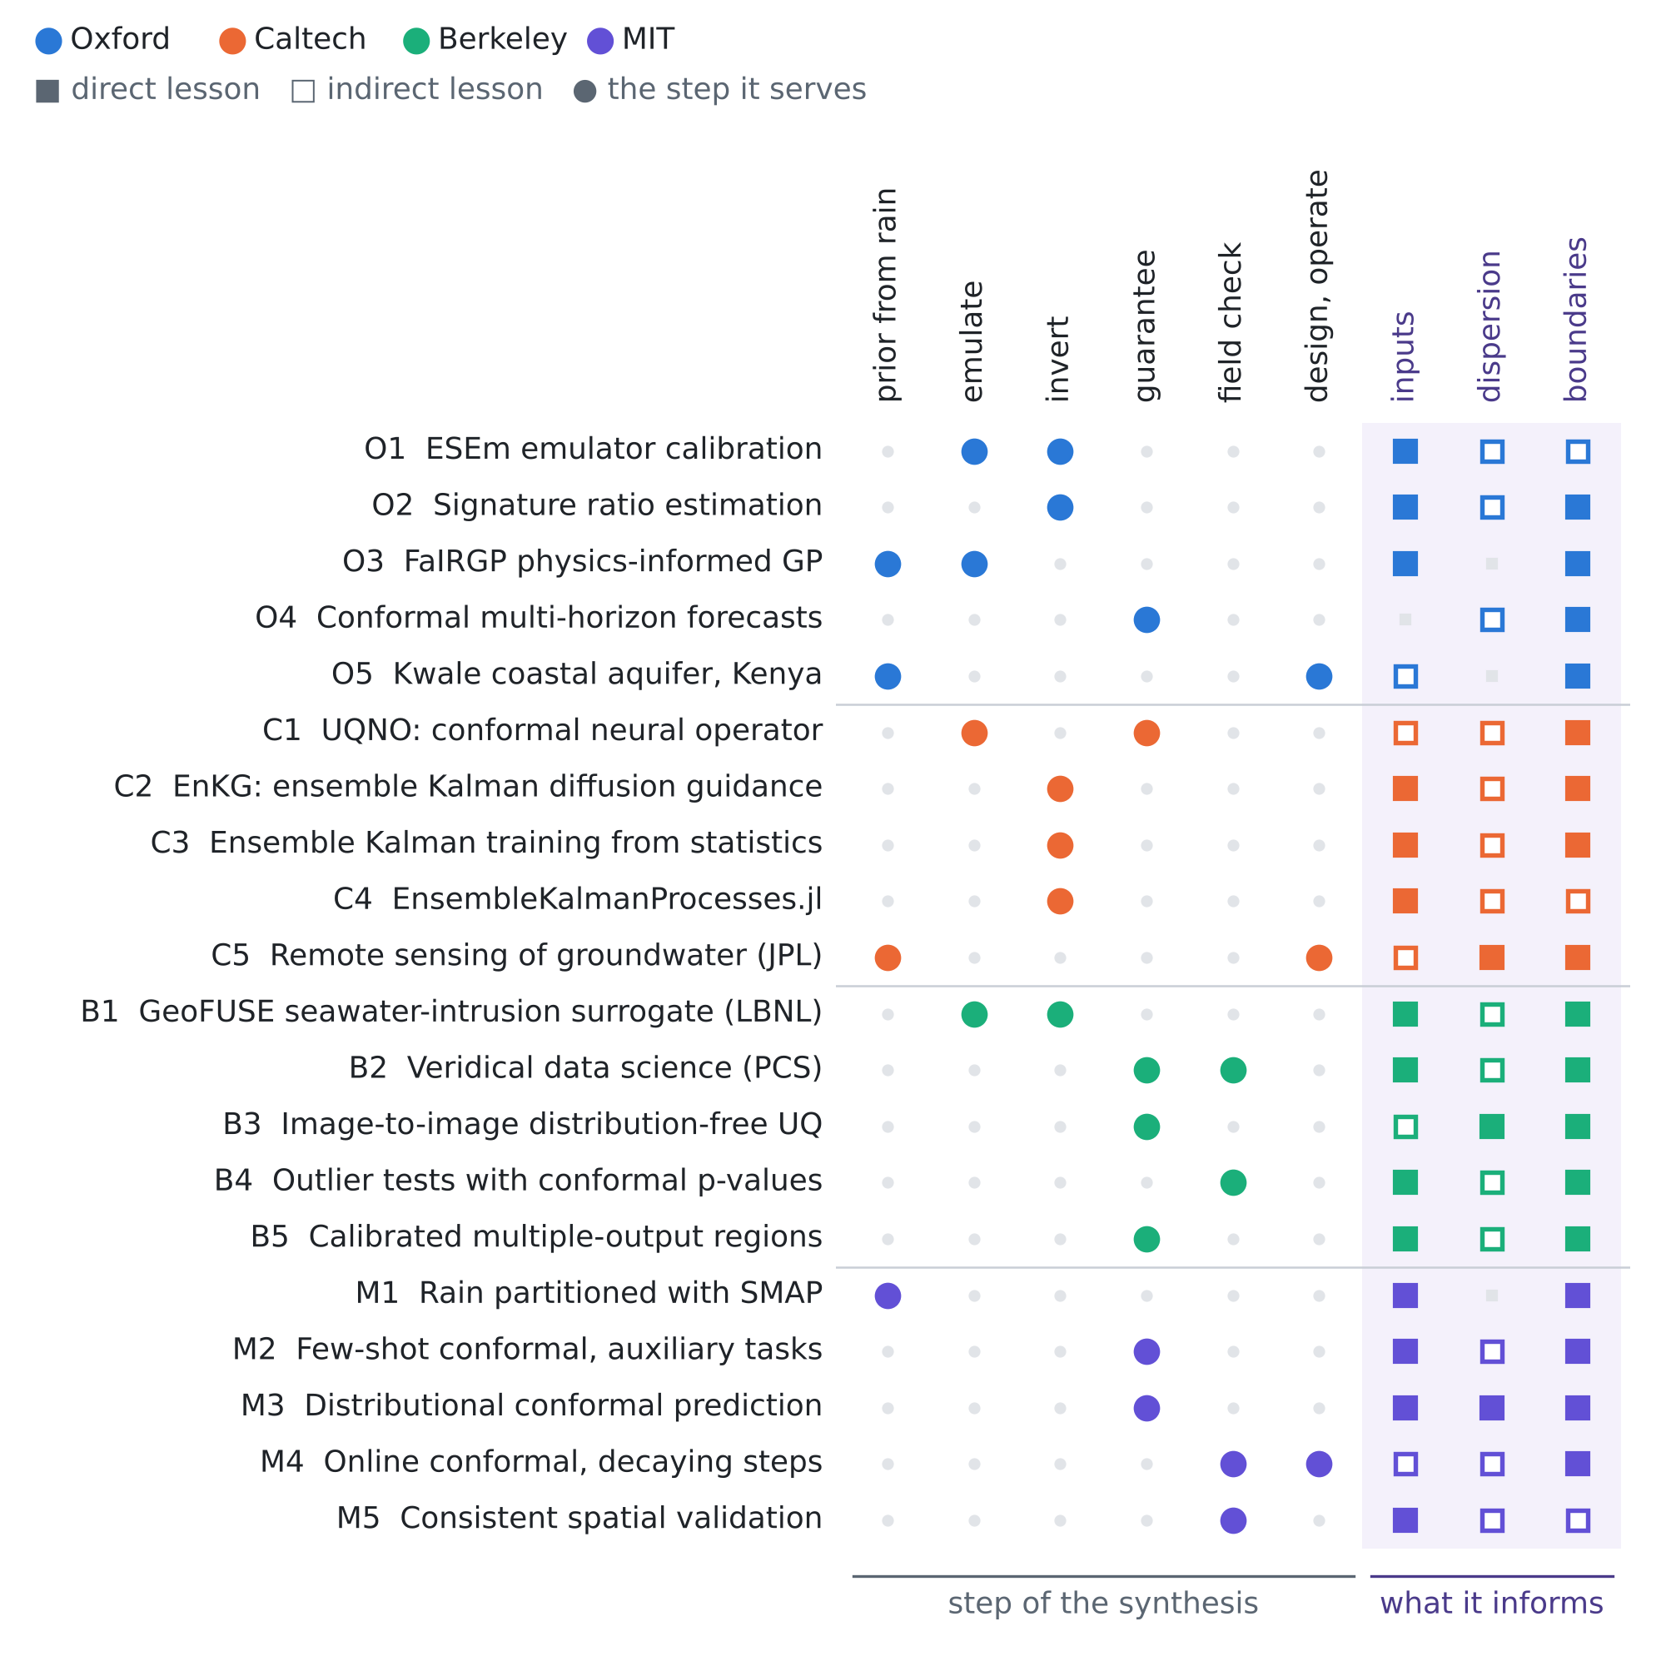
Figure 1. The twenty papers against the step of the synthesis they serve (Section 5.2) and the unknown they inform. Colour gives the institution; a filled square is a direct lesson, an open square an indirect one.
3.1 University of Oxford
O1 · Oxford · 2021
Model calibration using ESEm v1.1.0 – an open, scalable Earth system emulator
Duncan Watson-Parris, Andrew Williams, Lucia Deaconu, Philip Stier
Geoscientific Model Development 14(12), 7659–7672 (2021)
Links: doi:10.5194/gmd-14-7659-2021 · arXiv:2108.10747 · ORA record
Affiliation and verification: Watson-Parris and Stier: Atmospheric, Oceanic and Planetary Physics, University of Oxford (article summary); record in Oxford's ORA repository. Status: partly verified (landing pages reached through search results only).
What it does. An open-source tool to build, validate and sample emulators of expensive Earth-system models for calibration and uncertainty quantification. The emulator can be a Gaussian process, a convolutional network or a random forest; inference ranges from rejection sampling to MCMC; model output is matched to observations with the Community Intercomparison Suite. Case studies reduce parametric uncertainty in a climate model, explore precipitation sensitivity in a cloud-resolving model and treat CMIP6 scenario uncertainty.
Input parameters. The scalar unknowns ($logT$, $κ$, $τ$, the inflow mean, the initial interface) are emulated from a space-filling design of a few hundred runs and calibrated by rejection against the few heads; a calibration that would need ${10}^{5}$ runs needs ${10}^{2}$–${10}^{3}$.
Dispersion coefficient. Put the dispersivity in the design: if the emulated heads are flat in it, rejection returns the prior. The emulator's sensitivity is the cheapest identifiability test; Proposition 6 shows the heads are exactly flat in $w$ for the Fushë-Kuqe chloride model.
Boundary conditions from rain alone. Time-varying boundaries are functions, so emulate them through a few coefficients (mean sea level, mean and amplitude of the inland inflow, $κ$, $τ$) and leave the weekly departures to Gaussian fields.
Innovation step for our problem. Emulator error with a guarantee: calibrate the emulator itself by split conformal on held-out runs and add the calibrated radius to the discrepancy term, so the rejection step is honest about emulator error (the paper's posterior has no coverage guarantee).

O2 · Oxford · 2022
Amortised likelihood-free inference for expensive time-series simulators with signatured ratio estimation
Joel Dyer, Patrick Cannon, Sebastian M. Schmon
Proceedings of AISTATS 2022, PMLR 151, 11131–11144
Links: PMLR v151 · arXiv:2202.11585
Affiliation and verification: Dyer: University of Oxford (paper's address; INET Oxford lists the paper). Cannon: Improbable; Schmon: Improbable and Durham. Status: partly verified (landing pages reached through search results only).
What it does. SignatuRE is a kernel classifier for sequential data, built on path signatures and the signature kernel, for likelihood-free density-ratio estimation. It targets time-series simulators too costly for the large simulation budgets of neural ratio estimators, and gives more accurate inference than competing ratio methods when the budget is small; tests include an Ornstein–Uhlenbeck process.
Input parameters. Once the recharge error and the vadose delay are stochastic, the chain rain → recharge → heads has no tractable likelihood. Signature features of the head series summarise it without hand-made statistics, and one trained classifier gives posteriors of $\left(T,κ,τ\right)$ for any new record.
Dispersion coefficient. For an electrical-conductivity or chloride series at a pumping well, the signature captures the rise and tailing of a breakthrough, which carry the dispersivity information that heads lack.
Boundary conditions from rain alone. Give the rain path to the signature as a channel: the classifier then learns the rain–head lag, i.e. the vadose filter, and posteriors of the boundary parameters conditioned on the observed rain.
Innovation step for our problem. Amortised posteriors are approximate. Their simulation-based coverage can be checked and corrected exactly as in our T4 (conformal on simulated truths), and amortisation makes the check cheap: no retraining per test case.

O3 · Oxford · 2024
FaIRGP: A Bayesian energy balance model for surface temperatures emulation
Shahine Bouabid, Dino Sejdinovic, Duncan Watson-Parris
Journal of Advances in Modeling Earth Systems 16(6), e2023MS003926 (2024)
Links: arXiv:2307.10052 · doi:10.1029/2023MS003926
Affiliation and verification: Bouabid: Department of Statistics, University of Oxford (arXiv byline). Sejdinovic: Adelaide; Watson-Parris: Scripps/UCSD. Journal details from the author's BibTeX; the DOI was not resolved. Status: partly verified (landing pages reached through search results only).
What it does. A Gaussian-process emulator that satisfies the temperature-response equations of the FaIR energy balance model: physics in the mean, a GP for what the physics misses. It emulates global and spatial surface temperatures across future scenarios, outperforms energy balance models, gives tractable uncertainty quantification and also estimates radiative forcing.
Input parameters. It is the structure of our recharge law, $r=κ \left(k_{τ}*P\right)+e$: a linear filter of a known forcing plus a GP. When the heads respond linearly, the posterior of $κ$ and of $e\left(t\right)$ is closed form (in our test bed it is a one-dimensional mixture over $κ$).
Dispersion coefficient. Not treated (temperature). The lesson is structural: physics in the mean and the GP on the residual keep the residual from absorbing a signal the physics should carry.
Boundary conditions from rain alone. The recharge boundary becomes a physics-informed GP conditioned on the rain, updated by the heads through a linear operator, which is what our ensemble smoother with the exact solver does in ensemble form.
Innovation step for our problem. Learn the delay by marginal likelihood: in a linear head model the marginal likelihood of the heads given $τ$ is exact (a mixture over $κ$), so $τ$ can be integrated as a hyperparameter. This is the analytic version of our T3 repair, which put $τ$ in the prior.

O4 · Oxford · 2021
Conformal time-series forecasting
Kamilė Stankevičiūtė, Ahmed M. Alaa, Mihaela van der Schaar
Advances in Neural Information Processing Systems 34 (NeurIPS 2021)
Links: NeurIPS proceedings
Affiliation and verification: Stankevičiūtė is listed at the University of Oxford and the University of Cambridge in the NeurIPS PDF and the ACM record; the weakest Oxford link of the five. Status: partly verified (landing pages reached through search results only).
What it does. Extends split conformal prediction to multi-horizon forecasting with recurrent networks: a light wrapper gives intervals with frequentist coverage for any multi-horizon forecaster, assuming that independent series are exchangeable; joint coverage of the horizon uses a Bonferroni correction. It is compared with other uncertainty methods on synthetic and real data.
Input parameters. The exchangeable units must be independent series. With one aquifer they can only be simulated aquifers drawn from the prior, which is exactly our calibration set.
Dispersion coefficient. A multi-horizon chloride forecast at a pumping well is wrapped the same way; the dispersivity uncertainty enters through the simulated series.
Boundary conditions from rain alone. Each boundary function over 64 weeks is a 64-step horizon. Bonferroni at $α=0.10$ needs each week at level $0.10/64$, which gives a finite band only with $n≥639$ calibration series; the sup-norm score of GARANCIA-GO needs $n≥9$ for any horizon (Remark 1).
Innovation step for our problem. Replace the Bonferroni correction by the maximum standardised residual over the horizon: exact for any dependence between weeks, finite from $n=9$, and in T1 only 1.7–2.0 times the width of the exact pointwise band.

O5 · Oxford · 2020
Evidence of groundwater vulnerability to climate variability and economic growth in coastal Kenya
Nuria Ferrer, Albert Folch, Daniel Fernàndez-Garcia, Mike Lane, Mike Thomas, John Mwangi Gathenya, Calvince Wara, Patrick Thomson, Emilio Custodio, Rob Hope
Journal of Hydrology 586, 124920 (2020)
Links: doi:10.1016/j.jhydrol.2020.124920 · ORA record
Affiliation and verification: Accepted manuscript in Oxford's ORA; the related BGS model record lists Rob Hope at the University of Oxford. The paper's own affiliation list was not seen. Status: partly verified (landing pages reached through search results only).
What it does. A previously calibrated flow model of the Kwale coastal aquifer (southern Kenya) is run for 2010–2017 and for eight scenarios over six hypothetical future years. Extra pumping from economic growth has a small effect compared with climate variability; shallow-aquifer levels can fall by up to 5 m in a drought and recover fairly quickly when a wet period follows.
Input parameters. In a data-scarce coastal aquifer recharge from rain is the dominant control, so rank the inputs by their effect on the decision quantity (levels in a drought) before calibrating all of them.
Dispersion coefficient. The model is flow only (MODFLOW-2005): it shows how far a flow model goes (levels, drawdown) and where salinity needs a transport model and salinity data.
Boundary conditions from rain alone. Drought–recovery cycles expose the memory of the system, set by the vadose delay and the storativity; the scenarios build the recharge boundary from rain records of dry and wet years.
Innovation step for our problem. Turn the scenario set into a calibration set: draw the scenario years from the rain law, simulate, and give every scenario output a band with a stated miss rate (CRC over weeks).

3.2 California Institute of Technology (with JPL)
C1 · Caltech · 2024
Calibrated uncertainty quantification for operator learning via conformal prediction
Ziqi Ma, David Pitt, Kamyar Azizzadenesheli, Anima Anandkumar
Transactions on Machine Learning Research (2024)
Links: OpenReview · arXiv:2402.01960
Affiliation and verification: Anandkumar: Caltech (the paper is on her Caltech-hosted CV and the lab's 2024 highlights); Ma's Caltech affiliation seen only in a search snippet. arXiv v2 lists Ma, Azizzadenesheli and Anandkumar; the TMLR version adds Pitt. Status: partly verified (landing pages reached through search results only).
What it does. UQNO is a risk-controlling quantile neural operator: a residual operator trained with a quantile loss gives a band around an operator prediction, and conformal calibration rescales it. The guarantee is distribution-free and finite-sample, on the expected fraction of domain points whose true value lies in the band. On 2D Darcy flow and 3D car-surface pressure the bands are calibrated and efficient; in 3D it was the only method to meet the 98% target.
Input parameters. For a neural-operator surrogate from ($K$ field, $κ$, rain) to heads, UQNO certifies the surrogate-versus-simulator error over the domain, with simulator runs from the prior as calibration pairs.
Dispersion coefficient. For a surrogate of the chloride field, the domain-fraction guarantee bounds the share of the aquifer where the chloride band misses, the risk of misplacing the 250 mg/L zone.
Boundary conditions from rain alone. In the inverse direction (data → boundary functions) the same fraction-of-points risk is our fraction of weeks outside the band.
Innovation step for our problem. GARANCIA-GO is UQNO turned around: the operator is the reconstructor of the boundary functions, not the forward surrogate, and the calibration truths are simulated aquifers because boundaries are never observed; the sup-norm variant adds whole-function coverage, which a fraction-of-points risk cannot give.

C2 · Caltech · 2025
Ensemble Kalman diffusion guidance: a derivative-free method for inverse problems
Hongkai Zheng, Wenda Chu, Austin Wang, Nikola Kovachki, Ricardo Baptista, Yisong Yue
Transactions on Machine Learning Research (2025)
Links: arXiv:2409.20175 · TMLR listing
Affiliation and verification: Yue (Computing and Mathematical Sciences) and Baptista were at Caltech; affiliations not seen in the byline. Venue from the TMLR listing and the arXiv notes. Status: partly verified (landing pages reached through search results only).
What it does. EnKG solves inverse problems with a pre-trained diffusion prior using only forward-model evaluations, with no derivative or pseudo-inverse: an ensemble of particles estimates the guidance term by the statistical linearisation of ensemble Kalman methods. It is much more efficient than other derivative-free methods for expensive models such as Navier–Stokes, on imaging and scientific problems.
Input parameters. Most coastal codes have no adjoint. EnKG makes learned priors of $K$ fields usable with such codes as black boxes.
Dispersion coefficient. Appended to the ensemble state, the dispersivity is updated only through its covariance with the observed salinity; its covariance with heads is zero, so heads leave it alone (Proposition 6).
Boundary conditions from rain alone. It is the derivative-free form of FunDPS. In our RINDËRTIMI-GO note plain gradient guidance missed the heads by 24.5 cm, while the ensemble update with the exact solver fitted them to 2.1 cm; EnKG is the principled bridge between the two.
Innovation step for our problem. Use the EnKG ensemble as the reconstructor inside GARANCIA-GO: its bands come from a statistical linearisation and are uncalibrated, and one batch of simulated aquifers fixes their coverage.

C3 · Caltech · 2022
Training physics-based machine-learning parameterizations with gradient-free ensemble Kalman methods
Ignacio Lopez-Gomez, Costa Christopoulos, Haakon Ludvig Langeland Ervik, Oliver R. A. Dunbar, Yair Cohen, Tapio Schneider
Journal of Advances in Modeling Earth Systems 14, e2022MS003105 (2022)
Links: doi:10.1029/2022MS003105 · CaltechAUTHORS
Affiliation and verification: CaltechAUTHORS record; Schneider's climate dynamics group at Caltech. Status: partly verified (landing pages reached through search results only).
What it does. Training a parameterisation is cast as an inverse problem, so it can use partial observations or statistics tied to the quantities of interest. Unscented and ensemble Kalman inversion are compared: parallel forward runs, fast convergence, no gradients. An eddy-diffusivity mass-flux scheme is calibrated; the methods take batching, are robust to noise and model failures, and train hybrid closures with neural networks.
Input parameters. Calibrate $T$ and $κ$ against statistics rather than raw series (seasonal mean head, seasonal amplitude, lag of the head peak after the rain peak), which tolerate the gaps of sparse loggers.
Dispersion coefficient. Robustness to model failures matters for variable-density codes that fail for extreme dispersivity or $K$; unscented inversion gives a Gaussian estimate of how much salinity statistics constrain the dispersivity.
Boundary conditions from rain alone. The recharge closure (filter, coefficient, error) is a hybrid parameterisation, physics plus a learned part, and the paper shows how to train it from indirect data (heads), as recharge itself is never observed.
Innovation step for our problem. Calibrate on statistics, guarantee on functions: Kalman inversion for the parameters, then GARANCIA-GO bands for the boundary functions. The guarantee does not need the calibration to be exact, only the same reconstructor on simulated and field cases.

C4 · Caltech · 2022
EnsembleKalmanProcesses.jl: derivative-free ensemble-based model calibration
Oliver R. A. Dunbar, Ignacio Lopez-Gomez, Alfredo Garbuno-Iñigo, Daniel Zhengyu Huang, Eviatar Bach, Jin-long Wu
Journal of Open Source Software 7(80), 4869 (2022)
Links: doi:10.21105/joss.04869 · code
Affiliation and verification: A package of the Climate Modeling Alliance (CliMA) at Caltech; the per-author affiliations were not seen in the byline. Status: partly verified (landing pages reached through search results only).
What it does. A Julia toolbox for black-box, gradient-free calibration of model parameters against data with ensemble Kalman processes (ensemble and unscented Kalman inversion and related samplers). A TOML-file interface lets models written in any language be calibrated without rewriting them.
Input parameters. The coastal model stays in Python, MATLAB or a compiled code: a calibration loop of a few hundred runs for $T$, $κ$ and $τ$ around an unchanged simulator.
Dispersion coefficient. The samplers give approximate posterior samples of the dispersivity; comparing them with the prior shows whether the salinity data inform it at all.
Boundary conditions from rain alone. Weekly boundary values can be the calibrated parameters themselves; the ensemble then plays the role of our smoother.
Innovation step for our problem. A two-line extension of any such workflow: take the ensemble mean and spread per quantity, simulate $n≥20$ aquifers from the prior, and turn them into guaranteed bands (T2 shows the mean guarantee already holds at $n=20$).

C5 · Caltech · 2022
Remote sensing of groundwater: current capabilities and future directions
Kyra H. Adams, John T. Reager, Paul Rosen, David N. Wiese, Tom G. Farr, Shanti Rao, Bruce J. Haines, Donald F. Argus, Zhen Liu, Ryan Smith, James S. Famiglietti, Matthew Rodell
Water Resources Research 58(10), e2022WR032219 (2022)
Links: doi:10.1029/2022WR032219 · NSF PAR
Affiliation and verification: The corresponding author (Reager) has a jpl.nasa.gov address; the Jet Propulsion Laboratory is managed by Caltech for NASA. The full affiliation list was not seen. Status: partly verified (landing pages reached through search results only).
What it does. A review of remote sensing for groundwater from local to global scales, including proxies for extraction: gravity-based mass change (GRACE), surface-height change from InSAR, LiDAR and airborne electromagnetics, and satellite altimetry, used together with well heads, GNSS and numerical models. The authors argue that fusing these techniques gives better insight into groundwater use.
Input parameters. InSAR subsidence and GNSS add conditions on storage change, which constrains the storativity and, with the heads, the transmissivity; GRACE is too coarse for a 349 km² aquifer but bounds regional storage trends.
Dispersion coefficient. Airborne electromagnetics maps resistivity, hence salinity at depth: the one remote technique that sees the transition zone and so the dispersion width $w$.
Boundary conditions from rain alone. Satellite altimetry and coastal gauges observe the sea-level boundary directly, so it need not be reconstructed: with a gauge or an altimeter $η\left(t\right)$ becomes a datum instead of an unknown.
Innovation step for our problem. Rank the remote data by the guaranteed width they remove: add each source as an observation row of the reconstructor and recompute the calibrated band (our T1A against T1 does this for four loggers).

3.3 University of California, Berkeley (with Lawrence Berkeley National Laboratory)
B1 · Berkeley · 2025
GeoFUSE: an efficient surrogate model for seawater intrusion prediction and uncertainty reduction
Su Jiang, Chuyang Liu, Dipankar Dwivedi
Water Resources Research 61(9), e2024WR038898 (2025)
Links: doi:10.1029/2024WR038898 · arXiv:2410.20118
Affiliation and verification: Lawrence Berkeley National Laboratory, Berkeley, for Jiang and Dwivedi (Wiley listing) and first affiliation of Jiang and Liu (PDF); funded by an LBNL project on groundwater and salinity under sea-level rise. LBNL is the national laboratory managed by the University of California. Status: partly verified (landing pages reached through search results only).
What it does. A U-FNO surrogate, a PCA description of the geology and ES-MDA data assimilation. The surrogate is trained on 1,500 PFLOTRAN seawater-intrusion runs (100 more held out) of a 2D section of the Beaver Creek tidal stream and floodplain (Washington State); it cuts run time from hours to seconds (about 360,000 times faster). Assimilating monitoring-well data over four steps reduces geological uncertainty and improves 20-year salinity predictions.
Input parameters. The closest template for Fushë-Kuqe: $K$ (PCA coefficients), $κ$, the inland inflow and the initial interface in the prior ensemble, with the surrogate making the ensemble affordable.
Dispersion coefficient. What could be read covers the geology only; check whether the dispersivity was varied. If not, the salinity predictions inherit a fixed dispersivity, and by Proposition 6 only the salinity data could have informed it.
Boundary conditions from rain alone. Their tidal boundaries are prescribed; for us the sea level is uncertain ($η$ mean and weekly departures) and belongs in the ensemble.
Innovation step for our problem. GeoFUSE + GARANCIA-GO: an ES-MDA ensemble has no coverage guarantee (in T1 the raw ensemble missed 17–20% of the weeks at nominal 10%, and 67% for $κ$). The 100 held-out PFLOTRAN runs are already a calibration set for guaranteed salinity bands.

B2 · Berkeley · 2020
Veridical data science
Bin Yu, Karl Kumbier
Proceedings of the National Academy of Sciences 117(8), 3920–3929 (2020)
Links: arXiv:1901.08152 · author PDF
Affiliation and verification: Statistics Department, University of California, Berkeley (author affiliation in the PNAS record, as summarised in search results); the PDF is on the Berkeley statistics server. Status: partly verified (landing pages reached through search results only).
What it does. Three principles for the whole data-science life cycle: predictability (results are checked by prediction on held-out data), computability (computation, including simulation, is part of how data are produced and analysed) and stability (results must survive reasonable perturbations of the data and of the model and algorithm, including the human judgment calls). Together they form the PCS framework, with a workflow, documentation, and perturbation intervals that carry uncertainty beyond sampling to the judgment calls; it is demonstrated on a genomics case study.
Input parameters. With few conditions the inferred $T$, $κ$ and $τ$ depend on judgment calls: which rain product (station, E-OBS, ERA5-Land), which vadose kernel, which prior widths. Report each conclusion with the spread it shows across these reasonable choices.
Dispersion coefficient. The transition-zone width comes from a few chloride facts whose assignment to aquifer layers is itself a judgment call (the chloride study also runs the alternative "shallow" assignment of the mid-depth wells); the stability check reruns T4 with each assignment.
Boundary conditions from rain alone. T3 is a stability failure found by simulation: a vadose delay 2.5 times longer breaks every guarantee. A perturbation analysis over the delay exposes it before the bands are used in the field.
Innovation step for our problem. PCS-calibrated GARANCIA-GO: draw the judgment calls themselves (rain product, kernel form, prior widths) in the simulated aquifers, so that the conformal guarantee covers them by construction; the T3 repair, which put $τ$ in the prior, is the first instance.

B3 · Berkeley · 2022
Image-to-image regression with distribution-free uncertainty quantification and applications in imaging
Anastasios N. Angelopoulos, Amit P. Kohli, Stephen Bates, Michael I. Jordan, Jitendra Malik, Thayer Alshaabi, Srigokul Upadhyayula, Yaniv Romano
Proceedings of ICML 2022, PMLR 162, 717–730
Links: PMLR v162 · arXiv:2202.05265
Affiliation and verification: UC Berkeley EECS and the UC Berkeley Advanced Bioimaging Center (author listing); Romano: Technion. Status: partly verified (landing pages reached through search results only).
What it does. Per-pixel intervals around any image-to-image model: the model outputs a prediction and rough lower and upper lengths, and one scale factor is calibrated on held-out data so that, with probability at least $1−δ$, the expected fraction of pixels outside their intervals is at most $α$. Pixel-wise quantile regression gave the best rough intervals; applications are phase microscopy, accelerated MRI and super-resolution electron microscopy.
Input parameters. $K$ and head maps are images: a map-to-map surrogate gets per-cell bands with a fraction-of-cells guarantee.
Dispersion coefficient. A guaranteed probabilistic chloride map. The guarantee is on the share of cells, not on every cell, so it does not bound the toe position by itself.
Boundary conditions from rain alone. Our time-fraction CRC is the one-dimensional case, $m\left(t\right)±λs\left(t\right)$ with one $λ$. The paper shows that the heuristic scale decides efficiency; the ensemble spread is a good one here (CRC widths 1.11–1.36 times the exact posterior).
Innovation step for our problem. Calibrate one $λ$ per boundary function, as we do, and one more for the whole head field $h\left(x,t\right)$: a guaranteed band for the head map from four loggers.

B4 · Berkeley · 2023
Testing for outliers with conformal p-values
Stephen Bates, Emmanuel Candès, Lihua Lei, Yaniv Romano, Matteo Sesia
Annals of Statistics 51(1), 149–178 (2023)
Links: doi:10.1214/22-AOS2244 · arXiv:2104.08279
Affiliation and verification: The Annals record lists UC Berkeley among the affiliations (Bates), with Stanford, Technion and USC. Status: partly verified (landing pages reached through search results only).
What it does. Outlier detection as multiple testing. Conformal p-values are marginally valid but dependent across test points; they are positively dependent, which allows exact false discovery rate control in a weaker marginal sense. The paper also gives p-values valid conditionally on the training data and independent across test points, and a uniform confidence bound on the false positive rate of any outlier detector.
Input parameters. The field check is an outlier test: is the field aquifer an outlier among the simulated ones? The conformal p-value of the held-out-head score answers with a valid false-alarm rate (0.10 under the prior in T3).
Dispersion coefficient. The same test on salinity residuals detects a wrong dispersivity prior; on heads it cannot (Proposition 6).
Boundary conditions from rain alone. T3: a vadose delay 2.5 times longer in the field raises the alarm rate to 0.67, a parameter shift (inflow +0.8 m²/d, $κ×1.5$, sea level +0.1 m) only to 0.19.
Innovation step for our problem. One p-value per well and season, with the false-alarm rate controlled across them by the positive dependence result: a monitoring network that says which record conflicts with the prior.

B5 · Berkeley · 2023
Calibrated multiple-output quantile regression with representation learning
Shai Feldman, Stephen Bates, Yaniv Romano
Journal of Machine Learning Research 24(24), 1–48 (2023)
Links: JMLR v24 · arXiv:2110.00816
Affiliation and verification: Bates: Departments of EECS and Statistics, UC Berkeley (arXiv byline, from the search summary); Feldman and Romano: Technion. Status: partly verified (landing pages reached through search results only).
What it does. A deep generative model learns a representation in which the multivariate response is unimodal; multiple-output quantile regression is run there and mapped back. A conformal extension to multivariate responses returns regions with a pre-specified coverage, guaranteed in finite samples for any distribution; the regions are significantly smaller than those of existing techniques.
Input parameters. Joint regions for $\left(T,κ,τ\right)$ instead of three marginal intervals: the joint region shows the trade-off between $T$ and $κ$ that the heads leave open.
Dispersion coefficient. A joint region for (recharge, $w$) from chloride facts would show how a recharge error moves the inferred dispersion width.
Boundary conditions from rain alone. The boundary functions are dependent (recharge and inflow both raise the heads); a joint region over $\left(η,q_{L},r\right)$ is smaller than the product of separate bands.
Innovation step for our problem. Joint sup-norm bands: score each case by the largest standardised residual over all boundary functions together, which gives one guaranteed region for the whole set of boundary conditions.

3.4 Massachusetts Institute of Technology
M1 · MIT · 2020
Partitioning of historical precipitation into evaporation and runoff based on hydrologic dynamics identified with recent SMAP satellite measurements
Ruzbeh Akbar, Daniel J. Short Gianotti, Guido D. Salvucci, Dara Entekhabi
Water Resources Research 56(12), e2020WR027307 (2020)
Links: doi:10.1029/2020WR027307 · DSpace@MIT
Affiliation and verification: Author's final manuscript in DSpace@MIT; Entekhabi is MIT Civil and Environmental Engineering faculty. Byline affiliations not seen. Status: partly verified (landing pages reached through search results only).
What it does. SMAP brightness temperatures and gauge precipitation over the United States identify the soil-water loss function; with it, historical (1979–2019) evapotranspiration and drainage are reconstructed from precipitation alone. Drainage correlates with USGS streamflow at $R^{2}>0.6$ except in snowy and hyper-arid regions, and responds near-linearly to precipitation anomalies in parts of the Great Plains and nonlinearly in the southeastern US.
Input parameters. The recharge coefficient: a satellite-identified loss function turns a rainfall-only record into a drainage series, whose drainage fraction can replace our lognormal guess for $κ$ (median 0.35, log-sd 0.25) as an informative prior.
Dispersion coefficient. None directly.
Boundary conditions from rain alone. The nonlinear responses warn that "constant $κ$ × filtered rain" may misfit a wet-winter, dry-summer climate; a moisture-dependent coefficient is the next model. Caveats: US validation against streamflow, drainage is not recharge, and SMAP cells (about 36 km) are larger than the 349 km² polygon.
Innovation step for our problem. Use the satellite drainage as a second rain channel of the reconstructor and measure what it adds by the calibrated band of $κ$, with and without it.

M2 · MIT · 2021
Few-shot conformal prediction with auxiliary tasks
Adam Fisch, Tal Schuster, Tommi Jaakkola, Regina Barzilay
Proceedings of ICML 2021, PMLR 139, 3329–3339
Links: PMLR v139 · arXiv:2102.08898
Affiliation and verification: DSpace@MIT files the paper under CSAIL. Status: partly verified (landing pages reached through search results only).
What it does. With little data for the target task, conformal sets can be too large to be useful. The paper casts conformal prediction as meta-learning over exchangeable collections of auxiliary tasks, which train a few-shot model and a quantile predictor; the sets become substantially tighter while marginal coverage is kept, for any underlying model, on few-shot classification and regression in NLP, vision and chemistry.
Input parameters. The auxiliary tasks can be synthetic aquifers from the prior or other monitored aquifers; the target task is Fushë-Kuqe, and coverage holds if Fushë-Kuqe is exchangeable with the tasks.
Dispersion coefficient. Pooled over aquifers with measured dispersivities, the meta-learned quantile predictor would give calibrated intervals for a new site, again only under exchangeability.
Boundary conditions from rain alone. With $n$ field-measured boundary values (a few months of a tide gauge), split conformal needs $n≥9$ for a finite 90% interval; meta-learning shrinks the width at small $n$.
Innovation step for our problem. GARANCIA-GO is the special case in which every auxiliary task is simulated. The next step mixes simulated aquifers with real ones that have known boundaries, a route from "valid under the prior" towards "valid in the field".

M3 · MIT · 2021
Distributional conformal prediction
Victor Chernozhukov, Kaspar Wüthrich, Yinchu Zhu
Proceedings of the National Academy of Sciences 118(48), e2107794118 (2021)
Links: doi:10.1073/pnas.2107794118 · arXiv:1909.07889 · DSpace@MIT
Affiliation and verification: DSpace@MIT record; Chernozhukov is at MIT. Status: partly verified (landing pages reached through search results only).
What it does. Prediction intervals from models of the conditional distribution (quantile or distribution regression), with the conditional rank (probability integral transform) as conformity score and permutation of the estimated ranks. They are conditionally valid if the model is correct and unconditionally valid under misspecification, overfitting and time-series data; a shape adjustment gives optimal intervals.
Input parameters. The rank of the truth under the posterior is what simulation-based calibration checks (our T4 coverage of the importance-sampling intervals); the paper turns that diagnostic into intervals with a guarantee.
Dispersion coefficient. The T4 posterior of $w$ is a full distribution; its quantiles can be calibrated directly instead of the $m±qσ$ on the log scale that we used.
Boundary conditions from rain alone. Each week the ensemble gives a predictive distribution of $η\left(t\right)$; ranks of the simulated truths calibrate the whole distribution, useful when users need different levels.
Innovation step for our problem. Distributional GARANCIA-GO: replace the score $\left|g−m\right|/s$ by the rank of the truth in the ensemble, so one set of simulated aquifers gives guaranteed bands at every level at once.

M4 · MIT · 2024
Online conformal prediction with decaying step sizes
Anastasios N. Angelopoulos, Rina Foygel Barber, Stephen Bates
Proceedings of ICML 2024, PMLR 235, 1616–1630
Links: PMLR v235 · arXiv:2402.01139
Affiliation and verification: Bates: MIT (arXiv byline); Angelopoulos: UC Berkeley; Barber: University of Chicago. Status: partly verified (landing pages reached through search results only).
What it does. An online conformal method that updates the prediction threshold with decaying step sizes. Like earlier online methods it keeps a retrospective guarantee of long-run coverage for arbitrary sequences; unlike them it also estimates the population quantile when one exists, so that with a stable distribution the coverage is close to the target at every time point and not only on average, and the threshold is more stable than with fixed steps.
Input parameters. As head readings arrive week after week, the band around the reconstructed heads can be recalibrated online. In a stable regime the threshold settles, so a threshold that keeps drifting is itself a sign that the inputs ($T$, $κ$, $τ$) have changed.
Dispersion coefficient. For a chloride record at a pumping well, the online threshold of the chloride forecast keeps long-run coverage while the transition zone moves.
Boundary conditions from rain alone. The simulation-calibrated bands of GARANCIA-GO are fixed once. Online updating with the real readings adapts them after deployment: the route from "valid under the prior" to "valid over time in the field" for the observable heads.
Innovation step for our problem. Start the online threshold at the simulation-calibrated $\hat{λ}$ and let the decaying steps move it with the real readings: the prior gives the starting value, the record corrects it, and a threshold that keeps drifting is an alarm that complements the conformal p-value (B4).

M5 · MIT · 2025
Consistent validation for predictive methods in spatial settings
David R. Burt, Yunyi Shen, Tamara Broderick
Proceedings of AISTATS 2025, PMLR 258, 820–828
Links: PMLR v258 · arXiv:2402.03527
Affiliation and verification: MIT LIDS and EECS (Broderick); MIT News covered the paper. Status: partly verified (landing pages reached through search results only).
What it does. Standard validation can fail for spatial data. A validation method should become accurate as the validation data become denser; holdout and one-nearest-neighbour validation fail this, while the proposed spatial nearest-neighbour method meets it under infill asymptotics, on synthetic and real data.
Input parameters. Validating a $K$ or head map against clustered wells by random holdout is biased when the targets lie away from the wells; spatial nearest-neighbour weighting fixes the yardstick.
Dispersion coefficient. For a chloride map from a few wells clustered along the coast, it corrects the optimism of holdout for inland targets.
Boundary conditions from rain alone. Our field check holds out readings at random from the same four loggers; for targets far from them (the inland inflow) a spatially matched holdout is the right yardstick.
Innovation step for our problem. A spatial field check: choose the held-out readings so that their locations match those of the decision, and the conformal p-value tests the prior where the decision is taken.

4. Innovation: GARANCIA-GO, guaranteed bands for conditions that are never observed
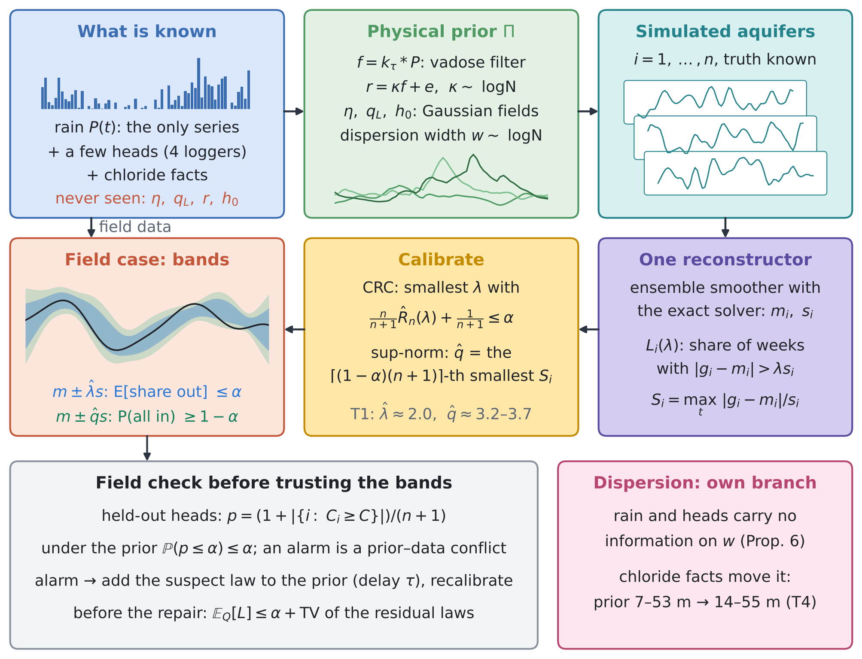
Figure 2. GARANCIA-GO. The rain is the only series; the physical prior given the rain generates simulated aquifers whose truth is known; the same reconstructor is run on each of them and on the field; the scores of the simulated cases calibrate $\hat{λ}$ and $\hat{q}$; the field check tests the prior before the bands are used. Dispersion is a separate branch, informed only by chloride. Thumbnails are real fields: rain and prior draws of the test bed, and one test case of T1 (inflow).
4.1 Set-up
Let the physical prior $P$ be the joint law of the rain $P$, the unknowns $u=\left(θ,g\right)$ (static inputs $θ$ such as $κ$, $τ$ and $w$, and boundary functions $g$ on an index set $T$: 64 weeks, or 32 cells for $h_{0}$) and the data $y$ (head readings, chloride facts). A reconstructor $R$ maps $\left(P,y\right)$ to a centre $m\left(t\right)$ and a scale $s\left(t\right)>0$ for each target; here it is the ensemble smoother with the exact solver of RINDËRTIMI-GO (128 members), but any method can be used. Calibration cases $\left(P_{i},u_{i},y_{i}\right)$, $i=1,…,n$, are independent draws from $P$, so their truth $g_{i}$ is known; the field is case $n+1$. With the standardised residuals ${\hat{s}}_{i}\left(t\right)=\left(g_{i}\left(t\right)−m_{i}\left(t\right)\right)/s_{i}\left(t\right)$ two scores are used:
Liλ=1Tt∈T​1sit>λ,  $$S_{i}=\max_{t∈T}\left|{\hat{s}}_{i}\left(t\right)\right|$$ | (7)
$L_{i}\left(λ\right)$ is the share of weeks outside the band $m_{i}±λs_{i}$; it is non-increasing and right-continuous in $λ$, with $B=1$ and $L_{i}\left(∞\right)=0$. $S_{i}$ is the smallest multiple of $s_{i}$ that contains the whole function. Figure 2 shows the loop.
4.2 Guarantees
Proposition 1 (whole-function band). If the calibration cases and the field case are independent draws from $P$ and $\hat{q}$ is the $⌈\left(1−α\right)\left(n+1\right)⌉$-th smallest of $S_{1},…,S_{n}$, then $P\{\left|g_{n+1}\left(t\right)−m_{n+1}\left(t\right)\right|≤\hat{q} s_{n+1}\left(t\right)$ for every $t∈T\}≥1−α$, and this probability is at most $1−α+1/\left(n+1\right)$ when the $S_{i}$ are almost surely distinct.

Proof. The reconstructor is the same map for every case, so $S_{1},…,S_{n+1}$ are i.i.d., hence exchangeable, and the event is $\{S_{n+1}≤\hat{q}\}$; apply (5). □
Proposition 2 (share of weeks outside the band). Under the same conditions, with $\hat{λ}$ from (6) with $B=1$ and $Λ=\left[0,∞\right]$, $E\left[L_{n+1}\left(\hat{λ}\right)\right]≤α$: on average over calibration sets and field cases, the band $m±\hat{λ}s$ misses at most a fraction $α$ of the weeks. If the residuals have continuous distributions, $E\left[L_{n+1}\left(\hat{λ}\right)\right]≥α−2/\left(n+1\right)$.

Proof. The losses (7) satisfy the conditions of Theorem 1 of the CRC paper, with $L_{i}\left(∞\right)=0≤α$ (our code searches $λ$ on a grid of step 0.01 up to 40, beyond every simulated score: the largest in T1 is 16.2, for $κ$). A continuous residual puts no jump at a fixed $λ$, which gives the lower bound by their Theorem 2. □
Proposition 3 (calibrated for the rain that fell). If every calibration case is simulated with the field's own rain record $P^{⋆}$ (unknowns drawn from $P\left(⋅∣P^{⋆}\right)$, data from the observation model given $P^{⋆}$) and the field unknowns are a draw from the same conditional law, Propositions 1 and 2 hold conditionally on $P^{⋆}$.

Proof. Given $P^{⋆}$ the cases are i.i.d.; the arguments of Propositions 1 and 2 apply conditionally. □
This is the form that answers "knowing only the rain": the band is calibrated for the rain that fell, not for an average rain. T1R checks it on a dry and a wet record.
Remark 1 (Bonferroni against the sup-norm score). A band built point by point with a Bonferroni correction, as in multi-horizon conformal forecasting (O4), takes the $⌈\left(1−α/H\right)\left(n+1\right)⌉$-th smallest residual at each of $H$ points. It is finite only if $n≥H/α−1$: 639 simulated aquifers for 64 weeks and 319 for 32 cells at $α$ = 0.10. The sup-norm score of Proposition 1 needs $n≥\left(1−α\right)/α$ = 9 for any $H$ and is exact for any dependence between the points.

Proof. For an integer $n$, $⌈x⌉≤n$ if and only if $x≤n$, and $\left(1−α/H\right)\left(n+1\right)≤n$ is $n+1≥H/α$. □
Proposition 4 (when the field is not the prior). Let the calibration cases be independent draws from $P$ and the field case an independent draw from another law $Q$, and let $ρ_{P}$, $ρ_{Q}$ be the laws of the standardised residual vector $\hat{s}={\left(\hat{s}\left(t\right)\right)}_{t∈T}$ of the field case under the two. Then

$$E\left[L_{n+1}\left(\hat{λ}\right)\right]≤α+TV\left(ρ_{P},ρ_{Q}\right),$$  $$P\left(S_{n+1}≤\hat{q}\right)≥1−α−TV\left(ρ_{P},ρ_{Q}\right)$$ | (8)
Proof. $\hat{λ}$ and $\hat{q}$ depend only on the calibration cases, which are independent of the field case. Given them, $L_{n+1}\left(\hat{λ}\right)$ and $1\{S_{n+1}≤\hat{q}\}$ are functions of $\hat{s}$ with values in $\left[0,1\right]$, so their conditional expectations under $ρ_{Q}$ and $ρ_{P}$ differ by at most the TV distance; average over the calibration cases and apply Propositions 2 and 1 to the $P$ terms. □
Two consequences. (i) Proposition 4 of the CRC paper, written for arbitrary sequences, gives α+i≤n​TVZi,Zn+1=α+n TVP,Q here; with field and calibration cases independent, the penalty does not grow with $n$. (ii) What matters is not how far the field parameters are from the prior but how far the law of the standardised residuals moves: a reconstructor whose residuals are nearly pivotal keeps its guarantee under a parameter shift, while a structural error that it cannot follow moves the residual law far (T3).
Proposition 5 (the field check). Let $C$ be a statistic of observable quantities only (here the mean standardised residual of the held-out head readings), $C_{1},…,C_{n}$ its values on the calibration cases and $p=\left(1+\left|\{i:C_{i}≥C_{n+1}\}\right|\right)/\left(n+1\right)$. If the field case is a draw from $P$, $P\left(p≤α\right)≤α$. If it is a draw from $Q$, the alarm rate satisfies

$$P_{Q}\left(p≤α\right)−α≤TV\left(ρ_{P}^{C},ρ_{Q}^{C}\right)$$ | (9)
so an alarm rate above $α$ is a lower bound on how far the field is from the prior, in the law of $C$.
Proof. The first claim is the validity of conformal p-values under exchangeability (Bates et al. 2023). For the second, given the calibration cases the alarm region $A=\{c:p\left(c\right)≤α\}$ is fixed and $Q\left(A\right)−P\left(A\right)≤TV$; average over the calibration cases and use $E\left[P\left(A\right)\right]≤α$. □
The converse fails. The TV distance that controls the guarantee in (8) is that of the residuals of unobserved functions, which the check cannot see, so the absence of an alarm proves nothing (T3, parameter shift: alarm rate 0.19, whole-function coverage down to 0.81).
Proposition 6 (dispersion is ancillary to rain and heads). Suppose the heads $y_{h}$ solve a flow problem whose coefficients do not involve the dispersion parameters $ϑ_{D}$ (the dispersivities, or $w$): constant density, or the sharp-interface model (4), in which the head and the interface depend on $K$, $R$ and the geometry while $w$ enters only the chloride profile. If the prior factorises as $π\left(ϑ_{D}\right) π\left(\text{rest}∣P\right)$, then

$$p\left(ϑ_{D}∣P,y_{h}\right)=π\left(ϑ_{D}\right)$$ | (10)
for any rain record and any number of head readings: only data that depend on $ϑ_{D}$ (chloride or conductivity profiles, transition-zone widths, salinity series at wells) can inform it.
Proof. The likelihood of $\left(P,y_{h}\right)$ does not depend on $ϑ_{D}$, so Bayes' rule returns the prior. □
Under variable density the heads depend on $ϑ_{D}$ only through the density coupling $ρ=ρ_{f}\left(1+δc\right)$, $δ$ = 0.025; the information is then bounded by the Fisher information $J^{⊤}Σ^{−1}J$ with $J=∂y_{h}/∂ϑ_{D}$, which is small away from the interface. T4 checks (10) on the Fushë-Kuqe facts: in the 20 000 prior draws the rank correlation between $w$ and the littoral head is +0.00, against +0.62 with the salinised area and +0.52 with the NE chloride.
Remark 2 (a guarantee for the calibration set at hand). Proposition 2 holds on average over calibration sets. For the one set at hand, choose $λ$ by the risk-controlling prediction sets of Bates et al. (2021): ${\hat{λ}}_{δ}$ is the smallest $λ$ whose Hoeffding–Bentkus p-value $min\{e^{−n h_{1}\left({\hat{R}}_{n}∧α, α\right)}, e P\left(Bin\left(n,α\right)≤⌈n{\hat{R}}_{n}⌉\right)\}$ is below $δ$, with $h_{1}\left(a,b\right)=alog\frac{a}{b}+\left(1−a\right)log\frac{1−a}{1−b}$. Then the conditional risk given the calibration set is at most $α$ with probability at least $1−δ$ (T5).

What is new. (1) Conformal calibration of boundary and initial conditions that are never observed, on aquifers simulated from the physical prior given the rain, with the same reconstructor as in the field (Propositions 1–3). (2) A shift bound in terms of the law of the standardised residuals, with no factor $n$ (Proposition 4). (3) A field check whose alarm rate is a lower bound on the prior–field distance (Proposition 5). (4) Dispersion ancillarity, with its check on the Fushë-Kuqe facts (Proposition 6, T4). (5) The sample sizes that the few-conditions problem needs: 9 simulated aquifers for a finite whole-function band against 639 for Bonferroni over 64 weeks, about 20 for the mean guarantee, and the Hoeffding–Bentkus version for one calibration set.

4.3 Tests
All tests are reproducible from experiments/garancia_go with fixed seeds (gar_exp.py, gar_rcps.py, gar_rainc.py):
• T1: 500 simulated aquifers of scenario B (rain + 4 loggers, each read with probability 0.25 per week, noise 2 cm; one reading in four held out for the field check), 1000 random splits into 200 calibration and 300 test cases; T1A: the same with rain only; T1R: calibration with one shared rain record, a dry and a wet window (400 cases each).
• T2: calibration sets of $n$ = 10 to 200; T5: the high-probability version of Remark 2 for $n$ = 50, 100 and 200, $δ$ = 0.10.
• T3: the field drawn from another law, a parameter shift (inflow mean +0.8 m²/d, $κ×1.5$, sea-level mean +0.1 m) and a structural error (vadose delay 35 d against 14 d), 300 field cases each; then the delay put in the prior (log-sd 0.5).
• T4: the Fushë-Kuqe chloride ensemble (20 000 prior draws): simulation-based coverage of the importance-sampling intervals on 600 synthetic truths with the conformal correction, and the real facts taken in groups.
T1: the guarantee on simulated aquifers. The exact posterior misses 0.094–0.106 of the weeks, as it should. The raw ensemble, read as mean ± 1.645 spread, misses 0.17–0.20 because its spread is too small (0.88–0.91 of the exact width), and misses $κ$ in 0.67 of the cases (spread 0.29 of the exact). After calibration the share of weeks outside is 0.095–0.100 for every target, at 1.11–1.36 times the exact width (Table 1). Pointwise 90% bands, even exact ones, contain the whole function rarely (sea level 2%, recharge 3%); the sup-norm band contains it in 90% of the cases at 1.71–2.04 times the exact pointwise width (Figure 4b). Figure 3 shows one test case: the raw interval of $κ$ misses the truth and the calibrated one covers it.
Table 1. T1 and T1A. Share of weeks outside the band / share of cases with the whole function inside, and width relative to the exact 90% band. CRC and sup-norm: mean over 1000 calibration sets of 200 cases, with the 10th–90th percentile range. Targets: risk ≤ 0.10, coverage ≥ 0.90.
Target | Exact posterior | Raw ensemble | CRC: risk / width | Sup-norm: coverage / width | Rain only: CRC / sup
sea level $η$ | 0.105 / 0.02 | 0.182 / 0.00 / 0.90 | 0.095 (0.088–0.101) / 1.13 | 0.900 (0.867–0.933) / 2.04 | 0.095 / 0.902
inflow $q_{L}$ | 0.102 / 0.20 | 0.167 / 0.08 / 0.91 | 0.095 (0.085–0.107) / 1.11 | 0.899 (0.863–0.930) / 1.84 | 0.096 / 0.901
recharge $r$ | 0.106 / 0.03 | 0.179 / 0.01 / 0.91 | 0.095 (0.087–0.104) / 1.13 | 0.901 (0.866–0.933) / 2.01 | 0.096 / 0.900
initial head $h_{0}$ | 0.101 / 0.45 | 0.198 / 0.23 / 0.88 | 0.096 (0.080–0.112) / 1.13 | 0.900 (0.867–0.933) / 1.71 | 0.098 / 0.900
coefficient $κ$ | 0.094 / 0.91 | 0.668 / 0.33 / 0.29 | 0.100 (0.063–0.137) / 1.36 | 0.900 (0.863–0.933) / 1.36 | 0.098 / 0.901

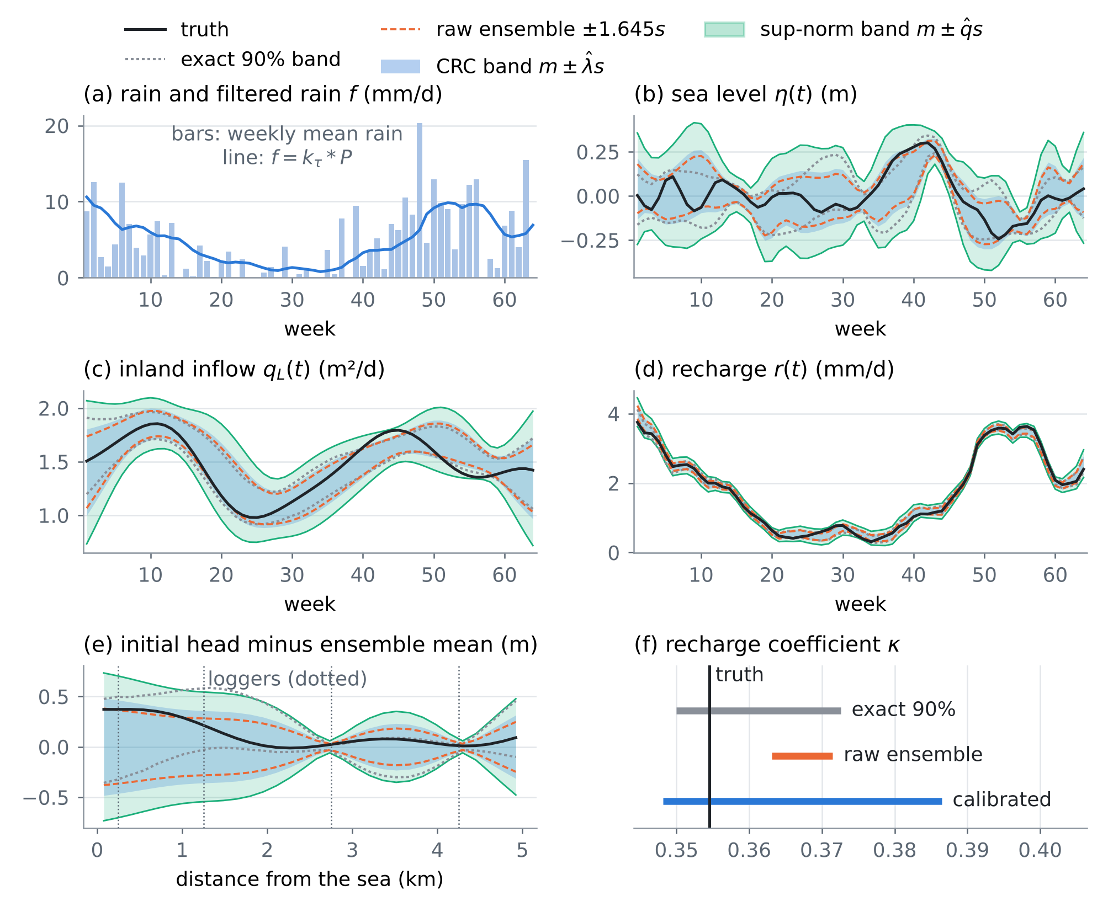
Figure 3. One test case of T1, the one with the median whole-function score for the recharge. Black: truth. Dotted grey: exact 90% band. Dashed orange: raw ensemble ± 1.645 spread. Blue: CRC band $m±\hat{λ}s$. Aqua: sup-norm band $m±\hat{q}s$. Panel (e) shows the initial head minus the ensemble mean so that the bands are visible; panel (f) the intervals of $κ$.
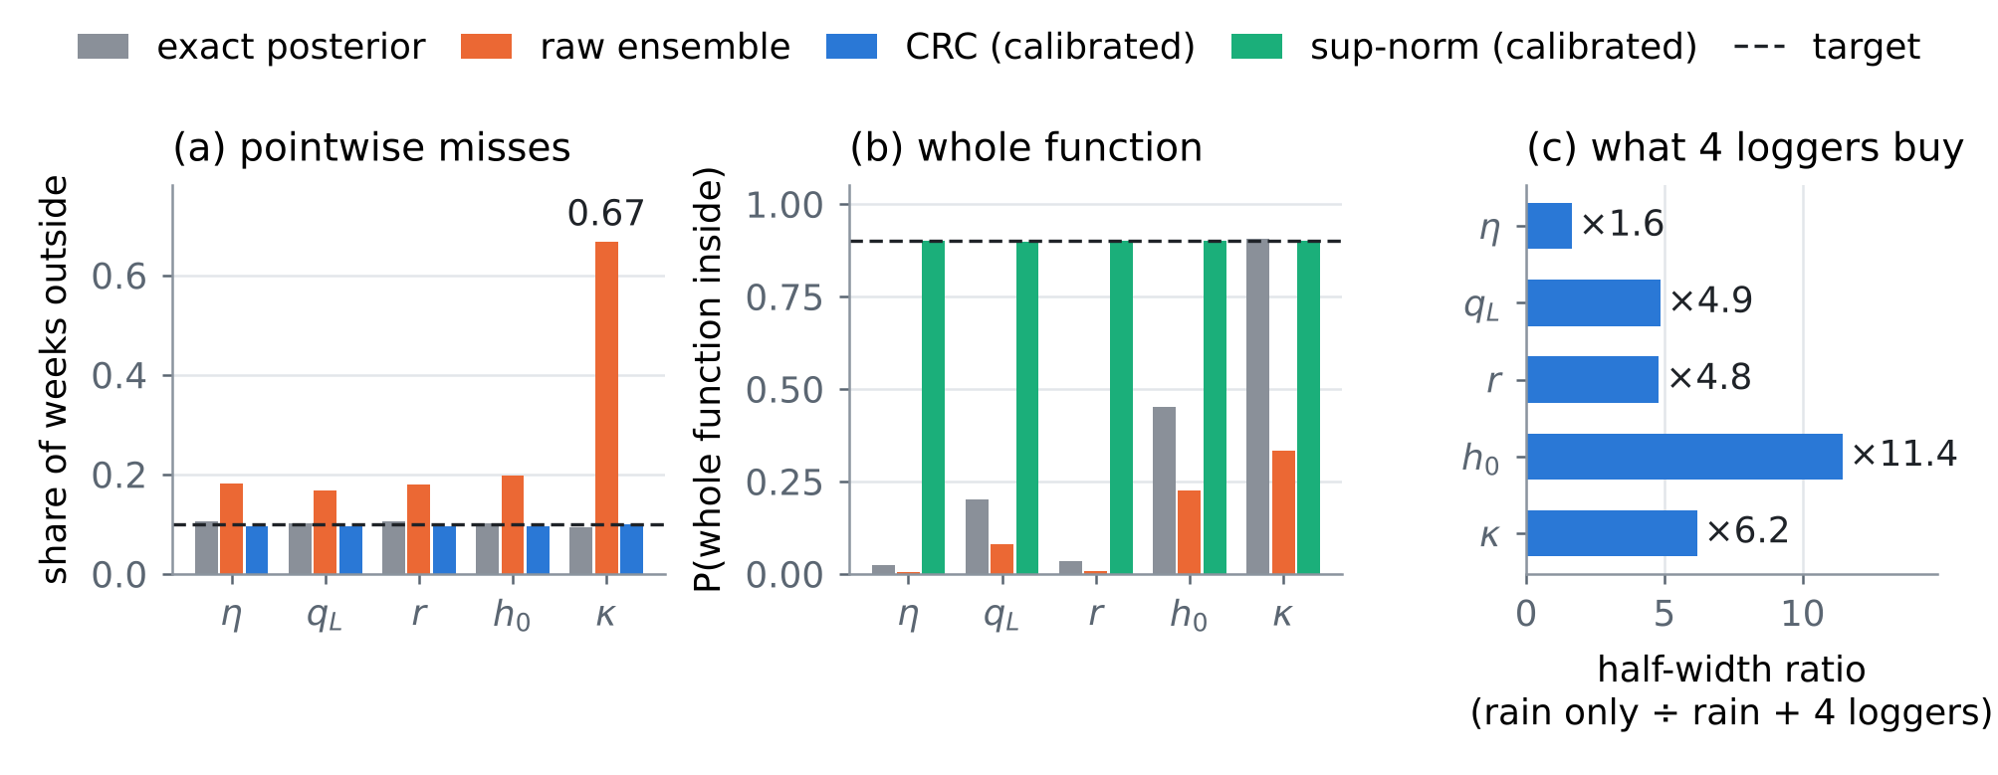
Figure 4. (a) Share of weeks outside the band, (b) share of cases with the whole function inside, for the exact posterior, the raw ensemble and the calibrated bands (T1, rain + 4 loggers). (c) The guaranteed (CRC) half-width with rain only divided by that with the four loggers (T1A against T1).
T1A: rain only. With no head reading the reconstructor is the prior given the rain, which is already calibrated (share outside 0.10–0.11). The calibrated bands keep the guarantees (CRC risk 0.095–0.098, coverage 0.900–0.902) but are wide. Table 2 gives the guaranteed half-widths in physical units: four loggers narrow the CRC band 1.6 times for the sea level, 4.8–4.9 for the recharge and the inflow, 6.2 for $κ$ and 11.4 for the initial head (Figure 4c). The sea level gains least: its weekly departures are correlated over only two weeks, each logger is read in one week out of four, and the readings mix the sea level with the recharge and the inflow.
Table 2. Mean 90% half-widths in physical units: exact posterior / CRC band / sup-norm band, with rain only (T1A) and with rain and four loggers (T1); last column, the ratio of the CRC half-widths.
Target | Units | Rain only | Rain + 4 loggers | Ratio
sea level $η$ | m | 0.183 / 0.187 / 0.339 | 0.102 / 0.114 / 0.208 | ×1.6
inflow $q_{L}$ | m²/d | 0.929 / 0.945 / 1.371 | 0.177 / 0.195 / 0.323 | ×4.9
recharge $r$ | mm/d | 0.552 / 0.575 / 0.943 | 0.107 / 0.120 / 0.213 | ×4.8
initial head $h_{0}$ | m | 2.870 / 2.895 / 3.890 | 0.225 / 0.253 / 0.384 | ×11.4
coefficient $κ$ | - | 0.147 / 0.160 / 0.160 | 0.019 / 0.026 / 0.026 | ×6.2

T1R: calibrated for the rain that fell. With every case sharing one rain record (Proposition 3), the dry window (946 mm in 64 weeks; the median of 40 draws is 1475 mm) gives CRC risk 0.095–0.098 and coverage 0.899–0.902, and the wet window (2249 mm) 0.095–0.100 and 0.899–0.901. The guaranteed half-width of $κ$ is 0.029 in the dry window and 0.016 in the wet one: a wet year identifies the recharge coefficient almost twice as well, because the recharge is larger against its error. The boundary functions keep similar widths (recharge 0.121 and 0.120 mm/d).
T2 and T5: how many simulations. The CRC band is conservative for small $n$ because of the $B/\left(n+1\right)$ term (risk 0.012–0.014 at $n$ = 10, i.e. bands wider than needed) and reaches 0.095 at $n$ = 200; the sup-norm coverage is 0.90–0.91 for every $n≥10$, but its 10th percentile over calibration sets rises from 0.79 at $n$ = 10 to 0.86–0.87 at $n$ = 200 (Figure 5). For $κ$, a 0/1 loss, CRC is split conformal: mean 0.091–0.099 for every $n$, with a 90th percentile of 0.21 at $n$ = 10. T5 makes this precise for one calibration set: with plain CRC the realised risk stays below 10% in only 68%–99% of the calibration sets for the boundary functions and 56%–60% for $κ$; the Hoeffding–Bentkus choice keeps it below 10% in 100% and 93%–97% of the sets, at 1.26–1.54 and 1.58–1.93 times the exact width (Table 3).
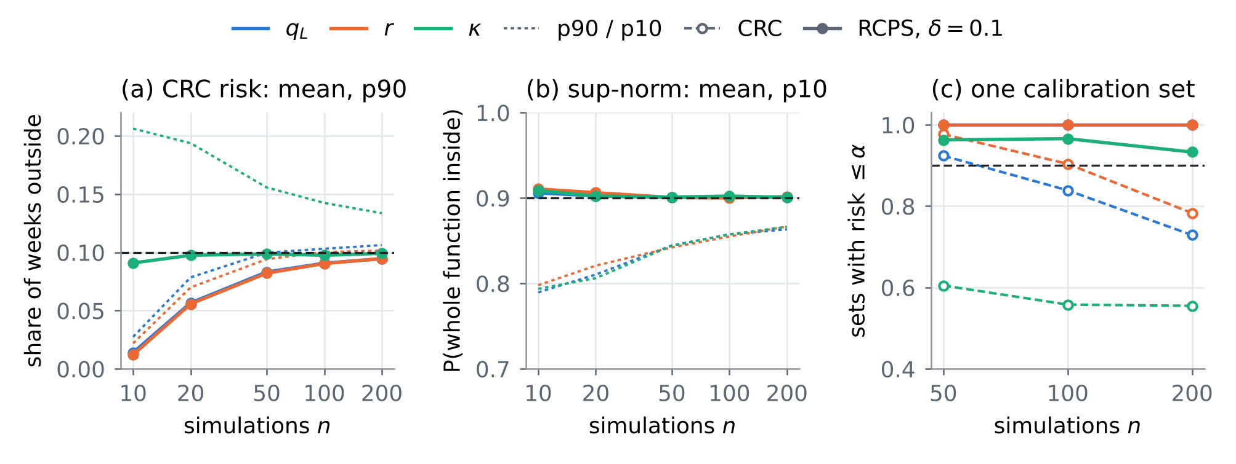
Figure 5. (a) CRC risk and (b) sup-norm coverage against the number of simulated aquifers $n$ (mean and the 90th or 10th percentile over 1000 calibration sets). (c) Share of calibration sets whose realised risk is at most 0.10, for CRC and for RCPS with the Hoeffding–Bentkus bound (T5; the RCPS lines of $q_{L}$ and $r$ coincide at 1.00).
Table 3. T5. Share of calibration sets with realised risk ≤ 0.10, CRC / RCPS ($δ$ = 0.10), for $n$ = 50, 100 and 200, and the band widths relative to the exact posterior for the three $n$.
Target | n = 50 | n = 100 | n = 200 | CRC width | RCPS width
$η$ | 0.99 / 1.00 | 0.94 / 1.00 | 0.81 / 1.00 | 1.17 / 1.14 / 1.13 | 1.54 / 1.38 / 1.27
$q_{L}$ | 0.92 / 1.00 | 0.84 / 1.00 | 0.73 / 1.00 | 1.16 / 1.13 / 1.11 | 1.52 / 1.36 / 1.26
$r$ | 0.98 / 1.00 | 0.90 / 1.00 | 0.78 / 1.00 | 1.18 / 1.14 / 1.13 | 1.54 / 1.37 / 1.27
$h_{0}$ | 0.83 / 1.00 | 0.76 / 1.00 | 0.68 / 1.00 | 1.18 / 1.15 / 1.14 | 1.53 / 1.37 / 1.27
$κ$ | 0.60 / 0.96 | 0.56 / 0.97 | 0.56 / 0.93 | 1.41 / 1.37 / 1.36 | 1.93 / 1.74 / 1.58

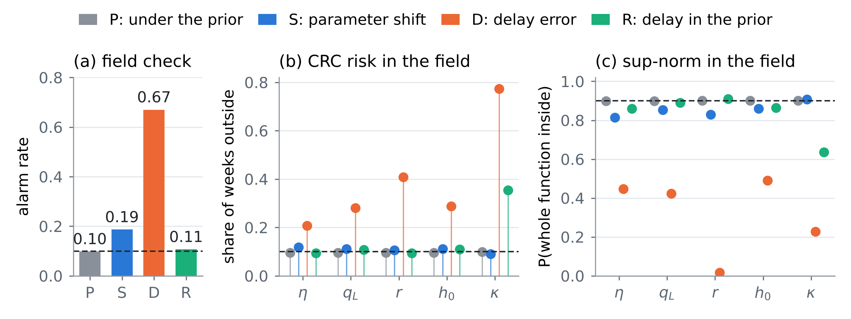
Figure 6. T3. (a) Alarm rate of the field check (conformal p-value ≤ 0.10). (b) CRC risk and (c) sup-norm coverage in the field, with the bands calibrated under the prior: P under the prior (T1), S parameter shift, D delay error, R delay put in the prior and recalibrated.
T3: when the field is not the prior. Under the parameter shift the alarm rate is 0.19 (0.10 under the prior), the CRC risk rises to 0.106–0.118 and the whole-function coverage falls to 0.81–0.86 ($κ$: 0.91): moderate damage, partly visible to the check. Under the delay error the reconstructor filters the rain with the wrong kernel, the residual law moves far, the alarm rate is 0.67 and every guarantee breaks (recharge: CRC risk 0.41, coverage 0.02; $κ$: 0.77 and 0.23). Putting the delay in the prior of the reconstructor and of the simulated aquifers (log-sd 0.5) brings the alarm rate back to 0.11 and the boundary functions back to CRC 0.093–0.109 and coverage 0.86–0.91, with bands 0.99–1.16 times as wide. $κ$ stays wrong (CRC 0.35, coverage 0.64, width ×2.36): with an uncertain delay the coefficient that multiplies a given filtered rain is no longer the same quantity in every member, so the recharge function, not $κ$, is the quantity to report.
T4: Fushë-Kuqe, and which fact informs which unknown. Over 300 synthetic truths the 90% importance-sampling intervals cover 0.91 ($w$), 0.89 ($R$) and 0.90 ($η_{g}$) of the cases (median effective sample size 2090); the conformal correction on the log scale ($m±\hat{q}σ$ with $\hat{q}$ = 1.69, 1.82, 1.63) gives 0.91, 0.92 and 0.93 at 1.02–1.10 times the width. Taken one group at a time (Figure 7, Table 4), the littoral head alone leaves $w$ at its prior, as Proposition 6 says; the chloride facts move it to 16.0–64.6 m; all facts give 12.8–47.8 m, 13.9–54.9 m after the correction, with a central value of 27.7 m. The littoral head and the chloride facts pull the recharge in opposite directions (49–286 against 106–427 mm/yr) and together give 94–337 mm/yr; the conductivity scale is hardly informed by any of them (0.33–0.77 against a prior 0.32–0.78).
Table 4. T4. 90% intervals at Fushë-Kuqe by group of facts (ESS: effective sample size of the importance weights), and the coverage of the intervals over 300 synthetic truths.
Facts used | ESS | Width w (m) | Recharge R (mm/yr) | K scale (–)
prior | 20 000 | 7.4–53.3 | 57–583 | 0.32–0.78
littoral head only | 13 082 | 7.4–53.8 | 49–286 | 0.34–0.78
chloride facts only | 2 261 | 16.0–64.6 | 106–427 | 0.32–0.77
all facts | 3 249 | 12.8–47.8 | 94–337 | 0.33–0.77
all facts, conformal |  | 13.9–54.9 | 88–357 | 0.35–0.83
simulated coverage, IS → conformal |  | 0.91 → 0.91 | 0.89 → 0.92 | 0.90 → 0.93

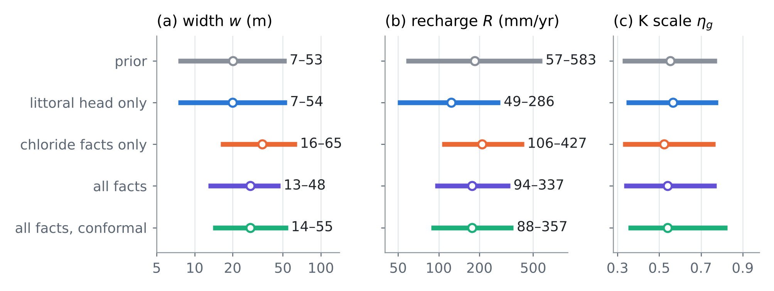
Figure 7. T4, Fushë-Kuqe. 90% intervals (dot: central value) of the transition-zone width $w$, the recharge $R$ and the conductivity scale $η_{g}$ from the 20 000 prior draws weighted by the facts taken one group at a time, and the conformal 90% interval with all facts.
5. Synthesis: how to solve the problem when the conditions are few
This section puts the twenty papers, the earlier ones linked here and the GARANCIA-GO tests into one procedure. Card numbers (O1–M5) point to Section 3; every other link is to the work itself.
5.1 Three facts that decide the problem
• Rain fixes when recharge comes, not how much. Through the vadose filter the rain gives the shape of $r\left(t\right)$; its size is $κ$, which the rain cannot tell. With rain only the guaranteed 90% half-width of $κ$ is 0.16 around a median of 0.35, and that of the recharge 0.58 mm/d; four loggers cut them to 0.026 and 0.12 mm/d (Table 2). A satellite-identified drainage fraction (M1) is the best prior for $κ$ when there are no heads.
• Every boundary needs a witness. Heads inland witness the inflow (0.95 → 0.19 m²/d), any early reading witnesses the initial head (2.9 → 0.25 m), and heads witness the sea level only weakly (0.19 → 0.11 m). A tide gauge or satellite altimetry turns the sea level from an unknown into a datum (C5).
• Dispersion has no witness in rain or heads. Under constant density, or in the sharp-interface model of Fushë-Kuqe, the heads do not depend on the dispersion parameters, so their posterior is their prior whatever the number of heads (Proposition 6; T4: the littoral head alone gives 7.4–53.8 m against a prior of 7.4–53.3 m). Only chloride or conductivity data move it.
5.2 The procedure in eight steps
Step 1. Write the physical prior from the rain. The rain law and the vadose filter give the timing (SHIU-GO); a lognormal $κ$, or better a drainage fraction identified from satellite soil moisture (M1); Gaussian fields for the sea level, the inflow and the initial head; the dispersion width from the chloride study. If the rain comes from a coarse grid, downscale it with error bars (Chau, Bouabid & Sejdinovic 2021). Put the physics in the mean and a Gaussian process on the rest (O3), check the prior against drought–recovery scenarios (O5), and add the remote-sensing conditions that exist (C5).
Step 2. Keep the unknowns few. A few numbers per boundary (mean, amplitude, $κ$, $τ$) and Gaussian departures; a certified reduction to the directions the data inform (Zahm et al. 2022); an emulator when the simulator is slow (O1), or a neural-operator surrogate for seawater intrusion (B1) built on U-FNO (Wen et al. 2022). Physics-informed networks are a poor choice for advection-dominated transport, where they are known to fail (Krishnapriyan et al. 2021).
Step 3. Invert with few runs and no derivatives. Ensemble Kalman inversion and its unscented form (Huang, Schneider & Stuart 2022; Calvello, Reich & Stuart 2025), trained on statistics (C3) with a ready toolbox (C4); calibrate–emulate–sample when runs are expensive (Cleary et al. 2021); the ensemble smoother with the exact solver for the boundary functions (RINDËRTIMI-GO); nonlinear transport-map smoothers when Gaussian updates fail (Ramgraber et al. 2023; Spantini, Baptista & Marzouk 2022); learned priors with ensemble guidance (C2) or function-space diffusion (Yao et al. 2025); amortised likelihood-free inference on signatures of the series (O2).
Step 4. Admit the structural error before it shows up. The recharge closure error and the vadose delay belong in the prior, and learned corrections belong inside the model component (Wu, Levine, Schneider & Stuart 2024; C3). T3: a field delay 2.5 times the model's breaks every guarantee (whole-function coverage of the recharge 0.02), and putting $τ$ in the prior restores it (0.91).
Step 5. Calibrate on simulated aquifers (GARANCIA-GO). CRC for the share of weeks (anchor A1), the sup-norm score for whole functions (anchor A2), Hoeffding–Bentkus for a guarantee per calibration set (Bates et al. 2021), stability under the judgment calls (B2); the same calibration for maps (B3) and neural operators (C1), joint regions (B5), full distributions (M3), multi-horizon forecasts (O4), and strength borrowed from other aquifers (M2). With 64 weeks Bonferroni needs 639 simulations and the sup-norm score 9 (Remark 1); the mean guarantee holds from about 20 (T2). A tutorial is Angelopoulos & Bates 2023.
Step 6. Check the prior against the field. The conformal p-value of held-out heads (B4), a permutation test on the record itself (Chernozhukov, Wüthrich & Zhu 2021), held-out readings placed like the decision (M5), and an online threshold that keeps recalibrating with the real readings (M4). An alarm rate above $α$ is a lower bound on how far the field is from the prior (Proposition 5); the absence of an alarm is not a proof.
Step 7. If the check fires, widen and recalibrate. Add the suspect law to the prior (T3); before the repair the damage is bounded by the TV distance of the residual laws (Proposition 4). For several risks at once use Learn-then-Test (Angelopoulos et al. 2025); for posterior samples, conformal Bayesian computation (Fong & Holmes 2021); for weighted or drifting calibration sets, conformal prediction beyond exchangeability (Barber et al. 2023).
Step 8. Choose the next measurement, then operate. Rank candidate data by the guaranteed width they remove (T1A against T1: four loggers are worth a factor 1.6–11.4); ensemble experimental design (Dunbar et al. 2022) and its theory (Huan, Jagalur & Marzouk 2024); when the model chooses where to measure, keep conformal validity under the feedback shift (Fannjiang et al. 2022); in operation, online conformal control (Angelopoulos, Candès & Tibshirani 2023; M4); and combine the few real measurements with many model predictions (Angelopoulos et al. 2023).
5.3 Dispersion with few conditions
• What informs it: depth profiles of electrical conductivity or chloride across the transition zone (two or three boreholes are worth more than any number of heads), depth-specific screens such as the mid-depth seawater fraction of 4.7% at Fushë-Kuqe, salinity time series at pumping wells (the shape of a breakthrough, O2), and airborne electromagnetics (C5).
• What does not: rain, heads, inflow, sea level (Proposition 6). Under variable density the heads carry information only through the density coupling, which is weak away from the interface.
• What can be guaranteed: the width of the transition zone, not the dispersivity at a point. At Fushë-Kuqe, 13.9–54.9 m (90%, calibrated). A dispersivity follows from $w$ only through a model of the mixing zone, whose error must be simulated as well.
• How to use it: give the simulated aquifers of GARANCIA-GO the calibrated interval of $w$ as prior, so that the guaranteed chloride bands carry the dispersion uncertainty.
5.4 Boundary conditions and inputs with few conditions
Table 5 gives, for each unknown, its witness and the guaranteed half-width with the data at hand.
Table 5. The guarantee ladder: the witness of each unknown and its guaranteed 90% half-width with rain only and with rain and four loggers (T1A, T1); for $w$, the 90% interval from the prior and from the Fushë-Kuqe facts (T4).
Unknown | Its witness | Rain only | Rain + 4 loggers
sea level $η\left(t\right)$ | tide gauge, altimetry (C5); heads near the coast | 0.19 m | 0.11 m
inland inflow $q_{L}\left(t\right)$ | a logger near the inland edge | 0.95 m²/d | 0.19 m²/d
recharge $r\left(t\right)$ | rain for the timing, heads for the size; satellite drainage (M1) | 0.58 mm/d | 0.12 mm/d
initial head $h_{0}\left(x\right)$ | any early reading; spin-up from the mean forcing | 2.9 m | 0.25 m
recharge coefficient $κ$ | heads (a wet year identifies it about twice as well, T1R) | 0.16 | 0.026
transition-zone width $w$ | chloride facts and profiles only (Proposition 6) | 7–53 m (prior) | heads: no change; chloride: 14–55 m

5.5 What stays impossible with few conditions
• A guarantee against the real aquifer without real ground truth: GARANCIA-GO guarantees under the prior given the rain, and the field check can refute that prior but never confirm it.
• Structural errors outside the prior are invisible to the guarantee and only partly visible to the check (T3: the parameter shift raised the alarm rate only to 0.19 while the whole-function coverage fell to 0.81).
• The dispersivity at a point: only the width of the transition zone is constrained.
• Extremes outside the simulated range: the rain law must contain them for the guarantee to cover them.
6. Limitations
• Every card is partly verified: the landing pages were reached through search results only, and no full text was read.
• The guarantees are marginal under the physical prior (or conditional on the rain record); they are not conditional on the field aquifer.
• The test bed is a linear one-dimensional section and the Fushë-Kuqe chloride model is steady and sharp-interface; Proposition 6 holds exactly there and approximately under variable density.
• The T4 correction uses a Gaussian score on the log scale; the distributional version (M3) would calibrate the whole posterior.
• When the delay is uncertain, $κ$ is not a well-defined target (T3); the recharge function is.
References
Anchors (provided by the user)
[A1] Angelopoulos, A. N., Bates, S., Fisch, A., Lei, L., & Schuster, T. (2024). Conformal risk control. The Twelfth International Conference on Learning Representations (ICLR 2024). arXiv:2208.02814 (PDF provided by the user). https://arxiv.org/abs/2208.02814
[A2] Tibshirani, R. (2023). Conformal prediction. Lecture notes, Advanced Topics in Statistical Learning, Spring 2023, University of California, Berkeley (PDF provided by the user). https://www.stat.berkeley.edu/~ryantibs/statlearn-s23/
The twenty papers
[O1] Duncan Watson-Parris, Andrew Williams, Lucia Deaconu, Philip Stier (2021). Model calibration using ESEm v1.1.0 – an open, scalable Earth system emulator. Geoscientific Model Development 14(12), 7659–7672 (2021). https://doi.org/10.5194/gmd-14-7659-2021
[O2] Joel Dyer, Patrick Cannon, Sebastian M. Schmon (2022). Amortised likelihood-free inference for expensive time-series simulators with signatured ratio estimation. Proceedings of AISTATS 2022, PMLR 151, 11131–11144. https://proceedings.mlr.press/v151/dyer22a.html
[O3] Shahine Bouabid, Dino Sejdinovic, Duncan Watson-Parris (2024). FaIRGP: A Bayesian energy balance model for surface temperatures emulation. Journal of Advances in Modeling Earth Systems 16(6), e2023MS003926 (2024). https://arxiv.org/abs/2307.10052
[O4] Kamilė Stankevičiūtė, Ahmed M. Alaa, Mihaela van der Schaar (2021). Conformal time-series forecasting. Advances in Neural Information Processing Systems 34 (NeurIPS 2021). https://proceedings.neurips.cc/paper/2021/hash/312f1ba2a72318edaaa995a67835fad5-Abstract.html
[O5] Nuria Ferrer, Albert Folch, Daniel Fernàndez-Garcia, Mike Lane, Mike Thomas, John Mwangi Gathenya, Calvince Wara, Patrick Thomson, Emilio Custodio, Rob Hope (2020). Evidence of groundwater vulnerability to climate variability and economic growth in coastal Kenya. Journal of Hydrology 586, 124920 (2020). https://doi.org/10.1016/j.jhydrol.2020.124920
[C1] Ziqi Ma, David Pitt, Kamyar Azizzadenesheli, Anima Anandkumar (2024). Calibrated uncertainty quantification for operator learning via conformal prediction. Transactions on Machine Learning Research (2024). https://openreview.net/forum?id=cGpegxy12T
[C2] Hongkai Zheng, Wenda Chu, Austin Wang, Nikola Kovachki, Ricardo Baptista, Yisong Yue (2025). Ensemble Kalman diffusion guidance: a derivative-free method for inverse problems. Transactions on Machine Learning Research (2025). https://arxiv.org/abs/2409.20175
[C3] Ignacio Lopez-Gomez, Costa Christopoulos, Haakon Ludvig Langeland Ervik, Oliver R. A. Dunbar, Yair Cohen, Tapio Schneider (2022). Training physics-based machine-learning parameterizations with gradient-free ensemble Kalman methods. Journal of Advances in Modeling Earth Systems 14, e2022MS003105 (2022). https://doi.org/10.1029/2022MS003105
[C4] Oliver R. A. Dunbar, Ignacio Lopez-Gomez, Alfredo Garbuno-Iñigo, Daniel Zhengyu Huang, Eviatar Bach, Jin-long Wu (2022). EnsembleKalmanProcesses.jl: derivative-free ensemble-based model calibration. Journal of Open Source Software 7(80), 4869 (2022). https://doi.org/10.21105/joss.04869
[C5] Kyra H. Adams, John T. Reager, Paul Rosen, David N. Wiese, Tom G. Farr, Shanti Rao, Bruce J. Haines, Donald F. Argus, Zhen Liu, Ryan Smith, James S. Famiglietti, Matthew Rodell (2022). Remote sensing of groundwater: current capabilities and future directions. Water Resources Research 58(10), e2022WR032219 (2022). https://doi.org/10.1029/2022WR032219
[B1] Su Jiang, Chuyang Liu, Dipankar Dwivedi (2025). GeoFUSE: an efficient surrogate model for seawater intrusion prediction and uncertainty reduction. Water Resources Research 61(9), e2024WR038898 (2025). https://doi.org/10.1029/2024WR038898
[B2] Bin Yu, Karl Kumbier (2020). Veridical data science. Proceedings of the National Academy of Sciences 117(8), 3920–3929 (2020). https://arxiv.org/abs/1901.08152
[B3] Anastasios N. Angelopoulos, Amit P. Kohli, Stephen Bates, Michael I. Jordan, Jitendra Malik, Thayer Alshaabi, Srigokul Upadhyayula, Yaniv Romano (2022). Image-to-image regression with distribution-free uncertainty quantification and applications in imaging. Proceedings of ICML 2022, PMLR 162, 717–730. https://proceedings.mlr.press/v162/angelopoulos22a.html
[B4] Stephen Bates, Emmanuel Candès, Lihua Lei, Yaniv Romano, Matteo Sesia (2023). Testing for outliers with conformal p-values. Annals of Statistics 51(1), 149–178 (2023). https://doi.org/10.1214/22-AOS2244
[B5] Shai Feldman, Stephen Bates, Yaniv Romano (2023). Calibrated multiple-output quantile regression with representation learning. Journal of Machine Learning Research 24(24), 1–48 (2023). https://www.jmlr.org/papers/v24/21-1280.html
[M1] Ruzbeh Akbar, Daniel J. Short Gianotti, Guido D. Salvucci, Dara Entekhabi (2020). Partitioning of historical precipitation into evaporation and runoff based on hydrologic dynamics identified with recent SMAP satellite measurements. Water Resources Research 56(12), e2020WR027307 (2020). https://doi.org/10.1029/2020WR027307
[M2] Adam Fisch, Tal Schuster, Tommi Jaakkola, Regina Barzilay (2021). Few-shot conformal prediction with auxiliary tasks. Proceedings of ICML 2021, PMLR 139, 3329–3339. https://proceedings.mlr.press/v139/fisch21a.html
[M3] Victor Chernozhukov, Kaspar Wüthrich, Yinchu Zhu (2021). Distributional conformal prediction. Proceedings of the National Academy of Sciences 118(48), e2107794118 (2021). https://doi.org/10.1073/pnas.2107794118
[M4] Anastasios N. Angelopoulos, Rina Foygel Barber, Stephen Bates (2024). Online conformal prediction with decaying step sizes. Proceedings of ICML 2024, PMLR 235, 1616–1630. https://proceedings.mlr.press/v235/angelopoulos24a.html
[M5] David R. Burt, Yunyi Shen, Tamara Broderick (2025). Consistent validation for predictive methods in spatial settings. Proceedings of AISTATS 2025, PMLR 258, 820–828. https://proceedings.mlr.press/v258/burt25a.html
Linked in the synthesis
[S1] Cleary, E., Garbuno-Inigo, A., Lan, S., Schneider, T., & Stuart, A. M. (2021). Calibrate, emulate, sample. Journal of Computational Physics 424, 109716. https://doi.org/10.1016/j.jcp.2020.109716
[S2] Huang, D. Z., Schneider, T., & Stuart, A. M. (2022). Iterated Kalman methodology for inverse problems. Journal of Computational Physics 463, 111262. https://doi.org/10.1016/j.jcp.2022.111262
[S3] Calvello, E., Reich, S., & Stuart, A. M. (2025). Ensemble Kalman methods: a mean-field perspective. Acta Numerica 34, 123–291. https://doi.org/10.1017/S0962492924000060
[S4] Dunbar, O. R. A., Howland, M. F., Schneider, T., & Stuart, A. M. (2022). Ensemble-based experimental design for targeting data acquisition to inform climate models. Journal of Advances in Modeling Earth Systems 14(9), e2022MS002997. https://doi.org/10.1029/2022MS002997
[S5] Wu, J.-L., Levine, M. E., Schneider, T., & Stuart, A. M. (2024). Learning about structural errors in models of complex dynamical systems. Journal of Computational Physics 513, 113157. https://doi.org/10.1016/j.jcp.2024.113157
[S6] Wen, G., Li, Z., Azizzadenesheli, K., Anandkumar, A., & Benson, S. M. (2022). U-FNO—An enhanced Fourier neural operator-based deep-learning model for multiphase flow. Advances in Water Resources 163, 104180. https://doi.org/10.1016/j.advwatres.2022.104180
[S7] Ramgraber, M., Baptista, R., McLaughlin, D., & Marzouk, Y. (2023). Ensemble transport smoothing. Part I: unified framework. Journal of Computational Physics: X 17, 100134. https://doi.org/10.1016/j.jcpx.2023.100134
[S8] Spantini, A., Baptista, R., & Marzouk, Y. (2022). Coupling techniques for nonlinear ensemble filtering. SIAM Review 64(4), 921–953. https://doi.org/10.1137/20M1312204
[S9] Zahm, O., Cui, T., Law, K., Spantini, A., & Marzouk, Y. (2022). Certified dimension reduction in nonlinear Bayesian inverse problems. Mathematics of Computation 91(336), 1789–1835. https://doi.org/10.1090/mcom/3737
[S10] Huan, X., Jagalur, J., & Marzouk, Y. (2024). Optimal experimental design: formulations and computations. Acta Numerica 33, 715–840. https://doi.org/10.1017/S0962492924000023
[S11] Angelopoulos, A. N., Bates, S., Fannjiang, C., Jordan, M. I., & Zrnic, T. (2023). Prediction-powered inference. Science 382(6671), 669–674. https://doi.org/10.1126/science.adi6000
[S12] Angelopoulos, A. N., Candès, E., & Tibshirani, R. J. (2023). Conformal PID control for time series prediction. Advances in Neural Information Processing Systems 36. https://proceedings.neurips.cc/paper_files/paper/2023/hash/47f2fad8c1111d07f83c91be7870f8db-Abstract-Conference.html
[S13] Fannjiang, C., Bates, S., Angelopoulos, A. N., Listgarten, J., & Jordan, M. I. (2022). Conformal prediction under feedback covariate shift for biomolecular design. Proceedings of the National Academy of Sciences 119(43), e2204569119. https://doi.org/10.1073/pnas.2204569119
[S14] Angelopoulos, A. N., Bates, S., Candès, E. J., Jordan, M. I., & Lei, L. (2025). Learn then test: calibrating predictive algorithms to achieve risk control. Annals of Applied Statistics 19(2), 1641–1662. https://doi.org/10.1214/24-AOAS1998
[S15] Fong, E., & Holmes, C. (2021). Conformal Bayesian computation. Advances in Neural Information Processing Systems 34. https://proceedings.neurips.cc/paper/2021/hash/97785e0500ad16c18574c64189ccf4b4-Abstract.html
[S16] Barber, R. F., Candès, E. J., Ramdas, A., & Tibshirani, R. J. (2023). Conformal prediction beyond exchangeability. Annals of Statistics 51(2), 816–845. https://doi.org/10.1214/23-AOS2276
[S17] Chau, S. L., Bouabid, S., & Sejdinovic, D. (2021). Deconditional downscaling with Gaussian processes. Advances in Neural Information Processing Systems 34. https://arxiv.org/abs/2105.12909
[S18] Angelopoulos, A. N., & Bates, S. (2023). Conformal prediction: a gentle introduction. Foundations and Trends in Machine Learning 16(4), 494–591. https://doi.org/10.1561/2200000101
[S19] Yao, J., Mammadov, A., Berner, J., Kerrigan, G., Ye, J. C., Azizzadenesheli, K., & Anandkumar, A. (2025). Guided diffusion sampling on function spaces with applications to PDEs. NeurIPS 2025; arXiv:2505.17004. https://arxiv.org/abs/2505.17004
[S20] Chernozhukov, V., Wüthrich, K., & Zhu, Y. (2021). An exact and robust conformal inference method for counterfactual and synthetic controls. Journal of the American Statistical Association 116(536), 1849–1864. https://doi.org/10.1080/01621459.2021.1920957
[S21] Bates, S., Angelopoulos, A., Lei, L., Malik, J., & Jordan, M. I. (2021). Distribution-free, risk-controlling prediction sets. Journal of the ACM 68(6), Article 43, 1–34. https://doi.org/10.1145/3478535
[S22] Krishnapriyan, A. S., Gholami, A., Zhe, S., Kirby, R. M., & Mahoney, M. W. (2021). Characterizing possible failure modes in physics-informed neural networks. Advances in Neural Information Processing Systems 34, 26548–26560. https://neurips.cc/virtual/2021/poster/26497
Data and project documents
[D1] Cenameri, S., & Beqiraj, A. (2016). Assessment of seawater intrusion in Fushë-Kuqe aquifer, Albania. Bulletin of the Geological Society of Greece 50(2), 665–670. https://doi.org/10.12681/bgsg.11772
[D2] Strack, O. D. L. (1976). A single-potential solution for regional interface problems in coastal aquifers. Water Resources Research 12(6), 1165–1174. https://doi.org/10.1029/WR012i006p01165
[D3] Internal documents of the project: RINDËRTIMI-GO, "Reconstructing all boundary conditions of a coastal aquifer from rain and the Fushë-Kuqe data" (November 2026; test bed, ensemble smoother with the exact solver); SHIU-GO (rain law, Erlang-2 vadose filter); the Fushë-Kuqe chloride study (chloride_fk/: Strack areal model and the 20 000-draw calibration ensemble); the code of this review in experiments/garancia_go/.
Verification note. The bibliographic data of the twenty cards and of the works linked in the synthesis come from search results that quote the publisher, arXiv, proceedings or repository pages; doi.org, arxiv.org, openreview.net and most publisher hosts could not be opened directly in this environment. The anchors were read from the PDFs provided. Every number of Sections 1, 4 and 5 is computed by the code in experiments/garancia_go/.

