CERTAIN-COAST — Work Packages
Certified early warning for seawater intrusion, liquefaction and extreme sea levels at the wellfields, port and energy landfall of a subsiding Adriatic coast
CERTAIN-COAST is organised in seven work packages over 36 months: four build the science and the system (WP1 coastal motion, WP2 coupled model and surrogate, WP3 certified alarms, WP4 monitoring network), one runs it live with the operators (WP5), one makes it last (WP6), and one manages data, access and risk (WP7). Each work package below gives its tasks, deliverables, milestones, the inputs it needs and the outputs it gives, its success criteria and risks, and what is new in it. Months count from the start of the grant.
Overview
 | Work package | Lead | Months | Objective | Deliverables | Effort
WP1 | Coastal motion and relative sea level | [NPD team] or [additional NATO co-director] | M1–M36 | O1 | D1.1 (M12) | [PM]
WP2 | One coupled model of the coast and its certified fast copy | [PPD team] | M4–M24 | O2 | D2.1 (M18), D2.2 (M22) | [PM]
WP3 | Certified multi-hazard alarm | [PPD team] | M13–M34 | O3 | D3.1 (M24), D3.2 (M27) | [PM]
WP4 | Monitoring network designed for the warnings | [NPD team] | M1–M36 | O4 | D4.1 (M6), D4.2 (M12) | [PM]
WP5 | Live demonstration at the wellfields, port and landfall | [NPD team] | M22–M36 | O5 | D5.1 (M34) | [PM]
WP6 | Training, transfer and dissemination | [PPD team] | M1–M36 | O6 | D6.1 (M33), D6.2 (M36) | [PM]
WP7 | Management, data and risk | [NPD team] (coordinator) | M1–M36 | — | D7.1 (M3), D7.2 (M12), D7.2 (M24), D7.3 (M36) | [PM]
 | Total |  | M1–M36 |  | 14 deliverables, 7 milestones | [PM]
Effort in person-months is contributed in kind, because salaries are not eligible for SPS funding; the teams fill it in, also in the box of each work package.
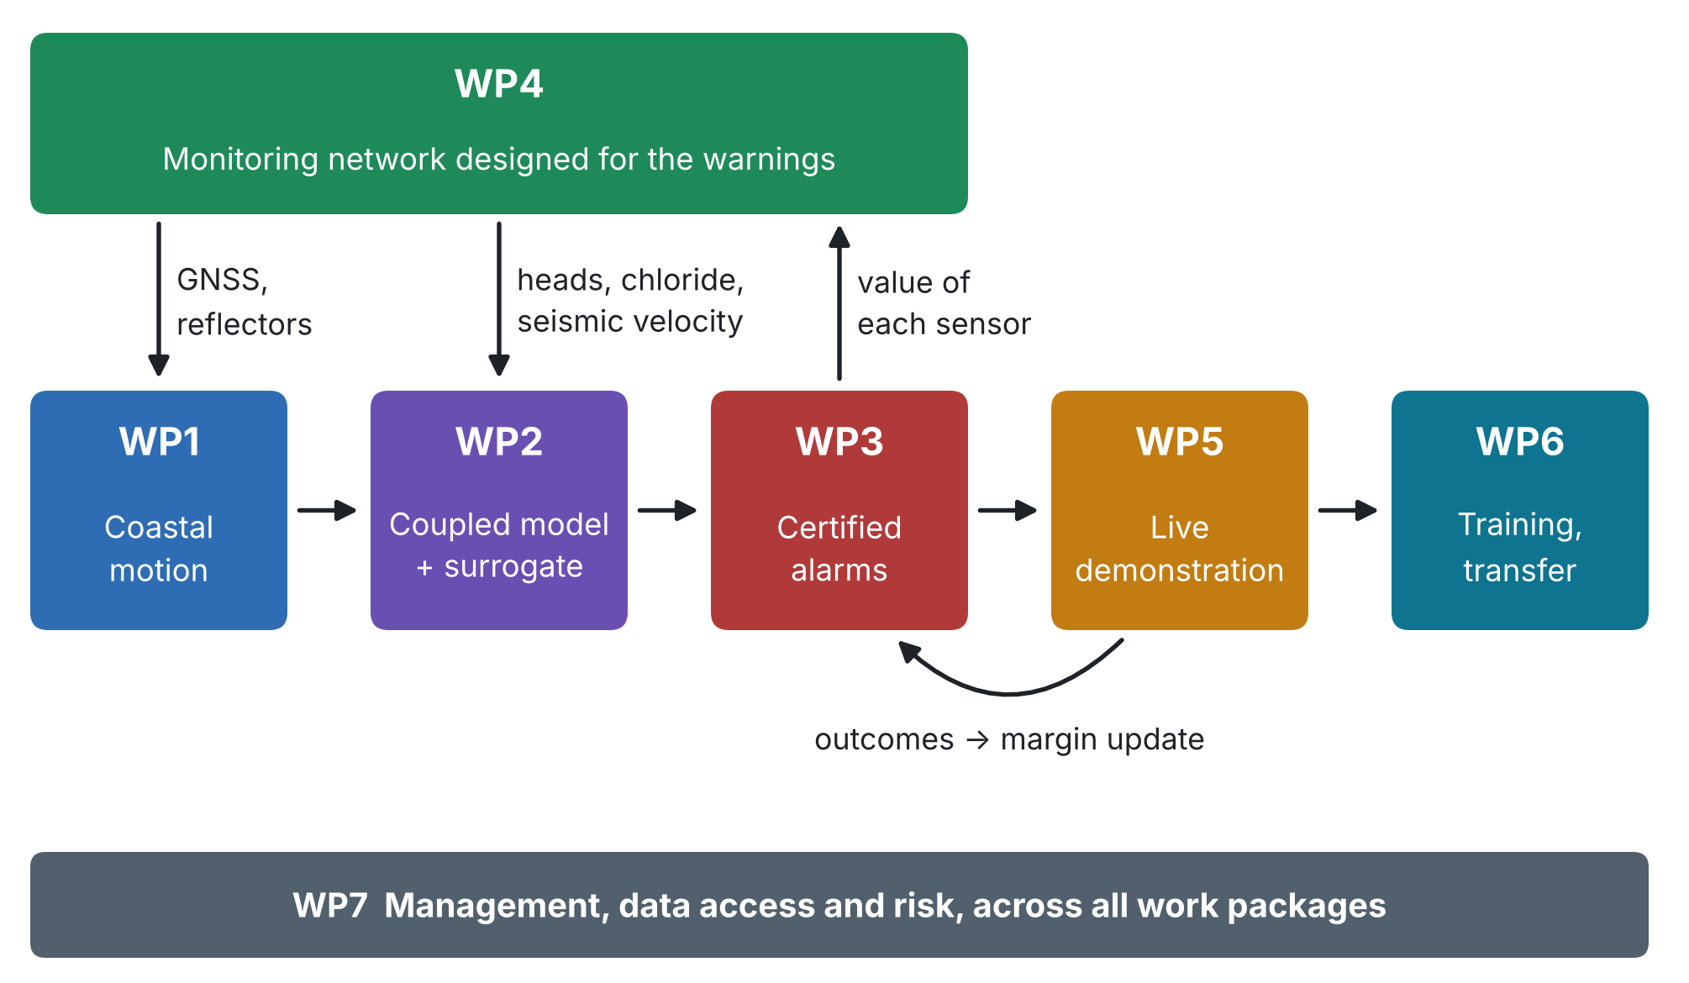
Figure 1. How the work packages feed each other. The live operation (WP5) feeds outcomes back to the alarms (WP3), and the alarms tell the network (WP4) which sensors are worth most.

WP1 Coastal motion and relative sea level
Lead | [NPD team] or [additional NATO co-director]
Participants | PPD team; Albanian research partner
Months | Month 1 to Month 36
Objective | O1: Measure the subsiding coast
Effort | [person-months, in kind]
Description
Measure the vertical motion of the land at the wellfields, the port and the landfall, separate what pumping can reverse from what it cannot, and deliver the relative sea level R(t) that drives every hazard model.
Tasks
Task | Description | Months
T1.1 | Sentinel-1 InSAR time series (2014 onwards) over the three asset areas | M1–M9
T1.2 | GNSS station(s) and corner reflectors at the assets; tie to the tide gauge | M3–M36
T1.3 | Elastic and inelastic compaction separated; pumping limit without inelastic compaction; 2019 coseismic and postseismic motion | M6–M12
T1.4 | R(t) series with uncertainty at each asset, updated through the demonstration | M10–M36
Deliverables
 | Deliverable | Type | Access | Month
D1.1 | Coastal motion atlas and R(t) series | Data, report | Public (regional); restricted (asset points) | M12
Milestones
• MS2 (Month 12): Network streaming; coastal motion known
Inputs and outputs
• Needs: Sentinel-1 archive; GNSS and corner reflectors (WP4); tide-gauge record
• Gives: R(t) and land motion at each asset, compaction parameters and the head limit h_pc → WP2, WP3 (extremes), WP5 (pumping rule)
Success criteria
• Vertical-velocity maps of the three asset areas with stated uncertainty; target uncertainty of the order of 1–2 mm/yr at asset points
• Elastic and inelastic compaction separated at every wellfield, and the pumping rate the land can sustain without inelastic compaction
• Time series R(t) with uncertainty at each asset, ready to drive the hazard models
Main risks (Risk Assessment)
• R4 inSAR loses coherence on vegetated plains or on new port works
What is new
• Relative sea level referred to each asset, and the switch from elastic to inelastic compaction turned into a warning (P1, P4, M5).

WP2 One coupled model of the coast and its certified fast copy
Lead | [PPD team]
Participants | NPD team
Months | Month 4 to Month 24
Objective | O2: Build one coupled physical model of the coast and a certified fast copy of it
Effort | [person-months, in kind]
Description
Build and calibrate one physical model that gives, from the same forcing, the chloride at the wells, the liquefaction factor of safety at the port and the landfall, and the extreme water level at all three; and a fast surrogate with an error bound on every forecast.
Tasks
Task | Description | Months
T2.1 | Conceptual model and data assembly: geology, wells, port and landfall geotechnical data | M4–M9
T2.2 | Coupled model: variable-density flow, salt memory, compaction, FS(x,t) = CRR/CSR(z_w), coastal water level on R(t) | M7–M15
T2.3 | Calibration on heads, conductivity, chloride, InSAR and seismic velocity | M12–M18
T2.4 | Neural or kernel operator surrogate with a-posteriori error bound | M15–M22
Deliverables
 | Deliverable | Type | Access | Month
D2.1 | Calibrated coupled model | Model | Restricted (site); public (synthetic coast) | M18
D2.2 | Certified surrogate | Software | Restricted (site); public (synthetic coast) | M22
Milestones
• MS3 (Month 18): Coupled model calibrated
• MS4 (Month 22): Go/no-go for live operation
Inputs and outputs
• Needs: R(t) and compaction (WP1); heads, chloride and seismic velocity (WP4); operator records (access agreements, WP7)
• Gives: Calibrated coupled model and certified surrogate → WP3, WP5; sensitivities for the network design → WP4
Success criteria
• One model that outputs the three hazard indicators from one set of forcings: chloride at each production well, FS at the port and landfall, total water level at each asset
• Calibration reproduces held-out observations within their stated uncertainty
• Surrogate fast enough to run thousands of storylines per day, with an a-posteriori error bound attached to each forecast
Main risks (Risk Assessment)
• R3 historical head and chloride records are incomplete or of uneven quality
• R5 the coupled model fails its validation test on held-out data
• R6 the surrogate fails its error bound in part of the domain
What is new
• One model in which the same water table drives intrusion, compaction and the liquefaction factor of safety, with a certified fast copy (P2, P3, M4).

WP3 Certified multi-hazard alarm
Lead | [PPD team]
Participants | NPD team; end-users (thresholds, T3.1)
Months | Month 13 to Month 34
Objective | O3: Certify the warnings
Effort | [person-months, in kind]
Description
Turn the forecasts into alarms whose miss rates are bounded: a margin made of the surrogate error bound, an online conformal risk-control term and an extreme-aware term; a joint guarantee over the three hazards.
Tasks
Task | Description | Months
T3.1 | Hazard indicators and thresholds agreed with the operators (chloride limit, FS < 1, design water level) | M13–M15
T3.2 | Margin construction and proofs: error bound + online conformal risk control + extreme-aware term | M15–M24
T3.3 | Joint guarantee over the three alarms; tolerances α_k allocated by consequence | M18–M24
T3.4 | Back-testing on the historical record and on storylines beyond it | M22–M27
T3.5 | Alarm refinement with the outcomes of the live operation | M28–M34
Deliverables
 | Deliverable | Type | Access | Month
D3.1 | Certified alarm algorithms and proofs | Report | Public | M24
D3.2 | Back-testing report | Report | Public (aggregated); restricted annex | M27
Milestones
• MS5 (Month 27): Miss-rate targets confirmed in back-testing
Inputs and outputs
• Needs: Surrogate and error bound (WP2); thresholds agreed with the operators (T3.1); nonstationary extremes (WP1)
• Gives: Certified alarms and proofs → WP5; value of each sensor → WP4; verification statistics → WP6
Success criteria
• Miss rate of each alarm at or below its target α_k (indicatively 5–10%) in back-testing over the historical record and in the live demonstration, reported with confidence intervals
• Joint miss probability of the three alarms at or below Σα_k, with the false-alarm rate reported alongside
• Under drought, storm and compound storylines beyond the record, miss rates within target where a static alarm fails (preparatory tests: 4–9% against 13–21%)
Main risks (Risk Assessment)
• R7 certified alarms are too cautious: the false-alarm rate is unacceptable to the operators
• R8 conditions move beyond the observed record (drought, compound storm, post-seismic change) and weaken the guarantees
• R14 no strong earthquake or surge occurs during the demonstration, so the guarantees are not tested on such events
What is new
• Alarms whose miss rates are certified, each and jointly, also beyond the observed record (M1, M2).

WP4 Monitoring network designed for the warnings
Lead | [NPD team]
Participants | Albanian research partner; additional NATO co-director (T4.4)
Months | Month 1 to Month 36
Objective | O4: Design and install the monitoring network for the warnings
Effort | [person-months, in kind]
Description
Choose the sensors jointly for their value to the three warnings, install them, keep them running and feed them into the model.
Tasks
Task | Description | Months
T4.1 | Goal-oriented design across sensor types: piezometers with conductivity, chloride sampling, GNSS, seismic noise, nodes, fibre | M1–M6
T4.2 | Procurement and installation | M4–M12
T4.3 | Operation, quality control, data streaming and assimilation | M12–M36
T4.4 | Seismic velocity calibrated against the water table at the port or landfall | M12–M24
Deliverables
 | Deliverable | Type | Access | Month
D4.1 | Network design report | Report | Restricted | M6
D4.2 | Network installed and streaming | Demonstrator | Restricted | M12
Milestones
• MS1 (Month 6): Network design agreed
• MS2 (Month 12): Network streaming; coastal motion known
Inputs and outputs
• Needs: Preliminary sensitivities (WP2); value of each sensor (WP3); site access (WP7)
• Gives: Data streams → WP1, WP2, WP5; seismic velocity as a water-table gauge → WP2
Success criteria
• Every candidate sensor ranked by its value for the three warnings; the installed network is the best-value set within the budget
• Network installed by Month 12 and operating with at least 90% data availability
• Seismic velocity changes calibrated against the water table at the port or landfall, as a pore-pressure sensor
Main risks (Risk Assessment)
• R2 security rules restrict access to the port or landfall (port-facility security, energy operator rules)
• R9 fibre-optic access is not granted, or seismic velocity responds too weakly to the water table
• R10 procurement or customs delays for sensors and loggers
• R11 theft, vandalism or damage of field equipment
• R12 a new borehole connects fresh and saline layers and lets seawater move between them
What is new
• A network designed for the warnings across seven sensor types, and seismic noise used as a water-table gauge (M3, P5).

WP5 Live demonstration at the wellfields, port and landfall
Lead | [NPD team]
Participants | End-users; civil protection; PPD team
Months | Month 22 to Month 36
Objective | O5: Demonstrate the system in operation at the three assets
Effort | [person-months, in kind]
Description
Run the system live for twelve months with the operators and civil protection, evaluate every operating decision against all three hazards, and execute the post-event protocol whenever it is triggered.
Tasks
Task | Description | Months
T5.1 | Bulletin protocol and decision interfaces with the operators and civil protection | M22–M23
T5.2 | Twelve months of live operation, bulletins logged and outcomes verified | M23–M34
T5.3 | Pumping rule evaluated against the three hazards together and agreed with the water utility | M24–M33
T5.4 | Post-event protocol after strong earthquakes or surges (on trigger) | M12–M36
Deliverables
 | Deliverable | Type | Access | Month
D5.1 | Live demonstration report | Report | Public (verification statistics); restricted annex | M34
Milestones
• MS6 (Month 34): Twelve months of live operation completed
Inputs and outputs
• Needs: Certified alarms (WP3); data streams (WP4); surrogate (WP2)
• Gives: Bulletin log and outcomes → WP3 (margin update), WP6 (procedures, verification); joint pumping rule
Success criteria
• At least 12 months of continuous operation with bulletins logged and their outcomes verified
• A pumping rule for the wellfields that keeps the three alarms within target together, documented and agreed with the operator
• Post-event protocol executed for every event above the agreed magnitude or water level during the demonstration
Main risks (Risk Assessment)
• R15 a missed alarm coincides with damage; trust and responsibilities are questioned
• R17 iT or cyber failure interrupts data streams or bulletins
• R21 a strong earthquake or storm damages the network or disrupts the project
What is new
• A pumping rule checked against all three hazards at once, and certified miss rates verified against a live bulletin log (P3).

WP6 Training, transfer and dissemination
Lead | [PPD team]
Participants | All partners; end-users (T6.2, T6.4)
Months | Month 1 to Month 36
Objective | O6: Transfer the system and build lasting capacity
Effort | [person-months, in kind]
Description
Build lasting capacity: early-career researchers trained by doing, operator staff trained to run the system unaided, open software and data, and procedures the operators and authorities can adopt.
Tasks
Task | Description | Months
T6.1 | Early-career researchers: exchanges, schools and supervised work in WP1–WP5 | M3–M36
T6.2 | Training of operator and civil-protection staff | M24–M36
T6.3 | Open software and data release with documentation | M30–M33
T6.4 | Operating procedures and policy brief | M30–M36
Deliverables
 | Deliverable | Type | Access | Month
D6.1 | Software and data release | Software, data | Public | M33
D6.2 | Operating procedures and policy brief | Report | Restricted (procedures); public (policy brief) | M36
Milestones
• MS7 (Month 36): Hand-over to the operators
Inputs and outputs
• Needs: Results of all work packages
• Gives: Trained people; open software and data; operating procedures; policy brief
Success criteria
• Early-career researchers trained through the project (indicatively at least 6) and operator staff trained to run the system unaided (indicatively at least 20)
• Open software and data release with documentation
• Operating procedures adopted by the operators of the wellfields, the port and the landfall (at least one per asset), and a policy brief delivered to the national authorities
Main risks (Risk Assessment)
• R16 over-reliance: operators drop their own checks and rely on the bulletins alone
What is new
• A coast kit and a transfer test on a second coast within the project; verification statistics published openly.

WP7 Management, data and risk
Lead | [NPD team] (coordinator)
Participants | Steering committee; all partners
Months | Month 1 to Month 36
Objective | Management of the project
Effort | [person-months, in kind]
Description
Coordinate the consortium, secure data access from the operators, manage risks and report.
Tasks
Task | Description | Months
T7.1 | Coordination, steering committee, reporting | M1–M36
T7.2 | Data management and access agreements with the water utility, port and landfall operators | M1–M3
T7.3 | Risk and quality management | M1–M36
Deliverables
 | Deliverable | Type | Access | Month
D7.1 | Data management plan and access agreements | Report | Public (data plan); restricted (agreements) | M3
D7.2 | Progress reports | Report | Restricted (to NATO SPS) | M12
D7.2 | Progress reports | Report | Restricted (to NATO SPS) | M24
D7.3 | Final report | Report | Public summary; restricted full report | M36
Inputs and outputs
• Needs: All work packages
• Gives: Access agreements and data management plan; risk register; progress and final reports
Success criteria
• Access agreements and data management plan delivered by Month 3
• Progress reports delivered in Months 12 and 24, final report in Month 36
• Every risk trigger acted on within two weeks of being crossed
Main risks (Risk Assessment)
• R1 operators delay access to well, port or landfall data; calibration and design start late
• R13 injury during field work (port traffic, storms, inspections after an earthquake)
• R18 loss of key researchers or of trained operator staff
• R19 equipment prices rise above the budget lines
• R20 sensitive information on critical-infrastructure vulnerability is disclosed through open data or publications
What is new
• Risk indicators with numeric triggers watched like the hazards, and a data plan with a security gate.

