NATO Science for Peace and Security Programme · Multi-Year Project · Call 2027-1

CERTAIN-COAST
Certified early warning to protect water, port and energy infrastructure on a sinking Adriatic coast
Additional files
Technical annex · three notes of the preparatory work · CVs of the two Project Directors
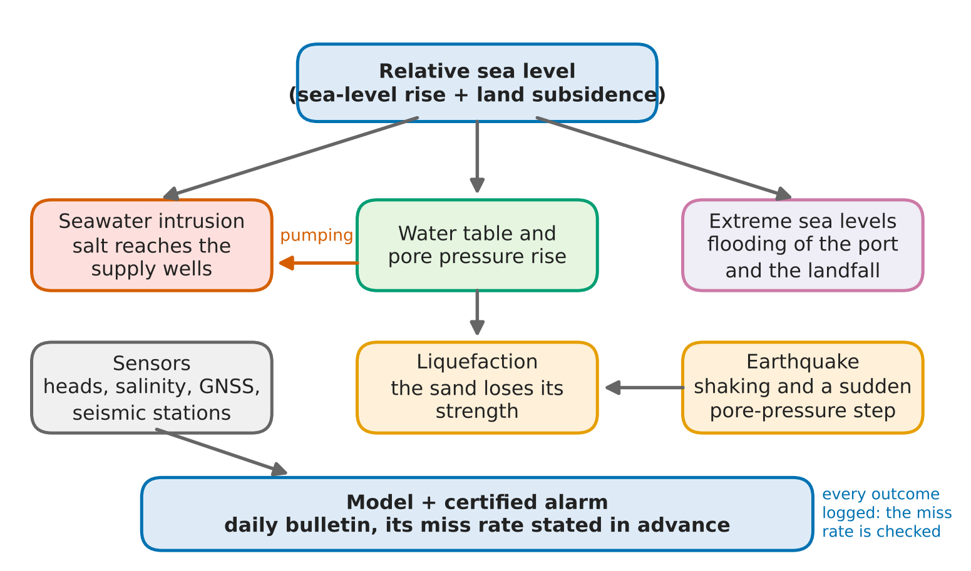
NATO-country Project Director | Assoc. Prof. Dr. Dulian Zeqiraj  Faculty of Geology and Mining, Polytechnic University of Tirana, Albania
Partner-country Project Director | Prof. Jassim Al-Khayat  Environmental Science Center, Qatar University, Qatar
End-user | Ministry of Infrastructure and Energy  Republic of Albania
November 2026

Contents
Part | Document | Page
1 | Technical annex  How the methods work, the preparatory tests, the gates with their fallbacks and the nine new contributions. | 3
2 | Technical note: the assembled system and the placement of the wells  Assembling the equations of a coastal aquifer, with the placement of recharge and pumping wells as the final goal. Preparatory work of the NPD's team, October 2026; corrected 8 November 2026. | 13
3 | Theory note: BEYOND-GO, the boundary where the model is cut  The boundary condition the flow equation is missing: a learnable boundary where the model is cut, four propositions with proofs and six numerical checks. Preparatory work of the NPD's team, November 2026. | 36
4 | Implementation report: SHOCK-GO, the earthquake in the aquifer  The earthquake, the aquifer and liquefaction: the pore-pressure step of each layer, the earthquake as a free pumping test, the design of the 2019 hindcast and the joint safe window, with numerical checks. Preparatory work of the NPD's team, November 2026. | 52
5 | CV of the NATO-country Project Director  Assoc. Prof. Dr. Dulian Zeqiraj, Faculty of Geology and Mining, Polytechnic University of Tirana. | 66
6 | CV of the partner-country Project Director  Prof. Jassim Al-Khayat, Environmental Science Center, Qatar University. | 68
Innovation What is new in each part
Nine contributions  Part 1 | Nine new contributions, each derived and tested before the project: from guarantees for quantities nobody measures and the value of a sensor to a boundary that learns the aquifer beyond the model and which aquifer feels an earthquake (Table 3 of the annex).
ASSEMBLY-GO  Part 2 | The placement of the wells is stated first, and the adjoint of its constraint, the chloride at the supply screen, decides how the equations are assembled. On the test, the goal-graded assembly runs a 30-year forecast 2.5 times faster than the complete one and ranks the 25 layouts as it does (rank correlation 0.997).
BEYOND-GO  Part 3 | A boundary condition that learns what lies beyond the model. Every member of its class is a physical exterior and every linear exterior is a member, so the learned boundary cannot be unphysical, cannot destabilise the model and loses nothing in generality.
SHOCK-GO  Part 4 | Which aquifer feels the earthquake: the static step of a layer under the free surface follows its own shear modulus, centimetres in soft surface sand and up to a metre in a confined aquifer. Its relaxation, a free pumping test, identifies the leakage time 5.8 times more sharply than a year of seasonal heads.
About these files
■ The technical annex explains how the methods work, the preparatory tests, and the gates of the project with their fallbacks. Parts 2 to 4 give the equations, the proofs and the numerical checks behind it; every number in them is computed by the scripts of the preparatory work of the NPD's team.
■ Every equation is set as native Word math. The names of the preparatory experiments are given in English (BEYOND-GO, SHOCK-GO, ASSEMBLY-GO, ...).
■ The open-source code of the project, in MATLAB that also runs in the free GNU Octave: https://github.com/dulianzeqiraj/certain-coast.

PART  1 | Technical annex  How the methods work, the preparatory tests, the gates with their fallbacks and the nine new contributions.

CERTAIN-COAST — Technical annex
Certified early warning to protect water, port and energy infrastructure on a sinking Adriatic coast
How the methods work, what was tested before the project, and what is new. This annex supplements the fields "How will the project reach the planned end state?" and "Work-plan" of the application form; work packages (WP), tasks (T), deliverables (D), months and milestones (MS) are those of the form. Test results come from synthetic test systems and preparatory models, not from measurements made by the project at the sites.
1. Two sites, three coupled hazards
The project protects two sites on the Albanian Adriatic coastal plain: at Durrës, the wellfields that supply drinking water and the port; near Fier, the landfall of the Trans Adriatic Pipeline (TAP). The demonstration runs on the project's monitoring network on the coast of Durrës and Fushë-Kuqe, with the Ministry of Infrastructure and Energy of Albania as the end-user, which uses the warnings to protect critical infrastructure; the port and the landfall are assessed from satellite radar, GNSS and public data only. Both sites stand on low ground near active faults, and at Durrës the land is sinking; the earthquake of 26 November 2019 caused liquefaction near the coast (Mavroulis, Lekkas and Carydis, 2021). Three hazards threaten these assets, and they are coupled through two variables, the relative sea level and the water table. Sea level enters the aquifer at its seaward boundary and sets how far seawater advances; the water table sets the effective stress in the sands and so their resistance to liquefaction; subsidence raises the relative sea level at every asset. Pumping lowers the water table: it increases seawater intrusion and, below the preconsolidation head, permanent subsidence, but it raises the factor of safety against liquefaction. No hazard can be managed alone, so one indicator is defined per hazard, oriented so that larger means more dangerous (Table 1).
Table 1. Hazard indicators, thresholds and lead times.
Hazard (assets) | Indicator | Threshold | Lead time, cadence
Seawater intrusion (Durrës wellfields) | I₁: chloride at the monitoring wells next to each wellfield | From the drinking-water standard, agreed with the end-user (for example 250 mg/L) | Weeks to months; weekly
Liquefaction (Durrës port; TAP landfall) | I₂: liquefaction potential index under the design shaking at the current water table | Class boundary of the design codes, agreed with the end-user | Daily; recomputed at once after an earthquake
Extreme water level (all assets) | I₃: total water level at each asset | Design or operational level of each asset | Hours to days for storms; return levels yearly

An alarm is missed when the indicator exceeds its threshold within the lead time and no alarm was issued; the long-run miss rate is the quantity the project certifies. Earthquakes are not forecast: the liquefaction alarm states how the ground would respond if the design earthquake struck now, a state that changes with the water table. In a preparatory test at a synthetic port, the chance that the liquefaction potential index exceeded 5 if the design earthquake struck on a given day moved between 0.16 in late July and 0.26 in early February.
2. The method chain
Six steps turn data into bulletins (Figure 1). Each step has a pass test and a fallback (Section 7). Three loops close the chain: verified outcomes update the alarm margins, new data are assimilated into the model, and the certified safe window of Section 6 tells the network how many years of safe operation each sensor adds.
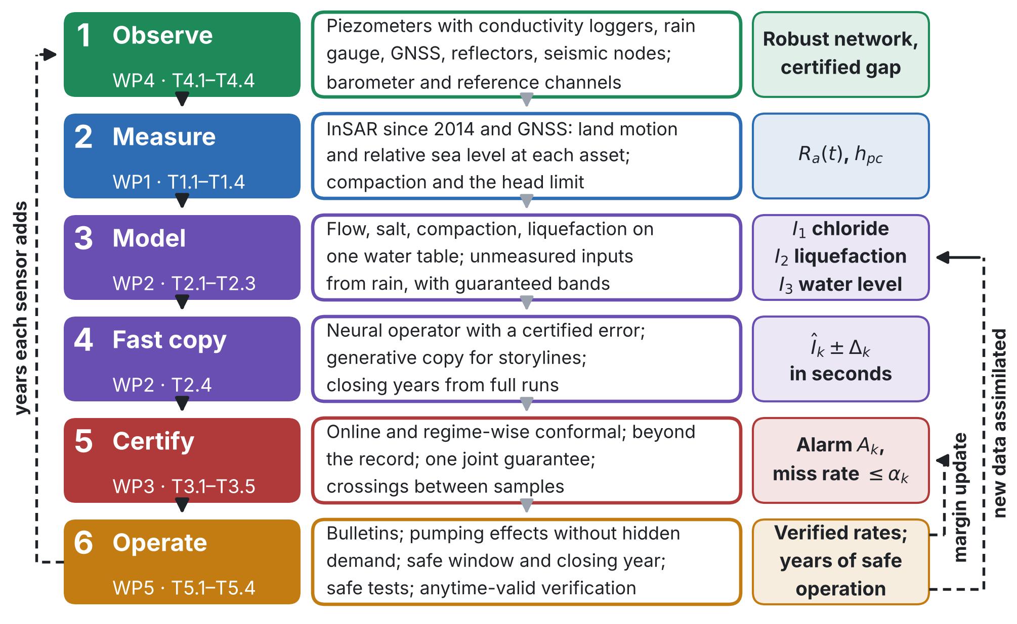
Figure 1. The CERTAIN-COAST method chain for the Durrës wellfields and port and the TAP landfall near Fier. Solid arrows: from data to bulletins. Dashed arrows: the three feedback loops.
3. Observe and measure (WP1, WP4)
3.1 Relative sea level at each asset (WP1, T1.1–T1.4)
Sentinel-1 ascending and descending time series since 2014 give the vertical and east components of land motion; a trajectory model separates trend, season, the coseismic step of 26 November 2019 and the postseismic transient. Corner reflectors and GNSS at the assets (T1.2) give stable radar targets on soft ground and tie the solution to a global frame. The tide gauge records sea level $η_{\text{TG}}$ relative to its own benchmark, which also moves, so the relative sea level at asset $a$ adds the differential vertical land motion $u_{z}$, propagated with its full covariance (target vertical-velocity uncertainty 1–2 mm/yr; Ohenhen et al., 2023):
$$R_{a}\left(t\right)=η_{\text{TG}}\left(t\right)+u_{z}^{\text{TG}}\left(t\right)−u_{z}^{a}\left(t\right)$$ | (1)
Elastic and inelastic compaction fitted to the InSAR and head records give the head limit $h_{\text{pc}}$ above which pumping causes no new permanent subsidence (Lees, Knight and Smith, 2022). The same $R_{a}\left(t\right)$ drives all three hazard models, so the warnings cannot disagree about where the sea is.
3.2 A network designed for the warnings, which corrects its own sensors (WP4, T4.1–T4.4)
The network is designed before it is bought (D4.1, Month 6). Candidates are piezometers with conductivity loggers, a local rain gauge, GNSS, corner reflectors, seismic nodes and, where access allows, fibre-optic sensing; the candidate sites are boreholes on public land and existing wells whose owners agree. Each candidate is valued by goal-oriented Bayesian design (Attia, Alexanderian and Saibaba, 2018) in two currencies: the guaranteed width it removes from the warning bands, and the years of certified safe operation it adds (Eq. (12)). A sensor is bought only if its guaranteed value is positive: in a preparatory test, a tide gauge that a standard ensemble rated as narrowing the recharge band by 15% widened the guaranteed band by 16–21%.
Loggers respond to air pressure (Rasmussen and Crawford, 1997) and drift. A barometer and a sealed reference channel on each logger hub are therefore design candidates beside the piezometers; their errors are removed by marginalisation, and the network is chosen against the worst plausible error model, with a certified distance from the best network (robust design; Chowdhary, Attia and Alexanderian, 2025). In a preparatory test with 12 sensors the worst-case information was 5.59 nats against 3.67 for the classical design (+52%), with a certified optimality gap of 18%; 90% forecast intervals covered 88–93% of outcomes after correction and 49–62% without, and corrected heads were within 2.9 cm root-mean-square against 7.6 cm raw.
Near the port and the TAP landfall, T4.2 places corner reflectors, a GNSS station and a seismic station on public land. Ambient seismic noise tracks the water table (Clements and Denolle, 2018), also on unused telecommunication fibre (Rodríguez Tribaldos and Ajo-Franklin, 2021); once calibrated against piezometers (T4.4), velocity changes measure the water table between wells, also near the port and the landfall, and a drop after an earthquake measures the softening of the ground.
4. Model and certify (WP2)
4.1 One coupled model (T2.1–T2.3)
One model, set up for the two sites on one coastal motion field (T2.1), couples variable-density flow, salt transport with memory in clays, the sea as a moving boundary driven by $R_{a}\left(t\right)$, compaction, the total water level at each asset, and liquefaction triggering with the water table taken from the flow model at every time step (Seed and Idriss, 1971; Boulanger and Idriss, 2014). Groundwater rise under sea-level rise is a hazard in its own right (Befus et al., 2020) and raises liquefaction severity where water tables are shallow (Grant et al., 2021); here one water table drives all three hazards, so a pumping decision is checked against all of them at once. Parameters are estimated jointly from heads, conductivity, chloride, InSAR and seismic velocity by an ensemble smoother (Emerick and Reynolds, 2013); the model is differentiable, so adjoint gradients of every indicator are available (Shen et al., 2023). Priors are stated so that an expert can read and dispute them (Simpson et al., 2017; Fuglstad et al., 2019) and are checked after calibration for prior-data conflict (Evans and Moshonov, 2006).
4.2 Guarantees for the inputs and boundaries nobody measures (T2.3)
Recharge, vadose delay, storage, the sea-level and inland boundaries, the initial head and the dispersion width are never measured, yet every warning depends on them. They are reconstructed from rain and heads by a function-space diffusion prior with an ensemble update through the exact solver, with the errors of the rain product simulated in the prior. Their bands are calibrated by conformal risk control (Angelopoulos, Bates, Fisch, Lei and Schuster, 2024) on simulated aquifers that carry these errors, and checked on measured anchor periods, so the guarantee does not depend on the simulator. With a loss $L_{i}\left(λ\right)$ between 0 and 1 for calibration case $i$ and its mean ${\hat{R}}_{n}\left(λ\right)$ over $n$ cases:
$$\hat{λ}=\text{inf}\left\{λ: \frac{n}{n+1}{\hat{R}}_{n}\left(λ\right)+\frac{1}{n+1}≤α\right\} \text{ and } \text{E}\left[L_{n+1}\left(\hat{λ}\right)\right]≤α$$ | (2)
For $α$ = 10%, at least 9 anchor periods give the average guarantee and 22 a 90% certificate. Under drift the calibration is matched to the forecast horizon, and a computable floor shows how far each band is from the narrowest valid one. In the preparatory test the raw ensemble missed 17–20% of the weeks and the calibrated bands 9.5–10% (target 10%); the risk stayed at 0.003–0.082 up to 20 years ahead under drift.
4.3 The boundary where the model is cut (T2.3, T4.1)
Every model of the aquifer ends somewhere inland, at a cut that geology does not mark. A fixed head, a prescribed inflow or a general-head boundary does not respond to pumping or to the sea as the aquifer beyond does, and the choice decides the answers. In the preparatory test, the fresh water lost to a 0.5 m rise of the sea over 20 years was 49 m³ per metre of coast with a prescribed inflow, 462 with a fixed head and 154 in the full aquifer (Werner and Simmons, 2009). For any linear aquifer beyond the cut, heterogeneous, leaky or closed, the exact boundary is a conductance plus positive storage compartments. With $u=h−\overset{‾}{h}$ the head at the cut above its reference and $q_{in}$ the inflow from rain, the outward flux is
$$q_{n}=−q_{in}\left(t\right)+C u+\sum_{m=1}^{M}{w_{m}}\left(u−y_{m}\right) \text{ and } {\dot{y}}_{m}=μ_{m}\left(u−y_{m}\right) \text{ and } C, w_{m}≥0$$ | (3)
Conversely, every such network is the exact boundary of some physical aquifer, so a learned boundary cannot be unphysical; the same positive memory describes diffusion into the silt and clay lenses inside the model (Haggerty and Gorelick, 1995). With $C,w_{m}≥0$ the boundary is passive: the model loses energy whatever its other parameters, as passive models of an external electrical network do (Gustavsen and Semlyen, 2001). A negative conductance that was stable in a 2 km test grew without bound in a 6 km model. The rates $μ_{m}$ sit on a fixed logarithmic grid, three to four per decade of period. The weights are learned from two piezometers between the wellfields and the cut (T4.1), which separate the boundary from everything else in the model, on the band of periods that changes of pumping excite. A neural network may supply $q_{in}$ from rain and monotone conductances, never the storages, and a prior learned from simulated geology fills the periods the data do not reach. In the test, six compartments reproduced the full aquifer to 7.8 mm root-mean-square over 20 years (best general-head boundary: 148 mm). Learned from the two piezometers while the pumping varied, the boundary predicted an unseen drought with doubled pumping to 6 mm (372 mm), and the fresh water lost to the sea-level rise within 4%. The proofs and the six checks are in the BEYOND-GO theory note, the third document of these files.
4.4 The earthquake in the aquifer (T2.2, T4.4, T5.4)
An earthquake changes the pore pressure at once, so the liquefaction indicator uses the pore pressure of that moment: below the water table of the day, $u=γ_{w}{\left(z−z_{w}\right)}_{\text{+}}+f Δp_{0}$, where $f$ is the share of the step left at the end of the shaking (close to zero in sand within a few metres of the water table, one in sand below clay). The static step follows from the published fault models of the 2019 earthquake (Ganas et al., 2020; Govorčin et al., 2020; Matraku et al., 2023; van der Heiden et al., 2026) through the horizontal strain at the surface (Okada, 1985). A soft layer under the free surface takes that strain and adjusts vertically, so for an undrained layer with shear modulus $G$, Skempton coefficient $B$ and undrained Poisson ratio $ν_{u}$
$$Δp_{0}=−κ \left(Δε_{xx}+Δε_{yy}\right) \text{ and } κ=\frac{2GB}{3} \frac{1+ν_{u}}{1−ν_{u}}$$ | (4)
A soft saturated sand ($ν_{u}$ near 1/2) deforms at almost constant volume, so its step scales with $G$, which the seismic nodes measure as shear-wave velocity (T4.4). With the four source models the step was 7–12 cm of head in soft surface sand ($G$ = 50 MPa) and 0.6–1.0 m in a stiffer confined aquifer ($G$ = 0.5 GPa); the usual estimate, $BK_{u}$ times the volumetric strain of the half-space, gave 35 times the soft-sand value. For liquefaction the water table of the day dominates: in an example profile the index fell from 20.2 to 9.3 as the water table deepened from 0.8 to 2.6 m. The cone-penetration resistance keeps the value it had when it was measured; re-normalising it with the stress of the day understated that slope by 33%. The step matters in the confined aquifer, and its relaxation is a free pumping test: 20 days of logger data after a 0.3 m step pinned the leakage time 5.8 times more sharply than a year of seasonal heads. The post-event protocol (T5.4) therefore reads the leakage of the confined aquifer from the loggers, and well records of November 2019 are sought where they exist. The mapped liquefaction of 2019 (Mavroulis, Lekkas and Carydis, 2021) cannot test the step: on a synthetic plain even 480 sites gave a power below 50%. The code and the checks are in the SHOCK-GO report, the fourth document of these files.
4.5 A fast copy with a certified error (T2.4)
Warnings need thousands of model runs a day. A neural operator (Li et al., 2021; Lu et al., 2021) is trained on runs of the coupled model, and its error on each forecast is bounded conformally (Ma et al., 2024), with the score normalised by the goal-oriented dual-weighted residual $η_{k}$ (Becker and Rannacher, 2001), so the bound is tight where the copy is right about the quantity that triggers the alarm:
$$Δ_{k}\left(ξ\right)={\hat{q}}_{1−δ} η_{k}\left(ξ\right) \text{ and } Pr\left[ \left|I_{k}\left(ξ\right)−{\hat{I}}_{k}\left(ξ\right)\right|≤Δ_{k}\left(ξ\right) \right]≥1−δ$$ | (5)
Forecasts whose bound is too wide are recomputed with the full model on a reduced domain. A generative copy (Gao, Kaltenbach and Koumoutsakos, 2024) explores long storylines of sea-level rise, subsidence, droughts and pumping and chooses which of them the full model runs; in a preparatory test its statistics alone put the closing year of the safe window 2–8 years too late, so closing years are always certified from full runs with the exact binomial bound (Clopper and Pearson, 1934).
5. Certified alarms (WP3)
5.1 Alarm rule, calibration under shift and beyond the record (T3.1–T3.2)
Thresholds $τ_{k}$ and tolerable miss rates $α_{k}$ are agreed with the end-user (T3.1). Alarm $k$ fires when the forecast at lead time $L_{k}$ comes within a margin $m_{k}$ of its threshold. The margin adds the certified copy error to a forecast error $γ_{k}$ that rises after a miss and falls slightly otherwise; with a constant step $λ$ the long-run miss rate stays within $C_{k}/\left(λT\right)$ of its target for any sequence of data (Gibbs and Candès, 2021, 2024; Angelopoulos, Barber and Bates, 2024):
$$A_{k}\left(t\right)=1\left\{{\hat{I}}_{k}\left(t+L_{k}\right)≥τ_{k}−m_{k}\left(t\right)\right\} \text{ and } m_{k}\left(t\right)=Δ_{k}\left(t\right)+γ_{k}\left(t\right)$$ | (6)
$$γ_{k}\left(t+1\right)=γ_{k}\left(t\right)+λ_{t} \left[ {\text{miss}}_{k}\left(t\right)−α_{k} \right] \text{ and } \left|\frac{1}{T}\sum_{t=1}^{T}{{\text{miss}}_{k}}\left(t\right)−α_{k}\right|≤\frac{C_{k}}{λ T}$$ | (7)
The guarantee also holds within each regime (drought, storm season, after an earthquake, each asset) by conformal prediction with conditional guarantees (Gibbs, Cherian and Candès, 2025), and for events rarer than the record by extreme conformal prediction (Pasche, Lam and Engelke, 2026). Still-water extremes use a generalised Pareto tail (Coles, 2001) whose threshold moves with the measured relative sea level of Eq. (1). In preparatory tests on a coupled variable-density model, an extreme-aware margin kept the share of seasons above the chloride limit at 4–9% across drought, human-feedback and compound storylines, where a static alarm allowed 13–21%.
5.2 One guarantee for the three assets (T3.3)
The alarms share inputs, so their misses are dependent. The probability that any alarm is missed is bounded by the sum of the tolerances, which are allocated where tightening them costs least in consequence-weighted false alarms, within caps agreed with the users. The margins are calibrated together by Learn then Test (Angelopoulos, Bates, Candès, Jordan and Lei, 2025), so every certified rate holds at once with probability at least $1−β$. The national authorities receive one joint guarantee for the wellfields, the port and the landfall.
5.3 Warnings for what happens between samples (T3.2)
Chloride is sampled weeks or months apart. Sparse samples pin the distribution of chloride on the sampling dates but not its time scale, so a well can turn salty between two samples that both look safe. The warning is therefore the probability that chloride crosses its limit $c^{⋆}$ at any time in the season $T$, reported as a band over the set $M$ of all models consistent with the records, in the spirit of robust bounds over calibrated models (Gierjatowicz et al., 2020) and of online forecasts from irregular records (Krach, Nübel and Teichmann, 2026):
$$\underline{p}={\text{inf}}_{P∈M}P\left[\max_{t∈T}c\left(t\right)>c^{⋆}\right] \text{ and } \overline{p}={\text{sup}}_{P∈M}P\left[\max_{t∈T}c\left(t\right)>c^{⋆}\right]$$ | (8)
The band is widened by a conformal margin calibrated on simulated aquifers and anchor periods and issued online as the conditional probability given the irregular samples and the daily heads; the network design adds the observation that closes it (a logger, or samples paired 1, 3 and 7 days apart). In the preparatory test the chance of a crossing within the season was 0.78, against 0.023 on a sampling date (34 times); the band was 0.18–1 with quarterly samples and 0.76–0.80 with a daily logger; for skewed chloride the margin restored 90.3% coverage (74% without), and a head logger raised the warning skill from 7% to 20%.
5.4 Back-testing and verification in operation (T3.4–T3.5)
The chain is replayed over the record since 2014 with the system frozen at each issue time, under a protocol published with a DOI before the results (D3.2, Month 27). At 95% confidence, verifying a 10% miss rate needs 29 exceedance events with no miss, 46 with one or 61 with two; a 5% rate needs 59, 93 or 124. In operation the ledger is published every quarter, so each miss rate is looked at many times, and a fixed-sample bound recomputed at every look loses its guarantee: in a simulation of six calibrated alarms it flagged at least one as broken in 68% of runs. Verification therefore uses e-processes, which stay valid however often they are checked (Ville, 1939; Vovk and Wang, 2021; Ramdas et al., 2023), with $x_{i}=1$ if event $i$ was missed:
Ekn=j​πji=1nqjαkxi1−qj1−αk1−xi and PrEkn≥1/β for some n≤β | (9)
In the simulation the e-process flagged a calibrated alarm in 2.2% of runs (at most 5% is guaranteed) and detected an alarm whose miss rate had risen to 25% in 84% of runs within 100 events.
6. Operate and decide (WP5)
Twelve months of live bulletins (T5.2) follow a dry run (T5.1). Each bulletin states, per asset, the forecast, the margin, the alarm state, the certified miss rate and the distance to the closing of the safe window, and is logged with its inputs and code version so that it can be reproduced and audited. A post-event protocol agreed with the end-user (T5.4) remeasures heads, chloride, GNSS and seismic velocity within days of a strong earthquake or storm, updates the model and recomputes the alarms and the window.
6.1 The effect of pumping without the hidden drought demand (T5.3)
In droughts the wellfields pump more while recharge falls, so a hidden cause drives both the pumping and the salinity, and substitutes for hidden confounders inferred from the treatment history (Bica, Alaa and van der Schaar, 2020) can miss it. CERTAIN-COAST measures the confounding path instead: the heads, after the drawdown estimated from the abstraction records is added back, read the recharge, and a calibrated physics check rejects any substitute that misses a confounder before an effect is reported. In the preparatory test the bias of the summed well effects was 0.59 unadjusted, 0.56 with a history substitute and 0.00 with the heads; the check had a size of 6% and a power of 99–100%. On the calibrated chloride model of Fushë-Kuqe, 40% less recharge would grow the shallow area above 250 mg/L from 31 to 65 km² (effect +33 km², conformal band 15–49 km²).
6.2 The certified safe operating window and the year it closes (T5.3)
Pumping moves the hazards in opposite directions, and sea-level rise and subsidence tighten all of them. At each bulletin and over the adaptation horizon the project computes the set of decisions $u$ (wellfield pumping $Q_{w}$, port dewatering) that meets the demand $D$, keeps every hazard within its certified limit and causes no new permanent subsidence, and the relative sea level and year at which this set becomes empty:
$$W_{α}\left(R\right)=\left\{ u: Q_{w}≥D, \underset{θ}{Pr}\left[I_{k}\left(u,R;θ\right)>τ_{k}\right]≤α_{k} \left(k=1,2,3\right), h\left(x,u,R\right)≥h_{\text{pc}}\left(x\right) \right\}$$ | (10)
$$R_{α}^{⋆}=\text{largest }R\text{ with }W_{α}\left(R\right)≠∅ \text{ and } t_{α}^{⋆}=\text{first }t\text{ with }W_{α}\left(R\left(t\right)\right)=∅$$ | (11)
This is a certified, multi-hazard adaptation tipping point (Kwadijk et al., 2010; Haasnoot et al., 2013); tipping points exist for seawater intrusion alone (Mazi, Koussis and Destouni, 2013). At the closing point the least dewatering that keeps liquefaction within its limit, $A$, meets the most dewatering the wellfield tolerates, $B$, and one multiplier $μ$ converts any change of a margin, from a sensor, a better model or a pumping test, into years:
$$μ=−{\left[\frac{d \left(B−A\right)}{dt}\right]}_{t=t_{α}^{⋆}}^{−1} \text{ and } Δt_{α}^{⋆}≈μ \left(ΔB−ΔA\right)$$ | (12)
On a synthetic transect with the three hazards of Durrës and illustrative values, the certified window closed at a relative sea level of 0.41 m, after 38 years; plans that watch one hazard believed they had 43 to 97 years, and the margins cost 84 years against the window without them. Valued in years by preposterior analysis, with Eq. (12) as a first-order shortcut, a sentinel piezometer between the wellfield and the sea added 21.6 years, and a GNSS station and two corner reflectors 5.6 and 5.0 years, where the classical criterion values them at zero because they narrow none of today's forecasts. For one managed head the window between liquefaction and intrusion has a closed form, $η+m_{int}≤h≤z_{s}−z^{⋆}\left(a\right)$, with $z^{⋆}\left(a\right)$ the water-table depth that keeps the index below 5 for 90% of the profiles under the design acceleration $a$ and $m_{int}$ the fresh head that keeps the interface 20 m deep. At a synthetic port it closed at 0.29 m of relative sea-level rise for 0.20 g and was already closed at 0.22 g, so the design acceleration chosen for the port decides the closing year.
6.3 Safe pumping tests chosen for the years they add (T5.3)
Routine pumping keeps the water table in a narrow band, so the records say little about how chloride responds near the onset of intrusion, which decides when the window closes. Short pumping and dewatering tests, each approved by the operator of the wells and by the permitting authority, would approach that onset safely; within the project they are planned and checked on the model, and run only where the well operator agrees. The response is linear in unknown coefficients of hinge features of the head, with a confidence set that holds in every week (Abbasi-Yadkori, Pál and Szepesvári, 2011). A test is chosen for the years it adds to the certified closing year, as in active identification with guarantees (Mania, Jordan and Recht, 2022) but for the decision, and only if the upper confidence bound of chloride stays below a test limit in every week of the test and the recovery (Koller et al., 2018). In the preparatory test the campaign raised the certified closing year from 10.8 to 31.9 years (true value 45) with chloride below 123 mg/L in 95% of runs, whereas tests chosen for parameter accuracy alone passed 250 mg/L in 42% of runs; the certificate held in all 1,000 runs. The years rest on the prior from the calibrated model, so the certified year is reported for the prior error radius $S$ and for $2S$ (doubling it cost 17.3 of the 31.9 years), for readers who trust the model less (Andrews and Shapiro, 2021).
6.4 Pumping rule and the value of the warning for each user (T5.3, D5.1)
Within the window, the pumping and drought rule supplies as much water as possible; it is checked for a sudden pumping stop, after which the water table recovers and the factor of safety falls, computed with the fast copy, confirmed with the full model and prepared for the authorities that issue water-use permits. Because each miss rate is certified, the value of a warning to each user in the cost-loss model (Murphy, 1977; Richardson, 2000) has a guaranteed lower bound for every cost-loss ratio agreed in T3.1, reported in D5.1.
6.5 Pumping before the source of the chloride is known (T4.1, T5.3)
Rising chloride at a wellfield need not be seawater. Deep brine drawn up under the wells, a drought that concentrates the recharge, or irrigation return flow and wastewater fit the same chloride record, and each calls for a different change of pumping. On a synthetic test bed with three wellfields and an alternative supply, acting on the wrong source let the blend exceed 250 mg/L with probability up to 100%, and the usual assumption of seawater intrusion up to 98%. CERTAIN-COAST therefore decides before the source is known. Tracer data $y$ (Br/Cl ratios, water isotopes, depth profiles from multilevel wells, nitrate and boron; Davis, Whittemore and Fabryka-Martin, 1998) give each candidate source $k$ an e-value. The sources that the data cannot exclude form a set that contains the true source with probability at least $1−β$, for any sample size and without a prior (Vovk and Wang, 2021):
Eky=1K−1j≠k​pjypky and Sy={ k: Eky<1/β } and Prk k∉Sy ≤β | (13)
The set keeps every source whose posterior under a flat prior exceeds $β/\left(K−1+β\right)$, and it is never empty. Where the end-member signatures are uncertain, the denominator is replaced by its supremum over them (universal inference; Wasserman, Ramdas and Balakrishnan, 2020). The pumping of the wellfields and the use of the alternative supply are then chosen at least social cost, safe for every source left in the set:
$$\min_{u} c\left(u\right) \text{s.t.} \underset{k}{Pr}\left[ {\text{Cl}}_{\text{blend}}\left(u\right)>250 \text{mg/L} \right]≤α \text{ for every }k∈S\left(y\right) ⇒ Pr\left[ \text{exceed} \right]≤α+β$$ | (14)
The bound holds whatever the true source is. The prior of experts and users is used only to choose which tracers to buy, by the cost of the decision they change (T4.1). Monthly samples multiply the e-values, so the set can be read at every steering meeting and acted on at any time without losing the guarantee (Ville, 1939). A ledger shows what not knowing the source costs the water supply, the farmers and the wetland. In the preparatory test the rule kept every source at or below 6.9% against a 10% budget, at €3.31 million. Pumping safe for all sources without tests cost €4.16 million, and €2.87 million if the source were known. Bayesian rules after the same tests reached 12.3% for the sources the prior did not favour. Monthly updates dropped the true source in 1.2–1.5% of cases, against 22% for an ordinary test repeated every month. A truth that mixes seawater and upconing breaks a list of pure sources (16.8%); admitting mixtures as hypotheses restores safety at a higher cost.
7. Gates, pass tests and fallbacks
Table 2. What each step must achieve before the next starts, and what happens if it does not.
Step and gate | Pass test | Fallback
Network design (WP4; MS1, Month 6) | Approved by the steering committee; certified optimality gap of at most 25% | Design re-run with the remaining budget; seismic nodes if fibre is not available
Network and coastal motion (WP4, WP1; MS2, Month 12) | At least 90% data availability; corrected heads within 3 cm root-mean-square of manual dips; vertical-velocity uncertainty of about 1–2 mm/yr at asset points | Corner reflectors and scatterers on structures where radar coherence is lost
Coupled model and unmeasured inputs (WP2; MS3, Month 18) | Held-out heads, chloride, InSAR and seismic velocity inside the 90% predictive intervals at close to the nominal rate; band for crossings at most 0.25 wide for each wellfield; the learned inland boundary passive | Model built in stages; two-dimensional sections through each asset with a wider error bound; a wider simulation-calibrated band, reported as such, if anchors are too few; a general-head boundary with a widened band if the inland boundary is not identified
Certified copy and alarm prototype (WP2, WP3; MS4, Month 22, go/no-go) | Error bound met on test runs; the prototype passes a dry run with the end-user | Full model on a reduced domain for flagged forecasts
Back-testing (WP3; MS5, Month 27) | Each miss rate at or below its target with a 95% confidence bound, crossings between samples included, under the pre-registered protocol | Margin widened: the miss target is kept and the extra false alarms are reported
Live operation (WP5; MS6, Month 34) | Twelve months of logged bulletins; no e-process reaches 1/β; safe window reported for each asset with a plan of safe pumping tests and the years it would add; the plausible chloride sources and the pumping in force published every month | If no strong event occurs, verification rests on back-testing and storylines; the window from routine records and the post-earthquake relaxation
Hand-over (WP6, WP7; MS7, Month 36) | An operating procedure for the bulletins agreed with the Ministry of Infrastructure and Energy; its trained staff use the bulletins in Months 34–36 with the project team only in support; at least four of its staff trained; agreement on keeping and maintaining the sensors signed by Month 33 (D6.2); open software and data with a DOI reproduced outside the team (D6.1, Month 33) | Extra training and tasks reassigned within the consortium; procedures restated jointly with the end-user; the university hosts the system until the agreement on the sensors is in place

8. What is new beyond the state of the art
The alarms assemble published methods of 2021–2026 (online and conditional conformal prediction, extreme conformal prediction, Learn then Test and anytime-valid verification); their joint use for coupled coastal hazards is an application and is not claimed as new. Nine contributions were derived and tested before the project (Table 3); the novelty statements rest on our literature search to date.
Table 3. The nine new contributions, the result of their preparatory test and where they are used.
Contribution | What is new | Preparatory test | Where
(i) Guarantees for quantities nobody measures | Bands for recharge, vadose delay, boundaries and dispersion that stay valid when the simulator or the rain product is wrong, with a computable floor | Raw ensemble missed 17–20% of weeks; calibrated bands 9.5–10% (target 10%) | T2.3; D2.1, MS3
(ii) The value of a sensor | The guaranteed band a sensor removes and the years of safe operation it adds | GNSS and corner reflectors: 5.6 and 5.0 years, where the classical criterion gives zero; a tide gauge rated useful widened the band by 16–21% | T4.1; D4.1, MS1
(iii) Pumping effects free of hidden confounding | The confounding path measured by the heads, with a calibrated check of every substitute | Bias 0.00 with the heads, against 0.56–0.59; check size 6%, power 99–100% | T5.3
(iv) Certified safe window and safe pumping tests | One window for three hazards and the year it closes; tests chosen for the years they add, with a chloride safety filter | Window closes after 38 years where single-hazard plans assume 43–97; tests: 10.8 to 31.9 years, chloride below 123 mg/L in 95% of runs | T5.3; D5.1, MS6
(v) A network that corrects its own sensors | Barometer and reference channels placed by design; robust choice with a certified optimality gap | +52% worst-case information; gap 18%; interval coverage 88–93% against 49–62% | T4.1–T4.3; D4.1
(vi) Warnings for what happens between samples | A certified band for a crossing at any time in the season, and the observation that closes it | Crossing 0.78 against 0.023 on a sampling date (34 times); band 0.18–1, narrowed to 0.76–0.80 by a logger | T3.2; D2.1, D3.2
(vii) Pumping before the source of the chloride is known | The sources that tracer e-values cannot exclude, kept without a prior; pumping safe for all of them; tracers bought for the decision they change; monthly updates valid at any time | Every source at or below 6.9% against a 10% budget (assuming seawater: up to 98%); €3.31 million against €4.16 million without tests; true source dropped in 1.2–1.5% of cases against 22% | T4.1, T5.3; MS6
(viii) A boundary that learns the aquifer beyond the model | A conductance plus positive storage compartments: exact for any linear aquifer beyond the cut, passive whatever the rest of the model, learned from two piezometers while the pumping varies | Six compartments 7.8 mm against 148 mm for the best general-head boundary; unseen drought with doubled pumping 6 mm against 372 mm; fresh water lost to sea-level rise within 4% (prescribed inflow: 3.1 times too little) | T2.3, T4.1; D2.1, MS3
(ix) Which aquifer feels an earthquake | The pore-pressure step of each layer from its own stiffness, in the liquefaction indicator with the pore pressure of the day; the step of the confined aquifer used as a free pumping test | Step 7–12 cm in soft sand and 0.6–1.0 m in a confined aquifer, where the usual estimate is 35 times the soft-sand value; leakage time 5.8 times sharper than from a year of seasons | T2.2, T4.4, T5.4; D2.1

Together they answer questions that no current coastal warning answers for its users: how often a warning will be missed and so what silence means; how many years of safe pumping and dewatering remain as the sea rises and the land sinks; which sensor or pumping test buys more of them; how the aquifer beyond the model answers new pumping and a rising sea; which layer an earthquake loads and what its relaxation reveals; and how to pump safely before anyone knows where the salt comes from. The system starts at TRL 3, each component shown in preparatory tests, and ends at TRL 6, demonstrated through twelve months of live operation on the project's monitoring network with the Ministry of Infrastructure and Energy as end-user; at the port and the landfall the warnings run on satellite, GNSS and public data.
Software and data. The NPD builds the model and the alarm algorithm and writes the code. The model, fast copies, alarms, safe window, test planner and network design are written in MATLAB, run also in the free GNU Octave (no licence is needed to use them) and are released under the Apache License 2.0 with tests (D6.1), in a repository that is public from the start: https://github.com/dulianzeqiraj/certain-coast. Data shared by the owners of wells and records are used under the access agreements of T7.2; derived products, the bulletin log and the verification ledger are released openly following FAIR principles, and the preparatory tests are scripted and released with the software.
References

Abbasi-Yadkori, Y., Pál, D., Szepesvári, C. (2011). Improved algorithms for linear stochastic bandits. Advances in Neural Information Processing Systems 24, 2312–2320.
Andrews, I., Shapiro, J.M. (2021). A model of scientific communication. Econometrica 89(5), 2117–2142. https://doi.org/10.3982/ECTA18155
Angelopoulos, A.N., Barber, R.F., Bates, S. (2024). Online conformal prediction with decaying step sizes. Proc. 41st International Conference on Machine Learning, PMLR 235, 1616–1630.
Angelopoulos, A.N., Bates, S., Candès, E.J., Jordan, M.I., Lei, L. (2025). Learn then test: calibrating predictive algorithms to achieve risk control. Annals of Applied Statistics 19(2), 1641–1662. https://doi.org/10.1214/24-AOAS1998
Angelopoulos, A.N., Bates, S., Fisch, A., Lei, L., Schuster, T. (2024). Conformal risk control. 12th International Conference on Learning Representations (ICLR 2024).
Attia, A., Alexanderian, A., Saibaba, A.K. (2018). Goal-oriented optimal design of experiments for large-scale Bayesian linear inverse problems. Inverse Problems 34(9), 095009. https://doi.org/10.1088/1361-6420/aad210
Becker, R., Rannacher, R. (2001). An optimal control approach to a posteriori error estimation in finite element methods. Acta Numerica 10, 1–102.
Befus, K.M., Barnard, P.L., Hoover, D.J., Finzi Hart, J.A., Voss, C.I. (2020). Increasing threat of coastal groundwater hazards from sea-level rise in California. Nature Climate Change 10(10), 946–952. https://doi.org/10.1038/s41558-020-0874-1
Bica, I., Alaa, A.M., van der Schaar, M. (2020). Time Series Deconfounder: estimating treatment effects over time in the presence of hidden confounders. Proc. 37th International Conference on Machine Learning, PMLR 119.
Boulanger, R.W., Idriss, I.M. (2014). CPT and SPT based liquefaction triggering procedures. Report UCD/CGM-14/01, University of California, Davis.
Chowdhary, A., Attia, A., Alexanderian, A. (2025). Robust optimal experimental design of infinite-dimensional Bayesian nonlinear inverse problems. arXiv:2409.09137.
Clements, T., Denolle, M.A. (2018). Tracking groundwater levels using the ambient seismic field. Geophysical Research Letters 45(13), 6459–6465. https://doi.org/10.1029/2018GL077706
Clopper, C.J., Pearson, E.S. (1934). The use of confidence or fiducial limits illustrated in the case of the binomial. Biometrika 26(4), 404–413.
Coles, S. (2001). An Introduction to Statistical Modeling of Extreme Values. Springer.
Davis, S. N., Whittemore, D. O., Fabryka-Martin, J. (1998). Uses of chloride/bromide ratios in studies of potable water. Groundwater 36(2), 338–350. https://doi.org/10.1111/j.1745-6584.1998.tb01099.x
Emerick, A.A., Reynolds, A.C. (2013). Ensemble smoother with multiple data assimilation. Computers & Geosciences 55, 3–15.
Evans, M., Moshonov, H. (2006). Checking for prior-data conflict. Bayesian Analysis 1(4), 893–914. https://doi.org/10.1214/06-BA129
Fuglstad, G.-A., Simpson, D., Lindgren, F., Rue, H. (2019). Constructing priors that penalize the complexity of Gaussian random fields. Journal of the American Statistical Association 114(525), 445–452. https://doi.org/10.1080/01621459.2017.1415907
Gao, H., Kaltenbach, S., Koumoutsakos, P. (2024). Generative learning for forecasting the dynamics of high-dimensional complex systems. Nature Communications 15, 8904. https://doi.org/10.1038/s41467-024-53165-w
Gibbs, I., Candès, E. (2021). Adaptive conformal inference under distribution shift. Advances in Neural Information Processing Systems 34.
Gibbs, I., Candès, E.J. (2024). Conformal inference for online prediction with arbitrary distribution shifts. Journal of Machine Learning Research 25(162), 1–36.
Ganas, A., Elias, P., Briole, P., et al. (2020). Ground deformation and seismic fault model of the M6.4 Durres (Albania) Nov. 26, 2019 earthquake, based on GNSS/InSAR observations. Geosciences 10(6), 210. https://doi.org/10.3390/geosciences10060210
Gibbs, I., Cherian, J.J., Candès, E.J. (2025). Conformal prediction with conditional guarantees. Journal of the Royal Statistical Society Series B 87(4), 1100–1126. https://doi.org/10.1093/jrsssb/qkaf008
Gierjatowicz, P., Sabate-Vidales, M., Šiška, D., Szpruch, L., Žurič, Ž. (2020). Robust pricing and hedging via neural SDEs. Working paper, SSRN 3646241.
Grant, A.R.R., Wein, A., Befus, K.M., et al. (2021). Changes in liquefaction severity in the San Francisco Bay Area with sea-level rise. Geo-Extreme 2021, Geotechnical Special Publication 329, 308–317. https://doi.org/10.1061/9780784483695.030
Govorčin, M., Wdowinski, S., Matoš, B., Funning, G.J. (2020). Geodetic source modeling of the 2019 Mw 6.3 Durrës, Albania, earthquake: partial rupture of a blind reverse fault. Geophysical Research Letters 47(22), e2020GL088990. https://doi.org/10.1029/2020GL088990
Gustavsen, B., Semlyen, A. (2001). Enforcing passivity for admittance matrices approximated by rational functions. IEEE Transactions on Power Systems 16(1), 97–104. https://doi.org/10.1109/59.910786
Haasnoot, M., Kwakkel, J.H., Walker, W.E., ter Maat, J. (2013). Dynamic adaptive policy pathways: a method for crafting robust decisions for a deeply uncertain world. Global Environmental Change 23(2), 485–498. https://doi.org/10.1016/j.gloenvcha.2012.12.006
Haggerty, R., Gorelick, S. M. (1995). Multiple-rate mass transfer for modeling diffusion and surface reactions in media with pore-scale heterogeneity. Water Resources Research 31(10), 2383–2400. https://doi.org/10.1029/95WR10583
Koller, T., Berkenkamp, F., Turchetta, M., Krause, A. (2018). Learning-based model predictive control for safe exploration. 2018 IEEE Conference on Decision and Control, 6059–6066. https://doi.org/10.1109/CDC.2018.8619572
Krach, F., Nübel, M., Teichmann, J. (2026). Optimal estimation of generic dynamics by path-dependent neural jump ODEs. Stochastic Processes and their Applications. https://doi.org/10.1016/j.spa.2026.105058
Kwadijk, J.C.J., Haasnoot, M., Mulder, J.P.M., et al. (2010). Using adaptation tipping points to prepare for climate change and sea level rise: a case study in the Netherlands. WIREs Climate Change 1(5), 729–740. https://doi.org/10.1002/wcc.64
Lees, M., Knight, R., Smith, R. (2022). Development and application of a 1D compaction model to understand 65 years of subsidence in the San Joaquin Valley. Water Resources Research 58(6), e2021WR031390. https://doi.org/10.1029/2021WR031390
Li, Z., Kovachki, N., Azizzadenesheli, K., Liu, B., Bhattacharya, K., Stuart, A., Anandkumar, A. (2021). Fourier neural operator for parametric partial differential equations. 9th International Conference on Learning Representations (ICLR 2021).
Lu, L., Jin, P., Pang, G., Zhang, Z., Karniadakis, G.E. (2021). Learning nonlinear operators via DeepONet based on the universal approximation theorem of operators. Nature Machine Intelligence 3, 218–229. https://doi.org/10.1038/s42256-021-00302-5
Ma, Z., Pitt, D., Azizzadenesheli, K., Anandkumar, A. (2024). Calibrated uncertainty quantification for operator learning via conformal prediction. Transactions on Machine Learning Research.
Mania, H., Jordan, M.I., Recht, B. (2022). Active learning for nonlinear system identification with guarantees. Journal of Machine Learning Research 23, 1–30.
Matraku, K., Jouanne, F., Dushi, E., et al. (2023). The 26 November 2019 Durrës earthquake, Albania: coseismic displacements and occurrence of slow slip events in the year following the earthquake. Geophysical Journal International 234(2), 807–838. https://doi.org/10.1093/gji/ggad101
Mavroulis, S., Lekkas, E., Carydis, P. (2021). Liquefaction phenomena induced by the 26 November 2019, Mw = 6.4 Durrës (Albania) earthquake and liquefaction susceptibility assessment in the affected area. Geosciences 11(5), 215. https://doi.org/10.3390/geosciences11050215
Mazi, K., Koussis, A.D., Destouni, G. (2013). Tipping points for seawater intrusion in coastal aquifers under rising sea level. Environmental Research Letters 8(1), 014001. https://doi.org/10.1088/1748-9326/8/1/014001
Murphy, A.H. (1977). The value of climatological, categorical and probabilistic forecasts in the cost-loss ratio situation. Monthly Weather Review 105(7), 803.
Ohenhen, L.O., Shirzaei, M., Ojha, C., Kirwan, M.L. (2023). Hidden vulnerability of US Atlantic coast to sea-level rise due to vertical land motion. Nature Communications 14, 2038. https://doi.org/10.1038/s41467-023-37853-7
Okada, Y. (1985). Surface deformation due to shear and tensile faults in a half-space. Bulletin of the Seismological Society of America 75(4), 1135–1154. https://doi.org/10.1785/BSSA0750041135
Pasche, O.C., Lam, H., Engelke, S. (2026). Extreme conformal prediction: reliable intervals for high-impact events. Extremes 29(2), 129–155. https://doi.org/10.1007/s10687-026-00536-9
Ramdas, A., Grünwald, P., Vovk, V., Shafer, G. (2023). Game-theoretic statistics and safe anytime-valid inference. Statistical Science 38(4), 576–601. https://doi.org/10.1214/23-STS894
Rasmussen, T.C., Crawford, L.A. (1997). Identifying and removing barometric pressure effects in confined and unconfined aquifers. Ground Water 35(3), 502–511. https://doi.org/10.1111/j.1745-6584.1997.tb00111.x
Richardson, D.S. (2000). Skill and relative economic value of the ECMWF Ensemble Prediction System. Quarterly Journal of the Royal Meteorological Society 126, 649–667.
Rodríguez Tribaldos, V., Ajo-Franklin, J.B. (2021). Aquifer monitoring using ambient seismic noise recorded with distributed acoustic sensing (DAS) deployed on dark fiber. Journal of Geophysical Research: Solid Earth 126, e2020JB021004. https://doi.org/10.1029/2020JB021004
Seed, H.B., Idriss, I.M. (1971). Simplified procedure for evaluating soil liquefaction potential. Journal of the Soil Mechanics and Foundations Division, ASCE 97(SM9), 1249–1273.
Shen, C., Appling, A.P., Gentine, P., et al. (2023). Differentiable modelling to unify machine learning and physical models for geosciences. Nature Reviews Earth & Environment 4(8), 552–567. https://doi.org/10.1038/s43017-023-00450-9
Simpson, D., Rue, H., Riebler, A., Martins, T.G., Sørbye, S.H. (2017). Penalising model component complexity: a principled, practical approach to constructing priors. Statistical Science 32(1), 1–28. https://doi.org/10.1214/16-STS576
van der Heiden, V., Schurr, B., Woollam, J., et al. (2026). Analysis of the 2019 Mw 6.4 Durrës, Albania, aftershock sequence: basement involved thrusting at the eastern Adriatic plate margin. Geophysical Journal International 246(2), ggag155. https://doi.org/10.1093/gji/ggag155
Ville, J. (1939). Étude critique de la notion de collectif. Gauthier-Villars, Paris.
Vovk, V., Wang, R. (2021). E-values: calibration, combination and applications. Annals of Statistics 49(3), 1736–1754. https://doi.org/10.1214/20-AOS2020
Wang, C.-Y., Chia, Y. (2008). Mechanism of water level changes during earthquakes: near field versus intermediate field. Geophysical Research Letters 35(12). https://doi.org/10.1029/2008GL034227
Wasserman, L., Ramdas, A., Balakrishnan, S. (2020). Universal inference. Proceedings of the National Academy of Sciences 117(29), 16880–16890. https://doi.org/10.1073/pnas.1922664117
Werner, A. D., Simmons, C. T. (2009). Impact of sea-level rise on sea water intrusion in coastal aquifers. Ground Water 47(2), 197–204. https://doi.org/10.1111/j.1745-6584.2008.00535.x

PART  2 | Technical note: the assembled system and the placement of the wells  Assembling the equations of a coastal aquifer, with the placement of recharge and pumping wells as the final goal. Preparatory work of the NPD's team, October 2026; corrected 8 November 2026.

TECHNICAL NOTE · THE ASSEMBLED SYSTEM · OCTOBER 2026
Assembling the equations of a coastal aquifer, with the placement of recharge and pumping wells as the final goal
D. Zeqiraj
Faculty of Geology and Mining, Polytechnic University of Tirana, Albania. Assembles the equations of the author's series into one system for the Fushë-Kuqe aquifer, states the placement of recharge and pumping wells as its final goal, and adds the innovation ASSEMBLY-GO.
Abstract. This note assembles into one system every equation the author's series has written for the Fushë-Kuqe coastal aquifer. The equations are: the flow equation with the two terms added to it (the memory of the silt and clay lenses, through a kernel κ_h and its tail K_h, and a learned closure Ψ); the salt equations with immobile zones; the long equation of seven ions with cation exchange, calcite, sulfate reduction and electro-diffusion; the toe and its mobility; the wells; and every boundary and initial condition. The assembled differential-algebraic system carries 31 unknowns per cell. Its block Jacobian couples flow and salt both ways and everything else one way, and its exact discrete adjoint gives the gradient of any goal in one backward sweep. The final goal is the placement of recharge and pumping wells. This is a chance-constrained, mixed-integer problem whose constraint is the chloride in the supply screen and whose safe yield is an order statistic of critical pumping rates. The innovation, ASSEMBLY-GO, lets this goal decide the assembly in four steps: one forward and one adjoint run weigh every term; the ion block is cut exactly, and terms below 2% of the limit are cut; the mesh is graded by the dual-weighted residual; the error that remains is calibrated into the constraint. On a vertical section with a 50-year pumping history the goal cut the memory of the lenses and the sea-level rise (weights at most 2.1×10⁻⁵, a five-hundredth of the limit) and kept the immobile zones, dispersion, buoyancy and the same-step coupling (weights 3.0×10⁻³ to 2.6×10⁻²); the one-pass split of flow and salt was 16% below the coupled screen chloride at half-year steps. The goal-guided assembly runs a 30-year forecast 2.5 times faster than the complete assembly, ranks the 25 layouts as it does (rank correlation 0.997) and, with its calibrated margin, chooses the supply well at 3.5 km and recharge well at 3.0 km at 5.95 m²/d per metre of coast, whose risk judged on 25 draws of the complete assembly is 8% (2 of 25; 95% interval 1–26%), against a target of 10% and a guarantee of 20%, the target plus the calibration level. Run once afterwards, the ion block leaves the chloride goal unchanged and keeps sodium at the screen at 125 mg/L.
Keywords: seawater intrusion; variable-density flow; memory kernel; multi-species reactive transport; saltwater toe; equation assembly; discrete adjoint; goal-oriented error estimation; managed aquifer recharge; well placement; chance constraint; Fushë-Kuqe
1. What this note does
The series has written the equations of the Fushë-Kuqe coastal aquifer piece by piece: the variable-density flow of the base paper [1], the two terms added to the flow equation in reviews 42 and 43 and their synthesis, a memory of the silt and clay lenses and a learned closure [2–4], the long equation of multi-species transport with cation exchange, immobile zones and reactions that follows it [4], the salt equations and the chloride standard [5, 6], the mobility of the saltwater toe [7], the boundary and initial conditions [7–9], and the objectives that place monitoring, recharge and supply wells [1, 6, 10, 11]. Review 60 collected twenty papers from Oxford, Caltech, Harvard and MIT for the next step [12]. This note takes that step: it assembles all the equations into one system, and it states the placement of recharge and pumping wells as the final goal of the assembly.
Section 2 writes every equation in one notation, with the two added flow terms, the salt equations, the long multi-species equation, the toe and its mobility, the wells and every boundary and initial condition. Section 3 assembles them: the state, the discrete operators, the assembled differential-algebraic system, its block Jacobian and the order in which the blocks depend on one another. Section 4 states the final goal as a chance-constrained, mixed-integer problem constrained by the assembled system, and derives its adjoint. Section 5 is the innovation, ASSEMBLY-GO, an assembly set by the placement goal. Section 6 tests it on a vertical section of a coastal aquifer, solving the assembled system in full and in the assembly the goal chooses, and placing a recharge well and a supply well with both. Section 7 gives the recipe for Fushë-Kuqe and the limits, and Section 8 lists the system at a glance.
Table 1. Map of the note. The equation numbers refer to this note; the last column gives where each group was first written in the series.
Group of equations | Equations | Block of the assembled system | Source in the series
Flow with the two added terms (memory, closure), Darcy, density | (1)–(6) | flow block h, memory states h_k | base paper; reviews 42–43; synthesis
Salt (sea fraction) with immobile zones, dispersion, screen chloride | (7)–(12) | salt block c, immobile states c_k | base paper; chloride study; synthesis
The long equation: seven ions, exchange, reactions, electro-diffusion, invariants | (13)–(21) | ion block C, exchanger β | reviews 30, 42, 43; synthesis; leak note
Toe and its mobility | (22)–(25) | diagnostic X(t) | review 45 (BOUNDARY-GO); this note
Wells | (26)–(28) | controls u | complete-system note; review 60
Boundary conditions | (29)–(32) | boundary data b(t) | reviews 44–45; assimilation note
Initial conditions | (33)–(35) | initial state y_0 | reviews 44–45; assimilation note
Assembly | (36)–(43) | all | this note
Final goal: placing the wells | (47)–(53) | controls u, adjoint λ | complete-system note; review 60; this note
ASSEMBLY-GO | (54)–(57) | the assembly itself | this note

INNOVATION ASSEMBLY-GO. The usual order is to assemble the most complete model one can and then optimise the wells on it. ASSEMBLY-GO reverses the order: the placement of recharge and pumping wells is stated first, and the adjoint of its constraint, the chloride at the supply screen, decides how the equations are assembled. One forward and one adjoint run of the complete system give the weight of every term for the decision. Blocks that the goal cannot see are cut exactly: the seven ions, the exchanger and the reactions (Theorem M1). Terms whose weight is below a small fraction of the chloride limit are cut, and their removal is predicted to first order. The mesh is graded by the dual-weighted residual of the goal. The error left by the cheap assembly is moved into the chance constraint as a calibrated margin, so that a layout accepted on the cheap assembly is accepted on the complete one. On the test of Section 6 the goal cut the memory of the lenses and the sea-level rise (weights at most 2.1×10⁻⁵, a five-hundredth of the limit) and kept the immobile zones, dispersion, buoyancy and the same-step coupling (weights 3.0×10⁻³ to 2.6×10⁻²); the goal-graded assembly runs a 30-year forecast 2.5 times faster than the complete assembly, ranks the 25 layouts as it does (rank correlation 0.997) and, with its calibrated margin, chooses the supply well at 3.5 km and recharge well at 3.0 km at 5.95 m²/d per metre of coast, whose risk judged on 25 draws of the complete assembly is 8% (2 of 25; 95% interval 1–26%), against a target of 10% and a guarantee of 20%, the target plus the calibration level.
2. The equations, in one notation
The domain $Ω$ is the aquifer between its top and its base, $x=\left(x,y,z\right)$ with $z$ the elevation (m a.s.l.) and $e_{z}$ the upward unit vector; time $t$ is in days unless stated. The unknowns are listed in Table 2. Sea water is described by its fraction $c$, computed from chloride, the reaction invariant (Section 2.3), so that the density follows a conservative tracer.
Table 2. The unknowns of the assembled system.
Symbol | Unknown | Units | Equations
$h_{f}$ | equivalent freshwater head | m | (1), (3)
$h_{k}$ | head of the storage compartment $k$ of the silt and clay lenses (Markovian lift of the memory) | m | (3)
$q$ | Darcy flux | m/d | (4)
$c$ | sea-water fraction from chloride | – | (7)
$c_{k}$ | sea-water fraction in the immobile zone $k$ | – | (8)
$c$ | concentrations of Cl, Na, K, Ca, Mg, SO₄, HCO₃ in the mobile water | meq/L | (13)
$c_{k}$ | ion concentrations in the immobile zone $k$ | meq/L | (14)
$β$ | equivalent fractions of Na, K, Ca, Mg on the exchanger | – | (15)
$X$ | position of the saltwater toe | m | (22)
$u$ | controls: sites, recharge rates, pumping rates and screens of the wells | m³/d | (47)
$θ$ | uncertain parameters (conductivity, inflow, dispersivity, memory, sea level, ...) | various | (50)

2.1 Flow, with the two added terms
The classical equation of variable-density flow balances storage, the divergence of the Darcy flux and the wells [13, 14]. The series added two terms to it [2–4]: a memory of the silt and clay lenses, through a kernel $κ_{h}$ and its tail $K_{h}$, and a learned closure $Ψ$ for dynamics that are missing from the model:
Ss ∂thf+∇⋅q=w​Qwt δx−xw − t0tKht−s ∂shfx,s ds + Ψhf,x;γ | (1)
where $S_{s}$ is the specific storage (1/m), $Q_{w}$ the rate of well $w$ at $x_{w}$ (positive for injection), $K_{h}$ the memory tail and $Ψ$ the closure with coefficients $γ$. The first added term is storage that is released late, by lenses that drain slowly; the second is everything the model leaves out, learned from data.
The memory was written in the synthesis article as a convolution of the head with a kernel $κ_{h}$. The two forms are the same, by the moment split (Lemma 1 of [4]):
$$\int_{0}^{∞}{κ_{h}}\left(r\right) h_{f}\left(t−r\right) dr=\overline{κ} h_{f}\left(t\right)−\int_{0}^{∞}{K_{h}}\left(r\right) ∂_{t}h_{f}\left(t−r\right) dr, \overline{κ}=\int_{0}^{∞}{κ_{h}}\left(r\right) dr, K_{h}\left(r\right)=\int_{r}^{∞}{κ_{h}}\left(u\right) du$$ | (2)
where $\overline{κ}$ is the total weight of the kernel, an instantaneous leakage that belongs to the base condition (32), and $K_{h}$ is the tail, a storage memory that acts only on changes of the head and vanishes at steady state. Equation (1) keeps the tail; the steady state of the assembled system is therefore the classical one.
For lenses that drain at rates $a_{k}$ the tail is a sum of exponentials, completely monotone, and the memory has an exact Markovian lift with one head $h_{k}$ per compartment, which is what is assembled:
$$K_{h}\left(r\right)=\sum_{k=1}^{K}{s_{k}}a_{k}e^{−a_{k}r} ⇒ \int_{t_{0}}^{t}{K_{h}}\left(t−s\right) ∂_{s}h_{f} ds=\sum_{k=1}^{K}{s_{k}}a_{k} \left(h_{f}−h_{k}\right), ∂_{t}h_{k}=a_{k} \left(h_{f}−h_{k}\right)$$ | (3)
where $s_{k}$ (1/m) is the storage capacity of compartment $k$ and $a_{k}$ (1/d) its rate; the compartment heads start from their legacy $h_{k}\left(t_{0}\right)$, which absorbs the term k​skake−akt−t0hft0−hkt0 of the integration by parts. In the kernel form κhr=k​skak2e−akr and κ=k​skak (Section 3.2 of [9]).
$$q=−K\left(∇h_{f}+\frac{ρ−ρ_{f}}{ρ_{f}} e_{z}\right), K=diag\left(K,K,K_{z}\right), h_{f}=\frac{p}{ρ_{f}g}+z$$ | (4)
where $K$ is the conductivity tensor for fresh water, $p$ the pressure and $g$ gravity. The buoyancy term makes salty water sink and drives the wedge.
$$ρ=ρ_{f}\left(1+δ c\right), δ=\frac{ρ_{s}−ρ_{f}}{ρ_{f}}, c=\frac{Cl−{Cl}_{f}}{{Cl}_{s}−{Cl}_{f}}$$ | (5)
where $δ=0.025$ is the density contrast and ${Cl}_{f}$, ${Cl}_{s}$ the chloride of fresh water (12.92 mg/L, well 193) and of Adriatic sea water (21,781 mg/L) [6]. Viscosity is constant (Boussinesq).
$$Ψ\left(h_{f},x;γ\right)=\sum_{j=1}^{J}{γ_{j}} ψ_{j}\left(h_{f},x\right), J\left(γ\right)=\frac{1}{T}\int_{0}^{T}{{∥\dot{y}−f_{0}\left(y\right)−m\left(y;γ\right)∥}^{2}}dt+R\left(γ\right)$$ | (6)
where $ψ_{j}$ are basis functions (zone indicators, $h_{f}$, $\left|∇h_{f}\right|$), $f_{0}$ the known model, $m$ its learned correction and $R$ a regulariser [9]. The closure is zero in every computed model of the series, including the test of Section 6; Section 6.2 gives where along the aquifer it would matter for the placement goal.
2.2 The salt equations
The sea-water fraction is transported with the flux of (4), dispersed by the Bear–Scheidegger tensor and exchanged with immobile zones in the silt and clay [4, 15]. In non-conservative form, which keeps $c$ unchanged where water is released from storage:
n ∂tc+∇⋅qc−c ∇⋅q−∇⋅nD∇c+k=1Kn bkak c−ck=w​Qw+ δx−xw cinj,w−c | (7)
where $n$ is the porosity, $b_{k}$ the capacity ratio and $a_{k}$ the rate of immobile zone $k$, $Q_{w}^{\text{+}}$ the injection rate of recharge well $w$ and $c_{inj,w}$ the sea fraction of the water it injects (zero for fresh water). Pumping wells remove water at the resident concentration and need no term.
$$∂_{t}c_{k}=a_{k} \left(c−c_{k}\right), k=1,…,K$$ | (8)
where $c_{k}$ is the sea fraction in zone $k$; at Fushë-Kuqe zone 1 is the silt ($a_{1}≈1$ yr⁻¹, $b_{1}=0.3$) and zone 2 the clay ($a_{2}≈0.05$ yr⁻¹, $b_{2}=0.6$) [3].
$$nD=\left(nD_{m}+α_{T}\left|q\right|\right)I+\left(α_{L}−α_{T}\right)\frac{qq^{⊤}}{\left|q\right|}$$ | (9)
where $D_{m}$ is the molecular diffusion and $α_{L}$, $α_{T}$ the longitudinal and transverse dispersivities [16].
Eliminating the zones turns them into a memory of the salt, with its own kernel and a term for the initial disequilibrium (Proposition 1 of [4]):
n∂tc+t0tκcs ∂tct−s ds+∇⋅qc−c∇⋅q−∇⋅nD∇c=−nk​bkake−akt−t0ct0−ckt0 | (10)
where κcs=k​bkake−aks; the source terms of (7) are omitted for brevity. The clay zone, with a time constant of twenty years, holds salt behind an advancing front and releases it behind a retreating one.
What a supply well delivers is the chloride averaged over its screen, which is the quantity the drinking-water standard is applied to [6, 17]:
$${Cl}_{w}\left(t\right)={Cl}_{f}+\left({Cl}_{s}−{Cl}_{f}\right){\overline{c}}_{w}\left(t\right), {\overline{c}}_{w}\left(t\right)=\frac{1}{L_{w}}\int_{z_{w}−L_{w}}^{z_{w}}{c}\left(x_{w},z,t\right)dz$$ | (11)
where $x_{w}$ is the position of the well, $z_{w}$ the top of its screen and $L_{w}$ the screen length.
$$\left\{{Cl}_{w}>250 \text{mg/L}\right\}=\left\{{\overline{c}}_{w}>ε_{lim}\right\}, ε_{lim}=\frac{250−{Cl}_{f}}{{Cl}_{s}−{Cl}_{f}}=0.01089$$ | (12)
where $ε_{lim}$ is the sea fraction at which the screen reaches the chloride standard: about one per cent of sea water.
2.3 The long equation: seven ions, exchange and reactions
The equation that follows the flow in the synthesis article transports the seven major ions with an exchanger in local equilibrium, the immobile zones and the reactions, plus a learned closure confined to the span of the stoichiometric matrix [4]:
$$∂_{t}\left(c+E s\left(c\right)\right)+\sum_{k=1}^{K}{b_{k}}a_{k}\left(c−c_{k}\right)+∇⋅\left(vc\right)−∇⋅\left(D∇c\right)=N\left(r\left(c\right)+Φ\left(c,x,t;ϑ\right)\right)$$ | (13)
where $v=q/n$, $E$ the exchange capacity (meq per litre of pore water, median 60), $s\left(c\right)$ the equivalent fractions on the exchanger for the cations and zero for the anions, $N$ the stoichiometric matrix (Na–Ca, Na–Mg and K–Ca exchange, sulfate reduction, calcite), $r$ the known rates and $Φ$ the learned closure.
$$∂_{t}c_{k}=a_{k}\left(c−c_{k}\right)+Γ_{k} c_{k}$$ | (14)
where $Γ_{k}$ holds the reactions inside zone $k$ (sulfate reduction in the clay).
$$K_{Na∖I}=\frac{β_{Na} a_{I}^{1/z_{I}}}{β_{I}^{1/z_{I}} a_{Na}}, I=K,Ca,Mg, β_{Na}+β_{K}+β_{Ca}+β_{Mg}=1, β_{Na}=\frac{2}{b_{β}+\sqrt{b_{β}^{2}+4a_{β}}}$$ | (15)
where $a_{I}$ are activities, $z_{I}$ charges, the Gaines–Thomas selectivities are 0.2, 0.4 and 0.5, and $a_{β}=\left(c_{Ca}/K_{Ca}^{2}+c_{Mg}/K_{Mg}^{2}\right)/c_{Na}^{2}$, $b_{β}=1+c_{K}/\left(K_{K}c_{Na}\right)$ give the closed form [6, 18, 19].
$$Ω=\frac{a_{{Ca}^{2\text{+}}} a_{{CO}_{3}^{2−}}}{K_{sp}}, r_{cal}=κ g\left(Ω\right), g\left(Ω\right)=\left\{\begin{matrix}{\left(1−Ω\right)}^{n_{1}}, & Ω≥Ω_{c} \\ {\left(1−Ω_{c}\right)}^{n_{1}}{\left(\frac{1−Ω}{1−Ω_{c}}\right)}^{n_{2}}, & Ω<Ω_{c}\end{matrix}\right.$$ | (16)
where $Ω$ is the calcite saturation ratio ($logK_{sp}=−8.43$ at 15 °C) and $g$ a rate law with a near- and a far-from-equilibrium branch [6, 20].
$$\frac{dc_{{SO}_{4},k}}{dt}=−k_{sr} c_{{SO}_{4},k}, \frac{dc_{{HCO}_{3},k}}{dt}=+2k_{sr} c_{{SO}_{4},k}, \log_{10}γ_{i}=−0.509 z_{i}^{2}\left(\frac{\sqrt{I}}{1+\sqrt{I}}−0.3 I\right)$$ | (17)
where $k_{sr}$ is the rate of sulfate reduction in the clay (median 0.05 yr⁻¹), and $γ_{i}$ the Davies activity coefficient with ionic strength $I$ [21].
Ji=vci−D+Di∇ci−ziDici∇ψ, ∇ψ=−j​zjDj∇cjj​zj2Djcj, i​zici=0 | (18)
where the electro-diffusive flux with zero electric current [22]; at Fushë-Kuqe the Péclet number is about $2.3×{10}^{5}$ and the leak of a reactive error into the chloride forecast is suppressed by about $4×{10}^{−6}$ (Theorem 2 of [23]).
$$u=W^{⊤}c, W^{⊤}N=0; f=\frac{Cl−{Cl}_{f}}{{Cl}_{s}−{Cl}_{f}}, ΔX=X_{obs}−\left[X_{f}+f\left(X_{s}−X_{f}\right)\right]={\left(Nξ\right)}_{X}$$ | (19)
$$BEX=Na+K+Mg−1.0716 Cl$$ | (20)
where the reaction invariants obey (13) without reactions; for these ions and reactions they are chloride and the charge balance, so chloride, hence $c$ and the density, are free of every reaction and of the closure $Φ$ (Proposition H1 of [6]). $f$, $ΔX$ and BEX are the field indicators of mixing, reaction extents and base exchange [24].
$$\frac{dq_{j}}{dt}=\frac{1}{τ_{j}}\left(\frac{Q_{j} f}{f+h_{j}}−q_{j}\right), Φ_{j}=\frac{dq_{j}}{dt} min\left(1,\frac{c_{ι\left(j\right)}}{c_{ι\left(j\right)}^{mix}\left(f\right)}\right)$$ | (21)
where the learned exchanger of TRACE-GO, one example of the closure $Φ$: the loading $q_{j}$ of exchanger $j$ relaxes toward a learned equilibrium with the sea fraction $f$ [2, 4].
2.4 The toe and its mobility
The toe is where the wedge of sea water meets the base of the aquifer. In the assembled system it is not a separate unknown but a functional of the salt field, the landward end of the half-sea-water line on the base:
$$X\left(t\right)=sup \left\{x: c\left(x,z_{b},t\right)≥\frac{1}{2}\right\}$$ | (22)
where $z_{b}$ is the elevation of the base. Where the base is not flat, $c$ is taken on the base surface.
Its mobility follows from the salt equation by the implicit-function theorem: on the line $c=1/2$ the total change of $c$ along the moving toe is zero, so
$$\frac{dX}{dt}=−{\left.\frac{∂_{t}c}{∂_{x}c}\right|}_{\left(X\left(t\right), z_{b}, t\right)}$$ | (23)
where $∂_{t}c$ is given by (7): the toe moves with the salt field, landward when the wedge gains salt at its tip and seaward when it loses it. This is exact and is what the assembled system computes.
Two reduced forms of the toe mobility are used for screening and for the boundary budget of review 45. The sharp-interface equilibrium of a confined aquifer with a seaward fresh flux $q_{s}$ per metre of coast [16, 25], and a first-order relaxation toward it:
Xeq=K δ B22 qs, qs=qin+r​qr−w​Qw, dXdt=Xequt−XτX | (24)
where $B$ is the thickness, $q_{in}$ the regional fresh inflow and $q_{r}$, $Q_{w}$ the recharge and pumping landward of the toe; $τ_{X}$ is the time the wedge takes to adjust, lengthened by the immobile zones by up to the factor 1+k​bk. BOUNDARY-GO used the linearised form $dX/dt=\left(−γ h\left(0.5 km\right)−X\right)/τ_{X}$ with $γ=1,000$ m per m of head and $τ_{X}=8$ yr [7]; Section 6.5 calibrates the relaxation law on the assembled system.
The toe is not what a supply well cares about. In the sharp-interface wedge the fresh water above the interface thickens landward as $B\sqrt{x/X}$, so a screen in the top $L_{w}$ metres at $x_{w}$ meets sea water only when
$$X ≥ x_{w}{\left(\frac{B}{L_{w}}\right)}^{2}$$ | (25)
where which for the screens of Section 6 ($B=60$ m, $L_{w}=20$ m) asks the toe to lie nine times as far inland as the well. In the dispersive, pumped aquifer the mixing zone and the upconing below the well bring the standard much earlier; the toe is a late and indirect indicator of the event that matters, which is why the goal of Section 4 is the screen chloride (11) and not the toe.
2.5 Wells
w​Qwt δx−xw → w​Qwt ℓwzLw δx−xwδy−yw | (26)
where each well is a line source over its screen, distributed by the length $ℓ_{w}\left(z\right)$ open in each layer (by transmissivity where layers differ); supply wells have $Q_{w}<0$ over the top of the aquifer, recharge wells $Q_{w}=q_{r}>0$ over the full thickness.
$$h_{well}=h_{cell}+\frac{Q_{w}}{2πT}ln\frac{r_{e}}{r_{w}}, r_{e}≈0.2 Δx; c=c_{inj}, c=c_{inj} \text{at recharge wells}$$ | (27)
where the head inside the well from the cell head (Peaceman [26]), needed when a drawdown limit is written for the well; injected water carries the composition of the recharge source (well 193) [6].
u=zR,zS,q,Q,L, k∈CR​zkR qk ρϵx−xk, zkR∈{0,1} → 0,1 | (28)
where $z^{R}$, $z^{S}$ are the site indicators of recharge and supply wells over the candidate sets $C_{R}$, $C_{S}$, $q$ and $Q$ the rates, $L$ the screens, and $ρ_{ϵ}$ a smoothed source used when the indicators are relaxed to intensities for gradient-based placement [12].
2.6 Boundary conditions
The boundary is split into the sea face, the top (recharge, rivers, drains), the land margins and the base, with the wells inside [6–8]:
hf=ρsρf ηt−δz on Γsea, ηt=η0+η t+j​Ajcosωjt−φj+ηsurget+ηiat | (29)
where hydrostatic sea water in equivalent freshwater head; the sea level has a mean, a rise, tides, surges and interannual anomalies. In the areal models the sea is linked through a conductance (the Robin condition (32) of [6]).
$$c=1, c=c_{sea} \text{where }q⋅n<0, \left(nD∇c\right)⋅n=0 \text{where }q⋅n≥0 \text{on }Γ_{sea}$$ | (30)
where the sea face switches with the direction of flow, for the salt and for every ion; $n$ is the outward normal.
$$q⋅n=−q_{in} \text{or} 0, c=0, c=c_{193} \text{on }Γ_{in}; nZ_{r}\frac{ds}{dt}=P−E\left(s\right)−L\left(s\right), −q⋅n=R=L\left(s\right) \text{on }Γ_{top}$$ | (31)
where the land margins receive the regional fresh inflow or are closed; recharge is the drainage of a root-zone water balance with soil memory (moisture $s$, root depth $Z_{r}$, rainfall $P$, evaporation $E$) [7].
$$q_{r}=C_{r}\left(h_{r}\left(t\right)−max\left(h_{f},z_{b}\right)\right), q_{d}=C_{d}{\left(h_{f}−z_{d}\right)}_{\text{+}}, −q⋅n=\overline{κ}\left(h_{f}−h_{base}\right)+\int_{t_{0}}^{t}{K_{h}}\left(t−s\right) ∂_{s}h_{f} ds \text{on }Γ_{base}$$ | (32)
where rivers and drains as Robin conditions, and a leaky base whose leakage follows the moment split (2): the instantaneous part $\overline{κ}$ and the memory tail.
2.7 Initial conditions
$$h_{f}\left(⋅,t_{0}\right)=h_{0}, h_{k}\left(⋅,t_{0}\right)=h_{k,0}, c\left(⋅,t_{0}\right)=c_{0}, c_{k}\left(⋅,t_{0}\right)=c_{k,0}, c\left(⋅,t_{0}\right)=c_{0}, β\left(⋅,t_{0}\right)=β_{eq}\left(c_{0}\right)$$ | (33)
where every state of the assembled system needs an initial value; the memory states $h_{k,0}$, $c_{k,0}$ are the legacy of the lenses and the immobile zones.
h0=ρsρfηt0−δz on Γsea, i​zic0,i=0, I​β0,I=1, ∂tg⋅,t0=f−Au0⋅,t0 on ∂Ω | (34)
where compatibility of the boundary and initial data of order 0 and 1, charge balance and the closure of the exchanger [8].
yt0=Φt0←tdevyss; pumping record or pyt0∣d0:T∝pyt0k​pdk∣ytk | (35)
where the present state is either the pre-development equilibrium $y_{ss}$ carried forward through the pumping record by the assembled system itself ($Φ$ is its flow map; this note), or the analysis of the data $d$ by a smoother [9]. In either case the memory states are not in equilibrium at $t_{0}$.
3. The assembly
3.1 The state and the discrete operators
After discretisation in space by finite volumes on $N$ cells, every field becomes a vector of cell values and every memory a set of local states. The assembled state is
$$y=\left(h, h_{1},…,h_{K}, c, c_{1},…,c_{K}, C, C_{1},…,C_{K}, β\right), dimy=N\left(2+2K+7\left(1+K\right)+4\right)$$ | (36)
where $h$, $c$ are the heads and sea fractions of the cells, $h_{k}$, $c_{k}$ the memory states, $C$ the $N×7$ array of ion concentrations and $β$ the $N×4$ exchanger fractions. With $K=2$ there are 31 unknowns per cell; the Fushë-Kuqe grid of 5,589 active cells with 20 layers would carry about 3.5 million unknowns. The toe $X$ is a functional of $c$, not a state.
On every face $f$ between the cells $f^{−}$ and $f^{\text{+}}$ (in the direction of increasing $x$ or $z$), with area $A_{f}$, distance $d_{f}$ and conductance $T_{f}=K_{f}A_{f}/d_{f}$, the flux and the salt flux are
$$Q_{f}=−T_{f}\left(h_{f^{\text{+}}}−h_{f^{−}}\right)−\left[f \text{vertical}\right]T_{f} d_{f} δ \frac{c_{f^{\text{+}}}+c_{f^{−}}}{2}, F_{f}=Q_{f} c_{↑f}−\frac{{\left(nD\right)}_{f}A_{f}}{d_{f}}\left(c_{f^{\text{+}}}−c_{f^{−}}\right)$$ | (37)
where $c_{↑f}$ is the upwind value (the sea value 1 on a sea face with inflow) and ${\left(nD\right)}_{f}=nD_{m}+\left(α_{L}q_{n}^{2}+α_{T}q_{t}^{2}\right)/\left|q\right|$ the normal dispersion, with $q_{n}$ the normal flux of the face and $q_{t}$ the mean of the four perpendicular fluxes of its two cells. In matrix form $Q=G_{h}h+G_{c}c+g_{0}\left(t\right)$, where $g_{0}$ carries the sea level and the regional inflow; $Div$ sums the outward fluxes of each cell, $U$ selects the upwind cell and $Grad$ takes differences across faces.
3.2 The assembled system
Written block by block, with $M_{S}=diag\left(S_{s}V\right)$, $M_{n}=diag\left(nV\right)$, $S_{k}$, $B_{k}$ the diagonal capacities and $A_{k}=a_{k}I$ the rates of the memory states, $V$ the cell volumes and $W$, $W^{\text{+}}$ the well sources (net and injection), the semi-discrete system is
MS h=−Div Qh,c,t−k​SkAkh−hk+Wu+VΨh;γ, hk=Akh−hk | (38)
Mnc=−Div FQ,c+diagc Div Q−k​MnBkAkc−ck−diagW+c−cinj | (39)
where with ${\dot{c}}_{k}=A_{k}\left(c−c_{k}\right)$ for the immobile zones.
MnddtC+E Sβ=−Div FQ,C+diagDiv Q C−k​MnBkAkC−Ck+MnNr+Φ | (40)
where the third block is the long equation (13) with the same flux operator, $S\left(β\right)$ places the exchanger fractions on the cations, and the algebraic constraint $0=g_{ex}\left(C,β\right)$ is the Gaines–Thomas equilibrium (15) in every cell; the immobile ion states follow (14).
Collected, the assembly is a differential-algebraic system of index one (the exchanger fractions are fixed by the solution through the closed form of (15)):
$$M \dot{y}=F\left(y;θ,b\left(t\right),u\left(t\right)\right), 0=g\left(y\right), y\left(t_{0}\right)=y_{0}$$ | (41)
where $θ$ are the uncertain parameters, $b\left(t\right)$ the boundary data of Section 2.6, $u\left(t\right)$ the controls of Section 2.5 and $y_{0}$ the present state (35).
3.3 Time stepping and the block Jacobian
Implicit Euler (or a Radau IIA method whose stage equations are generated from the same weak form [27]) turns (41) into one nonlinear system per step:
$$R_{n}\left(y_{n},y_{n−1},z_{n−1};u_{n}\right)=M \frac{y_{n}−y_{n−1}}{Δt}−F\left(y_{n}\right)=0$$ | (42)
where $z$ collects the local memory states, which are eliminated exactly in every cell:
$$h_{k}^{n}=α_{k}h_{k}^{n−1}+\left(1−α_{k}\right)h^{n}, α_{k}=\frac{1}{1+a_{k}Δt} ⇒ S_{k}A_{k}\left(h^{n}−h_{k}^{n}\right)=S_{k}A_{k} α_{k}\left(h^{n}−h_{k}^{n−1}\right)$$ | (43)
where and likewise for $c_{k}$: the memory becomes a diagonal storage term and a source from the previous step, so it adds nothing to the size of the system that is solved.
The Jacobian of (42) has the block structure that decides how the system can be solved:
$$J_{n}=\frac{∂R_{n}}{∂y_{n}}=\left(\begin{matrix}J_{hh} & J_{hc} & 0 & 0 \\ J_{ch} & J_{cc} & 0 & 0 \\ J_{Ch} & J_{Cc} & J_{CC} & J_{Cβ} \\ 0 & 0 & J_{βC} & J_{ββ}\end{matrix}\right)$$ | (44)
where with the flow–salt block
Jhh=MSΔt+k​SkAkαk+Div Gh, Jhc=Div Gc, Jch=Div diagc↑Gh−diagc Div Gh | (45)
Jcc=MnΔt+k​MnBkAkαk+DivdiagQ U+diagc↑Gc−diagdGrad
$$−diag\left(Div Q\right)−diag\left(c\right) Div G_{c}+diag\left(W^{\text{+}}\right)$$ | (46)
where $c_{↑}$ is $Uc$ plus the sea inflow values, $d_{f}={\left(nD\right)}_{f}A_{f}/d_{f}$. The dispersion coefficients are taken from the fluxes of the previous step, so the step also depends on $y_{n−1}$ through them; that dependence enters the adjoint of Section 4.4. The test assembles these blocks exactly; Newton then converges quadratically (largest residuals 7×10⁻¹, 2×10⁻², 2×10⁻³, 6×10⁻⁶, 2×10⁻¹¹, 1×10⁻¹³ in one half-year step), which is the check that the blocks are right.
Proposition A1 (the order of the blocks). In the assembled system (38)–(40) the only two-way coupling between blocks is between flow and salt: the flux depends on the salt through the density, and the salt on the flow through the flux. The ion block, the exchanger, the reactions, the closure $Φ$ and the toe are driven by $\left(h,c\right)$ and feed nothing back, apart from electro-diffusion, which couples the ions back to chloride at a relative order of $4×{10}^{−6}$ at Fushë-Kuqe. The Jacobian (44) is therefore block lower-triangular below the 2×2 flow–salt block.
Proof. The density (5) depends on $c$, which is computed from chloride, and chloride is a reaction invariant (Proposition H1 of [6]), so neither the reactions nor $Φ$, which lies in the span of $N$, nor the exchanger enter the flow or the salt equations. The flux (4) depends on $\left(h_{f},c\right)$ only; the ion equations depend on $Q$ and on the ions; the exchanger on the ions; the toe (22) on $c$. Hence $∂R_{h}/∂\left(C,β\right)=0$ and $∂R_{c}/∂\left(C,β\right)=0$. The electro-diffusive coupling (18) is the exception, bounded by Theorem 2 of [23]. □
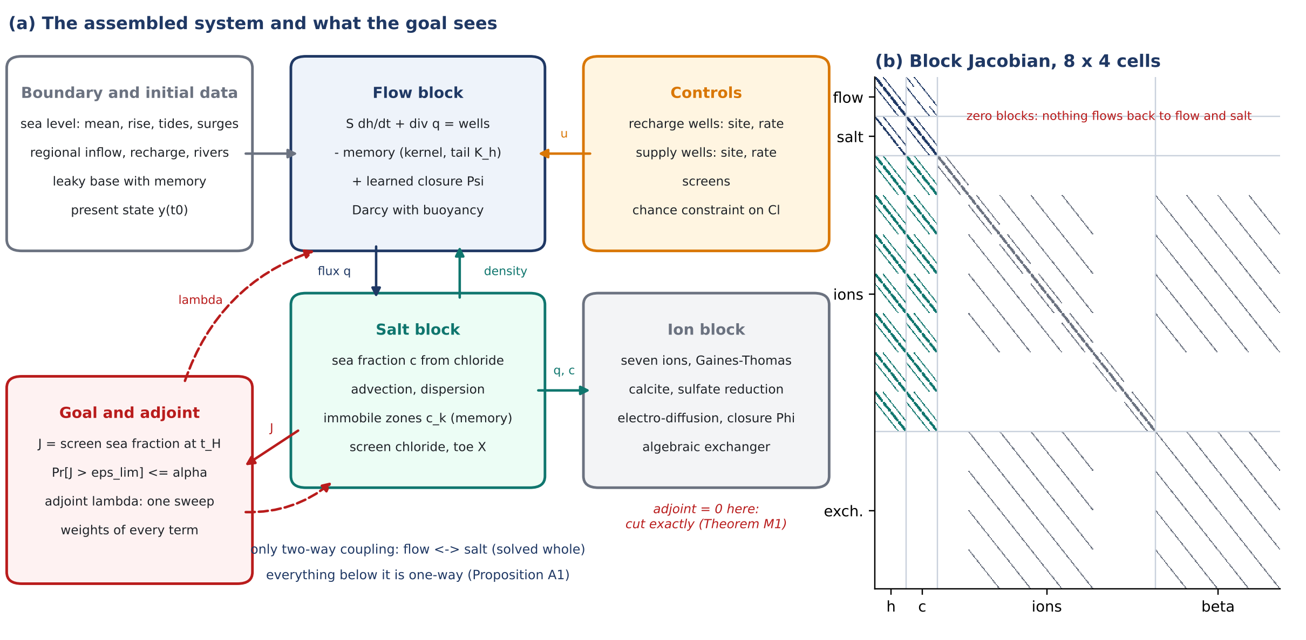
Figure 1. (a) The assembled system: boundary and initial data and the controls drive the flow block; flow and salt are coupled both ways (flux and density); the ion block is driven by them and feeds nothing back; the goal, the chloride at the supply screen, sends its adjoint back into the flow and salt blocks only. (b) The pattern of the assembled Jacobian (44) on a grid of 8 × 4 cells: flow–salt block (dark), ion and exchanger blocks (grey) below it, and the empty blocks above them that make the system block lower-triangular (Proposition A1).
3.4 Two clocks, and why the flow–salt block is solved whole
Heads diffuse with $D_{h}=T/S≈2×{10}^{7}$ m²/d and feel a pumping change kilometres away within a day; salt moves kilometres in decades. The ratio of the two clocks is about ${10}^{−5}$ [4], which suggests solving the flow and the salt one after the other, with the density lagged by a step. The test shows that this split, though consistent, is not harmless for the goal. Picard iteration between the two blocks did not converge at half-year steps (the change of the sea fraction between successive iterations grew from 6×10⁻² after the first to 3×10⁻¹ after thirty), while Newton on the whole block converged quadratically. The one-pass split approached the coupled value of the screen sea fraction only as the step was cut: it was 24%, 16%, 10%, 2% below the coupled value at steps of 1, 0.5, 0.25, 0.125 years, while the coupled value itself changed by at most 0.7% over the same steps. The flow–salt block is therefore solved whole, as in the monolithic solvers of [28, 29], and Section 5 lets the goal confirm that choice.
3.5 The reductions of the series as cuts of the assembly
Table 3. The models computed in the series are cuts of the assembled system. ASSEMBLY-GO chooses the cut by the goal instead of by habit.
Model of the series | Blocks kept | Blocks cut or frozen | Exact for
R1: areal steady flow with the Ghyben–Herzberg test [1] | flow (steady, depth-integrated) | salt, memory, ions; interface from the head | head-based questions at steady pumping
R2: Strack potential with a Gaussian mixing zone [5] | flow (steady), sharp interface + mixing width | salt transport, memory, ions | steady screen chloride, threshold form of P1–P2 [6]
R3: vertical variable-density section (this test, Section 6) | flow, salt, memory, immobile zones, ions | the third dimension | transients of a cross-section
R4: seven-ion flow line [2, 3] | salt, ions, exchange, memory | flow (prescribed velocity history) | chemistry along a flow path
Toe relaxation law (24) [7] | one ODE for X | everything else | the toe, slowly varying forcing

4. The final goal: placing recharge and pumping wells
4.1 Decisions, goal and constraint
The decision is where to put recharge wells and supply wells, how much to inject and pump and how to screen, within the constraints of the series (spacing, exclusion around supply wells, budget; (50) of [6]):
u=zR,zS,q,Q,L∈U, U=xk−xl≥dmin, xr−xw≥dex, j​cjzj≤B | (47)
where $z^{R}$, $z^{S}$ are binary site indicators over the candidate sets, $q$, $Q$ the recharge and pumping rates and $L$ the screens; $c_{j}$ are costs and $B$ the budget.
The goal of every supply well is the screen chloride (11) at the end of the planning horizon $t_{H}$; following WELL-GO [6], chloride is the standard that binds, and sodium is checked afterwards (Proposition P3 there):
$$J_{w}\left(u;θ\right)={\overline{c}}_{w}\left(t_{H};u,θ\right)=w_{w}^{⊤}c\left(t_{H}\right), \text{event} \max_{w}J_{w}>ε_{lim}$$ | (48)
where $w_{w}$ averages the cell values over the screen of well $w$ (interpolated linearly to $x_{w}$, so that every grid computes the same functional).
maxu∈U w​vxwQw−λRr​qr s.t. PrθmaxwJwu;θ>εlim≤α, My=Fy;θ,b,u, 0=gy | (49)
where $v\left(x_{w}\right)$ is the value of a cubic metre pumped at $x_{w}$, net of conveyance to the demand at the coast, and $λ_{R}$ the price of recharged water. The problem is mixed-integer (the sites), chance-constrained (the posterior of $θ$) and constrained by the assembled system [30–32]. At scale it can be solved with learned constraints inside a mixed-integer program [33], learned neighbourhood search [34] or Bayesian optimisation over mixed spaces [35], with the sites fixed first and the rates as recourse [36]; with a few candidate sites, as in the test, it is enumerated.
$$\frac{1}{N_{θ}}\sum_{i=1}^{N_{θ}}{1}\left\{\max_{w}J_{w}\left(u;θ_{i}\right)>ε_{lim}\right\}≤α$$ | (50)
where the sample-average form over $N_{θ}$ posterior draws, which is what is solved.
Proposition G1 (the safe yield of a layout is a quantile). Fix the sites and the recharge of a layout $ℓ$ and let $J\left(ℓ,Q;θ\right)$ be nondecreasing in the pumping $Q$ for every $θ$. Define the critical rate $Q_{c}\left(ℓ;θ\right)=sup \left\{Q≥0:J\left(ℓ,Q;θ\right)≤ε_{lim}\right\}$. Then the largest $Q$ that satisfies (50) is the order statistic
$$Q^{⋆}\left(ℓ\right)=Q_{c,\left(m\right)}\left(ℓ\right), m=\left\lfloor αN_{θ}\right\rfloor +1$$ | (51)
where the $m$-th smallest of the critical rates of the draws, and the placement problem becomes a choice among layouts of the value $v Q^{⋆}\left(ℓ\right)−λ_{R}q\left(ℓ\right)$.
Proof. By monotonicity $J\left(ℓ,Q;θ_{i}\right)>ε_{lim}$ if and only if $Q>Q_{c}\left(ℓ;θ_{i}\right)$, so the left side of (50) is the fraction of draws with $Q_{c}<Q$; it is at most $α$ exactly for $Q≤Q_{c,\left(m\right)}$. □
Monotonicity holds in every run of the test (more pumping never freshened a screen within the horizon). It reduces the chance constraint to one root-finding per draw and layout, each a few forward runs of the assembled system.
Remark G2 (on the draws and beyond them). Constraint (50) holds on the draws used. For a new draw exchangeable with them, and without ties, the probability that its critical rate falls below Q_c,(m) is m/(N_θ + 1): 3/26 = 11.5% for N_θ = 25 and α = 10%, slightly above α. Taking m = ⌊α(N_θ + 1)⌋ instead keeps it at most α (2/26 = 7.7% here). A statement that holds with high probability, rather than on average over the draws, needs a binomial bound and more draws.
4.2 The adjoint of the assembled system
Gradients of the goal with respect to every rate and every candidate site, and the weights of Section 5, come from one backward sweep. With $λ_{n}$ the adjoint of step $n$ and $μ_{n}$ that of the memory states,
$$J_{n}^{⊤}λ_{n}=δ_{n,N_{t}}{\frac{∂J}{∂y_{N_{t}}}}^{​⊤}−{\left(\frac{∂R_{n+1}}{∂y_{n}}\right)}^{​⊤}λ_{n+1}+B^{⊤}μ_{n}, μ_{n−1}=α μ_{n}−{\left(\frac{∂R_{n}}{∂z_{n−1}}\right)}^{​⊤}λ_{n}$$ | (52)
where for $n=N_{t},…,1$ with $λ_{N_{t}+1}=0$, $μ_{N_{t}}=0$; $B$ and $α$ are the diagonal maps of (43); a last solve with the Jacobian of the pre-development equilibrium carries the adjoint into the initial state. $∂R_{n+1}/∂y_{n}$ contains the storage and the dependence of the dispersion coefficients on the previous fluxes.
dJdp=−n​λn⊤∂Rn∂p, dJdQw=−n​λh,n⊤ew, dJdqrx=n​λh,n−diagcnλc,n​⊤erx | (53)
where $e_{w}$, $e_{r}\left(x\right)$ distribute a unit pumping over the supply screen and a unit injection over the full thickness at the candidate $x$; one sweep gives the sensitivity of the goal to a recharge well at every column of the grid. In the test the adjoint gradients agree with central differences of the complete assembly to 8 significant digits for the pumping rate and for the recharge rate (supply well at 2.0 km, recharge well at 1.0 km, step ${10}^{−5}$). At a layout where the net seaward flux past the supply well nearly vanishes they agree to 0.3%: there some face fluxes change direction under the perturbation, and the upwind goal is only piecewise differentiable.
5. ASSEMBLY-GO: an assembly set by the placement goal
The assembled system of Section 3 is large, and the placement problem of Section 4 asks for it thousands of times: one root-finding per layout and posterior draw, each a few forecasts. Review 60 proposed to let the goal decide the assembly [12]. Four results make this concrete. The first is exact, the second and third are first-order, and the fourth moves what is left into the constraint.
Theorem M1 (exact cuts). Let the goal $J$ depend only on the flow and salt states $\left(h,c\right)$, as the screen chloride (48) does, and let the assembled Jacobians be block lower-triangular below the flow–salt block (Proposition A1). Then at every step the adjoint vanishes on every downstream block, $λ_{C,n}=0$ and $λ_{β,n}=0$. Consequently (i) $J$ and its gradient with respect to every control are the same whether or not the ions, the exchanger, the reactions and the closure $Φ$ are assembled; (ii) the weight (54) of every parameter inside those blocks (selectivities, exchange capacity, reaction rates, closure coefficients) is zero; (iii) with electro-diffusion, (i) and (ii) hold up to the relative order of the leak bound, $4×{10}^{−6}$ at Fushë-Kuqe [23].
Proof. In the adjoint recursion (52) the right-hand side has no downstream component at $n=N_{t}$, because $J$ does not depend on $\left(C,β\right)$. The transposed Jacobian $J_{n}^{⊤}$ is block upper-triangular, so its downstream rows read $J_{CC}^{⊤}λ_{C}+J_{βC}^{⊤}λ_{β}=r_{C}$ and $J_{Cβ}^{⊤}λ_{C}+J_{ββ}^{⊤}λ_{β}=r_{β}$, with an invertible diagonal block (the ion transport operator and the exchange equilibrium of index one). With $r_{C}=r_{β}=0$ the only solution is zero. The cross-step Jacobian $∂R_{n+1}/∂y_{n}$ has the same triangular structure, so the downstream right-hand side stays zero at every earlier step, by induction backwards. Statement (i) follows because the flow–salt rows of the forward system do not contain the downstream unknowns. Statement (ii) follows because a parameter $p$ of a downstream block has $∂R_{n}/∂p$ supported on downstream rows only, so $λ_{n}^{⊤}∂R_{n}/∂p=0$. Statement (iii) follows from the perturbation bound of [23]. □
The theorem is the reason the series could put a learned chemistry closure into the model without touching the chloride forecast (the "cut" of [4, 23]), here turned into a rule of assembly: for a chloride goal the ion block is computed once, after the decision, to check sodium and hardness for the chosen layout (Proposition P3 of [6]).
Proposition M2 (the goal weight of a term). Give every term $T$ of the assembly a scale $s_{T}$, with $s_{T}=1$ for the term as assembled and $s_{T}=0$ for the term removed; for the coupling, let $s_{T}$ interpolate between the same-step density and the density of the previous step. The weight of $T$ for the goal, and the first-order change of the goal when $T$ is removed, are
wT=dJdsTsT=1=−n​λn⊤∂Rn∂sT, JsT=0−JsT=1=−wT+OΔy2 | (54)
where with one forward and one adjoint run of the complete assembly for all terms at once. The rule of assembly is
$$\text{cut }T⇔\max_{\text{reference cases}}\left|w_{T}\right|<τ ε_{lim}$$ | (55)
where with $τ$ a small fraction (here 2%, i.e. $\left|w_{T}\right|<2.2×10⁻⁴$, about 5 mg/L of chloride at the screen). The weight is the derivative with respect to the scale of the term, not the residual difference at a fixed state: removing the sea-level rise at a fixed state shifts the heads of the sea face by tens of centimetres and reverses inflow and outflow there, while the actual change of the goal is nil because the whole head field rises with the sea.
Proof. $J$ is a function of $s_{T}$ through the solution of $R_{n}\left(y;s_{T}\right)=0$; differentiating the constraints and using (52) gives dJ/dsT=−n​λn⊤∂Rn/∂sT [37, 38]. Taylor's theorem in $s_{T}$ gives the remainder. □
Proposition M3 (a mesh graded by the goal). Let $y_{H}$ be the solution of the assembly on a coarse mesh and $Iy_{H}$ its interpolation to the complete mesh $h$. The dual-weighted residual estimates the error of the goal and gives a cell-wise indicator [39]:
JhIyH−Jhyh≈n​λn⊤RnIyH, ηj=n​i∈column j​λn,i Rn,iIyH | (56)
where the column indicator $η_{j}$ is summed over the reference cases. The goal-graded mesh equidistributes ${\left(η_{j}/Δx_{j}\right)}^{1/3}$ over the same number of columns as the uniform coarse mesh, with a cap on the widest column.
The estimate itself is only first order and, for a goal that sits in the tail of a sharp front, it was not reliable in the test (Section 6.3); learned conservative fluxes are one way to keep such fronts sharp on coarse cells [40]. ASSEMBLY-GO therefore uses the indicator only to rank where the mesh matters, and does not rely on the estimate; the remaining error is calibrated by Proposition M4.
Proposition M4 (the error of the cheap assembly moves into the constraint). Let $A$ be the cheap assembly and $F$ the complete one. Draw $C$ calibration cases $\left(ℓ_{i},θ_{i}\right)$ like the decision cases, compute $r_{i}=Q_{c}^{A}\left(ℓ_{i};θ_{i}\right)−Q_{c}^{F}\left(ℓ_{i};θ_{i}\right)$, and let $m_{β}$ be the $⌈\left(1−β\right)\left(C+1\right)⌉$-th smallest $r_{i}$. Solve the placement on $A$ with the critical rates lowered by $m_{β}$:
$$Q_{A,β}^{⋆}\left(ℓ\right)={\left[Q_{c,\left(m\right)}^{A}\left(ℓ\right)−m_{β}\right]}_{\text{+}}, Pr\left[J_{F}\left(ℓ,Q_{A,β}^{⋆}\left(ℓ\right);θ\right)>ε_{lim}\right]≤α+β$$ | (57)
where for a new draw $θ$ exchangeable with the calibration cases, up to the sampling error of the draws.
Proof. If the case is exchangeable with the calibration cases, $Pr\left[r>m_{β}\right]≤β$ by the rank argument of split conformal prediction [41, 42]. On $\{r≤m_{β}\}$ we have $Q_{c}^{F}≥Q_{c}^{A}−m_{β}$, so exceeding the standard on $F$ at $Q_{A,β}^{⋆}$ implies $Q_{c}^{A}−m_{β}<Q_{A,β}^{⋆}$, i.e. $Q_{c}^{A}<Q_{c,\left(m\right)}^{A}$, which has probability at most $α$ (Proposition G1). A union bound gives $α+β$. □
The procedure. (1) Choose a few reference cases: layouts at their critical rates on the complete assembly. (2) For each, one forward and one adjoint run of the complete assembly give the weights of all terms, the gradients with respect to every rate and every recharge site, and the mesh indicator. (3) Cut the downstream blocks (Theorem M1) and the terms below the tolerance; keep the rest; grade the mesh. (4) Run $C$ calibration cases on both assemblies and compute the margin. (5) Solve the placement on the cheap assembly with the margin. (6) Run the complete assembly, ions included, once for the chosen layout: chloride against the margin, sodium and hardness against Proposition P3 of [6]. The cheap assembly can be replaced or completed by a neural-operator surrogate trained on runs of the assembly [43, 44], or differentiated end to end for gradient-based placement [45]; the margin of Proposition M4 applies to either, and the decision should then be operated and revalidated as in field practice for injection wells [46].
6. The test
6.1 The aquifer, the history and the decision
The test assembles the system on a vertical section of a confined coastal aquifer, the reduction R3 of Table 3. It is 4 km long and 60 m thick, its top is 10 m below sea level, and it has silt and clay lenses with hydraulic memory, immobile zones, and the ion block with exchange. The parameters are those of Fushë-Kuqe where the series has them (Table 4). The present state is made as at the field site, where the coastal screens salinised under pumping [47]: from the pre-development equilibrium, 50 years of pumping 4 m²/d per metre of coast from a well field 1.5 km from the coast. At the end of the history its screen delivers 364 mg/L of chloride in the median aquifer and the toe has moved from 349 m to 1070 m. The decision is where to put the new supply well (2.0, 2.5, 3.0 or 3.5 km from the coast), where to put one recharge well injecting 1 m²/d of fresh water (none, 0.5, 1.0, 1.5 km, the old well field, 2.0, 2.5 or 3.0 km), and how much to pump, so that the probability that the supply screen exceeds 250 mg/L at the end of a 30-year horizon is at most 10%: 25 layouts.
Table 4. The test bed. $ξ$ denotes independent standard normal variables.
Quantity | Value or prior | Source
Grid of the complete assembly | 120 × 20 cells (33 m × 3 m); half-year steps | this note
Conductivity $K$, anisotropy, porosity | $100 e^{0.25ξ}$ m/d (T ≈ 4,700–7,700 m²/d), $K_{z}/K=0.1$, $n=0.25$ | complete-system note, Table 2
Specific storage; lens capacities and rates | $5×{10}^{−6}$ 1/m; $s_{k}=2×{10}^{−5}$, $5×{10}^{−5}$ 1/m; $a_{k}=1$, 0.05 yr⁻¹ | reviews 43–45 (rates); this note
Immobile zones | $b_{1}=0.3$, $b_{2}∼U\left(0.3,0.9\right)$; $a_{1}=1$, $a_{2}=0.05$ yr⁻¹ | RHYTHM-GO
Dispersivities | $α_{L}=20 e^{0.4ξ}$ m, $α_{T}=α_{L}/10$ | chloride study (10 m, 1 m) widened
Regional fresh inflow | $4 e^{0.2ξ}$ m²/d per metre of coast | recharge 0.5 mm/d over about 8 km
Sea-level rise | $N\left(4,2^{2}\right)$ mm/yr | BOUNDARY-GO
Density contrast; end-members; standards | 0.025; well 193 and Adriatic water; Cl 250, Na 200 mg/L | complete-system note
Exchange | E = 60 meq/L; selectivities 0.2, 0.4, 0.5 | TRACE-GO
Draws | 25 design draws (the cheap assemblies choose; 10 for the two counter-examples), 25 evaluation draws (the complete assembly judges) and 40 calibration cases for the margin (16 for the counter-examples) | this note

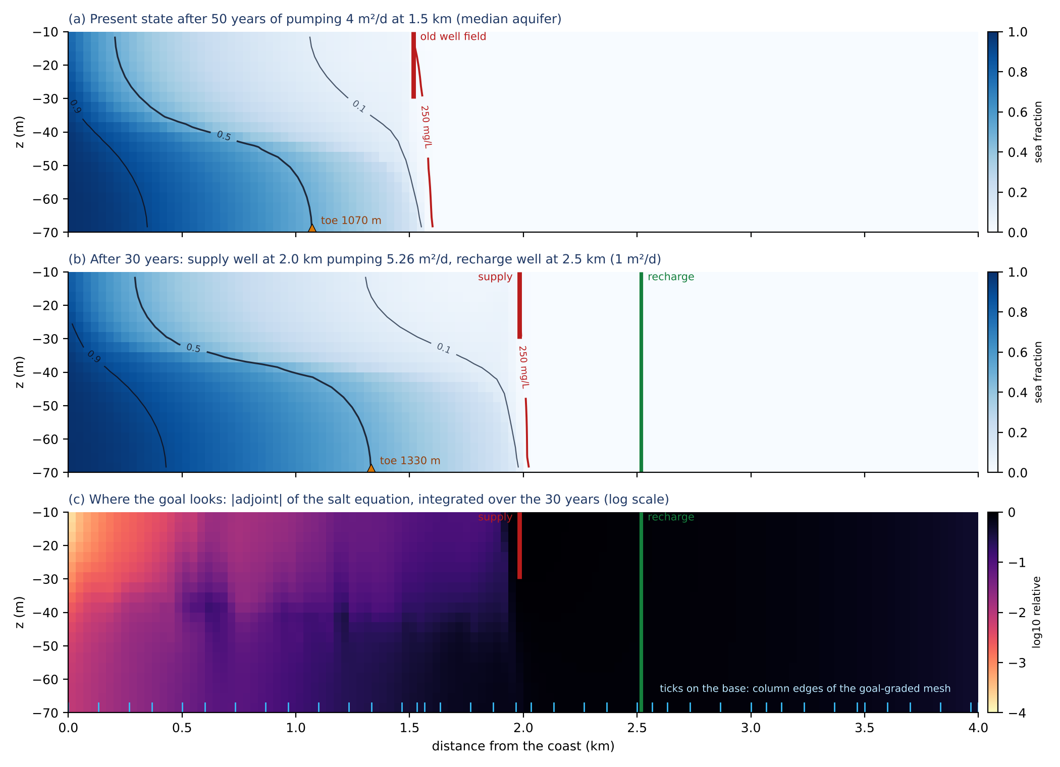
Figure 2. The test bed with the median parameters. (a) The present state after the 50-year history: the old screen at 1.5 km delivers 364 mg/L of chloride; the toe (triangle) is at 1070 m, against 349 m before development. (b) Thirty years later with a supply well at 2.0 km pumping 5.26 m²/d per metre of coast, its critical rate, and a recharge well at 2.5 km; the red line is the 250 mg/L contour, which touches the bottom of the screen; the toe has moved to 1330 m. (c) Where the goal looks: the adjoint of the salt equation for the screen chloride, integrated over the 30 years. The ticks on the base are the column edges of the goal-graded mesh.
6.2 What the goal kept and what it cut
Table 5 and Figure 3 give the weights of the eight terms at four reference cases, each a layout at its critical rate on the complete assembly, so that the screen sits exactly at 250 mg/L: S2.0-R2.5, S2.5, S3.0-R1.5, S3.5-R1.0 (S: supply well, R: recharge well, km from the coast). One forward and one adjoint run of the complete assembly took 11 s and about 4 s per case. The hydraulic memory of the lenses and the sea-level rise weigh at most 2.1×10⁻⁵, a five-hundredth of the limit. The lenses release stored water slowly, but at these capacities they change the head at the screen by millimetres. The rise lifts the whole head field with the sea and moves almost no water. The rule cut all three; removing them changed the goal by at most 2.1×10⁻⁵, as predicted to within 25%, and to within 1% in three of the four cases. The immobile zones, transverse dispersion and buoyancy weigh 6.3×10⁻³ to 2.6×10⁻², between half and twice the limit itself: they set the width and the speed of the mixing zone that reaches the screen. A 10% reduction of the immobile capacities or of the transverse dispersivity was predicted to within 8%. The same-step coupling weighs 3.0×10⁻³ to 6.6×10⁻³ and was kept. For this term the first-order number only says that it matters: the goal is not monotone in the lag (it rose by 5.5×10⁻⁵ for 1% of lag and by 7.5×10⁻⁴ for 20% in a separate check), and the full one-pass split moved it by -4.3×10⁻³ to -1.9×10⁻³, in the opposite direction to the first-order value.
Table 5. Goal weights $w_{T}$ of (54) over the four reference cases (sea fraction at the screen per unit scale of the term; the limit is $ε_{lim}=0.0109$ and the tolerance $τε_{lim}=2.2×10⁻⁴$). Check: the change of the goal predicted from the weight against the change computed by running the complete assembly without the term (cut terms), with the term reduced by 10% (kept terms), or with the one-pass split.
Term | Weight $w_{T}$ (range over 4 cases) | Check: predicted / actual change | Decision
Hydraulic memory, silt lenses | 6.6×10⁻⁷ – 9.6×10⁻⁶ | removed: 9.6×10⁻⁶ / 9.6×10⁻⁶ (largest) | cut
Hydraulic memory, clay lenses | 7.8×10⁻⁶ – 2.1×10⁻⁵ | removed: 2.1×10⁻⁵ / 2.1×10⁻⁵ (largest) | cut
Immobile zone, silt | 6.3×10⁻³ – 1.4×10⁻² | −10%: 6.3×10⁻⁴ / 6.2×10⁻⁴ (first case) | kept
Immobile zone, clay | 1.0×10⁻² – 1.2×10⁻² | −10%: 1.1×10⁻³ / 1.1×10⁻³ (first case) | kept
Transverse dispersion | 7.5×10⁻³ – 1.3×10⁻² | −10%: 1.3×10⁻³ / 1.4×10⁻³ (first case) | kept
Sea-level rise | 3.6×10⁻⁶ – 6.8×10⁻⁶ | removed: 6.8×10⁻⁶ / 7.7×10⁻⁶ (largest) | cut
Buoyancy (density coupling) | 9.8×10⁻³ – 2.6×10⁻² | δ −10%: -2.6×10⁻³ / -3.8×10⁻³ (first case; δ also enters the sea face) | kept
Same-step flow–salt coupling | 3.0×10⁻³ – 6.6×10⁻³ | one-pass split: -3.0×10⁻³… / -4.3×10⁻³ to -1.9×10⁻³ | kept

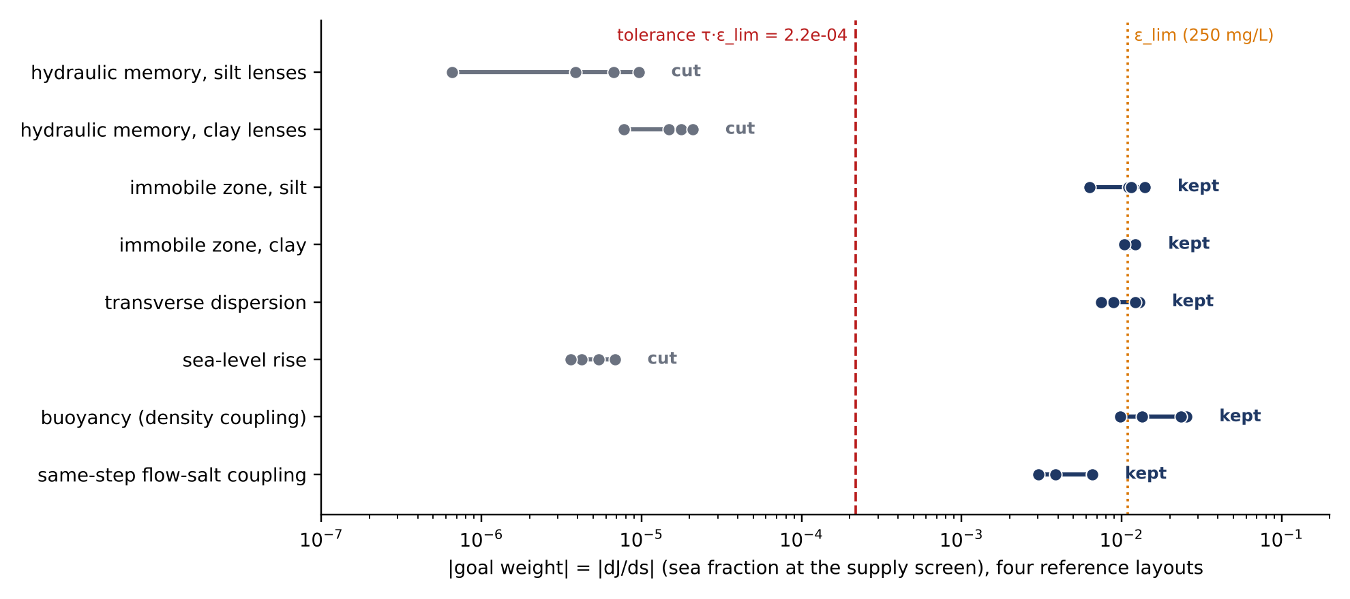
Figure 3. The goal weights of every term of the assembly, four reference layouts (dots). Grey terms lie three orders of magnitude below the tolerance (dashed) and are cut; dark terms lie near the limit itself (dotted) and are kept. The ion block is not shown: its weight is zero by Theorem M1.
The learned closure $Ψ$ is zero in the test, but its weight shows where dynamics missing from the model would matter for the decision. A missing source equal to 10 mm/yr of recharge spread over a 500-m band changes the screen sea fraction by at most 2.8×10⁻⁵ in the band at the coast and by up to 7.6×10⁻⁴ (7% of the limit) in the bands landward of the supply well, where every litre of fresh water passes the well. The closure, and the data that identify it, are therefore worth most for the inland water balance, not at the coast.
6.3 The mesh
The indicator (56), summed over the four reference cases, is largest where the supply screens draw water through the mixing zone (Figure 2c). The goal-graded mesh puts columns of 33–67 m at the candidate supply sites and at the old well field and columns of 100–133 m elsewhere (39 columns; the uniform coarse mesh has 40 columns of 100 m). Table 6 compares, on the four reference cases and eight further cases with random layouts and draws, the error of each coarse assembly in the goal with its dual-weighted estimate. Both coarse meshes overestimate the screen sea fraction, because a coarse cell smears the mixing zone upward. The goal-graded mesh does so on every case by 6.0×10⁻³ to 1.3×10⁻², and its estimate has the right sign and order on every case (ratio of estimate to error 0.40–0.87). The uniform mesh errs by anywhere between 2.4×10⁻³ and 1.8×10⁻², depending on where the supply well falls relative to its columns, and its estimate has the wrong sign in 6 of 12 cases. The goal-graded mesh is therefore not always the more accurate, but its error is the more predictable, which is what Proposition M4 needs.
Table 6. Error of the coarse assemblies in the goal (screen sea fraction, limit 0.0109) at the critical rate of the complete assembly, against the dual-weighted-residual estimate (56). Uniform: 40 columns of 100 m; goal-graded: 39 columns of 33–133 m. Same physics as the complete assembly.
Case | True error, uniform | Estimate, uniform | True error, goal-graded | Estimate, goal-graded
reference: S2.0-R2.5, Q = 5.26 | 2.36×10⁻³ | -2.02×10⁻² | 1.28×10⁻² | 5.32×10⁻³
reference: S2.5, Q = 5.12 | 1.53×10⁻² | 8.45×10⁻³ | 1.05×10⁻² | 6.08×10⁻³
reference: S3.0-R1.5, Q = 6.20 | 1.21×10⁻² | 1.06×10⁻² | 9.04×10⁻³ | 7.84×10⁻³
reference: S3.5-R1.0, Q = 6.74 | 2.69×10⁻³ | -4.65×10⁻³ | 5.98×10⁻³ | 4.63×10⁻³
random: S3.5-R2.0, Q = 10.28 | 3.99×10⁻³ | -2.42×10⁻³ | 8.43×10⁻³ | 6.22×10⁻³
random: S3.5-R1.0, Q = 9.02 | 2.77×10⁻³ | -3.93×10⁻³ | 7.39×10⁻³ | 5.76×10⁻³
random: S2.0-R3.0, Q = 3.84 | 3.47×10⁻³ | -1.67×10⁻² | 1.11×10⁻² | 4.48×10⁻³
random: S3.5, Q = 6.62 | 3.49×10⁻³ | -4.51×10⁻³ | 7.48×10⁻³ | 5.85×10⁻³
random: S3.0, Q = 4.46 | 1.20×10⁻² | 1.11×10⁻² | 8.11×10⁻³ | 6.95×10⁻³
random: S2.5-R3.0, Q = 7.21 | 1.81×10⁻² | 8.09×10⁻³ | 1.28×10⁻² | 7.18×10⁻³
random: S3.0-R0.5, Q = 3.95 | 1.13×10⁻² | 9.92×10⁻³ | 7.03×10⁻³ | 5.23×10⁻³
random: S3.0-R2.5, Q = 6.94 | 1.04×10⁻² | 9.88×10⁻³ | 8.16×10⁻³ | 6.23×10⁻³

6.4 Placing the wells
Every assembly solves the placement problem (49) the same way. For each of the 25 layouts and each draw it finds the critical rate by a bracketed secant on the logarithm of the goal (Proposition G1; 5.5 forecasts per root on average). It takes the safe yield as the order statistic (51) at $α=10\%$, and chooses the layout of largest value $v\left(x_{s}\right)Q^{⋆}−λ_{R}q_{r}$. The value counts water at the supply well less 0.2 per km of conveyance beyond 2 km, and recharged water at 0.5 of its value. The complete assembly does this on 25 evaluation draws and acts as the referee. The cheap assemblies do it on separate design draws (25 for the goal-guided and uniform assemblies, 10 for the two counter-examples), with and without the calibrated margin of Proposition M4 estimated from 40 calibration cases (16 for the two counter-examples). The full assembly needed 15 minutes per draw for all layouts.
Table 7. The placement on each assembly. Layout chosen by the value $v\left(x_{s}\right)Q^{⋆}−λ_{R}q_{r}$ with $v=1−0.2 \left(x_{s}−2 km\right)/km$ and $λ_{R}=0.5$; safe rate in m² per day per metre of coast; risk: fraction of the 25 evaluation draws of the complete assembly on which the screen exceeds 250 mg/L at that layout and rate (target 10%; 1 of 25 draws is 4%, 95% interval 0.1–20%, and 2 of 25 is 8%, 1–26%; guarantee 10% + β with β = 10%). Cost: median wall time of one 30-year forecast.
Assembly | Layout chosen | Safe rate (m²/d) | Risk on the complete assembly | Cost of one forecast
Complete assembly (referee, 25 evaluation draws) | S3.5-R3.0 | 6.36 | ≤ 10% on its own 25 draws; 11.5% expected on a new draw (Remark G2) | 3.9 s
goal-guided (ASSEMBLY-GO), 25 design draws, no margin | S3.5-R3.0 | 5.80 | 4% | 1.6 s (2.5× faster)
… with calibrated margin m = −0.15 m²/d | S3.5-R3.0 | 5.95 | 8%
uniform coarse mesh, same terms, 25 design draws, no margin | S3.5-R3.0 | 5.90 | 4% | 1.7 s (2.3× faster)
… with calibrated margin m = −0.08 m²/d | S3.5-R3.0 | 5.98 | 8%
goal mesh, density lagged one step, 10 design draws, no margin | S2.5-R3.0 | 5.16 | 20% | 0.2 s (17.8× faster)
… with calibrated margin m = −0.001 m²/d | S2.5-R3.0 | 5.16 | 20%
goal mesh, immobile zones removed, 10 design draws, no margin | S2.5-R3.0 | 4.39 | 4% | 1.8 s (2.3× faster)
… with calibrated margin m = −0.38 m²/d | S2.5-R3.0 | 4.77 | 8%

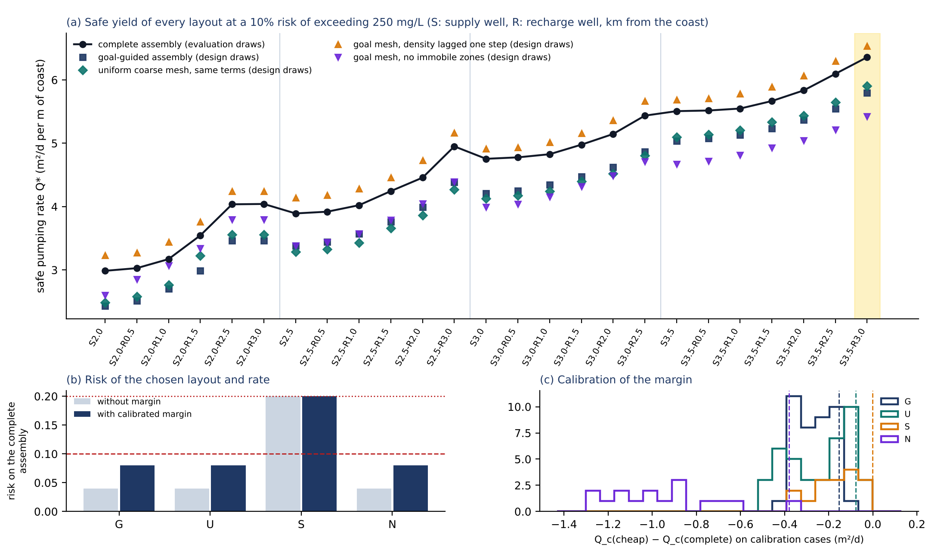
Figure 4. (a) Safe pumping rate $Q^{⋆}$ of every layout on the complete assembly (black, evaluation draws) and on the cheap assemblies (design draws, no margin); the layout chosen by the complete assembly is shaded. (b) Risk of the layout and rate each cheap assembly chooses, judged on the complete assembly, without and with the calibrated margin; dashed: $α=10\%$, dotted: $α+β$. (c) Calibration residuals $Q_{c}^{cheap}−Q_{c}^{complete}$ and the margins (dashed).
Both coarse assemblies are conservative: they overestimate the screen sea fraction (Table 6), so their safe rates lie below those of the complete assembly at 25 and 25 of the 25 layouts, by 0.51 m²/d on average for the goal-guided assembly and 0.51 m²/d for the uniform one. Yet they rank the 25 layouts almost exactly as the complete assembly does (rank correlation 0.997 and 0.999). Without a margin the goal-guided assembly chooses safely but gives water away. It chooses the supply well at 3.5 km and recharge well at 3.0 km at 5.80 m²/d, with a risk of 4% on the complete assembly; the complete assembly would allow 6.36 m²/d at that layout. The calibrated margins are negative: −0.15 m²/d for the goal-guided and −0.08 m²/d for the uniform assembly. A negative margin returns the water that the conservative bias withholds, and the guarantee of Proposition M4 still holds. With its margin the goal-guided assembly chooses the supply well at 3.5 km and recharge well at 3.0 km at 5.95 m²/d, with a risk of 8% on the complete assembly. The uniform assembly chooses the supply well at 3.5 km and recharge well at 3.0 km at 5.98 m²/d, with a risk of 8%. These risks rest on 25 evaluation draws: 1 of 25 (4%) has a 95% interval of 0.1–20% and 2 of 25 (8%) of 1–26%. They show that no assembly fails badly, not that the 10% target is met; the guarantee of Proposition M4 is 10% + β = 20%, and a few hundred evaluation draws of the chosen layouts would be needed to show the target itself. The complete assembly itself chooses the supply well at 3.5 km and recharge well at 3.0 km at 6.36 m²/d. The goal-guided assembly chooses the complete assembly's own best layout. Over conveyance prices from 0 to 0.4 per km, the goal-guided assembly with its margin chooses the complete assembly's layout for 4 of 5 prices and loses at most 0.1% of the value elsewhere. The two counter-examples remove a term the goal kept, on the same 10 design draws, so they can be compared with each other. Lagging the density one step (S) removes the conservative bias of the goal mesh: the 90% calibration residual is −0.001 m²/d against −0.15 for the goal-guided assembly, so the lag raises the critical rates by about 0.15 m²/d, in the direction of the one-pass split error of Section 3.4. With nothing left to cover the sampling error of 10 draws, its choice, the supply well at 2.5 km and recharge well at 3.0 km at 5.16 m²/d, exceeds the standard in 20% of the evaluation draws of the complete assembly, 2.0 times the risk allowed, with or without its margin. Without the immobile zones (N) the assembly is conservative by at least 0.38 m²/d in nine calibration cases of ten; that covers the same sampling error (risk 4% without the margin, 8% with it), but it chooses the supply well at 2.5 km and recharge well at 3.0 km and gives up 0.7% of the value. Part of both risks comes from having only 10 design draws; the difference between the two, on the same draws, is the effect of the term removed. One 30-year forecast took 3.9 s on the complete assembly and 1.6 s on the goal-guided one, 2.5 times less; the whole placement (all layouts, all draws) took 6.1 CPU-hours on the complete assembly and 1.9 on the goal-guided one.
6.5 The toe
The toe moves as (23) says, and the relaxation law (24) describes it. Fitted to each of the 75 forecasts of the complete assembly (three layouts at their safe rates, 25 evaluation draws), with the head at mid-depth 0.5 km from the coast as the driver, it reproduces the toe over 30 years with a median largest error of 1.2 and 0.8 m for 2 of the 3 layouts, and of 20 m for the layout where the toe hardly moves (median displacement 4 m), so that there is little to fit. The median relaxation time is 7–12 years and the median $γ$ is 556–1191 m per m of head (BOUNDARY-GO assumed 8 years and 1,000 m). As a proxy for the goal the toe does better here than the sharp-interface picture suggests: a threshold on the toe position, tuned to flag as many aquifers as actually exceed 250 mg/L at the screen, catches 6 of the 7 exceedances of the three layouts. With 7 events this is thin evidence, and the toe explains only part of the variation of the screen sea fraction (correlation 0.51–0.67). The inequality (25) says why the toe cannot replace the screen: the screen meets sea water through the mixing zone and the upconing below the well, long before a sharp-interface toe would reach nine times the distance of the well, so a toe criterion must be calibrated against the screen, layout by layout.
6.6 The ions, computed once
For the first reference layout at its critical rate, the complete assembly was run again with the seven-ion block and Gaines–Thomas exchange (E = 60 meq/L) through the whole history and forecast. The goal was identical to the last digit, as Theorem M1 says. The chloride computed by the ion block agrees with the chloride of the salt block within 3.0×10⁻³ mg/L. The ion block cost 1 s of the 13 s of that run (11%). The check it is kept for is sodium. At the screen it is 125 mg/L at the end of the horizon, when chloride is 250 mg/L: below 200 mg/L, as Proposition P3 of [6] predicts for intrusion with sodium taken up by the exchanger. Hardness at the screen is 6.30 meq/L against 3.65 for the recharge water. Behind the recharge well, 100 m landward at mid-depth, the water carries 18 mg/L of sodium and 13 mg/L of chloride.
6.7 One adjoint ranks the recharge sites
The adjoint sweep of each reference case also gives the sensitivity of the screen chloride to a small recharge well at every column (53). Ranking the candidate recharge sites by this marginal value, from one forward and one adjoint run, and comparing with the ranking by the safe yield of the complete assembly with a 1 m²/d recharge well at each site (25 draws and some 685 forecasts per supply site), the rank correlation is 0.90, 1.00, 1.00, 1.00 for the supply wells at 2.0, 2.5, 3.0, 3.5 km, and the best site is the same in 3 of 4 cases. The adjoint puts the largest marginal value of recharge landward of the supply well in 2 of 4 cases.
7. For Fushë-Kuqe: the recipe, and the limits
- Assemble flow and salt as one block, solved by Newton with the exact Jacobian; at Fushë-Kuqe the density coupling and the immobile zones of the silt and clay are not optional for a chloride goal (weights near the limit itself), while the hydraulic memory of the lenses can wait until a goal on heads or on the clay piezometers needs it.
- State the goal before the model: the chloride in the screens of the supply wells of the Gorre–Fushë-Kuqe field at the planning horizon, with the risk $α$ the utility accepts. One forward and one adjoint run of the complete three-dimensional system at a few reference layouts then give the weights of every term and the sensitivity to recharge at every candidate site.
- Cut the chemistry for the decision, not for the check: the seven ions, the exchanger and the learned chemistry closure do not change the chloride goal (Theorem M1) and are run once for the chosen layout, to check sodium (Proposition P3 of the complete-system note) and the softened water behind recharge wells.
- Calibrate the cheap model against the complete one with a few dozen paired runs and put the margin into the chance constraint; a coarse model that is consistently conservative gets its water back, one whose error changes sign does not.
- Rank the candidate recharge sites by one adjoint run before running any placement; on the test it agreed with the complete placement in 3 of 4 cases.
- Watch the placed wells with an alarm built for the new pumping: a head-based chloride alarm learned before the decision is valid after it only if the decision is corrected through the recorded pumping and an unrecorded change of climate is certified [48].
- Measure what the weights point to: the inland water balance, which carries the largest weight of a missing source, and chloride profiles through the transition zone near the supply screens, which set the mixing width that decides the standard.
The limits of the test are those of a cross-section. The section is two-dimensional, so wells are lines along the coast and rates are per metre of coast; the Peaceman correction, rivers, the lagoon and a leaky base are in the assembly but not in the test. The parameters follow the Fushë-Kuqe values of the series, but the aquifer is synthetic and its present state comes from an assumed pumping history, not from assimilated data. The chance constraint was judged on 25 evaluation draws, so the realised risks are resolved to about 4%. The safe yield is an order statistic, which controls the risk on the draws used; a certificate at confidence $1−δ$ in the Learn-then-Test sense would allow no exceedance among 25 draws at $δ=10\%$, lowering the value of the chosen layout by 11.6%, and none could be issued at $δ=5\%$ [48]. The conformal margin assumes that the decision cases are exchangeable with the calibration cases, which the selection of the best layout breaks mildly. The first-order weights are reliable for the terms that are cut and for small changes of the terms that are kept, but not for the full one-pass split, whose effect is not monotone in the lag. The dual-weighted estimate was not reliable on the uniform mesh, and the upwind goal is only piecewise differentiable where flow reverses. The prices of conveyance and recharge are illustrative. The sea-level rise was cut because the inland boundary of the section fixes the fresh inflow, so the whole head field rises with the sea and almost no water moves [49]. Where drains or a low land surface cap the water table, as on the plain of Durrës, where subsidence adds to the rise, or where pumping holds the heads below sea level, the rise steepens the gradients towards the wells and can move the wedge inland [49, 50]. The cut is therefore a property of this goal, this boundary and this horizon, not of the coast: in the three-dimensional model the relative sea level measured at each wellfield (InSAR and GNSS) stays in the assembly until its weight has been recomputed there. In the same way the sea fraction is read from chloride, which is right only where all the chloride is seawater; where it may also come from a drought that concentrates the recharge or from irrigation return flow, the ions that Theorem M1 cuts (Br/Cl, Na/Cl, nitrate, boron) carry the evidence about the source, and the placement must hold for every source that tracers cannot exclude [51]. The next step is the same procedure on the three-dimensional Fushë-Kuqe sector, with the present state from the assimilation of the chloride series of 1984–2001.
8. The system at a glance
Table 8. The assembled system at a glance, and what the placement goal needs of each block.
Block | Equations | Assembled in the test | For the chloride goal
Flow with storage and wells | (1), (4), (26) | yes (monolithic with salt) | kept
Memory of the lenses (kernel, tail, lift) | (2), (3) | yes | cut (weight below 2×10⁻⁵)
Learned closure Ψ | (6) | zero | sensitivity mapped (Section 6.2)
Density and buoyancy | (5) | yes | kept
Salt with immobile zones and dispersion | (7)–(10) | yes | kept
Screen chloride and the standard | (11), (12) | yes (the goal) | goal
Seven ions, exchange, reactions, Φ | (13)–(21) | yes, once (Section 6.6) | cut exactly (Theorem M1); checked after
Electro-diffusion | (18) | no | cut (leak bound 4 × 10⁻⁶)
Toe and its mobility | (22)–(25) | diagnostic | not a goal (Section 6.5)
Sea boundary, sea-level rise, tides | (29), (30) | hydrostatic sea, rise | rise cut for this horizon (weight below 10⁻⁵)
Land, recharge, rivers, base | (31), (32) | regional inflow; closed top and base | kept (inflow); others not in the test
Initial state | (33)–(35) | pre-development + 50-year history | kept
Placement problem and adjoint | (47)–(53) | yes | the final goal

Prepared on 27 October 2026 from the code and results of the ASSEMBLY-GO experiment in the author's repository (stages 0–5 and the analysis); every number about the test is read from the results of the ASSEMBLY-GO experiment and checked when the document is built. The references of other authors were checked against Crossref, the Official Journal or library catalogues (the eleven formerly marked "not verified" on 8 November 2026); the notes of the author's series ([2]–[12], [22], [23], [48], [51]) are unpublished and available from the author.
References
[1] Zeqiraj, D. (2026). Goal-oriented Bayesian experimental design for variable-density seawater intrusion: adjoint expected information gain for joint monitoring and managed-aquifer-recharge placement. Journal of Hydrology, 680, 136559. https://doi.org/10.1016/j.jhydrol.2026.136559
[2] Zeqiraj, D. (2026). Missing dynamics in coastal-aquifer flow and multi-species transport: 30 papers for a COST candidate system of equations. Literature review 42 of the author's series (23 October 2026), with the numerical experiment TRACE-GO.
[3] Zeqiraj, D. (2026). The transient state: flow and multi-species transport with memory, and what time-dependent data identify. Literature review 43 of the author's series (23 October 2026), with the numerical experiment RHYTHM-GO.
[4] Zeqiraj, D. (2026). The trace and the rhythm: an augmented transient system of variable-density flow and multi-species transport for coastal aquifers, and what chemistry and time-dependent data can identify. Synthesis article of reviews 42 and 43 (24 October 2026).
[5] Zeqiraj, D. (in preparation). From sparse hydrochemistry to decision-relevant information: probabilistic chloride mapping and goal-oriented monitoring design for seawater intrusion in the Fushë-Kuqe coastal aquifer, Albania. Code: chloride_fk in the author's repository.
[6] Zeqiraj, D. (2026). The Fushë-Kuqe system in full: variable-density flow, multi-species hydrogeochemistry, boundary and initial conditions, and the objective that places the wells. Technical note of the author's series (26 October 2026), with the numerical experiment WELL-GO.
[7] Zeqiraj, D. (2026). All the boundary and initial conditions of a coastal aquifer: sea, atmosphere, soil moisture, rivers, pumping regimes and the initial state, as stochastic and causal objects in the augmented transient system. Literature review 45 of the author's series (24 October 2026), with the numerical experiment BOUNDARY-GO.
[8] Zeqiraj, D. (2026). Boundary and initial conditions: the mathematics and computation of what a model is given. Literature review 44 of the author's series (24 October 2026), with the numerical experiment START-GO.
[9] Zeqiraj, D. (2026). Updating the boundary and initial conditions of the Fushë-Kuqe system by data assimilation: the expanded equations, why the update is right, and how it stays right in extreme events. Technical note of the author's series (October 2026), with the numerical experiment ASSIMILATION-GO.
[10] Zeqiraj, D. (2026). THRESHOLD-GO and THRESHOLD-MAR at Fushë-Kuqe: monitoring and managed aquifer recharge oriented to the intrusion risk of supply wells, recomputed with the geolocated sea boundary. Research note of the author's series.
[11] Zeqiraj, D. (2026). Bandits and the value of information for siting managed aquifer recharge: which pilot tests to make, when to stop and where to build. Literature review 53 of the author's series, with the numerical experiment SITE-GO.
[12] Zeqiraj, D. (2026). Assembling the equations, placing the wells: twenty papers from Oxford, Caltech, Harvard and MIT. Literature review 60 of the author's series (27 October 2026).
[13] Voss, C. I. & Souza, W. R. (1987). Variable density flow and solute transport simulation of regional aquifers containing a narrow freshwater–saltwater transition zone. Water Resources Research, 23(10), 1851–1866. https://doi.org/10.1029/WR023i010p01851
[14] Werner, A. D., Bakker, M., Post, V. E. A., Vandenbohede, A., Lu, C., Ataie-Ashtiani, B., Simmons, C. T. & Barry, D. A. (2013). Seawater intrusion processes, investigation and management: Recent advances and future challenges. Advances in Water Resources, 51, 3–26. https://doi.org/10.1016/j.advwatres.2012.03.004
[15] Haggerty, R. & Gorelick, S. M. (1995). Multiple-rate mass transfer for modeling diffusion and surface reactions in media with pore-scale heterogeneity. Water Resources Research, 31(10), 2383–2400. https://doi.org/10.1029/95WR01583
[16] Bear, J. (1979). Hydraulics of Groundwater. McGraw-Hill, New York (reprinted by Dover, 2007).
[17] Council of the European Union (1998). Council Directive 98/83/EC of 3 November 1998 on the quality of water intended for human consumption. Official Journal of the European Communities, L 330, 5.12.1998, 32–54; Annex I, Part C, indicator parameters: chloride 250 mg/L, sodium 200 mg/L. Repealed with effect from 12 January 2023 by Directive (EU) 2020/2184 (Official Journal of the European Union, L 435, 23.12.2020); the values should be checked against Annex I, Part C of the recast.
[18] Gaines, G. L. & Thomas, H. C. (1953). Adsorption studies on clay minerals. II. A formulation of the thermodynamics of exchange adsorption. The Journal of Chemical Physics, 21(4), 714–718. https://doi.org/10.1063/1.1698996
[19] Appelo, C. A. J. & Postma, D. (2005). Geochemistry, Groundwater and Pollution, second edition. A. A. Balkema, Leiden; CRC Press. https://doi.org/10.1201/9781439833544
[20] Plummer, L. N., Wigley, T. M. L. & Parkhurst, D. L. (1978). The kinetics of calcite dissolution in CO2–water systems at 5° to 60 °C and 0.0 to 1.0 atm CO2. American Journal of Science, 278(2), 179–216. https://doi.org/10.2475/ajs.278.2.179
[21] Davies, C. W. (1962). Ion Association. Butterworths, London, 190 pp.
[22] Zeqiraj, D. (2026). Transport of charged species in water and porous media: from structural electroneutrality to hydrogeochemistry. Literature review 30 of the author's series.
[23] Zeqiraj, D. (2026). The electrodiffusive leak of the cut: how much error of a reactive closure can reach the chloride forecast through ion coupling. Research note of the author's series (Theorem 2, experiment LINK-GO).
[24] Stuyfzand, P. J. (2008). Base exchange indices as indicators of salinization or freshening of (coastal) aquifers. In: Proceedings of the 20th Salt Water Intrusion Meeting (SWIM 20), 23–27 June 2008, Naples, Florida, USA (pages not checked).
[25] Strack, O. D. L. (1976). A single-potential solution for regional interface problems in coastal aquifers. Water Resources Research, 12(6), 1165–1174. https://doi.org/10.1029/WR012i006p01165
[26] Peaceman, D. W. (1978). Interpretation of well-block pressures in numerical reservoir simulation. Society of Petroleum Engineers Journal, 18(3), 183–194. https://doi.org/10.2118/6893-PA
[27] Farrell, P. E., Kirby, R. C. & Marchena-Menéndez, J. (2021). Irksome: automating Runge–Kutta time-stepping for finite element methods. ACM Transactions on Mathematical Software, 47(4), Article 30, 1–26. https://doi.org/10.1145/3466168
[28] Farrell, P. E., Knepley, M. G., Mitchell, L. & Wechsung, F. (2021). PCPATCH: software for the topological construction of multigrid relaxation methods. ACM Transactions on Mathematical Software, 47(3), Article 25. https://doi.org/10.1145/3445791
[29] Haghighat, E., Amini, D. & Juanes, R. (2022). Physics-informed neural network simulation of multiphase poroelasticity using stress-split sequential training. Computer Methods in Applied Mechanics and Engineering, 397, 115141. https://doi.org/10.1016/j.cma.2022.115141
[30] Charnes, A. & Cooper, W. W. (1959). Chance-constrained programming. Management Science, 6(1), 73–79. https://doi.org/10.1287/mnsc.6.1.73
[31] Nemirovski, A. & Shapiro, A. (2006). Convex approximations of chance constrained programs. SIAM Journal on Optimization, 17(4), 969–996. https://doi.org/10.1137/050622328
[32] Belotti, P., Kirches, C., Leyffer, S., Linderoth, J., Luedtke, J. & Mahajan, A. (2013). Mixed-integer nonlinear optimization. Acta Numerica, 22, 1–131. https://doi.org/10.1017/S0962492913000032
[33] Maragno, D., Wiberg, H., Bertsimas, D., Birbil, Ş. İ., den Hertog, D. & Fajemisin, A. O. (2025). Mixed-integer optimization with constraint learning. Operations Research, 73(2), 1011–1028. https://doi.org/10.1287/opre.2021.0707
[34] Song, J., Lanka, R., Yue, Y. & Dilkina, B. (2020). A general large neighborhood search framework for solving integer linear programs. Advances in Neural Information Processing Systems 33 (NeurIPS 2020). https://proceedings.neurips.cc/paper/2020/hash/e769e03a9d329b2e864b4bf4ff54ff39-Abstract.html
[35] Wan, X., Nguyen, V., Ha, H., Ru, B., Lu, C. & Osborne, M. A. (2021). Think global and act local: Bayesian optimisation over high-dimensional categorical and mixed search spaces. Proceedings of the 38th International Conference on Machine Learning, PMLR 139, 10663–10674. https://proceedings.mlr.press/v139/wan21b.html
[36] Bertsimas, D., Shtern, S. & Sturt, B. (2022). Technical note—two-stage sample robust optimization. Operations Research, 70(1), 624–640. https://doi.org/10.1287/opre.2020.2096
[37] Giles, M. B. & Pierce, N. A. (2000). An introduction to the adjoint approach to design. Flow, Turbulence and Combustion, 65(3–4), 393–415. https://doi.org/10.1023/A:1011430410075
[38] Hinze, M., Pinnau, R., Ulbrich, M. & Ulbrich, S. (2009). Optimization with PDE Constraints. Springer, Dordrecht. https://doi.org/10.1007/978-1-4020-8839-1
[39] Becker, R. & Rannacher, R. (2001). An optimal control approach to a posteriori error estimation in finite element methods. Acta Numerica, 10, 1–102. https://doi.org/10.1017/S0962492901000010
[40] Zhuang, J., Kochkov, D., Bar-Sinai, Y., Brenner, M. P. & Hoyer, S. (2021). Learned discretizations for passive scalar advection in a two-dimensional turbulent flow. Physical Review Fluids, 6(6), 064605. https://doi.org/10.1103/PhysRevFluids.6.064605
[41] Vovk, V., Gammerman, A. & Shafer, G. (2005). Algorithmic Learning in a Random World. Springer, New York. https://doi.org/10.1007/b106715
[42] Lei, J., G'Sell, M., Rinaldo, A., Tibshirani, R. J. & Wasserman, L. (2018). Distribution-free predictive inference for regression. Journal of the American Statistical Association, 113(523), 1094–1111. https://doi.org/10.1080/01621459.2017.1307116
[43] Azizzadenesheli, K., Kovachki, N., Li, Z., Liu-Schiaffini, M., Kossaifi, J. & Anandkumar, A. (2024). Neural operators for accelerating scientific simulations and design. Nature Reviews Physics, 6(5), 320–328. https://doi.org/10.1038/s42254-024-00712-5
[44] Lu, H., Saló-Salgado, L., Marzouk, Y. M. & Juanes, R. (2025). Uncertainty quantification of fluid leakage and fault instability in geologic CO₂ storage. Water Resources Research, 61, e2024WR039275. https://doi.org/10.1029/2024WR039275
[45] Alhashim, M. G., Hausknecht, K. & Brenner, M. P. (2025). Control of flow behavior in complex fluids using automatic differentiation. Proceedings of the National Academy of Sciences, 122(8), e2403644122. https://doi.org/10.1073/pnas.2403644122
[46] Hager, B. H., Dieterich, J., Frohlich, C., Juanes, R., Mantica, S., Shaw, J. H., Bottazzi, F., Caresani, F., Castineira, D., Cominelli, A., Meda, M., Osculati, L., Petroselli, S. & Plesch, A. (2021). A process-based approach to understanding and managing triggered seismicity. Nature, 595(7869), 684–689. https://doi.org/10.1038/s41586-021-03668-z
[47] Cenameri, S. & Beqiraj, A. (2016). Assessment of seawater intrusion in Fushë-Kuqe aquifer, Albania. Bulletin of the Geological Society of Greece, 50(2), 665–670. https://doi.org/10.12681/bgsg.11772
[48] Zeqiraj, D. (2026). What the twenty chloride papers and anchor regression give the Fushë-Kuqe work: checks, extractions and a chloride alarm that survives the decision. Note of the author's series (27 October 2026), with the experiment ANCHOR-GO (the ANCHOR-GO experiment).
[49] Werner, A. D. & Simmons, C. T. (2009). Impact of sea-level rise on sea water intrusion in coastal aquifers. Groundwater, 47(2), 197–204. https://doi.org/10.1111/j.1745-6584.2008.00535.x
[50] Michael, H. A., Russoniello, C. J. & Byron, L. A. (2013). Global assessment of vulnerability to sea-level rise in topography-limited and recharge-limited coastal groundwater systems. Water Resources Research, 49(4), 2228–2240. https://doi.org/10.1002/wrcr.20213
[51] Zeqiraj, D. (2026). Stakeholder decisions V: deciding when nobody knows where the chloride comes from. Thirty papers from Oxford, Caltech, Harvard and MIT and the innovation ORIGIN-GO. Review of the author's series (8 November 2026).

PART  3 | Theory note: BEYOND-GO, the boundary where the model is cut  The boundary condition the flow equation is missing: a learnable boundary where the model is cut, four propositions with proofs and six numerical checks. Preparatory work of the NPD's team, November 2026.

BEYOND-GO: the boundary condition the flow equation is missing
A transparent, learnable boundary for the coastal-aquifer flow equation: which term to add where the model is cut, why it must be passive, how few compartments it needs and when two piezometers can learn it. Four propositions with proofs and six numerical checks
Dulian Zeqiraj · November 2026 · theory note with numerical checks · follows the assembly note (ASSEMBLY-GO) and its flow equation with two added terms
1. Outcome
• The question. The flow equation of the series carries two added terms: the memory of the silt and clay lenses and a learned closure $Ψ$ [D1, eq. (1)]. Where the model is cut inland, its boundary is a prescribed inflow or a closed margin [D1, eq. (31)]. MODFLOW offers a fixed head, a prescribed flux or a general-head boundary (GHB) [17]. None of them responds to pumping or to the sea the way the aquifer beyond the cut does. Which term should be added so that the boundary is the true one, and can a neural network learn it?
• The term (Proposition 1). For every linear, confined exterior (heterogeneous, leaky or closed, of any shape), the exact boundary is a conductance plus a completely monotone memory: q⋅n=Cu+m​wmu−ym with $∂_{t}y_{m}=μ_{m}\left(u−y_{m}\right)$ and $C,w_{m},μ_{m}≥0$. It is the lens memory of [D1] moved onto the boundary. Conversely, every such network is the exact boundary of some physical exterior. With the 80 compartments of the test exterior the cut model reproduces the full aquifer to 1.3×10⁻¹³ m.
• Stable by construction (Proposition 2). With $C,w_{m}≥0$ the model loses energy whatever the rest of it is. A negative conductance $C=−0.02c$ that passes a 2 km test makes a 6 km model grow without bound.
• Few compartments (Proposition 3). Compartments much slower or faster than the band of interest collapse into a conductance and a boundary storage. Six compartments give 7.8 mm root-mean-square error at the boundary cell over 20 years, against 147.9 mm for the best calibrated GHB (19 times less); twelve give 0.44 mm.
• What two piezometers can learn (Proposition 4). Two piezometers between the closure and the cut learn the boundary apart from everything else in the model, but only on the band of periods that the pumping excites. Varied pumping with 2 mm noise gives a 1.3% error in the band and predicts a drought with doubled pumping, never seen in the data, to 6.1 mm (calibrated GHB: 372 mm). A closure inside the band corrupts the boundary (47.4% error).
• Where the neural network goes. The network belongs in the forcing (the inflow from rain), in a monotone conductance and in a learned prior on the boundary (the "neural regularizer"), not inside the operator. Trained on 400 simulated exteriors, the prior cuts the error where the data are silent by 3.9–4.4 times. It improves every prediction, even when built on a wrong geology.
• Sea-level rise (N6). Over 20 years of a 0.5 m rise, the fresh water that does not reach the sea depends on the inland boundary by a factor of 9.4. The prescribed inflow of [D1] gives 49 m³ per metre of coast, the truth 154 and BEYOND-GO with six compartments 160. The cut of sea-level rise in [D1] was therefore a property of its boundary, as [D1] suspected, not of the aquifer.

Innovation: BEYOND-GO. A boundary condition that learns what lies beyond the model. Its hypothesis class is exactly the class of linear passive exteriors: a conductance plus positive first-order compartments, on a fixed logarithmic grid of time scales. Every member of the class is a physical exterior, and every linear exterior is a member. The learned boundary therefore cannot be unphysical, cannot destabilise the model and loses nothing in generality.
Three further steps are new for coastal aquifers. (i) A rule for where a neural network may enter (the forcing and monotone conductances) and where it may not (the storages). (ii) An identifiability result that separates the boundary from the closure $Ψ$ with two piezometers and makes the pumping schedule the experiment that reveals the boundary. (iii) A prior learned from simulated geology that fills the periods the data cannot reach.
Transparent boundaries built from sums of exponentials are classical for waves [1–5]. Passive rational equivalents of an external network are standard in power systems [8, 9]. Positive multi-exponential memories are standard for mass transfer [14] and for head time series [15, 16]. The step taken here is to use the structure theorem as the hypothesis class of a learned boundary inside the flow equation, with its passivity, identifiability and design consequences.

2. The flow equation, the cut and the missing term
2.1 The equation with its two added terms
The assembly note writes the flow of the coastal aquifer as [D1, eq. (1)]
Ss ∂thf+∇⋅q=w​Qwt δx−xw−t0tKht−s ∂shfx,s ds+Ψhf,x;γ in Ω | (1)
where $S_{s}$ is the specific storage, $h_{f}$ the freshwater head, $q$ the Darcy flux and $Q_{w}$ the well rates. The first added term is the memory of the lenses. Its tail Khr=k​skake−akr is completely monotone and has an exact Markovian lift: one head $h_{k}$ per compartment, with $∂_{t}h_{k}=a_{k}\left(h_{f}−h_{k}\right)$ [D1, eq. (3)]. The second added term is the learned closure $Ψ$. Both act inside the domain $Ω$. This note is about the edge of $Ω$.
2.2 The boundary at the cut
A model of a coastal aquifer ends somewhere inland, at a cut $Γ$ that geology does not mark. The assembly note treats the land margins as receiving a prescribed regional inflow or as closed, $q⋅n=−q_{in}$ or $0$ [D1, eq. (31)]. Its limits section notes the consequence: sea-level rise was cut "because the inland boundary of the section fixes the fresh inflow, so the whole head field rises with the sea and almost no water moves" [D1, 19]. The other classical choices are a fixed head and a general-head boundary $q⋅n=C\left(h_{f}−\overline{h}\right)$ [17].
The aquifer beyond the cut (the exterior) acts on $Ω$ only through the flux across $Γ$. If the exterior is linear, that flux is its own forcing plus a linear, causal response to the history of the head on $Γ$:
$$q⋅n=−q_{in}\left(t\right)+Z\left[h_{f}−\overline{h}\right]\left(t\right) \text{on }Γ$$ | (2)
where $q_{in}\left(t\right)$ is the inflow that would enter if the head on $Γ$ stayed at a reference $\overline{h}$, and $Z$ is the response of the exterior: a Dirichlet-to-Neumann map with memory. The three classical boundaries are special cases: $Z=0$ is the prescribed inflow, $Z\left[u\right]=Cu$ is the GHB and $C→∞$ is the fixed head. None of them has memory, and the exterior always has it, because its storage fills and drains over its own time scales. The test exterior of Section 9 has time scales up to 7.2 years.
2.3 The term to add: BEYOND-GO
The response is written as a conductance plus a positive memory of the changes of the head:
$$Z_{θ}\left[u\right]\left(t\right)=C u\left(t\right)+\int_{t_{0}}^{t}{K_{Γ}}\left(t−s\right) ∂_{s}u\left(s\right) ds, K_{Γ}\left(r\right)=\sum_{m=1}^{M}{w_{m}} e^{−μ_{m}r}, u=h_{f}−\overline{h}$$ | (3)
with $C≥0$, $w_{m}≥0$ and $μ_{m}>0$. Exactly as for the lenses, the memory has a Markovian lift, one state per compartment:
$$Z_{θ}\left[u\right]=C u+\sum_{m=1}^{M}{w_{m}}\left(u−y_{m}\right), ∂_{t}y_{m}=μ_{m}\left(u−y_{m}\right), y_{m}\left(t_{0}\right)=y_{m,0}$$ | (4)
Here $y_{m}$ is the head of compartment $m$, $w_{m}$ its conductance, $σ_{m}=w_{m}/μ_{m}$ its storage and $1/μ_{m}$ its time scale. $C$ is the steady conductance from the cut to the fixed heads of the exterior (rivers, lakes, a leaky base). The initial values $y_{m,0}$ are the legacy of the exterior, like $h_{k}\left(t_{0}\right)$ for the lenses. An exterior at rest at $t_{0}$ has $y_{m,0}=u\left(t_{0}\right)$, and then (4) equals the convolution form (3). In the assembled semi-discrete system [D1, eq. (38)] the boundary adds one term to the head equation and $M$ states per boundary cell, of the same kind as the lens states:
MS h=…−PΓ⊤AΓC u+m​wmu−ym−qin, ym=μmu−ym, u=PΓh−h | (5)
where the dots stand for the right side of (38) of [D1], $P_{Γ}$ picks the cells on $Γ$ and $A_{Γ}$ holds their face areas. Figure 1 shows the construction. The rest of the note shows that the form (3)–(4) is exact (Section 3), stable (Section 4), cheap (Section 5) and learnable (Section 6), and where a neural network fits into it (Section 7).
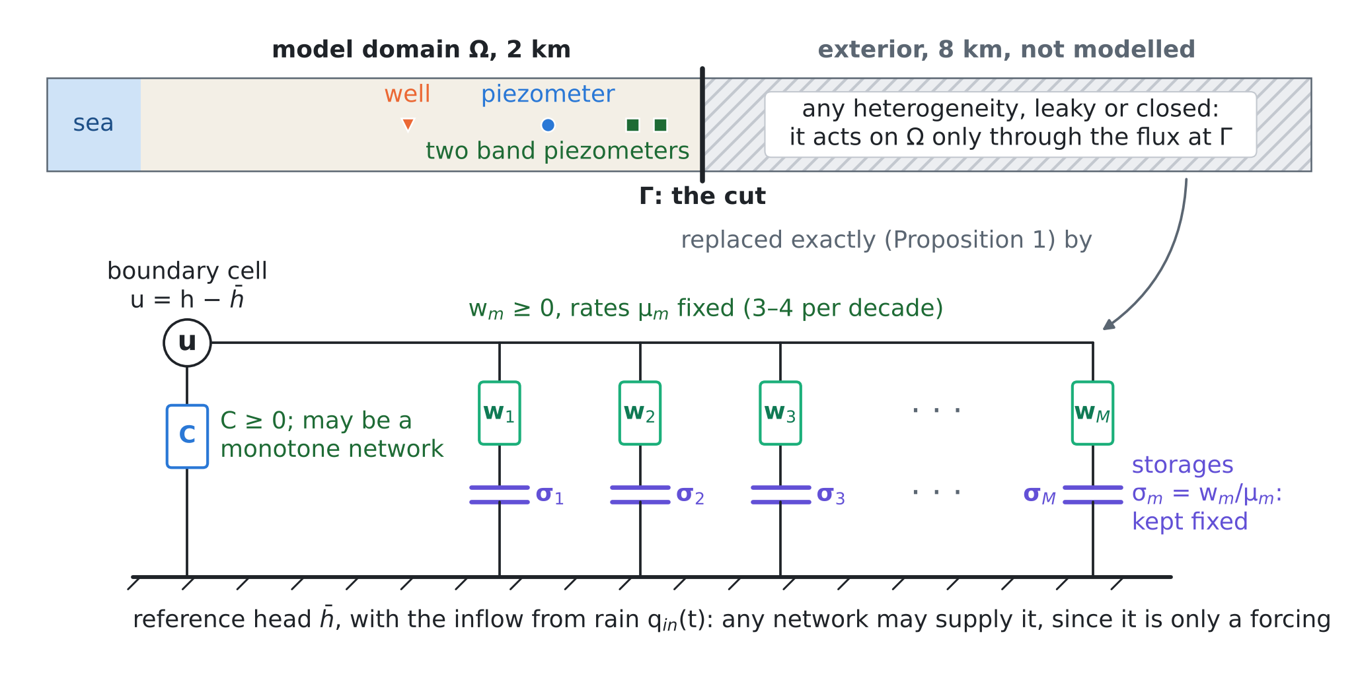
Figure 1. BEYOND-GO. The aquifer beyond the cut is replaced by a conductance $C$ to the far field and $M$ compartments, each a conductance $w_{m}$ in series with a storage $σ_{m}$. Green marks where a neural network may enter, violet what must stay fixed. The positions are those of the test bed of Section 9; the exterior is not drawn to scale.
3. Proposition 1: the exact boundary of any linear exterior
Let the exterior be discretised by any conservative scheme with positive storages and nonnegative conductances: the cell-centred finite volumes of MODFLOW, or lumped finite elements. Any heterogeneity, shape and number of layers is allowed. The exterior is linear (confined, or linearised about a reference state). Apart from fixed heads it has no sources, since its own forcing is moved into $q_{in}$ by linearity. $M_{e}$ is the diagonal matrix of storages. $A_{e}$ is the conductance matrix: the connections inside the exterior, the conductances to its fixed heads, and the conductance $c>0$ that links its first cell to the boundary cell of $Ω$. Write the boundary relation as $\hat{q}\left(s\right)=Z\left(s\right) \hat{u}\left(s\right)$ in the Laplace variable $s$.
Proposition 1 (structure and realisability). For zero initial deviation, the flux leaving $Ω$ through the cut is $\hat{q}=Z\left(s\right) \hat{u}$ with
Zs=C+n=1Newn ss+μn, C≥0, wn≥0, μn>0, C+n​wn=c | (6)

$$C=c−c^{2} e_{1}^{⊤}A_{e}^{−1}e_{1}, w_{n}=\frac{c^{2}β_{n}^{2}}{μ_{n}}, β_{n}=v_{n}^{⊤}M_{e}^{−1/2}e_{1}, M_{e}^{−1/2}A_{e}M_{e}^{−1/2} v_{n}=μ_{n}v_{n}$$ | (7)
where $e_{1}$ marks the first exterior cell and $v_{n}$ are orthonormal eigenvectors. In time this is (3)–(4) with $N_{e}$ compartments. $C=0$ if and only if the exterior has no fixed head (it is closed). Conversely, any $C≥0$, $w_{n}≥0$, $μ_{n}>0$ is the exact boundary of a physical exterior: a fixed head behind the conductance $C$ and $N$ isolated storage cells, cell $n$ holding storage $σ_{n}=w_{n}/μ_{n}$ behind conductance $w_{n}$.

Proof. The exterior heads, measured from the reference, obey $M_{e}\dot{v}=−A_{e}v+c e_{1}u$. The flux leaving $Ω$ is $q=c \left(u−e_{1}^{⊤}v\right)$. With zero initial deviation, the Laplace transform gives $\left(sM_{e}+A_{e}\right)\hat{v}=c e_{1}\hat{u}$, so $Z\left(s\right)=c−c^{2}e_{1}^{⊤}{\left(sM_{e}+A_{e}\right)}^{−1}e_{1}$. $A_{e}$ is symmetric and, because $c>0$ and the exterior is connected, positive definite. Hence Me−1/2AeMe−1/2=n​μnvnvn⊤ with $μ_{n}>0$, and e1⊤sMe+Ae−1e1=n​βn2/s+μn. Writing $1/\left(s+μ\right)=1/μ−s/\left(μ\left(s+μ\right)\right)$ gives (6), with C=c−c2n​βn2/μn=c−c2e1⊤Ae−1e1; letting $s→∞$ gives C+n​wn=c. To show $C≥0$, write $A_{e}=c e_{1}e_{1}^{⊤}+A^{′}$ with $A^{′}$ positive semidefinite (the exterior without the link). Then $e_{1}^{⊤}A_{e}^{−1}e_{1}=\max_{v}\left(2v_{1}−cv_{1}^{2}−v^{⊤}A^{′}v\right)≤\max_{v_{1}}\left(2v_{1}−cv_{1}^{2}\right)=1/c$. Equality needs a $v$ with $v_{1}=1/c$ and $A^{′}v=0$. For a connected exterior the kernel of $A^{′}$ is spanned by the constant vector if the exterior is closed and is zero otherwise, so $C=0$ exactly for a closed exterior. In time, ${\hat{y}}_{n}=μ_{n}/\left(s+μ_{n}\right) \hat{u}$ is ${\dot{y}}_{n}=μ_{n}\left(u−y_{n}\right)$, and $s/\left(s+μ_{n}\right) \hat{u}=\hat{u}−{\hat{y}}_{n}$, which is (4). For the converse, cell $n$ of the network obeys $σ_{n}{\dot{y}}_{n}=w_{n}\left(u−y_{n}\right)$ and takes the flux $w_{n}\left(u−y_{n}\right)$, and the fixed head takes $Cu$; the sum is (4). □
The continuous exterior. For a semi-infinite strip with transmissivity $T$ and storage coefficient $S$, the exterior head is $\hat{u} e^{−κx}$ with $κ=\sqrt{sS/T}$. The boundary is then of half order, a continuum of compartments:
$$Z\left(s\right)=\sqrt{ST} \sqrt{s}=\frac{\sqrt{ST}}{π}\int_{0}^{∞}{\frac{s}{s+μ}} μ^{−1/2} dμ, \text{that is} q⋅n=\sqrt{ST} ∂_{t}^{1/2}u$$ | (8)
with weight density $\left(\sqrt{ST}/π\right) μ^{−1/2}$. Since Proposition 1 holds on every mesh, the structure survives refinement. The limits have the form
Zs=C+0,∞​ss+μ νdμ, KΓr=0,∞​e−μr νdμ, ν≥0 | (9)
$Z$ is a complete Bernstein function and the memory kernel $K_{Γ}$ is completely monotone. By Bernstein’s theorem, every completely monotone kernel is such a positive mixture of exponentials, and the class is closed under pointwise limits [6]. This is the precise sense in which "a conductance plus a completely monotone memory" is the true boundary condition of a linear exterior, and nothing else is.
Three remarks. (i) The third term is the first one moved to the boundary. $K_{Γ}$ and the lens tail $K_{h}$ of [D1] are the same object: completely monotone memories with exact Markovian lifts. The lens memory is storage hidden inside $Ω$, and the boundary memory is storage hidden beyond $Γ$. The same structure describes multirate mass transfer into immobile zones [14]. (ii) Both can be run in an unmodified finite-volume code as extra cells. A storage cell behind a conductance is an ordinary cell. In principle MODFLOW 6 can hold them as hidden cells of an unstructured grid [17]; this was not tested here. (iii) Many boundary cells. In two or three dimensions the cut has many cells. Then $C$ and $w_{n}$ become positive semidefinite matrices ($w_{n}$ of rank one), and the exact operator is nonlocal along the cut. A local (diagonal) approximation keeps the positivity but loses the coupling along $Γ$.
4. Proposition 2: passivity, and what it allows a neural network to do
Take the inland, fresh part of the aquifer (constant density), with the lens memory of [D1] and the boundary (4) on $Γ$. Remove all forcing ($Q_{w}=0$, $Ψ=0$, $q_{in}=0$, sea at the reference head), or, equivalently, consider the difference of two solutions with the same forcing, in which every forcing cancels. $K$ is the conductivity tensor.
Proposition 2 (passivity). (a) The energy (10) is dissipated at the rate (11). (b) Hence the model is stable for every $K$, $S_{s}$, geometry and mesh, and any two runs with the same forcing converge. (c) The forcing $q_{in}\left(t\right)$ may be any function. The conductances $C$ and $w_{m}$ may depend on time and on the head, provided that they stay nonnegative and are nondecreasing in the head difference they act on. The storages $σ_{m}$ must stay fixed or decrease in time. (d) A negative conductance $C=−αc$, $α>0$, is not passive, and whether it is stable depends on the rest of the model. For a strip of length $L$ with the sea at $x=0$, it has growing modes if and only if $αcL>T$, at the rate given by (12).
E=12Ω​Ssh2 dV+12k​Ω​skhk2 dV+12m​σmΓ​ym2 dA | (10)

dEdt=−Ω​∇h⊤K ∇h dV−k​Ω​skakh−hk2dV−Γ​Ch2+m​wmh−ym2dA≤0 | (11)

$$\frac{tanhz}{z}=\frac{T}{αcL}, λ=\frac{Tz^{2}}{SL^{2}}, \text{on the mesh: growth if and only if }αc>\frac{T}{L−Δx/2}$$ | (12)

Proof. (a) Multiply (1), without forcing, by $h$ and integrate. The divergence term gives $−∫∇h^{⊤}K∇h$ minus the boundary flux Γ​h q⋅n; the sea face (at the reference head) contributes nothing. Multiply $∂_{t}h_{k}=a_{k}\left(h−h_{k}\right)$ by $s_{k}h_{k}$; the sum with the lens term of (1) is $−∫s_{k}a_{k}{\left(h−h_{k}\right)}^{2}$. Multiply $∂_{t}y_{m}=μ_{m}\left(h−y_{m}\right)$ by $σ_{m}y_{m}$, which gives $w_{m}y_{m}\left(h−y_{m}\right)$. Then −hCh+m​wmh−ym+m​wmymh−ym=−Ch2−m​wmh−ym2. (b) $E$ is a norm of the state and does not increase. (c) The forcing cancels in the difference of two solutions. With a state-dependent conductance $f$, the dissipation becomes $\left(h_{1}−h_{2}\right)\left(f\left(h_{1}\right)−f\left(h_{2}\right)\right)≥0$ when $f$ is nondecreasing. A time-varying storage adds $\frac{1}{2}{\dot{σ}}_{m}y_{m}^{2}$ to (11), which is not positive only if ${\dot{σ}}_{m}≤0$. (d) A growing mode $h=sinh\left(kx\right) e^{λt}$ with $λ=Tk^{2}/S$ satisfies $Tkcosh\left(kL\right)=αcsinh\left(kL\right)$. With $z=kL$ this is (12), which has a root $z>0$ if and only if $T/\left(αcL\right)<1$, because $tanhz/z$ falls from 1 to 0. On the mesh the conductance matrix $A$ is positive definite, and adding $−αc ee^{⊤}$ creates one negative eigenvalue if and only if $αc e^{⊤}A^{−1}e>1$. Here $e^{⊤}A^{−1}e$ is the resistance from the last cell to the sea, $\left(L−Δx/2\right)/T$. □
Passivity is a property of the boundary alone, as in the theory of dissipative systems [7]; stability with a non-passive term is a property of the whole model. Calibration changes the whole model: it moves $T$, and a model may later be extended to a larger $L$. Condition (12) shows that a term that was stable in validation can become unstable after either change. Check N3 shows this happening.
5. Proposition 3: how few compartments are needed
The exact network has one compartment per exterior cell (80 in the test). A model needs the boundary only on the band of periods its forcing and its questions contain: here from five days to forty years, $\left[ω_{min},ω_{max}\right]$ with $ω=2π/\text{period}$.
Proposition 3 (approximation). (a) For $\left|s\right|=ω$ in the band and $0<ε<1$, a compartment much slower than the band acts as a conductance, and one much faster acts as a boundary storage (13). On the band, $Z\left(s\right)$ is therefore $C^{′}+σ^{′}s$ plus the compartments inside the band, with C′=C+slow​wm and σ′=fast​σm. (b) The half-order boundary (8) is approximated to a relative error of order $ε$ by the trapezoidal rule in $x=lnμ$ with the nodes, weights and window (14). The count is (15): it grows with the logarithm of the band and the square of $ln\left(1/ε\right)$. (c) All weights are positive, so the approximation is passive (Proposition 2).
$$\frac{s}{s+μ}=1+O\left(ε\right) \text{if }μ≤ε ω_{min}, w \frac{s}{s+μ}=σs \left(1+O\left(ε\right)\right) \text{if }μ≥ω_{max}/ε$$ | (13)

$$μ_{j}=e^{x_{j}}, w_{j}=\frac{\sqrt{ST} η}{π} e^{x_{j}/2}, x_{j}=X_{−}+\left(j−1\right)η, η=\frac{π^{2}}{ln\left(1/ε\right)},$$  $$X_{−}=lnω_{min}−2ln\frac{2}{πε}, X_{\text{+}}=lnω_{max}+2ln\frac{2}{πε}$$ | (14)

$$M=1+\frac{X_{\text{+}}−X_{−}}{η}=1+\frac{ln\left(1/ε\right)}{π^{2}}\left[ln\frac{ω_{max}}{ω_{min}}+4ln\frac{2}{πε}\right]$$ | (15)

Proof. (a) $s/\left(s+μ\right)−1=−μ/\left(s+μ\right)$, whose modulus is at most $μ/ω≤ε$. And $s/\left(s+μ\right)−s/μ=−s^{2}/\left(μ\left(s+μ\right)\right)$, whose modulus relative to $ω/μ$ is at most $ω/μ≤ε$. (b) The integrand of (8) in $x=lnμ$ is $f\left(x\right)=s e^{x/2}/\left(π\left(s+e^{x}\right)\right)$. For $s=iω$ its poles nearest to the real axis lie at $\text{Im} x=−π/2$, so it is analytic in the strip $\left|\text{Im} x\right|<π/2$. The trapezoidal rule then converges like $exp\left(−2πd/η\right)$ with $d→π/2$ [10], that is like $exp\left(−π^{2}/η\right)=ε$. The tails decay as $e^{x/2}/π$ to the left and $ωe^{−x/2}/π$ to the right. Their integrals beyond $X_{−}$ and $X_{\text{+}}$, divided by $\left|\sqrt{s}\right|=\sqrt{ω}$, equal $ε$ at the two band ends for the window (14). (c) is immediate. □
Proposition 3(b) is an estimate, not a bound. The three errors add, and the trapezoidal constant is not one. Check N2 found the error at the predicted count to be 1.8–2.4 times $ε$, and the count that actually reaches $ε$ to be 19–21% larger. For a general exterior, check N1 fitted the weights by nonnegative least squares on a fixed logarithmic grid. Over 3.5 decades, 3, 6 and 12 compartments gave median impedance errors of 26.0%, 1.9% and 0.10%: about three to four compartments per decade are enough. The same positive rational fitting, with passivity enforced, is how external electrical networks are reduced [8, 9].
6. Proposition 4: what two piezometers can learn
Let heads be observed with noise at $x_{1}<x_{2}<L$ inside $Ω$, near the cut at $x=L$. Assume the band $\left(x_{1},L\right)$ contains no unknown source (known recharge is allowed) and the vertically integrated equation $S ∂_{t}h=T ∂_{xx}h+r$ holds in it. In this section $Z$ relates the deviations of flux and head at $x=L$.
Proposition 4 (identifiability and design). (a) Separation. For every $ω≠0$ at which the heads carry signal, the heads at $x_{1}$ and $x_{2}$ determine $Z\left(iω\right)$, whatever the rest of the model (the wells, the sea, the closure $Ψ$ outside the band). The reconstruction (16) amplifies noise by about (17). (b) Band. At frequencies where the forcing has no power, the data carry no information on $Z$. Outside the excited band, $Z$ is set by the structure and the prior, not by the data. (c) Confounding. If an unknown source acts inside the band (a closure $Ψ$, or an unknown inflow $q_{in}$ at the cut), it cannot be separated from $Z$ unless it is restricted. (d) Design. Place two piezometers between the closure region and the cut, with no unknown source between them and the cut. Space them about one diffusion length $\sqrt{T/\left(Sω_{max}\right)}$ apart, and vary the pumping across the band and independently of the rain.
$$\hat{h}\left(x,s\right)=A\left(s\right) e^{κx}+B\left(s\right) e^{−κx}+{\hat{h}}_{p}\left(x,s\right), κ=\sqrt{sS/T}, Z\left(s\right)=\frac{−T ∂_{x}\hat{h}\left(L,s\right)}{\hat{h}\left(L,s\right)}$$ | (16)

$$exp\left(\left(L−x_{2}\right)\sqrt{\frac{ωS}{2T}}\right)$$ | (17)

Proof. (a) In the band, the transformed equation $sS\hat{h}=T{\hat{h}}_{xx}+\hat{r}$ has the general solution (16), where ${\hat{h}}_{p}$ is fixed by the known recharge. The two observations give a linear system for $A$ and $B$ with determinant $−2sinh\left(κ\left(x_{2}−x_{1}\right)\right)$. For $s=iω$, $ω≠0$, $κ\left(x_{2}−x_{1}\right)$ has a nonzero real part, so this determinant is never zero. Then $\hat{h}\left(L\right)$ and $∂_{x}\hat{h}\left(L\right)$, and hence $Z\left(iω\right)$, follow; nothing outside the band enters. Continuing a solution of the heat equation sideways in this way is unique but ill-posed [11]. The growing exponential has modulus (17). (b) A frequency absent from the forcing is absent from the heads. In principle $Z$ is analytic, so its values on an interval fix it everywhere, but that continuation is unstable; with noise only Proposition 3(a) and the prior remain. (c) If the truth is $\left(Z,Ψ\right)$ with $Ψ$ acting at the boundary cell, the pair $\left(Z^{′},Ψ+\left(Z^{′}−Z\right)\left[u\right]\right)$ produces the same heads for every $Z^{′}$. The same holds for $q_{in}$, unless it is known or independent of the excitation. Pumping varied independently of the rain then acts as an instrument [12]. (d) follows from (a)–(c) and from the amplification (17). □
Proposition 4 makes the boundary a target of the experimental design of the series. The pumping schedule is the experiment. Its regime changes, months to years apart, are what make the boundary identifiable, as persistent excitation does in system identification [12]. The two piezometers are the sensors that this experiment needs.
7. Learning BEYOND-GO: where the neural network goes
The question that led to this note was whether a neural regulariser could learn the true boundary condition. Propositions 1–4 give the answer. A network should not replace the operator $Z$. Nothing linear lies outside the class (3)–(4), a free network can leave the passive class (Proposition 2), and outside the excited band it would extrapolate without control (Proposition 4). The network has three good places:
$$C=\text{softplus}\left(a_{0}\right), w_{m}=\text{softplus}\left(a_{m}\right), μ_{m}=μ_{1}ρ^{m−1}, q_{in}\left(t\right)=g_{ϕ}\left(P\left(t−r\right), 0≤r≤r_{max}\right)$$ | (18)
• The forcing. $q_{in}\left(t\right)$ is the inflow from rain $P$ and may be any network $g_{ϕ}$. It cancels in Proposition 2, so it cannot destabilise anything. GUARANTEE-GO and RECONSTRUCTION-GO already reconstruct this lateral inflow from rain [D2, D3]. BEYOND-GO adds the response that a prescribed inflow lacks.
• A monotone conductance. $C_{θ}\left(t,u\right)≥0$, nondecreasing in $u$, may be a network, for example for a river that dries out or a seasonal clogging (Proposition 2(c)). The storages $σ_{m}$ stay fixed, and the rates $μ_{m}$ sit on a fixed geometric grid with three to four per decade (Proposition 3).
• The learned regulariser. The network belongs in the objective, as a prior learned from geology:
Jθ=12k​dk−hkθσ2−logpϕfZθ, fZ=lnRe Ziωj, lnIm Ziωjj=124 | (19)
where $d_{k}$ are the observed heads and $σ$ their noise. The density $p_{ϕ}$ is trained on an ensemble of simulated exteriors. Each geological scenario (lengths, heterogeneous $T$, $S$, closed or leaky ends) gives its exact $Z$ by Proposition 1, its 48 features and so a sample. In check N5 $p_{ϕ}$ is a Gaussian with 1% shrinkage of its covariance, the linear case of a learned regulariser [13]; a neural density (for example a normalising flow) replaces it when the ensemble is richer. Its weight is not tuned: the noise level and the ensemble fix it. The gradient of $J$ comes from the adjoint of the time stepping, which carries $M$ scalar adjoint states per boundary cell, as for the lens compartments of [D1]. The checks below used finite differences over 13 parameters.
8. Other terms the flow equation may need
The same test (is the term passive, or at least does it keep the maximum principle?) sorts the other candidates. Table 1 lists them.
Table 1. Terms that can be added to the flow equation (1), the condition under which each keeps the model stable, and where each stands.
Term | What is added | Stable if | Status
Lens memory | −k​skakhf−hk, with $∂_{t}h_{k}=a_{k}\left(h_{f}−h_{k}\right)$ | always ($s_{k},a_{k}≥0$) | [D1], eqs. (1)–(3)
Learned closure | $Ψ\left(h_{f},x;γ\right)$ | dissipative: $Ψ$ nonincreasing in $h_{f}$ | [D1], eq. (6); zero in its tests
Boundary memory (BEYOND-GO) | Cu+m​wmu−ym on $Γ$ | $C,w_{m}≥0$; storages fixed | this note
Inelastic storage | $S_{s}=S_{ske}$ above the preconsolidation head $h_{pc}$, $S_{skv}$ below it | always ($S_{s}>0$: maximum principle) | MODFLOW 6 CSUB [18]; subsidence of the Durrës plain [D1]
Tidal and barometric loading | $+γ S_{s} ∂_{t}η_{σ}$ ($η_{σ}$: vertical load in head units, $γ$: loading efficiency) | a known forcing: stability unchanged | [21]

9. Numerical checks
Test bed. A one-dimensional coastal aquifer, 10 km long, with $T$ = 500 m²/d and $S$ = 0.05 (diffusivity ${10}^{4}$ m²/d). It uses cell-centred finite volumes of 100 m, implicit Euler with daily steps and 20 years of simulation. The sea is a fixed head at $x=0$; the far end is closed. The model sees only the first 2 km, and its cut at 2 km must stand in for the 8 km beyond. Recharge of 0.5 mm/d, with a seasonal swing of ±80%, falls on the model domain. The well is at 0.95 km. Its pumping is either steady (0.6 m²/d per metre of coast) or varied (regimes of 6 months to 3 years at 0.3–1.0 m²/d, with ±15% monthly changes). The piezometer is at 1.45 km, the band piezometers at 1.75 and 1.85 km, and the boundary cell at 1.95 km. The parameters are illustrative and not calibrated for Fushë-Kuqe. All checks run in 111 s (the BEYOND-GO code).
N1. The exact boundary and its reductions (Proposition 1)
The exact network of the 8 km closed exterior has 80 compartments, $C$ = 1.8×10⁻¹⁵ (zero up to rounding, as Proposition 1 says for a closed exterior) and $∑w_{n}=c$. With it, the cut model reproduces the full aquifer to 1.3×10⁻¹³ m at the boundary cell and 9.4×10⁻¹⁴ m at the piezometer, over 20 years in which the head at the boundary cell ranges over 1.25 m. Positive reductions with 3, 6 and 12 compartments were compared with a fixed head, a no-flow boundary and the best GHB (conductance scanned over 70 values, best $C$ = 0.203 m/d = 0.041$c$). Table 2 and Figure 2 show the result.
Table 2. N1: errors of the cut model against the full aquifer over 20 years with varied pumping (root mean square and maximum at the boundary cell, root mean square at the piezometer), and the error of the impedance over 3.5 decades (median and maximum).
Boundary at the cut | Boundary cell, rms | Boundary cell, max | Piezometer, rms | Impedance, median / max
Fixed head | 305.8 mm | 645.5 mm | 218.3 mm | –
No flow (prescribed inflow) | 242.0 mm | 545.1 mm | 166.3 mm | –
Calibrated GHB | 147.9 mm | 325.1 mm | 101.3 mm | –
BEYOND-GO, 3 compartments | 37.8 mm | 89.4 mm | 27.0 mm | 26.0% / 55.5%
BEYOND-GO, 6 compartments | 7.8 mm | 15.4 mm | 5.8 mm | 1.9% / 12.0%
BEYOND-GO, 12 (11 nonzero) | 0.44 mm | 1.04 mm | 0.32 mm | 0.10% / 0.75%
Exact network, 80 compartments | 1.3×10⁻¹³ m | – | 9.4×10⁻¹⁴ m | 0

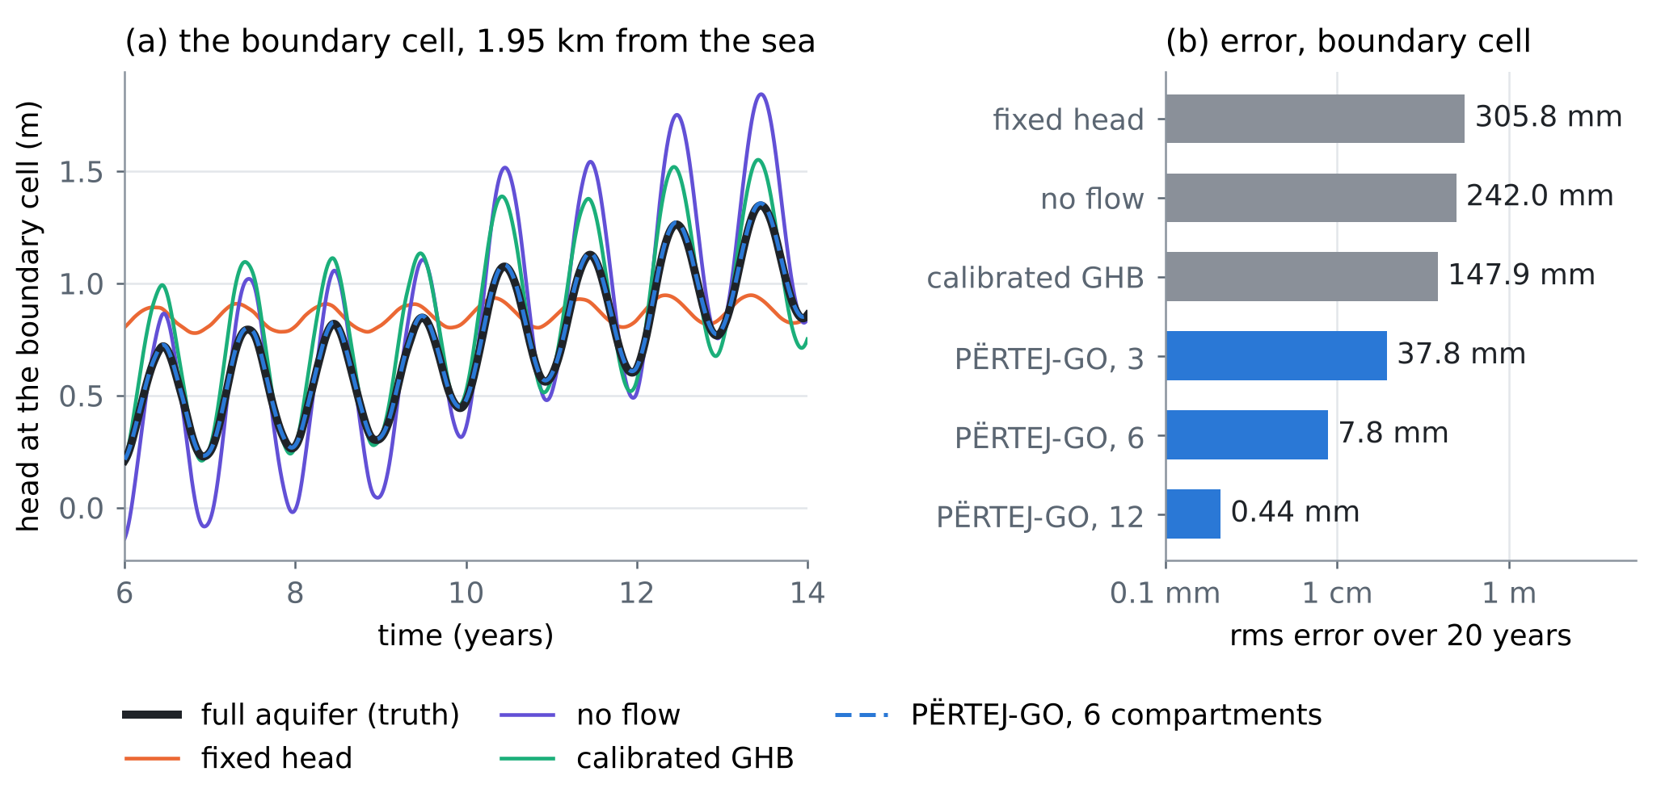
Figure 2. N1. (a) Head at the boundary cell in years 6–14: the full aquifer and five boundaries at the cut. The six-compartment BEYOND-GO lies on the truth. (b) Root-mean-square error over 20 years (logarithmic axis).
Even the best GHB, calibrated on these very data, misses by 147.9 mm, because a conductance cannot store water. Six positive compartments cut the error 19 times, and twelve cut it 335 times.
N2. How many compartments the half-order boundary needs (Proposition 3)
Table 3. N2: the count (15) against the count actually needed, for the half-order boundary (8) over 4 and 6 decades of period starting at 30 years.
Decades | Target ε | M by the count formula | Error at that M | M needed for ε
4 | 1% | 14 | 1.77% | 17
4 | 0.1% | 26 | 0.23% | 31
6 | 1% | 16 | 1.87% | 19
6 | 0.1% | 29 | 0.24% | 35

Two more decades add only 2–4 compartments, and ten times more accuracy roughly doubles the count, as (15) predicts (Figure 3a).
N3. Passivity (Proposition 2)
Start the model without forcing from a 1 m mound around the well. With the passive exact boundary the energy decreases at every step, from 12.5 to 0.0138 in five years. With $C=−0.2c$, above the threshold, the energy grows by a factor 3.4×10⁵² in five years. Its measured growth rate, 0.0338 per day, matches the rate of the semi-discrete model under implicit Euler (0.0338) to a relative 8×10⁻¹⁶. The continuous strip (12) gives 0.0399; the difference comes from the boundary term acting on the cell-centre head, half a cell inside the face. The thresholds are $α$ = 0.050 for the continuum and 0.0513 on the mesh. With $C=−0.02c$, below them, the 2 km model decays. The same boundary in longer models (Table 4, Figure 3c) shows the danger of Proposition 2(d).
Table 4. N3: the non-passive boundary $C=−0.02c$, stable in the 2 km test, in longer models.
Model length | Threshold α on the mesh | Growth rate (1/d) | Head amplitude
2 km | 0.0513 | -4.02×10⁻³ | halves in 172 days
4 km | 0.0253 | -3.74×10⁻⁴ | halves in 5.1 years
6 km | 0.0168 | 1.63×10⁻⁴ | doubles in 11.7 years
8 km | 0.0126 | 3.08×10⁻⁴ | doubles in 6.2 years

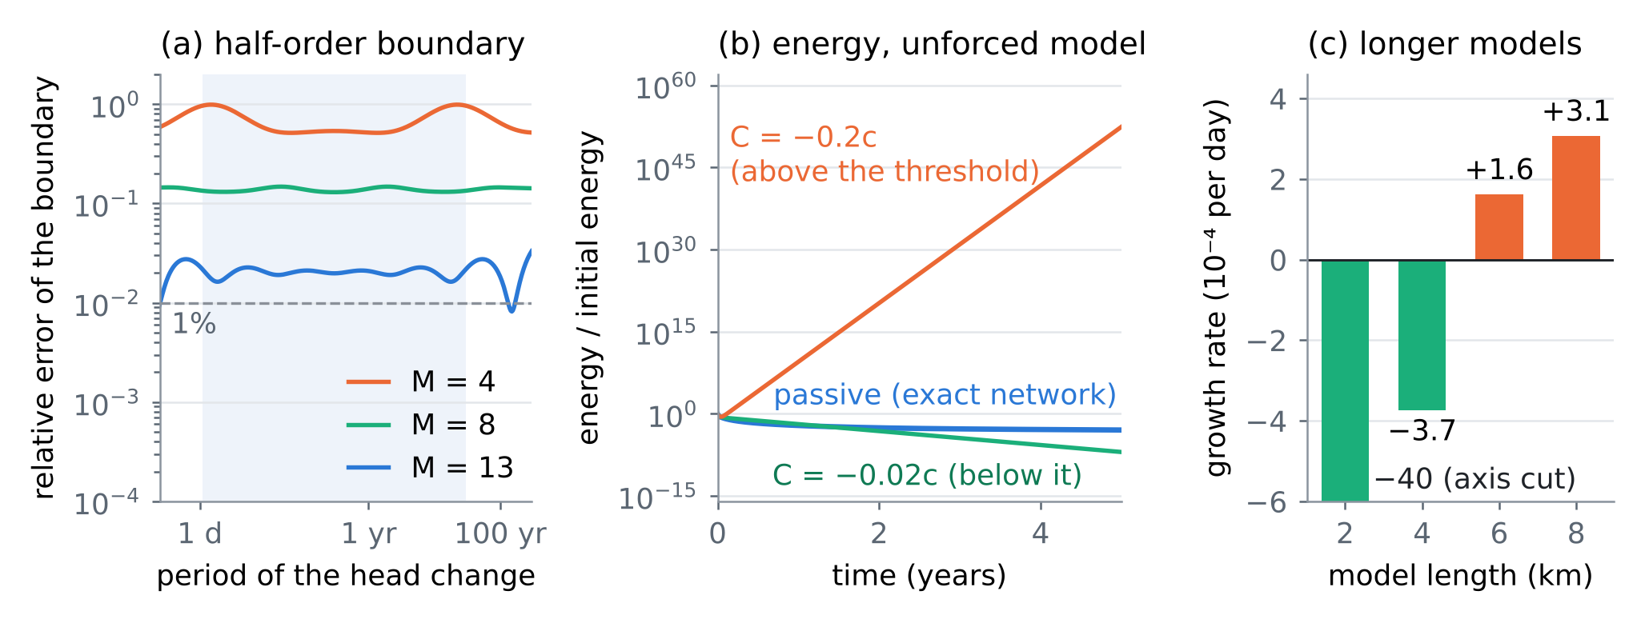
Figure 3. (a) N2: relative error of the half-order boundary with M = 4, 8 and 13 compartments on the quadrature (14); shaded, the four decades of the design. (b) N3: energy of the unforced model with the passive boundary and with two negative conductances. (c) N3: growth rate of the $C=−0.02c$ boundary as the model is lengthened.
N4. Learning the boundary from two piezometers (Proposition 4)
The boundary was learned from the two band piezometers by output error. The band cells (1.85 and 1.95 km) were simulated with the observed head at 1.75 km and the known recharge as inputs, and the 13 nonnegative parameters ($C$ and 12 compartments, 3.4 per decade) were chosen to reproduce the head at 1.85 km. Nothing else of the model was used, and no noisy data were differentiated. The learned boundary was then put into the cut model to predict a regime never seen in the data. Over 10 years, the pumping doubles from year 2 and a drought cuts recharge to 30% in years 3–8; the head at the boundary cell falls by 2.39 m. Table 5 and Figure 4 show the results.
Table 5. N4: median relative error of the learned impedance in three bands of period, and root-mean-square error of the prediction at the boundary cell. "Steady" and "varied" refer to the pumping during the 20 years of data.
Data | Noise | 40–200 years | 30 days–10 years | 2.5–10 days | Prediction
Steady pumping | 2 mm | 25.6% | 5.1% | 365% | 35.3 mm
Steady pumping | 10 mm | 201% | 16.1% | 549% | 227.4 mm
Varied pumping | 2 mm | 4.5% | 1.3% | 233% | 6.1 mm
Varied pumping | 10 mm | 29.6% | 5.2% | 387% | 34.9 mm
Varied, closure in the band (1.95 km) | 2 mm | 75.6% | 47.4% | 86.5% | –
Varied, closure outside it (1.25 km) | 2 mm | 6.3% | 3.3% | 258% | –
Exact boundary | – | – | – | – | 2.0×10⁻¹¹ mm
Calibrated GHB · no flow · fixed head | – | – | – | – | 372 mm · 605 mm · 1234 mm

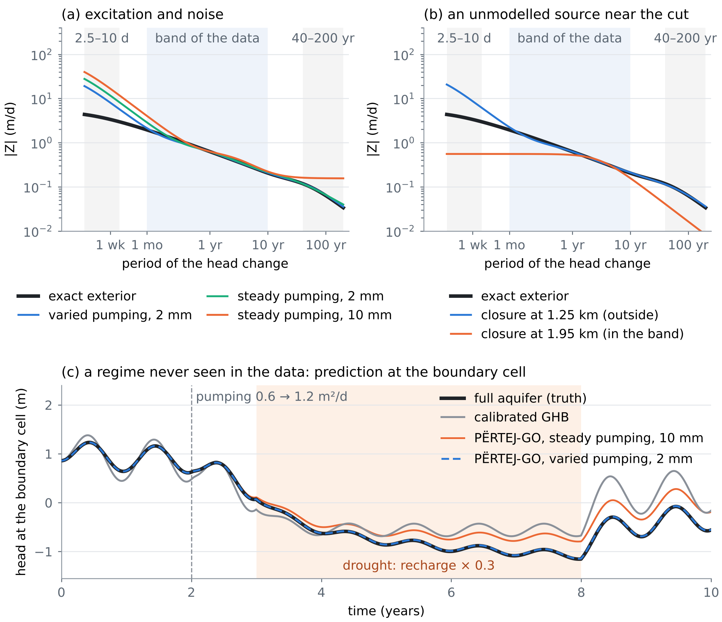
Figure 4. N4. (a) Modulus of the learned impedance against the exact one. Shaded: the band of the data (30 days–10 years) and, in grey, periods of 2.5–10 days and 40–200 years. (b) A closure source of 0.15 m²/d (seasonal) plus a 0.1 m²/d step in year 6, placed inside or outside the band. (c) Prediction of a regime never seen in the data.
The results follow Proposition 4 point by point. Inside the band, varied pumping learns the boundary four times better than steady pumping at the same noise (1.3% against 5.1%). At periods of 2.5–10 days, which no forcing excites, every estimate is wrong by more than 200%. That does not matter for the prediction, which has no power there either. Varied pumping also reaches the 40–200 year band, beyond the 20-year record, to 4.5%, because the positive structure links it to the band. A closure source between the piezometers and the cut corrupts the boundary (47.4%), while the same source outside the band leaves it intact (3.3%). The learned boundary predicts the new regime to 6.1 mm, 61 times better than the GHB calibrated on the full record.
N5. The learned regulariser (Section 7)
Two priors were trained, each on 400 simulated exteriors of 3–15 km, half closed and half leaky, with heterogeneous, correlated $T$. The right prior draws the median $T$ from 150–1500 m²/d and $S$ from 0.01–0.2. The truth lies at the 13th percentile of its Mahalanobis distances, within the prior but not at its centre. The wrong prior draws $T$ from 40–160 m²/d and $S$ from 0.004–0.02, a geology about six times less conductive. Under it the truth lies at the 98th percentile. The identifications of N4 were repeated with each prior (Table 6, Figure 5).
Table 6. N5: the identifications of N4 without a prior, with the right prior and with the wrong one (median relative error of the impedance; root-mean-square error of the prediction of N4).
Data | Prior | 40–200 years | 30 days–10 years | 2.5–10 days | Prediction
Steady, 2 mm | none | 25.6% | 5.1% | 365% | 35.3 mm
 | right | 1.9% | 3.8% | 93.5% | 12.2 mm
 | wrong | 14.3% | 3.2% | 90.4% | 13.6 mm
Steady, 10 mm | none | 201% | 16.1% | 549% | 227.4 mm
 | right | 176% | 9.9% | 126% | 191.6 mm
 | wrong | 110% | 7.9% | 115% | 76.2 mm
Varied, 2 mm | none | 4.5% | 1.3% | 233% | 6.1 mm
 | right | 3.8% | 1.1% | 53.1% | 5.2 mm
 | wrong | 4.4% | 1.1% | 59.5% | 5.5 mm
Varied, 10 mm | none | 29.6% | 5.2% | 387% | 34.9 mm
 | right | 12.8% | 4.8% | 88.8% | 20.2 mm
 | wrong | 20.7% | 5.0% | 90.2% | 26.2 mm

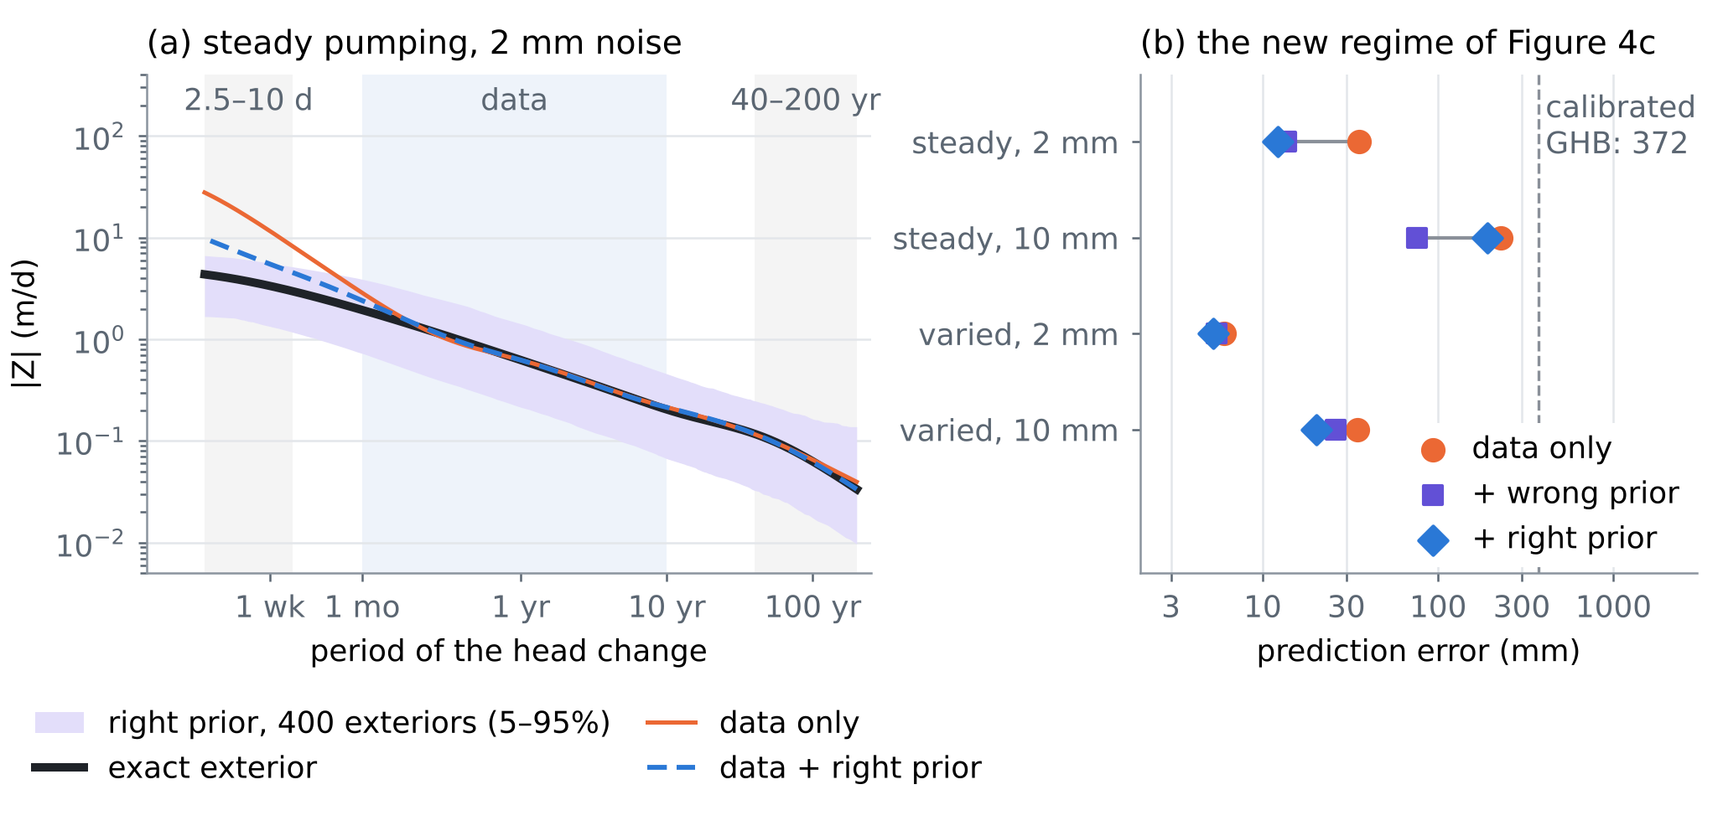
Figure 5. N5. (a) Steady pumping with 2 mm noise. The right prior (its 5–95% envelope in violet) brings the boundary much closer to the truth at the shortest periods, where the data are silent. (b) Error of the prediction of Figure 4c without a prior, with the wrong prior and with the right one.
The prior helps in every case and most where the data are silent. The error at periods of 2.5–10 days falls 3.9–4.4 times. The 40–200 year error for steady pumping with 2 mm noise falls from 25.6% to 1.9%, and every prediction improves. Two findings qualify this. First, the wrong prior still improved every case over no prior, and it was only slightly worse than the right one (better in one case). The prior acts mainly through the shape of the impedance, which all diffusive exteriors share, while the data fix its level inside the band. This is no licence to use a wrong prior: the Mahalanobis distance of the estimate flags it, though weakly. Under the wrong prior the estimates sit at percentiles 98.5–99.2 of its ensemble, and under the right one at 93.0–98.5. The data-only estimates sit far outside both (distances 247–659, against a 99th percentile of 56.6). Second, a prior does not replace the experiment. With steady pumping and 10 mm noise, the best prior still predicts to only 76.2 mm, while varied pumping with 2 mm noise and no prior predicts to 6.1 mm.
N6. Sea-level rise: the cut that the boundary decided
The sea was raised by 0.5 m over 20 years on top of the forcing of N1, and each cut model was compared with the full aquifer. The aquifer must store water as its heads rise with the sea, and that water comes from the fresh discharge to the sea (mean 0.291 m²/d per metre of coast). Less fresh discharge moves the toe inland. In the sharp-interface equilibrium of [D1, eq. (24)] the toe distance is inversely proportional to the fresh discharge. Table 7 shows the result.
Table 7. N6: fresh water that does not reach the sea during 20 years of a 0.5 m rise, the fall of the fresh discharge at year 20, and the landward shift of the equilibrium toe that this fall would cause [D1, eq. (24)].
Inland boundary | Fresh water lost (m³ per m of coast) | Discharge at year 20 | Equilibrium toe
Full aquifer (truth) | 154 | −10.2% | +11.3%
BEYOND-GO, 6 compartments | 160 | −11.1% | +12.5%
BEYOND-GO, 12 compartments | 155 | −10.2% | +11.4%
Prescribed inflow [D1, eq. (31)] | 49 | −2.4% | +2.4%
Calibrated GHB | 237 | −20.9% | +26.4%
Fixed head | 462 | −42.7% | +74.5%

The answer to the sea-level question changes by a factor of 9.4 with the inland boundary. The prescribed inflow, which led [D1] to cut sea-level rise, underestimates the lost fresh water 3.1 times. It sees the storage of the 2 km model but not that of the 8 km beyond it. The fixed head overestimates it three times, and even the GHB calibrated in N1 errs by 54%. BEYOND-GO with six compartments errs by 4%, and with twelve by 0.2%. The boundary learned from piezometers in a pumping experiment (N4) therefore decides a question that the assembly had to leave open, in line with the role of the inland boundary in the sea-level response of coastal aquifers [19, 20].
10. What BEYOND-GO adds
• A term for the flow equation with an exact pedigree. (3)–(4) is the boundary of every linear exterior and only of physical exteriors (Proposition 1). It sits next to the two terms the series already added and has the same mathematical form as the lens memory.
• Stability as a property of the learned boundary alone (Proposition 2), with a rule for neural networks: free in the forcing, monotone in the conductances, never in the storages. A non-passive term that passed validation failed when the model was lengthened (N3).
• Logarithmic cost (Proposition 3): 6–12 states per boundary cell, three to four per decade of period (N1, N2).
• Identifiability and design (Proposition 4): two piezometers separate the boundary from the closure $Ψ$ and from everything inside the model, and the pumping schedule is the experiment that reveals the boundary (N4).
• A learned prior from simulated geology that repairs the periods the data cannot reach, does not replace the experiment, and in this test was robust to a wrong geology (N5).
• An answer to a question the assembly left open: whether sea-level rise matters inland depends on the boundary, and BEYOND-GO reproduces the true response within 4% (N6).
11. Limits
The propositions assume a linear (confined or linearised), fresh exterior. An unconfined exterior with large changes of saturated thickness is only approximately linear. The sea face, where a wedge of salt water moves, is a different problem: density couples flow and salt, and Proposition 2 covers the constant-density part only. The checks are one-dimensional. In two and three dimensions the exact operator is nonlocal along the cut (remark (iii) of Section 3), and the identifiability of Proposition 4 then needs piezometers along the cut; neither was tested. The count (15) is an estimate within a factor of about 2.4 of $ε$. The learned prior was a Gaussian on 48 features of synthetic ensembles; the neural density of Section 7 is proposed, not tested. The two priors are two cases, not a study of misspecification. The inflow from rain $q_{in}$ was zero in the test bed, so its confounding with $Z$ (Proposition 4(c)) and the instrument of varied pumping are argued, not tested. The gradient came from finite differences, not the adjoint. The parameters are illustrative; on Fushë-Kuqe the band, the piezometer spacing and the pumping experiment must be designed with the calibrated $T$ and $S$.
Verification note. The external references [1–21] were checked in Crossref (DOI, authors, title, venue), November 2026. The note was drafted with the help of an AI assistant. Every number is computed by the BEYOND-GO code (results in its res folder) and inserted by the build script.
References
Published sources (checked in Crossref)
[1] Engquist, B., & Majda, A. (1977). Absorbing boundary conditions for the numerical simulation of waves. Mathematics of Computation 31(139), 629–651. https://doi.org/10.1090/S0025-5718-1977-0436612-4
[2] Hagstrom, T. (1999). Radiation boundary conditions for the numerical simulation of waves. Acta Numerica 8, 47–106. https://doi.org/10.1017/S0962492900002890
[3] Alpert, B., Greengard, L., & Hagstrom, T. (2000). Rapid evaluation of nonreflecting boundary kernels for time-domain wave propagation. SIAM Journal on Numerical Analysis 37(4), 1138–1164. https://doi.org/10.1137/S0036142998336916
[4] Jiang, S., & Greengard, L. (2004). Fast evaluation of nonreflecting boundary conditions for the Schrödinger equation in one dimension. Computers & Mathematics with Applications 47(6–7), 955–966. https://doi.org/10.1016/S0898-1221(04)90079-X
[5] Givoli, D. (2004). High-order local non-reflecting boundary conditions: a review. Wave Motion 39(4), 319–326. https://doi.org/10.1016/j.wavemoti.2003.12.004
[6] Schilling, R. L., Song, R., & Vondraček, Z. (2012). Bernstein Functions: Theory and Applications (2nd ed.). De Gruyter, Berlin. https://doi.org/10.1515/9783110269338
[7] Willems, J. C. (1972). Dissipative dynamical systems part I: General theory. Archive for Rational Mechanics and Analysis 45(5), 321–351. https://doi.org/10.1007/BF00276493
[8] Gustavsen, B., & Semlyen, A. (1999). Rational approximation of frequency domain responses by vector fitting. IEEE Transactions on Power Delivery 14(3), 1052–1061. https://doi.org/10.1109/61.772353
[9] Gustavsen, B., & Semlyen, A. (2001). Enforcing passivity for admittance matrices approximated by rational functions. IEEE Transactions on Power Systems 16(1), 97–104. https://doi.org/10.1109/59.910786
[10] Trefethen, L. N., & Weideman, J. A. C. (2014). The exponentially convergent trapezoidal rule. SIAM Review 56(3), 385–458. https://doi.org/10.1137/130932132
[11] Eldén, L., Berntsson, F., & Regińska, T. (2000). Wavelet and Fourier methods for solving the sideways heat equation. SIAM Journal on Scientific Computing 21(6), 2187–2205. https://doi.org/10.1137/S1064827597331394
[12] Åström, K. J., & Eykhoff, P. (1971). System identification—A survey. Automatica 7(2), 123–162. https://doi.org/10.1016/0005-1098(71)90059-8
[13] Arridge, S., Maass, P., Öktem, O., & Schönlieb, C.-B. (2019). Solving inverse problems using data-driven models. Acta Numerica 28, 1–174. https://doi.org/10.1017/S0962492919000059
[14] Haggerty, R., & Gorelick, S. M. (1995). Multiple-rate mass transfer for modeling diffusion and surface reactions in media with pore-scale heterogeneity. Water Resources Research 31(10), 2383–2400. https://doi.org/10.1029/95WR10583
[15] von Asmuth, J. R., Bierkens, M. F. P., & Maas, K. (2002). Transfer function-noise modeling in continuous time using predefined impulse response functions. Water Resources Research 38(12), 1287. https://doi.org/10.1029/2001WR001136
[16] Bakker, M., & Schaars, F. (2019). Solving groundwater flow problems with time series analysis: you may not even need another model. Groundwater 57(6), 826–833. https://doi.org/10.1111/gwat.12927
[17] Langevin, C. D., Hughes, J. D., Banta, E. R., Niswonger, R. G., Panday, S., & Provost, A. M. (2017). Documentation for the MODFLOW 6 Groundwater Flow Model. U.S. Geological Survey Techniques and Methods 6-A55. https://doi.org/10.3133/tm6A55
[18] Hughes, J. D., Leake, S. A., Galloway, D. L., & White, J. T. (2022). Documentation for the Skeletal Storage, Compaction, and Subsidence (CSUB) Package of MODFLOW 6. U.S. Geological Survey Techniques and Methods 6-A62. https://doi.org/10.3133/tm6A62
[19] Werner, A. D., & Simmons, C. T. (2009). Impact of sea-level rise on sea water intrusion in coastal aquifers. Ground Water 47(2), 197–204. https://doi.org/10.1111/j.1745-6584.2008.00535.x
[20] Michael, H. A., Russoniello, C. J., & Byron, L. A. (2013). Global assessment of vulnerability to sea-level rise in topography-limited and recharge-limited coastal groundwater systems. Water Resources Research 49(4), 2228–2240. https://doi.org/10.1002/wrcr.20213
[21] van der Kamp, G., & Gale, J. E. (1983). Theory of earth tide and barometric effects in porous formations with compressible grains. Water Resources Research 19(2), 538–544. https://doi.org/10.1029/WR019i002p00538
Notes of this series (in this repository)
[D1] Zeqiraj, D. (2026). Assembling the equations of a coastal aquifer, with the placement of recharge and pumping wells as the final goal (ASSEMBLY-GO). Technical note, October 2026; docs/research_notes/Assembled_System_Equations_Placing_Recharge_and_Pumping_Wells.docx in this repository.
[D2] Zeqiraj, D. (2026). Inputs, dispersion and boundary conditions from rain alone (GUARANTEE-GO, review I). docs/literature/ in this repository.
[D3] Zeqiraj, D. (2026). Reconstructing all boundary conditions of a coastal aquifer from rain and the Fushë-Kuqe data (RECONSTRUCTION-GO). the RECONSTRUCTION-GO research note in this repository.

PART  4 | Implementation report: SHOCK-GO, the earthquake in the aquifer  The earthquake, the aquifer and liquefaction: the pore-pressure step of each layer, the earthquake as a free pumping test, the design of the 2019 hindcast and the joint safe window, with numerical checks. Preparatory work of the NPD's team, November 2026.

SHOCK-GO: the earthquake, the aquifer and liquefaction, implemented
The first three steps of the TERMETET note as tested code: the liquefaction module with the pore pressure of the day, the coseismic step from four published models of the 26 November 2019 Durrës earthquake, and the design of the 2019 hindcast; with a joint safe window for liquefaction and seawater intrusion and a daily bulletin
Dulian Zeqiraj · November 2026 · implementation report with numerical checks · follows the working note of 31 October 2026 on the earthquake, the aquifer, human action and floods [D1]
1. Outcome
• What was built. Three modules in the SHOCK-GO experiment: the liquefaction triggering of Boulanger and Idriss [9, 10] with the liquefaction potential index (LPI) [11], driven by the pore pressure at the moment of the earthquake; Okada’s solution for a rectangular fault [1], written here and checked against five independent tests; and the three experiments E1–E3 of the plan, with the innovation E4. Everything runs in about 9 s. Figure 1 shows the chain.
• Liquefaction module (E1). All structural checks pass ($MSF$ = 1.000 at $M$ 7.5, $K_{σ}$ = 1.000 at $σ_{v}^{′}=P_{a}$). Equation (4.9) of [D1] holds to 3.3×10⁻¹⁰. A new closed form for the full sensitivity, $∂lnFS/∂z_{w}=\left(γ_{w}/σ_{v}^{′}\right)\left(1−C_{σ}/K_{σ}\right)$, holds to 3.4×10⁻¹⁰. In the example profile the LPI falls from 20.2 to 9.3 when the water table drops from 0.8 to 2.6 m, about 6.0 per metre. Re-normalising the CPT resistance with the stress of the day, a tempting shortcut, understates that slope by 33%.
• The coseismic step (E2): a correction of magnitude. The four published source models [4–7] agree on the sign of the step over 86% of the area where the strain matters. Its size, however, depends on the layer. A layer under the free surface takes the horizontal strain of the crust and adjusts vertically, so its pore pressure follows its own shear modulus: $Δp_{0}=−κ Δε_{a}$, $κ=2/3GB\left(1+ν_{u}\right)/\left(1−ν_{u}\right)$. In a confined aquifer ($G$ = 0.5 GPa) the head falls by 0.6–1.0 m over the hanging wall and rises by 0.2–0.3 m in front of it. In the soft surface sand ($G$ = 50 MPa) it falls by 7–12 cm and rises by 3–4 cm. Equation (2.2) of [D1], applied to the volumetric strain of the half-space, gives 35 times the soft-sand value.
• Consequence. For liquefaction of the surface sands the static step is negligible next to the seasonal swing of the water table (about 1 m). It matters for the confined aquifer and its wells. Rises of metres in liquefied areas, such as those of Chi-Chi cited in [D1], cannot come from the static strain of a soft layer. They point to the volumetric change caused by the shaking itself (Wang and Chia [14] use laboratory data on saturated sediments under cyclic loading), which the CSR–CRR comparison already represents.
• The earthquake as a free pumping test (E2). A 2.94–3.07-day 95% interval for the leakage time of the confined aquifer follows from 20 days of logger data after a 0.3 m step. A whole year of seasonal heads gives 2.67–3.37 days, an interval 5.8 times wider.
• The 2019 hindcast (E3). On a synthetic coastal plain, even with the largest step (the upper bound of (2.2) as written), 480 sites with CPT give a power of 49% to detect the step and 26% to detect the water table of the day. The 2019 liquefaction map [8] cannot test the chain; the well records of November 2019 can.

Innovation: SHOCK-GO. Three results are new. (i) Which aquifer feels the earthquake. The static step of a layer under the free surface follows its own shear modulus, $κ=2/3GB\left(1+ν_{u}\right)/\left(1−ν_{u}\right)$: centimetres in soft surface sand, up to a metre in a confined aquifer, and 35 times less in the soft sand than (2.2) as written. The step therefore leaves the liquefaction of the surface sands and stays in the confined aquifer and its wells. (ii) The earthquake as a free pumping test. The relaxation of that step identifies the leakage time 5.8 times more sharply than a year of seasonal heads. (iii) A design result. The 2019 liquefaction map cannot test the step, and tests the water table of the day only with several hundred CPTs.
The certified safe window and the liquefaction state "if the design earthquake struck now" are concepts of the CERTAIN-COAST proposal [D2]: its multi-hazard window and its indicator $I_{2}$. SHOCK-GO computes them with the liquefaction module. For one managed head the window between liquefaction and intrusion closes at $η_{close}\left(a\right)=z_{s}−z^{⋆}\left(a\right)−m_{int}−A$: at the synthetic port of E4, at 0.29 m of relative sea-level rise for 0.20 g (about 2059 at an illustrative 9 mm/yr), and it is already closed at 0.22 g. The probability that the LPI exceeds 5 if the earthquake struck that day moves between 0.16 (late July) and 0.26 (early February), a factor of 1.6 that a static hazard map hides.
The building blocks are published [1, 9–11, 13, 16]; sea-level rise and liquefaction have been studied together [17, 18]. In the sources read for this note we did not find the step coefficient of a layer under the free surface used to decide which aquifer feels an earthquake, nor the coseismic step used as a pumping test of the leakage time.

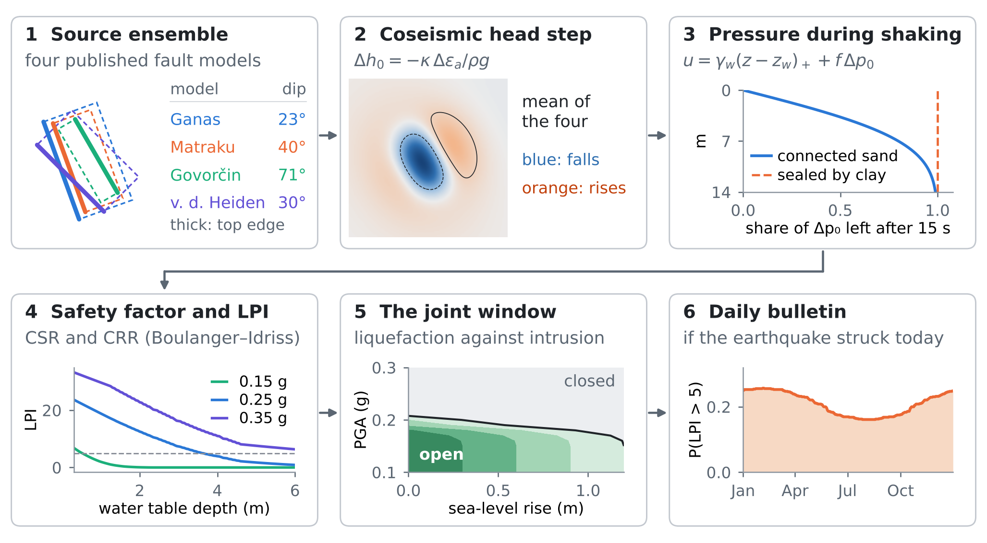
Figure 1. SHOCK-GO in six steps, each with its computed field: (1) the four source models (thick line: top edge of the fault); (2) the mean head step in the confined aquifer; (3) the share of the step left after 15 s of shaking; (4) LPI against the depth of the water table; (5) the joint safe window against sea-level rise and design acceleration; (6) the daily bulletin.
2. What was implemented
The note [D1] proposed three first steps: the liquefaction module, the coseismic step from the published source models, and a hindcast of the 2019 liquefaction. Table 1 lists what each step became. The parameters of the coastal plain, the soils and the ground motion are illustrative and the coordinates are local (km from the fault centroid); this is a test of the method, not a map of Durrës.
Table 1. The modules, what they compute and how they were checked.
Step of [D1] | Module | What it computes | Checked by
1. Liquefaction | liq.py | $σ_{v}$, $u$, $σ_{v}^{′}$, CSR, CRR, FS, LPI, $∂lnFS/∂z_{w}$ | structural values; finite differences of (4.9) and of the closed form
2. Coseismic step | okada85.py, liq.py | surface displacement and strain [1]; $Δp_{0}=−κ Δε_{a}$; drainage share $f$ | okada_checks.py (five tests); Biot’s law (1.1)
3. Hindcast design | the main script, E3 | AUC of four predictors; power against the number of sites | DeLong covariance [15]; 400 resamples per size
Innovation | the main script, E4 | joint window, closing sea level, daily bulletin | quantiles over 60 profiles and 12 accelerations

3. E1: the liquefaction module
3.1 The pore pressure of the day
The module follows (4.2)–(4.8) of [D1] (Boulanger and Idriss [9], eqs. 2.2, 2.7, 2.14, 2.16, 2.19, 2.20 and 2.24). One change is needed. In (4.1) the coseismic step was added to the water table. A step of pore pressure in a sand below a clay is not a movement of the water table: the water table is where $u=0$, and it does not move in the seconds of shaking. The step enters the pore pressure:
$$u\left(z\right)=γ_{w}{\left(z−z_{w}\right)}_{\text{+}}+f\left(z\right) Δp_{0}\left(z\right), σ_{v}^{′}\left(z\right)=σ_{v}\left(z\right)−u\left(z\right), σ_{v}\left(z\right)=\int_{0}^{z}{γ_{t}} dz^{′}$$ | (1)
where $z_{w}$ is the depth of the water table on the day, $Δp_{0}$ the undrained step (Section 4) and $f$ the share of it left at the end of the shaking (Section 4.5). Then, with $q=q_{c1Ncs}$,
$$FS=\frac{{CRR}_{7.5,1}\left(q\right) MSF\left(q,M\right) K_{σ}\left(q,σ_{v}^{′}\right)}{0.65 \left(σ_{v}/σ_{v}^{′}\right) \left(a_{max}/g\right) r_{d}\left(z,M\right)}, LPI=\int_{0}^{20 m}{max}\left(0,1−FS\right) \left(10−0.5z\right) dz$$ | (2)
with the functions of (4.3)–(4.7) of [D1]. $FS$ is set to infinity above the water table and in soils that cannot liquefy (clays and silts with $I_{c}$ above 2.6).
3.2 What the CPT resistance is, and the shortcut to avoid
$q_{c1Ncs}$ is a density index: the tip resistance normalised with the effective stress at the time of the CPT. It describes the sand and does not change when the water table moves later. The water table of the day enters only through CSR and $K_{σ}$. Re-normalising $q_{c1Ncs}$ with the stress of the day (through $C_{N}={\left(P_{a}/σ_{v}^{′}\right)}^{m}≤1.7$) mixes the state of the sand with the state of the water. For the example profile, with the CPT made at a water table of 2.0 m, the shortcut gives an LPI slope of 4.1 per metre instead of 6.0: it understates the effect of the water table by 33% (Figure 2e, dashed).
3.3 The sensitivity to the water table in closed form
Proposition 1 (sensitivity of the factor of safety). Below the water table, with the same unit weight above and below it, $q_{c1Ncs}$ fixed and $Δp_{0}=0$,
$$\frac{∂lnFS}{∂z_{w}}=\frac{γ_{w}}{σ_{v}^{′}}\left(1−\frac{C_{σ}}{K_{σ}}\right) \text{if }K_{σ}<1.1; \frac{∂lnFS}{∂z_{w}}=\frac{γ_{w}}{σ_{v}^{′}} \text{if }K_{σ}=1.1$$ | (3)
The first factor is (4.9) of [D1] with the opposite sign; the second is the share that $K_{σ}$ takes back. Because $C_{σ}≤0.3$ and $K_{σ}$ is near 1, a deeper water table always raises $FS$.

Proof. $CRR_{7.5,1}$ and $MSF$ depend on $q$ and $M$ only, and $r_{d}$ on $z$ and $M$. Below the water table $∂σ_{v}^{′}/∂z_{w}=γ_{w}$ and $σ_{v}$ does not change. Hence $∂lnCSR/∂z_{w}=−γ_{w}/σ_{v}^{′}$, which is (4.9). From (4.7), $∂K_{σ}/∂z_{w}=−C_{σ}γ_{w}/σ_{v}^{′}$ below the cap and zero on it. Subtracting the logarithmic derivative of CSR from that of $K_{σ}$ gives (3). □
Table 2 lists the structural checks. Both derivatives agree with central finite differences to about ${10}^{−10}$, the rounding level of the differences.
Table 2. Checks of the liquefaction module.
Check | Expected | Computed
$MSF$ at $M$ = 7.5 | 1 (definition) | 1.000
$K_{σ}$ at $σ_{v}^{′}=P_{a}$ | 1 (definition) | 1.000
$r_{d}$ at the surface, $M$ = 6.4 | close to 1 | 1.008
$CRR_{7.5,1}$ at $q_{c1Ncs}$ = 100 | from (4.5) | 0.137
(4.9) against finite differences | relative error ≈ 0 | 3.3×10⁻¹⁰
(3) against finite differences | relative error ≈ 0 | 3.4×10⁻¹⁰

3.4 An example profile
A coastal profile of a 1.2 m crust over three sands (median $q_{c1Ncs}$ of 82, 104 and 132, with CPT-like scatter) separated by silty clays was shaken by $M$ 6.4 at 0.25 g with the water table at 0.8, 1.6 and 2.6 m. The LPI is 20.2, 14.9 and 9.3 (Figure 2). The upper sand carries most of the LPI, because there the stress is low and the weight $10−0.5z$ is high; this is why the LPI is so sensitive to the water table when the liquefiable layers are shallow, as Maurer et al. [11] observed.
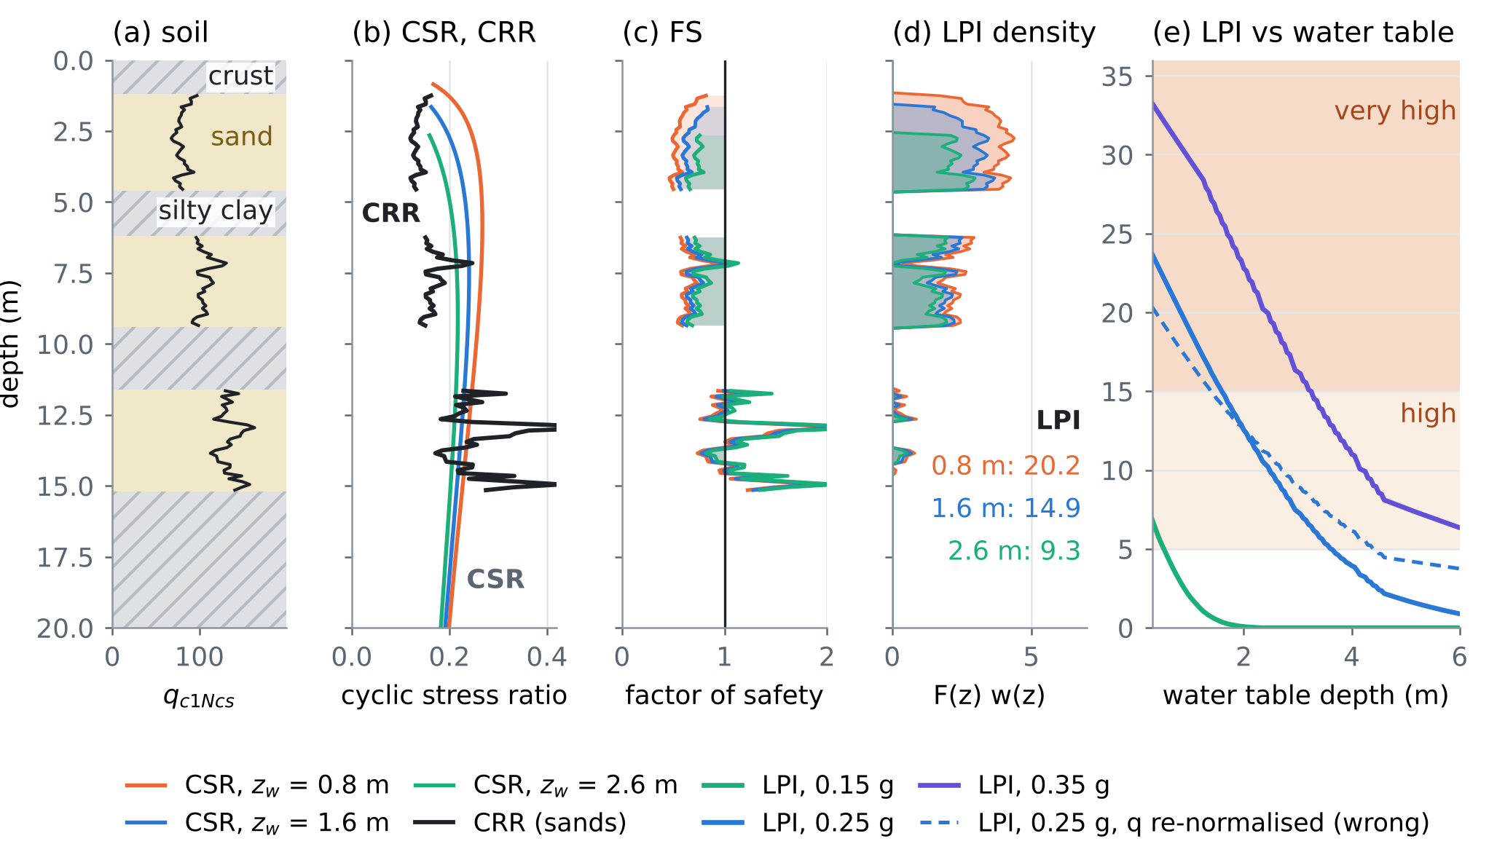
Figure 2. E1. (a) The profile: crust and silty clays hatched, sands shaded, $q_{c1Ncs}$ as a line. (b) CSR for three water tables and CRR of the sands. (c) Factor of safety; shaded where FS < 1. (d) The LPI integrand and the LPI for each water table. (e) LPI against the depth of the water table for three accelerations; dashed: the shortcut of Section 3.2. Shading: high (5–15) and very high (over 15) LPI.
4. E2: the coseismic step
4.1 Okada’s solution, written and checked
The surface displacement of a rectangular dislocation in an elastic half-space [1] was written in numpy (okada85.py), and the horizontal strains were taken by fourth-order central differences. The note cites Okada [2], the internal-deformation form; the surface form [1] is the one needed for a shallow layer (Section 4.3). Five tests that do not use the code itself (okada_checks.py) all pass (Table 3).
Table 3. Independent checks of okada85.py.
Test | What must hold | Result
C1. Fault reaching the surface | jump of displacement across the trace = slip vector (strike-slip, and reverse at 45°) | error ≤ 6.1×10⁻⁵ m per m of slip
C2. Point-source limit | a 200 m fault far away = the point-source formulas of [1] × area | relative error ≤ 6.1×10⁻⁴
C3. Plane strain | a 2000 km fault: surface displacement independent of $ν$ | 0.2% change for $ν$ 0.25 → 0.40 (20 km fault: 5.2%)
C4. Sense of motion | reverse lifts the hanging wall, normal lowers it; left-lateral moves the far side left | $u_{z}$ = +0.227 and -0.227 m; $u_{n}$ = +0.051 (east), -0.051 (west) m
C5. Strain step | strain independent of the difference step (1, 2, 4 m) | relative change ≤ 1.8×10⁻¹¹

4.2 Four published source models
The geometry of each model was taken from its abstract; what an abstract did not give was derived from the moment magnitude with uniform slip, $M_{0}=μLWs$, $M_{w}=\left(\log_{10}M_{0}−9.1\right)/1.5$ [3], $μ$ = 30 GPa (Table 4). The strike follows the NW–SE trend of the structure, set by the dip direction. All four are reverse faults (rake 90°).
Table 4. The source ensemble. Bold: from the abstract of the paper; the rest derived here.
Model | Dip | Centroid depth | L × W (km) | Slip (m) | Mw here
Ganas et al. 2020 [4] | 23° E | 16.5 km | 22 × 13 | 0.55 | 6.38
Matraku et al. 2023 [6] | 40° E | 15 km | 20 × 11 | 0.71 (uniform) | 6.38
Govorčin et al. 2020 [5] | 71° SW | 17 km (slip at 11–23 km) | 18 × 12.7 | 0.52 (uniform) | 6.30
van der Heiden et al. 2026 [7] | about 30° NE | 15 km (12–18 km) | 20 × 12 | 0.70 (uniform) | 6.40

4.3 The undrained step in a layer under the free surface
Equation (2.2) of [D1] gives the step as $Δp_{0}=−BK_{u}Δε_{v}$, with $Δε_{v}$ the volumetric strain of the half-space (2.1). That is right for an aquifer as stiff as the half-space. The sediments of a coastal plain are much softer and lie in a layer tens to hundreds of metres thick, against a deformation field that varies over kilometres. Such a layer takes the horizontal strain of the crust beneath it, while its top is free: $σ_{zz}=0$.
Proposition 2 (the step under a free surface). For an undrained ($ζ=0$) poroelastic layer obeying (1.1)–(1.2) of [D1], with imposed horizontal strains and $σ_{zz}=0$,
$$Δp_{0}=−κ Δε_{a}, Δε_{a}=Δε_{xx}+Δε_{yy}, κ=\frac{2GB}{3} \frac{1+ν_{u}}{1−ν_{u}}$$ | (4)
with $G$, $B$ and $ν_{u}$ of the layer. Equivalently $Δp_{0}=−BK_{u}Δε_{v}$ with the volumetric strain of the layer, $Δε_{v}=Δε_{a}\left(1−2ν_{u}\right)/\left(1−ν_{u}\right)$, not that of the half-space. A soft saturated layer ($ν_{u}→1/2$) deforms at almost constant volume, and $κ→2GB$: the step scales with the shear modulus of the layer, not with the stiffness of its water.

Proof. With $ζ=0$, (1.2) gives $p=−αMε_{v}$, and (1.1) becomes undrained elasticity with $λ_{u}=2Gν_{u}/\left(1−2ν_{u}\right)$. Then $σ_{zz}=0$ gives $ε_{zz}=−ν_{u}ε_{a}/\left(1−ν_{u}\right)$, so $ε_{v}=ε_{a}\left(1−2ν_{u}\right)/\left(1−ν_{u}\right)$. With $αM=BK_{u}$ and $K_{u}=2G\left(1+ν_{u}\right)/\left[3\left(1−2ν_{u}\right)\right]$, $p=−BK_{u}ε_{v}$ is (4). The identity was checked against (1.1)–(1.2) solved directly for five random materials, to $2×{10}^{−16}$. □
At the surface of the half-space $Δε_{v}=Δε_{a}\left(1−2ν\right)/\left(1−ν\right)$, so (2.2) as written corresponds to $κ_{\left(2.2\right)}=BK_{u}\left(1−2ν\right)/\left(1−ν\right)$ = 3.33 GPa for $BK_{u}$ = 5 GPa and $ν$ = 0.25. Table 5 compares the three coefficients. The confined aquifer and the soft sand are placeholders until $G$ is measured (seismic CPT or surface waves) and $B$ is taken from the tidal response of the wells, as Section 8 of [D1] proposes.
Table 5. The step coefficient and the step over the four source models. Head per microstrain of areal strain; ranges are the extremes of the four maps.
Layer | G, B, νu | κ | Head per microstrain | Fall (hanging wall) | Rise (in front)
Soft surface sand | 50 MPa, 0.98, 0.49 | 95 MPa | 10 mm | 7–12 cm | 3–4 cm
Confined aquifer | 0.5 GPa, 0.90, 0.45 | 0.79 GPa | 81 mm | 0.6–1.0 m | 0.2–0.3 m
(2.2) as written | $BK_{u}$ = 5 GPa, $ν$ = 0.25 | 3.33 GPa | 340 mm | 35 × soft sand | 4.2 × confined

4.4 The pattern and the agreement of the models
All four models put a fall of the head over the hanging wall, where the uplifted crust is stretched, and a rise in front of the buried top edge and behind the fault, where it is squeezed (Figure 3a–d). Where the areal strain of any model exceeds 0.75 microstrain, the four agree on the sign over 86% of the area. They disagree in a ring around the fall (Figure 3e, dotted), whose position is set by the dip: the 71° model of Govorčin et al. narrows the fall and moves the rise towards the trace. The ensemble therefore carries a real epistemic spread, as [D1] anticipated, but not in the sign over the hanging wall.
4.5 Drainage during the shaking
A sand connected to the water table through sand drains during the shaking. For one-dimensional diffusion from the water table, the share of the step left after a shaking of duration $t_{s}$ at depth $L$ below the water table is
$$f\left(L\right)=erf\left(\frac{L}{2\sqrt{D t_{s}}}\right) \text{for sand connected through sand;} f=1 \text{for sand sealed by clay}$$ | (5)
With a diffusivity of 1 m²/s and 15 s of shaking, 7% of the step is left at 0.5 m, 28% at 2 m, 64% at 5 m and 97% at 12 m (Figure 3g). The shallow sands that dominate the LPI lose most of a step in seconds; a sand sealed by clay keeps it.
4.6 The earthquake as a free pumping test
After the step, a confined sand below a leaky clay relaxes as $Δh\left(t\right)=Δh_{0}e^{−t/τ}$, which is (2.3) of [D1] reduced to one compartment. The leakage time $τ$ is the quantity that a pumping test measures. A 0.3 m step with $τ$ = 3 days was recorded every 15 minutes with 2 cm noise for 20 days. The fit gives $\hat{τ}$ = 3.00 days and a 95% bootstrap interval of 2.94–3.07 days. The same $τ$ from the phase lag of a whole year of daily heads (amplitude 0.5 m, same noise) has an interval of 2.67–3.37 days, 5.8 times wider (Figure 3h). Every well in the confined aquifer that logged the night of 26 November 2019 holds such a test.
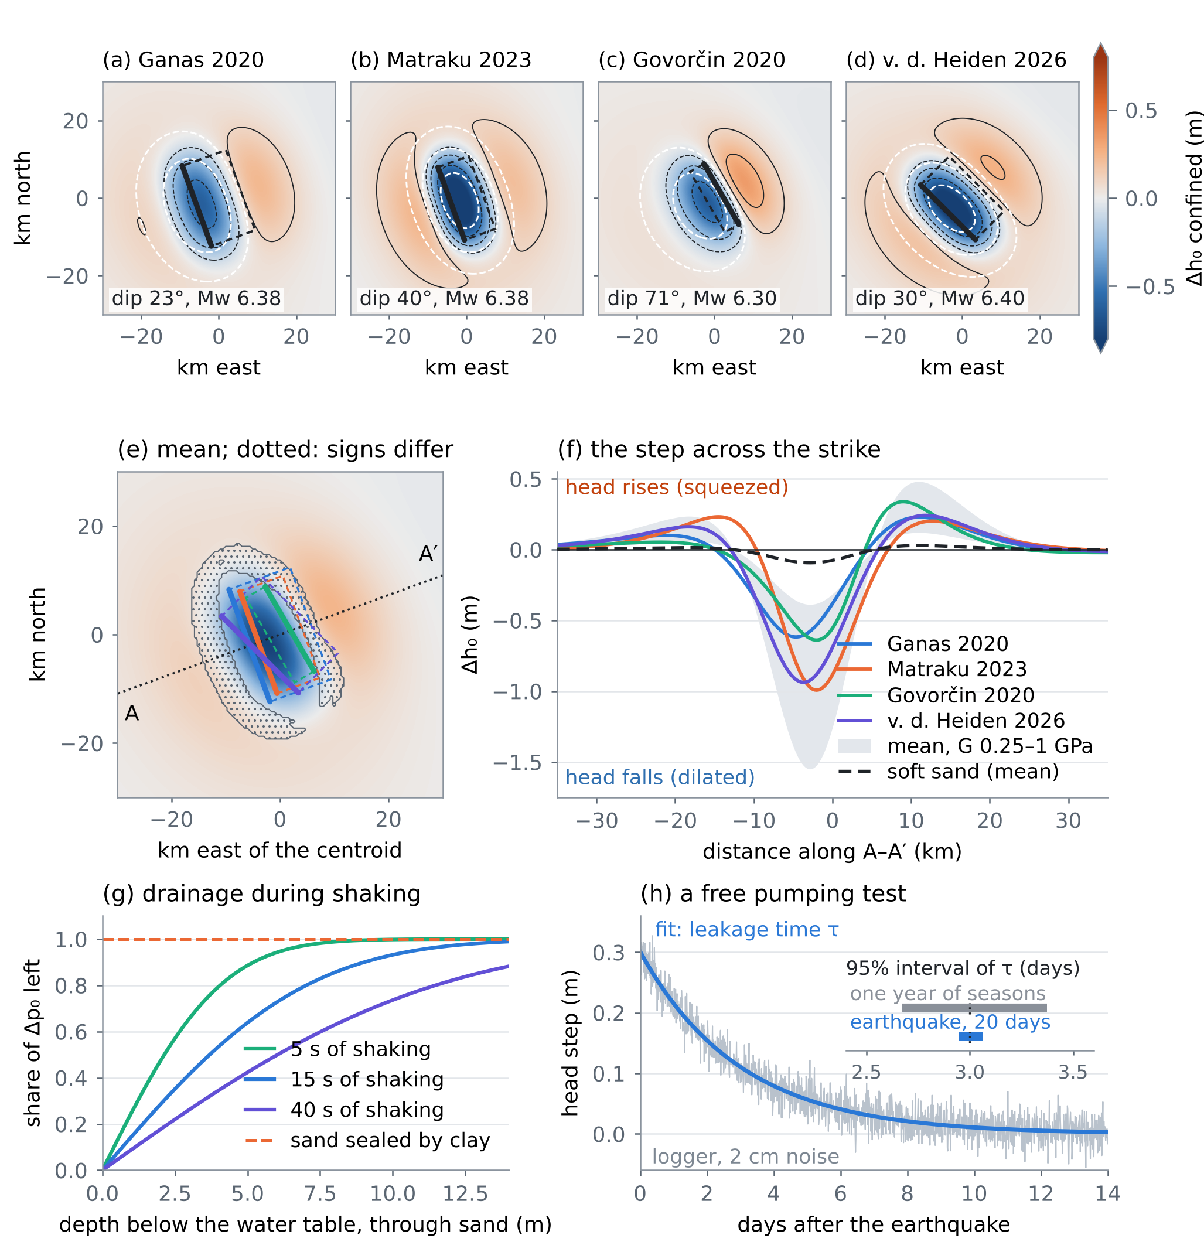
Figure 3. E2. (a–d) Head step in the confined aquifer for the four source models; contours at −0.5, −0.25, −0.1, 0.1 and 0.25 m; white dashed: uplift of 2, 5 and 10 cm; thick line: top edge of the fault. (e) Mean of the four; dotted where they disagree on the sign; A–A′: the transect. (f) The step along A–A′: the four models in the confined aquifer, the band of the mean for $G$ from 0.25 to 1 GPa, and the mean in the soft surface sand. (g) Share of the step left after the shaking, (5). (h) The relaxation after a 0.3 m step and the 95% intervals of $τ$ from the earthquake and from a year of seasons.
5. E3: designing the 2019 hindcast
The third step of [D1] is to ask whether the water table of the day and the step improve the prediction of where liquefaction occurred in 2019 [8]. Before collecting data, the test was designed on a synthetic coastal plain: 900 sites within 8 km of a coast that strikes N160°, over the fault of Ganas et al., each with a layered profile whose share of sand follows a smooth susceptibility field, a seasonal water table, and a peak acceleration that decays with distance with lognormal scatter. The truth uses the water table of 26 November and the largest step, (2.2) as written; 38% of the sites liquefy. Four predictors were compared by the area under the ROC curve (AUC), with the DeLong covariance for paired AUCs [15] and a one-sided test at 5%:
• M0: mean water table; M1: water table of the day; M2: M1 plus the step of the four-model mean; M3: M1 plus the step of the true source.
On all 900 sites the AUCs are 0.736, 0.738, 0.753 and 0.754 (Figure 4b). The gains are small because most of the information sits in the soil and the shaking. Table 6 gives the power: the chance that a hindcast with $N$ mapped sites detects the gain.
Table 6. Power of the paired-AUC test (400 resamples per size, one-sided, 5%).
Test | N = 30 | 60 | 120 | 240 | 480
Water table of the day (M1 vs M0) | 1% | 5% | 7% | 13% | 26%
Step, four-model mean (M2 vs M1) | 7% | 12% | 14% | 24% | 40%
Step, true source (M3 vs M1) | 6% | 14% | 17% | 30% | 49%

With the coefficient of soft sand (Section 4.3) the step changes the LPI of a site by a median of 0.02 and at most 0.77, against a median of 0.69 for the upper bound (Figure 4d). No number of sites would detect it. Design conclusion: the liquefaction map of 2019 cannot test the coseismic step, and it tests the water table of the day only with several hundred CPTs at mapped sites. The step should be tested where it is large, in the confined aquifer, on the well records of November 2019 (Section 4.6). A liquefaction hindcast remains useful to calibrate the triggering at the site, but with its low power stated in advance.
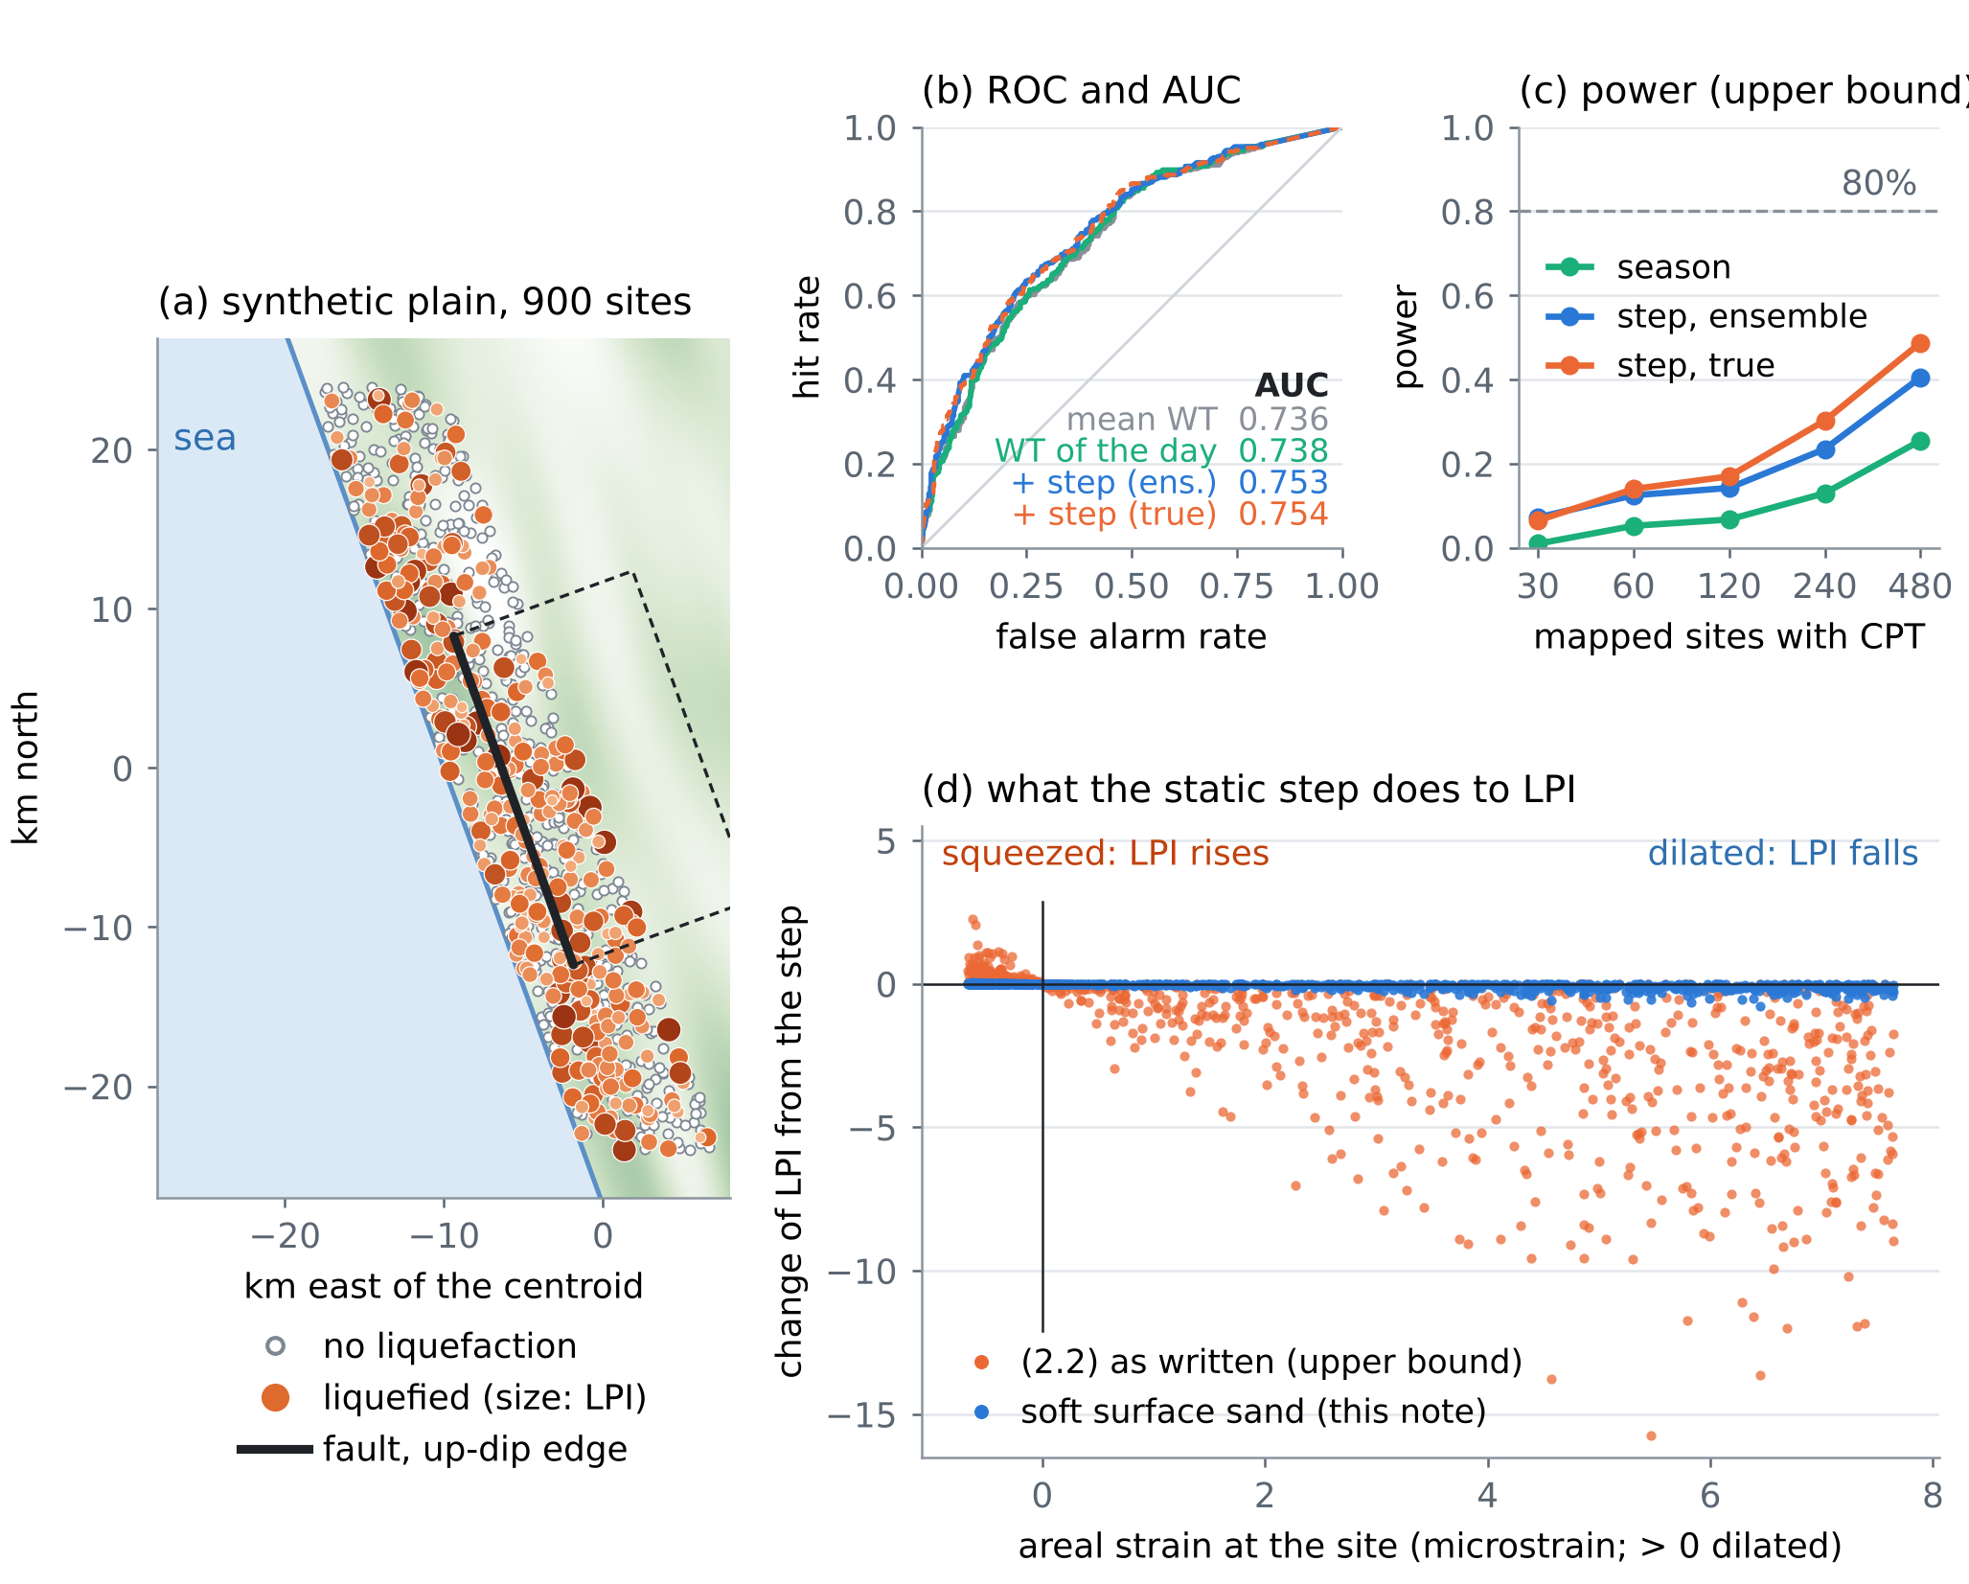
Figure 4. E3. (a) The synthetic plain: sites without and with liquefaction (size: LPI), the coast and the fault. (b) ROC curves and AUCs of the four predictors. (c) Power against the number of mapped sites (upper-bound step). (d) Change of LPI caused by the step, against the areal strain at the site: (2.2) as written (orange) and soft surface sand (blue).
6. E4: the joint safe window and the daily bulletin, computed
6.1 Two limits on one head
Let $h$ be the managed head at a low coastal site above mean sea level, $z_{s}$ the ground elevation and $z^{⋆}\left(a\right)$ the depth that the water table must keep for the LPI to stay below 5 under the design acceleration $a$, certified as the 90% quantile over the profiles of the site. Liquefaction asks for $h≤z_{s}−z^{⋆}\left(a\right)$. The Ghyben–Herzberg relation (3.7) of [D1] keeps the interface at least 20 m deep if $h≥η+m_{int}$ with $m_{int}$ = 20/40 = 0.5 m, $η$ being the relative sea-level rise [16]. This is the certified multi-hazard window of the proposal [D2], written for one managed head. The window and its width are
$$η+m_{int} ≤ h ≤ z_{s}−z^{⋆}\left(a\right), W\left(η,a\right)=z_{s}−z^{⋆}\left(a\right)−η−m_{int}$$ | (6)
A head that swings by $A$ over the year stays inside all year only if $W≥A$. The window closes for good at
$$η_{close}\left(a\right)=z_{s}−z^{⋆}\left(a\right)−m_{int}−A$$ | (7)
Both limits move the wrong way with time: sea-level rise and subsidence (3.3)–(3.5) of [D1] raise $η$; a larger design acceleration deepens $z^{⋆}$. Pumping to fight liquefaction lowers $h$ towards intrusion; recharge to fight intrusion raises it towards liquefaction.
6.2 The port of E4
A synthetic low port: ground at $z_{s}$ = 2.0 m, 60 CPT-like profiles with sands from 1–2 m depth, $A$ = 0.3 m. Table 7 and Figure 5 give the result. The median profile needs no lowering up to 0.22 g; the window is set by the weakest tenth of the port.
Table 7. The water table that keeps 90% of the port below LPI 5, and the sea level at which the all-year window closes. Years at an illustrative 9 mm/yr of relative sea-level rise (4 mm/yr of sea and 5 mm/yr of subsidence, not measured values).
Design acceleration | z* certified (90%) | z* median | η at closing | Year
0.15 g | 0.00 m | 0.00 m | 1.20 m | about 2159
0.18 g | 0.27 m | 0.00 m | 0.93 m | about 2129
0.20 g | 0.91 m | 0.00 m | 0.29 m | about 2059
0.22 g | 1.76 m | 0.00 m | -0.56 m | closed already
0.25 g | 2.89 m | 0.25 m | -1.69 m | closed already

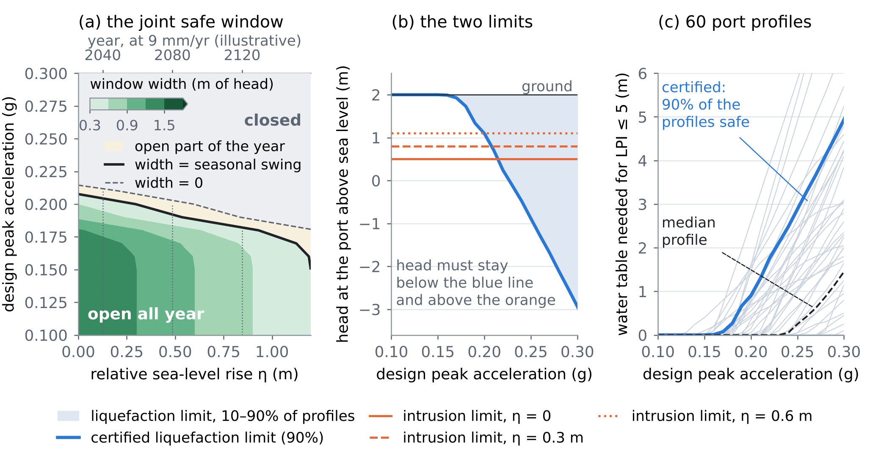
Figure 5. E4. (a) Width of the joint window against relative sea-level rise and design acceleration; the solid line is where it equals the seasonal swing, the dashed line where it vanishes; top axis: years at an illustrative 9 mm/yr. (b) The two limits on the head: liquefaction (blue, certified) and intrusion (orange) for three sea levels. (c) The water table needed for LPI ≤ 5 in each of the 60 profiles, their median and the certified 90% line.
6.3 The daily bulletin
The same profiles give, for each day $d$, the probability that the LPI exceeds 5 if the design earthquake ($M$ 6.4, median 0.22 g, lognormal scatter 0.35) struck that day:
$$P_{d}=Pr\left[LPI>5∣\text{earthquake on day }d\right]=\frac{1}{N_{p}N_{a}}\sum_{i=1}^{N_{p}}{\sum_{j=1}^{N_{a}}{1}}\left[{LPI}_{i}\left(z_{w}\left(d\right),a_{j}\right)>5\right]$$ | (8)
with $N_{p}$ = 60 profiles and $N_{a}$ = 12 accelerations. With the natural water table moving between 0.9 and 2.0 m, $P_{d}$ moves between 0.16 in late July and 0.26 in early February (Figure 6). With the logger network of the project, $z_{w}\left(d\right)$ is measured, and the bulletin can be issued daily, with the conformal or certified bounds of the CERTAIN-COAST cycle in place of the plain quantiles used here.
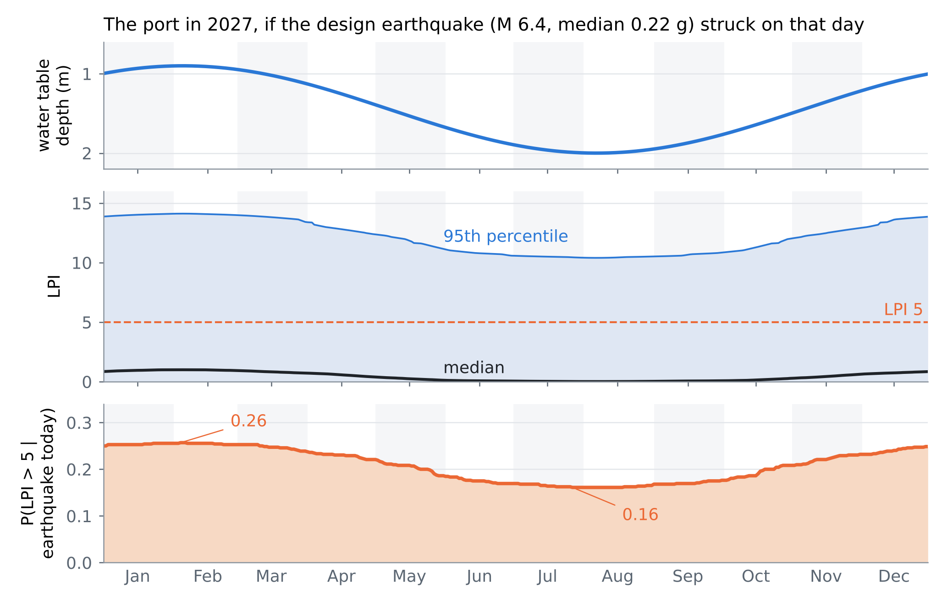
Figure 6. The daily bulletin for the port in 2027. Top: the water table. Middle: the median and the 5–95% band of the LPI over profiles and accelerations. Bottom: the probability that the LPI exceeds 5 if the earthquake struck that day.
7. What changes in the note
The revised Albanian note [D1] carries these changes. Its first page lists them, and each new paragraph opens with a short bold title:
• (4.1)–(4.2). The step enters the pore pressure, $u=γ_{w}{\left(z−z_{w}\right)}_{\text{+}}+fΔp_{0}$ (1), with the drainage share (5); the water table does not jump.
• (2.2). For a layer under the free surface, $Δp_{0}=−κ Δε_{a}$ (4); in soft sand the step is centimetres. The mechanism paragraph now separates the static step from the volumetric change caused by the shaking (Wang and Chia [14]), which CSR–CRR already contains, so that it is not counted twice.
• (2.4). The constant: from $e=3E/\left(4πr^{3}\right)$ and $\log_{10}E=5.24+1.44M$ it is −4.38, not −4.62; for $M$ 6.4 the radius of $e$ = 0.1 J/m³ becomes 88 km instead of 73 km. Both are larger than the distance from the 2019 source to the Durrës–Fushë Kuqe coast (a few tens of kilometres), so no decision there depends on it. Wang and Chia [14] present the relation as new; its printed constant must be read there before use.
• 4.5. $q_{c1Ncs}$ is fixed by the CPT; the full sensitivity is (3); the shortcut of Section 3.2 biases the slope by 33%.
• 3.3. The compaction equations are those of the CSUB package of MODFLOW 6 [20], which replaces SUB-WT.
• 5.6. Settlement from liquefaction is the integral of the post-shaking volumetric strain over depth, with the strain from $FS$ and $q_{c1Ncs}$ as in Zhang et al. [19]; the coefficients are taken from that paper, not repeated here.
8. Limits
The soils, the coastal plain and the ground motion are synthetic, and the port is not a real port. The source models use uniform slip on one rectangle; the published slip distributions are richer. The half-space is homogeneous; a layered crust changes the strain near the surface. The layer coefficients $G$, $B$ and $ν_{u}$ are assumed, not measured; Proposition 2 assumes a layer thin against the deformation field and fully undrained during the step. The cyclic generation of pore pressure is left inside CSR–CRR, as the triggering procedure intends, and is not modelled as a separate step. Drainage during the shaking is one-dimensional. The hindcast design uses one source as the truth and the upper bound of the step, so its powers are optimistic. The window uses one intrusion criterion (an interface 20 m deep) and a 90% quantile over 60 profiles; the year axis rests on an illustrative rate. The bulletin uses a fixed scenario earthquake, not a hazard curve. The settlement and the flood steps of [D1] were not implemented.
Verification note. The external references [1–20] were checked in Crossref (DOI, authors, title, venue), November 2026, except the report [9], which has no DOI. The geometry of the source models comes from their abstracts. The note was drafted with the help of an AI assistant. Every number is computed by the SHOCK-GO experiment (the main script, okada_checks.py; results in res/) and inserted by the build script.
References
Published sources
[1] Okada, Y. (1985). Surface deformation due to shear and tensile faults in a half-space. Bulletin of the Seismological Society of America 75(4), 1135–1154. https://doi.org/10.1785/BSSA0750041135
[2] Okada, Y. (1992). Internal deformation due to shear and tensile faults in a half-space. Bulletin of the Seismological Society of America 82(2), 1018–1040. https://doi.org/10.1785/bssa0820021018
[3] Hanks, T. C., & Kanamori, H. (1979). A moment magnitude scale. Journal of Geophysical Research: Solid Earth 84(B5), 2348–2350. https://doi.org/10.1029/JB084iB05p02348
[4] Ganas, A., et al. (2020). Ground deformation and seismic fault model of the M6.4 Durres (Albania) Nov. 26, 2019 earthquake, based on GNSS/InSAR observations. Geosciences 10, 210. https://doi.org/10.3390/geosciences10060210
[5] Govorčin, M., et al. (2020). Geodetic source modeling of the 2019 Mw 6.3 Durrës, Albania, earthquake: partial rupture of a blind reverse fault. Geophysical Research Letters 47, e2020GL088990. https://doi.org/10.1029/2020GL088990
[6] Matraku, K., et al. (2023). The 26 November 2019 Durrës earthquake, Albania: coseismic displacements and occurrence of slow slip events in the year following the earthquake. Geophysical Journal International 234, 807–838. https://doi.org/10.1093/gji/ggad101
[7] van der Heiden, V., et al. (2026). Analysis of the 2019 Mw 6.4 Durrës, Albania, aftershock sequence: basement involved thrusting at the eastern Adriatic plate margin. Geophysical Journal International 246, ggag155. https://doi.org/10.1093/gji/ggag155
[8] Mavroulis, S., Lekkas, E., & Carydis, P. (2021). Liquefaction phenomena induced by the 26 November 2019, Mw = 6.4 Durrës (Albania) earthquake and liquefaction susceptibility assessment in the affected area. Geosciences 11, 215. https://doi.org/10.3390/geosciences11050215
[9] Boulanger, R. W., & Idriss, I. M. (2014). CPT and SPT based liquefaction triggering procedures. Report UCD/CGM-14/01, Center for Geotechnical Modeling, University of California, Davis.
[10] Boulanger, R. W., & Idriss, I. M. (2016). CPT-based liquefaction triggering procedure. Journal of Geotechnical and Geoenvironmental Engineering 142, 04015065. https://doi.org/10.1061/(asce)gt.1943-5606.0001388
[11] Maurer, B. W., et al. (2014). Evaluation of the liquefaction potential index for assessing liquefaction hazard in Christchurch, New Zealand. Journal of Geotechnical and Geoenvironmental Engineering 140, 04014032. https://doi.org/10.1061/(asce)gt.1943-5606.0001117
[12] Rice, J. R., & Cleary, M. P. (1976). Some basic stress diffusion solutions for fluid-saturated elastic porous media with compressible constituents. Reviews of Geophysics 14, 227–241. https://doi.org/10.1029/rg014i002p00227
[13] Wang, C.-Y., & Manga, M. (2021). Water and Earthquakes. Springer International Publishing. https://doi.org/10.1007/978-3-030-64308-9
[14] Wang, C.-Y., & Chia, Y. (2008). Mechanism of water level changes during earthquakes: near field versus intermediate field. Geophysical Research Letters 35(12). https://doi.org/10.1029/2008GL034227
[15] DeLong, E. R., DeLong, D. M., & Clarke-Pearson, D. L. (1988). Comparing the areas under two or more correlated receiver operating characteristic curves: a nonparametric approach. Biometrics 44(3), 837–845. https://doi.org/10.2307/2531595
[16] Werner, A. D., et al. (2013). Seawater intrusion processes, investigation and management: recent advances and future challenges. Advances in Water Resources 51, 3–26. https://doi.org/10.1016/j.advwatres.2012.03.004
[17] Grant, A. R. R., et al. (2021). Changes in liquefaction severity in the San Francisco Bay Area with sea-level rise. Geo-Extreme 2021, 308–317. https://doi.org/10.1061/9780784483695.030
[18] Befus, K. M., et al. (2020). Increasing threat of coastal groundwater hazards from sea-level rise in California. Nature Climate Change 10, 946–952. https://doi.org/10.1038/s41558-020-0874-1
[19] Zhang, G., Robertson, P. K., & Brachman, R. W. I. (2002). Estimating liquefaction-induced ground settlements from CPT for level ground. Canadian Geotechnical Journal 39(5), 1168–1180. https://doi.org/10.1139/t02-047
[20] Hughes, J. D., Leake, S. A., Galloway, D. L., & White, J. T. (2022). Documentation for the Skeletal Storage, Compaction, and Subsidence (CSUB) Package of MODFLOW 6. U.S. Geological Survey Techniques and Methods 6-A62. https://doi.org/10.3133/tm6A62
Notes of this series (in this repository)
[D1] Zeqiraj, D. (2026). Tërmeti, akuiferi, veprimet njerëzore dhe përmbytjet: sistemi i ekuacioneve të çiftuara për bregdetin Durrës–Fushë Kuqe (the TERMETET note). Working note, 31 October 2026; revised version docs/research_notes/TERMETET_CERTAIN-COAST_Termeti_Akuiferi_Permbytjet_Sistemi_i_Ekuacioneve_rishikuar.docx in this repository.
[D2] CERTAIN-COAST (2026). Certified early warning to protect water, port and energy infrastructure on a sinking Adriatic coast. Technical annex of the NATO SPS application (draft), docs/certain_coast/CERTAIN-COAST_Technical_Annex.docx in this repository.

PART  5 | CV of the NATO-country Project Director  Assoc. Prof. Dr. Dulian Zeqiraj, Faculty of Geology and Mining, Polytechnic University of Tirana.

Dulian Zeqiraj
NATO-country Project Director, CERTAIN-COAST
1. Personal details
Item | Details
Name | Dulian Zeqiraj
Title and position | Assoc. Prof. Dr., Faculty of Geology and Mining (FGJM), Polytechnic University of Tirana
Department | Department of Energy Resources
Country | Albania (NATO member)
E-mail | dulian.zeqiraj@fgjm.edu.al
ORCID and researcher IDs | [ORCID, Scopus ID]
2. Education
Year | Degree | Institution | Field
[year] | Doctor of Sciences (Dr.) | [institution, country] | [field]
1991–1996 | University diploma (five years) | Faculty of Geology and Mining, University of Tirana, Albania | Drilling and production wells
3. Career
Years | Position | Institution
[year]– | Associate Professor | Faculty of Geology and Mining, Polytechnic University of Tirana
2008–[year] | Lecturer, Department of Reservoir Engineering (now Energy Resources) | Faculty of Geology and Mining, Polytechnic University of Tirana
2006–2008 | [position] | Albanian Geological Survey (Shërbimi Gjeologjik Shqiptar), Tirana
1996–2006 | [position] | Albpetrol, the national oil company, Albania
4. Expertise relevant to CERTAIN-COAST
• Seawater intrusion and monitoring design: goal-oriented Bayesian design of monitoring networks and of managed-aquifer-recharge wells for variable-density seawater intrusion (Journal of Hydrology, 2026).
• Inference and uncertainty in alluvial aquifers: Bayesian porosity inference with dependent errors; groundwater vulnerability (DRASTIC) coupled with numerical transport models (2026).
• Stochastic modelling of flow and transport: coupled geomechanical, geochemical and flow models of fractured and karst media; fracture initiation and propagation under fluid injection (2021–2022).
• Optimisation under uncertainty: placement and rates of wells; scheduling of field projects.
• Modelling software and field background: C++, Python and MATLAB; ten years in oil production (Albpetrol) and two years at the Albanian Geological Survey.
5. Selected publications (peer-reviewed, with DOI)
1. Zeqiraj, D. (2026). Goal-oriented Bayesian experimental design for variable-density seawater intrusion: Adjoint expected information gain for joint monitoring and managed-aquifer-recharge placement. Journal of Hydrology 680, 136559. https://doi.org/10.1016/j.jhydrol.2026.136559
2. Zeqiraj, D., Beqiraj, A. (2026). Adaptive stacked ensemble fusion: Bayesian porosity inference in alluvial aquifers when the errors are not independent. Journal of Contaminant Hydrology 283, 105086. https://doi.org/10.1016/j.jconhyd.2026.105086
3. Zeqiraj, D., Beqiraj, A., Jahja, A., Seitaj, B., Progni, F., Zeqo, E. (2026). Physical, biophysical, and chemical mechanisms of bidirectional coupling between DRASTIC vulnerability assessment and numerical transport modeling in heterogeneous aquifer systems. Journal of Hazardous Materials Advances 23, 101261. https://doi.org/10.1016/j.hazadv.2026.101261
4. Zeqiraj, D. (2022). 3D stochastic modeling of flow and solute transport in karst vadose zone. Case Studies in Chemical and Environmental Engineering 6, 100217. https://doi.org/10.1016/j.cscee.2022.100217
5. Zeqiraj, D. (2022). Stochastic modeling of fracture initiation and propagation during fluid flow in carbonate reservoir. Results in Applied Mathematics 13, 100244. https://doi.org/10.1016/j.rinam.2022.100244
6. Zeqiraj, D. (2022). Stochastic modeling of fluid flow in the simulation and quantification of fracture initiation and propagation in the oil carbonate reservoirs during water injection. Results in Control and Optimization 7, 100131. https://doi.org/10.1016/j.rico.2022.100131
7. Zeqiraj, D. (2021). Fully coupled stochastic geomechanical - geochemical - reservoir modeling for fracture reservoirs. Results in Engineering 11, 100242. https://doi.org/10.1016/j.rineng.2021.100242
Preprints (2026):
• Zeqiraj, D. (2026). Physics-informed deep learning for joint hydraulic conductivity–porosity mapping with Wasserstein optimal experimental design in alluvial aquifers. SSRN preprint. https://doi.org/10.2139/ssrn.7528503
• Zeqiraj, D., Beqiraj, A. (2026). Class probabilities for groundwater nitrate vulnerability maps: hierarchical Bayesian calibration of DRASTIC against monitoring data, and the value of new stations. SSRN preprint. https://doi.org/10.2139/ssrn.7511860
6. Projects and grants
Years | Project | Funder | Role
2025– | Modelling, simulation and optimisation of formation treatment methods to maximise the net profit of the massive carbonate reservoir of the Amonicë oil field (with Albpetrol Sh.A.) | National Agency for Scientific Research and Innovation (AKKSHI), Albania | Project leader
Other NATO SPS grants currently held: [none]
7. Work with end-users and in the field
• Albanian Geological Survey (SHGJSH): staff member, 2006–2008.
• Albpetrol, the national oil company: production wells and reservoirs, 1996–2006; since 2025 partner of his AKKSHI project, with field data, well records and the validation of a 3D reservoir model (MATLAB-MRST).
• Preparatory work for CERTAIN-COAST (2026): reviews with numerical tests and a calibrated chloride model of the Fushë-Kuqe aquifer, which supplies Durrës.
8. Teaching and supervision
• Master courses: Reservoir Engineering (well stimulation and enhanced oil recovery); Energy Resources (fossil and renewable); Physics of Energy Resources.
• [number] doctoral and [number] master students supervised.
9. Role in CERTAIN-COAST
As NATO-country Project Director, coordinates CERTAIN-COAST and is accountable for the SPS funds (WP7); leads the monitoring network designed for the warnings (WP4) and the live demonstration with the Ministry of Infrastructure and Energy, the end-user (WP5); contributes to the coupled model (WP2) and to the measurement of coastal motion and relative sea level (WP1). Chairs the steering committee, signs the access agreements for the wells (T7.2, Month 3) and oversees the hand-over to the Ministry of Infrastructure and Energy at Month 36.
10. Other
• Languages: Albanian (native); English [level]; [other languages]
• Programming: C++, Python, MATLAB

PART  6 | CV of the partner-country Project Director  Prof. Jassim Al-Khayat, Environmental Science Center, Qatar University.

Jassim Al-Khayat
Partner-country Project Director, CERTAIN-COAST
1. Personal details
Item | Details
Name | Prof. Jassim Abdulla Al-Khayat
Title and position | Research Professor and Manager of the research vessel Janan
Institution | Environmental Science Center, Qatar University, Doha
Country | Qatar (NATO partner country, Istanbul Cooperation Initiative)
Nationality | Qatari
2. Education
Year | Degree | Institution | Field
1993–1996 | PhD, Marine Biology | University of Wales, United Kingdom | Marine biology
1991–1992 | MSc, Marine Biology and Fisheries | University of Aberdeen, United Kingdom | Marine biology and fisheries
1979–1983 | BSc, Marine Science / Geology | Qatar University | Marine science and geology
3. Career
Years | Position | Institution
2021– | Research Professor and Manager of the research vessel Janan | Environmental Science Center, Qatar University
2007–2021 | Associate Professor and Coordinator of the Marine Sciences Program; Research Associate Professor | Qatar University
1996–2007 | Assistant Professor, then Associate Professor and Head of the Marine Sciences Department | Qatar University
4. Expertise relevant to CERTAIN-COAST
• Coastal and marine ecology: mangroves, intertidal habitats, marine biodiversity and benthic communities; mangrove loss, restoration and adaptation to climate change.
• Coastal sediments and carbon: carbon storage and cycling in the sabkhas and mudflats of Qatar; microbial processes in carbonate mineral formation; carbon mineralisation in sabkhas.
• Coastal pollution and monitoring: oil residues, metals in mangrove sediments, microplastics in beach sediments; satellite-based assessment of suspended sediments and shorelines.
• Field research and leadership: head of the Marine Sciences Department, coordinator of the marine science programmes and manager of the research vessel Janan.
5. Selected publications (peer-reviewed, with DOI)
1. Haseeba, K. P., Vethamony, P., Veerasingam, S., Aboobacker, V. M., Al-Khayat, J. A. (2025). A comprehensive review of oil residues in the world oceans: types, characteristics, sources and distribution. Marine Pollution Bulletin 217, 118106. https://doi.org/10.1016/j.marpolbul.2025.118106
2. Backer, S. A., Sankaran, R., Maruthavanan, R., Al-Khayat, J., Vethamony, P., et al. (2026). The shoreline shifts: a comprehensive review of change analysis focusing Arabian Gulf within global context. Regional Studies in Marine Science 102, 105433. https://doi.org/10.1016/j.rsma.2026.105433
3. Ibrahim, S. B. M., Sankaran, R., Backer, S. J., Al Absi, R., Mohammed, A. V., Al-Khayat, J. A., et al. (2026). Evaluation of mangrove ecosystem dynamics in the arid environment: for restoration on the Qatar coast using satellite data and hyperspectral imaging. Marine Pollution Bulletin 231, 119961. https://doi.org/10.1016/j.marpolbul.2026.119961
4. Backer, S. J., Sankaran, R., Al-Khayat, J. A., Vethamony, P., Rahman, M. M., Aravinth, J. (2026). Multi-decadal Landsat monitoring of shoreline dynamics in an enclosed arid gulf: comparison of 3-year and 10-year sampling designs. IEEE Journal of Selected Topics in Applied Earth Observations and Remote Sensing. https://doi.org/10.1109/JSTARS.2026.3747055
5. Al-Khayat, J., Veerasingam, S., Aboobacker, V. M., Vethamony, P. (2021). Hitchhiking of encrusting organisms on floating marine debris along the west coast of Qatar, Arabian/Persian Gulf. Science of the Total Environment 776, 145985. https://doi.org/10.1016/j.scitotenv.2021.145985
6. Al-Khayat, J. A., Vethamony, P., Nanajkar, M. (2021). Molluscan diversity influenced by mangrove habitat in the Khors of Qatar. Wetlands 41, 45. https://doi.org/10.1007/s13157-021-01441-6
6. Projects and grants
• Leads a five-year mangrove restoration project that assesses its environmental and socio-economic benefits.
• Has led a project on carbon mineralisation in sabkhas (microbial mats, minerals and carbon sequestration).
• Has led marine turtle conservation and monitoring programmes, and collaborative research with international institutions.
Other NATO SPS grants currently held: None
7. Work with end-users and in the field
• Manager of the research vessel Janan of Qatar University: field campaigns, research teams and institutional collaboration.
• Environmental monitoring, conservation and habitat restoration on the coasts of Qatar.
8. Teaching and supervision
• Head of the Marine Sciences Department (to 2007) and Coordinator of the Marine Sciences Program (2007–2021), Qatar University.
9. Role in CERTAIN-COAST
As partner-country Project Director, leads training, transfer and dissemination (WP6) for the team of the Environmental Science Center of Qatar University: the transfer study on the east coast of Qatar (selection and characterisation of the site, local environmental knowledge and public data, and the interpretation of the outputs with the Tirana team), the two-month exchanges of early-career researchers to the Durrës coast, a regional workshop, and a user-side review of the bulletins and operating procedures.
10. Other
• Honours: Outstanding Teaching Award, Qatar University (2015); National Incentive Award for Research, Qatar (2026).

