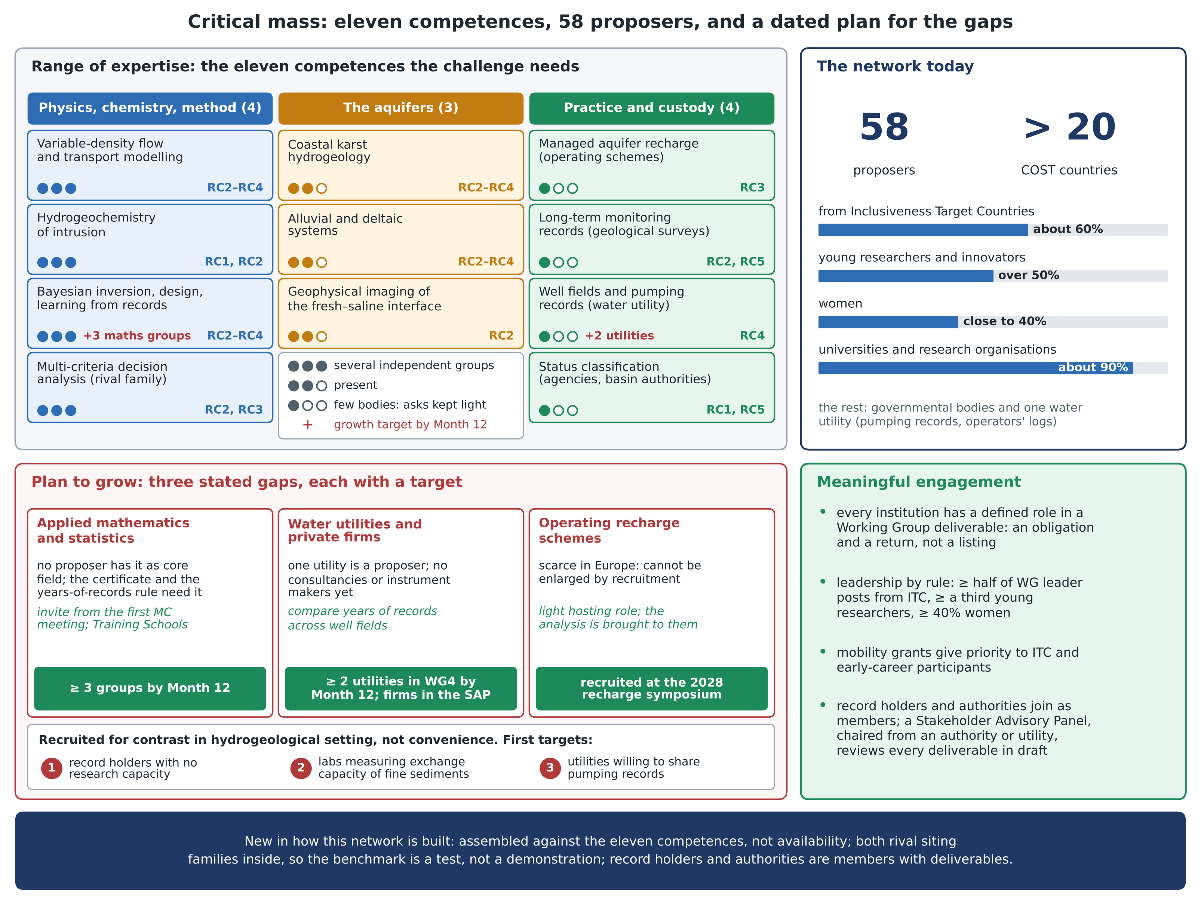
Figure. Critical mass of the network: the eleven competences the challenge needs, with how well each is held today and the objectives (RC1–RC5) it serves; the size and composition of the network; three stated gaps, each with a dated target; and the rules that make membership meaningful. Figures as in annex section 1.E.

