SYNTHESIS ARTICLE · COST CANDIDATE SYSTEM · OCTOBER 2026
The trace and the rhythm: an augmented transient system of variable-density flow and multi-species transport for coastal aquifers, and what chemistry and time-dependent data can identify
D. Zeqiraj
Faculty of Geology and Mining, Polytechnic University of Tirana, Albania. Synthesis of literature reviews 42 and 43 of the author's series and of the numerical experiments GJURMA-GO and RITMI-GO.
Abstract. Models of seawater intrusion couple one salt to variable-density flow and are calibrated on heads and chloride, usually at steady state. Two reviews of the author's series (sixty papers, 2020–2026) and two numerical experiments on the Fushë-Kuqe coastal aquifer in Albania lead to an augmented transient system: flow with a learned closure and a completely monotone memory kernel; transport of seven major ions with cation exchange, mass transfer to silt and clay zones and a learned reactive closure confined to the span of the stoichiometric matrix; and assimilation of the augmented state in time. This article collects the system in one place, explains every equation, and states seven innovations with their evidence. The field chemistry splits into reaction extents (I1). Chloride, the reaction invariant, pins transport and memory, and a cut protects its forecast (I2). Steady data are blind to exchange and memory, so the exchange signal of the field chemistry is a fingerprint of the transient state (I3). Each forcing frequency identifies one complex number of the memory symbol, with a resonance at each rate (I4). A goal needs only what its own forcing excites (I5). The memory has a Markovian embedding that makes the system assimilable with hybrid and robust filters (I6). The cheapest experiment is a sampling schedule, not a pumping rhythm (I7). A new result is added (I8, chloride sufficiency): for a chloride forecast the cut costs 15% in posterior standard deviation and removes every sensitivity to errors of the reactive closure (worst case 7.4 mg/L, 6.8 posterior standard deviations, reduced to zero); in the nonlinear twin it raises the coverage of the 90% interval from 72% to 98%. A time-scale atlas shows where processes, forcings, data and goals overlap, and an identifiability ledger lists, term by term, what the Fushë-Kuqe data already identify and what they do not.
Keywords: seawater intrusion; multi-species reactive transport; memory kernel; cation exchange; identifiability; data assimilation; optimal experimental design; Fushë-Kuqe

1. Introduction
The base paper of this series designs monitoring and managed recharge for a coastal aquifer with steady variable-density flow coupled to a single salt [1], the classical setting of seawater-intrusion modelling [2, 3]. Two things are missing from that setting. The first is the chemistry of the other ions: sodium, potassium, calcium, magnesium, sulfate and bicarbonate do not follow the mixing line of chloride, because cation exchange, sulfate reduction and calcite reactions act on them [4, 5]. Their departures from mixing are a trace of dynamics that the single-salt model leaves out. The second is time. A coastal aquifer under pumping is never at steady state, and the terms that make its chemistry and its heads depart from the classical model, exchange and memory, are exactly the terms that a steady state hides.
The author's notes on dynamic data assimilation proposed three additions to the flow model [6]: a learned closure with memory in the flow equation (N1), a hybrid filter that leaves the ensemble Kalman filter only where the forecast is far from Gaussian (N2), and robust reporting of aquifer status (N3). Review 42 [7] extended the same idea to the transport of several species and tested it on the chemistry of Fushë-Kuqe (experiment GJURMA-GO, gjurma is Albanian for trace). Review 43 [8] placed the whole system on the time axis and asked what time-dependent data identify (experiment RITMI-GO, ritmi: the rhythm). Each review collected thirty recent papers and proved a set of short propositions. This article brings the results of both reviews together as one system of equations, with each equation explained, and adds one new result.
Table 1 lists the innovations. I1–I7 come from the two reviews; I8 is new here. Section 2 describes the aquifer and its data, Section 3 the augmented transient system, Sections 4–10 the innovations I1–I7 with their evidence, and Section 11 the new result. Section 12 collects the candidate system for the COST proposal in an identifiability ledger, and Sections 13–14 give limitations and conclusions. Numbers are from three experiments in the author's repository (folders experiments/gjurma_go, experiments/ritmi_go and experiments/synthesis).
Table 1. The innovations at a glance. I1–I2 come from review 42 [7], I3–I7 from review 43 [8] together with proposals N1–N3 of the author's notes [6], and I8 is new in this article.
 | Innovation | Main statement | Evidence at Fushë-Kuqe
I1 | The trace: field split | Departures of six ions from chloride mixing are integrated closure terms; a stoichiometric least-squares split names the reactions, with uncertainty. | Na uptake of 4.7 and 5.8 meq/L at well 503; Na release of 1.8 meq/L at well 340.
I2 | Chloride pins transport; the cut | A learned closure confined to the span of $N$ leaves chloride closure-free; chloride identifies transport and memory; a cut protects the chloride forecast. | Chloride error at 5 km: 64.1 (classical), 23.7 (free closure), 15.6 mg/L (GJURMA); 13 of 16 directions informed.
I3 | Steady-state blindness | Steady data carry no information on exchange or non-reactive memory; with a reaction inside a zone, one combination. | Steady information 12.1 nats against 28.8 for the history; one SO₄ direction (cosine 1.000).
I4 | Spectral identifiability | A frequency identifies one complex number of the memory symbol; sensitivity to a rate peaks when the forcing frequency equals it; chloride separates memory from exchange. | M2 pins the diffusivity (sd ratio 0.013); MSf the fast storage rate (0.49); the slow rate stays near its prior.
I5 | Goal-oriented matching | A goal is identified when its gradient lies in the row space of the data Jacobian, whatever happens to the other parameters. | 2045 chloride goal aligned at 94% with the effective-velocity combination, whose sd falls from 0.33 to 0.025.
I6 | Assimilation in time | Completely monotone memory has a dissipative Markovian embedding; a hybrid filter switches by the non-Gaussianity measured against the data error; robust bands report status. | Switch zone 1.9–7.3 km, 28 of 75 cells, around the front and the field.
I7 | Designing the rhythm | Information for a fixed salinity cost: pumping rhythms add little, sampling choices add much. | Best pumping design 0.26 nats; monitoring 21.7 nats; 12 chosen samples cut the 2045 chloride error from 17.7 to 4.1 mg/L.
I8 | Chloride sufficiency (new) | For chloride goals the cut costs a computable price in precision and makes the forecast exactly insensitive to errors of the reactive closure. | Price 15% in sd; worst-case shift from 7.4 to 0 mg/L; coverage from 72% to 98%.

2. The Fushë-Kuqe coastal aquifer and its data
The Fushë-Kuqe aquifer on the Albanian Adriatic coast consists of two gravel and sand horizons separated by silt and clay, confined by a silt-clay cap (Figure 1). The well field of Gorre–Fushë-Kuqe abstracts about 750 L/s; the artesian head has fallen from 8.0 to 1.5 m, and salinity reaches about 1,500 and 3,500 mg/L in the two horizons; the transmissivity of the two groundwater bodies is 4,000–8,000 m²/d [9]. Two data sets are used. Sheet 5 holds major-ion analyses of four wells along the north-east to south-west flow path [10]: well 193 in the recharge zone, well 340 in the central sector near the abstraction field, and wells 341 and 503 in the Adriatic sector. Sheet 6 holds chloride at wells 341 and 503 in 1984, 1999 and 2001.
Both experiments use a coast-perpendicular flow line of 15 km in 75 cells, with the abstraction field at 6 km and the four wells at about 1, 2, 4.5 and 12 km; these positions are assumed, since the source gives none. Before 1975 the coastal segment drains to the sea at 15 m/yr; heavy pumping then draws water landward at 200 m/yr until 1990, a pause reverses the flow at 40 m/yr until 2000, and renewed pumping draws it landward at 50 m/yr to the forecast year 2045. Inland water flows toward the field at 50 m/yr. The truth carries seven species, cation exchange in local equilibrium with capacity $E=60$ meq/L, sulfate reduction in the clay of the coastal segment and mass transfer to immobile silt and clay zones. The goals are forecasts for 2045 under continued pumping: chloride at the edge of the abstraction field (5 km), sodium and hardness (Ca + Mg) at 3 km, and the length of the coastal strip with chloride above 250 mg/L.
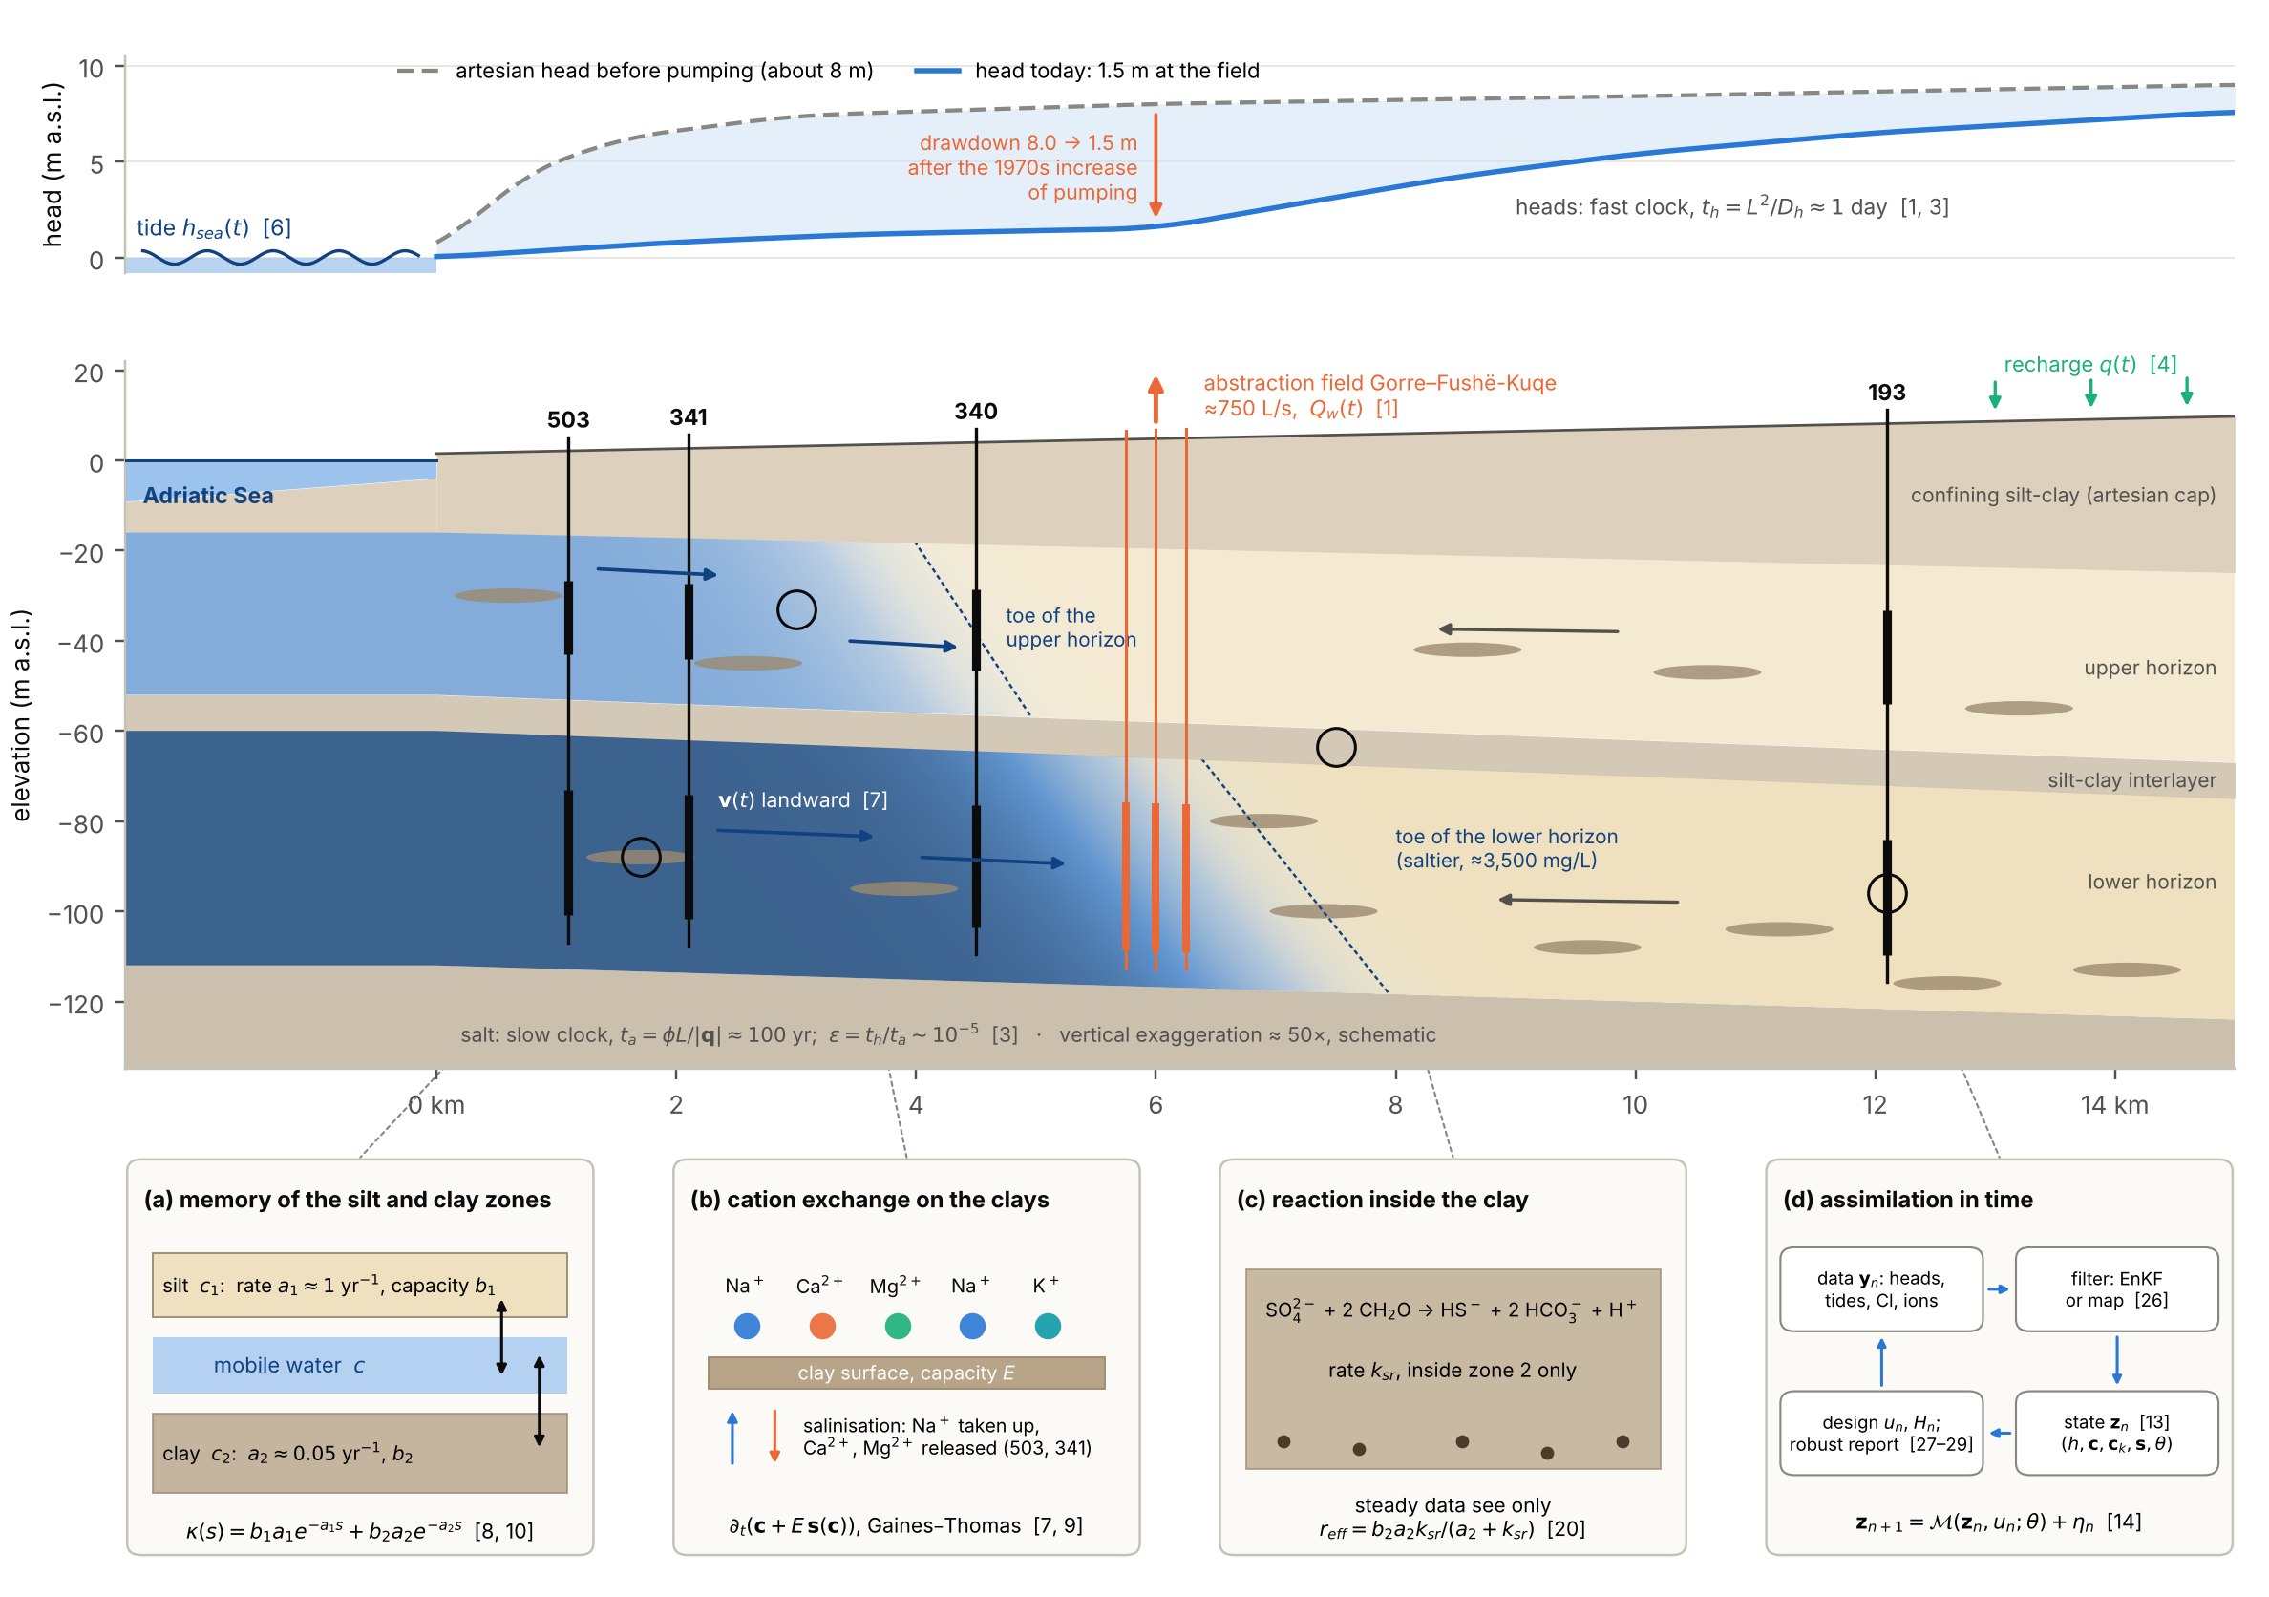
Figure 1. The augmented transient system drawn on a schematic Fushë-Kuqe cross-section (vertical exaggeration about 50×; well positions as assumed in the experiments). Top: heads before pumping and today; the tide drives the fast flow problem. Middle: the two aquifer horizons with silt-clay lenses and the salt wedge (darker blue: saltier), the monitoring wells with their screens, the abstraction field and the recharge. Bottom: the four processes that the classical model leaves out, (a) memory of the silt and clay zones, (b) cation exchange, (c) reaction inside the clay, and (d) the assimilation loop. Numbers in brackets are equation numbers of this article.

3. The augmented transient system

3.1 The classical system and its two clocks
In transient form, the classical system of the base paper couples the flow of a variable-density fluid to the transport of one salt [2, 3]:
Ss ∂thf+∇⋅q=w​Qwt δx−xw, q=−Kf∇hf+ρ−ρfρf∇z | (1)
where $h_{f}$ is the equivalent freshwater head (m), $S_{s}$ the specific storage (1/m), $q$ the Darcy flux (m/d), $K_{f}$ the hydraulic conductivity for fresh water, $ρ$ and $ρ_{f}$ the densities of the mixed water and of fresh water, $z$ the elevation, and $Q_{w}\left(t\right)$ the rate of well $w$ at $x_{w}$ (negative for abstraction). The buoyancy term $\left(ρ−ρ_{f}\right)/ρ_{f} ∇z$ makes salty water sink and drives the wedge of Figure 1.
$$ϕ ∂_{t}C+∇⋅\left(qC\right)−∇⋅\left(ϕ\left(D_{m}I+D\left(q\right)\right)∇C\right)=q_{s}C_{s}, ρ=ρ_{f}+\frac{∂ρ}{∂C} C$$ | (2)
where $C$ is the salt concentration, $ϕ$ the porosity, $D_{m}$ the molecular diffusion coefficient, $D\left(q\right)$ the mechanical dispersion tensor with longitudinal and transverse dispersivities, and $q_{s}C_{s}$ a source of salt. The density follows linearly from $C$, which closes the coupling with (1).
Two clocks run in this system. Heads diffuse with the hydraulic diffusivity $D_{h}=T/S$, salt moves with the pore velocity:
$$t_{h}=\frac{L^{2}}{D_{h}}, D_{h}=\frac{T}{S}, t_{a}=\frac{ϕL}{\left|q\right|}, ε=\frac{t_{h}}{t_{a}}$$ | (3)
where $L$ is a distance, $T$ the transmissivity and $S$ the storativity of a confined horizon. With $T$ = 4,000–8,000 m²/d and an assumed $S≈3×{10}^{−4}$, $D_{h}≈2×{10}^{7}$ m²/d, so a pumping change is felt 5 km away within $t_{h}≈1$ day, while salt needs $t_{a}≈100$ years for the same distance at a pore velocity of a few tens of metres per year; hence $ε∼{10}^{−5}$.
For $ε≪1$ the system is singularly perturbed [11]: on the clock of salinity the head satisfies the steady flow equation with the current pumping and sea level, and on the clock of tides and pumping tests the concentration field is frozen. The transient system therefore splits into a fast, linear flow problem driven by tides and pumping steps, and a slow, nonlinear transport problem driven by the history of pumping and sea level. Both carry memory, at rates that differ by orders of magnitude, and each can be identified only from forcing at its own clock. This is the thread of Sections 6–10.

3.2 Flow with a learned closure and memory (proposal N1)
Proposal N1 adds to the depth-integrated flow equation a closure expanded in a basis and a memory term [6, 12, 13]:
$$S ∂_{t}h=∇⋅\left(T∇h\right)+q+\sum_{j=1}^{m}{γ_{j}}Ψ_{j}\left(h,x\right)+\int_{0}^{∞}{κ_{h}}\left(r\right) h\left(x,t−r\right)dr$$ | (4)
where $q$ is the recharge (m/d), $Ψ_{j}$ are basis functions of the head and position (for example $h$, $\left|∇h\right|$ or zone indicators) with coefficients $γ_{j}$ learned from data, and $κ_{h}$ is a memory kernel that represents delayed yield from the unsaturated zone [14], storage in leaky aquitards [15] or exchange between channels and matrix.
Lemma 1 (moment split). If $κ_{h}$ is integrable with a finite first moment and $h$ is bounded and differentiable in time, then
$$\int_{0}^{∞}{κ_{h}}\left(r\right) h\left(t−r\right) dr=\overline{κ} h\left(t\right)−\int_{0}^{∞}{K_{h}}\left(r\right) ∂_{t}h\left(t−r\right) dr, \overline{κ}=\int_{0}^{∞}{κ_{h}}\left(r\right) dr, K_{h}\left(r\right)=\int_{r}^{∞}{κ_{h}}\left(u\right) du$$ | (5)
where $\overline{κ}$ is the total weight of the kernel and $K_{h}$ its tail. Proof: $K_{h}′=−κ_{h}$, $K_{h}\left(0\right)=\overline{κ}$ and $K_{h}→0$; integrating by parts, the boundary term at $r=0$ gives $\overline{κ}h\left(t\right)$ and the one at infinity vanishes because $h$ is bounded.
The memory term of N1 is therefore the sum of an instantaneous leakage $\overline{κ}h$, which a steady calibration sees but cannot tell apart from a closure term with $Ψ_{j}=h$, and a storage-type memory that acts only on $∂_{t}h$ and is invisible at steady state. For delayed yield and aquitard storage the tail is completely monotone, Khr=Sk​bkake−akr, and in the Laplace variable $λ$ the storage becomes $λS\left(1+{\hat{κ}}_{S}\left(λ\right)\right)$ with κSλ=k​bkak/ak+λ. A tide of angular frequency $ω$ then propagates inland as in the Jacob–Ferris solution [16, 17], with a complex wavenumber that carries the kernel:
$$\frac{\hat{h}\left(x,ω\right)}{\hat{h}\left(0,ω\right)}=exp\left(−x\sqrt{\frac{iωS\left(1+{\hat{κ}}_{S}\left(iω\right)\right)}{T}}\right)$$ | (6)
where $\hat{h}\left(x,ω\right)$ is the complex amplitude of the head oscillation at distance $x$ from the coast. The amplitude ratio and the phase lag at a well are the modulus and the argument of the right-hand side; with ${\hat{κ}}_{S}=0$ the classical solution is recovered. Each tidal constituent therefore measures one complex number, $1+{\hat{κ}}_{S}\left(iω\right)$, at its own frequency (Section 7).

3.3 Multi-species transport with exchange, memory and a learned closure
Let $c=\left(c_{\text{Cl}},c_{\text{Na}},c_{\text{K}},c_{\text{Ca}},c_{\text{Mg}},c_{\text{SO4}},c_{\text{HCO3}}\right)$ be the concentrations in the mobile water (meq/L). With cation exchange in local equilibrium, $K$ immobile zones and the stoichiometric closure of review 42, the transient transport system reads [4, 18, 19]
$$∂_{t}\left(c+E s\left(c\right)\right)+\sum_{k=1}^{K}{b_{k}}a_{k}\left(c−c_{k}\right)+∇⋅\left(v c\right)−∇⋅\left(D∇c\right)=N\left(r\left(c\right)+Φ\left(c,x,t;θ\right)\right)$$ | (7)
where $v=q/ϕ$ is the pore velocity, $D$ the dispersion tensor, $E$ the exchange capacity (meq per litre of pore water) and $s\left(c\right)$ the equivalent fractions on the exchanger, given by (9) for the cations and zero for chloride and the anions; $c_{k}$ is the concentration in immobile zone $k$ with capacity ratio $b_{k}$ and exchange rate $a_{k}$; $N$ is the stoichiometric matrix (one column per reaction, written per milliequivalent); $r$ are the known reaction rates and $Φ$ the learned closure with parameters $θ$.
$$∂_{t}c_{k}=a_{k}\left(c−c_{k}\right)+Γ_{k} c_{k}, k=1,…,K$$ | (8)
where $Γ_{k}$ is the matrix of first-order reactions inside zone $k$. At Fushë-Kuqe zone 1 is the silt ($a_{1}≈1$ yr⁻¹) and zone 2 the organic-rich clay ($a_{2}≈0.05$ yr⁻¹), where sulfate is reduced at rate $k_{sr}$ with the matching production of bicarbonate (Figure 1c).
$$K_{\text{Na}∖I}=\frac{β_{\text{Na}} a_{I}^{1/z_{I}}}{β_{I}^{1/z_{I}} a_{\text{Na}}}, I=\text{K}, \text{Ca}, \text{Mg}, β_{\text{Na}}+β_{\text{K}}+β_{\text{Ca}}+β_{\text{Mg}}=1$$ | (9)
where $β_{J}$ is the equivalent fraction of cation $J$ on the exchanger, $a_{J}$ its activity in solution (taken as its concentration), $z_{I}$ the charge of $I$ and $K_{\text{Na}∖I}$ the Gaines–Thomas selectivity [20]. Given the solution, the three selectivities and the closure condition fix $β$, and $E s\left(c\right)=Eβ$ is the exchangeable stock; it is solved by Newton's method in every cell and time step.
The immobile zones can be eliminated, and what remains is a memory term. Proposition 1 (mass transfer is memory [18, 19]). For a species that neither exchanges nor reacts inside the zones (chloride), (7)–(8) with $Γ_{k}=0$ are equivalent to
$$∂_{t}c+\int_{0}^{t}{κ}\left(s\right) ∂_{t}c\left(t−s\right) ds+∇⋅\left(vc\right)−∇⋅\left(D∇c\right)=−\sum_{k=1}^{K}{b_{k}}a_{k}e^{−a_{k}t}\left(c\left(0\right)−c_{k}\left(0\right)\right)$$ | (10)
where $κ\left(s\right)=\sum_{k=1}^{K}{b_{k}}a_{k}e^{−a_{k}s}$ is the memory kernel and the right-hand side is the relaxation of the initial disequilibrium between the mobile water and the zones. Proof: solving (8) gives $c−c_{k}=e^{−a_{k}t}\left(c\left(0\right)−c_{k}\left(0\right)\right)+\int_{0}^{t}{e^{−a_{k}s}} ∂_{t}c\left(t−s\right) ds$; multiply by $b_{k}a_{k}$ and sum.
The right-hand side is the term that the Mori–Zwanzig formalism attributes to the unresolved initial state [21, 22]. A learned memory kernel should therefore be sought among completely monotone functions, non-negative mixtures of exponentials (by Bernstein's theorem [23]), and be accompanied by a term for the initial state. The same structure appears in learned constitutive laws with memory [24] and in data-driven generalised Langevin equations [25].
For the analysis of transient data the system is linearised around a steady base state $\overline{c}$ and the flow is perturbed (pumping, sea level) by $\hat{q} e^{λt}$. For a species that does not react in the zones, ${\hat{c}}_{k}=a_{k}\hat{c}/\left(a_{k}+λ\right)$, and
$$λ\left[\left(1+\hat{κ}\left(λ\right)\right)I+E J_{s}\left(\overline{c}\right)\right]\hat{c}−L_{\overline{v}} \hat{c}=\hat{f}, \hat{κ}\left(λ\right)=\sum_{k=1}^{K}{\frac{b_{k}a_{k}}{a_{k}+λ}}$$ | (11)
where $\hat{κ}$ is the symbol of the memory (the Laplace transform of $κ$), $J_{s}$ the Jacobian of the equilibrium loading (zero rows and columns for chloride and the anions), $L_{\overline{v}}$ the linearised advection–dispersion operator and $\hat{f}$ the forcing by $\hat{q}$. For a species that decays at rate $k_{r}$ inside zone $k$, the term of that zone is $\left(λ+k_{r}\right) b_{k}a_{k}/\left(a_{k}+λ+k_{r}\right)$: the reaction shifts the argument of the memory symbol from $λ$ to $λ+k_{r}$. Equation (11) is the key to Sections 6–8: exchange enters through a real matrix and memory through a complex scalar, both multiplied by $λ$.

3.4 The stoichiometric learned closure
The closure $Φ$ is a vector of reaction rates, so its contribution $NΦ$ to (7) lies in the span of the stoichiometric matrix: whatever is learned, it cannot create or destroy chloride, nor break the charge balance. In GJURMA each exchange reaction $j$ (Na–Ca, Na–Mg, K–Ca) is a learned exchanger whose loading relaxes toward a learned equilibrium with the seawater fraction [7]:
$$\frac{dq_{j}}{dt}=\frac{1}{τ_{j}}\left(\frac{Q_{j} f}{f+h_{j}}−q_{j}\right), Φ_{j}=\frac{dq_{j}}{dt} \text{min}\left(1,\frac{c_{ι\left(j\right)}}{c_{ι\left(j\right)}^{\text{mix}}\left(f\right)}\right)$$ | (12)
where $q_{j}$ is the loading of exchanger $j$, $f$ the local seawater fraction, and $Q_{j}$, $h_{j}$ and $τ_{j}$ a learned capacity, half-saturation and relaxation time; the factor with the minimum, used during uptake, limits the uptake by the availability of the consumed ion $ι\left(j\right)$ (Na or K) relative to its mixing value, which keeps concentrations positive. First-order sulfate reduction in the clay and calcite proportional to the total exchange complete the closure: 11 parameters, 16 with transport and memory. A free closure that gives every species, chloride included, its own exchanger has 35 (40 in all).
Closures that react only to the current rate of change of salinity could not hold the deficits of strongly retained ions behind the front; the exchanger memory in (12) was needed. This agrees with neural closures with delay [26], with the stability requirements of learned chemical solvers [27] and with reaction networks learned in stoichiometric form [28].

3.5 The candidate system in state-space form
The density follows from the seawater fraction of chloride, and the state to be assimilated contains the heads, the mobile and immobile concentrations, the exchanger and the static parameters:
$$ρ=ρ_{f}\left(1+Δ_{ρ} f_{\text{sea}}\left(c_{\text{Cl}}\right)\right), z=\left(h,c,c_{1},…,c_{K},s,θ\right)$$ | (13)
where $Δ_{ρ}=\left(ρ_{s}−ρ_{f}\right)/ρ_{f}≈0.025$ for sea water of density $ρ_{s}$ between standard sea water and the saltier southern Adriatic (1.0285), and $f_{\text{sea}}\left(c_{\text{Cl}}\right)=\left(c_{\text{Cl}}−c_{\text{Cl}}^{\text{fresh}}\right)/\left(c_{\text{Cl}}^{\text{sea}}−c_{\text{Cl}}^{\text{fresh}}\right)$; $θ$ collects the closure coefficients, the kernel parameters and the uncertain transport parameters.
$$z_{n+1}=M\left(z_{n},u_{n};θ\right)+η_{n}, y_{n}=H_{n}z_{n}+e_{n}$$ | (14)
where $M$ is one time step of (1), (4) and (7)–(9), $u_{n}$ the pumping and recharge schedule, $η_{n}$ the model error, $y_{n}$ the data (heads, tides, chloride, major ions), $H_{n}$ the sampling operator and $e_{n}$ the data error. The schedule $u_{n}$ and the sampling operator $H_{n}$ are the design variables of Section 10.
Equations (1)–(14) are the augmented transient system. Its new terms are the closure and memory of (4), the exchange of (9), the zones of (8) and the closure of (12). The rest of the article asks what data identify them, what goals need them, and how to assimilate and design for them.

4. I1 – The trace: splitting the field chemistry into reactions
For each saline well the seawater fraction $f$ follows from chloride between the fresh end-member (well 193) and sea water, and the departure $Δ_{i}$ of every other ion from conservative mixing is the closure term of (7) integrated along the path of the water to that well [7]:
$$f=\frac{c_{\text{Cl}}−c_{\text{Cl}}^{\text{fresh}}}{c_{\text{Cl}}^{\text{sea}}−c_{\text{Cl}}^{\text{fresh}}}, Δ_{i}=c_{i}−\left(f c_{i}^{\text{sea}}+\left(1−f\right)c_{i}^{\text{fresh}}\right)={\left(Nξ\right)}_{i}$$ | (15)
where $c_{i}^{\text{sea}}$ and $c_{i}^{\text{fresh}}$ are the end-member concentrations of ion $i$ (meq/L) and $ξ$ the vector of reaction extents: the amount of each reaction, per litre of water, accumulated along the path. A positive Na–Ca extent means Na taken up by the exchanger and Ca released.
$$\hat{ξ}={\left(N^{⊤}N\right)}^{−1}N^{⊤}Δ, w^{⊤}N=0, w={\left(−1,−1,−1,−1,1,1\right)}^{⊤}$$ | (16)
where $N$ is restricted to the six non-conservative ions (Na, K, Ca, Mg, SO₄, HCO₃) and five reactions (Na–Ca, Na–Mg and K–Ca exchange, sulfate reduction, calcite dissolution). $N$ has rank 5 and its left null vector $w$ is the charge balance, so the residual of the split is the charge imbalance of the departures. Uncertainty is propagated by Monte Carlo from a 3% analytical error, a 10% uncertainty of the fresh end-member and a sea-water salinity between standard sea water and the southern Adriatic.
The seawater fractions are 5.4% at well 503, 5.3% at well 341 and 2.1% at well 340, and the residuals of the split are below 0.06 meq/L at all three wells, a consistency check rather than a proof. Table 2 and Figure 2 give the extents. On the Adriatic side the exchanger takes up sodium: 4.7 meq/L against calcium and 5.8 meq/L against magnesium at well 503, 4.5 meq/L against calcium at well 341. In the centre, at well 340, it releases sodium (1.8 meq/L against magnesium). Sulfate is reduced at all three wells, most strongly near the coast, and calcite precipitates. The signs are those of a salinising front on the coast and a freshening one in the centre [4, 5].
Table 2. Reaction extents of the field split (16) at the three saline wells of sheet 5 [10]: estimate and 90% interval. Positive exchange extents mean Na or K taken up by the exchanger; a negative calcite extent means precipitation.
Reaction (meq/L) | Well 503 | Well 341 | Well 340
Na–Ca exchange | 4.7 (3.5 to 6.0) | 4.5 (3.2 to 5.8) | -0.2 (-0.9 to 0.5)
Na–Mg exchange | 5.8 (5.2 to 6.5) | 0.4 (-0.1 to 0.9) | -1.8 (-2.2 to -1.5)
K–Ca exchange | 0.5 (0.2 to 0.8) | 0.4 (0.1 to 0.7) | 0.2 (0.0 to 0.4)
Sulfate reduction | 3.6 (3.2 to 4.1) | 1.7 (1.3 to 2.2) | 0.8 (0.6 to 1.1)
Calcite dissolution | -1.9 (-2.8 to -1.1) | -2.3 (-3.2 to -1.5) | -0.5 (-1.0 to 0.0)

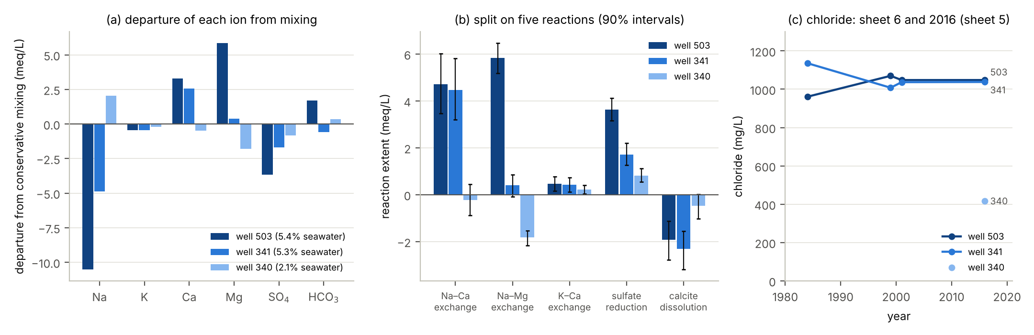
Figure 2. The trace in the Fushë-Kuqe chemistry. (a) Departure of each ion from conservative mixing with chloride (15). (b) Split on five reactions (16) with 90% intervals. (c) Chloride at wells 503 and 341 in 1984, 1999 and 2001 (sheet 6) and in 2016 (sheet 5), and at well 340 in 2016.
INNOVATION The departures from mixing are integrated closure terms of the transport equation. Split on a stoichiometric basis with uncertainty, they tell which closure the transport model needs, and in which direction the front moves, before any model is fitted. This moves the mass-balance reasoning of inverse geochemical modelling [29] inside the partial differential equation, and gives the learned closure of Section 3.4 its basis.

5. I2 – Chloride pins transport; the stoichiometric closure and the cut
Heads alone cannot separate the recharge from a flow closure. Proposition 2 (heads see only the total source). Let $σ\left(x,t\right)$ be the sum of the recharge, the closure and the memory term in (4). Two sets of recharge and closure parameters produce the same heads if and only if they produce the same $σ$:
$$σ\left(x,t\right)=q+\sum_{j=1}^{m}{γ_{j}}Ψ_{j}\left(h,x\right)+\int_{0}^{∞}{κ_{h}}\left(r\right) h\left(x,t−r\right) dr, δq=−\sum_{j=1}^{m}{δ}γ_{j}Ψ_{j} ⇒ δh≡0$$ | (17)
where $δq$ is a change of the recharge that lies in the span of the basis and $δγ_{j}$ the compensating change of the closure. Proof: (4) depends on recharge and closure only through $σ$, and for given $σ$, $T$, $S$ and boundary data its solution is unique.
The chemistry of the water can separate what heads cannot. Proposition 3 (reaction invariants [30, 31]). Write exchange and the reactions inside the zones as columns of $N$. For every matrix $W$ with $W^{⊤}N=0$ the components $u=W^{⊤}c$ obey conservative transport with the same memory:
$$∂_{t}u+\sum_{k=1}^{K}{b_{k}}a_{k}\left(u−u_{k}\right)+∇⋅\left(vu\right)−∇⋅\left(D∇u\right)=0, u=W^{⊤}c, W^{⊤}N=0$$ | (18)
where $u_{k}=W^{⊤}c_{k}$. Proof: storage, mass transfer, advection and dispersion act on every species in the same way and commute with $W^{⊤}$, while $W^{⊤}Nr=W^{⊤}NΦ=0$. For the seven ions and five reactions of Section 4 the invariants are chloride and the charge balance: chloride carries the transport alone, and no closure in the span of $N$ can touch it.
Proposition 4 (identifiability through invariants). (i) The transport and memory parameters are identifiable from the invariant components alone, as from a conservative tracer, whatever the closure in the span of $N$. (ii) Given the transport, the reaction rates are identifiable from the other species if and only if the rows of $N$ for the observed species have full column rank. (iii) With a single salt there is no invariant to separate transport from a closure. (iv) If the waters entering the aquifer (recharge, river leakage, sea water, leakage from the clays) have linearly independent invariant compositions, their fluxes are identifiable from the invariant concentrations, so the chemistry separates what Proposition 2 shows that heads cannot. Proof: (i) follows from Proposition 3; (ii) is the condition for $Nr$ to determine $r$; (iii) one species admits no non-zero $W$ once a reaction acts on it; (iv) the invariant equation (18) is linear in the source fluxes. □ For nonlinear closures the same questions can be settled before data are collected with algebraic tests of structural identifiability [32], and their practical side with profile likelihoods and geometric surrogates [33, 34].
The parameters are estimated with an ensemble smoother with multiple data assimilation [35, 36]. Fitted jointly, every parameter sees every datum, and a misfit of the reactive species can pull the transport. Proposition 5 (the cut protects the conservative forecast). If the transport and memory parameters $θ_{T}$ are estimated from the invariant data alone and the closure parameters $θ_{R}$ are then estimated with them held fixed, a cut in the sense of modular inference [37],
$$p_{\text{cut}}\left(θ_{T},θ_{R}∣y\right)=p\left(θ_{T}∣y_{\text{Cl}}\right) p\left(θ_{R}∣θ_{T},y\right)$$ | (19)
where $y_{\text{Cl}}$ are the chloride (invariant) data and $y$ all data, then the posterior of $θ_{T}$, and every forecast of an invariant such as chloride, depends only on the chloride data; a structural error of the reactive closure cannot bias it. Proof: the first factor uses only invariant data, and by Proposition 3 an invariant forecast depends only on $θ_{T}$. The price is that the reactive species no longer inform the transport; Section 11 computes it.
GJURMA-GO tested this on 40 synthetic truths of the Fushë-Kuqe flow line, each fitted to 34 data (seven ions at four wells in 2016 and the chloride history at 503 and 341) with 100 members and four iterations [7]. Five models were compared (Figure 3): the classical single-salt model applied to every ion by mixing (3 parameters), the free closure (40), GJURMA fitted jointly and with the cut (16), and an oracle with the true structure (10). The mean absolute error of chloride at 5 km in 2045 is 64.1 mg/L for the classical model, 23.7 for the free closure, 15.6 for GJURMA, 15.3 with the cut and 9.1 for the oracle; for hardness at 3 km the errors are 4.71, 1.83, 0.63, 0.51 and 0.28 meq/L. GJURMA reduces the classical error by 76–87% and the error of the free closure by 34–66% for the three concentration goals. Of the 40 directions of the free closure, 17 are informed by the data; of the 16 of GJURMA, 13; of the 10 of the oracle, 8 (Figure 7a). Confining the closure to the span of $N$ is what makes a learned model identifiable from 34 numbers.
The cut matters for honesty more than for accuracy: its errors are close to those of the joint fit, but its 90% intervals for chloride at 5 km cover the truth in 98% of the truths instead of 72%, for sodium in 65% instead of 50% and for hardness in 78% instead of 57%. The remaining under-coverage of the reactive goals is a structural error of the learned exchanger, which a richer exchanger within the same span, a discrepancy term or the robust band of Section 9 must absorb. Invariance as a principle of robust estimation [38] is the statistical side of the same idea.
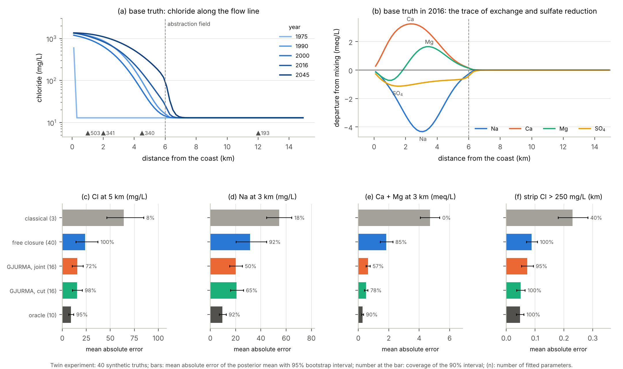
Figure 3. GJURMA-GO twin experiment [7]. (a) Chloride along the flow line in the base truth, 1975–2045. (b) Departures from mixing in 2016: the trace of exchange and sulfate reduction. (c–f) Mean absolute error of the 2045 goals for five models over 40 truths, with 95% bootstrap intervals; the number at each bar is the coverage of the 90% interval and the number in brackets the count of fitted parameters.
INNOVATION A learned closure is made identifiable by confining it to the span of the stoichiometric matrix: chloride then stays closure-free and pins transport and memory, the reactive species identify the closure, and the source waters separate recharge from the flow closure. The cut through the invariant makes the chloride forecast immune to errors of the reactive part; Section 11 quantifies its price and its protection.

6. I3 – Steady-state blindness and the transient fingerprint
The base paper designs monitoring for the steady state. Proposition 6 (steady-state blindness). Let $\left(\overline{c},{\overline{c}}_{k}\right)$ be the steady solution of (7)–(9) for time-independent flow and boundary data, unique for each parameter value. Then (i) $\overline{c}$ does not depend on the exchange capacity, the selectivities, the porosity, nor the rate and capacity of any zone without internal reaction; (ii) for a zone with a first-order internal reaction of rate $k_{r}$, $\overline{c}$ depends on $\left(a_{k},b_{k},k_{r}\right)$ only through
$$r_{\text{eff}}=\frac{b_{k} a_{k} k_{r}}{a_{k}+k_{r}}=\lim_{λ→0}\left(λ+k_{r}\right)\frac{b_{k}a_{k}}{a_{k}+λ+k_{r}}$$ | (20)
where $r_{\text{eff}}$ is the effective first-order rate at which the zone removes the species from the mobile water, the zero-frequency limit of the shifted memory symbol of (11). Proof: with $∂_{t}=0$ the exchange term and the storage vanish; (8) gives ${\overline{c}}_{k}=a_{k}\overline{c}/\left(a_{k}+k_{r}\right)$, so $b_{k}a_{k}\left(\overline{c}−{\overline{c}}_{k}\right)=r_{\text{eff}}\overline{c}$, which is zero when $k_{r}=0$; by uniqueness the solution depends on the parameters only in this way.
The Fisher information of any steady data set therefore vanishes along exchange, selectivities, porosity and non-reactive memory, and has rank at most one per reaction inside a zone. Corollary 1 (the exchange signal is a transient fingerprint). With two end-members, at steady state every species that takes part only in reversible reactions follows the mixing line of chloride, so the exchange extents of (16) vanish. A non-zero exchange extent is direct evidence that the aquifer is not at steady state, and its sign gives the direction of the front [5, 39]. The Fushë-Kuqe chemistry shows both directions (Table 2): the data the author already holds falsify the steady assumption of the base paper for the chemistry, in two sectors.
RITMI-GO tested Proposition 6 on the flow line with two immobile zones, sulfate reduction inside the clay and twelve uncertain parameters [8]. Steady data of seven ions at four wells carry 12.1 nats of information, the transient history 28.8 nats (Figure 4). Steady data leave the exchange capacity, the three selectivities and the silt memory exactly at their prior. Through sulfate and bicarbonate they see the clay memory and the sulfate-reduction rate along a single direction (singular values 0.82, $2×{10}^{−5}$ and $5×{10}^{−7}$), whose cosine with the gradient of $logr_{\text{eff}}$ is 1.000. The adjoint expected information gain of the base paper, computed at steady state, is therefore identically zero for exchange and memory, whatever the network: a design criterion for the augmented system must be transient.
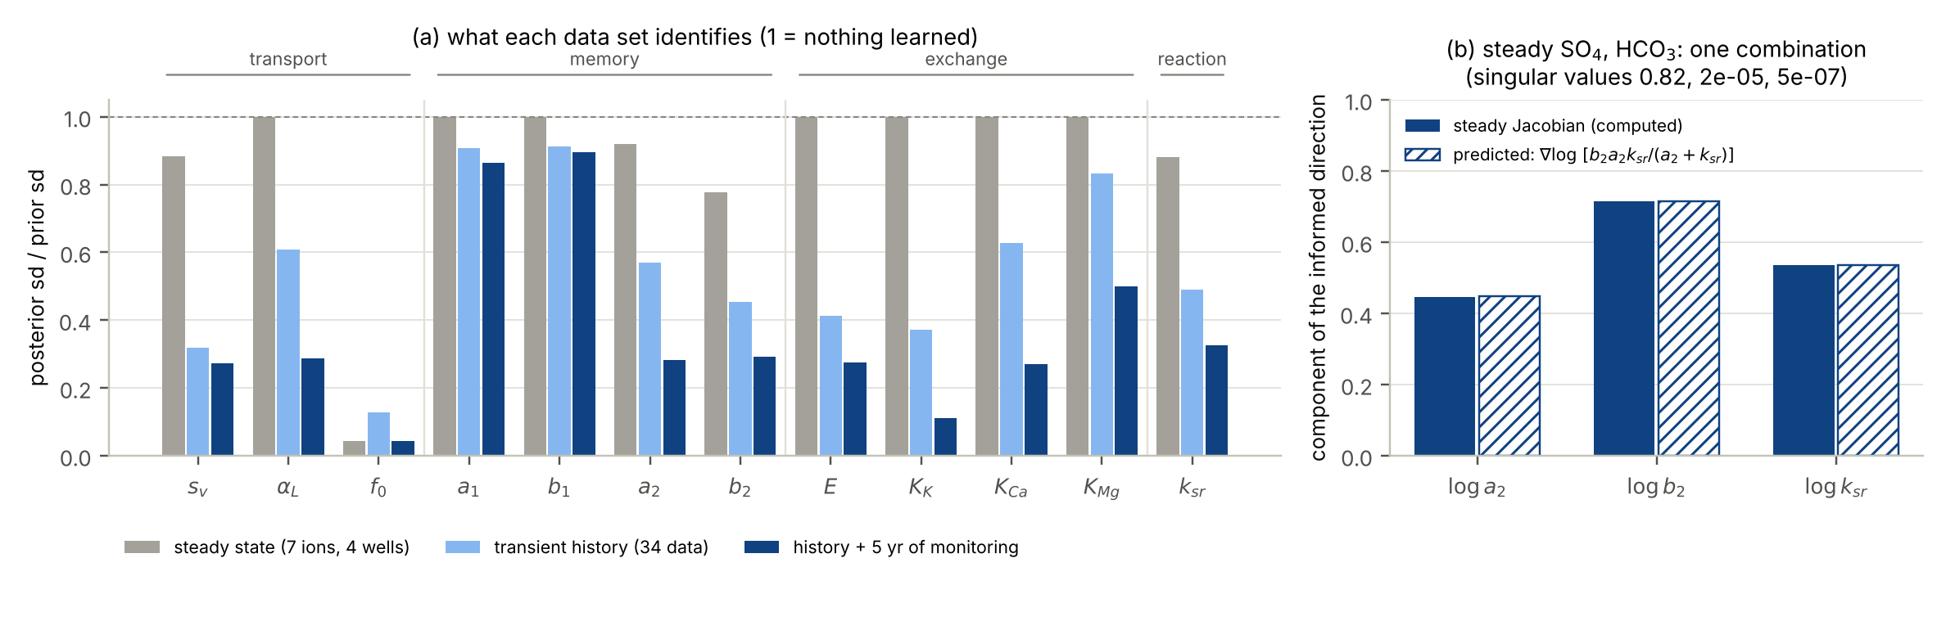
Figure 4. Steady-state blindness (RITMI-GO [8]). (a) Posterior over prior standard deviation of the twelve parameters, linearised at the prior mean, for steady data (seven ions at four wells), the transient history (34 data) and the history with five years of status-quo monitoring; 1 means nothing learned. (b) Steady sulfate and bicarbonate see one combination of the clay memory and the reaction rate: the informed direction of the steady Jacobian and the gradient of $logr_{\text{eff}}$ from (20).
INNOVATION Exchange and memory, the two new terms of the transport system, are invisible to steady data; only one combination of memory and reaction survives at steady state. The exchange signal already present in the field chemistry is a fingerprint of the transient state and gives the direction of the front.

7. I4 – What a transient forcing identifies: spectra and resonance
Proposition 7 (one frequency, one complex number; resonance). Let the base state be steady and the forcing periodic with angular frequency $ω$ and small amplitude. The response of every species that neither exchanges nor reacts in the zones depends on the memory only through $\hat{κ}\left(iω\right)$, and for the $K$-rate kernel
$$\left|\frac{∂\hat{κ}\left(iω\right)}{∂loga_{k}}\right|=b_{k} \frac{ω/a_{k}}{1+{\left(ω/a_{k}\right)}^{2}}, \left|\frac{∂\hat{κ}\left(iω\right)}{∂logb_{k}}\right|=\frac{b_{k}}{\sqrt{1+{\left(ω/a_{k}\right)}^{2}}}$$ | (21)
where the first expression is the sensitivity of the memory symbol to the rate of zone $k$ and the second to its capacity. Proof: differentiate $b_{k}a_{k}/\left(a_{k}+iω\right)$ with respect to $loga_{k}$ and $logb_{k}$ and take moduli. The sensitivity to a rate peaks, at $b_{k}/2$, when $ω=a_{k}$, and decays like $ω/a_{k}$ below and $a_{k}/ω$ above: a rate is informed only by forcing within about a decade of it, and one frequency determines at most two real combinations of the kernel.
Proposition 8 (structural versus practical identifiability of a kernel). Let $κ$ be completely monotone, that is, a mixture of exponentials with a positive measure $ν$ of capacities over rates:
κs=0,∞​a e−as νda, κλ=0,∞​a νdaa+λ | (22)
where $\hat{κ}$ is a Stieltjes transform, analytic off the negative real axis. (i) If $\hat{κ}$ is known on a set of frequencies with an accumulation point, for instance a band $\left[ω_{1},ω_{2}\right]$, $ν$ is determined uniquely (identity theorem and Stieltjes–Perron inversion [23]). (ii) The determination is unstable away from the band: analytic continuation amplifies the data errors exponentially [40]. A band of frequencies determines the whole kernel in principle, but in practice only the part whose rates lie in the band; the rest is carried by the prior.
Proposition 9 (chloride separates memory from exchange). In the cation block of (11) the exchange enters through the real, frequency-independent matrix $E J_{s}\left(\overline{c}\right)$ and the memory through the complex scalar $\hat{κ}\left(iω\right)$, both multiplied by $iω$. Chloride data at frequency $ω$ identify $\hat{κ}\left(iω\right)$, its only unknown besides transport; given $\hat{κ}\left(iω\right)$, cation data at the same frequency identify $E J_{s}$ along the excited directions. Without chloride, the memory and the part of the exchange matrix along the identity enter the same coefficient and separate only through the frequency dependence of $\hat{κ}$, with two frequencies or more. Proof: read (11) species by species. □ This is the transient form of the role of chloride in Section 5: there it pinned transport for the closure; here it also pins the memory, frequency by frequency.
Figure 5 puts all clocks on one axis: what the system remembers (the resonance ridges of (21)), what forces it, what the data resolve (from twice the sampling interval to the length of the record) and what the goals need. A process is identifiable from a data set only where its ridge overlaps both a forcing band and a data band. The atlas makes the gaps visible: the fast flow kernel is served by tides and loggers; the silt rate peaks at periods of about six years, where only the 2026–2031 monitoring and designed oscillations reach; the clay rate peaks at a century, where only the passage of the front and the historical chloride series reach; and exchange is seen by every change of composition, never by the single survey of 2016.
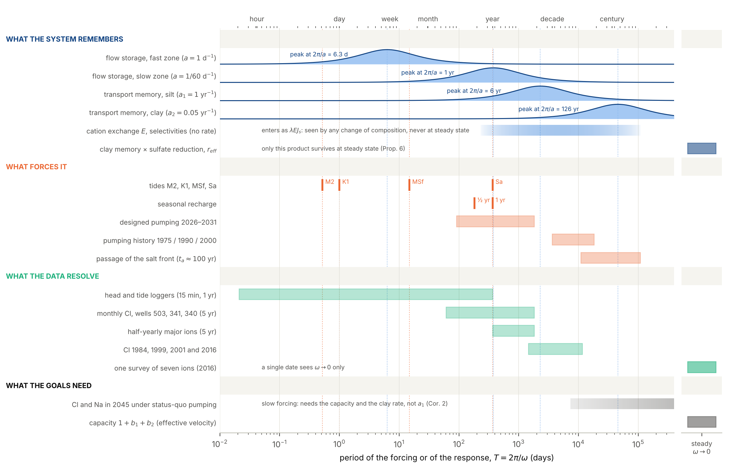
Figure 5. The time-scale atlas of the augmented system at Fushë-Kuqe (new). Ridges: sensitivity of the response to each rate, $\left|∂\hat{κ}\left(iω\right)/∂loga_{k}\right|$ from (21), normalised to one at its peak $ω=a_{k}$. Bands: periods excited by a forcing, or resolved by a data set (twice the sampling interval to the record length). Right column: what is visible at steady state ($ω→0$). The 2045 goals are driven by slow forcing and need the capacity $1+b_{1}+b_{2}$ and the clay rate, not the silt rate (Corollary 2).
The same argument applies to the flow kernel through (6). Tides are a natural experiment at fixed frequencies: semi-diurnal M2, diurnal K1, fortnightly MSf and annual Sa. For a two-rate storage kernel (fast rate 1 d⁻¹, slow rate 1/60 d⁻¹) observed at four wells 0.5–4 km from the coast, the M2 constituent alone pins the diffusivity (posterior over prior standard deviation 0.013) but leaves the fast storage rate at 0.74; the fortnightly MSf brings it to 0.49 and its capacity from 0.73 to 0.46; the slow rate remains at 0.91 even with the annual constituent and needs forcing of months, such as long pumping tests (Figure 6). Seasonal stress cycles are used in the same way to identify slow kernels in other geosystems [41, 42], and spectral decompositions of the response are the basis of the harmonic resolvent [43].
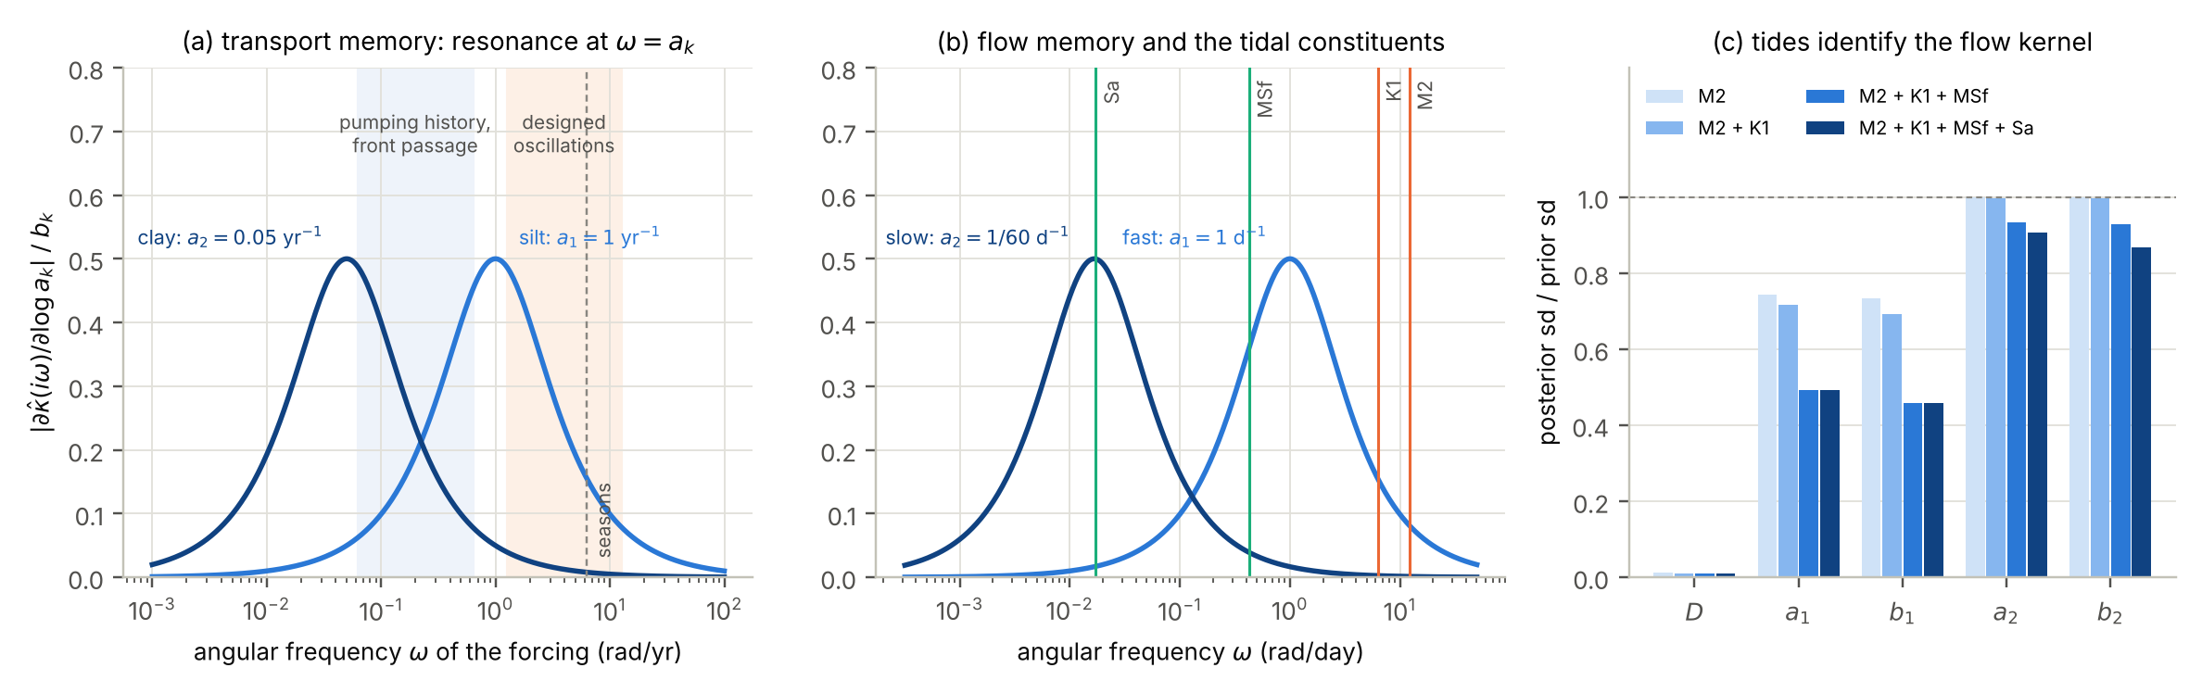
Figure 6. Spectral identifiability (RITMI-GO [8]). (a) Transport memory: sensitivity (21) to the silt and clay rates against the forcing frequency, with the bands of the pumping history and front passage and of designed oscillations. (b) Flow memory: the same for the fast and slow storage rates, with the four tidal constituents. (c) Posterior over prior standard deviation of the diffusivity and the four kernel parameters for increasing sets of tidal constituents.
INNOVATION Each forcing frequency measures one complex number of the memory symbol, with a resonance at each rate; tides identify the flow kernel constituent by constituent, and chloride separates memory from exchange at every frequency. The atlas turns these statements into a map of what the Fushë-Kuqe data can and cannot identify.

8. I5 – What a goal needs: goal-oriented spectral matching
Not everything has to be identified. Proposition 10 (goal-oriented spectral matching). Let the standardised parameters have prior $N\left(0,I\right)$, the data be $y=Jθ+e$ with $e∼N\left(0,σ^{2}I\right)$, and the goal be $g=Gθ$ (all linearised). As $σ→0$ the posterior variance of $g$ tends to zero if and only if $G^{⊤}$ lies in the range of $J^{⊤}$, whatever happens to the individual parameters in the null space of $J$:
$$G{\left(\frac{J^{⊤}J}{σ^{2}}+I\right)}^{−1}G^{⊤} → {∥P_{N\left(J\right)} G^{⊤}∥}^{2} \left(σ→0\right)$$ | (23)
where $J$ is the Jacobian of the data and $G$ that of the goal with respect to the standardised parameters, and $P_{N\left(J\right)}$ the orthogonal projector onto the null space of $J$. Proof: ${\left(J^{⊤}J/σ^{2}+I\right)}^{−1}$ converges to $P_{N\left(J\right)}$. In the spectral setting the rows of $J$ are sensitivities at the frequencies of the forcing that produced the data and $G$ collects sensitivities at the frequencies of the forcing under which the goal is predicted: when the band of the goal lies inside the band of the data, the goal is identified.
For a forecast of salinity in 2045 under status-quo pumping the forcing is slow, $ω≪a_{1}$. To leading order the goal depends on the memory through the zero-frequency capacity $1+\hat{κ}\left(0\right)=1+b_{1}+b_{2}$, which slows the front, and on the slow clay rate. Corollary 2 (lumping the fast silt zone). If every goal is driven by forcing much slower than $a_{1}$, the silt zone can be replaced by an effective porosity $1+b_{1}$ with an error of order $ω/a_{1}$ in the goal, and its rate need not, and cannot, be identified from the same slow data:
$$v_{\text{eff}}=\frac{v}{1+\hat{κ}\left(0\right)}=\frac{s_{v} \overline{v}}{1+b_{1}+b_{2}}, ψ=logs_{v}−log\left(1+b_{1}+b_{2}\right)$$ | (24)
where $s_{v}$ is the uncertain multiplier of the reference velocity field $\overline{v}$ and $ψ$ the effective-velocity combination of the parameters that the slow goals need.
In RITMI-GO the gradient of the 2045 chloride goal is aligned at 94% with the direction of $ψ$; the posterior standard deviation of $ψ$ falls from 0.33 (prior) to 0.072 with the history and 0.025 with five years of monitoring, while the fast rate $a_{1}$ stays near its prior (0.86) and the velocity multiplier is correlated with the silt capacity at 0.92. The individual parameters are poorly known; the combination the goal needs is well known. This is the task-oriented view of system identification [44, 45], the behavioural view of identifiability [46] and the goal-oriented criterion of the base paper [1], now in the frequency domain; approximation theory for memory in linear recurrent models [47] and data-selection criteria for reduced models [48] follow the same logic.
INNOVATION A goal is identified when its gradient lies in the row space of the data Jacobian; spectrally, when the band of its forcing lies inside the band of the data. The 2045 salinity goals need the capacity of the zones and the clay rate, which the passage of the front informs, not the silt rate.

9. I6 – Assimilation in time: Markovian embedding, hybrid and robust filters
Proposition 11 (Markovian embedding and dissipation). For κs=k​bkake−aks the transport equation with memory (10) and a given history is equivalent to (7)–(8) with $K$ hidden states $c_{k}$, whose initial values encode the history; the augmented state is Markov. For each species, under mass transfer alone,
$$\frac{d}{dt} \frac{1}{2}\left(c^{2}+\sum_{k=1}^{K}{b_{k}}c_{k}^{2}\right)=−\sum_{k=1}^{K}{b_{k}}a_{k}{\left(c−c_{k}\right)}^{2}≤0$$ | (25)
where the left-hand side is the rate of change of a quadratic energy of the mobile and immobile concentrations. Proof: substitute c=−k​bkakc−ck and ${\dot{c}}_{k}=a_{k}\left(c−c_{k}\right)$. The hidden states are therefore stable but observable only through the mobile concentration.
This makes the candidate system assimilable with standard sequential methods: the state (13) is filtered with the kernel and closure parameters as static states. The hidden states receive information only through their coupling to $c$, so their ensemble spread must be protected by inflation and by localisation per zone, and the completely monotone class is the right prior for a learned kernel: it guarantees the embedding and the dissipation, which a free neural kernel does not. Markovian lifts of Volterra processes [49] and functional detectability [50] give the general theory.
In the mean-field limit the error of the ensemble Kalman filter is controlled by the distance of the forecast from its Gaussian projection [51]. Proposal N2 measures this distance and switches to a transport-map analysis [52, 53] only where it matters:
$${\hat{ε}}_{n}\left(x\right)=\frac{W_{2}\left(μ_{n}\left(x\right), Gμ_{n}\left(x\right)\right)}{σ_{\text{obs}}}, \text{analysis}=\left\{\begin{matrix}\text{EnKF}, & {\hat{ε}}_{n}≤τ \\ \text{transport map}, & {\hat{ε}}_{n}>τ\end{matrix}\right.$$ | (26)
where $μ_{n}\left(x\right)$ is the forecast distribution of log chloride at $x$ and time $n$ (the ensemble), $Gμ_{n}$ the Gaussian with the same mean and variance, $W_{2}$ the Wasserstein distance, $σ_{\text{obs}}$ the observation error and $τ$ a threshold (here 1). Dividing by the observation error, not by the forecast spread, is the point: a non-Gaussian forecast matters only if the data can see the difference.
On the forecast of 2016 from 400 members (Figure 7b) the standardised distance is largest 13.5 km inland, where almost every member is fresh and no analysis can change anything: the standardised distance is the wrong switch. Scaled as in (26), the distance exceeds the observation error only between 1.9 and 7.3 km, around the front and the abstraction field, with its maximum (6.1) at 6.1 km. A hybrid filter would use the transport map in 28 of the 75 cells, at wells 341 and 340, and the Kalman analysis elsewhere, including well 503, where the forecast is salty, well determined and close to Gaussian (0.58). Low-rank ensemble filters for elliptic observations [54] make the Kalman part cheap.
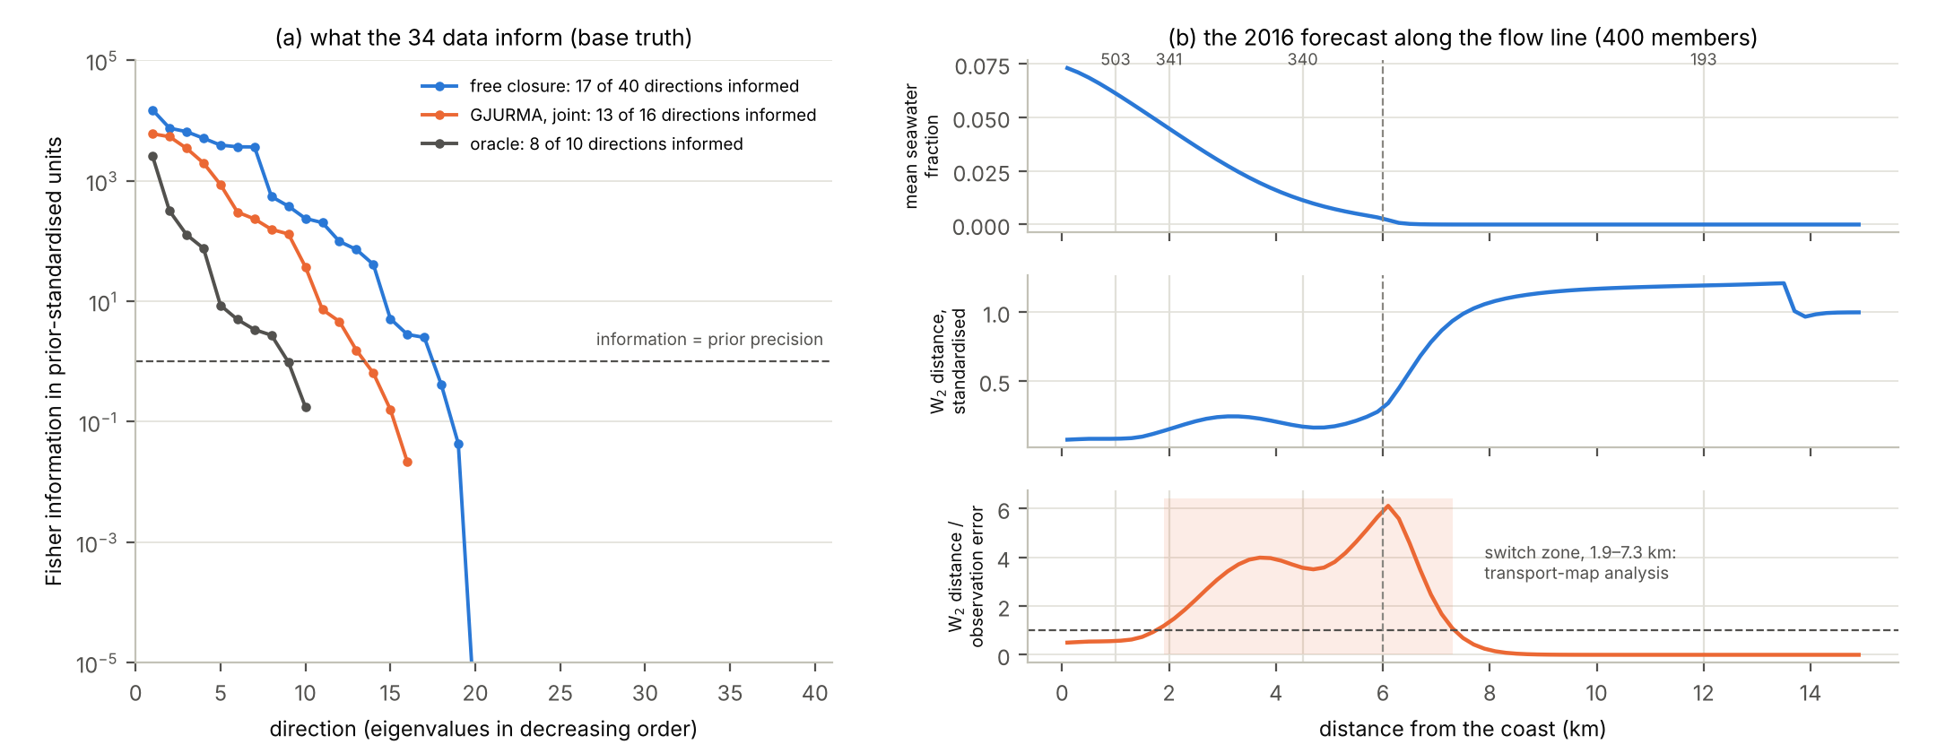
Figure 7. Identifiability and the switch of the hybrid filter (GJURMA-GO [7]). (a) Eigenvalues of the Fisher information of the 34 data for the free closure, GJURMA and the oracle (dashed: information equal to the prior precision). (b) The forecast of 2016 from 400 members: mean seawater fraction; Wasserstein distance of the standardised log-chloride forecast from the normal; and the switch statistic (26) (shaded: where it exceeds one).
Status reports must also hold for parties with different priors. Proposal N3 reports robust lower and upper expectations of a status quantity $φ$ [55]:
$$E\left(φ∣Y_{t}\right)=\underset{γ}{\text{sup}}\left(E^{γ}\left[φ∣Y_{t}\right]−{\left(\frac{α_{t}\left(γ\right)}{k}\right)}^{k′}\right), −E\left(−φ∣Y_{t}\right)≤E^{\hat{γ}}\left[φ∣Y_{t}\right]≤E\left(φ∣Y_{t}\right)$$ | (27)
where $φ$ is a status quantity (for example the indicator that chloride at a supply well exceeds 250 mg/L), $Y_{t}$ the data up to time $t$, $γ$ the uncertain model inputs (recharge, closure), $E^{γ}$ the filtered expectation under $γ$, $α_{t}\left(γ\right)$ the negative log-likelihood of $γ$ relative to the maximum-likelihood value $\hat{γ}$, and $k$, $k′$ constants that set the width of the band.
Proposition 12 (the plug-in lies inside the band). The plug-in value $E^{\hat{γ}}\left[φ∣Y_{t}\right]$ lies between the lower and the upper expectation. Proof: the penalty vanishes at $\hat{γ}$, so $\hat{γ}$ is admissible with zero penalty in the supremum and in the infimum. □ The width of the band depends on $k$ and $k′$ and not on a prior over recharge, the property a report shared among several administrations needs. The field fits of review 42 show why: with the assumed geometry, the 2045 forecasts of five models disagree by more than their intervals, chloride at the edge of the field between 568 and 672 mg/L and sodium at 3 km between 228 and 523 mg/L. Conformal control of time-series forecasts [56] offers a distribution-free complement.
INNOVATION Completely monotone memory has a dissipative Markovian embedding, so the augmented transient system can be assimilated sequentially. The hybrid filter must switch by the non-Gaussianity measured against the observation error, which confines the expensive analysis to a band around the front and the well field; the robust band reports status independently of priors.

10. I7 – Designing the rhythm: pumping or sampling?
A designed experiment adds forcing where the natural ones leave a gap. In the language of system identification [57, 58], the information about a parameter $θ$ of an experiment with input spectrum $Φ_{u}\left(ω\right)$, and its cost in salinity, are per unit time
$$I_{θ}=\frac{1}{2π}∫Φ_{u}\left(ω\right) \frac{{\left|∂_{θ}G\left(iω\right)\right|}^{2}}{Φ_{e}\left(ω\right)} dω, \text{cost}=\frac{1}{2π}∫Φ_{u}\left(ω\right){\left|G_{\text{Cl}}\left(iω\right)\right|}^{2}dω$$ | (28)
where $G$ is the transfer function from pumping to the observed concentrations, $Φ_{e}$ the spectrum of the data errors and $G_{\text{Cl}}$ the transfer function to chloride at the supply wells. Maximising information for a fixed cost is a least-costly identification experiment [59]; for a coastal aquifer the cost is real (extra salt at the well field), and a pause of pumping freshens the aquifer and costs only the water not delivered.
The cheapest design variable of all is the sampling operator $H_{n}$ of (14): when, where and which species to sample. With the five-year monitoring split into 210 units (a monthly chloride sample or a half-yearly ion campaign at one well), twelve units are chosen greedily to minimise
S⋆=arg minS=12 g​logVarg∣yhist,yS | (29)
where $S$ is a set of sampling units, $y_{\text{hist}}$ the historical data and the sum runs over the three concentration goals of 2045 (linearised posterior variances). The logarithm makes the criterion invariant to the units of the goals.
Twelve pumping designs for 2026–2031 were compared (Figure 8a): oscillations of 0.5–5 years, doublets, a pseudo-random binary sequence, pauses and surges. The best, a doublet with a five-year period, adds only 0.26 nats of information at the price of 14 mg/L of extra chloride at the well field; a two-year pause relieves 12 mg/L and adds 0.07 nats. The monitoring itself adds 21.7 nats. The greedy choice (29) picks late ion campaigns at wells 340 and 341 and two chloride samples at well 340 (Figure 8b): with them the linearised posterior standard deviation of chloride at 5 km in 2045 falls from 7.8 to 3.3 mg/L (routine schedule of the same size: 3.6; all 210 units: 1.1) and that of sodium at 3 km from 13.7 to 6.1 mg/L (routine 7.3).
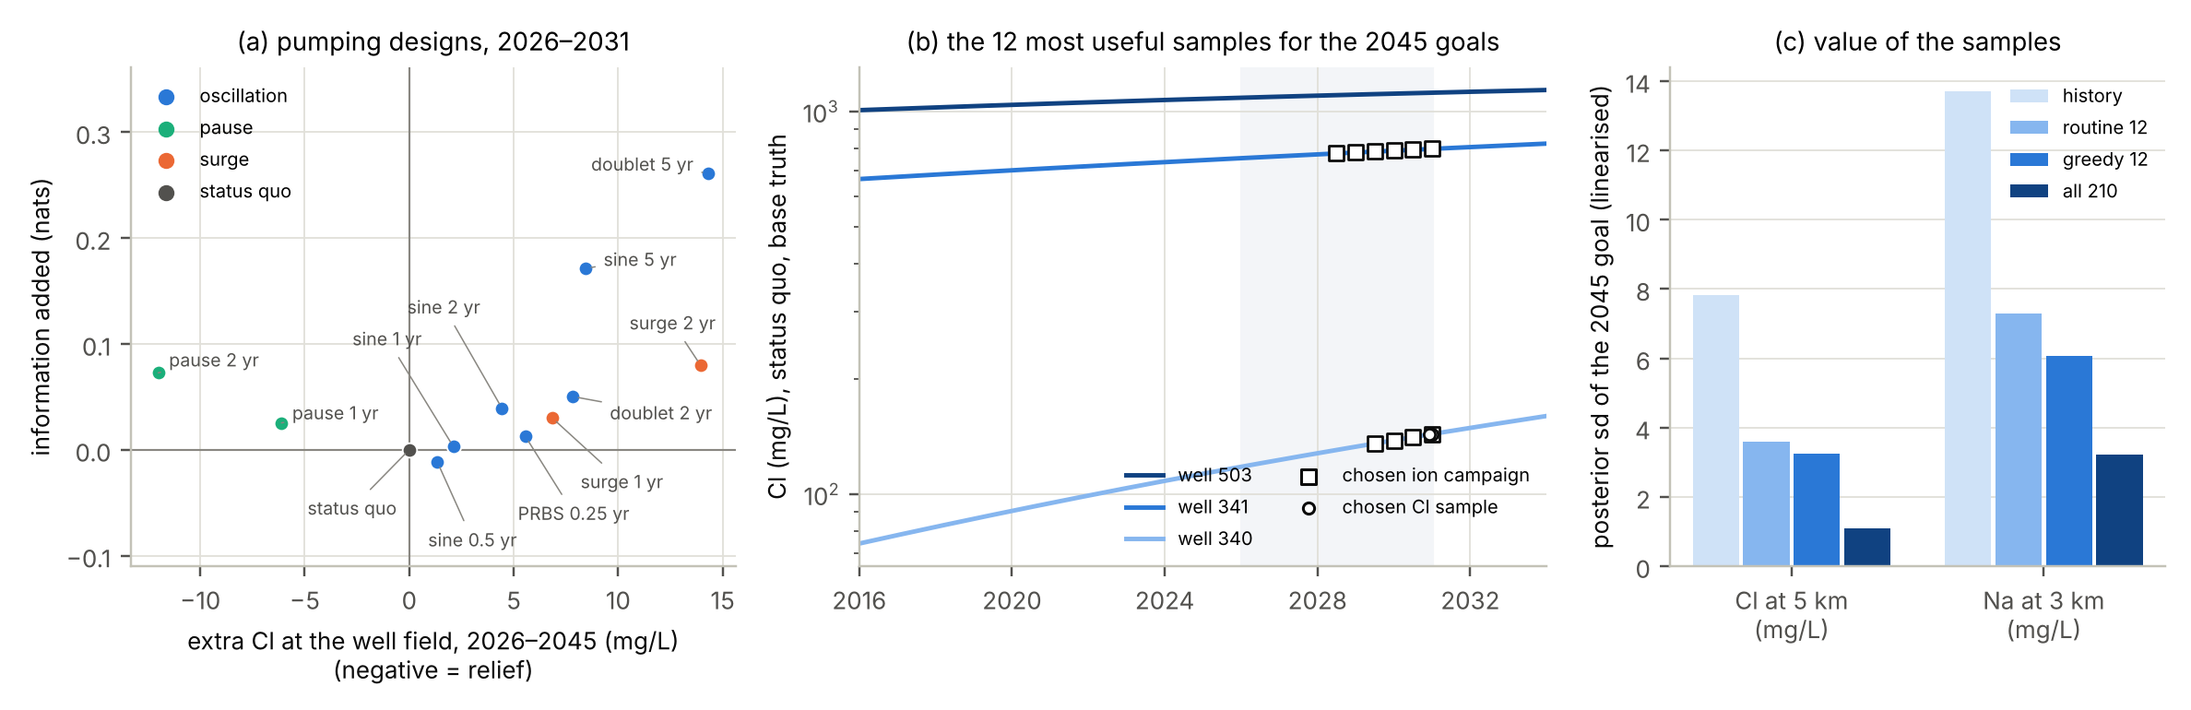
Figure 8. Designing the rhythm (RITMI-GO [8]). (a) Twelve pumping designs for 2026–2031: information added against extra chloride at the well field (negative: relief). (b) The twelve most useful samples (29) for the 2045 goals, on the chloride histories of wells 503, 341 and 340. (c) Linearised posterior standard deviation of two 2045 goals with the history only, a routine schedule of twelve samples, the twelve chosen samples and all 210 units.
The linearised ranking was checked with the ensemble smoother [35] (100 members, 4 iterations) on 24 synthetic truths (Figure 9). The root-mean-square error of chloride at 5 km in 2045 is 17.7 mg/L with the history alone, 7.5 with the routine twelve, 4.1 with the chosen twelve and 1.6 with all monitoring; for sodium at 3 km 18.5, 7.6, 5.6 and 4.3 mg/L. The chosen samples nearly halve the error of the routine schedule at no extra cost, and their 90% intervals cover the truth in 96% of the cases. A digital twin of the aquifer [60] would rerun this choice as data arrive, with online adjoints [61] for the gradients.
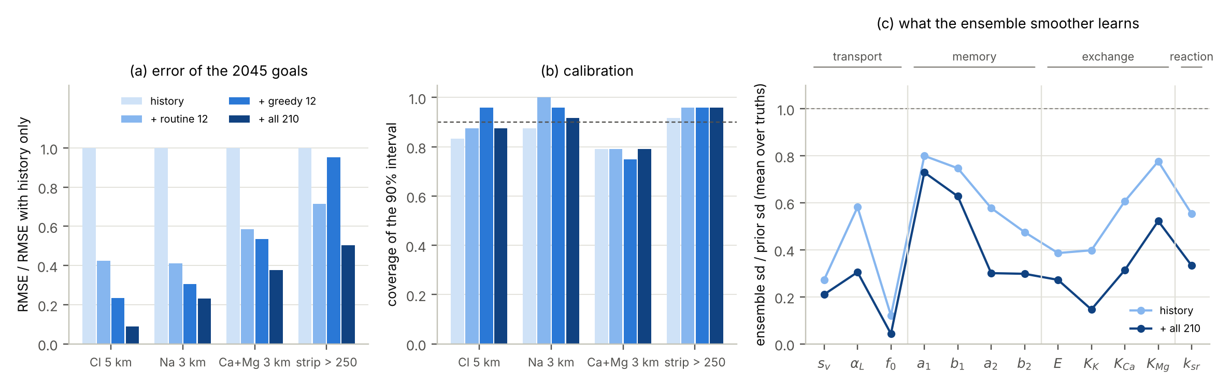
Figure 9. Nonlinear check with the ensemble smoother on 24 truths (RITMI-GO [8]). (a) Root-mean-square error of the four 2045 goals relative to the history alone. (b) Coverage of the 90% intervals (dashed: nominal). (c) Ensemble standard deviation over prior standard deviation of the twelve parameters, history alone and with all monitoring.
INNOVATION The information that a pumping rhythm can add is small and costs salt; the information of a well-chosen sampling schedule is large and free. For the 2045 goals at Fushë-Kuqe the best design variable is late ion campaigns at wells 340 and 341, not a pumping experiment.

11. I8 – New: chloride sufficiency and the price of the cut
The cut of Proposition 5 protects the chloride forecast, and the twin of Section 5 showed that it calibrates it. What does it cost, and how much does it protect? Linearise at the prior-mean truth of RITMI-GO, with the history and five years of monitoring (190 chloride data and 204 data of the other ions), and split the twelve standardised parameters into $θ_{T}$ (velocity, dispersivity, coastal salinity and the four memory parameters: seven) and $θ_{R}$ (exchange capacity, three selectivities, sulfate-reduction rate: five). Let $J$ be the whitened Jacobian (divided by the data error), with blocks $J_{T}$, $J_{R}$ by parameters and $J_{\text{Cl}}$, $J_{\text{ion}}$ by data; by Proposition 3, $J_{\text{Cl},R}=0$. Define
$$Σ_{1}={\left(J_{\text{Cl},T}^{⊤}J_{\text{Cl},T}+I\right)}^{−1}, Σ_{2}={\left(J_{R}^{⊤}J_{R}+I\right)}^{−1}, A=Σ_{2}J_{R}^{⊤}$$ | (30)
where $Σ_{1}$ is the posterior covariance of $θ_{T}$ from the chloride data alone (first factor of (19)), $Σ_{2}$ that of $θ_{R}$ from all data with $θ_{T}$ known, and $A$ the gain that maps residuals of all data into $θ_{R}$ (second factor of (19)).
Theorem 1 (chloride sufficiency). Let $Σ_{\text{joint}}={\left(J^{⊤}J+I\right)}^{−1}$ be the joint posterior covariance and $Σ_{TT}$ its $θ_{T}$ block. (i) The covariance of the linear-Gaussian cut is $Σ_{\text{cut}}=Σ_{\text{joint}}+B\left(Σ_{1}−Σ_{TT}\right)B^{⊤}$ with $B^{⊤}=\left(I, −{\left(AJ_{T}\right)}^{⊤}\right)$ and $Σ_{1}≽Σ_{TT}$, so the price $π_{g}$ of (31) is non-negative for every goal and computable before any datum is taken. (ii) A chloride goal has $G_{R}=0$; its cut variance $G_{T}Σ_{1}G_{T}^{⊤}$ depends on the chloride data only and tends to $∥P_{N\left(J_{\text{Cl},T}\right)}G_{T}^{⊤}∥^{2}$ as the data error vanishes. (iii) If the ion data carry a systematic error $δ_{\text{ion}}$ (whitened), as a misspecified reactive closure produces, the goal estimates shift by (31): for a chloride goal the cut shift is exactly zero. (iv) The cut has the smaller mean-squared error for a chloride goal if and only if $\left|δg_{\text{joint}}\right|>\sqrt{{\text{Var}}_{\text{cut}}\left(g\right)−{\text{Var}}_{\text{joint}}\left(g\right)}$.
$$π_{g}=\frac{{\text{Var}}_{\text{cut}}\left(g\right)}{{\text{Var}}_{\text{joint}}\left(g\right)}−1≥0, δg_{\text{joint}}=G Σ_{\text{joint}}J_{\text{ion}}^{⊤}δ_{\text{ion}}, δg_{\text{cut}}=G_{R} A_{\text{ion}}δ_{\text{ion}}$$ | (31)
where $g=Gθ$ is a linearised goal with blocks $G_{T}$, $G_{R}$; ${\text{Var}}_{\text{cut}}$ and ${\text{Var}}_{\text{joint}}$ are its variances under the cut and the joint posterior; $A_{\text{ion}}$ are the columns of $A$ for the ion data. The worst case over errors with a root-mean-square of one data error sd is $\sqrt{n_{\text{ion}}} ∥GΣ_{\text{joint}}J_{\text{ion}}^{⊤}∥$ for the joint fit.
Proof. (i) By block inversion, $Σ_{TT}^{−1}=I+J_{T}^{⊤}{\left(I+J_{R}J_{R}^{⊤}\right)}^{−1}J_{T}$. Because $J_{\text{Cl},R}=0$, the matrix ${\left(I+J_{R}J_{R}^{⊤}\right)}^{−1}$ is the identity on the chloride rows, so $Σ_{TT}^{−1}=Σ_{1}^{−1}+J_{\text{ion},T}^{⊤}{\left(I+J_{\text{ion},R}J_{\text{ion},R}^{⊤}\right)}^{−1}J_{\text{ion},T}≽Σ_{1}^{−1}$. The joint posterior has $Σ_{RR}=Σ_{2}+AJ_{T}Σ_{TT}J_{T}^{⊤}A^{⊤}$ and $Σ_{TR}=−Σ_{TT}J_{T}^{⊤}A^{⊤}$; the cut has the same blocks with $Σ_{TT}$ replaced by $Σ_{1}$, since $θ_{R}=A\left(y−J_{T}θ_{T}\right)+ϵ$ with $ϵ∼N\left(0,Σ_{2}\right)$ in both. (ii) $G_{R}=0$ by Proposition 3, and the limit is Proposition 10 applied to the chloride rows. (iii) The joint posterior mean is $Σ_{\text{joint}}J^{⊤}y$; the cut mean of $θ_{T}$ uses only chloride rows, on which $δ$ vanishes, and that of $θ_{R}$ moves by $Aδ$. (iv) Compare ${\text{Var}}_{\text{joint}}+δg_{\text{joint}}^{2}$ with ${\text{Var}}_{\text{cut}}$. □
At Fushë-Kuqe the chloride data have full rank (7) on the seven transport and memory parameters, so the part of the chloride-goal gradient they cannot see is zero to machine precision: chloride is sufficient for the chloride goal. The price is small (Figure 10a): the posterior standard deviation of chloride at 5 km in 2045 rises from 1.09 mg/L (joint) to 1.25 mg/L (cut), +15%; for sodium at 3 km from 3.23 to 4.28 mg/L (+32%) and for hardness from 0.096 to 0.110 meq/L (+14%). Chloride data alone give the same 1.25 mg/L for chloride but 32.5 mg/L for sodium: reactive goals need the ions, chloride goals do not.
The protection is large (Figure 10b). If the sodium data are all biased by one error standard deviation (5%), as a closure that misplaces the exchange would produce, the joint chloride forecast moves by 0.59 mg/L, about half its posterior standard deviation; calcium, magnesium and bicarbonate biases move it by 0.54, 0.56 and 0.40 mg/L. The worst error pattern with a root-mean-square of one standard deviation on the ion data moves it by 7.4 mg/L, 6.8 posterior standard deviations: an interval that would almost never cover. Under the cut all these shifts are exactly zero. By part (iv) the cut is preferable as soon as the joint shift exceeds 0.62 mg/L. The field fits of review 42 have root-mean-square misfits of 8.3 (joint) and 9.1 (cut) error standard deviations, mostly in sulfate and calcium: the misspecification is far beyond that threshold, and the cut is the right choice for the chloride forecasts of Fushë-Kuqe. The cut does not protect the reactive goals (worst-case shift of sodium 33.8 mg/L jointly, 23.2 with the cut); it stops the error of the closure from spreading to chloride. The nonlinear twin agrees (Figure 10c): coverage of the 90% interval for chloride rises from 72% to 98%.
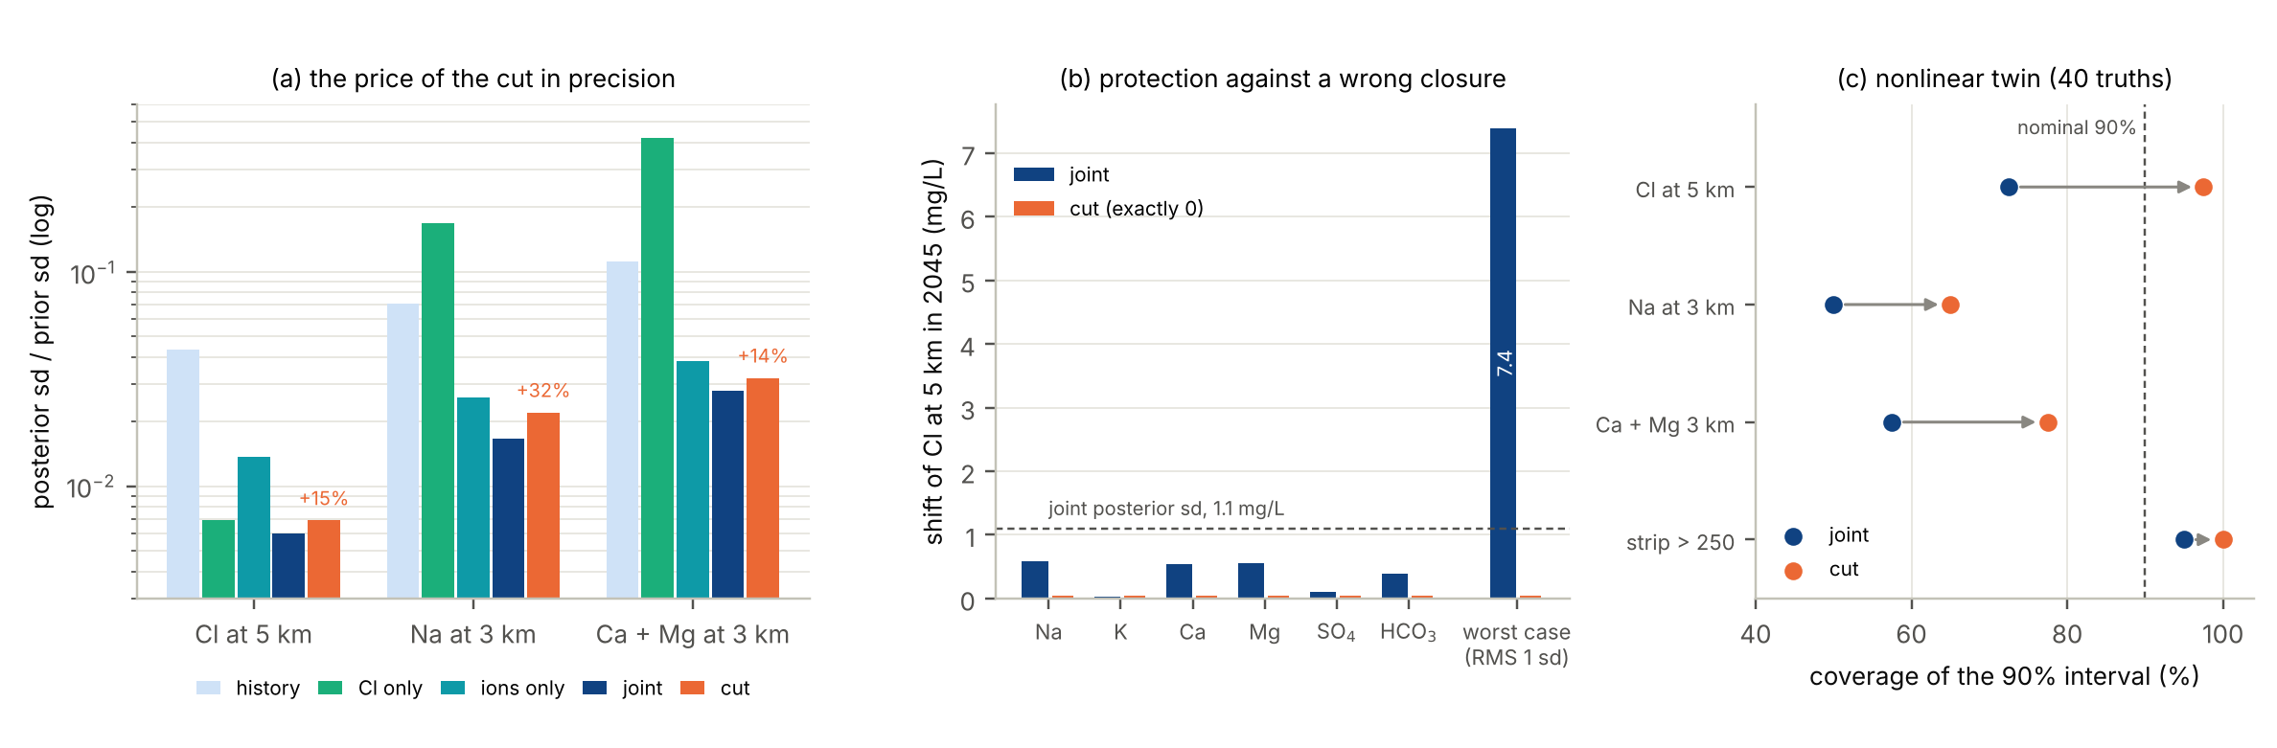
Figure 10. Chloride sufficiency (new). (a) Linearised posterior over prior standard deviation of three 2045 goals for the history, chloride data only, ion data only, the joint fit and the cut (history and five years of monitoring); percentages: price of the cut in standard deviation. (b) Shift of the 2045 chloride forecast when the data of one ion are biased by one error standard deviation, and in the worst case with a root-mean-square error of one standard deviation on all ion data; the cut shift is exactly zero. (c) Coverage of the 90% interval in the nonlinear twin of GJURMA-GO, joint fit against cut.
A practical consequence is that the design problem splits. The chloride network can be designed for the chloride goals on the chloride data alone, by (29) restricted to chloride units and $Σ_{1}$; the ion campaigns are then chosen for the reactive goals with the transport held at its chloride posterior. Each half is smaller than the joint problem, and the chloride half does not depend on a closure that is still being learned.
INNOVATION Chloride sufficiency: for a chloride goal, the cut through the reaction invariant has a non-negative, computable price in precision (here 15% in standard deviation) and makes the forecast exactly insensitive to any error of the reactive closure (here a worst case of 7.4 mg/L, 6.8 standard deviations, removed). A one-line rule, part (iv) of Theorem 1, says when to cut, and the monitoring design splits into a chloride half and a reactive half.

12. The candidate system for the COST proposal
The augmented transient system for the COST proposal is (1)–(14): flow with a learned closure and a completely monotone memory (N1), coupled through the density to the transport of seven ions with exchange, memory zones and a closure confined to the span of $N$, written as a Markovian state-space model and assimilated with a cut through chloride, a hybrid filter and robust status bands, with the sampling schedule and the pumping rhythm as design variables evaluated along the trajectory. Table 3 lists its terms with what hides them, what reveals them, whether the 2045 goals need them, and how well the Fushë-Kuqe data already identify them.
Table 3. The identifiability ledger of the candidate system. Last column: posterior over prior standard deviation from the history and five years of status-quo monitoring (RITMI-GO, linearised), or the tidal experiment of Section 7; 1 means nothing learned.
Term (equation) | Invisible to | Identified by | Needed by 2045 goals | Fushë-Kuqe now
Diffusivity $T/S$ (6) | steady heads (see $T$ only) | M2 tide, amplitude and phase | no (fast clock) | 0.013 with M2 (synthetic: no loggers yet)
Fast storage kernel (5)–(6) | steady heads; M2 alone | fortnightly MSf | no | 0.49 / 0.46 with MSf (synthetic)
Slow storage kernel | all four constituents | forcing of months: long pumping tests | no | 0.91 / 0.87: open
Flow closure and recharge (4) | heads (Proposition 2) | invariant chemistry of the source waters (Proposition 4) | through the recharge | open: not yet tested
Velocity, dispersivity, coastal salinity (7) | – | chloride history and monitoring | yes | 0.27, 0.29, 0.04
Silt memory $a_{1}$, $b_{1}$ (10) | steady data; slow forcing | forcing at periods of about 6 yr | only through $1+b_{1}+b_{2}$ | 0.86, 0.90 (rate not needed)
Clay memory $a_{2}$, $b_{2}$ (10) | steady data (except $r_{\text{eff}}$) | front passage, decades of chloride | yes | 0.28, 0.29
Exchange $E$ and selectivities (9) | steady data (Proposition 6) | any change of composition, with chloride (Proposition 9) | Na, hardness | 0.27; 0.11, 0.27, 0.50
Sulfate reduction $k_{sr}$ (8) | – | steady SO₄, HCO₃ via $r_{\text{eff}}$; transients | no | 0.33
Learned closure $θ$ (12) | heads; chloride | reactive species given transport (cut) | Na, hardness | 13 of 16 directions informed (twin)

The ledger translates into work packages:
- Field. One year of tide and head loggers at wells 503, 341 and 340 (15-minute sampling) for the flow kernel; continued monthly chloride; ion campaigns at wells 340 and 341 in 2028–2031, the units chosen by (29); analyses of source waters (recharge, river, clay pore water) for Proposition 4(iv).
- Model. The two- or three-dimensional variable-density model of the base paper with the full composition, real well positions and the pumping history, replacing the flow line.
- Learning. Completely monotone kernels in Stieltjes form (22) and the stoichiometric closure (12), with algebraic identifiability tests before fitting.
- Assimilation and reporting. Ensemble smoother and filter with the cut (19), transport-map analysis in the switch zone (26), robust status bands (27).
- Design. A transient goal-oriented criterion along the trajectory, sampling first and pumping rhythm second, split into a chloride half and a reactive half (Section 11).

13. Limitations
- Geometry and data. Both experiments use a one-dimensional flow line with assumed well positions, pumping history and seawater salinity; density is not coupled to transport in them, and the flow closure of N1 is not tested on Fushë-Kuqe data. The tidal results are synthetic: no tide or head loggers exist yet.
- Model family. The synthetic truths use the same memory and exchange structure as the learned models (except the free closure), so the tests do not ask whether a completely monotone kernel can be learned when the true one differs. Fisher information and Theorem 1 are linearised at the prior mean; the nonlinear checks cover the ranking of designs and the coverage of the cut, not every number.
- Field fits. No model fits the 34 field data within their 5% error (root-mean-square misfit 8.3–9.1 error standard deviations for GJURMA), and the 2045 forecasts of different models disagree by more than their intervals; the forecasts are conditional on the assumed geometry.
- Proposals N2 and N3. The switch statistic of N2 was computed but the transport-map analysis was not run, and the robust band of N3 was not computed for this model.
- Literature. Several classical references are cited without verified volume, page or DOI; these are marked in the reference list and must be checked before submission.

14. Conclusions
The classical steady, single-salt model of seawater intrusion hides two things that the Fushë-Kuqe data already show: a chemical trace of exchange and reaction, and a rhythm of transient forcing. The augmented transient system (1)–(14) restores both, and the eight innovations say how to make it identifiable and useful:
- I1 the departures from mixing split into reaction extents that name the closure and the direction of the front;
- I2 a closure confined to the span of $N$ leaves chloride closure-free, so chloride pins transport and memory;
- I3 steady data are blind to exchange and memory, and the exchange signal is a fingerprint of the transient state;
- I4 each forcing frequency identifies one complex number of the memory symbol, with a resonance at each rate;
- I5 a goal needs only the part of the system that its own forcing excites;
- I6 the memory has a dissipative Markovian embedding, and filters switch where the data can see non-Gaussianity;
- I7 the cheapest experiment is a sampling schedule, not a pumping rhythm;
- I8 chloride is sufficient for chloride goals: the cut costs a computable 15% and removes the sensitivity to errors of the closure.
Together they turn the candidate system from a list of terms into a programme: which data to take, in which order, for which goal, with which guarantee.
Data and code. The experiments are in the author's repository swi-goal-oed: experiments/gjurma_go (review 42), experiments/ritmi_go (review 43) and experiments/synthesis (Theorem 1 and Figures 1, 5 and 10).

References
[1] Zeqiraj, D. (2026). Goal-oriented Bayesian experimental design for variable-density seawater intrusion: adjoint expected information gain for joint monitoring and managed-aquifer-recharge placement. Journal of Hydrology, 680, 136559. https://doi.org/10.1016/j.jhydrol.2026.136559
[2] Voss, C. I. & Souza, W. R. (1987). Variable density flow and solute transport simulation of regional aquifers containing a narrow freshwater–saltwater transition zone. Water Resources Research (volume, pages and DOI not verified).
[3] Werner, A. D. et al. (2013). Seawater intrusion processes, investigation and management: recent advances and future challenges. Advances in Water Resources (volume, pages and DOI not verified).
[4] Appelo, C. A. J. & Postma, D. (2005). Geochemistry, Groundwater and Pollution, second edition. Balkema (pages not verified).
[5] Appelo, C. A. J. (1994). Cation and proton exchange, pH variations, and carbonate reactions in a freshening aquifer. Water Resources Research (volume, pages and DOI not verified).
[6] Asimilimi i të dhënave për dinamikën që mungon. Njëzet punime 2020–2026 nga Oxford, Harvard, MIT dhe Caltech (8 October 2026). Document of the author's series, Google Drive folder "ASIMILIMI DINAMIK I TE DHENAVE".
[7] Zeqiraj, D. (2026). Missing dynamics in coastal-aquifer flow and multi-species transport: 30 papers for a COST candidate system of equations. Literature review 42 of the author's series (23 October 2026), with the numerical experiment GJURMA-GO.
[8] Zeqiraj, D. (2026). The transient state: flow and multi-species transport with memory, and what time-dependent data identify. Literature review 43 of the author's series (23 October 2026), with the numerical experiment RITMI-GO.
[9] Fushe Kuqe coastal aquifer observatory: joint technical note FGJM-UPT and Deltares (26 September 2026). Internal technical note, Google Drive folder "20 TE GJITHA TE SHKARKUAARA".
[10] Cenameri, S. & Beqiraj, A. (2016). Assessment of seawater intrusion in Fushë-Kuqe aquifer, Albania. Bulletin of the Geological Society of Greece, 50(2), 665–670. https://doi.org/10.12681/bgsg.11772
[11] Kevorkian, J. & Cole, J. D. (1996). Multiple Scale and Singular Perturbation Methods. Springer (pages not verified).
[12] Levine, M. E. & Stuart, A. M. (2022). A framework for machine learning of model error in dynamical systems. Communications of the American Mathematical Society (volume, pages and DOI not verified).
[13] Wu, J.-L., Levine, M. E., Schneider, T. & Stuart, A. (2024). Learning about structural errors in models of complex dynamical systems. Journal of Computational Physics (volume, pages and DOI not verified).
[14] Boulton, N. S. (1963). Analysis of data from non-equilibrium pumping tests allowing for delayed yield from storage. Proceedings of the Institution of Civil Engineers (volume, pages and DOI not verified).
[15] Hantush, M. S. (1960). Modification of the theory of leaky aquifers. Journal of Geophysical Research (volume, pages and DOI not verified).
[16] Jacob, C. E. (1950). Flow of ground water. In H. Rouse (ed.), Engineering Hydraulics. Wiley (pages not verified).
[17] Ferris, J. G. (1951). Cyclic fluctuations of water level as a basis for determining aquifer transmissibility. International Association of Scientific Hydrology (publication number and pages not verified).
[18] Haggerty, R. & Gorelick, S. M. (1995). Multiple-rate mass transfer for modeling diffusion and surface reactions in media with pore-scale heterogeneity. Water Resources Research (volume, pages and DOI not verified).
[19] Carrera, J., Sánchez-Vila, X., Benet, I., Medina, A., Galarza, G. & Guimerà, J. (1998). On matrix diffusion: formulations, solution methods and qualitative effects. Hydrogeology Journal (volume, pages and DOI not verified).
[20] Gaines, G. L. & Thomas, H. C. (1953). Adsorption studies on clay minerals. II. A formulation of the thermodynamics of exchange adsorption. The Journal of Chemical Physics (volume, pages and DOI not verified).
[21] Zwanzig, R. (2001). Nonequilibrium Statistical Mechanics. Oxford University Press (pages not verified).
[22] Chorin, A. J., Hald, O. H. & Kupferman, R. (2002). Optimal prediction with memory. Physica D (volume, pages and DOI not verified).
[23] Widder, D. V. (1941). The Laplace Transform. Princeton University Press (pages not verified).
[24] Bhattacharya, K., Cao, L., Stepaniants, G., Stuart, A. M. & Trautner, M. (2026). Learning memory and material dependent constitutive laws. The SMAI Journal of Computational Mathematics, 12, 219–267. https://doi.org/10.5802/smai-jcm.148
[25] Xie, P., Car, R. & E, W. (2024). Ab initio generalized Langevin equation. Proceedings of the National Academy of Sciences, 121(14), e2308668121. https://doi.org/10.1073/pnas.2308668121
[26] Gupta, A. & Lermusiaux, P. F. J. (2021). Neural closure models for dynamical systems. Proceedings of the Royal Society A, 477(2252), 1–29 (article number not verified). https://doi.org/10.1098/rspa.2020.1004
[27] Kelp, M. M., Jacob, D. J., Kutz, J. N., Marshall, J. D. & Tessum, C. W. (2020). Toward stable, general machine-learned models of the atmospheric chemical system. Journal of Geophysical Research: Atmospheres, 125, e2020JD032759. https://doi.org/10.1029/2020JD032759
[28] Ji, W. & Deng, S. (2021). Autonomous discovery of unknown reaction pathways from data by chemical reaction neural network. The Journal of Physical Chemistry A, 125(4) (pages not verified). https://doi.org/10.1021/acs.jpca.0c09316
[29] Plummer, L. N., Prestemon, E. C. & Parkhurst, D. L. (1994). An interactive code (NETPATH) for modeling net geochemical reactions along a flow path. U.S. Geological Survey report (number not verified).
[30] Lichtner, P. C. (1985). Continuum model for simultaneous chemical reactions and mass transport in hydrothermal systems. Geochimica et Cosmochimica Acta (volume, pages and DOI not verified).
[31] Saaltink, M. W., Ayora, C. & Carrera, J. (1998). A mathematical formulation for reactive transport that eliminates mineral concentrations. Water Resources Research (volume, pages and DOI not verified).
[32] Hong, H., Ovchinnikov, A., Pogudin, G. & Yap, C. (2020). Global identifiability of differential models. Communications on Pure and Applied Mathematics (volume, pages and DOI not verified).
[33] Simpson, M. J., Browning, A. P., Drovandi, C., Carr, E. J., Maclaren, O. J. & Baker, R. E. (2021). Profile likelihood analysis for a stochastic model of diffusion in heterogeneous media. Proceedings of the Royal Society A, 477, 20210214. https://doi.org/10.1098/rspa.2021.0214
[34] Browning, A. P. & Simpson, M. J. (2023). Geometric analysis enables biological insight from complex non-identifiable models using simple surrogates. PLOS Computational Biology, 19(1), e1010844. https://doi.org/10.1371/journal.pcbi.1010844
[35] Emerick, A. A. & Reynolds, A. C. (2013). Ensemble smoother with multiple data assimilation. Computers & Geosciences (volume, pages and DOI not verified).
[36] Iglesias, M. A., Law, K. J. H. & Stuart, A. M. (2013). Ensemble Kalman methods for inverse problems. Inverse Problems (volume, pages and DOI not verified).
[37] Plummer, M. (2015). Cuts in Bayesian graphical models. Statistics and Computing (volume, pages and DOI not verified).
[38] Bühlmann, P. (2020). Invariance, causality and robustness. Statistical Science, 35(3), 404–426. https://doi.org/10.1214/19-STS721
[39] Helfferich, F. G. & Klein, G. (1970). Multicomponent Chromatography: Theory of Interference. Marcel Dekker (pages not verified).
[40] Trefethen, L. N. (2020). Quantifying the ill-conditioning of analytic continuation. BIT Numerical Mathematics (volume, pages and DOI not verified).
[41] Acosta, Avouac, Smith, Sirorattanakul, Kaveh & Bourne (2023; given names not verified). Earthquake nucleation characteristics revealed by seismicity response to seasonal stress variations induced by gas production at Groningen. Geophysical Research Letters, 50(19) (article number not verified). https://doi.org/10.1029/2023GL105455
[42] Howland, M. F., Dunbar, O. R. A. & Schneider, T. (2022). Parameter uncertainty quantification in an idealized GCM with a seasonal cycle. Journal of Advances in Modeling Earth Systems, 14(3), e2021MS002735. https://doi.org/10.1029/2021MS002735
[43] Padovan, A., Otto, S. E. & Rowley, C. W. (2020). Analysis of amplification mechanisms and cross-frequency interactions in nonlinear flows via the harmonic resolvent. Journal of Fluid Mechanics, 900, A14. https://doi.org/10.1017/jfm.2020.497
[44] Wagenmaker, A. J., Simchowitz, M. & Jamieson, K. (2021). Task-optimal exploration in linear dynamical systems. Proceedings of the 38th International Conference on Machine Learning, PMLR 139, 10641–10652. https://proceedings.mlr.press/v139/wagenmaker21a.html
[45] Sarkar, T., Rakhlin, A. & Dahleh, M. A. (2021). Finite time LTI system identification. Journal of Machine Learning Research, 22(26), 1–61. https://jmlr.org/papers/v22/19-725.html
[46] Markovsky, I. & Dörfler, F. (2023). Identifiability in the behavioral setting. IEEE Transactions on Automatic Control, 68(3), 1667–1677. https://doi.org/10.1109/TAC.2022.3209954
[47] Li, Z., Han, J., E, W. & Li, Q. (2022). Approximation and optimization theory for linear continuous-time recurrent neural networks. Journal of Machine Learning Research, 23(42), 1–85. https://www.jmlr.org/papers/v23/21-0368.html
[48] Sapsis, T. P. & Blanchard, A. (2022). Optimal criteria and their asymptotic form for data selection in data-driven reduced-order modelling with Gaussian process regression. Philosophical Transactions of the Royal Society A, 380, 20210197. https://doi.org/10.1098/rsta.2021.0197
[49] Cuchiero, C. & Teichmann, J. (2020). Generalized Feller processes and Markovian lifts of stochastic Volterra processes: the affine case. Journal of Evolution Equations (volume, issue and pages not verified). https://doi.org/10.1007/s00028-020-00557-2
[50] Muntwiler, S., Köhler, J. & Zeilinger, M. N. (2025). Nonlinear functional estimation: functional detectability and full information estimation. Automatica, 171, 111945 (DOI not verified). https://arxiv.org/abs/2312.13859
[51] Carrillo, J. A., Hoffmann, F., Stuart, A. M. & Vaes, U. (2024). The mean-field ensemble Kalman filter: near-Gaussian setting. SIAM Journal on Numerical Analysis, 62(6). https://doi.org/10.1137/24M1628207
[52] Spantini, A., Baptista, R. & Marzouk, Y. (2022). Coupling techniques for nonlinear ensemble filtering. SIAM Review (volume, pages and DOI not verified).
[53] Hütter, J.-C. & Rigollet, P. (2021). Minimax estimation of smooth optimal transport maps. The Annals of Statistics, 49(2), 1166–1194. https://doi.org/10.1214/20-AOS1997
[54] Le Provost, M., Baptista, R., Marzouk, Y. & Eldredge, J. D. (2022). A low-rank ensemble Kalman filter for elliptic observations. Proceedings of the Royal Society A, 478, 20220182. https://doi.org/10.1098/rspa.2022.0182
[55] Cohen, S. N. (2020). Uncertainty and filtering of hidden Markov models in discrete time. Probability, Uncertainty and Quantitative Risk, 5, article 4. https://doi.org/10.1186/s41546-020-00046-x
[56] Angelopoulos, A. N., Candès, E. & Tibshirani, R. (2023). Conformal PID control for time series prediction. Advances in Neural Information Processing Systems 36 (pages not verified). https://papers.neurips.cc/paper_files/paper/2023/file/47f2fad8c1111d07f83c91be7870f8db-Paper-Conference.pdf
[57] Ljung, L. (1999). System Identification: Theory for the User, second edition. Prentice Hall (pages not verified).
[58] Goodwin, G. C. & Payne, R. L. (1977). Dynamic System Identification: Experiment Design and Data Analysis. Academic Press (pages not verified).
[59] Bombois, X., Scorletti, G., Gevers, M., Van den Hof, P. M. J. & Hildebrand, R. (2006). Least costly identification experiment for control. Automatica (volume, pages and DOI not verified).
[60] Kapteyn, M. G., Pretorius, J. V. R. & Willcox, K. E. (2021). A probabilistic graphical model foundation for enabling predictive digital twins at scale. Nature Computational Science, 1(5), 337–347. https://doi.org/10.1038/s43588-021-00069-0
[61] Sirignano, J. & Spiliopoulos, K. (2022). Online adjoint methods for optimization of PDEs. Applied Mathematics & Optimization, 85(2), article 18. https://doi.org/10.1007/s00245-022-09852-5

