RESEARCH NOTE · TESTED INNOVATION
PRAG-GO on the Henry problem
Design oriented to the risk of exceeding a salinity threshold, tested with the variable-density solver of the SWI-Goal-OED project
Henry 41 × 21 · 14,000 solves per prior · 4,960 designs · exact EIG without linearization
SUMMARY Question: does the optimal monitoring design change when the goal is not the salt mass but the exceedance of the 1% threshold at the supply wells? Method: the Henry problem with the project solver (toe at 1.3918 m reproduced exactly), 12,000 realizations per prior, 4,960 designs with 3 wells and the exact EIG without linearization. Result: the salt-mass design reaches 80.4% (risk at A) and 84.4% (risk at A or B) of the optimum under the Gaussian prior, and 75.5% under local heterogeneity; PRAG-GO with adjoint reaches 100.0%, 99.6% and 99.8%. Theorem 1 survives the nonlinearity: the design for the concentration at A reaches 98.5%–99.4% of the optimum for the risk at A.
Contents
- The model: the port of the project solver and its check against the README numbers.
- The experiment: the prior, the two supply wells, the 32 candidates and the exact EIG estimator.
- Results: three priors, five criteria and the convergence check, with figures.
- Lessons and next steps for Fushë-Kuqe.
Date: October 12, 2026 · Continuation of the PRAG-GO proposal of Document 15

1. The question and the short answer
Document 15 proposed PRAG-GO: the monitoring-network design that maximizes the information about the exceedance of a salinity threshold, $q=I\left(\max_{w}c_{w}>τ\right)$, instead of the information about an average quantity such as the salt mass. Two theorems were proved there in the linear-Gaussian model: for a scalar goal, the risk and the mean have the same optimal design (Theorem 1), whereas for the risk over several zones the designs can differ (Theorem 2). This document takes the proposal to the Henry problem with the project's variable-density solver, where the model is not linear and the salinity is not Gaussian. There are three questions:
- How much does the project's current design lose, optimized for the salt mass, when the true goal is the risk at the supply wells?
- Does Theorem 1 survive in the nonlinear model: does the design for the mean concentration at a well also find the design for the risk at the same well?
- Does the closed-form PRAG-GO formula, computed with the project's adjoint sensitivities, find the exact optimal design, evaluated without any linearization?
INNOVATION On the Henry problem, the current salt-mass design captures only 75.5%–84.4% of the optimal information about the risk at the supply wells when the heterogeneity is continuous, whereas the closed-form PRAG-GO formula, computed with the project's adjoint sensitivities, reaches 99.6%–100% of the exact optimum for the “A or B” risk under all three priors.

2. The model: the Henry problem with the project solver
We used the same discretization as the project's validated scripts (src/vd_residual.m and src/vd_solve_forward.m), ported to Python: cell-centered finite volumes, equivalent freshwater head $h$ and relative salinity $c$, harmonic mean of the conductivity on the faces, and first-order upwind advection. With $K=K_{ref}e^{θ}$ for each cell, the coupled system solved by Newton's method is:
$$∇⋅\left(K\left(∇h+εc e_{z}\right)\right)=0, ∇⋅\left(qc\right)−∇⋅\left(ϕD∇c\right)=0, q=−K\left(∇h+εc e_{z}\right)$$
with $ε=0.025$, $ϕ=0.35$, $ϕD=6.6⋅{10}^{−6}$ m²/s (the corrected Henry value), a freshwater inflow of $6.6⋅{10}^{−5}$ m²/s on the left boundary and a hydrostatic sea on the right. The Jacobian is computed by finite differences with column coloring (10 residual evaluations instead of 1,722), so one 41 × 21 solve takes about 0.05 s. The port exactly reproduces the numbers in the project README:
Grid | Wedge toe (Python) | Wedge toe (project) | Residual |F|
16 × 8 | 1.4226 m | 1.4226 m | 3.2·10⁻¹⁷
32 × 16 | 1.3971 m | 1.3971 m | 2.3·10⁻¹⁶
41 × 21 | 1.3918 m | 1.3918 m | 3.5·10⁻¹⁴ (project: 3.5·10⁻¹⁴)

The adjoint sensitivities of the goals were checked with central differences along a random direction: the relative error was $1.6⋅{10}^{−4}$, as expected for a residual with upwind advection that is not differentiable everywhere.

3. The experiment: the prior, the wells and the criteria
The prior. The log-conductivity of each cell is Gaussian with an exponential covariance, $σ=0.5$, and correlation lengths of 0.5 m horizontally and 0.2 m vertically. Under this prior, the wedge toe has a mean of 1.36 m and a standard deviation of 0.18 m.
The goals. Two inland supply wells: A at $\left(0.61, 0.12\right)$ m and B at $\left(0.80, 0.60\right)$ m. The threshold is $τ=0.01$, i.e., 1% of seawater (about 190 mg/L chloride). The prior exceedance probability is 0.35 for A and 0.38 for “A or B”. For comparison we also keep the project's current goal, the salt mass in the window $1.0<x<1.6$ m.
Measurements and designs. 32 candidate points (8 columns × 4 depths) measure salinity with noise $σ_{ε}=0.01$; each design selects 3 points, giving 4,960 designs, all of which were evaluated.
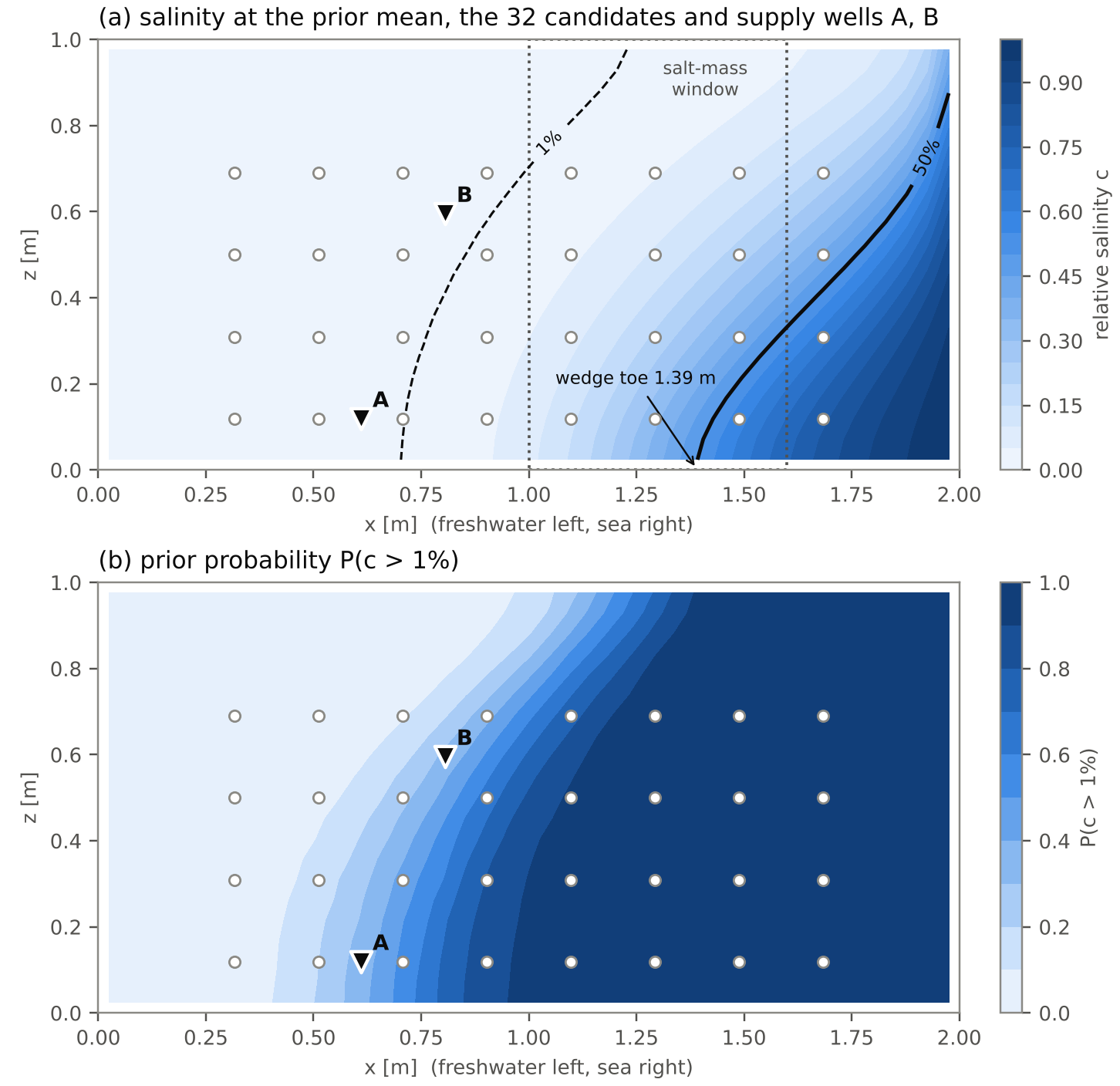
Figure 1. (a) Relative salinity at the prior mean with the 1% (dashed line) and 50% (solid line) isochlors, the salt-mass window (dotted rectangle), the 32 candidate points (circles) and the supply wells A, B (triangles). (b) Prior probability that salinity exceeds 1%, from 1,000 realizations.
The exact EIG. For a binary goal, the EIG is $EIG=h\left(p_{0}\right)−E_{y}\left[h\left(P\left(q=1∣y\right)\right)\right]$, with $h$ the binary entropy. We estimate it without any linearization, by reweighting an ensemble of 12,000 solutions of the Henry problem computed with the Python port of the project’s variable-density solver, with 2,000 outer synthetic data sets that are the same for all designs (common random numbers):
EIGd=hq−1Nyj=1Nyhpj, pj=i​wijqii​wij, wij=exp−yj−gdθi22σε2
The criteria compared. (1) The linear EIG of the salt mass, i.e., the project's current pipeline with Lemma 1 and the adjoint; (2) the linear EIG of the concentration at A, which by Theorem 1 gives the risk design for A; (3) the closed-form PRAG-GO formula for the risk at A or B, with the moments from the adjoint; (4) the same formula with the ensemble moments; (5) the same formula after a normal-score transform of each variable. Variant (5) is legitimate only for threshold goals, because the exceedance event does not change under a monotone transformation: $I\left(c>τ\right)=I\left(T\left(c\right)>T\left(τ\right)\right)$.
$${EIG}_{max}\left(d\right)=h\left(p_{0}\right)−E_{{\hat{z}}_{d}∼N\left(0,K_{d}\right)}\left[h\left(1−Φ_{2}\left(\frac{τ−μ_{A}−{\hat{z}}_{1}}{s_{1}},\frac{τ−μ_{B}−{\hat{z}}_{2}}{s_{2}};r\right)\right)\right]$$

4. Results with the Gaussian prior
The table gives the exact EIG of the design selected by each criterion, as a percentage of the exact optimum over all 4,960 designs, and the rank correlation (Spearman) of the criterion with the exact EIG.
Criterion | Risk at A: % of optimum | A or B: % of optimum | Spearman (A or B)
Linear EIG of the salt mass (current project) | 80.4% | 84.4% | 0.53
Linear EIG of the mean concentration at A and B | 97.6% | 99.2% | 0.97
Linear EIG of the concentration at A (Theorem 1) | 98.5% | 96.1% | 0.97
PRAG-GO, closed-form formula with adjoint | 98.5% | 100.0% | 0.98
PRAG-GO with ensemble moments | 86.8% | 85.2% | 0.57
PRAG-GO with normal-score ensemble | 94.7% | 95.1% | 0.85

The project's salt-mass design, wells (20, 25, 26), lies near the wedge toe and loses 19.6% of the information about the risk at A and 15.6% about the risk at A or B; its rank correlation with the exact EIG is only 0.53. The design for the concentration at A reaches 98.5% for the risk at A, so Theorem 1 remains nearly exact even with a nonlinear model. The two-zone PRAG-GO formula with the adjoint moments selected wells (12, 17, 24), which are the exact optimum for the risk at A or B (Spearman 0.98). With the ensemble moments, the same formula loses 14.8%: the global linearization mixes the regime where salinity is near zero with the one where it rises, and it selects wells near the 1% isochlor, where in half of the realizations the measurement is practically zero. The normal-score transform, legitimate only for threshold goals, raises it to 95.1%.
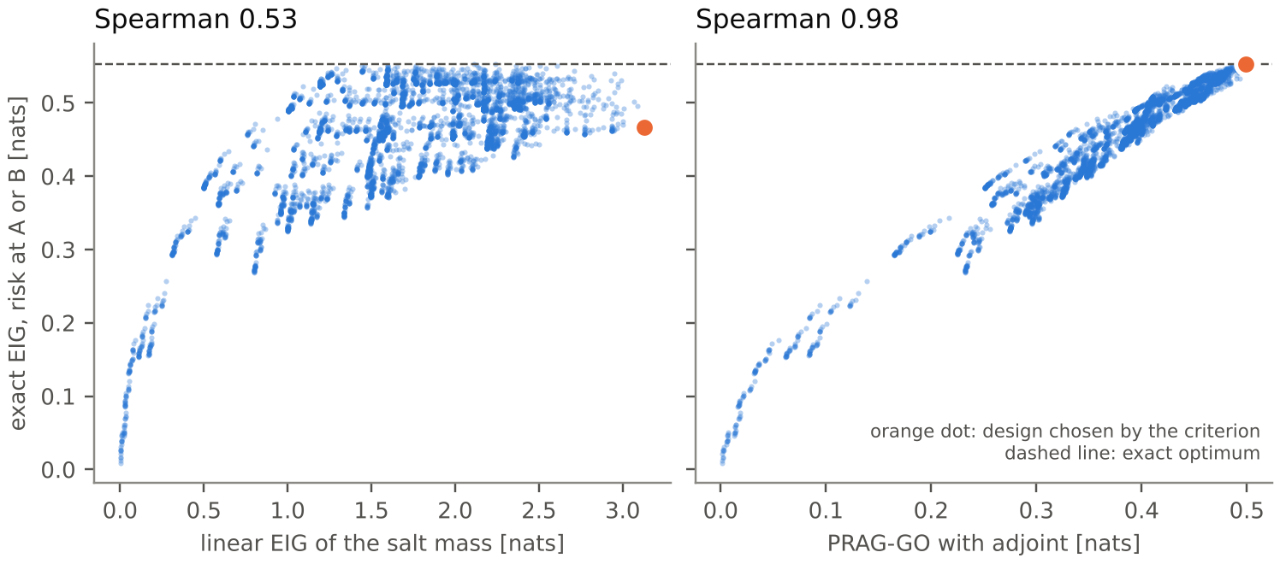
Figure 2. Criterion value versus the exact EIG of the “A or B” risk for all 4,960 designs. Left: the linear EIG of the salt mass; right: the PRAG-GO formula with adjoint. The orange dot is the design selected by the criterion; the dashed line is the exact optimum.
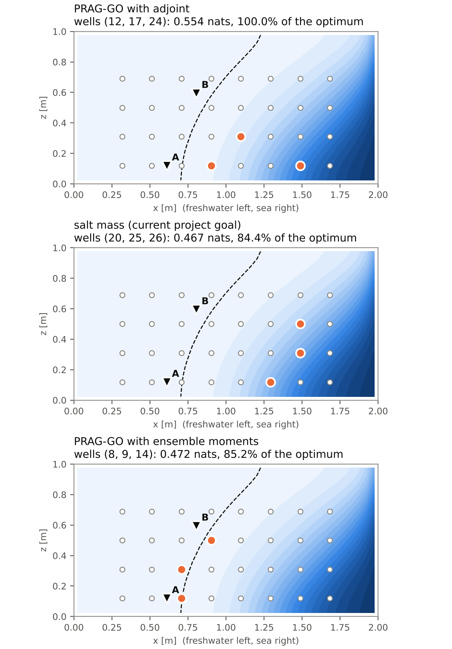
Figure 3. The three points selected (orange circles) by PRAG-GO with adjoint, by the linear EIG of the salt mass and by PRAG-GO with ensemble moments, with the exact EIG of the “A or B” risk. The dashed line is the 1% isochlor at the prior mean.
Convergence check. The selected designs were re-evaluated on two independent halves of the ensemble (6,000 realizations each) and with fresh noise. The percentages changed by at most about 1.5 points, while the five best designs are within 0.5% of one another: the optimum is flat, but the loss of the salt-mass design and the closeness of PRAG-GO to the optimum are robust.

5. Other priors: local heterogeneity and facies
We repeated the whole experiment with two other priors: (i) local heterogeneity, with $σ=0.7$ and correlation lengths of 0.2 m and 0.1 m; (ii) a two-facies mixture, in which the mean log-conductivity is $−0.5$ or $+0.5$ with probability $1/2$. In case (ii) the linear criteria use the Gaussian approximation of the mixture, i.e., the pooled covariance, as the current pipeline would do without knowledge of the facies.
Prior | P(A) / P(A or B) | Salt mass | Concentration at A | PRAG-GO adjoint | PRAG-GO normal-score
Gaussian (σ = 0.5; 0.5 m / 0.2 m) | 0.35 / 0.38 | 80.4% / 84.4% | 98.5% / 96.1% | 98.5% / 100.0% | 94.7% / 95.1%
Local (σ = 0.7; 0.2 m / 0.1 m) | 0.33 / 0.37 | 75.5% / 81.0% | 98.7% / 96.5% | 98.7% / 99.6% | 99.9% / 98.5%
Two facies (±0.5) | 0.48 / 0.48 | 96.0% / 97.3% | 99.4% / 99.5% | 99.4% / 99.8% | 99.6% / 99.1%

With local heterogeneity, the loss of the salt-mass design grows (75.5% for the risk at A), because the salinity near the toe is more weakly linked to the salinity inland; PRAG-GO with adjoint reaches 99.6% for A or B, and the normal-score variant 99.9% for A. With two facies, the risk depends mainly on one discrete variable, the facies, which almost any well identifies: the exact optimum captures 0.674 of the 0.693 nats available, and all criteria reach at least 96.0% except the ensemble linearization (92.9%, with Spearman only 0.10). When a discrete scenario dominates, goal orientation matters less; when the heterogeneity is continuous and local, it matters more.

6. What we learn
- The goal matters. The design optimized for the salt mass loses 15.6%–24.5% of the information about the regulatory risk under priors with continuous heterogeneity; with discrete facies the loss drops to 4.0%.
- Theorem 1 survives the nonlinearity. For a single well, the design for the mean concentration reaches 98.5% or more of the optimum for the risk: when the goal is a single zone, the project's Lemma 1 with the right goal is sufficient.
- The closed-form formula with adjoint is the best criterion tested. Two-zone PRAG-GO reaches 100.0%, 99.6% and 99.8% of the exact optimum, at the cost of one formula evaluation per design, with no ensemble.
- Local linearization can be better than global linearization. The ensemble moments lose 7–15%, because salinity is bounded and saturates near zero; the normal-score transform partly corrects this, and the correction is valid only for threshold goals.
- Where to measure. PRAG-GO selects wells that span the mixing zone from the 1% isochlor to the toe, the salt-mass design only near the toe, and the ensemble linearization near the 1% isochlor, where the measurement is often zero.

7. Next steps
- Code in the project: the PRAG-GO formula requires only $K_{d}$ and the moments of the two goals, which eig_operator.m already computes; a single new MATLAB function with Gauss–Hermite quadrature and $Φ_{2}$ is enough.
- Fushë-Kuqe: the 250 mg/L chloride threshold in the supply-well zones, with the 32 candidate wells and the current design (5 monitoring wells and 3 MAR sites) as the reference.
- Facies-aware prior: when the facies are recognized, PRAG-GO is computed as a mixture of the closed-form formulas, one for each scenario, instead of the pooled Gaussian approximation.
- Sensitivity to noise and threshold: $σ_{ε}=0.005$ and $0.02$, and thresholds from 0.5% to 5%.

8. References
[B1] Henry, H. R. (1964). Effects of dispersion on salt encroachment in coastal aquifers. In Sea Water in Coastal Aquifers, U.S. Geological Survey Water-Supply Paper 1613-C, C70–C84.
[B2] Voss, C. I. & Souza, W. R. (1987). Variable density flow and solute transport simulation of regional aquifers containing a narrow freshwater–saltwater transition zone. Water Resources Research, 23(10), 1851–1866. https://doi.org/10.1029/WR023i010p01851
[B3] Lindley, D. V. (1956). On a measure of the information provided by an experiment. The Annals of Mathematical Statistics, 27(4), 986–1005. https://doi.org/10.1214/aoms/1177728069
[B4] Blackwell, D. (1953). Equivalent comparisons of experiments. The Annals of Mathematical Statistics, 24(2), 265–272. https://doi.org/10.1214/aoms/1177729032
[B5] Leube, P. C., Geiges, A. & Nowak, W. (2012). Bayesian assessment of the expected data impact on prediction confidence in optimal sampling design. Water Resources Research, 48(2), W02501. https://doi.org/10.1029/2010WR010137
[B6] Zeqiraj, D. (2026). Goal-oriented Bayesian experimental design for variable-density seawater intrusion. Submitted to Journal of Hydrology; code: SWI-Goal-OED.

Note on reliability: all results are synthetic, on the 41 × 21 Henry problem, with two supply wells, noise $σ_{ε}=0.01$, a 1% threshold and 3-point designs. The solver is a Python port of the project's MATLAB scripts and exactly reproduces the README numbers; the adjoint sensitivities were checked with finite differences (relative error $1.6⋅{10}^{−4}$). The exact EIG is estimated by reweighting: the effective sample size at the optimum was about 2,000 for the Gaussian and local priors, but only 67–120 for the facies prior, where the posterior is very narrow; the check with independent halves confirmed the ranking in all three cases. The code and the full table of numbers are in experiments/prag_go_henry in the repository.

