RESEARCH NOTE · TWO INNOVATIONS TESTED
PRAG-GO and PRAG-MAR at Fushë-Kuqe
Monitoring and managed aquifer recharge oriented to the salinization risk of supply wells, tested in the field model of the SWI-Goal-OED project
Real polygon 349 km² · 5 589 cells · 14 000 solves per prior · 142 506 designs with 5 wells · exact EIG
SUMMARY Question: do the monitoring wells and MAR sites chosen for the intruded area also serve the regulatory question “will the supply wells be salinized?” Method: the project's field model, ported to Python and checked against the published numbers (92.7 km²; P21, A12, A13, A21, A10). Two real wells serve as supply wells, A23 in the north and R16 in the south, and the exact EIG, without linearization, is computed over all designs. Result: Theorem 1 holds, because the design for the area is optimal for the area threshold. The published design nevertheless captures only 57% of the information for the risk at A23 and 82% for “A23 or R16”. PRAG-GO selects the best design found for “A23 or R16”. PRAG-MAR lowers the risk from 0.79 to 0.04 with the same water.
Contents
- Model: port of the field model and reproduction of the published design.
- Experiment: the supply wells, three binary goals, the criteria and the exact estimator.
- Results: the 3- and 5-well designs, the convergence check and two other priors.
- PRAG-MAR: the closed-form formula for the recharge sites and its exact evaluation.
Date: October 12, 2026 · Follow-up to the note “PRAG-GO on the Henry problem”

1. The question and the short answer
The previous note tested PRAG-GO on the Henry problem: when the goal is the exceedance of a salinity threshold at the supply wells, the design optimized for the salt mass loses 16–25% of the information, while the closed-form PRAG-GO formula reaches 99.6–100% of the exact optimum. The next step was the field. At Fushë-Kuqe the project uses a confined flow model on the real polygon (349 km²) and selects 5 monitoring wells that are informative about the intruded area, as well as 3 managed aquifer recharge (MAR) sites that reduce it. This note asks the same questions of this model:
- Does Theorem 1 hold for the project's own goal? If the area is turned into a threshold (does it exceed 100 km²?), does the Lemma 1 design for the area remain optimal?
- How much information do the published wells provide about the supply wells? The regulatory question is whether the saltwater interface reaches the aquifer base beneath a supply well.
- Does PRAG-GO find the exact optimal design in the field? The designs are compared using the exact EIG, without linearization.
- Should the MAR location change as well? The question arises when the goal of recharge is to protect the wells rather than to reduce the area. PRAG-MAR is proposed for this purpose.
INNOVATION In the Fushë-Kuqe field model, the published 5-well monitoring design captures 86% of the information for the project question (does the intruded area exceed 100 km²?), but only 57% for the salinization risk of well A23 and 82% for “A23 or R16”. The closed-form PRAG-GO formula selects the best design found for “A23 or R16”. PRAG-MAR, a new formula with two adjoint solves, uses the same water to lower the probability that either well is salinized from 0.79 to 0.04, versus 0.62 with the published MAR sites.

2. The field model and its reproduction
We ported the project's shared script src/fushe_kuqe_field_design.m to Python, line by line. The geometry uses the polygon with 3 411 vertices and a grid with 0.25 km spacing. The hydraulic conductivity $K_{0}$ is interpolated by IDW from the 43 wells with $K$ measurements, and the coastline is the westernmost cell of each row, with $h=0$. Flow is steady in a confined aquifer of thickness $b=30$ m with recharge $R=5⋅{10}^{−4}$ m/day:
$$∇⋅\left(T∇h\right)=−R, T=K_{0} b e^{θ_{z}}$$
Here $θ_{z}$ is the log-multiplier of pilot zone $z$. Intrusion is determined by the Ghyben–Herzberg criterion: the interface lies at depth $ζ=h/δ$ below sea level, and saltwater reaches the aquifer base, at depth $b_{0}=40$ m, when (in meters):
$$q_{w}=I\left(ζ_{w}<b_{0}\right)=I\left(h_{w}<h_{c}\right), h_{c}=δ b_{0}=0.025⋅40=1.0$$
The project prior has 12 pilot zones. The facies class of each zone follows from its mean $K$: 4 zones of coarse gravel and 8 of medium gravel. The covariance is ${\left(Γ_{F}\right)}_{ij}=s_{i}s_{j} e^{−d_{ij}/L_{c}}ρ_{ij}$, where $L_{c}=8$ km, $s=0.30$, $0.45$ or $0.60$ depending on the facies, and $ρ_{ij}=ρ_{F}=0.6$ between different facies. The port reproduces the project's published numbers exactly:
Quantity | Python (this note) | Project (README, R2 log)
Active cells / area | 5 589 / 349.3 km² | 349.3 km² of active cells
Baseline intruded area | 92.7 km² (26.6% of the polygon) | 92.7 km² (26.6%)
Pilot zones | 12 | 12
Monitoring wells (5) | P21, A12, A13, A21, A10 | P21, A12, A13, A21, A10
MAR sites (3) | A18, P21, P16 | A18, P21, P16

3. The experiment: goals, wells and criteria
Supply wells. The data do not include the coordinates of the Gorre and Fushë-Kuqe pumping stations, toward which the wedge is moving according to Cenameri and Beqiraj (2016). We therefore chose the supply wells with a rule stated in advance. In each sector (north: N > 25 km; south: N < 25 km), the supply well is the well inside the aquifer, outside the published design, whose prior intrusion probability is closest to 1/2. This selected A = A23 (fine gravel, 1.9 km from the coast, P = 0.52) and B = R16 (medium gravel, 1.4 km from the coast, P = 0.64). The supply wells are not candidates, because pumping distorts their head. The candidates are the other 30 wells inside the aquifer, which measure head with noise $σ_{ε}=0.2$ m, as in the project.
Goals. We have three binary goals: the risk at A, $q_{A}=I\left(h_{A}<h_{c}\right)$; the risk at A or B, $q_{AB}=I\left(min\left(h_{A},h_{B}\right)<h_{c}\right)$; and the project question turned into a threshold, $q_{S}=I\left(S>100\right)$, where $S$ is the intruded area in km². The prior probabilities are 0.52, 0.80 and 0.44. The interface toe passing beneath a supply well is this sharp-interface model's approximation of the 250 mg/L chloride threshold being exceeded at the base of the well.
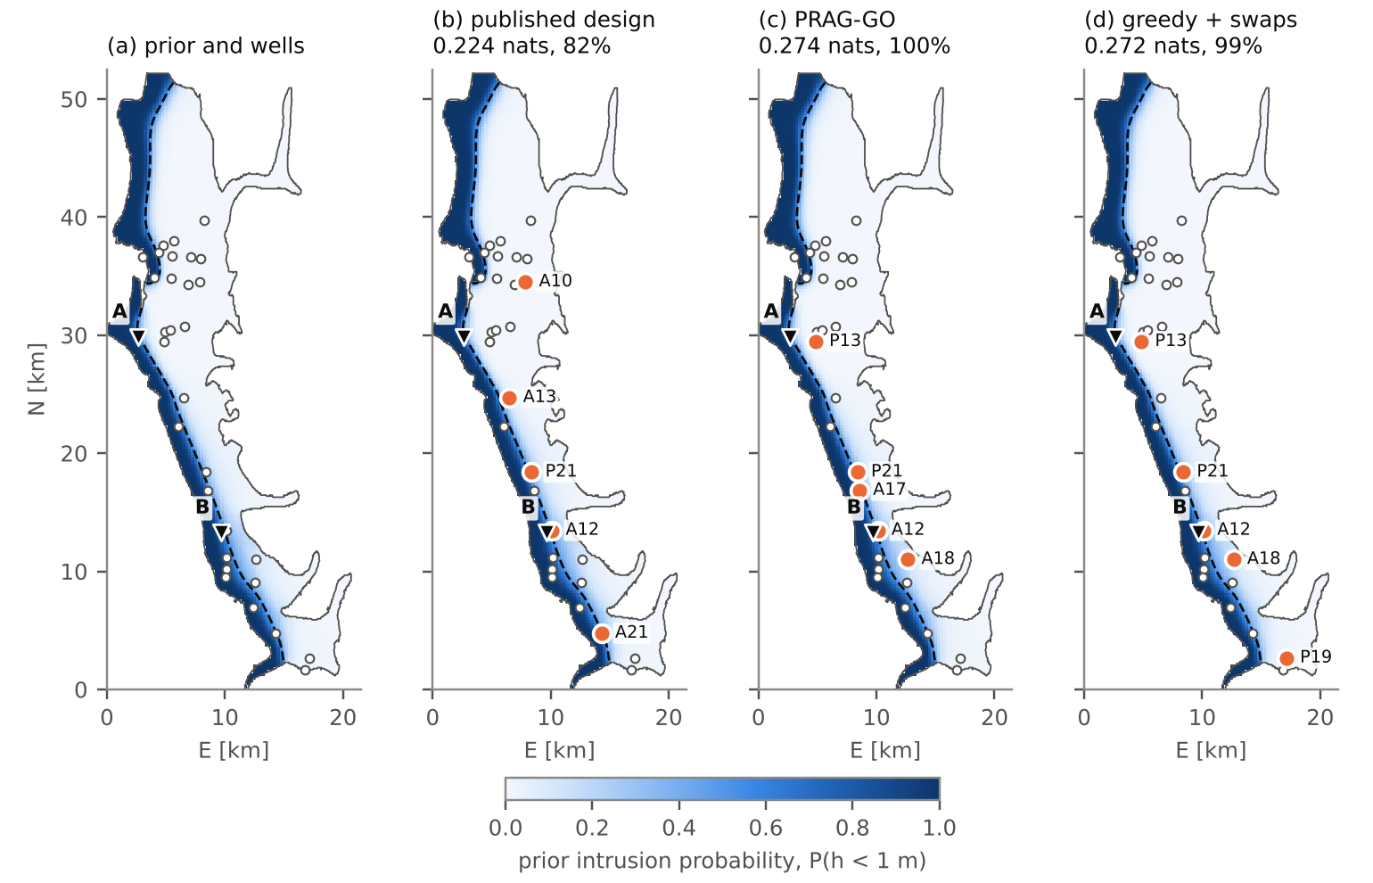
Figure 1. (a) Prior intrusion probability $P\left(h<1 m\right)$, from 1 000 realizations. The dashed line shows the interface toe under the prior mean, the white circles the 30 candidates, and the triangles the supply wells A = A23 and B = R16. (b–d) The 5-well designs (orange circles) and their exact EIG for the “A or B” risk: (b) the published design, (c) PRAG-GO, (d) the design from greedy search with swaps on the exact EIG. The values come from the ensemble with 48 000 realizations, as a percentage of the best design found.
Exact EIG. For each binary goal, $EIG=h\left(p_{0}\right)−E_{y}\left[h\left(P\left(q=1∣y\right)\right)\right]$, where $h$ is the binary entropy. We estimate it without linearization, by reweighting 12 000 prior solutions with 2 000 external synthetic data sets, the same for all designs:
EIGd=hq−1Nyj=1Nyhpj, pj=i​wijqii​wij, wij=exp−yj−gdθi22σε2
Criteria. We compare four criteria:
- the linear EIG of the area, which is the published pipeline with Lemma 1;
- the linear EIG of the head at A, which by Theorem 1 gives the design for the risk at A;
- the linear EIG of the mean head at A and B;
- the closed-form PRAG-GO formula for the “A or B” risk. We compute it with three kinds of moments: the project's linear moments, the ensemble moments, and the moments after the normal-score transform.
For the intrusion events $\left\{h<h_{c}\right\}$, the formula is:
$${EIG}_{AB}\left(d\right)=h\left(p_{0}\right)−E_{\hat{z}∼N\left(0,K_{d}\right)}\left[h\left(1−Φ_{2}\left(\frac{μ_{A}+{\hat{z}}_{1}−h_{c}}{s_{A}},\frac{μ_{B}+{\hat{z}}_{2}−h_{c}}{s_{B}};r\right)\right)\right]$$
Here $K_{d}$ is the information operator of the two heads, $s_{A}$, $s_{B}$ and $r$ are the posterior standard deviations and correlation, and the expectation is computed with 24 × 24 Gauss–Hermite quadrature.

4. Results with the published prior
Three wells, all 4 060 designs. The table gives the exact EIG of the design chosen by each criterion, as a percentage of the exact optimum for each goal, and the rank correlation (Spearman) with the exact EIG of the “A or B” risk.
Criterion | Area > 100 km² | Risk at A | A or B | Spearman (A or B)
Linear EIG of the area (published pipeline) | 100.0% | 32.3% | 80.2% | 0.827
Linear EIG of the head at A (Theorem 1) | 33.0% | 100.0% | 40.1% | 0.203
Linear EIG of the mean head at A and B | 85.4% | 91.4% | 100.0% | 0.957
PRAG-GO, linear moments | 90.2% | 91.6% | 97.6% | 0.996
PRAG-GO, ensemble moments | 85.4% | 91.4% | 100.0% | 0.995
PRAG-GO, normal-score | 90.2% | 91.6% | 97.6% | 0.996

Theorem 1 holds in the field for the project goal. The Lemma 1 design for the area (P21, A3, A18) is also the exact optimum for the area threshold, with Spearman 0.995. This design extends along the whole length of the coast, because the area integrates the salinity of the entire coastal strip. For the risk at A23 it captures only 32.3%, and its ranking bears almost no relation to the exact EIG (Spearman 0.072). The information about A23 comes from wells P13, A11, A25, 2–4 km east of it. The linear EIG of the head at A finds them exactly (100%), so Theorem 1 for the supply well also holds unchanged. For the “A or B” risk, the PRAG-GO formula reaches 97.6% with linear moments and 100.0% with ensemble moments, with Spearman 0.996.
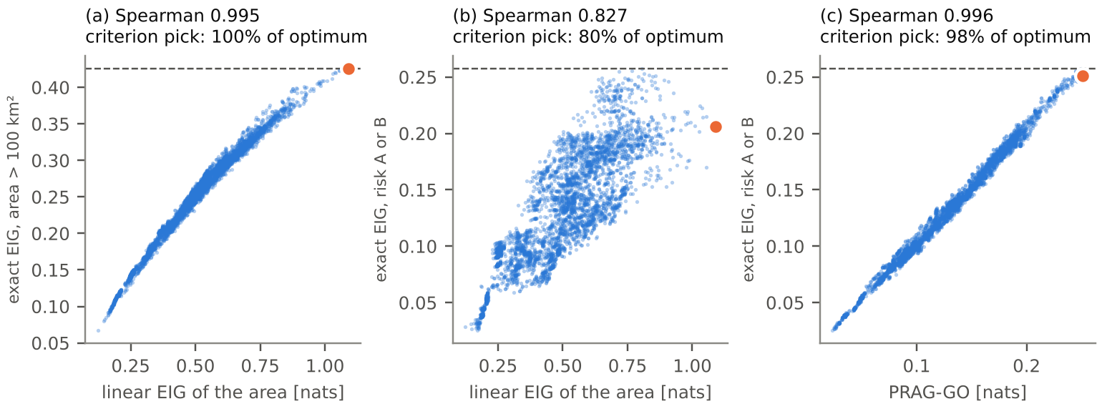
Figure 2. Criterion value versus exact EIG for all 4 060 designs with 3 wells. (a) Linear EIG of the area versus the area threshold: Theorem 1 in the field. (b) The same criterion versus the “A or B” risk. (c) PRAG-GO with linear moments versus the “A or B” risk. The orange dot is the design chosen by the criterion, and the dashed line is the exact optimum.
Five wells, the project budget. All 142 506 designs with 5 wells were ranked by each criterion. The exact EIG was computed for 3 671 designs: 3 000 random designs and the top 200 of each criterion. Greedy search with swaps on the exact EIG was run for each goal. The leading designs were then re-estimated with an ensemble four times larger (48 000 realizations), because reweighting overestimates the EIG when the effective sample size is small. The table gives the percentages from this re-estimate, relative to the best design found by any method:
Design | Wells | Area > 100 km² | Risk at A | A or B
Published (marginal EIG, 6 km apart) | P21, A10, A12, A13, A21 | 86.2% | 56.9% | 81.9%
Lemma 1 for the area, over all designs | P19, P21, A3, A13, A18 | 100.0% | 50.1% | 82.5%
Linear EIG of the head at A | P10, P13, A11, A24, A25 | 28.3% | 100.0% | 39.5%
PRAG-GO, linear moments | P13, P21, A12, A17, A18 | 79.9% | 88.7% | 100.0%
Greedy + swaps for “A or B” | P13, P19, P21, A12, A18 | 83.1% | 90.5% | 99.3%

The published design loses 43.1% of the information for the risk at A23 and 18.1% for “A or B”. It also loses 13.8% for its own goal. This last loss comes not from the goal but from the heuristic: the wells are chosen one at a time by marginal EIG, with 6 km spacing and snapping to the nearest well. Joint optimization of Lemma 1 over the same wells closes this gap. PRAG-GO selects P13, P21, A12, A17, A18: P13, 2.2 km from A23, and four wells 0.5–5.3 km around R16, along the mixing zone. This is the best design we found for “A or B”, slightly above that of the greedy search (99.3%), at the cost of one formula evaluation per design.
Convergence check. With 12 000 realizations, the percentages in the table were within 5 points of those with 48 000. The 3-well designs were re-estimated on two independent halves of the ensemble with fresh noise. The area design stayed at 31–35% for the risk at A and at 80–83% for “A or B”, while PRAG-GO stayed at 98–100%. The effective sample size for the reported designs is at least 200 with 48 000 realizations.

5. The second innovation: PRAG-MAR
The project selects the 3 MAR sites with the area adjoint: the cells where one m³/day of recharge reduces the intruded area the most. For protecting the supply wells, the right objective is their salinization probability. For fixed conductivity, the head is linear in a point source $Q$ in cell $k$:
$$h\left(θ,Q\right)=h\left(θ\right)+Q g_{k}\left(θ\right), g_{A}=−A_{θ}^{−T}e_{A}$$
Thus one transposed solve per supply well gives the effect of recharge in every cell at once. With the linear moments of $h_{A}$ and $h_{B}$, the probability that either well is salinized is $P_{AB}=1−Φ_{2}\left(a,b;r\right)$, where $a=\left(μ_{A}−h_{c}\right)/s_{A}$ and $b=\left(μ_{B}−h_{c}\right)/s_{B}$. Its gradient has a closed form:
$$−\frac{∂P_{AB}}{∂Q_{k}}=\frac{φ\left(a\right)}{s_{A}}Φ\left(\frac{b−ra}{\sqrt{1−r^{2}}}\right)g_{A,k}+\frac{φ\left(b\right)}{s_{B}}Φ\left(\frac{a−rb}{\sqrt{1−r^{2}}}\right)g_{B,k}$$
The weight of each well is the probability density of that well being exactly at the threshold. Under the prior, $μ_{A}=0.98$ m, $μ_{B}=0.88$ m, $s_{A}=s_{B}=0.32$ m and $r=0.18$. PRAG-MAR uses the same selection rule as the project (3 sites, at least 6 km apart in the north–south direction). The selected sites were evaluated exactly over 2 000 prior realizations, with recharge of 5 000 m³/day per site, about 9% of the natural recharge of the polygon.
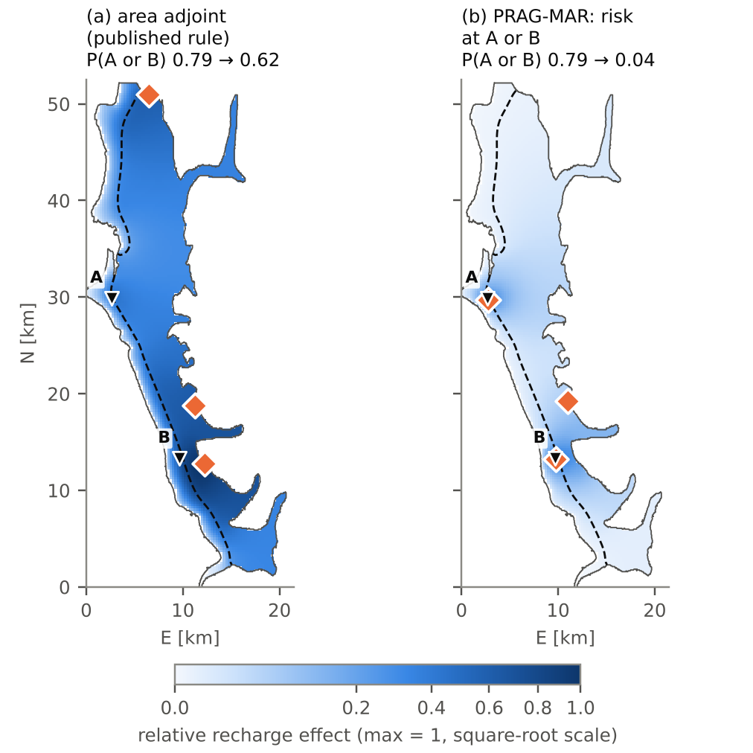
Figure 3. (a) The area adjoint field and the 3 published MAR sites (orange diamonds). (b) The PRAG-MAR field for the “A or B” risk and its 3 sites. The fields are normalized by their maximum and shown on a square-root scale. The probabilities in the titles are exact ensemble estimates, with 5 000 m³/day per site.
MAR sites | Nearest wells | P(A) | P(B) | P(A or B) | Mean area
No MAR | – | 0.51 | 0.63 | 0.79 | 98.4 km²
Area adjoint (published) | A18, P21, P16 | 0.51 | 0.28 | 0.62 | 87.2 km²
PRAG-MAR (closed form) | A23, R16, P21 | 0.01 | 0.03 | 0.04 | 89.5 km²

With the same amount of water, PRAG-MAR lowers the probability that either well is salinized from 0.79 to 0.04, while the published sites lower it to 0.62. The published sites do not protect A23 at all (0.51 → 0.51), because none of them lies in its sector. The cost of PRAG-MAR is in the area: it reduces the intruded area by 8.9 km², versus 11.1 km² for the published sites, i.e., 80% of the reduction. A greedy search on the exact ensemble risk found the same three sites, so the closed-form formula loses nothing here. With 2 500 and 10 000 m³/day per site, P(A or B) becomes 0.20 and 0.002 with PRAG-MAR, versus 0.69 and 0.54 with the published sites. Physically, PRAG-MAR rediscovers the hydraulic barrier near the well fields, but now with a formula that weights the wells by their risk and with the exact price in area.

6. Other priors
We repeated the monitoring experiment with two other priors. The first uses $ρ_{F}=0.805$, the field estimate from the project's Gate 3, which lies above the threshold $ρ_{c}=0.762$. The second has 50 pilot zones (a 10 × 16 grid) and correlation length $L_{c}=3$ km, i.e., more local heterogeneity. The supply wells and the candidates remain the same. The 5-well percentages come from the ensemble with 48 000 realizations.
Prior | P0: A / A or B / S | 3 wells, area → S / A or B | 3 wells, PRAG-GO → A or B | 5 wells, published → A / A or B | 5 wells, PRAG-GO → A or B
Published (12 zones, ρF = 0.6) | 0.52 / 0.80 / 0.44 | 100% / 80% | 98% | 57% / 82% | 100%
ρF = 0.805 (field estimate) | 0.52 / 0.80 / 0.44 | 100% / 81% | 98% | 60% / 83% | 100%
50 zones, Lc = 3 km | 0.58 / 0.87 / 0.40 | 100% / 47% | 100% | 38% / 68% | 100%

With $ρ_{F}=0.805$ the results barely change. This was expected, because in the project's R2 log the correlation of the EIG fields between the two values of $ρ_{F}$ is 0.998. With 50 zones, the head at the supply wells depends more on the local zones and the loss grows, as in the Henry problem with local heterogeneity. With 3 wells, the area design captures only 47% for “A or B” and 23% for the risk at A. With 5 wells, the published design captures 38% for A and 68% for “A or B”. PRAG-GO reaches 100% with 3 wells and 100% with 5. Theorem 1 holds under all three priors: the Lemma 1 design for the area is optimal for the area threshold. The design for the area and the design for the supply wells remain different designs, and the difference matters more when the heterogeneity is local.

7. What we learn
- Theorem 1 holds in the field. When the project goal is turned into a threshold, the Lemma 1 design for the area remains the exact optimum (100%, Spearman 0.995). The published pipeline needs no change for this question, apart from replacing the marginal heuristic with joint optimization.
- Supply wells require a different design. For the risk at A23, the published design captures 57%, and the 3-well design for the area 32%. With local heterogeneity these values drop to 38% and 23%. The information about a well comes from the wells 2–4 km around it, not from the whole coastal strip.
- PRAG-GO finds the optimal design. With the linear moments that the project already computes, PRAG-GO reaches 97.6% with 3 wells and the best design found with 5 wells, with Spearman 0.996.
- Linearization suffices in the field. Unlike in the Henry problem, the linear, ensemble and normal-score moments give almost the same choice. The head in a confined aquifer depends smoothly on log-K and does not saturate as salinity does.
- PRAG-MAR changes where recharge goes. With the same water, the risk to the wells drops from 0.79 to 0.04 instead of 0.62, with 80% of the area reduction. The formula requires two adjoint solves and matches the exact ensemble optimum.

8. Limitations and next steps
- Coordinates of the pumping stations. A23 and R16 are surrogates chosen by a rule. With the coordinates of the Gorre and Fushë-Kuqe stations, the code immediately gives the design for the real wells.
- Calibration with the data. Sheet 2_All_Wells contains piezometric levels for the wells, and Cenameri and Beqiraj (2016) give chloride for four wells. The prior should be conditioned on them before design, because the modeled area (26.6%) is above the published value of about 15%.
- The 250 mg/L threshold. The Ghyben–Herzberg criterion treats the interface as sharp. A variable-density cross-section along the A23 transect, with the Henry solver, would link the interface toe to the 250 mg/L isochlor.
- Code in the project. Two MATLAB functions in src/ are enough: prag_eig.m (the formula with $Φ_{2}$ and Gauss–Hermite quadrature, on top of eig_operator.m) and prag_mar.m (two solves with $A^{T}$, like the adjoint solve the project already performs for the MAR field).
- Joint design. Monitoring and MAR can be chosen together, with the value of information for the recharge decision as the goal.

9. References
[B1] Cenameri, S. & Beqiraj, A. (2016). Assessment of seawater intrusion in Fushë Kuqe aquifer, Albania. Bulletin of the Geological Society of Greece, 50(2), 665–670. https://doi.org/10.12681/bgsg.11772
[B2] Albanian Geological Survey (2024). Fushë-Kuqe aquifer data: polygon, 43 wells with K, and piezometric levels. Used with permission; data/Fushe_Kuqe_All_Data.xlsx in the repository.
[B3] Strack, O. D. L. (1976). A single-potential solution for regional interface problems in coastal aquifers. Water Resources Research, 12(6), 1165–1174. https://doi.org/10.1029/WR012i006p01165
[B4] Werner, A. D., Bakker, M., Post, V. E. A., Vandenbohede, A., Lu, C., Ataie-Ashtiani, B., Simmons, C. T. & Barry, D. A. (2013). Seawater intrusion processes, investigation and management: Recent advances and future challenges. Advances in Water Resources, 51, 3–26. https://doi.org/10.1016/j.advwatres.2012.03.004
[B5] Dillon, P. (2005). Future management of aquifer recharge. Hydrogeology Journal, 13(1), 313–316. https://doi.org/10.1007/s10040-004-0413-6
[B6] Lindley, D. V. (1956). On a measure of the information provided by an experiment. The Annals of Mathematical Statistics, 27(4), 986–1005. https://doi.org/10.1214/aoms/1177728069
[B7] Zeqiraj, D. (2026). Goal-oriented Bayesian experimental design for variable-density seawater intrusion. Submitted to Journal of Hydrology; code: SWI-Goal-OED.

Note on reliability: the geometry and the conductivity are real, while the thickness, base, recharge and coastline are the project's representative values. Intrusion comes from the Ghyben–Herzberg criterion in an uncalibrated model, so the absolute risk numbers are illustrative. The comparison between criteria and designs does not depend on this, because all of them are evaluated in the same model. The supply wells are surrogates chosen by a rule, and the recharge values of 2 500–10 000 m³/day per site are assumptions. The code and the full table of numbers are in experiments/prag_go_fushe_kuqe in the repository.

