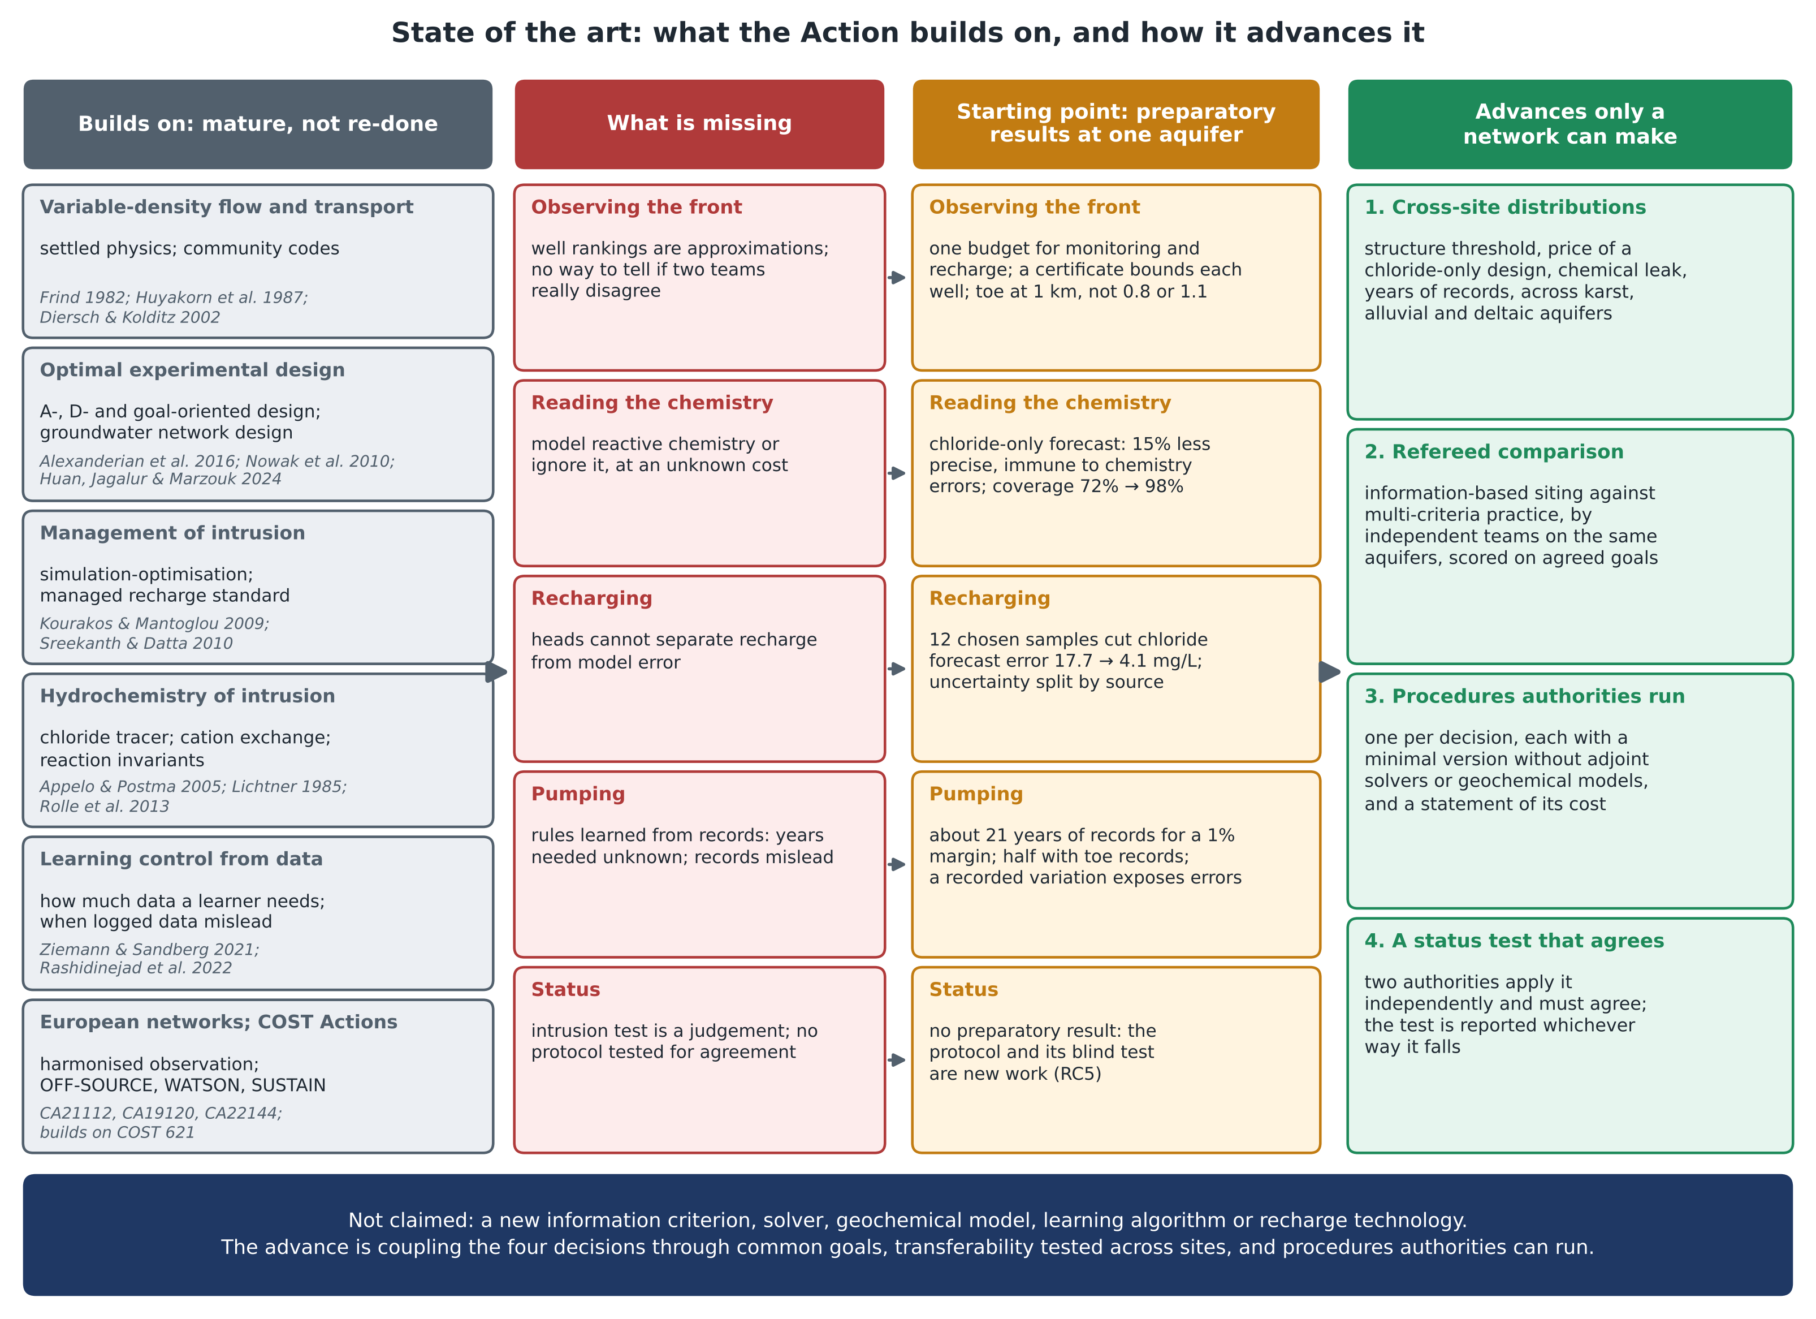
Figure. What the Action builds on (mature work it does not redo), what is missing for each decision, the preparatory results that are its starting point, and the four advances that only a network can make.

