CERTAIN-COAST — Deliverables
Certified early warning for seawater intrusion, liquefaction and extreme sea levels at the wellfields, port and energy landfall of a subsiding Adriatic coast
CERTAIN-COAST produces 14 deliverables over 36 months: 2 public, 4 restricted to the operators, authorities or the SPS Programme, and 8 with a public part and a restricted annex, following the two-tier dissemination plan. Each deliverable has an acceptance test stated in advance; three of them decide the evidence gates at Months 18, 22 and 27. Months count from the start of the grant.
1. Deliverables at a glance
No. | Deliverable | WP | Lead | Type | Access | Month | Milestone
D7.1 | Data management plan and access agreements | WP7 | [NPD team] (coordinator) | Report | Public + restricted annex | M3 | —
D4.1 | Network design report | WP4 | [NPD team] | Report | Restricted | M6 | MS1
D1.1 | Coastal motion atlas and R(t) series | WP1 | [NPD team] or [additional NATO co-director] | Data, report | Public + restricted annex | M12 | MS2
D4.2 | Network installed and streaming | WP4 | [NPD team] | Demonstrator | Restricted | M12 | MS2
D7.2 | Progress reports | WP7 | [NPD team] (coordinator) | Report | Restricted | M12 | —
D2.1 | Calibrated coupled model | WP2 | [PPD team] | Model | Public + restricted annex | M18 | MS3 (gate)
D2.2 | Certified surrogate | WP2 | [PPD team] | Software | Public + restricted annex | M22 | MS4 (gate)
D3.1 | Certified alarm algorithms and proofs | WP3 | [PPD team] | Report | Public | M24 | —
D7.2 | Progress reports | WP7 | [NPD team] (coordinator) | Report | Restricted | M24 | —
D3.2 | Back-testing report | WP3 | [PPD team] | Report | Public + restricted annex | M27 | MS5 (gate)
D6.1 | Software and data release | WP6 | [PPD team] | Software, data | Public | M33 | —
D5.1 | Live demonstration report | WP5 | [NPD team] | Report | Public + restricted annex | M34 | MS6
D6.2 | Operating procedures and policy brief | WP6 | [PPD team] | Report | Public + restricted annex | M36 | MS7
D7.3 | Final report | WP7 | [NPD team] (coordinator) | Report | Public + restricted annex | M36 | —

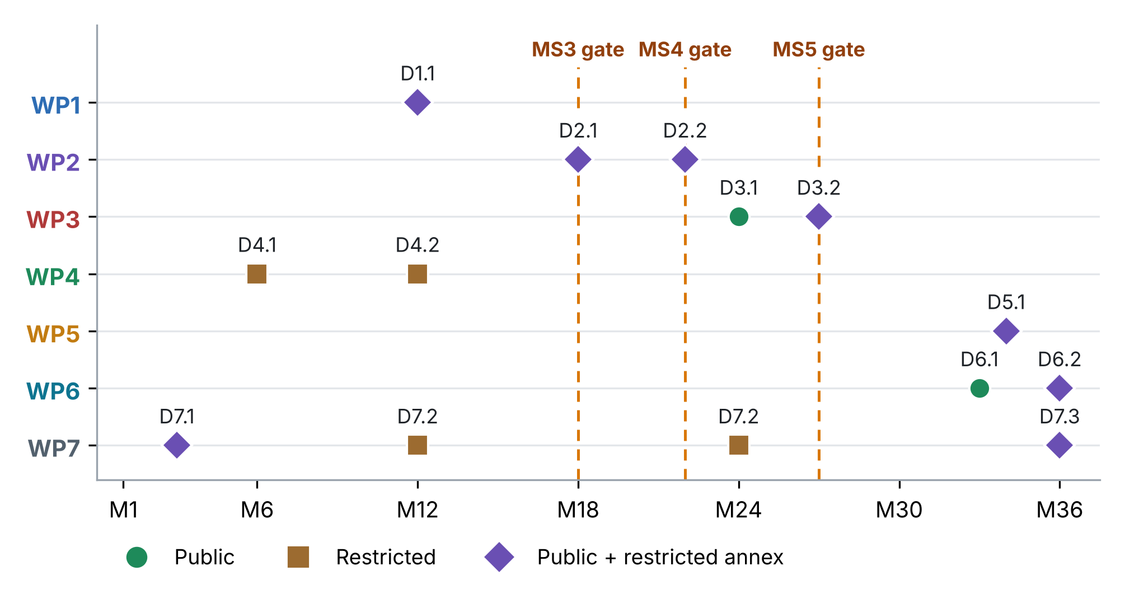
Figure 1. Deliverables by month and work package. Marker shows the access level; dashed lines mark the three evidence gates.
2. Deliverable descriptions
D7.1 Data management plan and access agreements WP7 · Month 3 · Report · Public + restricted annex
Contents | Data management plan (version 1); signed access agreements with the operators; data classification for the release gate.
Acceptance test | Access agreements signed by the operators; data management plan approved by the steering committee.
Format and where | Report; data plan public, agreements restricted.
Reviewed by | Steering committee
Depends on | Commitment letters
Feeds | All work packages
D4.1 Network design report WP4 · Month 6 · Report · Restricted
Contents | Ranking of every candidate sensor by its value for the three warnings per unit cost; the chosen network within budget; installation and access plan.
Acceptance test | Approved by the steering committee and the operators (MS1).
Format and where | Report, restricted (sensor locations inside sites).
Reviewed by | Steering committee; operators
Depends on | Preliminary sensitivities (WP2); access (D7.1)
Feeds | D4.2; procurement (T4.2)
D1.1 Coastal motion atlas and R(t) series WP1 · Month 12 · Data, report · Public + restricted annex
Contents | Vertical and east velocity maps of the three asset areas from Sentinel-1 (2014 onward) and GNSS; elastic and inelastic compaction parameters and the head limit h_pc; the 2019 coseismic and postseismic motion; relative sea level R(t) with uncertainty at each asset.
Acceptance test | Vertical-velocity uncertainty of the order of 1–2 mm/yr at asset points; InSAR and GNSS agree within their uncertainty.
Format and where | Report and gridded data (GeoTIFF, NetCDF); regional maps in Zenodo, asset-point values to the operators.
Reviewed by | WP2 lead; operators for asset points
Depends on | T1.1–T1.3; GNSS and corner reflectors (D4.2)
Feeds | WP2 sea boundary; WP3 extremes; WP5 pumping limit
D4.2 Network installed and streaming WP4 · Month 12 · Demonstrator · Restricted
Contents | Installed piezometers and loggers, GNSS, corner reflectors and seismic stations, with telemetry, quality control and data streaming.
Acceptance test | At least 90% data availability over the first month (MS2).
Format and where | Demonstrator and installation report, restricted.
Reviewed by | WP7; operators
Depends on | D4.1; procurement
Feeds | D1.1; D2.1; WP5
D7.2 Progress reports WP7 · Months 12 and 24 · Report · Restricted
Contents | Progress, deliverables and milestones; risk register; indicators (results, dissemination, gender, ethics); spending against the budget.
Acceptance test | Submitted to the SPS Programme on time and accepted.
Format and where | Report to the SPS Programme, restricted.
Reviewed by | Steering committee
Depends on | All work packages
Feeds | NATO SPS
D2.1 Calibrated coupled model WP2 · Month 18 · Model · Public + restricted annex
Contents | Set-up of the coupled model (variable-density flow, salt memory, compaction, liquefaction factor of safety, coastal water level); calibrated parameters from ES-MDA; validation on held-out data.
Acceptance test | Held-out heads, chloride, InSAR and seismic velocity fall inside the 90% predictive intervals at close to the nominal rate (gate MS3).
Format and where | Model files and report; site version restricted, synthetic-coast version public.
Reviewed by | Steering committee; WP3 lead
Depends on | D1.1; data from D4.2; operator records (D7.1)
Feeds | D2.2; WP3; WP4 refinement
D2.2 Certified surrogate WP2 · Month 22 · Software · Public + restricted annex
Contents | Trained neural or kernel operator of the coupled model; adjoint-weighted error indicator; conformal quantile; test report on held-out full-model runs.
Acceptance test | Coverage of the error bound at least 1 − δ on test runs; thousands of storylines per day; alarm prototype passes a dry run (gate MS4).
Format and where | Software and report; site version restricted, synthetic-coast version public (ONNX).
Reviewed by | Steering committee; WP5 lead
Depends on | D2.1
Feeds | D3.1; live operation (WP5)
D3.1 Certified alarm algorithms and proofs WP3 · Month 24 · Report · Public
Contents | Construction of the three-part margin; proofs of the miss-rate bound for each alarm and of the joint bound; allocation of tolerances by consequence; implementation with unit tests.
Acceptance test | Proofs checked by a reviewer outside WP3; implementation passes its tests and reproduces the synthetic examples.
Format and where | Report (public) and code (released with D6.1).
Reviewed by | Independent reviewer; steering committee
Depends on | D2.2; thresholds agreed in T3.1
Feeds | D3.2; WP5 bulletins
D3.2 Back-testing report WP3 · Month 27 · Report · Public + restricted annex
Contents | Back-testing of the full chain over the record since 2014 and on storylines beyond it (drought, compound storm, 2019-type earthquake, increased pumping), under a protocol frozen before the results.
Acceptance test | Miss rate of each alarm at or below its target with Clopper–Pearson intervals; false-alarm rate reported (gate MS5).
Format and where | Report; protocol published with a DOI before the results; aggregated results public, asset annex restricted.
Reviewed by | Steering committee; operators
Depends on | D3.1; D2.2; D1.1
Feeds | WP5; D5.1; papers
D6.1 Software and data release WP6 · Month 33 · Software, data · Public
Contents | Open software (model, surrogate, alarms, network design) with documentation, tests and containers; the synthetic test coast; open datasets; verification statistics.
Acceptance test | Release with a DOI; installed and run on the synthetic coast by someone outside the project team.
Format and where | Software (Apache-2.0) and data (CC BY 4.0) in Zenodo and a public repository.
Reviewed by | External tester; WP2 and WP3 leads
Depends on | D2.2; D3.1; D1.1
Feeds | Transfer workshop; other coasts
D5.1 Live demonstration report WP5 · Month 34 · Report · Public + restricted annex
Contents | Twelve months of bulletins to the operators and civil protection; the bulletin log with outcomes; verification of the miss and false-alarm rates; the joint pumping rule; post-event protocol executions.
Acceptance test | Observed miss rates within targets with confidence intervals; bulletin log complete and reproducible (MS6).
Format and where | Report; verification statistics public, asset annex restricted.
Reviewed by | Steering committee; operators; civil protection
Depends on | D3.1–D3.2; D4.2; D2.2
Feeds | D6.2; D7.3; papers
D6.2 Operating procedures and policy brief WP6 · Month 36 · Report · Public + restricted annex
Contents | Operating procedures for the wellfields, the port and the landfall, and the post-event protocol; a policy brief for the national authorities.
Acceptance test | At least one procedure adopted per asset; policy brief delivered to the national authorities (MS7).
Format and where | Procedures restricted to the operators; public version of the policy brief.
Reviewed by | Operators; civil protection
Depends on | D5.1
Feeds | Hand-over; national policy
D7.3 Final report WP7 · Month 36 · Report · Public + restricted annex
Contents | Results, verification of the guarantees, hand-over and sustainability arrangements, spending, and lessons for other coasts.
Acceptance test | Submitted to the SPS Programme and accepted; public summary released.
Format and where | Report; public summary, full report restricted.
Reviewed by | Steering committee
Depends on | All deliverables
Feeds | NATO SPS; follow-up funding
3. Quality assurance
• Owner. Each deliverable has a responsible author in the leading work package and a reviewer from another work package or outside the project.
• Timing. A complete draft is circulated four weeks before the due month and reviewed within two weeks.
• Release gate. Every deliverable is classified (public, restricted or both) and, if it uses operator data, sent to the operators for review of sensitive content before release.
• Acceptance. The steering committee checks the acceptance test of each deliverable; for D2.1, D2.2 and D3.2 the result decides the evidence gate (MS3, MS4, MS5).
• Version control. Deliverables, data and code are versioned; each public deliverable gets a persistent identifier.
4. What is new in these deliverables
• Every deliverable has a pass test. Each states in advance how it will be judged, and three of them decide whether the project moves on (gates at Months 18, 22 and 27).
• The central claim is registered before it is tested. The back-testing protocol of D3.2 is published with a DOI before the results are computed.
• Open and restricted in one deliverable. Mixed deliverables have a public part (methods, verification) and a restricted annex (asset-level results), so openness never exposes critical infrastructure.
• A stranger can run it. D6.1 is accepted only when someone outside the team installs the software and reproduces the synthetic coast.
• Guarantees checked in public. D5.1 publishes the observed miss and false-alarm rates of the live warnings, so anyone can check the certified rates.

