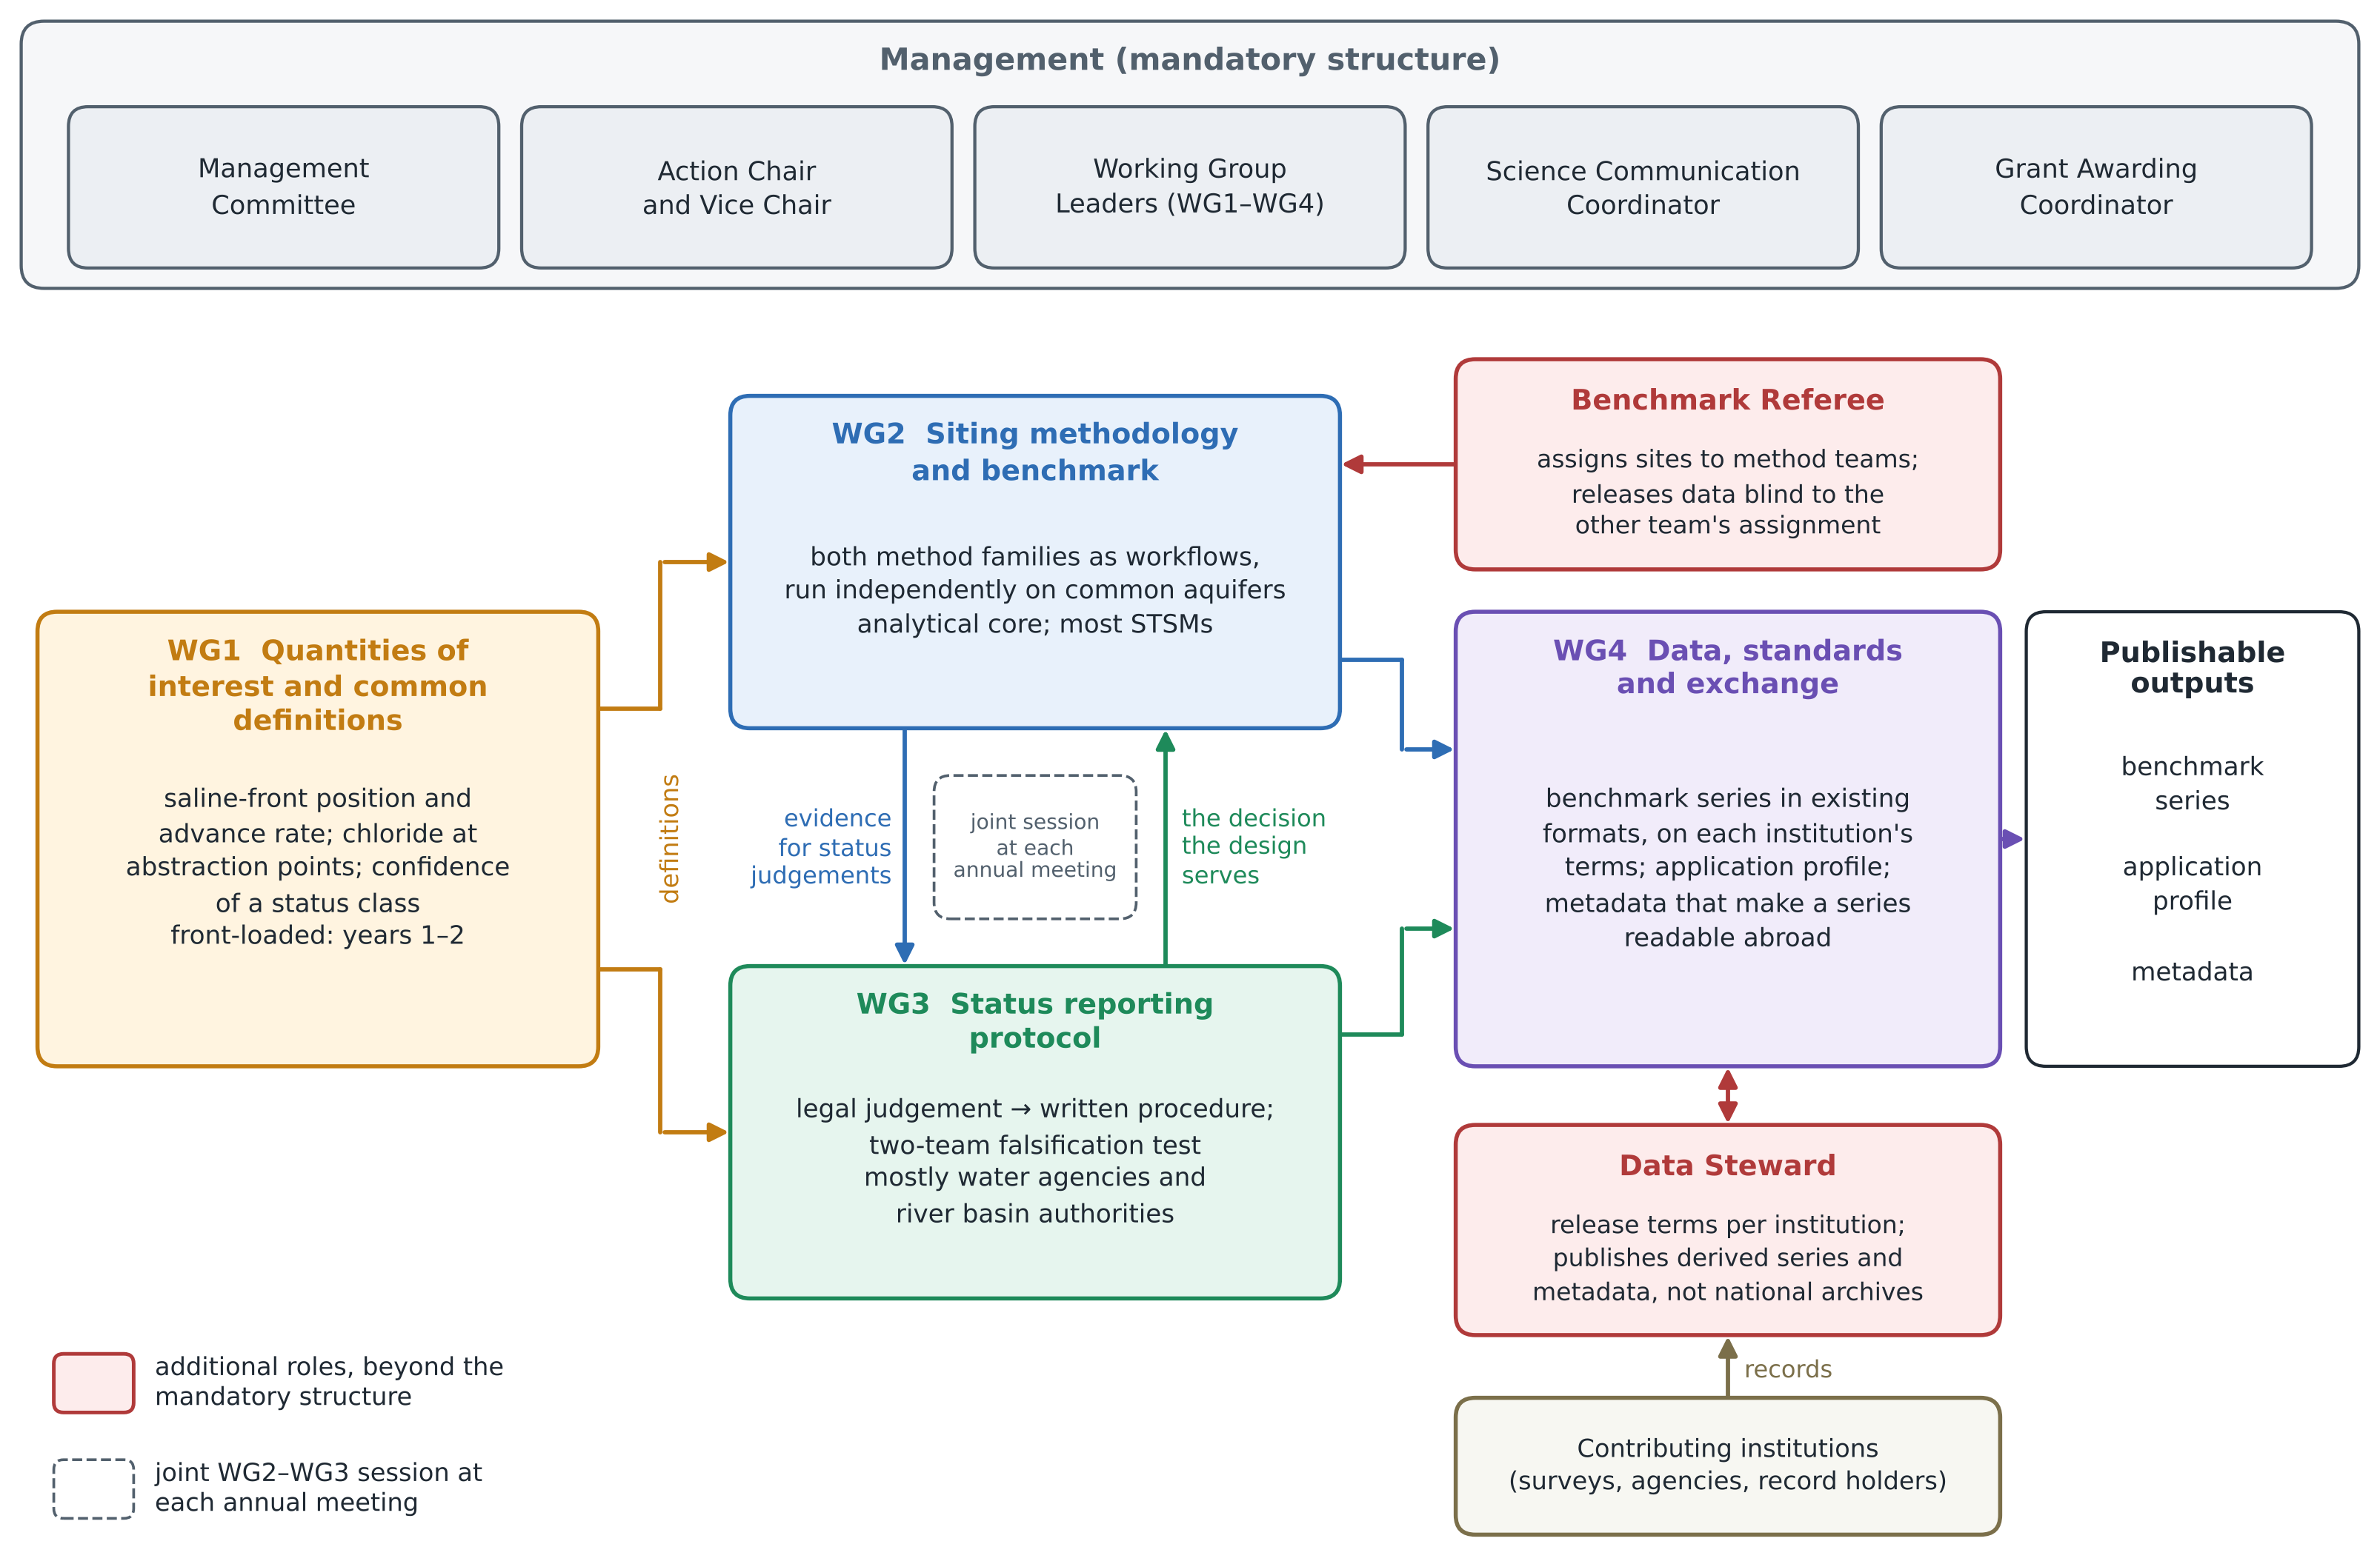
Figure. Organisation of the Action: four Working Groups, one per coordination objective, with what each passes to the others; the mandatory management structure (top); and the two additional roles, the Benchmark Referee and the Data Steward (red).

