TRONDITJA-GO: the earthquake, the aquifer and liquefaction, implemented
The first three steps of the TERMETET note as tested code: the liquefaction module with the pore pressure of the day, the coseismic step from four published models of the 26 November 2019 Durrës earthquake, and the design of the 2019 hindcast; with a joint safe window for liquefaction and seawater intrusion and a daily bulletin
Dulian Zeqiraj · November 2026 · implementation report with numerical checks · follows the working note of 31 October 2026 on the earthquake, the aquifer, human action and floods [D1]
1. Outcome
• What was built. Three modules in experiments/tronditja_go: the liquefaction triggering of Boulanger and Idriss [9, 10] with the liquefaction potential index (LPI) [11], driven by the pore pressure at the moment of the earthquake; Okada’s solution for a rectangular fault [1], written here and checked against five independent tests; and the three experiments E1–E3 of the plan, with the innovation E4. Everything runs in about 9 s. Figure 1 shows the chain.
• Liquefaction module (E1). All structural checks pass ($MSF$ = 1.000 at $M$ 7.5, $K_{σ}$ = 1.000 at $σ_{v}^{′}=P_{a}$). Equation (4.9) of [D1] holds to 3.3×10⁻¹⁰. A new closed form for the full sensitivity, $∂lnFS/∂z_{w}=\left(γ_{w}/σ_{v}^{′}\right)\left(1−C_{σ}/K_{σ}\right)$, holds to 3.4×10⁻¹⁰. In the example profile the LPI falls from 20.2 to 9.3 when the water table drops from 0.8 to 2.6 m, about 6.0 per metre. Re-normalising the CPT resistance with the stress of the day, a tempting shortcut, understates that slope by 33%.
• The coseismic step (E2): a correction of magnitude. The four published source models [4–7] agree on the sign of the step over 86% of the area where the strain matters. Its size, however, depends on the layer. A layer under the free surface takes the horizontal strain of the crust and adjusts vertically, so its pore pressure follows its own shear modulus: $Δp_{0}=−κ Δε_{a}$, $κ=2/3GB\left(1+ν_{u}\right)/\left(1−ν_{u}\right)$. In a confined aquifer ($G$ = 0.5 GPa) the head falls by 0.6–1.0 m over the hanging wall and rises by 0.2–0.3 m in front of it. In the soft surface sand ($G$ = 50 MPa) it falls by 7–12 cm and rises by 3–4 cm. Equation (2.2) of [D1], applied to the volumetric strain of the half-space, gives 35 times the soft-sand value.
• Consequence. For liquefaction of the surface sands the static step is negligible next to the seasonal swing of the water table (about 1 m). It matters for the confined aquifer and its wells. Rises of metres in liquefied areas, such as those of Chi-Chi cited in [D1], cannot come from the static strain of a soft layer. They point to the volumetric change caused by the shaking itself (Wang and Chia [14] use laboratory data on saturated sediments under cyclic loading), which the CSR–CRR comparison already represents.
• The earthquake as a free pumping test (E2). A 2.94–3.07-day 95% interval for the leakage time of the confined aquifer follows from 20 days of logger data after a 0.3 m step. A whole year of seasonal heads gives 2.67–3.37 days, an interval 5.8 times wider.
• The 2019 hindcast (E3). On a synthetic coastal plain, even with the largest step (the upper bound of (2.2) as written), 480 sites with CPT give a power of 49% to detect the step and 26% to detect the water table of the day. The 2019 liquefaction map [8] cannot test the chain; the well records of November 2019 can.

Innovation: TRONDITJA-GO (tronditja: the jolt). Two hazards pull the same managed head in opposite directions: liquefaction needs the water table deep, seawater intrusion needs the fresh head high. TRONDITJA-GO computes the window between them, $η+m_{int}≤h≤z_{s}−z^{⋆}\left(a\right)$, and the relative sea level $η_{close}\left(a\right)$ at which it closes for the design acceleration $a$. At the synthetic port of E4 the window closes at $η$ = 0.29 m for 0.20 g (about 2059 at an illustrative 9 mm/yr) and is already closed at 0.22 g. Neither a liquefaction map nor an intrusion model gives this number alone.
The same machinery gives a daily bulletin: the probability that the LPI exceeds 5 if the design earthquake struck on a given day, from the water table of that day. At the port it moves between 0.16 (late July) and 0.26 (early February), a factor of 1.6 that a static hazard map hides.
Two further results are new in this chain: the step coefficient $κ$ for a layer under the free surface, which decides which aquifer feels the earthquake, and the use of the coseismic step as a free pumping test for the leakage time. The building blocks are published [1, 9–11, 13, 16]; sea-level rise and liquefaction have been studied together [17, 18]. In the sources read for this note we did not find the joint window, its closing sea level or the daily bulletin.

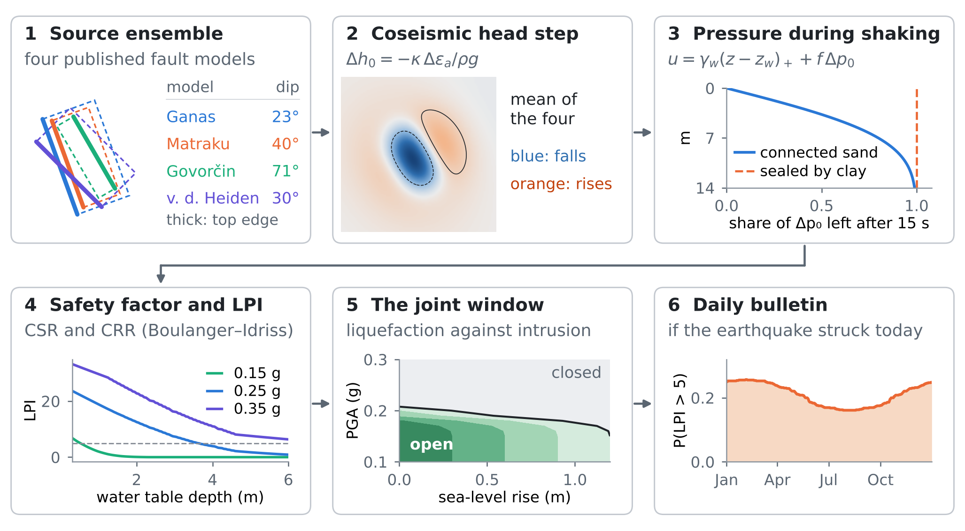
Figure 1. TRONDITJA-GO in six steps, each with its computed field: (1) the four source models (thick line: top edge of the fault); (2) the mean head step in the confined aquifer; (3) the share of the step left after 15 s of shaking; (4) LPI against the depth of the water table; (5) the joint safe window against sea-level rise and design acceleration; (6) the daily bulletin.
2. What was implemented
The note [D1] proposed three first steps: the liquefaction module, the coseismic step from the published source models, and a hindcast of the 2019 liquefaction. Table 1 lists what each step became. The parameters of the coastal plain, the soils and the ground motion are illustrative and the coordinates are local (km from the fault centroid); this is a test of the method, not a map of Durrës.
Table 1. The modules, what they compute and how they were checked.
Step of [D1] | Module | What it computes | Checked by
1. Liquefaction | liq.py | $σ_{v}$, $u$, $σ_{v}^{′}$, CSR, CRR, FS, LPI, $∂lnFS/∂z_{w}$ | structural values; finite differences of (4.9) and of the closed form
2. Coseismic step | okada85.py, liq.py | surface displacement and strain [1]; $Δp_{0}=−κ Δε_{a}$; drainage share $f$ | okada_checks.py (five tests); Biot’s law (1.1)
3. Hindcast design | tronditja_exp.py, E3 | AUC of four predictors; power against the number of sites | DeLong covariance [15]; 400 resamples per size
Innovation | tronditja_exp.py, E4 | joint window, closing sea level, daily bulletin | quantiles over 60 profiles and 12 accelerations

3. E1: the liquefaction module
3.1 The pore pressure of the day
The module follows (4.2)–(4.8) of [D1] (Boulanger and Idriss [9], eqs. 2.2, 2.7, 2.14, 2.16, 2.19, 2.20 and 2.24). One change is needed. In (4.1) the coseismic step was added to the water table. A step of pore pressure in a sand below a clay is not a movement of the water table: the water table is where $u=0$, and it does not move in the seconds of shaking. The step enters the pore pressure:
$$u\left(z\right)=γ_{w}{\left(z−z_{w}\right)}_{\text{+}}+f\left(z\right) Δp_{0}\left(z\right), σ_{v}^{′}\left(z\right)=σ_{v}\left(z\right)−u\left(z\right), σ_{v}\left(z\right)=\int_{0}^{z}{γ_{t}} dz^{′}$$ | (1)
where $z_{w}$ is the depth of the water table on the day, $Δp_{0}$ the undrained step (Section 4) and $f$ the share of it left at the end of the shaking (Section 4.5). Then, with $q=q_{c1Ncs}$,
$$FS=\frac{{CRR}_{7.5,1}\left(q\right) MSF\left(q,M\right) K_{σ}\left(q,σ_{v}^{′}\right)}{0.65 \left(σ_{v}/σ_{v}^{′}\right) \left(a_{max}/g\right) r_{d}\left(z,M\right)}, LPI=\int_{0}^{20 m}{max}\left(0,1−FS\right) \left(10−0.5z\right) dz$$ | (2)
with the functions of (4.3)–(4.7) of [D1]. $FS$ is set to infinity above the water table and in soils that cannot liquefy (clays and silts with $I_{c}$ above 2.6).
3.2 What the CPT resistance is, and the shortcut to avoid
$q_{c1Ncs}$ is a density index: the tip resistance normalised with the effective stress at the time of the CPT. It describes the sand and does not change when the water table moves later. The water table of the day enters only through CSR and $K_{σ}$. Re-normalising $q_{c1Ncs}$ with the stress of the day (through $C_{N}={\left(P_{a}/σ_{v}^{′}\right)}^{m}≤1.7$) mixes the state of the sand with the state of the water. For the example profile, with the CPT made at a water table of 2.0 m, the shortcut gives an LPI slope of 4.1 per metre instead of 6.0: it understates the effect of the water table by 33% (Figure 2e, dashed).
3.3 The sensitivity to the water table in closed form
Proposition 1 (sensitivity of the factor of safety). Below the water table, with the same unit weight above and below it, $q_{c1Ncs}$ fixed and $Δp_{0}=0$,
$$\frac{∂lnFS}{∂z_{w}}=\frac{γ_{w}}{σ_{v}^{′}}\left(1−\frac{C_{σ}}{K_{σ}}\right) \text{if }K_{σ}<1.1; \frac{∂lnFS}{∂z_{w}}=\frac{γ_{w}}{σ_{v}^{′}} \text{if }K_{σ}=1.1$$ | (3)
The first factor is (4.9) of [D1] with the opposite sign; the second is the share that $K_{σ}$ takes back. Because $C_{σ}≤0.3$ and $K_{σ}$ is near 1, a deeper water table always raises $FS$.

Proof. $CRR_{7.5,1}$ and $MSF$ depend on $q$ and $M$ only, and $r_{d}$ on $z$ and $M$. Below the water table $∂σ_{v}^{′}/∂z_{w}=γ_{w}$ and $σ_{v}$ does not change. Hence $∂lnCSR/∂z_{w}=−γ_{w}/σ_{v}^{′}$, which is (4.9). From (4.7), $∂K_{σ}/∂z_{w}=−C_{σ}γ_{w}/σ_{v}^{′}$ below the cap and zero on it. Subtracting the logarithmic derivative of CSR from that of $K_{σ}$ gives (3). □
Table 2 lists the structural checks. Both derivatives agree with central finite differences to about ${10}^{−10}$, the rounding level of the differences.
Table 2. Checks of the liquefaction module.
Check | Expected | Computed
$MSF$ at $M$ = 7.5 | 1 (definition) | 1.000
$K_{σ}$ at $σ_{v}^{′}=P_{a}$ | 1 (definition) | 1.000
$r_{d}$ at the surface, $M$ = 6.4 | close to 1 | 1.008
$CRR_{7.5,1}$ at $q_{c1Ncs}$ = 100 | from (4.5) | 0.137
(4.9) against finite differences | relative error ≈ 0 | 3.3×10⁻¹⁰
(3) against finite differences | relative error ≈ 0 | 3.4×10⁻¹⁰

3.4 An example profile
A coastal profile of a 1.2 m crust over three sands (median $q_{c1Ncs}$ of 82, 104 and 132, with CPT-like scatter) separated by silty clays was shaken by $M$ 6.4 at 0.25 g with the water table at 0.8, 1.6 and 2.6 m. The LPI is 20.2, 14.9 and 9.3 (Figure 2). The upper sand carries most of the LPI, because there the stress is low and the weight $10−0.5z$ is high; this is why the LPI is so sensitive to the water table when the liquefiable layers are shallow, as Maurer et al. [11] observed.
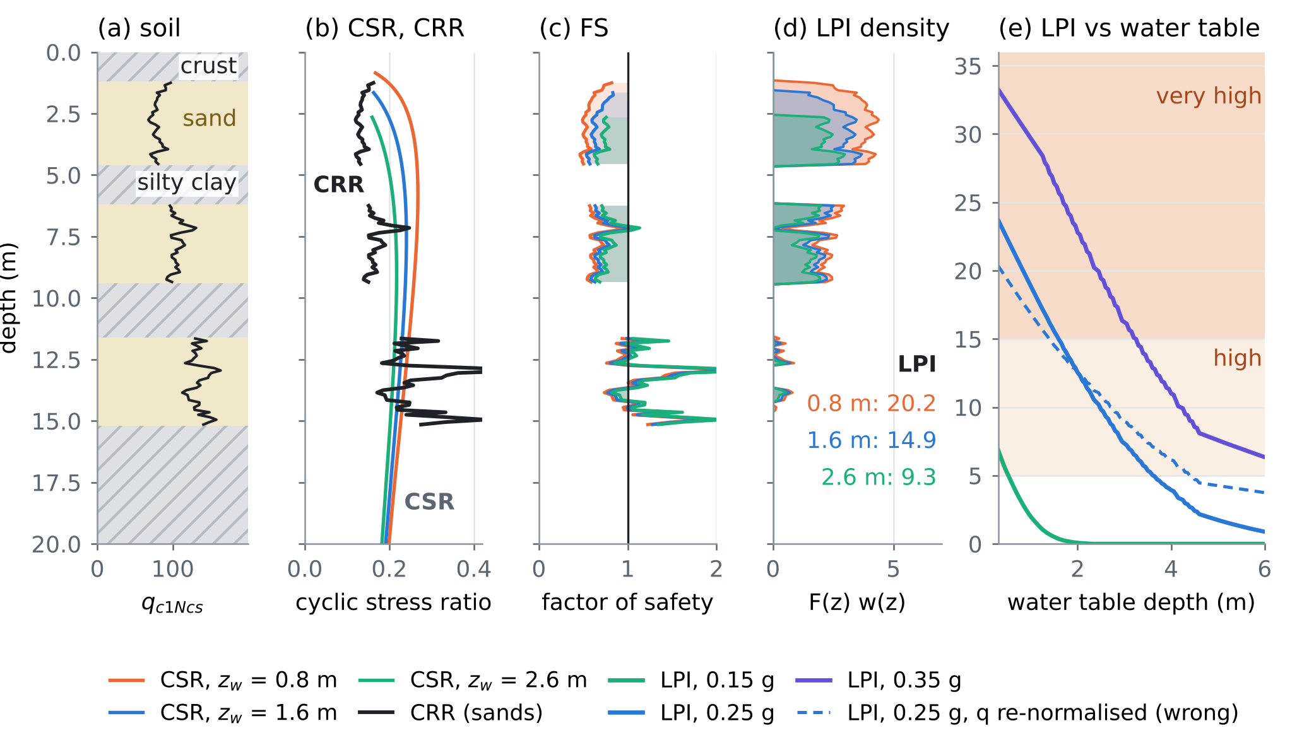
Figure 2. E1. (a) The profile: crust and silty clays hatched, sands shaded, $q_{c1Ncs}$ as a line. (b) CSR for three water tables and CRR of the sands. (c) Factor of safety; shaded where FS < 1. (d) The LPI integrand and the LPI for each water table. (e) LPI against the depth of the water table for three accelerations; dashed: the shortcut of Section 3.2. Shading: high (5–15) and very high (over 15) LPI.
4. E2: the coseismic step
4.1 Okada’s solution, written and checked
The surface displacement of a rectangular dislocation in an elastic half-space [1] was written in numpy (okada85.py), and the horizontal strains were taken by fourth-order central differences. The note cites Okada [2], the internal-deformation form; the surface form [1] is the one needed for a shallow layer (Section 4.3). Five tests that do not use the code itself (okada_checks.py) all pass (Table 3).
Table 3. Independent checks of okada85.py.
Test | What must hold | Result
C1. Fault reaching the surface | jump of displacement across the trace = slip vector (strike-slip, and reverse at 45°) | error ≤ 6.1×10⁻⁵ m per m of slip
C2. Point-source limit | a 200 m fault far away = the point-source formulas of [1] × area | relative error ≤ 6.1×10⁻⁴
C3. Plane strain | a 2000 km fault: surface displacement independent of $ν$ | 0.2% change for $ν$ 0.25 → 0.40 (20 km fault: 5.2%)
C4. Sense of motion | reverse lifts the hanging wall, normal lowers it; left-lateral moves the far side left | $u_{z}$ = +0.227 and -0.227 m; $u_{n}$ = +0.051 (east), -0.051 (west) m
C5. Strain step | strain independent of the difference step (1, 2, 4 m) | relative change ≤ 1.8×10⁻¹¹

4.2 Four published source models
The geometry of each model was taken from its abstract; what an abstract did not give was derived from the moment magnitude with uniform slip, $M_{0}=μLWs$, $M_{w}=\left(\log_{10}M_{0}−9.1\right)/1.5$ [3], $μ$ = 30 GPa (Table 4). The strike follows the NW–SE trend of the structure, set by the dip direction. All four are reverse faults (rake 90°).
Table 4. The source ensemble. Bold: from the abstract of the paper; the rest derived here.
Model | Dip | Centroid depth | L × W (km) | Slip (m) | Mw here
Ganas et al. 2020 [4] | 23° E | 16.5 km | 22 × 13 | 0.55 | 6.38
Matraku et al. 2023 [6] | 40° E | 15 km | 20 × 11 | 0.71 (uniform) | 6.38
Govorčin et al. 2020 [5] | 71° SW | 17 km (slip at 11–23 km) | 18 × 12.7 | 0.52 (uniform) | 6.30
van der Heiden et al. 2026 [7] | about 30° NE | 15 km (12–18 km) | 20 × 12 | 0.70 (uniform) | 6.40

4.3 The undrained step in a layer under the free surface
Equation (2.2) of [D1] gives the step as $Δp_{0}=−BK_{u}Δε_{v}$, with $Δε_{v}$ the volumetric strain of the half-space (2.1). That is right for an aquifer as stiff as the half-space. The sediments of a coastal plain are much softer and lie in a layer tens to hundreds of metres thick, against a deformation field that varies over kilometres. Such a layer takes the horizontal strain of the crust beneath it, while its top is free: $σ_{zz}=0$.
Proposition 2 (the step under a free surface). For an undrained ($ζ=0$) poroelastic layer obeying (1.1)–(1.2) of [D1], with imposed horizontal strains and $σ_{zz}=0$,
$$Δp_{0}=−κ Δε_{a}, Δε_{a}=Δε_{xx}+Δε_{yy}, κ=\frac{2GB}{3} \frac{1+ν_{u}}{1−ν_{u}}$$ | (4)
with $G$, $B$ and $ν_{u}$ of the layer. Equivalently $Δp_{0}=−BK_{u}Δε_{v}$ with the volumetric strain of the layer, $Δε_{v}=Δε_{a}\left(1−2ν_{u}\right)/\left(1−ν_{u}\right)$, not that of the half-space. A soft saturated layer ($ν_{u}→1/2$) deforms at almost constant volume, and $κ→2GB$: the step scales with the shear modulus of the layer, not with the stiffness of its water.

Proof. With $ζ=0$, (1.2) gives $p=−αMε_{v}$, and (1.1) becomes undrained elasticity with $λ_{u}=2Gν_{u}/\left(1−2ν_{u}\right)$. Then $σ_{zz}=0$ gives $ε_{zz}=−ν_{u}ε_{a}/\left(1−ν_{u}\right)$, so $ε_{v}=ε_{a}\left(1−2ν_{u}\right)/\left(1−ν_{u}\right)$. With $αM=BK_{u}$ and $K_{u}=2G\left(1+ν_{u}\right)/\left[3\left(1−2ν_{u}\right)\right]$, $p=−BK_{u}ε_{v}$ is (4). The identity was checked against (1.1)–(1.2) solved directly for five random materials, to $2×{10}^{−16}$. □
At the surface of the half-space $Δε_{v}=Δε_{a}\left(1−2ν\right)/\left(1−ν\right)$, so (2.2) as written corresponds to $κ_{\left(2.2\right)}=BK_{u}\left(1−2ν\right)/\left(1−ν\right)$ = 3.33 GPa for $BK_{u}$ = 5 GPa and $ν$ = 0.25. Table 5 compares the three coefficients. The confined aquifer and the soft sand are placeholders until $G$ is measured (seismic CPT or surface waves) and $B$ is taken from the tidal response of the wells, as Section 8 of [D1] proposes.
Table 5. The step coefficient and the step over the four source models. Head per microstrain of areal strain; ranges are the extremes of the four maps.
Layer | G, B, νu | κ | Head per microstrain | Fall (hanging wall) | Rise (in front)
Soft surface sand | 50 MPa, 0.98, 0.49 | 95 MPa | 10 mm | 7–12 cm | 3–4 cm
Confined aquifer | 0.5 GPa, 0.90, 0.45 | 0.79 GPa | 81 mm | 0.6–1.0 m | 0.2–0.3 m
(2.2) as written | $BK_{u}$ = 5 GPa, $ν$ = 0.25 | 3.33 GPa | 340 mm | 35 × soft sand | 4.2 × confined

4.4 The pattern and the agreement of the models
All four models put a fall of the head over the hanging wall, where the uplifted crust is stretched, and a rise in front of the buried top edge and behind the fault, where it is squeezed (Figure 3a–d). Where the areal strain of any model exceeds 0.75 microstrain, the four agree on the sign over 86% of the area. They disagree in a ring around the fall (Figure 3e, dotted), whose position is set by the dip: the 71° model of Govorčin et al. narrows the fall and moves the rise towards the trace. The ensemble therefore carries a real epistemic spread, as [D1] anticipated, but not in the sign over the hanging wall.
4.5 Drainage during the shaking
A sand connected to the water table through sand drains during the shaking. For one-dimensional diffusion from the water table, the share of the step left after a shaking of duration $t_{s}$ at depth $L$ below the water table is
$$f\left(L\right)=erf\left(\frac{L}{2\sqrt{D t_{s}}}\right) \text{for sand connected through sand;} f=1 \text{for sand sealed by clay}$$ | (5)
With a diffusivity of 1 m²/s and 15 s of shaking, 7% of the step is left at 0.5 m, 28% at 2 m, 64% at 5 m and 97% at 12 m (Figure 3g). The shallow sands that dominate the LPI lose most of a step in seconds; a sand sealed by clay keeps it.
4.6 The earthquake as a free pumping test
After the step, a confined sand below a leaky clay relaxes as $Δh\left(t\right)=Δh_{0}e^{−t/τ}$, which is (2.3) of [D1] reduced to one compartment. The leakage time $τ$ is the quantity that a pumping test measures. A 0.3 m step with $τ$ = 3 days was recorded every 15 minutes with 2 cm noise for 20 days. The fit gives $\hat{τ}$ = 3.00 days and a 95% bootstrap interval of 2.94–3.07 days. The same $τ$ from the phase lag of a whole year of daily heads (amplitude 0.5 m, same noise) has an interval of 2.67–3.37 days, 5.8 times wider (Figure 3h). Every well in the confined aquifer that logged the night of 26 November 2019 holds such a test.
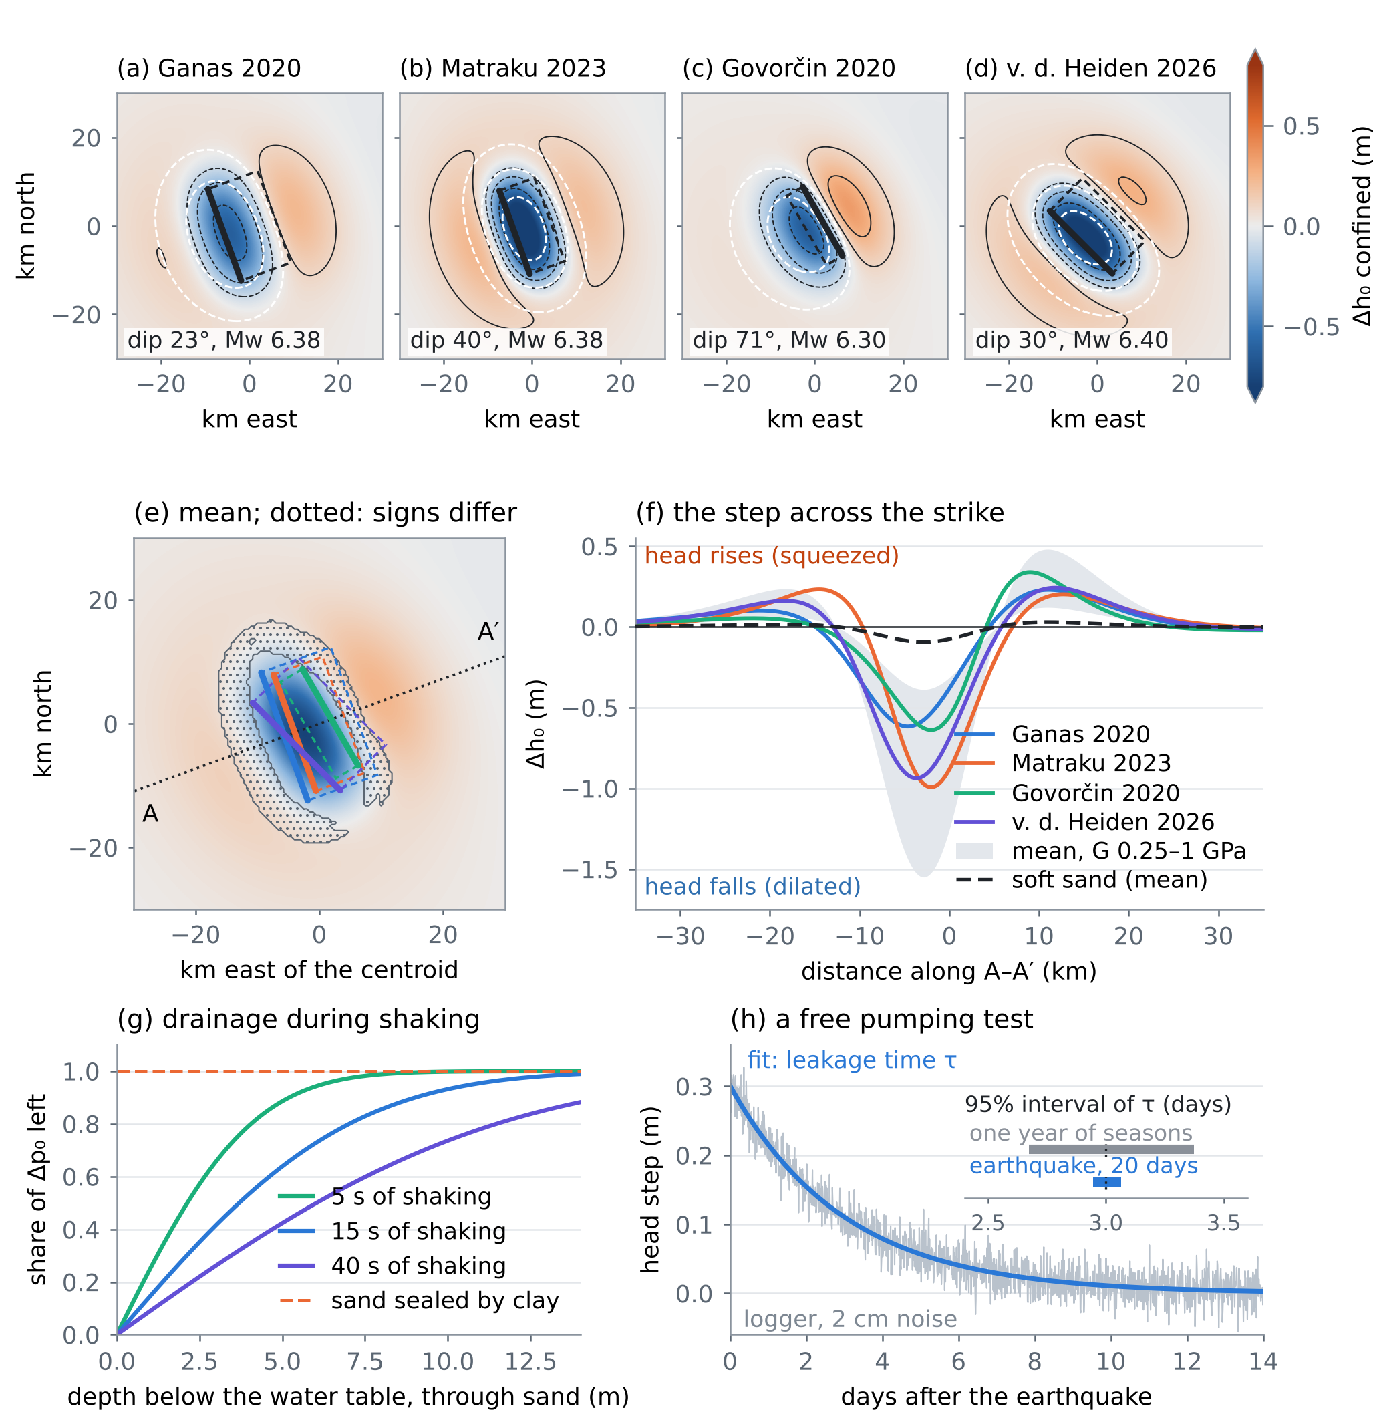
Figure 3. E2. (a–d) Head step in the confined aquifer for the four source models; contours at −0.5, −0.25, −0.1, 0.1 and 0.25 m; white dashed: uplift of 2, 5 and 10 cm; thick line: top edge of the fault. (e) Mean of the four; dotted where they disagree on the sign; A–A′: the transect. (f) The step along A–A′: the four models in the confined aquifer, the band of the mean for $G$ from 0.25 to 1 GPa, and the mean in the soft surface sand. (g) Share of the step left after the shaking, (5). (h) The relaxation after a 0.3 m step and the 95% intervals of $τ$ from the earthquake and from a year of seasons.
5. E3: designing the 2019 hindcast
The third step of [D1] is to ask whether the water table of the day and the step improve the prediction of where liquefaction occurred in 2019 [8]. Before collecting data, the test was designed on a synthetic coastal plain: 900 sites within 8 km of a coast that strikes N160°, over the fault of Ganas et al., each with a layered profile whose share of sand follows a smooth susceptibility field, a seasonal water table, and a peak acceleration that decays with distance with lognormal scatter. The truth uses the water table of 26 November and the largest step, (2.2) as written; 38% of the sites liquefy. Four predictors were compared by the area under the ROC curve (AUC), with the DeLong covariance for paired AUCs [15] and a one-sided test at 5%:
• M0: mean water table; M1: water table of the day; M2: M1 plus the step of the four-model mean; M3: M1 plus the step of the true source.
On all 900 sites the AUCs are 0.736, 0.738, 0.753 and 0.754 (Figure 4b). The gains are small because most of the information sits in the soil and the shaking. Table 6 gives the power: the chance that a hindcast with $N$ mapped sites detects the gain.
Table 6. Power of the paired-AUC test (400 resamples per size, one-sided, 5%).
Test | N = 30 | 60 | 120 | 240 | 480
Water table of the day (M1 vs M0) | 1% | 5% | 7% | 13% | 26%
Step, four-model mean (M2 vs M1) | 7% | 12% | 14% | 24% | 40%
Step, true source (M3 vs M1) | 6% | 14% | 17% | 30% | 49%

With the coefficient of soft sand (Section 4.3) the step changes the LPI of a site by a median of 0.02 and at most 0.77, against a median of 0.69 for the upper bound (Figure 4d). No number of sites would detect it. Design conclusion: the liquefaction map of 2019 cannot test the coseismic step, and it tests the water table of the day only with several hundred CPTs at mapped sites. The step should be tested where it is large, in the confined aquifer, on the well records of November 2019 (Section 4.6). A liquefaction hindcast remains useful to calibrate the triggering at the site, but with its low power stated in advance.
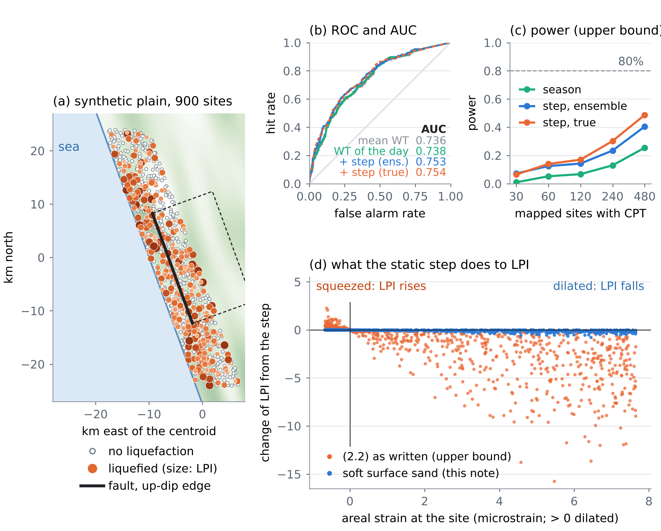
Figure 4. E3. (a) The synthetic plain: sites without and with liquefaction (size: LPI), the coast and the fault. (b) ROC curves and AUCs of the four predictors. (c) Power against the number of mapped sites (upper-bound step). (d) Change of LPI caused by the step, against the areal strain at the site: (2.2) as written (orange) and soft surface sand (blue).
6. E4, the innovation: the joint safe window and the daily bulletin
6.1 Two limits on one head
Let $h$ be the managed head at a low coastal site above mean sea level, $z_{s}$ the ground elevation and $z^{⋆}\left(a\right)$ the depth that the water table must keep for the LPI to stay below 5 under the design acceleration $a$, certified as the 90% quantile over the profiles of the site. Liquefaction asks for $h≤z_{s}−z^{⋆}\left(a\right)$. The Ghyben–Herzberg relation (3.7) of [D1] keeps the interface at least 20 m deep if $h≥η+m_{int}$ with $m_{int}$ = 20/40 = 0.5 m, $η$ being the relative sea-level rise [16]. The window and its width are
$$η+m_{int} ≤ h ≤ z_{s}−z^{⋆}\left(a\right), W\left(η,a\right)=z_{s}−z^{⋆}\left(a\right)−η−m_{int}$$ | (6)
A head that swings by $A$ over the year stays inside all year only if $W≥A$. The window closes for good at
$$η_{close}\left(a\right)=z_{s}−z^{⋆}\left(a\right)−m_{int}−A$$ | (7)
Both limits move the wrong way with time: sea-level rise and subsidence (3.3)–(3.5) of [D1] raise $η$; a larger design acceleration deepens $z^{⋆}$. Pumping to fight liquefaction lowers $h$ towards intrusion; recharge to fight intrusion raises it towards liquefaction.
6.2 The port of E4
A synthetic low port: ground at $z_{s}$ = 2.0 m, 60 CPT-like profiles with sands from 1–2 m depth, $A$ = 0.3 m. Table 7 and Figure 5 give the result. The median profile needs no lowering up to 0.22 g; the window is set by the weakest tenth of the port.
Table 7. The water table that keeps 90% of the port below LPI 5, and the sea level at which the all-year window closes. Years at an illustrative 9 mm/yr of relative sea-level rise (4 mm/yr of sea and 5 mm/yr of subsidence, not measured values).
Design acceleration | z* certified (90%) | z* median | η at closing | Year
0.15 g | 0.00 m | 0.00 m | 1.20 m | about 2159
0.18 g | 0.27 m | 0.00 m | 0.93 m | about 2129
0.20 g | 0.91 m | 0.00 m | 0.29 m | about 2059
0.22 g | 1.76 m | 0.00 m | -0.56 m | closed already
0.25 g | 2.89 m | 0.25 m | -1.69 m | closed already

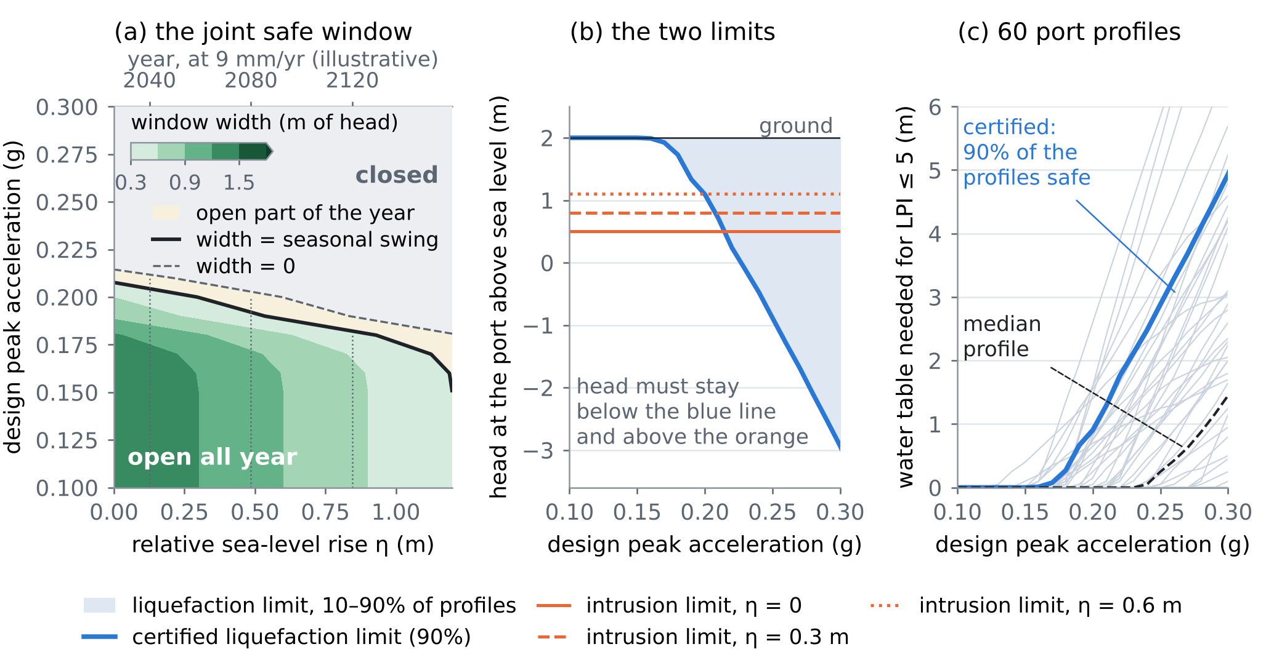
Figure 5. E4. (a) Width of the joint window against relative sea-level rise and design acceleration; the solid line is where it equals the seasonal swing, the dashed line where it vanishes; top axis: years at an illustrative 9 mm/yr. (b) The two limits on the head: liquefaction (blue, certified) and intrusion (orange) for three sea levels. (c) The water table needed for LPI ≤ 5 in each of the 60 profiles, their median and the certified 90% line.
6.3 The daily bulletin
The same profiles give, for each day $d$, the probability that the LPI exceeds 5 if the design earthquake ($M$ 6.4, median 0.22 g, lognormal scatter 0.35) struck that day:
$$P_{d}=Pr\left[LPI>5∣\text{earthquake on day }d\right]=\frac{1}{N_{p}N_{a}}\sum_{i=1}^{N_{p}}{\sum_{j=1}^{N_{a}}{1}}\left[{LPI}_{i}\left(z_{w}\left(d\right),a_{j}\right)>5\right]$$ | (8)
with $N_{p}$ = 60 profiles and $N_{a}$ = 12 accelerations. With the natural water table moving between 0.9 and 2.0 m, $P_{d}$ moves between 0.16 in late July and 0.26 in early February (Figure 6). With the logger network of the project, $z_{w}\left(d\right)$ is measured, and the bulletin can be issued daily, with the conformal or certified bounds of the CERTAIN-COAST cycle in place of the plain quantiles used here.
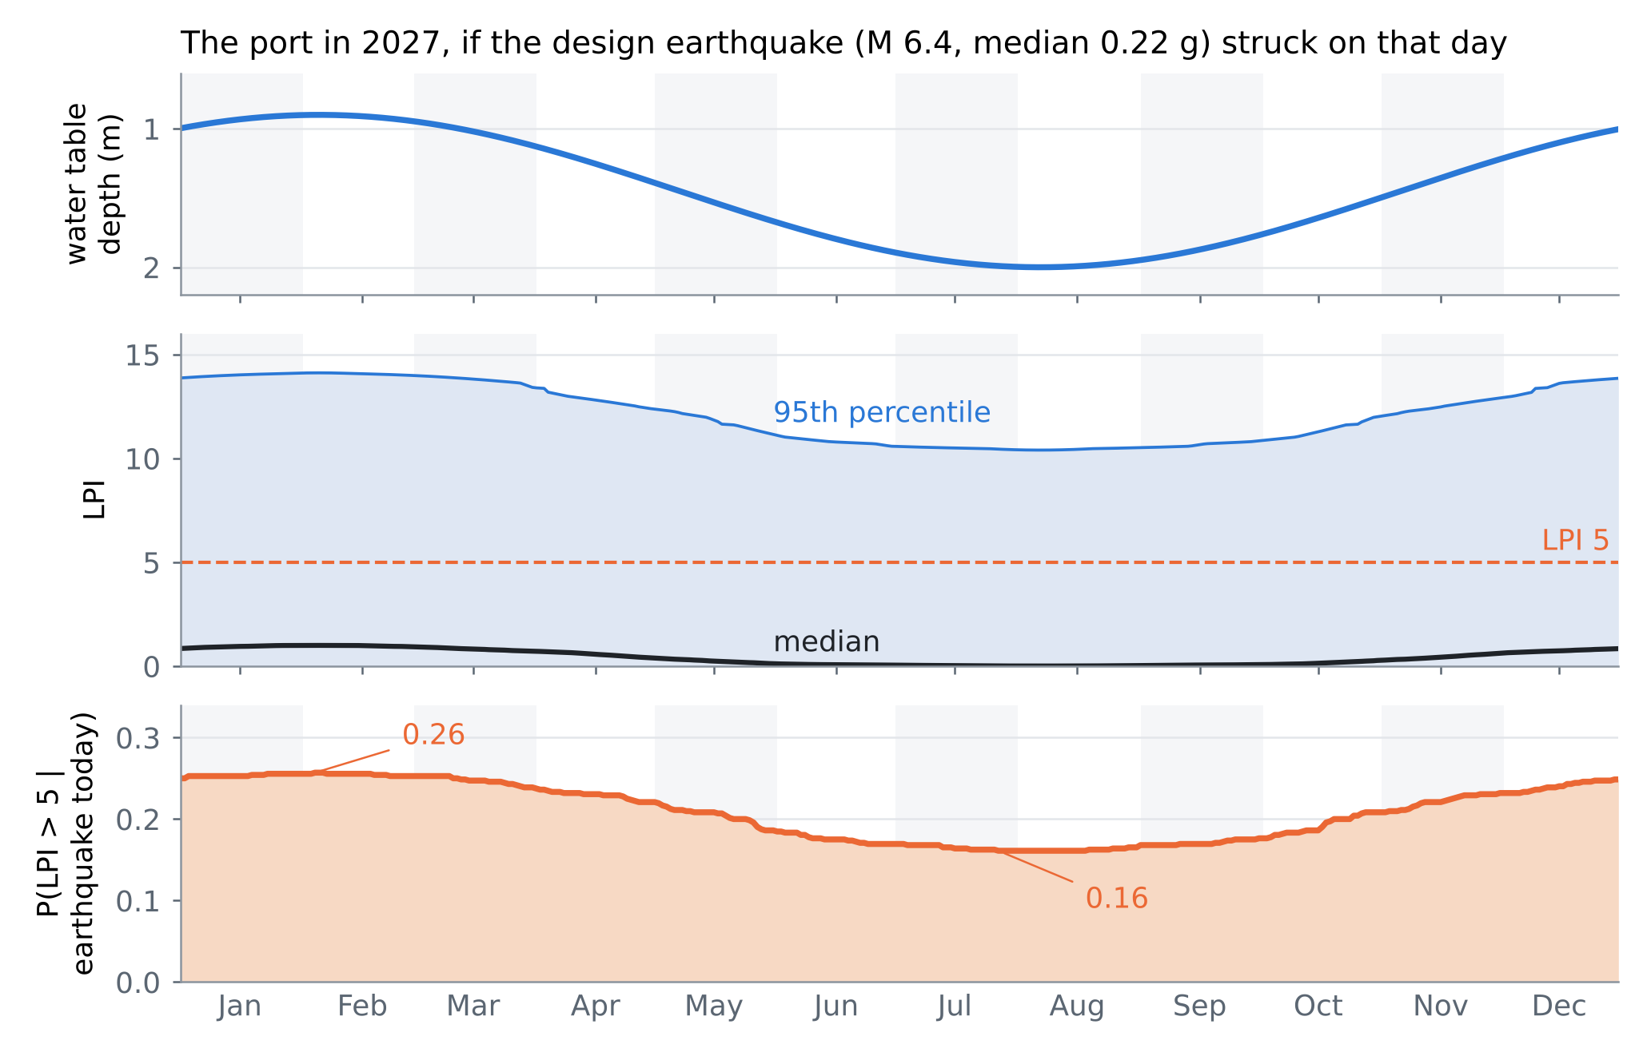
Figure 6. The daily bulletin for the port in 2027. Top: the water table. Middle: the median and the 5–95% band of the LPI over profiles and accelerations. Bottom: the probability that the LPI exceeds 5 if the earthquake struck that day.
7. What changes in the note
The revised Albanian note [D1] carries these changes. Its first page lists them, and each new paragraph opens with a short bold title:
• (4.1)–(4.2). The step enters the pore pressure, $u=γ_{w}{\left(z−z_{w}\right)}_{\text{+}}+fΔp_{0}$ (1), with the drainage share (5); the water table does not jump.
• (2.2). For a layer under the free surface, $Δp_{0}=−κ Δε_{a}$ (4); in soft sand the step is centimetres. The mechanism paragraph now separates the static step from the volumetric change caused by the shaking (Wang and Chia [14]), which CSR–CRR already contains, so that it is not counted twice.
• (2.4). The constant: from $e=3E/\left(4πr^{3}\right)$ and $\log_{10}E=5.24+1.44M$ it is −4.38, not −4.62; for $M$ 6.4 the radius of $e$ = 0.1 J/m³ becomes 88 km instead of 73 km. Both are larger than the distance from the 2019 source to the Durrës–Fushë Kuqe coast (a few tens of kilometres), so no decision there depends on it. Wang and Chia [14] present the relation as new; its printed constant must be read there before use.
• 4.5. $q_{c1Ncs}$ is fixed by the CPT; the full sensitivity is (3); the shortcut of Section 3.2 biases the slope by 33%.
• 3.3. The compaction equations are those of the CSUB package of MODFLOW 6 [20], which replaces SUB-WT.
• 5.6. Settlement from liquefaction is the integral of the post-shaking volumetric strain over depth, with the strain from $FS$ and $q_{c1Ncs}$ as in Zhang et al. [19]; the coefficients are taken from that paper, not repeated here.
8. Limits
The soils, the coastal plain and the ground motion are synthetic, and the port is not a real port. The source models use uniform slip on one rectangle; the published slip distributions are richer. The half-space is homogeneous; a layered crust changes the strain near the surface. The layer coefficients $G$, $B$ and $ν_{u}$ are assumed, not measured; Proposition 2 assumes a layer thin against the deformation field and fully undrained during the step. The cyclic generation of pore pressure is left inside CSR–CRR, as the triggering procedure intends, and is not modelled as a separate step. Drainage during the shaking is one-dimensional. The hindcast design uses one source as the truth and the upper bound of the step, so its powers are optimistic. The window uses one intrusion criterion (an interface 20 m deep) and a 90% quantile over 60 profiles; the year axis rests on an illustrative rate. The bulletin uses a fixed scenario earthquake, not a hazard curve. The settlement and the flood steps of [D1] were not implemented.
Verification note. The external references [1–20] were checked in Crossref (DOI, authors, title, venue), November 2026, except the report [9], which has no DOI. The geometry of the source models comes from their abstracts. The note was drafted with the help of an AI assistant. Every number is computed by experiments/tronditja_go (tronditja_exp.py, okada_checks.py; results in res/) and inserted by the build script.
References
Published sources
[1] Okada, Y. (1985). Surface deformation due to shear and tensile faults in a half-space. Bulletin of the Seismological Society of America 75(4), 1135–1154. https://doi.org/10.1785/BSSA0750041135
[2] Okada, Y. (1992). Internal deformation due to shear and tensile faults in a half-space. Bulletin of the Seismological Society of America 82(2), 1018–1040. https://doi.org/10.1785/bssa0820021018
[3] Hanks, T. C., & Kanamori, H. (1979). A moment magnitude scale. Journal of Geophysical Research: Solid Earth 84(B5), 2348–2350. https://doi.org/10.1029/JB084iB05p02348
[4] Ganas, A., et al. (2020). Ground deformation and seismic fault model of the M6.4 Durres (Albania) Nov. 26, 2019 earthquake, based on GNSS/InSAR observations. Geosciences 10, 210. https://doi.org/10.3390/geosciences10060210
[5] Govorčin, M., et al. (2020). Geodetic source modeling of the 2019 Mw 6.3 Durrës, Albania, earthquake: partial rupture of a blind reverse fault. Geophysical Research Letters 47, e2020GL088990. https://doi.org/10.1029/2020GL088990
[6] Matraku, K., et al. (2023). The 26 November 2019 Durrës earthquake, Albania: coseismic displacements and occurrence of slow slip events in the year following the earthquake. Geophysical Journal International 234, 807–838. https://doi.org/10.1093/gji/ggad101
[7] van der Heiden, V., et al. (2026). Analysis of the 2019 Mw 6.4 Durrës, Albania, aftershock sequence: basement involved thrusting at the eastern Adriatic plate margin. Geophysical Journal International 246, ggag155. https://doi.org/10.1093/gji/ggag155
[8] Mavroulis, S., Lekkas, E., & Carydis, P. (2021). Liquefaction phenomena induced by the 26 November 2019, Mw = 6.4 Durrës (Albania) earthquake and liquefaction susceptibility assessment in the affected area. Geosciences 11, 215. https://doi.org/10.3390/geosciences11050215
[9] Boulanger, R. W., & Idriss, I. M. (2014). CPT and SPT based liquefaction triggering procedures. Report UCD/CGM-14/01, Center for Geotechnical Modeling, University of California, Davis.
[10] Boulanger, R. W., & Idriss, I. M. (2016). CPT-based liquefaction triggering procedure. Journal of Geotechnical and Geoenvironmental Engineering 142, 04015065. https://doi.org/10.1061/(asce)gt.1943-5606.0001388
[11] Maurer, B. W., et al. (2014). Evaluation of the liquefaction potential index for assessing liquefaction hazard in Christchurch, New Zealand. Journal of Geotechnical and Geoenvironmental Engineering 140, 04014032. https://doi.org/10.1061/(asce)gt.1943-5606.0001117
[12] Rice, J. R., & Cleary, M. P. (1976). Some basic stress diffusion solutions for fluid-saturated elastic porous media with compressible constituents. Reviews of Geophysics 14, 227–241. https://doi.org/10.1029/rg014i002p00227
[13] Wang, C.-Y., & Manga, M. (2021). Water and Earthquakes. Springer International Publishing. https://doi.org/10.1007/978-3-030-64308-9
[14] Wang, C.-Y., & Chia, Y. (2008). Mechanism of water level changes during earthquakes: near field versus intermediate field. Geophysical Research Letters 35(12). https://doi.org/10.1029/2008GL034227
[15] DeLong, E. R., DeLong, D. M., & Clarke-Pearson, D. L. (1988). Comparing the areas under two or more correlated receiver operating characteristic curves: a nonparametric approach. Biometrics 44(3), 837–845. https://doi.org/10.2307/2531595
[16] Werner, A. D., et al. (2013). Seawater intrusion processes, investigation and management: recent advances and future challenges. Advances in Water Resources 51, 3–26. https://doi.org/10.1016/j.advwatres.2012.03.004
[17] Grant, A. R. R., et al. (2021). Changes in liquefaction severity in the San Francisco Bay Area with sea-level rise. Geo-Extreme 2021, 308–317. https://doi.org/10.1061/9780784483695.030
[18] Befus, K. M., et al. (2020). Increasing threat of coastal groundwater hazards from sea-level rise in California. Nature Climate Change 10, 946–952. https://doi.org/10.1038/s41558-020-0874-1
[19] Zhang, G., Robertson, P. K., & Brachman, R. W. I. (2002). Estimating liquefaction-induced ground settlements from CPT for level ground. Canadian Geotechnical Journal 39(5), 1168–1180. https://doi.org/10.1139/t02-047
[20] Hughes, J. D., Leake, S. A., Galloway, D. L., & White, J. T. (2022). Documentation for the Skeletal Storage, Compaction, and Subsidence (CSUB) Package of MODFLOW 6. U.S. Geological Survey Techniques and Methods 6-A62. https://doi.org/10.3133/tm6A62
Notes of this series (in this repository)
[D1] Zeqiraj, D. (2026). Tërmeti, akuiferi, veprimet njerëzore dhe përmbytjet: sistemi i ekuacioneve të çiftuara për bregdetin Durrës–Fushë Kuqe (the TERMETET note). Working note, 31 October 2026; revised version docs/research_notes/TERMETET_CERTAIN-COAST_Termeti_Akuiferi_Permbytjet_Sistemi_i_Ekuacioneve_rishikuar.docx in this repository.

