CERTAIN-COAST — Timeline
Certified early warning for seawater intrusion, liquefaction and extreme sea levels at the wellfields, port and energy landfall of a subsiding Adriatic coast
CERTAIN-COAST runs for 36 months. Year 1 measures the coast and builds the network, Year 2 builds the model, certifies the alarms and opens the live service, and Year 3 operates it for twelve months and hands it over. The timeline is driven by evidence rather than dates alone: three gates (MS3, MS4, MS5) must be passed before the next stage starts, and buffers sit where the Risk Assessment places the risks. Months count from the start date of the grant; all dates below are consistent with the Work Plan.
1. From application to start
When | What | Who
Now | Name the partner-country institution; collect the signed commitment letters; finalise budget and CVs | Applicants
[15 November 2026: confirm on nato.int] | Submit the application for the SPS call 2027-1 (in the phase the call specifies) | NATO-country Project Director
[per the call] | Evaluation by the Independent Scientific Evaluation Group; funding decision by the NATO Allies | NATO
[after approval] | Grant letter; acceptance of the award by the co-directors | All co-directors
Before Month 1 | Draft consortium agreement and access agreements; plan ethics approvals; update equipment quotes | Consortium
Month 1 | Project start | Consortium
Dates in brackets depend on the call and on NATO's evaluation; confirm them on nato.int.
2. The project year by year
Year 1 (Months 1–12): measure and build
• Access agreements and data management plan by Month 3 (D7.1); kick-off workshop with the operators in Month 2.
• Network designed for the warnings by Month 6 (D4.1, MS1); equipment ordered in Month 4; installed and streaming by Month 12 (D4.2).
• InSAR from 2014 onward, GNSS and corner reflectors; elastic and inelastic compaction separated; relative sea level at each asset by Month 12 (D1.1, MS2).
• Coupled model set up from Month 4; post-event protocol on standby from Month 12.
Year 2 (Months 13–24): model, certify, open the service
• Thresholds and acceptable false-alarm rates agreed with the operators (Months 13–15); training school in Month 14.
• Coupled model calibrated by Month 18 (D2.1, gate MS3); mid-term workshop in Month 18.
• Certified surrogate by Month 22 (D2.2); go/no-go for live operation in Month 22 (gate MS4); live bulletins from Month 23.
• Certified alarm algorithms and proofs by Month 24 (D3.1); first progress report in Month 12, second in Month 24.
Year 3 (Months 25–36): operate, verify, hand over
• Back-testing report and miss-rate targets confirmed by Month 27 (D3.2, gate MS5); joint pumping rule agreed with the utility by Month 33.
• Maintenance agreement signed by the operators by Month 33; open software and data released in Month 33 (D6.1).
• Twelve months of live operation completed in Month 34 (D5.1, MS6); operators issue every bulletin in Months 34–36.
• Transfer workshop in Month 35; procedures and policy brief, final workshop and hand-over in Month 36 (D6.2, MS7, D7.3).

3. Master timeline
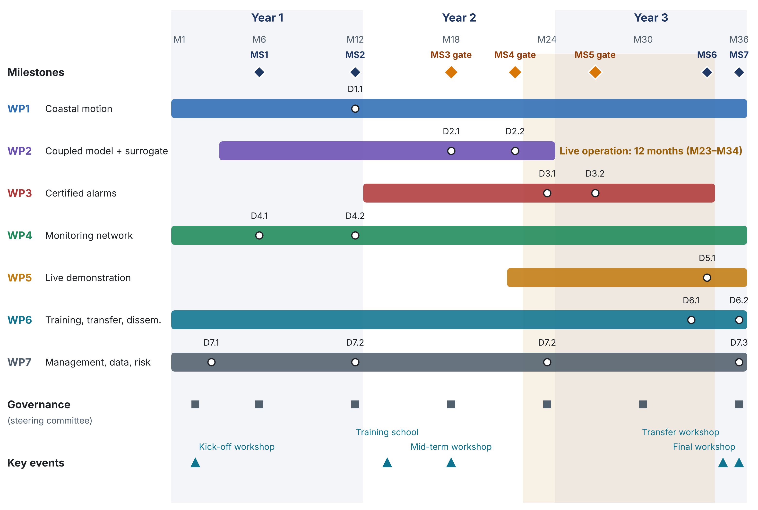
Figure 1. Master timeline. Bars: work packages; circles: deliverables; diamonds: milestones, with the three evidence gates in orange; shaded band: twelve months of live operation; squares: steering committee; triangles: key events.

4. Milestones and gates
 | Month | Milestone | Evidence
MS1 | M6 | Network design agreed | D4.1 approved by the steering committee and the operators
MS2 | M12 | Network streaming; coastal motion known | D4.2 (≥ 90% data availability over the first month) and D1.1 delivered
MS3 | M18 | Coupled model calibrated | D2.1: held-out observations reproduced within their stated uncertainty
MS4 | M22 | Go/no-go for live operation | D2.2 surrogate error bound met on the test set; alarm prototype passes a dry run
MS5 | M27 | Miss-rate targets confirmed in back-testing | D3.2: each miss rate ≤ α_k with its confidence interval reported
MS6 | M34 | Twelve months of live operation completed | D5.1 with the bulletin log and verified outcomes
MS7 | M36 | Hand-over to the operators | D6.2 procedures adopted; operator staff run the system unaided

5. Key dates month by month
Month | What | Type
M2 | Kick-off workshop | Event
M3 | D7.1: Data management plan and access agreements | Deliverable
M4 | Equipment ordered (T4.2) | Event
M6 | MS1: Network design agreed | Milestone
M6 | D4.1: Network design report | Deliverable
M12 | MS2: Network streaming; coastal motion known | Milestone
M12 | D1.1: Coastal motion atlas and R(t) series | Deliverable
M12 | D4.2: Network installed and streaming | Deliverable
M12 | D7.2: Progress reports | Deliverable
M12 | Post-event protocol on standby (T5.4) | Event
M13 | Thresholds agreed with operators begin (T3.1) | Event
M14 | Training school | Event
M18 | MS3: Coupled model calibrated | Gate
M18 | D2.1: Calibrated coupled model | Deliverable
M18 | Mid-term workshop | Event
M22 | MS4: Go/no-go for live operation | Gate
M22 | D2.2: Certified surrogate | Deliverable
M23 | Live bulletins start (T5.2) | Event
M24 | D3.1: Certified alarm algorithms and proofs | Deliverable
M24 | D7.2: Progress reports | Deliverable
M27 | MS5: Miss-rate targets confirmed in back-testing | Gate
M27 | D3.2: Back-testing report | Deliverable
M33 | D6.1: Software and data release | Deliverable
M33 | Maintenance agreement signed; joint pumping rule agreed (T5.3) | Event
M34 | MS6: Twelve months of live operation completed | Milestone
M34 | D5.1: Live demonstration report | Deliverable
M34 | Operators issue every bulletin (to Month 36) | Event
M35 | Transfer workshop | Event
M36 | MS7: Hand-over to the operators | Milestone
M36 | D6.2: Operating procedures and policy brief | Deliverable
M36 | D7.3: Final report | Deliverable
M36 | Final workshop | Event

6. Critical path, gates and buffers
The chain that decides the end date runs from the network design to the hand-over. Each link has a buffer placed where the Risk Assessment scores the risk highest:
Link | Months | Ends at | Buffer
Network design (T4.1) | M1–6 | MS1 | Equipment ordered in Month 4, before the design is final, for sensors certain to be needed
Procurement and installation (T4.2) | M4–12 | MS2 | Installation window of 8 months; highest-value sensors installed first
Calibration of the coupled model (T2.3) | M12–18 | MS3 (gate) | Model built in stages from Month 7, so calibration starts as soon as data stream
Certified surrogate (T2.4) | M15–22 | MS4 (gate) | Starts before calibration ends, on preliminary parameters
Live operation (T5.2) | M23–34 | MS6 | Back-testing (to Month 27) runs in parallel, not before
Hand-over (T6.4) | M30–36 | MS7 | Operators issue all bulletins from Month 34; procedures drafted from Month 30
A slip of up to two months at the go/no-go gate (MS4) is absorbed: live operation then runs from Month 25 to Month 36, still twelve months, and the operators still issue the bulletins in the final months. A longer slip triggers the fallbacks of the Risk Assessment (R5, R6) and is decided by the steering committee.
7. Governance and reporting calendar
Activity | When | Source
Steering committee | Months 2 (kick-off), 6, 12, 18, 24, 30, 36, and at each gate | Partnership; T7.1
Risk review | Every month; escalation within two weeks when a trigger is crossed | Risk Assessment; T7.3
Progress reports to NATO SPS | Months 12 and 24 (D7.2); final report Month 36 (D7.3) | Work Plan
Data management plan | Version 1 Month 3 (D7.1); version 2 Month 18; final Month 36 | Data Management Plan
Gender and ethics review | Yearly: Months 12, 24, 36; ethics at every steering committee | Gender Balance; Ethics
Maintenance and hand-over agreements | Month 33 and Month 36 | Sustainability

8. What is new in this timeline
• Gates, not only dates. Live operation starts only when the model passes its validation test (MS3) and the surrogate meets its error bound (MS4), and the guarantees are confirmed in back-testing (MS5); each gate has a stated pass test and a fallback.
• A full year of hazards. Twelve consecutive months of live operation include every season, the dry months that drive intrusion and the storm months that drive extreme sea levels, whatever the start date.
• Ready for the unexpected event. The post-event protocol is on standby from Month 12, so a strong earthquake or storm at any time after the network is installed becomes data rather than a disruption.
• Buffers where the risks are. Slack is placed on procurement, calibration and the go/no-go gate, the steps the Risk Assessment scores highest, not spread evenly.
• The hand-over is in the timeline, not after it. Operators issue every bulletin in the last three months, so the end state is demonstrated within the project.

