State of the art VI: how narrow can a guarantee be
Twenty more papers from Oxford, Caltech, Berkeley and MIT (2020–2026) with theorem-level results on inverse problems, the limits of uncertainty quantification, information and design, and transport; the state of the art and the step beyond it; and DYSHEMEJA-GO, the floor below which no valid band can go, and how close the bands of reviews I–V come to it
Dulian Zeqiraj · November 2026 · review with a numerically tested innovation · companion to reviews I–V (GARANCIA-GO, MATJA-GO, RESHJA-GO, ANKORA-GO, PRIRJA-GO)
1. Outcome
• Twenty new papers, five per institution, 2020–2026, each with links and its main theorem (Section 3, Figure 1). None was a card of reviews I–V or of the earlier reviews. This batch is the most mathematical of the series: stability and rates for inverse problems, optimality and impossibility results for uncertainty quantification, information bounds for design, and rigorous transport theory. Each card gives the theorem, the state of the art it sets, what it cannot yet do for us, three lessons and an innovation step.
• State of the art and beyond, for the proposal (Section 2, Table 1), and a map of all one hundred and twenty papers of reviews I–VI on the steps of the procedure (Section 5, Table 3).
• Innovation: DYSHEMEJA-GO (Section 4). Reviews I–V proved that their bands are valid; this review asks how narrow a valid band can be. Proposition F1: under the real law, no band of any kind — Bayesian, conformal, machine-learned — with an expected share of weeks outside at most α can be narrower on average than the Neyman–Pearson band of the exact posterior, $\{x:p\left(x∣y\right)≥τ^{⋆}\}$ with one threshold for all weeks. Proposition F2 splits the excess width of any calibrated band into band shape, reconstructor and calibration. Proposition F3: the floor can only fall as data are added, and with rain alone the floors of the sea level and the inflow are their prior widths. Proposition F4: replacing each truth by draws from its exact posterior leaves every expected risk unchanged and lowers the noise, which makes these comparisons precise.
• Test without shift (T18). The 20-anchor band of review IV is 1.34–1.54 times the floor, the simulation band of review I 1.15–1.42 times. The excess splits into band shape 1.01–1.05, ensemble reconstructor 1.13–1.39 and calibration on 20 anchors 1.10–1.17: the reconstructor, not the guarantee, is the largest single cost.
• Test under shift (T19). With a 35-day field delay the anchor band stays valid but is 1.66–5.83 times the floor of the real law. The exact posterior under the simulator's law closes the gap for the inflow and the sea level (1.21–1.24) but not for the recharge and $κ$ (3.30, 6.50); the exact posterior of an enlarged law in which the delay is unknown closes it for all four (1.18–1.34 times the floor with 20 anchors), and its simulation calibration becomes valid again (risk 0.066–0.099). Calibration on anchors keeps every band valid (risk 0.055–0.095 for the ensemble, 0.055–0.096 for the enlarged law).
• What the data can buy (T20). Four loggers remove 82% of the sea-level floor width and 94% of the inflow floor width left by the rain alone, 92% for the recharge and 88% for $κ$; a tide gauge takes the sea level to 94%. The anchor band stays 1.13–1.52 times the floor across six designs.

2. State of the art and the step beyond it
Reviews I–V (D1–D5) guarantee bands for the boundary conditions, the recharge coefficient and the inputs of a coastal aquifer when only the rain is known: calibrated on simulations, valued by the width a measurement removes, robust to an uncertain rain, made independent of the simulator by real anchors and kept valid years ahead under drift. A guarantee says that a band is not too narrow. It does not say that the band is not needlessly wide, and a reviewer can always ask whether a better method would have given a narrower band from the same data. This review answers that question with a floor.
Text for the proposal. The mathematics of inverse problems and of uncertainty quantification now gives sharp results on what data can and cannot determine: stability and contraction rates for PDE inverse problems, optimality and impossibility theorems for prediction sets, and information bounds for experimental design (Section 3). These results are rarely turned into a number for a specific aquifer and design. The project goes beyond the state of the art by computing, for each boundary function and each candidate monitoring design, the narrowest band that any valid method could achieve (DYSHEMEJA-GO); by reporting the efficiency of its own guaranteed bands against that floor; and by attributing the excess width to the reconstructor, the band shape and the calibration, so that effort goes where it narrows the band most.
Table 1. State of the art (2020–2026) and the step beyond it. Card numbers refer to Section 3; T numbers to the tests of Section 4.
Topic | State of the art | Its limit for our problem | Our step beyond | Evidence
Optimality of prediction sets | Neyman–Pearson optimality of conformal sets with the inverse-density score (B1); expected size of conformal sets (O1); conformal sets as scenario programs (O5) | Optimal score unknown in practice; no number for a given aquifer and design | A computable floor for guaranteed bands of boundary functions (Proposition F1) | T18: 20-anchor ensemble band 1.34–1.54 times the floor
Lower bounds for inverse problems | Sharp minimax rates for random linear operators (B2); constrained frequentist intervals and the Burrus conjecture (C1); simultaneous regions (C2) | Bounds for point estimates or worst cases, not for bands with a risk guarantee | The floor of the band itself, exact under the working law | Propositions F1, F3
Accuracy of posterior approximations | Bernstein–von Mises with n ≫ d² (M1); Gaussian variational inference (M2); two-sided certified dimension reduction (M3); sparse triangular transports (M5); posterior perturbation (C3) | Distances between distributions, not widths of guaranteed bands | The reconstructor factor of the decomposition (2) | T18: ensemble 1.13–1.39 times the exact posterior; exact posterior with 20 anchors 1.07–1.20 times the floor
Conditional and selective guarantees | Conditional risk control over learned tilts (B3); locally simultaneous inference (B4); self-calibrating conformal prediction (B5) | More validity at a price in width that is not measured | Floors for marginal and conditional validity, priced before the method is run | Proposition F2
Identifiability and design | Identifiability of diffusion impedance (O3); data-free bounds on target averages (O2); certified information bounds for design (M4); stable CUR selection (O4); randomized low-rank certificates (C4); subsampled averages (C5) | Information or worst-case currencies; no guaranteed-band value of a design | The floor of each candidate design, computable before field data (Proposition F3) | T20
Structural error | Posterior stability under perturbed laws (C3) | No account of how a wrong model structure widens a guaranteed band | Enlarged law with the vadose delay unknown, calibrated on anchors | T19: with a 35-day delay 1.66–5.83 times the floor for the ensemble, 1.18–1.34 for the enlarged law
Dispersion and mixing | No 2020–2026 theorem-level paper on field dispersion at the four institutions beyond those already used | Floors for dispersivity bands need a transport model | Left for the next step, with the transport model of review I | –

3. The twenty papers
Five papers per institution, all from 2020–2026 (Figure 1). The rules of the earlier reviews apply: direct use, a link to the institution at the time of publication (JPL for Caltech, Lawrence Berkeley National Laboratory for Berkeley), a state-of-the-art contribution and no paper that was a card before. This batch asks for a precise theorem; each card states it as the search results quote or closely paraphrase it, with its assumptions. Preprints are marked as such on their venue line.
Verification. The hosts doi.org, arxiv.org, openreview.net and most publisher pages were blocked in this environment, so the landing pages were reached through search results that quote them, and every card but B3 is marked partly verified; where an author list, a volume or the exact wording of a theorem could not be confirmed, the card says so. Six of the twenty are preprints (O5, C1, C2, C3, B1, M4).
3.1 University of Oxford
O1 · Oxford · 2024
On the expected size of conformal prediction sets
Guneet S. Dhillon, George Deligiannidis, Tom Rainforth
Proceedings of the 27th International Conference on Artificial Intelligence and Statistics (AISTATS 2024), PMLR 238, 1549–1557
Links: PMLR 238 · arXiv:2306.07254
Affiliation and verification: All three authors at the Department of Statistics, University of Oxford (search summary of the arXiv and PMLR listings); the printed byline was not seen. Status: partly verified (landing pages reached through search results only).
What it does. Result (abstract wording). The expected size of split-conformal prediction sets is quantified theoretically; because the exact quantity is usually not computable, point estimates and high-probability interval bounds that can be computed empirically are derived, and they need the data to be collected only once. The bounds are tested on real regression and classification datasets (numbers and exact assumptions not seen).
State of the art it sets. The first finite-sample, data-computable account of the expected size, not only the coverage, of conformal sets.
What it cannot yet do for us. No comparison with an oracle set or lower bound; no risk control or drift.
Input parameters. Estimate, with an interval, the expected width of the bands for $T$, $S$, $κ$ and $τ$ calibrated on simulations or anchors.
Dispersion coefficient. The same for bands on the dispersivity and the transition-zone width.
Boundary conditions from rain alone. The expected width of the sea-level, inflow and initial-interface bands with rain only, before a logger is installed.
Innovation step for our problem. Their size estimate is the numerator of the efficiency ratio of Proposition F2 and the floor of Proposition F1 its denominator: together they give an efficiency with error bars. Without shift the 20-anchor band is 1.33–1.54 times the floor (T18); their interval bound says how much of that ratio is sampling noise of the anchors and how much is a lasting cost.

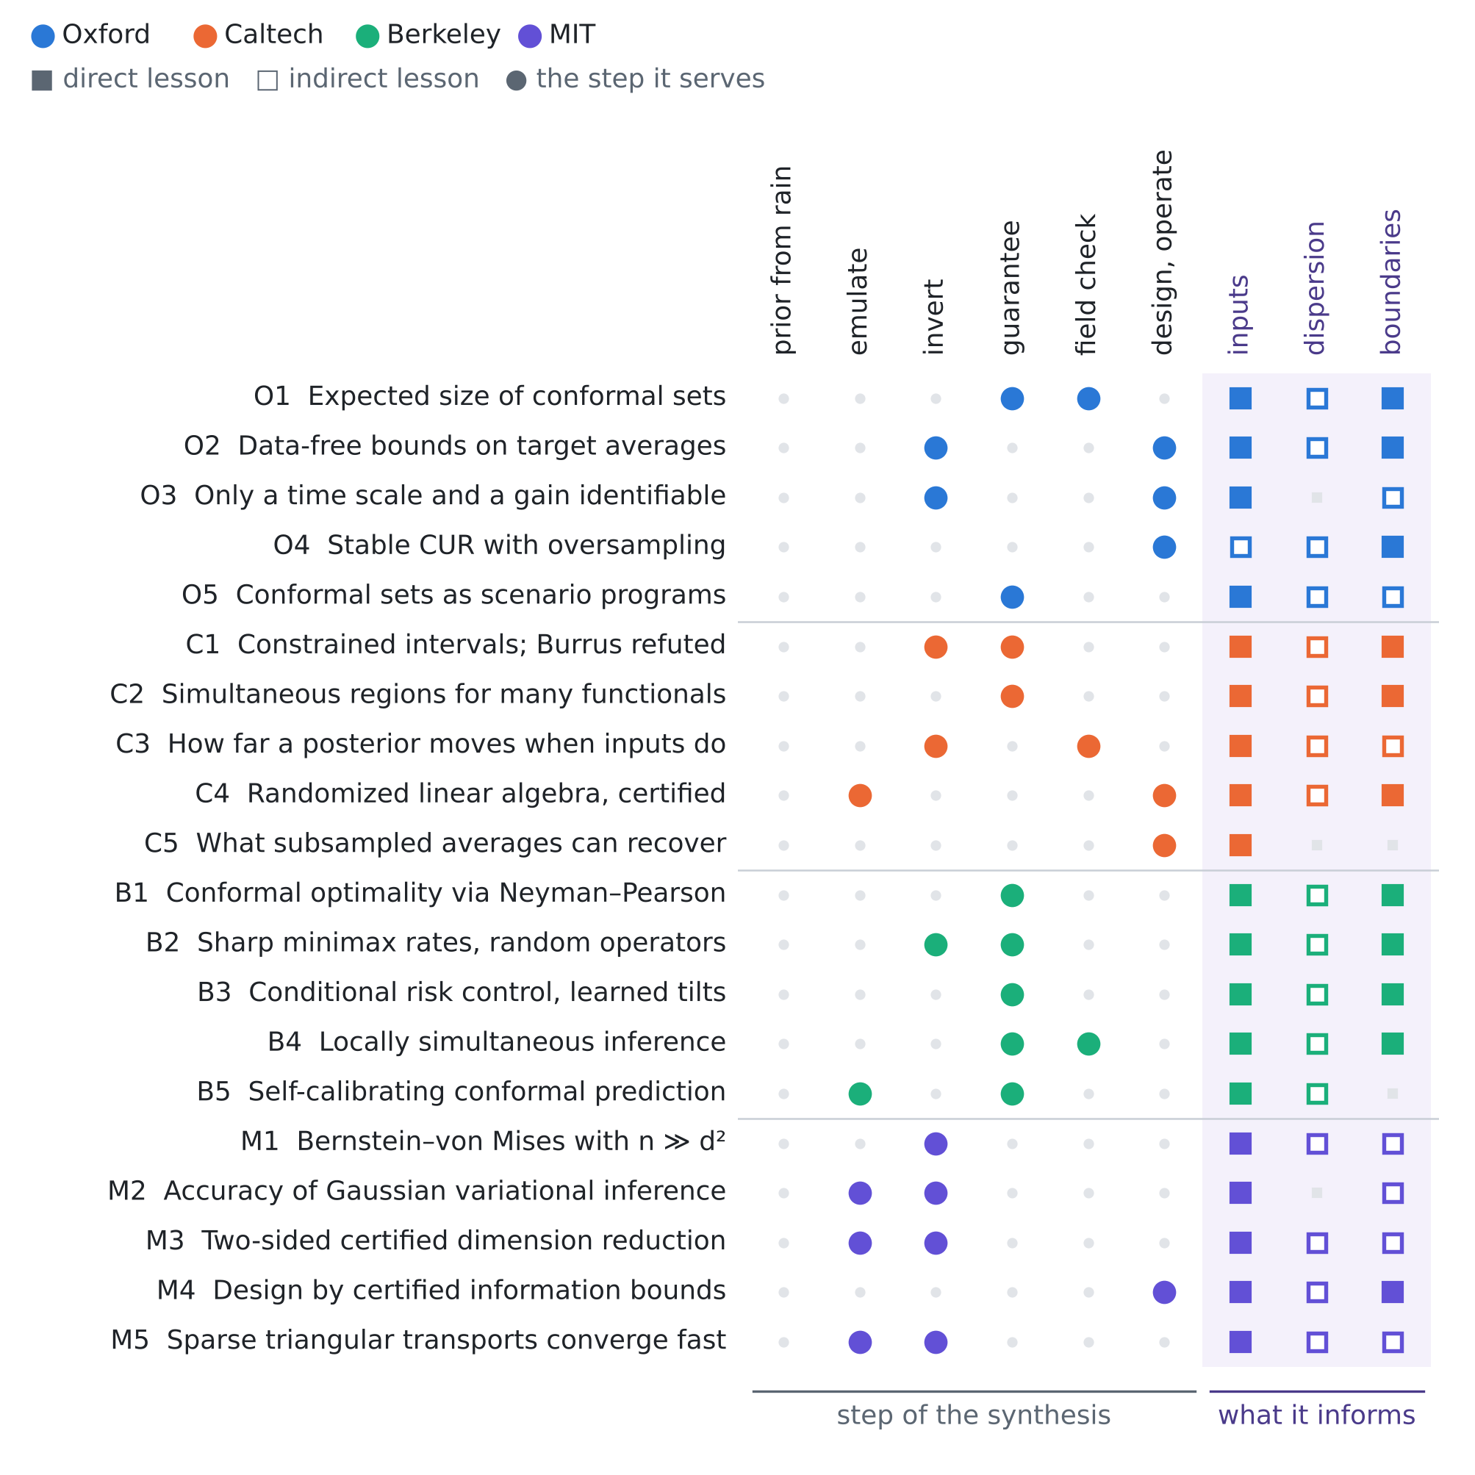
Figure 1. The twenty papers against the step of the procedure they serve and the unknown they inform. Colour gives the institution; a filled square is a direct lesson, an open square an indirect one.
O2 · Oxford · 2025
Bridging the gap between SOLA and deterministic linear inferences in the context of seismic tomography
Adrian Mag, Christophe Zaroli, Paula Koelemeijer
Geophysical Journal International 242(1), ggaf131 (2025)
Links: doi:10.1093/gji/ggaf131 · Oxford ORA
Affiliation and verification: Deposited in Oxford's repository ORA; the printed affiliations were not seen. Status: partly verified (landing pages reached through search results only).
What it does. Result. SOLA (subtractive optimally localized averages, a Backus–Gilbert method) is combined with deterministic linear inference, which bounds linear properties of a model under a norm-bound prior; the combined framework reads results through target kernels instead of imperfect resolving kernels while keeping the trade-offs between parameters. One case study shows that resolution and trade-off analysis can be done when no data values or errors are available. The method is for linear or linearised problems and the tests assume error-free data; no formal theorem statement was seen.
State of the art it sets. Design-stage, data-free bounds on chosen target averages that unify two schools of linear inference.
What it cannot yet do for us. Linear; worst-case rather than probabilistic; noise-free tests; not applied to groundwater.
Input parameters. Linearise the map from ($logT$, $S$, $κ$, $τ$) to the few heads: under a stated norm bound the bound on a zone average of $T$ is a deterministic floor, computable for candidate logger sites before they are installed.
Dispersion coefficient. The same for a target average over the mixing zone, with chloride facts as linearised functionals.
Boundary conditions from rain alone. The inland inflow as a linear property of rain-driven heads: the bound shows what rain alone and each added logger buy, without data.
Innovation step for our problem. Their bound is the worst-case, deterministic twin of the floor of Proposition F1, which is exact and probabilistic under a law. Both can be computed at the design stage (Proposition F3 (iii)); computed for the same target kernel, their difference separates what the norm bound and what the prior law contribute to the floor of a design.

O3 · Oxford · 2022
Identifiability of lithium-ion battery electrolyte dynamics
Luis D. Couto, Ross Drummond, Dong Zhang, Toby Kirk, David A. Howey
2022 American Control Conference (ACC), 1087–1093
Links: doi:10.23919/ACC53348.2022.9867154 · Oxford ORA
Affiliation and verification: Deposited in Oxford's repository ORA; the per-author affiliations were not seen. Status: partly verified (landing pages reached through search results only).
What it does. Result. Assuming equal electrolyte volume fractions in electrode and separator, an analytic impedance (transfer function) is derived for the diffusion dynamics and tested for structural identifiability: only the diffusion time scale and a geometric coupling parameter are identifiable, and simulations show identifiability problems for symmetric cells.
State of the art it sets. A closed-form structural-identifiability check for the impedance of a diffusion equation driven and observed at its boundaries.
What it cannot yet do for us. A battery model at a conference; the aquifer analogy is our inference.
Input parameters. The same structure as recharge in and heads out: the linear response identifies a diffusive time scale (about $L^{2}S/T$) and one gain (about $κ/S$), not $T$ and $S$ separately (our inference); a pumping test, the tidal response or a known sea forcing is needed to separate them.
Dispersion coefficient. None.
Boundary conditions from rain alone. The inflow gain and the time scale trade off unless the boundary forcing is known.
Innovation step for our problem. Where a combination is not identifiable, the floor of Proposition F1 stays at the prior: no method can narrow a band for $T$ alone below its prior width from rain and heads, while a band for the identifiable time scale can shrink. Computing the floor of both gives a number for the identifiability gap of a design, and the design that closes it.

O4 · Oxford · 2025
Accuracy and stability of CUR decompositions with oversampling
Taejun Park, Yuji Nakatsukasa
SIAM Journal on Matrix Analysis and Applications 46(1), 780–810 (2025)
Links: doi:10.1137/24M1660346 · arXiv:2405.06375
Affiliation and verification: Deposited in Oxford's repository ORA; the printed affiliations were not seen. Status: partly verified (landing pages reached through search results only).
What it does. Result. The square cross-approximation CUR can be unstable because its core may be nearly singular; the authors prove error bounds for it and for an ε-pseudoinverse variant with oversampling, show that the oversampled variant is numerically stable under roundoff, and recommend oversampling in proportion to the target rank (the exact form of the bound was not seen).
State of the art it sets. A stable, oversampled CUR with error guarantees.
What it cannot yet do for us. Deterministic; no posterior or coverage link.
Input parameters. Choose logger sites as rows of an ensemble head matrix: install somewhat more loggers than the number of modes to resolve, with the ε-truncation as the noise floor.
Dispersion coefficient. The same row selection for chloride sampling points.
Boundary conditions from rain alone. Reconstruct the modes of the sea boundary and the inflow from a few sites.
Innovation step for our problem. Use CUR to propose designs and the floor to price them. In T20 the floor of the inflow fell to 72% of its rain-only width with one logger and 6% with four; a CUR choice of four oversampled sites can be compared with the four fixed sites of reviews I–V by the same floor.

O5 · Oxford · 2025
Bridging conformal prediction and scenario optimization
Niall O'Sullivan, Licio Romao, Kostas Margellos
arXiv:2503.23561 (preprint, 2025)
Links: arXiv:2503.23561 · Oxford ORA
Affiliation and verification: Deposited in Oxford's repository ORA. Preprint; no journal version was confirmed. Status: partly verified (landing pages reached through search results only).
What it does. Result. With suitable score functions and set-predictor maps, plain conformal prediction recovers the known bounds on the probability of constraint violation of scenario programs; conversely, ranking the nonconformity scores is a one-dimensional scenario program with discarded constraints, which recovers conformal validity. Using the distribution of the violation probability, not only its mean, gives calibration-conditional bounds (their Theorem 6; the full assumptions were not seen).
State of the art it sets. An exact two-way equivalence between conformal prediction and scenario optimisation, with calibration-conditional guarantees.
What it cannot yet do for us. Preprint; nothing on the size of the sets or on drift.
Input parameters. With a handful of anchors, their Theorem 6 gives the probability that the miscoverage exceeds a chosen level: how much the bands must be inflated and how many anchors are needed.
Dispersion coefficient. The same for dispersivity bands.
Boundary conditions from rain alone. Pumping or sea-level rules certified over sampled rain years and the conformal bands can share one certificate.
Innovation step for our problem. Their calibration-conditional bound is the certificate version of the calibration factor of Proposition F2: with 20 anchors that factor averages 1.10–1.17 (T18); their Theorem 6 says how large it must be for a 90% certificate rather than on average, the question Proposition A2 of review IV answers with 22 anchors.

3.2 California Institute of Technology (with JPL)
C1 · Caltech · 2023
Optimization-based frequentist confidence intervals for functionals in constrained inverse problems: resolving the Burrus conjecture
Pau Batlle, Pratik Patil, Michael Stanley, Houman Owhadi, Mikael Kuusela
arXiv:2310.02461 (preprint, 2023; revised 2024)
Links: arXiv:2310.02461 · project page
Affiliation and verification: H. Owhadi: Caltech; the work is part of P. Batlle's Caltech PhD thesis; one listing gives P. Patil at UC Berkeley Statistics. The paper's own affiliation lines were not seen. Preprint. Status: partly verified (landing pages reached through search results only).
What it does. Theorem (as summarised). Intervals for a functional of a constrained parameter are built by inverting a constrained likelihood-ratio test, which turns coverage into type I error control, non-asymptotically, one functional at a time. The Burrus conjecture — that a χ²(1)-quantile calibration gives valid intervals for possibly rank-deficient linear Gaussian models with positivity constraints — is refuted by a counterexample built on a stochastic-dominance argument, which also disproves a general form of it.
State of the art it sets. Settles a decades-old conjecture and makes test inversion the correct construction for constrained linear-Gaussian inverse problems.
What it cannot yet do for us. Linear model with known Gaussian noise; no nonlinearity or model error; preprint.
Input parameters. $T$, $S$, $κ$ and $τ$ carry positivity or box constraints: the construction gives valid frequentist intervals for linearised functionals of them, and warns that the χ²(1) shortcut can undercover.
Dispersion coefficient. Dispersivity and transition-zone width are positive functionals once chloride is linearised.
Boundary conditions from rain alone. Positive functionals of the rain-driven model, such as the annual inflow or recharge, get valid intervals; the constraints carry information the rain alone lacks.
Innovation step for our problem. Their intervals are valid for every parameter value; the floor of Proposition F1 is the narrowest band valid on average under a law. Both are needed and differ in what they promise: for $κ$ with rain alone the floor is 0.144 (T20), the prior width, and their constrained interval would show how much more a guarantee at every $κ$ costs.

C2 · Caltech · 2025
Simultaneous frequentist calibration of confidence regions for multiple functionals in constrained inverse problems
Pau Batlle, Pratik Patil, Michael Stanley, Javier Ruiz Lupon, Houman Owhadi, Mikael Kuusela
arXiv:2510.11708 (preprint, 2025)
Links: arXiv:2510.11708
Affiliation and verification: H. Owhadi: Caltech; the affiliation lines were not seen. Preprint. Status: partly verified (landing pages reached through search results only).
What it does. Theorem (as summarised). Test inversion is extended from one functional to several at once: optimal calibration constants are derived for several joint test statistics, and the resulting regions keep finite-sample frequentist coverage while being uniformly less conservative than classical simultaneous strict bounds. Algorithms include reductions for high dimension and a row–null splitting for rank-deficient models; experiments report nominal coverage with substantially smaller regions (volume ratios not seen).
State of the art it sets. Optimal simultaneous calibration of confidence regions for several functionals of a constrained inverse problem.
What it cannot yet do for us. Linear Gaussian; preprint; numbers not seen.
Input parameters. A joint region for ($T$, $S$, $κ$, $τ$): the right comparator for joint risk-controlling sets.
Dispersion coefficient. The dispersivity can enter the same joint region.
Boundary conditions from rain alone. Simultaneous bands over yearly recharge, inflow and initial interface.
Innovation step for our problem. Proposition F1 extends to joint sets with the same proof, the threshold now on the joint posterior density, so a joint floor for ($r$, $q_{L}$, $η$, $κ$) can be computed in our test bed. With their regions and a joint calibration of the four bands it gives a three-way comparison: Bayesian floor, frequentist optimum and conformal practice, on the same data.

C3 · Caltech · 2023
Bayesian posterior perturbation analysis with integral probability metrics
Alfredo Garbuno-Iñigo, Tapio Helin, Franca Hoffmann, Bamdad Hosseini
arXiv:2303.01512 (preprint, 2023)
Links: arXiv:2303.01512
Affiliation and verification: F. Hoffmann: Caltech (search summary of the arXiv text). Preprint; no journal version found. Status: partly verified (landing pages reached through search results only).
What it does. Theorem (as summarised). The posterior is stable under perturbations of the likelihood potential, the data and the prior, measured in new families of integral probability metrics (Wasserstein as a special case), for likelihoods that are only locally Lipschitz and without requiring the prior and its perturbation to be equivalent, which total-variation and Hellinger results need. The constants were not seen.
State of the art it sets. Posterior stability beyond equivalent priors and globally Lipschitz likelihoods.
What it cannot yet do for us. Preprint; constants not seen; no lower bound.
Input parameters. An error budget for how far the exact posterior, and so the floor, moves when an emulator replaces the model or when the priors of $T$, $S$ and $κ$ are learned.
Dispersion coefficient. The posterior shift when literature dispersivity priors are swapped.
Boundary conditions from rain alone. The data-perturbation part bounds the posterior shift caused by errors in the rain series.
Innovation step for our problem. The floor is computed under a working law, and their bound says how far it can move when that law is perturbed: it turns the main limitation of Proposition F1 into a number. In T19 the recharge floor moved from 0.0439 to 0.0491 mm/d (+12%) between the simulator's law and the shifted parameters; a stability bound of their kind would cap such moves before the real law is known.

C4 · Caltech · 2020
Randomized numerical linear algebra: foundations and algorithms
Per-Gunnar Martinsson, Joel A. Tropp
Acta Numerica 29, 403–572 (2020)
Links: doi:10.1017/S0962492920000021 · arXiv:2002.01387 · CaltechAUTHORS
Affiliation and verification: J. A. Tropp: Caltech (CaltechAUTHORS record); P.-G. Martinsson: UT Austin. Status: partly verified (landing pages reached through search results only).
What it does. Result. A survey of the theory and algorithms of randomized linear algebra: error bounds for the randomized range finder and singular value decomposition, Nyström approximation, norm and trace estimation, and a posteriori error estimation. The standard range-finder bound states that with a Gaussian test matrix of $k+p$ columns the expected Frobenius error is at most ${\left(1+k/\left(p−1\right)\right)}^{1/2}$ times the best rank-$k$ error (its exact form in the survey was not checked).
State of the art it sets. The reference theorem base for randomized low-rank computation in uncertainty quantification and design.
What it cannot yet do for us. Not specific to design; linear or linearised posteriors.
Input parameters. With few heads the prior-preconditioned data-misfit Hessian has rank at most the number of observations; its randomized low-rank form, with a computable error certificate, gives the linear-Gaussian posterior at the cost of $k+p$ model solves.
Dispersion coefficient. The same for the Hessian of the chloride facts.
Boundary conditions from rain alone. The Hessian with respect to the boundary and recharge parameters shows which directions rain alone leaves unidentified.
Innovation step for our problem. The floor needs the exact posterior: one factorisation per case in our test bed, out of reach in a 2-D variable-density model. Their certified low-rank posterior makes the floor computable there, with the certificate entering as a known error, so that the ratio of a band to the floor is reported with a computable error and not an unknown one.

C5 · Caltech · 2022
Multiscale elliptic PDE upscaling and function approximation via subsampled data
Yifan Chen, Thomas Y. Hou
Multiscale Modeling & Simulation 20(1), 188–219 (2022)
Links: doi:10.1137/20M1372214 · CaltechAUTHORS · arXiv:2010.04199
Affiliation and verification: Caltech (CaltechAUTHORS record; T. Y. Hou is a Caltech professor; Y. Chen's Caltech thesis). Status: partly verified (landing pages reached through search results only).
What it does. Result. Numerical upscaling of rough-coefficient elliptic equations and scattered-data approximation are treated as one recovery problem, the coarse variables corresponding to the sampled data. Shrinking the subsampled lengthscale of local-average data can make the error blow up when the target lacks regularity, and a singular weight function repairs this; a companion paper proves a subsampled Poincaré inequality optimal in the lengthscale (rates not seen).
State of the art it sets. A rigorous link between upscaling and recovery from sparse local averages.
What it cannot yet do for us. Steady elliptic; no transport, noise or time dependence.
Input parameters. What a few loggers buy in heterogeneous transmissivity: near-point heads recover little unless weighted; the screen length and the spacing control the attainable error.
Dispersion coefficient. None directly.
Boundary conditions from rain alone. None.
Innovation step for our problem. The averaging scale of an observation matters as much as its position. In the floor of Proposition F1 a logger is a point head; replacing it by an average over a screen length changes the data operator, and the floor of each screen length can be computed before drilling — their question for elliptic recovery, asked for guaranteed bands.

3.3 University of California, Berkeley (with Lawrence Berkeley National Laboratory)
B1 · Berkeley · 2026
Conformal prediction through the lens of hypothesis testing: universality, impossibility, and optimality
Ryan J. Tibshirani, Rina Foygel Barber, Aaditya Ramdas
arXiv:2608.27310 (preprint, 2026)
Links: arXiv:2608.27310 · Berkeley copy
Affiliation and verification: Hosted on R. J. Tibshirani's UC Berkeley Statistics pages; the paper's affiliation line and the posting date were not seen. Preprint. Status: partly verified (landing pages reached through search results only).
What it does. Theorem (as quoted). "The optimal method for prediction sets, delivering the most efficient set among all methods with valid coverage for exchangeable distributions, is a conformal predictor whose score is the inverse conditional density of Y|X", for any joint law and any sample size, proved by Neyman–Pearson theory after recasting conformal prediction as the inversion of a permutation test of exchangeability. The universality and impossibility results (no distribution-free conditional coverage) are re-derived from classical testing theory; there are no experiments.
State of the art it sets. A finite-sample, any-distribution optimality theorem for the efficiency of conformal prediction.
What it cannot yet do for us. The optimal score needs the true conditional density; no estimation theory, rates or experiments; preprint.
Input parameters. The optimal conformal score for $T$, $S$, $κ$ and $τ$ is the inverse exact posterior density: the conformalised highest-density set.
Dispersion coefficient. The same for the dispersivity and the transition-zone width.
Boundary conditions from rain alone. With rain alone the optimal score is the inverse of $p$(boundary | rain): a flat posterior means no valid band can be narrow.
Innovation step for our problem. Their theorem and Proposition F1 are the same Neyman–Pearson argument seen from two sides: over all methods valid for every exchangeable law, and over all methods valid on average under one law. Together they say that conformalising the exact posterior reaches the floor as the calibration grows; T18 measures how close it is with 20 anchors: 1.07–1.20 times the floor, against 1.33–1.54 for the ensemble of reviews I–V.

B2 · Berkeley · 2024
Noisy recovery from random linear observations: sharp minimax rates under elliptical constraints
Reese Pathak, Martin J. Wainwright, Lin Xiao
The Annals of Statistics 52(6), 2816–2850 (2024); arXiv:2303.12613
Links: doi:10.1214/24-AOS2446 · arXiv:2303.12613
Affiliation and verification: R. Pathak: UC Berkeley EECS (search summaries; the Annals version is hosted on his Berkeley page); M. J. Wainwright: MIT from July 2022; L. Xiao: Meta. The journal affiliation block was not seen. Status: partly verified (landing pages reached through search results only).
What it does. Theorem (as summarised). For observations from a random linear operator plus noise, with the parameter in an arbitrary compact elliptical set and the error in an elliptical norm, a functional of the noise level, the law of the operator and the two ellipses gives the minimax risk; the result is non-asymptotic, sharp up to an explicit universal constant and asymptotically exact as the radius of the set grows. Applications include parametric and non-parametric regression with covariate shift.
State of the art it sets. The first constant-sharp, non-asymptotic minimax characterisation of linear inverse problems with random forward operators over arbitrary ellipses.
What it cannot yet do for us. Linear and elliptical; it bounds the risk of an estimator, not the length of a band with coverage.
Input parameters. Linearised heads are a random linear operator driven by the rain, applied to ($T$, $S$, $κ$); the functional is the error floor no estimate of them can beat.
Dispersion coefficient. Indirect: chloride linearised in the dispersivities, a strongly nonlinear problem.
Boundary conditions from rain alone. Recharge in time under a smoothness ellipse is the non-parametric case; the covariate-shift case covers a rain law that differs between calibration and target years.
Innovation step for our problem. Their floor is for the error of a point estimate, Proposition F1 for a band with a risk guarantee, computed exactly instead of up to a constant. In the linear-Gaussian case the two meet: the band floor is the posterior spread times a quantile, and the ratio of a guaranteed band to the floor (1.33–1.54 for the 20-anchor ensemble band, T18) plays the role of their constant.

B3 · Berkeley · 2025
Automatically adaptive conformal risk control
Vincent Blot, Anastasios N. Angelopoulos, Michael I. Jordan, Nicolas J-B. Brunel
Proceedings of the 28th International Conference on Artificial Intelligence and Statistics (AISTATS 2025), PMLR 258, 19–27; arXiv:2406.17819
Links: PMLR 258 · arXiv:2406.17819
Affiliation and verification: Title page of the proceedings PDF: A. N. Angelopoulos, University of California, Berkeley; M. I. Jordan, University of California, Berkeley and INRIA Paris. Status: verified (the proceedings PDF was opened and read).
What it does. Theorem 1 (as read). For exchangeable data and a loss in [0, 1] that is left-continuous and non-increasing over nested sets, the set built from the minimiser of an augmented objective with a regulariser $R$ over a vector space Λ of functions $λ\left(x,y\right)$ has, for every non-negative λ in Λ with positive mean, a λ-tilted risk at most α minus a term in the directional derivative of $R$. Λ = {1} gives marginal risk control, group indicators give group-conditional control with overlapping groups, and a learned embedding gives control over all covariate shifts linear in it. In a polyp-segmentation example the recall-controlled thresholds are 0.304 and 0.330, against 0.276 with plain conformal risk control.
State of the art it sets. Conditional risk control over a learned class of tilts.
What it cannot yet do for us. The guarantee is loosened by the regulariser; class-conditional only; no efficiency theorem; exchangeability assumed.
Input parameters. Bands for the inputs that widen where rain-only inversion is weak and narrow elsewhere.
Dispersion coefficient. Chloride losses controlled under every tilt of a learned embedding.
Boundary conditions from rain alone. Tilts in a rain-feature embedding cover drought and wet regimes for boundary bands.
Innovation step for our problem. A conditional guarantee moves a band toward a conditional floor, which is higher than the marginal floor of Proposition F1. Both floors can be computed in our test bed (the conditional one replaces the single threshold of (1) by one per group of weeks), which prices conditional validity in width before their method is run.

B4 · Berkeley · 2024
Locally simultaneous inference
Tijana Zrnic, William Fithian
The Annals of Statistics 52, 1227–1253 (2024); arXiv:2212.09009
Links: doi:10.1214/24-AOS2391 · arXiv:2212.09009
Affiliation and verification: Both authors: University of California, Berkeley (search summary of the arXiv listing). The volume was read from the DOI and year; the issue was not confirmed. Status: partly verified (landing pages reached through search results only).
What it does. Theorem (as quoted). Any simultaneous inference method can be refined to be simultaneous only over the selections plausible given the data; the refinement stays valid for any selection rule and, "under mild conditions satisfied by common confidence intervals", strictly dominates the underlying simultaneous method: it can never give less power. The motivating case is an interval for the winning treatment of a trial when, in hindsight, only one could have won.
State of the art it sets. Post-selection inference that dominates the simultaneous method it refines.
What it cannot yet do for us. Needs an underlying simultaneous method and a finite candidate set; no distribution-free version with few anchors.
Input parameters. After selecting the best-supported scenario of $T$, $S$ and $κ$, report bands nearly as narrow as unadjusted ones when the choice is clear.
Dispersion coefficient. The same when choosing among dispersivity models ranked by chloride fit.
Boundary conditions from rain alone. Choosing the boundary scenario (sea-level trend, inflow) supported by rain and heads.
Innovation step for our problem. The enlarged law of T19 effectively selects a delay from the data, so reporting the band for the selected delay is a selection problem. Their refinement says the price is small when the choice is clear; in T19 the enlarged law reached 1.18–1.34 times the floor of the true 35-day delay, a sign that the data pick the delay well, and the floor under the selected delay is the target such a band should approach.

B5 · Berkeley · 2024
Self-calibrating conformal prediction
Lars van der Laan, Ahmed M. Alaa
Advances in Neural Information Processing Systems 37 (NeurIPS 2024); arXiv:2402.07307
Links: NeurIPS 2024 · arXiv:2402.07307
Affiliation and verification: A. M. Alaa: UC Berkeley and UCSF (search summary of the arXiv version); L. van der Laan: University of Washington. Status: partly verified (landing pages reached through search results only).
What it does. Result (as summarised). Venn–Abers calibration is extended from binary classification to regression by isotonic regression and combined with conformal prediction, giving calibrated point predictions and intervals with valid coverage conditional on the calibrated predictions in finite samples; the exact theorem text was not seen. The calibrator must be refitted for every candidate outcome.
State of the art it sets. Finite-sample coverage conditional on the prediction, together with calibrated point predictions.
What it cannot yet do for us. Costly; conditions on the predicted value only; no efficiency result.
Input parameters. Bands on $T$ and $S$ that hold separately in zones of high and low prediction.
Dispersion coefficient. Chloride and transition-zone bands valid conditionally on the predicted salinity level, which matters near the 250 mg/L limit.
Boundary conditions from rain alone. None.
Innovation step for our problem. Calibrating the centre as well as the band attacks the reconstructor factor of Proposition F2: in T18 the ensemble centre and spread cost 1.13–1.39 times against the exact posterior. A self-calibrated centre should recover part of that, and the floor says how much is left to recover.

3.4 Massachusetts Institute of Technology
M1 · MIT · 2025
Improved dimension dependence in the Bernstein–von Mises theorem via a new Laplace approximation bound
Anya Katsevich
Information and Inference: A Journal of the IMA 14, iaaf020 (2025); arXiv:2308.06899
Links: arXiv:2308.06899 · Duke Scholars record
Affiliation and verification: MIT Mathematics postdoctoral fellow at the time (MIT e-mail on the arXiv version, as quoted; CV on klein.mit.edu); now at Duke. The DOI 10.1093/imaiai/iaaf020 was built from the article number and not seen. Status: partly verified (landing pages reached through search results only).
What it does. Theorem. If $f$ is convex with a unique global minimiser, the total-variation distance between $e^{−nf}$ and its Laplace approximation is of order $d/\sqrt{n}$, the tight dimension dependence; consequently, up to a model-dependent coefficient, $n≫d^{2}$ suffices for the Bernstein–von Mises theorem in generalized linear and multinomial models, improving the universal factor from $\sqrt{d^{3}/n}$ to $\sqrt{d^{2}/n}$.
State of the art it sets. The tightest known dimension dependence of the Bernstein–von Mises theorem in generalized linear models.
What it cannot yet do for us. Convex, well-specified, GLM-type likelihoods; no PDE forward model and no misspecification.
Input parameters. A total-variation error ε moves the coverage of any set by at most ε, so Gaussian bands are near-valid only when $n≫d^{2}$: with 8–10 unknowns that is about a hundred informative observations, beyond a few heads, and the floor must come from the exact posterior.
Dispersion coefficient. Dispersivities informed by a few chloride facts are outside the Gaussian regime.
Boundary conditions from rain alone. A long rain series gives large $n$ only for the directions it informs.
Innovation step for our problem. A total-variation error becomes a risk error one for one, so their bound limits how far a Laplace floor can be from the exact floor of Proposition F1. In our test bed the exact posterior was nearly Gaussian: the central interval and the exact mean ± λσ were within 0–5% of the floor (T18), a measured instance of their regime that the ensemble bands of reviews I–V, 1.33–1.54 times the floor, do not exploit.

M2 · MIT · 2024
On the approximation accuracy of Gaussian variational inference
Anya Katsevich, Philippe Rigollet
The Annals of Statistics 52, 1384–1409 (2024); arXiv:2301.02168
Links: arXiv:2301.02168 · Duke Scholars record
Affiliation and verification: P. Rigollet: MIT Mathematics; A. Katsevich: MIT postdoctoral fellow (CV). The DOI 10.1214/24-AOS2393 comes from one record and was not confirmed; the issue was not seen. Status: partly verified (landing pages reached through search results only).
What it does. Theorem (as summarised). For posteriors proportional to $e^{−nv}$ on $R^{d}$, Gaussian variational inference approximates the mean with error of order ${\left(d/\sqrt{n}\right)}^{3}$, the covariance with ${\left(d/\sqrt{n}\right)}^{2}$ and the distribution in total variation with $d/\sqrt{n}$, against $d/\sqrt{n}$ for the mean of the Laplace method; the proof uses a Hermite-series expansion of the log-posterior.
State of the art it sets. Sharp, dimension-explicit accuracy of Gaussian variational inference against the Laplace method.
What it cannot yet do for us. Log-concave-type, well-specified, large $n$; no PDE model.
Input parameters. When a Gaussian variational posterior can stand in for the exact one in computing the floor; with a few heads $n$ is small and the exact posterior is needed.
Dispersion coefficient. None directly.
Boundary conditions from rain alone. Rain-only posteriors are near-Gaussian only where the rain is informative.
Innovation step for our problem. A variational reconstructor is a cheap substitute for the exact posterior where the latter is out of reach, and Proposition F2 measures what it costs: replace the ensemble (1.13–1.39 times the exact-posterior band, T18) by a Gaussian variational posterior and read its reconstructor factor, which their rates predict falls as the informative observations grow.

M3 · MIT · 2025
Sharp detection of low-dimensional structure in probability measures via dimensional logarithmic Sobolev inequalities
Matthew T. C. Li, Tiangang Cui, Fengyi Li, Youssef Marzouk, Olivier Zahm
Information and Inference: A Journal of the IMA (2025), iaaf021; arXiv:2406.13036
Links: doi:10.1093/imaiai/iaaf021 · DSpace@MIT · arXiv:2406.13036
Affiliation and verification: Deposited in DSpace@MIT; Marzouk, M. T. C. Li and F. Li at MIT. Volume and issue not confirmed. Status: partly verified (landing pages reached through search results only).
What it does. Theorem (as summarised). The target is approximated as a perturbation of a reference measure along $r$ directions chosen to minimise an upper bound on the Kullback–Leibler divergence derived from the dimensional logarithmic Sobolev inequality. For Gaussian target and reference, minimising the bound is equivalent to minimising the divergence itself (the bound is sharp); for non-Gaussian targets the new majorants uniformly improve on earlier ones, the divergence is bracketed between a computable minorant and majorant, and the dimensional Poincaré inequality gives improved Hellinger bounds.
State of the art it sets. The first sharp, two-sided certified detection of low-dimensional posterior structure.
What it cannot yet do for us. Needs gradients of the log-density; the certificate is not turned into band length or coverage.
Input parameters. Certifies how many directions of the parameters rain and heads inform, and the minorant how much structure is unavoidably lost.
Dispersion coefficient. Tests whether $α_{L}$ and $α_{T}$ lie in the informed subspace; with rain and heads they likely do not.
Boundary conditions from rain alone. The same for directions of recharge in time and of the initial interface.
Innovation step for our problem. Pinsker's inequality turns their divergence majorant into a total-variation bound, hence a bound on the risk error of a reduced posterior, while their minorant says how much no reduction of dimension $r$ can avoid. That gives a principled choice of $r$: the smallest dimension whose certified loss keeps the reconstructor factor of Proposition F2 below a target such as 1.1.

M4 · MIT · 2024
Nonlinear Bayesian optimal experimental design using logarithmic Sobolev inequalities
Fengyi Li, Ayoub Belhadji, Youssef Marzouk
arXiv:2402.15053 (preprint, 2024)
Links: arXiv:2402.15053
Affiliation and verification: Massachusetts Institute of Technology (affiliation on the ar5iv rendering of the preprint). Preprint; no journal version found. Status: partly verified (landing pages reached through search results only).
What it does. Result. To choose $k$ of $n$ candidate observations that maximise the mutual information with the parameters, logarithmic Sobolev inequalities give cheap lower bounds on the mutual information; the greedy algorithm on this bound needs two matrices and then only row and column selection and Schur complements, avoiding mutual-information estimates in non-Gaussian settings. It is reported to beat random selection, Gaussian approximations and nested Monte Carlo estimators (numbers not seen; no approximation ratio confirmed).
State of the art it sets. Greedy nonlinear Bayesian design driven by a certified lower bound on mutual information, without nested Monte Carlo.
What it cannot yet do for us. Preprint; the guarantee is for the bound, not for the optimality of the design.
Input parameters. Ranks candidate logger sites by a guaranteed lower bound on the information about $T$, $S$, $κ$ and $τ$.
Dispersion coefficient. Ranks candidate chloride sampling points for the dispersivities.
Boundary conditions from rain alone. The gain of each added logger over rain alone.
Innovation step for our problem. Information and the floor answer the same design question in different currencies. Use their bound to propose designs and the floor to price them: in T20 four loggers remove 82% of the rain-only sea-level floor and a tide gauge 94%, a guaranteed-band currency that their ranking should reproduce.

M5 · MIT · 2022
Sparse approximation of triangular transports, part I: the finite-dimensional case
Jakob Zech, Youssef Marzouk
Constructive Approximation (2022); arXiv:2006.06994
Links: doi:10.1007/s00365-022-09569-2 · DSpace@MIT · arXiv:2006.06994
Affiliation and verification: Deposited in DSpace@MIT (Y. Marzouk, MIT). The journal was inferred from the DOI prefix; volume and pages were not confirmed. Status: partly verified (landing pages reached through search results only).
What it does. Theorem (as summarised). For analytic densities on ${\left[−1,1\right]}^{d}$, the error of approximating the Knothe–Rosenblatt transport decays exponentially in the size of the ansatz space, in the Hellinger, total-variation, Wasserstein and Kullback–Leibler distances; part II extends the result to posteriors on infinite-dimensional Banach spaces.
State of the art it sets. Exponential convergence of sparse triangular transports for analytic densities.
What it cannot yet do for us. Analytic densities on bounded domains; approximation, not estimation from samples.
Input parameters. A transport-map reconstructor can approximate the exact posterior of $T$, $S$, $κ$ and $τ$ with an error falling exponentially in its size: a route to the exact posterior where no closed form exists.
Dispersion coefficient. The same for posteriors of the dispersivities, whose densities are smooth.
Boundary conditions from rain alone. The same for low-dimensional parametrisations of boundary functions.
Innovation step for our problem. The reconstructor factor of Proposition F2 is the cost of not having the exact posterior. Their total-variation bound limits the risk error of a transport reconstructor, so a map of a given size has a certified distance to the floor; in a 2-D model, where the exact posterior is out of reach, the floor can be bracketed by maps of increasing size.

4. Innovation: DYSHEMEJA-GO, the floor of a guarantee
4.1 The floor and the set-up
Let $x_{w}$ ($w$ = 1, …, $T$ weeks) be a boundary function or the recharge coefficient, $y$ the data (the rain is known; the heads of the loggers are observed with noise), and $p_{w}\left(⋅∣y\right)$ the exact posterior density of $x_{w}$ under the real law $Q$. A band procedure is any rule that maps the data, and anything independent of the field case (simulations, anchors, randomisation), to sets $C_{w}$; its risk is the expected share of weeks outside, RC=1Tw​PrQxw∉Cw. For a threshold $τ$ the Neyman–Pearson sets and their common threshold are
Awτy={x:pwx∣y≥τ}, τ⋆: 1Tw=1TEQ1−Awτ⋆y​pwx∣y dx=α,  $$W^{⋆}=\frac{1}{2T}\sum_{w=1}^{T}{E_{Q}}\left|A_{w}^{τ^{⋆}}\left(y\right)\right|.$$ | (1)
$W^{⋆}$ is the floor: a mean half-width. In the test bed of reviews I–V (D6; 32 cells, 64 weeks, four loggers at 0.25, 1.25, 2.75 and 4.25 km) the latent fields are Gaussian given $κ$ and $κ$ is log-normal, so the exact posterior is a mixture over a 241-point grid of $logκ$ of Gaussians in the latent fields, and $p_{w}$ is a Gaussian mixture computed to machine precision (checked against the test bed's own solver: largest difference 10⁻¹¹). $τ^{⋆}$ is found on a grid of 4000 thresholds. For a band $m_{w}±λs_{w}$ (centre $m$ and scale $s$ from a reconstructor) let $λ_{s}^{⋆}$ be the multiplier at which its risk under $Q$ is exactly $α$, $λ_{σ}^{⋆}$ the same for the exact posterior mean $±λσ_{w}$, and $\overline{s}$, $\overline{σ}$ the mean scales. For any calibrated $\hat{λ}$:
$$\frac{\hat{λ}\overline{s}}{W^{⋆}}=\underset{\text{calibration}}{\underset{⏟}{\frac{\hat{λ}}{λ_{s}^{⋆}}}}⋅\underset{\text{reconstructor}}{\underset{⏟}{\frac{λ_{s}^{⋆}\overline{s}}{λ_{σ}^{⋆}\overline{σ}}}}⋅\underset{\text{band shape}}{\underset{⏟}{\frac{λ_{σ}^{⋆}\overline{σ}}{W^{⋆}}}}.$$ | (2)
Three reconstructors are compared: the ensemble smoother of reviews I–V (128 members, joint update of $κ$); the exact posterior under the simulator's law $P$ (exact under P); and the exact posterior of an enlarged law in which the vadose delay is unknown too (log-uniform on 7–56 d, on a grid of seven delays). Only the response to $κ$ changes with the delay, so one factorisation of the data covariance serves all delays. Each band is calibrated either on 300 simulated aquifers or on 10, 20 or 40 anchors (300 draws). Real laws: no shift, a 35-day field delay, and shifted parameters ($κ$ median 0.25 instead of 0.35, recharge error and inflow departures 1.5 times larger), as in review IV; 600 field cases each.
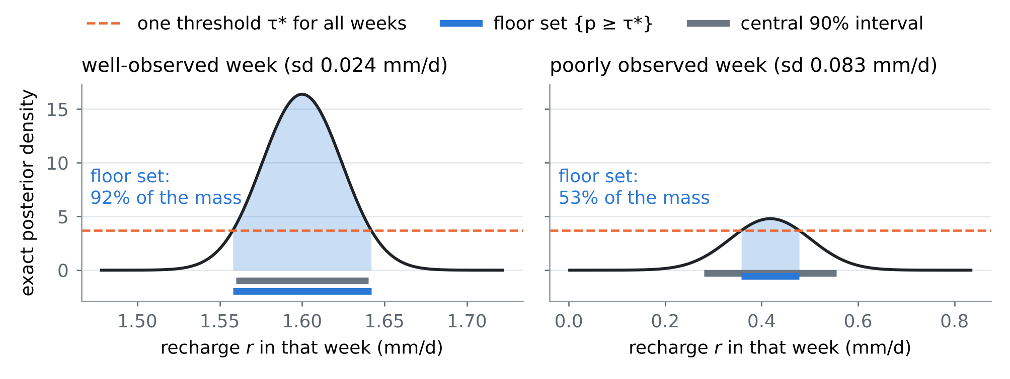
Figure 2. The floor in one field case: the exact posterior of the recharge in a well-observed and in a poorly observed week, the one threshold $τ^{⋆}$ of (1) (dashed), the floor sets (blue) and the central 90% intervals (grey). The floor spends coverage where it is cheap: the narrow posterior gets more than 90% of its mass, the wide one less.
4.2 Guarantees
Proposition F1 (the floor of every valid band). For every band procedure $C$ with $R\left(C\right)≤α$ under $Q$, 12Tw​EQCw≥W⋆, with equality for the sets (1). The floor depends only on $Q$, the design and $α$.

Proof. Fix $y$ and $w$, write $p=p_{w}\left(⋅∣y\right)$ and $A^{⋆}=A_{w}^{τ^{⋆}}\left(y\right)$. For any set $C$, C​τ⋆−p dx≥C∩A⋆​τ⋆−p dx≥A⋆​τ⋆−p dx, because the integrand is non-negative outside $A^{⋆}$ and non-positive on it. So $τ^{⋆}\left|C\right|−P\left(C∣y\right)≥τ^{⋆}\left|A^{⋆}\right|−P\left(A^{⋆}∣y\right)$. Anchors, simulations and randomisation are independent of the field truth given $y$, so the inequality holds for $C_{w}$ and can be averaged over them, over $y$ and over $w$: $τ^{⋆} E\left|C\right|≥τ^{⋆} E\left|A^{⋆}\right|+\left(1−R\left(C\right)\right)−\left(1−α\right)≥τ^{⋆} E\left|A^{⋆}\right|$. □
Proposition F2 (where the excess width comes from). The identity (2) holds for every calibrated band. Its last factor is at least 1, and so is the product of its last two factors; the first measures the calibration and tends to 1 as the number of calibration cases grows.

Proof. The exact-posterior band with $λ_{σ}^{⋆}$ and the reconstructor band with $λ_{s}^{⋆}$ both have risk exactly $α$, so Proposition F1 applies to each. The first factor is a ratio of an empirical to a population quantile of the same scores. □
Proposition F3 (what data can and cannot buy). (i) Adding observations never raises the floor. (ii) With rain alone, the floors of the sea level and of the inland inflow equal their prior floors: no method, however clever, can narrow those bands without heads or a gauge. (iii) The floor of a design can be computed before any field data exist, from the law and the design alone.

Proof. (i) A procedure that ignores the extra observations is a valid procedure of the larger design, so the minimum over the larger class is no larger (a Blackwell-type comparison). (ii) In the test bed the rain enters only the recharge; without heads the posterior of the sea level and of the inflow is their prior. (iii) (1) involves only expectations under $Q$. □
Proposition F4 (Rao–Blackwellised risk). For any band $C$, RC=1Tw​EQPrQxw∉Cw∣y. Replacing each field truth by draws from its exact posterior gives an unbiased estimate of $R\left(C\right)$ whose variance is no larger than that of the estimate from the truths.

Proof. The first statement is the tower property. Averaging the indicator over posterior draws estimates the conditional probability without bias, and $Var\left(E\left[X∣y\right]\right)≤Var\left(X\right)$ for the indicator $X$ of a miss. All population multipliers $λ^{⋆}$ below use 40 draws per week and field case. □
What is new. (1) A computable floor for guaranteed bands of boundary conditions and of the recharge coefficient from rain and a few heads: the width that no valid method can beat (Propositions F1, F3). (2) An exact decomposition of the excess width of a calibrated band into band shape, reconstructor and calibration (Proposition F2), measured with Rao–Blackwellised risks (Proposition F4). (3) The test that shows where the width of the earlier bands goes, and that putting a structural unknown (the vadose delay) into the simulator brings a valid band close to the floor. To our knowledge none of these appears in the one hundred and twenty papers of reviews I–VI.

4.3 Tests
T18: the floor without shift. Figure 3 and Table 2. The central 90% posterior interval is 1.00–1.04 times the floor: in this test bed the exact posterior is close to Gaussian with a spread that varies little between weeks, so the band shape costs little (1.01–1.05 for the exact posterior mean $±λσ$). The ensemble reconstructor costs 1.13–1.39: 128 members estimate the posterior spread, and above all the spread of $κ$, with error. Calibration costs nothing with 300 simulations (0.99–1.02) and 1.10–1.17 with 20 anchors. The enlarged law costs little when the delay is in fact the simulator's (1.01–1.05 times the floor with $λ$ known, 1.11–1.20 with 20 anchors).
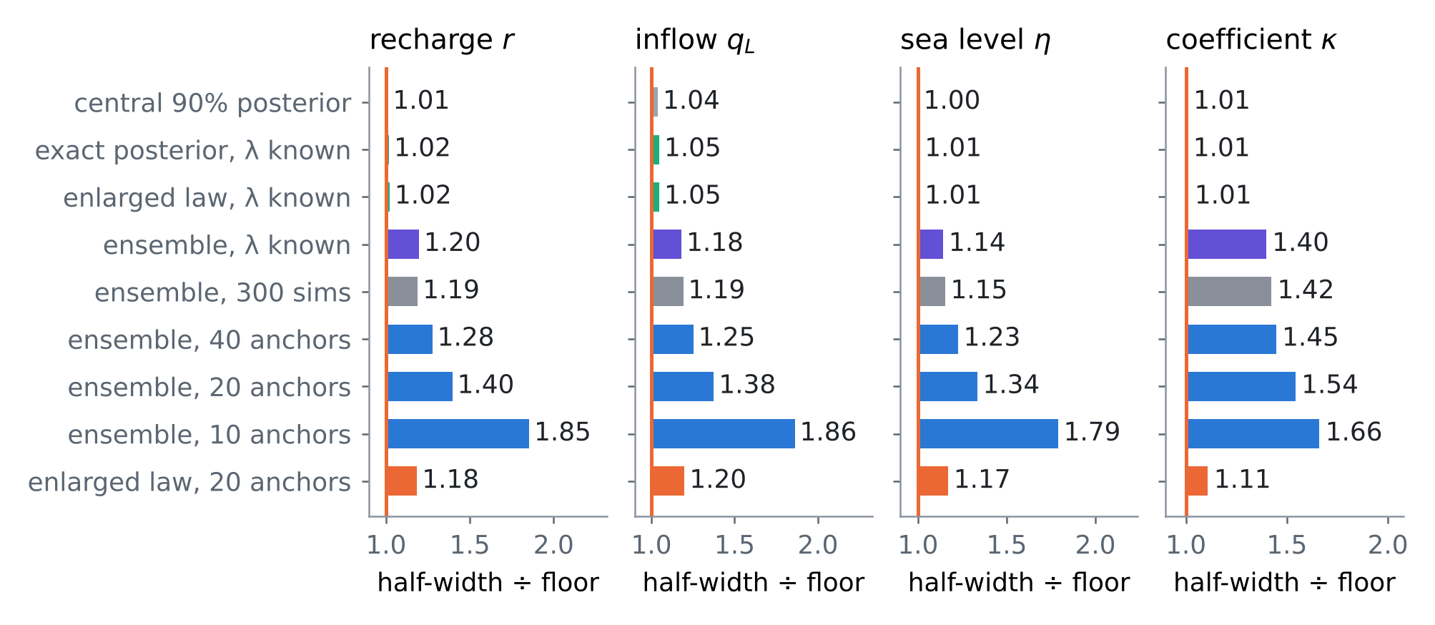
Figure 3. T18: half-width of each band divided by the floor $W^{⋆}$ of (1), without shift (real law = simulator's law), for the four goals. "λ known" means the population multiplier, computed with Rao–Blackwellised risk; the anchor and simulation bands are calibrated as in reviews I and IV.
Table 2. T18: the floor (mean half-width; recharge mm/d, inflow m²/d, sea level m, κ dimensionless) and every band as a multiple of it, without shift.
Band | Recharge r | Inflow qL | Sea level η | Coefficient κ
Floor W* | 0.0439 | 0.0548 | 0.0324 | 0.0177
Central 90% | 1.01 | 1.04 | 1.00 | 1.01
Exact, λ known | 1.02 | 1.05 | 1.01 | 1.01
Enlarged, λ known | 1.02 | 1.05 | 1.01 | 1.01
Ensemble, λ known | 1.20 | 1.18 | 1.14 | 1.40
Ensemble, 300 sims | 1.19 | 1.19 | 1.15 | 1.42
Ensemble, 40 anchors | 1.28 | 1.25 | 1.23 | 1.45
Ensemble, 20 anchors | 1.40 | 1.38 | 1.34 | 1.54
Ensemble, 10 anchors | 1.85 | 1.86 | 1.79 | 1.66
Enlarged, 20 anchors | 1.18 | 1.20 | 1.17 | 1.11

T19: the floor under shift. Figure 4. The floor is that of the real law: it knows the 35-day delay or the shifted parameters. Under the delay the ensemble band calibrated on anchors is valid but 1.66–5.83 times the floor, because its reconstructor misplaces the timing of recharge. The exact posterior under the simulator's law, calibrated on anchors, repairs the inflow and the sea level (1.21–1.24) but not the recharge and $κ$ (3.30 and 6.50): exact inference in the wrong structure is still wrong. The enlarged law removes most of the gap (1.18–1.34), and its simulation calibration becomes valid again because the 35-day delay lies inside its prior (risk 0.066–0.099, against 0.18–0.83 for the ensemble calibrated on simulations). Under shifted parameters, which the enlarged law does not contain, its simulation calibration is not repaired (risk 0.100–0.176, above 0.10 for 3 of the 4 goals), while the anchor bands stay valid at 1.39–1.77 (ensemble) and 1.17–1.27 (enlarged law) times the floor; here the exact posterior under the simulator's law is already close (1.17–1.26): a wrong prior costs little once anchors recalibrate, a wrong structure costs a lot. Every calibrated band narrower than the floor was invalid, as Proposition F1 requires (6 cases, all calibrated on simulations).
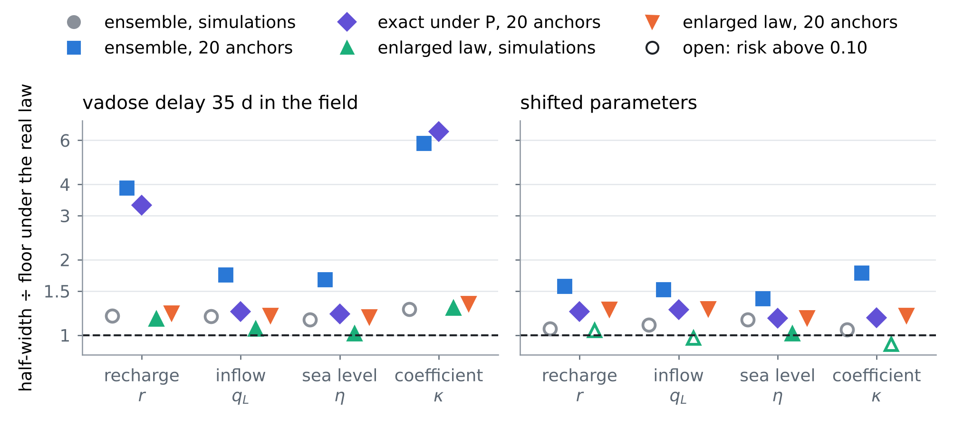
Figure 4. T19: half-width divided by the floor of the real law, under the 35-day delay (left) and shifted parameters (right). Filled markers have risk at most 0.10 (Rao–Blackwellised for the simulation calibrations); open markers are invalid bands.
T20: what the data can buy at best. Figure 5. The floor falls as loggers are added, as Proposition F3 requires. With rain alone the sea-level and inflow floors are the prior widths; four loggers remove 82% and 94% of them, eight 84% and 97%, and a tide gauge with four loggers 94% for the sea level. For the recharge and $κ$, which the rain already informs through the recharge coefficient, four loggers remove 92% and 88%. The 20-anchor band follows the floor at 1.13–1.52 times its width across the six designs, and the ratio grows with the data, from 1.13–1.28 with rain alone to 1.38–1.52 with eight loggers: the more the data say, the more the ensemble leaves unused. The floor never rose when observations were added (Proposition F3), but the guaranteed band did in 7 of 24 nested comparisons: with one logger at 2 km the sea-level band widened from 0.219 to 0.237 m while its floor fell from 0.184 to 0.181 m. That is the negative guaranteed value of review II seen from the floor: the data carried a little information, but the reconstructor turned it into a worse-shaped band, and the floor shows that the loss is the method's, not the instrument's.
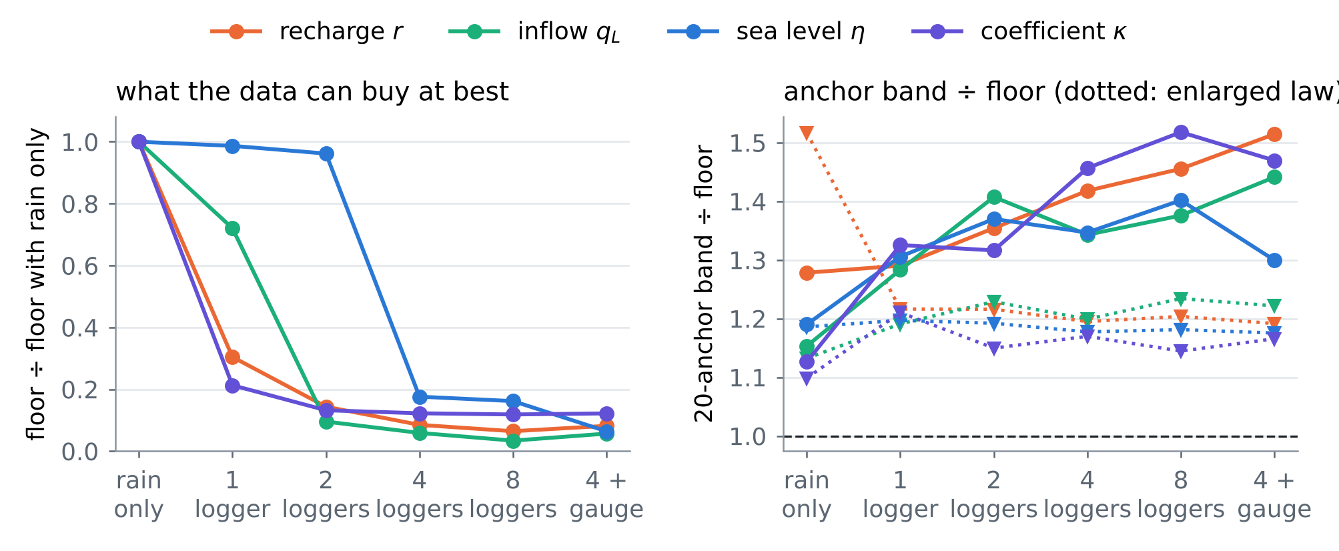
Figure 5. T20: the floor of six designs relative to rain alone (left), and the 20-anchor band divided by the floor (right; dotted: the enlarged law). No shift.
4.4 Using the floor at Fushë-Kuqe
• Before buying an instrument: compute the floor of each candidate design under the working law; an instrument that does not lower the floor cannot lower any guaranteed band (Proposition F3).
• When reporting a band: report its ratio to the floor. A ratio near 1 means the data are exhausted; a large ratio means the reconstructor or the model structure, not the data, limits the band (Proposition F2).
• Where to invest: in this test bed the structural unknown (the vadose delay) is worth more than more anchors or more ensemble members; for Fushë-Kuqe the candidate structural unknowns are the vadose delay, the inland-inflow regime and the rain bias, whose plausible ranges are to be set with the local hydrogeologists.
• Caveat: the floor is computed under a working law; it is a design and diagnostic tool. The guarantee in the field still comes from the anchors (review IV) and the horizon matching (review V).
5. Synthesis: one hundred and twenty papers in one procedure
Table 3 places the hundred and twenty papers of reviews I–VI on the steps of the procedure. Card numbers carry the review: I-O1 is card O1 of review I, VI-C2 card C2 of this review. Review VI adds the measure of how good a guarantee is: its distance from the floor.
Table 3. The one hundred and twenty papers of reviews I–VI against the steps of the procedure (card numbers of each review; a paper can serve several steps).
Step | I | II | III | IV | V | VI
prior from rain | O3, O5, C5, M1 | O1, O2, O5, C1, C2, C3, C4, B1, B4, M2, M5 | O1, O2, O3, O4, O5, C1, C2, C3, C4, C5, B1, B2, B3, B4, B5, M1, M2, M3 | O2, O5, C5, B3, B5 | O4, C1, C2, C4, B3, B4, B5, M3, M4, M5 | –
emulate | O1, O3, C1, B1 | C1, B5, M2 | C3, M4 | O1, O3, O4, C1, M4 | – | C4, B5, M2, M3, M5
invert | O1, O2, C2, C3, C4, B1 | O1, O2, O4, C4 | B1 | O4, C2, B2, M3 | B2 | O2, O3, C1, C3, B2, M1, M2, M3, M5
guarantee | O4, C1, B2, B3, B5, M2, M3 | O2, M1, M4 | C2, B5, M5 | O1, O3, C1, C2, C4, B1, B2, B3, B4, M1, M2 | O1, O2, O4, C3, C5, B1, B2, B4, M1, M2 | O1, O5, C1, C2, B1, B2, B3, B4, B5
field check | B2, B4, M4, M5 | C3, B1, B2, M3, M4 | O2, O4, C4, C5, B2, M1, M2, M4, M5 | O2, O4, C1, C3, C4, C5, B1, M3, M5 | O2, O3, O5, C1, C3, C4, B5, M3, M4 | O1, C3, B4
design, operate | O5, C5, M4 | O3, O4, C1, C2, C3, C5, B2, B3, B4, M1, M3 | C1, B4, M3 | B5, M1 | C5 | O2, O3, O4, C4, C5, M4

Order of work. (1) Build the simulated aquifers from the rain, with the rain product's errors (RESHJA-GO), and with every structural unknown that can be named (here the vadose delay) as a random quantity of the law. (2) Compute the floor of each candidate design (DYSHEMEJA-GO) and choose instruments by guaranteed value (MATJA-GO). (3) Use the exact posterior where the model allows it, the ensemble where it does not. (4) Calibrate on real anchors (ANKORA-GO), horizon-matched when the law drifts (PRIRJA-GO). (5) Report the band, its ratio to the floor, and the simulation-calibrated band alongside (GARANCIA-GO).
6. Limitations
• Every card but B3 (whose proceedings PDF was read) is partly verified: landing pages, and the exact wording of the theorems, were reached through search results only.
• The floor is that of the working law; under a law outside the model it is not known, and only the anchors protect the guarantee.
• The floor is for the average risk over weeks and cases (marginal coverage). Floors for conditional coverage, week by week, are higher and are not computed here.
• Dispersion does not enter the test bed of these reviews; the floor of a dispersivity or transition-zone band needs the transport model of review I and is left for the next step.
• The tests use the linear one-dimensional test bed of reviews I–V, two shifts and six designs.
References
Anchors (provided by the user)
[A1] Angelopoulos, A. N., Bates, S., Fisch, A., Lei, L., & Schuster, T. (2024). Conformal risk control. The Twelfth International Conference on Learning Representations (ICLR 2024). arXiv:2208.02814 (PDF provided by the user). https://arxiv.org/abs/2208.02814
[A2] Tibshirani, R. (2023). Conformal prediction. Lecture notes, Advanced Topics in Statistical Learning, Spring 2023, University of California, Berkeley (PDF provided by the user). https://www.stat.berkeley.edu/~ryantibs/statlearn-s23/
The twenty papers of this review
[O1] Guneet S. Dhillon, George Deligiannidis, Tom Rainforth (2024). On the expected size of conformal prediction sets. Proceedings of the 27th International Conference on Artificial Intelligence and Statistics (AISTATS 2024), PMLR 238, 1549–1557. https://proceedings.mlr.press/v238/dhillon24a.html
[O2] Adrian Mag, Christophe Zaroli, Paula Koelemeijer (2025). Bridging the gap between SOLA and deterministic linear inferences in the context of seismic tomography. Geophysical Journal International 242(1), ggaf131 (2025). https://doi.org/10.1093/gji/ggaf131
[O3] Luis D. Couto, Ross Drummond, Dong Zhang, Toby Kirk, David A. Howey (2022). Identifiability of lithium-ion battery electrolyte dynamics. 2022 American Control Conference (ACC), 1087–1093. https://doi.org/10.23919/ACC53348.2022.9867154
[O4] Taejun Park, Yuji Nakatsukasa (2025). Accuracy and stability of CUR decompositions with oversampling. SIAM Journal on Matrix Analysis and Applications 46(1), 780–810 (2025). https://doi.org/10.1137/24M1660346
[O5] Niall O'Sullivan, Licio Romao, Kostas Margellos (2025). Bridging conformal prediction and scenario optimization. arXiv:2503.23561 (preprint, 2025). https://arxiv.org/abs/2503.23561
[C1] Pau Batlle, Pratik Patil, Michael Stanley, Houman Owhadi, Mikael Kuusela (2023). Optimization-based frequentist confidence intervals for functionals in constrained inverse problems: resolving the Burrus conjecture. arXiv:2310.02461 (preprint, 2023; revised 2024). https://arxiv.org/abs/2310.02461
[C2] Pau Batlle, Pratik Patil, Michael Stanley, Javier Ruiz Lupon, Houman Owhadi, Mikael Kuusela (2025). Simultaneous frequentist calibration of confidence regions for multiple functionals in constrained inverse problems. arXiv:2510.11708 (preprint, 2025). https://arxiv.org/abs/2510.11708
[C3] Alfredo Garbuno-Iñigo, Tapio Helin, Franca Hoffmann, Bamdad Hosseini (2023). Bayesian posterior perturbation analysis with integral probability metrics. arXiv:2303.01512 (preprint, 2023). https://arxiv.org/abs/2303.01512v1
[C4] Per-Gunnar Martinsson, Joel A. Tropp (2020). Randomized numerical linear algebra: foundations and algorithms. Acta Numerica 29, 403–572 (2020). https://doi.org/10.1017/S0962492920000021
[C5] Yifan Chen, Thomas Y. Hou (2022). Multiscale elliptic PDE upscaling and function approximation via subsampled data. Multiscale Modeling & Simulation 20(1), 188–219 (2022). https://doi.org/10.1137/20M1372214
[B1] Ryan J. Tibshirani, Rina Foygel Barber, Aaditya Ramdas (2026). Conformal prediction through the lens of hypothesis testing: universality, impossibility, and optimality. arXiv:2608.27310 (preprint, 2026). https://arxiv.org/abs/2608.27310
[B2] Reese Pathak, Martin J. Wainwright, Lin Xiao (2024). Noisy recovery from random linear observations: sharp minimax rates under elliptical constraints. The Annals of Statistics 52(6), 2816–2850 (2024); arXiv:2303.12613. https://doi.org/10.1214/24-AOS2446
[B3] Vincent Blot, Anastasios N. Angelopoulos, Michael I. Jordan, Nicolas J-B. Brunel (2025). Automatically adaptive conformal risk control. Proceedings of the 28th International Conference on Artificial Intelligence and Statistics (AISTATS 2025), PMLR 258, 19–27; arXiv:2406.17819. https://proceedings.mlr.press/v258/blot25a.html
[B4] Tijana Zrnic, William Fithian (2024). Locally simultaneous inference. The Annals of Statistics 52, 1227–1253 (2024); arXiv:2212.09009. https://doi.org/10.1214/24-AOS2391
[B5] Lars van der Laan, Ahmed M. Alaa (2024). Self-calibrating conformal prediction. Advances in Neural Information Processing Systems 37 (NeurIPS 2024); arXiv:2402.07307. https://proceedings.neurips.cc/paper_files/paper/2024/hash/c1c49aba08e6c90f2b1f85751f497a2f-Abstract.html
[M1] Anya Katsevich (2025). Improved dimension dependence in the Bernstein–von Mises theorem via a new Laplace approximation bound. Information and Inference: A Journal of the IMA 14, iaaf020 (2025); arXiv:2308.06899. https://arxiv.org/abs/2308.06899
[M2] Anya Katsevich, Philippe Rigollet (2024). On the approximation accuracy of Gaussian variational inference. The Annals of Statistics 52, 1384–1409 (2024); arXiv:2301.02168. https://arxiv.org/abs/2301.02168
[M3] Matthew T. C. Li, Tiangang Cui, Fengyi Li, Youssef Marzouk, Olivier Zahm (2025). Sharp detection of low-dimensional structure in probability measures via dimensional logarithmic Sobolev inequalities. Information and Inference: A Journal of the IMA (2025), iaaf021; arXiv:2406.13036. https://doi.org/10.1093/imaiai/iaaf021
[M4] Fengyi Li, Ayoub Belhadji, Youssef Marzouk (2024). Nonlinear Bayesian optimal experimental design using logarithmic Sobolev inequalities. arXiv:2402.15053 (preprint, 2024). https://arxiv.org/abs/2402.15053
[M5] Jakob Zech, Youssef Marzouk (2022). Sparse approximation of triangular transports, part I: the finite-dimensional case. Constructive Approximation (2022); arXiv:2006.06994. https://doi.org/10.1007/s00365-022-09569-2
Data and project documents
[D1] Zeqiraj, D. (2026). Inputs, dispersion and boundary conditions from rain alone; GARANCIA-GO ("review I"), docs/literature/ in this repository.
[D2] Zeqiraj, D. (2026). State of the art II; MATJA-GO, the guaranteed value of a measurement ("review II"), docs/literature/ in this repository.
[D3] Zeqiraj, D. (2026). State of the art III: when the rain itself is uncertain; RESHJA-GO ("review III"), docs/literature/ in this repository.
[D4] Zeqiraj, D. (2026). State of the art IV: when the simulator is wrong; ANKORA-GO ("review IV"), docs/literature/ in this repository (Proposition A3 corrected on 5 November 2026).
[D5] Zeqiraj, D. (2026). State of the art V: when the world drifts; PRIRJA-GO ("review V"), docs/literature/ in this repository.
[D6] Internal documents of the project: RINDËRTIMI-GO (test bed, ensemble smoother with the exact solver, exact posterior); the code of this review in experiments/dyshemeja_go/.
Verification note. The bibliographic data of the twenty cards come from search results that quote the publisher, arXiv, proceedings or repository pages; doi.org, arxiv.org, openreview.net and most publisher hosts could not be opened directly in this environment. The anchors were read from the PDFs provided. Every number of Sections 1, 2 and 4 is computed by the code in experiments/dyshemeja_go/, experiments/ankora_go/ and experiments/garancia_go/.

