INTRODUCTION · THE PROBLEM THE SERIES ANSWERS
The problem: a safe coastal water supply under deep uncertainty
CLASSICAL one model · a head target · decide, then measure
NEW the chloride standard · every belief · decide and measure together

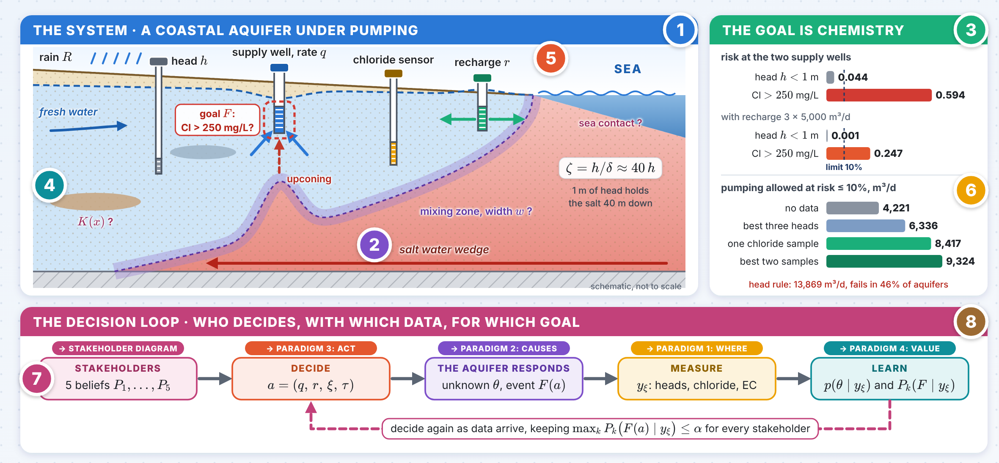
The numbers 1–8 in the picture point to the eight panels on the next pages; the innovation follows on the next page.

INNOVATION One goal event, one rule for everyone
The problem is stated on the event that matters, the drinking-water standard in the screen, and on every stakeholder’s belief, not on a head target and one model.
1 The problem in one line
$$\max_{a, ξ} E\left[W\left(a\right)\right] \text{s.t.} \max_{k} P_{k}\left(F\left(a\right)∣y_{ξ}\right)≤α$$
$W$: water delivered minus the cost of recharge and data; $P_{k}$: the belief of stakeholder $k$; $α=10\%$. Pumping, recharge, monitoring and the alarm are chosen together, for one event.
≤ 10% risk for everyone
2 Chemistry, not head, and still linear
{Clw>250}={φw<φw⋆}, φwa=φw0+j​Gwj aj
The potential is linear in every rate, so the chloride goal keeps the cheap structure of a head target, with a random threshold. Same aquifers, same pumping: the head says 0.044, chloride 0.594; with recharge the head says 0.001, chloride 0.247.
×13.5 risk the head misses
3 Measure what the goal needs
$$I\left(F;{Cl}_{\text{1 sample}}\right)=0.312 ≫ maxI\left(F;h_{1,2,3}\right)=0.089 \text{nats}$$
One shallow chloride sample tells more about the event than any three heads. It doubles the pumping allowed at 10% risk, from 4,221 to 8,417 m³/d.
×2.0 safe pumping
Test bed: 20,000 draws of a calibrated coastal-aquifer model, two supply wells, each pumped to a 50% own risk. The diagrams that follow answer the questions this one raises.

The problem · panels 1–4
1 Flow: fresh water floats on the sea  IDEA Fresh water flows to the sea above denser sea water. Pressure and density together drive the flow.  $$q=−\frac{k}{μ}\left(∇p+ρg ∇z\right), \frac{∂\left(nρ\right)}{∂t}+∇⋅\left(ρ q\right)=ρ Q$$  $$ζ=\frac{h}{δ}, δ=\frac{ρ_{s}−ρ_{f}}{ρ_{f}}≈0.025 ⇒ ζ≈40 h$$  WHY IT IS HARD Density couples flow to salt. One metre of fresh head at the coast holds the interface about 40 m down, so a small drawdown near a well lets the salt rise beneath the screen (upconing). The response is nonlinear and slow. |  | 2 Salt: transport and mixing  IDEA Salt moves with the water and spreads by dispersion: the mixing zone reaches the screen first.  $$\frac{∂\left(nC\right)}{∂t}+∇⋅\left(q C\right)−∇⋅\left(n D ∇C\right)=Q C_{in}$$  $$D=α_{T}\left|v\right| I+\left(α_{L}−α_{T}\right)\frac{v v^{⊤}}{\left|v\right|}+D_{m}I$$  TEST BED Chloride passes 250 mg/L at 1.09% sea water, sodium only at 1.50%. The sea contact is uncertain too: the intruded area at the prior mean is 92.7 km² with the whole shoreline open, 10.1 km² with the mapped contact.
3 The goal is chemistry in the screen  IDEA The event that matters is the drinking-water standard in the well screen. Chloride there falls as the potential rises, so the event is a threshold.  $$F\left(a\right)=\{{Cl}_{w}\left(a\right)>250 mg/L\}=\{φ_{w}\left(a\right)<φ_{w}^{⋆}\}$$  $${Cl}_{w}={Cl}_{f}+{\overset{‾}{c}}_{w}\left({Cl}_{s}−{Cl}_{f}\right), c\left(z\right)=Φ\left(\frac{z−ζ}{w}\right)$$  TEST BED With each well pumped to a 50% own risk, $P\left(h<1 m\right)=0.044$ but $P\left(Cl>250\right)=0.594$. The threshold $φ^{⋆}$ follows the width of the mixing zone (rank correlation 0.99997), not the potential at the well (0.011). |  | 4 What we do not know  IDEA Parameters, boundaries, the weather to come and the people who pump: each is uncertain, and only some can be measured.  $$θ=\left(logK\left(x\right), R, w, B, {Cl}_{s}, \text{sea contact}\right)∼p\left(θ\right)$$  ωi∝pdobs∣θi, ESS=i​ωi2i​ωi2  TEST BED 20,000 prior aquifers weighted by the documented facts keep an effective 3,249: the facts narrow the uncertainty but do not remove it. Beyond the parameters: wet and dry years, and pumping that departs from the plan.

The problem · panels 5–8
5 The decisions  IDEA Four levers: how much to pump and where, where to recharge, where to measure, and when to raise the alarm.  $$a=\left(q_{1},…,q_{m}; r_{1},…,r_{n}; ξ; τ\right)$$  $$q^{max}\left(y_{ξ}\right)=max\left\{q: P\left(F\left(q\right)∣y_{ξ}\right)≤α\right\}$$  TEST BED Recharge of 3 × 5,000 m³/d at sites chosen for chemistry lowers the risk from 0.594 to 0.247 (0.270 at sites chosen for the head, where the head itself reports 0.000). Reaching 10% needs 8,516 m³/d per site. |  | 6 Which data inform the goal  IDEA A measurement is worth what it tells about the event $F$ (entropy $H\left(F\right)=0.669$ nats), not about the parameters in general.  $$EIG\left(ξ\right)=I\left(F;y_{ξ}\right)=H\left(F\right)−E_{y_{ξ}}\left[H\left(F∣y_{ξ}\right)\right]$$  $$I\left(F;{Cl}_{1}\right)=0.312 \text{vs} I\left(F;h_{1,2,3}\right)≤0.089$$  TEST BED Pumping allowed at 10% posterior risk (20 m screens): 4,221 m³/d without data, 6,336 with the best three heads, 8,417 with one chloride sample, 9,324 with the best two. The head rule pumps 13,869 and fails the standard in 46% of aquifers.
7 Stakeholders: one aquifer, five beliefs  IDEA Utility, irrigators and hotels, municipality, water agency, environmental groups: one aquifer, five beliefs.  $$p_{k}\left(θ∣y\right) ∝ p\left(θ∣y\right) e^{λ_{k}^{⊤}z\left(θ\right)}$$  $$a \text{acceptable}⇔\max_{k}P_{k}\left(F\left(a\right)∣y_{ξ}\right)≤α$$  TEST BED The same plan carries a risk of 0.37 for the utility, 0.15 for irrigators and hotels, 0.43 for the municipality, 0.57 for the agency and 0.63 for environmental groups. At half the pumping, one chloride sample cuts the disagreement from 0.224 to 0.038. |  | 8 This series: one question per diagram  IDEA Each step of the loop is a machine-learning question with its own diagram.  $$ξ → y_{ξ} → p\left(θ∣y_{ξ}\right) → a → F\left(a\right)$$  $$a_{t+1}=π\left(p\left(θ∣y_{1:t}\right)\right), \max_{k}P_{k}\left(F\right)≤α$$  IN THIS SERIES 1 Robust design: where to measure when the noise model is uncertain. 2 Causal models: which process made the salt. 3 Deep RL: how many years of data a pumping policy needs. 4 Value of data without a prior. Stakeholders: a choice nobody can veto.

