DECISION UNDER DEEP UNCERTAINTY · STAKEHOLDERS DECIDING TOGETHER
Stakeholders deciding together: no veto, for every belief and every weather
CLASSICAL one model · average belief · decide in the crisis
NEW unanimous rule · belief radius · plans agreed before

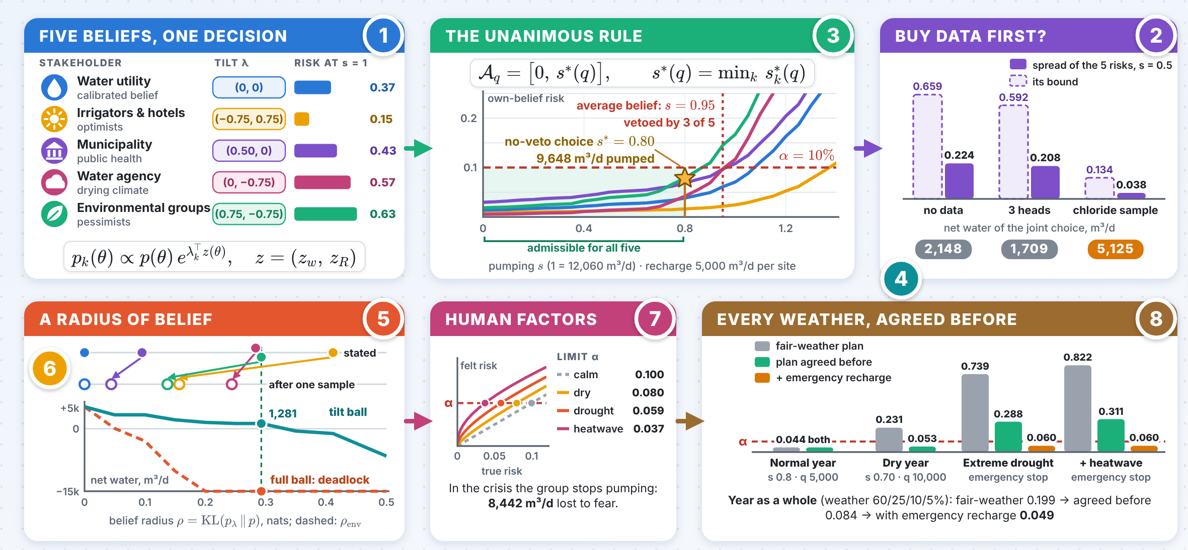
The numbers 1–8 in the picture point to the eight panels on the next pages; the innovation follows on the next page.

INNOVATION A decision nobody can veto
One rule for five beliefs, every belief within a radius, and every weather.
1 Unanimous and still decisive
$${\hat{P}}_{k}\left(F∣y,a\right)+1.645 {\hat{σ}}_{k}≤α ∀k ⇒ A_{q}=\left[0, \min_{k}s_{k}^{⋆}\left(q\right)\right]$$
Without data the group pumps 9,648 m³/d with 15,000 m³/d of recharge; the average-belief rule takes more but is vetoed by 3.0 of 5. One chloride sample, safe for all, lifts net water from 2,148 to 5,125 m³/d.
5,125 net m³/d, one sample
2 Every belief within a radius, not a list
$$\max_{λ: KL\left(p_{λ}∥p\right)≤ρ}P_{λ}\left(F\right)=P\left(F\right)+\sqrt{2ρ c^{⊤}S^{−1}c}+O\left(ρ\right)$$
Beliefs nobody stated push the risk of the stated-list choice to 0.119; the tilt ball at the pessimists’ radius keeps all 416 unstated beliefs at or below 0.089, while the full ball deadlocks.
0.119 → 0.089 worst unstated risk
3 One rule for every weather, agreed before
$$\overline{P}\left(s\right)≤P\left(s\left(1+e_{β}\right)\right)+β, α_{γ}=e^{−{\left(−logα\right)}^{1/γ}}$$
In a dry year the fair-weather plan fails (risk 0.231) and the plan agreed before holds (0.053); decided in the crisis, fear costs 8,442 m³/d. Over a whole year: 0.199 → 0.084 → 0.049.
0.231 → 0.053 dry-year risk

Stakeholders deciding together · panels 1–4
1 Beliefs as tilts of one calibration  IDEA All share the physics and the data model but dispute two drivers, the mixing-zone width and the recharge; each belief tilts the calibrated posterior.  $$p_{k}\left(θ\right)∝p\left(θ\right) e^{λ_{k}^{⊤}z\left(θ\right)}, z=\left(z_{w}, z_{R}\right)$$  $$p_{k}\left(θ∣y\right)∝p_{k}\left(θ\right) L\left(y∣θ\right)$$  2020–2026 Two sets of priors rank acts cautiously and incompletely (Echenique, Miyashita, Nakamura, Pomatto & Vinson 2022); exact Bayesian reasoning in a group is computationally hard (Hązła, Jadbabaie, Mossel & Rahimian 2021). |  | 2 Which data end a dispute  IDEA Two risks can differ only as much as the data leave both the disputed drivers and the failure event uncertain. Resolving the event is the cheap way.  $$\left|P_{k}\left(F∣y\right)−P_{j}\left(F∣y\right)\right|≤\max_{t} σ_{t}\left(Δλ^{⊤}z\right) σ_{t}\left(1_{F}\right)$$  $$≤\frac{1}{2}\max_{t} σ_{t}\left(Δλ^{⊤}z\right), σ_{t}={sd}_{t}\left(⋅∣y\right)$$  2020–2026 At pumping 0.5 the spread is 0.224 with no data, 0.208 with three heads and 0.038 with one chloride sample (bound 0.659 → 0.134). Which data enable optimal decisions (Bennouna, Bennouna, Amin & Ozdaglar 2025); pathwise concentration of beliefs (Fudenberg, Lanzani & Strack 2023).
3 One action nobody can veto  IDEA Failure is monotone in pumping and recharge, so each stakeholder accepts an interval of pumping; the group takes the top of the shortest one.  $${\hat{P}}_{k}\left(F∣y,a\right)+1.645 {\hat{σ}}_{k}\left(y,a\right)≤α ∀k$$  $$A_{q}=\left[0, s^{⋆}\left(q\right)\right], s^{⋆}\left(q\right)=\min_{k}s_{k}^{⋆}\left(q\right)$$  2020–2026 No data: pump 9,648 m³/d, recharge 15,000. Distributionally robust chance constraints (Coulson, Lygeros & Dörfler 2022); certified deviations from an equilibrium (Pantazis, Fele & Margellos 2024); equitable voting rules (Bartholdi, Hann-Caruthers, Josyula, Tamuz & Yariv 2021). |  | 4 Information that is safe to buy  IDEA Under the unanimous rule no stakeholder, judged by its own belief, takes more than the agreed risk when the group buys data first, whatever the data say.  $$P_{k}\left(F\left(a^{⋆}\left(Y\right)\right)\right)=E_{k}\left[P_{k}(F∣Y,a^{⋆}\left(Y\right))\right]≤α$$  $${VOI}_{k}=E_{k}\left[net\left(a^{⋆}\left(Y\right)\right)\right]−net\left(a_{⌀}^{⋆}\right)$$  2020–2026 One chloride sample is worth +2,977, +5,351, +1,554, +1,854 and −729 m³/d to the five; the last group loses water but its risk falls from 0.094 to 0.026. Information design in coordination games (Morris, Oyama & Takahashi 2024); costly information in committees (Gersbach, Mamageishvili & Tejada 2022).

Stakeholders deciding together · panels 5–8
5 A radius instead of a list  IDEA Protect every belief within a relative-entropy radius $ρ$ of the calibration, agreed before the data.  $$\max_{KL\left(q∥p\right)≤ρ}q\left(F\right)={kl}_{\text{+}}^{−1}\left(p\left(F\right),ρ\right)$$  $$\max_{B\left(ρ\right)}P_{λ}\left(F\right)=P\left(F\right)+\sqrt{2ρ c^{⊤}S^{−1}c}+O\left(ρ\right)$$  2020–2026 The full ball is the plain rule with limit $α_{ρ}$ (0.002 at $ρ=0.293$) and deadlocks; tilts pay for the failure the drivers explain ($R^{2}=0.072$). Relative-entropy robustness is optimal (Van Parys, Mohajerin Esfahani & Kuhn 2021) and Pareto-dominant (Sutter, Van Parys & Kuhn 2024). |  | 6 Bayes shrinks the radius  IDEA Tilts commute with Bayes’ rule: a tilted prior gives the same tilt of the calibrated posterior, with a radius that shrinks as data narrow the drivers.  $$p_{λ}\left(θ∣y\right)∝p\left(θ∣y\right) e^{λ^{⊤}z\left(θ\right)}$$  $$KL\left(p_{λ}\left(⋅∣y\right) ∥ p\left(⋅∣y\right)\right)≈\frac{1}{2}λ^{⊤}Cov\left(z∣y\right) λ$$  2020–2026 One sample shrinks the radii to medians 0.157, 0.044, 0.244 and 0.137 nats, yet in 20% of truths some belief within $ρ_{env}$ finds the stated-list choice unsafe; the tilt ball covers all for 3,981 m³/d. Guarantees for uncertainty sets (Bertsimas, den Hertog & Pauphilet 2021).
7 Overshoot and felt risk  IDEA Operators pump more than licensed and crises distort felt risk; both become a smaller licence or a tighter limit, so the rule stays decisive.  $$\overline{P}\left(s\right)≤P\left(s\left(1+e_{β}\right)\right)+β$$  $$α_{γ}=exp​\left(−{\left(−logα\right)}^{1/γ}\right)=0.080, 0.059, 0.037$$  2020–2026 Prelec weighting at $γ=0.9,0.8,0.7$. Probability weighting is optimal under finite precision (Juechems, Balaguer, Spitzer & Summerfield 2021); risk attitudes from noisy magnitude coding (Barretto-García, de Hollander, Grueschow, Polanía, Woodford & Ruff 2023); salience (Li & Camerer 2022). |  | 8 Every weather, agreed before  IDEA Agree a plan per weather regime before it comes; objective triggers switch plans, and an emergency stop is safe only if the recharge factor $f_{R}$ is above $f^{⋆}$.  Pk=r​πrr′​Mr′∣r Pk,rar′  $$f_{R}≥f^{⋆}=\max_{k} Q_{1−α}^{\left(k\right)}\left(f_{θ}\left(q,E\right)\right)$$  2020–2026 Triggers should err towards severity; $f^{⋆}$ = 1.011 with no recharge, 0.781–0.813 with 5,000 m³/d per site. Decision rules with indicators (Murgatroyd & Hall 2021); record-shattering extremes (Fischer, Sippel & Knutti 2021); predictive safety filters (Wabersich & Zeilinger 2023).

