POLYTECHNIC UNIVERSITY OF TIRANA
Faculty of Geology and Mining — Department of Energy Resources
Rain, infiltration and soil moisture from groundwater levels
What an inverse problem can and cannot recover, which data remove each ambiguity, and how to do it at a coastal plain: propositions with proofs and a synthetic Bayesian inversion (INFILTRIMI-GO)
D. Zeqiraj, Faculty of Geology and Mining, Polytechnic University of Tirana · Working document · 10 November 2026
Status. This working document answers one question: when we do not know exactly how much rain falls, how much of it infiltrates and how wet the soil is, can these be recovered from groundwater levels by an inverse problem, and what else is needed? Propositions 1–4 are proved here; Proposition 1 restates the water-table fluctuation method (Healy and Cook, 2002) in stochastic form, and Proposition 2 is a structural non-identifiability in the sense of Raue et al. (2009). All numbers come from a synthetic three-year daily record built to resemble a Mediterranean coastal plain; no observed data are used.
Summary
The question. Rain reaches the water table through a chain: the gauge reads the rain with an unknown error, part of the rain runs off, the soil stores what infiltrates, the plants take part of it back, and only what drains below the roots becomes recharge and raises the groundwater head. Every link is uncertain, and every link affects the heads. Which of these quantities can the heads tell us?
The answer, in six points.
• Recharge: yes, with its timing, but in units of specific yield. Each recharge pulse raises the head by recharge divided by specific yield $S_{y}$. From a daily logger with 1 cm noise, daily recharge is recovered within 2.9 mm and monthly recharge within 2.7 mm, because the errors cancel over a window, once $S_{y}$ is known (Proposition 1).
• Near the sea, slow recharge is hidden. With the illustrative diffusivity of the companion documents, a well sees half of the seasonal recharge signal at 336 m from the sea, half of the monthly signal at 96 m and half of single storms at 18 m (Proposition 1).
• Amounts in millimetres: not from the heads and the gauge alone. Multiplying the true rain, the evapotranspiration, the infiltration capacity, the soil storage and the specific yield by the same factor leaves every head unchanged (Proposition 2). In the synthetic test the true annual rain is then only known to lie between 496 and 1714 mm (truth 1039 mm).
• Fractions: yes. The share of the rain that becomes recharge, evapotranspiration or runoff does not change under that symmetry and is recovered from the heads and the gauge alone: recharge/rain 0.419 [0.417–0.421], truth 0.421.
• One anchor is enough for the amounts. A pumping test (specific yield), a soil-moisture probe or a chloride mass balance each removes the ambiguity; with all three the true rain is 1045 [1038–1052] mm and the recharge 439 [436–442] mm per year (truth 437).
• Soil moisture and infiltration capacity have blind spots. The heads see the soil only when it drains: on the 66 % of days below field capacity they carry no information on it, and the deficit is revealed only at the first recharge of the wet season (Proposition 3); looking back from that onset, the relative wetness is recovered within ±0.004 of field capacity. The infiltration capacity is seen only through storms that exceed it; without such storms the data give only a lower bound (Proposition 4).

1. The chain from rain to the water table
We use the simplest model that contains every link of the question, run on a daily step for one well (Table 1). The gauge rain $P_{g}$ is corrected by an unknown factor $m$ (undercatch, distance from the gauge); rain above the infiltration capacity $I_{c}$ runs off; the root zone stores the water θ; evapotranspiration takes $k_{et}$ times the potential rate, reduced when the soil is drier than field capacity $θ_{fc}$; water above field capacity drains to the water table with time constant $τ_{s}$; and the head responds to that recharge through the specific yield $S_{y}$ and drains towards a base level $h_{b}$ with time constant $τ_{a}$:
$$\begin{matrix} & P=m P_{g}, I=min\left(P,I_{c}\right), R=\frac{{\left(θ−θ_{fc}\right)}^{\text{+}}}{τ_{s}}, \\ & \frac{dθ}{dt}=I−k_{et} PET min​\left(1,\frac{θ}{θ_{fc}}\right)−R, S_{y}\frac{dh}{dt}=R−S_{y}\frac{h−h_{b}}{τ_{a}}.\end{matrix}$$ | (1)
The data are the daily gauge rain, the daily potential evapotranspiration (PET) of a weather station, and the daily head of a logger with noise $σ_{h}$ = 1 cm. The unknowns are $m$, $k_{et}$, $I_{c}$, $θ_{fc}$, $τ_{s}$, the initial wetness $φ_{0}=θ\left(0\right)/θ_{fc}$, $S_{y}$, $τ_{a}$, $h_{b}$ and $h\left(0\right)$. The model is a lumped form of the nonlinear transfer models used to estimate recharge from heads (Collenteur et al., 2021).
Table 1. Quantities of the chain and their values in the synthetic record.
Symbol | Meaning | Unit | Synthetic truth
m | True rain / gauge rain | – | 1.12
Ic | Infiltration capacity; rain above it runs off | mm/day | 30
k_et | Evapotranspiration / potential evapotranspiration | – | 0.9
θfc | Root-zone storage at field capacity | mm | 150
τs | Drainage time of the root zone | days | 8
Sy | Specific yield | – | 0.2
τa | Drainage time of the aquifer at the well | days | 150
Rain | True rain (gauge reads 1/m of it) | mm/year | 1039 (928)
R/P, ET/P, Q/P | Recharge, evapotranspiration and runoff as shares of the rain | – | 0.42, 0.47, 0.12

2. What the heads can and cannot tell: four propositions
Proposition 1 (recharge leaves a mark, in units of specific yield). Let the head be sampled daily with independent noise of standard deviation $σ_{h}$, and let $S_{y}$, $τ_{a}$ and $h_{b}$ be known. The recharge depth of each step, estimated as ${\hat{R}}_{k}Δt=S_{y}\left[\left(h_{k}−h_{k−1}\right)+\left(h_{k−1}−h_{b}\right)Δt/τ_{a}\right]$, has error standard deviation $σ_{h}S_{y}\sqrt{1+{\left(1−Δt/τ_{a}\right)}^{2}}≈\sqrt{2} σ_{h}S_{y}$ per step, and the error of its sum over any window stays of the same size, because the head differences telescope. Without $S_{y}$, only $R/S_{y}$ is recovered. In a coastal strip with the sea at $x=0$ and no flow at $x=L$, a recharge component of angular frequency ω produces a head fluctuation reduced by the factor
$$V\left(ω,x\right)=\left|1−\frac{coshκ\left(L−x\right)}{coshκL}\right|, κ=\sqrt{iω/D}, D=T/S_{y}.$$ | (2)
Proof. The daily step of the model is $h_{k}−h_{k−1}=R_{k}Δt/S_{y}−\left(h_{k−1}−h_{b}\right)Δt/τ_{a}$; solving for $R_{k}$ with noisy heads leaves the error $S_{y}\left[\left(ε_{k}−ε_{k−1}\right)+ε_{k−1}Δt/τ_{a}\right]/Δt$, whose variance is the stated one. Over a window the differences $ε_{k}−ε_{k−1}$ sum to the difference of the two end errors, and only the small terms $ε_{k−1}Δt/τ_{a}$ accumulate. For the strip, the Fourier transform in time of $S_{y}∂_{t}h=T∂_{x}^{2}h+r$ with $h\left(0\right)=0$ and $∂_{x}h\left(L\right)=0$ is $\hat{h}=\hat{r} \left(1−coshκ\left(L−x\right)/coshκL\right)/\left(iωS_{y}\right)$; the factor in brackets is (2). ∎
Reading. The heads are a good recharge meter, as the water-table fluctuation method assumes (Healy and Cook, 2002), but the meter is calibrated in units of $S_{y}$, whose uncertainty passes directly into the recharge (Crosbie et al., 2019). Factor (2) tells where to place the wells: single storms are seen almost everywhere, but half of the seasonal recharge is lost at 336 m from the sea (Figure 2a).
Proposition 2 (the scale symmetry of the chain). For every $c>0$ and every gauge record, the parameters $\left(m,k_{et},I_{c},θ_{fc},S_{y}\right)$ and $\left(cm,ck_{et},cI_{c},cθ_{fc},cS_{y}\right)$, with $τ_{s}$, $φ_{0}$, $τ_{a}$, $h_{b}$ and $h\left(0\right)$ unchanged, give the same heads:
$$h\left(t; c m, c k_{et}, c I_{c}, c θ_{fc}, c S_{y}\right)=h\left(t; m, k_{et}, I_{c}, θ_{fc}, S_{y}\right) \text{for all }t.$$ | (3)
Hence (i) from the heads and the gauge these five quantities are known only up to a common factor, and the Fisher information is singular along the direction $\left(1,1,1,1,1\right)$ of their logarithms; (ii) every ratio that the symmetry leaves unchanged is free of this ambiguity: recharge/rain, evapotranspiration/rain, runoff/rain and the relative wetness $θ/θ_{fc}$; (iii) one measurement that fixes any of the five, or any amount in millimetres such as the long-term recharge, removes the ambiguity.
Proof. Suppose $θ$ is multiplied by $c$ on day $t$. Then $P=cmP_{g}$, $min\left(cP,cI_{c}\right)=cmin\left(P,I_{c}\right)$, $ck_{et}PETmin\left(1,cθ/\left(cθ_{fc}\right)\right)$ and ${\left(cθ−cθ_{fc}\right)}^{\text{+}}/τ_{s}$ are all multiplied by $c$, so $θ$ is multiplied by $c$ on day $t+1$ and the recharge $R$ on every day; the initial state $φ_{0}θ_{fc}$ starts the induction. The head changes by $R/S_{y}$, which is unchanged. (i) The derivative of the heads along the orbit is zero, so the sensitivity matrix $J$ satisfies $Jv=0$ for the tangent $v$, and $v$ is in the null space of the Fisher matrix $J^{⊤}Σ^{−1}J$. (ii) The ratios are homogeneous of degree zero. (iii) A measurement of any of these quantities has a nonzero derivative along $v$ and adds information in that direction. ∎
Reading. This is a structural non-identifiability: no amount of head data removes it. In the synthetic record the Jacobian of the heads has nine singular values between 71 and 6562 and one of 1.7e-07, and the null direction coincides with the symmetry (cosine 1.0000). With one anchor the smallest singular value becomes 4.5 (pumping test, $S_{y}$ within 10 %), 106.4 (soil probe, 6 mm) or 2.2 (chloride balance, 20 %) (Figure 2b).
Proposition 3 (soil moisture is seen only when the soil drains). While $θ<θ_{fc}$ the recharge is zero and the head does not depend on $θ$: two soil states below field capacity give the same heads until the first recharge. If the soil holds $θ_{0}<θ_{fc}$ at the end of the dry season, the first recharge occurs at the first $t^{⋆}$ with
$$\int_{t_{0}}^{t^{⋆}}{\left(I−E\right)}dt=θ_{fc}−θ_{0},$$ | (4)
so the onset of recharge seen in the heads measures the soil deficit in millimetres of rain, once $m$ is known, or as a fraction of $θ_{fc}$ otherwise.
Proof. $R={\left(θ−θ_{fc}\right)}^{\text{+}}/τ_{s}=0$ for $θ≤θ_{fc}$, so the head equation does not contain θ; integrating the soil equation with $R=0$ until θ reaches $θ_{fc}$ gives (4). ∎
Reading. In the synthetic record the soil is below field capacity on 66 % of the days (shaded in Figure 1b). On those days the heads carry no information on the soil; the first autumn recharge reveals how much the summer evapotranspiration has removed, which calibrates $k_{et}$ again each year. A smoother that also uses the later heads therefore recovers the relative wetness of the dry season (Figure 4b); a real-time filter cannot, until the onset.
Proposition 4 (infiltration capacity needs storms). The heads depend on $I_{c}$ only through days with true rain above $I_{c}$. If no day of the record exceeds $P_{max}$, every $I_{c}≥P_{max}$ gives the same heads, and the data give at most the lower bound $I_{c}≥P_{max}$:
$$\frac{∂h\left(t\right)}{∂I_{c}}=0 \text{for all }t \text{if} P\left(s\right)≤I_{c} \text{for all }s≤t.$$ | (5)
Proof. $min\left(P,I_{c}\right)=P$ for all days when $I_{c}≥maxP$, so the chain does not contain $I_{c}$. ∎
Reading. The synthetic record has 20 storm days above $I_{c}$ in three years. With them, and with a pumping test and a soil probe, $I_{c}$ = 30.1 [29.9–30.4] mm/day (truth 30). In the same climate with every storm cut below $I_{c}$, the posterior is 90 [30–270] mm/day: a lower bound and nothing more (Figure 4b).
3. Which data remove which ambiguity
Table 2. Data sources, what each one fixes, and the caveat at a coastal plain such as Fushë Kuqe–Mat.
Data | What it measures | What it fixes | Caveat on a coastal plain
Daily head loggers (1 cm) | Recharge pulses and their timing, in units of Sy | Fractions; τs, τa; onset of recharge | Shallow water table: evaporation from it biases the method (Boumis et al., 2022); log the pumping; place wells beyond the distance of (2)
Rain gauge on the plain | Timing and relative size of the rain | Nothing absolute unless its catch is calibrated (m = 1) | Storm totals vary over short distances; gauges catch less rain in wind
Pumping test | Specific yield Sy | The scale symmetry | Sy is itself uncertain; Crosbie et al. (2019) constrain its magnitude and uncertainty for this method
Soil-moisture probe (0–1 m) | Soil water in mm, also when the soil is dry | The scale symmetry; the blind spots of Proposition 3 | Point measurement; satellite soil moisture (Entekhabi et al., 2010) is near-surface and kilometres wide
Chloride mass balance | Long-term recharge = rain × Cl(rain) / Cl(groundwater) | The scale symmetry | Assumes that all chloride comes from rain (Scanlon et al., 2002); invalid where groundwater chloride comes from the sea, so use only inland, fresh wells
Lysimeter | Drainage below the roots, in mm | The scale symmetry and the soil model | Costly; Collenteur et al. (2021) compared head-based recharge with lysimeter data

Recharge varies widely with climate and land surface (Moeck et al., 2020) and shifts with long-term aridity (Berghuijs et al., 2024), so the shares of the rain should be measured at the site rather than assumed. Proposition 2 says what is needed: the heads and the gauge give the shares; one of the anchors in Table 2 gives the millimetres.
4. Synthetic test (INFILTRIMI-GO)
Three years of daily rain were generated for a plain with wet winters and dry summers (true rain 1039 mm/year, potential evapotranspiration about 1040 mm/year); the gauge reads 928 mm/year. The chain (1) with the values of Table 1 gives the true soil water, recharge and head (Figure 1). Five data sets were inverted: S0, heads and gauge only; S1, plus a pumping test ($S_{y}$ within 10 %); S2, plus a daily soil-moisture probe (6 mm); S3, plus a chloride mass balance (mean recharge within 20 %); S4, all of them. For each, the most probable parameters were found by bounded least squares from eight starts, and the posterior was sampled by differential-evolution Markov chain Monte Carlo (ter Braak, 2006) with 64 chains, uniform priors on the logarithms of the positive parameters and a move along the symmetry of Proposition 2; the largest Gelman–Rubin statistic is 1.024.
Table 3. Posterior median and 90 % interval for each data set (S0 heads and gauge; S1 + pumping test; S2 + soil probe; S3 + chloride balance; S4 all).
Quantity | Truth | S0 | S1 | S2 | S3 | S4
True rain (mm/year) | 1039 | 938 [496–1714] | 1039 [884–1216] | 1046 [1039–1053] | 1049 [747–1458] | 1045 [1038–1052]
Recharge (mm/year) | 437 | 394 [208–717] | 436 [371–509] | 439 [436–442] | 439 [313–612] | 439 [436–442]
Recharge / rain | 0.421 | 0.419 [0.417–0.421] | 0.419 [0.417–0.421] | 0.420 [0.418–0.421] | 0.419 [0.417–0.421] | 0.420 [0.418–0.421]
Evapotranspiration / rain | 0.467 | 0.468 [0.467–0.470] | 0.468 [0.467–0.470] | 0.468 [0.467–0.469] | 0.468 [0.467–0.470] | 0.468 [0.467–0.469]
Runoff / rain | 0.118 | 0.119 [0.117–0.120] | 0.119 [0.117–0.121] | 0.119 [0.117–0.120] | 0.119 [0.117–0.121] | 0.119 [0.117–0.120]
Specific yield | 0.200 | 0.181 [0.095–0.329] | 0.200 [0.170–0.234] | 0.201 [0.200–0.203] | 0.201 [0.144–0.280] | 0.201 [0.200–0.202]
Field capacity (mm) | 150 | 134 [71–245] | 149 [127–175] | 150 [150–151] | 150 [107–209] | 150 [150–151]
Infiltration capacity (mm/day) | 30.0 | 27.1 [14.3–49.4] | 29.9 [25.5–35.1] | 30.1 [29.9–30.4] | 30.2 [21.6–42.0] | 30.1 [29.9–30.4]

Reading. With the heads and the gauge alone (S0) the amounts are lost along the symmetry: the true rain spans 496–1714 mm and $S_{y}$ 0.10–0.33, limited only by the prior ranges, while the shares are found (recharge/rain within ±0.6 %). Any one anchor (S1–S3) brings the amounts back, each with the precision of its own measurement: the pumping test (10 %) and the chloride balance (20 %) leave intervals of about ±16 % and ±34 % on the rain, while the soil probe, which measures millimetres every day, gives the tightest intervals of all. Figure 3 shows the ridge and how each anchor cuts it. For soil moisture the heads alone give the shape, the relative wetness θ/θfc within a band about 0.01 wide, but not the size: the band of the soil water in millimetres is about 133 mm wide, and a probe narrows it to about 1 mm (Figure 4).
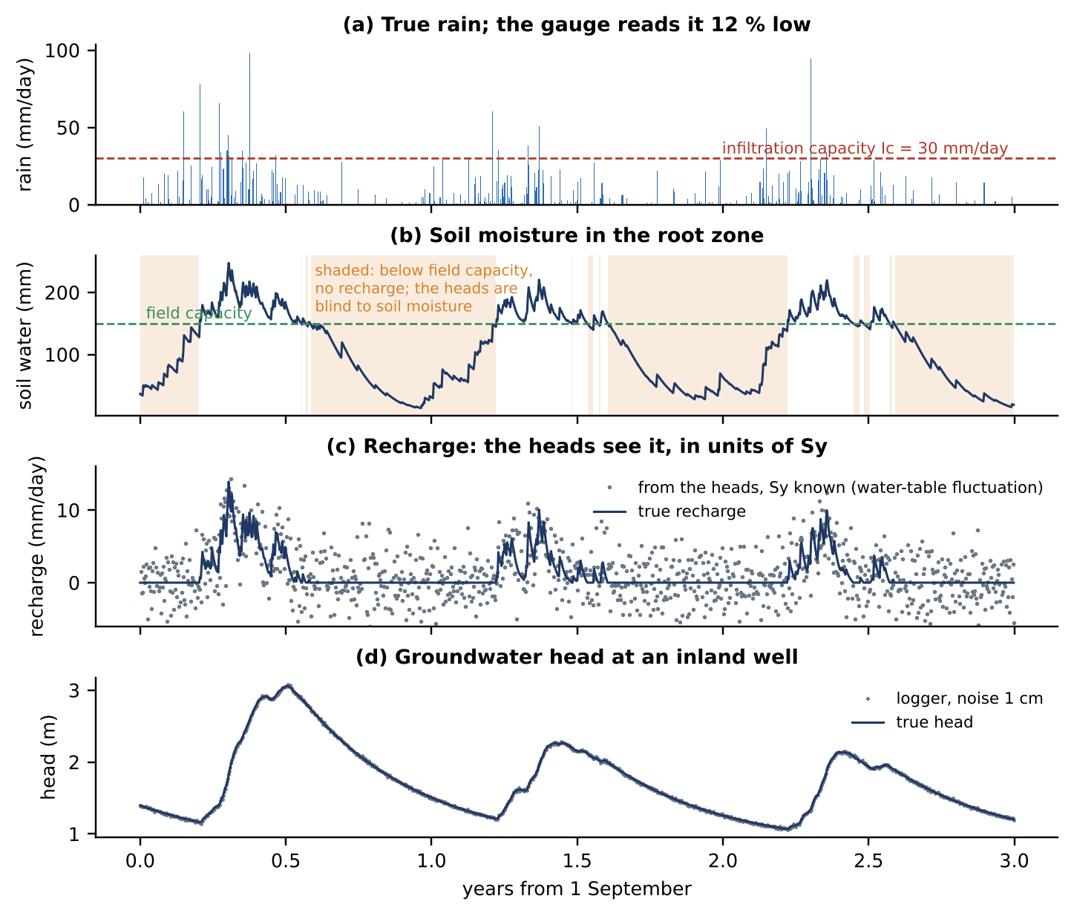
Figure 1. The synthetic chain. (a) True rain and the infiltration capacity. (b) Soil water; shaded: days below field capacity, when the heads carry no information on the soil (Proposition 3). (c) True recharge and its estimate from the heads with Sy known (Proposition 1). (d) Head at the well, true and logged.
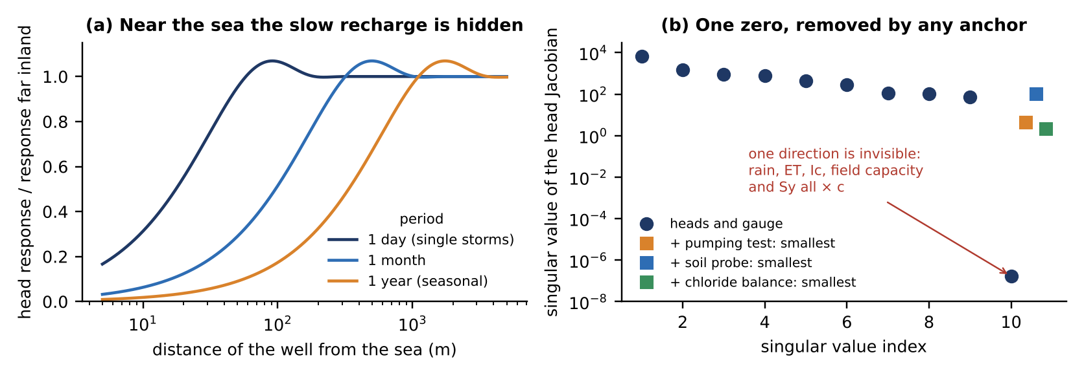
Figure 2. (a) Head response to recharge at a well, relative to the response far inland, against its distance from the sea, for three periods (factor (2); D = 5000 m²/day, L = 5 km); it slightly exceeds 1 where the boundary echo returns in phase. (b) Singular values of the Jacobian of the heads: one is zero, the scale symmetry of Proposition 2; any one anchor lifts it.
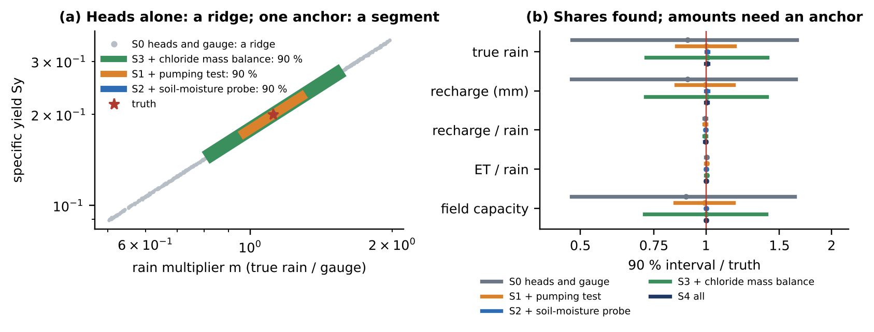
Figure 3. (a) Posterior samples of the rain multiplier m and the specific yield Sy from the heads and the gauge alone (grey): a ridge; coloured: the 90 % segment of the ridge that each anchor picks. (b) 90 % intervals divided by the truth: amounts (rain, recharge, field capacity) need an anchor; shares of the rain do not.
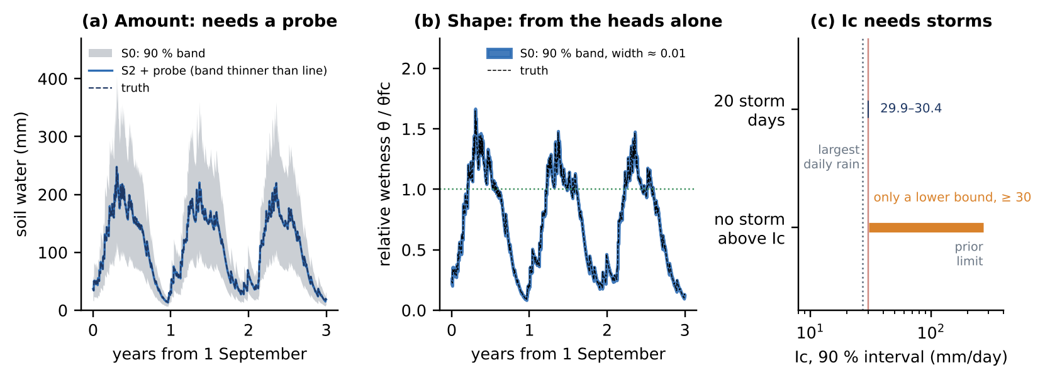
Figure 4. (a) Soil water in millimetres: 90 % band from the heads and the gauge (grey) and the median with a soil probe (blue; its band is thinner than the line). (b) Relative wetness θ/θfc from the heads and the gauge alone. (c) Infiltration capacity: 90 % interval with storms above it and without (Proposition 4).
5. How to do it at Fushë Kuqe–Mat
• Step 1. Heads. Daily loggers (1 cm) in three to five wells at different distances from the sea and the rivers, at least two of them beyond about 336 m, where the seasonal recharge is seen (Proposition 1); log the pumping.
• Step 2. Rain, evaporation and soil. One rain gauge and one soil-moisture profile station on the plain, and the potential evapotranspiration of the nearest weather station (Propositions 2 and 3).
• Step 3. One anchor per unit. A pumping test in each hydrogeological unit for $S_{y}$; a chloride mass balance only in inland, fresh wells (Table 2).
• Step 4. Inversion. The chain (1) for each well, as here: least squares for the most probable parameters, then Markov chain Monte Carlo. Report the shares of the rain first, which are always identified, then the amounts with their anchors, and the soil water as a band.
• Step 5. Every year. Use the first autumn recharge to update the summer evapotranspiration (Proposition 3), and report the infiltration capacity as a lower bound until a storm exceeds it (Proposition 4).
• Step 6. Link to the warning model. Recharge is the class-P boundary of "Boundary conditions as operators": the cap on infiltration is applied to the rain record, and the aquifer response is linear.

6. Innovation
The building blocks are known: the water-table fluctuation method, the bucket model of the root zone and structural identifiability. What this document adds, to our knowledge (to be verified against the literature before submission):
• The scale symmetry of the rain–soil–aquifer chain (Proposition 2) as an exact group action, with its consequence: the shares of the rain are always identifiable from the heads and the gauge, and the amounts need exactly one anchor. The choice of field measurements becomes a rank-one decision: any one of a pumping test, a soil probe, a chloride balance or a lysimeter is enough, and a second one only narrows the intervals.
• A stochastic water-table fluctuation rule with telescoping errors, and a coastal visibility factor (Proposition 1), which says how precisely recharge is recovered and where to place wells to see it.
• Blind spots of soil moisture and the deficit revealed at onset (Proposition 3), which turns the first autumn recharge into a yearly calibration of summer evapotranspiration.
• The storm-exceedance condition for infiltration capacity (Proposition 4).
• A data-worth table for the site from one synthetic inversion (Table 3), ready to be repeated with the real wells.

7. Limitations
• The model is lumped at one well: one root zone, one aquifer reservoir, no lateral flow, no preferential flow and no evaporation from a shallow water table, which matters on a low coastal plain (Boumis et al., 2022).
• The gauge error is a constant factor; in reality it varies from storm to storm, which widens every interval. Parameters are constant in time; land use and irrigation are ignored.
• Noise is Gaussian and the record is synthetic; with real data the model error, not the logger noise, will dominate.
• Factor (2) uses the illustrative diffusivity of the companion documents (5000 m²/day) and a strip; the distances must be recomputed with the calibrated aquifer.

References

Berghuijs, W. R., Collenteur, R. A., Jasechko, S., Jaramillo, F., Luijendijk, E., Moeck, C., van der Velde, Y. & Allen, S. T. (2024). Groundwater recharge is sensitive to changing long-term aridity. Nature Climate Change 14(4): 357–363. https://doi.org/10.1038/s41558-024-01953-z
Boumis, G., Kumar, M., Nimmo, J. R. & Clement, T. P. (2022). Influence of shallow groundwater evapotranspiration on recharge estimation using the water table fluctuation method. Water Resources Research 58(10): e2022WR032073. https://doi.org/10.1029/2022WR032073
Collenteur, R. A., Bakker, M., Klammler, G. & Birk, S. (2021). Estimation of groundwater recharge from groundwater levels using nonlinear transfer function noise models and comparison to lysimeter data. Hydrology and Earth System Sciences 25(5): 2931–2949. https://doi.org/10.5194/hess-25-2931-2021
Crosbie, R. S., Doble, R. C., Turnadge, C. & Taylor, A. R. (2019). Constraining the magnitude and uncertainty of specific yield for use in the water table fluctuation method of estimating recharge. Water Resources Research 55(8): 7343–7361. https://doi.org/10.1029/2019WR025285
Entekhabi, D., Njoku, E. G., O'Neill, P. E., Kellogg, K. H., Crow, W. T., Edelstein, W. N., Entin, J. K., Goodman, S. D., Jackson, T. J., Johnson, J., Kimball, J., Piepmeier, J. R., Koster, R. D., Martin, N., et al. (2010). The Soil Moisture Active Passive (SMAP) mission. Proceedings of the IEEE 98(5): 704–716. https://doi.org/10.1109/JPROC.2010.2043918 (classical)
Healy, R. W. & Cook, P. G. (2002). Using groundwater levels to estimate recharge. Hydrogeology Journal 10(1): 91–109. https://doi.org/10.1007/s10040-001-0178-0 (classical)
Moeck, C., Grech-Cumbo, N., Podgorski, J., Bretzler, A., Gurdak, J. J., Berg, M. & Schirmer, M. (2020). A global-scale dataset of direct natural groundwater recharge rates: a review of variables, processes and relationships. Science of the Total Environment 717: 137042. https://doi.org/10.1016/j.scitotenv.2020.137042
Raue, A., Kreutz, C., Maiwald, T., Bachmann, J., Schilling, M., Klingmüller, U. & Timmer, J. (2009). Structural and practical identifiability analysis of partially observed dynamical models by exploiting the profile likelihood. Bioinformatics 25(15): 1923–1929. https://doi.org/10.1093/bioinformatics/btp358 (classical)
Scanlon, B. R., Healy, R. W. & Cook, P. G. (2002). Choosing appropriate techniques for quantifying groundwater recharge. Hydrogeology Journal 10(1): 18–39. https://doi.org/10.1007/s10040-001-0176-2 (classical)
ter Braak, C. J. F. (2006). A Markov chain Monte Carlo version of the genetic algorithm Differential Evolution: easy Bayesian computing for real parameter spaces. Statistics and Computing 16(3): 239–249. https://doi.org/10.1007/s11222-006-8769-1 (classical)

Five of the ten references are from 2019 or later. The five earlier ones are used directly: Healy and Cook (2002) and Scanlon, Healy and Cook (2002) for the methods, Raue et al. (2009) for structural identifiability, ter Braak (2006) for the sampler, and Entekhabi et al. (2010) for satellite soil moisture. Companion documents, not counted: "A deterministic-first treatment of boundary and initial conditions in groundwater models" and "Boundary conditions as operators" (10 November 2026). Code: infiltrimi_exp.py (numpy, scipy; about 8 minutes) reproduces every number, infiltrimi_figs.py draws the figures and build_infiltrimi_doc.py builds this document (folder experiments/infiltrimi_go).

