State of the art VIII: what the salt would have done
Twenty more papers from Oxford, Caltech, Berkeley and MIT (2022–2026) on dispersion and mixing, counterfactuals in nonlinear systems, calibrated simulation-based inference and coastal aquifers under climate scenarios; the state of the art and the step beyond it; KRIPA-GO, the counterfactual salinity of the Fushë-Kuqe aquifer under a drier recharge regime and the role of the dispersion coefficient; and a three-page summary of novelty
Dulian Zeqiraj · November 2026 · review with a numerically tested innovation on the real Fushë-Kuqe chloride model · companion to reviews I–VII
1. Outcome
• Twenty new papers, five per institution, all from 2022–2026, each with links (Section 3, Figure 1), none of them a card of reviews I–VII. This batch turns to the nonlinear, salinity side of the problem and to the dispersion coefficient, the unknown the earlier reviews left open.
• State of the art and beyond, for the proposal (Section 2, Table 1), a map of the one hundred and sixty papers of reviews I–VIII (Section 5) and a three-page summary of novelty (Section 7).
• Innovation: KRIPA-GO (Section 4), on the real chloride model of Fushë-Kuqe (D2) and the documented facts. Proposition L1: the potential is linear in the recharge, so the aquifer under a drier regime follows from the factual state alone — even from the factual heads alone (checked to 1.5×10⁻¹¹ m) — without the conductivity or the recharge. Proposition L2: a drier regime never shrinks the salinized area, and the dispersion width enters the salinity counterfactual but not the interface one. Proposition L3: whether the transition zone itself would widen in the drier world is a cross-world question that no factual data answer. Proposition L4: conformal calibration on simulated twins gives the counterfactual bands a guarantee.
• The Fushë-Kuqe counterfactual (T26). With 40% less recharge the shallow area above 250 mg/L chloride would have been 65 km² instead of 31 km² (posterior medians): an increase of 33 km² (90% band 15–49) km². The toe of the wedge would have advanced over 33 km² (27–40), and the mid-depth seawater fraction of the SW band would have risen by 24 points (15–37).
• The dispersion coefficient decides the salinity counterfactual (T28). The width $w$ carries 62% of the posterior variance of the area effect and 74% of the fraction effect; the heads add nothing (width ratio 1.03), the chloride facts halve it. If the transition zone widened as $c^{−1/2}$ in the drier world, the area effect would be 64 km² instead of 33 km².
• Guarantee (T27). On 300 simulated test data sets the conformal bands cover 0.887–0.900 for the six counterfactual goals (importance sampling alone 0.883–0.923).

2. State of the art and the step beyond it
Reviews I–VII (D1) guarantee bands for the boundary conditions, the recharge coefficient and the inputs of a coastal aquifer when only the rain is known, measure their distance from the narrowest possible band, and, in review VII, extend the guarantees to counterfactuals of the recharge and the heads. Two gaps remained. All counterfactuals so far lived in a linear test bed, where effects are free of the latent boundaries; the quantity that matters at Fushë-Kuqe — where the chloride exceeds 250 mg/L — is nonlinear in the state. And the dispersion coefficient, one of the three families of unknowns of the whole series, had no counterfactual role yet.
Text for the proposal. Mixing and dispersion in porous media, counterfactual attribution in nonlinear Earth systems and calibrated simulation-based inference have advanced rapidly (Section 3), but they meet rarely: attribution studies give no coverage, inference studies ask no counterfactual question, and dispersion studies do not say how the width of the mixing zone changes a scenario's answer. The project goes beyond the state of the art by computing, for the real Fushë-Kuqe aquifer, what the salinized area, the toe of the wedge and the seawater fraction of the wells would have been under a drier or a wetter recharge regime, with conformal guarantees (KRIPA-GO); by proving that this counterfactual needs the factual state but neither the conductivity nor the recharge; by measuring how much of its uncertainty is the dispersion coefficient, and which data can reduce it; and by naming the one cross-world assumption about dispersion that no data can test.
Table 1. State of the art (2022–2026) and the step beyond it. Card numbers refer to Section 3; T numbers to the tests of Section 4.
Topic | State of the art | Its limit for our problem | Our step beyond | Evidence
Counterfactuals of salinity | Climate-scenario reactive transport (B2); warming and groundwater age (B5); drought cascades (C4); path dependence of coastal salinity (O1); drought indices and pooled ensembles (O3, O4) | Scenarios without coverage; the unknowns that matter for the salt not identified | Guaranteed counterfactual salinity of a real aquifer, from the factual state (Propositions L1, L4) | T26: salinized area 31 → 65 km² under 40% less recharge; conformal effect band 15–49 km²
Dispersion and mixing coefficients | Unbiased effective coefficients from multiscale data (C1); learned and regime-invariant mixing closures (C2, C3, M1); non-local stochastic transport (C5); matrix diffusion (B1); geometry versus mixing in porous plumes (O2); large deviations of conservative transport (O5) | Coefficients estimated or learned, but never asked how they change a scenario's answer | The share of a counterfactual that is the dispersion, and which data reduce it | T28: $w$ carries 62% (area) and 74% (fraction) of the effect's variance; heads 1.03, chloride 0.60 of the prior width
Cross-world assumptions | Out-of-distribution closures (C2); regime invariance (C3); state-dependent mixing (M1) | Whether a coefficient changes under the counterfactual forcing is untestable from one climate | The cross-world dispersion law made explicit and priced (Proposition L3) | T28: area effect 33 → 48 → 64 km² for β = 0, 1/4, 1/2
Calibrated inference and surrogates | Amortized conditional transport (M3); rates for flow generators (M4); certified features (M5); out-of-domain surrogate uncertainty (B3); rare events beyond the band (O5) | No coverage for counterfactual quantities; surrogates extrapolate under scenarios | Exact state abduction instead of extrapolation; conformal bands on simulated twins | T25: twin interface from the heads to 1.5×10⁻¹¹ m; T27: coverage 0.887–0.900
Counterfactual estimands | Panel counterfactuals and their randomness (B4); counterfactual dose curves (M2) | Linear, independent units; no physics | A monotone salt response that identifies the probabilities of causation; dose-response over the recharge factor (Proposition L2) | T26: +48 km² at half the recharge, −15 km² at 1.5 times

3. The twenty papers
Five papers per institution, all published 2022–2026 in the version cited (Figure 1), with a link to the institution at the time of publication (JPL for Caltech, Lawrence Berkeley National Laboratory for Berkeley), a state-of-the-art contribution and no paper that was a card before. Each card states the main result as the search results quote or closely paraphrase it, what it cannot yet do for us, three lessons (inputs, dispersion, boundary conditions) and an innovation step tied to the numbers of Section 4.
Verification. The hosts doi.org, arxiv.org, jmlr.org, proceedings.mlr.press, proceedings.neurips.cc and most publisher pages could not be opened in this environment; landing pages were reached through search results that quote them, and every card is marked partly verified, with what could not be confirmed.
3.1 University of Oxford
O1 · Oxford · 2024
Offshore freshened groundwater reservoirs controlled by submarine faults with a complex dependency on antecedent hydrogeological conditions
A. Paldor, C. Bertoni, B. Penny, H. A. Michael
Science of The Total Environment 952, 175834 (2024)
Links: doi:10.1016/j.scitotenv.2024.175834 · Oxford ORA
Affiliation and verification: Listed on the Oxford Earth Sciences site and deposited in ORA; Bertoni has an Oxford Earth Sciences profile. The affiliation printed on this paper was not seen (other sources also list her in Trieste). Status: partly verified (landing pages reached through search results only).
What it does. Result (abstract wording). In a variable-density model of a faulted submarine confined aquifer in the Levant Basin, built from geological data, faults close to the coastline within the brackish zone control offshore salinities regardless of the initial conditions, while the influence of distal faults depends on antecedent conditions: they control the offshore freshened groundwater if the antecedent fresh–saltwater interface lies seaward of the fault, so that one geological system can be active or passive depending on its hydrological history. Manuscript snippets indicate that faster discharge raises the hydrodynamic dispersion; the dispersivity values were not seen.
State of the art it sets. Path dependence of coastal and offshore salinity controlled by structural features, shown with variable-density models.
What it cannot yet do for us. No uncertainty quantification; one site; dispersivities and their sensitivity not seen.
Input parameters. The effect of a structural parameter on salinity cannot be identified without the initial interface: the same conductivity field can hold two salinity states.
Dispersion coefficient. The transition zone widens where the flow is fast ($D=α\left|v\right|$): a drier regime with slower discharge changes the width as well as the position of the interface (our inference).
Boundary conditions from rain alone. The initial interface and the sea-level history are not ignorable: a drought counterfactual has to carry the antecedent interface as an unknown.
Innovation step for our problem. KRIPA-GO's counterfactual is a steady regime: it assumes the interface has come to equilibrium with the drier recharge, and its answer — a salinized area of 31 → 65 km² — is the limit of a lasting regime. Their path dependence names the first condition for that limit (no structure near the antecedent interface that could lock another state in); their flow-dependent dispersion names the second, the cross-world law of the width (Proposition L3). With purely mechanical dispersion the steady width scales with the dispersivity rather than the velocity, which supports the shared width $w′=w$ (our inference).

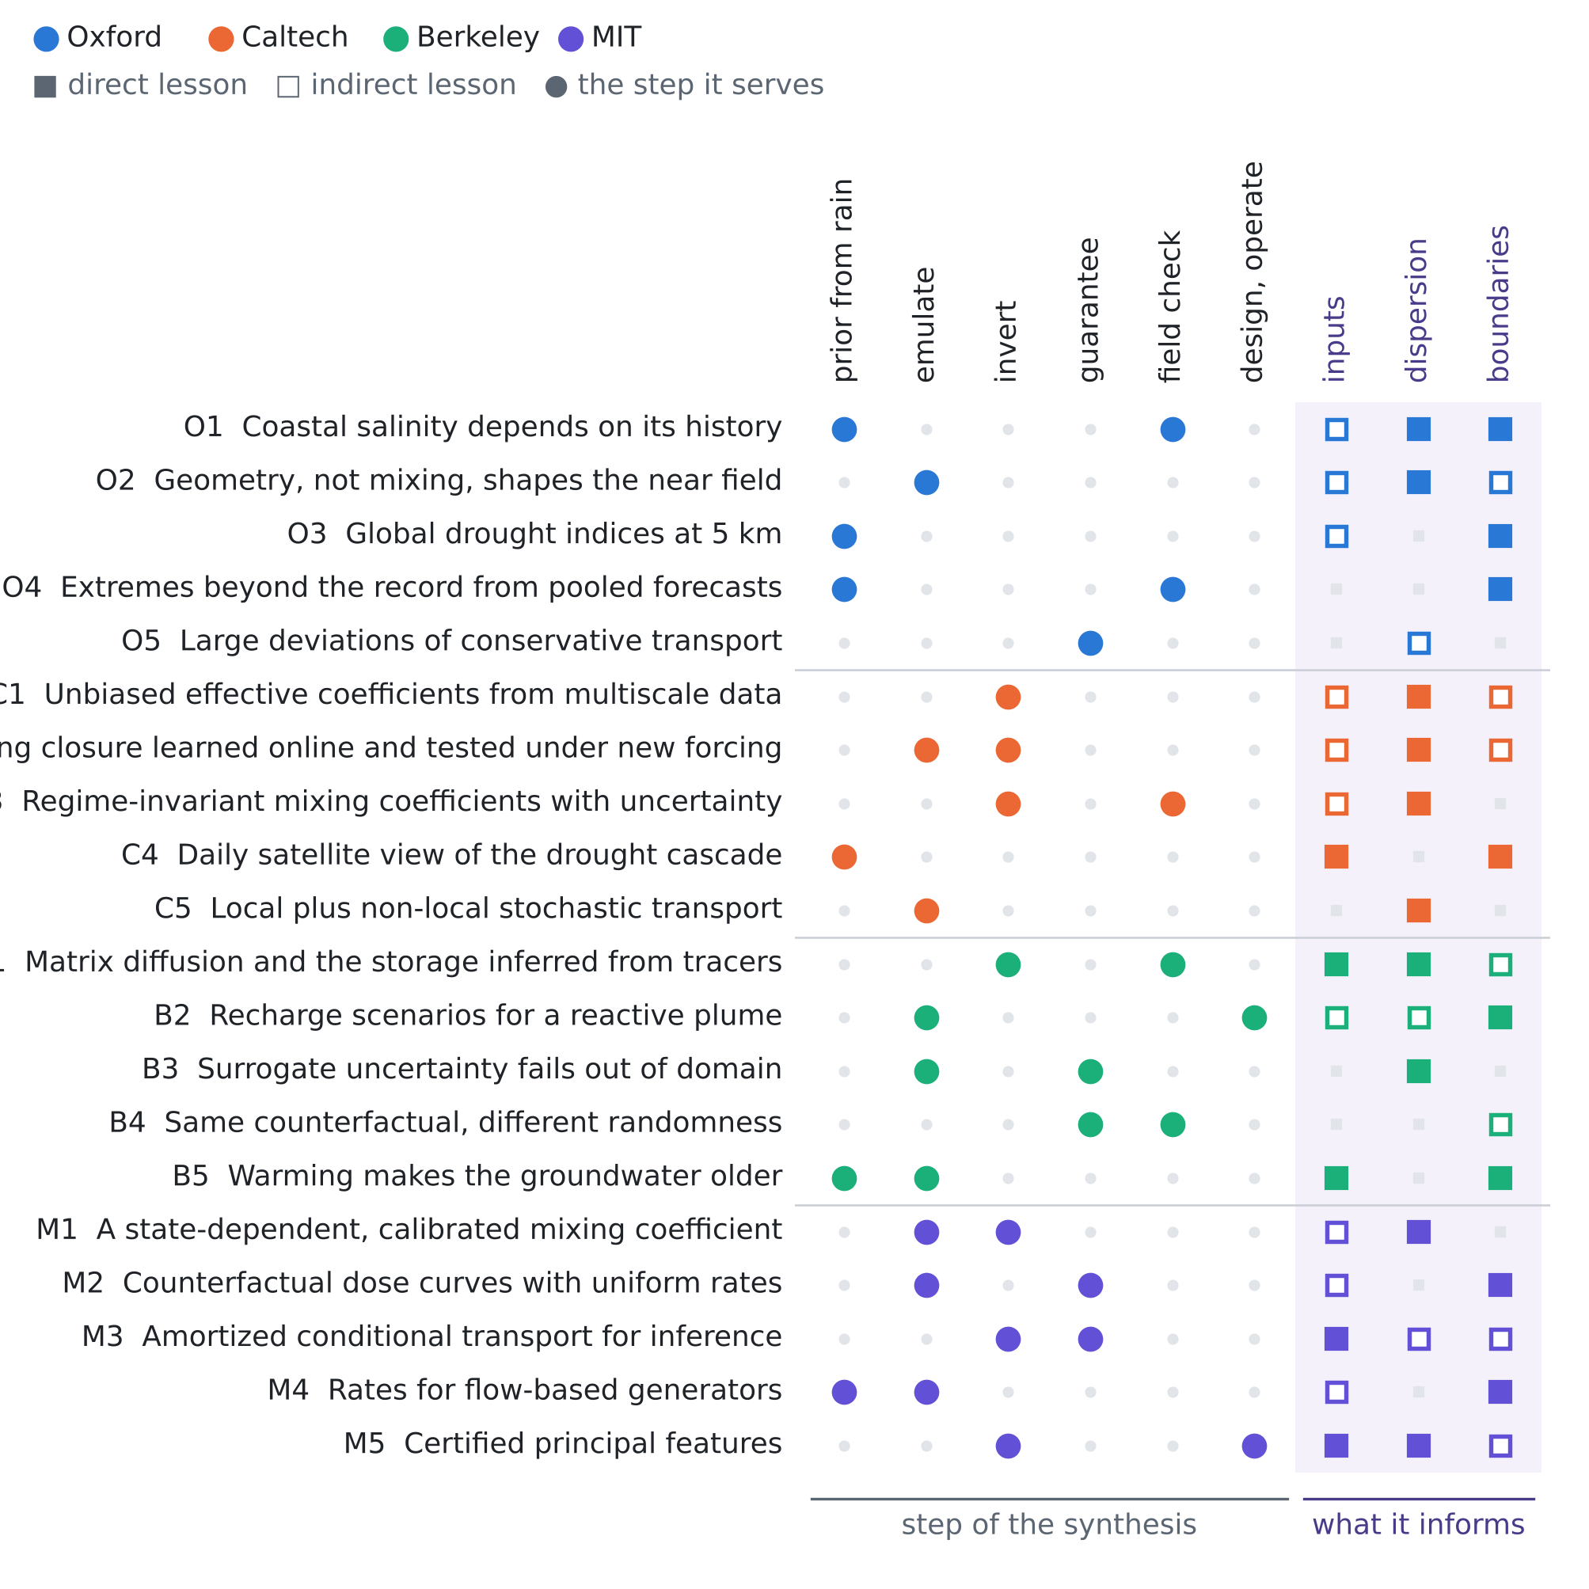
Figure 1. The twenty papers against the step of the procedure they serve and the unknown they inform. Colour gives the institution; a filled square is a direct lesson, an open square an indirect one.
O2 · Oxford · 2023
The near-field shape and stability of a porous plume
Graham P. Benham
Journal of Fluid Mechanics 955, A13 (2023)
Links: doi:10.1017/jfm.2022.1068 · arXiv:2204.13510
Affiliation and verification: The arXiv and journal versions list the Mathematical Institute, University of Oxford (search summaries); the author was a Departmental Lecturer at Oxford in 2022–2023. Status: partly verified (landing pages reached through search results only).
What it does. Result (closely paraphrased). Near the injection point a buoyant plume in a porous medium adjusts its cross-section to conserve mass, and these adjustments — rather than mixing with the ambient fluid, which acts over larger distances — control its near-field shape. At moderate injection rates the plume reaches a steady state and matches the buoyancy velocity within a few plume widths; the steady shape depends on one parameter, the inlet velocity over the buoyancy velocity, and a linear stability analysis shows the interface becomes unstable when that ratio is much smaller than one.
State of the art it sets. A one-parameter theory of the near-field shape and stability of porous plumes.
What it cannot yet do for us. Homogeneous medium, no field data, no coastal geometry; mixing is left to the far field.
Input parameters. Only the ratio of the inlet to the buoyancy velocity (permeability times density contrast) is identifiable from the near-field shape.
Dispersion coefficient. Near-field interface geometry carries almost no information on the dispersion; the dispersivity is learned far from the source, which bears on where chloride samples should be placed (our inference).
Boundary conditions from rain alone. The inflow relative to the buoyancy velocity sets the stability: a drought that lowers the inflow could cross the threshold (our inference).
Innovation step for our problem. The same split between geometry and mixing runs through Proposition L2: the toe of the wedge is a sharp-interface (geometric) quantity and its counterfactual, 33 km² (27–40), is free of the dispersion, while the shallow salinized area, set by the mixing zone, depends on the width $w$ for 62% of its posterior variance (T28).

O3 · Oxford · 2023
Global high-resolution drought indices for 1981–2022
Solomon H. Gebrechorkos et al. (full author list not seen)
Earth System Science Data 15(12), 5449–5466 (2023)
Links: doi:10.5194/essd-15-5449-2023 · Oxford ORA
Affiliation and verification: The ORA record lists the School of Geography and the Environment, University of Oxford. Status: partly verified (landing pages reached through search results only).
What it does. Result. Four 5 km datasets of the Standardized Precipitation-Evapotranspiration Index for 1981–2022 (CHIRPS or MSWEP rain combined with GLEAM or hPET evaporation), at accumulation scales of 1 to 48 months, because existing global indices are coarser than 50 km; the data are archived at CEDA. It is likely the dataset behind a 2025 paper of the same group used in review V.
State of the art it sets. The highest-resolution global multi-scale drought-index record.
What it cannot yet do for us. No groundwater; uncertainty only as the spread of four members; 5 km may be coarse for the coastal plain.
Input parameters. The accumulation scale that best tracks the heads estimates the vadose delay and the aquifer memory (our inference).
Dispersion coefficient. None.
Boundary conditions from rain alone. A drought counterfactual can be defined as an index percentile at a given accumulation scale, with the spread of the four members as forcing uncertainty.
Innovation step for our problem. The recharge factor $c$ of KRIPA-GO is a regime, not a year; their index at 12–48 months is the rain-side definition of such a regime from the rain alone. Mapping an index class at Fushë-Kuqe to $c$ turns the dose-response of T26 (half the recharge adds 48 km² of salinized area) into a salinity answer per drought class.

O4 · Oxford · 2022
Extreme floods in Europe: going beyond observations using reforecast ensemble pooling
Manuela I. Brunner, Louise J. Slater
Hydrology and Earth System Sciences 26(2), 469–482 (2022)
Links: doi:10.5194/hess-26-469-2022 · HESS
Affiliation and verification: Slater at the University of Oxford (search result); Brunner at the University of Freiburg. Status: partly verified (landing pages reached through search results only).
What it does. Result (as summarized). Pooling the reforecasts of the European Flood Awareness System across lead times and members gives 130 series instead of one, enough to analyse events rarer than about twice a century; over 234 Central European catchments the uncertainty bounds are on average about 80% narrower than from observations alone, while pooling can carry biases from the simulated meteorology.
State of the art it sets. Regional frequency of extremes from pooled, physically consistent forecast ensembles.
What it cannot yet do for us. Wet extremes only; no groundwater; no coverage guarantee; tied to the model meteorology.
Input parameters. None.
Dispersion coefficient. None.
Boundary conditions from rain alone. Counterfactual forcing beyond the observed rain record can be drawn from pooled ensembles, with bias checks.
Innovation step for our problem. Pooled ensembles are a source of the recharge regimes the record does not contain, dry and wet. KRIPA-GO says what each regime would do to the salt — from +48 km² of salinized area at half the recharge to −15 km² at 1.5 times (T26) — and their bias check is the mechanism check of Proposition L4.

O5 · Oxford · 2023
Non-equilibrium large deviations and parabolic-hyperbolic PDE with irregular drift
Benjamin Fehrman, Benjamin Gess
Inventiones Mathematicae (2023), 573–636 (volume not seen)
Links: doi:10.1007/s00222-023-01207-3 · arXiv:1910.11860
Affiliation and verification: Deposited in Oxford ORA; Fehrman at the Mathematical Institute, University of Oxford. The affiliation printed on the paper was not seen. Status: partly verified (landing pages reached through search results only).
What it does. Result (quoted). A robust well-posedness theory in energy-critical spaces for the skeleton equation, a degenerate parabolic-hyperbolic PDE with irregular drift, built on renormalized and kinetic solutions (a nonlinear extension of DiPerna–Lions and Ambrosio), with applications to the lower-semicontinuous envelopes of restricted rate functions and to zero-noise large deviations of conservative singular stochastic PDE; the authors state that it solves a long-standing open problem in the large deviations of zero-range processes and links macroscopic fluctuation theory with fluctuating hydrodynamics.
State of the art it sets. A rigorous rare-event theory for conservative, diffusive particle systems.
What it cannot yet do for us. Lattice and particle systems, no Darcy advection; far from field use.
Input parameters. None directly.
Dispersion coefficient. In macroscopic fluctuation theory the probability of a rare front is set by a rate function built from the diffusivity and the mobility (the standard form, not quoted from this paper).
Boundary conditions from rain alone. None.
Innovation step for our problem. KRIPA-GO gives the counterfactual of the typical salt front and a conformal band whose upper end is 49 km² of extra salinized area; large deviations are the route to the probability of a drought salinization far beyond that band — the tail a 90% guarantee leaves out — with the dispersion entering through the rate function.

3.2 California Institute of Technology (with JPL)
C1 · Caltech · 2023
Drift Estimation of Multiscale Diffusions Based on Filtered Data
Assyr Abdulle, Giacomo Garegnani, Grigorios A. Pavliotis, Andrew M. Stuart, Zanoni (given name not seen)
Foundations of Computational Mathematics 23, 33–84 (2023)
Links: doi:10.1007/s10208-021-09541-9 · CaltechAUTHORS · arXiv:2009.13457
Affiliation and verification: CaltechAUTHORS record (Stuart, Computing and Mathematical Sciences); the per-author affiliations were not seen. The DOI suggests online-first publication in 2021; the 2023 volume is cited. Status: partly verified (landing pages reached through search results only).
What it does. Result. For overdamped Langevin dynamics with two scales and a homogenized single-scale surrogate, the maximum-likelihood estimator of the homogenized drift computed from the raw multiscale data is asymptotically biased, while the estimator computed from data smoothed by a linear time-invariant filter of the exponential family is asymptotically unbiased, in both the homogenized and the multiscale regime. Sharp estimates of the minimal filter width relative to the multiscale parameter are given, with an estimator of the effective diffusion coefficient and Bayesian uncertainty quantification (theorem numbers from a search summary; the statements were not read).
State of the art it sets. Provably unbiased estimation of homogenized (effective) coefficients from multiscale data, without subsampling.
What it cannot yet do for us. Gradient-type diffusions with a periodic fast scale and continuous paths; no sparse data, no counterfactual change of forcing.
Input parameters. Fitting $T$, $S$, $κ$ or $τ$ of a coarse aquifer model to head series with fast tidal or pumping cycles is biased; the series should be filtered first, with a width above the fast scale.
Dispersion coefficient. An effective dispersion coefficient is a homogenized diffusion coefficient: estimated naively from fine-scale chloride fluctuations it is biased, with a filtered estimator it is consistent. Dispersion from data must be scale-aware.
Boundary conditions from rain alone. The tide is the fast scale to filter out of the sea boundary.
Innovation step for our problem. In KRIPA-GO the width $w$ is such an effective coefficient, and it decides the salinity counterfactual: it carries 62% of the posterior variance of the drought effect on the salinized area (T28). Their filtered estimator is the principled way to turn chloride series into the $w$ the counterfactual needs; the toe counterfactual, free of $w$ (Proposition L2), needs no such step.

C2 · Caltech · 2024
Online Learning of Entrainment Closures in a Hybrid Machine Learning Parameterization
Costa Christopoulos, Ignacio Lopez-Gomez, Tom Beucler, Yair Cohen, Charles Kawczynski, Oliver R. A. Dunbar, Tapio Schneider
Journal of Advances in Modeling Earth Systems 16(11), e2024MS004485 (2024)
Links: doi:10.1029/2024MS004485 · CaltechAUTHORS
Affiliation and verification: CaltechAUTHORS record; PDF hosted by CliMA at Caltech; the work is part of the first author's 2025 Caltech PhD dissertation. Status: partly verified (landing pages reached through search results only).
What it does. Result. The lateral entrainment and detrainment (mixing) closure of an eddy-diffusivity/mass-flux scheme is made data-driven and trained online, through the single-column solver, against large-eddy simulations forced by GCM-simulated Pacific conditions. Ensemble Kalman inversion calibrates the physical and the data-driven mixing parameters jointly, without derivatives, and the calibrated scheme outperforms existing schemes, especially in the tropics and subtropics. One summary reports that it stays accurate under 4 K warmer sea-surface temperatures; this was not reconfirmed, and no numbers were seen.
State of the art it sets. Online, derivative-free learning of a mixing closure inside the solver, tested under a changed forcing.
What it cannot yet do for us. No coverage guarantee; one distribution shift; abundant simulated targets.
Input parameters. $T$, $S$ and $κ$ calibrated jointly with a learned closure, without derivatives, against output statistics only.
Dispersion coefficient. A dispersion law $D\left(v,∇c\right)$ learned as a closure inside the variable-density solver from salinity outputs, then tested under a drier forcing.
Boundary conditions from rain alone. The large-scale forcing varies across training cases; the warmer climate is the template for "the same closure, a counterfactual forcing".
Innovation step for our problem. Proposition L3 says what their out-of-distribution test cannot: whether the closure itself changes under the new forcing is a cross-world question for any single factual climate. In KRIPA-GO, letting the transition zone widen as $c^{−1/2}$ under a 40% drier regime moves the salinized-area effect from 33 to 64 km² (T28); a closure trained across forcings is how that law could be learned instead of assumed.

C3 · Caltech · 2026
Online learning of eddy-viscosity and backscattering closures for geophysical turbulence using ensemble Kalman inversion
Yifei Guan, Pedram Hassanzadeh, Tapio Schneider, Oliver Dunbar, Daniel Zhengyu Huang, Jinlong Wu, Ignacio Lopez-Gomez
Physical Review Research 8, 023215 (2026)
Links: doi:10.1103/mnbm-3g56 · CaltechAUTHORS · arXiv:2409.04985
Affiliation and verification: CaltechAUTHORS record ("Published May 27, 2026"), listed in the library feeds of Schneider and Dunbar; the per-author affiliations were not seen. Status: partly verified (landing pages reached through search results only).
What it does. Result. Ensemble Kalman inversion tunes one parameter each of the Smagorinsky and Leith eddy-viscosity closures and two of the Jansen–Held backscatter closure, so that the energy spectrum of large-eddy simulations matches direct numerical simulation in eight cases of two-dimensional geophysical turbulence. The optimized parameters are constant across broad flow regimes, the backscatter closure performs best a priori and a posteriori, only spectra are needed, and calibrate–emulate–sample quantifies the parametric uncertainty.
State of the art it sets. Spectrum-matched closure coefficients that are regime-invariant, with Bayesian uncertainty.
What it cannot yet do for us. Two-dimensional turbulence, not porous media; eight cases; Bayesian, not distribution-free.
Input parameters. With scarce data, calibrate on statistics, such as variances or spectra of the heads against the rain.
Dispersion coefficient. A one- or two-parameter mixing closure can be regime-invariant, which supports carrying a dispersivity unchanged into a drier regime; the backscatter term warns that a purely Fickian closure can be insufficient.
Boundary conditions from rain alone. None.
Innovation step for our problem. Regime invariance is the shared-width assumption $w′=w$ of KRIPA-GO. Their test is a way to check it across regimes; KRIPA-GO prices its failure: under $w′=w c^{−1/4}$ the salinized-area effect rises from 33 to 48 km², while the toe effect does not change (T28).

C4 · Caltech · 2025
Revisiting Sub-Surface Drought Cascades With Daily Satellite Observations of Soil Moisture and Terrestrial Water Storage
Daniel Blank, Annette Eicker, John T. Reager, Andreas Güntner
Water Resources Research 61(8), e2024WR039321 (2025)
Links: doi:10.1029/2024WR039321 · HCU research portal
Affiliation and verification: Reager is described as JPL's in the search summary of his 2025 GRACE-FO Science Team presentation; the JPL affiliation was not confirmed from the paper's own author block. Status: partly verified (landing pages reached through search results only).
What it does. Result. Daily GRACE and GRACE-FO total water storage, combined with SMOS, SMAP and ESA CCI surface and root-zone soil moisture over 2015–2022, are analysed through the rates of change of de-seasonalized anomalies. Surface soil moisture fluctuates fast and recovers quickly, the root zone more slowly and the whole column slowest, so drought signals are damped and delayed as they propagate downward. Recovery times of days per layer appear in presentation slides and were not checked against the paper.
State of the art it sets. The first global, daily, satellite-only quantification of the drought cascade from the surface to deep storage.
What it cannot yet do for us. About 300 km resolution; groundwater not separated; descriptive, without causal analysis or guarantees.
Input parameters. Layer-by-layer recovery times and lags as priors or bounds for the vadose delay and the recharge coefficient.
Dispersion coefficient. None.
Boundary conditions from rain alone. The shape of the recharge response to a rain deficit (damping plus delay): what is needed to build "the recharge had the rain been a drought" from the rain series alone.
Innovation step for our problem. The steady KRIPA-GO counterfactual is the end point of their cascade: a lasting 40% recharge deficit raises the salinized area from 31 to 65 km² (T26). Their damping and delay give the transient path towards that end point, and the dose-response of T26 gives its size for every deficit.

C5 · Caltech · 2022
Augmenting the Double-Gaussian Representation of Atmospheric Turbulence and Convection via a Coupled Stochastic Multi-Plume Mass-Flux Scheme
Mikael K. Witte, Adam Herrington, Joao Teixeira, Marcin J. Kurowski, Maria J. Chinita, Rachel L. Storer, Kay Suselj, Georgios Matheou, Julio Bacmeister
Monthly Weather Review 150(9), 2339–2355 (2022); DOI not seen
Links: UCAR record · JPL CV citing it
Affiliation and verification: Teixeira, Kurowski and Suselj are listed at "JPL, California Institute of Technology" on 2023 CESM workshop slides, and Kurowski's JPL CV cites the paper; the paper's header was not seen. Status: partly verified (landing pages reached through search results only).
What it does. Result. Multiple stochastic mass-flux plumes, with stochastic lateral entrainment, are coupled at little extra cost to the double-Gaussian probability-density closure of subgrid turbulence, because the double-Gaussian closure alone cannot reproduce key features of shallow cumulus convection; transport is split into a local eddy-diffusivity part and a non-local, stochastic plume part.
State of the art it sets. A coupled stochastic multi-plume and probability-density closure of turbulent transport.
What it cannot yet do for us. Atmospheric; no data-driven calibration, uncertainty quantification or theory.
Input parameters. None.
Dispersion coefficient. A single local dispersion coefficient can miss non-local, stochastic transport: preferential pathways that shift or widen the transition zone could be represented by a stochastic mass-flux-like term.
Boundary conditions from rain alone. None.
Innovation step for our problem. KRIPA-GO uses one local width $w$ for the whole sector and shows how much rides on it: the drought effect on the salinized area is 13 km² for the narrowest tenth of $w$ and 43 km² for the widest (T28). A non-local stochastic transport term would turn this single number into a spatial field, the limitation named in Section 6.

3.3 University of California, Berkeley (with Lawrence Berkeley National Laboratory)
B1 · Berkeley · 2025
Matrix Diffusion Controls Mountain Hillslope Groundwater Ages and Inferred Storage Dynamics
N. E. Thiros, E. R. Woodburn, W. P. Gardner, J. P. Dennedy-Frank, K. H. Williams
Groundwater 63(3), 306–318 (2025)
Links: doi:10.1111/gwat.13475 · PMC12049175 · LBNL Watershed Function
Affiliation and verification: Listed with a research highlight on the Lawrence Berkeley National Laboratory Watershed Function site; DOE OSTI record 2543161. The per-author affiliations were not seen. Status: partly verified (landing pages reached through search results only).
What it does. Result. With an integrated hydrologic model and particle tracking of a montane hillslope (East River, Colorado), a Monte Carlo analysis over uncertain matrix and fracture parameters shows that matrix diffusion is necessary to predict tritium and helium-4 at two wells jointly. The best scenario is a dynamic bedrock reservoir that loses considerable storage in low-snow periods; high terrigenic helium, read as old ages, can largely be a product of matrix diffusion, and ignoring it when assimilating tracers into advection-dominated models can overestimate the drainable storage. No numbers were seen.
State of the art it sets. The first demonstration that diffusion controls the storage inferred from multiple tracers in a hillslope.
What it cannot yet do for us. Fractured bedrock, not coastal; no variable density; a Monte Carlo fit without a guarantee.
Input parameters. A storage calibrated on a handful of tracer or chloride facts with a single-porosity advective model is biased high, which makes the drought response look damped: a bias towards optimism.
Dispersion coefficient. Matrix diffusion (mass transfer) and mechanical dispersion leave similar marks on ages and concentrations; one effective dispersion parameter absorbs both, and a few facts cannot separate them. Slow exchange adds memory, so a transition zone does not simply rescale under drought.
Boundary conditions from rain alone. The dry-period storage loss comes from the recharge in time; there is no sea boundary in the paper.
Innovation step for our problem. Their result is a warning for the chloride facts of KRIPA-GO: a few concentrations interpreted with one effective width $w$ absorb any slow exchange. The facts narrow the counterfactual area effect to 0.60 of its prior width (T28); a mass-transfer process would change what that width means, and with it the cross-world law of Proposition L3.

B2 · Berkeley · 2022
Reactive transport modeling for supporting climate resilience at groundwater contamination sites
Zexuan Xu, Rebecca Serata, Haruko Wainwright, Miles Denham, Sergi Molins, Hansell Gonzalez-Raymat, Konstantin Lipnikov, J. David Moulton, Carol Eddy-Dilek
Hydrology and Earth System Sciences 26(3), 755–773 (2022)
Links: doi:10.5194/hess-26-755-2022 · eScholarship
Affiliation and verification: The eScholarship record is filed under Lawrence Berkeley National Laboratory (search summary); Xu appears with an LBNL affiliation in a related 2022 preprint. The per-author affiliations were not seen. Status: partly verified (landing pages reached through search results only).
What it does. Result. Two-dimensional reactive transport of uranium, tritium and nitrate at the Savannah River Site F-Area (Amanzi), under perturbed infiltration, cap failure and downscaled CMIP5 projections to 2100, shows that the competing effects of dilution and remobilization change the pH and hence the sorption of uranium. For cap failure at +10% to +50% recharge, +50% gives the earliest peak and +20% the highest; the −10% and −20% recharge scenarios diverge strongly around 2040 and converge by 2100.
State of the art it sets. The reference DOE/LBNL workflow for climate-scenario reactive transport at a contaminated site.
What it cannot yet do for us. Deterministic scenarios without uncertainty bands; no variable density and no salinity.
Input parameters. The map from the recharge coefficient to a reactive concentration is not monotone, so a guaranteed recharge band cannot simply be propagated to a guaranteed concentration band.
Dispersion coefficient. Dilution (mixing) competes with chemistry; no dispersivity sensitivity was seen.
Boundary conditions from rain alone. Precipitation → infiltration → recharge-in-time scenarios; the counterfactual gap depends on the horizon, so bands should be indexed by time.
Innovation step for our problem. KRIPA-GO's salt response is monotone (Proposition L2: a drier regime never lowers the chloride of any screen), which is what makes the salinity counterfactual sign-identified for every value of the unknowns. Their non-monotone uranium response shows where that property ends: salinity is conservative, reactive ions are not.

B3 · Berkeley · 2024
Using Uncertainty Quantification to Characterize and Improve Out-of-Domain Learning for PDEs
S. Chandra Mouli, Maddix, Alizadeh, Gupta, Stuart, Mahoney, Wang (other given names not seen)
Proceedings of the 41st International Conference on Machine Learning (ICML 2024), PMLR 235, 36372–36418
Links: PMLR 235 · arXiv:2403.10642
Affiliation and verification: Mahoney is in Statistics at UC Berkeley, at ICSI and at Lawrence Berkeley National Laboratory (his Berkeley page); the paper's own header was not seen. Status: partly verified (landing pages reached through search results only).
What it does. Result (abstract wording). Several uncertainty-quantification methods for neural operators fail for test inputs that are even moderately out of domain, even when the model approximates the solution well in domain. A cheap diverse ensemble (DiverseNO) and an update that enforces conservation laws (Operator-ProbConserv) improve out-of-domain accuracy and calibration. The test families include the heat equation with the diffusion constant trained on [1, 5] and tested on [6, 7], the porous-medium equation, the Stefan problem and linear advection.
State of the art it sets. The reference study of out-of-domain uncertainty of neural operators when a PDE coefficient shifts.
What it cannot yet do for us. No distribution-free guarantee; one- and two-dimensional benchmarks; no variable-density coupling.
Input parameters. None directly.
Dispersion coefficient. A drier regime lowers velocities and hence mechanical dispersion, which can push a surrogate outside its trained coefficient range, where its own error bars are unreliable.
Boundary conditions from rain alone. None on the rain; the Stefan problem is a moving-interface analogue of the toe.
Innovation step for our problem. State abduction (Proposition L1) avoids the out-of-domain problem for the interface: the drier aquifer is computed exactly as $cϕ$, not extrapolated by a surrogate (error 1.5×10⁻¹¹ m from the heads alone, T25). Where a surrogate is unavoidable — a transient section model — their result says its error bars must be recalibrated, for example on simulated twins (Proposition L4).

B4 · Berkeley · 2023
Same Root Different Leaves: Time Series and Cross-Sectional Methods in Panel Data
Dennis Shen, Peng Ding, Jasjeet Sekhon, Bin Yu
Econometrica 91(6), 2125–2154 (2023)
Links: doi:10.3982/ECTA21248 · arXiv:2207.14481
Affiliation and verification: Yu at the Departments of Statistics and EECS, UC Berkeley (journal listing); Shen a postdoctoral fellow at the Simons Institute, UC Berkeley, 2021–2023, hosted by Ding, Sekhon and Yu (his CV). Status: partly verified (landing pages reached through search results only).
What it does. Result (quoted). Without any assumptions, horizontal regression (unconfoundedness, using time-series patterns) and vertical regression (synthetic controls, using cross-sectional patterns) yield algebraically equivalent point estimates for several standard estimators; but the source of randomness assumed by each leads to a distinct estimand and quantification of uncertainty even for the same point estimate, and a confidence interval built for one estimand may have incorrect coverage for another.
State of the art it sets. The equivalence theory of synthetic-control and unconfoundedness estimators for panel counterfactuals.
What it cannot yet do for us. Linear estimators; no spatial dependence or nonlinear (salinity) outcomes.
Input parameters. None directly.
Dispersion coefficient. None.
Boundary conditions from rain alone. Two ways to build the drought counterfactual of a well: its own rain-driven history, or other wells in the same year. The point estimate can coincide while the band does not.
Innovation step for our problem. KRIPA-GO's guarantee states its source of randomness: data sets simulated from the prior ensemble, so the coverage 0.887–0.900 (T27) is over aquifers of the prior, not over years or wells. A field guarantee over wells would be a different estimand with a different band — their theorem in the salinity setting.

B5 · Berkeley · 2026
Warming and snow loss increase reliance on old groundwater in a Colorado River headwater
Erica R. Siirila-Woodburn, Nicholas Thiros, Michelle Newcomer and colleagues (full author list not confirmed)
Nature Geoscience 19(5), 549–555 (2026)
Links: doi:10.1038/s41561-026-01945-y · LBNL highlight
Affiliation and verification: Berkeley Lab Watershed Function highlight; OSTI record whose PDF is headed "UC Berkeley Previously Published Works". The per-author affiliations were not seen. Status: partly verified (landing pages reached through search results only).
What it does. Result (quoted). As streamflow declines with warming, the age of the groundwater supporting it gets older, in part because intermediate-aged (1–3 year) groundwater declines twice as fast; old groundwater may be buffering the streamflow response, especially in low-snow years. Integrated hydrologic modelling with particle tracking over water years 2015–2021. A Berkeley Lab summary gives 15% more reliance on old groundwater per degree of warming; this number was not seen in the paper.
State of the art it sets. A 2026 model-based attribution of warming effects on the age of the groundwater that feeds streams.
What it cannot yet do for us. A mountain, snow-dominated setting; no salinity; no uncertainty bands seen.
Input parameters. Transit-time and vadose-delay distributions are not invariant under a climate intervention, so a delay calibrated in wet years mis-predicts a drought.
Dispersion coefficient. None seen (ages from advective particle tracking).
Boundary conditions from rain alone. Perturbing the meteorological forcing is the counterfactual design; at a coast, drought shifts reliance to older, possibly more saline, water.
Innovation step for our problem. Their counterfactual climate is the transient analogue of the steady recharge counterfactual of KRIPA-GO. At the coast the old, slow water a drought leaves behind is the advancing wedge: a 40% drier regime would extend the toe over 33 km² (27–40) (T26), a counterfactual free of the dispersion (Proposition L2).

3.4 Massachusetts Institute of Technology
M1 · MIT · 2025
Formulation and calibration of CATKE, a one-equation parameterization for microscale ocean mixing
Wagner, Hillier, Constantinou, Silvestri, Souza, Burns and colleagues (given names and the full list not seen)
Journal of Advances in Modeling Earth Systems 17, e2024MS004522 (2025)
Links: doi:10.1029/2024MS004522 · DSpace@MIT · arXiv:2306.13204
Affiliation and verification: Deposited in DSpace@MIT and listed in the MIT EAPS publication database of John Marshall; the per-author affiliations were not seen. Status: partly verified (landing pages reached through search results only).
What it does. Result. Turbulent kinetic energy is a prognostic variable and a diagnostic mixing length carries a dynamic convective-adjustment component, so the scheme estimates both the depth of convective plumes and the time scale of convective mixing, which static convective-adjustment schemes cannot. The free parameters are fitted by ensemble Kalman inversion to minimise the error between 21 large-eddy simulations and the single-column predictions at three vertical resolutions; the scheme predicts idealized and realistic simulations accurately compared with parameterizations common in climate models.
State of the art it sets. A calibrated, regime-aware mixing closure with validation on held-out scenarios.
What it cannot yet do for us. Ocean turbulence, not Darcy flow; ensemble or point estimates, no coverage guarantee.
Input parameters. A template for calibrating a few closure parameters by ensemble Kalman inversion against a refined variable-density simulator run over many forcing scenarios.
Dispersion coefficient. Write the dispersion coefficient as a closure — a velocity scale times a mixing length — that depends on the regime, including density-driven convection; calibrate on some scenarios, validate on others.
Boundary conditions from rain alone. None directly; the calibration library must contain the counterfactual forcing regime.
Innovation step for our problem. CATKE's mixing coefficient changes with the flow state; in the aquifer the transition-zone width would change with the flow when the recharge drops — the cross-world dispersion of Proposition L3. KRIPA-GO prices its range: from 33 to 64 km² of drought effect on the salinized area (T28). A state-dependent closure calibrated across forcings is the way to narrow that range.

M2 · MIT · 2024
Kernel methods for causal functions: dose, heterogeneous and incremental response curves
Rahul Singh, Liyuan Xu, Arthur Gretton
Biometrika 111(2), 497–516 (2024)
Links: doi:10.1093/biomet/asad042 · arXiv:2010.04855
Affiliation and verification: A search summary lists "Rahul Singh (MIT Economics)"; the printed byline was not seen, and the affiliation at the time of the 2024 publication is not confirmed. Status: partly verified (landing pages reached through search results only).
What it does. Result (quoted). Kernel ridge regression estimators of dose, heterogeneous and incremental response curves have closed-form solutions and uniform consistency with finite-sample rates; the rates depend on the smoothness of the causal estimand and the spectral decay of the covariance operator, not on the dimension of the data. The identification assumptions (selection on observables) were not re-read.
State of the art it sets. Uniform finite-sample rates for nonparametric counterfactual dose curves.
What it cannot yet do for us. No unmeasured confounding assumed; independent data; no dynamics or delays.
Input parameters. The incremental response is the elasticity of recharge or heads to the rain, a handle on the recharge coefficient.
Dispersion coefficient. None.
Boundary conditions from rain alone. The rain amount as the dose and the recharge as the outcome: the curve at a drought dose is the counterfactual recharge boundary, and uniform rates support a band over every drought severity at once.
Innovation step for our problem. The KRIPA-GO dose-response is the aquifer's counterfactual dose curve over the recharge factor $c$: half the recharge adds 48 km² of salinized area, 50% more removes 15 km² (T26). Their uniform rates are the statistical counterpart for a curve learned from data rather than computed from a model.

M3 · MIT · 2025
Efficient neural network approaches for conditional optimal transport with applications in Bayesian inference
Zheyu Oliver Wang, Ricardo Baptista, Youssef Marzouk, Lars Ruthotto, Deepanshu Verma
SIAM Journal on Scientific Computing 47(4), C979–C1005 (2025)
Links: arXiv:2310.16975 · NSF PAR
Affiliation and verification: Marzouk is at MIT (MIT addresses in his contemporaneous papers); the byline of this paper and its DOI were not seen. Status: partly verified (landing pages reached through search results only).
What it does. Result. Two methods for conditional optimal transport: PCP-Map writes the conditional map as the gradient of a partially input-convex neural network, with a faster implementation; COT-Flow uses a regularized neural-ODE flow, slower to train but faster to sample. Both perform sampling and conditional density estimation for simulation-based Bayesian inverse problems and are benchmarked there.
State of the art it sets. Efficient, structured neural conditional optimal transport for amortized simulation-based inference.
What it cannot yet do for us. No coverage or error guarantee.
Input parameters. An amortized joint posterior of $T$, $S$, $κ$ and $τ$ for every realization of the data.
Dispersion coefficient. Dispersivities and the transition-zone width can be added to the parameter vector at no extra cost per data set.
Boundary conditions from rain alone. Conditioning on the rain gives posteriors of the boundary conditions; on a hypothetical drought rain, counterfactual posteriors.
Innovation step for our problem. KRIPA-GO weights a 20 000-draw ensemble (effective sample size about 3250 with the real facts); their amortized maps are the scalable replacement when facts multiply. Proposition L4 then supplies the missing coverage layer, calibrated on simulated data sets (0.887–0.900, T27).

M4 · MIT · 2024
Distribution learning via neural differential equations: a nonparametric statistical perspective
Youssef Marzouk, Zhi (Robert) Ren, Sven Wang, Jakob Zech
Journal of Machine Learning Research 25(232), 1–61 (2024)
Links: JMLR 25(232) · arXiv:2309.01043
Affiliation and verification: MIT addresses for Marzouk, Ren and Wang in the arXiv version (search summary); Zech at Heidelberg. Status: partly verified (landing pages reached through search results only).
What it does. Result (closely paraphrased). The first general nonparametric convergence analysis of ODE-based distribution learning trained by maximum likelihood: a convergence theorem for any class of velocity fields that satisfies simple boundary constraints, with the complexity measured by the $C^{1}$ metric entropy of the class; for smooth target densities it gives nearly minimax-optimal rates for $C^{k}$ and for neural-network velocity fields.
State of the art it sets. The first nonparametric rate theory for neural-ODE density learning.
What it cannot yet do for us. Unconditional densities only; smoothness assumptions.
Input parameters. Rates for learning the prior or the posterior of the parameters with flows.
Dispersion coefficient. None directly.
Boundary conditions from rain alone. A guarantee for a learned generator of rain or recharge regimes used to draw drought scenarios.
Innovation step for our problem. A learned generator of recharge regimes would feed the KRIPA-GO dose-response with realistic drier regimes instead of one factor $c$; their rates say how many simulations it needs, and the linearity of the potential in the recharge (Proposition L1) makes each generated regime a linear combination of a few precomputed solves.

M5 · MIT · 2024
Principal feature detection via ϕ-Sobolev inequalities
Matthew T. C. Li, Youssef Marzouk, Olivier Zahm
Bernoulli (2024), doi:10.3150/23-BEJ1702 (volume and pages not seen)
Links: doi:10.3150/23-BEJ1702 · arXiv:2305.06172
Affiliation and verification: Marzouk is at MIT; the affiliation of the first author was not seen. Status: partly verified (landing pages reached through search results only).
What it does. Result. A high-dimensional target is approximated as a low-dimensional update of a reference measure, a feature map composed with a profile function; error bounds come from ϕ-Sobolev inequalities, which interpolate between the log-Sobolev and Poincaré inequalities, and the same features certify the error for all Amari α-divergences with α in (0, 1]. Linear features are eigenvectors of a matrix of log-density gradients; no normalizing constants are needed.
State of the art it sets. Dimension reduction certified across a whole family of divergences.
What it cannot yet do for us. A close relative of dimension-reduction results used in review VI; linear features only.
Input parameters. Shows which combinations of $T$, $S$, $κ$ and $τ$ the data inform.
Dispersion coefficient. Tests whether the dispersivity and the transition-zone width lie in the informed subspace or stay prior-driven.
Boundary conditions from rain alone. The same test for the boundary and initial parameters.
Innovation step for our problem. The variance shares of T28 are a crude version of their certified features: for the salinized-area effect one direction, the dispersion width, carries 62% of the posterior variance; for the toe, the thinning length carries 54%. Their certificates would bound the error of a counterfactual computed in that reduced space.

4. Innovation: KRIPA-GO, the salt counterfactual
4.1 The aquifer and its twin
The areal chloride model of Fushë-Kuqe (D2, D3; 3545 active cells of 250 m in the coastal sector) is steady: the Strack potential $ϕ$ solves a Poisson problem with conductivity $K$ and recharge $R$, the sharp interface $ζ$ follows from $ϕ$ in two zones, and the chloride of a well screen is the screen average of a transition zone of width $w$, the dispersion coefficient of the model:
$$∇⋅\left(K∇ϕ\right)+R=0, ϕ=0 \text{at the shore},$$  $$ζ=d+\sqrt{2ϕ/δ} \text{if} ϕ<δB^{2}/2, ζ=ϕ/\left(δB\right)+d+B/2 \text{otherwise},$$  $$Cl=Cl_{f}+\left(Cl_{s}−Cl_{f}\right) \frac{1}{z_{2}−z_{1}}\int_{z_{1}}^{z_{2}}{Φ}\left(\frac{z−ζ}{w}\right)dz.$$ | (1)
$d$ is the depth of the aquifer top, $B$ the thickness, $δ$ = 0.025 the density contrast and $Φ$ the standard normal distribution function. The unknowns are a facies-conditional conductivity field (12 zones and a scale $η$), $R$, three thickness parameters, a ground offset, $w$ and the seawater chloride; the calibration ensemble holds 20000 prior draws, and the four documented facts (shallow salinized area, littoral head, mid-depth seawater fraction, NE chloride bound; D4) weight them (effective sample size 3249). The twin aquifer has the same conductivity, geometry and seawater, a recharge $cR$ ($c$ = 0.6 for a 40% drier regime; $c$ from 0.5 to 1.5 for the dose-response, $c>1$ standing for managed recharge) and a transition-zone width $w′$:
$$ϕ′=c ϕ, ζ′=ζ\left(ϕ′\right), Cl′=Cl\left(ζ′,w′\right), w′=w \text{shared, or} w′=w c^{−β}.$$ | (2)
The goals are the shallow area with chloride above 250 mg/L, the area of the wedge toe and the median seawater fraction of the mid-depth screens of the SW band, in the factual and the twin aquifer, and their differences (the effects). The factual heads also determine the potential, by inverting the state map:
$$ϕ=\frac{{\left(h−δd\right)}^{2}}{2δ} \text{if} h<δ\left(d+B\right), ϕ=B \left(h−δ\left(d+B/2\right)\right) \text{otherwise}.$$ | (3)
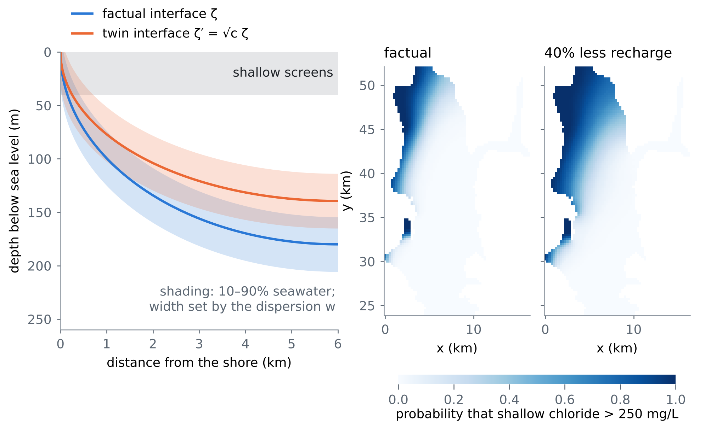
Figure 2. Left: the twin wedge in a schematic section; the interface of the drier aquifer is $\sqrt{c}$ times as deep below the aquifer top (Proposition L1) and the shading, set by the dispersion $w$, decides how much of the shallow screens it salts (Proposition L2). Right: the posterior probability that the shallow chloride exceeds 250 mg/L at Fushë-Kuqe given the documented facts, in the factual aquifer and with 40% less recharge (1000 posterior draws); the area with probability above one half grows from 31 to 65 km².
4.2 Guarantees
Proposition L1 (state abduction). For every conductivity field and geometry, the potential of the aquifer with recharge $cR$ is $cϕ$. Hence the twin interface, heads and chloride are functions of the factual potential, the geometry, $c$ and $w′$; by (3) they are functions of the factual heads and the geometry alone, without $K$ or $R$. In the inner zone, $ζ′−d=\sqrt{c} \left(ζ−d\right)$.

Proof. The discretised problem is $A\left(K\right)ϕ=R a$ with $a$ the cell areas; the shore condition and the Robin link to the sea are homogeneous, so $A\left(K\right)\left(cϕ\right)=cR a$ and the solution is unique. The state map $ϕ↦\left(h,ζ\right)$ is continuous and strictly increasing in each cell (both branches agree at $ϕ=δB^{2}/2$), so it can be inverted from $h$, which gives (3). For $c<1$ an inner-zone cell stays in the inner zone and $ζ′−d=\sqrt{2cϕ/δ}=\sqrt{c}\left(ζ−d\right)$. □
Proposition L2 (monotone salt; where the dispersion enters). For $c<1$ and $w′=w$: (i) $ζ′≤ζ$ in every cell and the chloride of every screen rises, so the salinized area and the toe area cannot shrink, for every value of the unknowns — the probability that the drier regime increased the salt is one, and the probabilities of necessity and sufficiency of the counterfactual are identified; (ii) the toe area depends on $ζ′$ only, so its counterfactual is free of $w$, while the chloride and the salinized area depend on $w$; (iii) the heads carry no information on $w$, which only chloride facts can reduce.

Proof. (i) $ζ\left(ϕ\right)$ is nondecreasing (Proposition L1) and $cϕ≤ϕ$; the screen average of $Φ\left(\left(z−ζ\right)/w\right)$ decreases in $ζ$, because $Φ$ decreases in $ζ$ for every $z$. (ii) The toe is where $ζ<d+B$. (iii) The heads are functions of $ϕ$ and the geometry (3), and $w$ enters neither $ϕ$ nor the geometry; under the prior $w$ is independent of them (review I found the rank correlation of $w$ with the littoral head to be 0.00). □
Proposition L3 (dispersion across worlds is not identified). Every factual quantity depends on $w$ and not on $w′$; the counterfactual chloride depends on $w′$. So the joint law of $\left(w,w′\right)$ is not identified by any factual data, however many: a counterfactual salinity band must state its assumption on $w′$ (shared, or a law such as $w′=w c^{−β}$).

Proof. The factual model (1) involves $w$ only; the twin (2) involves $w′$. Any coupling of $w′$ to $w$ leaves the factual law unchanged (review VII, Proposition K3, for the recharge noise). □
Proposition L4 (guaranteed counterfactual bands). Let data sets be simulated from the prior ensemble, let $m$ and $s$ be the importance-weighted posterior mean and sd of a counterfactual goal computed without the simulated truth, and let $q$ be the $⌈\left(n+1\right)\left(1−α\right)⌉$-th smallest of $n$ calibration scores $\left|x−m\right|/s$. Under the model, including its assumption on $w′$, the band $m±qs$ covers the counterfactual goal of a new data set with probability at least $1−α$.

Proof. The scores of the calibration sets and of the new set are exchangeable under the model; split conformal prediction (A2). The guarantee inherits the mechanism, as in review VII (Proposition K4). □
What is new. (1) Counterfactual salinity for a real coastal aquifer — salinized area, toe, seawater fraction of wells — under drier and wetter recharge regimes, with conformal guarantees. (2) State abduction: the drier aquifer follows from the factual state, even from the factual heads alone, without the conductivity or the recharge (Proposition L1). (3) A monotone salt response that identifies the probabilities of causation (Proposition L2). (4) The first measurement of how much of a salinity counterfactual is the dispersion coefficient, and which data reduce it (T28). (5) The cross-world dispersion assumption made explicit and priced (Proposition L3). To our knowledge none of these appears in the one hundred and sixty papers of reviews I–VIII.

4.3 Tests
T25: exactness of state abduction. Over 200 draws the re-solved twin potential differs from $cϕ$ by at most 1.1×10⁻¹⁵ of its maximum, and the twin interface computed from the factual heads alone (3) differs from the re-solved one by at most 1.5×10⁻¹¹ m. Over all 20000 draws, every cell and every $c<1$, the shallow chloride never fell (smallest change 0 mg/L), as Proposition L2 requires.
T26: the Fushë-Kuqe counterfactual. Table 2 and Figure 3. With the documented facts, the shallow salinized area is 31 km² (posterior median; 90% band 10–63); with 40% less recharge it would have been 65 km², an effect of 33 km² (90% band 15–49) km² after the conformal correction. Without the facts (the interventional answer) the effect band is 1–59 km², 1.7 times wider: the value of abduction of the four facts. The toe would have advanced over 33 km² (27–40) and the mid-depth seawater fraction of the SW band would have risen by 24 points (15–37). The dose-response is smooth and asymmetric: half the recharge adds 48 km² of salinized area, while 50% more recharge (a managed-recharge regime) removes 15 km².
Table 2. T26: Fushë-Kuqe with the documented facts. Posterior median and 90% band of the factual and the counterfactual goal (40% less recharge, shared dispersion); the effect without facts (prior, interventional) and with the facts (conformal band, T27).
Goal | Factual | Counterfactual | Effect, no facts | Effect, facts (conformal)
shallow salinized area (km²) | 31.3 (9.8–63.1) | 65.4 (22.2–108.9) | 17.0 (1.4–58.6) | 32.9 (15.3–49.3)
toe area (km²) | 94.8 (63.6–124.5) | 128.2 (95.8–161.2) | 31.2 (14.8–40.1) | 33.4 (27.4–40.1)
mid-depth seawater fraction (points) | 9.6 (2.9–25.8) | 35.3 (19.4–60.8) | 15.9 (0.0–43.7) | 24.4 (14.7–36.8)

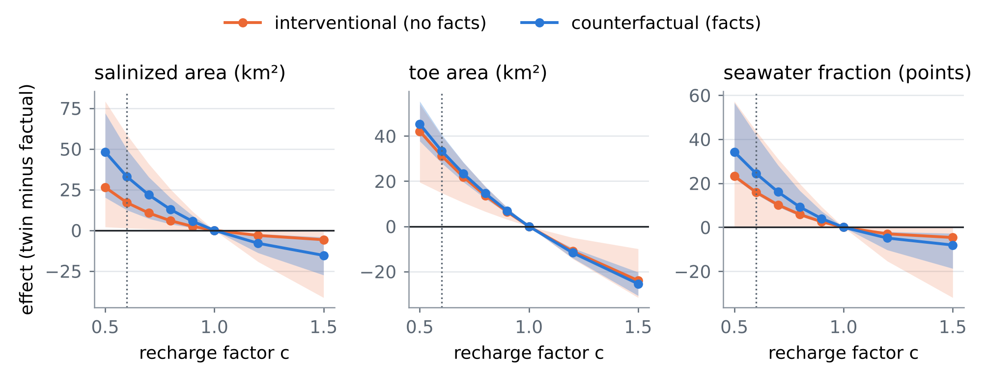
Figure 3. T26: the effect of a recharge factor $c$ on the three goals (median and 90% band); orange without the facts (interventional), blue with them (counterfactual). The dotted line marks the 40% drier regime of Table 2; $c>1$ is a wetter or managed-recharge regime.
T27: coverage. Figure 4, left. On 600 data sets simulated from the prior (300 for calibration, 300 for test) the importance-sampling bands already cover 0.883–0.923, and the conformal bands 0.887–0.900, for the effects and the counterfactual levels of the three goals; the conformal multipliers are 1.36–1.63 for the effects. The guarantee is model-based: it holds as long as the mechanism, including the assumption on $w′$, is the model's.
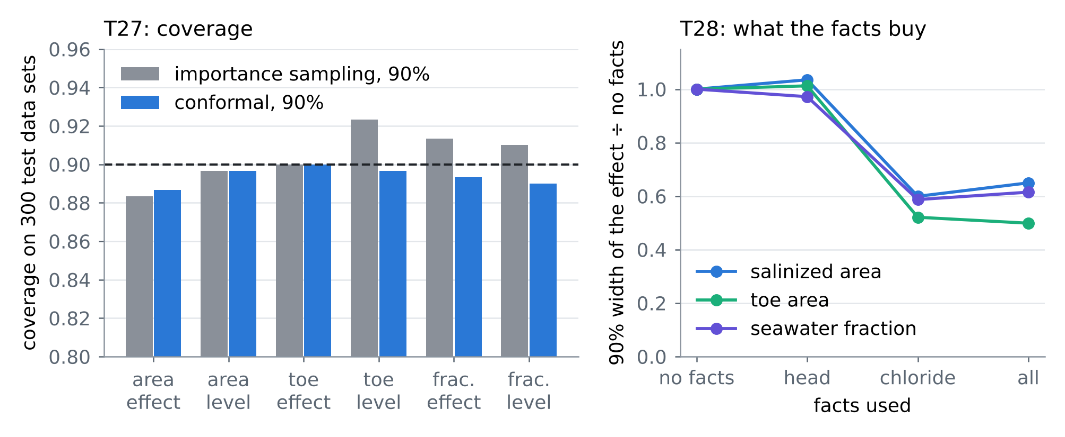
Figure 4. Left, T27: coverage of the 90% bands on 300 simulated test data sets (dashed: 0.90). Right, T28: the 90% width of the effect with each group of facts, relative to no facts.
T28: what the counterfactual depends on. Figures 4 (right) and 5. The littoral head does not narrow the salinity effects (width ratio 1.03 for the area, 0.97 for the fraction); the chloride facts do (0.60 and 0.59). Under the posterior the dispersion width $w$ alone carries 62% of the variance of the area effect and 74% of the fraction effect, the recharge 21% of the latter; the toe effect is free of $w$ (Proposition L2 (ii)) and is set mostly by the thinning length of the aquifer (54%). The sign of the dispersion's influence depends on the goal: a wide transition zone makes the drought salt more of the shallow area (effect 13 km² for the narrowest tenth of $w$, 43 km² for the widest) but less of the mid-depth screens (42 against 17 points). Finally the cross-world assumption: if the transition zone widened in the drier world as $c^{−1/4}$ or $c^{−1/2}$, the area effect would be 48 or 64 km² instead of 33 km² (Proposition L3), while the toe effect would not change.
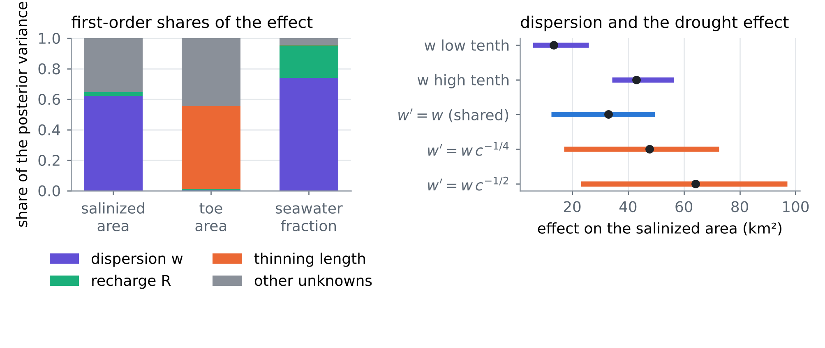
Figure 5. T28: left, first-order shares of the posterior variance of the three effects; right, the effect on the salinized area for the narrowest and widest tenth of the posterior of $w$, and under three cross-world laws of the dispersion width (median and 90% band).
4.4 Using the salt counterfactual at Fushë-Kuqe
• Scenarios without the unknowns that cannot be had: the drier or the managed-recharge aquifer follows from the factual state; a good map of the factual heads replaces the conductivity field for the interface counterfactual (Proposition L1).
• Measure chloride, not heads, for salinity scenarios: the dispersion width decides most of the salinity counterfactual and only chloride data inform it (T28); the chloride-sampling design of D2 is the instrument.
• State the dispersion assumption: report the shared-width band and the widened-width band side by side; whether the mixing zone would widen under a drier regime is to be set with the local hydrogeologists from the tidal and pumping regime.
• Toe first: the toe counterfactual is free of the dispersion and is the robust headline; the salinized area is the decision quantity and carries the dispersion uncertainty.
5. Synthesis: one hundred and sixty papers in one procedure
Table 3 places the hundred and sixty papers of reviews I–VIII on the steps of the procedure; card numbers carry the review (VIII-C2 is card C2 of this review).
Table 3. The one hundred and sixty papers of reviews I–VIII against the steps of the procedure (card numbers of each review; a paper can serve several steps).
Step | I | II | III | IV | V | VI | VII | VIII
prior from rain | O3, O5, C5, M1 | O1, O2, O5, C1, C2, C3, C4, B1, B4, M2, M5 | O1, O2, O3, O4, O5, C1, C2, C3, C4, C5, B1, B2, B3, B4, B5, M1, M2, M3 | O2, O5, C5, B3, B5 | O4, C1, C2, C4, B3, B4, B5, M3, M4, M5 | – | O1, O5, C3, C4, C5, B5 | O1, O3, O4, C4, B5, M4
emulate | O1, O3, C1, B1 | C1, B5, M2 | C3, M4 | O1, O3, O4, C1, M4 | – | C4, B5, M2, M3, M5 | O1, O3, O5, C4, B1, B2, B5, M1, M2, M3 | O2, C2, C5, B2, B3, B5, M1, M2, M4
invert | O1, O2, C2, C3, C4, B1 | O1, O2, O4, C4 | B1 | O4, C2, B2, M3 | B2 | O2, O3, C1, C3, B2, M1, M2, M3, M5 | O2, O3, C1, C2, B2, M2, M5 | C1, C2, C3, B1, M1, M3, M5
guarantee | O4, C1, B2, B3, B5, M2, M3 | O2, M1, M4 | C2, B5, M5 | O1, O3, C1, C2, C4, B1, B2, B3, B4, M1, M2 | O1, O2, O4, C3, C5, B1, B2, B4, M1, M2 | O1, O5, C1, C2, B1, B2, B3, B4, B5 | C1, B1, B3, M1, M4, M5 | O5, B3, B4, M2, M3
field check | B2, B4, M4, M5 | C3, B1, B2, M3, M4 | O2, O4, C4, C5, B2, M1, M2, M4, M5 | O2, O4, C1, C3, C4, C5, B1, M3, M5 | O2, O3, O5, C1, C3, C4, B5, M3, M4 | O1, C3, B4 | C5, B3, B4, M4 | O1, O4, C3, B1, B4
design, operate | O5, C5, M4 | O3, O4, C1, C2, C3, C5, B2, B3, B4, M1, M3 | C1, B4, M3 | B5, M1 | C5 | O2, O3, O4, C4, C5, M4 | O4, C2 | B2, M5

6. Limitations
• Every card is partly verified: landing pages, and the exact wording of the results, were reached through search results only.
• The chloride model is steady: the counterfactual is a regime counterfactual (a long-term drier or wetter recharge), not a year-by-year one; the transient version needs the variable-density section model.
• The guarantee of Proposition L4 is model-based: it inherits the facies prior, the four facts and their error model, and the assumption on the cross-world dispersion; field anchors with measured chloride would make it model-free for the factual part (review IV).
• The width $w$ is one number for the whole sector; a spatially varying dispersion, and its dependence on tides and pumping, would change the variance shares of T28.
References
Anchors (provided by the user)
[A1] Angelopoulos, A. N., Bates, S., Fisch, A., Lei, L., & Schuster, T. (2024). Conformal risk control. The Twelfth International Conference on Learning Representations (ICLR 2024). arXiv:2208.02814 (PDF provided by the user). https://arxiv.org/abs/2208.02814
[A2] Tibshirani, R. (2023). Conformal prediction. Lecture notes, Advanced Topics in Statistical Learning, Spring 2023, University of California, Berkeley (PDF provided by the user). https://www.stat.berkeley.edu/~ryantibs/statlearn-s23/
The twenty papers of this review
[O1] A. Paldor, C. Bertoni, B. Penny, H. A. Michael (2024). Offshore freshened groundwater reservoirs controlled by submarine faults with a complex dependency on antecedent hydrogeological conditions. Science of The Total Environment 952, 175834 (2024). https://doi.org/10.1016/j.scitotenv.2024.175834
[O2] Graham P. Benham (2023). The near-field shape and stability of a porous plume. Journal of Fluid Mechanics 955, A13 (2023). https://doi.org/10.1017/jfm.2022.1068
[O3] Solomon H. Gebrechorkos et al. (full author list not seen) (2023). Global high-resolution drought indices for 1981–2022. Earth System Science Data 15(12), 5449–5466 (2023). https://doi.org/10.5194/essd-15-5449-2023
[O4] Manuela I. Brunner, Louise J. Slater (2022). Extreme floods in Europe: going beyond observations using reforecast ensemble pooling. Hydrology and Earth System Sciences 26(2), 469–482 (2022). https://doi.org/10.5194/hess-26-469-2022
[O5] Benjamin Fehrman, Benjamin Gess (2023). Non-equilibrium large deviations and parabolic-hyperbolic PDE with irregular drift. Inventiones Mathematicae (2023), 573–636 (volume not seen). https://doi.org/10.1007/s00222-023-01207-3
[C1] Assyr Abdulle, Giacomo Garegnani, Grigorios A. Pavliotis, Andrew M. Stuart, Zanoni (given name not seen) (2023). Drift Estimation of Multiscale Diffusions Based on Filtered Data. Foundations of Computational Mathematics 23, 33–84 (2023). https://doi.org/10.1007/s10208-021-09541-9
[C2] Costa Christopoulos, Ignacio Lopez-Gomez, Tom Beucler, Yair Cohen, Charles Kawczynski, Oliver R. A. Dunbar, Tapio Schneider (2024). Online Learning of Entrainment Closures in a Hybrid Machine Learning Parameterization. Journal of Advances in Modeling Earth Systems 16(11), e2024MS004485 (2024). https://doi.org/10.1029/2024MS004485
[C3] Yifei Guan, Pedram Hassanzadeh, Tapio Schneider, Oliver Dunbar, Daniel Zhengyu Huang, Jinlong Wu, Ignacio Lopez-Gomez (2026). Online learning of eddy-viscosity and backscattering closures for geophysical turbulence using ensemble Kalman inversion. Physical Review Research 8, 023215 (2026). https://doi.org/10.1103/mnbm-3g56
[C4] Daniel Blank, Annette Eicker, John T. Reager, Andreas Güntner (2025). Revisiting Sub-Surface Drought Cascades With Daily Satellite Observations of Soil Moisture and Terrestrial Water Storage. Water Resources Research 61(8), e2024WR039321 (2025). https://doi.org/10.1029/2024WR039321
[C5] Mikael K. Witte, Adam Herrington, Joao Teixeira, Marcin J. Kurowski, Maria J. Chinita, Rachel L. Storer, Kay Suselj, Georgios Matheou, Julio Bacmeister (2022). Augmenting the Double-Gaussian Representation of Atmospheric Turbulence and Convection via a Coupled Stochastic Multi-Plume Mass-Flux Scheme. Monthly Weather Review 150(9), 2339–2355 (2022); DOI not seen. https://impacts.ucar.edu/en/publications/augmenting-the-double-gaussian-representation-of-atmospheric-turb/
[B1] N. E. Thiros, E. R. Woodburn, W. P. Gardner, J. P. Dennedy-Frank, K. H. Williams (2025). Matrix Diffusion Controls Mountain Hillslope Groundwater Ages and Inferred Storage Dynamics. Groundwater 63(3), 306–318 (2025). https://doi.org/10.1111/gwat.13475
[B2] Zexuan Xu, Rebecca Serata, Haruko Wainwright, Miles Denham, Sergi Molins, Hansell Gonzalez-Raymat, Konstantin Lipnikov, J. David Moulton, Carol Eddy-Dilek (2022). Reactive transport modeling for supporting climate resilience at groundwater contamination sites. Hydrology and Earth System Sciences 26(3), 755–773 (2022). https://doi.org/10.5194/hess-26-755-2022
[B3] S. Chandra Mouli, Maddix, Alizadeh, Gupta, Stuart, Mahoney, Wang (other given names not seen) (2024). Using Uncertainty Quantification to Characterize and Improve Out-of-Domain Learning for PDEs. Proceedings of the 41st International Conference on Machine Learning (ICML 2024), PMLR 235, 36372–36418. https://proceedings.mlr.press/v235/mouli24a.html
[B4] Dennis Shen, Peng Ding, Jasjeet Sekhon, Bin Yu (2023). Same Root Different Leaves: Time Series and Cross-Sectional Methods in Panel Data. Econometrica 91(6), 2125–2154 (2023). https://doi.org/10.3982/ECTA21248
[B5] Erica R. Siirila-Woodburn, Nicholas Thiros, Michelle Newcomer and colleagues (full author list not confirmed) (2026). Warming and snow loss increase reliance on old groundwater in a Colorado River headwater. Nature Geoscience 19(5), 549–555 (2026). https://doi.org/10.1038/s41561-026-01945-y
[M1] Wagner, Hillier, Constantinou, Silvestri, Souza, Burns and colleagues (given names and the full list not seen) (2025). Formulation and calibration of CATKE, a one-equation parameterization for microscale ocean mixing. Journal of Advances in Modeling Earth Systems 17, e2024MS004522 (2025). https://doi.org/10.1029/2024MS004522
[M2] Rahul Singh, Liyuan Xu, Arthur Gretton (2024). Kernel methods for causal functions: dose, heterogeneous and incremental response curves. Biometrika 111(2), 497–516 (2024). https://doi.org/10.1093/biomet/asad042
[M3] Zheyu Oliver Wang, Ricardo Baptista, Youssef Marzouk, Lars Ruthotto, Deepanshu Verma (2025). Efficient neural network approaches for conditional optimal transport with applications in Bayesian inference. SIAM Journal on Scientific Computing 47(4), C979–C1005 (2025). https://arxiv.org/abs/2310.16975
[M4] Youssef Marzouk, Zhi (Robert) Ren, Sven Wang, Jakob Zech (2024). Distribution learning via neural differential equations: a nonparametric statistical perspective. Journal of Machine Learning Research 25(232), 1–61 (2024). https://jmlr.org/papers/v25/23-1280.html
[M5] Matthew T. C. Li, Youssef Marzouk, Olivier Zahm (2024). Principal feature detection via ϕ-Sobolev inequalities. Bernoulli (2024), doi:10.3150/23-BEJ1702 (volume and pages not seen). https://doi.org/10.3150/23-BEJ1702
Data and project documents
[D1] Zeqiraj, D. (2026). Reviews I–VII of this series (GARANCIA-GO, MATJA-GO, RESHJA-GO, ANKORA-GO, PRIRJA-GO, DYSHEMEJA-GO, SHKAKU-GO), docs/literature/ in this repository.
[D2] Zeqiraj, D. (in preparation). From sparse hydrochemistry to decision-relevant information: probabilistic chloride mapping and goal-oriented monitoring design for seawater intrusion in the Fushë-Kuqe coastal aquifer, Albania; the areal chloride model and its calibration ensemble (chloride_fk/ in this repository).
[D3] Zeqiraj, D. (2026). Journal of Hydrology 680, 136559 (the companion study of the chloride model; facies-conditional conductivity prior).
[D4] Cenameri, M., & Beqiraj, A. (2016). Documented seawater-intrusion facts and hydrochemical analyses of the Fushë-Kuqe–Lezhë sector, as compiled in the project workbook (sheets 5 and 7).
[D5] The code of this review: experiments/kripa_go/ (with chloride_fk/python/).
Verification note. The bibliographic data of the twenty cards come from search results that quote the publisher, arXiv, proceedings or repository pages; doi.org, arxiv.org, jmlr.org, proceedings.mlr.press, proceedings.neurips.cc and most publisher hosts could not be opened directly in this environment. The anchors were read from the PDFs provided. Every number of Sections 1, 2, 4 and 7 is computed by the code in experiments/kripa_go/ with the chloride model of chloride_fk/python/ and its calibration ensemble.

7. Summary of novelty
The step in one paragraph. The eight reviews of this series turn one question — what can be known, with a guarantee, about the inputs, the dispersion and the boundary conditions of a coastal aquifer when only the rain is always known — into a procedure with proofs and tests. Reviews I–VI made the bands valid under calibration, measurement choice, an uncertain rain, a wrong simulator and a drifting world, and measured how close they come to the narrowest possible band. Review VII asked what would have happened under another rain, with a guarantee. This review asks the same of the salt itself, on the real Fushë-Kuqe model, and finds that a 40% drier recharge regime would roughly double the salinized area (31 → 65 km²), that this answer needs the factual state but not the conductivity, and that the dispersion coefficient — the unknown the series had left open — carries most of its uncertainty.
7.1 What is new in this review
• A salinity counterfactual with a guarantee for a real aquifer: the drought effect on the salinized area is 33 km² (90% band 15–49) km², on the toe 33 km² (27–40), on the seawater fraction of the SW wells 24 points (15–37) (T26, T27); no attribution study of Section 3 gives a coverage statement.
• State abduction: the drier aquifer is $ϕ′=cϕ$ of the factual one, and its interface follows from the factual heads alone (error 1.5×10⁻¹¹ m): scenario questions no longer need the conductivity field (Proposition L1).
• Monotone salt and identified probabilities of causation: a drier regime never lowers the chloride of any screen, for any value of the unknowns (Proposition L2; checked over all draws and cells).
• The dispersion coefficient, measured inside a counterfactual: 62% of the posterior variance of the area effect and 74% of the fraction effect; the sign of its influence differs between the shallow and the mid-depth screens (T28).
• Which data reduce a salinity counterfactual: the head facts do not (width ratio 1.03), the chloride facts do (0.60); the toe counterfactual is free of the dispersion (T28).
• The cross-world dispersion assumption: not identified by any factual data (Proposition L3); it moves the area effect from 33 to up to 64 km², and must be reported (T28).
• Dose-response for planning: half the recharge adds 48 km² of salinized area; 50% more recharge (managed aquifer recharge) removes 15 km² (T26).
7.2 The novelty that each of the twenty papers brings to our problem
Table 4. The step beyond each card of Section 3, in one line.
Card | Paper | The step beyond it in this project
O1 | Coastal salinity depends on its history | The antecedent interface and the flow dependence of dispersion as the two conditions under which the steady salinity counterfactual (31 → 65 km²) holds.
O2 | Geometry, not mixing, shapes the near field | Geometry versus mixing: the toe counterfactual (33 km² (27–40)) is free of the dispersion, the salinized-area counterfactual is mostly dispersion (62%).
O3 | Global drought indices at 5 km | Drought-index classes mapped to the recharge factor, which turns the dose-response into salinity per drought class.
O4 | Extremes beyond the record from pooled forecasts | Pooled forecast ensembles as the source of regimes beyond the record, for which KRIPA-GO gives the salt response.
O5 | Large deviations of conservative transport | Rare-event theory for conservative transport, as the route from the counterfactual band to the probability of an extreme salinization beyond it.
C1 | Unbiased effective coefficients from multiscale data | The effective dispersion coefficient as the quantity that decides a salinity counterfactual (62% of its variance), estimated with scale-aware filtering.
C2 | A mixing closure learned online and tested under new forcing | A closure learned across forcings as the way to learn the cross-world dispersion law, which moves the drought effect from 33 to 64 km².
C3 | Regime-invariant mixing coefficients with uncertainty | Regime invariance of a mixing coefficient as a testable form of the shared-dispersion assumption, whose failure KRIPA-GO prices.
C4 | Daily satellite view of the drought cascade | Satellite drought cascades as the transient path to the steady salinity counterfactual (31 → 65 km²).
C5 | Local plus non-local stochastic transport | Non-local stochastic transport as the next model of the transition zone, beyond a single width that already spans 13–43 km² of drought effect.
B1 | Matrix diffusion and the storage inferred from tracers | Mass transfer and dispersion leave the same mark on a few facts: the chloride facts that narrow the counterfactual to 0.60 of its prior width must be read with that ambiguity.
B2 | Recharge scenarios for a reactive plume | The monotonicity that identifies a salinity counterfactual (Proposition L2) holds for a conservative tracer and fails for reactive ones, as their uranium response shows.
B3 | Surrogate uncertainty fails out of domain | Exact state abduction removes the out-of-domain error of a surrogate for the interface counterfactual; where a surrogate is unavoidable, twins recalibrate it.
B4 | Same counterfactual, different randomness | A salinity counterfactual band must state its source of randomness (here aquifers of the prior); over wells or years it is a different estimand.
B5 | Warming makes the groundwater older | Drought shifts reliance to old water; at the coast that is the advancing wedge, whose counterfactual toe (33 km² (27–40)) is free of the dispersion.
M1 | A state-dependent, calibrated mixing coefficient | A flow-state-dependent mixing coefficient as the physical form of the cross-world dispersion law, which moves the drought effect up to 64 km².
M2 | Counterfactual dose curves with uniform rates | The recharge factor as a dose: a counterfactual dose curve of the salinized area, from +48 km² at half the recharge to −15 km² at 1.5 times.
M3 | Amortized conditional transport for inference | Amortized conditional transport for the counterfactual posterior, with the coverage layer of Proposition L4 on top.
M4 | Rates for flow-based generators | Rates for learned regime generators; with the potential linear in the recharge (Proposition L1), each generated regime costs a linear combination of precomputed solves.
M5 | Certified principal features | The dispersion width as the principal feature of the salinity counterfactual (62% of its variance), with certified error for a reduced counterfactual.

7.3 Eight reviews, one chain of innovations
Table 5. The innovations of reviews I–VIII (numbers from each review's tests).
 | Innovation | Question | New answer | Key number
I | GARANCIA-GO | Are bands for the boundaries from rain valid? | simulation-calibrated conformal risk control | raw ensemble misses 17–20% of weeks; calibrated 0.095–0.100
II | MATJA-GO | What is an instrument worth? | the guaranteed value of a measurement | a tide gauge is worth zero for recharge, a factor 14 for sea level
III | RESHJA-GO | What if the rain is uncertain? | the rain product's errors inside the simulator | κ misses 0.70–0.76 if ignored; risk 0.093–0.103 when modelled
IV | ANKORA-GO | What if the simulator is wrong? | a few real anchors | risk ≤ 0.10 under every law; simulation-calibrated up to 0.83
V | PRIRJA-GO | What if the world drifts? | horizon-matched anchors | risk 0.003–0.082 up to 10 years under drift
VI | DYSHEMEJA-GO | How narrow can a guarantee be? | the Neyman–Pearson floor | the 20-anchor band is 1.34–1.54 times the floor
VII | SHKAKU-GO | What would have happened? | guaranteed counterfactual bands | a 40% drought lowers the head at the well by 1.94 m; floor 0.088 m
VIII | KRIPA-GO | What would the salt have done? | state abduction and the dispersion counterfactual | salinized area 31 → 65 km²; dispersion 62% of the effect's variance

7.4 What the proposal can now claim, and what stays open
• Claim: guaranteed bands for every family of unknowns — inputs, boundary conditions and, through the chloride facts, the dispersion width — from rain and a few heads, valid under a wrong simulator, an uncertain rain and drift, with their distance from the best possible band known.
• Claim: guaranteed answers to scenario questions — how the heads, the recharge and the salinized area would have differed under a drier or a managed-recharge regime — together with the assumptions no data can test, stated and priced.
• Claim: a design rule: heads for the boundaries and the recharge coefficient, chloride for the dispersion and the salinity scenarios, anchors for the guarantee in the field.
• Open: a transient, variable-density counterfactual of the transition zone; a spatially varying and flow-dependent dispersion; field anchors with measured chloride to make the salinity guarantee model-free.
7.5 Innovation statement for the proposal
Ready to paste. The project delivers, for the first time for a coastal aquifer, guaranteed answers to "what would have happened" questions about its salt. From the rain, a few heads and a handful of chloride facts, it computes how the salinized area, the toe of the seawater wedge and the salinity of the wells would have differed under a drier or a managed-recharge regime, with bands that cover the truth at the stated rate on simulated aquifers (0.887–0.900 for 90% bands). Three results make this possible and are new. First, the counterfactual aquifer follows from the observed state alone — the conductivity field and the recharge are not needed — so a map of heads is enough for the interface. Second, the salt response to a drier regime is monotone, so the direction of the effect is certain and only its size is uncertain. Third, the dispersion coefficient is identified as the quantity that decides the size: it carries 62% of the uncertainty of the salinized-area effect, heads cannot reduce it and chloride samples can. Applied to Fushë-Kuqe, a 40% drier regime would raise the salinized area from 31 to 65 km²; managed recharge of +50% would lower it by 15 km². The one assumption no data can test — whether the mixing zone itself would widen in the drier world — is stated and priced (up to 64 km²), which turns a scientific caveat into a monitoring and design decision.

