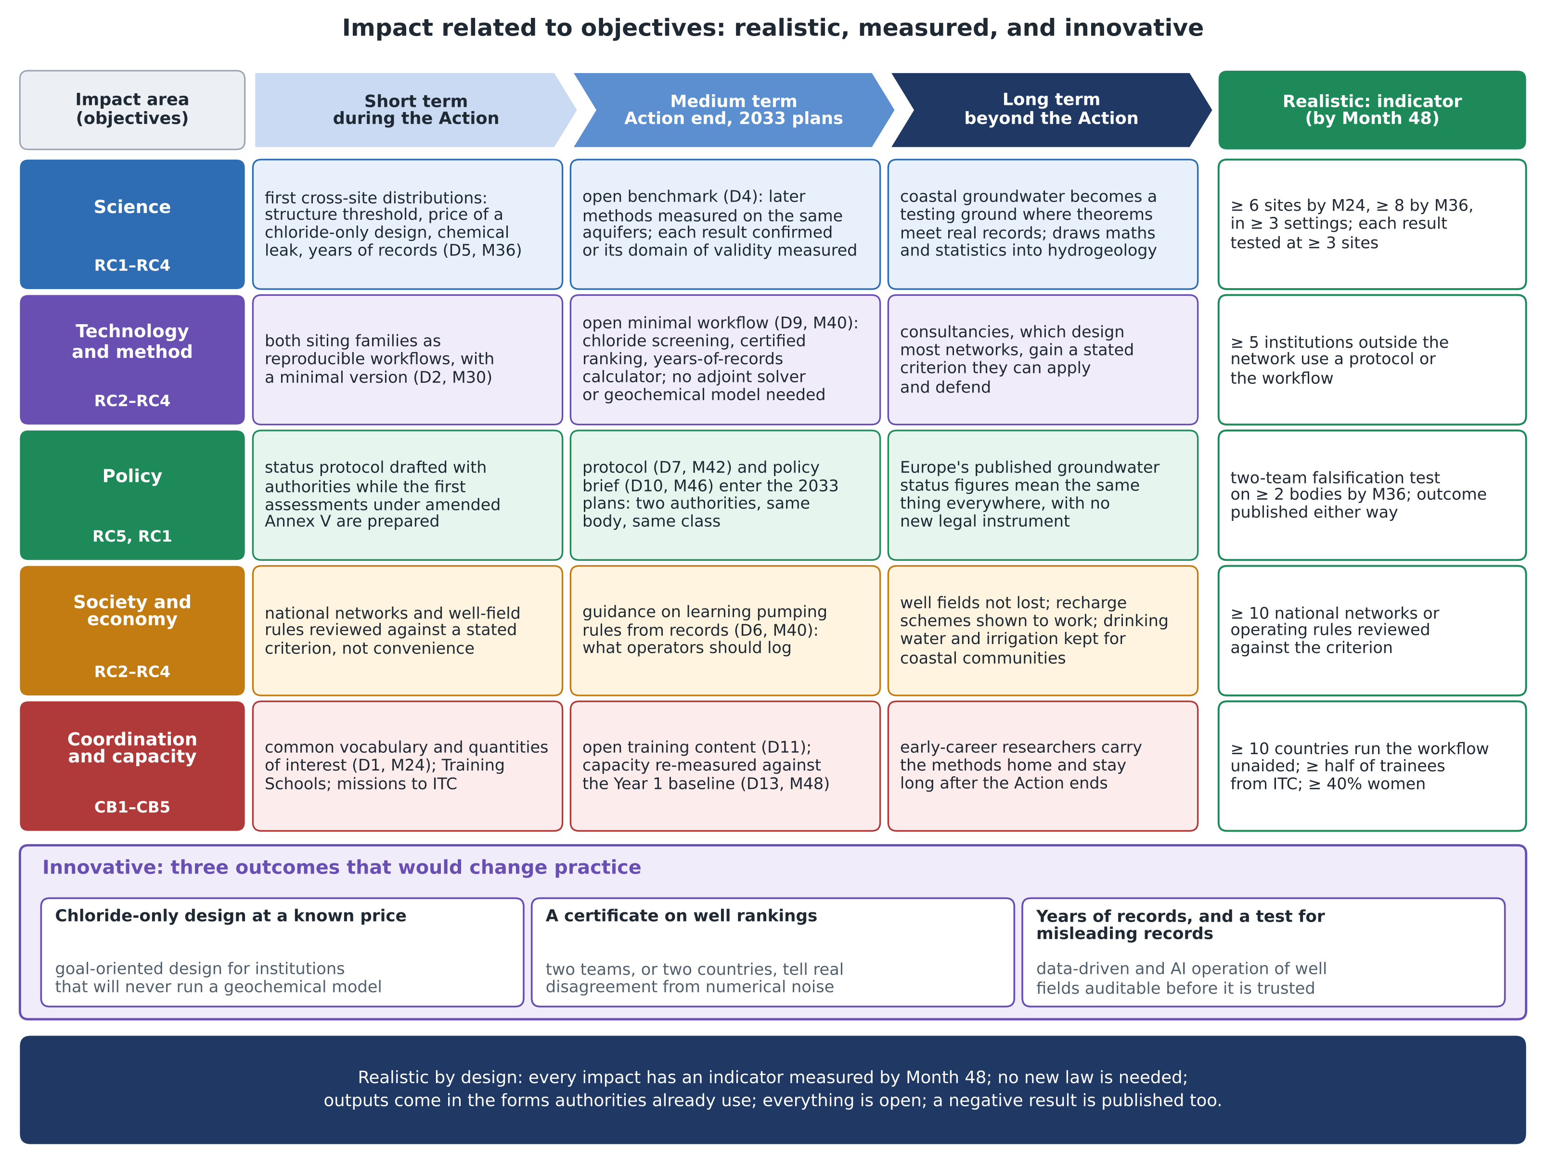
Figure. Impact related to objectives: for each impact area (science, technology and method, policy, society and economy, coordination and capacity) and the objectives it serves, the short-, medium- and long-term impact, the indicator that makes it realistic, and the three outcomes that make it innovative. Content as in annex sections 2.A and 3.C.

