State of the art IV: when the simulator is wrong
Twenty more papers from Oxford, Caltech, Berkeley and MIT (2020–2026) on transferring knowledge between sites, inference under shift, mixing and coastal boundaries; the state of the art and the step beyond it; and ANKORA-GO, guarantees made independent of the simulator by a few real anchors
Dulian Zeqiraj · November 2026 · review with a numerically tested innovation · companion to reviews I–III (GARANCIA-GO, MATJA-GO, RESHJA-GO)
1. Outcome
• Twenty new papers, five per institution, 2020–2026, each with links (Section 3, Figure 1). None was a card of reviews I–III or of the earlier reviews. They address the weak point the three earlier reviews share: every guarantee was calibrated on simulated aquifers and holds only if the simulator's prior is the real law. Each card gives the state of the art the paper sets, what it cannot yet do for us, three lessons and an innovation step.
• State of the art and beyond, for the proposal (Section 2, Table 1), and a map of all eighty papers of reviews I–IV on the steps of the procedure (Section 5, Table 3).
• Innovation: ANKORA-GO (Section 4). A few anchors, sites or periods where a boundary function was actually measured, calibrate the band instead of the simulations. Proposition A1: the guarantee then holds for whatever the real law is. Proposition A2: at least 9 anchors are needed for a guarantee on average and 22 for a certificate at 90% confidence, whatever method is used. Proposition A3: mixing simulations and anchors narrows the band at the price of a bias proportional to the weight put on the simulations.
• Test: the simulation-calibrated guarantee breaks under every realistic shift (T12, 600 field cases per law). With a field vadose delay of 35 d, shifted parameters or an unrecognised rain bias, the share of weeks outside the 90% bands is 0.11–0.82 instead of at most 0.10, up to 0.82 for $κ$. Calibrated on 20 real anchors it is 0.056–0.099, and on 40 anchors 0.077–0.099, under all four laws.
• The price (T13). Without shift, 20 anchors widen the band by 14% on average against the simulations (40 anchors: 6%); under shift the band widens by as much as the real errors demand, up to 8.4 times for $κ$ under a rain bias. Ten anchors are valid but very conservative.
• Mixing (T14). Putting half of the calibration weight on simulations keeps the guarantee when there is no shift (risk 0.074–0.094) and narrows the band by 7%, but breaks it under shift (risk 0.08–0.19, above 0.10 in 9 of 12 cases): the anchors cannot tell which case they are in, so the safe rule is to calibrate on anchors alone and use the simulations to choose instruments and to build the score.

2. State of the art and the step beyond it
Reviews I–III (D1–D3) guarantee bands for boundary conditions, choose instruments and handle an uncertain rain, always by calibrating on aquifers simulated from a prior. Their common limit is stated in each of them: the guarantee is marginal under that prior, and a wrong prior is detected by the field check only partly (review I, Proposition 5). This review asks how real data with known truth, which exist but are scarce, can make the guarantee hold for the real world.
Text for the proposal. Hydrological and hydrogeological knowledge is increasingly transferred between sites through large-sample datasets, regionalisation and machine learning trained on many catchments, and simulation-based inference is calibrated on synthetic data (Section 3). Such transfers are judged by average skill, and their uncertainty statements hold only if the training sites, or the simulator, resemble the target. The project goes beyond the state of the art by calibrating its guarantees on a few real anchors, sites or periods where a boundary function was measured, so that they hold whatever the real law is (ANKORA-GO); by stating how many anchors any method needs (9 for an average guarantee, 22 for a certificate at 90% confidence); and by quantifying, with tests, what simulations still contribute and what mixing them with anchors costs.
Table 1. State of the art (2020–2026) and the step beyond it. Card numbers refer to Section 3; T numbers to the tests of Section 4.
Topic | State of the art | Its limit for our problem | Our step beyond | Evidence
Transferring knowledge between sites | Donor-site priors from site similarity (B3); network regionalisation with representative sites (B5); pre-training on simulations, fine-tuning on gauges (O1, O3); intervals for the transfer error across domains (M2) | Judged by average skill, or guaranteed only for domains drawn from one family; nothing certifies the target site | Calibrate the target's bands on anchors chosen by similarity (Proposition A1); aquifer-level scores when anchors come from several aquifers | T12: with 20 anchors risk 0.056–0.099 under every law
Inference with few real labels | Prediction-powered inference, power-tuned (B1) and with anchors chosen in waves (M1); clustered conformal prediction (B4) | For means or classes, not for bands of boundary functions; asymptotic, with no minimum sample stated | Anchor-calibrated risk control; at least 9 anchors on average, 22 for a certificate (Proposition A2) | Propositions A1–A2
Simulators that may be wrong | Post hoc uncertainty from simulated truth, checked at ground stations (C1); prior-free frequentist intervals (C2); emergent constraints across ensembles (O4); physics-guided rescaling for use out of distribution (M4); simulation-calibrated guarantees (reviews I–III) | The ground truth only checks; or the forward model must be right; or no coverage is stated | Anchors make the guarantee simulator-free; simulations keep the design roles and build the score | T12: simulation-calibrated risk 0.11–0.82 under shift
Mixing simulations and real data | Power-tuned prediction-powered inference (B1); proxy-calibrated parameters validated at field probes (O2) | The mix inherits the simulator's bias in proportion to its weight | Exact bias bound α + ψ·TV (Proposition A3); anchors alone as the safe rule | T14: ψ = 0.5 gives risk 0.08–0.19 under shift
Benchmarks with measured truth | Satellite, wells and models across 14 aquifers (C3); withheld-truth validation at flux towers (C4); replicate experiments that measure the noise of the truth (M5) | Skill scores, not coverage; model-to-data factors of 2.4–4 left uncorrected | Benchmark sites and periods as anchors that calibrate, with replicates for the anchors' own noise | T13: risk 0.011–0.099 with 10, 20 or 40 anchors
Calibration periods and regimes | Multiyear, contrast-spanning calibration at an observatory (B2); regime-dependent calibration that exposes a closure's structural error (M3) | One period or one regime gives unreliable parameters | Anchor periods chosen to span wet and dry years; anchors calibrated per regime as a test of the simulator | Proposition A1 (the law of the anchors is the law guaranteed)
Dispersion and the coast | Mixing closures calibrated with full uncertainty (M3); recharge-dependent transport pathways (B2); relict offshore fresh water (O5); observation-anchored sea level (C5) | No field dispersivity with a guarantee; sea boundary and initial interface taken from models | Tide-gauge years and chloride profiles as anchors for the sea boundary and the transition zone | T12: sea-level risk 0.11–0.17 from simulations under shift, 0.056–0.057 with 20 anchors

3. The twenty papers
Five papers per institution, all from 2020–2026 (Figure 1). The rules of the earlier reviews apply: direct use, a link to the institution at the time of publication (JPL for Caltech, Lawrence Berkeley National Laboratory for Berkeley), a state-of-the-art contribution, and no paper that was a card before. This batch gives priority to transferring knowledge between sites and to inference under shift, then to mixing and coastal boundaries. Five of the twenty are preprints, a working paper or a workshop paper (O1, O3, B1, M1, M2); the venue line of each card says so. No new 2020–2026 paper on field dispersivity was found at the four institutions, so dispersion is served indirectly (M3, O4, O5, M5).
Verification. The hosts doi.org, arxiv.org, openreview.net and most publisher pages were blocked in this environment, so every landing page was reached through search results that quote it, and every card is marked partly verified; where an author list or a volume could not be confirmed, the card says so.
3.1 University of Oxford
O1 · Oxford · 2026
Global river forecasting with a topology-informed AI foundation model
Hancheng Ren, Gang Zhao, Shuo Wang, Louise Slater, Dai Yamazaki, Shu Liu, Jingfang Fan, Shibo Cui, Ziming Yu, Shengyu Kang, Depeng Zuo, Dingzhi Peng, Zongxue Xu, Bo Pang
arXiv:2602.22293 (preprint, February 2026); companion abstract EGU26-22456
Links: arXiv:2602.22293 · EGU26-22456
Affiliation and verification: L. Slater: School of Geography and the Environment, University of Oxford (search summary of the EGU26 abstract); the other affiliations seen were Beijing Normal University and the University of Tokyo. Preprint; no journal version was seen. Status: partly verified (landing pages reached through search results only).
What it does. GraphRiverCast is a graph network that follows the river-network topology and simulates several river variables over the globe. It is pre-trained on physics-based CaMa-Flood simulations driven by bias-corrected runoff and then fine-tuned on sparse in-situ gauges. In a "ColdStart" mode it needs no past river states, and in 7-day global pseudo-hindcasts it reaches NSE ≈ 0.82. After fine-tuning it is reported to beat physics-based and locally trained baselines, and the gauge information spreads through the network to ungauged reaches.
State of the art it sets. A global river model pre-trained on simulations and fine-tuned on observations, carrying sparse gauge information to ungauged reaches.
What it cannot yet do for us. No calibrated uncertainty and no guarantee after fine-tuning; no per-basin gains seen; surface water only.
Input parameters. The closest real-world template for this batch: learn from the simulated aquifers (the prior over $T$, $S$, $κ$, $τ$), then correct with a few real heads; the connectivity of the aquifer plays the role of the river topology in carrying anchor information to unmonitored wells.
Dispersion coefficient. None.
Boundary conditions from rain alone. ColdStart maps the forcing history alone to the state, which bears on the unknown initial heads and interface; river inflow is the analogue of the inland boundary.
Innovation step for our problem. Fine-tuning changes the estimator, not its guarantee, so keep the two roles of the anchors apart: fine-tune on some anchors and calibrate (1) on the others. The band then holds for the real law whatever the fine-tuning did (Proposition A1), and at least 9 anchors must be kept for the calibration (Proposition A2).

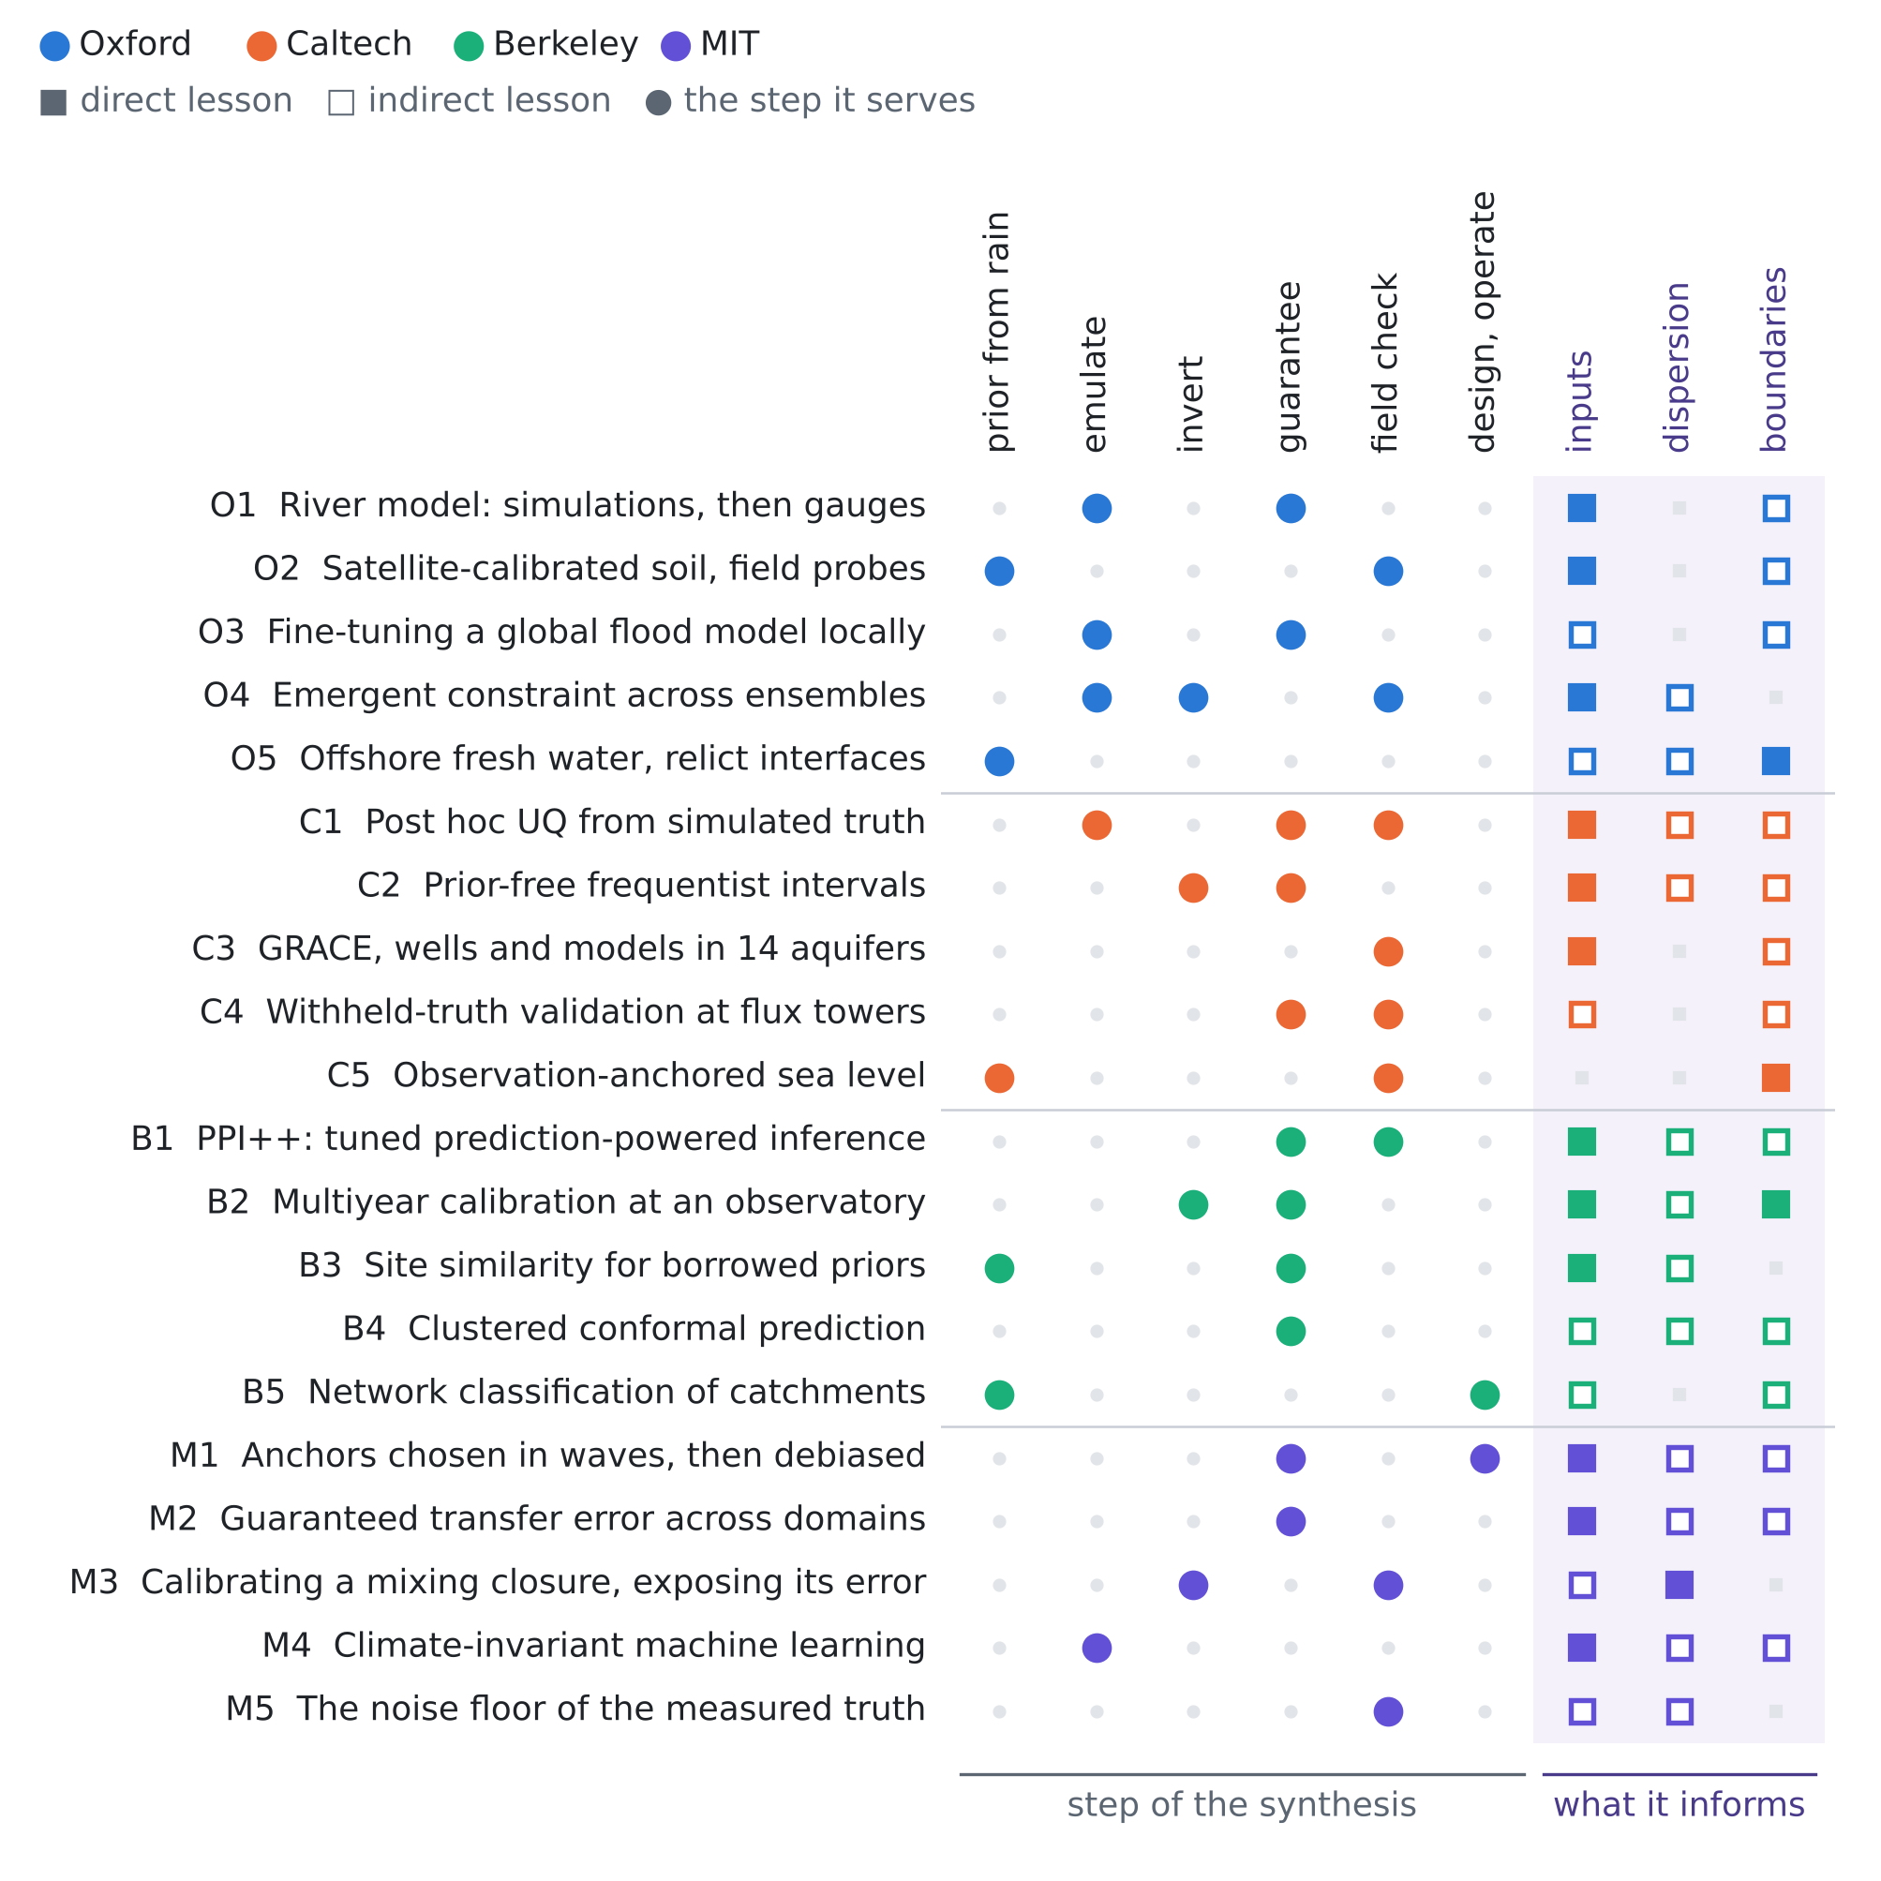
Figure 1. The twenty papers against the step of the procedure they serve and the unknown they inform. Colour gives the institution; a filled square is a direct lesson, an open square an indirect one.
O2 · Oxford · 2021
Improving soil moisture prediction of a high-resolution land surface model by parameterising pedotransfer functions through assimilation of SMAP satellite data
E. Pinnington, J. Amezcua, E. Cooper, S. Dadson, R. Ellis, J. Peng, E. Robinson, R. Morrison, S. Osborne, T. Quaife (initials as seen)
Hydrology and Earth System Sciences 25, 1617–1641 (2021)
Links: doi:10.5194/hess-25-1617-2021 · NORA copy
Affiliation and verification: The affiliation list includes the School of Geography and the Environment, University of Oxford (search summary); Dadson and Peng each appear with two affiliations, but which author holds the Oxford one was not seen. Status: partly verified (landing pages reached through search results only).
What it does. SMAP satellite soil moisture is assimilated to calibrate the constants of the pedotransfer functions that give the soil parameters of the JULES land-surface model, run at 1 km over Great Britain. The calibrated model is judged against independent COSMOS-UK cosmic-ray probes, with an average 22% reduction of the root-mean-square error over 11 probes.
State of the art it sets. Satellite-driven calibration of pedotransfer constants at 1 km, validated at independent field probes.
What it cannot yet do for us. The 11 field probes only validate: they neither correct the calibration nor certify its uncertainty, and no interval or coverage was seen.
Input parameters. Our structure exactly: a wide but biased proxy (for us the simulations) calibrates a few shared constants, the soil-to-recharge parameters behind $κ$ and $τ$, and a handful of ground anchors test them.
Dispersion coefficient. None.
Boundary conditions from rain alone. The timing of recharge from rain, through a calibrated land-surface parameterisation.
Innovation step for our problem. Make the probes calibrate, not only validate. With 11 independent probes (1) already has a finite solution (Proposition A2 needs 9), so the satellite-calibrated model could carry a band that holds for the real soils, not only an error score; a certificate at 90% confidence would need 22 probes.

O3 · Oxford · 2025
Fine flood forecasts: incorporating local data into global models through fine-tuning
Emil Ryd, Grey Nearing
ICLR 2025 Workshop "Tackling Climate Change with Machine Learning" (papers track); arXiv:2504.12559
Links: arXiv:2504.12559 · workshop page
Affiliation and verification: Ryd: University of Oxford; Nearing: Google Research (search summary of the arXiv author block). Workshop paper. Status: partly verified (landing pages reached through search results only).
What it does. A global machine-learning streamflow model is pre-trained on the Caravan dataset (about 6000 basins) and then fine-tuned on single basins, a random sample of 159. It is compared with the pre-trained model and with single-basin models by mean and median NSE and KGE (the numbers were not seen). Fine-tuning helps, most where the global model was poor; code and a pre-trained model are open.
State of the art it sets. Basin-level fine-tuning of a global large-sample model beats both global-only and single-basin training.
What it cannot yet do for us. No uncertainty or guarantee; it needs years of local flow, far more than a handful of heads; surface water only.
Input parameters. A recipe for moving a many-site prior to one site, and the lesson that local data help most where the prior is worst, that is, where the simulator is wrong.
Dispersion coefficient. None.
Boundary conditions from rain alone. Rain-to-flow learned over many basins, a route to the inland inflow from rain alone.
Innovation step for our problem. Their finding is what T13 shows as width: anchors widen the band little where the simulator is right (+14% with 20 anchors) and as much as needed where it is wrong (up to 8.4 times for $κ$). Add the guarantee they lack: after fine-tuning to a site, calibrate the band on held-out local periods by (1).

O4 · Oxford · 2020
Constraining uncertainty in aerosol direct forcing
Watson-Parris, Bellouin, Deaconu, Schutgens, Yoshioka, Regayre, Pringle, Johnson, Smith, Carslaw, Stier (surnames in the published order; given names not seen)
Geophysical Research Letters 47(9), e2020GL087141 (2020)
Links: doi:10.1029/2020GL087141 · Oxford ORA · White Rose copy
Affiliation and verification: Deposited in Oxford's repository ORA; Watson-Parris and Stier were at Oxford's Atmospheric, Oceanic and Planetary Physics in 2020 (review I, card O1); the per-author affiliations of this paper were not seen. Status: partly verified (landing pages reached through search results only).
What it does. Across CMIP5 fixed-SST aerosol runs, AeroCom Phase II and a 26-parameter perturbed-parameter ensemble of HadGEM3-UKCA, present-day aerosol optical depth tracks the anthropogenic share of aerosol, so satellite observations of total aerosol narrow that share and the direct forcing. Emulators sampled at 10⁶ parameter combinations give a clear-sky estimate of about −0.69 ± 0.14 W m⁻². The authors warn that emergent constraints must be physically based and observationally robust.
State of the art it sets. An emergent constraint checked across three model ensembles and an emulated perturbed-parameter ensemble.
What it cannot yet do for us. No coverage guarantee; it assumes that the relation found across the ensembles holds in reality, which is exactly the weak point of this review.
Input parameters. Learn the relation between an observable (a few heads, chloride facts) and a target ($T$, $κ$) across the simulated aquifers, then insert the real value; demanding that the relation hold across different simulator families is a practical check of the prior.
Dispersion coefficient. The same logic for chloride against the transition-zone width or the dispersivity (our inference).
Boundary conditions from rain alone. None.
Innovation step for our problem. Anchors test the assumption an emergent constraint makes. Fit the observable-to-target relation on simulations, then calibrate its band on anchors by (1): if the relation transfers, the band stays near the simulation width; if not, it widens until valid. Agreement between simulator families is necessary for the mixing of (2) to be safe, not sufficient (T14: ψ = 0.5 fails under shift in 9 of 12 cases).

O5 · Oxford · 2021
Offshore freshened groundwater in continental margins
Aaron Micallef (first author), with Christian Berndt, Claudia Bertoni, Denis Cohen and others (the full list and its order were not confirmed)
Reviews of Geophysics 59(1), e2020RG000706 (2021; online November 2020)
Links: doi:10.1029/2020RG000706 · GEOMAR repository
Affiliation and verification: C. Bertoni: Department of Earth Science(s), University of Oxford (search summary of the affiliation list); the byline itself was not seen. An early citation gives volume 58. Status: partly verified (landing pages reached through search results only).
What it does. The review compiles more than 300 records of offshore freshened groundwater and estimates a global volume of about 10⁶ km³. Most known occurrences lie in water less than 100 m deep, within 55 km of the coast, in siliciclastic aquifers of passive margins. How the deposits are detected and modelled was not seen in detail.
State of the art it sets. The first global synthesis and volume estimate of offshore freshened groundwater.
What it cannot yet do for us. An inventory, not a site inference: no method to infer the offshore interface from onshore heads and chloride.
Input parameters. Offshore extensions of confined layers change the effective $T$ and $S$ near the coast.
Dispersion coefficient. Relict fresh water means the transition zone need not be in steady state (our inference).
Boundary conditions from rain alone. The initial interface may not be in equilibrium with today's sea level and should be seeded from the sea-level history; the sea boundary may belong at the offshore outcrop, not at the shoreline (our inference for a siliciclastic coastal plain such as Fushë-Kuqe).
Innovation step for our problem. A relict interface is a shift of the initial condition that simulations started at equilibrium cannot represent, so a toe band calibrated on them risks failing as the simulation calibration fails under the delayed law of T12 (risk up to 0.83). Seed the simulated interfaces from sea-level history, and treat offshore surveys of freshened groundwater as anchors for the initial condition.

3.2 California Institute of Technology (with JPL)
C1 · Caltech · 2021
Post hoc uncertainty quantification for remote sensing observing systems
Amy Braverman, Jonathan Hobbs, Joaquim Teixeira, Michael Gunson
SIAM/ASA Journal on Uncertainty Quantification 9(3) (2021); pages not seen
Links: doi:10.1137/19M1304283 · NASA NTRS · JPL copy
Affiliation and verification: NASA Jet Propulsion Laboratory (NTRS record; the paper is hosted on JPL's uncertainty-quantification site; a search summary places all four authors at JPL); the byline was not seen. Status: partly verified (landing pages reached through search results only).
What it does. Operational retrieval code cannot be re-run for uncertainty quantification, so it is done after the fact: a Gaussian-mixture regression fitted to an ensemble of simulated pairs (true state, operational estimate) gives the distribution of the truth given the estimate, which is applied to each new retrieval. It is shown on four months of OCO-2 data and compared with TCCON ground stations, where the truth is measured. No coverage numbers were seen.
State of the art it sets. Operational post hoc uncertainty trained on simulated truth and checked at an independent ground network.
What it cannot yet do for us. The conditional law is only as good as the simulated pairs; the ground stations check it but do not correct it, and nothing is guaranteed.
Input parameters. Learn the law of ($T$, $κ$, $τ$ given our estimate from rain and a few heads) from the simulated aquifers, as they learn the truth given a retrieval, and use the anchor sites or periods as they use TCCON.
Dispersion coefficient. The same post hoc law for $α_{L}$ and the transition-zone width, with the few chloride profiles as the ground network.
Boundary conditions from rain alone. A post hoc law for the initial interface and the inland inflow.
Innovation step for our problem. Turn their ground check into the calibration: score the post hoc band at the anchors and set $λ$ by (1). The band is then valid where the simulated pairs are wrong (Proposition A1), and the ratio of anchor- to simulation-calibrated half-width says how wrong: about 1.14 without shift and up to 4.85 for $κ$ with the vadose delay (T13, 20 anchors).

C2 · Caltech · 2022
Objective frequentist uncertainty quantification for atmospheric CO2 retrievals
Pratik Patil, Mikael Kuusela, Jonathan Hobbs
SIAM/ASA Journal on Uncertainty Quantification 10(3), 827–859 (2022); arXiv:2007.14975
Links: doi:10.1137/20M1356403 · arXiv:2007.14975
Affiliation and verification: Hobbs: Jet Propulsion Laboratory, California Institute of Technology (search summary of the paper text); DOI and pages as quoted by two bibliographic listings; the DOI page was not opened. Status: partly verified (landing pages reached through search results only).
What it does. The operational OCO-2 retrieval (Bayesian optimal estimation with a prior) gives intervals that are poorly calibrated in the frequentist sense, at single locations and over regions. The authors invert the target functional (XCO₂) directly under known physical constraints by convex programming; the intervals have guaranteed frequentist coverage if the forward model is right, with no prior, and reach the nominal coverage in tests. They also rank the nuisance variables that drive the interval length.
State of the art it sets. Prior-free intervals with guaranteed frequentist coverage where prior-based operational intervals fail.
What it cannot yet do for us. The (linearised) forward model and the noise must be known; intervals can be wide; no real anchors are used.
Input parameters. Constraint-only intervals for goal functionals (mean $T$, $κ$, toe position) whose coverage does not depend on the simulator's prior: the fallback when the anchors show the prior is wrong.
Dispersion coefficient. Bounds such as $α_{L}>0$, $α_{T}≤α_{L}$ and plausible ranges give dispersivity intervals that survive a wrong prior.
Boundary conditions from rain alone. Sign and bound constraints on the inland inflow give a prior-free interval for the toe.
Innovation step for our problem. Use their prior-free interval as the base band $m±s$ of (1) for $κ$, the unknown that shifts most. The anchors keep the guarantee for any law (Proposition A1), and a base that does not come from the prior should shrink the widening of T13 under shifted parameters (1.58 times for $κ$ with 20 anchors), a pure prior shift; under the delay and the rain bias the forward model itself is wrong and only the anchors help. To be tested.

C3 · Caltech · 2020
Comparison of groundwater storage changes from GRACE satellites with monitoring and modeling of major U.S. aquifers
Ashraf Rateb (first author), with Bridget R. Scanlon, Sean Swenson, David Wiese and others (the full list and its order were not confirmed)
Water Resources Research 56(12), e2020WR027556 (2020)
Links: doi:10.1029/2020WR027556 · ADS record · USGS record
Affiliation and verification: JPL only through D. Wiese, listed at the NASA Jet Propulsion Laboratory on the USGS Powell Center page of the GRACE working group; the byline affiliations were not seen, so this is the weakest institutional link of the review. Status: partly verified (landing pages reached through search results only).
What it does. In 14 major U.S. aquifers over 2002–2017, with about 23,000 wells, GRACE storage changes agree with the well monitoring (r = 0.52–0.95), and six southwestern and south-central aquifers lost about 90 km³. Global hydrological models that include pumping overestimate the GRACE depletion by about 2.4 times; in the Mississippi Embayment the regional model's decline is about four times GRACE, with storage parameters, stream capture, pumping or recharge named as possible causes.
State of the art it sets. The largest three-way test of models against measured truth (satellite, wells, models) across major aquifers.
What it cannot yet do for us. Basin scale, far coarser than a coastal plain; no salinity; no formal correction.
Input parameters. A measured size for the model-to-reality error in real aquifers, factors of 2.4–4, traced to storage coefficients and recharge, the inputs we estimate.
Dispersion coefficient. None.
Boundary conditions from rain alone. Recharge and pumping forcing are named as causes, so anchor periods with measured pumping are the ones to keep.
Innovation step for our problem. Use their factors to size the shifts of a stress test and report the simulation-calibrated risk against the shift factor. Our law with factor 1.5 already gives 0.11–0.25 (T12), so a factor of 2.4–4 is beyond what simulation calibration can certify, while the anchor calibration stays at most 0.10 at any factor (Proposition A1).

C4 · Caltech · 2022
CARDAMOM-FluxVal version 1.0: a FLUXNET-based validation system for CARDAMOM carbon and water flux estimates
Yan Yang, A. Anthony Bloom, Shuang Ma, Paul Levine, Alexander Norton, Nicholas C. Parazoo and others (the list may continue; not confirmed)
Geoscientific Model Development 15(4), 1789–1802 (2022)
Links: doi:10.5194/gmd-15-1789-2022 · code, Zenodo
Affiliation and verification: NASA Jet Propulsion Laboratory (search summary; CARDAMOM is developed by Bloom's group at JPL); the byline was not seen. Status: partly verified (landing pages reached through search results only).
What it does. A benchmark of the Bayesian model–data fusion system CARDAMOM (with the intermediate-complexity model DALEC) against more than 200 FLUXNET2015 eddy-covariance sites for gross primary production, net ecosystem exchange and evapotranspiration. Skill is scored against assimilated and withheld observations, by land cover, by time scale and by the length of the assimilated record; assimilation improves the skill in several respects (numbers not seen).
State of the art it sets. Many-site, withheld-truth validation of a Bayesian model–data fusion system, with skill against record length.
What it cannot yet do for us. Carbon and evapotranspiration, not groundwater; skill scores, not coverage; the sites do not correct the prior.
Input parameters. A protocol for anchors: assimilate part of an anchor record, withhold the rest and report skill against record length, which says how many years of heads are needed; the evapotranspiration skill bears on recharge.
Dispersion coefficient. None.
Boundary conditions from rain alone. Recharge in time, indirectly through evapotranspiration.
Innovation step for our problem. Replace their skill scores by the realised risk of (1) at withheld anchors, against the number of anchors: T13 does this for 10, 20 and 40 anchors (risk 0.011–0.099; without shift a half-width 1.03–1.55 times the simulation band), and Proposition A2 gives the floor of 9 anchors below which no guarantee exists, however long each record.

C5 · Caltech · 2022
Observation-based trajectory of future sea level for the coastal United States tracks near high-end model projections
B. D. Hamlington, D. P. Chambers, T. Frederikse, S. Dangendorf, S. Fournier, B. Buzzanga, R. S. Nerem (initials as seen)
Communications Earth & Environment 3, 230 (2022)
Links: doi:10.1038/s43247-022-00537-z · JPL news
Affiliation and verification: A "JPL-led team" (JPL news release of 15 November 2022, which quotes Hamlington as leader of NASA's Sea Level Change Team); the byline was not seen. Status: partly verified (landing pages reached through search results only).
What it does. Twenty-eight years of satellite altimetry (1993–2020) and NOAA tide gauges give the rate and acceleration of sea level along the U.S. coast, which are extrapolated to 2050 with two treatments of internal variability. The observation-based trajectories lie near or above the high-end model projections, up to about 30 cm above today along the contiguous coast and highest on the Gulf and Southeast coasts, with wide ranges.
State of the art it sets. Observation-anchored near-term regional sea-level trajectories, checked against model projections.
What it cannot yet do for us. U.S. coasts only; sensitive to internal variability; no tides or surges.
Input parameters. None.
Dispersion coefficient. None.
Boundary conditions from rain alone. Build the sea boundary $η\left(t\right)$ and its uncertainty from a local tide gauge and altimetry rather than from model projections alone; here the observed anchor moved the scenario to the high end.
Innovation step for our problem. A tide gauge is an anchor for $η$ in the sense of (1): calibrate the band of the sea-level reconstruction on gauge years, not on simulated sea levels. In T12 the simulation-calibrated sea-level band left 0.11–0.17 of the weeks outside under the three shifts; calibrated on 20 anchors it left 0.056 under every law.

3.3 University of California, Berkeley (with Lawrence Berkeley National Laboratory)
B1 · Berkeley · 2023
PPI++: efficient prediction-powered inference
Anastasios N. Angelopoulos, John C. Duchi, Tijana Zrnic
arXiv:2311.01453 (2023, revised 2024)
Links: arXiv:2311.01453 · code
Affiliation and verification: Angelopoulos: UC Berkeley; Duchi and Zrnic: Stanford (arXiv listing, as quoted). No journal version was seen. Status: partly verified (landing pages reached through search results only).
What it does. Prediction-powered inference combines many model predictions with a small labelled set to give confidence sets for any estimand defined by a convex loss. A tuning parameter moves the estimator between classical inference on the labels alone and plain prediction-powered inference, and a plug-in "power tuning" chooses it from the data; the authors report that the result is essentially never worse than either extreme and helps most when the predictor is not very accurate.
State of the art it sets. Inference that takes its power from predictions or simulations but never depends on them being right.
What it cannot yet do for us. The labelled cases must be a random sample of the target; no temporal or spatial dependence, and no guidance for single-digit samples chosen on purpose.
Input parameters. Treat simulator outputs for $T$, $S$, $κ$ or $τ$ as the predictions and the few anchor sites or periods as the labels: the interval stays valid from the anchors even if the simulator is wrong, and the tuned weight measures what the simulation is worth.
Dispersion coefficient. The same applies to the transition-zone width when a few chloride profiles exist; with three to ten profiles the interval honestly falls back to near-classical width.
Boundary conditions from rain alone. Estimands such as the mean bias of simulated heads under an assumed sea level or inflow can be corrected by anchors in the same way.
Innovation step for our problem. Its tuning parameter plays the role of our share $ψ$ in (2), but for a mean, not a band. Carry the power tuning over to risk control: choose $ψ$ by a rule that is itself validated on the anchors, so the mix can never be worse than anchors alone; T14 shows why the untuned mix is unsafe.

B2 · Berkeley · 2022
Quantifying subsurface flow and solute transport in a snowmelt-recharged hillslope with multiyear water balance
Tetsu K. Tokunaga, Anh Phuong Tran, Jiamin Wan, Wenming Dong, Alexander W. Newman, Curtis A. Beutler, Wendy Brown, Amanda N. Henderson, Kenneth H. Williams
Water Resources Research 58(12), e2022WR032902 (2022)
Links: doi:10.1029/2022WR032902 · eScholarship · LBNL highlight
Affiliation and verification: Lawrence Berkeley National Laboratory (eScholarship deposit; Watershed Function project highlight; search summary); the byline affiliations were not seen. Status: partly verified (landing pages reached through search results only).
What it does. At an instrumented hillslope of the East River observatory, a transmissivity-feedback model calibrated on one year of water balance and measured conductivity profiles predicted later years poorly. A well-constrained field-scale conductivity came only from fitting the fluxes over years with very different recharge and from carrying excess recharge from one year to the next. Solute export in high-snowmelt years runs through shallow soil and weathered rock and goes quiet in snow-drought years.
State of the art it sets. Multi-year, contrast-spanning calibration at an observatory as the remedy for one-period calibration.
What it cannot yet do for us. A mountain hillslope at one site, not a coast; no formal guarantee or uncertainty for transfer.
Input parameters. One calibration period gives an unreliable conductivity: anchor periods must span contrasting recharge, and the carry-over of storage between years is a recharge memory like the vadose delay.
Dispersion coefficient. The active transport pathways, hence the effective mixing, change with the recharge regime.
Boundary conditions from rain alone. The recharge in time carries interannual memory, so the initial state matters; a few water-table and chemistry measurements act as anchors.
Innovation step for our problem. Choose anchor periods to span the recharge contrast, a wet and a dry year at least, because Proposition A1 guarantees only on average over the law the anchors are drawn from: anchors from wet years alone would certify nothing for a drought.

B3 · Berkeley · 2023
Defining hydrogeological site similarity with hierarchical agglomerative clustering
Nura Kawa, Karina Cucchi, Yoram Rubin, Sabine Attinger, Falk Heße
Groundwater 61(4), 563–573 (2023)
Links: doi:10.1111/gwat.13261 · repository record
Affiliation and verification: Kawa (Statistics), Cucchi and Rubin (Civil and Environmental Engineering): UC Berkeley, as listed on the team's EGU 2018 abstract of the same project; the journal byline was not seen. Status: partly verified (landing pages reached through search results only).
What it does. Site similarity is defined from observable site traits (environment, rock type) by hierarchical agglomerative clustering, and groups of similar sampled sites supply "ex-situ" prior distributions for the Bayesian estimation of hydraulic conductivity at a site without data of its own. It replaces expert judgment about which sites belong together; code and database are public.
State of the art it sets. Data-driven choice of donor sites for informative priors in hydrogeology.
What it cannot yet do for us. Conductivity only; no coverage check of the transferred priors at held-out sites.
Input parameters. A principled way to borrow transmissivity priors for a coastal plain from measured analogue sites: a prior anchored on real data instead of on judgment.
Dispersion coefficient. The same pipeline could supply dispersivity priors if the database held them; not done.
Boundary conditions from rain alone. None.
Innovation step for our problem. Use the similarity to choose the anchors, not only the prior: Proposition A1 needs anchors exchangeable with the field, and a cluster of similar aquifers is the closest practical version of that assumption. Score the clustering by the coverage of the anchor-calibrated band at held-out sites.

B4 · Berkeley · 2023
Class-conditional conformal prediction with many classes
Tiffany Ding, Anastasios N. Angelopoulos, Stephen Bates, Michael I. Jordan, Ryan J. Tibshirani
Advances in Neural Information Processing Systems 36 (NeurIPS 2023); arXiv:2306.09335
Links: NeurIPS 2023 · arXiv:2306.09335
Affiliation and verification: UC Berkeley (paper hosted on Tibshirani's Berkeley Statistics page; Jordan and Tibshirani Berkeley faculty); the byline was not seen. Status: partly verified (landing pages reached through search results only).
What it does. Class-conditional coverage is hard when there are many classes and few labelled examples per class, and the per-class method gives sets too large to use. Clustered conformal prediction groups classes whose score distributions look alike and calibrates per cluster; on four image datasets with up to 1000 classes it typically improves class-conditional coverage and set size.
State of the art it sets. Pooling scarce labels across similar groups for near-conditional conformal guarantees.
What it cannot yet do for us. Built for classification with exchangeability inside clusters; no model of a simulation-to-reality shift.
Input parameters. When each kind of site has only a handful of anchors, pool them across hydrogeologically similar groups.
Dispersion coefficient. Chloride or interface prediction errors can be calibrated per cluster of settings.
Boundary conditions from rain alone. None.
Innovation step for our problem. With 20 anchors in total but several boundary types (sea level, inflow, recharge), calibrate per cluster of anchors with similar score laws: the guarantee becomes nearly conditional on the type of aquifer, which is what a stakeholder at one aquifer needs, and the minimum of Proposition A2 applies per cluster.

B5 · Berkeley · 2024
A network approach for multiscale catchment classification using traits
Fabio Ciulla, Charuleka Varadharajan
Hydrology and Earth System Sciences 28(7), 1617–1651 (2024)
Links: doi:10.5194/hess-28-1617-2024 · eScholarship
Affiliation and verification: Both authors: Lawrence Berkeley National Laboratory (search summary; eScholarship copy; DOE/OSTI dataset). Status: partly verified (landing pages reached through search results only).
What it does. 9067 catchments of the contiguous US are classified with 274 non-categorical traits (temperature, precipitation, land use, human interference) by network cluster detection instead of Euclidean clustering. At continental scale it finds 25 interpretable trait categories and 34 catchment clusters with distinct streamflow behaviour, and degree centrality picks a representative catchment for each cluster.
State of the art it sets. Network-based, scale-adaptive regionalisation with explicit representative sites.
What it cannot yet do for us. Surface catchments only: no groundwater or coastal traits and no guarantee on transfer.
Input parameters. A recipe for deciding which measured sites a target belongs with before parameters are transferred.
Dispersion coefficient. None.
Boundary conditions from rain alone. The traits are rain- and climate-heavy, so similarity can be judged from what is known everywhere.
Innovation step for our problem. The representative catchment of each cluster is the natural site to instrument as an anchor: one well-measured site per cluster of similar coastal aquifers, until each cluster holds the 9 (or 22) anchors that Proposition A2 requires.

3.4 Massachusetts Institute of Technology
M1 · MIT · 2026
M-estimation under two-phase multiwave sampling with applications to prediction-powered inference
Dan M. Kluger, Stephen Bates
arXiv:2602.16933 (preprint, February 2026; revised March 2026)
Links: arXiv:2602.16933
Affiliation and verification: Both authors at MIT (search summary; the paper acknowledges the MIT IDSS Michael Hammer Postdoctoral Fellowship). Preprint; the arXiv page was not opened. Status: partly verified (landing pages reached through search results only).
What it does. Cheap proxies (machine-learning or simulator predictions) exist for every unit, and expensive accurate measurements are taken in successive waves. A multiwave predict-then-debias estimator is shown to be asymptotically linear and normal, with asymptotically valid confidence intervals, and an approximately greedy rule chooses the units to measure in the next wave, more efficiently than uniform sampling; simulation studies support the theory.
State of the art it sets. Adaptive, wave-by-wave choice of the real measurements, with valid debiased inference afterwards.
What it cannot yet do for us. Validity is asymptotic and needs many units; simulations only; a finite population with proxies for every unit; no spatial or temporal dependence.
Input parameters. Where and when to spend the next pumping test or head campaign, given simulator predictions everywhere, with the final interval still valid after the adaptive choice.
Dispersion coefficient. Which wells get the chloride or conductivity profiles that anchor the transition-zone width.
Boundary conditions from rain alone. Which periods to monitor (after storms, at low sea level, in dry spells) for recharge and inflow.
Innovation step for our problem. Combine their waves with weighted risk control: an adaptively chosen anchor enters (1) with a weight inverse to its probability of being chosen, as in their estimator, so anchors can be placed where the simulator is most in doubt and still certify the field average. The finite-sample proof for risk control is open.

M2 · MIT · 2025
The transfer performance of economic models
Isaiah Andrews, Drew Fudenberg, Lihua Lei, Annie Liang, Chaofeng Wu
arXiv:2202.04796 (working paper, first posted 2022; version 5, March 2025)
Links: arXiv:2202.04796 · RePEc record
Affiliation and verification: Partly MIT: I. Andrews rejoined MIT Economics as a professor in September 2023 (MIT News), before the 2025 revision, and D. Fudenberg is listed at MIT in an earlier review of this series; the affiliation block was not seen, and one version names a Harvard department for a co-author. Working paper. Status: partly verified (landing pages reached through search results only).
What it does. Out-of-domain prediction is formalised, and a model's transfer error is its performance in a new domain. Finite-sample intervals cover the realised transfer error at a chosen level when domains are drawn independently from one family, generalising conformal inference. Predicting certainty equivalents of lotteries across subject pools, black-box algorithms slightly beat economic models within a pool, but across pools their intervals are wider and their upper bounds higher: the structured models transfer more reliably.
State of the art it sets. Distribution-free, finite-sample guarantees on the error of a model moved to a new domain, from a modest number of domains.
What it cannot yet do for us. Domains must be independent draws from one family, which is questionable for one Albanian aquifer; coarse with few domains; no hydrological use.
Input parameters. Treat each aquifer, simulated or a measured benchmark site, as a domain: an interval for how much a rain-to-head calibration of $T$, $κ$, $τ$ degrades when moved to Fushë-Kuqe, and an argument for physics-structured estimators over black boxes.
Dispersion coefficient. A transfer-error interval for dispersivity–scale relations borrowed from other sites.
Boundary conditions from rain alone. The same for inflow or recharge relations regionalised from analogue basins.
Innovation step for our problem. Their domains are our anchors one level up. When the anchors come from several aquifers, calibrate (1) on one aquifer-level score per aquifer (its share of weeks outside the band), so the guarantee holds for a new aquifer of the same family; the minimum of Proposition A2 is then counted in aquifers, not in years.

M3 · MIT · 2020
Uncertainty quantification of ocean parameterizations: application to the K-Profile-Parameterization for penetrative convection
Souza, Wagner, Ramadhan, Allen, Churavy, Schloss, R. Ferrari (surnames as matched; the other given names were not seen)
Journal of Advances in Modeling Earth Systems 12(12) (2020); article number not seen
Links: doi:10.1029/2020MS002108 · DSpace@MIT
Affiliation and verification: MIT (deposited in DSpace@MIT, handle 1721.1/136064); the byline was not seen. Status: partly verified (landing pages reached through search results only).
What it does. A Bayesian approach to calibrating and checking turbulent-mixing parameterizations: the convective limit of the K-Profile Parameterization is calibrated against an ensemble of large-eddy simulations of penetrative convection in the ocean surface boundary layer, which gives the uncertainty of its parameters. The calibration exposes structural deficiencies of the closure, and the authors propose an alternative scaling that removes them; they state that the method applies to any parameterization.
State of the art it sets. Bayesian calibration that both estimates a mixing closure and diagnoses its structural error.
What it cannot yet do for us. The truth is large-eddy simulation, not field data; ocean convection, not porous media.
Input parameters. A misspecification test: if the calibrated $T$ or $κ$ drift with the forcing regime (wet against dry years), the model's structure is wrong, not only its parameters.
Dispersion coefficient. The closest card to dispersion: a mixing closure calibrated with full uncertainty against high-resolution truth, where regime-dependent posteriors reveal its form error; the same logic applies to the dispersivity of the transition zone.
Boundary conditions from rain alone. None.
Innovation step for our problem. Make their regime test an anchor test: calibrate $\hat{λ}$ separately on wet-season and dry-season anchors. If the two differ by more than their sampling spread, the simulator is wrong in a regime-dependent way, and only anchors from both regimes can certify the band (Proposition A1; card B2).

M4 · MIT · 2024
Climate-invariant machine learning
Tom Beucler, Pierre Gentine, Janni Yuval, Ankitesh Gupta, Liran Peng, Jerry Lin, Sungduk Yu, Stephan Rasp, Fiaz Ahmed, Paul A. O'Gorman, J. David Neelin, Nicholas J. Lutsko, Michael Pritchard
Science Advances 10(6), eadj7250 (2024); arXiv:2112.08440
Links: doi:10.1126/sciadv.adj7250 · arXiv:2112.08440
Affiliation and verification: MIT through P. A. O'Gorman (the paper's supplement is hosted on his MIT group site, pog.mit.edu); the printed affiliations were not seen. Status: partly verified (landing pages reached through search results only).
What it does. Machine-learning parameterizations trained in one climate fail in others. Physically rescaling their inputs and outputs makes "climate-invariant" networks that keep high offline accuracy across climates and configurations in three atmospheric models; in the arXiv version they predict well in test climates 4 K and 8 K warmer than the training climate.
State of the art it sets. Physics-guided rescaling as the main tool for making simulation-trained machine learning generalise out of distribution.
What it cannot yet do for us. Empirical, with no coverage guarantee; the invariances must be known; no real anchors; atmosphere, not groundwater.
Input parameters. Train the simulation-based reconstructor on dimensionless inputs and outputs (head scaled by $rL^{2}/T$, time by $SL^{2}/T$) so that it survives the move to the real site.
Dispersion coefficient. Express the transition-zone width relative to the aquifer thickness, with Péclet numbers or dispersivity ratios.
Boundary conditions from rain alone. Scale rain, recharge and sea level by their climatology, so the reconstructor stays valid in a drier or higher-sea climate.
Innovation step for our problem. Rescaling and anchors do different jobs: rescaling shrinks the shift, anchors certify what is left. Measure the first with the second: a rescaled reconstructor should bring the anchor-to-simulation width ratio of T13 under shift (1.20–8.41 with 20 anchors) back toward its no-shift value (1.13–1.16). To be tested first on the delayed law, where the shift is a time scale.

M5 · MIT · 2024
Physical variability in meter-scale laboratory CO2 injections in faulted geometries
Malin Haugen, Lluís Saló-Salgado, Kristoffer Eikehaug, Benyamine Benali, Jakub W. Both, Erlend Storvik, Olav Folkvord, Ruben Juanes, Jan Martin Nordbotten, Martin A. Fernø
Transport in Porous Media 151, 1169–1197 (2024)
Links: doi:10.1007/s11242-023-02013-4 · DSpace@MIT · arXiv:2301.07347
Affiliation and verification: MIT (deposited in DSpace@MIT; Saló-Salgado and Juanes at MIT); the byline was not seen. A companion of card M3 of review II, not the same paper. Status: partly verified (landing pages reached through search results only).
What it does. Meter-scale CO₂ injections in two faulted geometries (normal faults with and without clay smear) were repeated in the laboratory, 16 runs in all, to measure the run-to-run variability of the migration patterns, and the distance of history-matched simulation models to an experiment was judged against it: a measured noise floor for the truth itself.
State of the art it sets. Replicate experiments that measure the variability of the truth alongside history-matched forecasts.
What it cannot yet do for us. Laboratory scale, multiphase CO₂, not a field or variable-density seawater.
Input parameters. Even a perfectly measured anchor carries irreducible variability, which an anchor-corrected guarantee must count as noise in the anchor, not as simulator bias.
Dispersion coefficient. The variability of dissolution and convective mixing bounds how much one chloride snapshot can reveal about the mixing parameters.
Boundary conditions from rain alone. None (controlled in the laboratory).
Innovation step for our problem. Count anchor noise before reading the anchor correction as shift: replicate anchors (two loggers in one well, repeated chloride profiles) estimate the noise of the measured truth, and a gap between the anchor- and simulation-calibrated bands smaller than that noise is no evidence of a wrong simulator. The guarantee of Proposition A1 covers the measured boundary, not the true one (Section 6).

4. Innovation: ANKORA-GO, guarantees that do not depend on the simulator
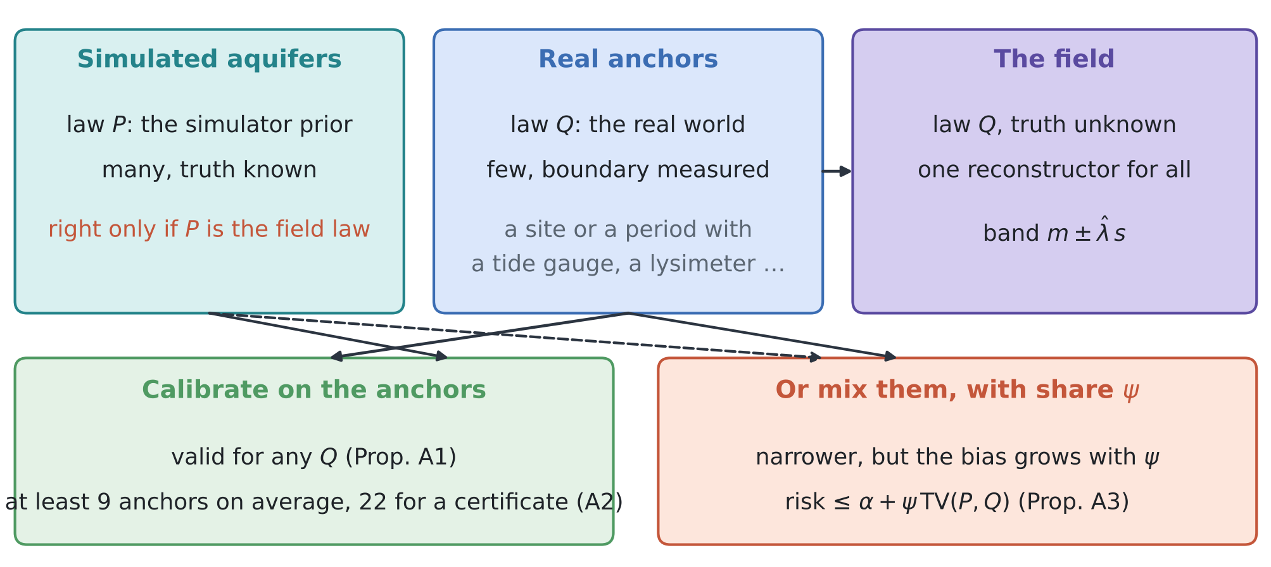
Figure 2. ANKORA-GO. Simulated aquifers come from the simulator's law $P$; anchors and the field come from the real law $Q$. Calibrating on the anchors makes the guarantee hold for any $Q$; mixing simulations in narrows the band but adds a bias proportional to their share $ψ$ of the weight.
4.1 Anchors and the set-up
An anchor is a case in which the boundary function of interest was measured while the usual data were collected: a neighbouring coastal aquifer with a tide gauge and a dense logger network, a period in which a temporary tide gauge, lysimeter or stream gauge was operated, or a monitored benchmark site. The reconstructor is run on an anchor exactly as on the field (rain and the usual heads), and its error against the measured truth is scored. Anchors are few and costly; simulated aquifers are many and free, but come from the simulator's law $P$, while anchors and field come from the real law $Q$.
The test bed is that of reviews I–III (D4): 32 cells, 64 weekly steps, the ensemble smoother with the exact solver (128 members) and four loggers (0.25, 1.25, 2.75, 4.25 km). Four real laws $Q$ are compared: no shift; a vadose delay of 35 d in the field against 14 d in the simulator; shifted parameters (recharge coefficient median 0.25 instead of 0.35, recharge error and inland-inflow departures 1.5 times larger); and the rain bias of review III (a product with a 20% record bias and daily errors, treated as exact). With $L_{j}\left(λ\right)$ the share of the 64 weeks of anchor $j$ outside the band $m±λs$, the anchor calibration is
$${\hat{λ}}_{A}=inf\left\{λ:\frac{1}{m+1}\left(\sum_{j=1}^{m}{L_{j}}\left(λ\right)+1\right)≤α\right\}$$ | (1)
and the mixed calibration gives weight $w$ to each of $n$ simulated aquifers:
$${\hat{λ}}_{ψ}=inf\left\{λ:\frac{w\sum_{i=1}^{n}{L_{i}^{sim}}\left(λ\right)+\sum_{j=1}^{m}{L_{j}}\left(λ\right)+1}{wn+m+1}≤α\right\}\text{, with }ψ=\frac{wn}{wn+m+1}.$$ | (2)
$ψ$ = 0 is (1), and $ψ→1$ is the simulation calibration of review I. All calibrations are computed exactly from the pooled scores (weighted quantiles, no grid). Each result averages 300 random draws of $m$ anchors from 600 field cases of each law; the risk is measured on the remaining cases.
4.2 Guarantees
Proposition A1 (anchors make the guarantee independent of the simulator). Let the anchors and the field case be exchangeable draws from the real law $Q$, whatever it is, and let the reconstructor and the score be fixed independently of the anchors (they may be designed, tuned or chosen with simulations from any law $P$). Then the band with ${\hat{λ}}_{A}$ of (1) satisfies $E_{Q}\left[L_{field}\left({\hat{λ}}_{A}\right)\right]≤α$, and, for continuous scores, $E_{Q}\left[L_{field}\left({\hat{λ}}_{A}\right)\right]≥α−2/\left(m+1\right)$.

Proof. The losses of the $m+1$ cases are exchangeable under $Q$ and bounded by $B=1$, so Theorems 1 and 2 of conformal risk control (anchor A1) apply with $n=m$. The simulations enter only through the fixed map from data to band, which leaves exchangeability intact. □
Proposition A2 (how many anchors any method needs). (i) (1) has a finite solution for every law only if $m≥\left(1−α\right)/α$, that is 9 anchors at $α$ = 0.10. (ii) No procedure that is valid for every real law can certify $R_{Q}\left(λ\right)≤α$ with confidence $1−δ$ from fewer than $logδ/log\left(1−α\right)$ anchors, that is 22 at $α=δ$ = 0.10.

Proof. (i) Since $L_{j}≥0$, the left side of (1) is at least $1/\left(m+1\right)$ for every $λ$, so it can reach $α$ only if $m+1≥1/α$. (ii) Take a law whose loss is 0 or 1, with $Pr\left(L=1\right)=α+ϵ$: all $m$ anchors show $L=0$ with probability ${\left(1−α−ϵ\right)}^{m}$, and a valid procedure must refuse to certify on that event unless this probability is at most $δ$; let $ϵ→0$. □
Proposition A3 (what mixing simulations with anchors costs). With the mixed calibration (2), $E_{Q}\left[L_{field}\left({\hat{λ}}_{ψ}\right)\right]≤α+ψ TV\left(ρ_{P},ρ_{Q}\right)$, where $ρ_{P}$, $ρ_{Q}$ are the laws of the standardised residual vector under the two laws. The bias grows linearly with the share $ψ$ of the weight on simulations, while the slack $1/\left(wn+m+1\right)$ of the calibration shrinks.

Proof. This is the weighted, non-exchangeable form of conformal risk control (Barber et al. 2023; anchor A1): the coverage gap is at most the sum of the normalised weights times the total-variation distance between each calibration case and the field case. It is zero for the anchors and at most $TV\left(ρ_{P},ρ_{Q}\right)$ for each simulation, and the simulations carry the share $ψ$. □
What is new. (1) Guarantees for boundary conditions that hold whatever the real law, by calibrating on a few measured cases while the simulator keeps its other roles (Proposition A1). (2) Distribution-free lower bounds on the number of such cases: 9 for an average guarantee and 22 for a 90% certificate at $α$ = 0.10 (Proposition A2), a planning number for any monitoring programme. (3) The exact cost of mixing simulations and anchors, and the test that shows the mix inherits the simulator's bias (Proposition A3, T14). To our knowledge none of these appears in the eighty papers of reviews I–IV.

4.3 Tests
T12: the simulation-calibrated band under shift. Figure 3 and Table 2. Without shift the simulation calibration holds (risk 0.088–0.115; one pool of 300 simulated aquifers, Monte Carlo error about ±0.02). Under each shift it breaks: the share of weeks outside is 0.11–0.82, worst for $κ$ (0.82 with the longer delay, 0.79 with the rain bias) and for the recharge (0.44). Calibrated on anchors, the risk is at most 0.10 for every law and goal: 0.011–0.093 with 10 anchors, 0.056–0.099 with 20 and 0.077–0.099 with 40, approaching 0.10 from below as Proposition A1 says.
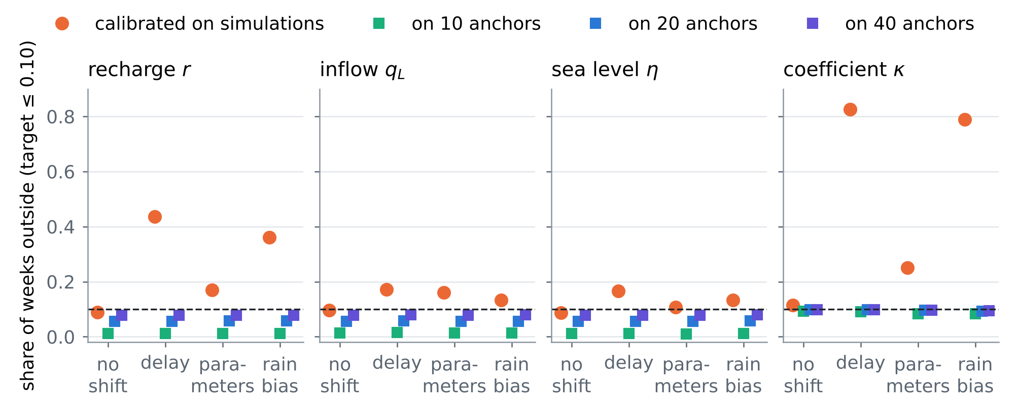
Figure 3. T12: share of weeks outside the 90% band in the field, for the band calibrated on 300 simulated aquifers and on 10, 20 or 40 real anchors, under the four real laws (dashed: target 0.10).
Table 2. T12–T13: realized risk (share of weeks outside; bold above 0.105) of the band calibrated on simulations and on 10, 20 and 40 anchors, and the half-widths with simulations and with 20 anchors. Units: recharge mm/d, inflow m²/d, sea level m, κ dimensionless.
Real law | Goal | Sims | 10 anchors | 20 anchors | 40 anchors | hw sims | hw 20 anc.
no shift | recharge r | 0.090 | 0.012 | 0.056 | 0.077 | 0.054 | 0.061
 | inflow qL | 0.097 | 0.014 | 0.056 | 0.077 | 0.065 | 0.075
 | sea level η | 0.088 | 0.011 | 0.056 | 0.078 | 0.038 | 0.043
 | coefficient κ | 0.115 | 0.093 | 0.097 | 0.098 | 0.023 | 0.026
vadose delay 35 d | recharge r | 0.437 | 0.013 | 0.056 | 0.079 | 0.054 | 0.173
 | inflow qL | 0.172 | 0.015 | 0.058 | 0.079 | 0.065 | 0.094
 | sea level η | 0.166 | 0.012 | 0.056 | 0.078 | 0.038 | 0.054
 | coefficient κ | 0.825 | 0.091 | 0.099 | 0.099 | 0.023 | 0.112
shifted parameters | recharge r | 0.170 | 0.011 | 0.057 | 0.078 | 0.054 | 0.076
 | inflow qL | 0.160 | 0.014 | 0.057 | 0.078 | 0.065 | 0.089
 | sea level η | 0.108 | 0.011 | 0.056 | 0.078 | 0.038 | 0.045
 | coefficient κ | 0.250 | 0.083 | 0.096 | 0.097 | 0.024 | 0.037
rain bias | recharge r | 0.361 | 0.012 | 0.057 | 0.077 | 0.054 | 0.151
 | inflow qL | 0.132 | 0.013 | 0.056 | 0.080 | 0.065 | 0.085
 | sea level η | 0.133 | 0.012 | 0.057 | 0.079 | 0.038 | 0.049
 | coefficient κ | 0.788 | 0.083 | 0.093 | 0.094 | 0.024 | 0.203

T13: the price of the guarantee. Figure 4. Without shift the anchor-calibrated band is 46% wider than the simulation-calibrated one with 10 anchors, 14% with 20 and 6% with 40: the slack $1/\left(m+1\right)$ of (1). Under shift the band widens much more, because the real errors are larger than the simulator believes; that width is not a cost of the method but the honest size of the uncertainty. Reshaping the score week by week on the simulations before calibrating on anchors did not narrow the band (change 1–3%): the ensemble's week-to-week spread already has the right shape.
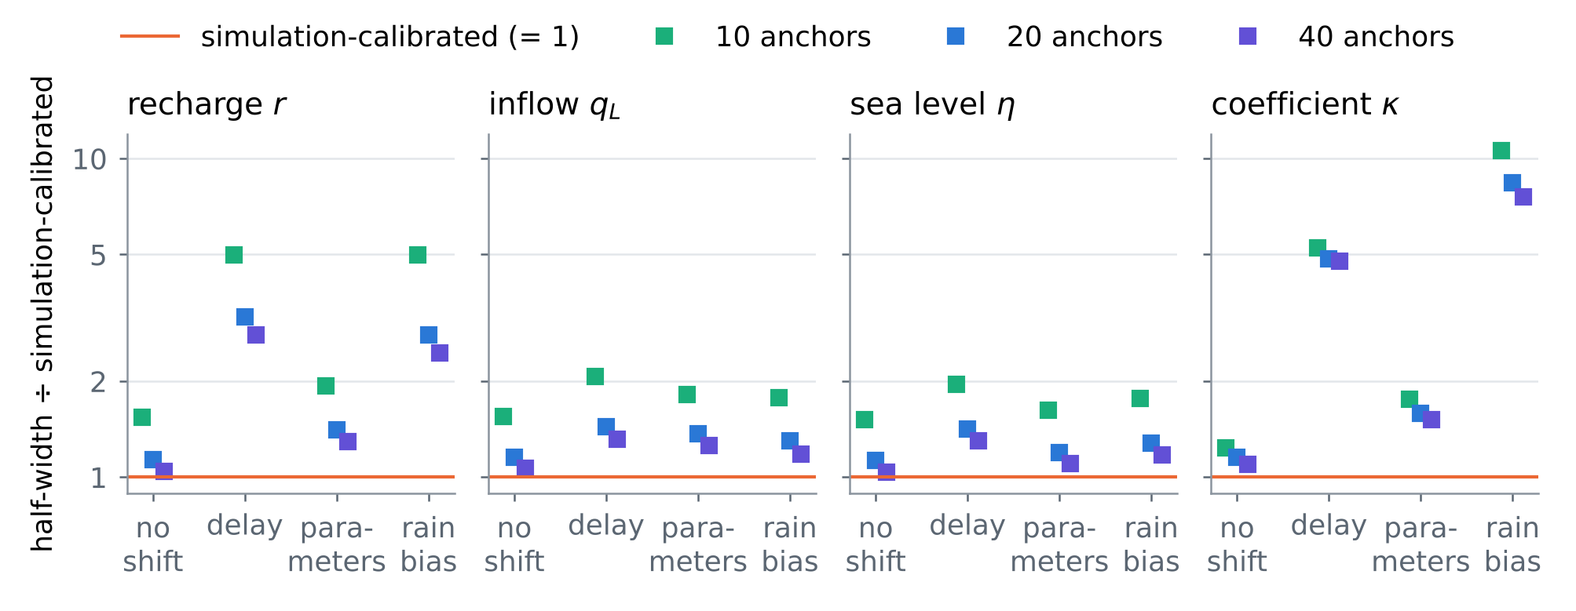
Figure 4. T13: half-width of the anchor-calibrated band divided by that of the simulation-calibrated band, for 10, 20 and 40 anchors and the four real laws.
T14: mixing simulations and anchors. Figure 5. With 20 anchors and a share $ψ$ of the weight on simulations, the band narrows steadily towards the simulation band as $ψ→1$. Without shift the risk stays below 0.10 (at $ψ$ = 0.5: 0.074–0.094); under shift it rises with $ψ$, as Proposition A3 predicts (at $ψ$ = 0.5: 0.08–0.19, above 0.10 in 9 of 12 cases). The anchors cannot distinguish the two situations with 20 cases, so the safe rule is $ψ$ = 0; a mix is defensible only when an independent argument bounds the distance between simulator and reality.
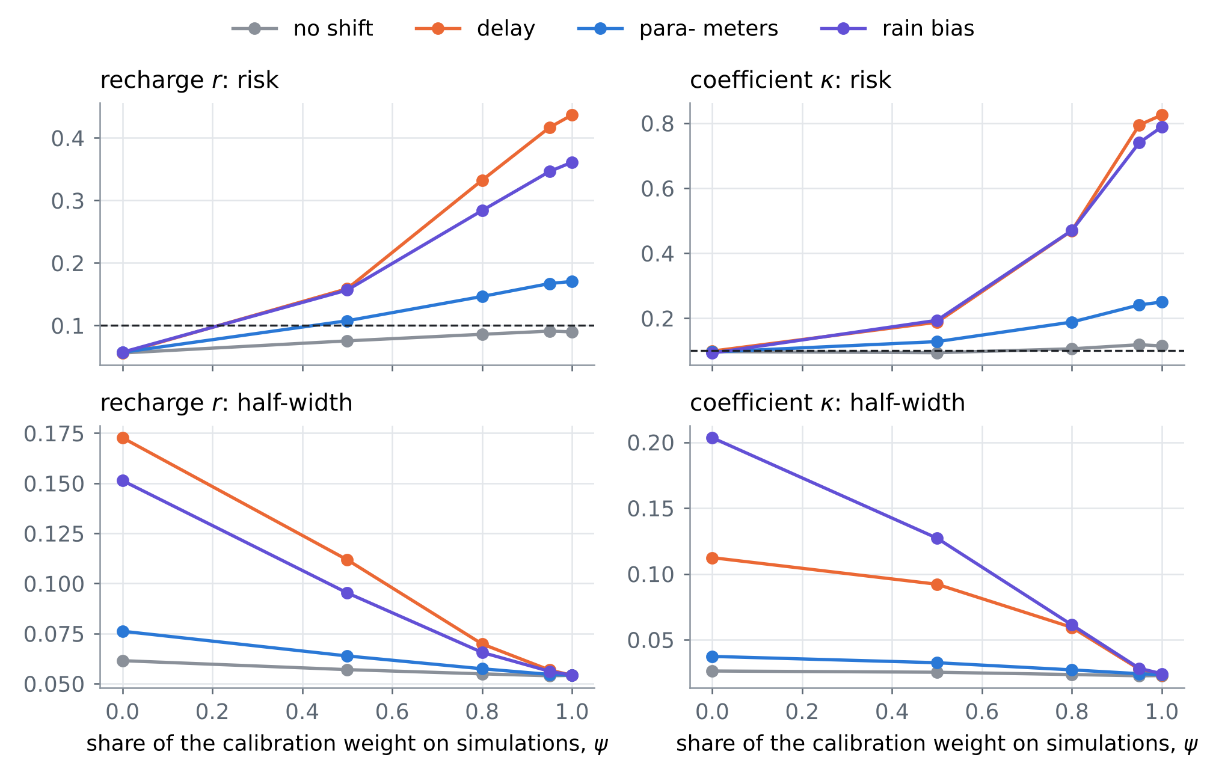
Figure 5. T14: risk (top) and half-width (bottom) of the mixed calibration (2) against the share $ψ$ of the weight on simulations, for the recharge and for $κ$, with 20 anchors.
4.4 Where anchors come from at a coastal aquifer
• Sea level: any period with a local tide gauge, or a neighbouring harbour gauge with land motion corrected (review II, C3); each year of record is one anchor for the sea-level boundary of that year.
• Recharge and its coefficient: a lysimeter or a soil-moisture station with drainage, or a dense head-monitoring campaign on a neighbouring plain; for $κ$ the anchors must also carry a local rain gauge, or the floor of review III returns.
• Inland inflow: a gauged river reach or a well transect at the inland boundary in a neighbouring aquifer.
• Exchangeability: anchors from different years of one aquifer are only approximately exchangeable with the field year; anchors from similar neighbouring aquifers are closer to the assumption. For Fushë-Kuqe, the list of candidate anchors (Adriatic coastal aquifers with monitoring, years with gauges) is to be compiled with the national monitoring agencies.
5. Synthesis: eighty papers in one procedure
Table 3 places the eighty papers of reviews I–IV on the steps of the procedure. Card numbers carry the review: I-O1 is card O1 of review I, IV-C2 card C2 of this review. Review IV adds the step that turns every other one from a statement about the simulator into a statement about the world: calibration on real anchors.
Table 3. The eighty papers of reviews I–IV against the steps of the procedure (card numbers of each review; a paper can serve several steps).
Step | Review I | Review II | Review III | Review IV
prior from rain | O3, O5, C5, M1 | O1, O2, O5, C1, C2, C3, C4, B1, B4, M2, M5 | O1, O2, O3, O4, O5, C1, C2, C3, C4, C5, B1, B2, B3, B4, B5, M1, M2, M3 | O2, O5, C5, B3, B5
emulate | O1, O3, C1, B1 | C1, B5, M2 | C3, M4 | O1, O3, O4, C1, M4
invert | O1, O2, C2, C3, C4, B1 | O1, O2, O4, C4 | B1 | O4, C2, B2, M3
guarantee | O4, C1, B2, B3, B5, M2, M3 | O2, M1, M4 | C2, B5, M5 | O1, O3, C1, C2, C4, B1, B2, B3, B4, M1, M2
field check | B2, B4, M4, M5 | C3, B1, B2, M3, M4 | O2, O4, C4, C5, B2, M1, M2, M4, M5 | O2, O4, C1, C3, C4, C5, B1, M3, M5
design, operate | O5, C5, M4 | O3, O4, C1, C2, C3, C5, B2, B3, B4, M1, M3 | C1, B4, M3 | B5, M1

Order of work. (1) Build the simulated aquifers from the rain, with the rain product's errors (RESHJA-GO). (2) Use them to design the reconstructor and to choose the instruments by guaranteed value (MATJA-GO). (3) Calibrate the final bands on real anchors (ANKORA-GO), at least 9 of them, 20 to 40 for a band within 10–20% of the simulation band when the simulator is right. (4) Report the simulation-calibrated band (GARANCIA-GO) alongside, as the narrow band that holds if the simulator is right; the gap between the two is the measured cost of not knowing the real law. For several goals at once and a guarantee per calibration set, the risk-controlling sets of S2 apply to the anchors unchanged; the few anchors can also correct a large number of cheaper predictions by prediction-powered inference (S3).
6. Limitations
• Every card is partly verified: landing pages were reached through search results only.
• The guarantee of Proposition A1 needs the anchors to be exchangeable with the field; anchors from other years or other aquifers satisfy this only approximately, and the bound of Proposition A3 then applies to them as well.
• Measured boundary functions are themselves uncertain (gauge errors, land motion); the anchors' truth must be better than the band being calibrated.
• The tests use the linear one-dimensional test bed of reviews I–III and three illustrative shifts.
References
Anchors (provided by the user)
[A1] Angelopoulos, A. N., Bates, S., Fisch, A., Lei, L., & Schuster, T. (2024). Conformal risk control. The Twelfth International Conference on Learning Representations (ICLR 2024). arXiv:2208.02814 (PDF provided by the user). https://arxiv.org/abs/2208.02814
[A2] Tibshirani, R. (2023). Conformal prediction. Lecture notes, Advanced Topics in Statistical Learning, Spring 2023, University of California, Berkeley (PDF provided by the user). https://www.stat.berkeley.edu/~ryantibs/statlearn-s23/
The twenty papers of this review
[O1] Hancheng Ren, Gang Zhao, Shuo Wang, Louise Slater, Dai Yamazaki, Shu Liu, Jingfang Fan, Shibo Cui, Ziming Yu, Shengyu Kang, Depeng Zuo, Dingzhi Peng, Zongxue Xu, Bo Pang (2026). Global river forecasting with a topology-informed AI foundation model. arXiv:2602.22293 (preprint, February 2026); companion abstract EGU26-22456. https://arxiv.org/abs/2602.22293
[O2] E. Pinnington, J. Amezcua, E. Cooper, S. Dadson, R. Ellis, J. Peng, E. Robinson, R. Morrison, S. Osborne, T. Quaife (initials as seen) (2021). Improving soil moisture prediction of a high-resolution land surface model by parameterising pedotransfer functions through assimilation of SMAP satellite data. Hydrology and Earth System Sciences 25, 1617–1641 (2021). https://doi.org/10.5194/hess-25-1617-2021
[O3] Emil Ryd, Grey Nearing (2025). Fine flood forecasts: incorporating local data into global models through fine-tuning. ICLR 2025 Workshop "Tackling Climate Change with Machine Learning" (papers track); arXiv:2504.12559. https://arxiv.org/abs/2504.12559
[O4] Watson-Parris, Bellouin, Deaconu, Schutgens, Yoshioka, Regayre, Pringle, Johnson, Smith, Carslaw, Stier (surnames in the published order; given names not seen) (2020). Constraining uncertainty in aerosol direct forcing. Geophysical Research Letters 47(9), e2020GL087141 (2020). https://doi.org/10.1029/2020GL087141
[O5] Aaron Micallef (first author), with Christian Berndt, Claudia Bertoni, Denis Cohen and others (the full list and its order were not confirmed) (2021). Offshore freshened groundwater in continental margins. Reviews of Geophysics 59(1), e2020RG000706 (2021; online November 2020). https://doi.org/10.1029/2020RG000706
[C1] Amy Braverman, Jonathan Hobbs, Joaquim Teixeira, Michael Gunson (2021). Post hoc uncertainty quantification for remote sensing observing systems. SIAM/ASA Journal on Uncertainty Quantification 9(3) (2021); pages not seen. https://doi.org/10.1137/19M1304283
[C2] Pratik Patil, Mikael Kuusela, Jonathan Hobbs (2022). Objective frequentist uncertainty quantification for atmospheric CO2 retrievals. SIAM/ASA Journal on Uncertainty Quantification 10(3), 827–859 (2022); arXiv:2007.14975. https://doi.org/10.1137/20M1356403
[C3] Ashraf Rateb (first author), with Bridget R. Scanlon, Sean Swenson, David Wiese and others (the full list and its order were not confirmed) (2020). Comparison of groundwater storage changes from GRACE satellites with monitoring and modeling of major U.S. aquifers. Water Resources Research 56(12), e2020WR027556 (2020). https://doi.org/10.1029/2020WR027556
[C4] Yan Yang, A. Anthony Bloom, Shuang Ma, Paul Levine, Alexander Norton, Nicholas C. Parazoo and others (the list may continue; not confirmed) (2022). CARDAMOM-FluxVal version 1.0: a FLUXNET-based validation system for CARDAMOM carbon and water flux estimates. Geoscientific Model Development 15(4), 1789–1802 (2022). https://doi.org/10.5194/gmd-15-1789-2022
[C5] B. D. Hamlington, D. P. Chambers, T. Frederikse, S. Dangendorf, S. Fournier, B. Buzzanga, R. S. Nerem (initials as seen) (2022). Observation-based trajectory of future sea level for the coastal United States tracks near high-end model projections. Communications Earth & Environment 3, 230 (2022). https://doi.org/10.1038/s43247-022-00537-z
[B1] Anastasios N. Angelopoulos, John C. Duchi, Tijana Zrnic (2023). PPI++: efficient prediction-powered inference. arXiv:2311.01453 (2023, revised 2024). https://arxiv.org/abs/2311.01453
[B2] Tetsu K. Tokunaga, Anh Phuong Tran, Jiamin Wan, Wenming Dong, Alexander W. Newman, Curtis A. Beutler, Wendy Brown, Amanda N. Henderson, Kenneth H. Williams (2022). Quantifying subsurface flow and solute transport in a snowmelt-recharged hillslope with multiyear water balance. Water Resources Research 58(12), e2022WR032902 (2022). https://doi.org/10.1029/2022WR032902
[B3] Nura Kawa, Karina Cucchi, Yoram Rubin, Sabine Attinger, Falk Heße (2023). Defining hydrogeological site similarity with hierarchical agglomerative clustering. Groundwater 61(4), 563–573 (2023). https://doi.org/10.1111/gwat.13261
[B4] Tiffany Ding, Anastasios N. Angelopoulos, Stephen Bates, Michael I. Jordan, Ryan J. Tibshirani (2023). Class-conditional conformal prediction with many classes. Advances in Neural Information Processing Systems 36 (NeurIPS 2023); arXiv:2306.09335. https://proceedings.neurips.cc/paper_files/paper/2023/hash/cb931eddd563f8d473c355518ce8601c-Abstract.html
[B5] Fabio Ciulla, Charuleka Varadharajan (2024). A network approach for multiscale catchment classification using traits. Hydrology and Earth System Sciences 28(7), 1617–1651 (2024). https://doi.org/10.5194/hess-28-1617-2024
[M1] Dan M. Kluger, Stephen Bates (2026). M-estimation under two-phase multiwave sampling with applications to prediction-powered inference. arXiv:2602.16933 (preprint, February 2026; revised March 2026). https://arxiv.org/abs/2602.16933
[M2] Isaiah Andrews, Drew Fudenberg, Lihua Lei, Annie Liang, Chaofeng Wu (2025). The transfer performance of economic models. arXiv:2202.04796 (working paper, first posted 2022; version 5, March 2025). https://arxiv.org/abs/2202.04796
[M3] Souza, Wagner, Ramadhan, Allen, Churavy, Schloss, R. Ferrari (surnames as matched; the other given names were not seen) (2020). Uncertainty quantification of ocean parameterizations: application to the K-Profile-Parameterization for penetrative convection. Journal of Advances in Modeling Earth Systems 12(12) (2020); article number not seen. https://doi.org/10.1029/2020MS002108
[M4] Tom Beucler, Pierre Gentine, Janni Yuval, Ankitesh Gupta, Liran Peng, Jerry Lin, Sungduk Yu, Stephan Rasp, Fiaz Ahmed, Paul A. O'Gorman, J. David Neelin, Nicholas J. Lutsko, Michael Pritchard (2024). Climate-invariant machine learning. Science Advances 10(6), eadj7250 (2024); arXiv:2112.08440. https://doi.org/10.1126/sciadv.adj7250
[M5] Malin Haugen, Lluís Saló-Salgado, Kristoffer Eikehaug, Benyamine Benali, Jakub W. Both, Erlend Storvik, Olav Folkvord, Ruben Juanes, Jan Martin Nordbotten, Martin A. Fernø (2024). Physical variability in meter-scale laboratory CO2 injections in faulted geometries. Transport in Porous Media 151, 1169–1197 (2024). https://doi.org/10.1007/s11242-023-02013-4
Linked in the text (first review, earlier work and the field)
[S1] Barber, R. F., Candès, E. J., Ramdas, A., & Tibshirani, R. J. (2023). Conformal prediction beyond exchangeability. Annals of Statistics 51(2), 816–845. https://doi.org/10.1214/23-AOS2276
[S2] Bates, S., Angelopoulos, A., Lei, L., Malik, J., & Jordan, M. I. (2021). Distribution-free, risk-controlling prediction sets. Journal of the ACM 68(6), Article 43, 1–34. https://doi.org/10.1145/3478535
[S3] Angelopoulos, A. N., Bates, S., Fannjiang, C., Jordan, M. I., & Zrnic, T. (2023). Prediction-powered inference. Science 382(6671), 669–674. https://doi.org/10.1126/science.adi6000
Data and project documents
[D1] Zeqiraj, D. (2026). Inputs, dispersion and boundary conditions from rain alone; GARANCIA-GO ("review I"), docs/literature/ in this repository.
[D2] Zeqiraj, D. (2026). State of the art II; MATJA-GO, the guaranteed value of a measurement ("review II"), docs/literature/ in this repository.
[D3] Zeqiraj, D. (2026). State of the art III: when the rain itself is uncertain; RESHJA-GO ("review III"), docs/literature/ in this repository.
[D4] Internal documents of the project: RINDËRTIMI-GO (test bed, ensemble smoother with the exact solver); the code of this review in experiments/ankora_go/.
Verification note. The bibliographic data of the twenty cards come from search results that quote the publisher, arXiv, proceedings or repository pages; doi.org, arxiv.org, openreview.net and most publisher hosts could not be opened directly in this environment. The anchors were read from the PDFs provided. Every number of Sections 1, 2 and 4 is computed by the code in experiments/ankora_go/, experiments/reshja_go/ and experiments/garancia_go/.

