**EP4US2 – Final Project**

**Abdullah Mir - 400070827**

**Algorithm**

The algorithm used to pinpoint location is fairly simplistic. The RSSI values are sent as character arrays to node red from each ESP beacon via MQTT protocol; a function node is then used to convert them into integer values and compare them to see to which beacon the tag is closest. This then determines which room the tag is in by checking which room the closest beacon is in and outputs the result in the dashboard.

I didn’t use a minimum threshold that determines if the speaker is in a given room as all the rooms involved are adjacent/share a boundary. The threshold can be breached even when the tag isn’t in a given room due to the proximity of all the rooms.

I also didn’t use any sort of filtering, although I explored the idea a fair bit. For the most part, the filtering uses some sort of averaging method based on previously recorded values. I found this undesirable due to the close proximity of the rooms as the room the tracker is in can change in an instant and using filtering would delay the response a fair amount.

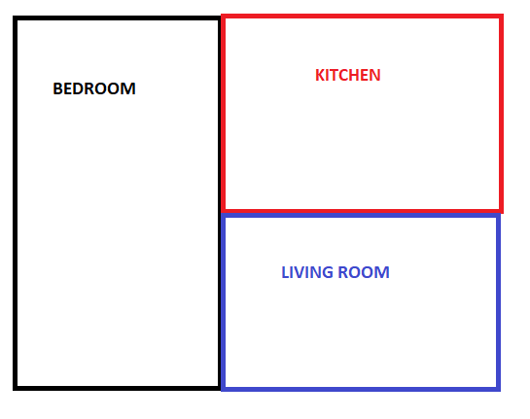

*HIGH-LEVEL FLOOR PLAN*

The figure above shows a high-level floor plan of the rooms that are being monitored. The crosses show where the beacons are located in each room. Checking to see which room the tag is closest too isn’t necessarily 100% accurate as the RSSI depends on the direct distance from the microcontroller, i.e. RSSI is a function of the radius of a circle around each beacon. Therefore, having cuboid rooms means the algorithm can be ineffective. However, the placement of the beacons and the walls between rooms(which also reduce signal strength) helps circumvent the inaccuracies. There isn’t a physical wall between the kitchen and living room as they are in an ‘open concept’ type fashion, but there is a thick wall surrounding the bedroom.