COMPXXXX Assignment
Your Name (Student ID)
2026-03-08
By including this statement, we the authors of this work, verify that:
- We hold a copy of this assignment that we can produce if the original is lost or damaged.
- We hereby certify that no part of this assignment/product has been copied from any other student’s work or from any other source except where due acknowledgement is made in the assignment.
- No part of this assignment/product has been written/produced for us by another person except where such collaboration has been authorized by the subject lecturer/ tutor concerned.
- We are aware that this work may be reproduced and submitted to plagiarism detection software programs for the purpose of detecting possible plagiarism (which may retain a copy on its database for future plagiarism checking).
- We hereby certify that we have read and understand what the School of Computing, Engineering and Mathematics defines as minor and substantial breaches of misconduct as outlined in the learning guide for this unit.
orders <- read_csv("project_orders.csv")
products <- read_csv("project_product_info.csv")
head(orders)
## # A tibble: 6 × 7
## InvoiceNo StockCode Quantity InvoiceDate UnitPrice CustomerID Country
## <chr> <chr> <dbl> <chr> <dbl> <dbl> <chr>
## 1 536365 85123A 6 1/12/2010 8:26 2.55 17850 United Kingd…
## 2 536365 71053 6 1/12/2010 8:26 3.39 17850 United Kingd…
## 3 536365 84406B 8 1/12/2010 8:26 2.75 17850 United Kingd…
## 4 536365 84029G 6 1/12/2010 8:26 3.39 17850 United Kingd…
## 5 536365 84029E 6 1/12/2010 8:26 3.39 17850 United Kingd…
## 6 536365 22752 2 1/12/2010 8:26 7.65 17850 United Kingd…
head(products)
## # A tibble: 6 × 2
## StockCode Description
## <chr> <chr>
## 1 85123A WHITE HANGING HEART T-LIGHT HOLDER
## 2 71053 WHITE METAL LANTERN
## 3 84406B CREAM CUPID HEARTS COAT HANGER
## 4 84029G KNITTED UNION FLAG HOT WATER BOTTLE
## 5 84029E RED WOOLLY HOTTIE WHITE HEART.
## 6 22752 SET 7 BABUSHKA NESTING BOXES
#template to answer the questions

Q1

(a)

Explanation
The purpose of this analysis is to evaluate product performance based on the total revenue generated. The orders data contains information on transactions, such as the quantities and price per unit of each item, and the product information data contains product descriptions. These two datasets were joined based on the StockCode variable, enabling the addition of product descriptions to the orders data.
Before performing the analysis, the data was cleaned by deleting orders for canceled transactions and those with negative quantities, as they are deemed inaccurate for the purpose of the analysis. The revenue for each product was determined by multiplying the quantities of each item purchased by the price per unit of each item. The data was then split into groups based on the products, and the revenue generated by each product was determined.
The products were also ranked based on the revenue generated, and the best and worst-selling products were identified. The percentage contribution of the top three products to the revenue generated was also determined.

Code
# Data Cleaning
orders_clean <- orders %>%
filter(!str_detect(InvoiceNo, "^C")) %>% # remove cancelled orders
filter(Quantity > 0) %>% # remove negative quantities
mutate(StockCode = toupper(StockCode)) # standardize stock codes
products <- products %>%
mutate(StockCode = toupper(StockCode))
# Join datasets
data <- orders_clean %>%
left_join(products, by = "StockCode")
# Remove missing descriptions
data <- data %>%
filter(!is.na(Description))
# Calculate revenue
data <- data %>%
mutate(Revenue = Quantity * UnitPrice)
# Revenue by product
product_revenue <- data %>%
group_by(StockCode, Description) %>%
summarise(TotalRevenue = sum(Revenue), .groups = "drop") %>%
arrange(desc(TotalRevenue))
# Top 10 products
top10 <- product_revenue %>%
slice_max(TotalRevenue, n = 10)
# Bottom 10 products
bottom10 <- product_revenue %>%
slice_min(TotalRevenue, n = 10)
# Top 3 contribution
top3 <- product_revenue %>%
slice_max(TotalRevenue, n = 3)
total_revenue <- sum(product_revenue$TotalRevenue)
top3_percentage <- sum(top3$TotalRevenue) / total_revenue * 100
# Display tables
kable(top10, caption = "Top 10 Products by Revenue")
Top 10 Products by Revenue
StockCode | Description | TotalRevenue
85123A | WHITE HANGING HEART T-LIGHT HOLDER | 212942.56
DOT | DOTCOM POSTAGE | 206248.77
22423 | REGENCY CAKESTAND 3 TIER | 174484.74
23843 | PAPER CRAFT , LITTLE BIRDIE | 168469.60
M | Manual | 156225.64
47566 | PARTY BUNTING | 99504.33
85099B | JUMBO BAG RED RETROSPOT | 94340.05
23166 | MEDIUM CERAMIC TOP STORAGE JAR | 81700.92
POST | POSTAGE | 78101.88
23084 | RABBIT NIGHT LIGHT | 66964.99
kable(bottom10, caption = "Bottom 10 Products by Revenue")
Bottom 10 Products by Revenue
StockCode | Description | TotalRevenue
B | Adjust bad debt | -11062.060
23001 | TRAVEL CARD WALLET DOTCOMGIFTSHOP | 0.000
23595 | adjustment | 0.000
35600A | Found by jackie | 0.000
84611B | thrown away | 0.000
PADS | PADS TO MATCH ALL CUSHIONS | 0.003
21268 | VINTAGE BLUE TINSEL REEL | 0.840
90084 | PINK CRYSTAL GUITAR PHONE CHARM | 0.850
84201C | HAPPY BIRTHDAY CARD TEDDY/CAKE | 0.950
84206B | CAT WITH SUNGLASSES BLANK CARD | 0.950
top3_percentage
## [1] 5.311123
#Visualisation
ggplot(top10, aes(x=reorder(Description,TotalRevenue), y=TotalRevenue))+
geom_bar(stat="identity")+
coord_flip()+
labs(title="Top 10 Products by Revenue")
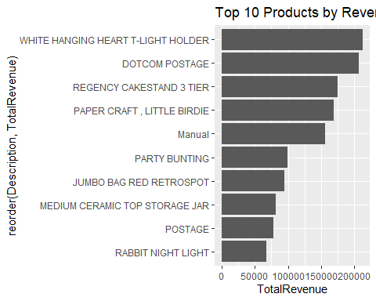

Interpretation
This analysis represent the revenue generated from the sale of a number of products is significant. This indicates that revenue concentration exists, which means that the products that have generated the revenue are the ones that have performed better.

Q2
#Explanation of the Task
The goal of this task is to identify the most valuable customers for the business and analyse their purchasing behaviour.
First, the total spending of each customer is calculated by summing the revenue generated from all of their transactions. Revenue is defined as: Revenue = Quantity * Unit price Cancelled transactions (Invoice numbers starting with “C”) must be excluded because they represent returned or cancelled purchases.
After calculating the total spending per customer, the Top 5 highest-spending customers are identified.
Then, for these customers, their purchasing behaviour is analysed by determining which products they purchased the most based on total quantity. This helps the business understand product preferences among its most valuable customers.
#Clean missing data
data_clean <- data %>%
filter(!is.na(CustomerID))
#Calculate Customer Spending
# Remove rows with missing CustomerID
data_clean <- data %>%
filter(!is.na(CustomerID))
# Calculate total spending per customer
customer_spending <- data_clean %>%
group_by(CustomerID) %>%
summarise(TotalSpending = sum(Revenue, na.rm = TRUE)) %>%
arrange(desc(TotalSpending))
class(data)
## [1] "tbl_df" "tbl" "data.frame"
ls()
## [1] "bottom10" "customer_spending" "data"
## [4] "data_clean" "orders" "orders_clean"
## [7] "product_revenue" "products" "top10"
## [10] "top3" "top3_percentage" "total_revenue"
ls()
## [1] "bottom10" "customer_spending" "data"
## [4] "data_clean" "orders" "orders_clean"
## [7] "product_revenue" "products" "top10"
## [10] "top3" "top3_percentage" "total_revenue"
#Top 5 Customers
top_customers <- customer_spending %>%
slice_head(n = 5)
kable(top_customers, caption = "Top 5 Highest Spending Customers")
Top 5 Highest Spending Customers
CustomerID | TotalSpending
14646 | 287627.1
18102 | 265212.8
17450 | 208144.5
16446 | 168472.5
14911 | 153055.5
#Products Purchased by Top Customers
top_customer_products <- data_clean %>%
filter(CustomerID %in% top_customers$CustomerID) %>%
group_by(CustomerID, Description) %>%
summarise(TotalQuantity = sum(Quantity, na.rm = TRUE), .groups = "drop") %>%
arrange(CustomerID, desc(TotalQuantity))
# Visualization
top_customer_products %>%
slice_max(TotalQuantity, n = 10)
## # A tibble: 10 × 3
## CustomerID Description TotalQuantity
## <dbl> <chr> <dbl>
## 1 16446 PAPER CRAFT , LITTLE BIRDIE 80995
## 2 17450 WHITE HANGING HEART T-LIGHT HOLDER 8228
## 3 18102 CREAM HEART CARD HOLDER 5946
## 4 17450 HEART OF WICKER SMALL 5286
## 5 14646 RABBIT NIGHT LIGHT 4801
## 6 14646 SPACEBOY LUNCH BOX 4492
## 7 17450 HEART OF WICKER LARGE 4282
## 8 14646 PACK OF 72 RETROSPOT CAKE CASES 4104
## 9 18102 BLACK HEART CARD HOLDER 4104
## 10 14646 DOLLY GIRL LUNCH BOX 4096
ggplot(top_customer_products,
aes(x = reorder(Description, TotalQuantity),
y = TotalQuantity,
fill = factor(CustomerID))) +
geom_bar(stat = "identity") +
coord_flip() +
labs(
title = "Top Purchased Products by Top Customers",
x = "Product Description",
y = "Total Quantity Purchased",
fill = "Customer ID"
) +
theme_minimal()
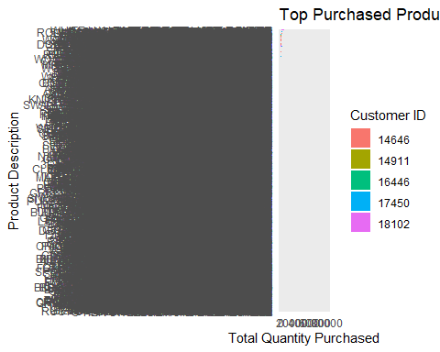 #Interpretation
The results show that a small number of customers generate a significant portion of the company’s revenue. The top five customers have spent considerably more than the average customer, indicating that they are highly valuable to the business.
By analysing their purchasing behaviour, it becomes clear that these customers frequently purchase specific products in large quantities. This suggests strong product preferences among high-value customers.
From a business perspective, these customers are critical for maintaining revenue growth. The company could benefit from implementing loyalty programs, personalised promotions, or exclusive offers to retain these high-value customers. Additionally, ensuring that the products frequently purchased by these customers remain available in stock can help maintain customer satisfaction and continued spending.
#Q3 #(a) Explanation
The aim of this task is to analyse product consumption across different countries to understand global market demand.
First, the total revenue generated by each country is calculated. Revenue is defined as: Revenue = Quantity * Unit price The dataset already contains the calculated revenue variable from the previous task. Cancelled transactions were removed during the data cleaning stage, so only valid transactions are included in the analysis.
The data is grouped by Country to determine the total revenue generated in each country. This allows us to identify which countries contribute the most to overall sales.
Next, product consumption is analysed by identifying the single product with the highest total quantity sold in each country. This helps determine which products are most popular in different regions.
Finally, the results are presented in a summary table and visualised using a bar chart to compare revenue across countries.
# Calculate total revenue by country
country_revenue <- data %>%
group_by(Country) %>%
summarise(TotalRevenue = sum(Revenue, na.rm = TRUE)) %>%
arrange(desc(TotalRevenue))
# Display table
kable(country_revenue, caption = "Total Revenue by Country")
Total Revenue by Country
Country | TotalRevenue
United Kingdom | 9429895.71
EIRE | 298532.43
Netherlands | 293140.27
Germany | 239772.03
France | 225434.63
Australia | 141021.41
Spain | 72565.62
Switzerland | 59581.72
Belgium | 42169.87
Norway | 39265.02
Sweden | 38596.50
Portugal | 38545.59
Japan | 37905.97
Singapore | 33651.53
Finland | 28471.75
Hong Kong | 22515.58
Channel Islands | 21434.89
Denmark | 19862.15
Italy | 18153.16
Cyprus | 14791.93
Austria | 11109.38
Israel | 8168.37
Poland | 7642.00
Iceland | 4817.30
Unspecified | 4800.55
Greece | 4795.62
USA | 3778.84
Canada | 3695.10
Malta | 2926.49
United Arab Emirates | 1967.68
Lithuania | 1780.46
Lebanon | 1711.58
European Community | 1459.65
Brazil | 1197.15
RSA | 1021.78
Czech Republic | 826.74
Bahrain | 824.94
Saudi Arabia | 145.92
# Calculate quantity sold for each product in each country
country_products <- data %>%
group_by(Country, Description) %>%
summarise(TotalQuantity = sum(Quantity, na.rm = TRUE), .groups = "drop")
# Identify most sold product in each country
top_product_country <- country_products %>%
group_by(Country) %>%
slice_max(TotalQuantity, n = 1)
# Display table
kable(top_product_country, caption = "Most Popular Product by Country")
Most Popular Product by Country
Country | Description | TotalQuantity
Australia | MINI PAINT SET VINTAGE | 2952
Austria | SET 12 KIDS COLOUR CHALK STICKS | 288
Bahrain | ICE CREAM SUNDAE LIP GLOSS | 96
Belgium | FAIRY CAKES NOTEBOOK A7 SIZE | 640
Brazil | DOLLY GIRL LUNCH BOX | 24
Brazil | GREEN REGENCY TEACUP AND SAUCER | 24
Brazil | PINK REGENCY TEACUP AND SAUCER | 24
Brazil | ROSES REGENCY TEACUP AND SAUCER | 24
Brazil | SET OF 4 PANTRY JELLY MOULDS | 24
Brazil | SET OF 6 SPICE TINS PANTRY DESIGN | 24
Brazil | SET/3 RED GINGHAM ROSE STORAGE BOX | 24
Brazil | SMALL HEART FLOWERS HOOK | 24
Canada | RETRO COFFEE MUGS ASSORTED | 504
Channel Islands | RAIN PONCHO | 407
Cyprus | HEART DECORATION PAINTED ZINC | 384
Czech Republic | WOODEN STAR CHRISTMAS SCANDINAVIAN | 72
Czech Republic | WOODEN TREE CHRISTMAS SCANDINAVIAN | 72
Denmark | RED HARMONICA IN BOX | 288
EIRE | WHITE HANGING HEART T-LIGHT HOLDER | 2184
European Community | CHARLIE AND LOLA FIGURES TINS | 24
European Community | CHOCOLATE 1 WICK MORRIS BOX CANDLE | 24
European Community | RED ROCKING HORSE HAND PAINTED | 24
European Community | ROCKING HORSE GREEN CHRISTMAS | 24
European Community | ROCKING HORSE RED CHRISTMAS | 24
European Community | SET OF 60 PANTRY DESIGN CAKE CASES | 24
European Community | SET OF 60 VINTAGE LEAF CAKE CASES | 24
European Community | SET/3 VANILLA SCENTED CANDLE IN BOX | 24
European Community | WHITE ROCKING HORSE HAND PAINTED | 24
Finland | PINK 3 PIECE POLKADOT CUTLERY SET | 1104
France | RABBIT NIGHT LIGHT | 4024
Germany | ROUND SNACK BOXES SET OF4 WOODLAND | 1233
Greece | 4 LAVENDER BOTANICAL DINNER CANDLES | 48
Greece | 4 PEAR BOTANICAL DINNER CANDLES | 48
Hong Kong | PINK 3 PIECE POLKADOT CUTLERY SET | 240
Iceland | 3D DOG PICTURE PLAYING CARDS | 252
Israel | WOODLAND CHARLOTTE BAG | 130
Italy | FEATHER PEN,COAL BLACK | 336
Japan | RABBIT NIGHT LIGHT | 3408
Lebanon | ASSTD FRUIT+FLOWERS FRIDGE MAGNETS | 24
Lithuania | FELTCRAFT DOLL ROSIE | 48
Lithuania | IVORY ENCHANTED FOREST PLACEMAT | 48
Lithuania | RED HARMONICA IN BOX | 48
Malta | GRAND CHOCOLATECANDLE | 81
Netherlands | RABBIT NIGHT LIGHT | 4801
Norway | SMALL FOLDING SCISSOR(POINTED EDGE) | 576
Poland | STRAWBERRY CERAMIC TRINKET BOX | 168
Portugal | mailout | 376
RSA | mailout | 20
Saudi Arabia | ASSORTED BOTTLE TOP MAGNETS | 12
Saudi Arabia | HOMEMADE JAM SCENTED CANDLES | 12
Saudi Arabia | PLASTERS IN TIN CIRCUS PARADE | 12
Saudi Arabia | PLASTERS IN TIN SKULLS | 12
Saudi Arabia | PLASTERS IN TIN STRONGMAN | 12
Singapore | CHRISTMAS TREE PAINTED ZINC | 384
Spain | PINK 3 PIECE POLKADOT CUTLERY SET | 2178
Sweden | MINI PAINT SET VINTAGE | 2916
Switzerland | PLASTERS IN TIN WOODLAND ANIMALS | 639
USA | SET 12 COLOURING PENCILS DOILY | 88
United Arab Emirates | ASSORTED CHEESE FRIDGE MAGNETS | 72
United Arab Emirates | BIG DOUGHNUT FRIDGE MAGNETS | 72
United Kingdom | PAPER CRAFT , LITTLE BIRDIE | 80995
Unspecified | WORLD WAR 2 GLIDERS ASSTD DESIGNS | 96
#Revenue Comparison Across Countries
ggplot(country_revenue,
aes(x = reorder(Country, TotalRevenue),
y = TotalRevenue)) +
geom_bar(stat = "identity") +
coord_flip() +
labs(
title = "Total Revenue by Country",
x = "Country",
y = "Total Revenue"
) +
theme_minimal()
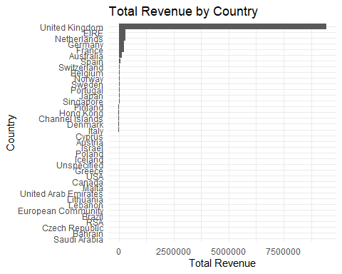 #Interpretation
The results show clear differences in revenue generation across countries. The United Kingdom generates the highest revenue, which is expected because the retailer is based in the UK and likely has a larger customer base there.
Other European countries such as Germany, France, and the Netherlands also contribute significantly to the company’s revenue. This indicates that the retailer has a strong presence in the European market.
The analysis of product consumption shows that different countries have different product preferences. Some products are extremely popular in specific countries, suggesting that cultural preferences or seasonal demand may influence purchasing behaviour.
From a business perspective, these insights can help the company:
Identify high-performing international markets
Adjust marketing strategies for different countries
Promote products that are popular in specific regions
Expand operations in countries with strong demand
Understanding regional purchasing behaviour allows the business to better target customers and improve global sales performance.
#Q4 #(a) Explanation
The purpose of this task is to analyse sales trends over time using the transaction date variable InvoiceDate.
First, the month and year are extracted from the InvoiceDate variable to allow analysis of sales over time. This allows transactions to be grouped by month and year.
Next, the total revenue for each month is calculated by summing the revenue generated from all transactions in that month. This helps identify which months generate the highest sales.
In addition, the analysis identifies products that consistently appear among the lowest-selling products across multiple months. This helps determine which products perform poorly over time and may require review by the business.
Finally, the monthly revenue trend is visualised using a time-series line plot to observe any patterns or seasonal effects in sales.
# Load libraries
library(dplyr)
library(lubridate)
library(ggplot2)
library(knitr)
# Convert InvoiceDate to datetime and remove invalid dates
data <- data %>%
mutate(InvoiceDate = dmy_hm(InvoiceDate)) %>%
filter(!is.na(InvoiceDate))
# Create Year, Month, and YearMonth variables
data <- data %>%
mutate(
Year = year(InvoiceDate),
Month = month(InvoiceDate),
YearMonth = floor_date(InvoiceDate, "month")
)
# Inspect
head(data)
## # A tibble: 6 × 12
## InvoiceNo StockCode Quantity InvoiceDate UnitPrice CustomerID Country
## <chr> <chr> <dbl> <dttm> <dbl> <dbl> <chr>
## 1 536365 85123A 6 2010-12-01 08:26:00 2.55 17850 United …
## 2 536365 85123A 6 2010-12-01 08:26:00 2.55 17850 United …
## 3 536365 71053 6 2010-12-01 08:26:00 3.39 17850 United …
## 4 536365 84406B 8 2010-12-01 08:26:00 2.75 17850 United …
## 5 536365 84029G 6 2010-12-01 08:26:00 3.39 17850 United …
## 6 536365 84029E 6 2010-12-01 08:26:00 3.39 17850 United …
## # ℹ 5 more variables: Description <chr>, Revenue <dbl>, Year <dbl>,
## # Month <dbl>, YearMonth <dttm>
colnames(data)
## [1] "InvoiceNo" "StockCode" "Quantity" "InvoiceDate" "UnitPrice"
## [6] "CustomerID" "Country" "Description" "Revenue" "Year"
## [11] "Month" "YearMonth"
# Calculate monthly revenue
monthly_revenue <- data %>%
group_by(YearMonth) %>%
summarise(TotalRevenue = sum(Revenue, na.rm = TRUE),
.groups = "drop")
# Plot monthly revenue trend
ggplot(monthly_revenue, aes(x = YearMonth, y = TotalRevenue)) +
geom_line(color = "steelblue", size = 1) +
geom_point(color = "red", size = 2) +
labs(
title = "Monthly Revenue Trend",
x = "Month",
y = "Total Revenue"
) +
theme_minimal()
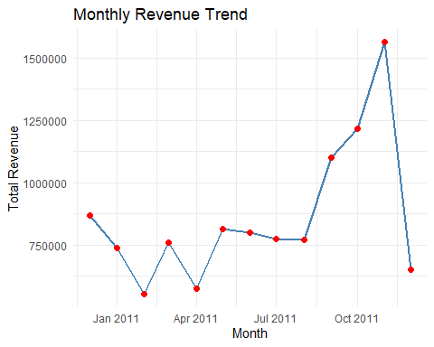
# Check range and summary
range(monthly_revenue$YearMonth)
## [1] "2010-12-01 UTC" "2011-12-01 UTC"
summary(monthly_revenue$YearMonth)
## Min. 1st Qu. Median
## "2010-12-01 00:00:00" "2011-03-01 00:00:00" "2011-06-01 00:00:00"
## Mean 3rd Qu. Max.
## "2011-06-01 07:23:04" "2011-09-01 00:00:00" "2011-12-01 00:00:00"
#Identify Highest Sales Months
top_months <- monthly_revenue %>%
arrange(desc(TotalRevenue)) %>%
slice_head(n = 5)
kable(top_months, caption = "Months with Highest Sales")
Months with Highest Sales
YearMonth | TotalRevenue
2011-11-01 | 1563226
2011-10-01 | 1214040
2011-09-01 | 1100625
2010-12-01 | 868633
2011-05-01 | 813138
# Identify top 5 highest revenue months
top_months <- monthly_revenue %>%
arrange(desc(TotalRevenue)) %>%
slice_head(n = 5)
# Display
kable(top_months, caption = "Months with Highest Sales")
Months with Highest Sales
YearMonth | TotalRevenue
2011-11-01 | 1563226
2011-10-01 | 1214040
2011-09-01 | 1100625
2010-12-01 | 868633
2011-05-01 | 813138
# Calculate monthly revenue per product
monthly_product_sales <- data %>%
group_by(Year, Month, Description) %>%
summarise(
MonthlyRevenue = sum(Revenue, na.rm = TRUE),
.groups = "drop"
)
# Identify lowest-selling product per month
lowest_products <- monthly_product_sales %>%
group_by(Year, Month) %>%
slice_min(MonthlyRevenue, n = 1, with_ties = FALSE)
# Display
kable(lowest_products, caption = "Lowest Selling Products per Month")
Lowest Selling Products per Month
Year | Month | Description | MonthlyRevenue
2010 | 12 | LUNCH BOX WITH CUTLERY FAIRY CAKES | 0.00
2011 | 1 | OLD DOC RUSSEL METAL SIGN | 0.00
2011 | 2 | DOORMAT MERRY CHRISTMAS RED | 0.00
2011 | 3 | DIAMANTE BOW BROOCH RED COLOUR | 0.00
2011 | 4 | ACRYLIC HANGING JEWEL,BLUE | 0.00
2011 | 5 | ANTIQUE GLASS HEART DECORATION | 0.00
2011 | 6 | ANTIQUE GLASS PLACE SETTING | 0.00
2011 | 7 | ? | 0.00
2011 | 8 | Adjust bad debt | -11062.06
2011 | 9 | CREAM AND PINK FLOWERS PONY | 0.00
2011 | 10 | ACRYLIC JEWEL SNOWFLAKE, PINK | 0.00
2011 | 11 | BLUE GIANT GARDEN THERMOMETER | 0.00
2011 | 12 | BLUE GIANT GARDEN THERMOMETER | 0.00
# Optional: Monthly revenue trend with Year-Month interaction
monthly_revenue_interaction <- data %>%
group_by(Year, Month) %>%
summarise(TotalRevenue = sum(Revenue, na.rm = TRUE),
.groups = "drop")
ggplot(monthly_revenue_interaction,
aes(x = interaction(Year, Month),
y = TotalRevenue,
group = 1)) +
geom_line(color = "darkgreen", size = 1) +
geom_point(color = "orange", size = 2) +
labs(
title = "Monthly Revenue Trend (Year-Month Interaction)",
x = "Month",
y = "Total Revenue"
) +
theme_minimal()
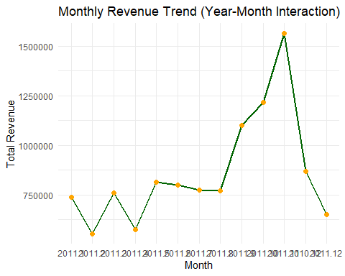 #Interpretation
The monthly revenue analysis reveals fluctuations in sales across different months. Some months show significantly higher revenue compared to others, suggesting the presence of seasonal demand patterns.
For example, higher sales may occur during holiday seasons such as November and December, when customers tend to purchase more gifts and seasonal products. Lower sales months may occur during periods with less consumer spending.
The analysis of lowest-selling products across months indicates that some products consistently perform poorly. These products may have limited demand, outdated designs, or may not appeal to the majority of customers.
From a business perspective, these insights can help the company:
Identify seasonal sales trends
Improve inventory planning
Plan promotional campaigns during low-sales periods
Consider discontinuing or redesigning consistently low-performing products
Understanding sales trends over time allows the business to make better strategic decisions and optimise revenue throughout the year.

