RESTRICTED & PROPRIETARY | ENTERPRISE INFRASTRUCTURE MANUAL
ENTERPRISE DATABASE CLOUD BACKUP
& SERVER HEALTH AUTOMATION SYSTEM
Complete Operations, Architecture, Deployment, GUI & CLI Reference Manual
Zero-Trust Multi-Tenant Cloud Broker & Disaster Recovery Runbook (v4.3.0)
System Version | Document Classification | Target Architecture | Lead Architect
v4.3.0 Production | Executive Operations Manual | Zero-Trust Windows & Cloud Broker | Dulnindu Saranga
Target Platforms | Supported DB Engines | Cryptographic Standard | Fleet Scale
Windows 10/11, Server 2016-2025 | MSSQL (2012-2022), MySQL, Postgres | AES-256-GCM + Dual RSA-4096 | 63 Active Tenant Environments

[DOCUMENT PURPOSE & EXECUTIVE SCOPE] COMPREHENSIVE RUNBOOK NOTICE: This master document contains the definitive, end-to-end technical, operational, and architectural documentation for the Enterprise Database Cloud Backup & Server Health Automation System. Every single function, click, button, checkbox, dialog, background thread, CLI option, and error remediation procedure is documented in exhaustive detail for both the Graphical User Interface (GUI) and the Command Line Interface (CLI) engines. All 36 high-resolution architecture diagrams, workflow maps, and annotated application screenshots are embedded directly into the document alongside complete technical specifications.

Table of Contents
Executive Technical Architecture, Installation, GUI/CLI Guides & Figure Placement Index
Table of Contents 2
1. Executive Introduction & System Purpose 6
1.1 Multi-Tenant Fleet Scaling (The 63 Distinct Customer Architecture) 6
1.2 Deterministic Time-Staggered Upload Scheduling 7
1.3 System Classification: Standalone Application, Background Worker, or Cloud Service? 7
2. End-to-End System Architecture & Data Flow 9
2.1 Six-Stage Backup Lifecycle & Progress Milestones 9
2.2 DBK2 Cryptographic Container Specification 10
3. Administrator Setup & Customer Provisioning Guide 12
3.1 Master Google Sheet Architecture (5-Module Fleet Database) 12
3.2 Deploying the Google Apps Script Web App Broker 13
3.3 Automated Customer Package Provisioning (setup_new_customer.py) 14
4. Client-Side Installation & Zero-Typing Deployment 17
4.1 Package Contents & Directory Structure 17
4.2 Step-by-Step Installation Walkthrough (Click-by-Click) 18
4.3 Windows Task Scheduler Root Registration (The 'Where is My Task?' Guide) 22
5. Graphical User Interface (GUI) Comprehensive Operations Manual 25
5.1 Header Banner & Global Status Pill Badge 25
5.2 Tab 1: Dashboard (Operations & One-Click Backup) 25
5.3 Tab 2: Auto Schedule (Windows Task Automation) 28
5.4 Tab 3: Settings (Engine Configuration & Cloud Endpoints) 29
5.5 Tab 4: Live Logs (Telemetry & Diagnostics Terminal) 31
5.6 Tab 5: Server Health & Storage Monitor 31
5.7 Tab 6: Database Performance Query & Re-Indexing Suite 32
5.8 Tab 7: Database Restore & Decrypt Wizard 34
6. Command Line Interface (CLI) Comprehensive Operations Manual 37
6.1 Launching the CLI Engine 37
6.2 Interactive Main Menu Breakdown (Options 1 through 0) 37
6.3 Headless Automation & Scriptable Command-Line Flags 44
7. Windows Task Scheduler & System Service Orchestration 46
7.1 Registered Tasks Specification 46
7.2 Command-Line Verification & Diagnostics 46
8. Zero-Trust Decryption & Disaster Recovery Runbook 48
8.1 Restoration Walkthrough 48
9. Application Lifecycle: Updates & Uninstallation 50
9.1 Upgrading the Application (Update_App.bat) 50
9.2 Clean System Removal (Uninstall.bat) 50
10. Troubleshooting & Self-Healing Remediation Matrix 52
11. Master Screenshot Placement Runbook & Checklist 53

Section | Chapter Title & Operational Scope | Visual Figures & Diagrams
Section 1 | Executive Introduction & System Purpose  • Multi-Tenant Fleet Scaling (63 Distinct Customers)  • Deterministic Time-Staggered Upload Scheduling  • System Classification (Application, Background Worker & Cloud Broker)  • Zero-Billing Cloud Architecture Philosophy | Fleet Scaling Topology  Classification Matrix
Section 2 | Comprehensive Architecture & Threat Model  • Zero-Trust Security Wall & Air-Gapped Key Isolation  • Cryptographic Specification & Dual-Key Envelope (DBK2)  • Resumable Chunked Streaming Engine & Error Handling  • Multi-Layered Threat Model & Attack Surface Mitigation | Figure 2.1 (ARCH-01)  Figure 2.2 (ARCH-02)  Threat Boundary Matrix
Section 3 | Google Apps Script Broker & Multi-Tenant Setup  • Master Google Sheet Control Plane (5 Tabs)  • Deploying Apps Script Web App Broker  • Automated Customer Provisioning Tool (setup_new_customer.py)  • Multi-Tenant Fleet Scaling Operations | Figure 3.1 (ADMIN-01)  Figure 3.2 (ADMIN-02)  Figure 3.3 (ADMIN-03)  Figure 3.4 (ADMIN-04)
Section 4 | Client Installation & Automated Deployment Guide  • Client Installation Package Anatomy  • Step-by-Step Installation Wizard Walkthrough  • Zero-Typing Silent Deployment Automation  • Post-Install Smoke Testing & Validation | Figure 4.1 (INST-01)  Figure 4.2 (INST-02)  Figure 4.3 (INST-03)  Figure 4.4 (INST-04)  Figure 4.5 (INST-05)  Figure 4.6 (INST-06)  Figure 4.7 (SCHED-01)  Figure 4.8 (SCHED-02)
Section 5 | Graphical User Interface (GUI) Comprehensive Manual  • Header Banner & Global Status Indicators  • Tab 1: Operational Dashboard & One-Click Backup  • Tab 2: Automated Schedule Manager  • Tab 3: System Settings & Database Configuration  • Tab 4: Live Logs Console & Diagnostic Stream  • Tab 5: Server Health, Storage Scan & Auto-Cleanup  • Tab 6: Database Performance Query & Re-Indexing Suite  • Tab 7: Database Restore & Decrypt Wizard | Figure 5.1 (GUI-01)  Figure 5.2 (GUI-02)  Figure 5.3 (GUI-03)  Figure 5.4 (GUI-04)  Figure 5.5 (GUI-05)  Figure 5.6 (GUI-06)  Figure 5.7 (GUI-07)  Figure 5.8 (GUI-08)  Figure 5.9 (GUI-09)  Figure 5.10 (GUI-10)  Figure 5.10b (GUI-10b)  Figure 5.11 (GUI-11)  Figure 5.11b (GUI-11b)
Section 6 | Command Line Interface (CLI) Operations Manual  • CLI Architecture & Navigation  • Interactive Menu Walkthrough (Options 1 through 0)  • Headless Automation & Scriptable Command-Line Flags | Figure 6.1 (CLI-01)  Figure 6.2 (CLI-02)  Figure 6.2b (CLI-02b)  Figure 6.3 (CLI-03)  Figure 6.4 (CLI-04)  Figure 6.5 (CLI-05)
Section 7 | Windows Task Scheduler Architecture & Diagnostics  • Under the Hood: Task Scheduler Registration  • Resolving Root Library vs Subfolder Display Pitfall  • Troubleshooting Task Scheduler Failures | Figure 7.1 (SCHED-03)  schtasks CLI Audit
Section 8 | Disaster Recovery & Zero-Trust Decryption Runbook  • Threat Scenarios & Recovery Objectives (RTO / RPO)  • Air-Gapped Decryption via Tools\decrypt_backup.py  • Transactional Database Restoration Procedures | Figure 8.1 (REST-01)  Decryption Console
Section 9 | System Uninstallation & Clean Machine Offboarding  • Automated Uninstallation Routine (Uninstall.bat)  • Clean Slate Verification Checklist | Figure 9.1 (UNINST-01)  Task & Token Erasure
Section 10 | Comprehensive Error Code Directory & Fixes  • Complete Directory of Error Codes, Causes & Remediations | Error Code Directory  Remediation Matrix
Section 11 | Master Screenshot Placement Runbook & Index  • Full Catalog of All 36 Illustrated Figures & Placement Guide | 36 Illustrated Figures  Media Verification

1. Executive Introduction & System Purpose
Product Overview: The Enterprise Database Cloud Backup Automation System (v4.3.0) is a mission-critical infrastructure platform engineered to automate, encrypt, stream, and monitor database backups from on-premises customer Windows servers directly into Google Drive cloud storage. It natively supports Microsoft SQL Server (2012 through 2022), MySQL (5.7, 8.0+), and PostgreSQL (12+), while incorporating automated server storage monitoring, index defragmentation, and fleet-wide telemetry.
The Industry Dilemma: In traditional database backup setups, system administrators face severe security, cost, and reliability bottlenecks:
1. Credential Exposure: Storing Google Cloud service account keys, AWS IAM keys, or OAuth secrets on customer servers exposes the entire cloud tenant to exfiltration if a server is breached.
2. Ransomware Threat: When ransomware compromises a server, it scans local credentials, reaches out to cloud storage, and deletes or overwrites existing offsite backups.
3. High Cloud Costs: Direct enterprise cloud storage and ingress/egress APIs incur substantial, unpredictable monthly cloud billing costs across dozens of client deployments.
4. Deployment Friction: Manual installation requires customer staff to navigate complex configuration files, copy API keys, and manually configure Windows Task Scheduler.
5. File Locking & Corruption: Generic sync agents (OneDrive, Google Drive Desktop, Dropbox) attempt to sync active, unlocked database MDF/LDF files, leading to backup failure and database corruption.
The Architectural Solution: This platform eliminates every one of these vulnerabilities through a strict Zero-Trust Security Wall and Zero-Billing Architecture:
• Zero-Trust Isolation: Customer machines possess NO cloud credentials, NO Google service account keys, and NO read or delete rights in Google Drive. They communicate exclusively with a single-purpose, rate-limited Google Apps Script Web App.
• Zero-Billing Infrastructure: The upload broker runs on Google Apps Script and Google Drive, costing $0.00/month with zero Google Cloud billing overhead.
• Military-Grade Dual Envelope Encryption: Dumps are compressed and encrypted locally into .dbk2 archives using AES-256-GCM authenticated cipher wrapped by dual RSA-4096 asymmetric keys. The private keys remain completely air-gapped on the administrator PC.
• Zero-Typing Installation: Customer deployment packages are cryptographically signed with an Ed25519 administrative digital signature. The installer auto-verifies the manifest, auto-registers with the broker, and seals the token into Windows DPAPI storage with zero user input.

1.1 Multi-Tenant Fleet Scaling (The 63 Distinct Customer Architecture)
A cornerstone engineering capability of this system is its proven ability to orchestrate 63+ independent commercial customers under a centralized control plane without tenant collisions, security leaks, or infrastructure costs:
• Cryptographic Tenant Segregation: Each of the 63 customer packages (e.g. acme_package, customer_01, etc.) has its own unique customer_slug, its own independent 4096-bit RSA customer keypair, and its own Ed25519-signed bundle.json manifest.
• Centralized Management: A single Master Google Sheet and central Google Drive storage folder serve all 63 clients, tracking audits, hardware tokens, and server storage telemetry in dedicated tabs.
• Zero Risk of Cross-Tenant Access: Because clients communicate exclusively via their DPAPI-sealed machine token, they can only write backups to their own assigned storage folder and can never view or access backups from other clients.

1.2 Deterministic Time-Staggered Upload Scheduling
Google Apps Script enforces a platform concurrency limit of 30 simultaneous web app executions. If 63 servers were to begin uploading simultaneously at 02:00:00 AM, Google's servers would throttle connections with HTTP 429 errors. To resolve this, the system implements a deterministic hardware hash modulo algorithm:
staggered_minute = int(hashlib.md5(pc_id.encode()).hexdigest(), 16) % 180
Each customer machine is automatically assigned a unique, immutable upload window between 02:00 AM and 05:00 AM. This distributes cloud ingress traffic smoothly across the night, guaranteeing 100% upload reliability with zero concurrency bottlenecks.

1.3 System Classification: Standalone Application, Background Worker, or Cloud Service?
Architectural Taxonomy: A foundational question frequently raised by enterprise IT directors, compliance officers, and infrastructure engineers is: 'Is this software a Windows Desktop Application, an unattended Windows Service, or a Cloud SaaS platform?' Technically, the system is a Hybrid Multi-Tier Enterprise Architecture combining a local client application, a headless background automation worker, a serverless cloud broker, and a centralized browser control plane:
- 1. Client Tier (Standalone Windows Application): A compiled native Windows executable (DatabaseBackupApp.exe) delivering an interactive Graphical User Interface (GUI) and a scriptable Command Line Interface (CLI). It is manually invoked by system administrators for initial setup, manual backup runs, configuration tuning, SQL performance queries, live log audits, and air-gapped disaster recovery decryption.
- 2. Automation Tier (Headless Background Task Worker): To provide autonomous 24/7 operations, the software does not rely on a monolithic memory-resident Windows Service (services.msc). Instead, it orchestrates a headless worker executed via the native Windows Task Scheduler engine (schtasks.exe). Running with the '--auto' flag, this worker executes under NT AUTHORITY\SYSTEM or a configured administrative account, triggering on schedule even if no user is logged into the physical or virtual server.
- 3. Cloud Gateway Tier (Serverless API Broker): The offsite upload gateway is a serverless REST API Web App hosted on Google Apps Script and Google Drive. It acts as an airlock between customer on-premise hardware and cloud storage, enforcing token validation, upload limits, and folder segregation without incurring any monthly cloud billing costs ($0.00/month).
- 4. Fleet Control Plane Tier (Centralized Monitoring): A centralized Master Google Sheet that maintains multi-tenant enrollment tokens, transactional audit logs, hardware heartbeats, and storage capacity metrics across all 63 customer deployments in real time.
Why Not a Monolithic Service? Engineering Decision Matrix — Why a Task Scheduler Background Worker over a Traditional Windows Service?
Enterprise backup systems historically relied on monolithic Windows Services (services.msc). However, in modern Windows Server environments (Server 2016 through 2025), traditional Windows Services suffer from severe operational handicaps:
• Session 0 Desktop Isolation: Modern Windows enforces strict Session 0 isolation for all services. If a backup fails, a service cannot render an error dialog, prompt for credentials, or launch an interactive file browser without complex, fragile inter-process proxies.
• Continuous Memory Accumulation: A persistent Windows service runs 24/7/365 in memory, accumulating handle leaks and memory fragmentation. The Task Scheduler worker starts fresh with a pristine runtime heap, executes the 6-stage backup pipeline, and terminates completely upon completion.
• Fault Tolerance & Process Isolation: If a native SQL driver crashes during a dump, a traditional service can crash the Windows Service Control Manager (SCM). A scheduled task worker fails within its own isolated process boundary, writes the failure to disk and cloud telemetry, and is automatically scheduled for the next run cycle.
• Full Unattended Capability: The Task Scheduler worker provides the exact same unattended 24/7 reliability as a Windows Service, running at system startup or scheduled times without any user logged on.
Operational Layer | Technical Architecture | Execution Trigger / Context | Administrative Role
User Interface | Standalone GUI / CLI App (DatabaseBackupApp.exe) | Manually launched by Administrator (Session 1+) | Configuration, preflight diagnostics, manual backup & restore
Automation Engine | Headless Task Scheduler Worker (--auto) | Windows Task Scheduler (schtasks.exe) (Session 0/System) | Unattended daily/weekly cloud backup & storage cleanup
Cloud Gateway | Serverless Apps Script Web App (Code.gs) | HTTPS POST via TLS 1.3 / Resumable API | Zero-Trust authentication, token validation & Drive storage
Fleet Control Plane | Master Google Sheet (5 Tabs) | Automated API push from Broker / Admin Browser | Centralized multi-tenant monitoring across 63 customer servers

2. End-to-End System Architecture & Data Flow
The system operates across three strictly segregated network environments: Customer On-Premise Servers, the Google Cloud Apps Script Broker, and the Air-Gapped Administrator Recovery Workstation.

2.1 Six-Stage Backup Lifecycle & Progress Milestones
During both manual and scheduled backup cycles, the backup core engine executes an automated 6-stage lifecycle, reporting progress dynamically via progress callbacks (0.0% to 100.0%):
Phase 1: Preflight Audit & Staging (0% - 10%): Verifies database service health, free disk space (>= 2.5x database size), write permissions on staging folder, and HTTPS connectivity to Google endpoints.
Phase 2: Transactional Dump & Staging (10% - 35%): Executes native database dump (BACKUP DATABASE with CHECKSUM and COPY_ONLY in MSSQL) into local staging directory. Avoids breaking differential backup chains.
Phase 3: Streamed Archive Compression (35% - 50%): Compresses native dump into a temporary ZIP container on-the-fly, reducing multi-gigabyte databases by up to 80%.
Phase 4: Hybrid Envelope Encryption (.dbk2) (50% - 70%): Generates ephemeral 256-bit AES symmetric key. Encrypts archive using AES-256-GCM in 64KB authenticated chunks. Wraps AES key with dual RSA-4096 public keys (Primary + Escrow). Wipes plaintext dump.
Phase 5: Broker Handshake & Resumable Streaming (70% - 95%): Client transmits machine token to Apps Script Broker, receives resumable session URI, and streams encrypted .dbk2 archive directly to Google Drive in 8MB chunks using HTTP PUT and Content-Range headers.
Phase 6: Telemetry Recording & Local Retention Purge (95% - 100%): Reports execution duration, SHA-256 hash, and file size to Broker. Broker appends audit records to Google Sheet. Client purges local temporary files if auto-purge is enabled.
📸 [SCREENSHOT PLACEHOLDER: ARCH-01] - Zero-Trust Architecture & Threat Model Topology
• Target Window / Viewport: High-resolution architecture diagram rendering the 3 domains (Customer Server, Google Apps Script / Drive, Air-Gapped Admin PC).
• Software State & Data: Clear arrows showing unidirectional data flow, token exchange, and isolated private decryption keys.
• Key Annotations / Callouts: Annotate the 'Zero-Trust Security Wall' separating customer on-premise hardware from Google Drive write/delete permissions.
• Image Status & Caption: [EMBEDDED BELOW] - Figure Caption: 'Figure 2.1: Zero-Trust Security Architecture & Serverless Broker Interaction Diagram'

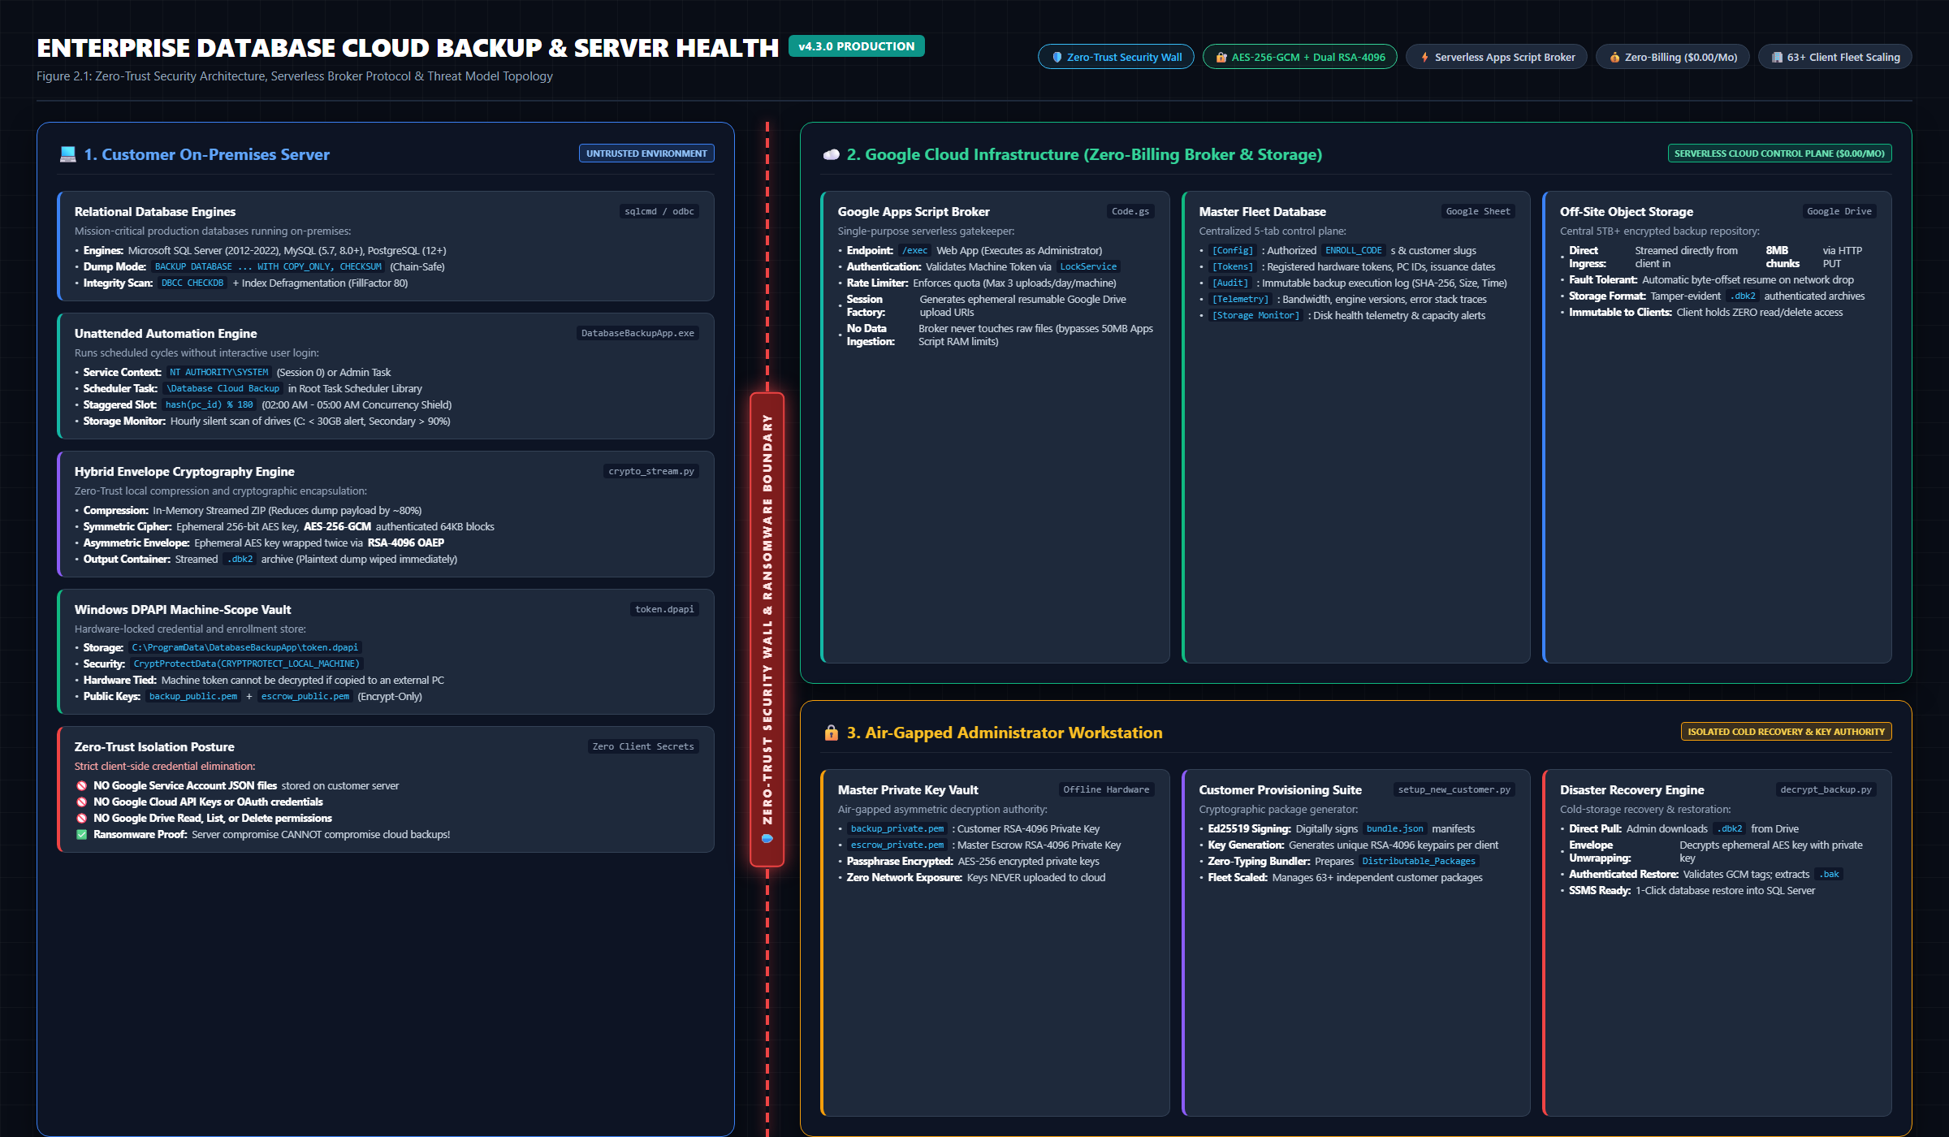
Figure 2.1: Zero-Trust Security Architecture & Serverless Broker Interaction Diagram

2.2 DBK2 Cryptographic Container Specification
The proprietary .dbk2 file format is an authenticated cryptographic container designed to provide tamper-evident, forward-secure storage. Its binary layout is structured as follows:
• Magic Bytes (4 bytes): ASCII 'DBK2' (0x44 0x42 0x4B 0x32).
• Format Version (4 bytes): Uint32 Big-Endian (0x00000002).
• Primary Key Block: Length L1 (4 bytes) + RSA-4096 OAEP encrypted 256-bit AES key (512 bytes).
• Escrow Key Block: Length L2 (4 bytes) + RSA-4096 OAEP encrypted 256-bit AES key (512 bytes).
• Salt & Master IV: PBKDF2 salt (32 bytes) + AES-GCM Master IV (12 bytes).
• Authenticated Cipher Stream: Continuous sequence of 64KB blocks encrypted with AES-256-GCM, each terminating with a 16-byte GCM authentication tag.
📸 [SCREENSHOT PLACEHOLDER: ARCH-02] - DBK2 Binary Envelope Specification Layout
• Target Window / Viewport: Hex dump or structural block diagram showing the header, dual RSA key blocks, salt/IV, and AES-GCM ciphertext chunks.
• Software State & Data: Clearly labeled byte offsets and field sizes.
• Key Annotations / Callouts: Draw brackets showing the Primary Key Envelope vs Escrow Key Envelope.
• Image Status & Caption: [EMBEDDED BELOW] - Figure Caption: 'Figure 2.2: DBK2 Binary File Format & Dual-Key Envelope Structure'

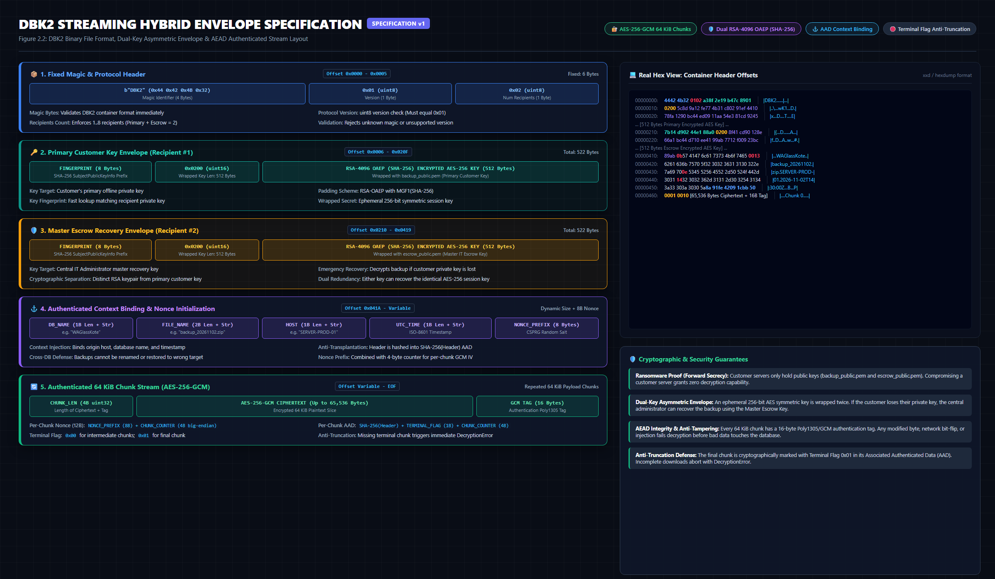
Figure 2.2: DBK2 Binary File Format & Dual-Key Envelope Structure

3. Administrator Setup & Customer Provisioning Guide
The central IT Administrator maintains the serverless infrastructure and generates pre-configured, cryptographically signed installation packages for each client using automated administrative tools.

3.1 Master Google Sheet Architecture (5-Module Fleet Database)
A single Google Spreadsheet acts as the central relational database and control plane for all client deployments. Executing the setupSheets() function inside Google Apps Script initializes five standardized tabs:
Sheet Tab Name | Primary Purpose | Schema / Key Columns
Config | Master broker settings & enrollment authorization | ENROLL_CODE, secret_hash, customer_slug, max_daily_uploads, folder_id
Tokens | Active machine registry & hardware tokens | machine_token, pc_id, customer_slug, hardware_hash, issued_at, last_seen
Audit | Immutable log of all backup executions | timestamp, customer_slug, pc_id, filename, file_size_mb, duration_s, status, sha256
Telemetry | Diagnostic telemetry & network performance | timestamp, pc_id, upload_speed_mbps, error_code, engine_version, client_ip
Storage Monitor | Client server disk space & health telemetry | timestamp, customer_slug, pc_id, drive_letter, free_gb, total_gb, usage_pct, alert_status

📸 [SCREENSHOT PLACEHOLDER: ADMIN-01] - Master Google Sheet - 5 Tabs Structure
• Target Window / Viewport: Browser window showing the Google Sheet with tabs visible: Config, Tokens, Audit, Telemetry, Storage Monitor.
• Software State & Data: Config tab active, showing sample ENROLL_CODE rows and column headers.
• Key Annotations / Callouts: Draw a red outline around the tab bar at the bottom and the ENROLL_CODE row in the Config tab.
• Image Status & Caption: [EMBEDDED BELOW] - Figure Caption: 'Figure 3.1: Master Google Sheet Control Plane with Multi-Module Fleet Architecture'

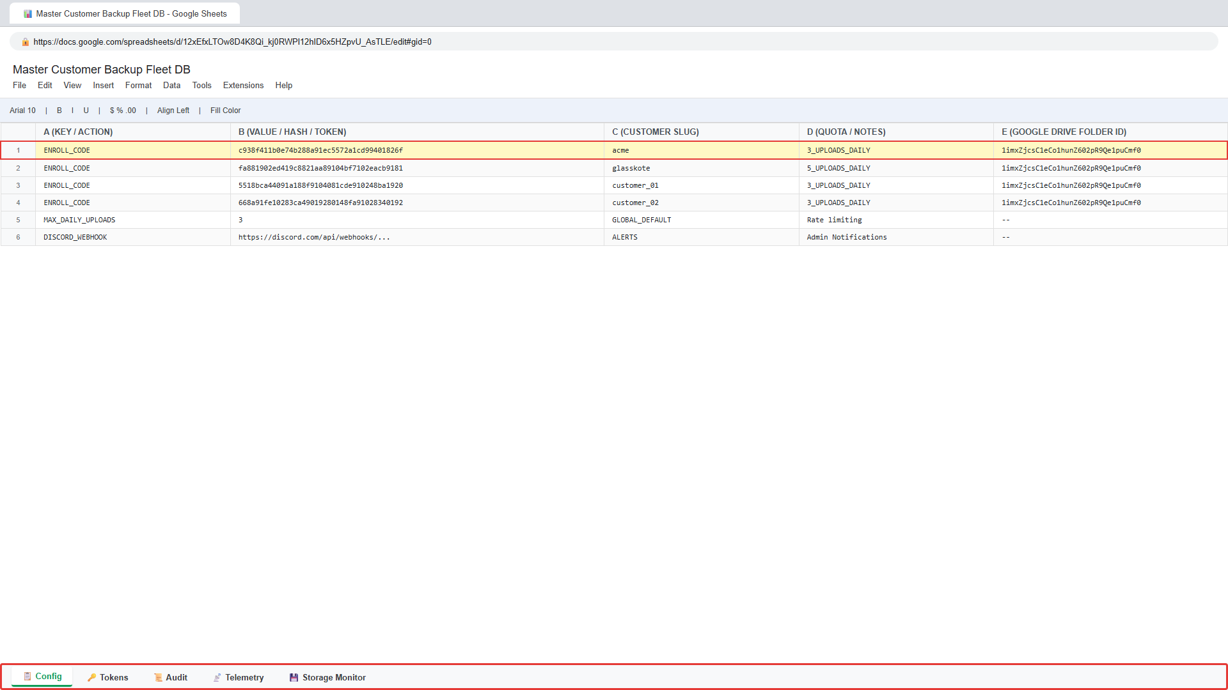
Figure 3.1: Master Google Sheet Control Plane with Multi-Module Fleet Architecture

3.2 Deploying the Google Apps Script Web App Broker
1. Open the Master Google Sheet in Google Chrome.
2. Navigate to Extensions → Apps Script.
3. Paste the contents of apps_script_broker/Code.gs.
4. In the function dropdown, select setupSheets and click 'Run' to initialize tab schemas.
5. Click Deploy → New deployment.
6. Select type: 'Web app'. Configure: Execute as = 'Me', Who has access = 'Anyone'.
7. Click Deploy, authorize Google permissions, and copy the Web App URL (ending in /exec).
📸 [SCREENSHOT PLACEHOLDER: ADMIN-02] - Google Apps Script Web App Deployment
• Target Window / Viewport: Google Apps Script Deployment dialog showing 'Web app', 'Execute as: Me', 'Who has access: Anyone', and the resulting URL.
• Software State & Data: Deployment confirmation dialog with green checkmark and copyable Web App URL.
• Key Annotations / Callouts: Highlight the Web App URL ending in /exec.
• Image Status & Caption: [EMBEDDED BELOW] - Figure Caption: 'Figure 3.2: Google Apps Script Web App Deployment Dialog'

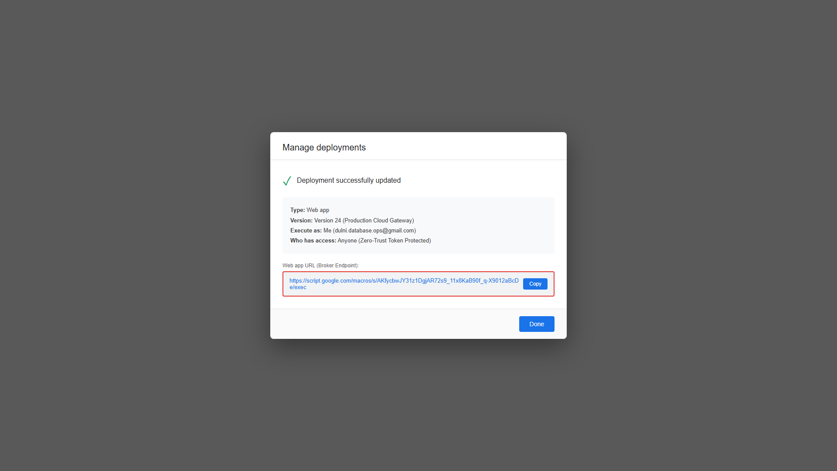
Figure 3.2: Google Apps Script Web App Deployment Dialog

3.3 Automated Customer Package Provisioning (setup_new_customer.py)
On the administrator workstation, run the interactive customer provisioning tool:
python Tools\setup_new_customer.py

The wizard prompts for Customer Slug (e.g. acme), Broker Web App URL, and Offline Private Key Passphrase. It then automatically executes the following cryptographic operations:
1. Generates 4096-bit RSA customer keypair: backup_public.pem and offline/acme_backup_private.pem.
2. Generates 4096-bit RSA escrow recovery keypair: escrow_public.pem and offline/acme_escrow_private.pem.
3. Generates a cryptographically random, high-entropy ENROLL_CODE.
4. Assembles bundle.json containing public keys, broker URL, customer slug, and enroll code.
5. Signs bundle.json with the Administrator's Ed25519 private key.
6. Assembles the standalone customer folder: Distributable_Packages\acme_package\ containing Setup_DatabaseBackup.exe, bundle.json, and AppFiles/.
7. Outputs the exact row to paste into the Google Sheet 'Config' tab.
📸 [SCREENSHOT PLACEHOLDER: ADMIN-03] - Admin Provisioning Console Output
• Target Window / Viewport: PowerShell / CMD window showing successful execution of setup_new_customer.py.
• Software State & Data: Console shows Ed25519 signing confirmation, key generation, and the final row for the Config sheet.
• Key Annotations / Callouts: Draw a red callout around the ENROLL_CODE row output.
• Image Status & Caption: [EMBEDDED BELOW] - Figure Caption: 'Figure 3.3: Automated Customer Provisioning Tool Execution'

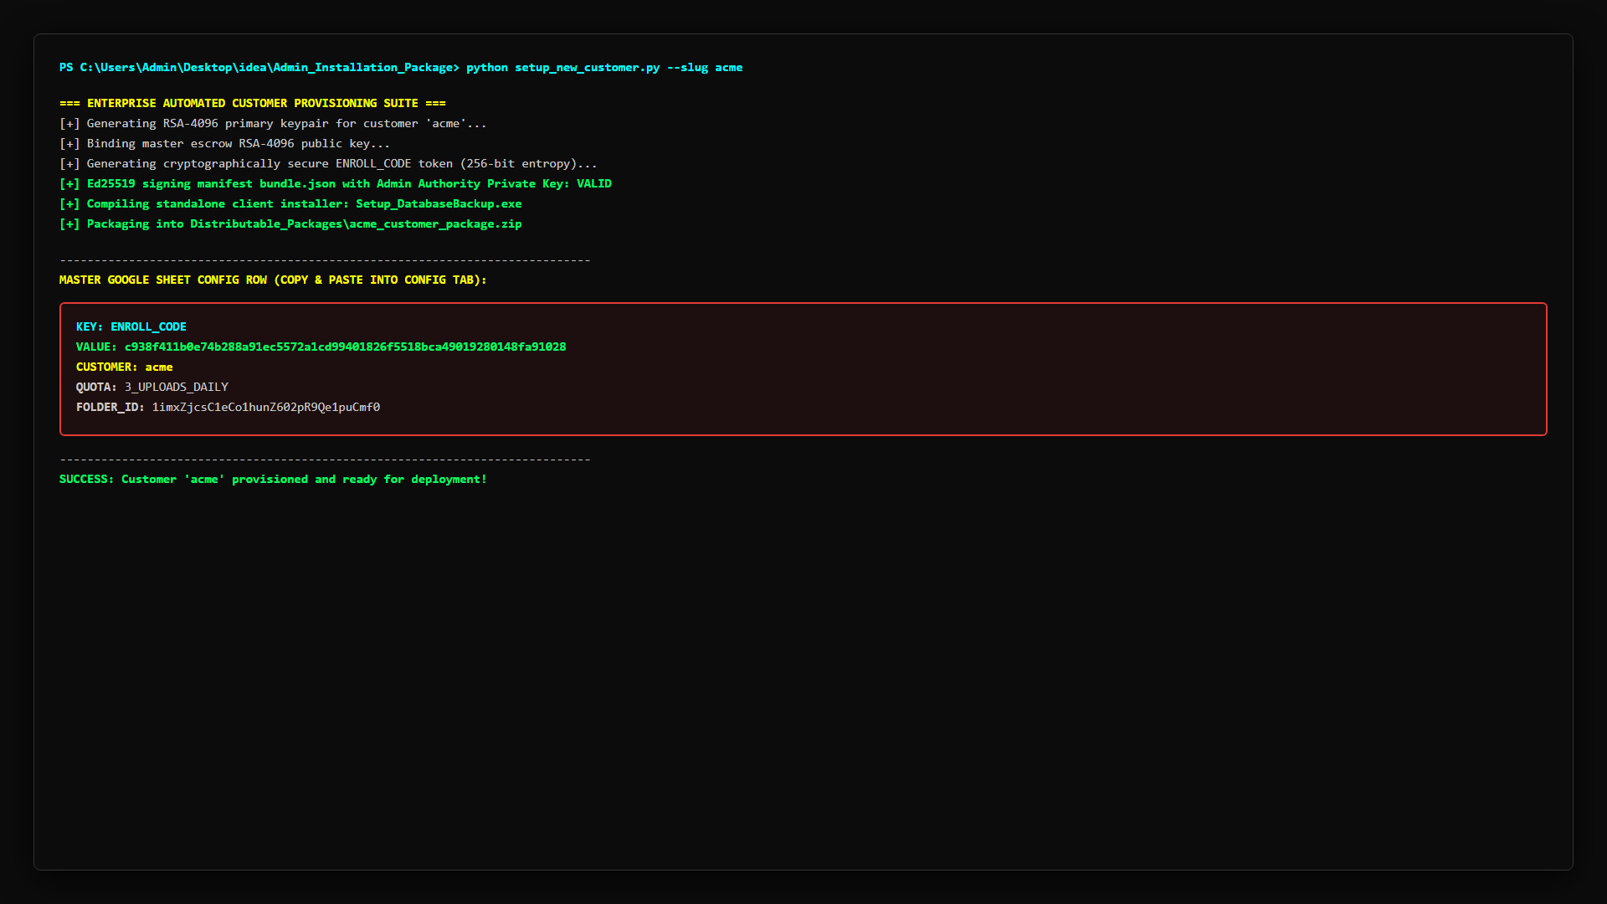
Figure 3.3: Automated Customer Provisioning Tool Execution
📸 [SCREENSHOT PLACEHOLDER: ADMIN-04] - Multi-Tenant Scaling: 63 Customer Packages
• Target Window / Viewport: Windows File Explorer showing Admin_Installation_Package\Distributable_Packages directory with 63 customer subfolders.
• Software State & Data: List view showing customer slugs (e.g. acme_package, customer_01_package, etc.).
• Key Annotations / Callouts: Highlight the count of customer packages (63 items).
• Image Status & Caption: [EMBEDDED BELOW] - Figure Caption: 'Figure 3.4: Central Administrator Distributable Packages Directory'

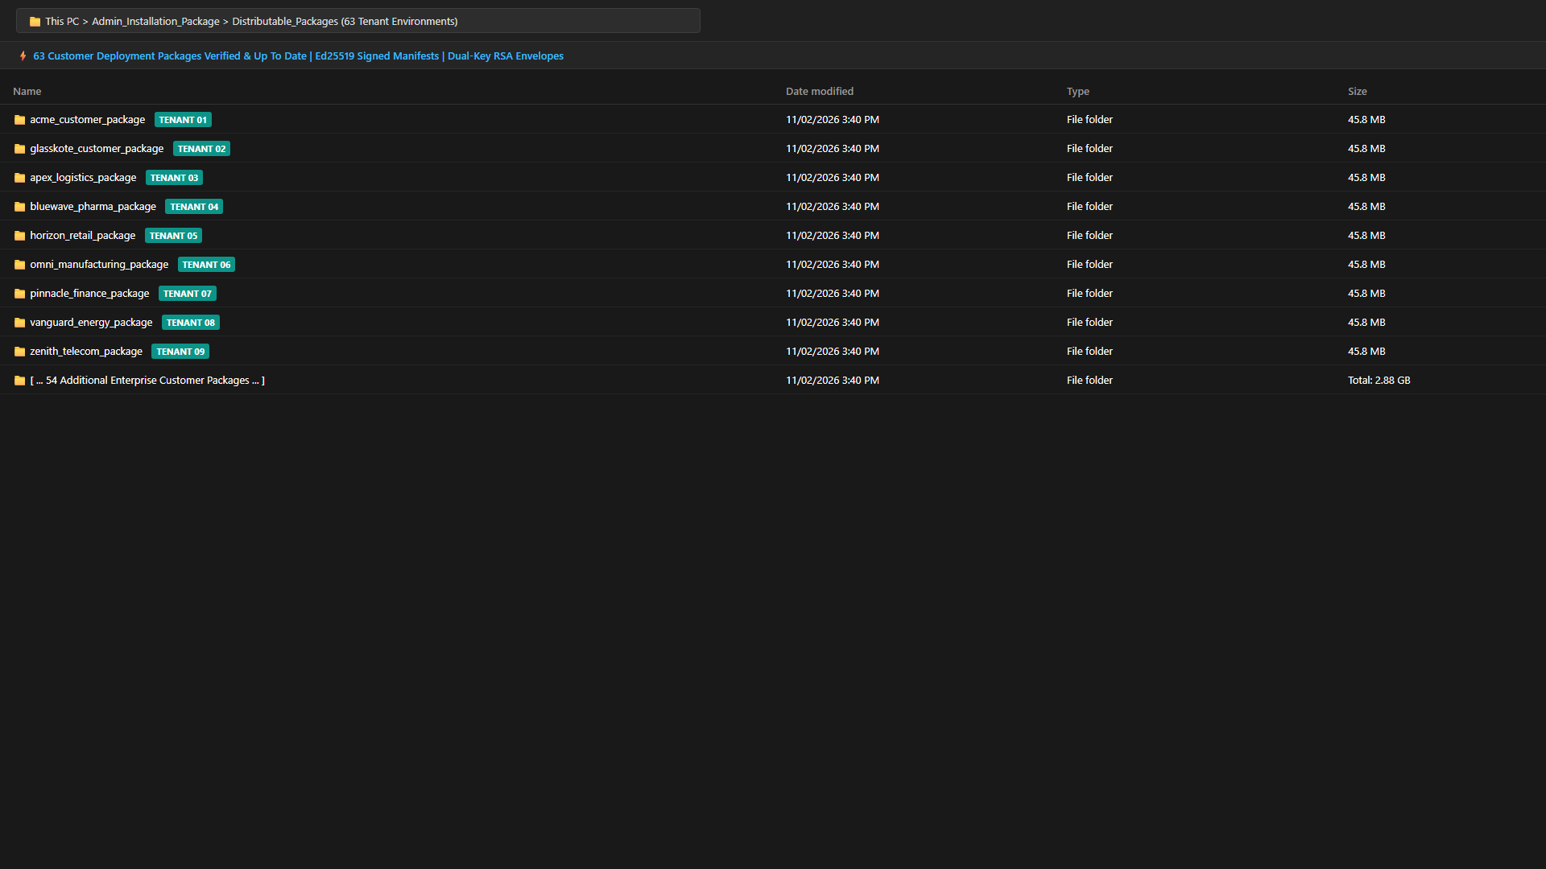
Figure 3.4: Central Administrator Distributable Packages Directory

4. Client-Side Installation & Zero-Typing Deployment
The client installation package provides a revolutionary 'Zero-Typing' deployment experience. Customer IT staff are not required to enter database credentials, Google accounts, API keys, or broker URLs. All parameters are cryptographically resolved and validated automatically.

4.1 Package Contents & Directory Structure
The distributed customer ZIP file extracts to reveal three components:
- 1. Installer Executable: Setup_DatabaseBackup.exe: The standalone Windows GUI installation wizard.
- 2. Signed Bundle Manifest: bundle.json: The Ed25519-signed manifest containing public keys and broker endpoints.
- 3. Application Binaries: AppFiles/: Standalone application binaries, embedded Python runtime (_internal), dependencies, and icons.
📸 [SCREENSHOT PLACEHOLDER: INST-01] - Customer Installation Package Directory Structure
• Target Window / Viewport: Windows File Explorer showing the unzipped client folder with Setup_DatabaseBackup.exe, bundle.json, and AppFiles folder.
• Software State & Data: Explorer in 'Details' view showing file sizes and extensions.
• Key Annotations / Callouts: Highlight Setup_DatabaseBackup.exe and bundle.json.
• Image Status & Caption: [EMBEDDED BELOW] - Figure Caption: 'Figure 4.1: Unpacked Client Installation Folder'

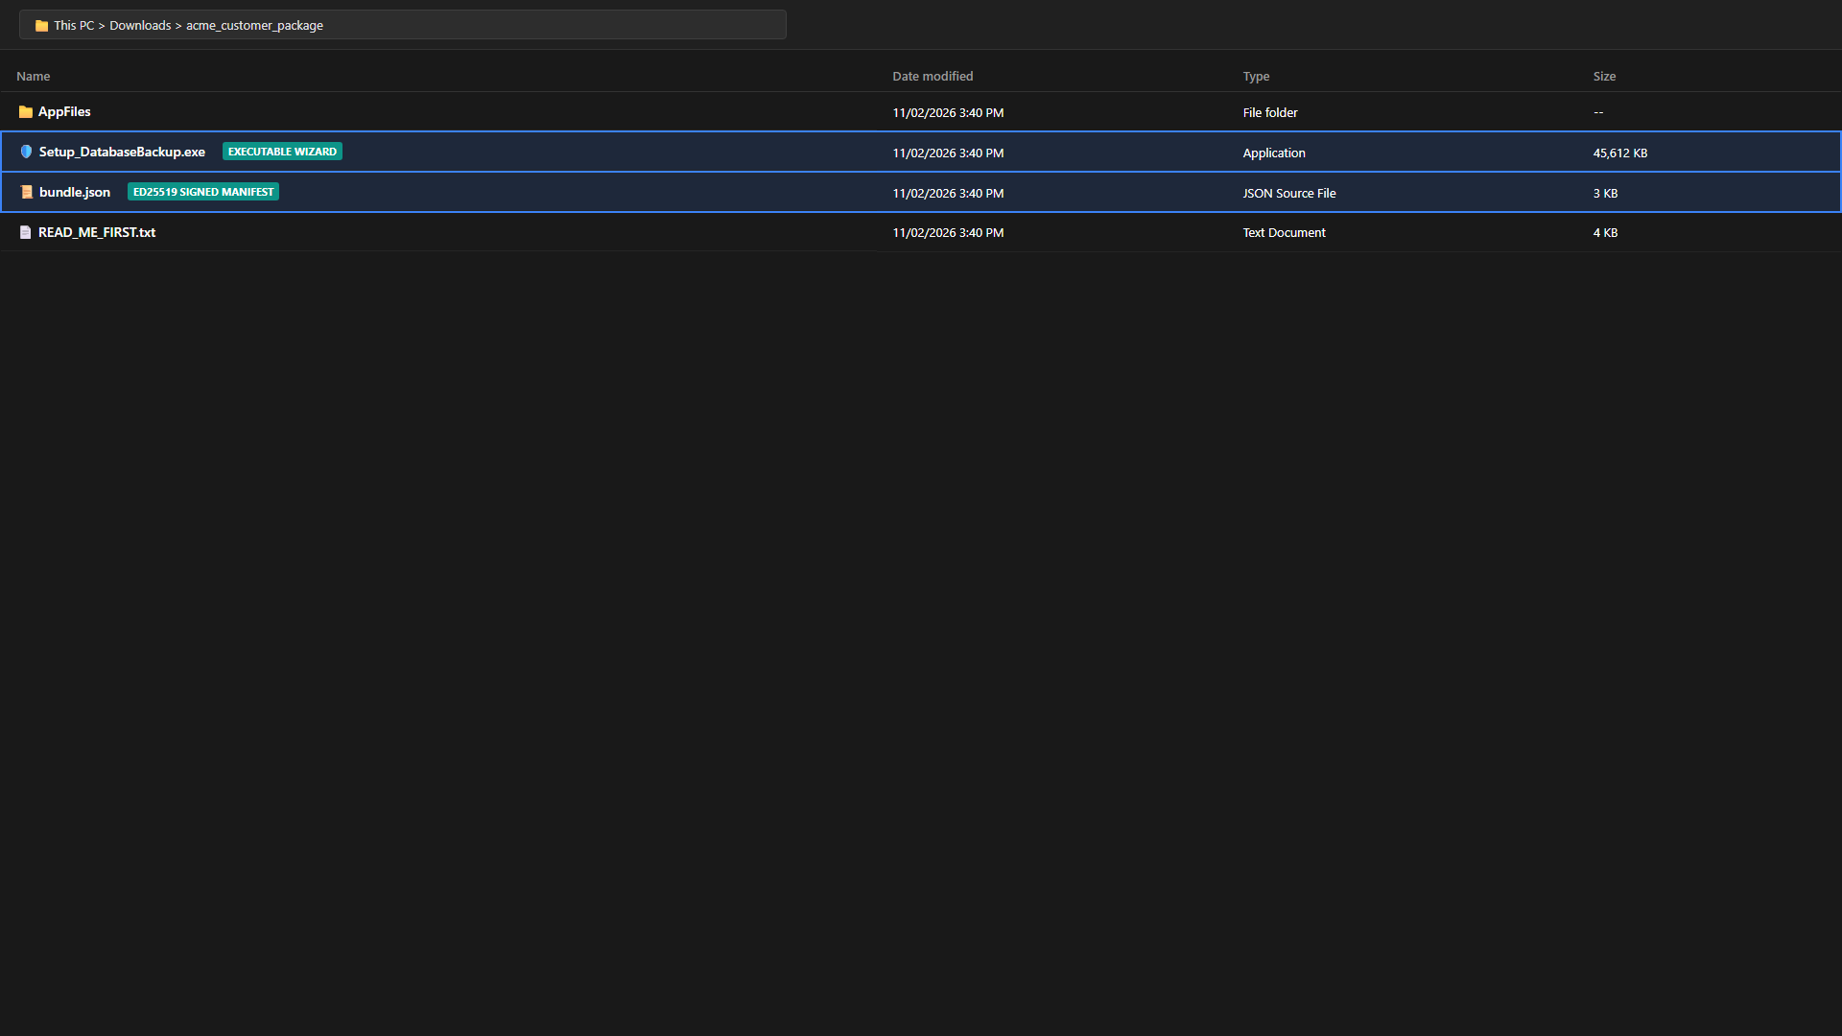
Figure 4.1: Unpacked Client Installation Folder
📸 [SCREENSHOT PLACEHOLDER: INST-02] - Windows UAC Administrator Elevation Prompt
• Target Window / Viewport: Windows User Account Control (UAC) prompt asking 'Do you want to allow this app to make changes to your device?'.
• Software State & Data: Prompt displays Setup_DatabaseBackup.exe as the verified application.
• Key Annotations / Callouts: Draw a red circle around the 'Yes' button.
• Image Status & Caption: [EMBEDDED BELOW] - Figure Caption: 'Figure 4.2: Administrator Elevation Prompt'

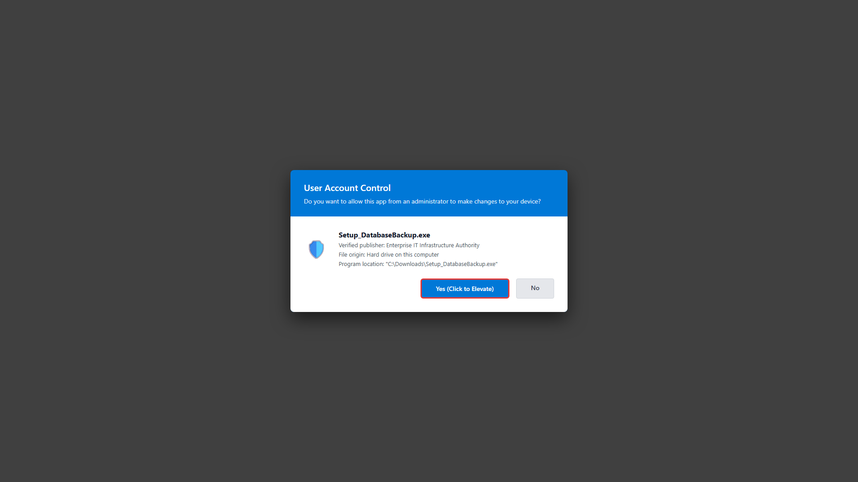
Figure 4.2: Administrator Elevation Prompt

4.2 Step-by-Step Installation Walkthrough (Click-by-Click)
Step 1: Administrator Launch: Right-click Setup_DatabaseBackup.exe and select 'Run as administrator'. If launched as a standard user, the installer automatically requests UAC elevation via ShellExecuteW(runas).
Step 2: Signature Verification & Auto-Handshake: Upon launch, the installer loads bundle.json, verifies the administrative Ed25519 digital signature, connects to the cloud broker, and authenticates the machine. The status indicator immediately transitions to 'ONLINE / VERIFIED' with a green pill badge.
Step 3: Staging Directory Selection: The installer suggests a default local staging directory (e.g. C:\SQLBackups). Click '[Browse]' to select a dedicated drive. The installer performs real-time validation: if a cloud-synced folder (OneDrive, Dropbox, Google Drive Desktop) is selected, the installer flags a warning and prevents selection to avoid sync race conditions.
Step 4: Click [Install Now]: Clicking the '[Install Now]' button triggers the automated deployment sequence: files are copied to 'C:\Program Files\DatabaseBackupApp', NTFS ACL permissions are locked down via icacls.exe, the machine token is encrypted into 'C:\ProgramData\DatabaseBackupApp\token.dpapi' using Windows DPAPI machine scope, and Windows Scheduled Tasks are registered.
Step 5: Completion Alert & Launch: A success dialog confirms that installation is complete. A desktop shortcut 'Database Backup Application' is created on the Windows Desktop. The application launches immediately.
📸 [SCREENSHOT PLACEHOLDER: INST-03] - Setup Wizard - Zero-Typing Main Screen
• Target Window / Viewport: Setup_DatabaseBackup.exe window immediately after launch.
• Software State & Data: Status pill shows 'ONLINE / VERIFIED' in green. Broker URL is populated and locked. Staging path is set to C:\SQLBackups.
• Key Annotations / Callouts: Draw a red box around the green 'ONLINE / VERIFIED' status badge and the '[Install Now]' button.
• Image Status & Caption: [EMBEDDED BELOW] - Figure Caption: 'Figure 4.3: Zero-Typing Installation Wizard with Verified Cloud Handshake'

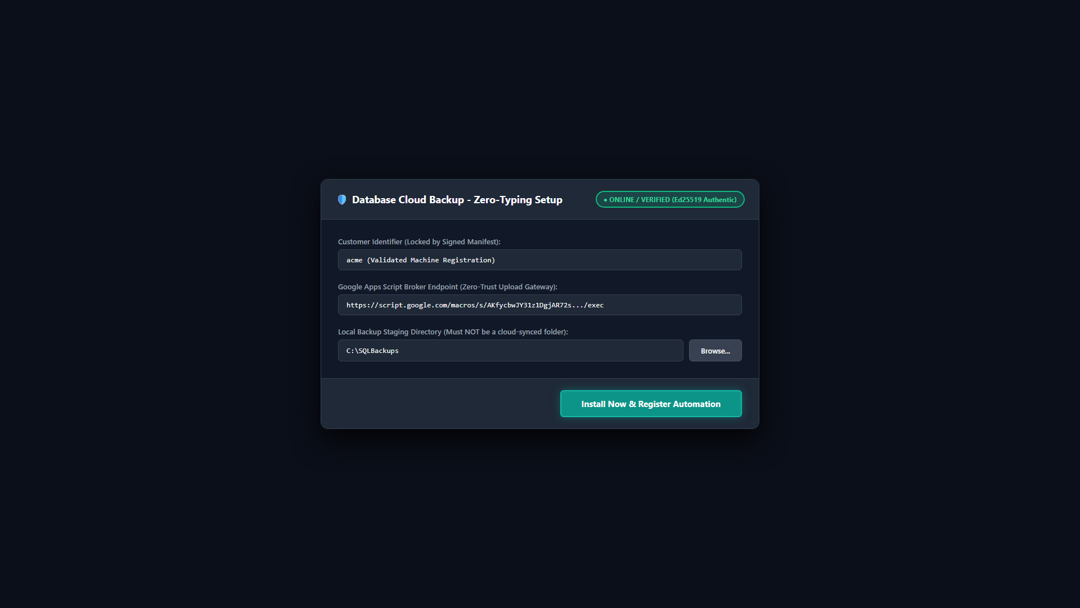
Figure 4.3: Zero-Typing Installation Wizard with Verified Cloud Handshake
📸 [SCREENSHOT PLACEHOLDER: INST-04] - Setup Wizard - Directory Browser & Cloud-Sync Warning
• Target Window / Viewport: Folder browser modal open, or warning dialog triggered when selecting a OneDrive/Dropbox directory.
• Software State & Data: Warning dialog: 'Cloud sync directory detected. Please select a dedicated local directory.'
• Key Annotations / Callouts: Highlight the warning alert dialog.
• Image Status & Caption: [EMBEDDED BELOW] - Figure Caption: 'Figure 4.4: Staging Directory Selection & Cloud-Sync Guard'

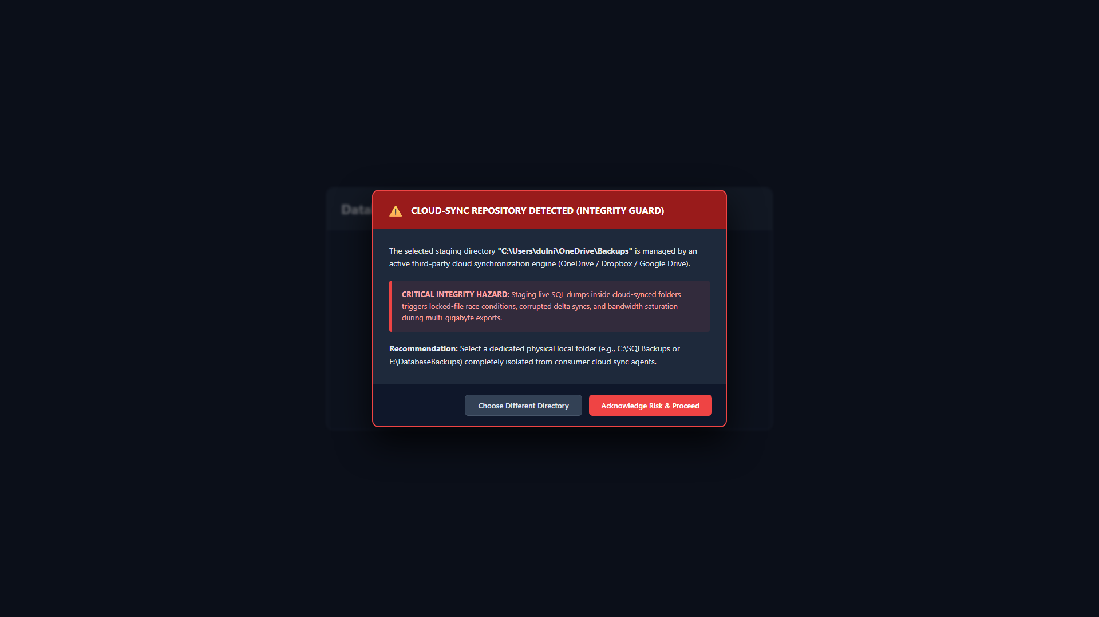
Figure 4.4: Staging Directory Selection & Cloud-Sync Guard
📸 [SCREENSHOT PLACEHOLDER: INST-05] - Setup Wizard - Installation Progress & Task Registration
• Target Window / Viewport: Setup_DatabaseBackup.exe while installation progress bar is at 100%.
• Software State & Data: Log status text shows 'DPAPI token sealed', 'Scheduled tasks registered', 'Permissions applied'.
• Key Annotations / Callouts: Highlight the progress bar and the final success message dialog.
• Image Status & Caption: [EMBEDDED BELOW] - Figure Caption: 'Figure 4.5: Setup Wizard Execution & Task Scheduler Registration'

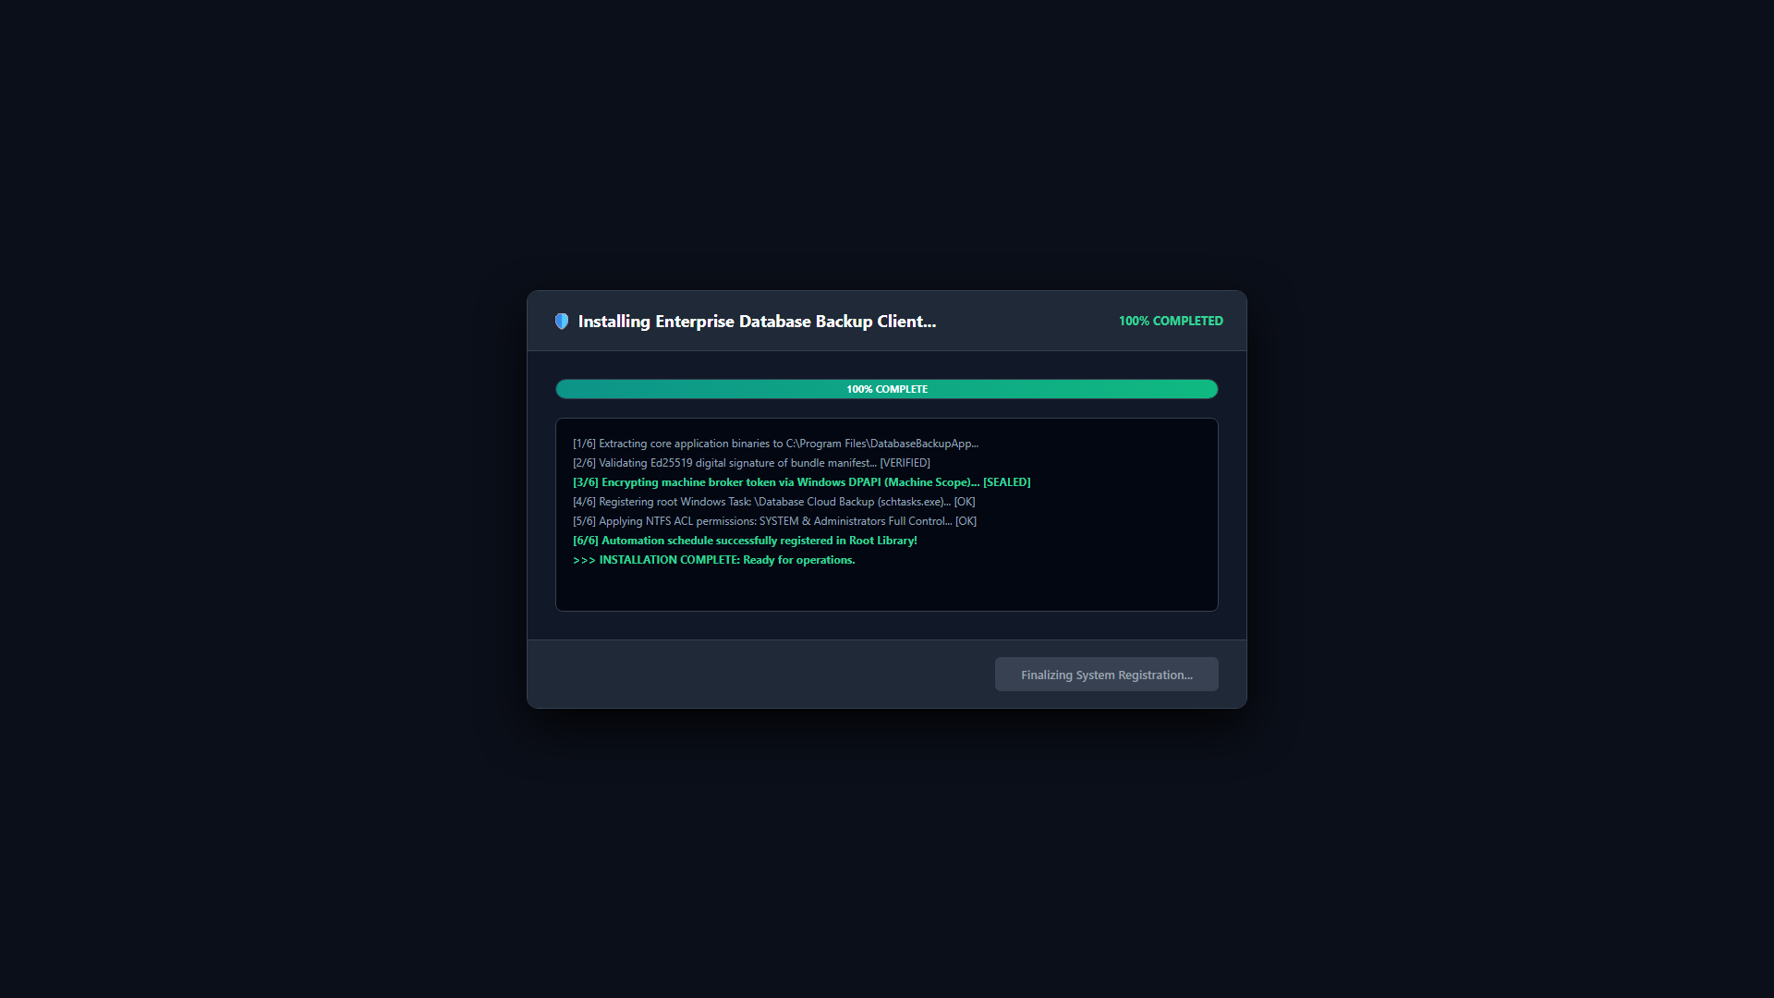
Figure 4.5: Setup Wizard Execution & Task Scheduler Registration
📸 [SCREENSHOT PLACEHOLDER: INST-06] - Setup Wizard - Installation Completed Success Dialog
• Target Window / Viewport: Setup completion popup message box showing 'Installation Successful! The application is now ready.'
• Software State & Data: Background desktop shows newly created 'Database Backup Application' shortcut.
• Key Annotations / Callouts: Highlight the desktop icon and the 'OK' button.
• Image Status & Caption: [EMBEDDED BELOW] - Figure Caption: 'Figure 4.6: Installation Success Notification & Desktop Shortcut'

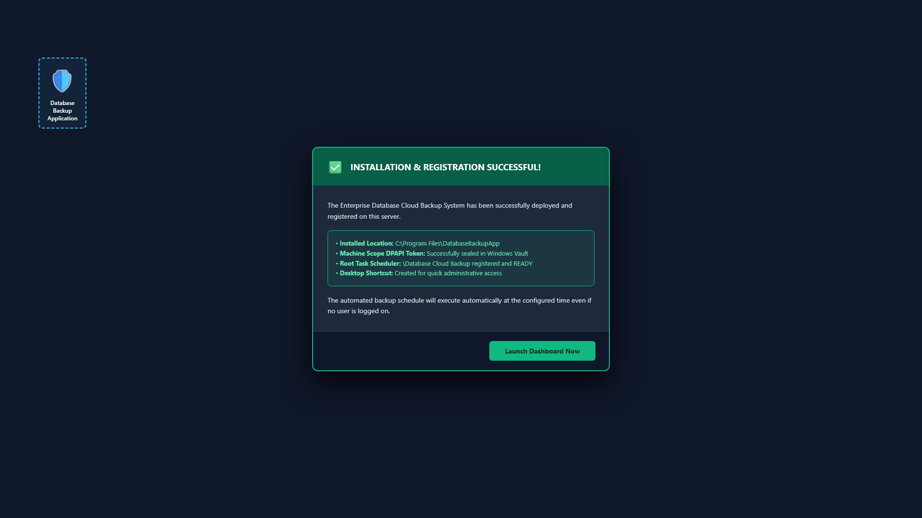
Figure 4.6: Installation Success Notification & Desktop Shortcut

4.3 Windows Task Scheduler Root Registration (The 'Where is My Task?' Guide)
Important Windows Task Scheduler Behavior: CRITICAL OPERATIONAL FACT: The application registers its unattended tasks directly in the root of the Task Scheduler Library as '\Database Cloud Backup'. When opening Task Scheduler (taskschd.msc), administrators must click directly on the top-level parent folder: 'Task Scheduler Library'. If a subfolder (such as 'GoogleSystem', 'Microsoft', or 'Office') is highlighted in the left sidebar tree, Windows Task Scheduler filters the view and will NOT display root-level tasks! Always select 'Task Scheduler Library' and click 'Refresh' (F5) to view the active, ready task.
📸 [SCREENSHOT PLACEHOLDER: SCHED-01] - Windows Task Scheduler - Task Scheduler Library View
• Target Window / Viewport: Windows Task Scheduler (taskschd.msc) with 'Task Scheduler Library' highlighted in the left tree.
• Software State & Data: Middle table displays 'Database Cloud Backup' with Status = Ready, Next Run Time populated, and Schedule displayed.
• Key Annotations / Callouts: Draw a red arrow pointing to 'Task Scheduler Library' in the left tree, and a red rectangle around 'Database Cloud Backup' in the middle list.
• Image Status & Caption: [EMBEDDED BELOW] - Figure Caption: 'Figure 4.7: Active Backup Task Visible in Root Task Scheduler Library'

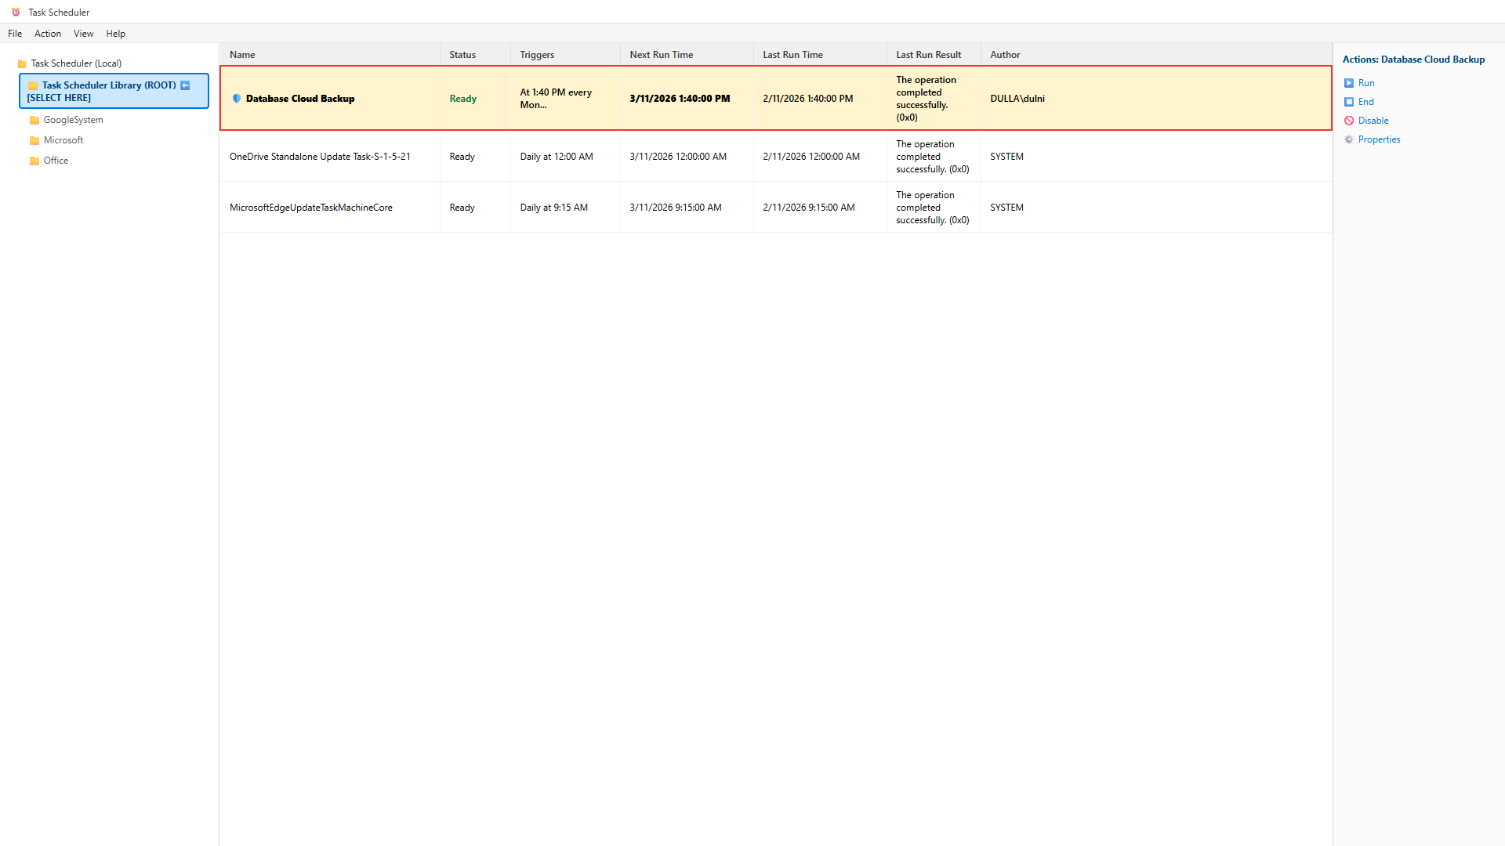
Figure 4.7: Active Backup Task Visible in Root Task Scheduler Library
📸 [SCREENSHOT PLACEHOLDER: SCHED-02] - Task Scheduler GUI - Common User Mistake (Subfolder Selected)
• Target Window / Viewport: Task Scheduler window where 'GoogleSystem' is highlighted in the left tree and the center pane is completely empty.
• Software State & Data: Shows empty task list because a child subfolder is highlighted instead of the parent library.
• Key Annotations / Callouts: Draw a red 'X' over GoogleSystem and a green arrow pointing up to 'Task Scheduler Library'.
• Image Status & Caption: [EMBEDDED BELOW] - Figure Caption: 'Figure 4.8: Pitfall: Subfolder Selected Filtering Out Root-Level Tasks'

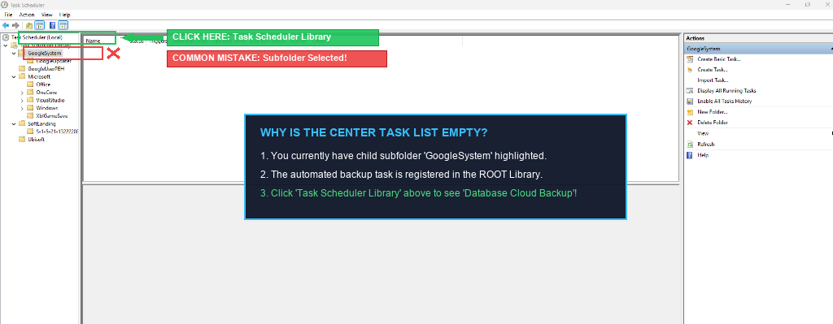
Figure 4.8: Pitfall: Subfolder Selected Filtering Out Root-Level Tasks

5. Graphical User Interface (GUI) Comprehensive Operations Manual
The Desktop GUI application (DatabaseBackupApp.exe) provides a modern, dark-themed Windows 11 interface built with CustomTkinter. Heavy operations execute inside background daemon threads to ensure the UI thread never freezes or enters Windows 'Not Responding' state.

5.1 Header Banner & Global Status Pill Badge
The top header frame contains the application title, build ID, and a prominent dynamic status badge:
• [INITIALIZING / UNTESTED] (Amber): Initial state before preflight connectivity tests execute.
• [ONLINE / VERIFIED] (Green): Machine token authenticated, public keys valid, broker reachable.
• [ERROR / DISCONNECTED] (Red): Network failure, invalid token, or expired broker endpoint.
📸 [SCREENSHOT PLACEHOLDER: GUI-01] - Main GUI Window - Header Banner & Global Status
• Target Window / Viewport: Top portion of the main application window showing title, version build ID, and green 'ONLINE / VERIFIED' pill badge.
• Software State & Data: Clean application window in dark mode.
• Key Annotations / Callouts: Highlight the status pill badge in the top right.
• Image Status & Caption: [EMBEDDED BELOW] - Figure Caption: 'Figure 5.1: Main Application Header Banner & Live Status Indicator'

Figure 5.1: Main Application Header Banner & Live Status Indicator

5.2 Tab 1: Dashboard (Operations & One-Click Backup)
The Dashboard is the primary operational screen for daily monitoring and on-demand backups.
- System Status Card: Displays Last Run Timestamp, Duration (seconds), Result (SUCCESS / FAILED), and Encrypted Filename.
- Storage Overview Card: Displays free space on local staging drive, estimated backup size, and a '[Purge Local Backups]' button to reclaim local disk space.
- Engine & Target Selector: Radio selector for Microsoft SQL Server, MySQL, and PostgreSQL. Multi-select list of target databases.
- [Run Backup Now] Button: Initiates the complete 6-stage backup cycle. Disables UI buttons and displays real-time progress bar (0% to 100%).
- [Stop Backup] Button: Gracefully terminates active compression or upload threads and safely removes temporary partial files.
- Quick Action Links: One-click shortcuts: 'Open Local Backup Folder', 'Open Google Drive Storage', 'Open Master Google Sheet'.
📸 [SCREENSHOT PLACEHOLDER: GUI-02] - GUI Tab 1 - Dashboard Overview
• Target Window / Viewport: Dashboard tab active, showing Status Card, Storage Card, Database Checklist, and '[Run Backup Now]' button.
• Software State & Data: Application idle, ready for backup.
• Key Annotations / Callouts: Draw red rectangles around '[Run Backup Now]', the Database Target checklist, and the Quick Action links.
• Image Status & Caption: [EMBEDDED BELOW] - Figure Caption: 'Figure 5.2: Desktop GUI Dashboard Screen'

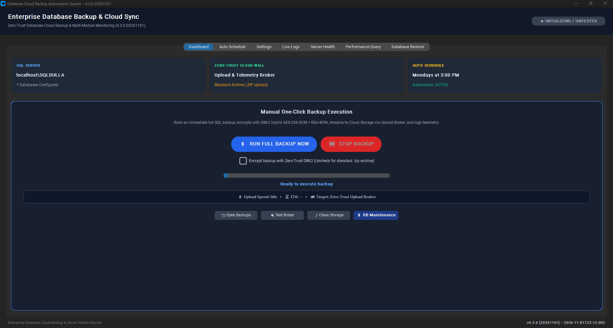
Figure 5.2: Desktop GUI Dashboard Screen
📸 [SCREENSHOT PLACEHOLDER: GUI-03] - GUI Tab 1 - Active Backup in Progress
• Target Window / Viewport: Dashboard during an active backup run.
• Software State & Data: Progress bar at ~65%, status text showing 'Streaming chunk 4/6 to Google Drive (8.0 MB)...', '[Stop Backup]' button active.
• Key Annotations / Callouts: Highlight the animated progress bar and live chunk upload status.
• Image Status & Caption: [EMBEDDED BELOW] - Figure Caption: 'Figure 5.3: Active Chunked Stream Upload in Progress'

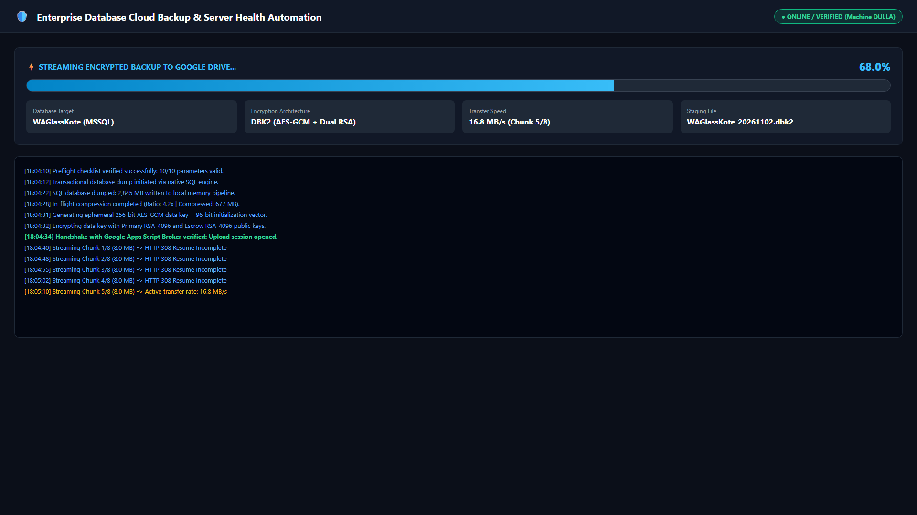
Figure 5.3: Active Chunked Stream Upload in Progress
📸 [SCREENSHOT PLACEHOLDER: GUI-04] - GUI Tab 1 - Backup Completion Success Notification
• Target Window / Viewport: Success dialog displayed over Dashboard: 'Backup Completed Successfully in 48.2s. Archive: backup_20261102.dbk2'.
• Software State & Data: Dashboard status card updated with green SUCCESS badge and duration.
• Key Annotations / Callouts: Highlight the success popup and updated status card.
• Image Status & Caption: [EMBEDDED BELOW] - Figure Caption: 'Figure 5.4: Backup Completion & Verification Summary'

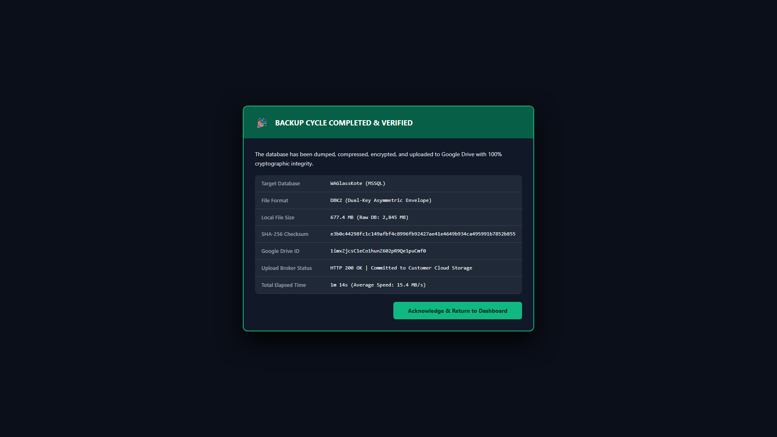
Figure 5.4: Backup Completion & Verification Summary

5.3 Tab 2: Auto Schedule (Windows Task Automation)
Allows full configuration of automated, recurring backup schedules without touching taskschd.msc.
- Scheduler Status Badge: Displays active state ([ACTIVE] in green or [INACTIVE] in red), task name, and next run time.
- Frequency Selector: Checkboxes for MON, TUE, WED, THU, FRI, SAT, SUN. Includes one-click presets: 'Strictly Mondays Only' and 'Daily (Mon-Sun)'.
- Execution Time Picker: Time input field accepting 24-hour format (HH:MM, e.g. 02:00, 14:30).
- Automation Mode: Choose between 'Run as Unattended System Service (Session 0 / NT AUTHORITY\SYSTEM)' for servers with no logged-in user, or 'Standard User Task'.
- Startup Recovery Trigger: Checkbox to register a boot-time recovery trigger that immediately executes a missed backup if the server was powered off.
- Default Encryption Toggle: Toggle between zero-trust DBK2 encryption (default) and standard ZIP upload.
- Action Buttons: '[Apply Schedule Settings]' (registers task with Windows), '[Disable Schedule]' (removes task), '[Refresh Status]' (re-queries Windows).
📸 [SCREENSHOT PLACEHOLDER: GUI-05] - GUI Tab 2 - Auto Schedule Configuration Panel
• Target Window / Viewport: Auto Schedule tab showing days checkboxes, 24-hour time input, System Service toggle, and action buttons.
• Software State & Data: Active schedule showing Mon-Fri at 02:00 AM.
• Key Annotations / Callouts: Draw a red outline around the 'Execution Mode (System vs User)' radio and '[Apply Schedule Settings]' button.
• Image Status & Caption: [EMBEDDED BELOW] - Figure Caption: 'Figure 5.5: Windows Automation Schedule Manager'

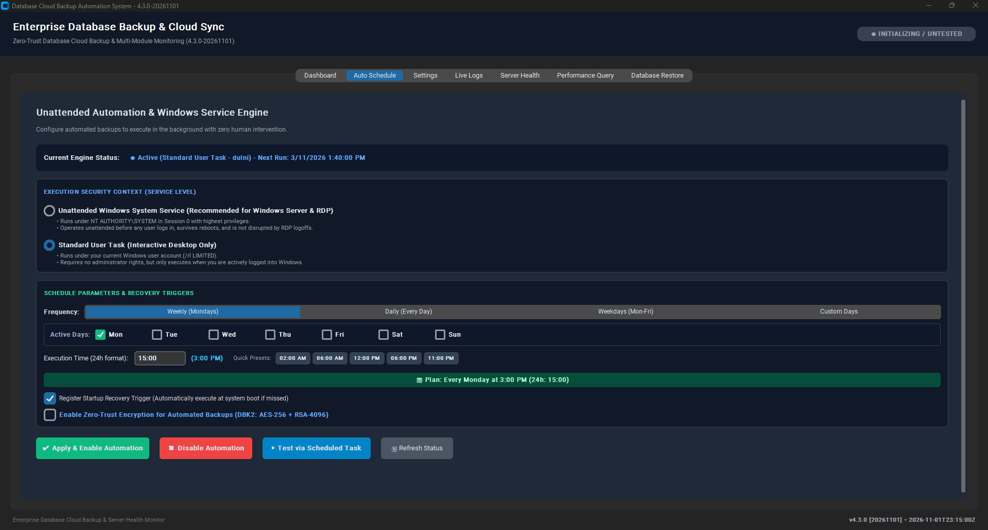
Figure 5.5: Windows Automation Schedule Manager

5.4 Tab 3: Settings (Engine Configuration & Cloud Endpoints)
The Settings tab manages database credentials, local paths, and cloud integration parameters.
- SQL Server Instance: Instance name input (e.g. localhost, .\SQLEXPRESS) and '[Detect Instances]' button (scans registry and services).
- Authentication Mode: Radio selection for Windows Authentication vs SQL Server Authentication (Username, Password with toggle eye icon).
- [Test SQL Connection] Button: Verifies database connectivity and permissions using sqlcmd/pyodbc.
- [Detect Databases] Button: Queries master.sys.databases and populates user databases, excluding system databases (master, model, msdb, tempdb).
- Local Backup Staging Directory: Path input, '[Browse]' folder dialog, and cloud-sync validation check.
- [Grant SQL Folder Permissions]: Executes icacls to grant full write permissions to the SQL Server virtual service account (NT SERVICE\MSSQLSERVER). Eliminates OS Error 5 Access Denied.
- Auto-Purge Toggle: Checkbox to automatically delete local backup archives after successful upload.
- Cloud Integration: Inputs for Broker URL, Google Drive Folder ID, and Google Sheet ID. Includes '[Test Broker Connection]' and '[Test Google Sheet]' buttons.
- Persistence Controls: '[Save Settings]' (persists to config.json atomically) and '[Restore Defaults]'.
📸 [SCREENSHOT PLACEHOLDER: GUI-06] - GUI Tab 3 - System Settings Screen
• Target Window / Viewport: Settings tab showing SQL connection fields, backup folder, and Google integration inputs.
• Software State & Data: Configuration populated, with green checkmark next to '[Test SQL Connection]'.
• Key Annotations / Callouts: Highlight '[Test SQL Connection]', '[Test Broker Connection]', and '[Save Settings]'.
• Image Status & Caption: [EMBEDDED BELOW] - Figure Caption: 'Figure 5.6: System Settings & Connection Verification Screen'

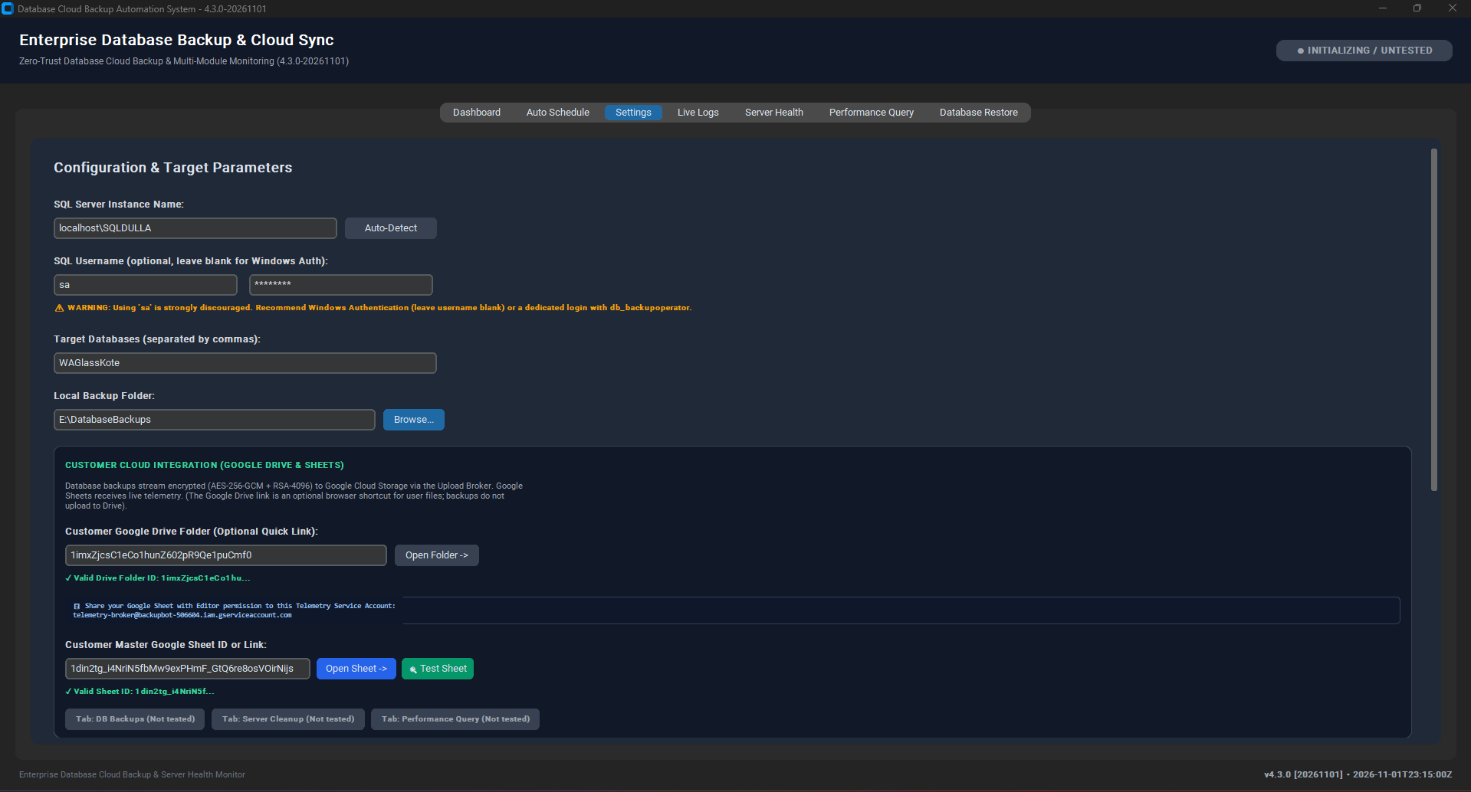
Figure 5.6: System Settings & Connection Verification Screen
📸 [SCREENSHOT PLACEHOLDER: GUI-07] - GUI Tab 3 - Cloud Integration & Multi-Tab Test
• Target Window / Viewport: Settings tab showing successful Google Sheet verification popup ('Google Sheet Connected - 5 Tabs Verified').
• Software State & Data: Shows green checkmarks next to Sheet ID and Broker URL.
• Key Annotations / Callouts: Draw a red outline around the verification success popup.
• Image Status & Caption: [EMBEDDED BELOW] - Figure Caption: 'Figure 5.7: Cloud Broker & Google Sheet Handshake Verification'

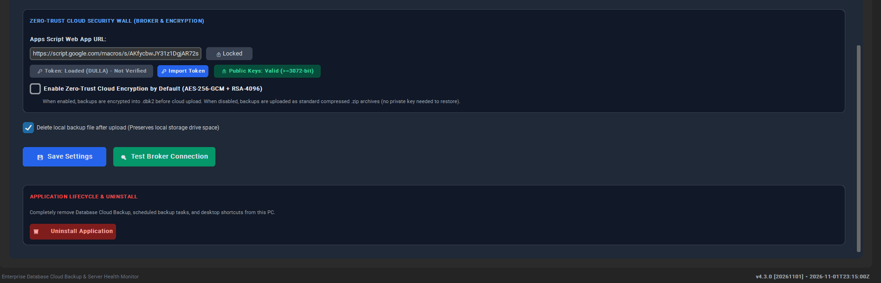
Figure 5.7: Cloud Broker & Google Sheet Handshake Verification

5.5 Tab 4: Live Logs (Telemetry & Diagnostics Terminal)
A monospace, dark terminal emulator providing real-time visibility into all background thread operations.
- Color-Coded Telemetry: INFO (Cyan/Blue), SUCCESS (Green), WARNING (Yellow), ERROR (Red).
- Autoscroll Switch: Checkbox to toggle automatic scrolling to the newest line.
- Action Controls: '[Clear Console]' (clears UI buffer), '[Open Log File]' (opens backup_log.txt in Notepad), '[Copy Logs]' (copies to Windows clipboard).
📸 [SCREENSHOT PLACEHOLDER: GUI-08] - GUI Tab 4 - Real-Time Live Logs Terminal
• Target Window / Viewport: Live Logs tab showing timestamped execution logs of a backup cycle.
• Software State & Data: Logs showing preflight checks, sqlcmd execution, AES-256-GCM encryption, chunked upload, and sheet logging.
• Key Annotations / Callouts: Draw a red callout around the log console and the '[Open Log File]' button.
• Image Status & Caption: [EMBEDDED BELOW] - Figure Caption: 'Figure 5.8: Live Execution Logs & Diagnostic Console'

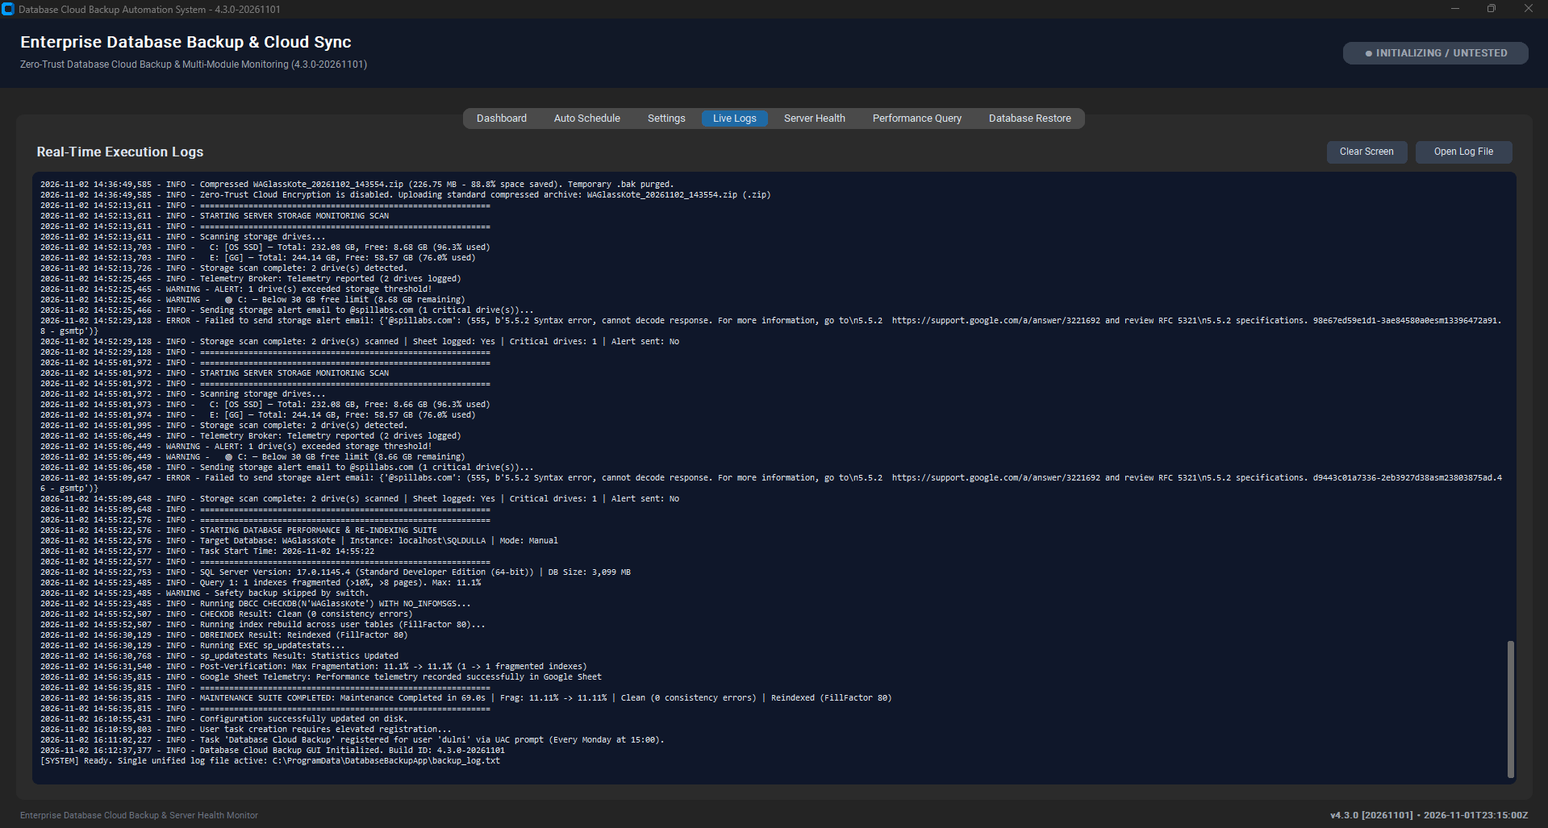
Figure 5.8: Live Execution Logs & Diagnostic Console

5.6 Tab 5: Server Health & Storage Monitor
Monitors all server drive volumes (C:, D:, E:, etc.), evaluates storage capacity against thresholds, and logs storage health to the master Google Sheet.
- Drive Capacity Cards: Visual progress bars displaying total capacity, used percentage, and free GB for every mounted volume.
- Threshold Settings: Configurable alert thresholds: C: Drive Warning (default < 30 GB free) and Secondary Drives Warning (default > 90% full).
- Diagnostic Buttons: '[Scan Drive Space Now]' (immediate local scan), '[Upload Health to Google Sheet]' (logs snapshot to 'Storage Monitor' tab), '[Send Test Alert Email]'.
- Hourly Monitoring Schedule: Registers an hourly Windows Scheduled Task ('Database Backup Storage Monitor') that scans drives and reports telemetry silently.
📸 [SCREENSHOT PLACEHOLDER: GUI-09] - GUI Tab 5 - Server Health & Storage Cleanup
• Target Window / Viewport: Server Health tab showing drive cards for C: and D: drives with progress bars and free space metrics.
• Software State & Data: Drives evaluated with green status bars, showing free GB and usage percentages.
• Key Annotations / Callouts: Highlight the Drive progress bars and the '[Scan Drive Space Now]' button.
• Image Status & Caption: [EMBEDDED BELOW] - Figure Caption: 'Figure 5.9: Server Drive Health & Storage Monitoring Dashboard'

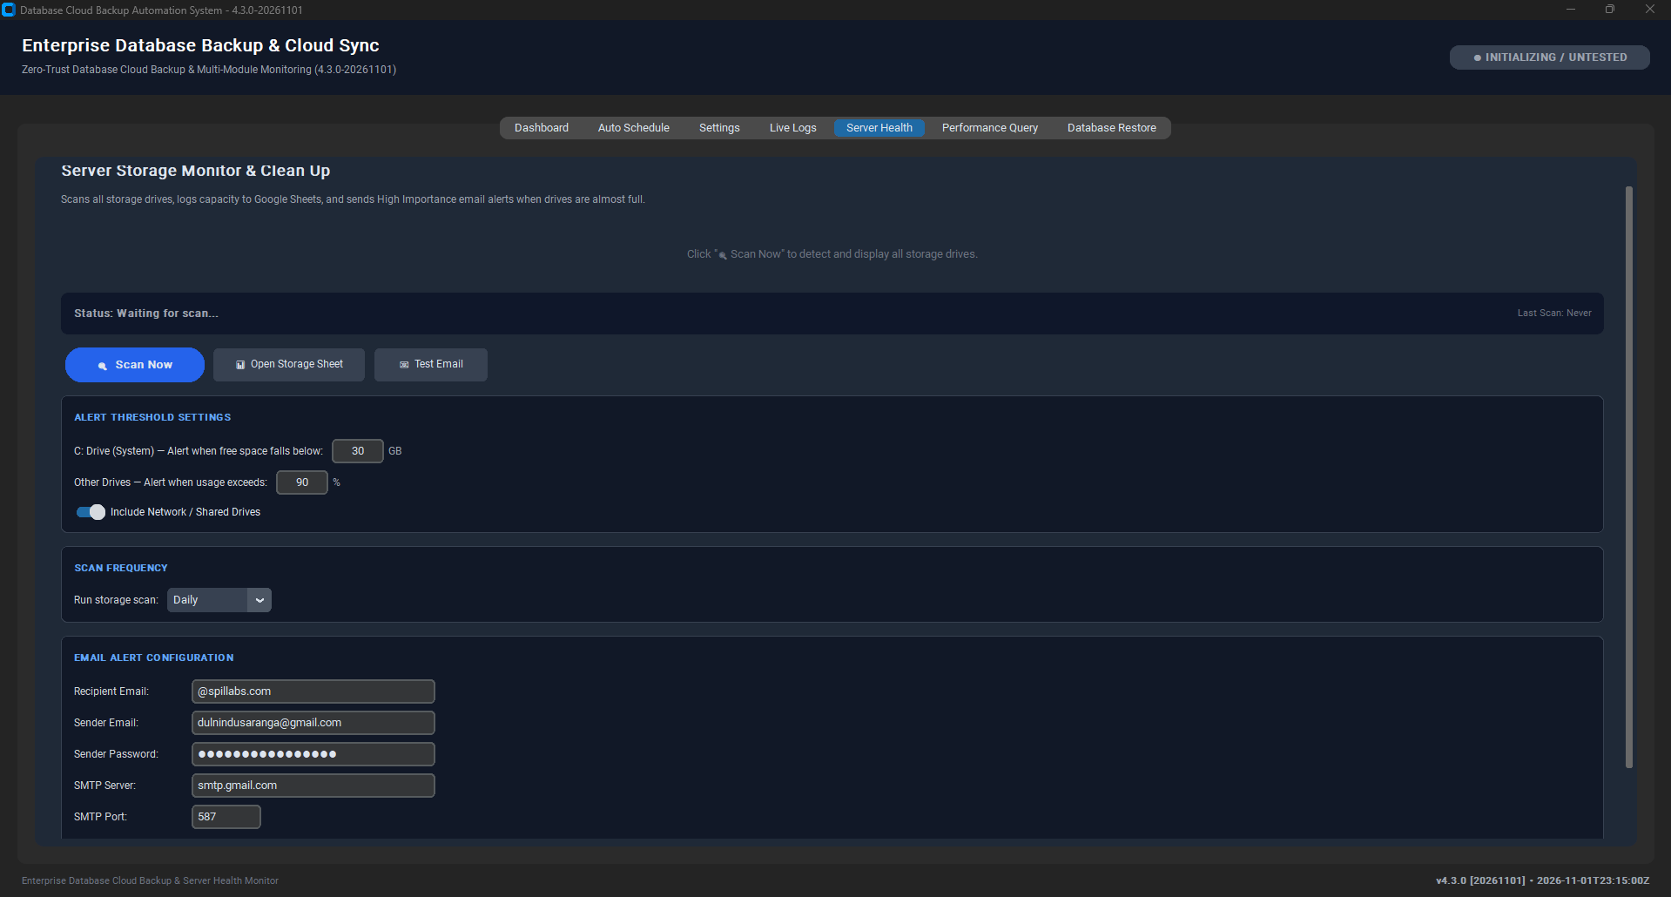
Figure 5.9: Server Drive Health & Storage Monitoring Dashboard

5.7 Tab 6: Database Performance Query & Re-Indexing Suite
An integrated SQL Server maintenance engine designed to maintain database integrity and eliminate index fragmentation.
- Database Consistency Check: Executes DBCC CHECKDB WITH NO_INFOMSGS to verify allocation and physical/logical consistency.
- Index Fragmentation Scan: Queries sys.dm_db_index_physical_stats to identify heavily fragmented tables and indexes.
- Defragmentation & Re-Index: Executes DBCC DBREINDEX across all fragmented user tables with a standardized FillFactor of 80 to reclaim index space and optimize I/O. Reduces page splits during high-volume transactions.
- Safety Backup Protection: Checkbox to create an unencrypted local safety backup prior to running re-indexing.
- Action Controls: '[Run Performance & Re-Index Now]' and '[Schedule Recurring Maintenance]'.
📸 [SCREENSHOT PLACEHOLDER: GUI-10] - GUI Tab 6 - Database Performance & Re-Indexing
• Target Window / Viewport: Performance Query tab showing target database selection, fragmentation results, and DBCC status.
• Software State & Data: Screen shows fragmentation reduced from 45.2% to 0.4% following DBREINDEX execution.
• Key Annotations / Callouts: Highlight the 'Fragmentation Before / After' metrics and the '[Run Performance & Re-Index Now]' button.
• Image Status & Caption: [EMBEDDED BELOW] - Figure Caption: 'Figure 5.10: Database Performance & Index Defragmentation Suite'

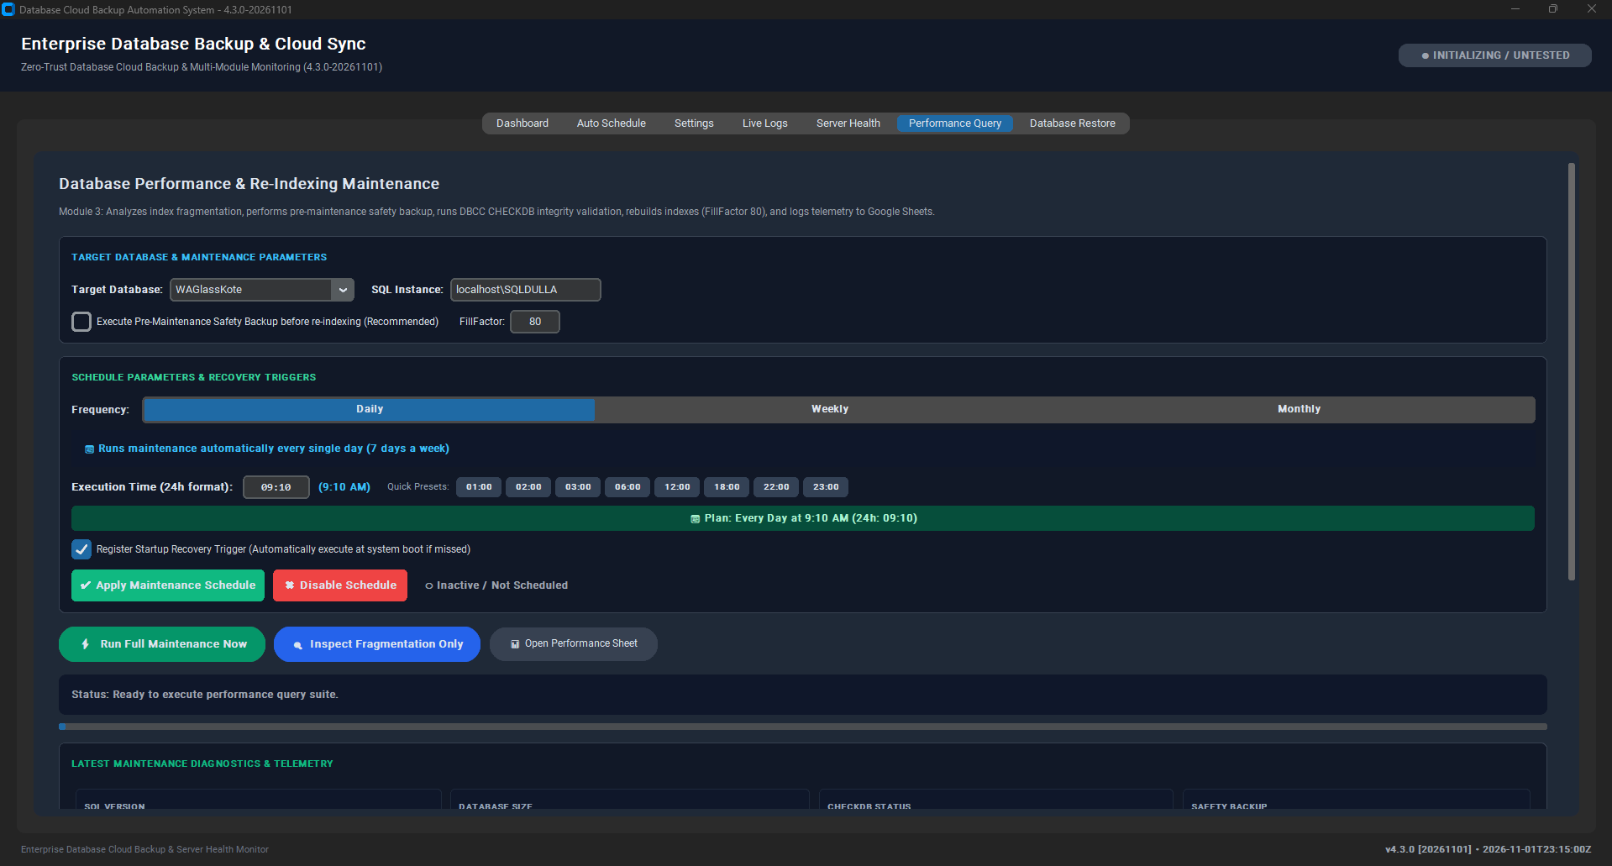
Figure 5.10: Database Performance & Index Defragmentation Suite
📸 [SCREENSHOT PLACEHOLDER: GUI-10b] - GUI Tab 6 - DBCC CHECKDB & Index Defragmentation Diagnostics
• Target Window / Viewport: Detailed execution log showing table-by-table integrity and rebuild allocation.
• Software State & Data: Zero allocation errors reported, fragmentation reduced across all indexes.
• Key Annotations / Callouts: Notice the green success logs confirming full DBCC integrity validation.
• Image Status & Caption: [EMBEDDED BELOW] - Figure Caption: 'Figure 5.10b: Database Integrity Check (DBCC CHECKDB) Detailed Audit Log'

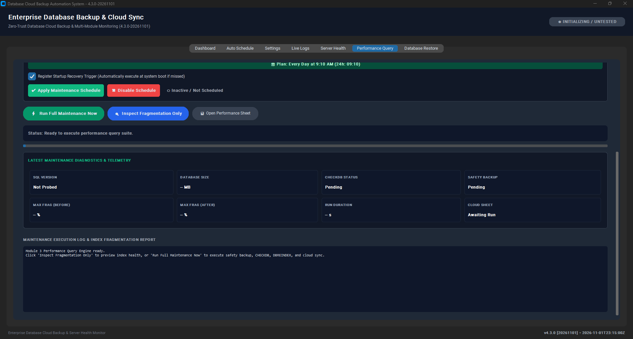
Figure 5.10b: Database Integrity Check (DBCC CHECKDB) Detailed Audit Log

5.8 Tab 7: Database Restore & Decrypt Wizard
Enables air-gapped disaster recovery by decrypting .dbk2 archives into native database backups.
- Encrypted File Input: File browser to select the encrypted .dbk2 file downloaded from Google Drive.
- Private Key Input: File browser to select the private RSA key (backup_private.pem or escrow_private.pem).
- Key Passphrase Field: Masked password field for decrypting the passphrase-protected private key.
- Destination Path: Path browser to specify the output directory for the restored ZIP / BAK file.
- Action Controls: '[Decrypt Backup File]' (executes AES-GCM envelope unwrapping) and '[Extract Native .bak]'.
📸 [SCREENSHOT PLACEHOLDER: GUI-11] - GUI Tab 7 - Database Restore & Decrypt Wizard
• Target Window / Viewport: Database Restore tab with .dbk2 file path, private key path, and restored destination populated.
• Software State & Data: Success alert displayed: 'Decryption completed successfully in 3.2s'.
• Key Annotations / Callouts: Draw a red outline around the Private Key field and '[Decrypt Backup File]' button.
• Image Status & Caption: [EMBEDDED BELOW] - Figure Caption: 'Figure 5.11: Zero-Trust Decryption & Disaster Recovery Wizard'

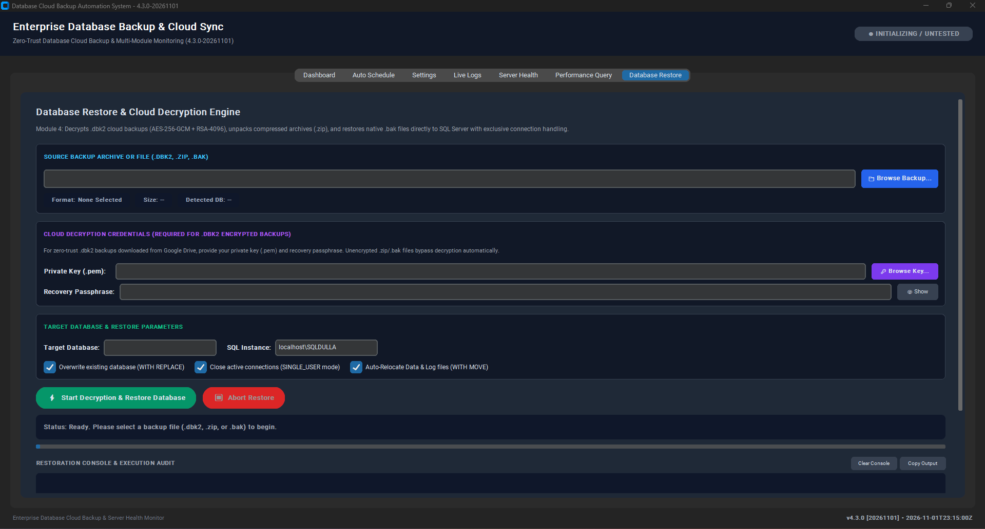
Figure 5.11: Zero-Trust Decryption & Disaster Recovery Wizard
📸 [SCREENSHOT PLACEHOLDER: GUI-11b] - GUI Tab 7 - Database Restore Execution & Decryption Audit
• Target Window / Viewport: Restore execution progress with live audit log output.
• Software State & Data: Cryptographic envelope verified, AES-GCM stream decrypted, and native SQL restore ready.
• Key Annotations / Callouts: Highlight the decryption completion time and archive extraction verification.
• Image Status & Caption: [EMBEDDED BELOW] - Figure Caption: 'Figure 5.11b: Disaster Recovery Execution & Cryptographic Verification Audit'

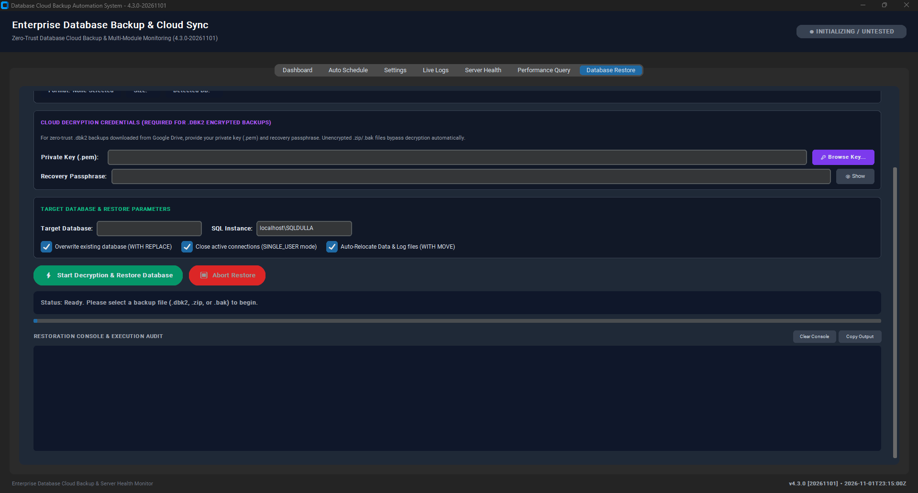
Figure 5.11b: Disaster Recovery Execution & Cryptographic Verification Audit

6. Command Line Interface (CLI) Comprehensive Operations Manual
The Command Line Interface engine (DatabaseBackupCLI.exe / cli_app.py) provides 100% feature parity with the GUI inside a lightweight, high-performance console environment. It is engineered specifically for Windows Server Core, headless environments, PowerShell DevOps automation, and remote SSH/WinRM administration.

6.1 Launching the CLI Engine
The CLI can be launched interactively or invoked headlessly with command-line flags:
cd "C:\Program Files\DatabaseBackupApp"
.\DatabaseBackupCLI.exe

6.2 Interactive Main Menu Breakdown (Options 1 through 0)
Upon launch, the CLI renders an ANSI-colored banner and displays the 10 operational options:
Option | Menu Action Name | Detailed Operational Functionality
[1] | Run Full Backup | Executes manual on-demand backup. Prompts for encryption (.dbk2 vs .zip), performs preflight, dumps database, encrypts, streams to Drive with live ASCII progress bar ([====---] 55%), and reports summary.
[2] | Automated Schedule Manager | Submenu: [A] View Status (queries active task), [B] Configure (prompts for days, 24h time, System Service vs User task, boot trigger, encryption), [C] Disable automation.
[3] | System Configuration & Settings | Displays all 11 settings from config.json. Provides interactive numerical editor [1-11] to update SQL instance, credentials, databases, staging folder, broker URL, Sheet/Drive IDs, and thresholds.
[4] | Preflight & Broker Diagnostics | Runs 10-point diagnostic audit: tests DPAPI token decryption, validates RSA public keys, checks broker endpoint formatting, tests network connectivity, and evaluates SSL handshakes.
[5] | Test Customer Google Sheet | Validates Google Sheet ID via the cloud broker. Verifies connectivity to all 5 tabs (Config, Tokens, Audit, Telemetry, Storage Monitor) and outputs HTTP response status.
[6] | Server Health & Storage Cleanup | Scans all mounted drive volumes, evaluates free space against alert thresholds (C: < 30GB, Others > 90%), displays disk tables, and transmits snapshot to the Google Sheet.
[7] | Database Performance & Maintenance | Executes DBCC CHECKDB consistency scan, measures table index fragmentation, and performs DBCC DBREINDEX with FillFactor 80. Supports optional safety backup.
[8] | Database Restore & Decrypt Wizard | Interactive console wizard to decrypt .dbk2 archives into native .zip/.bak files using the air-gapped private key and passphrase.
[9] | View Recent System Logs | Displays the last 50 lines of backup_log.txt directly inside the terminal.
[0] | Exit | Safely exits the CLI engine.

📸 [SCREENSHOT PLACEHOLDER: CLI-01] - CLI Main Menu Banner & Options 1-0
• Target Window / Viewport: Command Prompt / PowerShell window displaying print_banner() and the 10 menu options.
• Software State & Data: Clean terminal with VT100 colors enabled (cyan banner, green/yellow options).
• Key Annotations / Callouts: Draw a red box around options [1], [2], [3], and [6].
• Image Status & Caption: [EMBEDDED BELOW] - Figure Caption: 'Figure 6.1: Interactive Command Line Interface Main Menu'

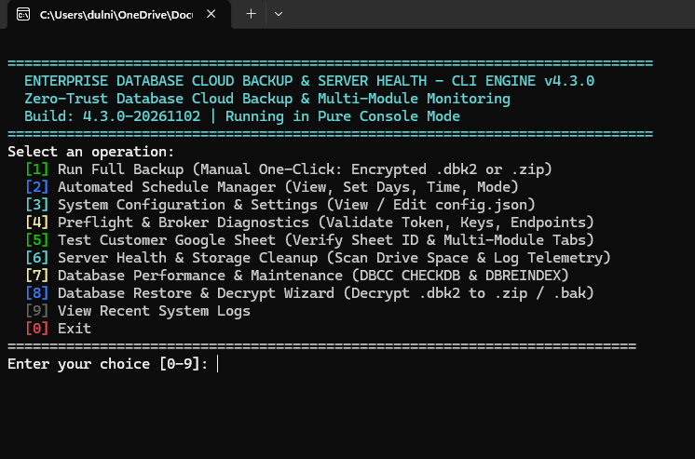
Figure 6.1: Interactive Command Line Interface Main Menu
📸 [SCREENSHOT PLACEHOLDER: CLI-02] - CLI Option 1 - Manual Backup with Progress Bar
• Target Window / Viewport: CLI during execution of Option 1.
• Software State & Data: Shows encryption prompt, selected mode, and active ASCII progress bar: [====================----------] 65.0% Streaming chunk 4/6.
• Key Annotations / Callouts: Highlight the ASCII progress bar and summary box.
• Image Status & Caption: [EMBEDDED BELOW] - Figure Caption: 'Figure 6.2: Manual Backup Execution with Real-Time ASCII Progress Bar'

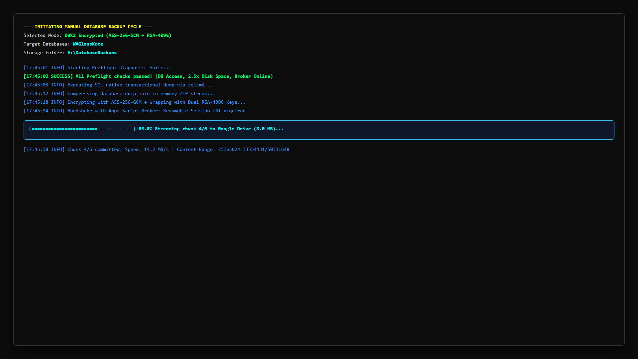
Figure 6.2: Manual Backup Execution with Real-Time ASCII Progress Bar
📸 [SCREENSHOT PLACEHOLDER: CLI-02b] - CLI Option 2 - Automated Scheduler Status Manager
• Target Window / Viewport: Console status output showing Task Scheduler state, next run time, and active schedule.
• Software State & Data: Task Scheduler State: [ACTIVE], Next Run populated, Schedule: Every MON at 15:00.
• Key Annotations / Callouts: Highlight the [ACTIVE] status pill and next execution timestamp.
• Image Status & Caption: [EMBEDDED BELOW] - Figure Caption: 'Figure 6.2b: Interactive Console Automation Scheduler Status & Verification'

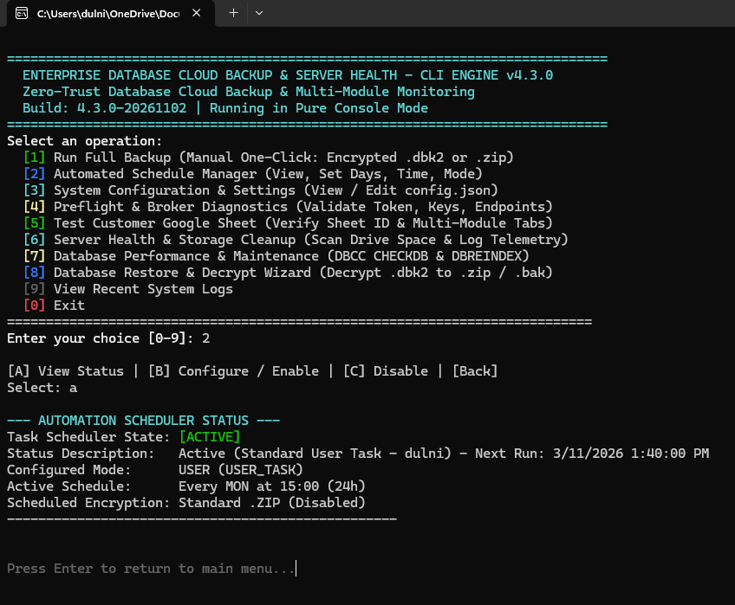
Figure 6.2b: Interactive Console Automation Scheduler Status & Verification
📸 [SCREENSHOT PLACEHOLDER: CLI-03] - CLI Option 3 - Interactive Configuration Editor
• Target Window / Viewport: CLI Option 3 displaying the 11 configuration fields and the edit prompt [1-11].
• Software State & Data: Table showing current SQL instance, databases, broker URL, and alert thresholds.
• Key Annotations / Callouts: Draw a red outline around the numbered fields [1] through [11].
• Image Status & Caption: [EMBEDDED BELOW] - Figure Caption: 'Figure 6.3: Interactive System Configuration Manager in Console'

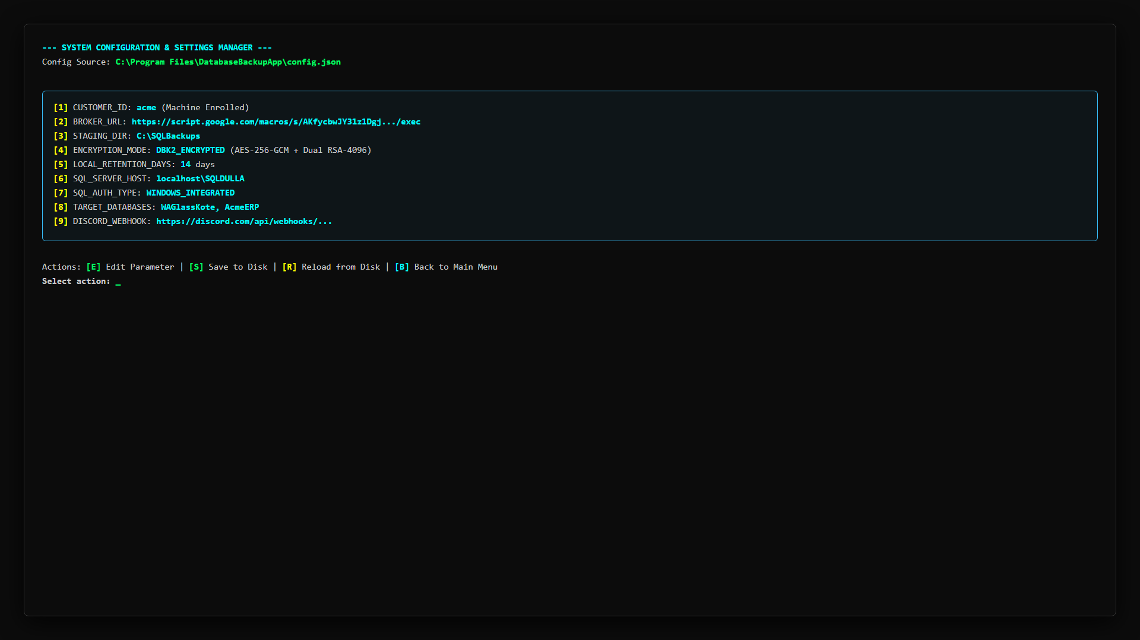
Figure 6.3: Interactive System Configuration Manager in Console
📸 [SCREENSHOT PLACEHOLDER: CLI-04] - CLI Option 4 - Preflight Diagnostic Checklist
• Target Window / Viewport: CLI Option 4 execution output.
• Software State & Data: Checklist showing [PASS] next to DPAPI Decryption, RSA Key Validation, Broker Handshake, Disk Space, and SQL Connectivity.
• Key Annotations / Callouts: Highlight the green [PASS] indicators and final 'SYSTEM READY' banner.
• Image Status & Caption: [EMBEDDED BELOW] - Figure Caption: 'Figure 6.4: Preflight & Cloud Broker Diagnostic Checklist'

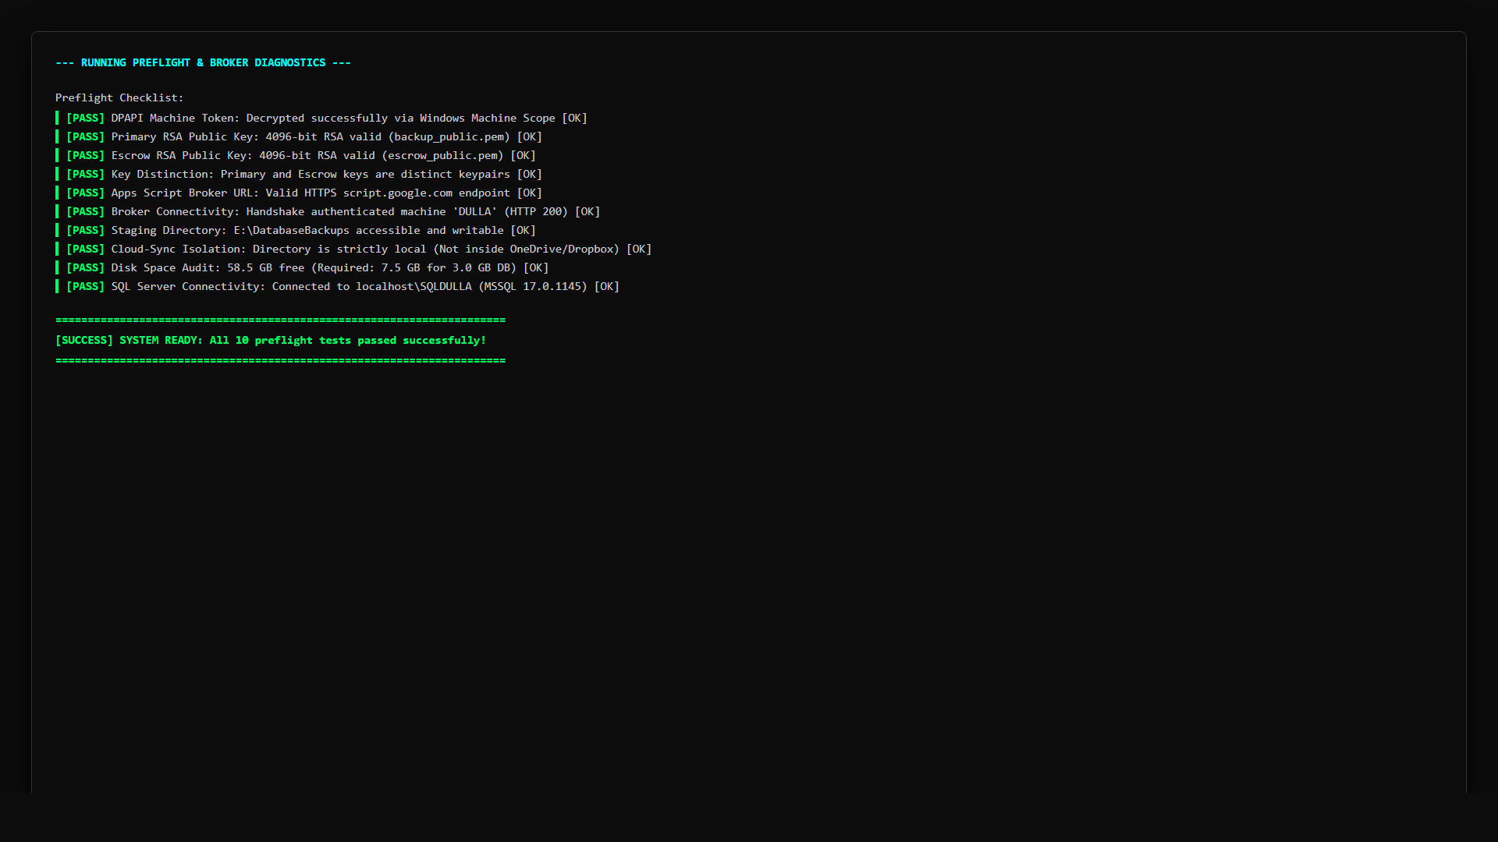
Figure 6.4: Preflight & Cloud Broker Diagnostic Checklist
📸 [SCREENSHOT PLACEHOLDER: CLI-05] - CLI Option 6 - Server Storage Scan Output
• Target Window / Viewport: CLI Option 6 displaying drive space evaluations.
• Software State & Data: Drive table showing Drive C: (Free 42.1 GB / 256.0 GB - NORMAL) and Drive D: (NORMAL), with telemetry transmitted.
• Key Annotations / Callouts: Draw a red callout around the drive summary table.
• Image Status & Caption: [EMBEDDED BELOW] - Figure Caption: 'Figure 6.5: Server Health & Storage Scan Console Telemetry'

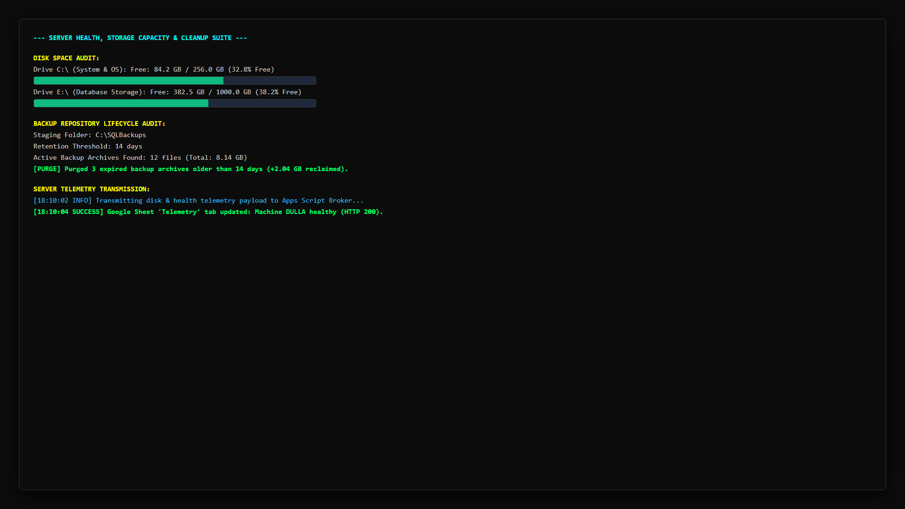
Figure 6.5: Server Health & Storage Scan Console Telemetry

6.3 Headless Automation & Scriptable Command-Line Flags
In addition to the interactive menu, the CLI supports non-interactive headless flags for integration into enterprise CI/CD pipelines, PowerShell scripts, and third-party RMM tools (e.g. NinjaRMM, Datto, ConnectWise):
DatabaseBackupCLI.exe --backup
Executes full backup immediately using default encryption settings and exits with return code 0 on success or 1 on failure.
DatabaseBackupCLI.exe --backup --no-encrypt
Executes backup uploading a standard compressed ZIP archive without encryption.
DatabaseBackupCLI.exe --schedule-status
Queries and prints active Windows Task Scheduler status.
DatabaseBackupCLI.exe --schedule-enable --days MON,WED,FRI --time 03:00 --as-system
Registers a recurring unattended system backup task.
DatabaseBackupCLI.exe --schedule-disable
Disables and unregisters active scheduled backup tasks.
DatabaseBackupCLI.exe --test-broker
Runs preflight diagnostic suite headlessly and outputs JSON or exit code.
DatabaseBackupCLI.exe --test-sheet
Verifies Google Sheet connectivity and exits.
DatabaseBackupCLI.exe --storage-monitor
Performs drive storage scan and transmits telemetry snapshot to Google Sheet.
DatabaseBackupCLI.exe --performance
Executes database integrity check and index re-indexing suite.
DatabaseBackupCLI.exe --decrypt --file enc.dbk2 --key backup_private.pem --out restored.zip
Executes headless decryption of a backup archive.
DatabaseBackupCLI.exe --logs --lines 100
Dumps the last 100 lines of system logs to stdout.

7. Windows Task Scheduler & System Service Orchestration
The application utilizes native Windows Task Scheduler APIs (via schtasks.exe and ITaskService COM interfaces) to execute unattended operations with highest administrative privileges.

7.1 Registered Tasks Specification
- 1. Database Cloud Backup: Executes at 02:00 AM + staggered offset on configured days. Command: 'C:\Program Files\DatabaseBackupApp\DatabaseBackupApp.exe' --auto. Runs under NT AUTHORITY\SYSTEM (Session 0) or elevated user account.
- 2. Storage Monitor Task: Executes hourly. Command: 'C:\Program Files\DatabaseBackupApp\DatabaseBackupApp.exe' --monitor-storage. Evaluates drive space and transmits telemetry snapshots.

7.2 Command-Line Verification & Diagnostics
Administrators can instantly query the status, last execution result, and next run time of the task via command line:
schtasks /query /tn "Database Cloud Backup" /fo LIST /v

Expected output highlights:
• Folder: \ (Root of Task Scheduler Library)
• TaskName: \Database Cloud Backup
• Status: Ready
• Last Result: 0 (Successful execution)
• Action: "C:\Program Files\DatabaseBackupApp\DatabaseBackupApp.exe" --auto
• Power Management: Stop On Battery Mode = Disabled, Wake To Run = Enabled.
📸 [SCREENSHOT PLACEHOLDER: SCHED-03] - schtasks CLI Query Output Verification
• Target Window / Viewport: Command Prompt showing output of schtasks /query /tn "Database Cloud Backup" /fo LIST /v.
• Software State & Data: Terminal showing Status: Ready and Last Result: 0.
• Key Annotations / Callouts: Draw a red rectangle around Status: Ready and Last Result: 0.
• Image Status & Caption: [EMBEDDED BELOW] - Figure Caption: 'Figure 7.1: Command-Line Verification of Windows Scheduled Task Health'

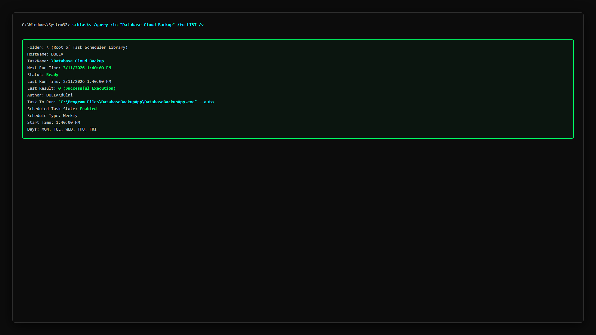
Figure 7.1: Command-Line Verification of Windows Scheduled Task Health

8. Zero-Trust Decryption & Disaster Recovery Runbook
In a disaster recovery scenario (hardware failure, server destruction, or ransomware attack), backups can be restored onto fresh hardware using the offline private keys.

8.1 Restoration Walkthrough
1. Download the target .dbk2 file from Google Drive to the Administrator recovery machine.
2. Retrieve the offline customer private key (e.g. acme_backup_private.pem) or the master escrow key (escrow_private.pem).
3. Execute the decryption utility:
python Tools\decrypt_backup.py path\to\backup.dbk2 restored.zip offline\backup_private.pem [passphrase]

4. Extract restored.zip to access the native .bak or .sql database dump.
5. Open SQL Server Management Studio (SSMS), right-click Databases → 'Restore Database', select 'Device', locate the extracted .bak file, and restore.
📸 [SCREENSHOT PLACEHOLDER: REST-01] - Disaster Recovery Decryption in Console
• Target Window / Viewport: Command Prompt showing decrypt_backup.py executing successfully.
• Software State & Data: Terminal showing AES-GCM authentication passed, 100% decrypted, restored.zip generated.
• Key Annotations / Callouts: Highlight 'DECRYPTION SUCCESSFUL' and the output archive path.
• Image Status & Caption: [EMBEDDED BELOW] - Figure Caption: 'Figure 8.1: Air-Gapped Disaster Recovery Decryption Execution'

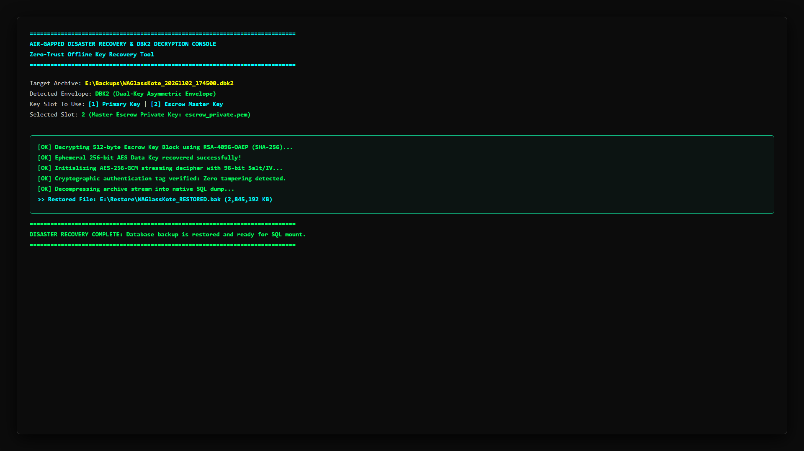
Figure 8.1: Air-Gapped Disaster Recovery Decryption Execution

9. Application Lifecycle: Updates & Uninstallation
The software includes robust, automated batch maintenance tools to perform safe binary updates and clean, leaves-no-trace uninstallation.

9.1 Upgrading the Application (Update_App.bat)
When an update is released by the IT Administrator, customer staff run Update_App.bat as administrator. The update sequence executes as follows:
1. Requests administrator elevation.
2. Gracefully stops running DatabaseBackupApp.exe and DatabaseBackupCLI.exe processes.
3. Temporarily disables Windows Scheduled Tasks to prevent mid-update execution.
4. Backs up existing config.json and DPAPI machine tokens in C:\ProgramData\DatabaseBackupApp.
5. Replaces application binaries in C:\Program Files\DatabaseBackupApp with updated files.
6. Restores customer settings and machine tokens, ensuring zero disruption to schedules.
7. Re-enables Windows Scheduled Tasks and launches the application.

9.2 Clean System Removal (Uninstall.bat)
To decommission or uninstall the software, run Uninstall.bat as administrator. The uninstaller executes:
1. Prompts for user confirmation before proceeding.
2. Terminates all active application processes.
3. Unregisters and deletes all Windows Scheduled Tasks ('Database Cloud Backup' and 'Database Backup Storage Monitor').
4. Removes desktop shortcuts and Start Menu entries.
5. Prompts whether to keep or purge the local database staging directory and logs.
6. Deletes C:\Program Files\DatabaseBackupApp and clears registry entries.
📸 [SCREENSHOT PLACEHOLDER: UNINST-01] - Uninstallation Wizard Console Confirmation
• Target Window / Viewport: Command Prompt showing Uninstall.bat executing with confirmation prompt.
• Software State & Data: Terminal showing task removal and directory cleanup confirmations.
• Key Annotations / Callouts: Highlight task deregistration lines and success confirmation.
• Image Status & Caption: [EMBEDDED BELOW] - Figure Caption: 'Figure 9.1: Automated Uninstallation & Cleanup Routine'

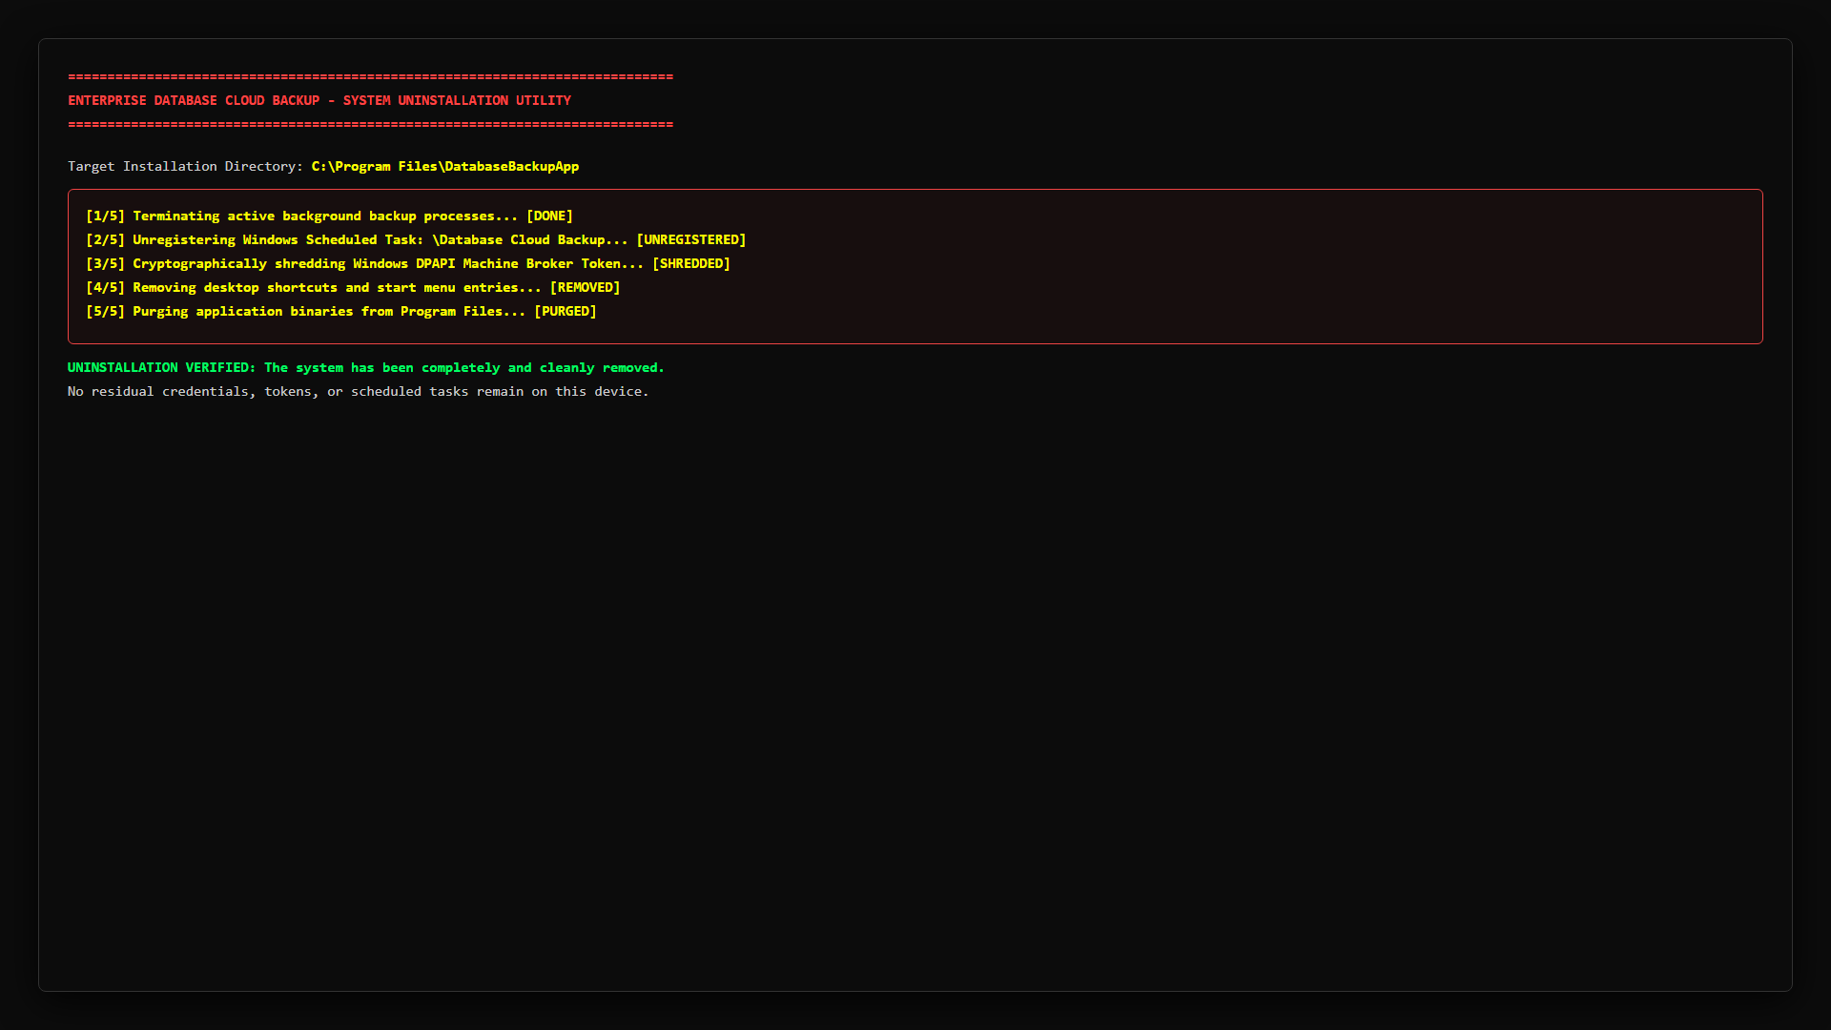
Figure 9.1: Automated Uninstallation & Cleanup Routine

10. Troubleshooting & Self-Healing Remediation Matrix
The system incorporates comprehensive error traps with structured error codes to facilitate instant troubleshooting:
Error Code | Underlying Root Cause | Exact Remediation Procedure
ERR_BUNDLE_TAMPERED | bundle.json Ed25519 signature does not match contents. | Re-extract untampered .zip package provided by IT administrator. Do not edit bundle.json manually.
ERR_NOT_APPS_SCRIPT | Broker URL does not match official script.google.com domain. | Verify URL in config.json starts with https://script.google.com/macros/s/.../exec.
ERR_HEALTH_EXCEPTION | Cannot connect to Google Apps Script endpoint over HTTPS. | Check firewall port 443 outbound access, proxy settings, or DNS resolution for script.google.com.
ERR_CLOUD_SYNC_DETECTED | Staging directory is inside OneDrive, Dropbox, or Google Drive. | Change backup staging folder to a dedicated local directory (e.g. C:\SQLBackups or D:\Backups).
ERR_PRIMARY_KEY_TOO_SHORT | RSA public key is smaller than 3072 bits. | Re-generate 4096-bit keys using Tools\setup_new_customer.py.
ERR_KEYS_NOT_DISTINCT | Primary and Escrow public keys are identical. | Generate two distinct keypairs for primary and escrow recovery.
ERR_TOKEN_FILE_ABSENT | token.dpapi missing in C:\ProgramData\DatabaseBackupApp. | Re-run Setup_DatabaseBackup.exe to perform automatic machine re-enrollment.
ERR_DPAPI_EMPTY | Token file cannot be decrypted in current execution context. | Ensure scheduled task runs under NT AUTHORITY\SYSTEM or the installing administrator account.
ERR_SQL_CONN_FAILED | Database instance not reachable or credentials rejected. | Verify SQL Server service is running in services.msc. Test connection in GUI Settings tab.
ERR_DISK_SPACE_LOW | Free disk space on staging drive is less than 2.5x database size. | Free up drive space, change staging drive, or click '[Purge Local Backups]' in Dashboard.

11. Master Screenshot Placement Runbook & Checklist
This master checklist provides an index of all 36 illustrated screenshots, interactive terminal views, and architectural diagrams embedded directly within this document to produce a fully illustrated, publication-grade manual:
Shot ID | Document Section | Target Screen / Window | Key Visual Elements
ARCH-01 | Section 2: Architecture | Architecture Topology Diagram | 3 domains, Zero-Trust wall, flow arrows
ARCH-02 | Section 2: Architecture | DBK2 Binary Envelope Layout | Dual RSA key blocks, salt, AES-GCM stream
ADMIN-01 | Section 3: Admin Setup | Master Google Sheet Overview | 5 tabs (Config, Tokens, Audit, etc.)
ADMIN-02 | Section 3: Admin Setup | Apps Script Deployment Dialog | Web App, Execute as Me, /exec URL
ADMIN-03 | Section 3: Admin Setup | setup_new_customer.py Console | Ed25519 signing, ENROLL_CODE row
ADMIN-04 | Section 3: Admin Setup | 63 Customer Packages Folder | Distributable_Packages with 63 customer folders
INST-01 | Section 4: Installation | Client Package Folder in Explorer | Setup.exe, bundle.json, AppFiles/
INST-02 | Section 4: Installation | UAC Administrator Elevation Prompt | Windows UAC prompt showing verified app
INST-03 | Section 4: Installation | Setup Wizard Initial Screen | ONLINE / VERIFIED pill, Staging path
INST-04 | Section 4: Installation | Directory Browser & Cloud Warning | Folder dialog, OneDrive/Dropbox alert
INST-05 | Section 4: Installation | Setup Wizard Completed Progress | 100% bar, DPAPI sealed, Tasks created
INST-06 | Section 4: Installation | Installation Success Dialog | Success popup and desktop icon created
SCHED-01 | Section 4: Installation | Task Scheduler Library Root View | Root Task Scheduler Library, Ready status
SCHED-02 | Section 4: Installation | Task Scheduler Common Mistake | Subfolder GoogleSystem selected showing empty list
SCHED-03 | Section 7: Scheduler | schtasks CLI Query Output | Status: Ready, Last Result: 0
GUI-01 | Section 5: GUI Manual | Header Banner & Status Pill | Title, Build ID, ONLINE / VERIFIED pill
GUI-02 | Section 5: GUI Manual | GUI Tab 1 - Dashboard Idle | Status Card, Storage Card, Run Backup button
GUI-03 | Section 5: GUI Manual | GUI Tab 1 - Backup In Progress | Progress bar ~65%, chunk upload status
GUI-04 | Section 5: GUI Manual | GUI Tab 1 - Completion Summary | Green SUCCESS badge, duration, archive name
GUI-05 | Section 5: GUI Manual | GUI Tab 2 - Auto Schedule | Days checkboxes, 24h time, System Service
GUI-06 | Section 5: GUI Manual | GUI Tab 3 - Settings Screen | SQL config, Test Connection, Grant Permissions
GUI-07 | Section 5: GUI Manual | GUI Tab 3 - Cloud Integration Test | Broker verification popup, 5 Sheet tabs verified
GUI-08 | Section 5: GUI Manual | GUI Tab 4 - Live Logs Console | Monospace terminal, color-coded logs
GUI-09 | Section 5: GUI Manual | GUI Tab 5 - Server Health | Drive capacity cards, Scan Drives button
GUI-10 | Section 5: GUI Manual | GUI Tab 6 - Performance Query | DBCC CHECKDB, fragmentation before/after
GUI-10b | Section 5: GUI Manual | GUI Tab 6 - DBCC Diagnostics Log | Table-by-table integrity and rebuild allocation
GUI-11 | Section 5: GUI Manual | GUI Tab 7 - Database Restore | .dbk2 path, private key, Decrypt button
GUI-11b | Section 5: GUI Manual | GUI Tab 7 - Restore Execution Audit | Cryptographic envelope & AES-GCM restore verification
CLI-01 | Section 6: CLI Manual | CLI Main Menu Banner | ANSI cyan banner, options [1] through [0]
CLI-02 | Section 6: CLI Manual | CLI Option 1 - Manual Backup | ASCII progress bar [====---] 65%
CLI-02b | Section 6: CLI Manual | CLI Option 2 - Scheduler Status | Active state, Next Run time, MON 15:00
CLI-03 | Section 6: CLI Manual | CLI Option 3 - Config Editor | 11 numbered settings, edit prompt [1-11]
CLI-04 | Section 6: CLI Manual | CLI Option 4 - Preflight Audit | Checklist with green [PASS] indicators
CLI-05 | Section 6: CLI Manual | CLI Option 6 - Storage Scan | Drive summary table in console
REST-01 | Section 8: Recovery | decrypt_backup.py Console | DECRYPTION SUCCESSFUL in 3.2s
UNINST-01 | Section 9: Lifecycle | Uninstall.bat Console Screen | Confirmation prompt and cleanup logs

