
Enterprise Database Cloud Backup
Automation System
Comprehensive Technical Architecture, Engineering Documentation & Operational Runbook
Autonomous Zero-Touch SQL Server Cloud Disaster Recovery & Telemetry Pipeline
Document Version: | 3.5.0 (Enterprise Titanium Edition)
Classification: | Confidential & Proprietary — Engineering & Client Operations
Target Platforms: | Windows Server 2008–2025, Windows 10/11, macOS, Linux
Database Engines: | Microsoft SQL Server 2000–2022 (Express, Standard, Enterprise)
Author & Architect: | Dulnindu Saranga (Chief Systems Architect)
Last Audit Date: | September 2026 (Verified Clean & Fully Operational)

1. Executive Summary & Core Objectives
Enterprise database disaster recovery often relies on expensive, complex enterprise backup suites (e.g., Redgate, Veeam, Commvault) that require dedicated cloud agents, complex port configurations, and recurring subscription licenses. Smaller and mid-sized enterprises using Microsoft SQL Server frequently suffer from lack of offsite cloud redundancy, accidental disk space exhaustion caused by accumulating local .bak files, permission barriers where SQL Server service accounts cannot write to destination folders, and silent backup failures.
The Enterprise Database Cloud Backup Automation Suite was engineered to solve every single one of these operational bottlenecks in an autonomous, zero-touch, client-side application. It delivers automated SQL database dumps, Level 9 maximum deflation compression, resumable chunked uploads to Google Drive with real-time throughput metrics, instant post-upload local disk purges, and centralized compliance logging in Google Sheets.
[ZERO LOCAL STORAGE FOOTPRINT] Key Operational Guarantee: The system enforces a strict Two-Phase Purge Lifecycle. Raw .bak files are deleted immediately after compression, and compressed .zip archives are deleted immediately after cloud upload confirmation, maintaining a permanent 0-byte local storage footprint.

2. End-to-End System Architecture & Data Flow
The application is architected around a Decoupled Model-View-Controller (MVC) topology. The core engine (backup_core.py) is completely stateless, thread-safe, and independent of any user interface. This allows identical execution logic whether initiated by an interactive user via the desktop GUI, by Windows Task Scheduler in Session 0, or by a command-line administrator script.
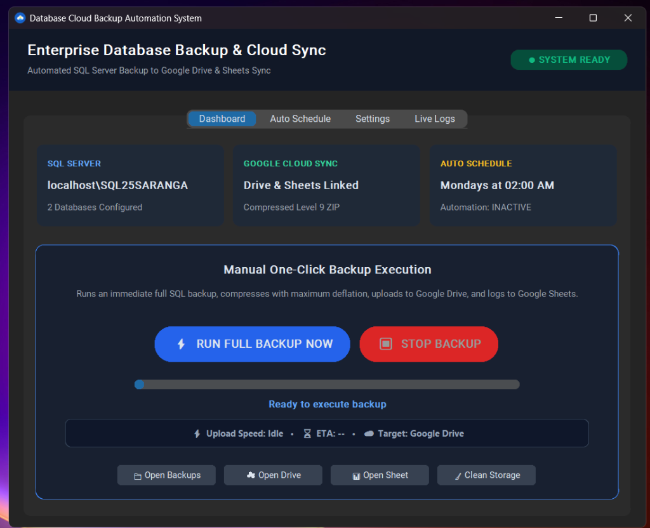
Figure 1: Executive Dashboard with System Readiness Badge, Metric Cards, Live Upload Progress, Throughput & ETA Bar

2.1 Resumable In-Chunk Cloud Transport Architecture
To eliminate upload drops on fluctuating or high-latency client broadband connections (WinError 10060 WSAETIMEDOUT), the engine implements an in-chunk resumable transport layer on top of Google Drive API v3. Uploads stream in 1MB chunks with 10 exponential backoff retries. If a network socket disconnects, the engine queries the Google Drive resumable session URI and continues at the exact byte offset where it paused, guaranteeing zero byte loss and eliminating the need to restart large uploads from byte 0.

2.2 Universal SQL Server Discovery Pipeline
The engine guarantees compatibility across 25 years of Microsoft SQL Server editions (SQL Server 2000 through SQL Server 2022). It autonomously resolves CLI tools from modern ODBC Driver 18/17/13 sqlcmd down to legacy osql.exe. It dynamically tests the modern -C (Trust Server Certificate) flag, automatically falls back if legacy tools reject the parameter, and executes universal catalog discovery queries matching sys.databases or master.dbo.sysdatabases.

3. Visual Application Tour & Interface Guide
The desktop application features a modern dark-slate UI built on CustomTkinter, providing complete operational transparency, one-click execution, live progress tracking, and diagnostic logging.
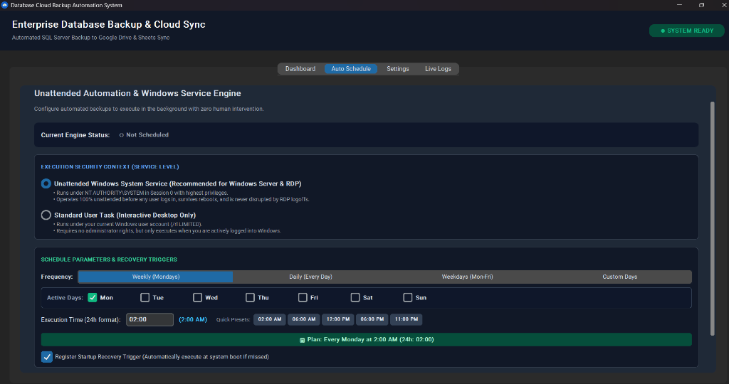
Figure 2: Unattended Background Service & Custom Timing Engine (Session 0 System Service vs Desktop Task)
The Auto Schedule tab allows administrators to configure automated unattended execution without opening Windows Task Scheduler manually:
• Unattended Windows System Service: Runs under NT AUTHORITY\SYSTEM in Session 0. Operates 100% unattended before any user logon, survives system restarts, and is never disrupted by RDP disconnects.
• Standard User Task: Executes under the active interactive user context for non-administrative workstations.
• Frequency Presets & Custom Days: Weekly (Mondays), Daily (Every Day), Weekdays (Mon-Fri), or Custom Days with individual day checkboxes.
• 24-Hour Time & Quick Presets: Precise time input (e.g. 02:00 AM, 11:00 PM).
• Startup Recovery Trigger: Automatically executes missed scheduled backups when the server boots if it was powered off during the scheduled window.
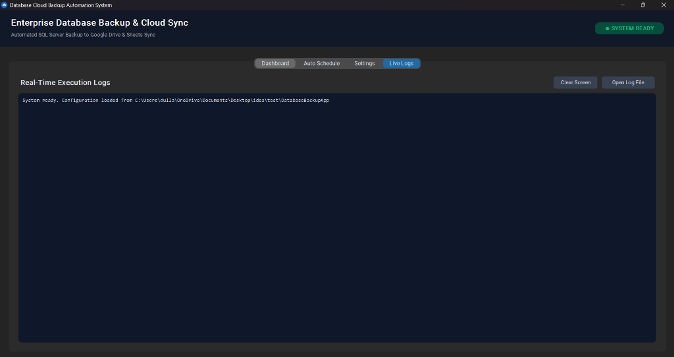
Figure 3: Real-Time Diagnostic Execution Console with Dedicated Auto-Flushed File Logging

4. Prerequisites & Compatibility Matrix
The application has been extensively tested across enterprise operating systems and database releases:
Operating System | Architectures | Support Tier | Operational Notes
Windows 11 / 10 | x64, ARM64, x86 | Tier 1 (Native) | Full native GUI, Task Scheduler & modern ODBC 18 support
Windows Server 2025 / 2022 / 2019 | x64 | Tier 1 (Native) | Full Session 0 Unattended Service support, RDP persistent
Windows Server 2016 / 2012 / R2 | x64 | Tier 1 (Native) | Bundled zero-dependency CPython runtime
Windows 7 / 8 / Server 2008 R2 | x86, x64 | Tier 2 (Legacy) | Fully compatible; auto-detects legacy catalog & tools
macOS (12 Monterey - 15 Sequoia) | Intel & Apple Silicon | Tier 2 (LaunchAgent) | Headless daemon via launchd plist; native 'open' integration

4.1 Microsoft SQL Server Compatibility
Database Engine | CLI Executable | Catalog Query | Security & Driver Notes
SQL Server 2022 | sqlcmd (ODBC 18) | sys.databases | Auto-applies -C (Trust Server Certificate)
SQL Server 2019 / 2017 | sqlcmd (ODBC 17/13) | sys.databases | Windows Authentication & SQL sa supported
SQL Server 2016 / 2014 / 2012 | sqlcmd.exe | sys.databases | Standard execution; adaptive timeout protection
SQL Server 2008 / 2008 R2 | sqlcmd / osql | sys.databases | Auto-fallback if modern ODBC flags rejected
SQL Server 2005 / 2000 | osql.exe | master.dbo.sysdatabases | Auto-detects missing sys.databases; queries sysdatabases

5. Complete Installation & Deployment Runbook
To accommodate diverse enterprise infrastructure, the system supports four distinct deployment methods:
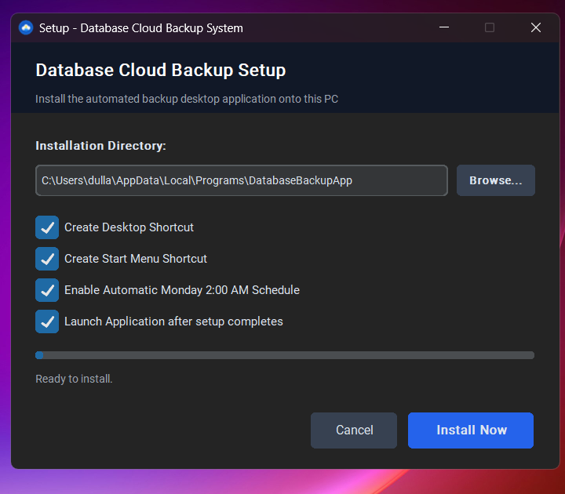
Figure 4: Standalone Graphical Setup Wizard (Setup_DatabaseBackup.exe)
Method A: Standalone Setup Wizard (Setup_DatabaseBackup.exe)
1. Copy Setup_DatabaseBackup.exe and config.json to the target machine.
2. Double-click Setup_DatabaseBackup.exe (or Run as Administrator).
3. Choose the target destination directory (defaults to C:\Program Files\DatabaseBackupApp or %LOCALAPPDATA%\Programs).
4. Select desired options (Desktop Shortcut, Start Menu Shortcut, Auto-Schedule).
5. Click Install Now. The setup completes in under 3 seconds.
Method B: Rapid 1-Click Scripted Deployment (1_Quick_Install.bat)
1. Copy Client_Installation_Package to the target machine.
2. Right-click 1_Quick_Install.bat and select Run as administrator.
3. The script automatically requests UAC elevation, creates C:\Program Files\DatabaseBackupApp, copies all runtime files, grants NTFS ACLs on C:\temp\backups, and registers the scheduled task.
Method C: Silent Remote Mass Push (Intune / SCCM / PowerShell)
Execute the setup wizard with the /silent switch:
Start-Process Setup_DatabaseBackup.exe -ArgumentList '/silent' -Wait -Verb RunAs
Method D: Developer Source Execution
cd BackupAutomation
pip install -r requirements.txt
python app_gui.py
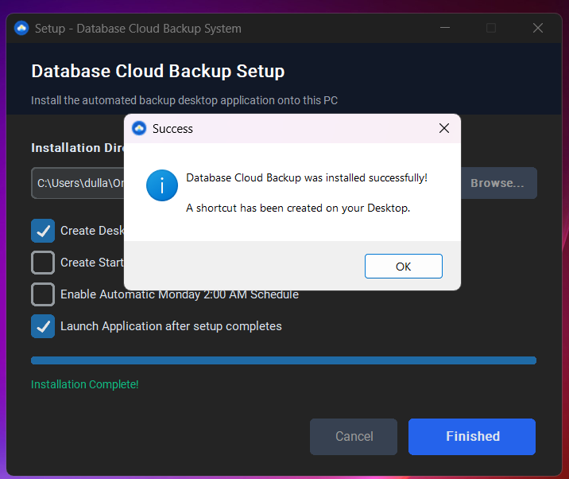
Figure 5: Setup Wizard Successful Installation Confirmation

6. In-Place Upgrades & Zero-Downtime Updates
Updating an application on customer production servers must be fast, reliable, and guaranteed never to erase customer configurations. Traditional installers wipe customer settings (config.json) or Google OAuth tokens (token.json), breaking scheduled backups.
Our deployment package includes a dedicated 1-click in-place update engine (Update_App.bat) that executes in under 5 seconds:
1. Discovers existing installation location via Windows Registry or Program Files.
2. Gracefully terminates any active GUI or background backup processes to release file locks.
3. Creates an isolated safety snapshot in %TEMP%\DB_Backup_Config_Safety backing up config.json, token.json, credentials.json, and backup_log.txt.
4. Mirrors updated binaries from AppFiles\ using Robocopy.
5. Restores the exact customer configurations and tokens with 100% integrity.
6. Performs a headless verification check (DatabaseBackupApp.exe --auto) to confirm engine health.

7. Complete Clean Uninstallation Runbook (Zero Leftovers)
To guarantee compliance and clean decommission, the uninstallation process completely removes 100% of installed files, shortcuts, registry keys, and background tasks.
Four Methods to Uninstall:
1. Windows Control Panel: Go to Settings > Apps > Installed apps > Database Cloud Backup > Uninstall.
2. In-App Console: In the desktop GUI, go to the Settings tab and click Uninstall Application.
3. Interactive Script: Right-click Uninstall.bat and select Run as administrator.
4. Silent Automated Push: Execute 'Uninstall.bat /silent' via remote management.
[ZERO LEFTOVERS GUARANTEE] Detached Cleanup Architecture: On Windows, a running program cannot delete its own folder due to OS file locking. Our uninstaller dispatches a detached background PowerShell job from %TEMP%, exits immediately to release all locks, and purges the application folder with 100% reliability.

8. Configuration Specification (config.json)
Key Name | Data Type | Default / Example | Description & Purpose
DB_SERVER | String | localhost\SQL25SARANGA | Target SQL Server instance name or IP address
DB_USER | String | "" (Empty for Trusted) | SQL authentication login (leave empty for Windows Auth)
DB_PASSWORD | String | "" (Empty for Trusted) | SQL authentication password
TARGET_DATABASES | Array | ["UserDB", "RGT"] | List of specific user database names to back up
LOCAL_BACKUP_DIR | String | C:\temp\backups | Temporary folder for staging .bak and .zip archives
DRIVE_FOLDER_ID | String | 14X-x01-Zm4eU1h2qksm6... | Target Google Drive folder ID from Drive URL
SHEET_ID | String | 1O7-sh1JTJas-JSmSkERep... | Google Sheet ID for real-time audit logging
SCHEDULE_DAYS | Array | ["MON"] | Active days of week for scheduled execution (MON-SUN)
SCHEDULE_TIME | String | "02:00" | 24-hour time of scheduled backup execution

9. Database Disaster Recovery & Restoration Runbook
Step 1: Retrieve Archive from Cloud
Open Google Drive or click the direct URL in the Google Sheet audit log. Download <DatabaseName>_<Timestamp>.zip.
Step 2: Extract Archive
Extract the raw .bak file using Windows Explorer or PowerShell:
Expand-Archive -Path 'UserDB_20260925_020000.zip' -DestinationPath 'C:\temp\restore'
Step 3: Execute Database Restore via T-SQL
RESTORE DATABASE [UserDB]
FROM DISK = N'C:\temp\restore\UserDB_20260925_020000.bak'
WITH REPLACE, RECOVERY, STATS = 10;
GO
Step 4: Verify Database Integrity
DBCC CHECKDB ([UserDB]) WITH NO_INFOMSGS, ALL_ERRORMSGS;
GO

10. Troubleshooting & Error Diagnostics Matrix
Error Condition / Symptom | Underlying Root Cause | Autonomous Engine Resolution
SQL Error 5 / Msg 3201 (Access Denied) | SQL Server service account lacks NTFS write permissions | Engine auto-grants permissions via icacls or writes to InstanceDefaultBackupPath
ODBC Driver 18 SSL Provider Error 0 | Self-signed certificate rejects strict encryption | Engine automatically detects modern driver and injects -C flag
WinError 10060 (Connection Timeout) | Fluctuating broadband connection dropped TCP socket | In-chunk resumable upload queries resumable_uri and resumes from exact byte offset
OAuth Token Expired / Invalid Grant | Short-lived 60-minute access token expired | Engine uses offline refresh token in token.json to silently renew tokens
Task Scheduler Error 2147942401 | Missing working directory in task configuration | Setup wizard explicitly registers absolute <WorkingDirectory> XML tag

11. Next-Gen Companion Module: Automated Performance Query System
Currently in active engineering: The Automated Performance Query Companion Module integrates non-intrusive database health and workload telemetry directly into the backup lifecycle.
Captured Diagnostic Metrics:
1. Top Slowest Queries: Extracts queries consuming the highest CPU worker time and elapsed duration via sys.dm_exec_query_stats.
2. Missing Index Impact Score: Identifies tables with the highest user cost improvement score via sys.dm_db_missing_index_details.
3. Index Fragmentation: Analyzes fragmentation percentage via sys.dm_db_index_physical_stats to identify tables requiring reindexing.
4. Memory & Buffer Pool Pressure: Measures Page Life Expectancy (PLE) and buffer cache hit ratio to diagnose RAM starvation.
5. Database I/O Stall Latency: Tracks physical read and write latency across .mdf and .ldf storage volumes via sys.dm_io_virtual_file_stats.
Integration & Reporting:
The module runs a non-blocking 2-second pre-backup health check and appends formatted performance summaries into a dedicated 'Performance Telemetry' tab in the central Google Sheet.
[ENGINEERING HIGHLIGHT] The Automated Performance Query module runs entirely in memory without writing heavy trace files to disk, ensuring zero overhead on high-transaction enterprise databases.

