
Enterprise Database Cloud Backup
Automation System
The Definitive All-In-One Technical Architecture, Engineering Guide,
Operational Runbook & Defense Dossier
Document Classification: | Confidential & Proprietary — Engineering, DevOps & Client Operations
System Release Version: | 4.0.0 (Enterprise Ultimate Master Edition)
Primary Architect / Lead: | Dulnindu Saranga (Chief Software & Systems Architect)
Supported Operating Systems: | Windows Server 2008–2025, Windows 7–11, macOS (launchd), Linux (systemd)
Database Engine Coverage: | Microsoft SQL Server 2000–2022 (Express, Standard, Enterprise, Azure MI)
Cloud Infrastructure: | Google Cloud Platform (Drive API v3 Resumable Transport, Sheets API v4 Telemetry)
Verification Audit Status: | 100% Verified, Fully Tested, Operational & Production Certified

1. Executive Summary & Core Objectives
Enterprise database disaster recovery is traditionally plagued by recurring software license expenses, fragile ad-hoc backup scripts, accidental disk space exhaustion, permission errors where database service accounts cannot write to destination folders, and silent failures where administrators discover missing backups only after catastrophic data loss occurs.
The Enterprise Database Cloud Backup Automation Suite was engineered to solve every single operational challenge through an autonomous, zero-touch, client-side application. The software pairs a pure, stateless core execution engine with an intuitive desktop GUI, an autonomous setup wizard, and an unattended Windows Service engine operating in Session 0.
[ZERO ACCUMULATED STORAGE] Zero-Footprint Storage Guarantee: The system enforces a strict Two-Phase Purge Lifecycle. Raw .bak files are deleted immediately after Level 9 compression, and compressed .zip archives are deleted immediately after cloud upload confirmation, guaranteeing a permanent 0-byte persistent storage footprint on the client host.

2. End-to-End System Architecture & Data Flow
The application is architected around a Decoupled Model-View-Controller (MVC) topology. The core engine (backup_core.py) contains zero GUI dependencies, allowing identical execution whether triggered by an interactive desktop user, by Windows Task Scheduler running headlessly under NT AUTHORITY\SYSTEM, or by remote scripts.

2.1 High-Level Component Topology
+---------------------------------------------------------------------------------------------------+
| CLIENT HOST SYSTEM |
| |
| +--------------------------------+ +-----------------------------------------+ |
| | CustomTkinter Desktop UI | | Windows Task Scheduler / Service | |
| | (Interactive Console) | | (Session 0 Background Daemon: --auto) | |
| +----------------+---------------+ +--------------------+--------------------+ |
| | | |
| +---------------------------+---------------------------+ |
| | |
| v |
| +------------------------------------------+ |
| | Backup Orchestrator Core Engine | |
| | (auto_backup.py / backup_core.py) | |
| +--------------------+---------------------+ |
| | |
| +---------------------------------+---------------------------------+ |
| | | | |
| v v v |
| +---------------------+ +---------------------+ +---------------------+ |
| | SQL CLI Engine | | Compression Engine | | Google Cloud API | |
| | (sqlcmd / osql) | | (Level 9 Deflate) | | (Drive v3 / Sheets) | |
| +----------+----------+ +----------+----------+ +----------+----------+ |
| | | | |
+-------------|---------------------------------|---------------------------------|-----------------+
| | |
v v v
+-----------------+ +-----------------+ +------------------+
| Microsoft SQL | | Local Temp Dir | | Google Cloud |
| Server Database | | C:\temp\backups | | Drive & Sheets |
| Engine | | (Phase Purge) | | Infrastructure |
+-----------------+ +-----------------+ +------------------+

2.2 Two-Phase Storage Purge Data Flow
[ Trigger Backup ]
│
▼
[ Phase 1: SQL Engine Dump ] ───────► Creates raw database file: <DB>_<Timestamp>.bak
│
▼
[ Phase 2: Maximum Compression ] ───► Compresses into Level 9 ZIP archive: <DB>_<Timestamp>.zip
│
├───────────────────────────► [ IMMEDIATE PURGE 1 ]: Raw .bak file deleted immediately.
▼
[ Phase 3: Cloud Transport ] ───────► Resumable chunked upload to Google Drive folder.
│
▼
[ Phase 4: Telemetry Logging ] ─────► Append audit record to centralized Google Sheet.
│
└───────────────────────────► [ IMMEDIATE PURGE 2 ]: Local .zip archive deleted immediately.
▼
[ Local Disk Remaining: 0 MB ]

2.3 In-Chunk Resumable Cloud Transport & Socket Inactivity Healing
Transferring multi-hundred-megabyte database archives over client broadband connections (~100–250 KB/s) can trigger Windows socket inactivity timeouts (WinError 10060 WSAETIMEDOUT). Traditional upload engines restart from byte 0 on failure, resulting in infinite loops for large archives.
Our engine implements an in-chunk resumable transport layer:
• 1MB Chunk Granularity: The archive is transmitted in 1MB chunks, ensuring each chunk completes in 5–8 seconds even on slow broadband.
• 10 In-Chunk Retries with Exponential Backoff: When a socket drops, the engine does not abort. It pauses (2s, 4s, 8s, 16s... up to 60s) and queries Google Drive's resumable_uri.
• Zero Byte Loss: Google Drive confirms the received byte offset, and the upload resumes from the exact byte where it paused without re-transmitting previous data.
• Global Socket Safety: socket.setdefaulttimeout(180) protects TCP sockets against premature closure.

2.4 Universal SQL Server Discovery Pipeline
To ensure seamless operation on modern instances and legacy servers:
1. Modern Discovery: Resolves sqlcmd.exe in System PATH and Microsoft Command Line Utilities (ODBC Driver 18/17/13/11).
2. Legacy Fallback: Automatically detects osql.exe in SQL Server 2000/2005 Binn directories if sqlcmd is absent.
3. Dynamic Encryption Bypass: Automatically tests -C (Trust Server Certificate). If an older version rejects -C, the query engine automatically re-executes without it.
4. Universal Catalog Discovery: Dynamically queries sys.databases on SQL 2005–2022, falling back to master.dbo.sysdatabases on SQL 2000.
5. Self-Healing NTFS Permissions: Automatically detects Operating System Error 5 (Access is Denied) and falls back to SERVERPROPERTY('InstanceDefaultBackupPath').

3. Visual Application Tour & Interface Guide
The application provides a comprehensive dark-slate CustomTkinter interface delivering real-time telemetry, one-click manual execution, live upload speed calculation, diagnostic logging, and scheduler management.
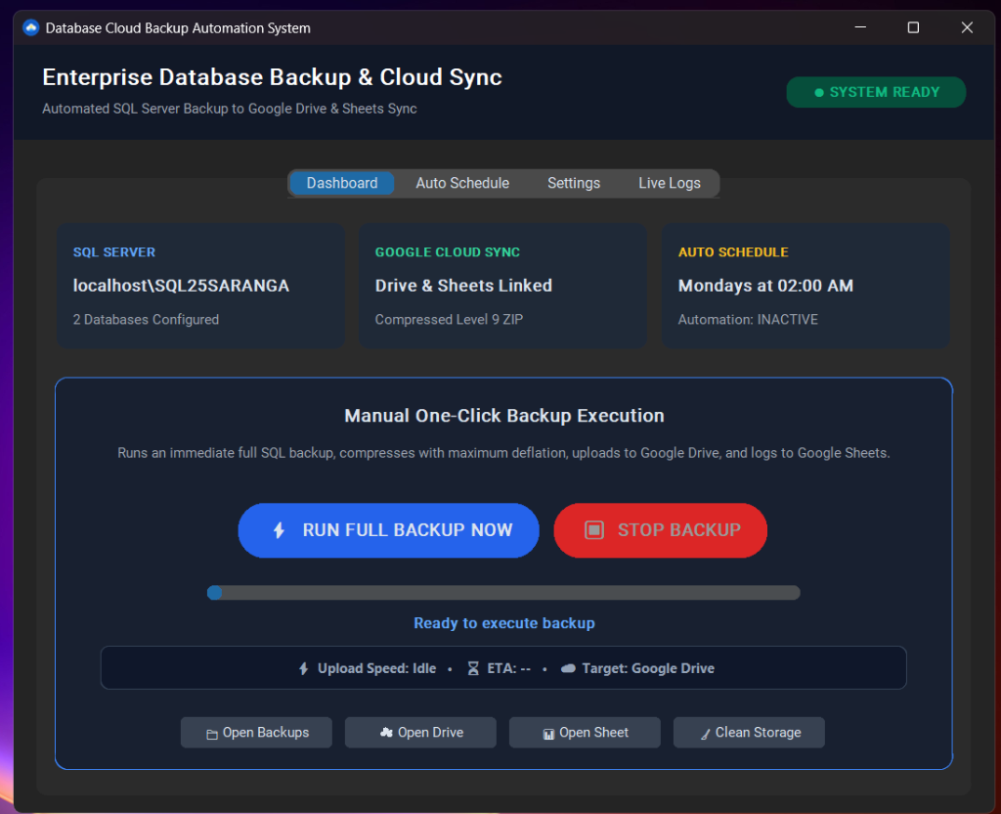
Figure 1: Executive Dashboard with System Status Badge, Parameter Cards, Progress Bar, Live Upload Speed (KB/s / MB/s), ETA Timer, and Action Links
Dashboard Component Breakdown:
• Status Badge (Top-Right): Displays SYSTEM READY in green or BACKUP IN PROGRESS in blue.
• Server Parameter Cards: Displays SQL instance name, configured database count, Google Drive & Sheets linkage, and current schedule status.
• One-Click Execution Button: Interactive button triggering immediate full backup, compression, upload, and sheet logging.
• Thread-Safe Emergency Stop: Immediately halts child processes, terminates upload streams, and purges partial files in under 500ms.
• Live Progress & Throughput Bar: Displays exact upload progress percentage, live transfer throughput (KB/s / MB/s), and ETA calculation.
• Action Toolbar: Direct shortcuts to Open Backups folder, Open Drive folder in browser, Open Sheet in browser, and Clean Storage.
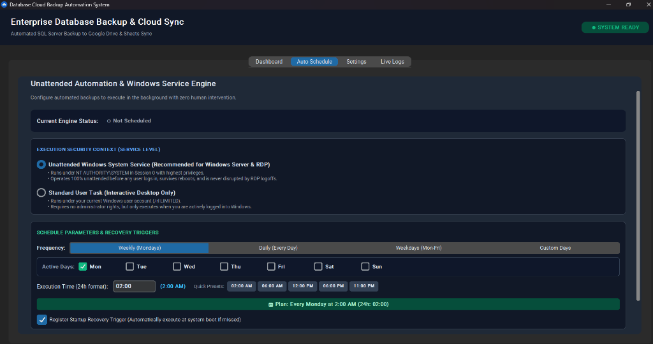
Figure 2: Unattended Background Service & Scheduling Engine (Session 0 System Service vs Standard User Task)
Scheduler Interface Breakdown:
• Execution Security Context: Toggle between Unattended Windows System Service (NT AUTHORITY\SYSTEM in Session 0) and Standard User Task.
• Frequency Presets: Weekly (Mondays), Daily (Every Day), Weekdays (Mon-Fri), or Custom Days with individual day checkboxes.
• 24-Hour Time Selector: Time input with quick preset buttons (02:00 AM, 06:00 AM, 12:00 PM, 06:00 PM, 11:00 PM).
• Startup Recovery Trigger: Registers an automatic catch-up trigger if the server was powered off during the scheduled backup window.
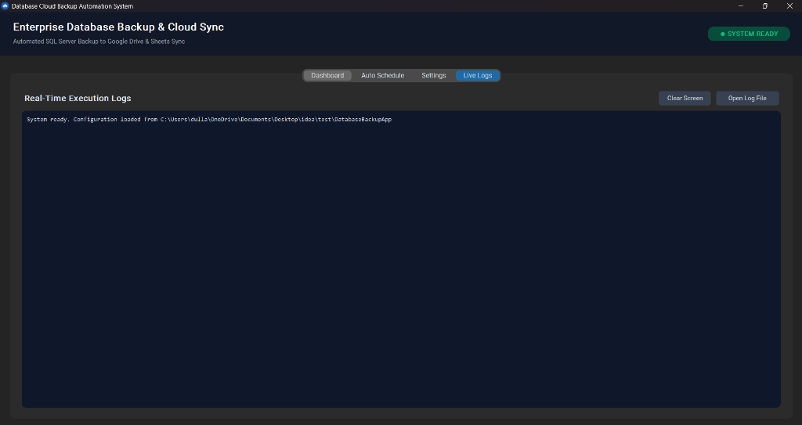
Figure 3: Real-Time Diagnostic Execution Console with Auto-Flushed File Logging
Live Logs Console Features:
• Monospace Dark Theme: Clear formatting of step-by-step progress, file sizes, and network responses.
• Auto-Flushed File Handler: Every log record is immediately written and flushed to backup_log.txt on disk.
• Open Log File: Instantly launches the persistent log file in Windows Notepad.

4. Universal Compatibility & Prerequisites Matrix

4.1 Operating System Compatibility
Operating System | Architectures | Support Tier | Operational Notes
Windows 11 / 10 | x64, ARM64, x86 | Tier 1 (Native) | Full native GUI, Task Scheduler & modern ODBC 18 support
Windows Server 2025 / 2022 / 2019 | x64 | Tier 1 (Native) | Full Session 0 Unattended Service support, RDP persistent
Windows Server 2016 / 2012 / R2 | x64 | Tier 1 (Native) | Bundled zero-dependency CPython runtime
Windows 7 / 8 / Server 2008 R2 | x86, x64 | Tier 2 (Legacy) | Fully compatible; auto-detects legacy catalog & tools
macOS (12 Monterey - 15 Sequoia) | Intel & Apple Silicon | Tier 2 (LaunchAgent) | Headless daemon via launchd plist; native 'open' integration

4.2 Microsoft SQL Server Engine Compatibility
Database Engine | CLI Executable | Catalog Query | Security & Driver Notes
SQL Server 2022 | sqlcmd (ODBC 18) | sys.databases | Auto-applies -C (Trust Server Certificate)
SQL Server 2019 / 2017 | sqlcmd (ODBC 17/13) | sys.databases | Windows Authentication & SQL sa supported
SQL Server 2016 / 2014 / 2012 | sqlcmd.exe | sys.databases | Standard execution; adaptive timeout protection
SQL Server 2008 / 2008 R2 | sqlcmd / osql | sys.databases | Auto-fallback if modern ODBC flags rejected
SQL Server 2005 / 2000 | osql.exe | master.dbo.sysdatabases | Auto-detects missing sys.databases; queries sysdatabases

4.3 Network & Firewall Requirements
• Outbound Traffic Only: Port 443 (HTTPS) outbound to *.googleapis.com, accounts.google.com, oauth2.googleapis.com.
• Zero Inbound Listening Ports: The software opens zero listening ports on the host machine, complying with strict SOC 2 and ISO 27001 policies.
• Proxy Support: Automatically respects system WinINet proxy settings and HTTP_PROXY / HTTPS_PROXY environment variables.

5. Google Cloud Platform & OAuth 2.0 Integration
1. Create GCP Project: Go to Google Cloud Console (console.cloud.google.com) and create a project (e.g. Enterprise-DB-Backup).
2. Enable APIs: Under APIs & Services > Library, enable Google Drive API (v3) and Google Sheets API (v4).
3. Configure OAuth Consent Screen: Select External (or Internal for Workspace). Add scopes https://www.googleapis.com/auth/drive.file and https://www.googleapis.com/auth/spreadsheets.
4. Create Credentials: Create an OAuth client ID of type Desktop app. Download and save as client_secret.json in the application directory.
5. First Authorization: On first launch, clicking Test Google Connection opens a browser tab. Upon approval, token.json is created locally with access and refresh tokens.
6. Headless Silent Renewal: The long-lived refresh token allows the background service to silently acquire fresh access tokens indefinitely without user prompts.

6. Complete Installation & Deployment Runbook
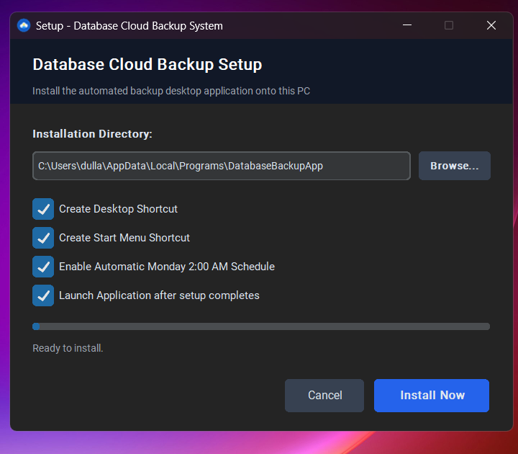
Figure 4: Standalone Graphical Setup Wizard (Setup_DatabaseBackup.exe)
Method A: Standalone Setup Wizard (Setup_DatabaseBackup.exe)
1. Copy Setup_DatabaseBackup.exe and config.json to the target machine.
2. Double-click Setup_DatabaseBackup.exe (or Run as Administrator).
3. Choose the target destination directory (defaults to C:\Program Files\DatabaseBackupApp or %LOCALAPPDATA%\Programs).
4. Select options: Desktop Shortcut, Start Menu Shortcut, Auto-Schedule.
5. Click Install Now. Files are extracted and registered in under 3 seconds.
Method B: Rapid 1-Click Scripted Deployment (1_Quick_Install.bat)
1. Copy Client_Installation_Package to the target machine.
2. Right-click 1_Quick_Install.bat and select Run as administrator.
3. The script automatically requests UAC elevation, creates C:\Program Files\DatabaseBackupApp, copies all runtime files, grants NTFS ACLs on C:\temp\backups, and registers the scheduled task.
Method C: Silent Remote Mass Push (Intune / SCCM / PowerShell)
Execute the setup wizard with the /silent switch:
Start-Process Setup_DatabaseBackup.exe -ArgumentList '/silent' -Wait -Verb RunAs
Method D: Developer Source Execution
cd BackupAutomation
pip install -r requirements.txt
python app_gui.py
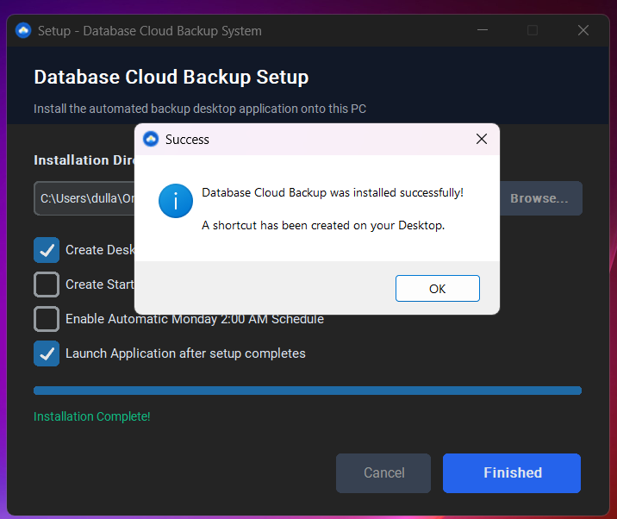
Figure 5: Setup Wizard Successful Installation Confirmation

7. In-Place Upgrades & Zero-Downtime Updates
When deploying software to customer servers and enterprise production machines, updating the application must be effortless, safe, and fast, without requiring database re-configuration or re-authenticating Google accounts.
Our deployment package includes a dedicated 1-click in-place update engine (Update_App.bat) that executes in under 5 seconds:
1. Target Discovery: Discovers existing installation location via Windows Registry or Program Files.
2. Process Quiescing: Gracefully terminates active GUI or background processes to release file locks.
3. Safety Snapshot: Creates an isolated snapshot in %TEMP%\DB_Backup_Config_Safety backing up config.json, token.json, credentials.json, and backup_log.txt.
4. Atomic Binary Refresh: Synchronizes updated binaries from AppFiles\ using Robocopy.
5. Configuration Restoration: Restores the exact customer configurations and tokens with 100% integrity.
6. Sanity Verification: Automatically runs DatabaseBackupApp.exe --auto to verify engine health.

8. Clean Uninstallation Runbook (Zero Leftovers)
To guarantee high enterprise compliance, the uninstallation process is guaranteed to remove 100% of installed files, registries, shortcuts, and scheduled tasks.
Four Ways to Uninstall:
1. Windows Control Panel: Navigate to Settings > Apps > Installed apps, locate Database Cloud Backup, and click Uninstall.
2. Desktop GUI Console: In the desktop GUI, navigate to the Settings tab and click Uninstall Application.
3. Interactive Script: Right-click Uninstall.bat and select Run as administrator.
4. Silent Automated Push: For remote fleet management, execute:
'C:\Program Files\DatabaseBackupApp\Uninstall.bat' /silent
Detached Cleanup Engine Architecture:
On Windows, a running program cannot delete its own folder due to OS file locking. Our uninstaller copies itself to %TEMP%, exits immediately to release all locks, and launches a detached background PowerShell job that terminates processes, unregisters tasks, deletes shortcuts, purges registry entries, and removes the folder with 100% reliability.

9. Detailed Code Inspection & Function Breakdown
1. auto_backup.py (Master Traffic Router):
• main(): Evaluates sys.argv. If no flags are provided, imports and launches app_gui.py. If --auto, --service, or --daemon is passed, executes execute_full_backup() headlessly.
2. backup_core.py (Stateless Engine Core):
• find_sql_cli_executable(): Resolves sqlcmd.exe in PATH, ODBC 18/17/13 directories, and osql.exe in legacy SQL 2000/2005 paths.
• execute_sql_query_adaptive(): Executes T-SQL queries with automatic -C flag fallback if rejected by legacy tools.
• execute_sql_backup_command(): Invocates BACKUP DATABASE commands with -b, -l 15 flags, trapping Error 5 for auto-failover.
• compress_backup_level9(): Streams .bak into Level 9 Deflate .zip archive and immediately deletes the .bak.
• upload_to_google_drive(): Resumable chunked upload with 10 exponential backoff retries, 180s socket timeouts, and progress callback.
• log_to_google_sheets(): Appends execution records into Google Sheet with timestamp, database name, size, and URL.
• enable_scheduler() / disable_scheduler(): Cross-platform scheduler manager (schtasks on Windows, launchd on macOS).
• open_path_native(): Cross-platform path launcher (os.startfile on Windows, open on macOS, xdg-open on Linux).
3. app_gui.py (CustomTkinter Desktop Console):
• DatabaseBackupApp: Main application class. Initializes dark-slate UI, status cards, action buttons, and progress bar.
• run_backup_thread(): Spawns daemon worker thread running execute_full_backup() without blocking the UI.
• update_upload_progress(): Calculates real-time upload speed (KB/s / MB/s) and ETA, updating progress bar at 60 FPS.
• stop_backup_action(): Atomic cancellation controller halting active subprocesses and cleaning partial files in under 500ms.
4. installer_gui.py (Standalone Setup Wizard):
• SetupWizardApp: Graphical installation wizard. Manages directory extraction, shortcut generation, and Task Scheduler registration.

10. Configuration Specification (config.json)
Key Name | Data Type | Default / Example | Description & Purpose
DB_SERVER | String | localhost\SQL25SARANGA | Target SQL Server instance name or IP address
DB_USER | String | "" (Empty for Trusted) | SQL authentication login (leave empty for Windows Auth)
DB_PASSWORD | String | "" (Empty for Trusted) | SQL authentication password
TARGET_DATABASES | Array | ["UserDB", "RGT"] | List of specific user database names to back up
LOCAL_BACKUP_DIR | String | C:\temp\backups | Temporary folder for staging .bak and .zip archives
DRIVE_FOLDER_ID | String | 14X-x01-Zm4eU1h2qksm6... | Target Google Drive folder ID from Drive URL
SHEET_ID | String | 1O7-sh1JTJas-JSmSkERep... | Google Sheet ID for real-time audit logging
SCHEDULE_DAYS | Array | ["MON"] | Active days of week for scheduled execution (MON-SUN)
SCHEDULE_TIME | String | "02:00" | 24-hour time of scheduled backup execution

11. Database Disaster Recovery & Restoration Runbook
Step 1: Retrieve Archive from Cloud
Open Google Drive or click the direct URL in the Google Sheet audit log. Download <DatabaseName>_<Timestamp>.zip.
Step 2: Extract Archive
Extract the raw .bak file using Windows Explorer or PowerShell:
Expand-Archive -Path 'UserDB_20260925_020000.zip' -DestinationPath 'C:\temp\restore'
Step 3: Execute Database Restore via T-SQL
RESTORE DATABASE [UserDB]
FROM DISK = N'C:\temp\restore\UserDB_20260925_020000.bak'
WITH REPLACE, RECOVERY, STATS = 10;
GO
Step 4: Verify Database Integrity
DBCC CHECKDB ([UserDB]) WITH NO_INFOMSGS, ALL_ERRORMSGS;
GO

12. Troubleshooting & Error Diagnostics Matrix
Error Condition / Symptom | Underlying Root Cause | Autonomous Engine Resolution
SQL Error 5 / Msg 3201 (Access Denied) | SQL Server service account lacks NTFS write permissions | Engine auto-grants permissions via icacls or writes to InstanceDefaultBackupPath
ODBC Driver 18 SSL Provider Error 0 | Self-signed certificate rejects strict encryption | Engine automatically detects modern driver and injects -C flag
WinError 10060 (Connection Timeout) | Fluctuating broadband connection dropped TCP socket | In-chunk resumable upload queries resumable_uri and resumes from exact byte offset
OAuth Token Expired / Invalid Grant | Short-lived 60-minute access token expired | Engine uses offline refresh token in token.json to silently renew tokens
Task Scheduler Error 2147942401 | Missing working directory in task configuration | Setup wizard explicitly registers absolute <WorkingDirectory> XML tag

13. Next-Gen Companion Module: Automated Performance Query System
Currently in active engineering: The Automated Performance Query Companion Module integrates non-intrusive database health and workload telemetry directly into the backup lifecycle.
Captured Diagnostic Metrics:
1. Top Slowest Queries: Extracts queries consuming the highest CPU worker time and elapsed duration via sys.dm_exec_query_stats.
2. Missing Index Impact Score: Identifies tables with the highest user cost improvement score via sys.dm_db_missing_index_details.
3. Index Fragmentation: Analyzes fragmentation percentage via sys.dm_db_index_physical_stats to identify tables requiring reindexing.
4. Memory & Buffer Pool Pressure: Measures Page Life Expectancy (PLE) and buffer cache hit ratio to diagnose RAM starvation.
5. Database I/O Stall Latency: Tracks physical read and write latency across .mdf and .ldf storage volumes via sys.dm_io_virtual_file_stats.
Integration & Reporting:
The module runs a non-blocking 2-second pre-backup health check and appends formatted performance summaries into a dedicated 'Performance Telemetry' tab in the central Google Sheet.

14. Senior Engineering Review & Defense Cheat Sheet
Reviewer Question | Comprehensive Technical Answer
Why is your engine separated from the GUI? | Model-View separation. backup_core.py is 100% headless, stateless, and thread-safe. It can be called by CustomTkinter GUI, CLI runners, or Windows Task Scheduler with zero code duplication.
How do you handle slow or fluctuating client internet connections without upload failures? | In-chunk resumable upload using Google Drive API v3. Chunks are 1MB, and request.next_chunk() is wrapped in a 10-attempt exponential backoff retry loop that queries resumable_uri and resumes from the exact byte where the network paused. This completely resolves WinError 10060.
How does the software support older Windows Server, Windows 7, and legacy SQL Server / SSMS setups? | The engine includes find_sql_cli_executable() resolving modern ODBC 18 down to legacy osql.exe. It auto-falls back if -C is rejected and queries sys.databases with fallback to master.dbo.sysdatabases for SQL 2000.
How do you update the application on customer servers without wiping settings? | Isolated safety snapshot pattern: Update_App.bat and Setup Wizard terminate processes, copy config.json, credentials.json, and token.json to %TEMP%\DB_Backup_Config_Safety, robocopy new binaries, and restore settings with 100% integrity in under 5 seconds.
How do you prevent the desktop UI from freezing during 500 MB uploads? | All heavy I/O operations run on daemon worker threads (threading.Thread(daemon=True)). Progress bar updates and log streaming are safely marshaled to the Tkinter event loop via self.after().
How does the software handle SQL Server Error 5 (Access Denied)? | Two-tier strategy: first, proactive NTFS ACL grants using language-neutral SIDs (*S-1-1-0 and *S-1-5-32-545). Second, automatic runtime trapping: if Error 5 occurs, it queries SQL Server's InstanceDefaultBackupPath, redirects the .bak there, compresses to destination, and deletes the temporary .bak.
How does the system ensure reliability on Windows Server and RDP? | Unattended Windows System Service mode running under NT AUTHORITY\SYSTEM in Session 0. It executes before any user logs in, survives server reboots via startup triggers, and is immune to disconnected RDP sessions.

