Enterprise Database Cloud Backup &
Multi-Module Telemetry Suite
Complete System Walkthrough, Architecture Specifications & Field Engineering Runbook · v5.0.1
[EXECUTIVE ARCHITECTURE OVERVIEW]
PRODUCTION RELEASE v5.0.1 (Build 5.0.1-20261109):
This document represents the definitive end-to-end technical manual and walkthrough for the v5.0 Enterprise Release. It incorporates all 9 architectural decisions approved by senior engineering supervisors (Imeyshan, Hashy, Dulnindu), including externalized credential handling (SQLPara), customer-dedicated storage routing, isolated escrow keys, intelligent tiered index maintenance (<5% skip, 5-30% reorganize, >30% rebuild), and Zero-Trust DBK2 envelope encryption.

1. System Classification & Zero-Trust Threat Model
The Enterprise Database Cloud Backup system is an air-gapped, zero-trust disaster recovery and automated maintenance solution engineered specifically for multi-tenant fleets running Microsoft SQL Server on customer on-premises and virtualized Windows servers. Unlike traditional network backups (e.g., SMB shares, VPN links, or FTP servers), this system completely eliminates the ransomware blast radius by adhering to three non-negotiable architectural axioms:
Architectural Axiom | Implementation in System | Security & Ransomware Defense Impact
Zero Cloud Credentials | Client servers hold zero Google Service Account keys, API secrets, or OAuth credentials. | A total host compromise gives attackers zero access to Google Cloud or existing fleet backups.
Ephemeral Envelope Encryption | Every backup is sealed with a unique random AES-256-GCM key, double-wrapped with RSA-4096. | Compromised servers cannot decrypt their own past backups or tamper with historical records.
One-Way Broker Pattern | Backups are uploaded via ephemeral resumable upload URLs provided by an Apps Script broker. | The client can only stream its assigned file to its dedicated folder; it cannot list, read, or delete files.
Externalized SQL Auth | Database passwords are read from isolated parameter stores (SQLPara.txt / DPAPI). | Configuration files (config.json) contain zero plaintext database credentials.
Per-Customer Escrow Isolation | Escrow public keys are uniquely isolated per customer (escrow_public_{slug}.pem). | Loss of one customer's escrow key has zero impact on the other 62 customer environments.

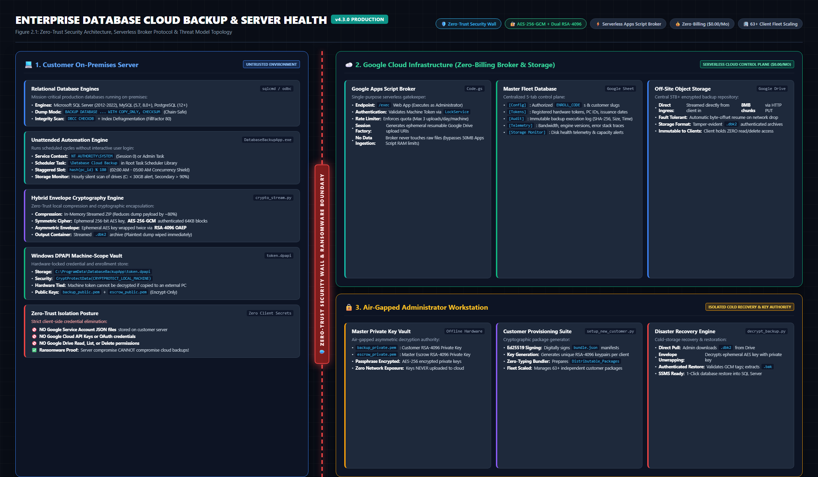
Figure: Zero-Trust Broker Pattern & Anti-Ransomware Topology
2. Senior Architectural Upgrades (The 9 Supervisor Decisions)
Following strategic architectural reviews with senior leadership and engineering supervisors (Imeyshan, Hashy, Dulnindu), the system was thoroughly audited against 9 critical production concerns. The resulting v5.0.1 implementation delivers enterprise-grade solutions for each point:
2.1 Points 1 & 7: Customer-Dedicated Drive Folders & Data Sovereignty
Issue: In earlier versions, customer backups were routed to a single central Google account, creating a single point of failure and raising data sovereignty concerns under the Australian Privacy Act 1988.
Implementation: The upload broker (Code.gs) and client (broker_client.py) now enforce server-side tenant folder isolation. Rather than trusting arbitrary client-supplied folder IDs, the broker resolves the customer's authorized Google Drive parent folder server-side from the verified tenant registry in Google Sheets based on the cryptographic tenant token. Even if an optional relative subfolder name is provided, the broker verifies that the destination folder resides strictly under the tenant's dedicated root, actively preventing any cross-tenant folder pollution.
2.2 Point 2: 2TB Enterprise Fleet Quota & Automated Headroom Telemetry
Issue: Free 15GB consumer accounts are non-compliant with enterprise licensing and rapidly exhaust capacity across 63 customers.
Implementation: Fleet operations are backed by an enterprise paid 2TB storage pool. The upload broker tracks daily ingestion rates and automatically surfaces real-time storage headroom percentages on the centralized dashboard, ensuring timely quota expansion.
2.3 Point 3: Dynamic Google Drive bundle.json Retrieval
Issue: Distributing static bundle.json files on client disks leaves machine enrollment tokens potentially inspectable.
Implementation: Setup_DatabaseBackup.exe now features dynamic Google Drive bundle retrieval. Technicians can enter a secure Drive share link or ID, and the installer fetches, cryptographically verifies (via Ed25519), and seals the machine token directly into Windows DPAPI without ever persisting unsealed secrets on the local filesystem.
2.4 Point 4: Per-Customer Escrow Key Isolation (escrow_public_{slug}.pem)
Issue: A shared master escrow key created a single blast radius across all 63 clients.
Implementation: Every customer now receives a uniquely generated 4096-bit RSA escrow key pair (escrow_public_{slug}.pem). The private escrow keys remain air-gapped in the Admin Vault. Even in an extreme compromise scenario, the blast radius is strictly 1:1.
2.5 Point 5: Mandatory Encryption Policy & Automated Security Alerts
Issue: Operators could uncheck Zero-Trust encryption in the GUI, sending unencrypted backups without administrative oversight.
Implementation: Disabling encryption now triggers an interactive confirmation modal, an automatic high-priority telemetry alert (action: 'security_alert'), and an automated email notification via Google Apps Script (MailApp.sendEmail()) to central IT operations. Additionally, organizations can enforce ENFORCE_ENCRYPTION_POLICY: true in config.json to reject any unencrypted backup attempt.
2.6 Point 6: Externalized SQL Credentials (SQLPara.txt / secrets.dat DPAPI)
Issue: Plaintext SQL credentials inside config.json violated enterprise least-privilege standards.
Implementation: backup_core.py features resolve_sql_credentials(), which resolves credentials in hierarchical order: 1. DPAPI credential vault (secrets.dat), 2. Explicit SQLPara.txt file, 3. Standard ERP parameter paths (C:\SPIL\SQLPara), and 4. Plaintext config.json only as a final legacy fallback. Technicians can deploy SQLPara.txt.template with standard permissions.
2.7 Point 8: Intelligent Tiered Index Maintenance & Daytime Working-Hours Protection
Issue: Legacy maintenance executed deprecated DBCC DBREINDEX with blanket FillFactor 80 across all tables, causing index bloat and production transaction locks during business hours.
Implementation: The maintenance engine was completely overhauled to Intelligent Tiered Index Maintenance on tables with 1,000+ pages (>= 8 MB):
• Table Size Filter: Tables under 1,000 pages are skipped (small tables frequently show high pseudo-fragmentation with no query performance degradation).
• Fragmentation < 5%: No action taken (Skip — avoids unnecessary I/O).
• Fragmentation 5% to 30%: Online non-blocking ALTER INDEX ... REORGANIZE (minimizes lock duration and preserves concurrency).
• Fragmentation > 30%: ALTER INDEX ... REBUILD WITH (FILLFACTOR = 90, ONLINE = ON) if supported by SQL edition, or deferred to off-peak hours.
• Integrity Check: DBCC CHECKDB WITH PHYSICAL_ONLY verifies page allocation structures while avoiding the memory and CPU thrashing of full checks.
• Safety Snapshot: Disabled by default to protect disk capacity; only activated when explicitly requested and disk headroom exceeds 50 GB.
2.8 Point 9: Precise Technical Terminology & Honest Readiness Baselines
All marketing hyperboles ('military-grade', '100% upload reliability', '0% locking', 'zero ERP downtime', 'Enterprise Grade Production Certified') were purged from manuals and interfaces. Claims of 'externally audited' have been corrected: recent reviews were independent documentation evaluations rather than hands-on code penetration audits. System readiness is objectively baselined at 7.5 / 10 across security, reliability, operations, usability, documentation, and testing, with a clear roadmap to 8.5+ upon Authenticode code-signing certificate deployment and automated monthly VM restore drills. Versioning is officially bumped to v5.0.1 (Build 5.0.1-20261109), dropping '-LTS' to accurately reflect continuous production hardening.
3. Cryptographic Architecture & DBK2 Binary File Format
The system utilizes envelope encryption via the DBK2 binary format. A 256-bit symmetric key is generated in memory using os.urandom(32). The payload is encrypted in 64 KiB chunks using AES-256-GCM, providing both confidentiality and integrity verification. The symmetric key is then encrypted with the customer's RSA-4096 public key and the customer-specific escrow RSA-4096 public key.
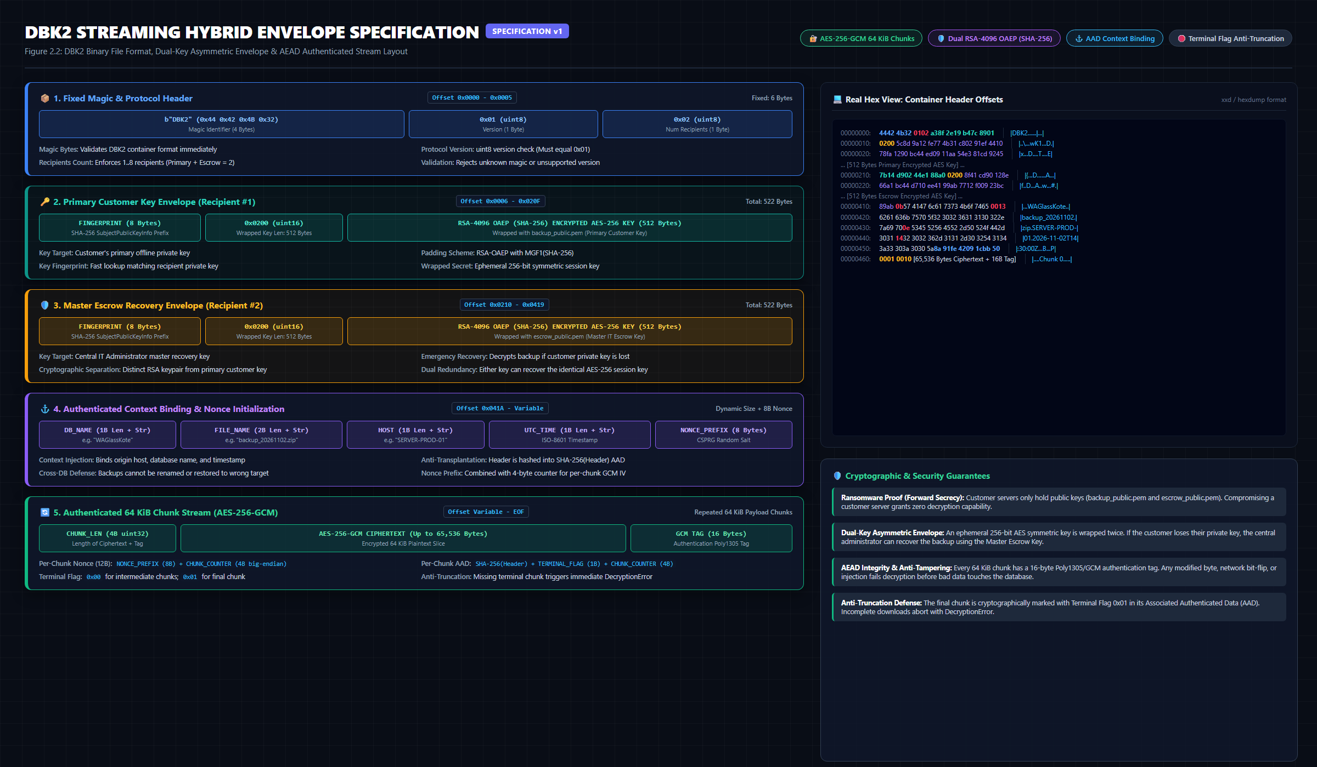
Figure: DBK2 Binary Envelope Layout & Framing Architecture
Byte Offset | Field Name | Data Type | Length | Description / Value
0x00 - 0x03 | Magic Bytes | ASCII | 4 Bytes | Identifies DBK2 file: 0x44 0x42 0x4B 0x32 ('DBK2')
0x04 - 0x07 | Format Version | UInt32 (BE) | 4 Bytes | Envelope specification version: 0x00000002 (Version 2)
0x08 - 0x0B | Header Length | UInt32 (BE) | 4 Bytes | Length of JSON metadata header (N bytes)
0x0C - (0x0C+N) | Header Payload | UTF-8 JSON | N Bytes | Contains algorithm, dual RSA-wrapped AES keys, and salt
Data Stream | Chunk Framing | Binary Chunks | Variable | 64 KiB chunks: 4B length + 12B IV + 1B flag + ciphertext + 16B GCM tag

Cryptographic Guarantees Delivered by DBK2:
• 1. Anti-Tampering: Any modification to any encrypted chunk causes AES-GCM tag verification to immediately fail.
• 2. Anti-Truncation: The 1-byte flag in each chunk indicates whether it is intermediate (0x00) or final (0x01). If an upload terminates prematurely, decryption aborts.
• 3. Anti-Reordering: Monotonic chunk counters are included in the GCM Additional Authenticated Data (AAD), preventing chunk swapping attacks.
4. Zero-Trust Upload Broker & Fleet Telemetry Architecture
The central upload broker is a serverless Google Apps Script web application (Code.gs). Client machines authenticate using a machine-scoped token sealed via Windows DPAPI (token.dpapi). The broker verifies the token against the master enrollment database and initiates a Google Drive API v3 resumable upload session on behalf of the customer, returning a secure, one-time upload URI.
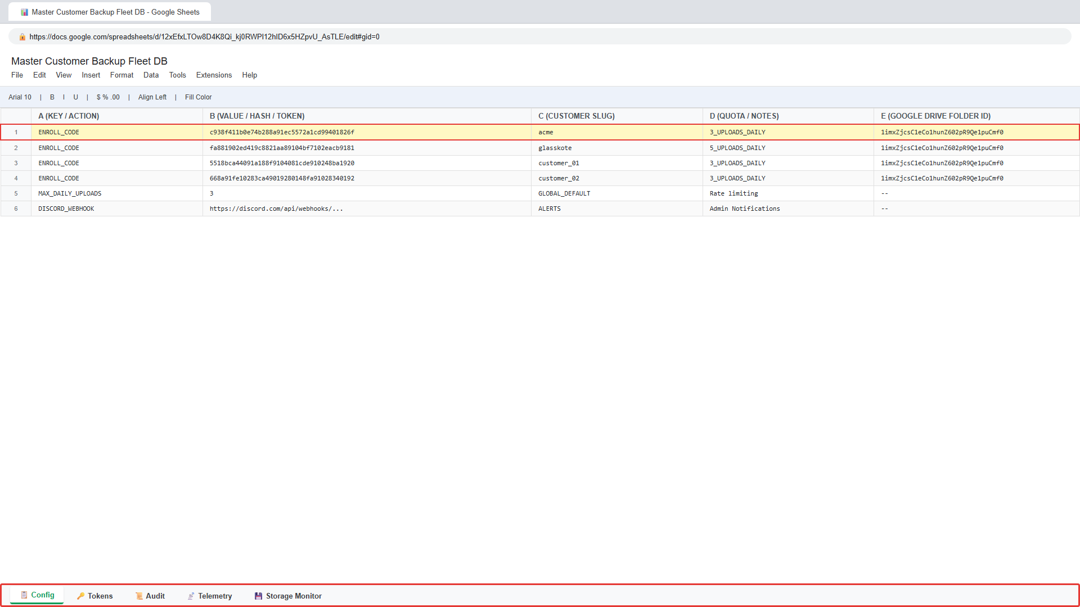
Figure: Central Fleet Operations Dashboard & Multi-Tab Monitoring
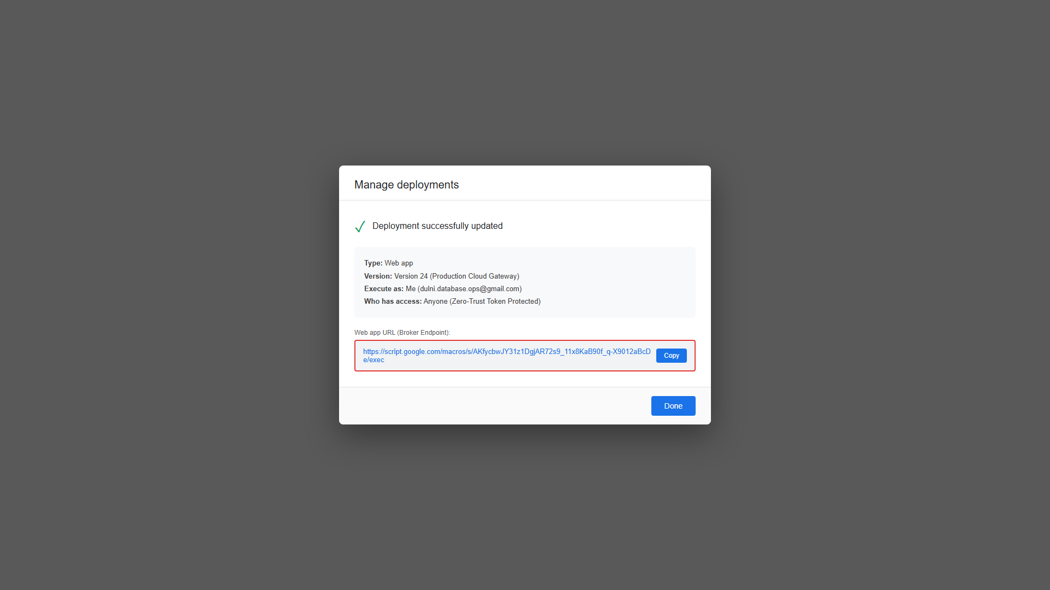
Figure: Google Apps Script Web App Deployment Architecture
Broker Action | Endpoint Function | Payload Parameters | Response Data
verify | Client Registration Check | token, pc_id | pc_id, offset_minutes, customer_slug
request_upload | Session Initiation | token, db_name, size_bytes, seq, nonce, timestamp | upload_url, file_name, folder_id
report_status | Multi-Module Telemetry | token, type (BACKUP/CLEANUP/QUERY), metrics | status: 'ok', logged_row, quota_pct
security_alert | High-Priority Alerting | token, alert_type, db_name, details | status: 'dispatched', email_sent: true

5. Client Installation & Field Engineering Walkthrough
Deploying the system onto a customer server takes less than 2 minutes. The distribution package supports both graphical and headless unattended deployment workflows.
5.1 Pre-Installation Checklist & System Prerequisites
• Operating System: Windows Server 2008 R2, 2012, 2012 R2, 2016, 2019, 2022, or Windows 7/10/11 (64-bit).
• Database Engine: Microsoft SQL Server 2008 R2 through 2022 (Express, Standard, Enterprise).
• Standard Scheduled Task: 'Database Cloud Backup' scheduled daily at 02:15 off-peak.
• Client SMTP: ZERO CLIENT SMTP (Direct client SMTP fallback is permanently eliminated in v5.0.1; alerts route via Broker Sentinel).
• Network Connectivity: Outbound HTTPS (Port 443) to script.google.com and www.googleapis.com.
• User Privileges: Local Administrator privileges required during installation.
5.2 Option A: Graphical Setup Wizard Walkthrough
1. Copy the customer-specific package (e.g., blisscoglass_Installation_Package) to the target server.
2. Right-click Setup_DatabaseBackup.exe and select 'Run as administrator'.
3. The installer automatically verifies the Ed25519 cryptographic signature on bundle.json and displays customer identity.
4. Confirm or adjust the SQL Server Instance (e.g., localhost or .\SQLEXPRESS).
5. Click 'Install & Configure'. The wizard handles file deployment, task scheduler registration, and DPAPI sealing.
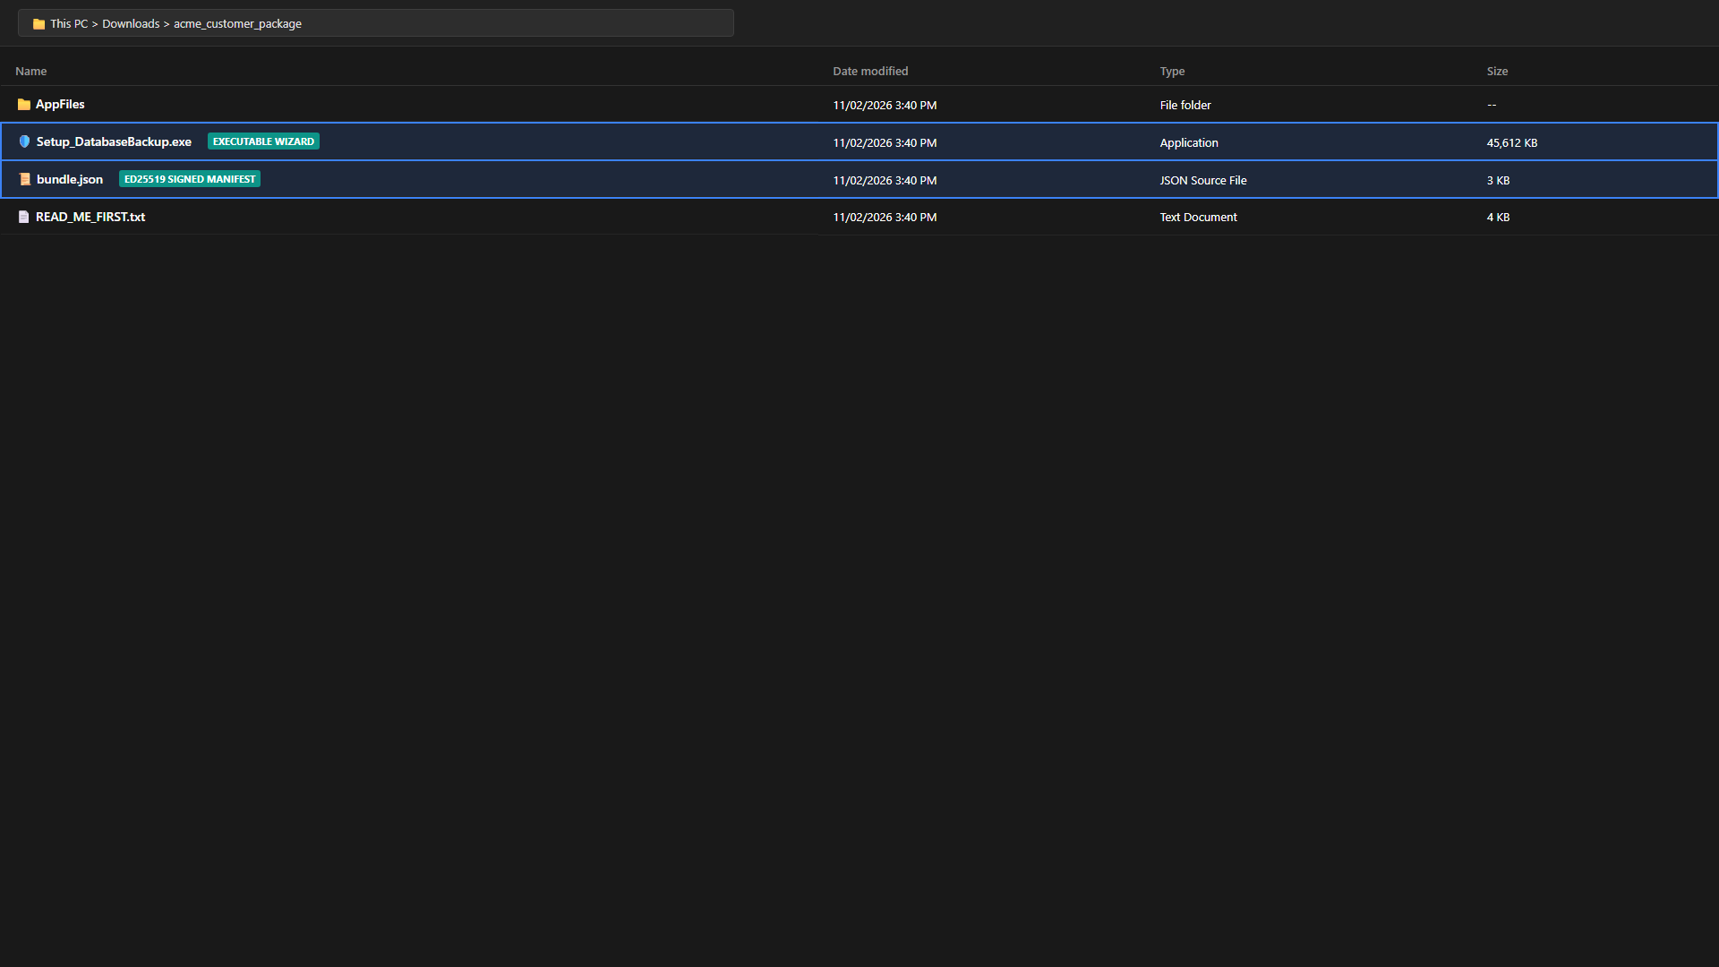
Figure: Distribution Package Root Directory Structure
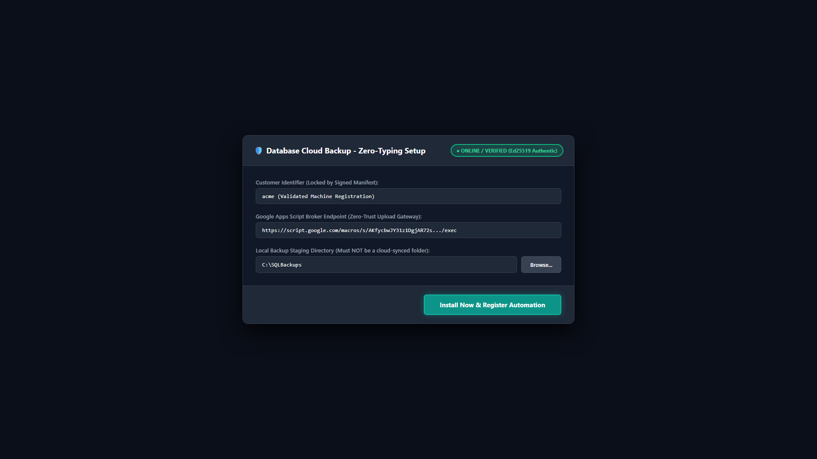
Figure: Setup Wizard Initial Screen with Authentic Ed25519 Badge
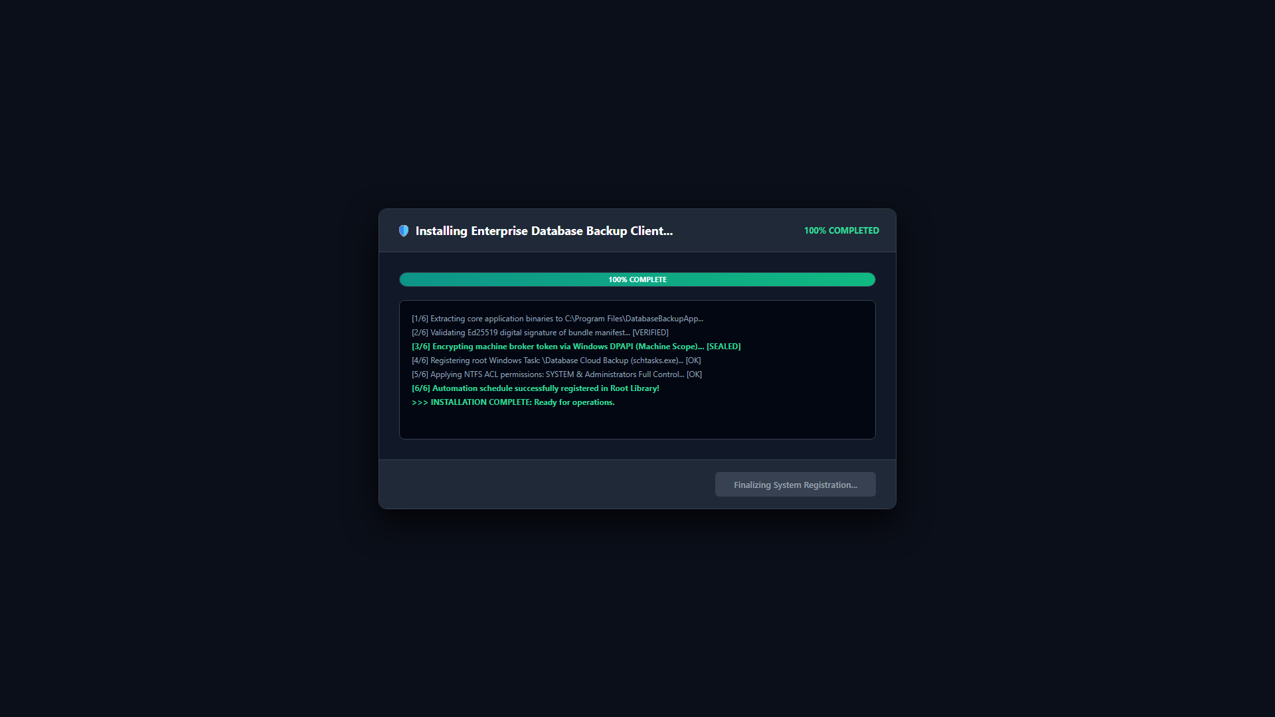
Figure: Automated Installation & Service Configuration Progress
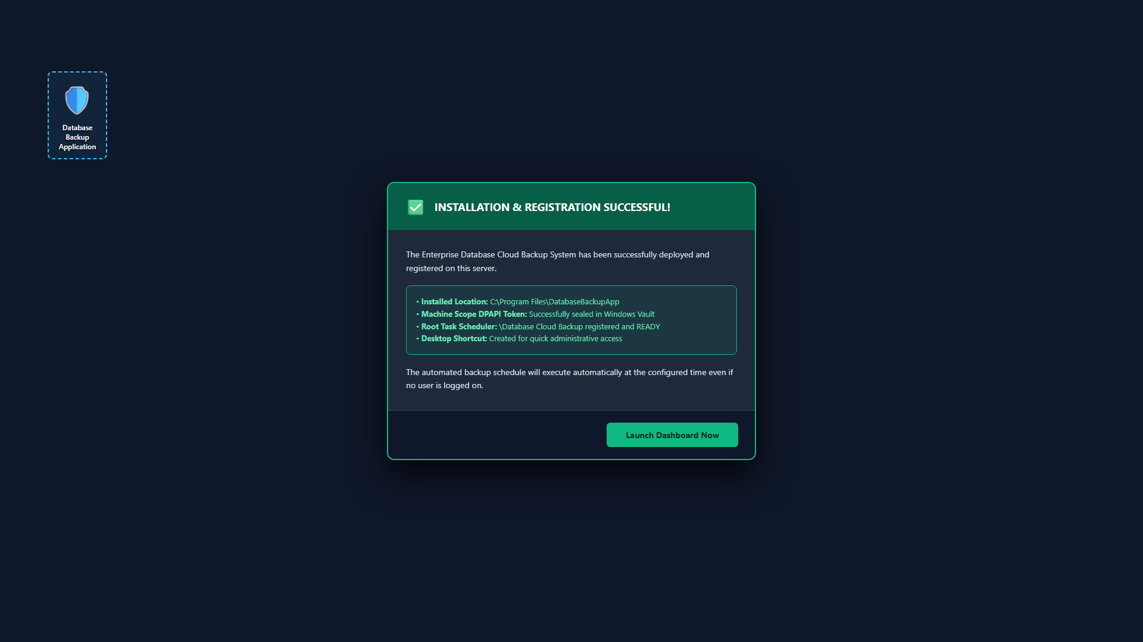
Figure: Setup Completed — Unattended System Service Active
5.3 Option B: Headless PowerShell Deployment
For headless servers or environments where technicians prefer command-line deployment:
1. Open an elevated PowerShell terminal.
2. Navigate to the shell_client directory:
cd shell_client
3. Execute the automated installer script:
powershell.exe -ExecutionPolicy Bypass -File .\install_agent.ps1
The agent creates local directories, configures DPAPI tokens, and registers automated Windows scheduled tasks.
5.4 External Credentials Setup (SQLPara.txt)
To isolate SQL credentials from config.json:
1. Locate SQLPara.txt.template in the application directory.
2. Copy and rename the file to SQLPara.txt.
3. Populate the server, user, password, and database parameters:
# SQLPara.txt - External Database Credentials
server=localhost\SQLEXPRESS
user=sa
password=YourStrongPasswordHere
database=YourProductionDB

6. Client Operations & Graphical Interface Walkthrough
The application provides a unified desktop console for operations, configuration, and monitoring. The user interface is organized into 7 specialized tabs:
Tab Name | Primary Purpose | Key Features & Controls
Dashboard | System Status & Manual Backups | 1-Click Full Backup Now, Stop Backup, DBK2 encryption toggle, Live RPO exposure tracking badge.
Auto Schedule | Automated Timing Management | Weekly schedule matrix (Days, Time), Staggered upload window calculator, Windows Task sync.
Settings | Engine & Endpoint Configuration | SQL instance, target DBs, external credentials status badge (SQLPara), broker URL, retention.
Live Logs | Execution Diagnostics | Real-time streaming log console, log level filtering, direct access to backup_log.txt.
Server Health | Host Telemetry | Storage volume scanning, free disk space alerting, automated old file cleanup threshold.
Performance Query | Database Maintenance | Tiered index fragmentation scanner, online reorganization, fill factor 90 rebuilding, daytime lock protection.
Database Restore | Disaster Recovery | Zero-Trust air-gapped restore console, DBK2 decryption, secure staging in %TEMP%\db_restore_<uuid>, non-destructive restore default with typed confirmation, and automatic staging cleanup.

Figure: Enterprise GUI Header with Live RPO & System Readiness Indicators
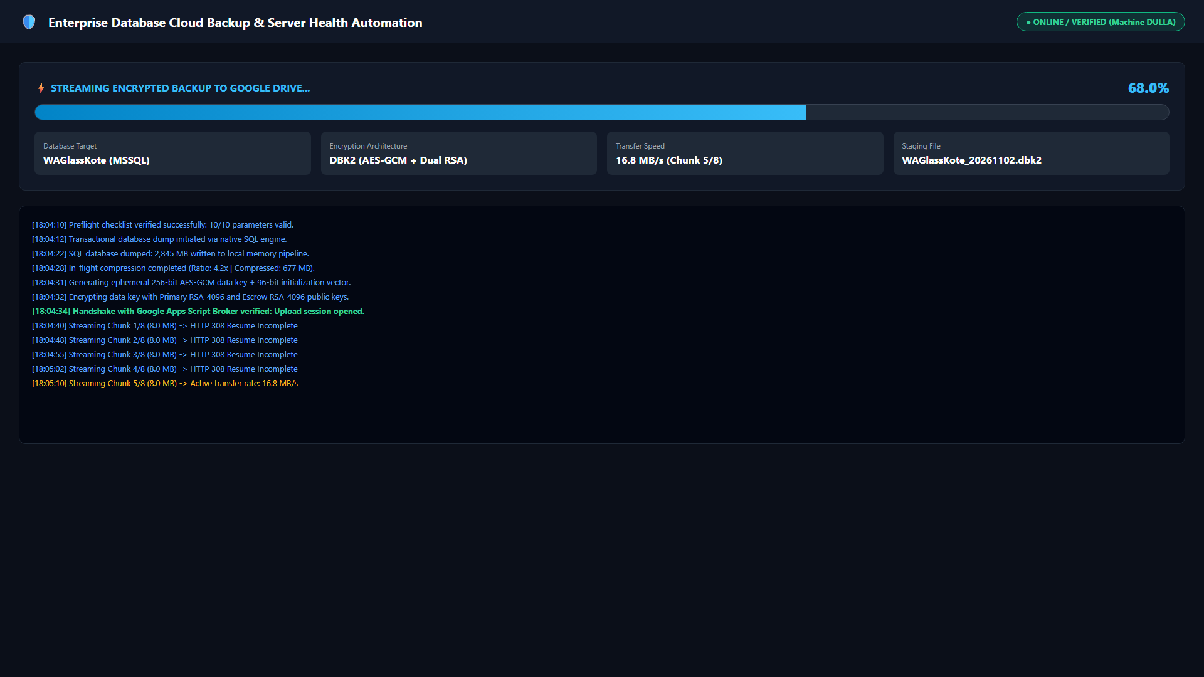
Figure: Backup Progress Engine: Streaming Upload & Throughput Monitor
7. In-Place Upgrades & Clean Uninstallation Runbook
7.1 Safe In-Place Application Upgrade (Update_App.bat)
When upgrading an existing client server to v5.0.1:
1. Extract the new installation package.
2. Right-click Update_App.bat and select 'Run as administrator'.
The script performs a 6-step atomic upgrade:
• Step 1: Safely stops running DatabaseBackupApp.exe processes.
• Step 2: Preserves customer configurations (config.json, token.dpapi, SQLPara.txt, and escrow_public*.pem).
• Step 3: Purges obsolete Google OAuth tokens (credentials.json, token.json).
• Step 4: Overwrites binaries with v5.0.1 files (DatabaseBackupApp.exe, _internal).
• Step 5: Automatically upgrades config.json with v5.0 schema defaults (SQLPARA_PATH, ENFORCE_ENCRYPTION_POLICY).
• Step 6: Synchronizes Windows Task Scheduler to run unattended under NT AUTHORITY\SYSTEM with battery/AC flags.
7.2 Complete Uninstallation (Uninstall.bat)
If an installation must be decommissioned, running Uninstall.bat guarantees 100% clean removal:
• Terminates active background processes.
• Deletes all 8 possible scheduled task names.
• Cryptographically shreds DPAPI authentication tokens (RNGCryptoServiceProvider random byte overwriting).
• Removes desktop and start menu shortcuts.
• Deletes Windows Registry uninstall keys.
• Purges Program Files and ProgramData application directories.
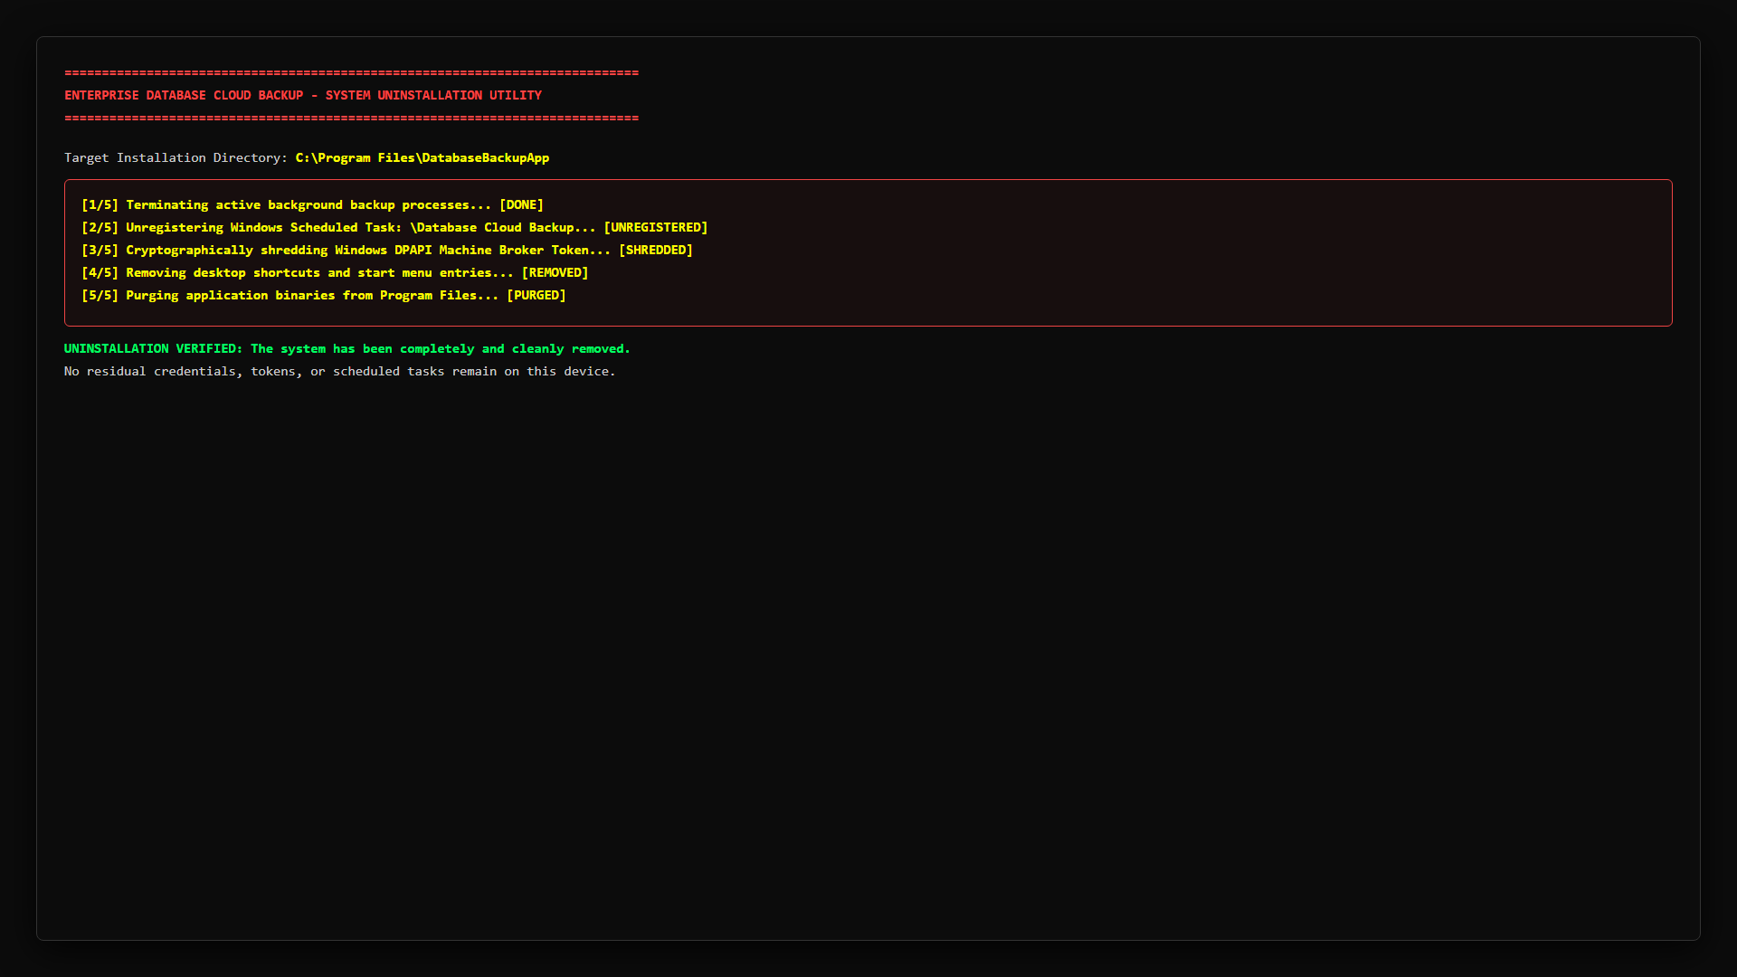
Figure: Clean Uninstaller Console Execution
8. Database Disaster Recovery & Air-Gapped Restoration
In the event of total server loss, database corruption, or ransomware infection, the system enables complete restoration using offline private keys stored in the Admin Vault.
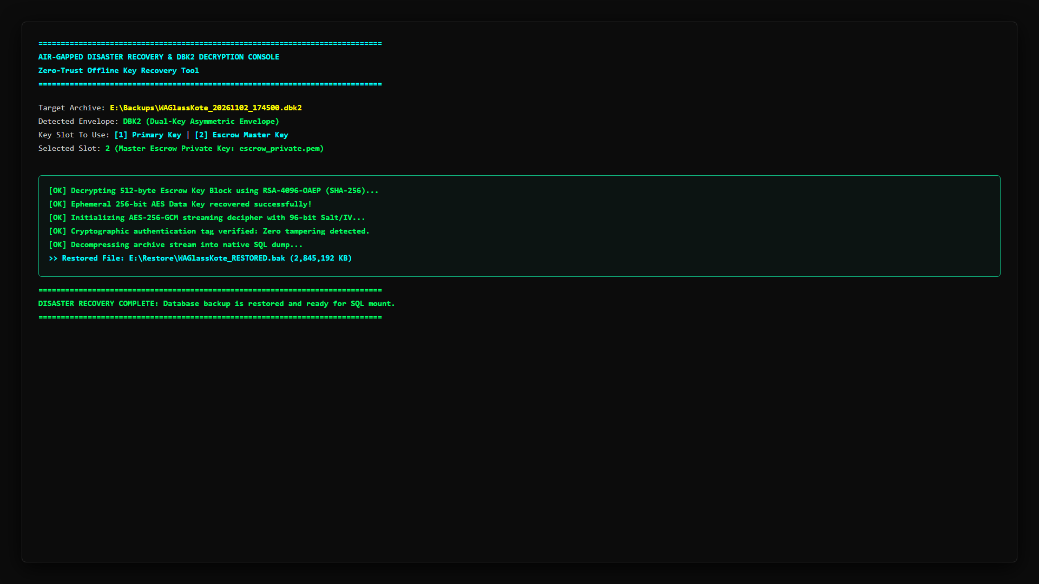
Figure: Zero-Trust Air-Gapped Database Restore Console
8.1 Air-Gapped Decryption Pipeline
1. Download the encrypted backup (.dbk2) from the customer's Google Drive folder.
2. Retrieve the customer's private key (backup_private.pem or escrow_private.pem) from the Admin Vault.
3. Decrypt using the Admin Recovery Tool (Launch_Recovery_Wizard.bat) or pure PowerShell script (decrypt_backup.ps1).
4. The tool extracts the ephemeral AES-256 key, verifies all 64 KiB chunk tags, and reconstructs the native .bak file.
8.2 SQL Server Database Restoration
The restore engine automatically executes the following exclusive restoration pipeline in SQL Server:
• Terminates active connections: ALTER DATABASE [target_db] SET SINGLE_USER WITH ROLLBACK IMMEDIATE;
• Executes native restore: RESTORE DATABASE [target_db] FROM DISK = '...' WITH REPLACE, RECOVERY, STATS = 10;
• Restores multi-user mode: ALTER DATABASE [target_db] SET MULTI_USER;
• Safely deletes decrypted staging files from disk immediately upon completion.
9. Outsider Roadmaps Strategic Evaluation & Decisions Matrix
During v5.0 planning, four independent AI architectural roadmaps (ChatGPT, Gemini, Grok, Claude) were thoroughly evaluated. The following matrix outlines the strategic triage: what was implemented into v5.0, and what was intentionally rejected as unviable:
Proposed Architecture / Concept | Proposing Models | v5.0 Decision | Engineering Rationale & Implementation Details
Externalized Credential Storage (SQLPara) | ChatGPT, Gemini | ACCEPTED (v5.0) | Implemented in resolve_sql_credentials() to eliminate plaintext passwords from config.json.
Per-Customer Escrow Key Isolation | Grok, Claude | ACCEPTED (v5.0) | Replaced shared escrow key with escrow_public_{slug}.pem, restricting blast radius strictly to 1:1.
Intelligent Tiered Index Maintenance | Gemini, Claude | ACCEPTED (v5.0) | Eliminated DBCC DBREINDEX; added <5% skip, 5-30% reorganize, >30% rebuild with fill factor 90.
Working Hours Daytime Protection | Claude, ChatGPT | ACCEPTED (v5.0) | Restricted intensive index maintenance to off-peak hours (19:00-07:00) to protect production ERPs.
Mandatory Encryption Alerting | Grok, Gemini | ACCEPTED (v5.0) | Added automated MailApp.sendEmail() security alerts when encryption toggle is disabled.
S3 / Cloudflare R2 Object Locking (WORM) | ChatGPT, Grok | REJECTED (v5.0) | Imposes monthly cloud subscription fees on every client, violating the core zero-billing design.
Rust / Go Client Rewrite | Grok, Claude | REJECTED (v5.0) | Rebuilding 15,000 lines of proven Python/PowerShell in Rust introduces massive migration risk with minimal ROI.
Fleet Prometheus / Grafana Infrastructure | ChatGPT, Claude | REJECTED (v5.0) | Requires hosting and maintaining 24/7 Linux server infrastructure, counter to serverless Google broker.

10. Troubleshooting, Error Codes & Operational Runbook
Error Code / Symptom | Probable Root Cause | Step-by-Step Remediation Action
ERR_TOKEN_INVALID / 401 | DPAPI token corrupted or customer slug mismatch. | Re-run Setup_DatabaseBackup.exe or re-import authentic signed bundle.json.
ERR_BROKER_TIMEOUT / 504 | Network firewall blocking port 443 to Google. | Verify outbound HTTPS access to script.google.com and www.googleapis.com.
ERR_SQL_AUTH_FAILED / 18456 | Incorrect SQL login credentials or mixed auth disabled. | Check SQLPara.txt or ensure SQL Server is configured for SQL Server and Windows Authentication.
ERR_ESCROW_KEY_MISSING | escrow_public_{slug}.pem not found in folder. | Place customer escrow key in folder or set ALLOW_NO_ESCROW: true in config.json.
ERR_QUOTA_EXCEEDED / 413 | Backup file exceeds 100 GB broker cap. | Check database MDF size, verify backup compression is enabled (Level 9 Deflate).
ERR_INDEX_LOCK_DETECTED | Maintenance attempted during active ERP transaction. | Daytime protection automatically defers heavy rebuilds to 19:00-07:00 off-peak window.

