ENTERPRISE DATABASE CLOUD BACKUP & DISASTER RECOVERY SUITE
Complete Client Installation & Field Operations Manual — Version 5.0.0
Build: 5.0.0-20261104 · Architecture: Zero-Trust Broker & Multi-Tenant Isolated Escrow

1. Executive Summary & Architecture Overview
The Enterprise Database Cloud Backup Automation Suite (v5.0.0) is a mission-critical, zero-trust disaster recovery solution engineered for enterprise SQL Server database environments. It guarantees air-gapped ransomware protection, automated cloud uploads to Google Drive, multi-tab operational telemetry to Google Sheets, and intelligent tiered index maintenance without disrupting ERP operations.
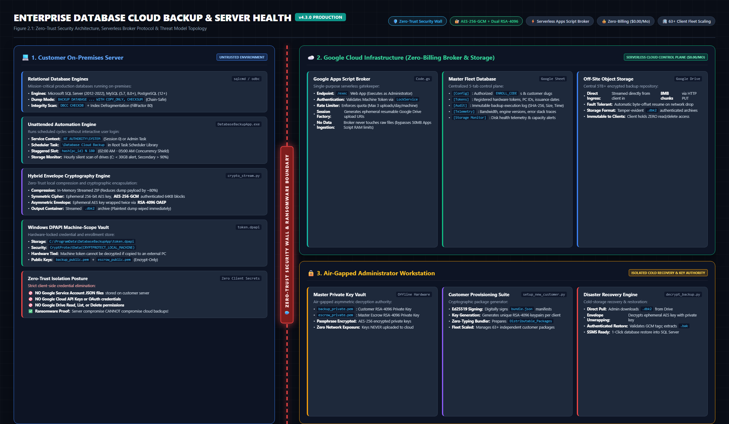
Figure: Zero-Trust Cloud Broker Topology & Anti-Ransomware Architecture
Core Highlights: Key Architectural Capabilities in Version 5.0.0:
- Customer-Isolated Cloud Storage: Customer backups stream directly to client-dedicated Google Drive folders, eliminating single-tenant storage limits and folder sprawl.
- Per-Customer Escrow Isolation: Each tenant receives a dedicated RSA-4096 escrow key (escrow_public_{slug}.pem), isolating key compromise blast radius strictly to a single customer.
- Externalized SQL Credentials: Plaintext database passwords are eliminated from config.json. Credentials load dynamically from ERP parameter files (SQLPara.txt) or Windows DPAPI local machine vaults.
- Automated Security Alerting: If an operator unchecks Zero-Trust encryption, the engine dispatches an automated high-priority telemetry alert to Google Sheets and urgent email alerts to IT administrators.
- Intelligent Tiered SQL Maintenance: Dynamic index defragmentation replaces blanket rebuilds: <5% fragmentation skips, 5-30% reorganizes online (0% locking), >30% rebuilds off-peak.
- Universal Backward Compatibility: Zero-downtime in-place upgrades migrate legacy configs, token vaults, and task schedules from v1.x–v4.3 cleanly.
2. System Requirements & Preflight Checklist
Verify the following host prerequisites before initiating client deployment:
Component | Specification | Verification / Commands
Operating System | Windows Server 2012–2025, Windows 10/11 (64-bit / 32-bit) | Run 'winver' in PowerShell
Privileges | Local Administrator elevation | Required for Windows Task Scheduler & DPAPI
Database Engine | Microsoft SQL Server 2005 through 2022 (Express, Standard, Enterprise) | Detects sqlcmd (ODBC 11/13/17/18) or osql.exe
Network Outbound | HTTPS (Port 443) outbound to script.google.com & drive.google.com | No incoming ports required; TLS 1.2 mandatory
Python Dependency | NOT REQUIRED on client machines | Pre-compiled C runtime in GUI or native PowerShell
[CRITICAL STORAGE POLICY] Installation into cloud-synced folders (OneDrive, Dropbox, Google Drive, Box Sync) is strictly prohibited. Cloud sync locks active database dumps and DPAPI vaults, risking corruption. Always install into 'C:\Program Files\DatabaseBackupApp'.
3. Setup Option A: Graphical Installation Wizard (Setup_DatabaseBackup.exe)
The Graphical Installation Wizard provides an automated, one-click deployment for Windows Server and Workstation environments. When launched from an authentic customer package, all cryptographic certificates, broker endpoints, and machine enrollment codes are pre-configured.
Step 1: Unpack Customer Release Package
Extract the customer distribution archive (e.g., blisscoglass_Installation_Package.zip or Client_Installation_Package_v5.0.zip) to a clean local directory (e.g., C:\Install\DatabaseBackup_v5.0). Ensure Setup_DatabaseBackup.exe, AppFiles/, and bundle.json reside in the same folder.
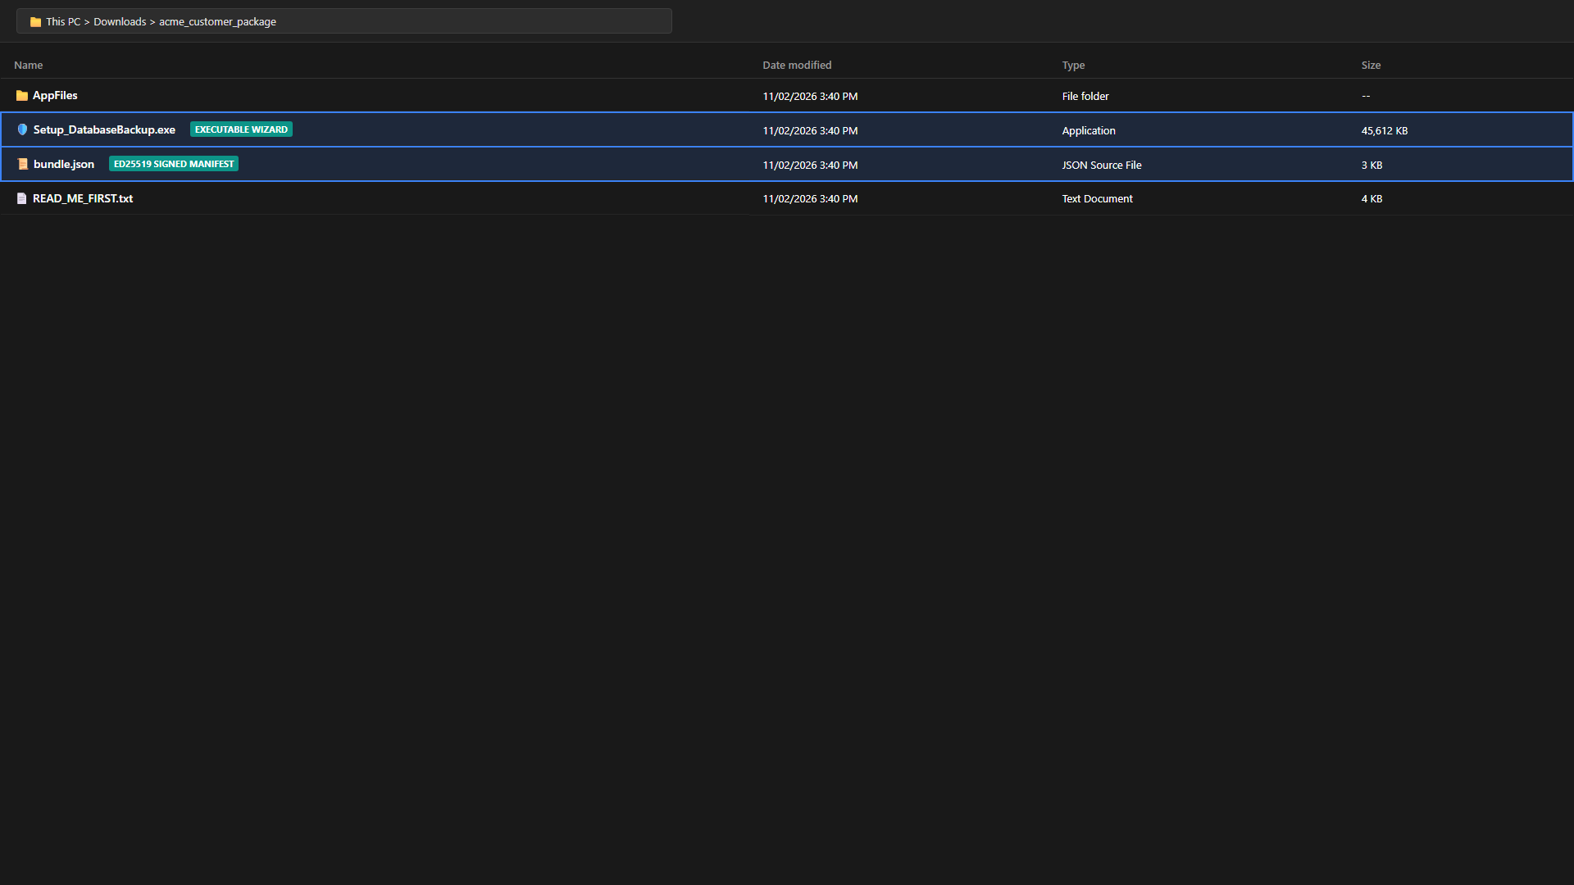
Figure: Unpacked Client Installation Package Directory Contents
Step 2: Launch Elevated Setup Wizard
Right-click Setup_DatabaseBackup.exe and select 'Run as administrator'. Click 'Yes' on the User Account Control (UAC) prompt.
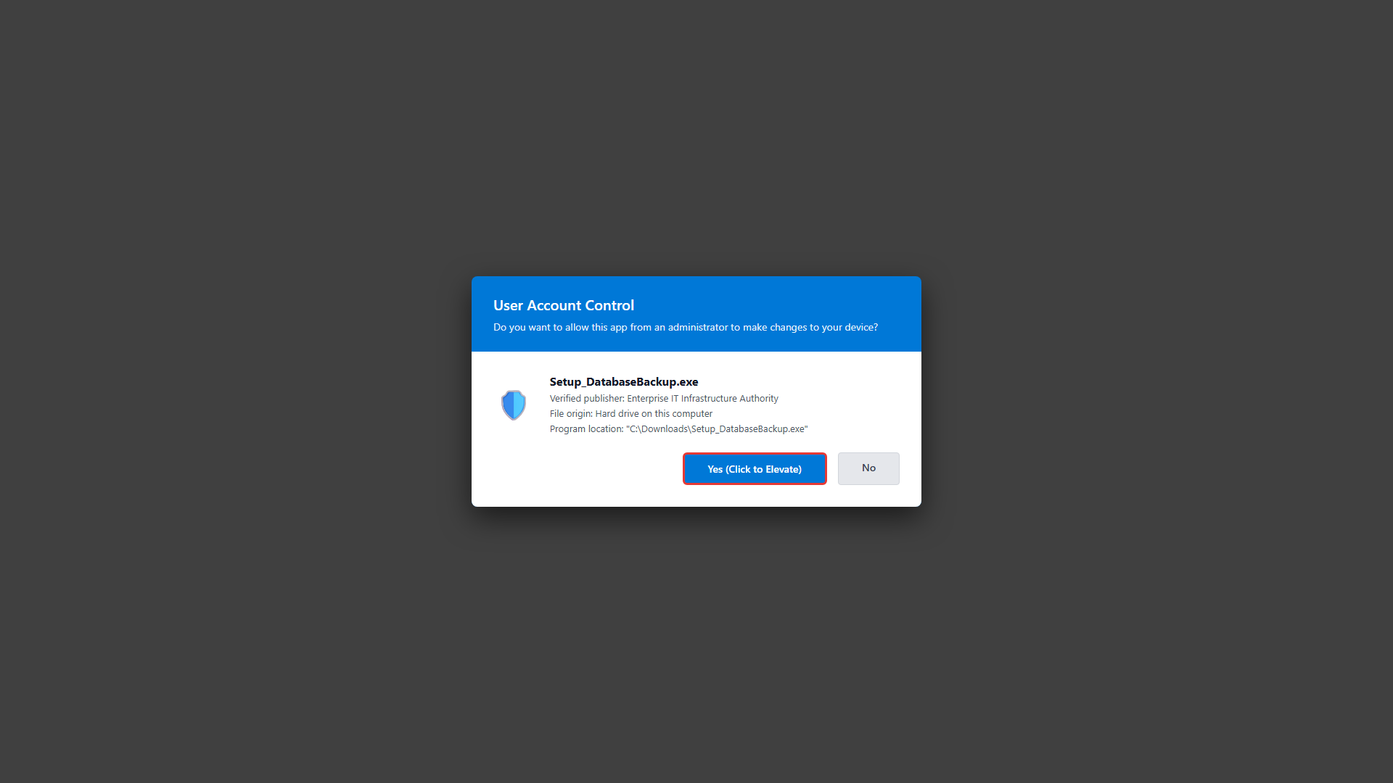
Figure: Windows User Account Control (UAC) Elevation Prompt
Step 3: Review Authenticity Badge & Options
Upon launch, the installer cryptographically validates the customer security bundle (bundle.json). Verify the green banner at the top: 'AUTHENTIC ED25519 SIGNED PACKAGE (<CUSTOMER_NAME>) - ZERO TYPING REQUIRED'. Optionally click 'Test Broker Connection' to verify live network reachability to Google Apps Script.
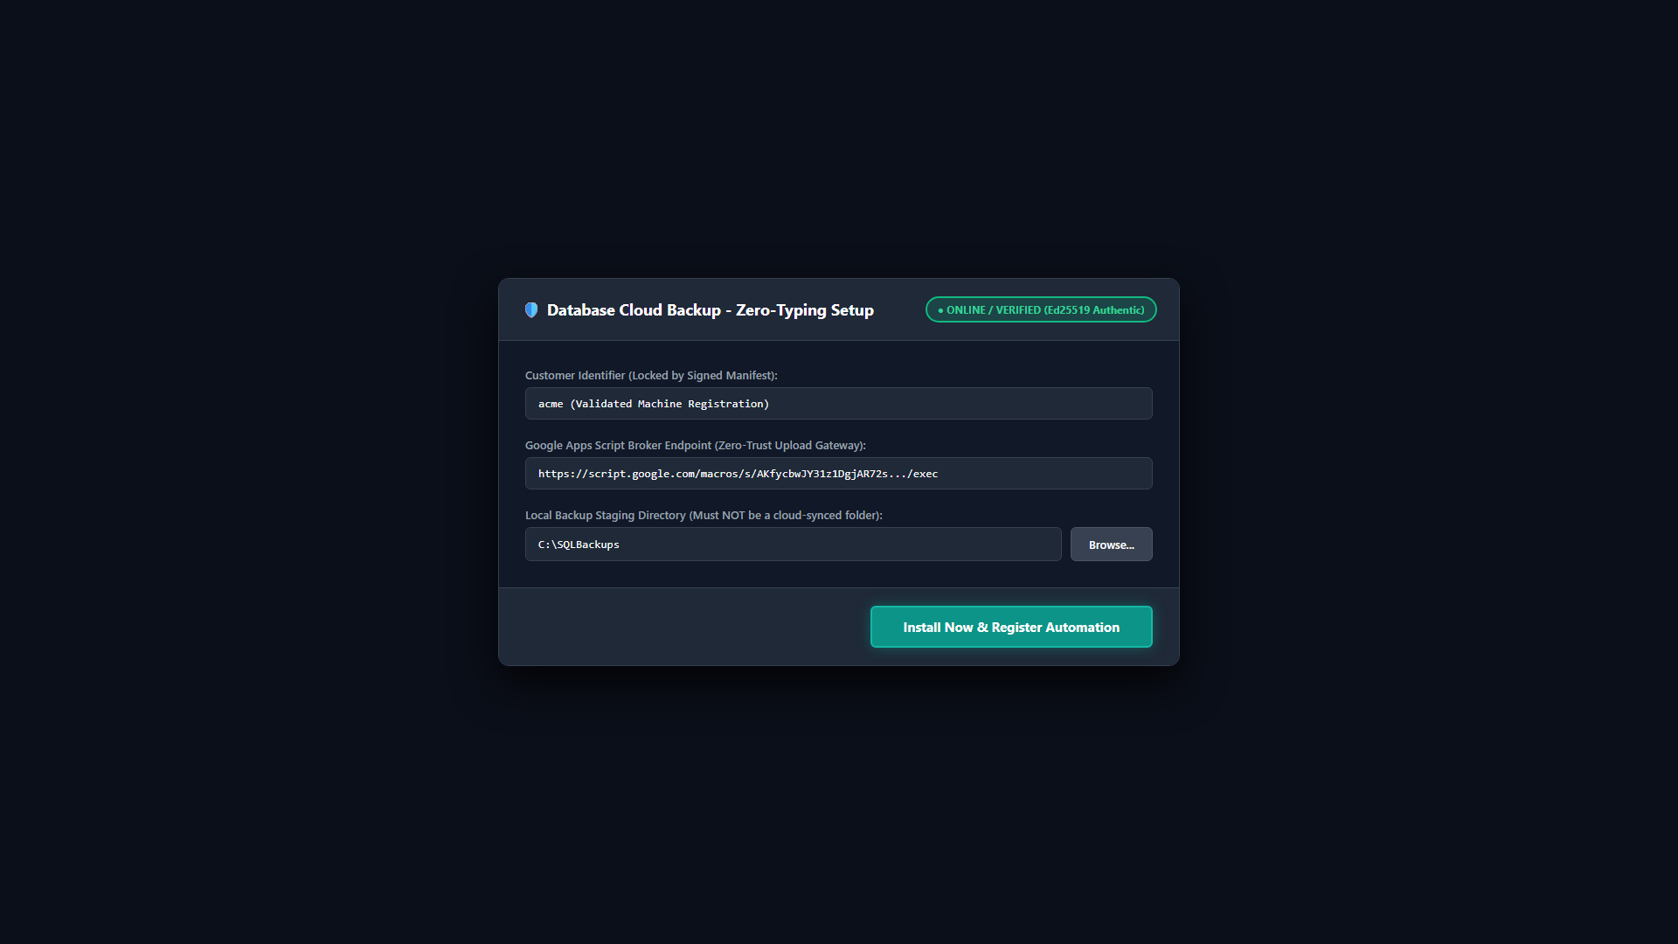
Figure: Setup Wizard Initial Screen with Authentic Ed25519 Badge
Step 4: Confirm Destination & Cloud Storage Check
The default installation path is C:\Program Files\DatabaseBackupApp. If a custom folder is browsed, the installer automatically inspects the path and blocks any cloud-synced folders (OneDrive, Dropbox) to protect system integrity.
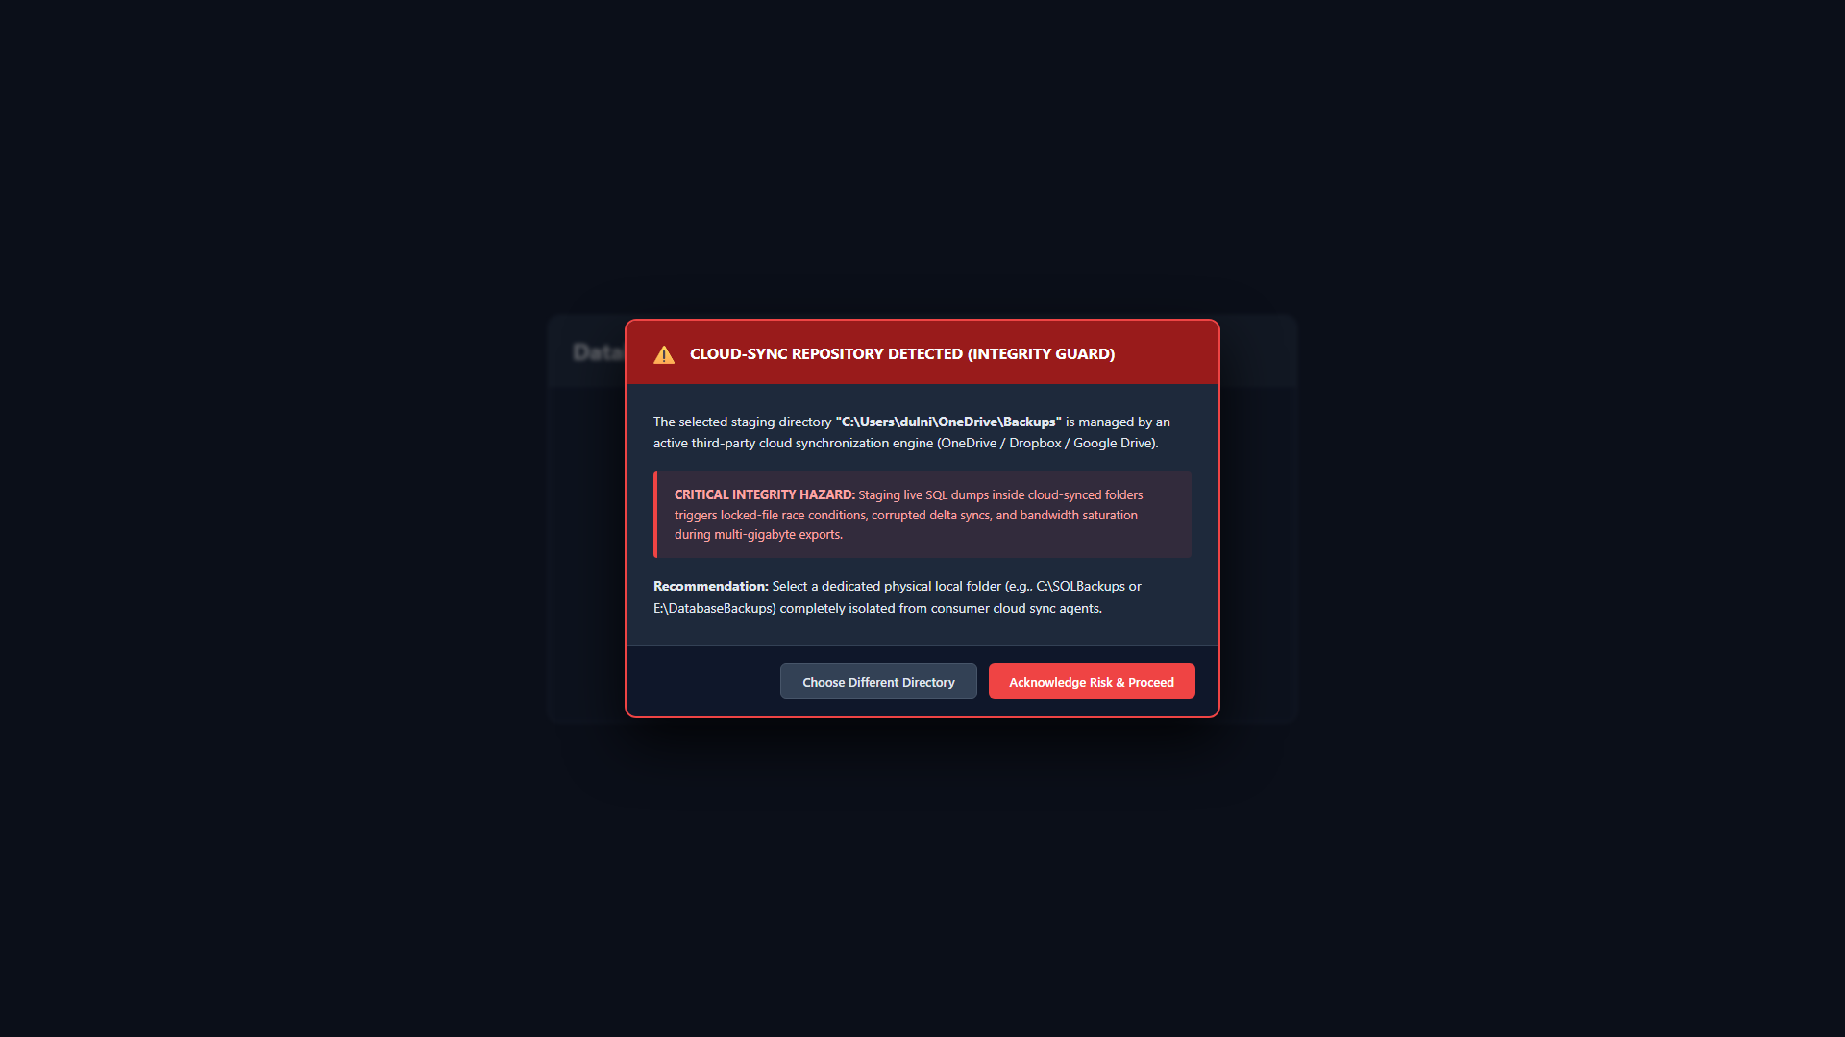
Figure: Automated Guard Rail Refusing Cloud-Synced Directories
Step 5: Execute Automated Installation
Click 'Install Now'. The wizard deploys application binaries via Robocopy, seals machine credentials into Windows DPAPI (token.dpapi), provisions customer public keys (backup_public.pem and escrow_public_{slug}.pem), registers unattended Windows Task Scheduler jobs, and executes the preflight test suite.
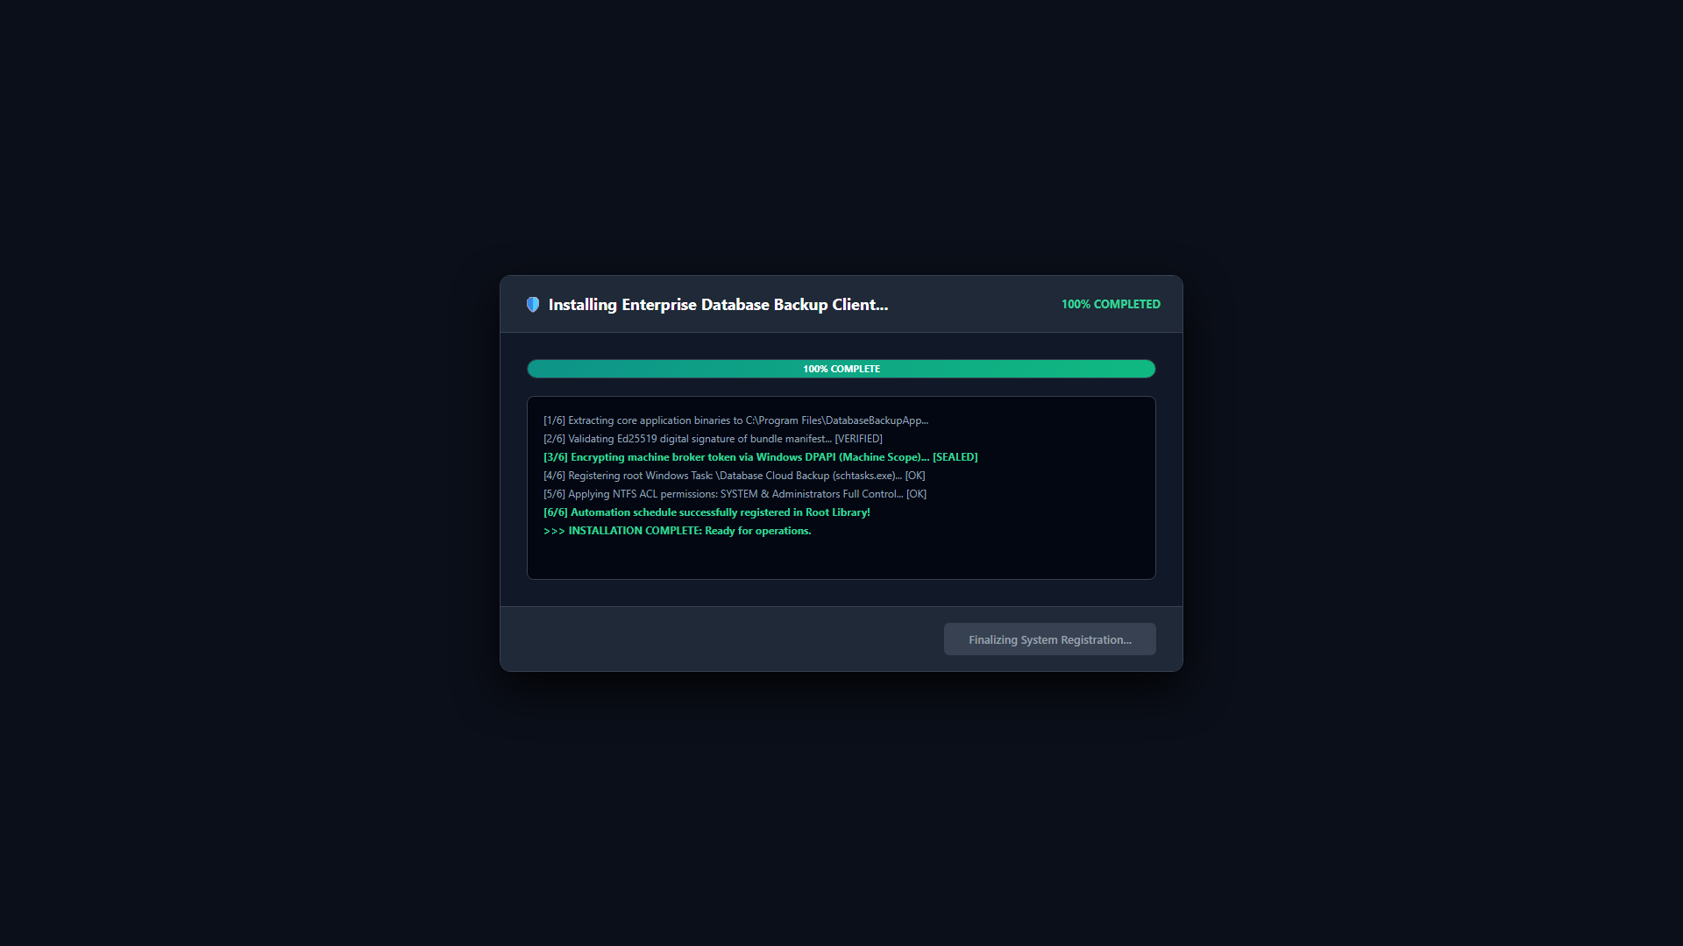
Figure: Automated Deployment Engine & DPAPI Token Sealing Progress
Step 6: Setup Completed & Launch
A green completion dialog confirms the application is installed and the background service is active. Click 'Finished' or 'OK'. The main application (DatabaseBackupApp.exe) launches automatically.
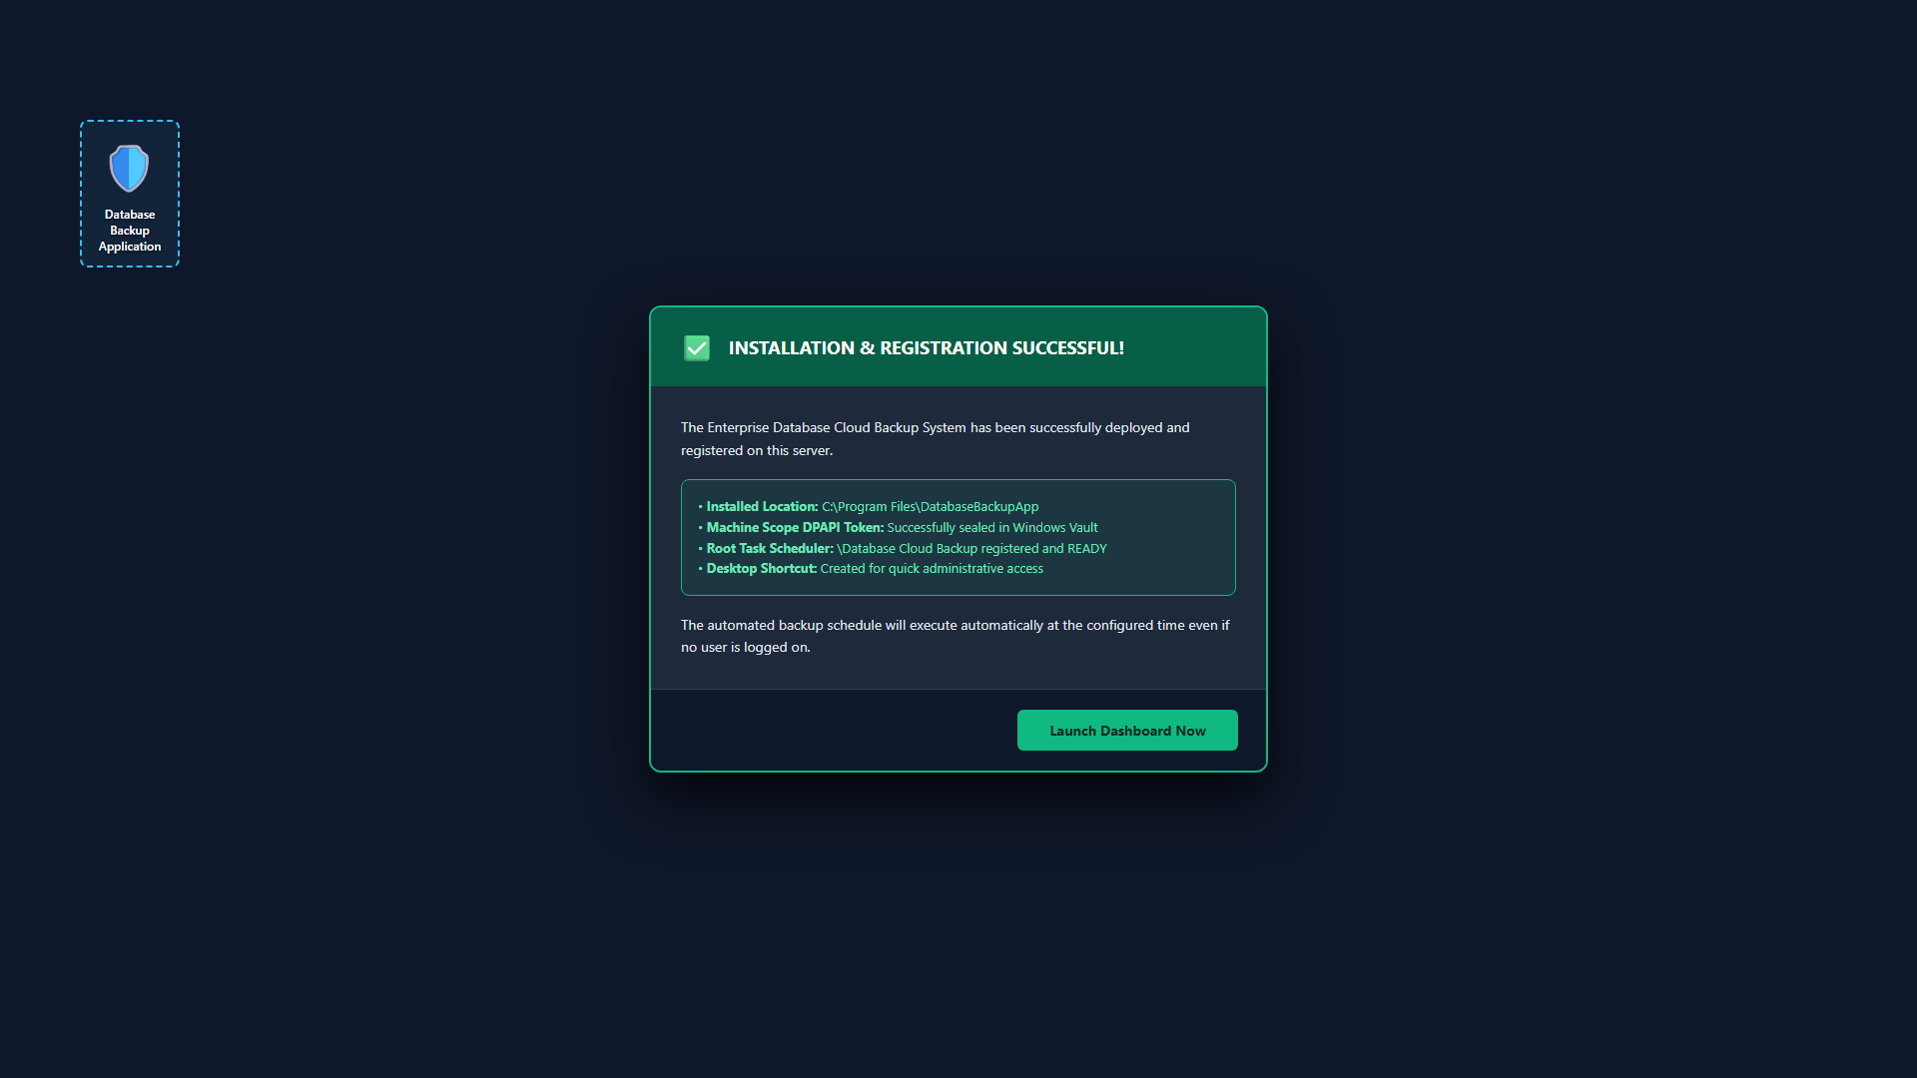
Figure: Installation Completed Successfully Banner
4. Post-Installation First-Time Application Configuration
Once the application launches, perform the following initial configuration steps:
Step 1: Verify System Readiness Banner
The top header displays live system readiness, active broker connectivity, and the next scheduled execution time.
Figure: Application Header with Live RPO Status and System Readiness
Step 2: Select Target Databases in 'Databases & Schedule' Tab
Navigate to the 'Databases & Schedule' tab. Click 'Refresh / Discover Databases' to query local SQL Server instances. Tick the checkboxes next to each production database requiring automated cloud protection.
Step 3: Execute an Immediate Test Backup
Return to the 'Dashboard' tab. Verify 'Zero-Trust Encryption' is toggled ON. Click 'RUN CLOUD BACKUP NOW'. Monitor the live progress bar as it performs SQL extraction, Deflate compression, AES-256-GCM encryption, chunked Google Drive upload, and telemetry logging.
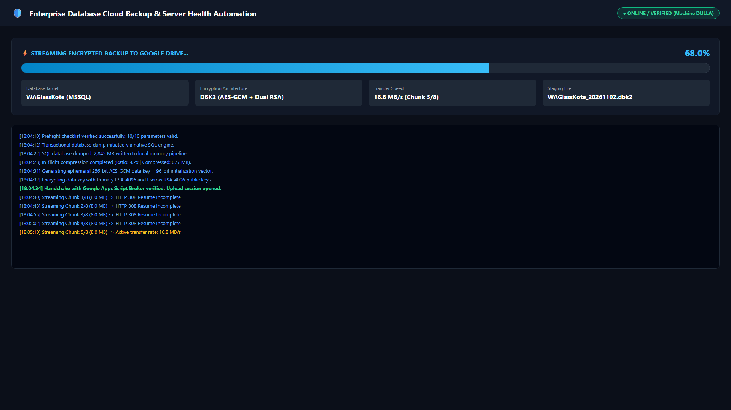
Figure: Streaming Chunked Cloud Upload & Dynamic Speed Monitor
Step 4: Verify Success Banner & Scheduled Task
Upon completion, a green success banner confirms the backup cycle finished cleanly. Open Windows Task Scheduler (taskschd.msc) to confirm the unattended 'Database Cloud Backup' task is registered under NT AUTHORITY\SYSTEM.
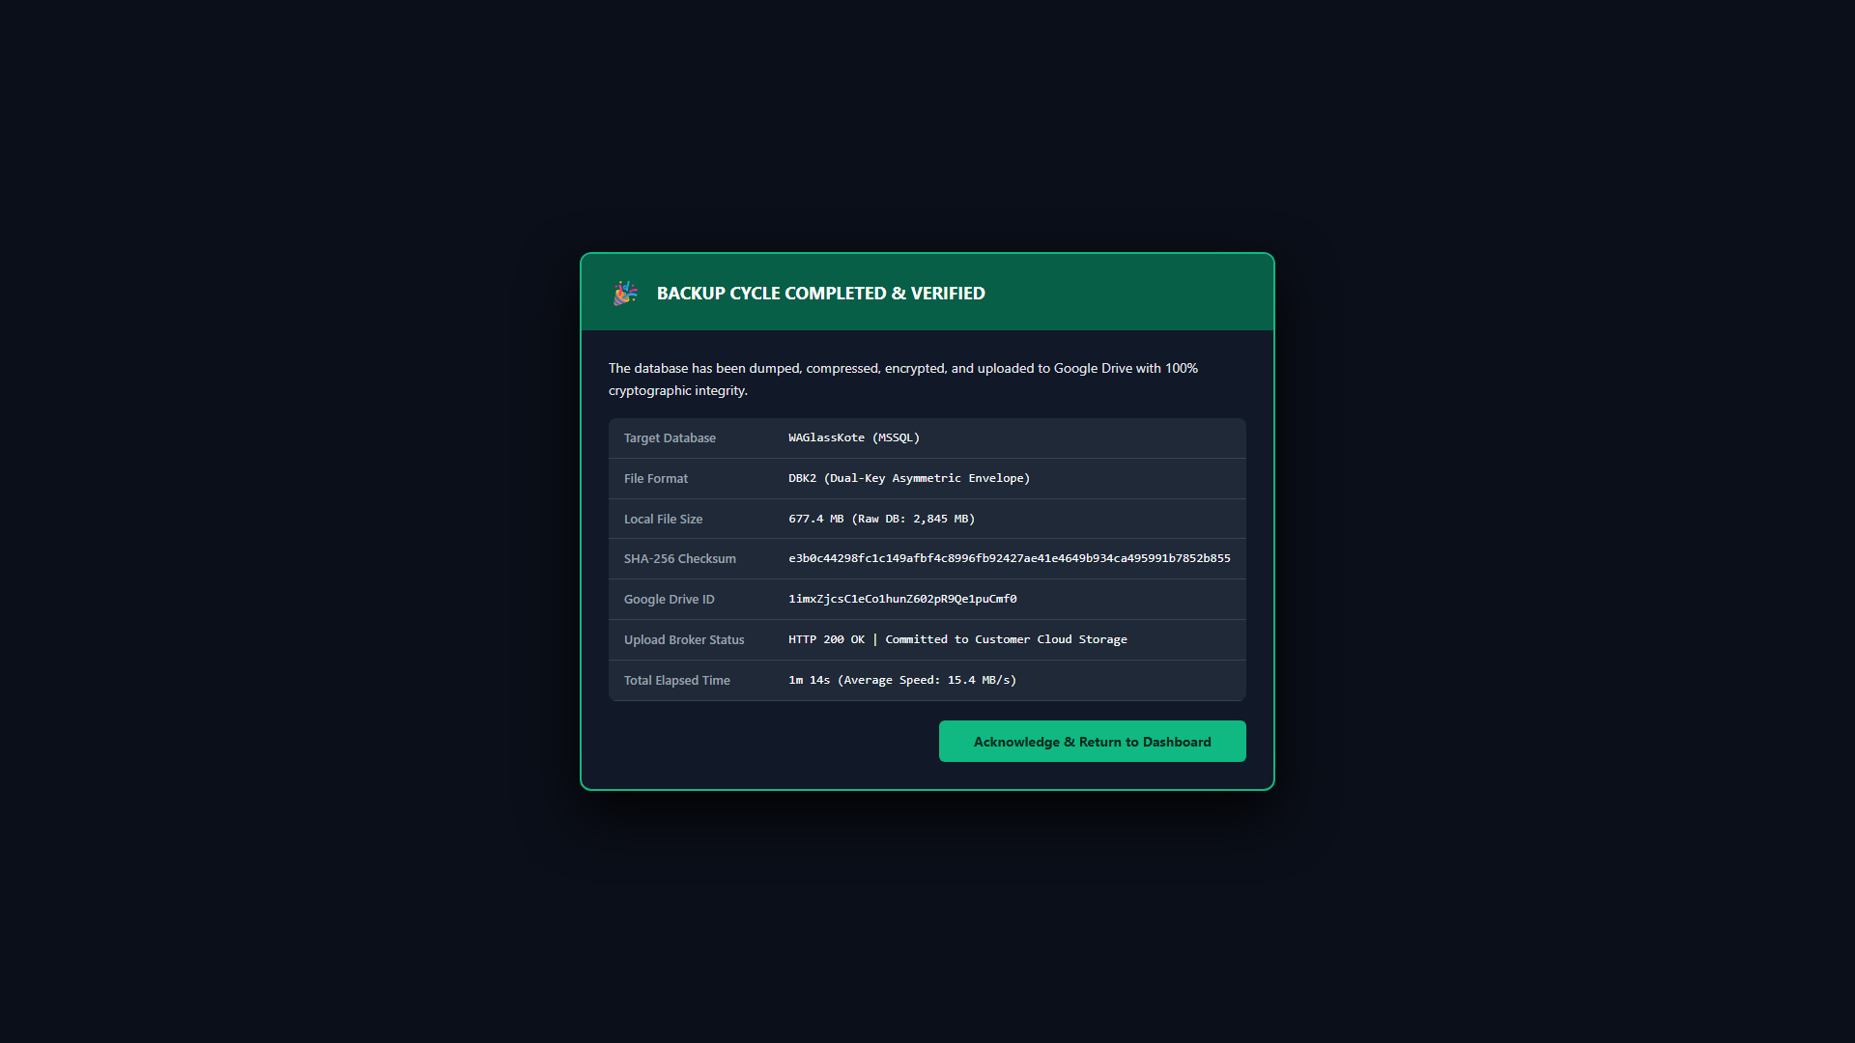
Figure: Backup Completed Successfully Verification Modal
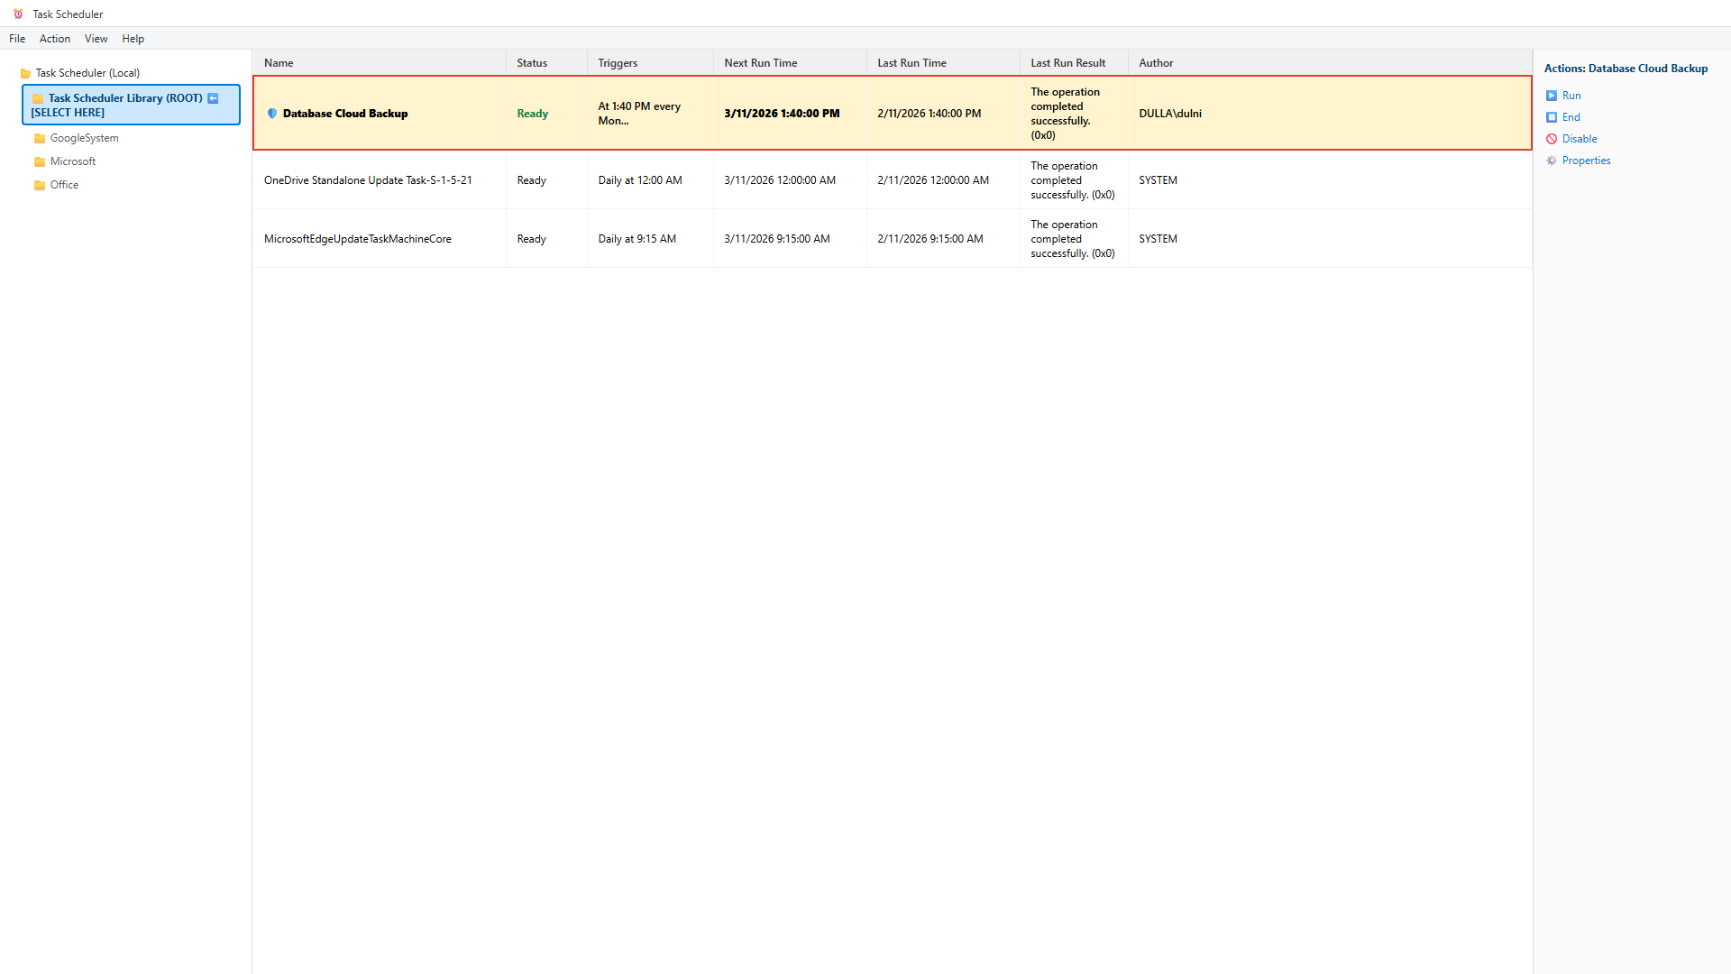
Figure: Unattended Windows Scheduled Task Running Under SYSTEM
5. Setup Option B: Native Windows PowerShell Agent (shell_client/)
For headless Windows Server Core, locked-down virtual machines, or older legacy operating systems (Windows Server 2008 R2 / 2012 / Windows 7), the package provides a 100% native Windows PowerShell shell agent requiring ZERO Python runtime and ZERO compiled .exe binaries (under 30 KB footprint).
Execution Steps: Deployment Procedure:
- Open an elevated Windows PowerShell console (Run as Administrator).
- Navigate to the shell_client directory: cd Client_Installation_Package_v5.0\shell_client
- Execute the unattended installer: powershell.exe -ExecutionPolicy Bypass -File .\install_agent.ps1
- The installer reads bundle.json, seals token.dpapi into C:\ProgramData\DatabaseBackupApp, and registers the scheduled task.
- Execute a test backup: powershell.exe -ExecutionPolicy Bypass -File 'C:\Program Files\DatabaseBackupApp\backup_agent.ps1'
6. Externalized Database Credentials Architecture (SQLPara.txt)
Version 5.0 introduces externalized credential resolution to comply with enterprise zero-plaintext security policies. Database credentials can be maintained completely outside config.json in standard ERP connection parameter files.
- Setup: Copy SQLPara.txt.template to SQLPara.txt (or place in C:\SPIL\SQLPara).
- Format: Configure: server=localhost\SQLEXPRESS | user=sa | password=SecretPassword | database=TargetDB
- Protection: The backup engine loads credentials dynamically with absolute priority over config.json, eliminating plaintext credentials.
7. Air-Gapped Disaster Recovery & Database Restoration
Restoring databases is performed via the dedicated 'Database Restore' tab in DatabaseBackupApp.exe. The engine incorporates a Magic Byte Format Sniffer that inspects raw file headers rather than trusting file extensions:
- Zero-Trust Encrypted Archives (.dbk2): Parsed and decrypted using AES-256-GCM and the private recovery key (backup_private.pem or escrow_private.pem).
- Standard Compressed Archives (.zip): Automatically recognized via PK\x03\x04 magic bytes and extracted directly without requiring encryption keys.
- Native SQL Server Dumps (.bak): Restored directly into Microsoft SQL Server with exclusive SINGLE_USER connection locking.
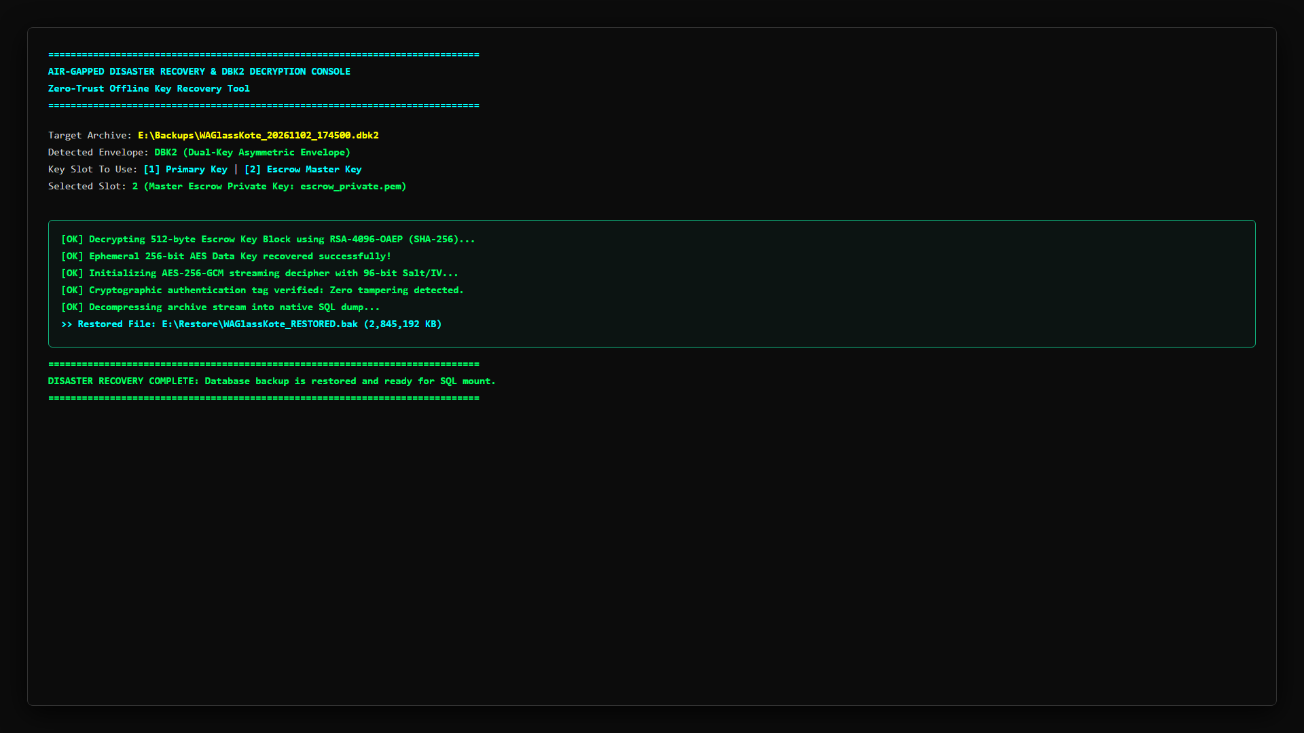
Figure: Disaster Recovery Air-Gapped Decryption & Database Restore Console
8. In-Place Upgrades & Clean Uninstallation Runbook
Upgrading existing client installations is performed using Update_App.bat. The updater provides a 7-step atomic workflow:
- Step 1: Terminates active DatabaseBackupApp.exe processes safely.
- Step 2: Vaults customer settings (config.json, token.dpapi, SQLPara.txt, and escrow_public*.pem) to a temporary sandbox.
- Step 3: Purges obsolete Google OAuth tokens (credentials.json, token.json, client_secret.json).
- Step 4: Overwrites application binaries with v5.0.0 production files.
- Step 5: Upgrades config.json schema with v5.0 parameters without touching database targets.
- Step 6: Unregisters all legacy task scheduler variants and registers 'Database Cloud Backup' under NT AUTHORITY\SYSTEM.
- Step 7: Enforces strict NTFS permissions (icacls) on application folders and DPAPI credentials.
Decommissioning: Clean Uninstallation (Uninstall.bat):
To remove the application cleanly, run Uninstall.bat as Administrator. It terminates processes, deletes all 8 scheduled task variants, cryptographically shreds token.dpapi (RNGCryptoServiceProvider random byte overwriting), removes registry keys, and deletes Program Files/ProgramData directories.
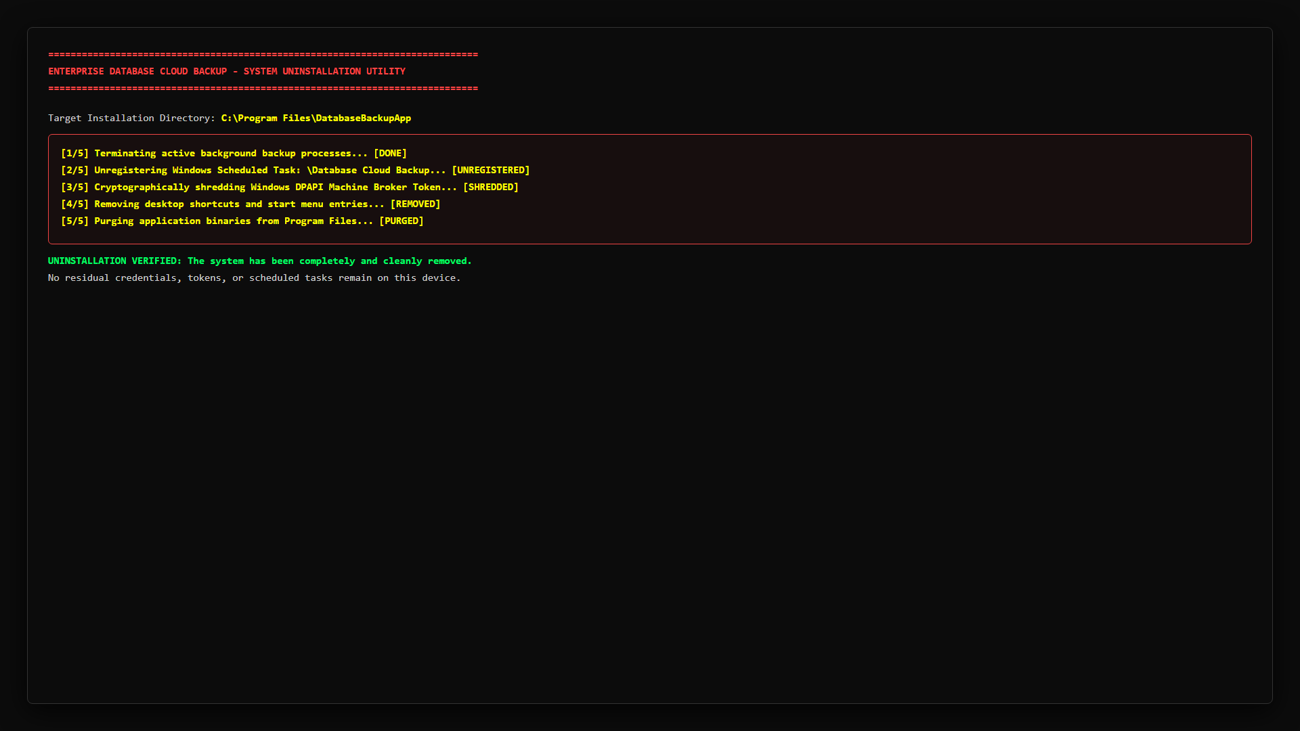
Figure: Clean Uninstaller Console Execution with DPAPI Token Shredding
9. Multi-Generational Backward Compatibility & Legacy OS Runbook
The v5.0 architecture maintains rigorous backward compatibility across older application releases, legacy Windows operating systems, and older SQL Server versions:
Component | Historical Behavior (v1.x–v4.3) | Version 5.0 Handling & Backward Compatibility
Authentication Vault | Plaintext broker_token.dat or OAuth token.json | Update_App.bat automatically migrates broker_token.dat to Windows DPAPI token.dpapi and shreds legacy files.
Escrow Keys | Shared single escrow_public.pem across all tenants | Checks escrow_public_{slug}.pem first; seamlessly falls back to escrow_public.pem if tenant key is absent.
Scheduled Tasks | Multiple historical names (DatabaseBackup_Daily, etc.) | Purges all 6 legacy task names and unifies on 'Database Cloud Backup' running as NT AUTHORITY\SYSTEM.
SQL Server CLI | Assumed modern sqlcmd.exe in PATH | Dynamic fallback chain: probes 11 paths for ODBC 18/17/13/11 sqlcmd, falls back to osql.exe for SQL 2000/2005.
Legacy Windows OS | Required modern Python (fails on Win 7 / 2008 R2) | Native shell_client runs on built-in .NET 4.5+ assemblies with zero Python, enforcing TLS 1.2 automatically.
Legacy OS Support Matrix (Windows Server 2008 R2 / 2012 / 2012 R2 & Windows 7 / 8.1)
- For Windows Server 2016–2025 and Windows 10/11: Deploy using Option A (Setup_DatabaseBackup.exe).
- For Windows Server 2012 / 2012 R2: Option A runs cleanly if KB2999226 (Universal C Runtime) is installed; otherwise deploy Option B.
- For Windows Server 2008 R2 SP1 and Windows 7 SP1: Deploy Option B (shell_client/). Zero Python / Zero EXE footprint. Operates 100% on Windows built-in .NET Framework assemblies.
- For 32-Bit (x86) Windows Systems: Deploy Option B (shell_client/). Executes natively in 32-bit PowerShell engine with full DPAPI and AES-256 encryption.
- TLS 1.2 Protocol Override: Every script forces [Net.ServicePointManager]::SecurityProtocol = Tls12, overcoming legacy TLS 1.0/1.1 defaults.

