|  |
| --- |
| Software design |
| Computer Store |
| Version 1.0 |
| Prepared by class SE1431, Group ?  Nguyen Duy Hieu  Chu Tuan Thong  Leng Tuan Du  Luong Hoang Ha  Tran Nhat Hoang  …..  July21, 2021 |

Contents

Revision history 4

1. Document description 5

2. SRS overview 5

2.1. List of system users 5

2.2. List of use cases 5

2.3. Use case diagram 5

2.3.1. Preliminary use case diagram 5

2.3.2. Use case detail diagrams 6

2.4. Activity diagrams of use case scenarios 7

2.4.1. Activity diagram for use case “Borrow Book” 7

2.4.2. Activity diagram for use case “Return Book” 8

2.4.1. Activity diagram for use case “Reserve Book” 8

3. Data model 9

3.1. Entity Relationship Diagram 9

3.2. Table details/Chi tiết các bảng 9

3.2.1. Table name: Borrower 9

3.2.2. Table name: Book 9

3.2.3. Table name: Copy 10

3.2.4. Table name: CirculatedCopy 10

3.2.5. Table name: Reservation 10

4. Class diagram (p.61 – p70) 11

4.1. List of classes in the Layers 11

4.2. Modeling the Class Behaviors - sequence diagrams ( p. 66, 77) 11

4.2.1. Sequence diagram for use case “Borrow Book” 11

4.2.2. Sequence diagram for use case “Return Book” 12

4.2.3. Sequence diagram for use case “Reserve Book” 13

5. User Interface Model Design (p. 70 – p.74) 13

5.1. User interface model design 13

5.2. Interface Flow Diagrams (p. 51) 13

# Revision history

|  |  |  |  |
| --- | --- | --- | --- |
| **Date** | **Authors** | **Modifications** | **Version** |
|  |  |  |  |
|  |  |  |  |
|  |  |  |  |
|  |  |  |  |
|  |  |  |  |

# Document description

Apply to small and medium computer store management system

Store management in general as well as in detail.

Make reports, aggregate statistics.

# SRS overview

## 2.1. List of system users

1. Admin
2. Staff

## 2.2. List of use cases

1. Login
2. Logout
3. Computer information
4. Staff information
5. Supplier information
6. Import bills
7. Sell product
8. Customer information
9. Statistical
10. Search computer
11. Search staff
12. Search supplier
13. Search customer
14. Exit

## 2.3. Use case diagram

### 2.3.1. Preliminary use case diagram

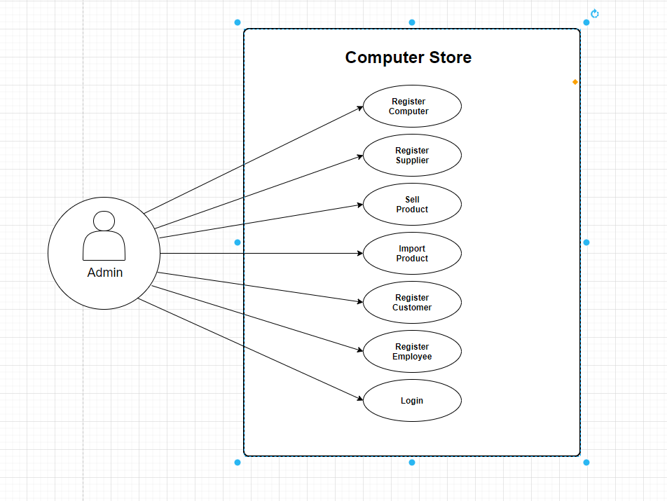

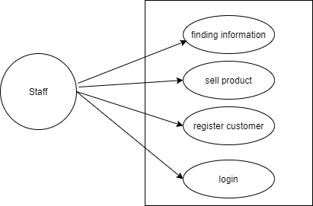

### 2.3.2. Use case detail diagrams

## 2.4. Activity diagrams of use case scenarios

### 2.4.1. Activity diagram for use case “Login”

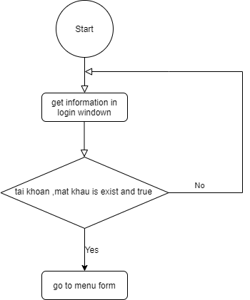

### Activity diagram for use case “Logout”

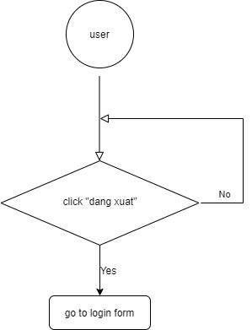

### 2.4.3. Activity diagram for use case “Computer Information”

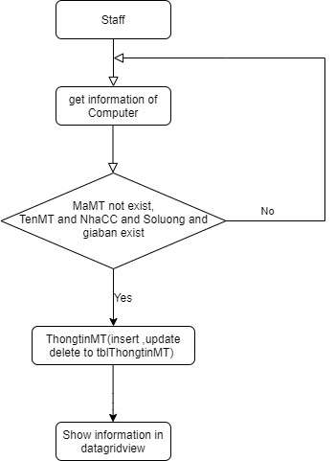

### 2.4.4. Activity diagram for use case “Staff Information”

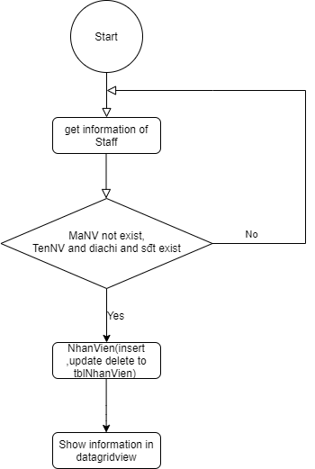

### 2.4.5. Activity diagram for use case “supplier information”

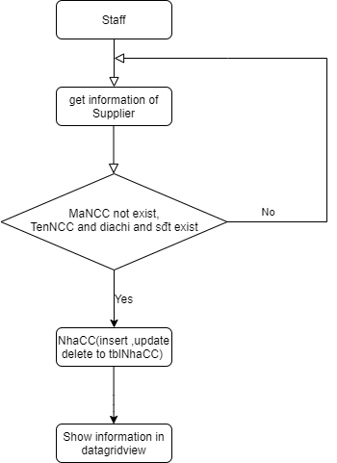

### 2.4.6. Activity diagram for use case “Import bills”

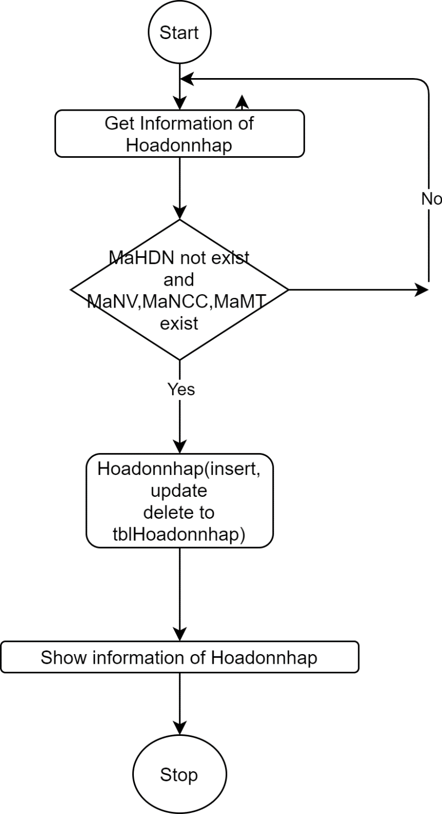

### 2.4.7. Activity diagram for use case “sell product”

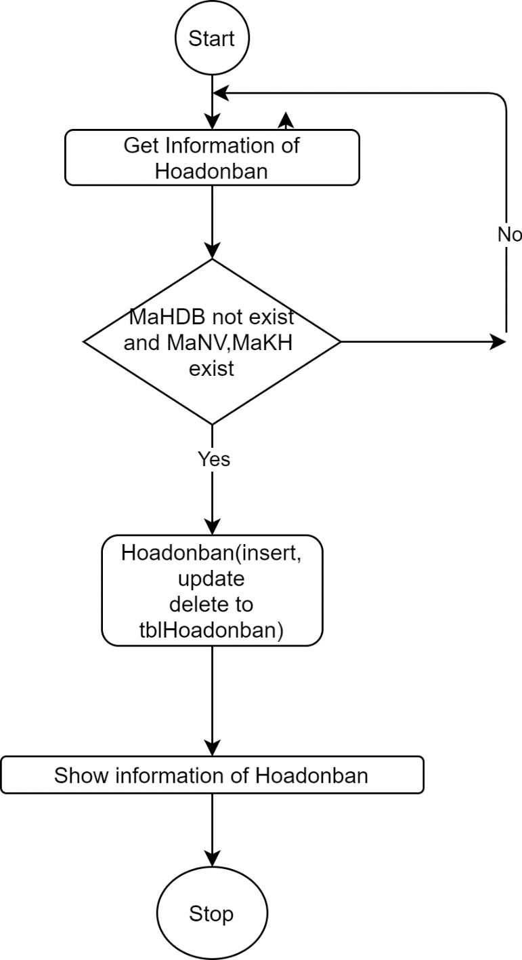

### 2.4.8. Activity diagram for use case “Customer Information”

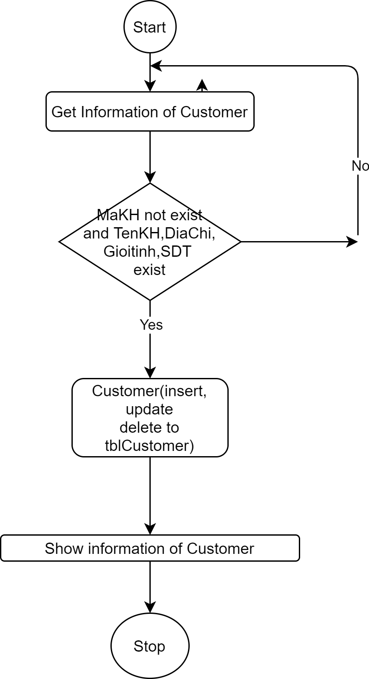

### 2.4.9. Activity diagram for use case “Search computer”

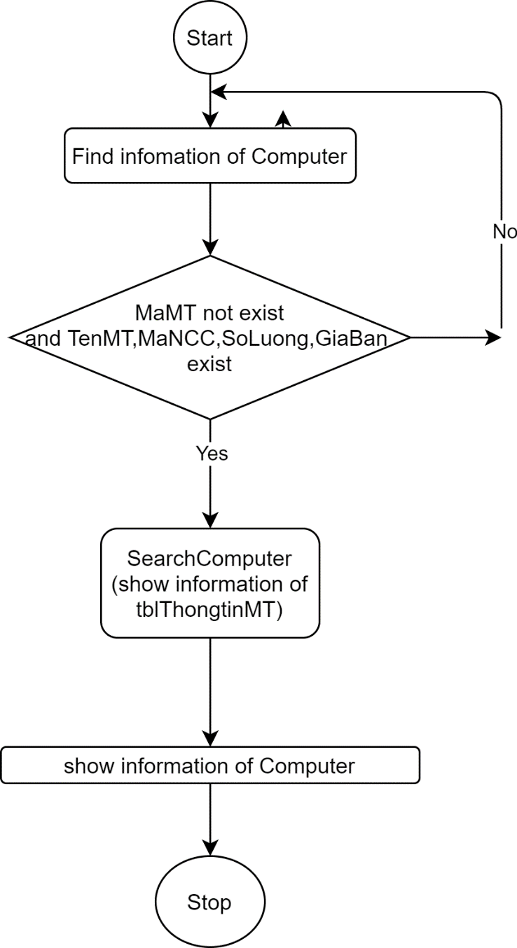

### 2.4.10. Activity diagram for use case “Search staff”

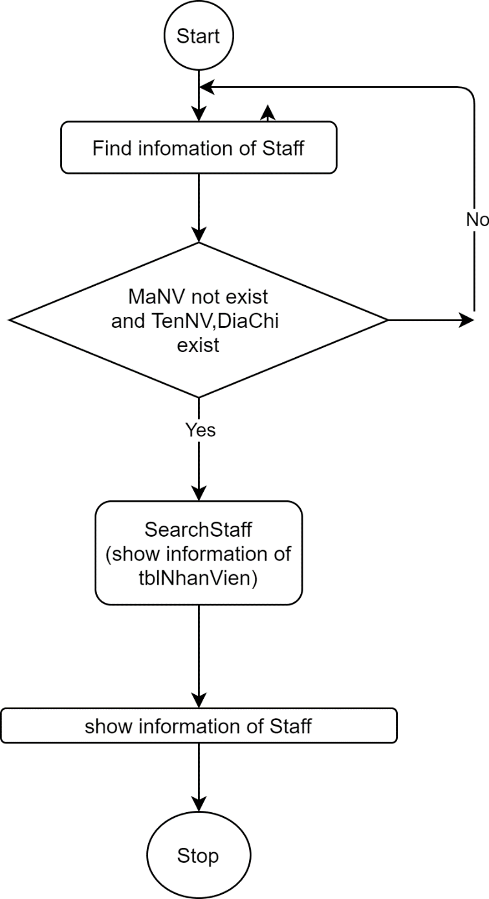

### 2.4.11. Activity diagram for use case “Search supplier”

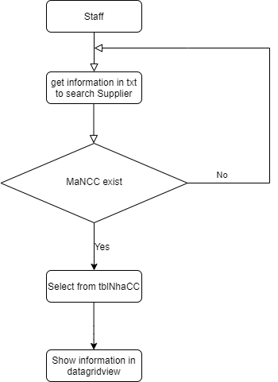

### 2.4.12. Activity diagram for use case “search Customer”

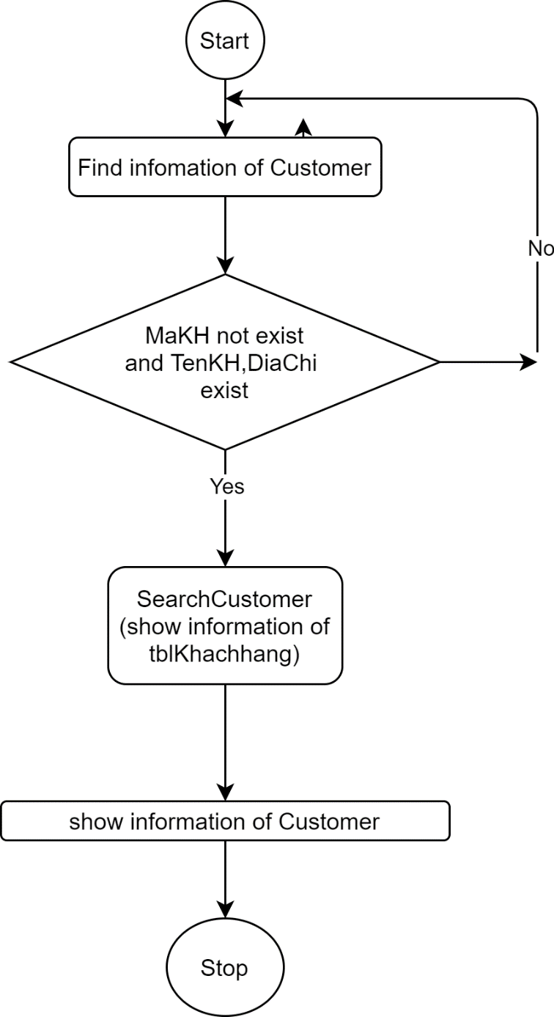

### 2.4.13. Activity diagram for use case “Statistical”

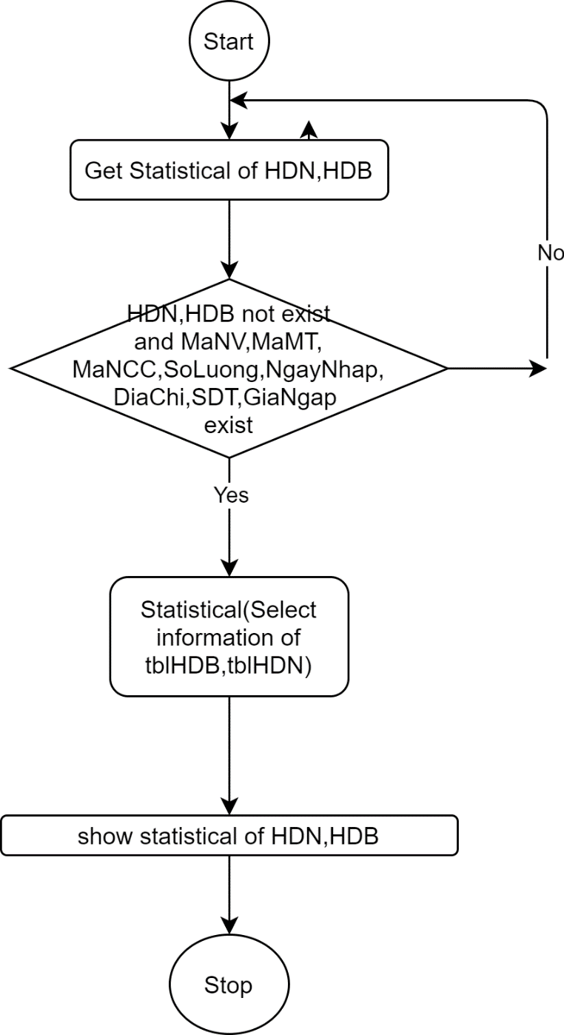

# Data model

## Entity Relationship Diagram

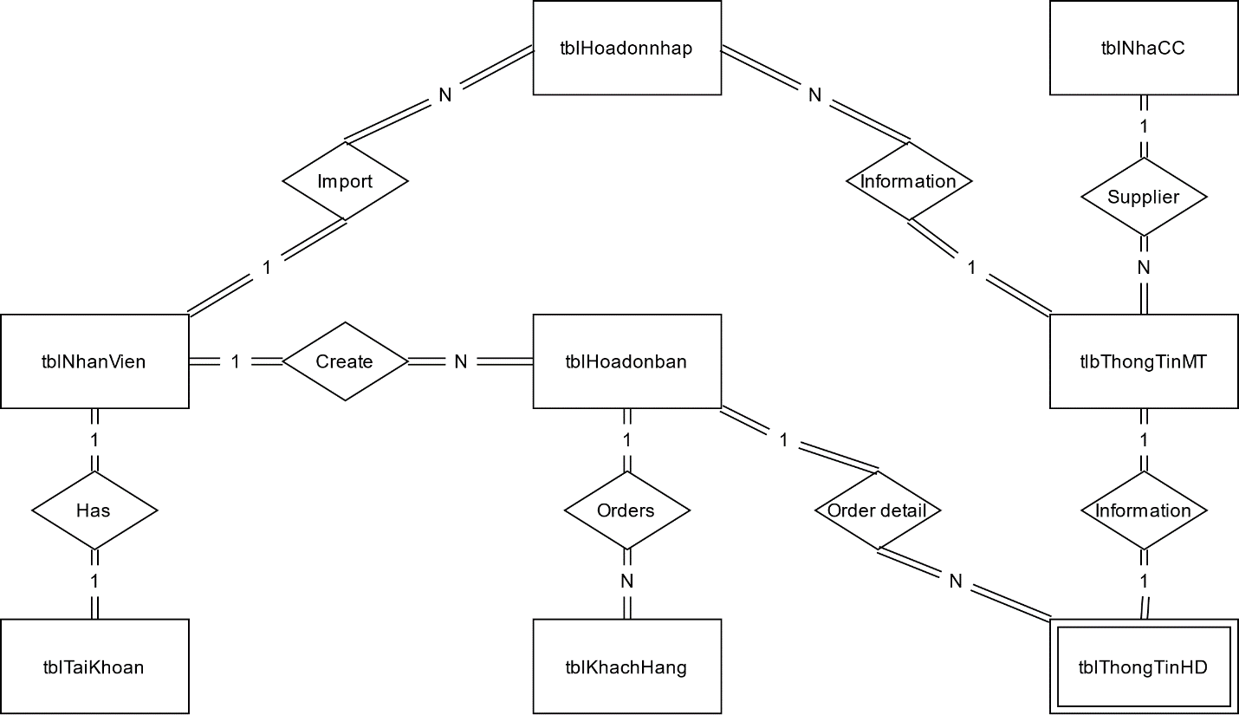

Figure 1: Simple Entity Relationship Diagram

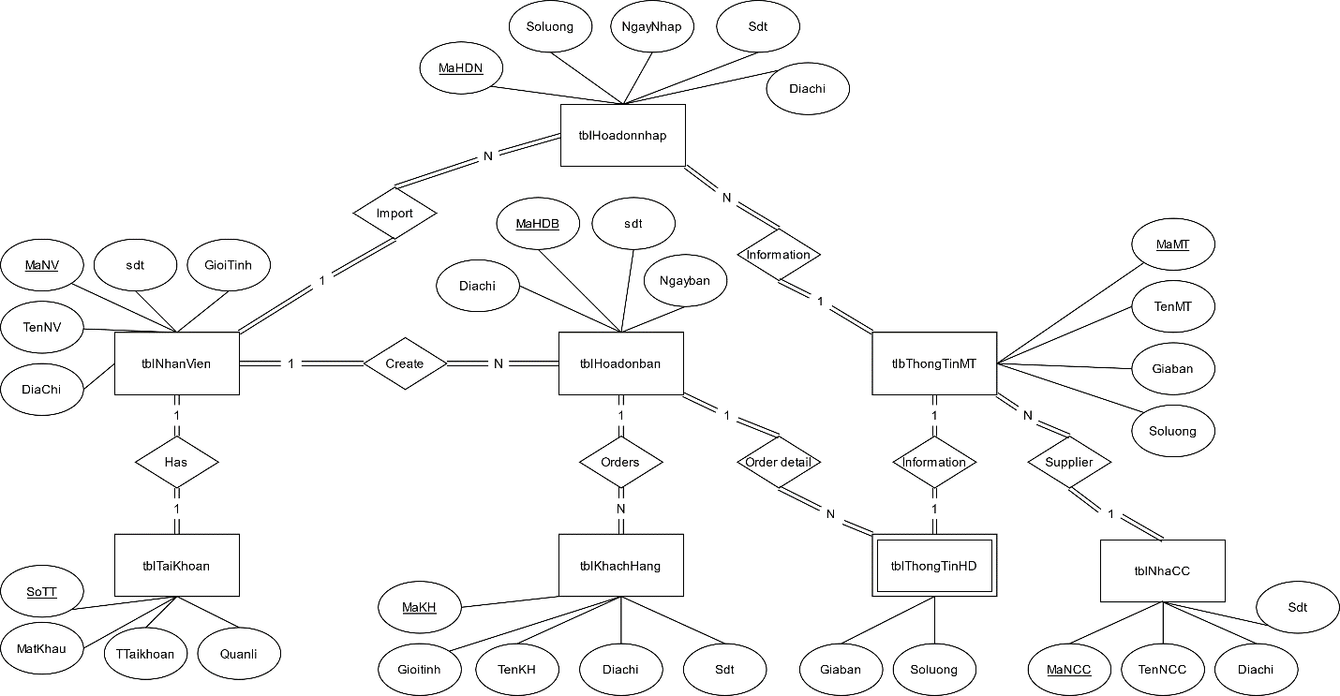

Figure 2: Full Entity Relationship Diagram

Table details/Chi tiếtcácbảng

Note: Attribute with underline is Primary key

### Table name: tblThongtinMT

|  |  |  |  |
| --- | --- | --- | --- |
| **Field name** | **Type** | **Size** | **Note** |
| MaMT | Varchar | 10 | Primary key |
| TenMT | NVarchar | 50 | Not null |
| MaNCC | NVarchar | 10 | Foreign key, refers to tblNhaCC |
| Soluong | Integer | 10 | Not null |
| Giaban | Float | 10 | Not null |

### Table name: tblHoadonban

|  |  |  |  |
| --- | --- | --- | --- |
| **Field name** | **Type** | **Size** | **Note** |
| MaHDB | Varchar | 10 | Primary key |
| MaNV | Varchar | 10 | Foreign key, refers to tblNhanVien |
| MaKH | Varchar | 10 | Foreign key, refers to tblKhachhang |
| Ngayban | Date |  | Not Null |
| Diachi | Nvarchar | MAX | Not Null |
| sdt | Varchar | 10 | Not Null |

### Table name: tblHoadonnhap

|  |  |  |  |
| --- | --- | --- | --- |
| **Field name** | **Type** | **Size** | **Note** |
| MaHDN | Varchar | 10 | Primary key |
| MaNV | Varchar | 10 | Foreign key, refers to tblNhanVien |
| MaMT | Varchar | 10 | Foreign key, refers to tblThongtinMT |
| Soluong | Integer |  | Not Null |
| Ngaynhap | Date |  | Not Null |
| Diachi | NVarchar | MAX | Not Null |
| Sdt | varchar | 10 | Not Null |
| Gianhap | float |  | Not Null |

### Table name: tblNhaCC

|  |  |  |  |
| --- | --- | --- | --- |
| **Field name** | **Type** | **Size** | **Note** |
| MaNCC | Varchar | 10 | Primary key |
| TenNCC | NVarchar | 50 | Not Null |
| Diachi | Nvarchar | MAX | Not null |
| Sdt | Varchar | 10 | Not null |

### Table name: tblKhachhang

|  |  |  |  |
| --- | --- | --- | --- |
| **Field name** | **Type** | **Size** | **Note** |
| MaKH | Varchar | 10 | Primary key |
| TenKH | NVarchar | 50 | Not Null |
| Gioitinh | NVarchar | 5 | Not Null |
| Diachi | NVarchar | MAX | Not null |
| Sdt | Varchar | 10 | Not null |

### Table name: tblNhanVien

|  |  |  |  |
| --- | --- | --- | --- |
| **Field name** | **Type** | **Size** | **Note** |
| MaNV | Varchar | 10 | Primary key |
| TenNV | NVarchar | 50 | Not Null |
| Gioitinh | Nvarchar | 5 | Not Null |
| Diachi | Nvarchar | MAX | Not null |
| Sdt | Varchar | 10 | Not null |

### Table name: tblThongTinHD

|  |  |  |  |
| --- | --- | --- | --- |
| **Field name** | **Type** | **Size** | **Note** |
| MaHDB | Varchar | 10 | Primary key, refers to tblHoadonban |
| MaMT | Varchar | 10 | Primary key, refers to tblThongtinMT |
| Soluong | Integer |  | Not Null |
| Giaban | Float |  | Not null |

### Table name: tblNhanVien

|  |  |  |  |
| --- | --- | --- | --- |
| **Field name** | **Type** | **Size** | **Note** |
| SoTT | Integer |  | Primary key |
| TTaiKhoan | Varchar | 24 | Not Null |
| MatKhau | varchar | 24 | Not Null |
| MaNV | Nvarchar | 10 | Not null, refers to tblNhanVien |
| Quanli | Bit |  | Not null |

# Class diagram (p.61 – p70)

## Modeling the Class Behaviors- sequence diagrams( p. 66, 77)

### Sequence diagram for use case “Sell product”

