**Creating Microservices for account and loan**

package com.cognizant.account;

import org.springframework.web.bind.annotation.*;

*@RestController*

*@RequestMapping*("/accounts")

public class AccountController {

*@GetMapping*("/{number}")

    public Account getAccountDetails(*@PathVariable* String number) {

        return new Account(number, "savings", 234343);

    }

    public static class Account {

        private String number;

        private String type;

        private double balance;

        public Account(String number, String type, double balance) {

            this.number = number;

            this.type = type;

            this.balance = balance;

        }

        public String getNumber() { return number; }

        public String getType() { return type; }

        public double getBalance() { return balance; }

    }

}

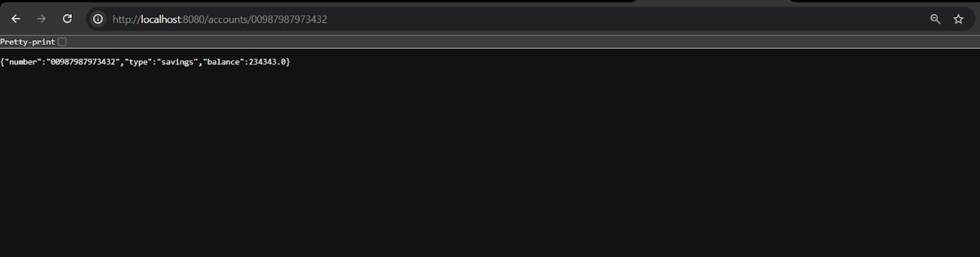

package com.cognizant.loan;

import org.springframework.web.bind.annotation.*;

*@RestController*

*@RequestMapping*("/loans")

public class LoanController {

*@GetMapping*("/{number}")

    public Loan getLoanDetails(*@PathVariable* String number) {

        return new Loan(number, "car", 400000, 3258, 18);

    }

    public static class Loan {

        private String number;

        private String type;

        private double loan;

        private double emi;

        private int tenure;

        public Loan(String number, String type, double loan, double emi, int tenure) {

            this.number = number;

            this.type = type;

            this.loan = loan;

            this.emi = emi;

            this.tenure = tenure;

        }

        public String getNumber() { return number; }

        public String getType() { return type; }

        public double getLoan() { return loan; }

        public double getEmi() { return emi; }

        public int getTenure() { return tenure; }

    }

}

server.port=8081

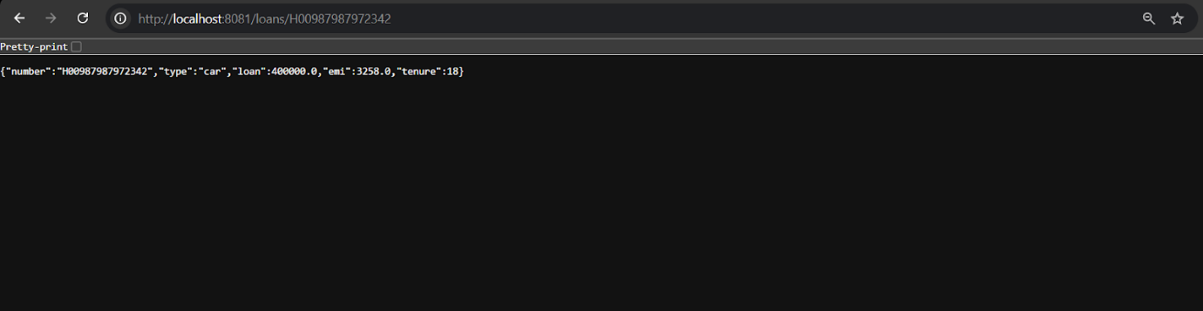

**Create Eureka Discovery Server and register microservices**

package com.cognizant.eureka_discovery_server;

import org.springframework.boot.SpringApplication;

import org.springframework.boot.autoconfigure.SpringBootApplication;

import org.springframework.cloud.netflix.eureka.server.EnableEurekaServer;

*@EnableEurekaServer*

*@SpringBootApplication*

public class EurekaDiscoveryServerApplication {

   public static void main(String[] args) {

       SpringApplication.*run*(EurekaDiscoveryServerApplication.class, args);

   }

}

server.port=8761

eureka.client.register-with-eureka=false

eureka.client.fetch-registry=false

logging.level.com.netflix.eureka=OFF

logging.level.com.netflix.discovery=OFF

spring.devtools.restart.enabled=false

package com.cognizant.account;

import org.springframework.boot.SpringApplication;

import org.springframework.boot.autoconfigure.SpringBootApplication;

import org.springframework.cloud.client.discovery.EnableDiscoveryClient;

*@EnableDiscoveryClient*

*@SpringBootApplication*

public class AccountApplication {

public static void main(String[] args) {

SpringApplication.*run*(AccountApplication.class, args);

}

}

package com.cognizant.loan;

import org.springframework.boot.SpringApplication;

import org.springframework.boot.autoconfigure.SpringBootApplication;

import org.springframework.cloud.client.discovery.EnableDiscoveryClient;

*@EnableDiscoveryClient*

*@SpringBootApplication*

public class LoanApplication {

public static void main(String[] args) {

SpringApplication.*run*(LoanApplication.class, args);

}

}

server.port=8080

spring.application.name=account-service

eureka.client.service-url.defaultZone=http://localhost:8761/eureka

spring.devtools.restart.enabled=false

server.port=8081

spring.application.name=loan-service

eureka.client.service-url.defaultZone=http://localhost:8761/eureka

spring.devtools.restart.enabled=false

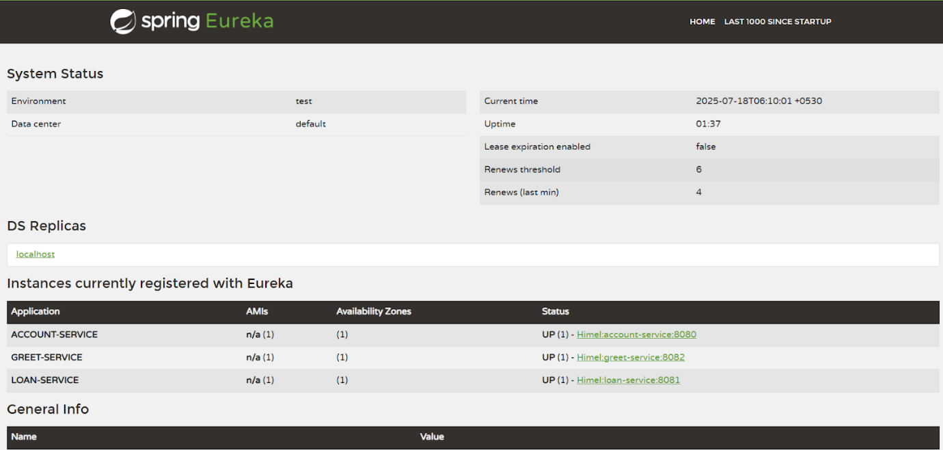

server.port=9090

spring.application.name=api-gateway

eureka.client.service-url.defaultZone=http://localhost:8761/eureka

spring.cloud.gateway.discovery.locator.enabled=true

spring.cloud.gateway.discovery.locator.lowerCaseServiceId=true

spring.devtools.restart.enabled=false

package com.cognizant.api_gateway;

import org.slf4j.Logger;

import org.slf4j.LoggerFactory;

import org.springframework.cloud.gateway.filter.GlobalFilter;

import org.springframework.core.Ordered;

import org.springframework.stereotype.Component;

import org.springframework.web.server.ServerWebExchange;

import reactor.core.publisher.Mono;

*@Component*

public class LogFilter implements GlobalFilter, Ordered {

   private final Logger logger = LoggerFactory.*getLogger*(LogFilter.class);

*@Override*

   public Mono<Void> filter(ServerWebExchange exchange, org.springframework.cloud.gateway.filter.GatewayFilterChain chain) {

       logger.info("Incoming Request: " + exchange.getRequest().getURI());

       return chain.filter(exchange);

   }

*@Override*

   public int getOrder() {

       return -1;

   }

}