**React**

**1. ReactJS hands-on:**

import React from 'react';

function App() {

  return (

    <div>

      <h1>Welcome to the first session of React</h1>

    </div>

  );

}

export default App;

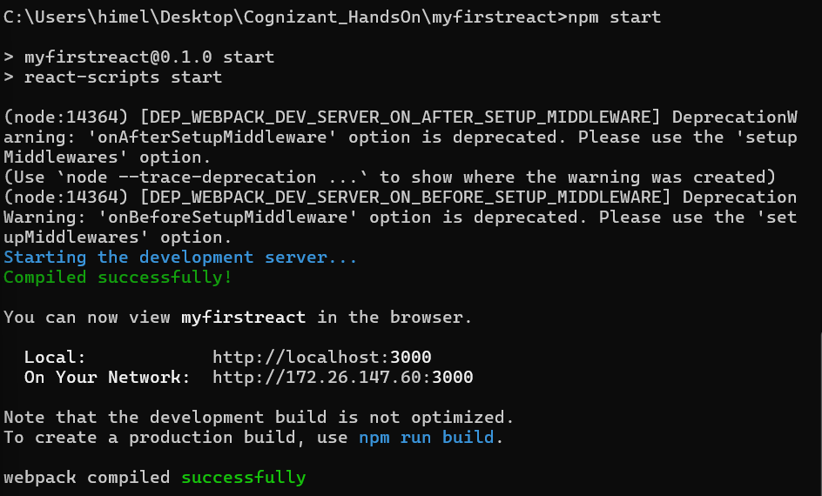

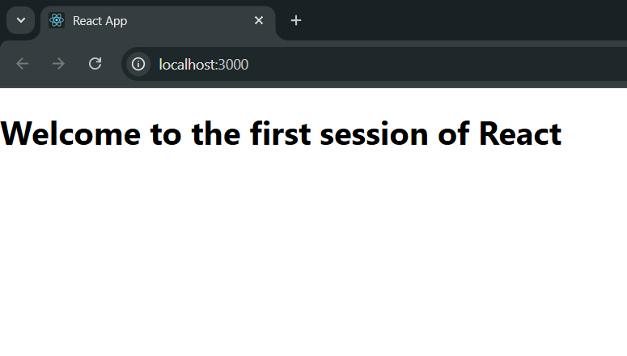

**2. ReactJS hands-on:**

import React from 'react';

function Home() {

  return (

    <div>

      <h2>Welcome to the Home page of Student Management Portal</h2>

    </div>

  );

}

export default Home;

import React from 'react';

function About() {

  return (

    <div>

      <h2>Welcome to the About page of the Student Management Portal</h2>

    </div>

  );

}

export default About;

import React from 'react';

function Contact() {

  return (

    <div>

      <h2>Welcome to the Contact page of the Student Management Portal</h2>

    </div>

  );

}

export default Contact;

import React from 'react';

import Home from './Components/Home';

import About from './Components/About';

import Contact from './Components/Contact';

function App() {

  return (

    <div>

      <h1>Student Management Portal</h1>

      <Home />

      <About />

      <Contact />

    </div>

  );

}

export default App;

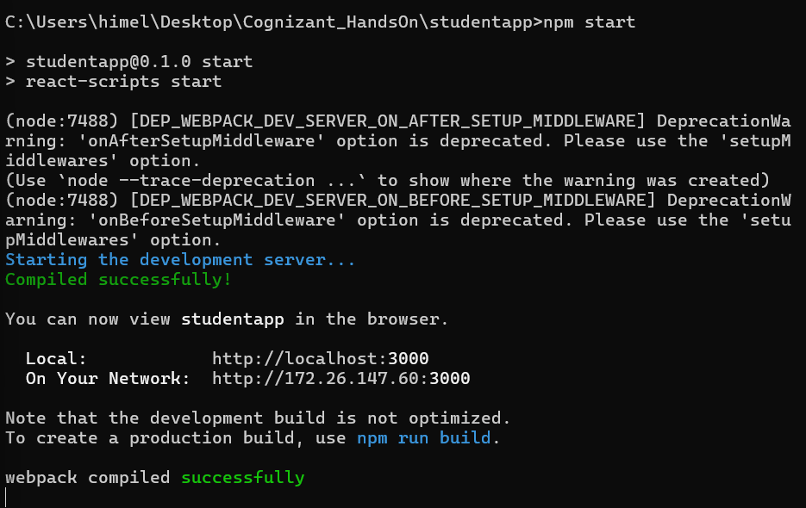

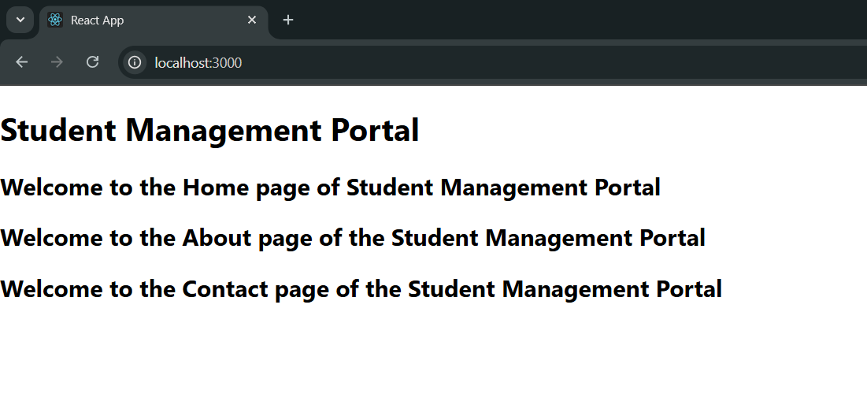

**3. ReactJS hands-on:**

import React from 'react'

import '../Stylesheets/mystyle.css';

const percentToDecimal= (decimal) => {

return (decimal.toFixed(2) + '%')

}

const calcScore = (total, goal) => {

return percentToDecimal(total/goal)

}

export const CalculateScore = ({Name,School, total, goal}) => (

<div className="formatstyle">

<h1><font color="Brown">Student Details :</font></h1>

<div className="Name">

<b> <span> Name: </span> </b>

<span>{Name}</span>

</div>

<div className="School">

<b> <span> School: </span> </b>

<span>{School}</span>

</div>

<div className="Total">

<b><span>Total :</span></b>

<span>{total}</span>

<span>Marks</span>

</div>

<div className="Score">

<b>Score :</b>

<span>

{calcScore(

total,

goal

)}

</span>

</div>

</div>

)

.Name

{

font-weight:300;

color:blue;

}

.School

{

color:crimson;

}

.Total

{

color:darkmagenta;

}

.formatstyle

{

text-align:center;

font-size:large;

}

.Score

{

color:forestgreen;

}

import {CalculateScore} from 'C:/Users/himel/Desktop/Cognizant_HandsOn/scorecalculatorapp/src/Components/CalculateScore';

function App()

{

return(

<div>

<CalculateScore Name={"Steeve"}

School={"DNV Public School"}

total={284}

goal={3}

/>

</div>

)

}

export default App;

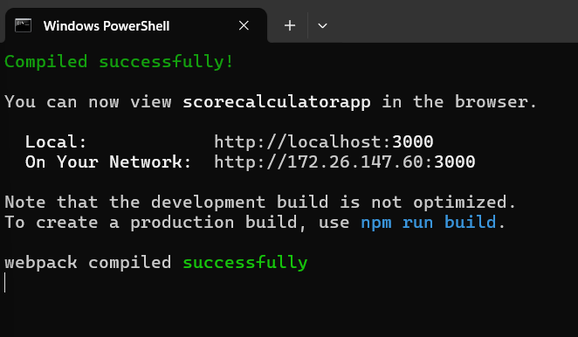

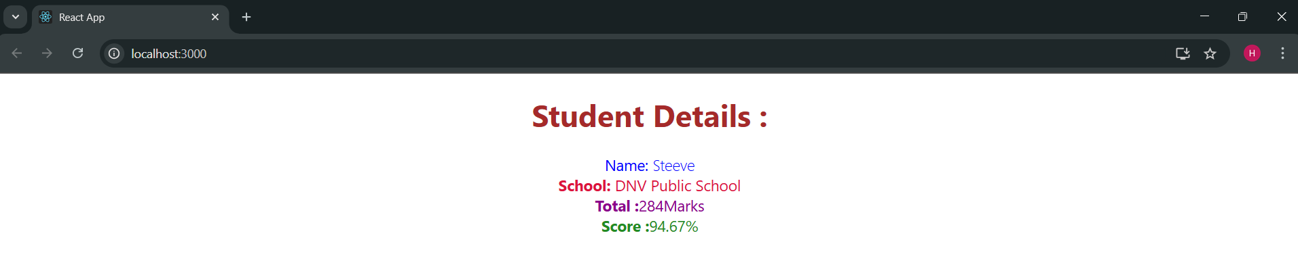

**4. ReactJS hands-on:**

import React from 'react';

export default class Post extends React.Component {

  // constructor(id, title, body){

  //   this.id=id;

  //   this.title=title;

  //   this.body=body;

  // }

  render() {

    return (

      <div style={{ border: '1px solid gray', padding: '15px', margin: '10px' }}>

        <h3>{this.props.title}</h3>

        <p>{this.props.body}</p>

      </div>

    );

  }

}

import React, { Component } from 'react';

import Post from './Post';

export default class Posts extends Component {

  constructor(props) {

    super(props);

    this.state = {

      posts: [],

      hasError: false

    };

  }

  loadPosts = () => {

    fetch('https://jsonplaceholder.typicode.com/posts')

      .then((res) => res.json())

      .then((data) => this.setState({ posts: data.slice(0, 5) })) // limiting to 5 for brevity

      .catch((error) => {

        console.error('Error loading posts:', error);

        this.setState({ hasError: true });

      });

  };

  componentDidMount() {

    this.loadPosts();

  }

  render() {

    return (

      <div style={{ padding: '20px' }}>

        <h2>Latest Blog Posts</h2>

        {this.state.posts.map((post) => (

          <Post key={post.id} title={post.title} body={post.body} />

        ))}

      </div>

    );

  }

  componentDidCatch(error, info) {

    alert('Something went wrong while rendering the posts.');

    console.error('Error Boundary Caught:', error, info);

  }

}

import React from 'react';

import './App.css';

import Posts from './Posts';

function App() {

  return (

    <div className="App">

      <Posts />

    </div>

  );

}

export default App;

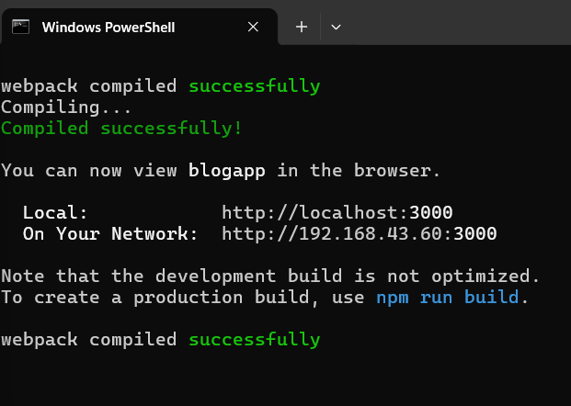

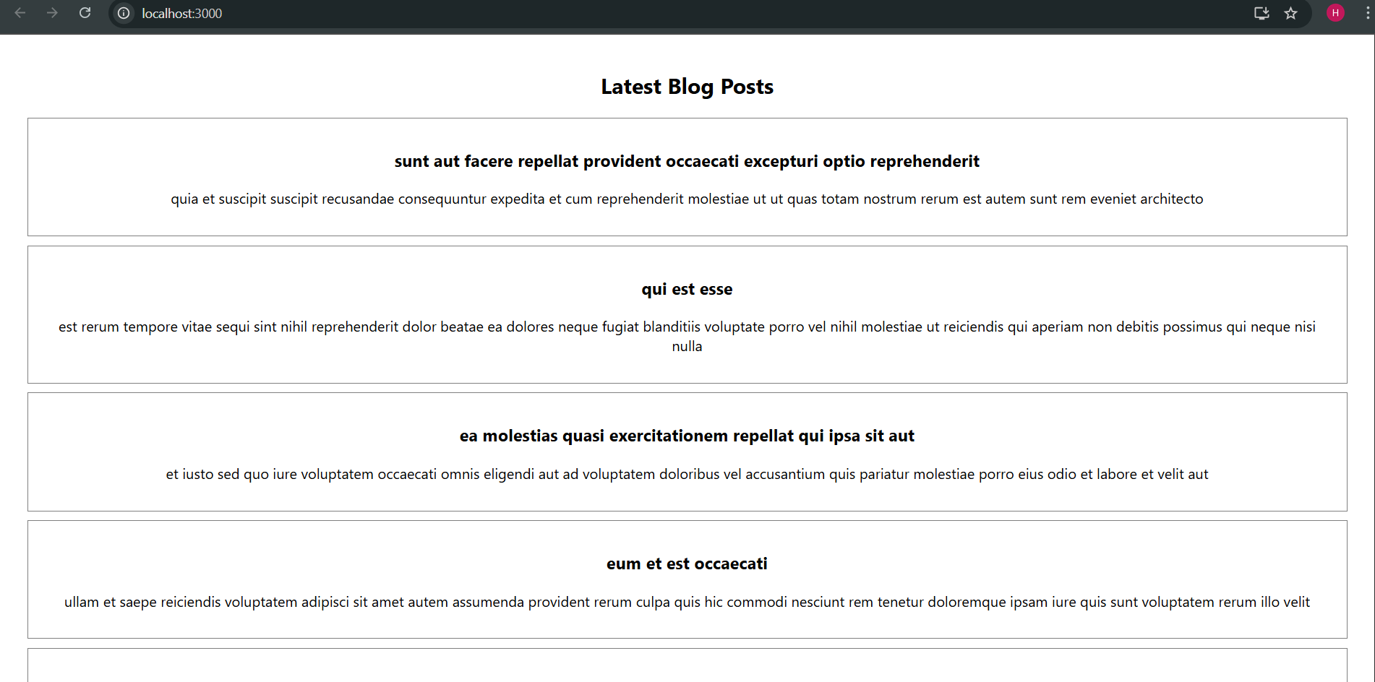

**5. ReactJS hands-on:**

import styles from './CohortDetails.module.css';

function CohortDetails(props) {

    return (

        <div className={styles.box}>

            <h3 style={{ color: props.cohort.currentStatus === 'Ongoing' ? 'green' : 'blue' }}>

                {props.cohort.cohortCode} -

                <span>{props.cohort.technology}</span>

            </h3>

            <dl>

                <dt>Started On</dt>

                <dd>{props.cohort.startDate}</dd>

                <dt>Current Status</dt>

                <dd>{props.cohort.currentStatus}</dd>

                <dt>Coach</dt>

                <dd>{props.cohort.coachName}</dd>

                <dt>Trainer</dt>

                <dd>{props.cohort.trainerName}</dd>

            </dl>

        </div>

    );

}

export default CohortDetails;

.box {

  width: 300px;

  display: inline-block;

  margin: 10px;

  padding: 10px 20px;

  border: 1px solid black;

  border-radius: 10px;

}

dt {

  font-weight: 500;

}

import logo from './logo.svg';

import './App.css';

import { CohortsData} from './Cohort'

import CohortDetails from './CohortDetails';

function App() {

  return (

  <div>

    <h1>Cohorts Details</h1>

    {CohortsData.map(cohort => <CohortDetails cohort={cohort}/>)}

  </div>

  );

}

export default App;

