**React**

**9. ReactJS hands-on:**

import React from 'react';

const ListofPlayers = () => {

  const players = [

    { name: 'Virat', score: 95 },

    { name: 'Rohit', score: 88 },

    { name: 'Dhoni', score: 78 },

    { name: 'Pant', score: 65 },

    { name: 'Hardik', score: 55 },

    { name: 'Jadeja', score: 72 },

    { name: 'Shami', score: 40 },

    { name: 'Bumrah', score: 90 },

    { name: 'Gill', score: 75 },

    { name: 'Surya', score: 60 },

    { name: 'Ashwin', score: 82 },

  ];

  const lowScorers = players.filter(player => player.score < 70);

  return (

    <div>

      <h2>All Players (Using map)</h2>

      <ul>

        {players.map((player, index) => (

          <li key={index}>{player.name} - {player.score}</li>

        ))}

      </ul>

      <h2>Players with score below 70 (Arrow + Filter)</h2>

      <ul>

        {lowScorers.map((player, index) => (

          <li key={index}>{player.name} - {player.score}</li>

        ))}

      </ul>

    </div>

  );

};

export default ListofPlayers;

import React from 'react';

const IndianPlayers = () => {

  const T20Players = ['Virat', 'Rohit', 'Hardik', 'Surya'];

  const RanjiTrophyPlayers = ['Rahane', 'Pujara', 'Jadeja'];

  const allPlayers = [...T20Players, ...RanjiTrophyPlayers];

  const oddTeam = allPlayers.filter((_, i) => i % 2 !== 0);

  const evenTeam = allPlayers.filter((_, i) => i % 2 === 0);

  return (

    <div>

      <h2>Merged Players</h2>

      <ul>

        {allPlayers.map((player, i) => (

          <li key={i}>{player}</li>

        ))}

      </ul>

      <h2>Even Team Players (Destructured)</h2>

      <ul>

        {evenTeam.map((player, i) => (

          <li key={i}>{player}</li>

        ))}

      </ul>

      <h2>Odd Team Players (Destructured)</h2>

      <ul>

        {oddTeam.map((player, i) => (

          <li key={i}>{player}</li>

        ))}

      </ul>

    </div>

  );

};

export default IndianPlayers;

import React from 'react';

import ListofPlayers from './ListofPlayers';

import IndianPlayers from './IndianPlayers';

function App() {

  const flag = true;

  return (

    <div className="App">

      <h1>🏏 Cricket App</h1>

      {flag ? <ListofPlayers /> : <IndianPlayers />}

    </div>

  );

}

export default App;

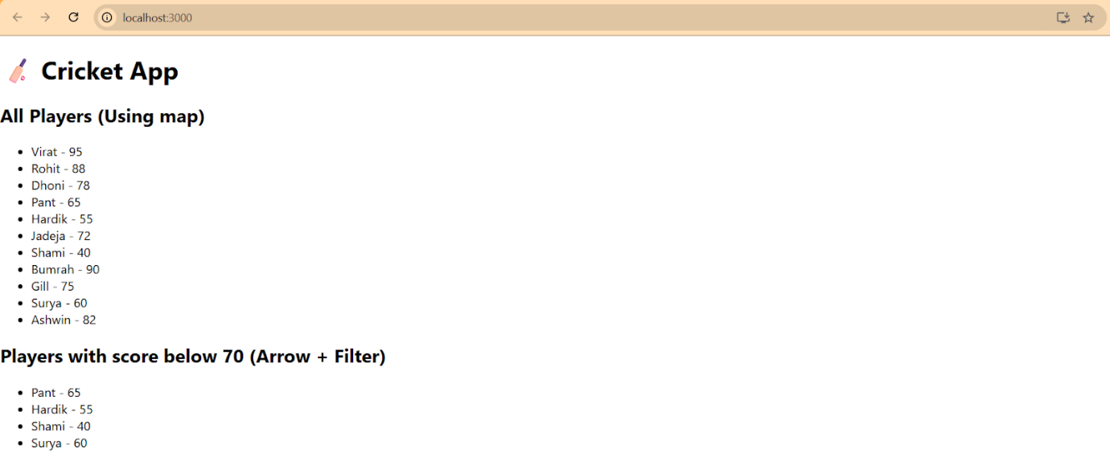

import React from 'react';

import ListofPlayers from './ListofPlayers';

import IndianPlayers from './IndianPlayers';

function App() {

  const flag = false;

  return (

    <div className="App">

      <h1>🏏 Cricket App</h1>

      {flag ? <ListofPlayers /> : <IndianPlayers />}

    </div>

  );

}

export default App;

