|  |
| --- |
| Name: N.D. Manula Sajina Narasingha |
| Student Reference Number: 10707288 |



|  |  |  |
| --- | --- | --- |
| Module Code: PUSL2002 | Module Name: Web Development Platforms | |
| Coursework Title: | | |
| Deadline Date:  13/01/2020 | | Member of staff responsible for coursework:  Dr. Rasika Ranaweera |
| Programme:  Bsc (HONS) Software Engineering | | |
| Please note that University Academic Regulations are available under Rules and Regulations on the University website [www.plymouth.ac.uk/studenthandbook](http://www.plymouth.ac.uk/studenthandbook). | | |
| Group work: please list all names of all participants formally associated with this work and state whether the work was undertaken alone or as part of a team. Please note you may be required to identify individual responsibility for component parts.  N.N.M.S. Narasingha - 10707288  M.R.T. Fernando - 10707199  N.N.D.G. Liyanage - 10707256  P.Y.S.D.S. Manawadu - 10707274  L.A.L. Fernando - 10025597  ***We confirm that we have read and understood the Plymouth University regulations relating to Assessment Offences and that we are aware of the possible penalties for any breach of these regulations. We confirm that this is the independent work of the group.***    Signed on behalf of the group: | | |
| Individual assignment: ***I confirm that I have read and understood the Plymouth University regulations relating to Assessment Offences and that I am aware of the possible penalties for any breach of these regulations. I confirm that this is my own independent work.***  Signed : | | |
| Use of translation software: failure to declare that translation software or a similar writing aid has been used will be treated as an assessment offence.  I *have used/not used translation software.  If used, please state name of software………………………………………………………………… | | |
| **Overall mark _____% Assessors Initials ______ Date_________** | | |

*Please delete as appropriateSci/ps/d:/students/cwkfrontcover/2013/14



***Web Development Platforms***

***PUSL2002***

***Coursework***

***2020–2021***

Group Number -100

Group Members

N.N.M.S. Narasingha - 10707288

P.Y.S.D.S. Manawadu - 10707274

N.N.D.G. Liyanage - 10707256

M.R.T. Fernando - 10707199

L.A.L. Fernando - 10025597

Introduction to the Project

The main objective of developing this project is to introduce a website for farmers to develop a market. This project is jointly launched by the Department of Agriculture (DOA) of Sri Lanka and Keels. Through this project, farmers can feed their produce and Keels staff can purchase them. Another important reason for developing this project is that farmers can sell their produce at any time they want. Also, the replacement of the traditional system with a computerized system. Keels buys crops directly from farmers so that profits can be made directly to farmers. In the traditional system, intermediaries make huge profits. This will enable farmers to sell their crops directly by breaking that indirect supply chain.

screen shots of all pages

Loading page



login Page

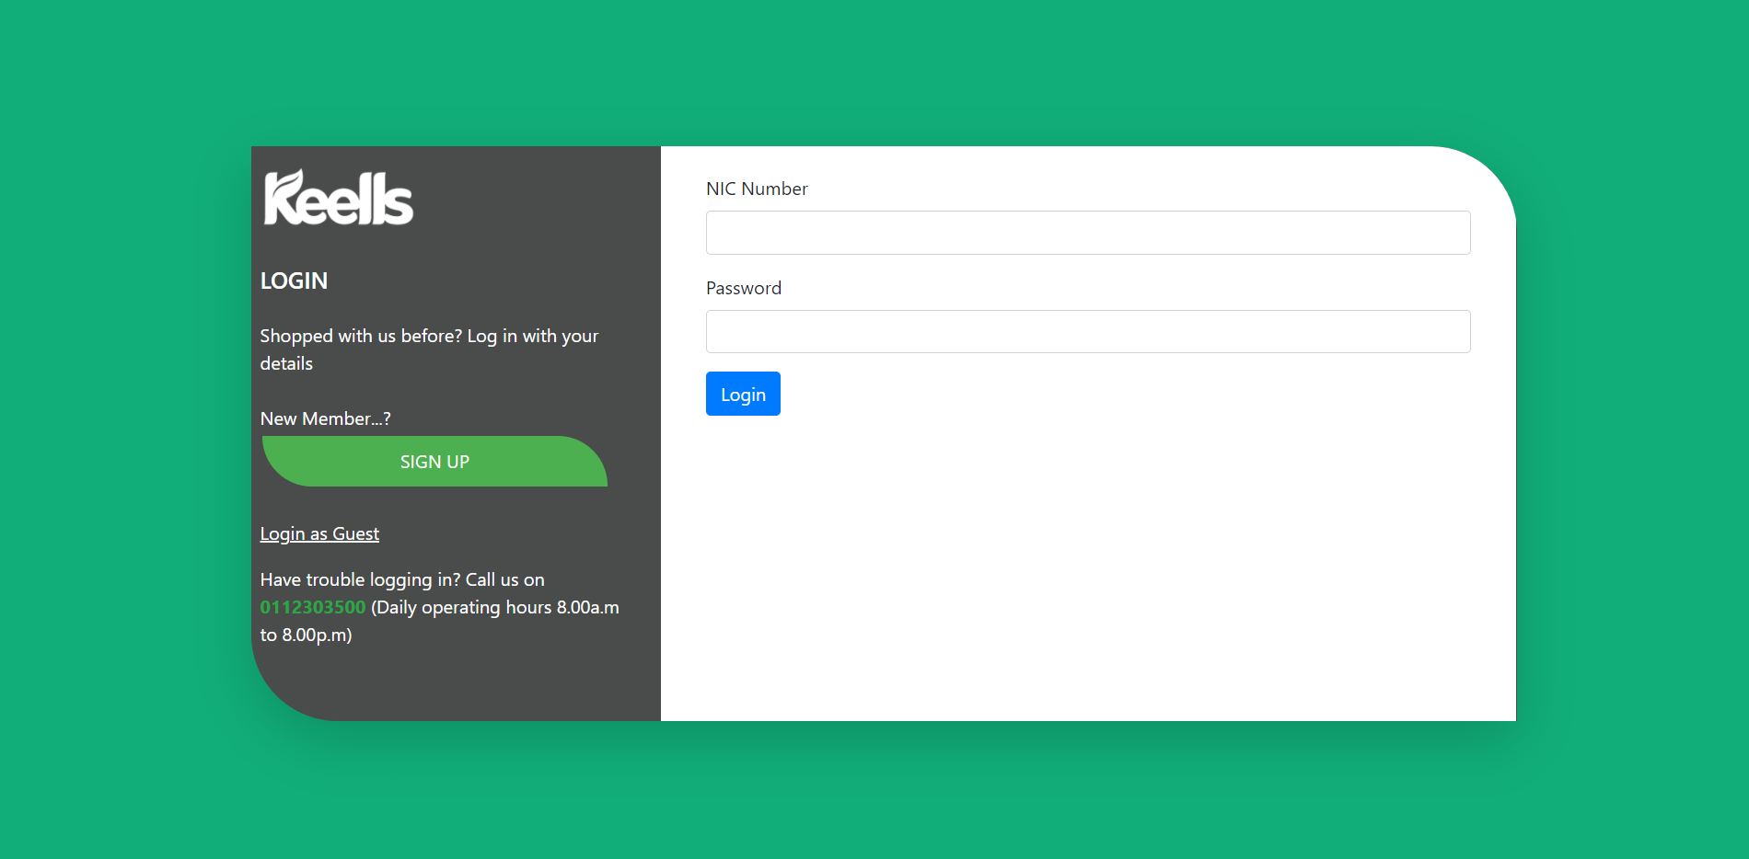

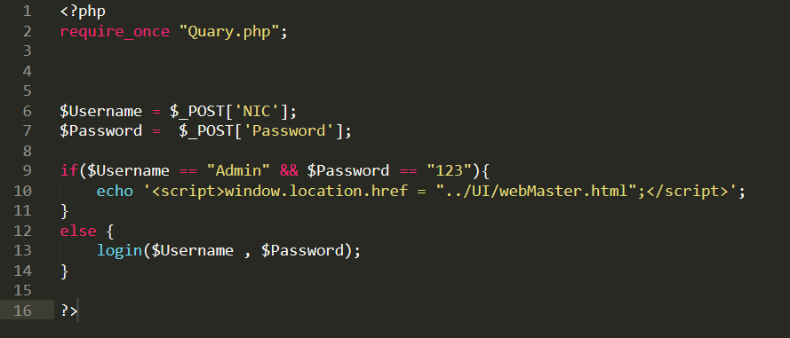

Sign Up Page



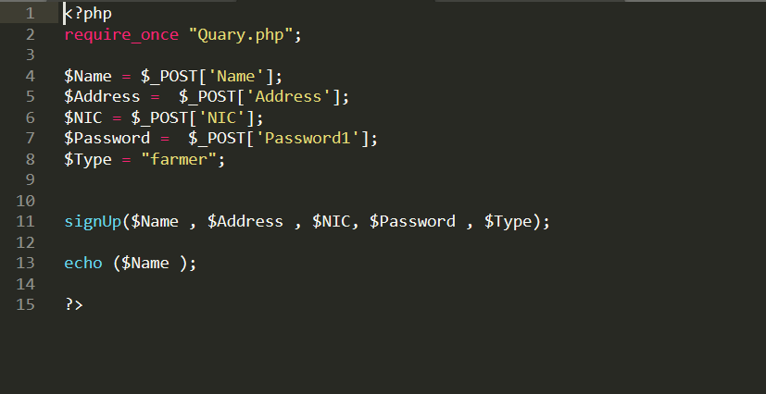

Create New Login

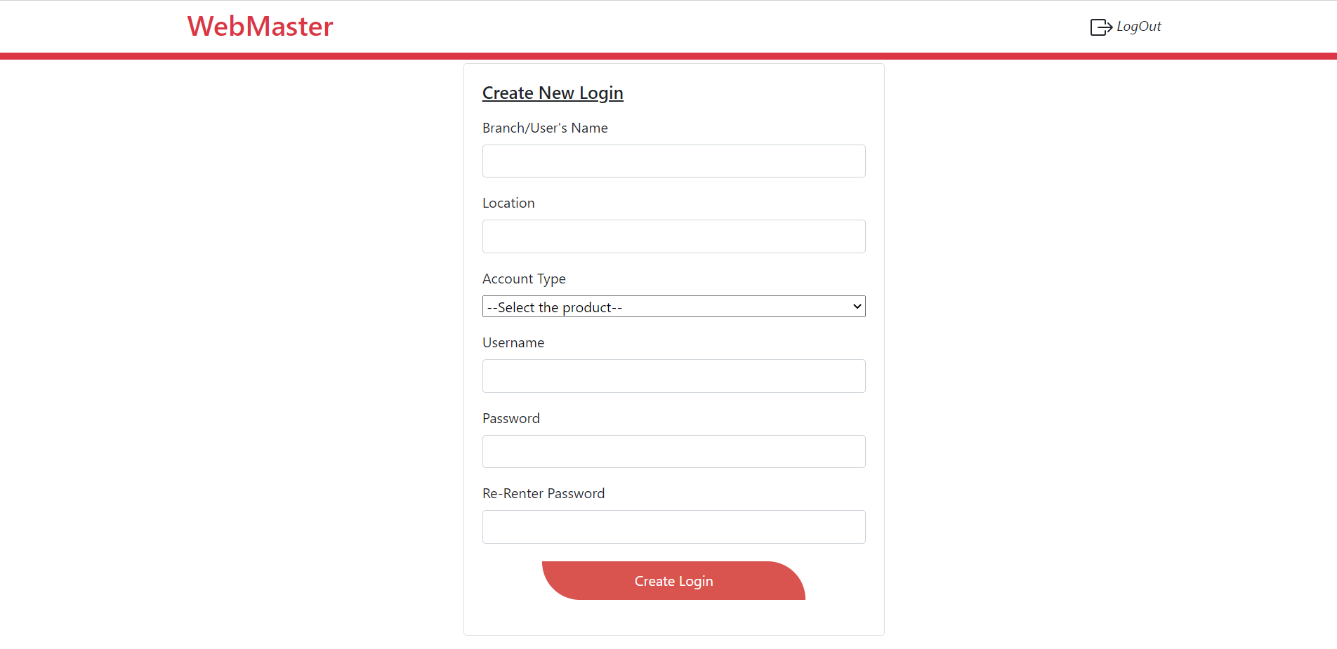

Add New Harvest

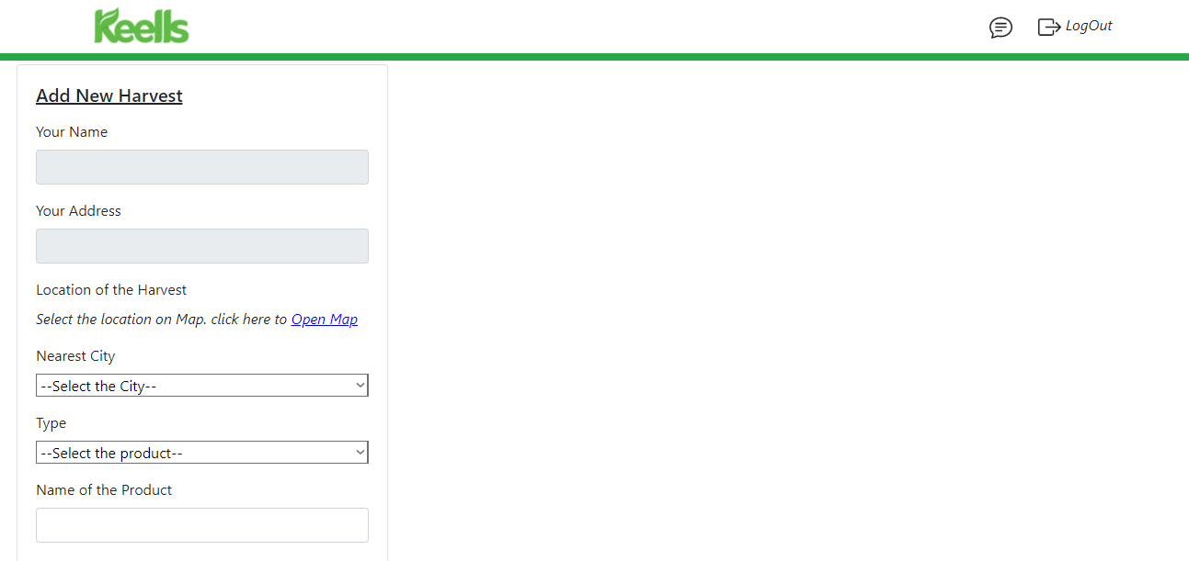

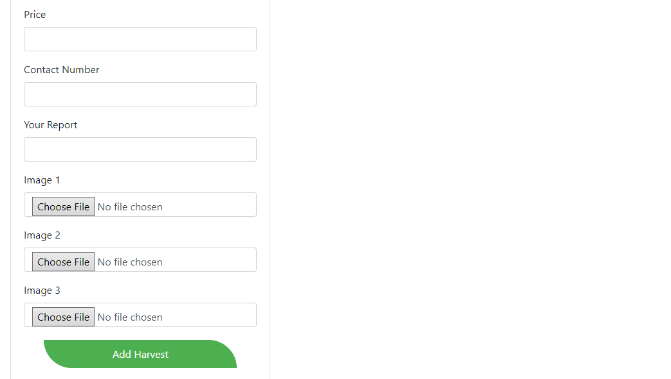

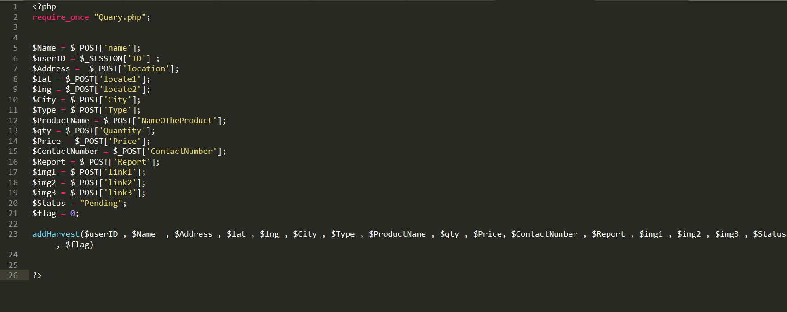

Delete Harvest

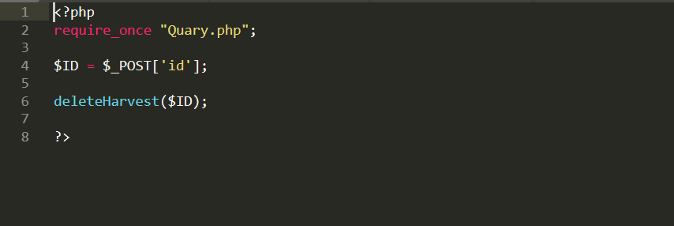

Edit Harvest

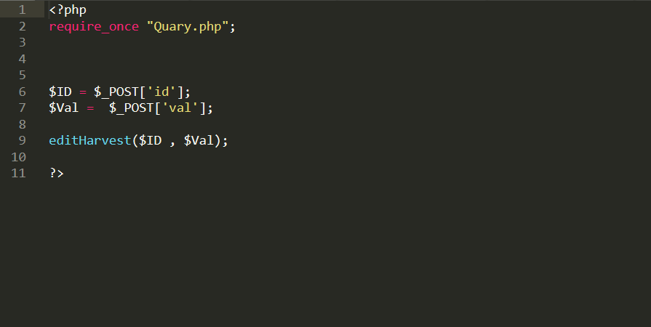

Update Harvest Status

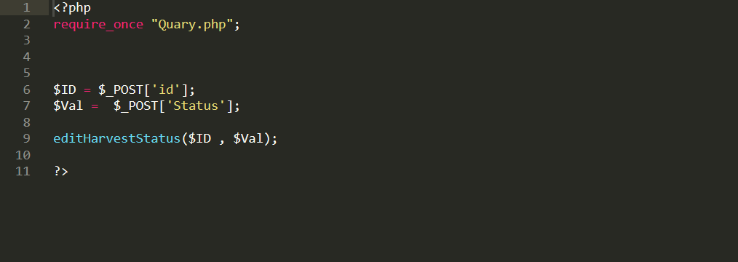

Map

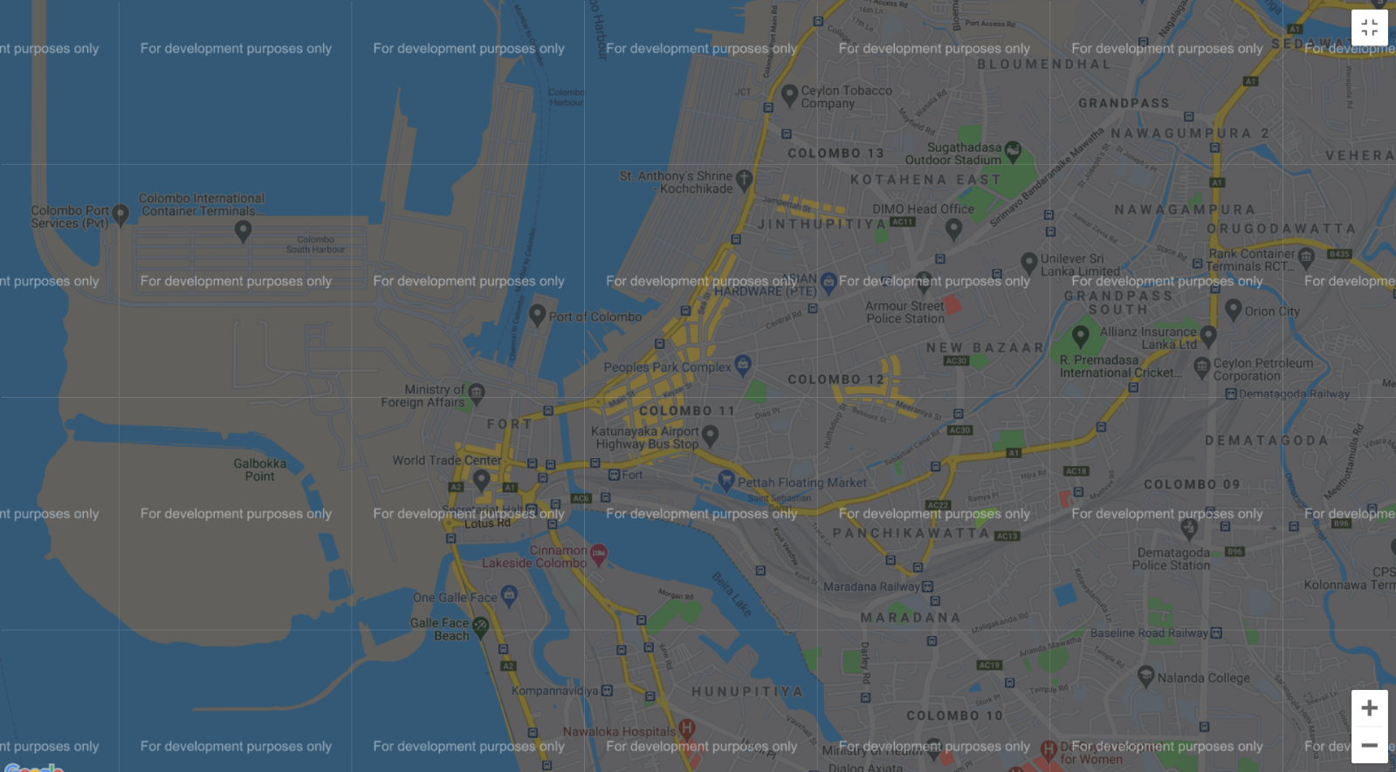

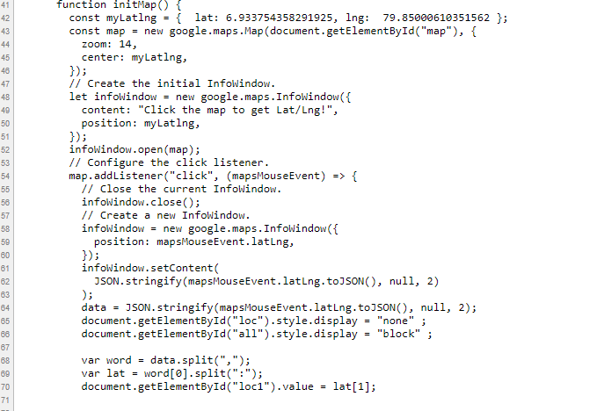

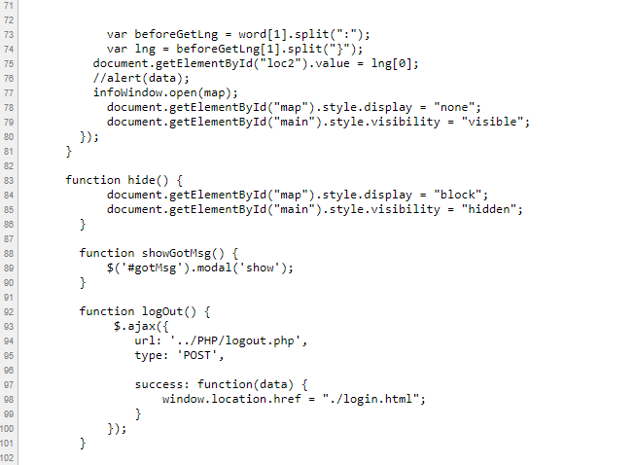

Message Box

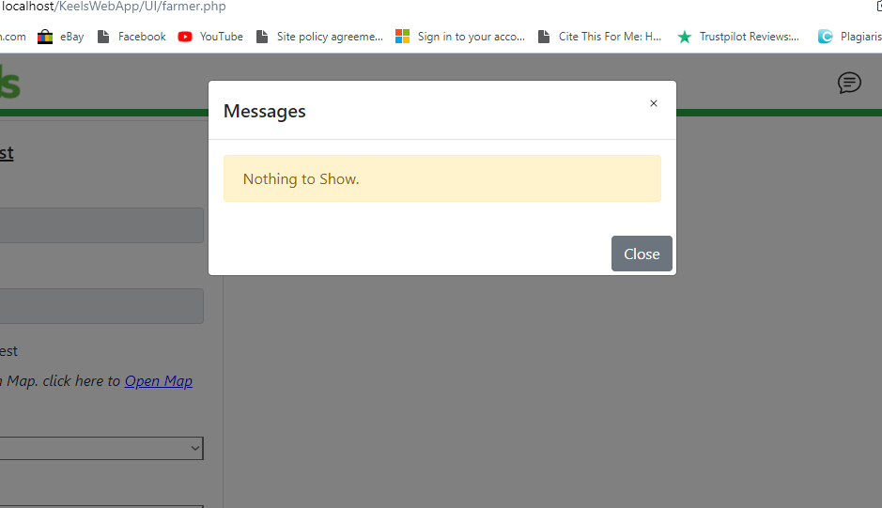

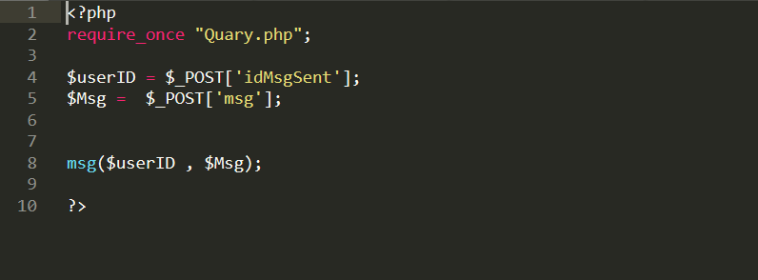

Logout



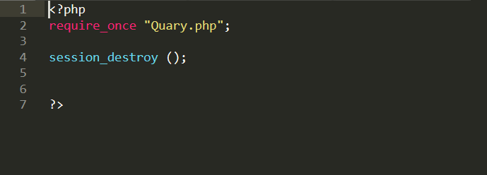

Database

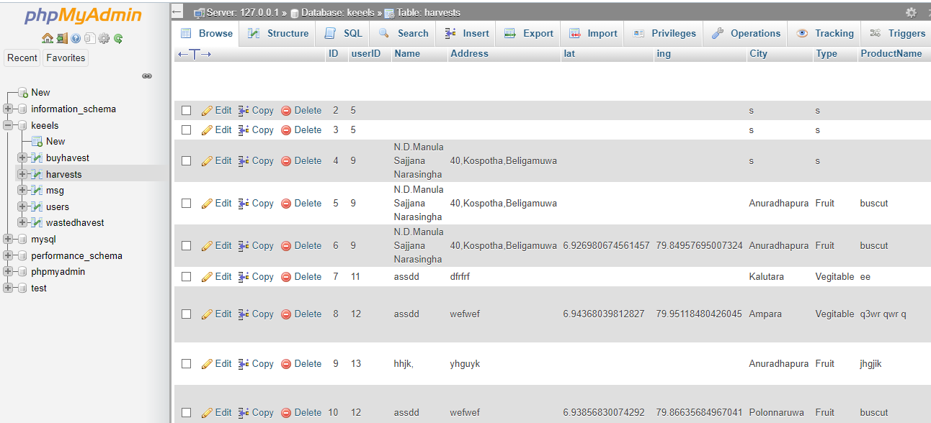

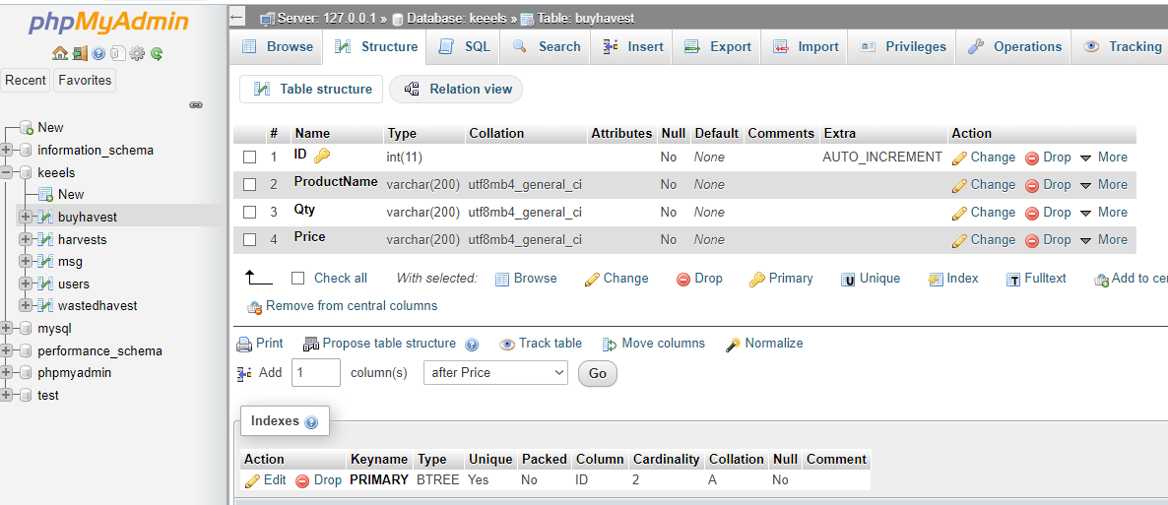

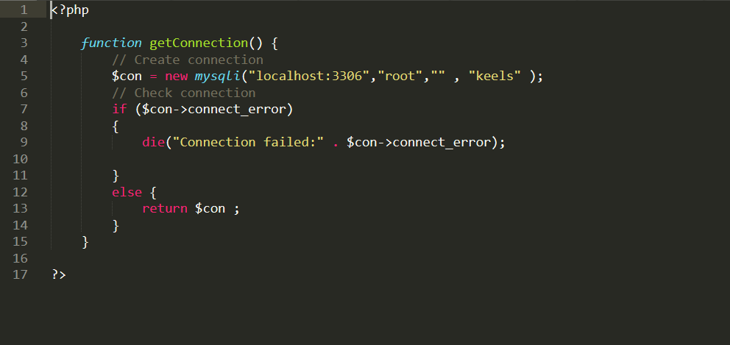

Discussion about challenges

* Users should be able to easily navigate through a website. If users are not able to browse through a website easily, they will leave as soon as they arrive. The most important aspect of web design is the ability to navigate. Users of different backgrounds use this site. Therefore, we need to develop a system that makes it easy for all those users to navigate. That is the main challenge we face in designing this system.
* There are a lot of issues we encountered while creating this php website. There were problems creating the google map. To list farmers across Sri Lanka, there were several issues when linking a Google Map to a MySQL database.
* Providing a great user experience is one of the challenges we face in creating this site. When users enter the site, they are childish. It is our duty to control their confusion and guide them through a decision.
* The content of the website plays an important role. Using the right words not only contributes to the promotion of the website, but also helps to attract visitors.

Conclusion

The system was developed so that farmers could feed their produce and Keells staff could purchase them. It allows to solve many problems related to agriculture. A major problem is the inability of farmers to sell their produce at reasonable prices. This system provides a proper solution to their problem. This method equips the farmer with knowledge related to selling the harvest. With the current method, the government can use this method to keep the farmers up to date.

Workload Matrix

|  |  |  |  |  |  |
| --- | --- | --- | --- | --- | --- |
| Student Id | 10707288 | 10707199 | 10707256 | 10707274 | 10025597 |
| Start page |  |  |  |  | **\*** |
| Login page |  |  |  |  | **\*** |
| Logout page |  |  |  |  | * |
| Sign Up | * |  |  |  |  |
| Add New Harvest |  |  |  | * |  |
| Delete Harvest |  | **\*** |  |  |  |
| Update Harvest Status | * |  |  |  |  |
| Edit Harvest |  | * |  |  |  |
| Add Inventory |  |  |  | **\*** |  |
| Wasted Inventory |  |  |  | * |  |
| Create Web Master |  |  |  | * |  |
| Get Category |  |  | * |  |  |
| Guest |  |  | **\*** |  |  |
| Send Messages | * |  |  |  |  |
| Get Data to Dialog Box |  |  | * |  |  |
| Set Flag | * |  |  |  |  |
| Database |  | * |  |  |  |